I. Regulation No. 6 - 5.6 (c)
Problem: How to interpret the ‘One Continuous Line’ requirement?

Question | In the picture below the Direction indicator is Reciprocally incorporated with the DRL. Under operation of the D.I. the following occurs:  All light sources within Bar 1 illuminates simulatneosly, followed by Bar 2 and then 3. There is no pulsation of the light sources within each bar.  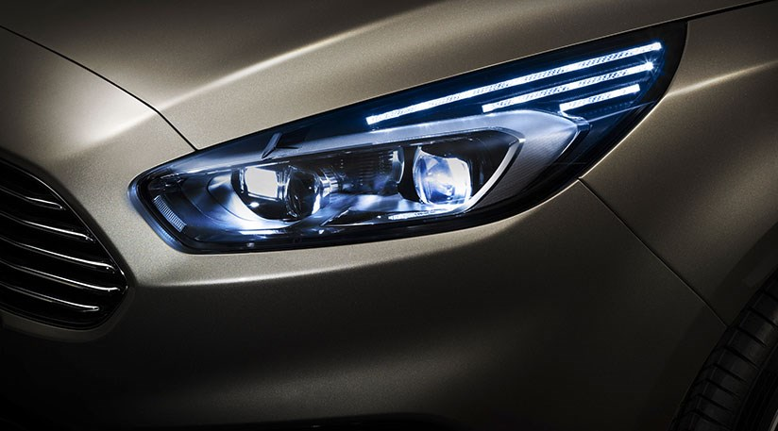  Bar 2  Bar 3  Bar 1  The type approval authority (A) understands that a cycle consists of bar 1 illuminating all light sources within that bar simulatneosly, followed by Bar 2 and then 3. There is no pulsation of the light sources within each bar. The type approval authority (A) is trying to determine the rationale behind the approval of this lamp and in particular how it meets the requirements of paragraph 5.6 (c)
Relevant text or paragraph reference | 5.6. For direction indicator lamps of categories 1, 1a, 1b, 2a or 2b the flash may be produced by sequential activation of their light sources if the following conditions are met:  (a) Each light source, after its activation, shall remain lit until the end of the ON cycle;  (b) The sequence of activation of the light sources shall proceed in a uniform progressive manner from inboard towards the outboard edge of the apparent surface;  (c) It shall be one continuous line with no repeating alternation in the vertical direction (e.g. no waves).  (d) The variation shall finish no more than 200 ms after the beginning of the ON cycle;  (e) For the orthogonal projection in the direction of the axis of reference of a rectangle, circumscribing the apparent surface of the direction indicator shall have its longer sides parallel to the H-plane, the ratio of the horizontal to the vertical sides shall not be less than 1.7.  Compliance to the conditions mentioned above shall be verified in flashing mode.
The type approval authority (A) is trying to establish how to interpret the ‘One Continuous Line’ requirement. Has the above lamp been approved due to the overlap shown in the diagram below and therefore the lamp is seen as providing a continuous line in the direction from inboard to the outboard of the vehicle?

Inboard edge of lamp
Bar 1
Bar 2
Outboard edge of lamp
Overlap shows progressive movement of the DI towards the outboard edge of the lamp

Bar 3

Or is there an alternative logic?

https://m.youtube.com/watch?v=N4WUrb1-Khk

The type approval authority (A) is a synonym for a type approval authority.
II. Resolution proposed
The intention is to establish a task force on “sequential activation”. This task force should clarify the interpretation or formulate a working document for the 76th GRE to change R6.

