INF.3
Economic Commission for Europe
Inland Transport Committee
Working Party on the Transport of Dangerous Goods
101st session 22 August 2016
Geneva, 8–11 November 2016
Item 9 of the provisional agenda
Any other business
Press report related to notification of occurrence ID 61 in ECE/TRANS/WP.15/2016/15
Transmitted by the Government of Germany
Mercury spill: large scale fire brigade operation at Erfurter Kreuz
27 August 2015, 3:12 hours
Thörey (Ilm district) A logistics operator from Thörey asked for assistance from the rescue services when nearly two kilogrammes of mercury spilled from two packages from GDR times.
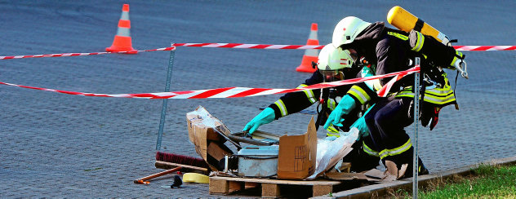

Using breathing apparatus, the rescue services examined the packages and packed them up preventing mercury from spilling further. Photo: Hans-Peter Stadermann
On Wednesday afternoon, two defective packages caused a large scale fire brigade operation in the business park in Thörey. As they suspected a mercury spill, the persons in charge called experts trained for such emergencies to their aid to rule out that employees would be exposed to harmful substances.
At GLS, up to 14,000 mail consignments are sorted and loaded per day. In the halls of the logistic centre, the packages run on large conveyor belts. Here, an observant staff member noticed that silver-coloured beads were leaking from two packages.
The belt was stopped and the packages were brought outside with a forklift. A series of measures was initiated directly to protect the staff members.
On the one hand, the persons in charge at GLS tried to find out the contents of the packages by contacting consignor and consignee. On the other hand, at that point in time, they were already speaking on the phone with the rescue coordination centre.
As a precaution, staff members left their work place, as inhaled mercury is highly toxic.
Soon it became clear that the problem could not be solved without professional assistance. The packages contained old measuring devices that evidently had not been packed carefully enough. Impacts or vibration during transport had damaged components out of which spilled nearly two kilogrammes of mercury.
On Wednesday night, the fire brigade could not be absolutely certain whether it was indeed mercury. But there was a strong suspicion that this was the case. Therefore, it had been absolutely right that the company had decided to call the fire brigade, said deputy city fire inspector Stephan Jäger. It was a coincidence that - together with colleagues from Plaue - he was at the scene of the incident, as he came from an out-of-office appointment and was driving through Thörey.
The main work was done by the colleagues from Thörey and Ichtershausen as well as by the special squad for dangerous goods. Equipped with breathing apparatus, they entered the premises, examined the packages and - together with the leaking beads- packed them up properly so that the threat could be eliminated. Now, a special disposal contractor has to deal with the removal of the defective measuring devices.
26 August 2015
Large scale fire brigade operation at Erfurter Kreuz
On Wednesday night, there was a large scale fire brigade operation in the business park in Thörey.
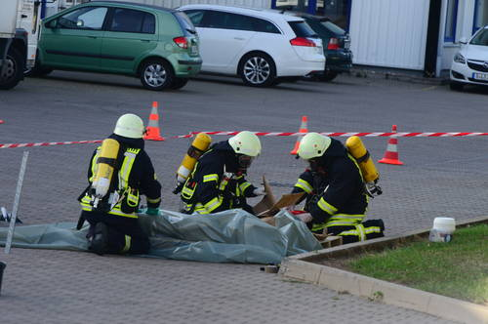

Fire brigade operation in the Thörey business park. Here, a package at the GLS premises had probably leaked mercury. The special squad for dangerous goods of the Ilm district was also on site. Photo: Hans-Peter Stadermann
Rights to the photos: TA

