UN/SCETDG/49/INF.31
UN/SCEGHS/31/INF.9

Committee of Experts on the Transport of Dangerous Goods
and on the Globally Harmonized System of Classification
and Labelling of Chemicals 15 June 2016
Sub-Committee of Experts on the  Transport of Dangerous Goods | Sub-Committee of Experts on the Globally Harmonized System of Classification and Labelling of Chemicals
Forty-ninth session | Thirty-first session
Geneva, 27 June – 6 July 2016  Item 10 (c) of the provisional agenda  Issues relating to the Globally Harmonized System of Classification and Labelling of Chemicals: Classification criteria for flammable gases | Geneva, 5– 8 July 2016  Item 2 of the provisional agenda  Joint work with the Sub-Committee of Experts on the Transport of Dangerous Goods (TDG Sub-Committee)
Background information regarding hazard communication for flammable gases
Transmitted by the experts from Belgium and Japan
1. This document is submitted as background to the formal Proposal for modification of the classification criteria and hazard communication for flammable gases (ST/SG/AC.10/C.3/2016/17 − ST/SG/AC.10/C.4/2016/4), transmitted by the experts from Belgium and Japan.
2. During the December 2015 sessions of the Sub-Committee of Experts on the Transport of Dangerous Goods (TDG Sub-Committee) and the Sub-Committee of Experts on the Globally Harmonized System of Classification and Labelling of Chemicals, (GHS Sub-Committee), the joint TDG-GHS informal working group on classification criteria for flammable gases presented the results of its work consisting of new classification criteria to be used for dividing flammable gases. As noted in the report, there was full support for the criteria in option 3 in informal documents INF.15 (TDG Sub-Committee, 48th session) - INF.4 (GHS Sub-Committee, 30th session) i.e., allowing for sub-categorization of current category 1 into category 1A and 1B, with category 1B addressing gases with a lower flammability limit greater than 6% or a fundamental burning velocity of less than 10 cm/s.
3. It was noted that the new sub-category 1B would allow the classification of gases and gas mixtures with a lower burning velocity developed by the refrigeration and foam plastics industries following the phasing down of high global warming potential substances. It was also noted that the criteria in option 3 would not entail any change in classification for transport purposes.
4. This recommendation was based on factors such as:
- safety considerations including the necessity to mark off reliable hazard areas for flammable gases and the necessity to provide the right hazard guidance for users of, for instance, blowing agents, solvents, cleaners and other process gases,
- the need of a wider adoption of gases with low global warming potential (flammable) to deal with climate change issues (Montreal Protocol and Kyoto Protocol)
4. In the consensus recommendation from the IWG on flammable gases categories, led by the Belgian and Japanese GHS Delegations, gases which meet the criteria of category 1 or 1A and which have a lower flammability limit (LFL) of more than 6% by volume in air; and/or a fundamental burning velocity (FBV) less than 10 cm/s may be categorised as Category 1B gases.
5. There has been discussion regarding the appropriate hazard statements for the revised categories. Belgium and Japan agreed to bring forward further information regarding the appropriateness of the signal word and hazard statement (warning/flammable gas) for the proposed category 1B. This document contains three pieces of information in this regard:
- The first is a set of tests which have been undertaken in response to the request for better understanding of the differences in escape time and consequences of ignition between the proposed 1A and 1B flammable gases categories. Gases in the testing are both pure gases in commercial use and mixtures created to illustrate these parameters for distinguishing between 1A and 1B gases. (See Annex 1).
- These tests results have been analysed by Dr. Denis Clodic, Expert on Global Warming and Gas Flammability, (See Annex 2)
- The third is an Expert Opinion from Professor M. J. Kalsher, Rensselaer Polytech Institute, regarding Hazard Communication Elements for a Proposed Modification of the Categories of Flammable Gases within the GHS Framework. (See Annex 3)

Annex 1
Tests undertaken to better understand the differences in escape time and consequences of ignition between the proposed 1A and 1B flammable gases categories
TESTING THE RELATIVE HUMAN ESCAPE TIME FOR FLAMMABLE GASES
This test was designed to confirm, for various gases in the proposed 1A and 1B categories, the relative time between a) the start of a leak, b) a standard warning from a leakage tester at ¼ LFL and c) the creation of flammable conditions at 1/1 LFL; in other words, the time, after an alarm sounds, during which it is possible for a person to avoid and escape a warehouse or workshop before the conditions for a flammable environment are reached.
ESCAPE TIME TEST SET UP
- The test gas was leaked in a 1.5m³ container (1,800x900x900mm), at a rate of 3.5L/min, equivalent to either a severed 3cm pipe in a 18,000m³ warehouse (L 100m, W 30m, H 6m) or a severed 1.5cm pipe in a standard workshop (L 5m, W 6m, H 5m).
- The gas concentration was measured by oxygen replacement.
- Leakage testers were placed at 6 locations in the test apparatus. Escape time is the time from the ¼ LFL alarm to the 1/1 LFL (flammable atmosphere). To obtain conservative (shortest) escape time values, the ¼ LFL alarm times are recorded when all six testers signal the ¼ LFL and flammable atmosphere (1/1 LFL) is recorded when the first tester signals the flammable concentration.

Figure 1: Escape time test set-up
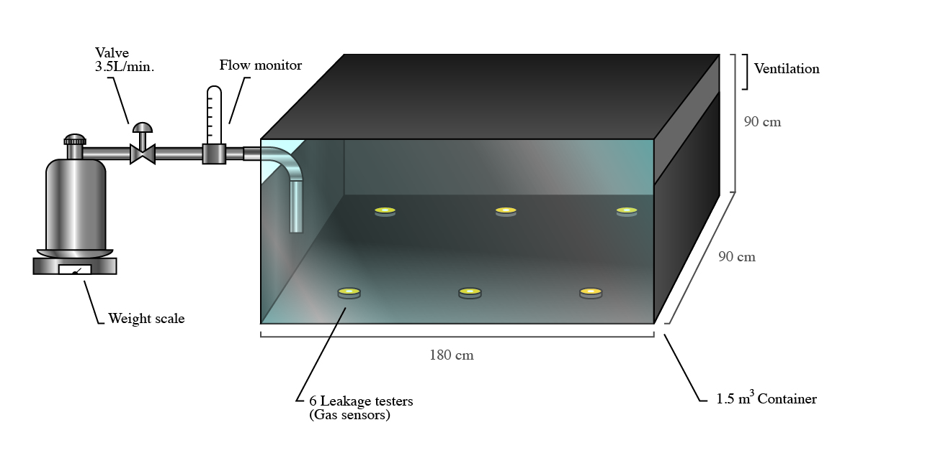
DIFFERENCES IN RELATIVE ESCAPE TIMES FOR THE TESTED FLAMMABLE GASES
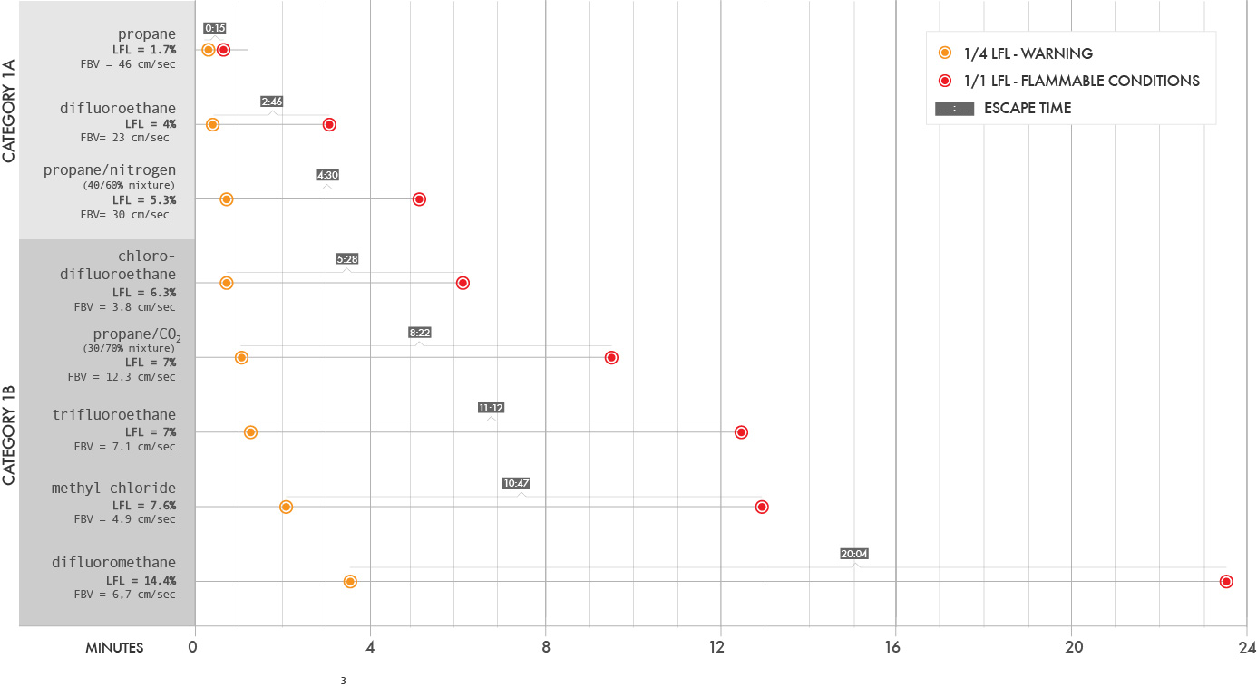
Figure 2: Differences in Relative Escape Times for the Tested Flammable Gases
An enlarged version of this graph is available on the last page of this document

ESCAPE TIME TEST RESULTS
- The test results are consistent, although not identical, to theoretical results and as expected, gases with higher LFL provide more escape time.
- Although escape times just above and below the LFL threshold are within one minute of each other, there are significant differences between the two categories of gases as a whole. Two gases with the same LFL but different FBV’s would, if ignited, have different consequences.
- Gases in the 1B group uniformly allowed for reasonable exit after an alarm. P. Hughes and E. Ferrett indicate that occupational structures should provide 2 to 3 minutes escape time. The results here indicate that in realistic situations category 1B gases allow an escape time of 5 minutes and more. The time would vary depending on structure size, geometry and leak rate but the observation of relative escape time remains valid.
TESTING THE CONSEQUENCES OF AN IGNITION
Two tests were designed for examining the consequences of an ignition in a real life situation for gases categorised as 1A or 1B:
1. One test simulates a slow long term leak into a sealed, unvented, equipment room. In this case, there is sufficient time for the flammable gas to form a homogenous fuel/air mixture and the equipment in such room act as obstacles, potentially causing flame turbulence increasing the severity of the flame (worst case scenario).
2. The other is an accelerated test simulating a leak into a workshop or warehouse. The test was accelerated to make it practical to test multiple substances on multiple runs in a reasonable time. Consequently, a worst case scenario is recreated. Concrete block obstacles were included in the test apparatus, representing worktables and shelving, potentially causing flame turbulence.
For each test, an ignition source energetic enough to ensure ignition was used.
1. For four of the homogenous fuel/air mixture test, the ignition source was instantaneous (milliseconds). For the fifth one a longer duration ignition source was required to ensure ignition.
2. For the accelerated leak test, the ignition source was maintained until the end of the tests, so combustion continues even without self-propagation.
CONSEQUENCES TEST 1 (homogenous cloud) - SET UP
- A homogenous fuel/air mixture was created in a sealed space (1.5m³) with obstacles.
- The right side of the test box is a vinyl sheet which fully separates from the box in the case of a sudden high pressure or flaps open to release over-pressure in the case of a slow pressure rise (required for laboratory safety).
- The fuel concentration was raised in steps until ignition occurred (additional gas added, pressure equalised, mixed and homogenised). Concentration is noted for each test as a percentage of Φ. Φ is a 1:1 air/gas equivalence ratio.
- Results were video-taped.
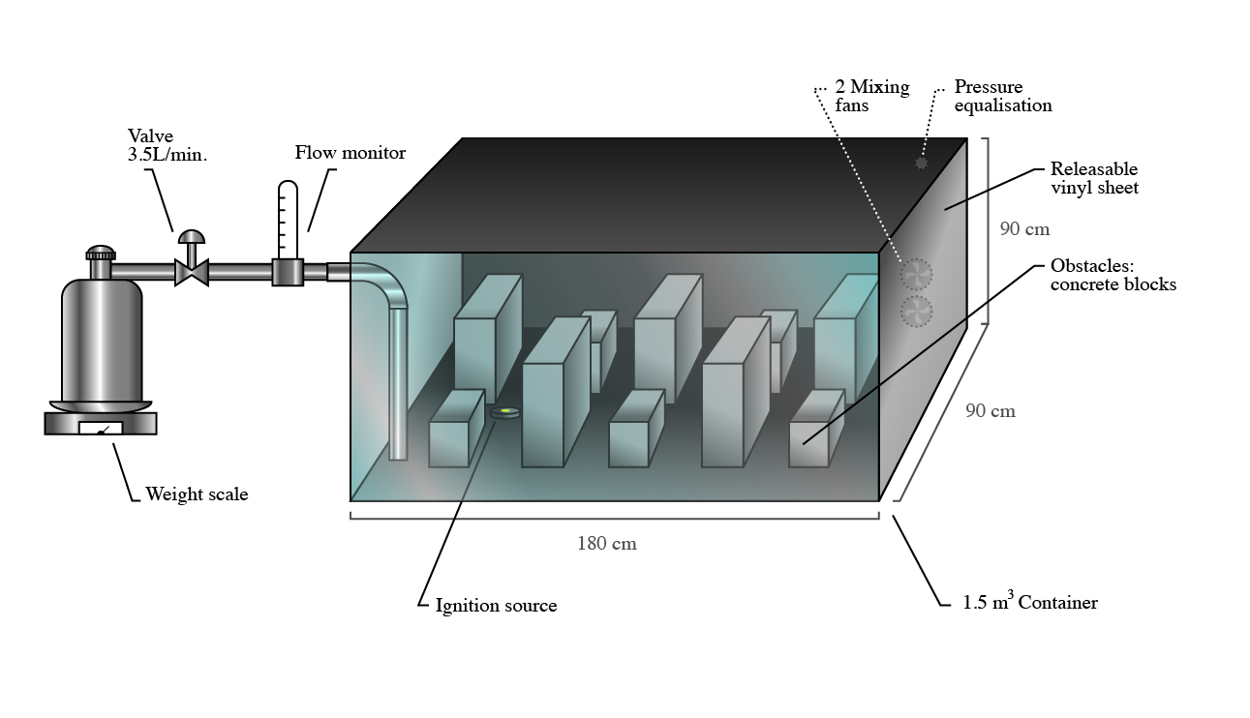
Figure 3: Consequences test (homogenous cloud) - set up
CONSEQUENCES TEST 2 (accelerated leak) - SET UP
The gas was introduced at a constant rate (15 L/min) in a vented space with obstacles sized and positioned to simulate work tables and stocking shelves.
- A high energy ignition source (5kV, 10mA, AC 60Hz) was positioned among the obstacles.
- The gas was leaked until ignition occurred.
- Results were video-taped. For the sake of demonstrating the results, the time (up to 20 minutes) during which the gas builds to a flammable concentration without any visible change has been edited out of the videos.
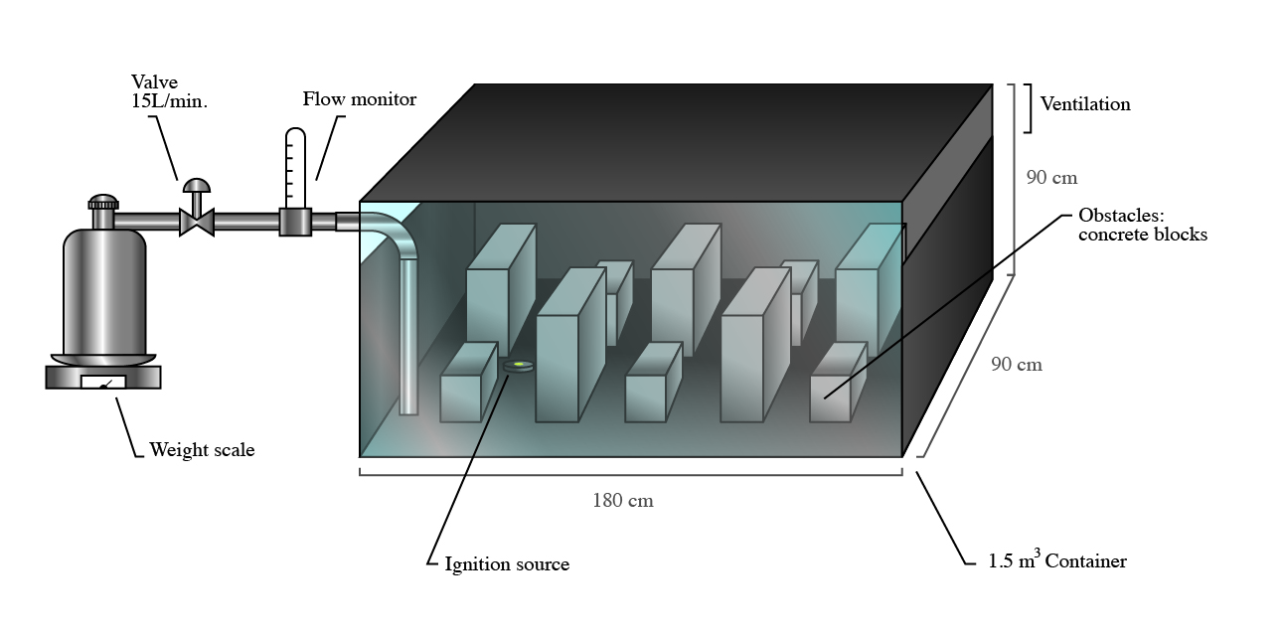
Figure 4: Consequences test (accelerated leak) - set up
CONSEQUENCES TEST 1 (homogenous cloud) – RESULTS
The videos of the test results exhibit a significant difference in the consequences of the combustion between the two categories of gases (see video links below).
As expected, the test results show a significant combustion with high overpressure for the 1A gases. For the tested 1B gases the flame propagation is noticeably milder and the over pressures vent and equalise immediately.
CONSEQUENCES TEST 2 (accelerated leak) – RESULTS
The videos of the test results exhibit a significant difference in the consequences of the combustion between the two categories of gases (see video links below). The test results for 1A gases show fire with a sustained and significant flame occurring. For the tested 1B gases, the flame remains small and sustains only with a continuous ignition source. When the ignition source is stopped, the flame extinguishes despite the continuing gas supply.

 | TEST GAS | OBSERVATIONS
CATEGORY 1A | Propane  FBV = 46 cm/sec  LFL = 1.7%v/v | Propane was used because it is the standard flammability gas.  Homogenous cloud  Having a high FBV (46 cm/sec), the results for propane demonstrate the severe consequences of a category 1A gas ignition. The gas concentration at ignition time was 0.65 Φ.  Accelerated leak  Once ignited, the propane flame spreads quickly and in all directions. As it exhausts the supply of pooled gas the flame burns selectively upstream towards the leak. This burning upstream introduces the extreme danger that the source of the gas might also ignite. In this video the flame sustains, even away from the ignition source, until the gas leak is terminated.  To view video please click on the image below:  Note the password is TDG-GHS
 | Difluoroethane  FBV = 23 cm/sec  LFL = 4%v/v | Difluoroethane demonstrates a gas with approximately 50% of the FBV of propane but still with extreme flammability.  Homogenous cloud  The combustion of the homogenous cloud is noticeably less severe than the propane cloud although quite dangerous. The gas concentration was at ignition time 0.65 Φ.  Accelerated leak  The leak test for difluoroethane shows slightly less severe consequences than propane but is fairly dangerous in itself and burns upstream to the leak source. In this video the flame is extinguished by terminating the gas leak.  To view video please click on the image below:  Note the password is TDG-GHS
CATEGORY 1B | Propane/CO₂ mixture (30 / 70%)  FBV = 12.3 cm/sec  LFL = 7%v/v | This is not a commercially available or useful gas mixture. It was mixed specifically for this test to show a borderline gas with a high LFL and a fundamental burning velocity slightly above the threshold.  Homogenous cloud  The combustion of the homogenous cloud is relatively mild compared to the 1A gases. Moreover, the flame quenches against the obstacles. The gas concentration at ignition time was 0.55 Φ.  Accelerated leak  The flame, although difficult to see, occurs at 40 seconds. It quickly depletes the gas from the leak, drops again below LFL, and auto-extinguishes It ignites again, burns locally at the ignition source without propagating until the ignition source is turned off. It does not propagate upstream towards the source of the leak.  To view video please click on the image below:  Note the password is TDG-GHS
 | Difluoromethane  FBV = 6.7 cm/sec  LFL = 14.4%v/v | Difluoromethane, which is a commercial gas, is eligible for category 1B because of both its very high LFL and its low FBV.  Homogenous cloud  The test results show a mild flame that rises because of the buoyancy of the warm gas and remains above the obstacles. Over-pressure generation is gradual and the vinyl sheet flaps open and remains intact. The gas concentration at ignition time was 0.85 Φ.  Accelerated leak  The flame, although difficult to see, burns locally at the ignition source without propagating until the ignition source is turned off. It does not propagate upstream towards the source of the leak.  To view video please click on the image below:  Note the password is TDG-GHS
CATEGORY 1B | Chlorodifluoroethane  FBV = 3.8 cm/sec  LFL = 6.3%v/v | Chlorodifluoroethane sits firmly in the 1B category because of both its high LFL and its very low FBV.  Homogenous cloud  In this test, the flame does not propagate through the cloud; it auto-extinguishes within 15cm of the source.  A real time and a slow motion video are provided. In the real time video, although the flame is within the circle indicated, it is difficult or impossible to discern. The gas concentration at ignition time was 1.0 Φ.  Accelerated leak  In this test, the flame although not self-propagating, continues to burn at the ignition source as long as the ignition source is energised. While burning, it creates an updraft which pulls gas which has pooled in the bottom of the box back to the ignition source. The flame does not however propagate upstream to the source of the leak. When the ignition source is extinguished the combustion ceases.  To view video please click on the image below:  Note the password is TDG-GHS

Annex 2
Analysis of test results and conclusions for Hazard Communication by Dr. Denis Clodic, Expert on Global Warming and Gas Flammability
The videos of the 2 series of tests on consequences of an ignition for 5 different gases show significant differences between “1A” and “1B” substances.
Among those 5 gases, 2 are representative of category “1A” and 3 of category “1B”.
Table 1 summarizes the properties related to the thresholds between the two categories i.e: the lower flammability limit (LFL) and the fundamental burning velocity (FBV).
Table 1 - Category 1A and 1B substances being tested
Category | Substance | LFL (%) | FBV (cm/s)
1A | propane | 1.7 | 46
1A | Difluoroethane (R-152a) | 4 | 23
1B | Propane / CO2 (30/70%) | 7 | 12.3
1B | Difluromethane (R-32) | 14.4 | 6.7
1B | Chlorodifluoroethane (R-142b) | 6.3 | 3.8

The 1st series is called “homogeneous cloud” the second is called “accelerated leak”.
Homogeneous cloud test
The 1st series of tests simulate long term slow leak leading to a flammable concentration within the occupied space.
Momentum
One obvious difference between the two “1A” substances and the three 3 “1B” substances is the ignited gas flow momentum on the weak wall (vinyl sheet), the rupture is much quicker for “1A” substances. This difference can be referenced qualitatively to the FBV, the higher the FBV the quicker the rupture. Moreover, Chlorodifluoroethane (R-142b) with a FBV of 3.8 cm/s does not generate any rupture.
Energy release
In order to quantify those differences, the time during which the flame is sustained is significantly different: the higher the FBV the shorter the time of energy release.
For a given amount of energy a shorter time of release results in a higher energy concentration and a higher possible severity of damages. The FBV is a consistent measure of the consequences of ignition.
Table 2 - Energy release time
Category | substance | Energy release time (s) | FBV (cm/s)
1A | propane | 1.2 | 46
1A | Difluoroethane (R-152a) | 4 | 23
1B | Propane / CO2 (30/70%) | 6.4 | 12.3
1B | Difluromethane (R-32) | 8.9 | 6.7
1B | Chlorodifluoroethane (R-142b) | No propagation | 3.8
Accelerated leak test
The analysis of the test “leak near an ignition source” shows:
- A strong propagation for 1A substances, the higher the FBV the larger the propagation volume
- No propagation for any of the 3 “1B” substances, the flame is confined in a small volume and as stated in the video if the ignition source is switched off the flame stops even when the leak goes on.
Table 3 summarizes the main difference between “1A” and “1B” substances for the accelerated leak test.
Table 3 – accelerated leak test
Category | substance | Flame propagation | FBV (cm/s)
1A | propane | Yes | 46
1A | Difluoroethane (R-152a) | Yes | 23
1B | Propane / CO2 (30/70%) | No | 12.3
1B | Difluromethane (R-32) | No | 6.7
1B | Chlorodifluoroethane (R-142b) | No | 3.8
Consequences on hazard communication
In the light of those two series of tests my conclusions are as follows:
- “1A” and “1B” substances are flammable and so their pictogram should be identical
- The flammability intensity or reactivity is significantly different between “1A” and “1B” substances with the chosen thresholds of LFL > 6% or FBV < 10 cm/s
- The difference of flammability is well covered by naming “1A” by the current hazard statement “extremely flammable gas” and “1B” substances by a new hazard statement “flammable gas”.

Annex 3

Expert opinion from Professor M. J. Kalsher, Rensselaer Polytech Institute, regarding hazard communication elements for a proposed modification of the categories of flammable gases within the GHS framework
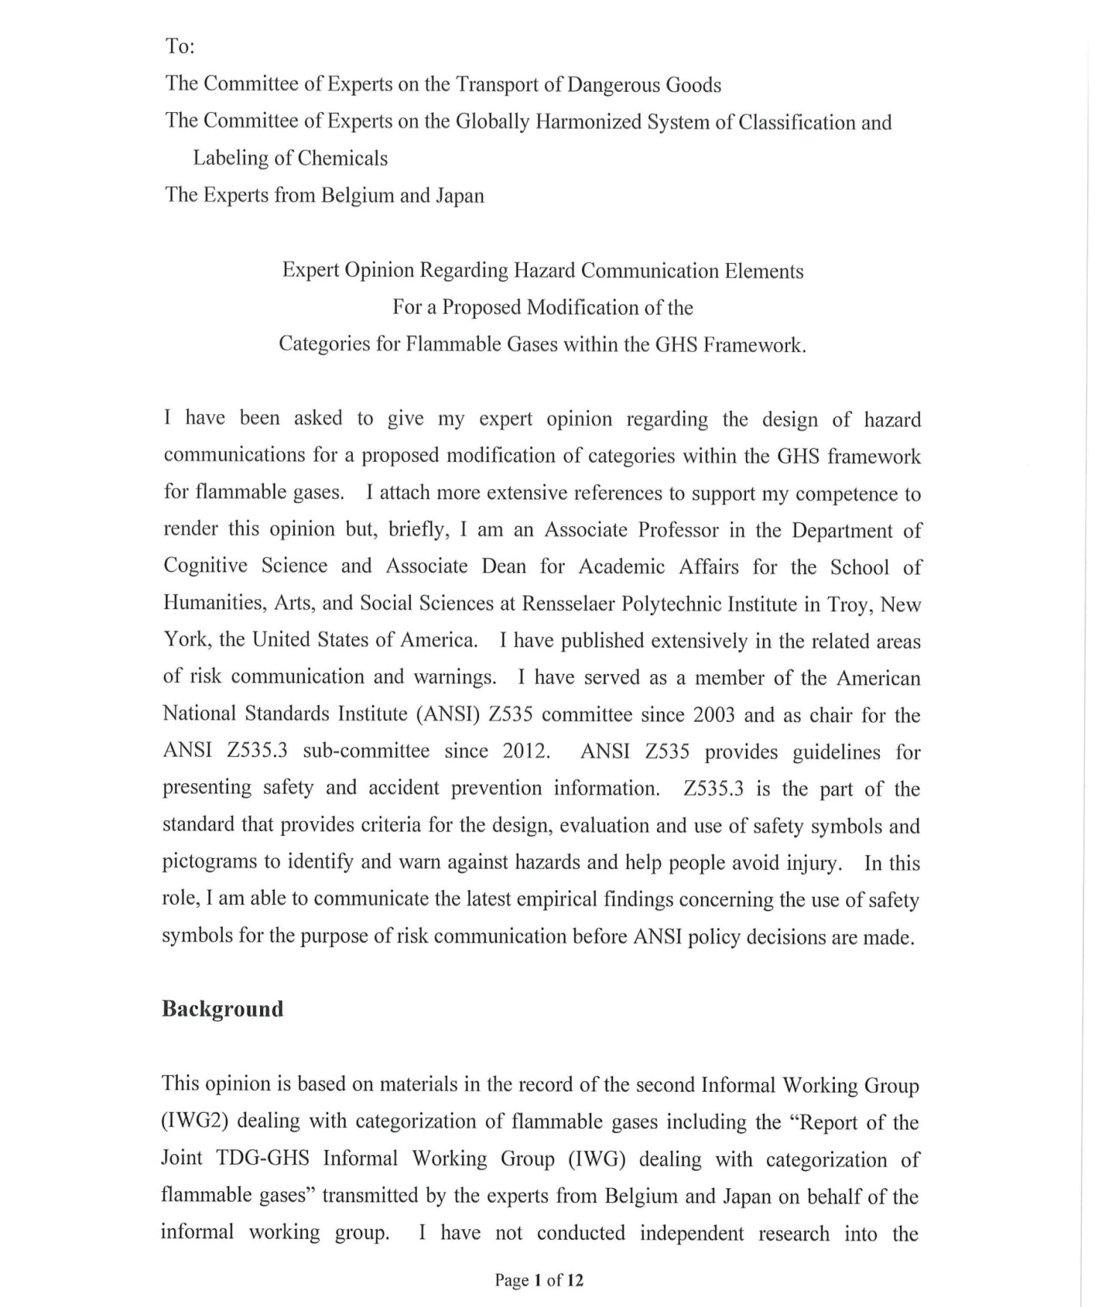

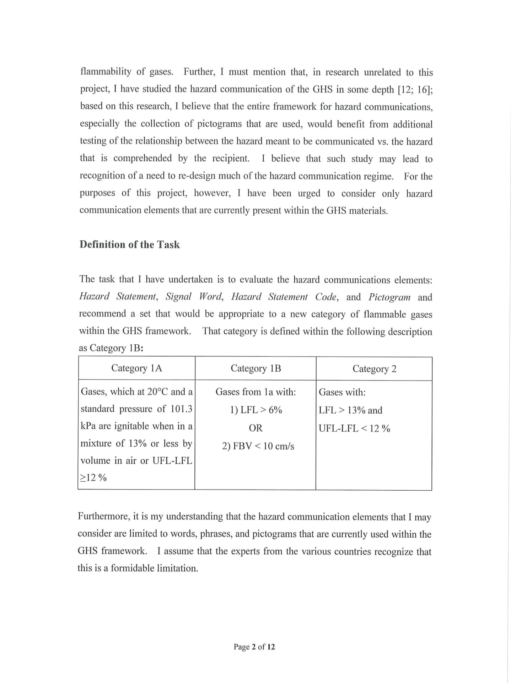
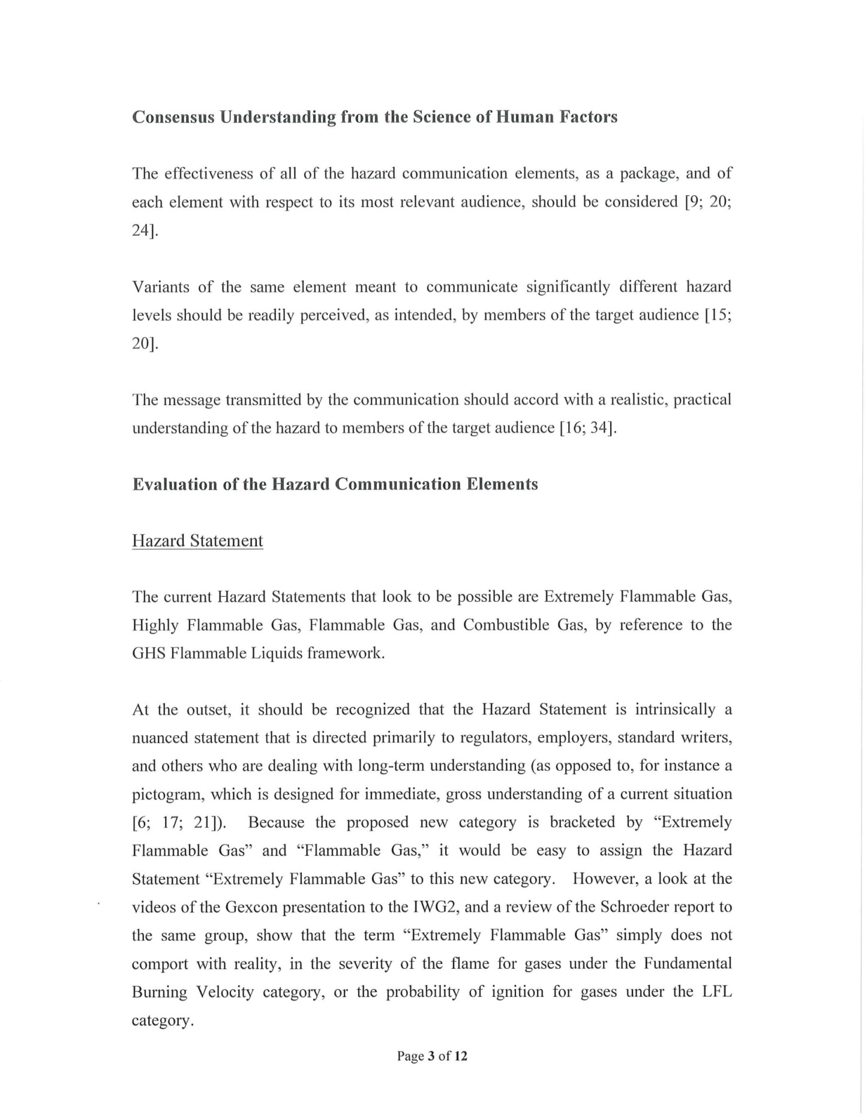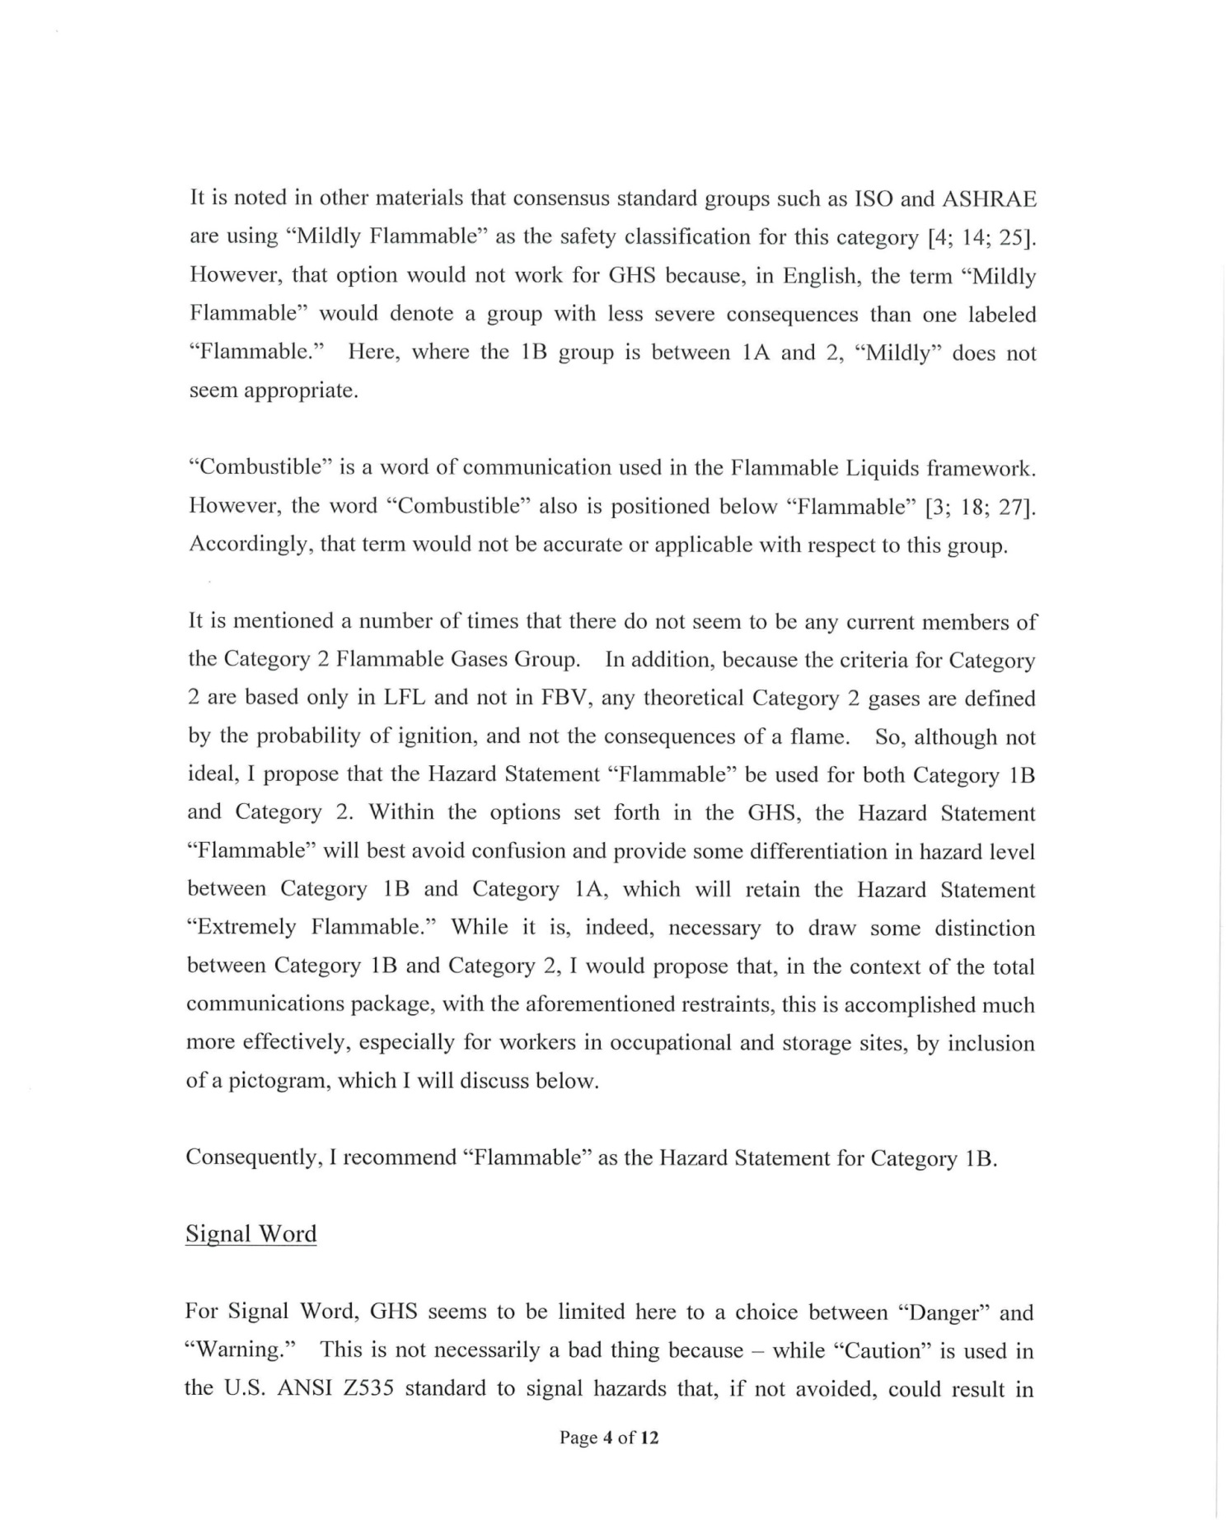
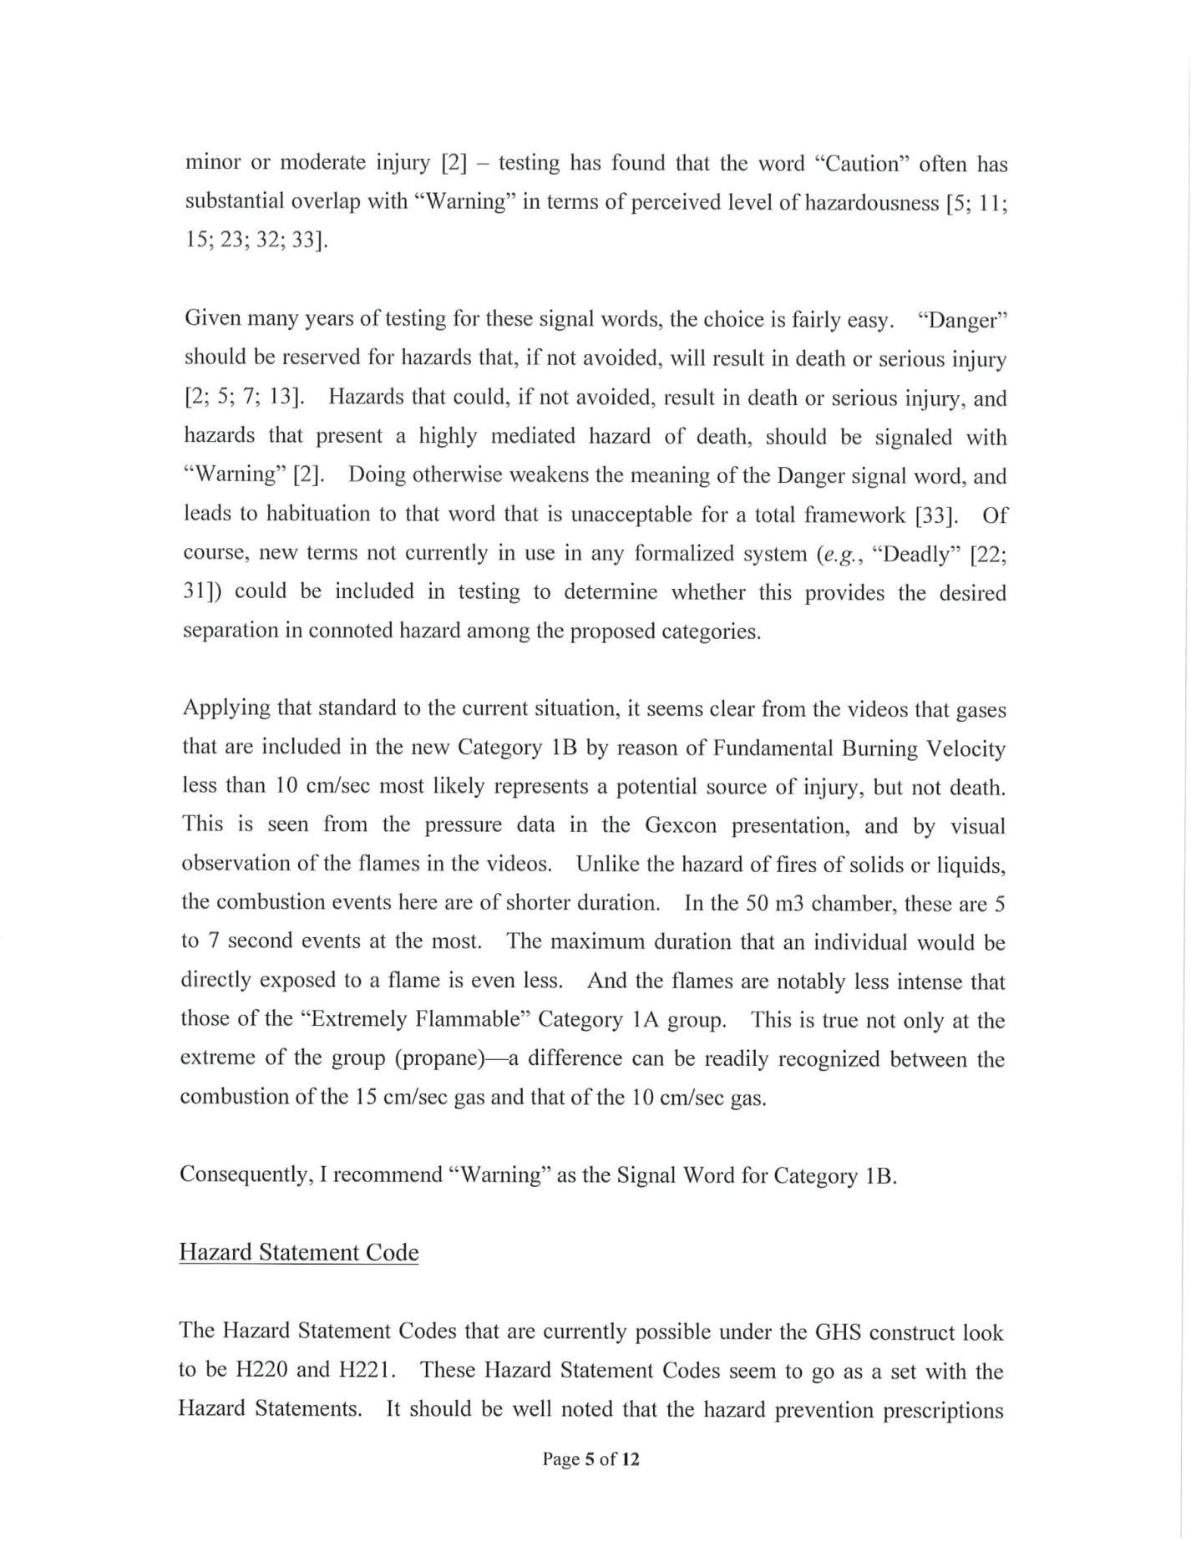
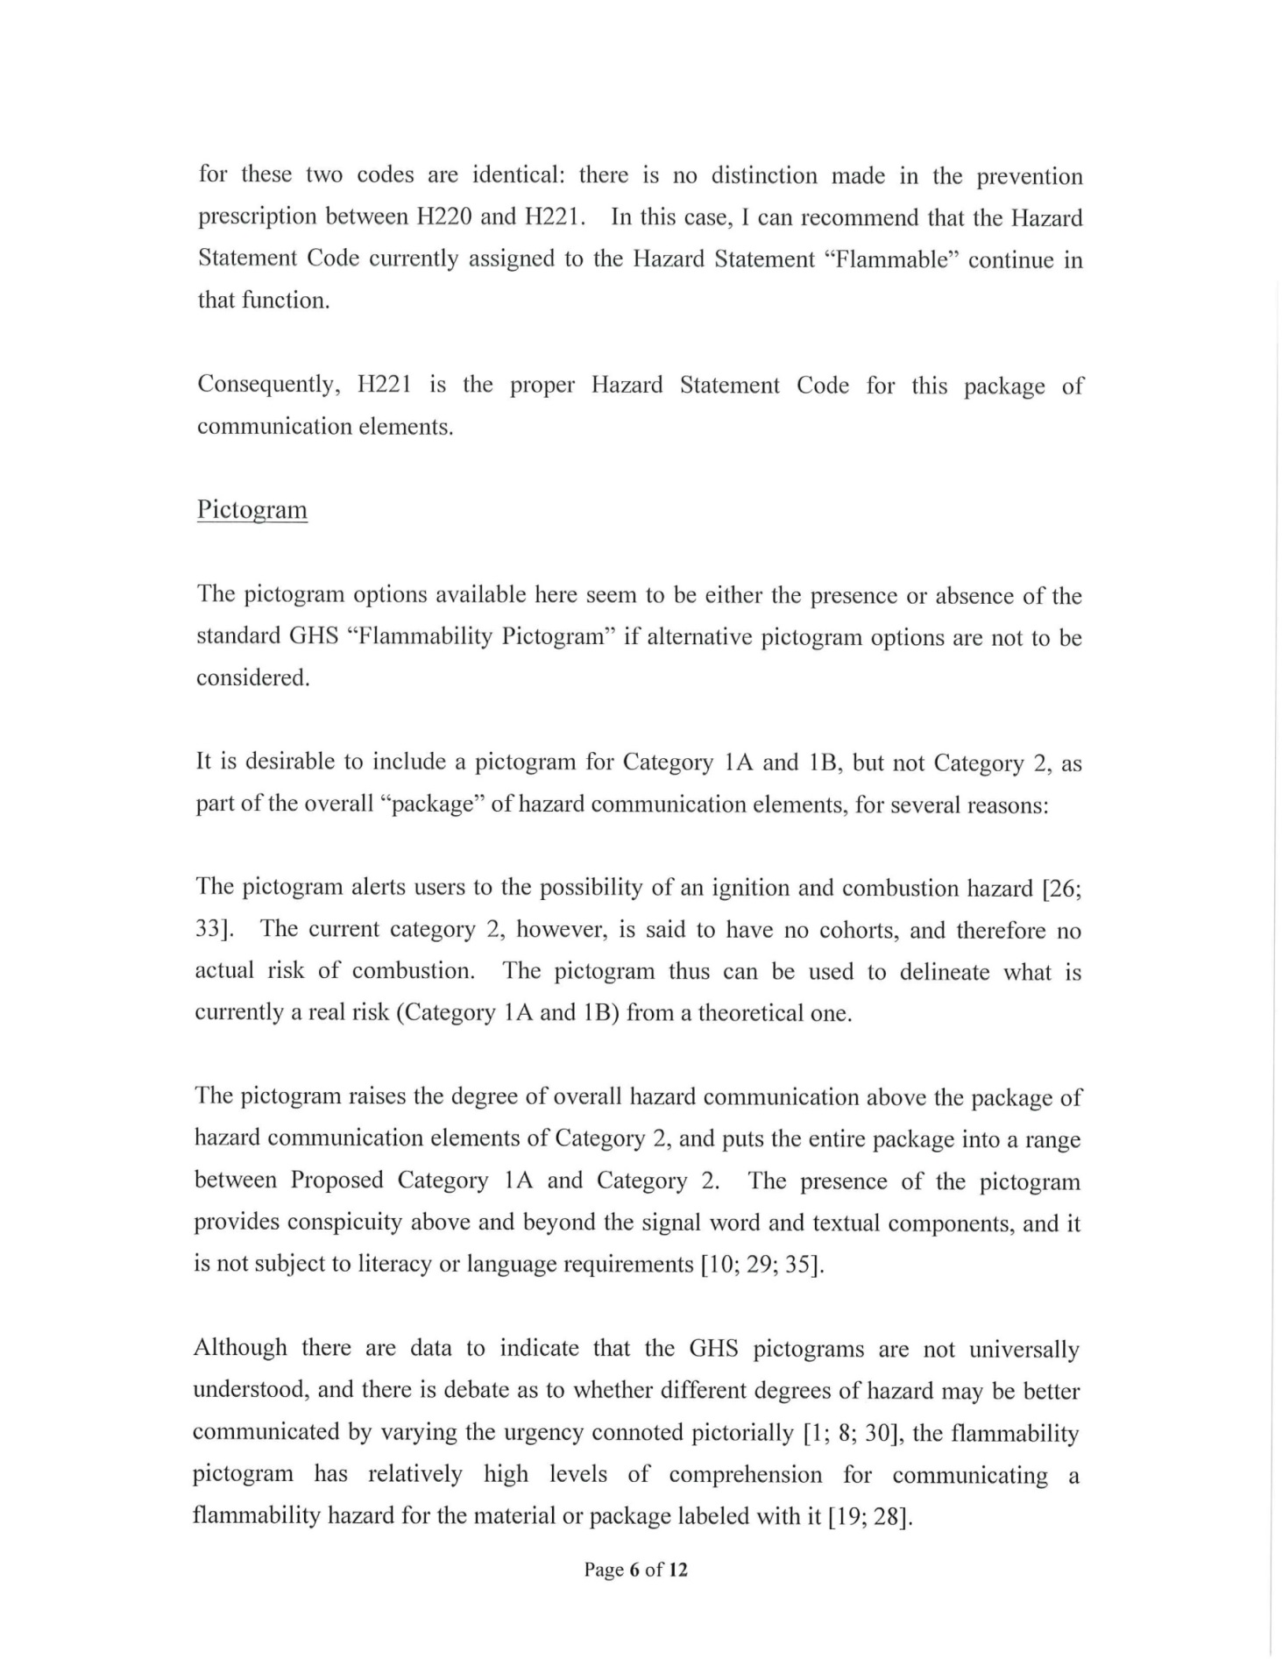
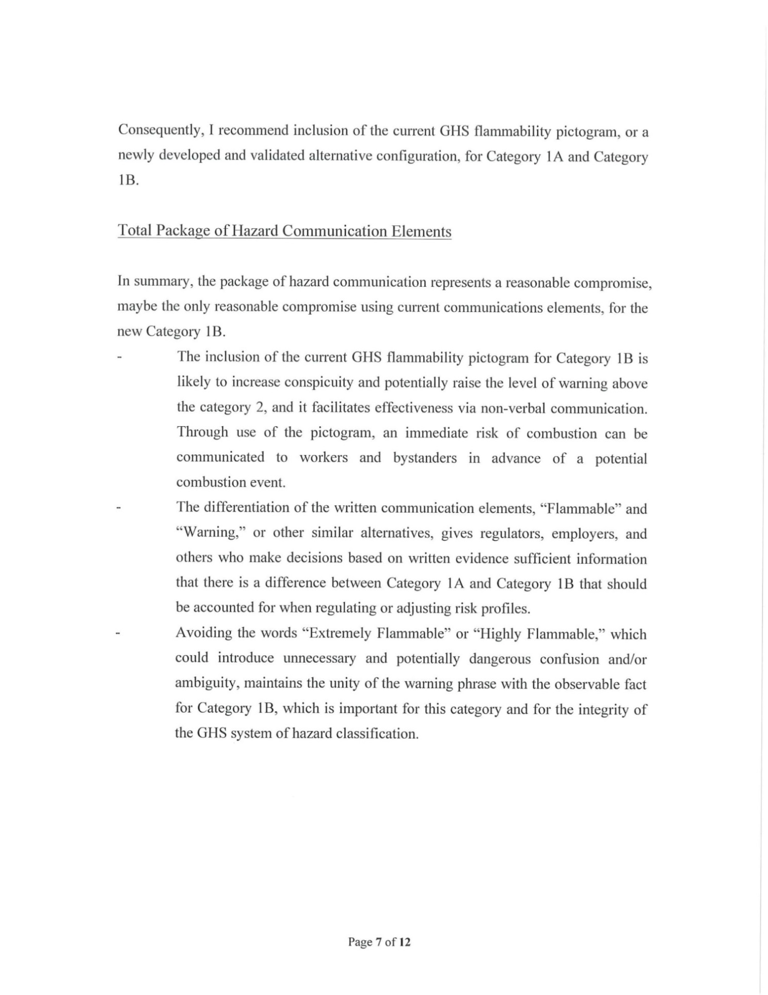
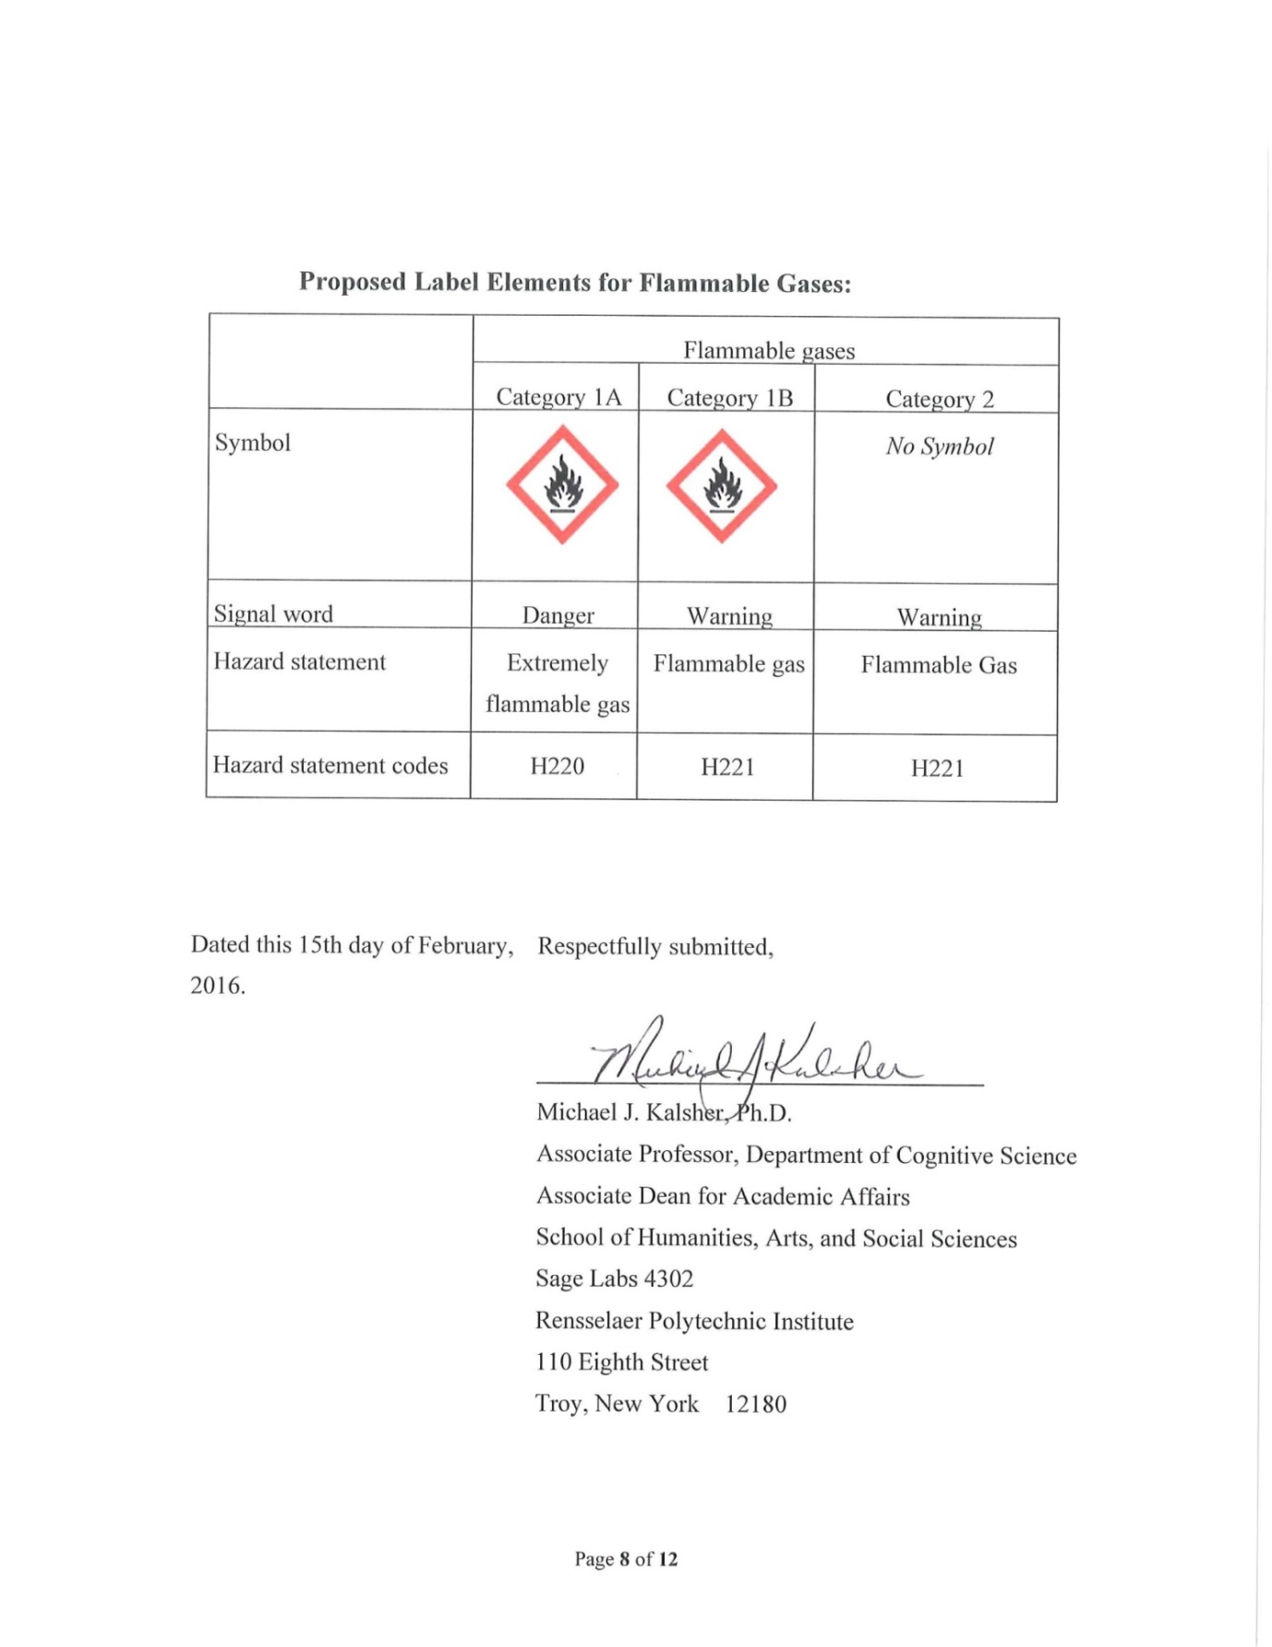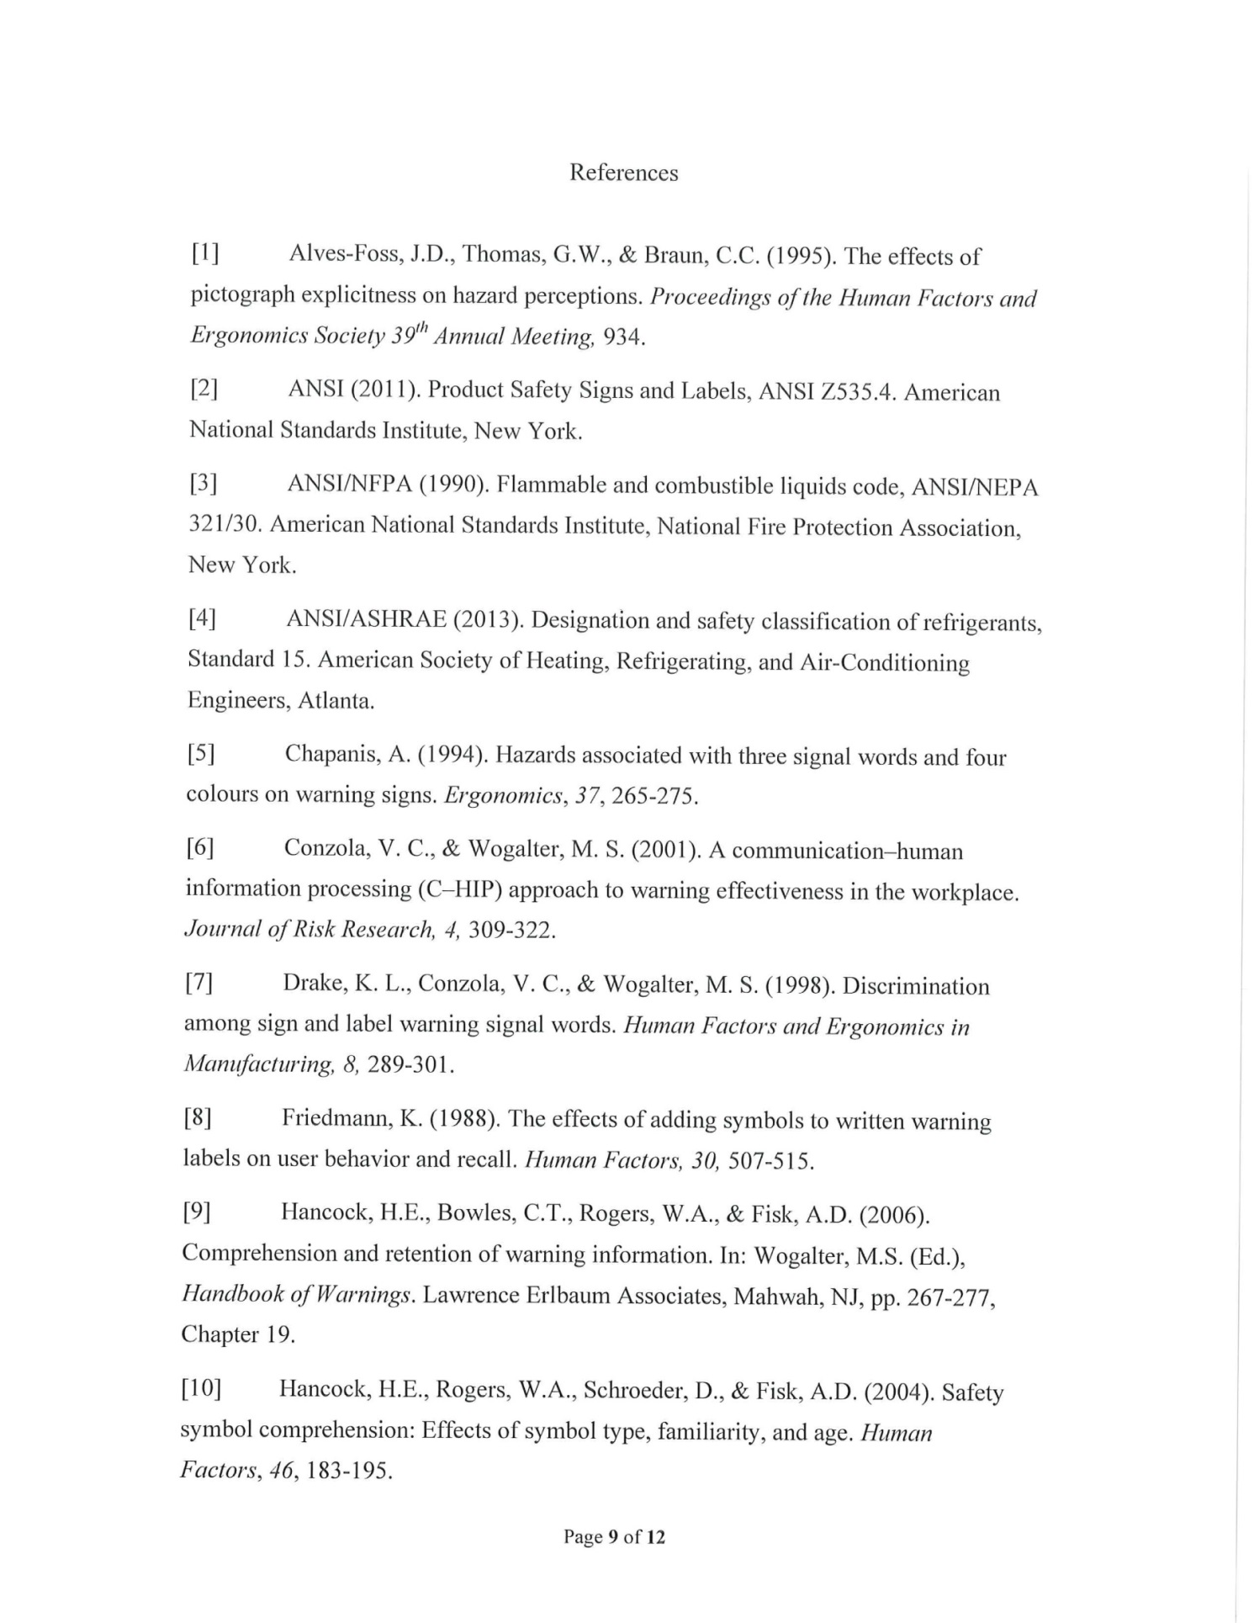
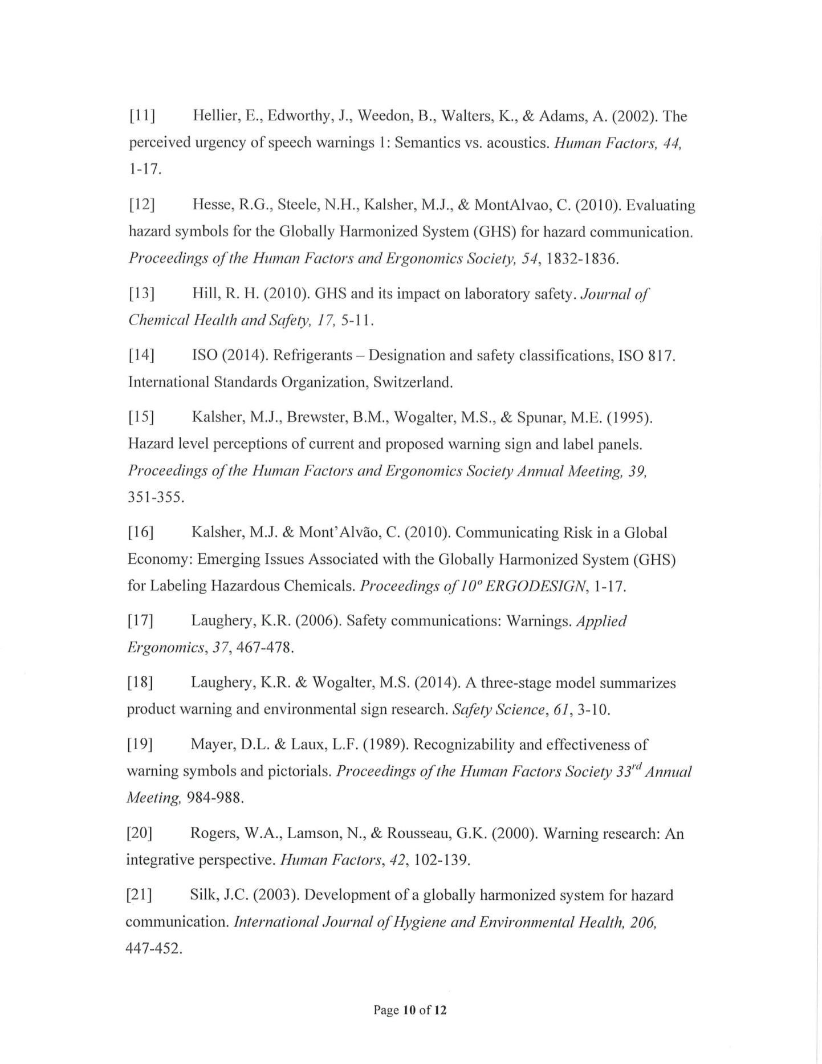
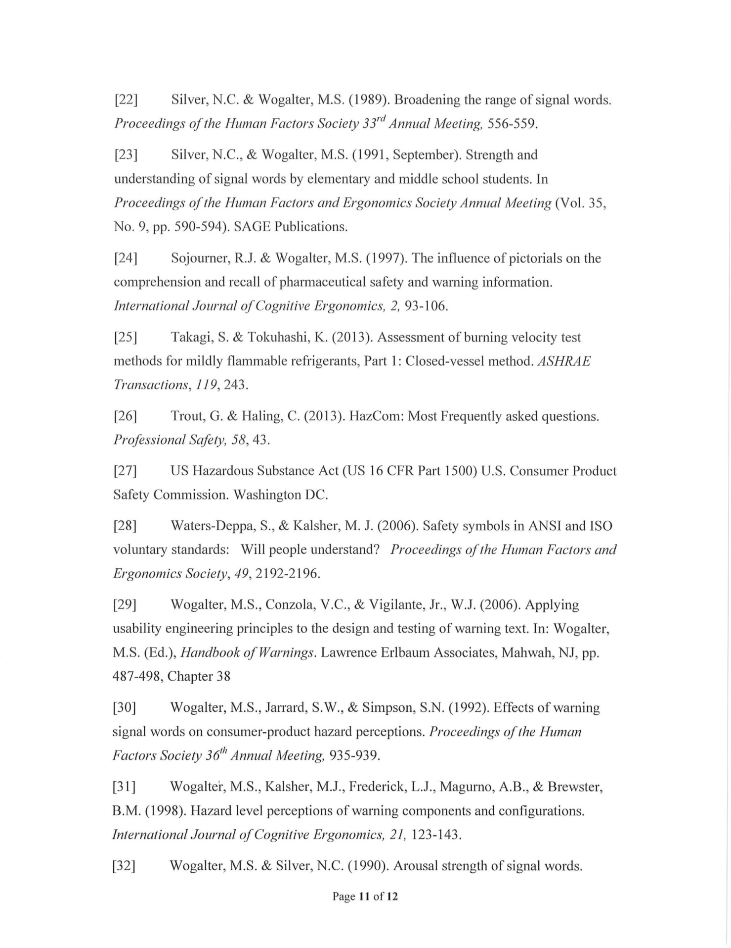
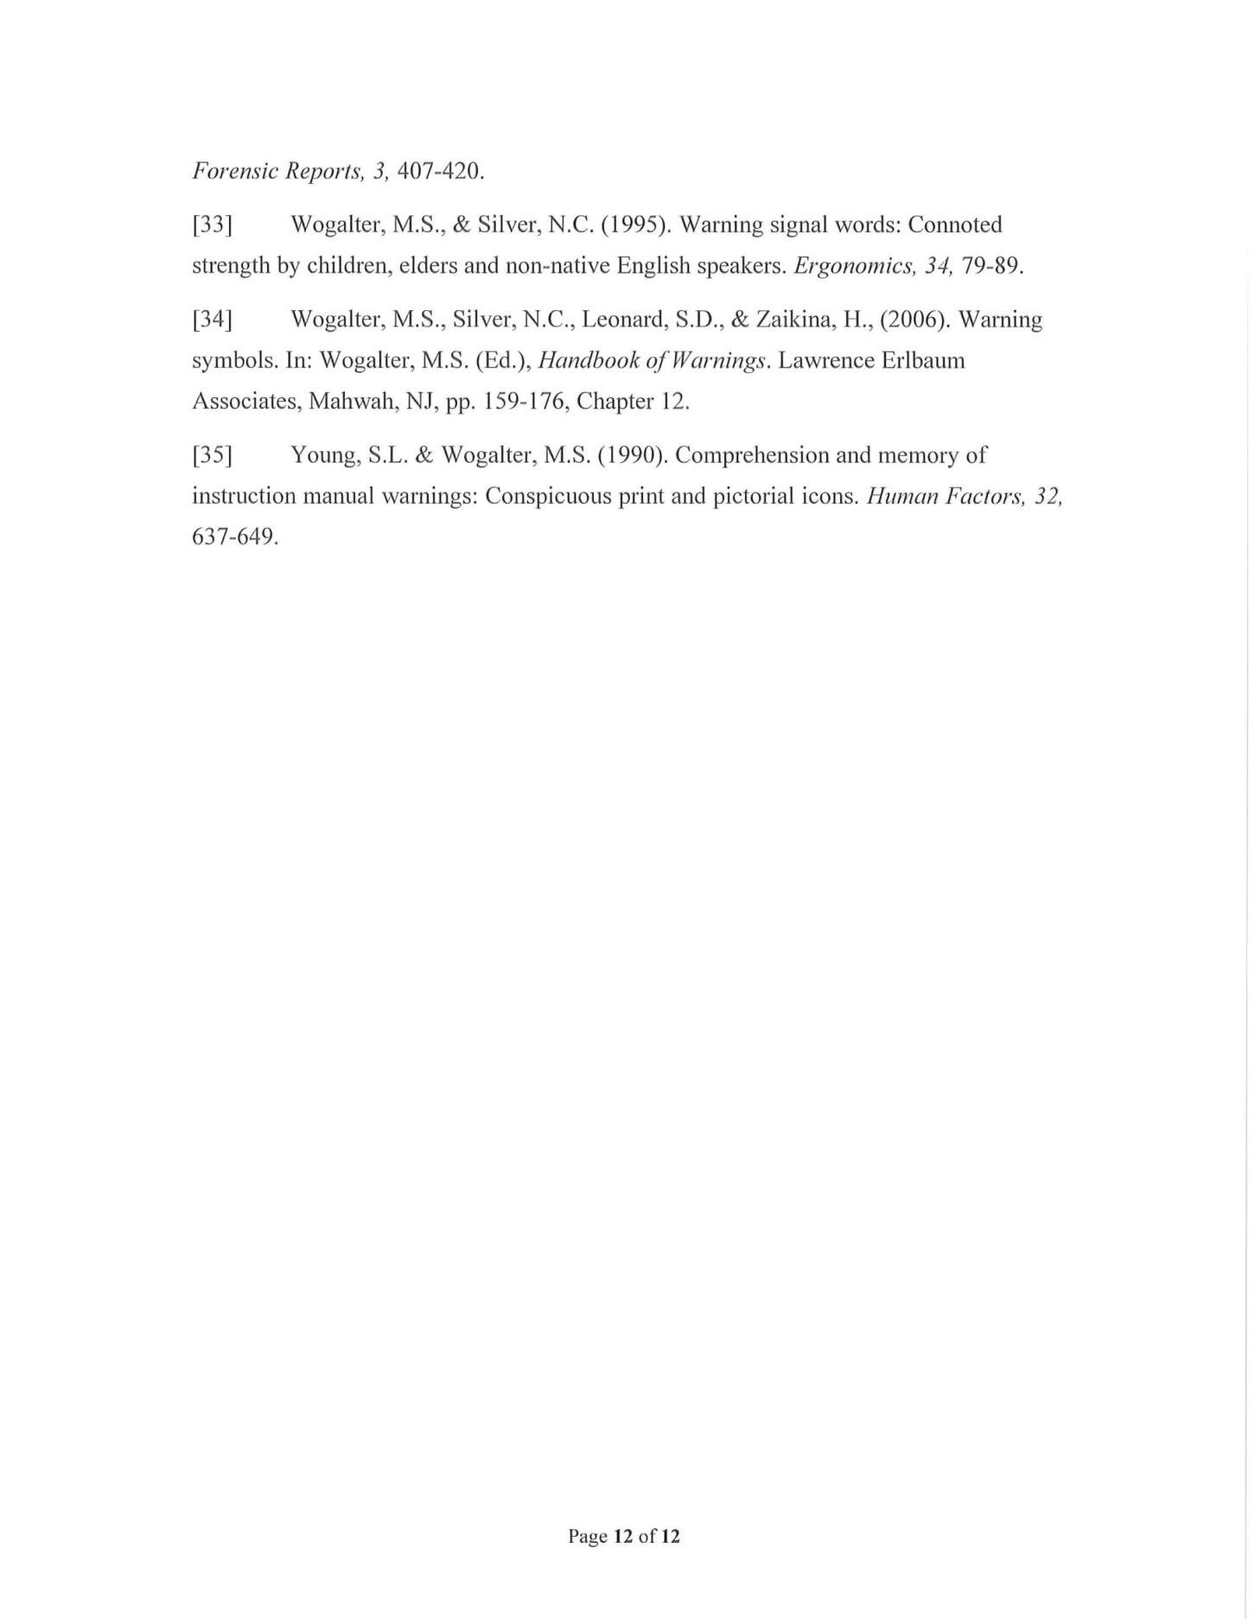

FIGURE 2 : ENLARGEMENT - DIFFERENCES IN RELATIVE ESCAPE TIMES FOR THE TESTED FLAMMABLE GASE

Refer to the report of the GHS Sub-Committee on its 30th session (ST/SG/AC.10/C.4/60, paras. 4 to 8)
Gases which at 20 °C and a standard pressure of 101.3 kPa: are ignitable when in a mixture of 13% or less by volume in air; or have a flammable range with air of at least 12 percentage points regardless of the lower flammable limit are considered Category 1A gases.
P. Hughes and E. Ferrett, International Health and Safety at Work: for the NEBOSH International General Certificate in Occupational Health and Safety, 2015, page 362

