|  |  |  |  |
| --- | --- | --- | --- |
|  | United Nations | ECE/TRANS/WP.29/GRSG/2015/22 | |
|  | **Economic and Social Council** | | Distr.: General  10 July 2015  Original: English |

**Economic Commission for Europe**

Inland Transport Committee

**World Forum for Harmonization of Vehicle Regulations**

**Working Party on General Safety Provisions**

**109th session**

Geneva, 29 September – 2 October 2015

Item 5 of the provisional agenda

**Regulation No. 43 (Safety glazing)**

Proposal for amendments to Regulation No. 43 (Safety glazing)

Submitted by the expert from Hungary[1]*

The text reproduced below was prepared by the expert from Hungary to clarify the requirements on the abrasion test machine. It is mainly based on informal document GRSG‑108-15, distributed during the 108th session of the Working Party on General Safety Provisions (GRSG) (see report ECE/TRANS/WP.29/GRSG/87, para. 20). The modifications to the current text of Regulation No. 43 are marked in bold characters.

**I. Proposal**

*Annex 3, paragraph 4.1.1.,* amend to read (keeping footnote 2 but replacing Figure 4):

"4.1.1. Abrading instrument2 shown ……

# Figure 4

**Diagram of abrading instrument**

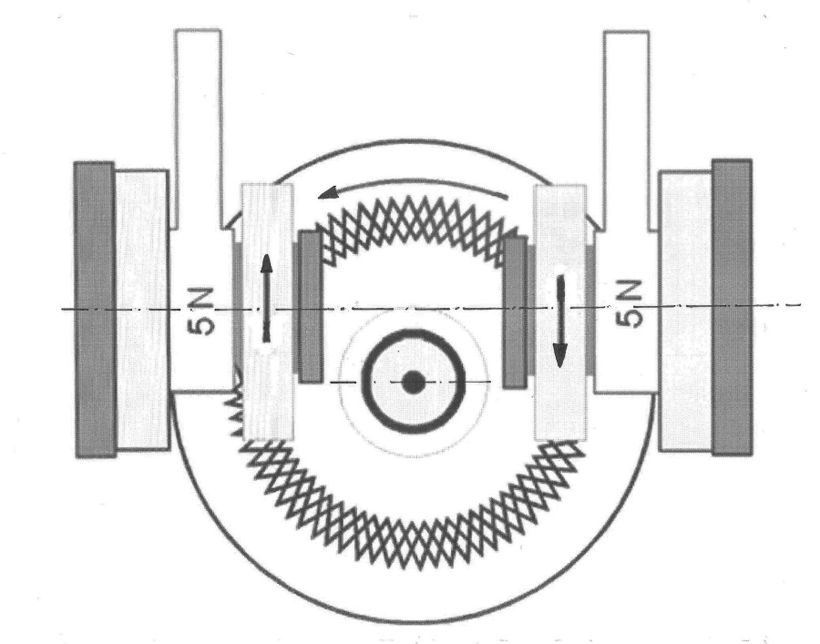

Two weighted parallel arms each carrying a special abrasive wheel freely rotating on a ball-bearing horizontal spindle; each wheel rests on the test specimen under the pressure exerted by a mass of 500 g.

**The distance between the symmetry planes of the wheels shall be 65 mm and the offset of the wheel axis from the turntable axis shall be 19 mm.**

**Wheels shall be placed evenly on the specimen in their full width so that the abrasion is nearly the same within the full width of the abraded area. Abraded particles shall be sucked away during the test so that they do not influence abrasion**.

The turntable of the abrading instrument shall ……"

II. Justification

1. The offset of the axis and the distance of the wheels are currently not specified and Figure 4 shows no offset between the axes. However, the offset and the distance have a considerable influence on the sliding impact between the wheels and the glass, i.e. to the abrading effect. Therefore, both shall be specified as proposed above.

2. Description of the method shall comply with the parameters of the Taber instrument which is referred to in the Regulation.

1. * In accordance with the programme of work of the Inland Transport Committee for 2012–2016 (ECE/TRANS/224, para. 94 and ECE/TRANS/2012/12, programme activity 02.4), the World Forum will develop, harmonize and update Regulations in order to enhance the performance of vehicles. The present document is submitted in conformity with that mandate.