Proposal for the 07 series of amendments to Regulation No. 48 (Installation of lighting and light-signalling devices)

Note: The text reproduced below was prepared by the expert from Poland to improve the OICA and GTB proposal in ECE/TRANS/WP.29/GRE/2015/5 introducing new criteria on the automatic levelling of headlamps based on the GTB glare and visibility studies. The modifications to the proposed text are marked in **blue bold** for new **Polish changes** or **~~orange strikethrough~~** for deleted characters of the GTB-OICA proposal.

I. Proposal

*Paragraph 2.4.,* amend to read:

"2.4. "Unladen vehicle" means a vehicle without driver, crew, passengers and load**,** but~~with a full supply of fuel, spare wheel and the tools normally carried~~ **including 100 per cent of normal fluids, ~~at least 90 per cent~~ reserve or less of fuel and, where provided as standard equipment, any tools and the spare wheel."**

*Paragraph 2.5.,* amend to read:

"2.5. "*Laden vehicle*" means a vehicle loaded to its technically ~~permissible~~ maximum **permissible** mass, as stated by the manufacturer~~, who shall also fix the distribution of this~~ **. This** mass **is distributed** between the axles in accordance with the method described in Annex 5."

*Insert a new paragraph 2.27.,* to read:

**"2.27. *"*Vehicles of category N1 derived from M1" means vehicles in N1 category which, in front of the A-pillars, are of the same general structure and shape as a pre-existing M1 category vehicle;"**

*Insert new paragraphs 6.2.6.1.1. to 6.2.6.1.1.2.,* to read:

**"6.2.6.1.1. ~~for vehicles in Category M~~~~1~~ ~~[and, at the discretion of the manufacturer, vehicles in category N~~~~1~~ ~~derived from M~~~~1~~~~]~~ For vehicles in M and N categories**

**6.2.6.1.1.1. The initial downward inclination of the cut-off of the dipped-beam to be set in the unladen vehicle state with the addition of one person in the driver’s seat shall be specified within an accuracy of 0.1 per cent by the manufacturer, and indicated in a clearly legible and indelible manner on each vehicle by the symbol shown in Annex 7 in a location close to either headlamp or the manufacturer's plate.**

**The value of this indicated downward inclination shall be defined in accordance with paragraph 6.2.6.1.1.2.**

**6.2.6.1.1.2.** **Depending on the mounting height in metres (h) of the ~~[lower edge of the apparent surface~~ headlamp reference axis in the direction of the reference axis of the dipped-beam headlamp~~]~~, measured on the vehicles under the loading conditions prescribed in Annex 5 of this Regulation, the downward inclination of the cut-off of the dipped beam headlamp, starting from the initial inclination value set by the vehicle manufacturer as prescribed in paragraph 6.2.6.1.1.1. above, shall remain between the limits (see diagram below):**



**(Option 1)**

**h = 0.5 m: from 0.0 per cent to -1.6 per cent;**

**h = 0.8 m: from 0.0 per cent to -2.0 per cent;**

**h = 1.2 m: from -0.6 per cent to ~~- 2.6~~ -3.8 per cent.**

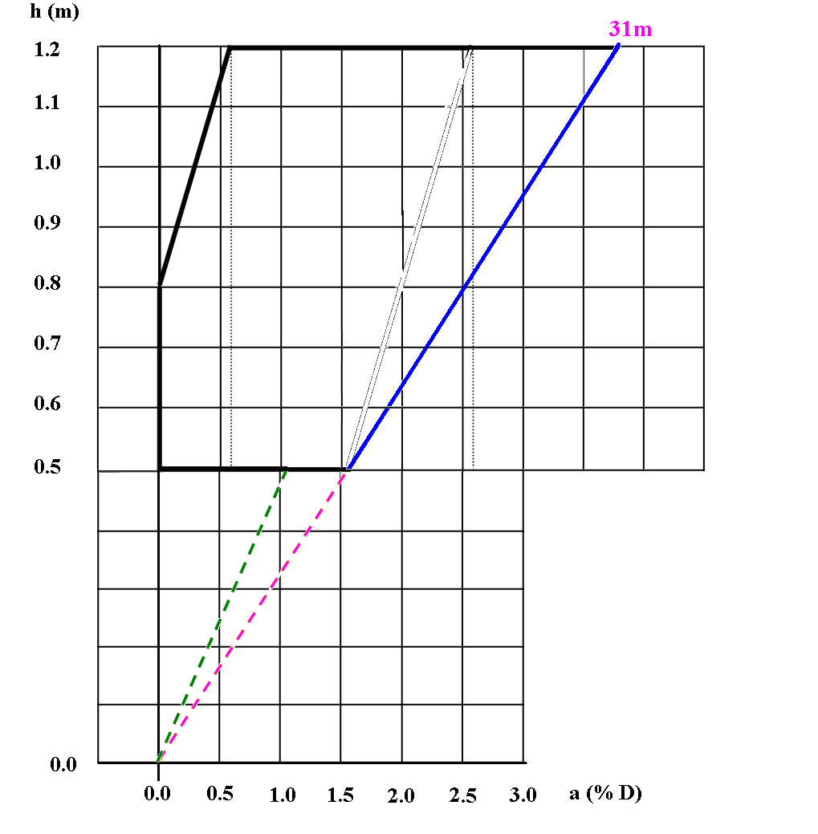

**(Option 2)**

**[h = 0.5 m: from 0.0 per cent to ~~-1.6~~ 1.1 per cent;**

**h = 0.8 m: from 0.0 per cent to -2.0 per cent;**

**h = 1.2 m: from -0.6 per cent to - 2.6 per cent ]**

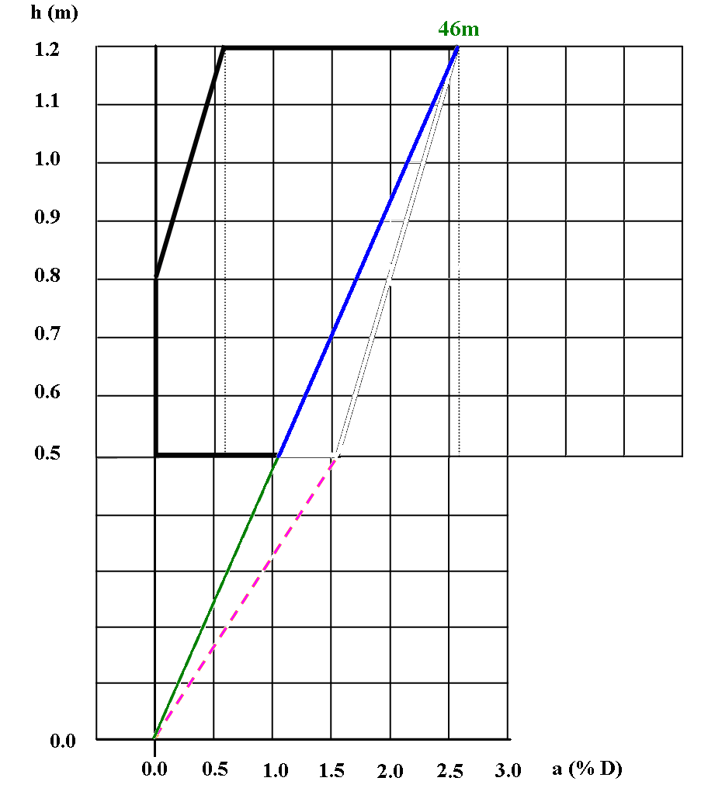

**For the intermediate mounting heights, the limits vary linearly between the indicated values.**

*~~Insert a new paragraph 6.2.6.1.2.~~*~~, to read~~

**~~"6.2.6.1.2. for vehicles in all other M and N categories,"~~**

*~~Paragraphs 6.2.6.1.1. to 6.2.6.1.2.,~~* ~~amend to read:~~

**~~"6.2.6.1.2.1.~~** ~~The initial downward inclination of the cut-off of the dipped-beam to be set in the unladen vehicle state with~~ **~~the addition of~~** ~~one person in the driver’s seat shall be specified within an accuracy of 0.1 per cent by the manufacturer and indicated in a clearly legible and indelible manner on each vehicle close to either headlamp or the manufacturer's plate by the symbol shown in Annex 7. The value of this indicated downward inclination shall be defined in accordance with Paragraph~~ **~~6.2.6.1.2.2.~~**

**~~6.2.6.1.2.2.~~** ~~Depending on the mounting height in metres (h) of the lower edge of the apparent surface in the direction of the reference axis of the dipped-beam headlamp, measured on the unladen vehicles, the vertical inclination of the cut-off of the dipped-beam shall, under all the static conditions of Annex 5, remain between the following limits and the initial aiming shall have the following values:~~

~~h ≤0.8~~

~~Limits: between –0.5 per cent and –2.5 per cent~~

~~Initial aiming: between –1.0 per cent and –1.5 per cent~~

~~0.8 ≤h ≤1.0~~

~~Limits: between –0.5 per cent and –2.5 per cent~~

~~Initial aiming: between –1.0 per cent and –1.5 per cent~~

~~Or, at the discretion of the manufacturer,~~

~~Limits: between –1.0 per cent and –3.0 per cent~~

~~Initial aiming: between –1.5 per cent and –2.0 per cent~~

~~The application for the vehicle type-approval shall, in this case, contain information as to which of the two alternatives is to be used.~~

~~h ≥1.0~~

~~Limits: between –1.0 per cent and –3.0 per cent~~

~~Initial aiming: between –1.5 per cent and –2.0 per cent~~

~~The above limits and the initial aiming values are summarised in the diagram below.~~

~~For Category N3G (off-road) vehicles where the headlamps exceed a height of 1,200mm, the limits for the vertical inclination of the cut-off shall be between: –1.5 per cent and –3.5 per cent.~~



*Insert new paragraphs 6.2.6.2.1. to 6.2.6.2.1.4.,* to read:

**~~"6.2.6.2.1. For vehicles in category M~~~~1~~~~, [and, at the discretion of the manufacturer, vehicles in category N~~~~1~~ ~~derived from M~~~~1~~~~]:~~**

**6.2.6.2.1.1. in the case where the vertical inclination limits prescribed in paragraph 6.2.6.1.1.2. of this Regulation are exceeded more than two times under the loading conditions defined in paragraph 2.1.1.3. of Annex 5 to this Regulation (~~50 per cent~~ the difference between the lowest and the highest dipped beam inclination caused by loading) an automatic headlamp levelling device shall be installed;**

**6.2.6.2.1.2. in the case where the vertical inclination limits prescribed in paragraph 6.2.6.1.1.2. of this Regulation are not exceeded more than two times under the loading condition defined in paragraph 2.1.1.3. of Annex 5 to this Regulation (~~50 per cent~~ difference between the lowest and the highest dipped beam inclination caused by loading), ~~a further verification shall be carried out under the loading conditions defined in paragraph 2.1.1.7. of Annex 5 to this Regulation. In the case where the vertical inclination limits prescribed in paragraph 6.2.6.1.1.2. of this Regulation are exceeded under this loading condition~~ either a manual levelling device or an automatic levelling device shall be installed.**

**6.2.6.2.1.3. Where a headlamp levelling device is used, it shall ensure that the vertical inclination limits prescribed in paragraph 6.2.6.1.1.2. of this Regulation are not exceeded under ~~the~~ any loading conditions ~~defined in Annex 5, paragraph 2.1~~. when used according manufacturer prescription described in user manual.**

**Where a manual levelling device is used, it may be adjusted either continuously or non-continuously, provided it has a stop position with which the headlamps can be returned to the initial inclination defined in paragraph 6.2.6.1.1.1. by means of the usual adjusting screws or similar means.**

**This manually adjustable device shall be operable from the driver's seat.**

**For this device, the loading conditions defined in paragraph 2.1. of Annex 5 that require adjustment of the dipped-beam shall be clearly marked near the control of the device (see Annex 8).**

**6.2.6.2.1.4. In the event device failure as described in paragraph 6.2.6.2.1.3., the cut-off line of the dipped-beam shall not assume a position higher than at the time when the failure of the device occurred."**

*~~Insert a new paragraph 6.2.6.2.2.,~~* ~~to read~~

**~~"6.2.6.2.2. For vehicles in all other M and N categories,"~~**

*~~Paragraphs 6.2.6.2.2.1. to 6.2.6.2~~*~~.~~*~~2~~*~~.~~*~~3.~~*~~, amend to read:~~

**~~"6.2.6.2.2.1.~~** ~~In the case where a headlamp levelling device is necessary to satisfy the requirements of paragraphs~~ **~~6.2.6.1.2.1.~~** ~~and~~ **~~6.2.6.1.2.2.~~**~~, the device shall be automatic.~~

**~~6.2.6.2.2.2.~~** ~~However, devices which are adjusted manually, either continuously or non-continuously shall be permitted, provided they have a stop position at which the lamps can be returned to the initial inclination defined in paragraph~~ **~~6.2.6.1.2.1.~~** ~~by means of the usual adjusting screws or similar means.~~

~~These manually adjustable devices shall be operable from the driver's seat.~~

~~Continually adjustable devices shall have reference marks indicating the loading conditions that require adjustment of the dipped-beam.~~

~~The number of positions on devices which are not continuously adjustable shall be such as to ensure compliance with the range of values prescribed in paragraph~~ **~~6.2.6.1.2.2.~~** ~~in all the loading conditions defined in Annex 5.~~

~~For these devices also, the loading conditions of Annex 5 that require adjustment of the dipped beam shall be clearly marked near the control of the device (see Annex 8).~~

**6.2.6.2.2.3.** In the event of a failure of devices described in paragraphs **~~6.2.6.2.1.~~** ~~and~~ **~~6.2.6.2.1.~~ 6.2.6.2.2.1. and 6.2.6.2.2.2**, the dipped-beam shall not assume a position in which the dip is less than it was at the time when the failure of the device occurred."

*Paragraph 6.2.9.,* amend to read:

"6.2.9. Other requirements

The requirements of paragraph 5.5.2. shall not apply to dipped-beam headlamps.

**Only dipped-beam headlamps according to Regulations Nos. 98 or 112 may be used to produce bend lighting.**

**If bend lighting is produced by a horizontal movement of the whole beam or the kink of the elbow of the cut-off, it shall be activated only if the vehicle is in forward motion; this shall not apply if bend lighting is produced for a right turn in right hand traffic (left turn in left hand traffic).**

Dipped-beam headlamps with a light source or LED module(s) producing the principal dipped beam and having a total objective luminous flux which exceeds 2,000 lm shall only be installed in conjunction with the installation of headlamp cleaning device(s) according to Regulation No. 45.([1])

**~~For vehicles in categories~~~~M and N other than vehicles in category M~~~~1~~ ~~[and, at the discretion of the manufacturer, vehicles in category N~~~~1~~ ~~derived from M~~~~1~~~~], w~~**~~ith respect to vertical inclination the provisions of paragraph 6.2.6.2.2.~~ **~~6.2.6.2.2.2.~~** ~~above shall not be applied for dipped-beam headlamps~~

~~(a) With LED module(s) producing the principal dipped-beam, or~~

~~(b) W~~ **~~w~~**~~ith a light source producing the principal dipped-beam and having an objective luminous flux which exceeds 2,000 lumens.~~

~~In the case of filament lamps for which more than one test voltage is specified, the objective luminous flux which produces the principal dipped-beam, as indicated in the communication form for the type approval of the device, is applied.~~

~~In the case of dipped-beam headlamps equipped with an approved light source, the applicable objective luminous flux is the value at the relevant test voltage as given in the relevant data sheet in the Regulation, according to which the applied light source was approved, without taking into account the tolerances to the objective luminous flux specified on this datasheet.~~

~~Only dipped-beam headlamps according to Regulation Nos. 98 or 112 may be used to produce bend lighting.~~

~~If bend lighting is produced by a horizontal movement of the whole beam or the kink of the elbow of the cut-off, it shall be activated only if the vehicle is in forward motion; this shall not apply if bend lighting is produced for a right turn in right hand traffic (left turn in left hand traffic).~~ "

*Paragraphs 6.22.6.1. to 6.22.6.1.2*., amend to read:

"6.22.6.1. Vertical orientation:

6.22.6.1.1. The initial downward inclination of the cut-off of the basic passing-beam to be set in the unladen vehicle state **with the addition of** one person in the driver's seat shall be specified with**in** a**n** ~~precision~~ **accuracy** of 0.1 per cent by the manufacturer and indicated in **a** clearly legible and indelible manner on each vehicle, close to either the front lighting system or the manufacturer's plate, by the symbol shown in Annex 7.

Where differing initial downward inclinations are specified by the manufacturer for different lighting units that provide or contribute to the cut-off of the basic passing-beam, these values of downward inclination shall be specified with**in** a**n** ~~precision~~ **accuracy** of 0.1 per cent by the manufacturer and indicated in **a** clearly legible and indelible manner on each vehicle, close to either the relevant lighting units or on the manufacturer**'**s plate, in such a way that all the lighting units concerned can be unambiguously identified.

6.22.6.1.2. The downward inclination of the horizontal part of the "cut-off" of the basic passing-beam shall remain between the limits indicated in paragraph **6.2.6.1.1 ~~for vehicles in category M~~~~1~~ ~~[and, at the discretion of the manufacturer, vehicle in category N~~~~1~~ ~~derived from M~~~~1~~~~] and~~**~~6.2.6.1.2.~~ **~~for vehicles of all other categories~~** of this Regulation under all the static loading conditions of the vehicle of Annex 5 of this Regulation; and the initial aiming shall be within the specified values.

6.22.6.1.2.1. In case the passing-beam is generated by several beams from different lighting units, the **relevant requirements** ~~provisions according to paragraph 6.22.6.1.2.~~ **as** above **indicated** apply to each said beam's "cut-off" (if any), which is designed to project into the angular zone, as indicated under item 9.4. of the communication form conforming to the model in Annex 1 to Regulation No. 123."

6.22.6.2. Headlamp levelling device

6.22.6.2.1. In the case where a headlamp levelling device is necessary to satisfy the requirements of paragraph 6.22.6.1.2., the device shall be automatic.

6.22.6.2.2. In the event of a failure of this device, the **cut-off line of the basic** passing-beam shall not assume a position **higher than** ~~in which the downward inclination dip is less than~~it was at the time when the failure of the device occurred.

*Insert a new paragraph 12.6.,* to read

**"12.6. Transitional provisions applicable to 07 series of amendments**

**Contracting Parties applying this Regulation:**

**From [1 September 2020] (36 months after the date of entry into force) shall grant approvals only if the vehicle type to be approved meets the requirements of this Regulation as amended by the 07 series of amendments."**

*Annex 5*, amend to read:

"Annex 5

States of loading to be taken into consideration in determining variations in the vertical orientation of the dipped-beam headlamps

Loading conditions on axles referred to in paragraph**s** ~~6.2.6.1.~~ **6.2.6.1.1.2., 6.2.6.1.2.2., 6.2.6.2.1.1., 6.2.6.2.1.2.,** **6.2.6.2.2.2** and 6.2.6.3.1.

1. For the following tests, the mass of the passengers shall be calculated on the basis of 75 kg per person **if not differently prescribed by manufacturer**.

2. Loading conditions for different types of vehicles:

**If change of quantity of fuel in tank from reserve to full influences dipped beam inclination more than 0.1% it should be treated as a load factor in two stage: full and reserve respectively to check influence for dipped beam inclination .**

**The lowest and highest dipped beam inclination loading characteristic should be obtained by measurements according Annex 6.**

**The lowest dipped beam inclination loading characteristic and the highest dipped beam inclination loading characteristic should be measured according p. 2.2 and 2.2 below and putted in common table and common graph with dipped beam inclination resolution not more than 0.1% and loading resolution not more than 25 kg or 5% of difference between minimum and maximum load.**

**Example of characteristics is presented on graph below.==**

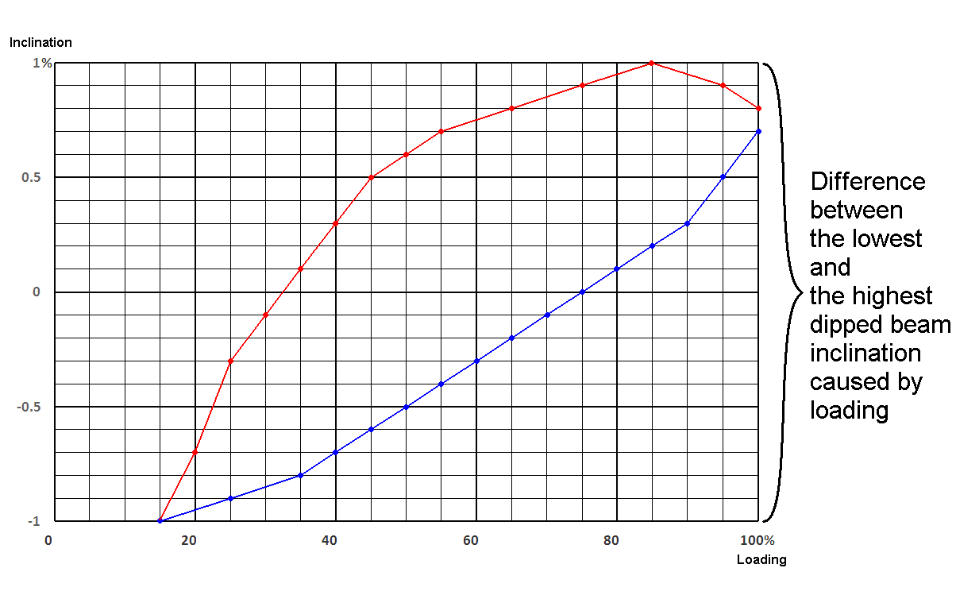

2.1. Vehicles in Category M1([2]3)**, [and, at the discretion of the manufacturer, N1 derived from M1]**

2.1.1. The ~~angle of the light beam~~ **downward inclination of the cut-off** of the dipped-beam headlamps shall be determined under the following load conditions:

2.1.1.1. One person in the driver's seat;

~~2.1.1.2.~~ ~~The driver, plus one passenger in the front seat farthest from the driver;~~

**2.1.1.2.** **~~50 per cent loading~~ The lowest** **dipped beam inclination loading characteristic**

**~~"50 per cent loading" means 50 - per cent of the difference between the laden and unladen state of the vehicle, as defined respectively in paragraphs 2.5. and 2.4. of this Regulation.~~**

**The following sequence shall be used ~~in the order proposed below~~ to ~~attain~~ determine ~~the 50 per cent loading condition~~ lowest dipped beam inclination loading characteristics:**

**(a) ~~the driver~~ 75 kg on driver seat;**

**(b) adding successively with 25 kg step on the front seat starting from furthest from the driver until a mass ~~up to 75 kg~~ per seat allowed by manufacturer will be obtained;**

**(c) adding successively with 25 kg step for the row immediately behind the driver's seat, ~~seat load the two outer~~ evenly load each seats with up to a mass per seat allowed by manufacturer ~~75 kg per seat~~;**

**d) adding successively with 25 kg step for the next rows (if applicable) in direction from the front to the rear, evenly load each seat with up to a mass per seat allowed by manufacturer.**

**(d) where additional load is necessary, it shall be evenly distributed in the luggage / load compartment(s) under condition of p. 2.1.2.**

~~2.1.1.4. The driver, one passenger in the front seat farthest from the driver, all the seats farthest to the rear occupied;~~

~~2.1.1.5. All the seats occupied~~**;**

2.1.1.**4**. ~~All the seats occupied, plus an evenly distributed load in the luggage / load, in order to obtain the permissible load on the rear axle or on the front axle if the boot luggage / load compartment is at the front. If the vehicle has a front and a rear boot luggage / load compartment, the additional load shall be appropriately distributed in order to obtain the permissible axle loads. However, if the maximum permissible laden mass is obtained before the permissible load on one of the axles, the loading of the boot luggage / load compartment (s) shall be limited to the figure which enables that mass to be reached;~~

**The highest dipped beam inclination loading characteristic**

**The following sequence shall be used to achieve the highest dipped beam inclination loading characteristics**

1. **75 kg on driver seat;**
2. **adding successively with 25 kg step evenly distributed in the back load compartment until allowed by manufacturer maximum load of back load compartment will be obtained.**
3. **Adding successively with 25 kg step, starting for the row seats farthest from the front evenly load at each seat with up to a mass per seat allowed by manufacturer;**

**d) Adding successively with 25 kg step for the next rows (if applicable) in direction from the rear to the front, evenly load each seat with up to a mass per seat allowed by manufacturer.**

**d) repeat this procedure to obtain full loading according manufacturer prescription described in user manual** **under condition of p. 2.1.2.**

2.1.1.**7**. ~~Driver, plus an evenly distributed load in the boot luggage / load compartment, in order to obtain the permissible load on the corresponding axle.~~

~~However, if the maximum permissible laden mass is obtained before the permissible load on the axle, the loading of the boot luggage / load compartment (s) shall be limited to the figure which enables that mass to be reached.~~

2.1.2. In determining the above loading conditions, account shall be taken of any loading restrictions laid down by the manufacturer.

2.2. Vehicles in Categories M2, ~~and~~ M3 **and N**;(3)

The ~~angle of the light beam from~~ **downward inclination of the cut-off of** the dipped-beam headlamps shall be determined under the following loading conditions:

2.2.1. Vehicle unladen and one person in the driver's seat;

**2.2.1.1** **The lowest dipped beam inclination loading characteristic**

**Adding successively with 5% step of maximum technically permissible load starting from the front of vehicle distributed as much as possible to the front and as allowed by manufacturer until the maximum permissible mass of the vehicle is attained under condition of p. 2.1.2. and 2.2.2.**

**2.2.1.2 The highest dipped beam inclination loading characteristic**

**Adding successively with 5% step of maximum technically permissible load from the rear of vehicle distributed as much as possible to the rear and as allowed by manufacturer until the maximum permissible mass of the vehicle is attained under condition of p. 2.1.2. and 2.2.2.**

2.2.2. Vehicles laden such that each axle carries its maximum technically permissible load or until the maximum permissible mass of the vehicle is attained by loading the front and rear axles proportionally to their maximum technically permissible loads, whichever occurs first.

~~2.3. Vehicles in Category N ([3]3) [except, at the discretion of the manufacturer, N1 derived from M1] with load surfaces~~:

2.~~3.1. The angle of the light beam from downward inclination of the cut-off of the dipped-beam headlamps shall be determined under the following loading conditions;~~

~~2.3.1.1. Vehicle unladen and one person in the driver's seat;~~

~~2.3.1.2. Driver, plus a load so distributed as to give the maximum technically permissible load on the rear axle or axles, or the maximum permissible mass of the vehicle, whichever occurs first, without exceeding a front axle load calculated as the sum of the front axle load of the unladen vehicle plus 25 per cent of the maximum permissible payload on the front axle.~~

~~Conversely, the front axle is so considered when the load surfaces is at the front.~~

~~2.4. Vehicles in Category N (3) [except, at the discretion of the manufacturer, N1 derived from M1] without a load surface:~~

~~2.4.1. Drawing vehicles for semi-trailers:~~

~~2.4.1.1. Unladen vehicle without a load on the coupling attachment and one person in the driver's seat;~~

~~2.4.1.2. One person in the driver's seat: technically permissible load on the coupling attachment in the position of the attachment corresponding to the highest load on the rear axle.~~

~~2.4.2. Drawing vehicles for trailers:~~

~~2.4.2.1. Vehicle unladen and one person in the driver's seat;~~

~~2.4.2.2. One person in the driver's seat, all the other places in the driving cabin being occupied."~~

*Annex 6*, amend to read:

"Annex 6

Measurement of the ~~variation~~ **characteristics** of dipped‑beam inclination as a function of load

1. Scope

This annex specifies a method for measuring ~~variation~~ **characteristics** in motor vehicle dipped‑beam inclination, in relation to its initial inclination, caused by changes in vehicle attitude due to loading.

2. Definitions

2.1. Initial inclination

2.1.1. Stated initial inclination

The value of the dipped‑beam initial inclination specified by the motor vehicle manufacturer serving as a reference value for the calculation of permissible variations.

2.1.2. Measured initial inclination

The mean value of dipped‑beam inclination or vehicle inclination measured with the vehicle in **the first loading** condition ~~No. 1, as defined in Annex 5,~~ for the category of vehicle under test, **as defined in Annex 5 to this Regulation.** It serves as a reference value for the assessment of variations in beam inclination as the load varies.

2.2. Dipped‑beam inclination

It may be defined as follows:

Either as the angle, expressed in milliradians, between the direction of the beam towards a characteristic point on the horizontal part of the cut‑off in the luminous distribution of the headlamp and the horizontal plane,

Or by the tangent of that angle, expressed in percentage inclination, since the angles are small (for these small angles, 1 per cent is equal to 10 mrad).

If the inclination is expressed in percentage inclination, it can be calculated by means of the following formula:



where:

h1 is the height above the ground, in millimetres, of the above‑ mentioned characteristic point, measured on a vertical screen perpendicular to the vehicle longitudinal median plane, placed at a horizontal distance L.

h2 is the height above the ground, in millimetres, of the centre of reference (which is taken to be the nominal origin of the characteristic point chosen in h1):

L is the distance, in millimetres, from the screen to the centre of reference.

Negative values denote downward inclination (see Figure 1).

Positive values denote upward inclination.

**Figure 1**

**Dipped‑beam downward inclination of a category M1 vehicle**



*Notes:*

1. This drawing represents a category M1 vehicle, but the principle shown applies equally to vehicles of other categories.

2. Where the vehicle does not incorporate a headlamp levelling system, the variation in dipped‑beam inclination is identical with the variation in the inclination of the vehicle itself.

3. Measurement conditions

3.1. If a visual inspection of the dipped‑beam pattern on the screen or a photometric method is used, measurement shall be carried out in a dark environment (for example, a dark room) of sufficient area to allow the vehicle and the screen to be placed as shown in Figure 1. Headlamp centres of reference shall be at a distance from the screen of at least 10 m.

3.2. The ground on which measurements are made shall be as flat and horizontal as possible, so that the reproducibility of measurements of dipped‑beam inclination can be assured with an accuracy of ±0.5 mrad (±0.05 per cent inclination).

3.3. If a screen is used, its marking, position and orientation in relation to the ground and to the median longitudinal plane of the vehicle, shall be such that the reproducibility of the measurement of the dipped‑beam inclination can be assured with an accuracy of ±0.5 mrad (±0.05 per cent inclination).

3.4. During measurements, the ambient temperature shall be between 10 and 30 °C.

4. Vehicle preparation

4.1. Measurements shall be carried out on a vehicle which has travelled a distance of between 1,000 km and 10,000 km, preferably 5,000 km.

4.2. Tyres shall be inflated to the full‑load pressure specified by the vehicle manufacturer. The vehicle shall be ~~fully replenished (fuel, water, oil) and equipped with all the accessories and tools specified by the manufacturer. Full fuel replenishment means that the fuel tank shall be filled to not less than 90 per cent of its capacity.~~ **"unladen" as defined in paragraph 2.4. of this Regulation.**

4.3. The vehicle shall have the parking brake released and the gearbox in neutral.

4.4. The vehicle shall be conditioned for at least 8 h at the temperature specified in paragraph 3.4. above.

4.5. If a photometric or visual method is used, headlamps with a well‑defined dipped-beam cut‑off should preferably be installed on the vehicle under test in order to facilitate the measurements. Other means are allowed to obtain a more precise reading (for example, removal of the headlamp lens).

5. Test procedure

5.1. General

The variations in either dipped‑beam or vehicle inclination, depending on the method chosen, shall be measured separately for each side of the vehicle. The results obtained from both left and right headlamps under all the load conditions specified in Annex 5, shall be within the limits set out in paragraph 5.5. below. The load shall be applied gradually without subjecting the vehicle to excessive shocks.

5.1.1. Where an AFS is fitted, the measurements shall be carried out with the AFS in its neutral state.

5.2. Determination of the measured initial inclination

The vehicle shall be prepared as specified in paragraph 4. above and laden **to the first loading condition for the category of vehicle under test,** as specified in Annex 5 ~~(first loading condition of the respective vehicle category)~~ **to this Regulation**. Before each measurement, the vehicle shall be rocked as specified in paragraph 5.4. below. Measurements shall be made three times.

5.2.1. If none of the three measured results differ by more than 2 mrad (0.2 per cent inclination) from the arithmetic mean of the results, that mean shall constitute the final result.

5.2.2. If any measurement differs from the arithmetic mean of the results by more than 2 mrad (0.2 per cent inclination), a further series of 10 measurements shall be made, the arithmetic mean of which shall constitute the final result.

5.3. Measurement methods

Any method may be used to measure variations of inclination provided that the readings are accurate to within ± 0.2 mrad (±0.02 per cent inclination).

5.4. Treatment of vehicle in each loading condition

The vehicle suspension and any other part likely to affect dipped‑beam inclination shall be activated according to the methods described below.

However, the technical authorities and manufacturers may jointly propose other methods (either experimental or based upon calculations), especially when the test poses particular problems, provided such calculations are clearly valid.

5.4.1. M1category vehicles with conventional suspension

With the vehicle standing on the measuring site and, if necessary, with the wheels resting on floating platforms (which shall be used if their absence would lead to restriction of the suspension movement likely to affect the results of measurements), rock the vehicle continuously for at least three complete cycles, for each cycle, first the rear and then the front end of the vehicle is pushed down.

The rocking sequence shall end with the completion of a cycle. Before making the measurements, the vehicle shall be allowed to come to rest spontaneously. Instead of using floating platforms, the same effect can be achieved by moving the vehicle backwards and forwards for at least a complete wheel revolution.

5.4.2. M2, M3 and N category vehicles with conventional suspension

5.4.2.1. If the treatment method for category M1 vehicles described in paragraph 5.4.1. is not possible, the method described in paragraphs 5.4.2.2. or 5.4.2.3. **below** may be used.

5.4.2.2. With the vehicle standing on the measuring site and the wheels on the ground, rock the vehicle by temporarily varying the load.

5.4.2.3. With the vehicle standing on the measuring site and the wheels on the ground, activate the vehicle suspension and all other parts which may affect the dipped‑beam inclination by using a vibration rig. This can be a vibrating platform on which the wheels rest.

5.4.3. Vehicles with non‑conventional suspension, where the engine has to be running.

Before making any measurement wait until the vehicle has assumed its final attitude with the engine running.

5.5. Measurements

The variation of the inclination of the dipped‑beam shall be assessed for each of the different loading conditions **as specified in Annex 5 to this Regulation,** in relation to the measured initial inclination determined in accordance with paragraph 5.2. above.

If the vehicle is fitted with a manual headlamp‑levelling system, the latter shall be adjusted to the positions specified by the manufacturer for given loading conditions (according to Annex 5 **to this Regulation**).

5.5.1. To begin with, a single measurement shall be made in each loading condition. Requirements have been met if, for all the loading conditions, the variation in inclination is within the calculated limits (for example, within the difference between the stated initial inclination and the lower and upper limits specified for approval) with a safety margin of 4 mrad (0.4 per cent inclination).

5.5.2. If the result(s) of any measurement(s) does (do) not lie within the safety margin indicated in paragraph 5.5.1. **above** or exceed(s) the limit values, a further three measurements shall be made in the loading conditions corresponding to this (these) result(s) as specified in paragraph 5.5.3. **below**.

5.5.3. For each of the above loading conditions:

5.5.3.1. If none of the three measured results differs by more than 2 mrad (0.2 per cent inclination) from the arithmetic mean of the results, that mean shall constitute the final result.

5.5.3.2. If any measurement differs from the arithmetic mean of the results by more than 2 mrad (0.2 per cent inclination), a further series of 10 measurements shall be made, the arithmetic mean of which shall constitute the final result.

5.5.3.3. If a vehicle is fitted with an automatic headlamp‑levelling system which has an inherent hysteresis loop, average results at the top and bottom of the hysteresis loop shall be taken as significant values.

All these measurements shall be made in accordance with paragraphs 5.5.3.1. and 5.5.3.2. **above**.

5.5.4. Requirements have been met, if, under all loading conditions, the variation between the measured initial inclination determined in accordance with paragraph 5.2. **above** and the inclination measured under each loading condition is less than the values calculated in paragraph 5.5.1. **above** (without safety margin).

5.5.5. If only one of the calculated upper or lower limits of variation is exceeded, the manufacturer shall be permitted to choose a different value for the stated initial inclination, within the limits specified for approval."

*Annex 7*, amend to read:

"Annex 7

Indication of the downward inclination of the dipped-beam headlamps cut-off referred to in paragraphs ~~6.2.6.1.1.~~ **6.2.6.1.1.1. and 6.2.6.1.2.1.** and **of the** downward inclination of the front fog lamp cut-off referred to in paragraph 6.3.6.1.2. of this Regulation



**⇑ ⇑**

|  |  |
| --- | --- |
| Standard symbol for  dipped-beam headlamp | Value of the stated  initial adjustment |

Example 1

~~The size of the symbol and characters is left to the discretion of the manufacturer.~~



**⇑** **⇑**

|  |  |
| --- | --- |
| Standard symbol for  front fog lamp | Value of the downward inclination |

Example 2

~~The size of the symbol and characters is left to the discretion of the manufacturer.~~

**Note: The size of the symbol and characters is left to the discretion of the manufacturer."**

*Annex 8*, amend to read:

"Annex 8

The controls for the headlamp-levelling devices referred to in paragraphs 6.2.6.2.2., 6.2.6.2.1.2. and 6.2.6.2.2.2. of this Regulation

1. SPECIFICATIONS

1.1. Downward inclination of the dipped-beam shall in all cases be produced in one of the following ways:

(a) By moving a control downwards or to the left;

(b) By rotating a control in a counter clockwise direction;

(c) By depressing a button (push-pull control).

If several buttons are used to adjust the beam, the button which gives the greatest downward inclination shall be installed to the left or below the button(s) for other dipped-beam positions.

A rotary control which is installed edge-on, or with only the edge visible, should follow the operating principles of control of Types (a) or (c)

* + 1. This control shall carry symbols indicating clearly the movements corresponding to the downward and upward inclination of the dipped-beam.
  1. The "0" position corresponds to the initial inclination according to paragraphs ~~6.2.6.1.1.~~ **6.2.6.1.1.1. and 6.2.6.2.1.1.** of this Regulation.
  2. The "0" position which, according to paragraph ~~6.2.6.2.2.~~ **6.2.6.2.2.2.** of this Regulation has to be a "stop position", need not necessarily be at the end of the scale.
  3. The marks used on control shall be explained in the owner's handbook.
  4. Only the following symbols may be used to identify the controls:



~~Symbols employing five lines instead of four may also be used~~

Example 1



Example 2



Example 3



**Note: Symbols employing five lines instead of four may also be used."**

*Annex 9, paragraphs 1.3.1. , 1.3.2. and 1.3.1.2.*, amend to read:

"1.3.1. Initial downward inclination

The initial downward inclination of the cut‑off of the dipped-beam, **as prescribed in paragraph** **6.2.6.1.1.1.** and the class "F3" front fog lamps, **as prescribed in paragraph** 6.3.6.1.2.1.1., shall be set to the plated figure as required and shown in Annex 7 **to this Regulation**.

Alternatively the manufacturer shall set the initial aim to a figure that is different from the plated figure where it can be shown to be representative of the type approved when tested in accordance with the procedures contained in Annex 6 **to this Regulation** and in particular paragraph 4.1.

1.3.2. Variation of inclination with load

**~~For vehicles in M~~~~1~~ ~~category, [and, at the discretion of the manufacturer, N~~~~1~~ ~~derived from M~~~~1~~~~]~~ The variation of the dipped-beam downward inclination as a function of the loading conditions specified within this section shall remain within the range prescribed in paragraph** **6.2.6.1.1.2.**

**~~For vehicles in categories M and N other than M~~~~1~~ ~~[and, at the discretion of the manufacturer, N~~~~1~~ ~~derived from M~~~~1~~~~], t~~**~~he variation of the dipped-beam downward inclination as a function of the loading conditions specified within this section shall remain within the range:~~

~~0.2 per cent to 2.8 per cent for headlamp mounting height h < 0.8;~~

~~0.2 per cent to 2.8 per cent for headlamp mounting height 0.8 ≤ h ≤ 1.0; or~~

~~0.7 per cent to 3.3 per cent (according to the aiming range chosen by the manufacturer at the approval);~~

~~0.7 per cent to 3.3 per cent for headlamp mounting height 1.0 < h ≤ 1.2 m;~~

~~1.2 per cent to 3.8 per cent for headlamp mounting height h > 1.2 m.~~

**~~For all the categories of vehicles, i~~**~~n the case of a class "F3" front fog lamp with (a) light source(s) having a total objective luminous flux which exceeds 2,000 lumens, the variation of the downward inclination as a function of the loading conditions specified within this section shall remain within the range:~~

~~0.7 per cent to 3.3 per cent for front fog lamp mounting height h ≤ 0.8 ;~~

~~1.2 per cent to 3.8 per cent for front fog lamp mounting height h > 0.8 m.~~

~~The states of loading~~ **~~conditions defined in Annex 5 to this Regulation~~** ~~to be used shall be as follows, as indicated in Annex 5 of this Regulation,~~ **~~the following:~~** ~~[for every system adjusted accordingly].~~

~~1.3.2.1. Vehicles in category M~~~~1~~~~:~~

~~Paragraph 2.1.1.1.~~

~~Paragraph 2.1.1.6.~~ **~~7.~~** ~~taking into account Paragraph 2.1.2."~~

II. Justification

**JUSTIFIED CRITICISM OF GTB&OICA PROPOSAL**

The GTB & OICA proposal is trying to improve situation and propose basically interesting solution. But in details it does not make significant progress comparing present situation. It is based on many erroneous or incomplete assumptions mixed with many true and real findings. Finally the proposal is not enough unambiguous and beneficial to justify their introduction.

As justification it was presented very complicated and overloaded material which require very big effort to go through and understand it and in addition it is needed to analyse sources documents which were not attached. It makes strong impression for inexperienced reader but if you are trying to go into details the impressions significantly change. In fact many of presented studies are incomplete or excluding each other or using good practice of proving should be rejected.

It will need many time more effort to prepare and go through detailed counter argumentation and probably will be not possible to accept for more of contracting parties.

In fact it is proposed in place of famous artificial 2000 lm “gentleman agreement” criterion (50% between 1000lm halogen and 3000 lm gas discharge) another 50% (this time “50% load”) artificial “gentleman agreement”.

Below are expressed **only some examples** of basic errors and weak points of proposal, which of course do not cover everything.

1. Proposal “solve” only car and “car similar” vehicles and do not touch heavy vehicles which create significant percentage of traffic causing glare and insufficient road illumination. GTB&OICA proposal cannot even promise that on similar way can be solved problem of the rest vehicles and propose “old solution” for them instead require automatic levelling for vehicles not covered by proposal. But from the road traffic safety point of view it should be proposed consistent solution for all vehicles.
2. The 50% load is similar to 2000lm artificial fixed criterion which does not correspond to real possibilities. 50% load can be significantly differently distributed between seats and trunk. How can driver decide if 50% load of back seats or only trunk require or not the use of manual device and how can appropriate use the manual leveling device when sensitivity and nonlinearity of suspensions in relation to different axle bases in relation to mass distribution give in reality very many different load/pitch characteristics?
3. The argue that most of cars are used by one or two persons only and such cars take part in most accidents (in French and German research) even true are completely inappropriate argue because:

* Possible usage of cars can change in the future (e.g. famous CO2 reduction). Also it can be different in other countries especially for economical reasons.
* Average measures for most often situations are inappropriate to evaluate accident probability. Accidents are statistically exceptional phenomenon and is controlled by different rules of **small numbers**.
* Glaring and be glared there are two complete different situation. Cars with full load or load placed only in trunk has passing beams too high and cause glare to other road users but provides good road illumination. For this reasons they do not participate in accidents even if are in statistical minority in traffic. Cars with one or two persons usually have passing beams too low and do not glare but have to short road illumination distance. They are exposed for glare by first group and because of lack of visibility there is much higher probability to have accident in such loaded car. Then glared driver with insufficient visibility (one or two persons in front seat) cause accident with unexpected obstacles as pedestrian, animals etc. The driver who’s car caused glare (full load or trunk load) is away in the moment of accident because in the dark the driver do not see what happen some seconds after passing by and is not represented in accident statistics especially as glare dependent.
* GTB&OICA proposal is neglecting statistically small but important for safety periodical night traffic in weekends or holidays with many full loaded vehicles when significant glare is caused by many cars.

1. Right borderline of aiming/levelling tolerance is based on CIE TC4-45 preparatory work for headlight assessment standard. But for this work were used good and very good contemporary headlamps which are much better than **type approval** **minimum requirements** (Reg. No 112). Moreover the number of headlamps is to small and not representative from statistical “rules of the art” point of view. Reg. No 112 control minimum performance not the “average” of European market. For this reasons proposed line is inappropriate. As it was many times demonstrated by Poland and is very easy to check on the theoretical and practical base that the road illumination distance is linearly dependent on mounting height and cut-off inclination by line crossing 0,0 point (mounting height, cut-off inclination).

**CONSTRUCTIVE IMPROVEMENT**

Poland, however, does not stop at a justified criticism of the GTB & OICA proposal.

Because general formal construction of proposal is proper it is needed to change only specific requirements which are incorrectly proposed.

Poland propose to correct GTB&OICA proposal by redefining improperly defined requirements and expanding specific requirements **for all vehicles**, not just for cars.

There are two aspects of proposed change:

1. Replacement of artificial and ambiguous 50% load criterion by difference between maximum and minimum pitch caused by load change in **whole range of possible load distributions**. It is universal criterion for **all kind of vehicles** not only for cars. Threshold to allow for use the two-position (or stepless) manual levelling device should be the difference between maximum and minimum pitch not more than doubled tolerance field. Because in such situation two step manual device will allow to bring cut-off inclination to required position.

1) Vehicles meeting range of tolerances do not need any levelling device.

2) Vehicles which are inside doubled tolerance range can use manual or automating levelling.

3) Vehicles exceeding doubled tolerances range shall use automatic levelling only.

1. Adjusting the right borderline of aiming/levelling tolerance to line described by **road illumination distance** independently on mounting height - straight line crossing 0,0 point of height/aim co-ordinate system. This road illumination distance is value which should be required from road traffic safety point of view. It is purely “performance oriented” and can be adjusted by contracting parties for minimum accepted value. Present GTB&OICA proposal correspond to range between 31m and 46m and is ambiguous. Poland suggest it to be at least 50m but we are open to other opinion.

1. Contracting Parties to the respective Regulations can still prohibit the use of mechanical cleaning systems when headlamps with plastic lenses, marked 'PL', are installed.
2. (3) As defined in the Consolidated Resolution on the Construction of Vehicles (R.E.3), ECE/TRANS/WP.29/78/Rev.2, para. 2.
3. (3) As defined in the Consolidated Resolution on the Construction of Vehicles (R.E.3) document ECE/TRANS/WP.29/78/Rev.**3**, para. 2.