UN/SCETDG/46/INF.24
Committee of Experts on the Transport of Dangerous Goods
and on the Globally Harmonized System of Classification
and Labelling of Chemicals
Sub-Committee of Experts on the Transport of Dangerous Goods 17 November 2014
Forty-sixth session
Geneva, 1 – 9 December 2014
Item 2 (b) of the provisional agenda
Recommendations made by the Sub-Committee on its forty-third, forty-fourth and forty-fifth sessions and pending issues: listing, classification and packing
Dangerous goods in machinery, apparatus or articles – Comments on ST/SG/AC.10/C.3/2014/102
Submitted by the expert from Germany
Introduction
1. In ST/SG/AC.10/C.3/2014/102, the expert from the United Kingdom proposes new entries for dangerous goods in machinery, apparatus or articles including several consequential amendments. The issue was discussed at a lunch time working group at the forty-fifth session. The working group felt, that it would be helpful to have some examples of articles containing dangerous goods which have been subject of competent authority approvals to help in determining whether the proposed provisions are workable.
2. The annex to this document contains some examples of kitchen containers and vehicles superstructures. Among others, they contain articles classified as dangerous goods, like batteries and fire extinguishers. Throughout the proposal in document ST/SG/AC.10/C.3/2014/102, the term “dangerous substances” has been used in the draft text. It is proposed to replace the term “dangerous substances” with “dangerous goods” and to adopt the proper shipping names unchanged in order to cover dangerous articles installed (together with other dangerous goods) within another article.
3. In document UN/SCETDG/43/INF.36, the expert of Germany proposed to review the classification requirements with regard to their provisions relating to articles. New entries for articles are proposed for classes 2, 3, 4, 5, 6, and 8. Thus, the corresponding classification provisions should be amended accordingly. This would also reflect the existing entries for articles in these classes (UN 2870, UN 3292, UN 3356 and UN 3506).
Proposal 1
Amendments to the proposal in ST/SG/AC.10/C.3/2014/102
4. Replace the term “dangerous substances” with “dangerous goods” throughout the text.
Proposal 2
Consequential Amendments
5. Amend 2.3.1.1 to read as follows:
“Class 3 includes the following substances and articles containing substances of this class: […]”
Amend 2.4.1.1 to read as follows:
“The substances of class 4 and articles containing such substances are divided into three divisions as follows: […]”
Amend 2.4.2.1 to read as follows:
“Division 4.1 includes the following types of substances and articles containing such substances: […]”
Amend 2.4.2.1.1 to read as follows:
“Division 4.2 includes the following types of substances and articles containing such substances: […]”
Insert the following new sentences in the beginning of 2.4.4.1:
“Division 4.3 includes the following types of substances and articles containing such substances: […]”
Amend 2.5.1 to read as follows:
“The substances of class 5 and articles containing such substances are divided into two divisions as follows: […]”
Amend 2.6.1 to read as follows:
“The substances of Class 6 and articles containing such substances are divided into two divisions as follows:
(a) Division 6.1 Toxic substances
Division 6.1 includes substances liable either to cause death or serious injury or to harm human health swallowed or inhaled or by skin contact and articles containing such substances;
(b) Division 6.2 Infectious substances
Division 6.2 includes substances known or reasonably expected to contain pathogens and articles contaminated with or containing such substances. Pathogens are defined as microorganisms (including bacteria, viruses, rickettsiae, parasites, fungi) and other agents such as prions, which can cause disease in humans or animals.”
Amend 2.8.1 as follows:
“Class 8 substances (corrosive substances) are includes substances which, by chemical action, will cause severe damage when in contact with living tissue, or, in the case of leakage, will materially damage, or even destroy, other goods or the means of transport and articles containing such substances”.

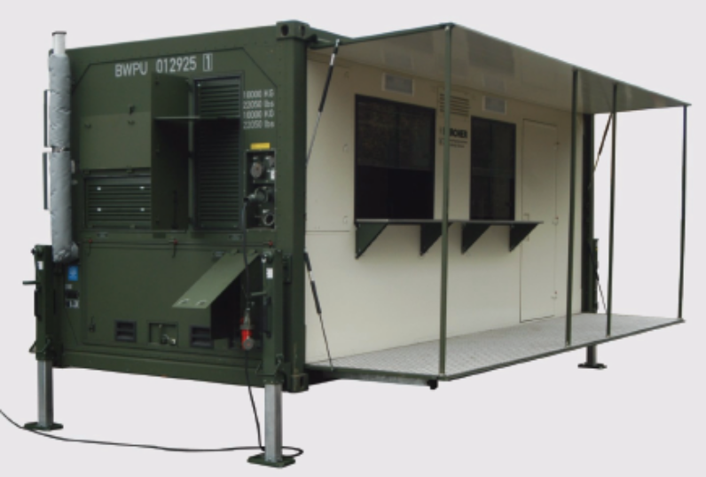
Kitchen Container Cooking (ZuCon) 8,5
4.862-110.0 cleaning agent disinfectant 3p. (20 bags 6.290-838.0 20g) class 5.2, UN 3108, LQ
6.290-358.0 kitchen accessories, oven cleaner ETOLIT 4 bottles 1l class 8, UN1824, III , LQ
6.545-021.0 fire extinguisher, 1 p. class 2.2, UN 1044
6.290-354.0 cleaning agent, 1L bottle, 3 p. class 3, UN 1987, LQ
6.295-560.0 RM 33 , 1 jerrican 20L class 8,
UN1824, II
6.545-021.0 fire extinguisher 1 p. class 2.2, UN 1044
Installed 4x 6.654-062.0 battery 100 Ah exempted SP 238 (class 8 UN2800)
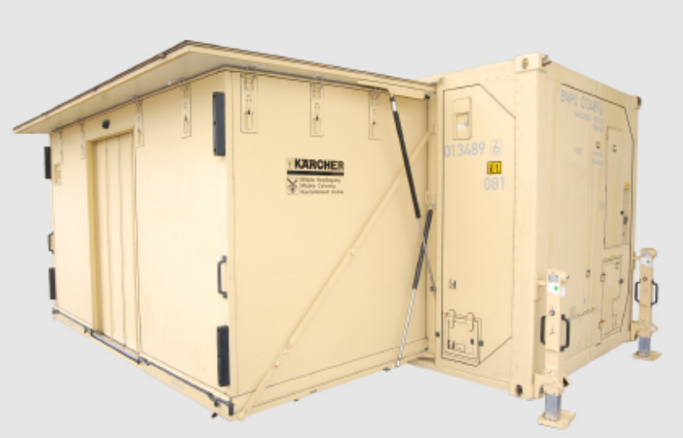
Kitchen Container Preparation (VorCon) 8,5-2
6.295-560.0 cleaning agent 33 20L class 8, UN1824, II
6.290-361.0 REINIGER GESCHIRR 12l 2Kanister class 8, UN 3266, II,
4.862-110.0 RM Desinfektionsmittel 2Stk
(20Beutel 6.290-838.0 á 20g) class 8 5.2, UN 3108, LQ
Installed 2x 6.654-062.0 battery 100 Ah exempted SP 238 (class 8 UN2800)

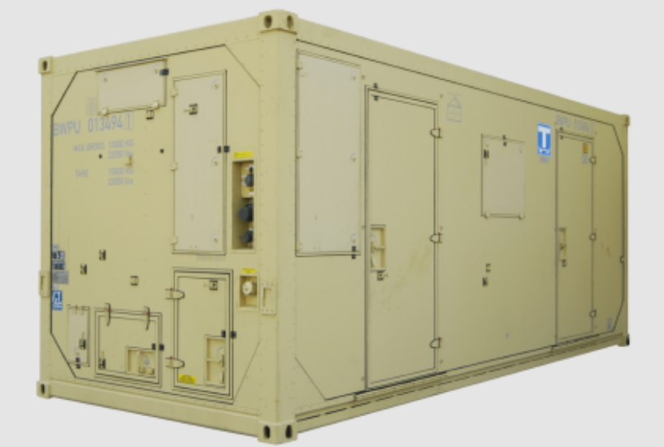
Kitchen Container Convenience Food (ConvenCon) 8,5
6.545-021.0 fire extinguisher 1p. class 2.2, UN 1044
Installed 2x 6.654-062.0 battery 100 Ah exempted SP 238 (class 8 UN2800)
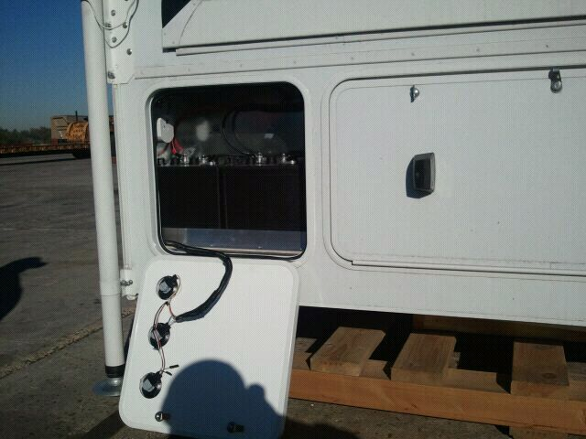
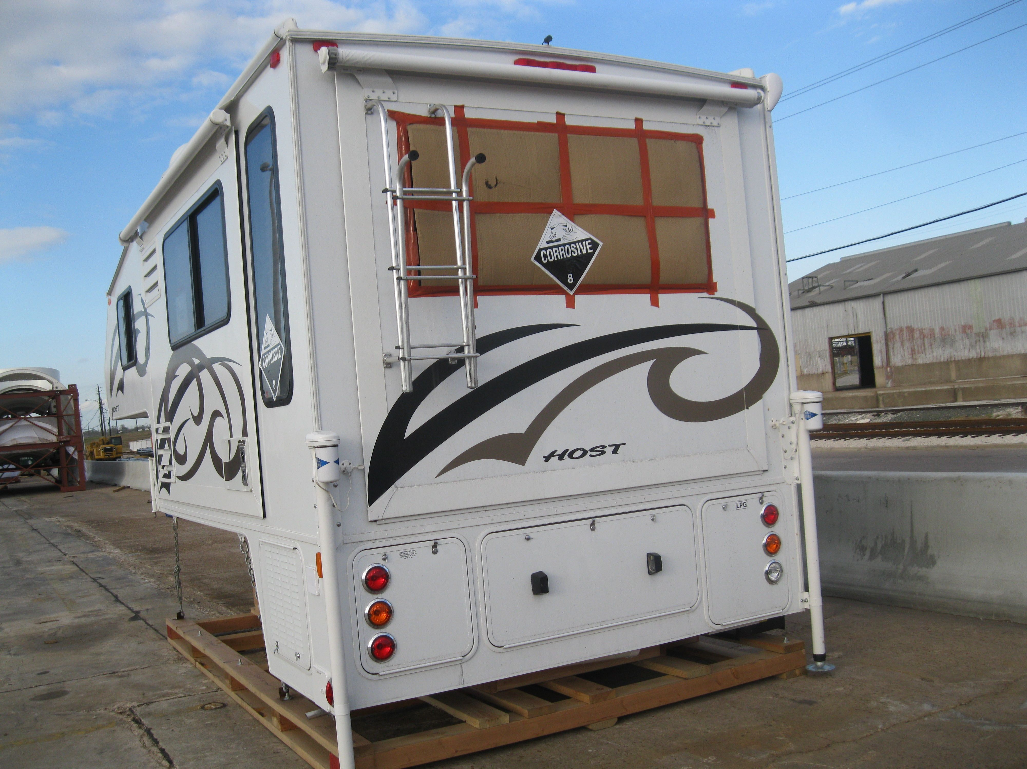
Vehicle superstructure with power supply battery

