UN/SCETDG/45/INF.38
Committee of Experts on the Transport of Dangerous Goods
and on the Globally Harmonized System of Classification
and Labelling of Chemicals
Sub-Committee of Experts on the Transport of Dangerous Goods 17 June 2014
Forty-fifth session
Geneva, 23 June – 2 July 2014
Item 7 (f) of the provisional agenda
Miscellaneous proposals of amendments to the Model Regulations
on the Transport of Dangerous Goods: marking and labelling

Proposal for amendment to the descriptions of labels and marks
Transmitted by the International Paint & Printing Ink Council (IPPIC) and the European Chemical Industry Council (CEFIC)
Introduction and discussion
1. During its 43rd session the Sub-Committee, after discussion on proposals to allow reduced sized labels and marks in certain circumstances (ST/SG/AC.10/C.3/2013/28), requested the expert from IPPIC to revise the proposal. Most experts recognized that it could be difficult to affix labels of a normal size on small packages, taking into account the number of other marks that must be affixed owing to other labelling requirements. However, they were not in favour of extending existing derogations.
2. Reference is made to document ST/SG/AC.10/C.3/2014/35 transmitted by the European Industrial Gases Association (EIGA) and the European Liquefied Petroleum Gas Association (AEGPL), in which the problems of attaching labels to small cylinders is discussed.
3. IPPIC and CEFIC have noted a similar issue with the practical application of labels and markings to smaller packages. The strict requirement for transport labels/marks to be 100 x 100 mm, irrespective of package design and other labelling requirements, creates difficulties for companies to fulfil all legal requirements related to product labelling.
4. IPPIC and CEFIC are aware from member companies that, for some smaller single packagings, the label/mark occupies a large proportion of the available surface area, and may overlap raised components such as beads, chimes and ends. This can lead to adhesion failure and lifting of, or damage to, the labels. All such required information must remain legible and be securely fixed to the package, which can become a problem for such packagings.
5. This problem is exacerbated if a second transport label or mark is required. On some size packagings it is impossible to affix more than one transport label of the required size.
6. To ensure that all of the transport information can be adequately communicated, it is best if this can all be seen in one aspect; it should not be necessary for operators to have to move the package to see all of the relevant information. Furthermore it is a requirement for certain marks to be located adjacent to other markings, for example the environmentally hazardous mark as per 5.2.1.6.2.
7. It should be noted that, under the GHS hazard labelling for supply, substantial label information is also mandatory. The current transport requirements make no allowance for the fitting of other regulatory marks/labels.
8. Some genuine examples of labelled packagings, illustrating the issue described above, are presented in the Annex to this document.
9. The descriptions of the limited quantities marks in sections 3.4.7 and 3.4.8, the environmentally hazardous substance mark in 5.2.1.6.3 and labels in 5.2.2.2.1 all provide for a reduction in the dimensions of the mark or label (below the normal minimum of 100 mm x 100 mm) where this is necessitated by the size of the package. The same provisions appear in the corresponding sections of the modal regulations for transport of dangerous goods by land, sea and air.
10. IPPIC and CEFIC propose to amend the descriptions of the aforementioned labels and marks to clarify that their dimensions may be reduced when necessitated not solely by the physical size of the packaging, but also due to its design and the other regulatory elements which need to be displayed thereon. The views of the Sub-Committee are invited on the most appropriate wording for this clarification. Where not already specified, a minimum of 50 mm x 50 mm for the reduced dimensions can be considered as an option (text proposed in square brackets).
Proposal 1: Limited quantity marking
11. Amend paragraphs 3.4.7.2 and 3.4.8.2 to read as follows:
“3.4.7.2 If the size and/or design of the package so requires, taking into account the presence of other regulatory marks or labels, the minimum outer dimensions shown in Figure 3.4.1 may be reduced to be not less than 50 mm x 50 mm provided the marking remains clearly visible. The minimum width of the line forming the diamond may be reduced to a minimum of 1 mm.
NOTE: The provisions of 3.4.7 from the seventeenth revised edition of the Model Regulations may continue to be applied until 31 December 2016.”
“3.4.8.2 If the size and/or design of the package so requires, taking into account the presence of other regulatory marks or labels, the minimum outer dimensions shown in Figure 3.4.2 may be reduced to be not less than 50 mm x 50 mm provided the marking remains clearly visible. The minimum width of the line forming the diamond may be reduced to a minimum of 1 mm. The symbol "Y" shall remain in approximate proportion to that shown in Figure 3.4.2.
NOTE: The provisions of 3.4.8 from the seventeenth revised edition of the Recommendations on the Transport of Dangerous Goods, Model Regulations may continue to be applied until 31 December 2016.”
Proposal 2: Environmentally hazardous substance mark
12. Amend section 5.2.1.6.3 and figure 5.2.2 to read as follows:
“5.2.1.6.3 The environmentally hazardous substance mark shall be as shown in Figure 5.2.2.

Figure 5.2.2
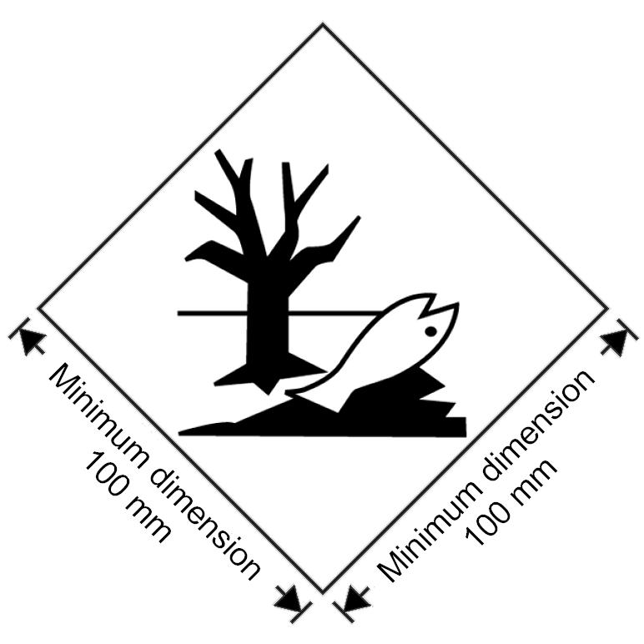
Environmentally hazardous substance mark
The marking shall be in the form of a square set at an angle of 45 degrees (diamond-shaped). The symbol (fish and tree) shall be black on white or suitable contrasting background. The minimum dimensions shall be 100 mm x 100 mm and the minimum width of line forming the diamond shall be 2 mm. If the size and/or design of the package so requires, taking into account the presence of other regulatory marks or labels, the dimensions/line thickness may be reduced [to be not less than 50 mm x 50 mm ]provided the marking remains clearly visible. Where dimensions are not specified, all features shall be in approximate proportion to those shown.
NOTE 1: The labelling provisions of 5.2.2 apply in addition to any requirement for packages to bear the environmentally hazardous substance mark.
NOTE 2: The provisions of 5.2.1.6.3 from the seventeenth revised edition of the Recommendations on the Transport of Dangerous Goods, Model Regulations may continue to be applied until 31 December 2016.”
Proposal 3: Class/division labels
13. Amend paragraph 5.2.2.2.1.1.3 to read as follows:
“5.2.2.2.1.1.3 If the size and/or design of the package so requires, taking into account the presence of other regulatory marks or labels, the dimensions may be reduced [to be not less than 50 mm x 50 mm ]provided the symbols and other elements of the label remain clearly visible. The line inside the edge shall remain 5 mm to the edge of the label. The minimum width of the line inside the edge shall remain 2 mm. Dimensions for cylinders shall comply with 5.2.2.2.1.2.
NOTE: The provisions of 5.2.2.2.1.1 from the seventeenth revised edition of the Recommendations on the Transport of Dangerous Goods, Model Regulations may continue to be applied until 31 December 2016. When so applied, 5.2.2.2.1.1.1, 5.2.2.2.1.1.2 and 5.2.2.2.1.1.3 shall not apply until 31 December 2016.”

Annex
Examples of single packagings showing difficulties in properly accommodating 100 mm x 100 mm transport labels

Example 1: 5 litre container

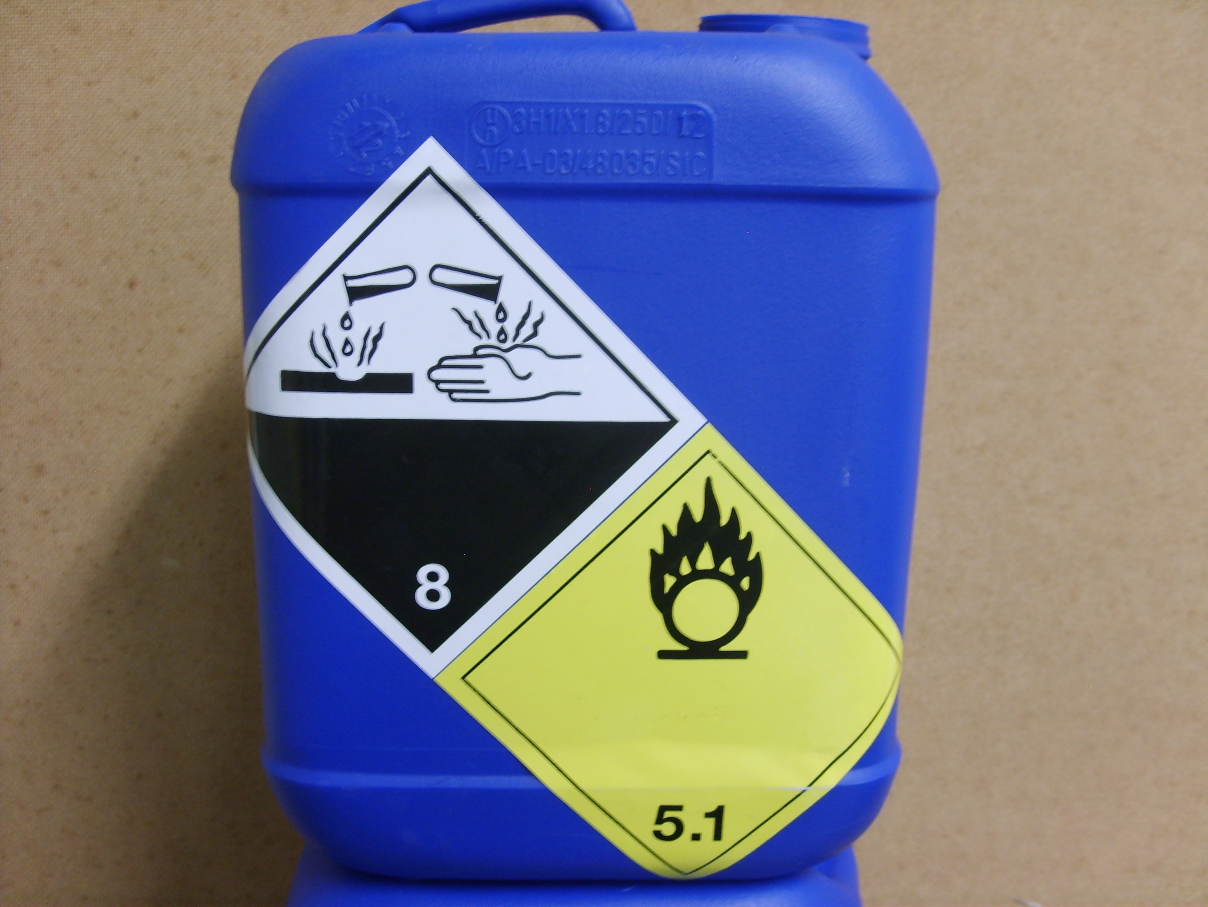

This packaging contains a product classified as Class 8 and Class 5.1. Two transport labels are therefore required to be displayed on the packaging. In order to affix two transport labels of 100 mm x 100 mm on the container, these must be applied over the raised portion of the container and wrap underneath it such that they are not completely visible. This gives an increased likelihood that the labels will lift during transport, leading to reduced legibility and, therefore, reduced safety. It also does not allow the orientation arrows to be shown on the same face as the transport labels.

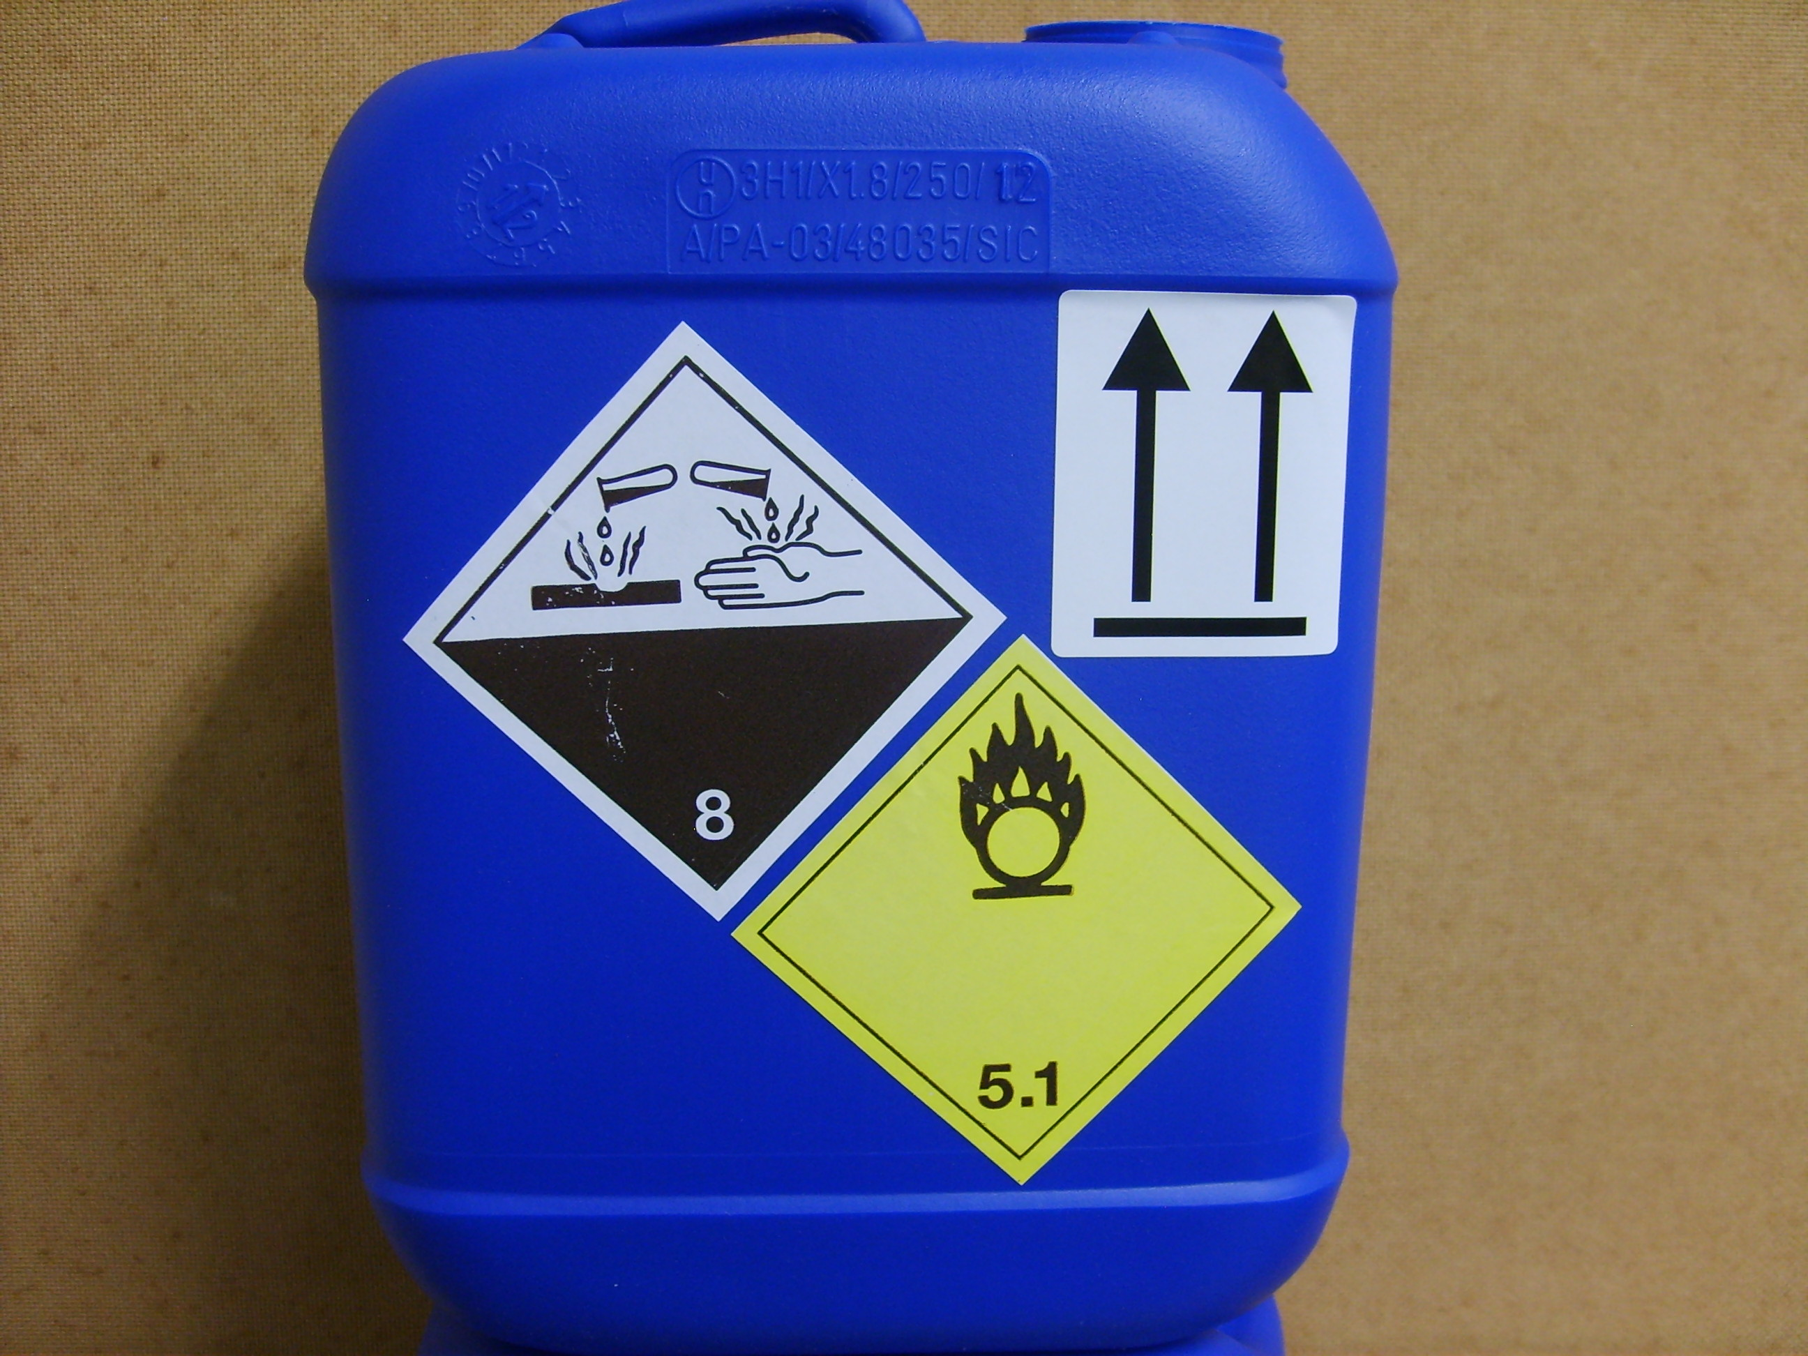
A small reduction in the size of the transport labels, e.g. to 70 x 70 mm, would enable all labels to be accommodated comfortably and securely, without prejudicing safety since such labels would still be clearly visible and legible from a single aspect – see above.
Example 2: 5 litre pail
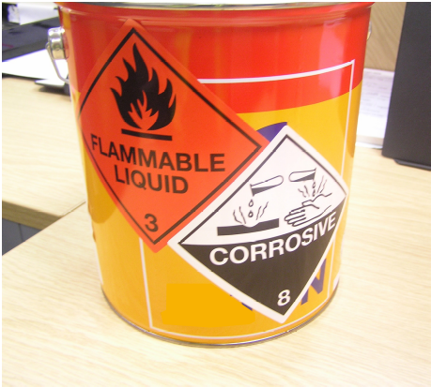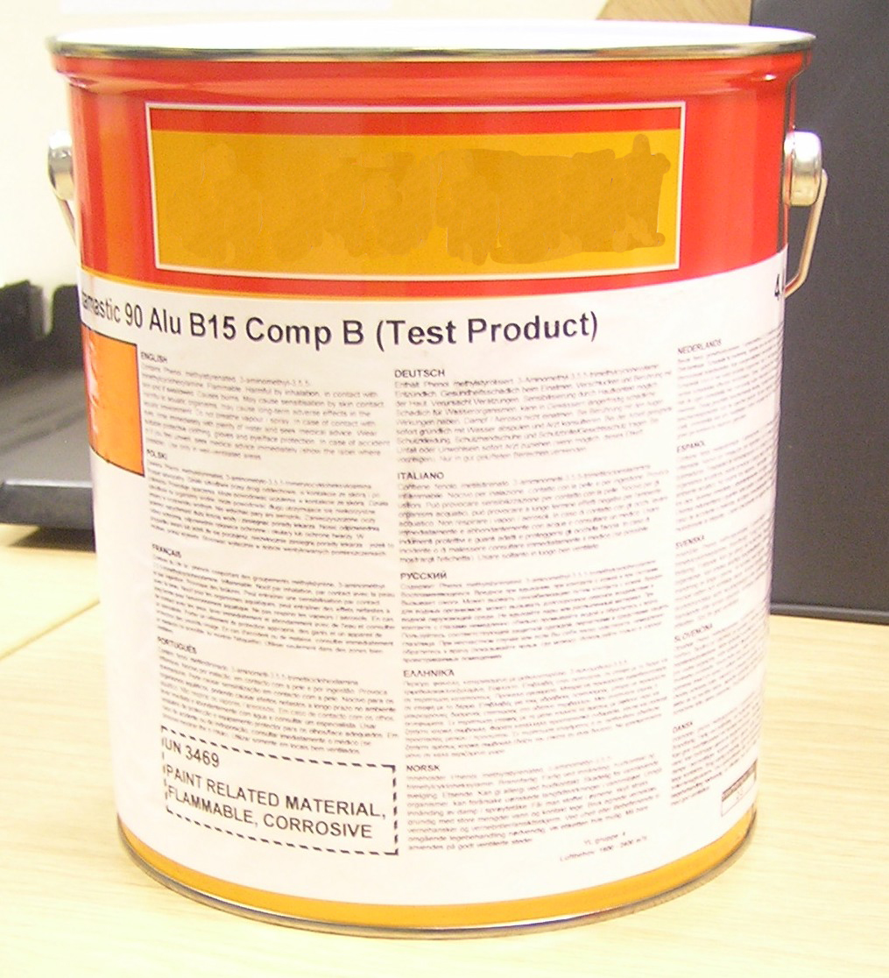

This packaging contains a product classified as UN 3469 PAINT RELATED MATERIAL, flammable, corrosive (packing group II). Two transport labels, Class 3 and Class 8, are therefore required to be displayed on the packaging. (The product is also classified as an environmentally hazardous substance, but the corresponding mark is not required on packages of 5 litres maximum).
It is only just possible to affix two transport labels of 100 mm x 100 mm on the pail without partially covering the obligatory supply label. The transport labels must adjoin one another along one edge in order to fit onto the pail; even so, one label overlaps onto the top flange of the pail, which is not ideal as the label is less securely affixed and thus more likely to peel away.
A small reduction in the size of the transport labels, e.g. by 20%, would enable two labels to be accommodated comfortably and securely on the pail, without prejudicing safety since such labels would still be clearly visible and legible.
Example 3: 2.5 litre pail

This packaging contains a flammable product, UN 1263 PAINT. Only one 100 mm x 100 mm transport label can fit on the pail alongside the supply label. Since this overlaps the strengthening bead in the pail wall, it is necessary for the Class 3 label to be pre-printed onto the pail during manufacture to prevent problems with label adhesion or distortion. This increases costs for the consignor and reduces flexibility in packaging stock allocation, without any obvious safety benefit: a label reduced in size, such that it just fits below the bead, would still be clearly visible and legible on the pail.
In addition, it is impossible to accommodate a second transport label on this packaging unless the consignor would be permitted to reduce the size of both.

