UN/SCETDG/45/INF.19
Committee of Experts on the Transport of Dangerous Goods
and on the Globally Harmonized System of Classification
and Labelling of Chemicals
Sub-Committee of Experts on the Transport of Dangerous Goods 10 June 2014
Forty-fifth session
Geneva, 23 June – 2 July 2014
Item 2 (a) of the provisional agenda
Explosives and related matters: tests and criteria for flash compositions
Comments on the apparatus, materials and criteria of US- and HSL Flash Composition Tests
Transmitted by the expert from Japan
Background
1. “US Flash Composition Test” proposed by the United States of America (USA) has been developed at the Sub-Committee on the Transport of Dangerous Goods (TDG) as a candidate of alternative to the HSL Flash Composition Test.
2. At 42nd TDG, it was adopted that further work will be undertaken to ensure compatibility between US Flash Composition Test (US test) and HSL Flash Composition Test (HSL test) before the US test is formally accepted.
3. At 43rd TDG, new proposals were submitted from USA on materials and criteria of US tests, and modification of HSL test apparatus (see ST/SG/AC.10/ C.3/2013/23 and /24). These proposals raised several technical issues including availability of the specific steel grade for the witness plate, validity of modifying HSL test apparatus, and so on.
4. In order to address all issues raised so far, Japan has conducted experiments of US-, HSL- and modified HSL tests for 69 kinds of fireworks compositions. This informal paper provided findings of this work and discussed possible solutions for issues on the apparatus, materials and appropriate criteria of US- and HSL tests.
Discussion
Availability of specific steel grade for witness plate of US test
5. In the proposal from USA (see ST/SG/AC.10/C.3/2013/24), steel grades of ST37 or S235JR compatible were recommended for the 1 mm thick witness plate of US test. Although these steel are popularly used in Japan, 1 mm thick plates of this steel were not commercially available. On the other hand, SPCC (cold-rolled steel, JIS G 3141, ISO 3574 1999 CR1) was found to be highly available for 1 mm thick plate.
6. In this work, all indentation data of US test shown in Table 2 were obtained using SPCC (China Steel) witness plates due to the availability issue. Table 1 in Annex of this paper showed mechanical properties of some SPCC products in comparison with those of US recommendation (ST37 or S235JR). It was clear that values of percentage permanent elongation of SPCCs (38 - 54 %) were significantly higher than that of ST37 or S235JR (26 %). This meant that the indentation depth of SPCC witness plate had higher threshold of tear than that of ST37 or S235JR witness plate.
7. The criterion of indentation depth had a meaning that beyond this criterion, the witness plate could be regarded as being torn. Therefore, the difference in percentage permanent elongation i.e. indentation threshold of tear between SPCC and ST37 or S235JR was essential to determine the criterion of indentation depth. The expert from Japan invites TDG to consider how to standardize the steel grade in terms of worldwide availability.
Influence of air gap between sample and witness plate of US test
8. Figure 1 demonstrated considerable effect of an air gap between the witness plate surface and the bottom end of sample filled in the sample tube on the indentation depth. It was shown that air gap 8 mm in thickness could decrease indentation depth by 2 - 3 mm. Expert from Japan invites TDG to consider adding appropriate wording to avoid making unnecessary air gap in “Procedure” description of US Flush Composition Test.
Recommended thickness of aluminium bursting disc of HSL test
9. In this work, all HSL tests were conducted using aluminium bursting disc 0.2 mm in thickness as recommended in APPENDIX 7 of Manual of Tests and Criteria. However, in many cases, measurements were failed due to interruption of pressure rise caused by unexpected bursting of the disc below 2070 kPa. Such cases were denoted by quotation mark “a)” in Table 2. Therefore, the recommended thickness of 0.2 mm was considered to be too small. To avoid experimental failure due to such unexpected bursting of disc below 2070 kPa, the expert from Japan invites TDG to consider simply increasing the recommended thickness of aluminium bursting disc from 0.2 mm to 0.4 mm.
Effect of modifying HSL test apparatus
10. The modification of the HSL test apparatus proposed by USA (see ST/SG/AC.10/C.3/2013/23) was intended to improve operability particularly in replacing igniters by modifying current electrode structure having side screw to be much simpler one. However, this modification raised concern that the difference in the pressure leakage rates through the feed ports of electrodes between current- and modified HSL test apparatus resulted in difference in performance i.e. the value of Δt.
11. Figure 2 showed the comparison of Δt measured by current- and modified HSL test for very same samples. Although data points showed significant scattering, that was possibly caused by poor reproducibility of burning rate of each sample, the distribution of scattered data showed no noticeable bias between two different electrode structures. High-speed video observation looking at the feed ports of the electrodes was also conducted for both structures but no visible gas leaking was observed. Thus, the difference in the gas leaking rate, if any, seemed to be so small that no noticeable difference appeared in terms of test performance between current- and modified HSL tests apparatus.
12. Figure 3 shows typical alignment of igniter at the upper side of the ignition plug of current HSL test apparatus. In this work, lead wires of igniter were not connected directly to electrodes that were screwed from the bottom of the plug, but connected to intermediate lead wires that were connected to the screwed electrodes. The metal body and insulating coat of the intermediate lead wires (PEW enamelled Cu wire 0.8 mm in diameter) were strong enough to withstand multiple experiments without being replaced. Thus, by using the intermediate lead wires, procedures of igniter replacing in current HSL test could be significantly simplified.
13. According to the results mentioned above, the expert form Japan considered that the modification of HSL test apparatus was not indispensable although the simplified electrode structure of the modified HSL test apparatus was preferable.
Appropriate criteria for US tests
14. Table 2 showed all data of US-, HSL- and modified HSL tests for 69 kinds of firework compositions. From this table, all indentation depths were plotted in Fig. 4 as a function of corresponding Δt. Because current- and modified HSL tests were considered to be equivalent in this work, smaller value was selected as Δt among those obtained by current- and modified HSL tests. As for the US test, average value of indentation depth was defined including the case that at least one of the witness plates was slightly torn.
15. Distribution of the data plotted in Fig. 4 showed rough tendency that larger indentation depth corresponded to smaller Δt. However, there were some abnormal cases such as White #61, Green #19, Red blinking #33 and Blue #21 that did not apply to the tendency.
16. Figure 4 showed that the witness plate started to be torn at the indentation depth of about 17 mm. Therefore, the appropriate criterion of indentation depth could be set to 17 mm. This value was also acceptable in respect that the black powders could mostly be classified into non-flash composition.
17. However, it should be noted that this criterion was based on SPCC witness plate. In case that witness plates of ST37 or S235JR compatible were used, or there was no standardization for steel grade, the criterion of 15 mm based on ST37 or S235JR witness plate (see ST/SG/AC.10/C.3/2013/24) should be selected in order to stay on the safe side.
18. As for the criterion of HSL test, Δt = 6 ms was adopted from 18th edition of Model Regulations. Another possible criterion was considered to be 4 ms if there was a consensus that black powders could be regarded as a standard of non-flash composition.
19. Compatibility between US- and HSL tests was also an important factor in determining criterion. The compatibility: γ was examined as functions of HSL test criterion and US test criterion as follows,
γ (x, y) = (number of data in the compatible region in Fig. 4) / (total number of data)×100,
where x and y were HSL test criterion and US test criterion, respectively.
20. Figure 5 shows a mapping of compatibility: γ using all data of this work. Combination of x = 4 ms and y = 17 mm derived by the above discussions gave reasonable compatibility of about 84 %. Combination of currently adopted criterion x = 6 ms and y = 15 mm proposed by USA also gave reasonable compatibility of about 84 %. Other combinations, such as x = 4 ms and y = 15 mm or x = 6 ms and y = 17 mm gave slightly lower compatibilities of 78 – 80 %.
Proposal
21. The Sub-Committee is invited to discuss following views from the experts from Japan,
• The steel grade of ST37 or S235JR (recommended by USA) and SPCC (only available for 1 mm thick plate in Japan) were not compatible in terms of indentation threshold of tear. Therefore it is necessary to consider how to standardize the steel grade.
• Appropriate wording to avoid making unnecessary air gap should be added in “Procedure” description of US Flush Composition Test.
• To avoid experimental failure due to unexpected bursting of aluminium disc below 2070 kPa, recommended thickness of aluminium bursting disc described in APPENDIX 7 of Manual of Tests and Criteria should be changed from 0.2 mm to
0.4 mm.
• The modification of HSL test apparatus is not indispensable although the simplified electrode structure of the modified HSL test apparatus was preferable.
• The appropriate criteria of indentation depth based on SPCC witness plate could be set to 17 mm. This value was also acceptable in respect that the black powders could mostly be classified into non-flash composition.
• In case that SPCC could not be a standard grade of witness plate, the criterion of 15 mm should be selected in order to stay on the safe side.
• If there is a consensus that black powder can be regarded as a standard of non-flash composition, the criterion of HSL test can be changed to 4 ms.
Annex

Table 1 Mechanical properties of SPCC steels compared with those of recommended steel by USA

Steel grade | Density  (kg/m³) | Ultimate tensile strength  (kN/mm²) | Percentage  permanent  elongation  (%) | Stretch limit or  Rapture strength  (kN/mm²)
US recommendation  ST37 or S235JR | 7850 | 340 | 26 | 185 - 355
SPCC-SD  (Nisshin Steel) | 7798 | 326 - 338 | 44 - 46 | 242 - 254
SPCC  (unknown) | 7835 | 237 - 287 | 52 - 54 | 183 - 195
SPCC  (Nippon Steel & Sumitomo Metal) | 7780 | 338 - 379 | 39 - 40 | 251 - 291
SPCC  (China Steel)  Used in this work | 7858 | 336 – 357 | 42 - 45 | 252 - 273
SPCC  (unknown) | --- | 335 - 337 | 38 - 40 | 268 - 270

Tensile tests for SPCC were conducted according to ISO 6892-1

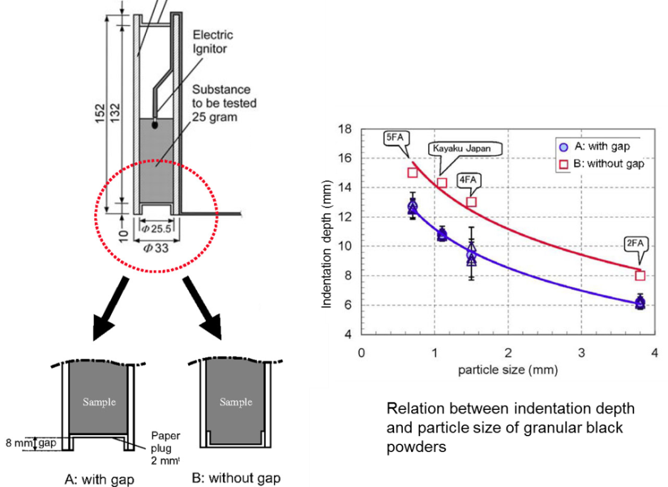
Fig. 1 Influence of a gap between the witness plate surface and the bottom end of sample filled in the sample tube on indentation depth

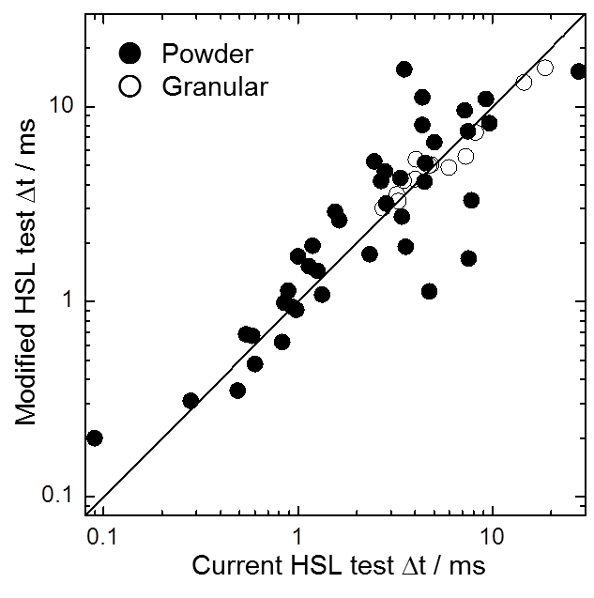
Fig. 2 Comparison of Δt between current- and modified HSL tests for very same samples

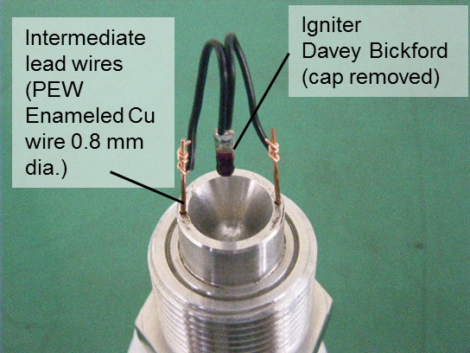

Fig. 3 Typical alignment of igniter at the upper side of the ignition plug of current HSL test apparatus

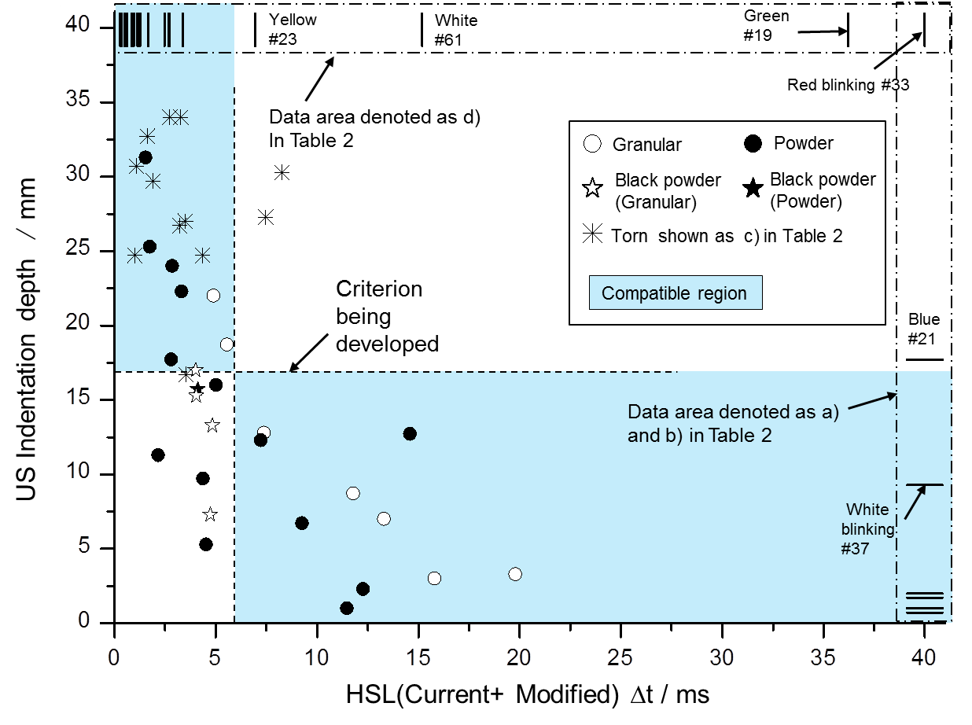

Fig. 4 Plots of indentation depth as a fnction of corresponding Δt for various compositions

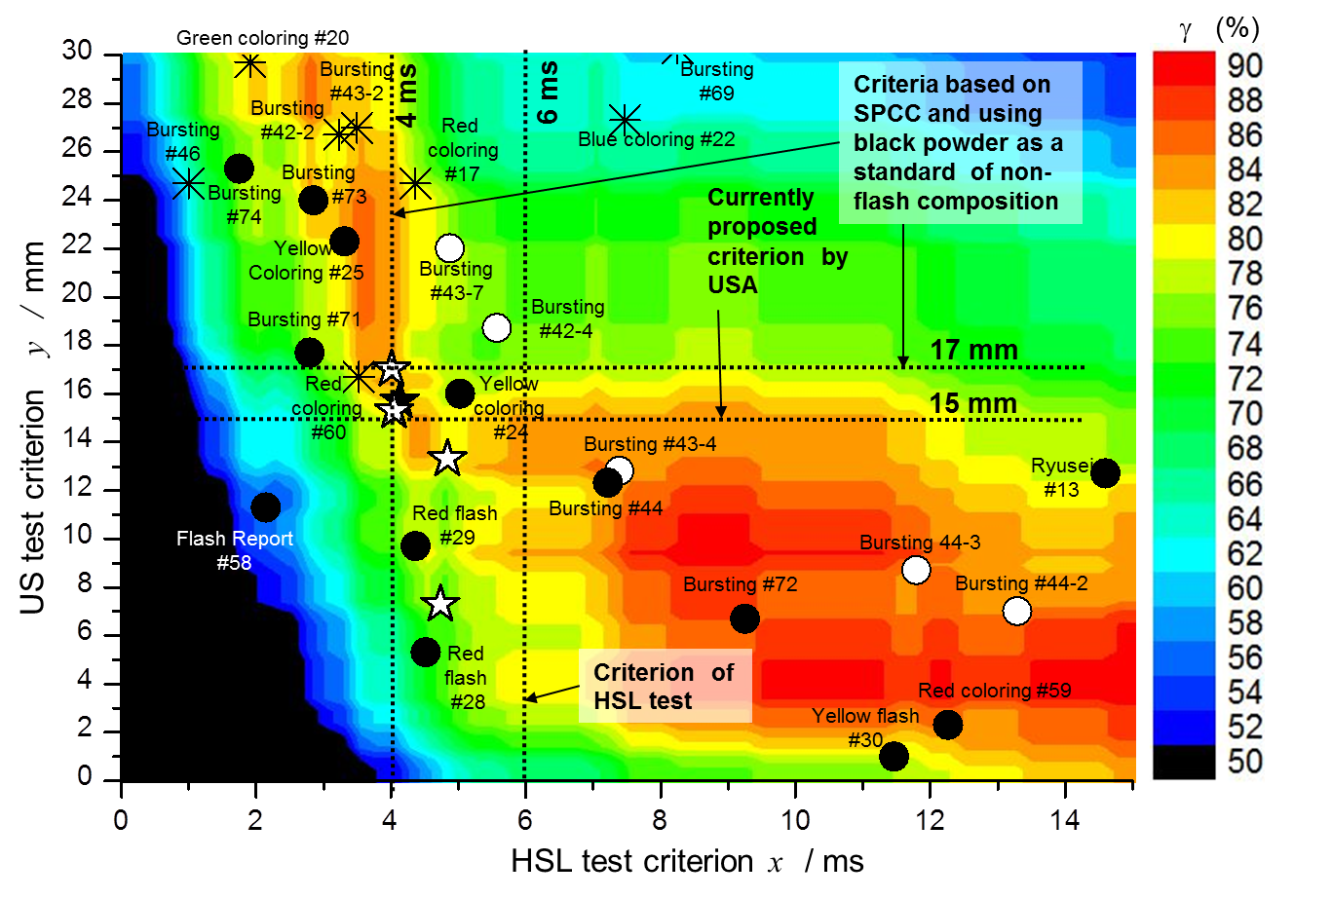
Fig. 5 Compatibility mapping as functions of HSL test criterion: x and US test criterion: y

Table 2 Comparison of US-, HSL- and modified HSL-Flash Composition Tests for various fireworks compositions
Abbreviations and quotation marks

PR : Phenol resin CR : Chlorinated rubber
VR : Vinsole resin KTBP : Potassium terebiphthalate
PVC : Polyvinyl chloride
a) As the gauge pressure rise was always interrupted by disc bursting below 2070 kPa, minimum time interval from 690 kPa to final
pressure was shown as a lower limit of Δt (690 - 2070 kPa).
b) The gauge pressure profile always showed peak below 2070 kPa.
c) Average value of indentation depth was defined although at least one of the witness plates was slightly torn.
d) Indentation depth was not defined because at least one of the witness plates was totally pierced.

Sample identification name &  Composition  (wt. %) | Configuration | US test  Indentation depth  (mm) | HSL test  (Current)  t (ms) | HSL test  (Modified)  t (ms) | HSL test  (Current + Modified)  t (ms)
Report #1  KClO₄/Al(P2000)＝77/23 | Powder | -- d) | 0.60 | 0.48 | 0.48
Report #2  KClO₄/Al(P2000)/S = 67/20/13 | Powder | -- d) | 0.49 | 0.35 | 0.35
Report #3  KClO₄/Al(P2000)/MgAl(#100) = 71/21/8 | Powder | -- d) | 0.54 | 0.68 | 0.54
Report #4  KClO₄/Al(P3000) ＝77/23 | Powder | -- d) | 0.28 | 0.31 | 0.28
Report #5  KClO₄/Al(P3000)/S = 67/20/13 | Powder | -- d) | 0.09 | 0.20 | 0.09
Flash Report #6  KClO₄/Ba(NO₃)₂/Al(P2000)//MgAl = 30/30/30/10 | Powder | -- d) | 0.94 | 0.94 | 0.94
Flash Report #55  KClO₄/Ba(NO₃)₂/Al(P2000)/MgAl = 40/40/15/5 | Powder | -- d) | 0.58 | 0.67 | 0.58
Sample identification name &  Composition  (wt. %) | Configuration | US test  Indentation depth  (mm) | HSL test  (Current)  t (ms) | HSL test  (Modified)  t (ms) | HSL test  (Current + Modified)  t (ms)
Flash Report #56  KClO₄/Ba(NO₃)₂/Al(P2000)/MgAl = 35/35/22.5/7.5 | Powder | -- d) | 0.83 | 0.62 | 0.62
Flash Report #57  KClO₄/Ba(NO₃)₂/Al(P2000)/MgAl = 25/25/37.5/12.5 | Powder | 32.7 c) | 1.63 | 2.62 | 1.63
Flash Report #58  KClO₄/Ba(NO₃)₂/Al(P2000)/MgAl = 20/20/45/15 | Powder | 11.3 | 2.15 | 6.08 a) | 2.15
Flash Report #7  Ba(NO₃)₂/MgAl/Al(P2000) = 55/45/5 | Powder | 2.0 | -- b) | -- b) | -- b)
Whistle #9  KClO₄/C₇H₅KO₂ = 71/29 | Powder | -- d) | 0.89 | 1.14 | 0.89
Whistle #10  KClO₄/C₇H₅KO₂/Ti(#30-60) = 62/25/13 | Powder | -- d) | 1.26 | 1.44 | 1.26
Whistle #12  KClO₄/KTBP/Ti = 62/25/13 | Powder | -- d) | 7.56 | 1.67 | 1.67
Ryusei #13 (rocket propellant)  KNO₃/C(fine hemp)/S = 77/15/8 | Powder | 12.7 | 14.60 | 15.42 a) | 14.60
Hachi #14 (bee effect)  KNO₃/C/S/Ti = 58/18/12/12 | Powder | 1.7 | -- b) | -- b) | -- b)
Black powder #16 (Kayaku.Japan)  KNO₃/C/S=75/15/10 | Granular | 17.0 | 4.01 | 4.26 | 4.01
Black powder #16-1 (Kayaku Japan)  KNO₃/C/S=75/15/10 | Powder | 15.7 | 4.48 | 4.13 | 4.13
Black powder #16-2 (WANO 5FA)  KNO₃/C/S=75.5 / 15.2 / 9.3 | Granular | 15.3 | 4.05 | 5.38 | 4.05
Black powder #16-3 (WANO 4FA)  KNO₃/C/S=75.5 / 15.2 / 9.3 | Granular | 13.3 | 4.84 | 5.05 | 4.84
Sample identification name &  Composition  (wt. %) | Configuration | US test  Indentation depth  (mm) | HSL test  (Current)  t (ms) | HSL test  (Modified)  t (ms) | HSL test  (Current + Modified)  t (ms)
Black powder #16-4 (WANO 2FA)  KNO₃/C/S=75.5 / 15.2 / 9.3 | Granular | 7.3 | 4.74 | 5.00 | 4.74
Red coloring #17  KClO₄/PR/CR/MgAl/SrCO₃ = 56/11/5/11/17 | Powder | 24.7 c) | 4.36 | 8.06 | 4.36
Red coloring #59  KClO₄/PR/CR/MgAl/SrCO₃ = 66/6/4/7/17 | Powder | 2.3 | -- b) | 12.27 | 12.27
Red coloring #60  KClO₄/PR/CR/MgAl/SrCO₃ = 46/19/7/11/17 | Powder | 16.7 c) | 3.52 | 15.53 | 3.52
Green coloring #19  KClO₄/PR/CR/MgAl/BaN = 33/14/7/14/33 | Powder | -- d) | 48.51 a) | 31.33 | 31.33
Green coloring #20  KClO₄/PR/CR/C (cotton) /BaN = 48/10/5/7/30 | Powder | 29.7 c) | 3.59 | 1.91 | 1.91
Blue coloring #21  KClO₄/PR/CR/MgAl/CuO = 56/11/5/11/17 | Powder | 17.7 c) | 17.28 a) | 48.66 a) | 17.28 a)
Blue coloring #22  KClO₄/PR/CR/C(hemp)/CuO = 58/12/6/6/18 | Powder | 27.3 c) | 7.47 | 7.47 | 7.47
Yellow coloring #23  KClO₄/PR/CR/MgAl/Cryolite = 56/11/5/11/17 | Powder | -- d) | 6.95 | 36.67 a) | 6.95
Yellow coloring #24  KClO₄/PR/CR/MgAl/Na₂C₂O₄ = 56/11/5/11/17 | Powder | 16.0 | 5.03 | 6.56 | 5.03
Yellow coloring #25  KClO₄/PR/CR/C(hemp)/Na₂C₂O₄ = 58/12/6/6/18 | Powder | 22.3 | 7.80 | 3.31 | 3.31
White coloring #27  KClO₄/PR/MgAl/Sb₂S₃ = 58/12/18/12 | Powder | -- d) | 3.37 | 4.31 | 3.37
White coloring #27-1  KClO₄/PR/MgAl/Sb₂S₃ = 58/12/18/12 | Hoshi (star) | 1.0 | 68.79 a) | -- b) | 68.79 a)
Sample identification name &  Composition  (wt. %) | Configuration | US test  Indentation depth  (mm) | HSL test  (Current)  t (ms) | HSL test  (Modified)  t (ms) | HSL test  (Current + Modified)  t (ms)
White coloring #27-2  KClO₄/PR/MgAl/Sb₂S₃ = 58/12/18/12 | Hoshi (star)  coated with black powder ignition enhancer | 0.7 | 31.26 a) | 22.87 a) | 22.87 a)
White coloring #27-3  KClO₄/PR/MgAl/Sb₂S₃ = 58/12/18/12 | Crushed  #27-2 | 3.0 | 18.73 | 15.81 | 15.81
White coloring #61  KClO₄/PR/MgAl/Sb₂S₃ = 68/9/14/9 | Powder | -- d) | 27.88 | 15.18 | 15.18
White coloring #62  KClO₄/PR/MgAl/Sb₂S₃ = 48/15/22/15 | Powder | -- d) | 2.47 | 5.24 | 2.47
Red flash #28  KClO₄/PR/Mg(#80)/CR/SrCO₃ = 40/16/20/8/16 | Powder | 5.3 | 4.52 | 5.16 | 4.52
Red flash #29  KClO₄/PR/Mg/PVC/BaN = 31/13/16/9/31 | Powder | 9.7 | 4.37 | 11.19 | 4.37
Yellow flash #30  KClO₄/PR/Mg/PVC/Cryolite = 40/16/20/12/12 | Powder | 1.0 | 11.47 | 33.85 a) | 11.47
Flash dew #31  KClO₄/Ba(NO₃)₂/PR/Al(P2000)/S/H₃BO₃ = 31/31/13/16/6/3 | Powder | -- d) | 2.67 | 4.17 | 2.67
Flash dew #32  KClO₄/Al(P2000)/PR = 62/19/19 | Powder | -- d) | 4.74 | 1.13 | 1.13
Red blinking #33  NH₄ClO₄/Mg/SrSO₄ = 50/30/20 | Powder | -- d) | 64.39 a) | 86.77 a) | 64.39 a)
White blinking #37  NH₄ClO₄/MgAl/BaSO₄ = 50/30/20 | Powder | 9.3 | 31.38 a) | 37.63 a) | 31.38 a)
Yellow blinking #38  Ba(NO₃)₂/CR/MgAl/S = 58/6/18/18 | Powder | 1.0 | 26.52 a) | 28.80 a) | 28.80 a)
Sample identification name &  Composition  (wt. %) | Configuration | US test  Indentation depth  (mm) | HSL test  (Current)  t (ms) | HSL test  (Modified)  t (ms) | HSL test  (Current + Modified)  t (ms)
Waterfall #39  KClO₄/Al(P2000)/Al(P50) = 53/16/31 | Powder | -- d) | 3.42 | 2.73 | 2.73
Waterfall #40  KClO₄/Al(P2000)/Al(P50)/S = 50/15/30/5 | Powder | -- d) | 0.98 | 0.91 | 0.91
Waterfall #41  KClO₄/Al(P2000)/Al(P50)/Sb₂S₃ = 50/15/30/5 | Powder | -- d) | 1.19 | 1.94 | 1.19
Bursting #42  KClO₄/C(hemp) = 71/29 | Powder | 31.3 | 1.55 | 2.89 | 1.55
Bursting #42-2  KClO₄/C(hemp) = 71/29 | Granular  (cork core) | 26.7 c) | 3.23 | 3.56 | 3.23
Bursting #42-3  KClO₄/C(hemp) = 71/29 | Granular  (rice chaff core) | 34 c) | 3.28 | 3.28 | 3.28
Bursting #42-4  KClO₄/C(hemp) = 71/29 | Granular  (cottonseed core) | 18.7 | 7.30 | 5.57 | 5.57
Bursting #69  KClO₄/C(hemp) = 90/10 | Powder | 30.3 c) | 9.67 | 8.25 | 8.25
Bursting #70  KClO₄/C(hemp) = 80/20 | Powder | -- d) | 0.85 | 0.99 | 0.85
Bursting #71  KClO₄/C(hemp) = 60/40 | Powder | 17.7 | 2.80 | 4.66 | 2.80
Bursting #72  KClO₄/C(hemp) = 50/50 | Powder | 6.7 | 9.26 | 10.96 | 9.26
Bursting #43  KClO₄/KNO₃/C(hemp) = 53/26/21 | Powder | 30.7 c) | 1.33 | 1.09 | 1.09
Sample identification name &  Composition  (wt. %) | Configuration | US test  Indentation depth  (mm) | HSL test  (Current)  t (ms) | HSL test  (Modified)  t (ms) | HSL test  (Current + Modified)  t (ms)
Bursting #43-2  KClO₄/KNO₃/C(hemp) = 53/26/21 | Granular  (cork core) | 27.0 c) | 3.49 | 4.18 | 3.49
Bursting #43-3  KClO₄/KNO₃/C(hemp) = 53/26/21 | Granular  (rice chaff core) | 34.0 c) | 2.73 | 3.02 | 2.73
Bursting #43-4  KClO₄/KNO₃/C(hemp) = 53/26/21 | Granular  (cottonseed core) | 12.7 | 8.20 | 7.39 | 7.39
Bursting #43-7  KClO₄/KNO₃/C(hemp) = 53/26/21 | Granular  (cork core:  thick coating) | 22.0 | 5.97 | 4.88 | 4.88
Bursting #73  KClO₄/KNO₃/C(hemp) = 60/29/11 | Powder | 24.0 | 2.85 | 3.19 | 2.85
Bursting #74  KClO₄/KNO₃/C(hemp) = 46/23/31 | Powder | 25.3 | 2.34 | 1.75 | 1.75
Bursting #44  KNO₃/C(hemp)/S = 77/15/8 | Powder | 12.3 | 7.22 | 9.59 | 7.22
Bursting #44-2  KNO₃/C(hemp)/S = 77/15/8 | Granular  (cork core) | 7.0 | 14.56 | 13.30 | 13.30
Bursting #44-3  KNO₃/C(hemp)/S = 77/15/8 | Granular  (rice chaff core) | 8.7 | 11.80 | 13.65 a) | 11.80
Bursting #44-4  KNO₃/C(hemp)/S = 77/15/8 | Granular  (cottonseed core) | 3.3 | 19.80 | 29.59 a) | 19.80
Bursting #45  KClO₄/C(hemp)/Al(P3000) = 59/23/18 | Powder | -- d) | 1.14 | 1.52 | 1.14
Bursting #46  KClO₄/C(hemp)/Ti = 59/23/18 | Powder | 24.7 c) | 1.00 | 1.71 | 1.00

