 | United Nations | ST/SG/AC.10/C.3/2014/89
 | Secretariat |  | Distr.: General  10 September 2014  Original: English
Committee of Experts on the Transport of Dangerous Goods
and on the Globally Harmonized System of Classification
and Labelling of Chemicals
Sub-Committee of Experts on the Transport of Dangerous Goods
Forty-fifth session
Geneva, 1 – 9th December 2014
Item 2 (e) of the provisional agenda
Recommendations made by the Sub-Committee on its forty-third,
forty-fourth and forty-fifth sessions and pending issues: miscellaneous pending issues
Appropriate hazard communication – lithium batteries and Class 9
Transmitted by the expert from the United Kingdom
Introduction
1. At the forty-fifth session, the United Kingdom submitted ST/SG/C.10.C.3/2014/18, proposing new marks to better communicate the hazards associated with lithium batteries and other substances and articles in Class 9. This followed ICAO’s expression of concern about the transport of lithium batteries (ST/SG/C.10.C.3/2013/49 and informal document INF.48 at the forty-fourth session). It also reflected the more general apprehensions about lack of information conveyed by the current Class 9 marking system voiced during debate by many members of the Sub Committee.
2. The proposals put forward in ST/SG/AC.10/C.3/2014/18 were discussed in plenary and at a lunchtime working group, the conclusions of which were summarised in informal document INF.66. The current proposal is based on the working group’s recommendations, as agreed by a majority of those present.
3. For lithium batteries, the working group’s conclusions were that a new marking system should:
(a) Indicate the main hazard (flammability) only;
(b) Associate this hazard with damage to the batteries;
(c) Differentiate between lithium ion/lithium metal batteries;
(d) Adapt the battery image used by ICAO; and
(e) Retain existing exemptions (e.g. SP 188).
4. For Class 9 marking more generally, the conclusions were:
(a) Add an appropriate pictogram to the lower half of the existing Class 9 label;R
(b) Possibly allow separate but adjacent Class 9/specific pictogram labels as an alternative;
(c) Use existing pictograms from the Model Regulations or GHS in so far as possible;
(d) Standardise on a black and white design;
(e) Continue existing exemptions (LQ, EQ, special provisions); and
(f) Require the same pictogram for exempt categories as for the corresponding regulated Class 9 entry, in diamond or rectangle, with no language and no Class mark.
5. The United Kingdom accordingly presents below three proposals for marking systems, which could be adopted singly or in combination:
(a) For lithium batteries;
(b) For Environmentally Hazardous Substances (EHS) and elevated temperature entries; and
(c) For other Class 9 entries (asbestos, capacitors).
6. The United Kingdom would suggest that label numbers are allocated in the order these substances/articles are listed at 2.9.2, as follows:
9A – Substances which, on inhalation as fine dust, may endanger health, from GHS:

9B – Substances evolving flammable vapour, based on commercial warning signs:

9C – Lithium batteries, adapted from the ICAO label:
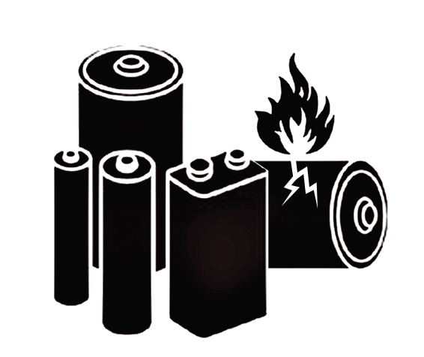
9D – Capacitors, from the electrical symbols for capacitor and current:
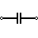 and/or 
9E – Life saving appliances, from IMO shipboard signage:

9F – Substances and articles which, in the event of fire, may form dioxins, based on the Model Regulations’ flame and toxic symbols:
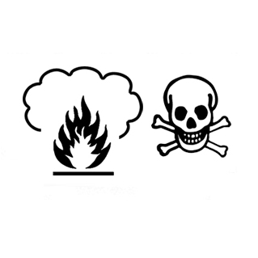
9G – Substances transported or offered for transport at elevated temperatures, from 5.3.2.2 of the Model Regulations:
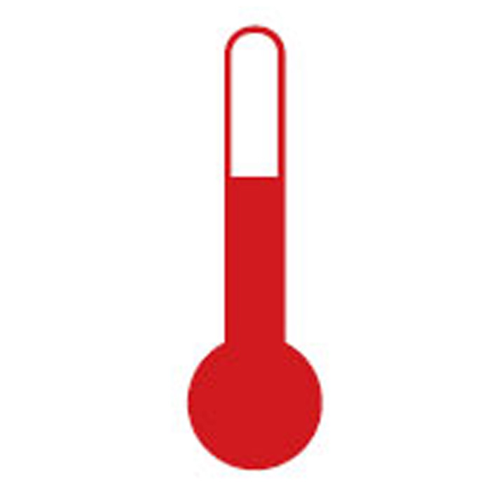
9H – Environmentally hazardous substances, from 5.2.1.6.3 (figure 5.2.2) of the Model Regulations:

9I – Genetically modified (micro) organisms, from the DNA double helix:

7. Further consideration should be given to the entries grouped together as ‘Other substances or articles presenting a danger during transport, but not meeting the definitions of another class’, but this is beyond the scope of this paper.
Proposal 1
8. In the Dangerous Goods List in Chapter 3.2, add Special Provision CCC against the following UN numbers in column (6): 3090, 3091, 3480 and 3481.
9. At 3.3.1, special provision188:
Amend point (f) to read (new text underlined):
“Except for packages containing button cell batteries installed in equipment (including circuit boards), or no more than four cells installed in equipment or no more than two batteries installed in equipment, each package shall be marked with the following:
(i) An indication that the package contains “lithium metal” or “lithium ion” cells or batteries, as appropriative. After [31 December 2019], this requirement shall be met by application of the appropriate lithium battery mark, as illustrated at 5.2.1.9;
(ii) Existing (ii) is to be deleted. Renumber the following paragraphs accordingly;
10. At 3.3.1, special provision 376, amend the second subparagraph under the NOTE to read (new text underlined):
“Packages shall be marked “DAMAGED/DEFECTIVE LITHIUM-ION BATTERIES” or “DAMAGED/DEFECTIVE LITHIUM METAL BATTERIES”, as applicable, and [after 31 December 2019] shall be marked with the appropriate lithium battery mark, as illustrated at 5.2.1.9.”
11. At 3.3.1, special provision 377, amend the third subparagraph to read (new text underlined):
“Packages shall be marked “LITHIUM BATTERIES FOR DISPOSAL” or “LITHIUM BATTERIES FOR RECYCLING”, as applicable, and [after 31 December 2019] shall be marked with the appropriate lithium battery mark or marks, as illustrated at 5.2.1.9.”
12. At 3.3.1, add a new Special Provision CCC, to read:
“The class 9 label to be used is No. 9C, see 5.2.2.2.2.”
13. At 5.2.2.2.2, under CLASS 9 Miscellaneous dangerous substances and articles, including environmentally hazardous substances, after the generic Class 9 label, add the following:
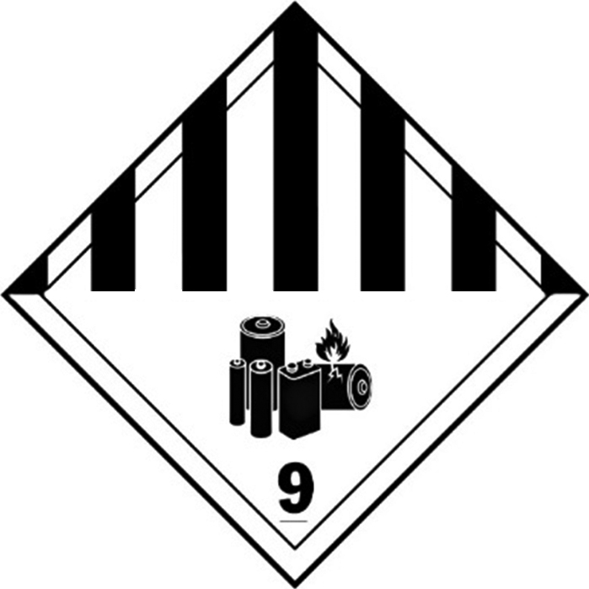
(No.9C)
Symbol (seven vertical black stripes in upper half; battery group, one broken and emitting flame in lower half): black;
Background: white;
Figure “9” underlined in bottom corner’
14. Insert new 5.2.1.9, to read as follows:
“Lithium battery marks
The lithium battery mark to be displayed in accordance with the special provisions of Chapter 3.3 shall be as shown in figures XXX and YYY for lithium metal and lithium ion batteries respectively. In cases of a mixed load of lithium metal and lithium ion batteries, both marks shall be displayed.
Where the lithium batteries are contained in, or packed with, equipment, ‘UN 3091’ or ‘UN 3481’ should be substituted for the UN numbers shown below. In cases of a mixed load of batteries and batteries in equipment, it is sufficient to display the battery label only.
100 mm
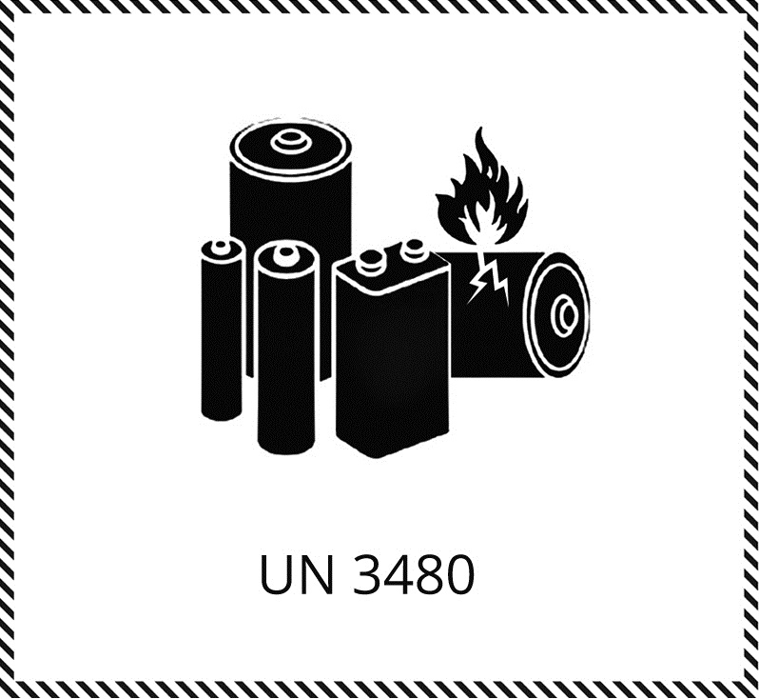
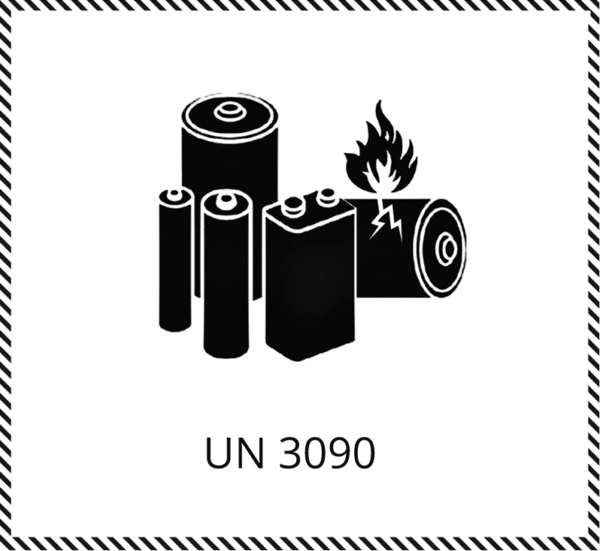
Fig. XXX 80mm Fig. YYY
Lithium battery mark for lithium Lithium battery mark for lithium
metal batteries ion batteries
The mark shall be in the form of a rectangle with hatched edging. The dimensions shall be [100mm x 80mm] and the minimum width of the hatching shall be 5mm. The symbol (group of batteries, one damaged and emitting flame, over the UN number for lithium ion or lithium metal batteries or cells) shall be black on white. The hatching shall be black. If the size of the package so requires, the dimensions/line thickness may be reduced, provided the marking remains clearly visible.’
Note: The format of the dimension indicators should be standardised with those used elsewhere in the Model Regulations, e.g. Figure 5.5.1.
Proposal 2
15. In the Dangerous Goods List in Chapter 3.2, add Special Provision GGG against the following UN numbers in column (6): 3257, 3258
16. At 3.3.1, add a new Special Provision GGG, to read:
“Cargo transport units shall display the class 9 placard (No. 9G), see 5.2.2.2.2, in accordance with the provisions of Chapter 5.3. As an alternative, until [31 December 2019], the provisions of 5.3.2.2 may be used.”
17. At 5.2.2.2.2, under CLASS 9, after the generic Class 9 label, in alphabetical order with other labels, add the following:
18.
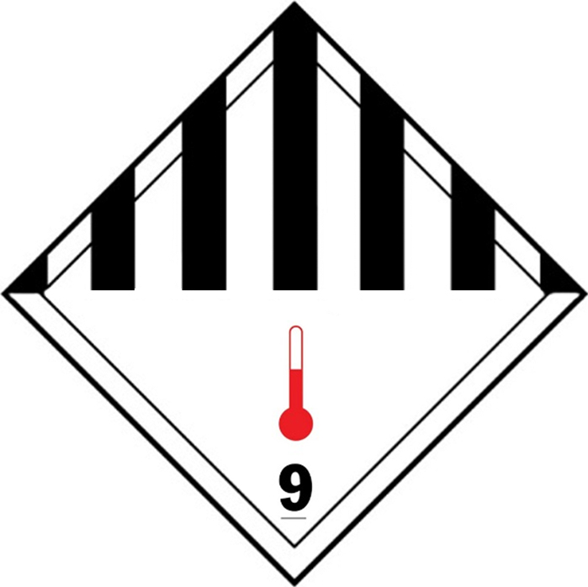
(No.9G)
Symbol (seven vertical stripes in upper half; black;
thermometer in lower half red);
Background: white;
Figure “9” underlined in bottom corner’
19. In the Dangerous Goods List in Chapter 3.2, add Special Provision HHH against the following UN numbers in column (6): 3077, 3082
20. At 3.3.1, add a new Special Provision HHH, to read:
“The class 9 label to be used is No. 9H, see 5.2.2.2.2. As an alternative, until [31 December 2019], the provisions of 5.2.1.6 may be used.”
21. At 5.2.2.2.2, under CLASS 9, after the generic Class 9 label, in alphabetical order with other labels, add the following:
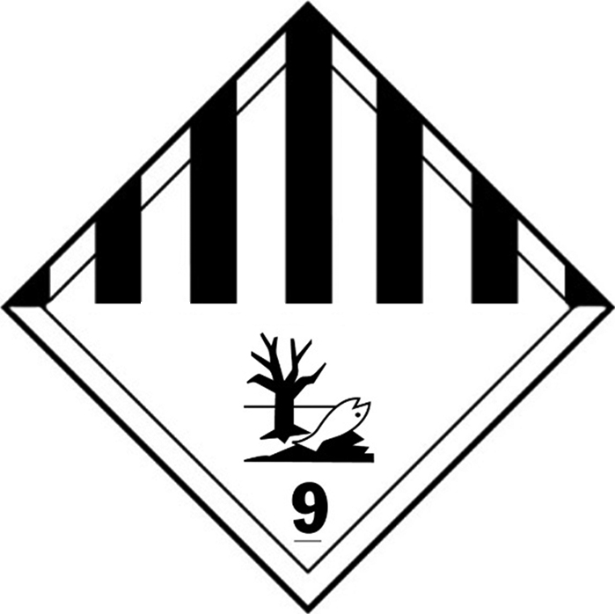
(No.9H)
Symbol (seven vertical black stripes in upper half, fish and tree in lower half):
black; Background: white;
Figure “9” underlined in bottom corner’
Proposal 3
22. In the Dangerous Goods List in Chapter 3.2, add Special Provision AAA against the following UN numbers in column (6): 2212, 2590.
23. At 3.3.1, add a new Special Provision AAA, to read:
“The class 9 label to be used is No. 9A, see 5.2.2.2.2. As an alternative, until [31 December 2019], the generic class 9 label without the aspiration hazard symbol may be used.”
24. At 5.2.2.2.2, under CLASS 9, after the generic Class 9 label, add the following:
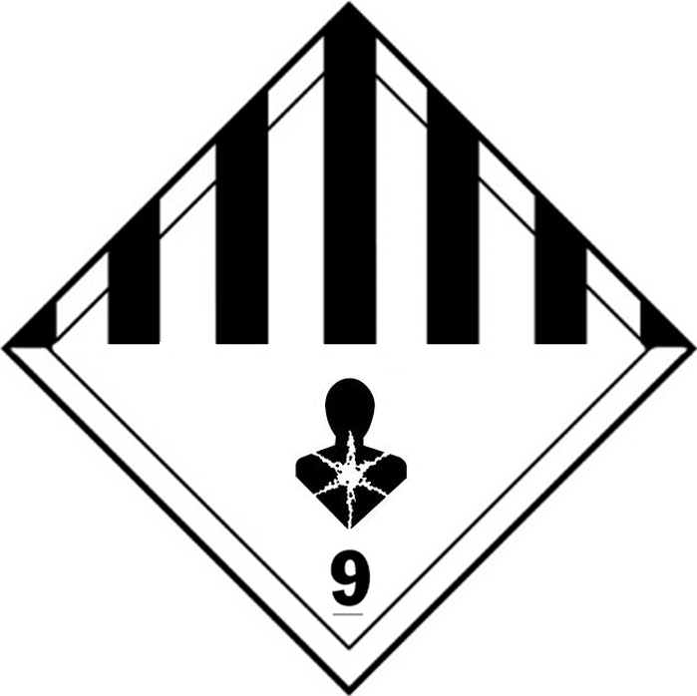
(No. 9A)
Symbol (seven vertical stripes in upper half,
aspiration hazard in lower half): black;
Background: white;
Figure “9” underlined in bottom corner
25. In the Dangerous Goods List in Chapter 3.2, add Special Provision BBB against the following UN numbers in column (6): 2211, 3314.
26. At 3.3.1, add a new Special Provision BBB, to read:
“The class 9 label to be used is No. 9B, see 5.2.2.2.2. As an alternative, until [31 December 2019], the generic class 9 label without the flammable vapour symbol may be used.”
27. At 5.2.2.2.2, under CLASS 9, after the generic Class 9 label, in alphabetical order with other labels, add the following:
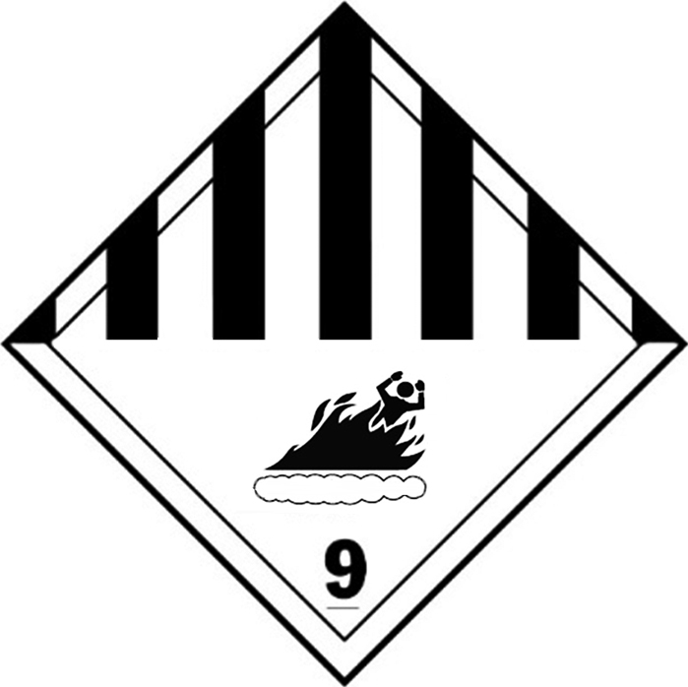
(No. 9B)
Symbol (seven vertical stripes in upper half, figure engulfed in flame from vapour in lower half): black;
Background: white
Figure “9” underlined in bottom corner’
28. In the Dangerous Goods List in Chapter 3.2, add Special Provision DDD against the following UN numbers in column (6): 3499, 3508.
29. At 3.3.1, add a new Special Provision DDD, to read:
“The class 9 label to be used is No. 9D, see 5.2.2.2.2. As an alternative, until [31 December 2019], the generic class 9 label without the capacitor and/or electric shock symbols may be used. ”
30. At 5.2.2.2.2, under CLASS 9, after the generic Class 9 label, in alphabetical order with other labels, add the following:
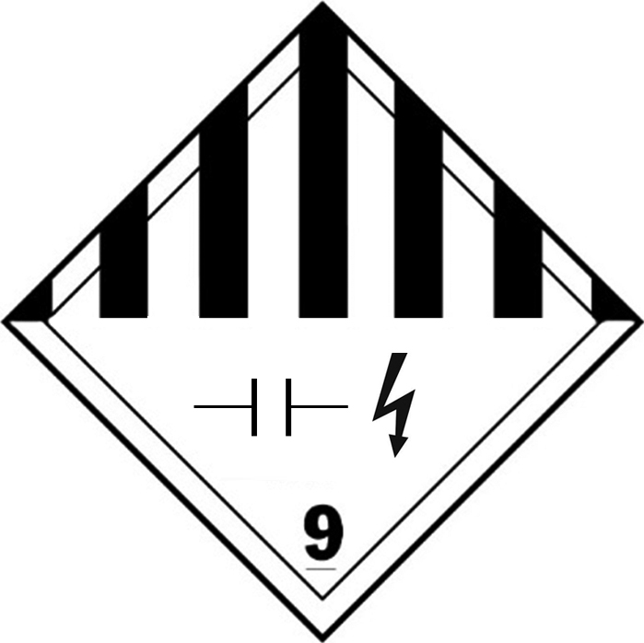
(No. 9D)
Symbol (seven vertical stripes in upper half): black;
(capacitor and/or electric shock symbols in lower half): black;
Background: white;
Figure “9” underlined in bottom corner’
31. In the Dangerous Goods List in Chapter 3.2, add Special Provision EEE against the following UN numbers in column (6): 2990, 3072, 3268.
32. At 3.3.1, add a new Special Provision EEE, to read:
“The class 9 label to be used is No. 9E, see 5.2.2.2.2. As an alternative, until [31 December 2019], the generic class 9 label without the life vest symbol may be used.”
33. At 5.2.2.2.2, under CLASS 9, after the generic Class 9 label , add the following in alphabetical order with other labels:
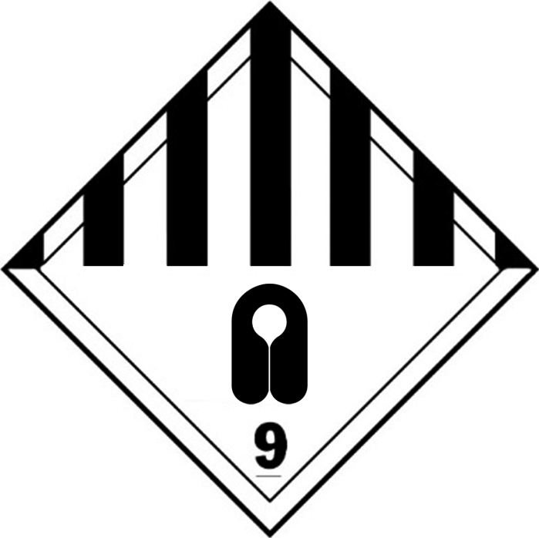
(No. 9E)
Symbol (seven vertical stripes in upper half,
life vest symbol in lower half): black;
Background: white;
Figure “9” underlined in bottom corner’
[alternative:
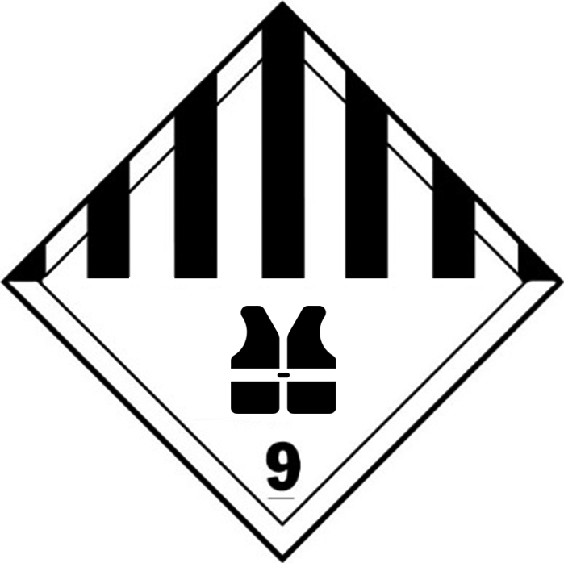
34. In the Dangerous Goods List in Chapter 3.2, add Special Provision FFF against the following UN numbers in column (6): 2315, 3432, 3151, 3152.
35. At 3.3.1, add a new Special Provision FFF, to read:
“The class 9 label to be used is No. 9E, see 5.2.2.2.2. As an alternative, until [31 December 2019], the generic class 9 label without the fire induced toxic emissions may be used.”
36. At 5.2.2.2.2, under CLASS 9, after the generic Class 9 label , in alphabetical order with other labels, add the following:
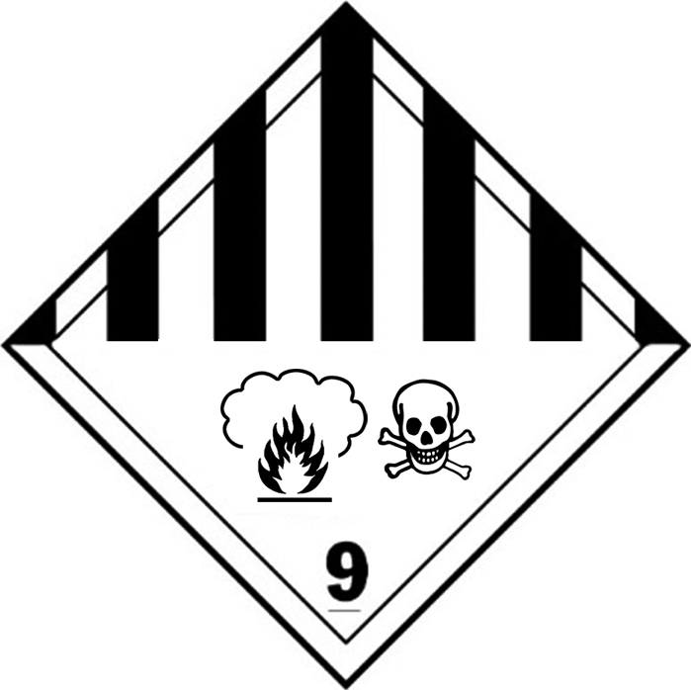
(No. 9F)
Symbol (seven vertical stripes in upper half,
flame causing toxic emissions, skull and crossbones
in lower half): black;
Background: white;
Figure “9” underlined in bottom corner’
37. In the Dangerous Goods List in Chapter 3.2, add Special Provision III against the following UN number in column (6): 3245.
38. At 3.3.1, add a new Special Provision III, to read:
39. “The class 9 label to be used is No. 9I, see 5.2.2.2.2. As an alternative, until [31 December 2019], the generic class 9 label without the DNA double helix may be used.”
40. At 5.2.2.2.2, under CLASS 9, after the generic Class 9 label, in alphabetical order with other labels, add the following:
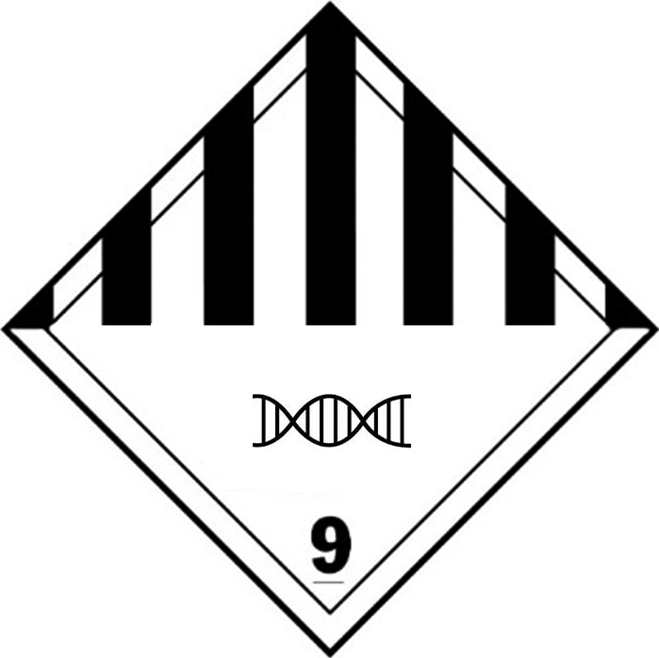
(9I)
Symbol (seven vertical stripes in upper half,
DNA double helix in lower half): black;
Background: white;
Figure “9” underlined in bottom corner’

In accordance with the programme of work of the Sub-Committee for 2013-2014 approved by the Committee at its sixth session (refer to ST/SG/AC.10/C.3/84, para. 86 and ST/SG/AC.10/40, para. 14).

