 | United Nations | ST/SG/AC.10/42/Add.3
 | Secretariat |  | Distr.: General  20 February 2015  English  Original: English and French
Committee of Experts on the Transport of Dangerous Goods
and on the Globally Harmonized System of Classification
and Labelling of Chemicals
Report of the Committee of Experts on the Transport of Dangerous Goods and on the Globally Harmonized System of Classification and Labelling of Chemicals on its seventh session
held in Geneva on 12 December 2014
Addendum
Annex III
Amendments to the fifth revised edition of the Globally Harmonized System of Classification and Labelling of Chemicals (GHS) (ST/SG/AC.10/30/Rev.5)

Chapter 1.2
Add the following definition for desensitized explosives in the alphabetical order:
“Desensitized explosives mean solid or liquid explosive substances or mixtures which are phlegmatized to suppress their explosive properties in such a manner that they do not mass explode and do not burn too rapidly and therefore may be exempted from the hazard class “Explosives” (see Chapter 2.1; see also Note 2 to paragraph 2.1.2.2).”
Chapter 1.4
1.4.10.4.4 Insert a new paragraph 1.4.10.4.4 to read as follows:
“1.4.10.4.4 Use of GHS pictograms in transport
In transport, a GHS pictogram not required by the UN Model Regulations on the Transport of Dangerous Goods, Model Regulations should only appear as part of a complete GHS label (see 1.4.10.5.4.1) and not independently.”.
Chapter 1.5
Table 1.5.2 Replace section 9 “Physical and chemical properties” with the following:

“9. | Physical and chemical properties | Physical state;  Colour;  Odour;  Melting point/freezing point;  Boiling point or initial boiling point and boiling range;  Flammability;  Lower and upper explosion limit/flammability limit;  Flash point;  Auto-ignition temperature;  Decomposition temperature;  pH;  Kinematic viscosity;  Solubility;  Partition coefficient n-octanol/water (log value);  Vapour pressure;  Density and/or relative density;  Relative vapour density;  Particle characteristics.”

Insert a new note at the end of the table to read as follows:
“NOTE : The order of the physical and chemical properties presented in Section 9 may be followed on the SDS as shown in this table, but is not mandatory. The competent authority may decide to prescribe an order for Section 9 of the SDS, or they may leave it to the preparer of the SDS to re-order the properties, if deemed appropriate.”
Chapter 2.1
2.1.2.1 (f) Replace “articles which contain only extremely insensitive substances or mixtures” by “articles which predominantly contain extremely insensitive substances or mixtures”.
2.1.2.2 Amend Note 2 to read as follows:
“NOTE 2: Some explosive substances and mixtures are wetted with water or alcohols, diluted with other substances or dissolved or suspended in water or other liquid substances to suppress or reduce their explosive properties. They may be a candidate for classification as desensitized explosives (see chapter 2.17) or may be treated differently from explosive substances and mixtures (as desensitized explosives) for some regulatory purposes (e.g. transport), see 1.3.2.4.5.2.”
Figure 2.1.3 Amend the figure by inserting a new box between the boxes that read “Would the hazard hinder fire-fighting in the immediate vicinity?” and “Are there hazardous effects outside the package”, as follows:
Figure 2.1.3: Procedure for assignment to a division in the class of explosives (Class 1 for transport)
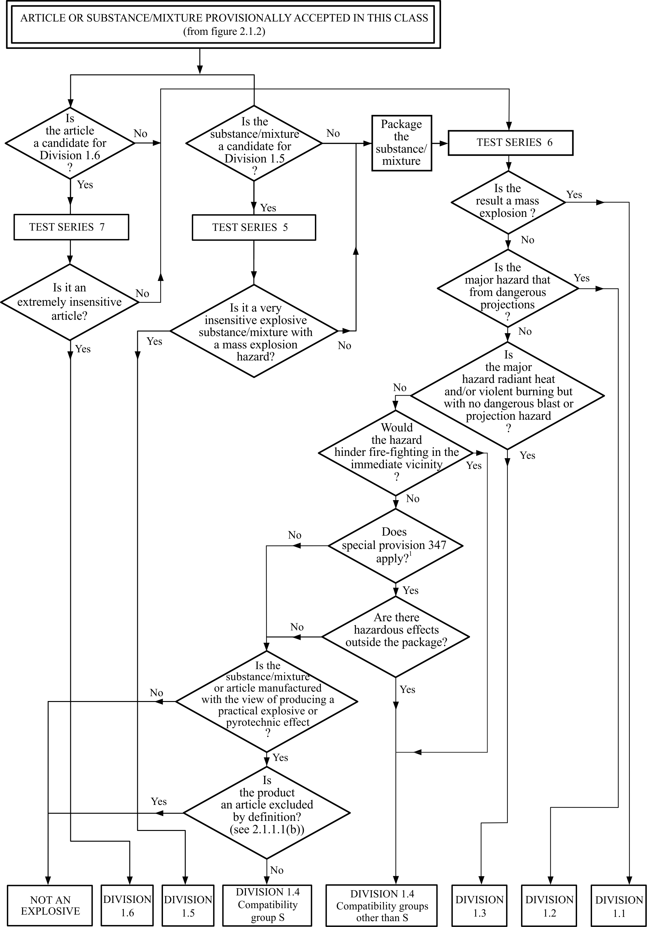
¹ See Chapter 3.3 of the UN Model Regulations on the Transport of Dangerous Goods, Model Regulations for details.”
2.1.4.2.2 Amend the first sentence to read as follows: “The acceptance procedure for the hazard class “Explosives” need not be applied if:”
2.1.4.2.2 (c) Amend to read as follows:
“(c) For an organic substance, or a homogenous mixture of organic substances, containing a chemical group (or groups) associated with explosive properties:
- the exothermic decomposition energy is less than 500 J/g, or
- the onset of exothermic decomposition is 500 ºC or above
as indicated by Table 2.1.3.
Table 2.1.3: Decision to apply the acceptance procedure for the hazard class “explosives” for an organic substance or a homogenous mixture of organic substances
Decomposition energy  (J/g) | Decomposition onset temperature  (°C) | Apply acceptance procedure?  (Yes/No)
< 500 | < 500 | No
< 500 | ≥ 500 | No
≥ 500 | < 500 | Yes
≥ 500 | ≥ 500 | No
The exothermic decomposition energy may be determined using a suitable calorimetric technique (see section 20.3.3.3 of the UN Recommendations on the Transport of Dangerous Goods, Manual of Tests and Criteria); or”.
Chapter 2.2
Amend the chapter title to read: “Flammable gases”.
2.2.1 Renumber current paragraph 2.2.1.2 as 2.2.1.3. Insert a new paragraph 2.2.1.2 to read as follows:
“2.2.1.2 “A pyrophoric gas is a flammable gas that is liable to ignite spontaneously in air at a temperature of 54 ºC or below.”
2.2.2 Renumber current paragraph 2.2.2.2 as new 2.2.2.3 (current table 2.2.2 becomes table 2.2.3). Insert a new paragraph 2.2.2.2 to read as follows:
“2.2.2.2 A flammable gas is additionally classified as pyrophoric if it meets the criteria in the following table:
Table 2.2.2: Criteria for pyrophoric gases
Category | Criteria
Pyrophoric gas | Flammable gas that ignite spontaneously in air at a temperature of 54 ºC or below.
NOTE 1: Spontaneous ignition for pyrophoric gases is not always immediate, and there may be a delay.
NOTE 2: In the absence of data on its pyrophoricity, a flammable gas mixture should be classified as a pyrophoric gas if it contains more than 1% (by volume) of pyrophoric component(s).”.
2.2.3 Renumber current paragraph before the table as 2.2.3.1. Amend current table 2.2.3 to read as follows:
“Table 2.2.4: Label elements for flammable gases
 | Flammable gas |  | Additional sub-categories
 |  |  | Pyrophoric gas | Chemically unstable gas
 | Category 1 | Category 2 | Pyrophoric gas | Category A | Category B
Symbol | Flame | No symbol | Flame | No additional symbol | No additional symbol
Signal word | Danger | Warning | Danger | No additional signal word | No additional signal word
Hazard statement | Extremely flammable gas | Flammable gas | May ignite spontaneously if exposed to air | May react explosively even in the absence of air | May react explosively even in the absence of air at elevated pressure and/or temperature
”
Insert a new paragraph 2.2.3.2 to read as follows:
“2.2.3.2 If a flammable gas or gas mixture is additionally classified in one or more sub-categories, then all relevant classification(s) should be communicated on the safety data sheet as specified in Annex 4, and the relevant hazard communication elements included on the label.”
2.2.4.1 In decision logic 2.2 (a), insert two additional boxes with the text “Go to decision logics 2.2 (b) and 2.2 (c)” immediately to the right of the existing Category 1 and Category 2 boxes, as follows:

2.2.4.2 Insert a new paragraph 2.2.4.2 to read as follows:
At 20 °C and a standard pressure of 101.3 kPa, does it:
(a)ignite when in a mixture of 13% or less by volume in air?; or
(b)have a flammable range with air of at least 12 percentage points regardless of the lower flammable limit?
Category 1

Danger
Yes
No
Category 2
No symbol
Warning
Go to decision logics 2.2 (b) and 2.2 (c)
Go to decision logics 2.2 (b) and 2.2 (c)
“2.2.4.2 Decision logic for pyrophoric gases
To classify a flammable gas as a pyrophoric gas, data on its ability to ignite in air are required. The classification is according to decision logic 2.2 (b).
Decision logic 2.2 (b)
Flammable gas or gas mixture
Does the flammable gas or gas mixture ignite spontaneously in air at a temperature of 54 ºC or below? ¹
Yes
Pyrophoric gas

Danger

¹ In the absence of data on its pyrophoricity, a flammable gas mixture should be classified as a pyrophoric gas if it contains more than 1% (by volume) of pyrophoric component(s).”
- Current paragraph 2.2.4.2 becomes new paragraph 2.2.4.3 and current decision logic 2.2 (b) becomes 2.2 (c).
2.2.4.3 Current paragraphs 2.2.4.3 and 2.2.4.3.1 become new 2.2.4.4 and 2.2.4.4.1. Current paragraph 2.2.4.3.2 (“Chemical instability…classification purposes”) becomes new paragraph 2.2.4.4.4.
2.2.4.4.2 and 2.2.4.4.3 Insert two new paragraphs 2.2.4.4.2 and 2.2.4.4.3, to read as follows:
“2.2.4.4.2 Pyrophoricity should be determined at 54°C in accordance with either IEC 60079-20-1 ed1.0 (2010-01) “Explosive atmospheres – Part 20-1: Material characteristics for gas and vapour classification – Test methods and data” or DIN 51794 “Determining the ignition temperature of petroleum products”.
2.2.4.4.3 The classification procedure for pyrophoric gases need not be applied when experience in production or handling shows that the substance does not ignite spontaneously on coming into contact with air at a temperature of 54 ºC or below. Flammable gas mixtures, which have not been tested for pyrophoricity and contain more than one percent pyrophoric components, should be classified as a pyrophoric gas. Expert judgement on the properties and physical hazards of pyrophoric gases and their mixtures should be used in assessing the need for classification of flammable gas mixtures containing one percent or less pyrophoric components. In this case, testing need only be considered if expert judgement indicates a need for additional data to support the classification process.”.
Chapter 2.12
Table 2.12.1, criteria for Category 3:
Replace “equal to or greater than 1 litre” by “greater than 1 litre”.
Consequential amendment to decision logic 2.12:
In the second box, replace “flammable gas is ≥ 1 litre per kg” by “flammable gas is > 1 litre per kg”.

Chapter 2.17
Add a new chapter 2.17 in the GHS to read as follows:
“Chapter 2.17
Desensitized explosives
2.17.1 Definitions and general considerations
2.17.1.1 Desensitized explosives are solid or liquid explosive substances or mixtures which are phlegmatized to suppress their explosive properties in such a manner that they do not mass explode and do not burn too rapidly and therefore may be exempted from the hazard class “Explosives” (Chapter 2.1; see also Note 2 of Chapter 2.1.2.2).
2.17.1.2 The class of desensitized explosives comprises:
(a) Solid desensitized explosives: explosive substances or mixtures which are wetted with water or alcohols or are diluted with other substances, to form a homogeneous solid mixture to suppress their explosive properties.
NOTE: This includes desensitization achieved by formation of hydrates of the substances.
(b) Liquid desensitized explosives: explosive substances or mixtures which are dissolved or suspended in water or other liquid substances, to form a homogeneous liquid mixture to suppress their explosive properties.
2.17.2 Classification criteria
2.17.2.1 Any explosive which is desensitized shall be considered in this class, unless:
(a) It is manufactured with the view to producing a practical, explosive or pyrotechnic effect; or
(b) It has a mass explosion hazard according to test series 6 (a) or 6 (b) or their corrected burning rate according to the burning rate test described in part V, subsection 51.4 of the UN Recommendations on the Transport of Dangerous Goods, Manual of Tests and Criteria is greater than 1200 kg/min; or
(c) Their exothermic decomposition energy is less than 300 J/g.
NOTE 1: Substances or mixtures which meet the criterion (a) or (b) shall be classified as explosives (see Chapter 2.1). Substances or mixtures which meet the criterion (c) may fall within the scope of other physical hazard classes.
NOTE 2: The exothermic decomposition energy may be estimated using a suitable calorimetric technique (see section 20, sub-section 20.3.3.3 in Part II of the UN Recommendations on the Transport of Dangerous Goods, Manual of Tests and Criteria).
2.17.2.2 Desensitized explosives shall be classified as packaged for supply and use in one of the four categories of this class depending on the corrected burning rate (A_{c}) using the test “burning rate test (external fire)” described in Part V, sub-section 51.4 of the UN Recommendations of the Transport of Dangerous Goods, Manual of Tests and Criteria, according to Table 2.17.1:
Table 2.17.1: Criteria for desensitized explosives
Category | Criteria
1 | Desensitized explosives with a corrected burning rate (A_{C}) equal to or greater than 300 kg/min but not more than 1200 kg/min
2 | Desensitized explosives with a corrected burning rate (A_{C}) equal to or greater than 140 kg/min but less than 300 kg/min
3 | Desensitized explosives with a corrected burning rate (A_{C}) equal to or greater than 60 kg/min but less than 140 kg/min
4 | Desensitized explosives with a corrected burning rate (A_{C}) less than 60 kg/min
NOTE 1: Desensitized explosives should be prepared so that they remain homogeneous and do not separate during normal storage and handling, particularly if desensitized by wetting. The manufacturer/supplier should give information in the safety data sheet about the shelf-life and instructions on verifying desensitization. Under certain conditions the content of desensitizing agent (e.g. phlegmatizer, wetting agent or treatment) may decrease during supply and use, and thus, the hazard potential of desensitized explosive may increase. In addition, the safety data sheet should include advice on avoiding increased fire, blast or protection hazards when the substance or mixture is not sufficiently desensitized.
NOTE 2: Desensitized explosives may be treated differently for some regulatory purposes (e.g. transport). Classification of solid desensitized explosives for transport purposes is addressed in Chapter 2.4, section 2.4.2.4 of the UN Recommendations on the Transport of Dangerous Goods, Model Regulations. Classification of liquid desensitized explosives is addressed in Chapter 2.3, section 2.3.1.4 of the Model Regulations.
NOTE 3: Explosive properties of desensitized explosives should be determined by test series 2 of the UN Recommendations on the Transport of Dangerous Goods, Manual of Tests and Criteria, and should be communicated in the safety data sheet. For testing of liquid desensitized explosives for transport purposes, refer to section 32, sub-section 32.3.2 of the Manual of Tests and Criteria. Testing of solid desensitized explosives for transport purposes is addressed in section 33, sub-section 33.2.3 of the Manual of Tests and Criteria.
NOTE 4: For the purposes of storage, supply and use, desensitized explosives do not fall additionally within the scope of chapters 2.1 (explosives), 2.6 (flammable liquids) and 2.7 (flammable solids).
2.17.3 Hazard communication
General and specific considerations concerning labelling requirements are provided in Hazard communication: Labelling (Chapter 1.4). Annex 1 contains summary tables about classification and labelling. Annex 3 contains examples of precautionary statements and pictograms which can be used where allowed by the competent authority.
Table 2.17.2: Label elements for desensitized explosives
 | Category 1 | Category 2 | Category 3 | Category 4
Symbol | Flame | Flame | Flame | Flame
Signal word | Danger | Danger | Warning | Warning
Hazard statement | Fire, blast or projection hazard; increased risk of explosion if desensitizing agent is reduced | Fire or projection hazard; increased risk of explosion if desensitizing agent is reduced | Fire or projection hazard; increased risk of explosion if desensitizing agent is reduced | Fire hazard; increased risk of explosion if desensitizing agent is reduced
2.17.4 Decision logic and guidance
The decision logic and guidance which follow are not part of the harmonized classification system, but have been provided here as additional guidance. It is strongly recommended that the person responsible for classification studies the criteria before and during use of the decision logic.

2.17.4.1 Decision logic
To classify desensitized explosives, data for the explosive potential and the corrected burning rate should be determined as described in Part V of the UN Recommendations on the Transport of Dangerous Goods, Manual of Tests and Criteria. Classification is according to decision logic 2.17.1.
Decision logic 2.17.1 for desensitized explosives

Test 6 (a), 6 (b)
No
Does it contain an explosive substance or mixture which is phlegmatized to suppress the explosive properties?
Is the exothermic decomposition energy less than 300 J/g ?
Yes
No

Not classified as a desensitized explosive

May fall within the scope
of other physical hazard classes

Yes
The substance/mixture is a solid or liquid?
Is the result a mass explosion?
Burning rate test
(Part V, sub-section 51.4)
Hazard class “Explosives”
(see criteria in Chapter 2.1)
Is the result a mass explosion?
A_{C} > 1200 kg/min?
No
Yes
Explosive
Division 1.1

Danger
Yes
No
Yes
No
Explosive
Division 1.1

Danger

Category 2

Danger
No
A_{C} ≥ 300 kg/min but
≤ 1200 kg/min?
A_{C} ≥ 140 kg/min but
< 300 kg/min?
A_{C} ≥ 60 kg/min but
< 140 kg/min?
A_{C} < 60 kg/min?
Yes
Category 1

Danger
Category 3

Warning
Category 4

Warning

No

No

No

Yes
Yes
Yes

2.17.4.2 Guidance
2.17.4.2.1 The classification procedure for desensitized explosives does not apply if:
(a) The substances or mixtures contain no explosives according to the criteria in Chapter 2.1; or
(b) The exothermic decomposition energy is less than 300 J/g.
2.17.4.2.2 The exothermic decomposition energy should be determined using the explosive already desensitized (i.e.: the homogenous solid or liquids mixture formed by the explosive and the substance(s) used to suppress its explosive properties). The exothermic decomposition energy may be estimated using a suitable calorimetric technique (see Section 20, sub-section 20.3.3.3 in Part II of the UN Recommendations on the Transport of Dangerous Goods, Manual of Tests and Criteria).”
Chapter 3.3
Figure 3.3.1, Note (d), amend the end of the second sentence to read:
“…OECD Test Guidelines 437 (Bovine Corneal Opacity and Permeability (BCOP)), 438 (Isolated Chicken Eye (ICE)) and 460 (Fluorescein leakage (FL)).”.
Chapter 3.5
3.5.2.6 Delete the reference “Mouse spot test (OECD 484),” and its related footnote 1 (“¹ This Test Guideline has been cancelled but may continue to be used until 2 April 2014.”).
Chapter 3.7
Table 3.7.1 In the heading, first column, replace “ingredients classified as” by “ingredient classified as”.
3.7.2.5.1 At the end of the paragraph, insert “, 443” after “416”.
Chapter 3.8
3.8.3.4.6 Insert a new paragraph 3.8.3.4.6 as follows:
“3.8.3.4.6 In cases where the additivity approach is used for Category 3 ingredients, the “relevant ingredients” of a mixture are those which are present in concentrations ≥1% (w/w for solids, liquids, dusts, mists, and vapours and v/v for gases), unless there is a reason to suspect that an ingredient present at a concentration <1% is still relevant when classifying the mixture for respiratory tract irritation or narcotic effects.”
Chapter 3.10
3.10.3.3.1 to 3.10.3.3.3.3 Amend to read as follows:
“3.10.3.3.1 The “relevant ingredients” of a mixture are those which are present in concentrations ≥ 1%.
3.10.3.3.2 Category 1
3.10.3.3.2.1 A mixture is classified as Category 1 when the sum of the concentrations of Category 1 ingredients is ≥ 10%, and the mixture has a kinematic viscosity ≤ 20.5 mm²/s, measured at 40°C.
3.10.3.3.2.2 In the case of a mixture which separates into two or more distinct layers, the entire mixture is classified as Category 1 if in any distinct layer the sum of the concentrations of Category 1 ingredients is ≥ 10%, and it has a kinematic viscosity ≤ 20.5 mm²/s, measured at 40°C.
3.10.3.3.3 Category 2
3.10.3.3.3.1 A mixture is classified as Category 2 when the sum of the concentrations of Category 2 ingredients is ≥ 10% and the mixture has a kinematic viscosity ≤ 14 mm²/s, measured at 40 °C.
3.10.3.3.3.2 In classifying mixtures in this category, the use of expert judgment that considers surface tension, water solubility, boiling point, volatility is critical and especially when Category 2 ingredients are mixed with water.
3.10.3.3.3.3 In the case of classifying a mixture which separates into two or more distinct layers, the entire mixture is classified as Category 2 if in any distinct layer the sum of the concentrations of Category 2 ingredients is ≥ 10%, and it has a kinematic viscosity ≤ 14 mm²/s, measured at 40°C.”.
Chapter 4.1
4.1.1.5 Amend the end of the first sentence to read as follows:
“…OECD Test Guidelines 107, 117 or 123.”.
4.1.3.5.5.3 to 4.1.3.5.5.4 insert the text “multiplied by their corresponding M factors” in the following paragraphs, as follows:
4.1.3.5.5.3.1: Second sentence after “ingredients”
4.1.3.5.5.3.2: Second sentence after “Acute 1”
4.1.3.5.5.3.3: Second sentence after “Acute 1”
4.1.3.5.5.4.1: Second sentence after “ingredients”
4.1.3.5.5.4.2: Second sentence after “Chronic 1”
4.1.3.5.5.4.3: Second sentence after “Chronic 1”
Annex 1
Table A1.2
- Amend the title to read: “Flammable gases (see Chapter 2.2 for classification criteria)”.
- In the hazard class column, amend the text in the column to read “Flammable gases”.
- Insert a new row for pyrophoric gases, before the row for “A (chemically unstable gases)” as follows:
Classification |  | Labelling |  |  |  | Hazard statement codes
Hazard class | Hazard category | Pictogram |  | Signal word | Hazard statement | Hazard statement codes
Hazard class | Hazard category | GHS | UN Model Regulationsª | Signal word | Hazard statement | Hazard statement codes
Flammable gases | Pyrophoric gas | 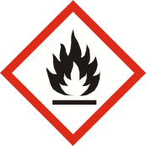 |  | Danger | May ignite spontaneously if exposed to air | H232

Table A1.17
Insert a new Table A1.17 for the new hazard class ”Desensitized explosives” as follows:
“A1.17 Desensitized explosives (see Chapter 2.17 for classification criteria)
Classification |  | Labelling
Hazard  class | Hazard  category | Pictogram |  | Signal word | Hazard statement | Hazard statement  Codes
Hazard  class | Hazard  category | GHS | UN Model Regulationsª | Signal word | Hazard statement | Hazard statement  Codes
Desensitized explosives | 1 | 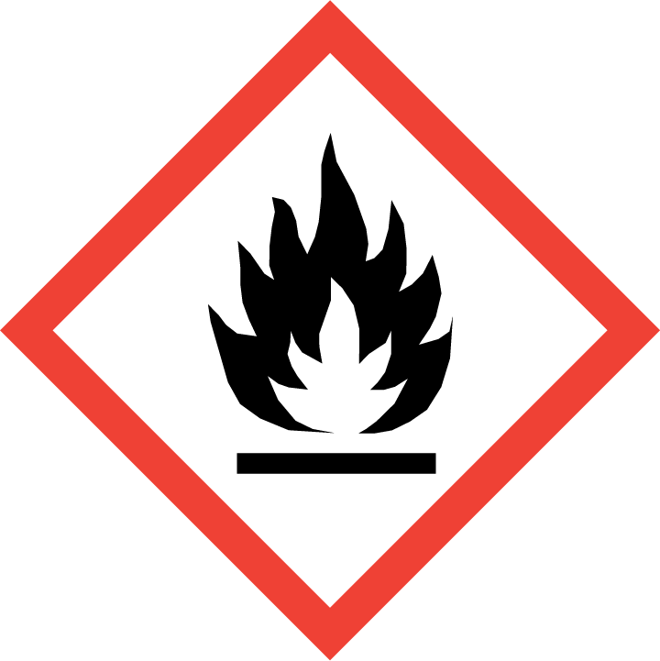 | Not applicable | Danger | Fire, blast or projection hazard; increased risk of explosion if desensitizing agent is reduced | H206
Desensitized explosives | 2 |  | Not applicable | Danger | Fire or projection hazard; increased risk of explosion if desensitizing agent is reduced | H207
Desensitized explosives | 3 |  | Not applicable | Warning | Fire or projection hazard; increased risk of explosion if desensitizing agent is reduced | H207
Desensitized explosives | 4 |  | Not applicable | Warning | Fire hazard; increased risk of explosion if desensitizing agent is reduced | H208
ª Classification and labelling of desensitized explosives are addressed in transport regulations in a different way. In transport, solid desensitized explosives are classified in Division 4.1 (flammable solids) and shall bear a Division 4.1 label (see Chapter 2.4, section 2.4.2.4 of the UN Recommendations on the Transport of Dangerous Goods, Model Regulations). Liquid desensitized explosives are classified in Class 3 (flammable liquids) for transport purposes and shall bear a Class 3 label (see Chapter 2.3, section 2.3.1.4 of the Model Regulations).”

Current tables A1.17 to A1.29 become tables A1.18 to A1.30.

Annex 3
Section 1, Table A3.1.1:
- Insert the following physical hazard statements:
Code | Physical hazard statements | Hazard class (GHS chapter) | Hazard  category
(1) | (2) | (3) | (4)
H206 | Fire, blast or projection hazard; increased risk of explosion if desensitizing agent is reduced | Desensitized explosives (chapter 2.17) | 1
H207 | Fire or projection hazard; increased risk of explosion if desensitizing agent is reduced | Desensitized explosives (chapter 2.17) | 2, 3
H208 | Fire hazard; increased risk of explosion if desensitizing agent is reduced | Desensitized explosives (chapter 2.17) | 4
H232 | May ignite spontaneously if exposed to air | Flammable gases (chapter 2.2) | Pyrophoric gas
- For H230 and H231 amend the name of the hazard class in column (3) to read: “Flammable gases (chapter 2.2)”
Section 2, Table A3.2.2:
- P210
Insert a new row for the hazard class “Desensitized explosives (chapter 2.17)”, hazard categories “1, 2, 3, 4”.
- P212
Insert the following new precautionary statement
Code | Prevention precautionary statements | Hazard class | Hazard category | Conditions for use
(1) | (2) | (3) | (4) | (5)
P212 | Avoid heating under confinement or reduction of the desensitizing agent | Desensitized explosives (chapter 2.17) | 1, 2, 3, 4

- P222
Insert a new row for the hazard class “Flammable gases (chapter 2.2)”, hazard category “Pyrophoric gas”, with the same condition for use as the one currently applicable to pyrophoric liquids and pyrophoric solids in column 5.
- P230
Amend the condition for use in column 5 to read as follows:
“- For substances and mixtures which are wetted, diluted, dissolved or suspended with a phlegmatizer in order to suppress their explosive properties
…Manufacturer/supplier or the competent authority to specify appropriate material”.
Consequential amendment:
Amend accordingly the condition for use in the matrix tables of Annex 3, section 3 (paragraph A3.3.5), applicable to explosives, divisions 1.1 to 1.3 and 1.5.
Insert a new row for the hazard class “Desensitized explosives (chapter 2.17)”, hazard categories “1, 2, 3, 4” with the following condition for use in column 5: “…Manufacturer/supplier or the competent authority to specify appropriate material”
- P233
Insert a new row for the hazard class “Desensitized explosives (chapter 2.17)”, hazard categories “1, 2, 3, 4”.
- P280
Insert a new row for the hazard class “Flammable gases (chapter 2.2)”, hazard category “Pyrophoric gas” with the following condition for use in column 5: “Manufacturer/supplier or the competent authority to specify the appropriate type of equipment”.
Insert a new row for the hazard class “Desensitized explosives (Chapter 2.17)”, hazard categories “1, 2, 3, 4” with the following condition for use in column 5: “Manufacturer/supplier or the competent authority to specify the appropriate type of equipment”.
Section 3, table A3.2.3:
- P370
Insert a new row for the hazard class “Desensitized explosives (chapter 2.17)”, hazard categories “1, 2, 3”.
- P371
Insert a new row for the hazard class “Desensitized explosives (chapter 2.17)”, hazard category “4”
- P375
Insert a new row for the hazard class “Desensitized explosives (chapter 2.17)”, hazard categories “1,2,3”
- P380
Insert a new row for the hazard class “Desensitized explosives (chapter 2.17)”, hazard categories “1, 2, 3, 4”
- P370 + P380 + P375
Insert a new row for the hazard class “Desensitized explosives (chapter 2.17)”, hazard categories “1, 2, 3”
- P371 + P380 + P375
Insert a new row for the hazard class “Desensitized explosives (chapter 2.17)”, hazard category “4”
Section 2, table A3.2.4
- P401
Insert a new row for the hazard class “Desensitized explosives (chapter 2.17)”, hazard categories “1, 2, 3, 4”, with the following condition for use in column 5: “…Manufacturer/supplier or the competent authority to specify local/regional/national/international regulations as applicable.”
Section 3, table A3.2.5
- P501
Insert a new row for the hazard class “Desensitized explosives (chapter 2.17)”, hazard categories “1, 2, 3, 4” with the following condition for use in column 5:
“… in accordance with local/regional/national/international regulations (to be specified).
Manufacturer/supplier or the competent authority to specify whether disposal requirements apply to content, container or both.”
Section 3, paragraph A3.3.5:
- In the three tables for “Flammable gases (including chemically unstable gases) (chapter 2.2)”, amend the first line in the headings to read: “FLAMMABLE GASES”.
- Insert the following new tables for pyrophoric gases and desensitized explosives :

FLAMMABLE GASES

(Chapter 2.2)

(Pyrophoric gases)

Symbol
Flame
Hazard category | Signal word |  | Hazard statement |  |  |  | 
Pyrophoric gas | Danger |  | H232 | May ignite spontaneously if exposed to air

Precautionary statements
Prevention |  | Response |  |  | Storage | Disposal
P222
Do not allow contact with air.
– if emphasis of the hazard statement is deemed necessary.
P280
Wear protective gloves/protective clothing/eye protection/face protection.
Manufacturer/supplier or the competent authority to specify the appropriate type of equipment.
Note: This table lists only precautionary statements that are assigned due to the pyrophoricity of the gas. For the other precautionary statements, that are assigned based on the flammability, see the respective tables for flammable gases.”.
DESENSITIZED EXPLOSIVES

(Chapter 2.17)
Symbol
Flame
Hazard category | Signal word |  | Hazard statement
1 | Danger |  | H206 | Fire, blast or projection hazard; increased risk of explosion if desensitizing agent is reduced
2 | Danger |  | H207 | Fire or projection hazard; increased risk of explosion if desensitizing agent is reduced
3 | Warning |  | H207 | Fire or projection hazard; increased risk of explosion if desensitizing agent is reduced

Precautionary statements
Prevention |  | Response |  |  | Storage | Disposal
P210  Keep away from heat, hot surfaces, sparks, open flames and other ignition sources. No smoking  P212  Avoid heating under confinement or reduction of the desensitizing agent  P230  Keep wetted with…  ...Manufacturer/supplier or the competent authority to specify appropriate material.  P233  Keep container tightly closed  P280  Wear protective gloves/protective clothing/eye protection/face protection |  | P370+P380+P375  In case of fire: Evacuate area. Fight fire remotely due to the risk of explosion |  |  | P401  Store in accordance with…  …Manufacturer/supplier or the competent authority to specify local/regional/ national/international regulations as applicable. | P501  Dispose of contents/containers to…  …in accordance with local/regional/national /international regulations (to be specified).  Manufacturer/supplier or the competent authority to specify whether disposal requirements apply to contents, container or both.

DESENSITIZED EXPLOSIVES

(Chapter 2.17)
Symbol
Flame
Hazard category | Signal word |  | Hazard statement
4 | Warning |  | H208 | Fire hazard; increased risk of explosion if desensitizing agent is reduced

Precautionary statements
Prevention |  | Response |  |  | Storage | Disposal
P210  Keep away from heat, hot surfaces, sparks, open flames and other ignition sources. No smoking  P212  Avoid heating under confinement or reduction of the desensitizing agent  P230  Keep wetted with…  ...Manufacturer/supplier or the competent authority to specify appropriate material.  P233  Keep container tightly closed  P280  Wear protective gloves/protective clothing/eye protection/face protection |  | P371+P380+P375  In case of major fire and large quantities: Evacuate area. Fight fire remotely due to the risk of explosion |  |  | P401  Store in accordance with…  …Manufacturer/supplier or the competent authority to specify local/regional/ national/international regulations as applicable. | P501  Dispose of contents/containers to…  …in accordance with local/regional/national /international regulations (to be specified).  Manufacturer/supplier or the competent authority to specify whether disposal requirements apply to contents, container or both.
Annex 4
Section 9
Replace current section 9 in Annex 4 of the GHS with the following:
“A4.3.9 SECTION 9: Physical and chemical properties and safety characteristics
A4.3.9.1 This section of Annex 4 provides guidance for SDS preparers and is provided for information purposes. This guidance does not prescribe how this information should be presented on the SDS. The guidance is divided into three tables as described below.
A4.3.9.2 Table A4.3.9.1 provides guidance on the physical and chemical properties specified by Chapter 1.5, Table 1.5.2. The SDS preparer should clearly describe/identify the physical and chemical properties specified in Table 1.5.2. In cases where the specific physical and chemical properties required by Table 1.5.2 do not apply or are not available under a particular subheading, this should be clearly indicated.
A4.3.9.3 Table A4.3.9.2 lists properties/safety characteristics and test results that are not required on the SDS but may be useful to communicate when a substance or mixture is classified in the respective physical hazard class. Data which is deemed relevant with regard to a specific physical hazard but not resulting in classification (e.g. negative test results close to the criterion) may also be useful to communicate.
A4.3.9.4 Table A4.3.9.3 lists further properties/safety characteristics and test results that are not required on the SDS but may be useful to communicate for a substance or mixture. Other physical properties/safety characteristics of the substance or mixture not identified in this table may also be useful to communicate.
NOTE: The properties in Tables A4.3.9.1, A4.3.9.2, and A4.3.9.3 may be presented with or without any division (that is, as a list). Also the order of the properties may be adjusted if deemed appropriate.
A4.3.9.5 Generally, the information given in this section of the SDS should relate to standard conditions for temperature and pressure (temperature of 20 °C and absolute pressure of 101.3 kPa). If other conditions apply, these should be indicated together with the respective property.
A4.3.9.6 Data on the SDS should be provided in appropriate units. Where the data relate to a hazard class, the units of measure should be as specified in the criteria for that hazard class.
A4.3.9.7 If relevant for the interpretation of the information or numeric value given, indicate the determination method (e.g., open-cup/closed-cup for flash point) or state whether the value was calculated.
A4.3.9.8 In the case of a mixture, where valid data is available for the mixture as a whole, it should be provided. When data for the mixture as a whole cannot be provided, data for the most relevant ingredient(s) may be provided, and this data should clearly indicate to which ingredient(s) the data apply.
A4.3.9.9 Other appropriate physical or chemical parameters or safety characteristics, in addition to those listed below, may also be included in this section of the SDS.
Table A4.3.9.1: Basic physical and chemical properties
This table lists basic physical and chemical properties and safety characteristics. Relevant information as required should be indicated for every property listed in this table, such as a short description, value(s), unit, conditions (e.g., temperature, pressure), method, each as appropriate.
If specific properties or safety characteristics do not apply (based on the respective information about applicability in the column “Remarks/Guidance”) they should still be listed in the SDS with the statement “not applicable”.
If information on specific properties or safety characteristics is not available, they should still be listed in the SDS with the statement “not available”. It is recommended that, where appropriate, a short explanation is included as to why the data is not available, e.g., “melts”, “decomposes”, “dissolves”.
Property | Remarks/Guidance
Physical state | − generally at standard conditions  − for definitions for gas, liquid and solid see Chapter 1.2
Colour | − indicate the colour of the substance or mixture as supplied  − in cases where one SDS is used to cover variants of a mixture which may have different colours the term 'various' can be used to describe the colour (see A4.3.1.1 for an SDS for variants of a mixture)
Odour | − give a qualitative description of the odour if it is well-known or described in the literature  − if available, indicate the odour threshold (qualitatively or quantitatively)
Melting point / freezing point | − not applicable to gases  − at standard pressure  − indicate up to which temperature no melting point was observed in case the melting point is above the measuring range of the method  − indicate if decomposition or sublimation occurs prior to or during melting  − for waxes and pastes the softening point/range may be indicated instead  − for mixtures indicate if it is technically not possible to determine the melting point/freezing point
Boiling point or  initial boiling point and boiling range | − generally at standard pressure (a boiling point at lower pressure might be indicated in case the boiling point is very high or decomposition occurs before boiling)  − indicate up to which temperature no boiling point was observed in case the boiling point is above the measuring range of the method  − indicate if decomposition occurs prior to or during boiling  − for mixtures indicate if it is technically not possible to determine the boiling point or range; in that case indicate also the boiling point of the lowest boiling ingredient
Flammability | − applicable to gases, liquids and solids  − indicate whether the substance or mixture is ignitable (capable of catching on fire or being set on fire, even if not classified for flammability)  − if available and appropriate, further information may be indicated in addition, e.g.  - whether the effect of ignition is other than a normal combustion (e.g., an explosion)  - ignitability under non-standard conditions  − more specific information on the flammability may be indicated based on the respective hazard classification in accordance with Table A4.3.9.2
Lower and upper explosion limit / flammability limit | − not applicable to solids  − for flammable liquids indicate at least the lower explosion limit:  - if the flash point is approximately > -25 °C, it might be not possible to determine the upper explosion limit at standard temperature; in that case it is recommended to indicate the upper explosion limit at elevated temperature  - if the flash point is > +20 °C the same holds for both the lower and upper explosion limit  Note: Depending on the region of the world the term “explosion limit“ or “flammability limit” is used, but is supposed to mean the same.
Flash point | − not applicable to gases, aerosols and solids  − for information on test methods etc., see Chapter 2.6, paragraph 2.6.4.2  for mixtures:  − indicate a value for the mixture itself if available, otherwise indicate the flash point(s) of those substances with the lowest flash point(s) as these are generally the main contributing ones
Auto-ignition temperature | − applicable to gases and liquids only  for mixtures:  − indicate a value for the mixture itself if available, otherwise indicate the auto-ignition temperature(s) of those ingredients with the lowest auto-ignition temperature(s)
Decomposition temperature | − applicable to self-reactive substance and mixtures and organic peroxides and other substances and mixtures which may decompose  − indicate  - the SADT (self-accelerating decomposition temperature), together with the volume to which it applies or  - the decomposition onset temperature (see also section 20.3.3.3 of the Manual of Tests and Criteria)  − indicate whether the temperature given is the SADT or the decomposition onset temperature  − if no decomposition was observed, indicate up to which temperature no decomposition was observed, e.g., as “no decomposition observed up to x °C/°F”
pH | − not applicable to gases  − applicable to aqueous liquids and solutions (the pH is linked to aqueous media by definition; measurements carried out in other media do not give the pH)  − indicate the concentration of the test substance in water  − where the pH is ≤ 2 or ≥ 11.5, see Table A4.3.9.3 for information on acid/alkaline reserve
Kinematic viscosity | − applicable to liquids only  − use preferably mm²/s as unit (as the classification criteria for the hazard class aspiration hazard are based on this unit)  − the dynamic viscosity may be indicated in addition. The kinematic viscosity is linked to the dynamic viscosity by the density:  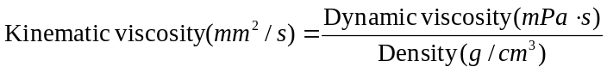  − for non-Newtonian liquids, indicate thixotropic or rheopexic behaviour
Solubility | − generally at standard temperature  − indicate the solubility in water  − the solubility in other (non-polar) solvents may also be included  − for mixtures, indicate if it is fully or only partially soluble in or miscible with water or other solvent
Partition coefficient  n-octanol/water (log value) | − not applicable to inorganic and ionic liquids  − generally not applicable to mixtures  − may be calculated (using QSAR – Quantitative structure-activity relationship)  − indicate whether the value is based on testing or on calculation
Vapour pressure | − generally at standard temperature  − indicate the vapour pressure at 50 °C for volatile fluids in addition (in order to enable distinction between gases and liquids based on the definitions in Chapter 1.2)  − in cases where one SDS is used to cover variants of a liquid mixture or liquefied gas mixture indicate a range for the vapour pressure  − for liquid mixtures or liquefied gas mixtures, indicate a range for the vapour pressure or at least the vapour pressure of the most volatile ingredient(s) where the vapour pressure of the mixture is predominantly determined by this/these ingredient(s)  − for liquid mixtures or liquefied gas mixtures, the vapour pressure may be calculated using the activity coefficients of the ingredients  − the saturated vapour concentration (SVC) may be indicated in addition. The saturated vapour concentration can be estimated as follows:  where  - VP is the vapour pressure  - MW is the molecular weight
Density and/or relative density | − applicable to liquids and solids only  − generally at standard conditions  − indicate as appropriate  - the absolute density and/or  - the relative density based on water at 4 °C as reference (sometimes also called the specific gravity)  − a range may be indicated in cases where variations in density are possible, e.g., due to batch manufacture, or where one SDS is used to cover several variants of a substance or mixture  NOTE: For clarity, the SDS should indicate if absolute density (indicate units) and/or relative density (no units) is being reported.
Relative vapour density | − applicable to gases and liquids only  − for gases, indicate the relative density of the gas based on air at 20 °C as reference (=MW/29)  − for liquids, indicate the relative vapour density based on air at 20 °C as reference (=MW/29)  − for liquids, the relative density of the vapour/air-mixture at 20 °C (air = 1) may be indicated in addition. It can be calculated as follows:  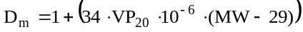  where  - D_{m} is the relative density of the vapour/air mixture at 20 °C  - VP₂₀ is the vapour pressure at 20 °C in mbar  - MW is the molecular weight
Particle characteristics | − applicable to solids only  − indicate the particle size (median and range)  − if available and appropriate, further properties may be indicated in addition, e.g.  - size distribution (range)  - shape and aspect ratio  - specific surface area

Table A4.3.9.2: Data relevant with regard to physical hazard classes (supplemental)
This table lists properties/safety characteristics and test results that are not required on the SDS but may be useful to communicate when a substance or mixture is classified in the respective physical hazard class. Data which is deemed relevant with regard to a specific physical hazard but not resulting in classification (e.g., negative test results close to the criterion) may also be useful to communicate. Include any relevant information, such as a short description, value(s), unit, conditions (e.g., temperature, pressure), method, each as appropriate.
The name of the hazard class the data relates to may be indicated together with the data but it is not necessary to do so because the resulting classification is already indicated in Section 2 of the SDS. Thus, the data may be listed in the same way as the data according to Table A4.3.9.1.
Unless otherwise specified, the test methods referred to in this Table are described in the Recommendations on the Transport of Dangerous Goods, Manual of Tests and Criteria (referred to as the Manual of Tests and Criteria hereafter).
Chapter | Hazard class | Property/Safety characteristic/Test result and  Remarks/Guidance
2.1 | Explosives | − indicate the sensitivity to shock, generally determined by the UN gap test: test 1 (a) and/or test 2 (a) (section 11.4 or 12.4 of the Manual of Tests and Criteria) (indicate at least + or −)  − indicate the effect of heating under confinement, generally determined by the Koenen test: test 1 (b) and/or test 2 (b) (section 11.5 or 12.5 of the Manual of Tests and Criteria) (indicate preferably the limiting diameter)  − indicate the effect of ignition under confinement, generally determined by test 1 (c) and/or test 2 (c) (section 11.6 or 12.6 of the Manual of Tests and Criteria) (indicate at least + or −)  − indicate the sensitiveness to impact, generally determined by test 3 (a) (section 13.4 of the Manual of Tests and Criteria) (indicate preferably the limiting impact energy)  − indicate the sensitiveness to friction, generally determined by test 3 (b) (section 13.5 of the Manual of Tests and Criteria) (indicate preferably the limiting load)  − indicate the thermal stability, generally determined by test 3 (c) (section 13.6 of the Manual of Tests and Criteria) (indicate at least + or −)  − in addition, this entry is also applicable to substances and mixtures which are exempted based on Note 2 in Chapter 2.1, section 2.1.3 and to other substances and mixtures which show a positive effect if heated under confinement  − indicate the package (type, size, net mass of substance or mixture) based on which the division was assigned or based on which the substance or mixture was exempted
2.2 | Flammable gases | for pure flammable gases:  − no data on the explosion / flammability limits is needed because these are indicated based on Table A4.3.9.1  − indicate the T_{Ci} (maximum content of flammable gas which, when mixed with nitrogen, is not flammable in air, in %) as per ISO 10156  for flammable gas mixtures:  − indicate the explosion / flammability limits, if tested (if classification as flammable is based on the calculation as per ISO 10156, assignment of cat. 1 is compulsory)
2.3 | Aerosols | − indicate the total percentage (by mass) of flammable components unless the Aerosol is classified as Aerosol cat. 1 because it contains more than 1 % flammable components or has a heat of combustion of at least 20 kJ/g and is not submitted to the flammability classification procedures (see the Note in Chapter 2.3, paragraph 2.3.2.2)
2.4 | Oxidizing gases | for pure oxidising gases:  − indicate the C_{i} (coefficient of oxygen equivalency) as per ISO 10156  for oxidising gas mixtures:  − indicate “Oxidising gas category 1 (tested as per ISO 10156)” for tested mixtures or indicate the calculated Oxidising Power (OP) as per ISO 10156
2.5 | Gases under pressure | for pure gases:  − indicate the critical temperature  for gas mixtures:  − indicate the pseudo-critical temperature; it is estimated as the mole weighted average of the critical temperatures of the components as follows:  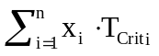  where  - x_{i} is molar fraction of component i  - T_{Crit i} is the critical temperature of component i
2.6 | Flammable liquids | − no additional data is needed because the boiling point and the flash point are indicated based on Table A4.3.9.1  − indicate information on sustained combustibility if exemption based on Test L.2 (section 32.5.2 of the Manual of Tests and Criteria), in accordance with Note 2 in Chapter 2.6, section 2.6.2, is considered
2.7 | Flammable solids | − indicate the burning rate (or burning time for metal powders), generally determined by Test N.1 (section 33.2.1 of the Manual of Tests and Criteria)  − indicate whether the wetted zone has been passed or not
2.8 | Self-reactive substances and mixtures | − for the SADT (self-accelerating decomposition temperature), see the entry for the decomposition energy in Table A4.3.9.1  − indicate the decomposition energy (value and method of determination)  − indicate detonation properties (Yes/Partial/No), also in packaging where relevant  − indicate deflagration properties (Yes rapidly/Yes slowly/No), also in packaging where relevant  − indicate the effect of heating under confinement (Violent/Medium/Low/No), also in packaging where relevant  − indicate the explosive power if applicable (Not low/Low/None)
2.9 | Pyrophoric liquids | − indicate whether spontaneous ignition or charring of the filter paper occurs, generally determined by Test N.3 (section 33.3.1.5 of the Manual of Tests and Criteria) (indicate e.g. “the liquid ignites spontaneously in air” or “a filter paper with the liquid chars in air”)
2.10 | Pyrophoric solids | − indicate whether spontaneous ignition occurs when poured or within five minutes thereafter, generally determined by Test N.2 (section 33.3.1.4 of the Manual of Tests and Criteria) (e.g., “the solid ignites spontaneously in air”)  − indicate whether pyrophoric properties could be altered over time, e.g., by formation of a protective surface layer through slow oxidation
2.11 | Self-heating substances and mixtures | − indicate whether spontaneous ignition occurs, include possible screening data and/or method used (generally Test N.4, section 33.3.1.6 of the Manual of Tests and Criteria) and note the maximum temperature rise obtained  − indicate the results of screening tests according to Chapter 2.11, paragraph 2.11.4.2, if relevant and available
2.12 | Substances and mixtures which, in contact with water, emit flammable gases | − indicate the identity of the emitted gas, if known  − indicate whether the emitted gas ignites spontaneously  − indicate the gas evolution rate, generally determined by Test N.5 (section 33.4.1.4 of the Manual of Tests and Criteria), unless the test has not been completed e.g. because the gas ignites spontaneously
2.13 | Oxidizing liquids | − indicate whether spontaneous ignition occurs when mixed with cellulose, generally determined by Test O.2 (section 34.4.2 of the Manual of Tests and Criteria) (e.g., “the mixture with cellulose (prepared for Test O.2) ignites spontaneously”)
2.14 | Oxidizing solids | − indicate whether spontaneous ignition occurs when mixed with cellulose, generally determined by Test O.1 or Test O.3 (sections 34.4.1 or 34.4.3 of the Manual of Tests and Criteria) (e.g., “the mixture with cellulose (prepared for Test O.1 or O.3) ignites spontaneously”)
2.15 | Organic peroxides | − for the SADT (self-accelerating decomposition temperature) see the entry for the decomposition energy in Table A4.3.9.1  − indicate the decomposition energy (value and method of determination), if available  − indicate detonation properties (Yes/Partial/No), also in packaging where relevant  − indicate deflagration properties (Yes rapidly/Yes slowly/No), also in packaging where relevant  − indicate the effect of heating under confinement (Violent/Medium/Low/No), also in packaging where relevant  − indicate the explosive power if applicable (Not low/Low/None)
2.16 | Corrosive to metals | − indicate which metals are corroded by the substance or mixture (e.g., “corrosive to aluminium” or “corrosive to steel” etc.), if available  − indicate the corrosion rate and whether it refers to steel or aluminium, generally determined by Test C.1 (section 37.4 of the Manual of Tests and Criteria), if available  − include a reference to other sections of the SDS with regard to compatible or incompatible materials (e.g., to packaging compatibilities in Section 7 or to incompatible materials in Section 10), as appropriate
2.17 | Desensitized explosives | − indicate what desensitizing agent is used  − indicate the exothermic decomposition energy  − indicate the corrected burning rate A_{c}

Table A4.3.9.3: Further safety characteristics (supplemental)
This table lists further properties/safety characteristics and test results that are not required on the SDS but may be useful to communicate for a substance or mixture. Other physical properties/safety characteristics of the substance or mixture not identified in this table may also be useful to communicate. Include all relevant information, such as a short description, value(s), unit, conditions (e.g., temperature, pressure), method, each as appropriate.
Safety characteristic and/or test result | Remarks/Guidance
Mechanical sensitivity | − applicable to energetic substances and mixtures with an exothermic decomposition energy ≥ 500 J/g in accordance with the Manual of Tests and Criteria, Appendix 6, section 3.3 (c)  − indicate the sensitiveness to impact, generally determined by test 3 (a) (section 13.4 of the Manual of Tests and Criteria) (indicate preferably the limiting impact energy)  − indicate the sensitiveness to friction, generally determined by test 3 (b) (section 13.5 of the Manual of Tests and Criteria) (indicate preferably the limiting load)
SAPT (self-accelerating polymerization temperature) | − applicable to substances and mixtures which may self-polymerize thereby generating dangerous amounts of heat and gas or vapour  − indicate the volume for which the SAPT is given
Formation of explosible dust/air mixtures | − not applicable to gases and liquids  − not applicable to solids containing only substances which are fully oxidized (e.g., silicon dioxide)  − in case formation of explosible dust/air mixtures might be possible based on Section 2 of the SDS, relevant safety characteristics may be indicated in addition, such as  - lower explosion limit / minimum explosible concentration  - minimum ignition energy  - deflagration index (K_{st})  - maximum explosion pressure  − indicate the particle characteristics to which the data apply if different from the particle characteristics as indicated based on Table A4.3.9.1  NOTE 1: The ability to form explosible dust/air mixtures may be determined e.g. by VDI* 2263-1 "Dust Fires and Dust Explosions; Hazards - Assessment - Protective Measures; Test Methods for the Determination of the Safety Characteristics of Dusts" or by ISO/IEC 80079-20-2 "Explosive atmospheres - Part 20-2: Material characteristics - Combustible dusts test methods" (in preparation).  NOTE 2: Explosion characteristics are specific for the tested dust. Normally they cannot be transferred to other dusts even if these are comparable. Fine-sized dusts of a particular substance tend to react stronger than coarser dusts.
Acid/alkaline reserve | − applicable to substances and mixtures which have an extreme pH (pH ≤ 2 or ≥ 11.5)  − indicate acid/alkaline reserve when used for evaluating skin and eye hazards
”
Annex 7
Add the following new example:
“Example 8: Example of labelling of small packaging
Small immediate container that cannot be labelled based on shape/size and restrictions relating to the method of use, contained in an outside packaging which can display the entire information required on the GHS label
Cardboard box containing glass ampoules of a product used as laboratory reagent. Each ampoule contains 0.5 g.

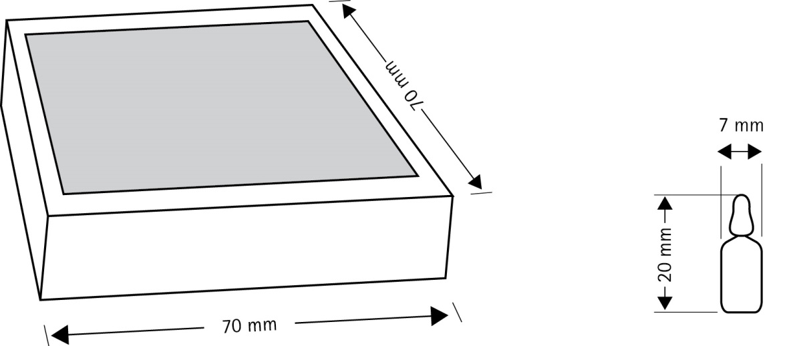

The working solution of the reagent is prepared by removing the top of the ampoule and placing the bottom half (containing the product) in the required amount of deionized water. Consequently, labels cannot be applied to the actual ampoules as they may contaminate the working solution, which may affect subsequent reactions. It is impossible to put all applicable GHS label elements on the immediate container (i.e. the glass ampoule) due to its size and shape.
The area available on the outer cardboard box is large enough to carry a legible version of the required GHS label elements.
The unlabelled glass ampoule is sealed in a polythene sleeve with an end tag for a label – the ampoule is not removed from the polythene sleeve until the point of intended use, i.e. preparation of the working solution. The area available for a label on the end tag is not sufficient to include all the required label elements. The labelling includes at least:
- the product identifier, signal word and name plus telephone number of the supplier on one side of the end tag;
- the hazard pictograms on the other side of the end tag.
This ensures that the user is aware of the product identity (enables identification of the associated safety data sheet), its hazards (indicates that the product is hazardous and needs to be handled/stored appropriately) and the name/contact details of the supplier (if needed in an emergency situation). The signal word and the pictogram are not on the same side in order to ensure the presence of safety information on both sides of the end tag.
Inner packaging: sleeve with minimum required GHS label elements
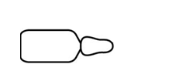
30 mm

15 mm

7 mm
BLAHZENIC ACID
Company XYZ
Phone + 000 0000000
SIGNAL WORD

One side
20 mm
Polythene sleeve

READ
FULL LABEL
Reverse side




Outer packaging: all required GHS label elements (including hazard and precautionary statements) appear on the outside packaging
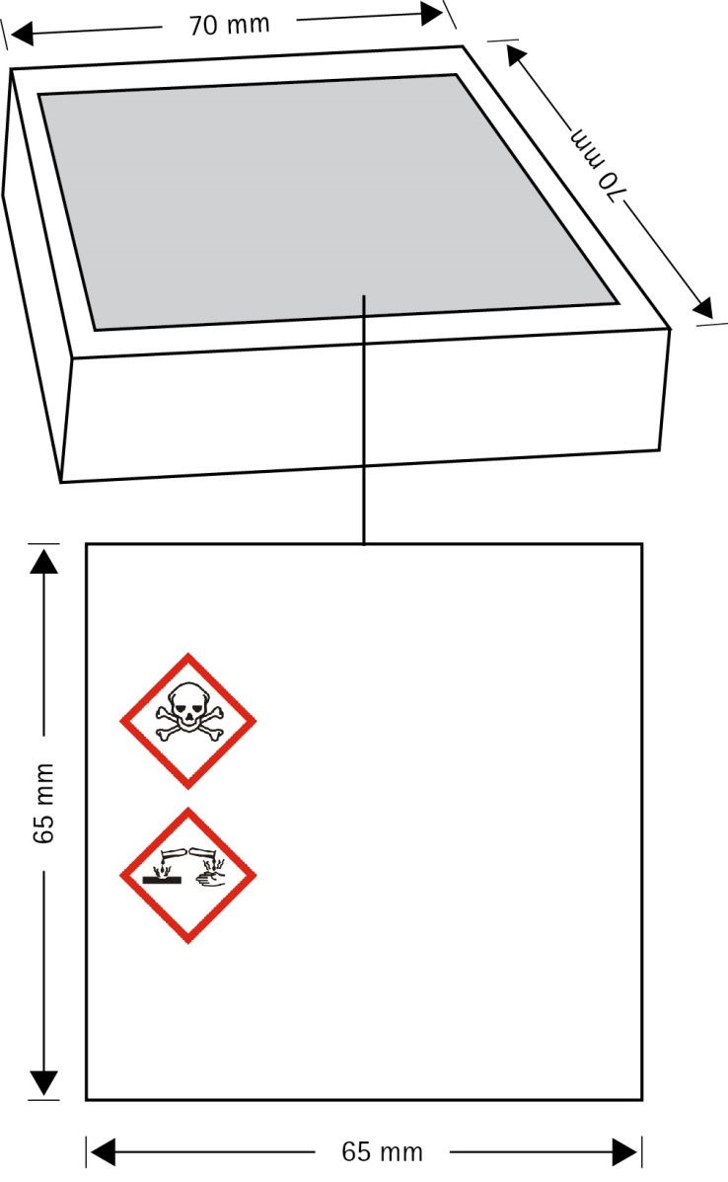”
Product identifier
(see 1.4.10.5.2 (d))
Signal word
(see 1.4.10.5.2 (a))
Hazard statements (see 1.4.10.5.2 (b))
Additional information as required by the competent authority as appropriate.
Supplier identification (see 1.4.10.5.2 (e))
BLAHZENIC ACID
Precautionary statements
(see 1.4.10.5.2 (c))
Annex 9
A9.3.5.1 Amend and merge the two last sentences to read as follows:
“OECD Guidance Document on aquatic toxicity testing of difficult substances and mixtures is a good source of information …” (remainder of the paragraph unchanged).
A9.5.2.4.2 In the first paragraph, at the end of the first sentence, delete “the pH-metric method (OECD Test Guideline in preparation).”.
In the sixth sentence, replace “(OECD Test Guideline in preparation)” by “(OECD Test Guideline 123)” and delete “(OECD draft Guideline, 1998)”.
A9.5.3.2.1 In the first sentence, replace “(DoE, 1996; ECETOC 1996; and US EPA 1996)” by “(DoE, 1996; ECETOC 1996; US EPA 1996; OECD, 2000)”.
Delete the second sentence (“OECD is in the process …(OECD 2000))”.
Amend the beginning of the third sentence to read as follows: “The OECD Guidance Document on Aquatic Toxicity Testing of Difficult Substances and Mixtures (OECD, 2000), is also a good source of information for bioconcentration studies…”. (Remainder of the paragraph unchanged).
Annex 9, Appendix I
Section 2.4.1 Delete the first and second sentences (“At present…scheduled guidance”).
Amend the beginning of the third sentence to read as follows: “According to the definitions set out in the OECD Guidance Document concerning aquatic direct photolysis (OECD, 1997), phototransformation…”. (Remainder of the paragraph unchanged).
Section 2.4.2 Amend the end of the first sentence to read as follows: “…water by sunlight, OECD Test Guideline 316 Phototransformation of chemicals in water-direct photolysis, and OPPTS 835.5270 Indirect photolysis screening test.”.
In the second sentence, insert “as well as OECD Test Guideline 316” after “The OPPTS 835.2210 test”.
Section 3.7.4 Amend the first sentence to read as follows: “Two OECD Test Guidelines address aerobic and anaerobic transformation in soil and in aquatic sediments (Test Guidelines 307 and 308 respectively).”.
Annex 9, Appendix III
Section 2.2.1 At the end of the third sentence, replace “OECD draft Guideline, 1998” by “OECD Guideline 123”.
Delete the last sentence (“The slow stirring method…final OECD guidance”).
Annex 9, Appendix V
Section 2 Delete “(in preparation)” after “OECD Test Guideline 221” and the reference to OECD Test Guideline 204 (1998) and its related footnote.
Section 3 For “OECD Test Guideline 303A (1981)”, delete “Draft update available 1999”.
Replace the references to “OECD (1998b)”, “OECD (1999)” and “OECD (2000)” by the following:
“OECD Test Guideline 308: Aerobic and Anaerobic Transformation in Aquatic Sediment Systems. OECD guidelines for testing of chemicals.”
“OECD Test Guideline 307: Aerobic and Anaerobic Transformation in Soil. OECD guidelines for testing of chemicals.”
“OECD Test Guideline 309: Aerobic Mineralisation in Surface Water – Simulation Biodegradation Test. OECD guidelines for testing of chemicals.”
Section 4 Replace “OECD draft Test Guideline, 1998. Partition Coefficient
n-Octanol/Water Pow. Slow-stirring method for highly hydrophobic chemicals. Draft proposal for an OECD Guideline for Testing of Chemicals” by “OECD Test Guideline 123: Partition Coefficient (1-Octanol/Water): Slow-Stirring Method. OECD guidelines for testing of chemicals”.
Annex 9, Appendix VI
Section 1 Amend the reference to OECD 2000 to read as follows: “OECD 2000. Guidance Document on Aquatic Toxicity Testing of Difficult Substances and Mixtures, Series on Testing and Assessment No.23, OECD, Paris”.

Unstable explosives as defined in Chapter 2.1 can also be stabilized by desensitization and consequently may be classified as desensitized explosives, provided all criteria of Chapter 2.17 are met. In this case the desensitized explosive should be tested according to test series 3 (Part I of the UN Recommendations on the Transport of Dangerous Goods, Manual of Tests and Criteria) because information about its sensitiveness to mechanical stimuli is likely to be important for determining conditions for safe handling and use. The results should be communicated in the safety data sheet.
* VDI stands for “Verein Deutscher Ingenieure”

