Draft Addendum 1 - Specifications for the Construction, Preparation and Certification of the 50th percentile male Biofidelic Rear Impact Dummy, (BioRID-II) anthropometric test device
Contents
Page
1. Introduction 5
1.1. General Design 5
1.2. Instrumentation 6
1.2.1. Available Instrumentation 6
1.2.2. Instrumentation Location 7
1.3. Required Tools 7
1.4. Abbreviations of Screw Types Used 8
2. Physical Properties 9
2.1. Dimensions 9
2.2. Masses 12
Annex 1. Assembly, disassembly and inspection 14
1. Mechanical Subsystems 14
1.1. Head 14
1.1.1. Assembly 14
1.1.2. Removal 14
1.1.3. Disassembly 14
1.2. Spinal Column – Cervical portion 15
1.2.1. Assembly 15
1.2.2. Disassembly 15
1.2.3. Bumper Replacement 15
1.3. Spinal Column - Thoracic and Lumbar Portions 16
1.3.1. Assembly 16
1.3.2. Disassembly 16
1.4. Spinal Column - Muscle Substitute System 18
1.4.1. Assembly 18
1.4.2. Disassembly 19
1.4.2.1.Spring Loaded Muscle Substitutes: 19
1.4.2.2.Damper Loaded Muscle Substitute: 19
1.4.3. Cable Installation 20
1.4.3.1.Damper cable 20
1.4.3.2.Spring Cable 22
1.4.4. Damper Removal and Installation 24
1.4.5. Damper Filling 26
1.5. Static Spine Setup Procedure 27
1.5.1. Thoracic and Lumbar Spine 27
1.5.2. Cervical Spine Set-up (Pretension) 29
1.5.3. Cervical Spine Setup (Tension) 29
1.5.4. Damper Cable Adjustment 32
1.5.5. Static Spine Measurements 32
1.6. Torso Flesh and Lifting Bracket 35
1.6.1. Assembly 35
1.6.2. Removal 35
1.6.3. Abdomen Filling Procedure 36
1.7. Pelvic Assembly 37
1.7.1. Assembly 37
1.7.2. Disassembly 37
1.8. Arms 37
1.8.1. Assembly 37
1.8.2. Disassembly 38
1.9. Legs 39
1.9.1. Assembly 39
1.9.2. Removal 39
1.10. Joint Adjustment Procedure 40
1.10.1. Joint adjustment - Arms and Hands 41
1.10.2. Joint adjustment - Legs and Feet 42
1.11. Clothing 43
1.11.1. Shirts and Shorts 43
1.11.2. Shoes 43
2. Instrumentation 44
2.1. Head Assembly 44
2.1.1. Assembly Components 44
2.1.2. Installation 44
2.1.3. Skull Cap Contact Switch 45
2.2 Spinal Column – Cervical portion 46
2.2.1. Assembly Components 46
2.2.2. Mounting of Accelerometers 46
2.3. Spinal Column - Thoracic and Lumbar Portions 46
2.3.1. Assembly Components 46
2.3.2. Mounting of Accelerometers 47
2.4. Pelvis 47
2.4.1. Assembly components 47
2.4.2. Mounting of accelerometers 47
2.5. Cable Routing 48
2.5.1. Grounding 48
2.5.2. Head and Neck Cable Routing 48
2.5.3. Thoracic Spine Cable Routing. 48
2.5.4. Pelvis Cable Routing 49
2.6. Accelerometer Handling 50
2.6.1. Care 50
2.6.2. Preliminary Checks 50
2.6.3. Installation Procedure 50
2.6.4. Recalibration 51
2.6.5. Cleaning 51
3. Bumper Maintenance 51
3.1. Overview 51
3.2. Replacement Interval 51
3.3. Replacement Procedure 51
4. Storage and Handling 53
4.1. Transport Chair 53
4.2. Lifting Procedure 53
5. Repairing the Vinyl Flesh and Silicone Jacket 54
5.1. Silicone Jacket 54
5.2. Vinyl Limb Flesh 54
6. Torque Value Table 56
Annex 2. Engineering Drawings and Parts List 57
1. Drawings 57
1.1. Introduction 57
1.2. Drawing Descriptors 57
1.3. Revisions 57
2. Parts 58
3. Part Numbers 58
4. List of appendices 58
Drawing Appendices 59
Appendix 1. Assembly Drawings 59
Table 1. Drawing Index 59
Appendix 2. Head 60
Table 1. Drawings 60
Table 2. Parts 60
Appendix 3. Cervical Spine 61
Table 1. Drawings 61
Table 2. Parts 62
Appendix 4. Thoracic and Lumbar Spine 63
Table 1. Drawings 63
Table 2. Parts 66
Appendix 5. Torso and Pelvis 67
Table 1. Drawings 67
Table 2. Parts 68
Appendix 6. Muscle Substitute 69
Table 1. Drawings 69
Table 2. Parts 70
Appendix 7. Arms and Hands 71
Table 1. Drawings 71
Table 2. Parts 71
Appendix 8. Legs and Feet 73
Table 1. Drawings (Leg Assembly) 73
Table 4. Parts 74
Appendix 9. Tools 75
Table 1. Drawings 75
Table 2. Parts 76
Annex 3. Certification Procedures 77
1. Sled Test – without head restraint 77
2 Sled test – with head restraint 77
3. Torso Flesh Stiffness. 77
4. Pelvis stiffness 77
Appendix 1 – Schematic and General Arrangement of Equipment 77
Appendix 2 – Certification Corridors 77

Draft Mutual Resolution Addendum 1
1. Introduction
This document, addendum 1 to the Mutual Resolution, aims to set out a standard specification for build and certification of the Biofidelic Rear Impact Dummy (BioRID-II) UN.
BioRID-II UN is a 50th percentile male dummy, developed to mimic occupant behaviour in automotive rear impact collisions of low severity.
BioRID-II UN has a fully articulated spine, providing a more anthropomorphic response in a collision while still maintaining the level of repeatability and reproducibility established by previous dummies used in automotive impact testing.
BioRID-II UN is able to record many measurements, including thorax loading and head acceleration and rotation, which can be correlated to the risk of whiplash associated disorders and other injuries.
1.1. General Design
For the purposes of application in the context of UN ECE Regulations, the BioRID II UN anthropometric test dummy is defined by compliance with the build and calibration requirements set out in this document and accompanying engineering drawings (Appendix X). The generic build level, e.g. BioRID IIg, is not sufficient to determine the status of the dummy and it is necessary to establish that the individual components that comprise the dummy are manufactured to the particular level of drawing revision that are tabled in Annex II.
BioRID-II UN incorporates a fully articulated two-dimensional spine with 24 vertebrae. The spine consists of seven cervical (C1-C7), twelve thoracic (T1-T12) and five lumbar (L1-L5) vertebrae.
The head assembly and the top cervical vertebra (C1) are connected using an occipital interface plate. Upon this interface is mounted a 6-channel or 3-channel upper neck load cell, or if no load cell is used, a load cell structural replacement. The superior thoracic vertebra (T1) is contoured as a cervical vertebra on the upper side and as a thoracic vertebra on the lower side in order to mate the cervical and thoracic regions. Similarly the upper surface of the superior lumbar vertebra (L1) is shaped like the thoracic vertebrae and the underside shaped like the lumbar vertebrae to mate the thoracic and lumbar regions. The lowest lumbar vertebra (L5) connects the spine to the pelvis through a sacrum lumbar and pelvis interface plate.
The vertebrae for the BioRID II UN are made of durable plastic and are connected with pins at each joint that allow for angular motion in the sagittal plane only. The occipital and pelvis interfaces are made of aluminium. There are rubber blocks glued to the top of each vertebra to simulate the compression resistance of the muscles and discs between each human vertebra.
To increase the biofidelity of the neck motion response, tensioning cables are incorporated into the neck region of the spine. There are three cables originating at the top of the neck, with threaded adjustments for controlling cable tension. One cable goes through the cervical vertebrae, around a damper assembly at the T4 vertebra and back through the vertebrae to the top of the neck. The two other cables also start at the top of the neck but terminate at two spring-loaded cable-tensioning devices mounted on the right side of the torso.
The upper torso flesh is made of moulded silicone. Included in the flesh mould are: the left and right arm attachment yokes with reinforcement plates, the abdomen interface attachment, the abdomen cavity, the abdomen valve and the spine-torso interface. The flesh material and/or external surface characteristics enable positive attachment of adhesive targets.
The arms and legs are Hybrid III 50th percentile dummy assemblies and the head and pelvis are modified Hybrid III 50th percentile dummy assemblies.
1.2. Instrumentation
1.2.1. Available Instrumentation
Table 1 lists the available instrumentation for the BioRID II UN Dummy. Section 2.4 of Annex 1 describes cable installation requirements. Any instrumentation used shall not change the mass or centre of mass of components.
Note: table 1 and figure 1 will need amending once injury criteria are finalised!!!!
Table 1.
BioRID UN Instrumentation
Location | Type | Measurement | Number of Channels
Head | Accelerometer | AX, AY, AZ | 3
Head | Gyro | AVX, AVY, AVZ | 1 - 3
Head | Skull Cap Load Cell | FX, FZ, MY | 3
Head | Skull Cap Contact Switch | Event | 1
Head | Tilt Sensor | Angle | 1
Upper Neck | Load Cell | FX, FY, FZ, MX,MY,MZ | 6
Neck (C4) | Accelerometer | AX, AZ | 2
Thorax (T1) | Load Cell | FX, FZ, MY | 3
Thorax (T1) | Accelerometer | AX, AZ | 2
Thorax (T1) | Gyro | AVX, AVY, AVZ | 1 - 3
Thorax (T1) | Tilt Sensor | Angle | 1
Thorax (T8) | Accelerometer | AX, AZ | 2
Thorax (T8) | Gyro | AVX, AVY, AVZ | 1 - 3
Lumbar (L1) | Accelerometer | AX, AZ | 2
Lumbar (L1) | Gyro | Angular | 1 - 3
Lumbar Load Cell | Load Cell | FX, FX, FZ, MX, MY, MZ | 6
Muscle Tension (2) | Load Cell | Force | 2
Pelvis | Accelerometer | AX, AY, AZ | 3
Pelvis | Gyro | AVX, AVY, AVZ | 1 - 3
Pelvis | Tilt Sensor | Angle | 1
Femur (Left and Right) | Load Cell | FX, FY,FZ, MX, MY, MZ | 12

1.2.2. Instrumentation Location
The location of the instrumentation shall be as illustrated in figure 1.
Figure 1.
Instrumentation layout
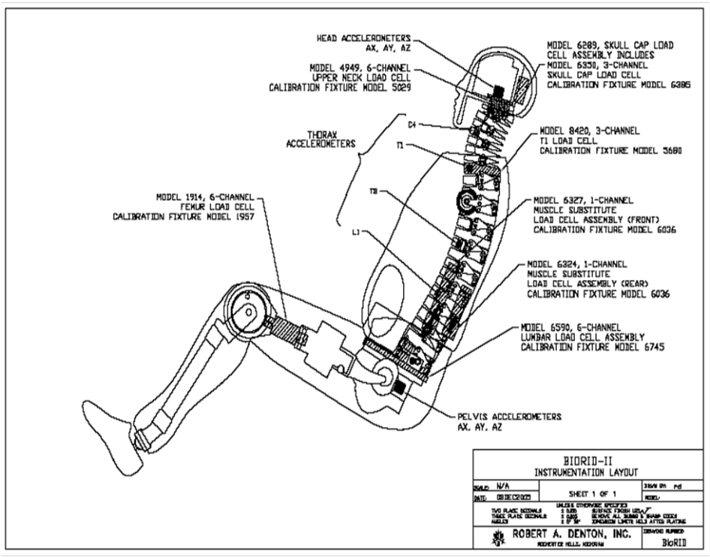

1.3. Required Tools
The following special tools will allow assembly, disassembly and calibration of the BioRID II Rear Impact Dummy.
Hex spanner, Ball end (0.05" – 3/8" and 1.5 mm – 10 mm)
Hex spanner, ‘T’-handle (3/32" - 3/8" and 2 mm – 10 mm)
Screwdriver, standard tip (2.5 mm tip width)
Pin punch (6 mm (0.25") dia.)
Brass mallet
Thread locking adhesive (e.g. cyanoacrylate)
Open-end spanner (13 mm)
Synthetic gear oil of ISO viscosity grade 680
1.4. Abbreviations of Screw Types Used
The abbreviations listed in table 2 shall be used within this addendum
Table 2.
Abbreviations of screw types

Screw Type | Abbreviation
Socket Head Cap Screw | SHCS
Button Head Cap Screw | BHCS
Flat Head Cap Screw | FHCS
Socket Set Cup Point | SSCP
Socket Head Shoulder Screw | SHSS

2. Physical Properties
2.1. Dimensions
Table 2 specifies key dimensions that are checked when the dummy is seated in the dummy measurement chair. These measurements enable dimensional conformity to be checked without having to inspect every component, and allow the level of compression in the flesh to be monitored. They shall be performed whenever the dummy is certified and may additionally be performed outside certification if desired.
The dummy measurement chair shall feature a flat, rigid, smooth, clean, dry, horizontal surface. The seating surface shall be at least 406 mm (16 in) wide and 406 mm (16 in) deep, with a vertical section at least 406 mm (16 in) wide and 914 mm (36 in) high attached to the rear of the seating fixture. It shall feature an adjustable head strap capable of supporting the dummy’s head against forward movement. A suitable chair is shown in figure 2.
The procedure for taking these measurements is as follows:
Level the seat of the dummy measurement chair such that it lies parallel to the X-Y plane in the coordinate reference system. Zero the digital inclinometer on the seat surface with it oriented in the X-coordinate direction.
Position the dummy on the measurement chair such that the dummy’s midsagittal plane is vertical and centred upon the test surface, and position the head strap of the chair so it runs round the front of the head, directly under the nose (figure 2). Insert the head levelling tool on the top of the skull, then insert the H-Point tool through the pelvis into the H-Point reference square hole mounted at the base of the spine.
Position the lower torso so the H-Point reference hole on the H-point tool is between 13.5 – 14.0mm (5.3 – 5.5 inches) from the seat back on both sides of the dummy when measured in the X coordinate direction (figure 3). Measure the height (Z coordinate direction) from the seat to the H-Point reference hole (figure 4) and compare to the tolerance band specified in table 2. Place the inclinometer on the top of the H-Point tool (figure 5) and confirm that this angle is between 0 and 6 degrees; if it is not, adjust the dummy position and repeat the measurements of the H-point positions (X and Z directions) and angles until all are within tolerance .
Place the inclinometer on the top of the head levelling tool (figure 6). The head angle shall be 26.5 +/- 2 degrees. The head strap may be adjusted to allow slump on the spine in order to attain correct angle.
Measure the thigh clearance by placing a level across the highest point on the thighs and measuring the vertical distance (Z coordinate direction) from the seat to the bottom of the level on each side of the dummy (figure 7). Hold the measuring ruler in a vertical orientation such that it touches the outer thigh.
To find the buttock to knee length, place a level across the furthest forward point of both the knees and measure the distance (X coordinate direction) between the level to the seat back. Measurements shall be taken on either side such that the tape or ruler is oriented in the X direction and touches the side of the dummy (figure 8).
Place a level on the top of the head and centre the bubble. Measure the dimension from the seat to the underside of the level (Z coordinate direction) to find the seated height (figure 9).
Level the feet front to back by holding a digital inclinometer to the soles of the feet. Place a straight edge transversely under the balls of the feet, such that it contacts both feet, and measure the vertical distance between the straight edge and the knee pivot to find the knee pivot height on both sides of the dummy, as shown in figure 10. The measuring device shall be vertical and shall touch the dummy Measure the length and width of each foot using a ruler, at the longest and widest points of the foot respectively.
Figure 2.
Seating the dummy in the measurement
chair

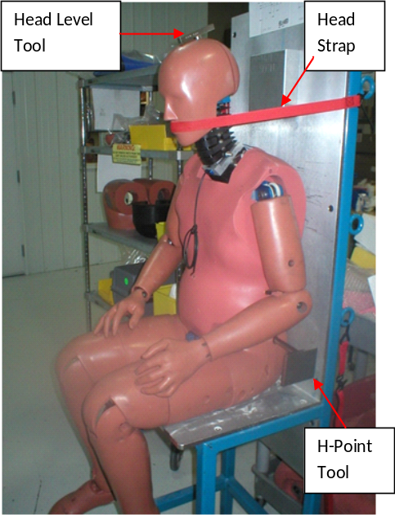  Figure 4.  Measuring the H-Point height (left side) | Figure 3.  Setting the longitudinal position of the lower torso  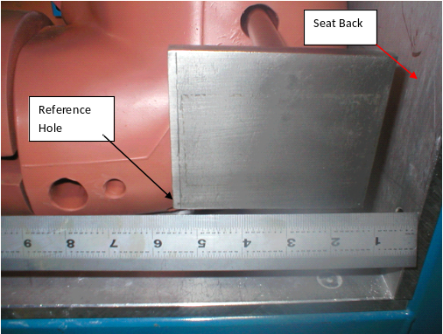
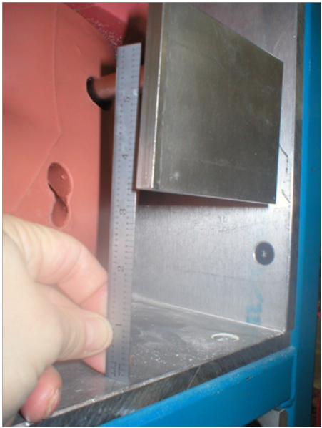  Figure 6.  Measuring the angle of the head levelling tool |  | Figure 5.  Measuring the H-point tool angle  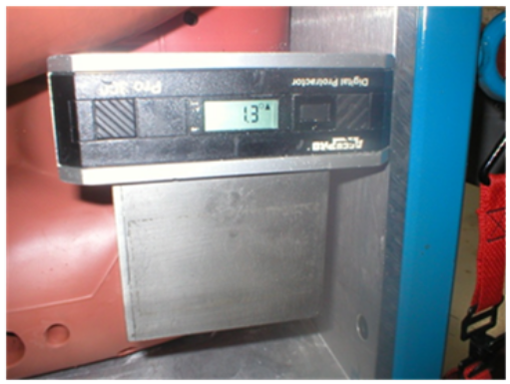
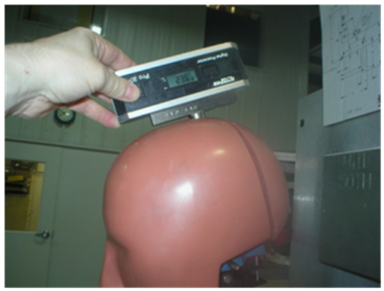 |  | Figure 7.  Measuring the thigh clearance  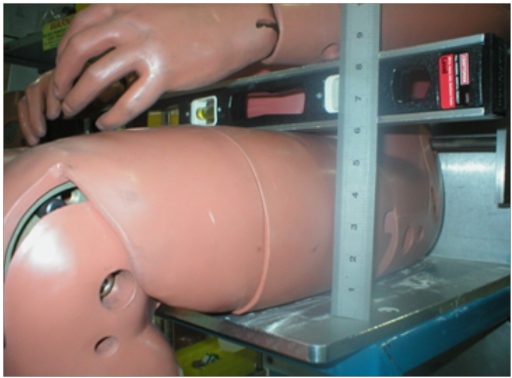
Figure 9
Measuring the seated height of the dummy
Figure 8.  Measuring the knee to buttock length  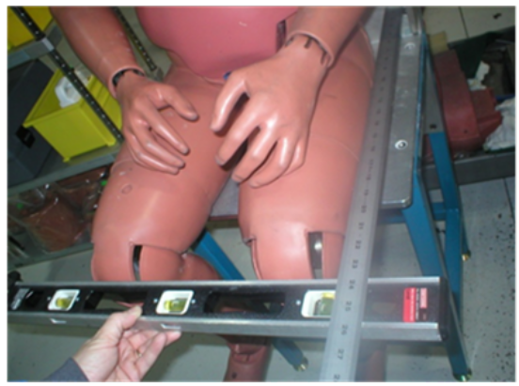 |  | 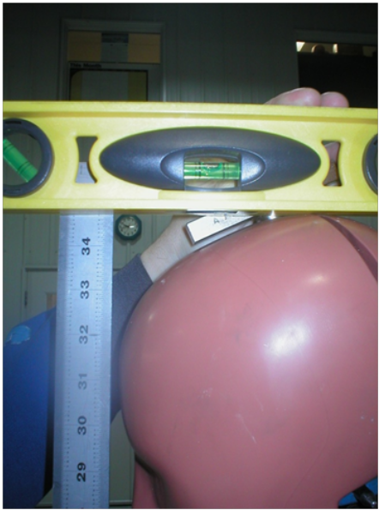

Figure 10
Measuring the left knee pivot height
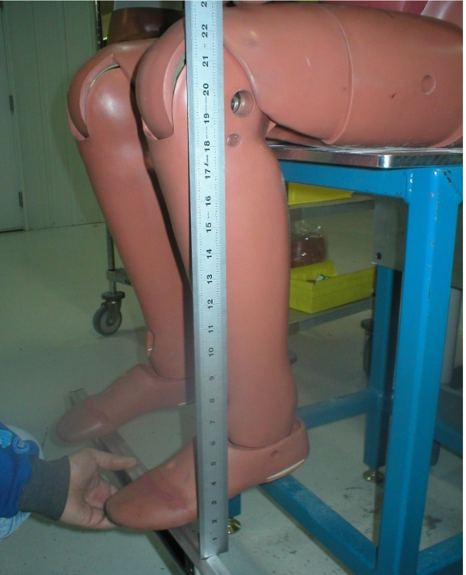

Table 3
Dimensions of BioRID UN
 | Imperial (in) |  | Metric (mm)
Feature | Lower | Upper | Lower | Upper
Right H-Point above seat | 3.3 | 3.5 | 84 | 89
Left H-Point above seat | 3.3 | 3.5 | 84 | 89
Right H-Point from Seat Rear | 5.3 | 5.5 | 135 | 140
Left H-Point from Seat Rear | 5.3 | 5.5 | 135 | 140
Seated Height | 34.6 | 35 | 879 | 889
Right Thigh Clearance | 5.5 | 6.1 | 140 | 155
Left Thigh Clearance | 5.5 | 6.1 | 140 | 155
Right Buttock to Knee Length | 22.8 | 23.8 | 579 | 605
Left Buttock to Knee Length | 22.8 | 23.8 | 579 | 605
Right Knee Pivot Height | 19.1 | 19.7 | 485 | 500
Left Knee Pivot Height | 19.1 | 19.7 | 485 | 500
Right Foot Length | 9.9 | 10.5 | 251 | 267
Left Foot Length | 9.9 | 10.5 | 251 | 267
Right Foot Width | 3.6 | 4.2 | 91 | 107
Left Foot Width | 3.6 | 4.2 | 91 | 107

2.2. Masses
The masses of the BioRID II UN dummy shall conform to the specifications in table 4. After replacing parts, including instrumentation, the mass of the segment containing the replaced part shall be rechecked.
Table 4.
Masses of BioRID UN components
Assembly | Mass
Assembly | lbs |  | kgs
Assembly | Lower Corridor | Upper Corridor | Lower Corridor | Upper Corridor
Head | 9.9 | 10.1 | 4.49 | 4.58
Torso | 92.5 | 94.5 | 41.96 | 42.86
Right Upper Arm | 4.2 | 4.6 | 1.91 | 2.09
Left Upper Arm | 4.2 | 4.6 | 1.91 | 2.09
Right Lower Arm | 3.65 | 3.85 | 1.66 | 1.75
Left Lower Arm | 3.65 | 3.85 | 1.66 | 1.75
Right Hand | 1.15 | 1.35 | 0.52 | 0.61
Left Hand | 1.15 | 1.35 | 0.52 | 0.61
Right Upper Leg | 13 | 13.4 | 5.90 | 6.08
Left Upper Leg | 13 | 13.4 | 5.90 | 6.08
Right Lower Leg | 9.3 | 9.6 | 4.22 | 4.35
Left Lower Leg | 9.3 | 9.6 | 4.22 | 4.35
Right Foot | 2.4 | 2.7 | 1.09 | 1.22
Left Foot | 2.4 | 2.7 | 1.09 | 1.22

Annex 1
Assembly, disassembly and inspection
This annex deals with protocols for assembly, disassembly and maintenance of BioRID II UN. For parts lists and engineering drawings of the components referred to in this annex, see annex 2.
1. Mechanical Subsystems
1.1. Head
1.1.1. Assembly
BioRID II UN uses a modified Hybrid III 50th percentile head assembly. The skull base and ballast are modified to accommodate the upper neck load cell and the tensioning cables that extend out of the neck section. Figure 1 shows a breakdown of all head components, which are listed within Annex 2.
1.1.2. Removal
To remove the head from the neck assembly, loosen the two M4 nylon tipped set screws clamping the condyle pin to the O.C Plate and firmly press down on the top of the head assembly to compress the elastomer bumpers on the Occipital Condyle. While the bumpers are compressed, push the condyle pin out of the head-neck joint using a 1/4" (6mm) rod toward the dummy’s right side. Once the pin is removed, pull the head away from the neck assembly.
1.1.3. Disassembly
Take out the two 1/4-20 x 5/8" SHCS securing the skull cap assembly to the skull. Disconnect the two connector plugs at the top surface of the load cell, inside the head, by sliding the outer sleeve of the connector away from the load cell. Remove the four 1/4-28 x 7/8" SHCS at the base of the skull.
Push the load cell into the inside of the skull and rotate it 90º so that the occipital condyle hole is vertical. The load cell can then be pulled out through the back of the skull.
Accelerometers may be mounted on the top surface of the neck load cell. To remove them from the load cell take out the four #10-24 x 1/4" SHCS that secure the mounting plate in place.
To remove the head skin from the assembly, lift the rear flaps and peel it away from the skull. Check the skin for damage.
Figure 1.
Head assembly exploded view
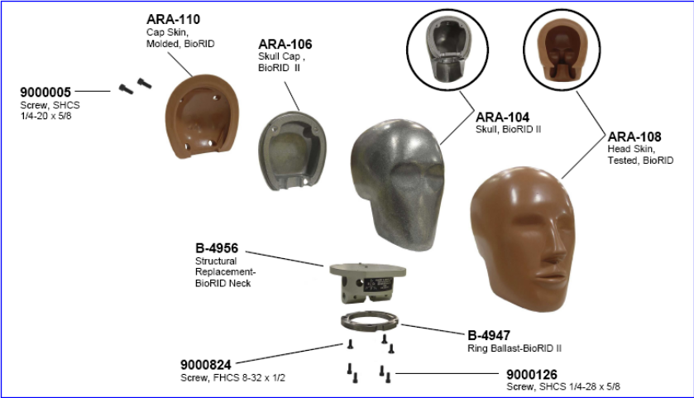
1.2. Spinal Column – Cervical portion
1.2.1. Assembly
The cervical portion of the spine assembly links the T1 vertebra to Occipital interface plate. Figure 2 shows a breakdown of the assembly, the components for which are listed within Annex 2.
1.2.2. Disassembly
Prior to disassembly of the spine, loosen or remove the muscle substitute assembly as described in section 1.2.3.2.
To disassemble the cervical spine, take off the M8 jam nuts on each side of the spine at the C7–T1 joint and loosen or remove the two M2.5 SHCS used to lock the T1 pin to the vertebrae, then push the T1 pin out of the assembly. Do not hammer or directly impact the joint; this may cause damage. Use a 6 mm punch and tap lightly to slide the remaining cervical spine pins out, until the cervical spine is completely disassembled.
Check the bumpers; if any are loose or have become detached; follow the procedure described in section 1.2.1.3.
1.2.3. Bumper Replacement
There are rubber bumper pads on each vertebra. If any are loose or have fallen off, re-glue them to the vertebra as follows:
Remove old glue from the bumper and the vertebra and scrub the area with acetone or methyl ethyl ketone (MEK). Draw a line on the vertebra 2 mm from the anterior edge when replacing the anterior bumper to guide positioning; use this to position the bumpers 2mm from the edge when gluing. The posterior bumper shall be glued flush with the posterior edge of the vertebra when being replaced. The bumpers shall be centred relative to the sides of the vertebrae in all cases.
Apply a thin coat of cyanoacrylate adhesive to the bumper and gently press the bumper into place on the vertebra. Hold for approximately 30 seconds. Wipe away excess glue, using acetone or MEK if necessary.
Figure 2.
Breakdown of components in the cervical portion of the spinal column
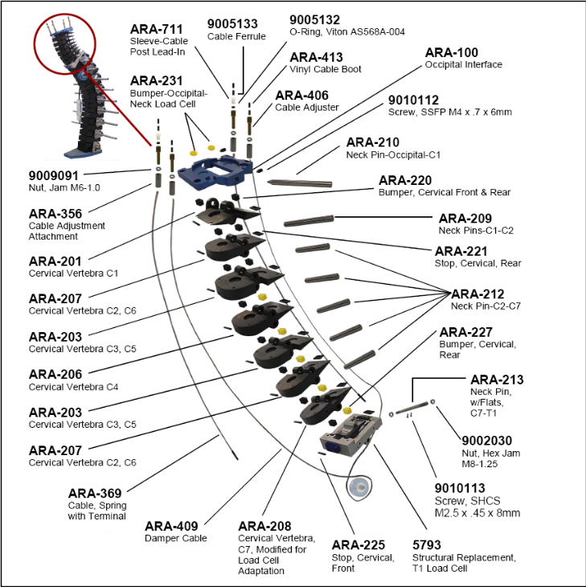
1.3. Spinal Column - Thoracic and Lumbar Portions
1.3.1. Assembly
Figures 3 and 4 illustrate the thoracic and lumbar region of the spine; a list of components may be found in Annex 2.
1.3.2. Disassembly
To facilitate disassembly of the spine, the muscle substitute assembly shall first be loosened or removed as described in section 1.2.3.2.
Before starting to take off each vertebra, it is recommended that the operator mark each component with tape or paint to aid reassembly. The torsion adjustment washer position at each vertebral junction can be marked with a paint marker to show its position relative to the torsion washer.
Take out the four M6 X 1 X 20 FHCS at the underside of the interface plate and pull the pelvis interface plate away from the spine. Remove the M8 x 1.25 x 10 BHCS that lock the adjustment washers in place on the torsion washer.
To remove the pins, lay the spine assembly on a firm, flat work surface with the pins vertical. Use two wooden blocks to provide clearance under the spine for the pins to move downward. Then, starting with the pin joining S1 and L5, tap the pin out of the torsion washer on the dummy’s left side using a 6 mm pin punch and a brass mallet or equivalent. Take care not to damage the pin, washer or vertebrae through use of excessive force.
Continue working along the spine assembly separating the torsion pins from the torsion washers. After all the pins on one side are loose, turn the spine over and repeat the process on the opposite side until all the pins are free from the torsion washers.
Pull the pins and torsion washers from the spine assembly. For easier re-assembly, take out the pin–adjustment washer assemblies one at a time starting at the S1–L5 joint, working bottom to top, and set aside each part as it is taken off so it can be re-assembled in the same sequence. Note that there are shim or spacer washers at S1 between the torsion washer and the vertebra, and at T4 there is a cable pulley wheel inside; these must be reinstalled correctly upon reassembly. If any bumpers are loose or have fallen off, they shall be re-glued to the vertebra using the procedure described in 1.2.1.3.
Figure 3
Spinal Column Thoracic and Lumbar - Part 1
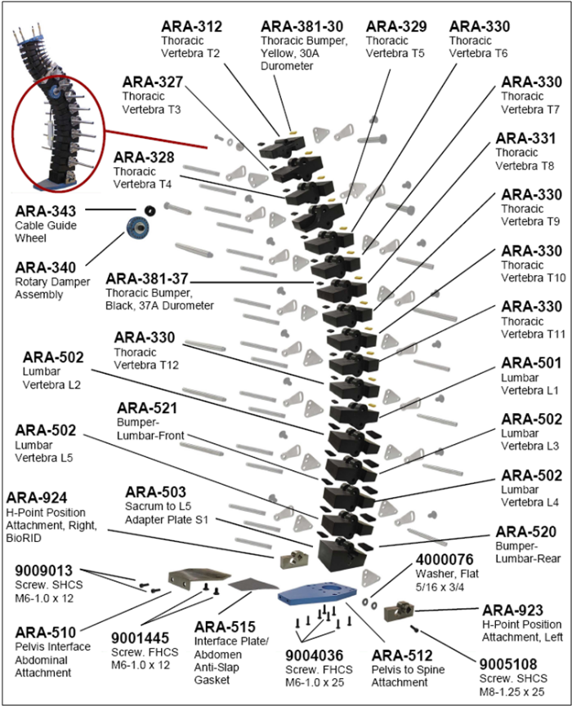

Figure 4
Spinal Column Thoracic and Lumbar - Part 2

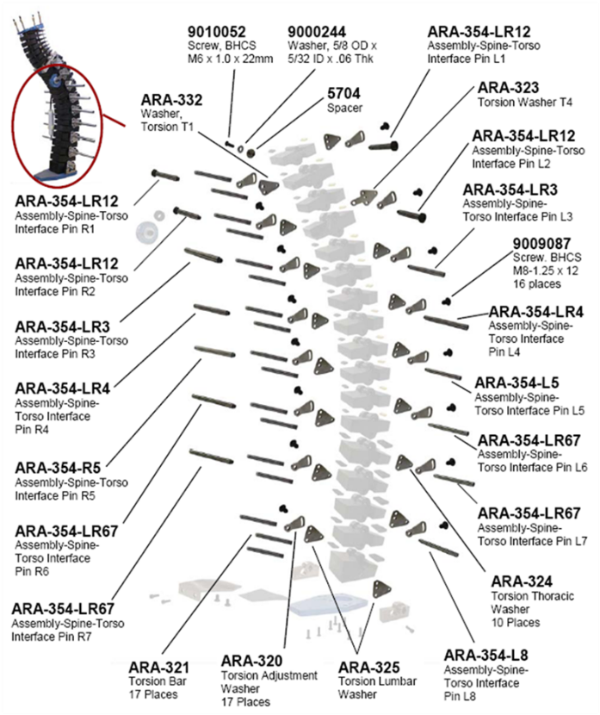

1.4. Spinal Column - Muscle Substitute System
1.4.1. Assembly
The muscle substitute assembly is a system of springs and cables running through each vertebra from the OC plate to T3. Figure 5 shows a breakdown of the assembly; a list of the components is in Annex 2.
Figure 5
Muscle Substitute Assembly Components
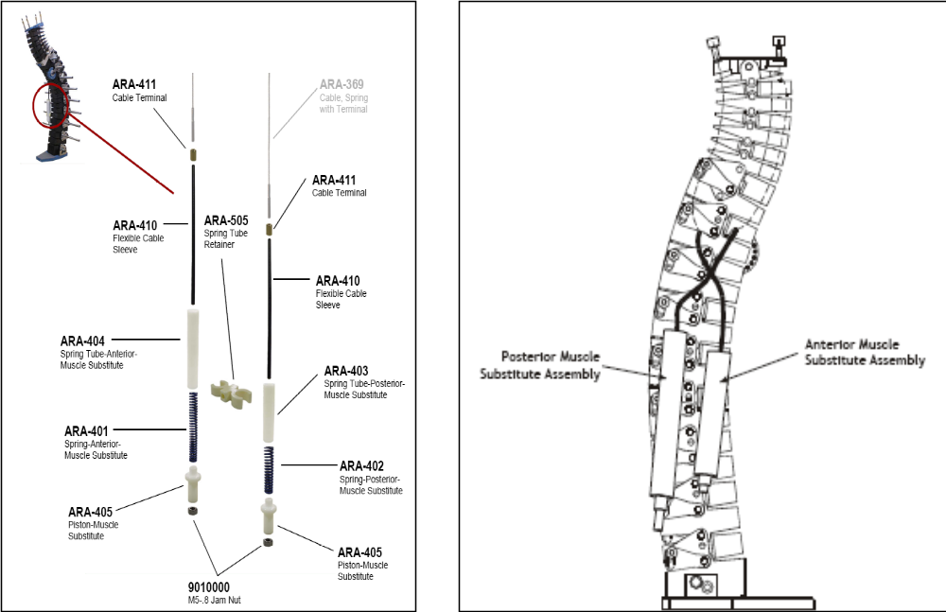
1.4.2. Disassembly
Prior to disassembly of the spine, the muscle substitute cables must be loosened or removed. The procedure for this is as follows.
1.4.2.1. Spring Loaded Muscle Substitutes:
Loosen and remove the two M5 nuts and lower spring cable adjusters at the base of each spring assembly and slide the springs out from the tubes.
Pull the cable through the adjustment screw at the top of the torso so that the cable crimp is accessible, and cut the cable below the crimp, between the crimp and the adjustment screw. Pull the cable down and out through the vertebrae and spring tubes.
1.4.2.2. Damper Loaded Muscle Substitute:
Loosen and remove the two M5 nuts and lower spring cable adjusters at the base of the spring assembly. Loosen the cable adjustment screws and posts at the top of the torso, on the dummy’s left side, and adjust the posts all the way down.
Compress cervical vertebrae toward the rear and pull the cable out of the rear adjustment screw, then cut the cable between the cable crimp and the adjustment screw. Repeat this procedure for the front adjustment screw.
Remove the damper mounting screw (M8 X 1.25 X 12 SHCS) located at T4 and pull the damper unit from the spine assembly. Loosen the two M3 SHSS that clamp the damper to the damper cable and remove the cable from the damper slot.
1.4.3. Cable Installation
Figure 6 is an exploded view of the upper neck components related to the three cables.
Figure 6.
Cable Detail
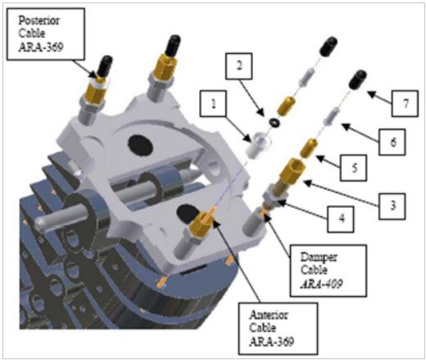

1.4.3.1. Damper cable
Feed the damper cable down through the top of the rear damper cable adjuster, and then down through the back cable holes of the vertebra, from the O.C. plate down through T3 (Figure 7). After cable is fed out through the damper cavity, feed it up through the front cable holes on the vertebra, from T3 up through the front damper cable adjuster on the O.C. plate (Figure 8).
Set the damper adjustment screw so that it is ½ turn open by turning it clockwise until travel stops, then turning it counter-clockwise ½ turn (Figure 9).
Overlap the cable as shown in Figure 10 and wrap the cable around the damper drum, making sure the cable is seated in the slot. Slide tapered projection of the end of the damper paddle into the tapered slot on the mounting plate (Figure 11) and slide clamp bracket over damper/plate assembly (Figure 12). Ensure that shallow slot on seal washer and the mating projection on the clamp bracket are mated (Figure 13).
Install the M8 mounting bolt and lock washer until it is finger tight. Tighten the M3 setscrew to firmly seat the damper into the tapered slot on the mounting plate (figure 14). Torque the mounting bolt to 5 ft/lbs (6.8 Nm).
Feed one #9005133 ferrule onto the end of the rear damper cable (Figure 15) and crimp the ferrule within 4" (100 mm) from the end of the cable (Figure 16).
Feed one #9005133 ferrule onto the end of the front damper cable (Figure 17). Ensure that the cable adjusters are adjusted all the way down, then pull up on both ends of cable with one hand so that the cable is seated tightly around the damper and so that rear ferrule touches the top of the cable adjuster.
Crimp the front ferrule while both front and rear ferrules are touching the adjacent adjuster (Figure 18). Leave both damper adjusters adjusted all the way down.

Figure 7  Damper cable installation (1)  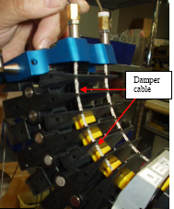  Figure 9  Damper Adjustment Screw setting | Figure 8  Damper Cable Installation (2)  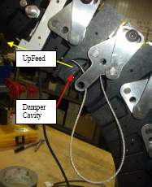
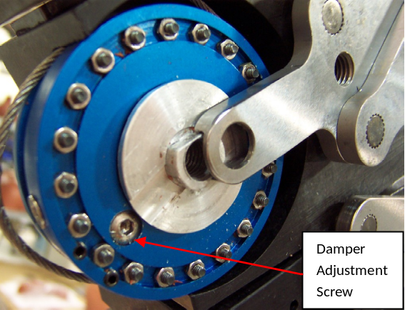  Figure 11  Slide damper into place | Figure 10  Damper Cable overlap  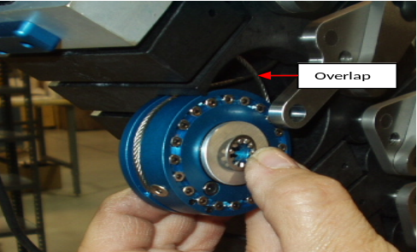  Figure 12  Install Damper Clamp Bracket
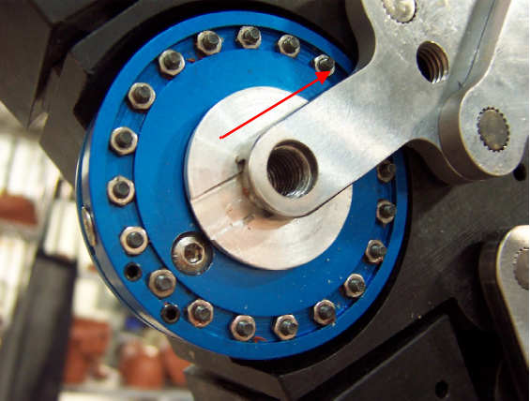  Figure 13  Damper Clamp Bracket mate | 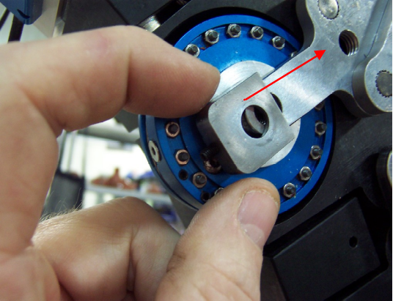
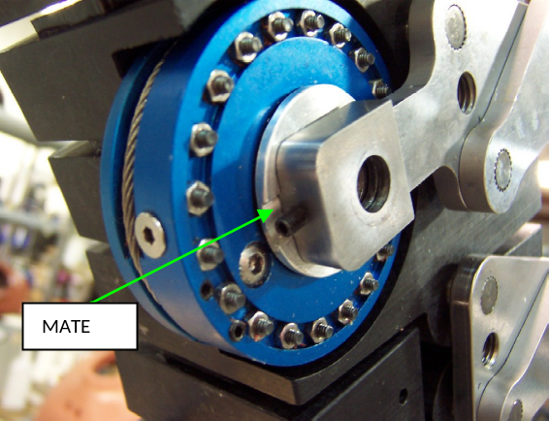  Figure 15  Damper Cable Ferrule installation | Figure 14  Damper Clamp Set Screw  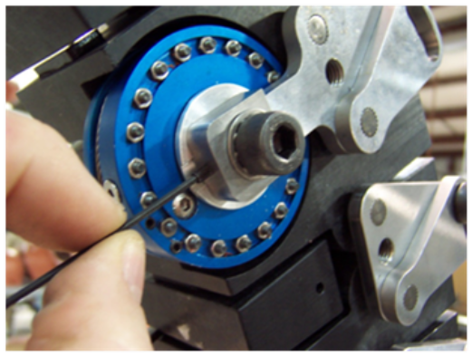
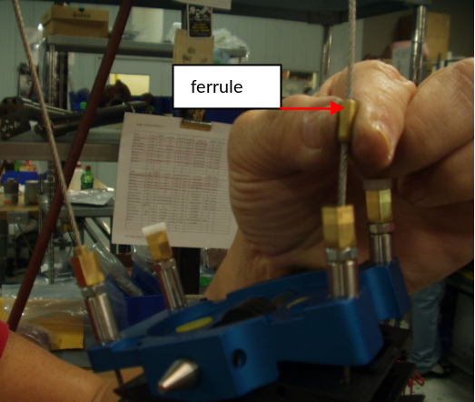  Figure 17  Damper Cable setting | Figure 16  Ferrule crimping  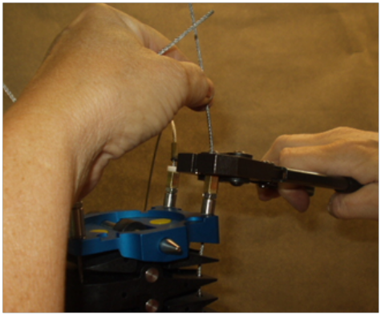  Figure 18.  Crimp Front Damper Ferrule
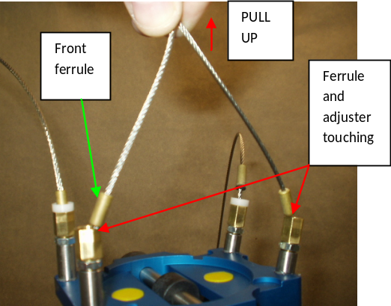 | 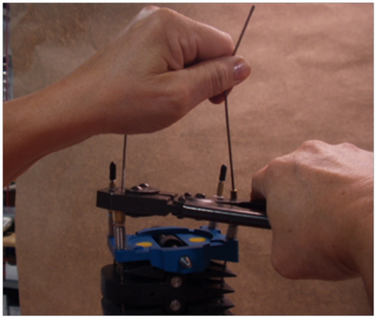
1.4.3.2. Spring Cable
Feed the anterior spring cable #ARA-369 through the small cable hole at the top of the longer spring tube (Figure 19), and up through all vertebra from T3 to the O.C. plate. Feed the anterior spring onto the end of the cable (Figure 20) and install the lower cable adjuster onto the threaded stud (Figure 21) until the adjuster is flush with the end of the cable stud.
Feed the posterior spring cable #ARA-369 through the small cable hole at the top of the shorter spring tube and up through all vertebra from T3 to the O.C. plate. Feed the posterior spring onto the end of the cable, install the lower cable adjuster and turn it upward so that there is 16 mm protruding (Figure 22). Masking tape may be used to assist in retaining the cable and spring assemblies in position through the next steps.
Ensure that both the front and the rear upper cable adjusters are adjusted all the way down. Install a #9005132 O-ring on both front and rear spring cables, followed by #9005133 ferrules, as shown in Figure 23.
Pull the anterior cable up to remove any slack remaining in the cable. Slide the ferrule down until it touches the top of the #ARA-711 cable guide (Figure 24) and crimp the ferrule in place. Repeat this step for the posterior spring cable assembly.
If smaller cable crimpers were used for ease, finish crimping all four ferrules with #9000827 cable crimpers, or equivalent. Use the smallest opening on the jaws.
Cut the ends of all four cables approximately 10mm above the ferrules. Place #9010293 cable caps on all four cables ends and crimp them in place with small crimpers. Place 1 drop of cyanoacrylate adhesive on the sides of each of the 4 cable caps and install vinyl caps #ARA-413 over them. Squeeze the vinyl caps briefly to ensure they adhere to the cable caps.
Figure 19
Anterior Spring Cable Insertion
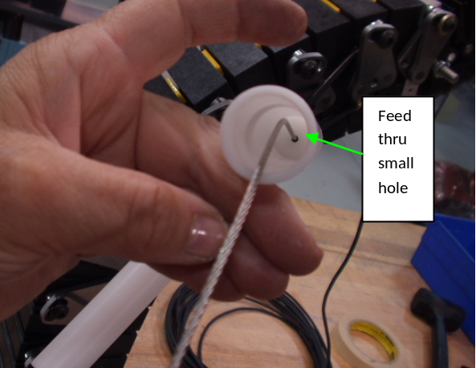 | Figure 20  Anterior Spring Insertion  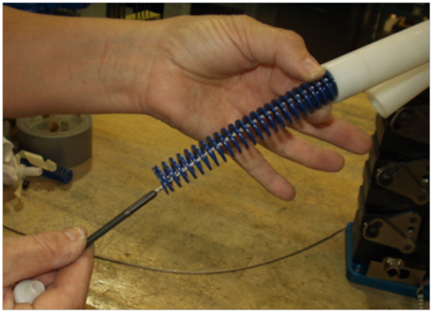

Figure 21  Cable Adjust Installation  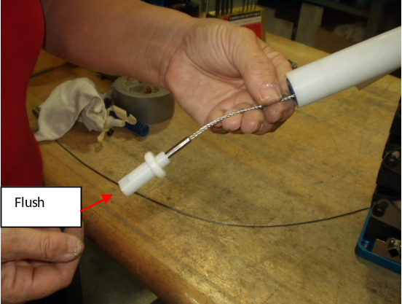 | Figure 22  Setting the Posterior Spring Cable  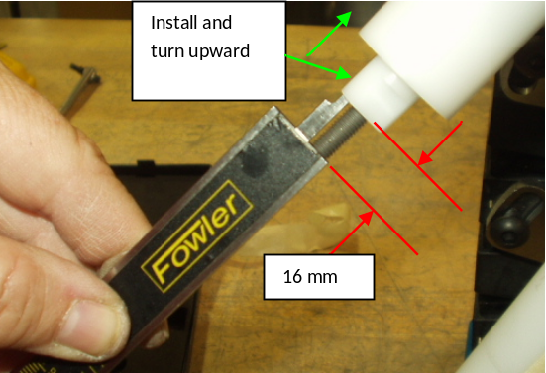  Figure 24  Remove Slack from Spring Cable
Figure 23  Ferrule Installation Front and Rear Spring Cable  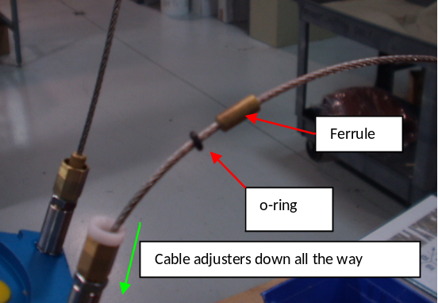 | 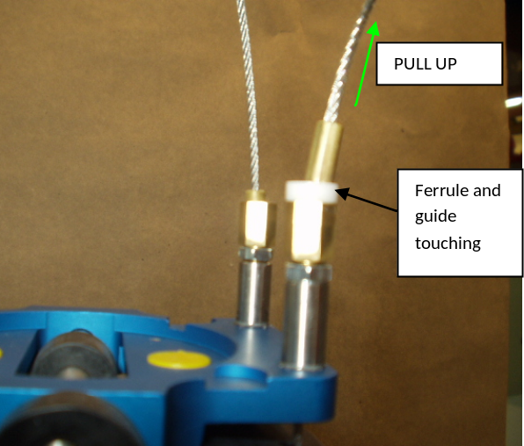
1.4.4. Damper Removal and Installation
In addition to damper replacement or maintenance, it is also necessary to remove the damper for maintenance work on the T1 load cell or for neck bumper replacement. The following are steps to remove and re-install the ARA-375 damper. Figure 25 is an exploded view of the damper assembly.
Loosen the locknuts on both adjusters for the damper cable, then turn the adjusters until they are at the lowest extremity of their travel, such that cable is as loose as possible (figure 26). Loosen both of the M3 cable clamping set screws to enable removal of cable from the mating slot on the side of the damper body (figure 27).
Back off the M3 setscrew (9010295) by two turns (figure 28). Remove the M8 damper mounting screw (9010294), then remove the Clamp Bracket (ARA-346). Slide the damper towards the front of the spine (figure 29) and turn the damper to untwist cable (figure 30) and disengage the damper from the cable.
When re-installing the damper, be sure that the cable overlap is correct; see figure 31 for a view of the correct overlap direction. Engage the cable within the cable slot of the damper.
Slide the tapered projection of the paddle into the tapered slot on the mounting plate (figure 32). If the parts will not mate, then the projection is out of position.
Slide the damper all of the way into the mating slot on the plate, then slide the clamp bracket (ARA-346) over the damper/plate assembly. After installing the clamp bracket, be sure that the shallow slot on the seal washer and the mating projection on the clamp bracket are mated. It may be necessary to spin the washer to line-up the slot with the projection.
Install the M8 mounting bolt (9010294) and lock washer (9005200) with fingers until finger tight. Tighten the M3 set screw (9010295) to firmly seat damper into the tapered slot on the mounting plate.
Note that some damper units exist with only one M3 set screw to clamp the cable to the damper; these older units do not comply with the BioRID II UN specification, which requires two such screws.
Figure 25
Exploded View of Damper Assembly
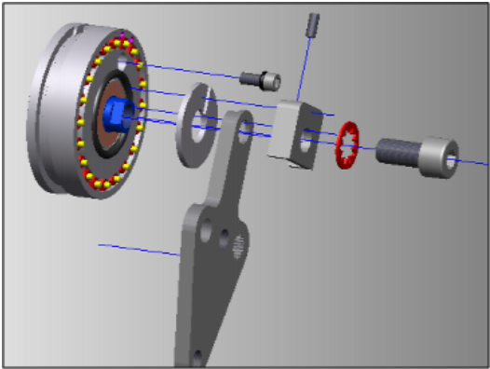 | Figure 26.  Loosen Adjusters  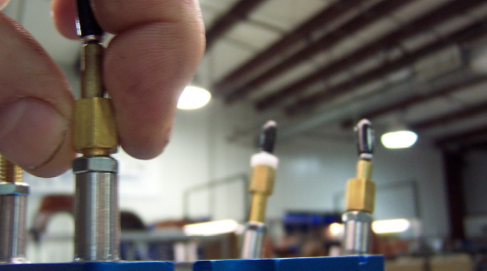

Figure 27  Loosen M3 Clamping Screws  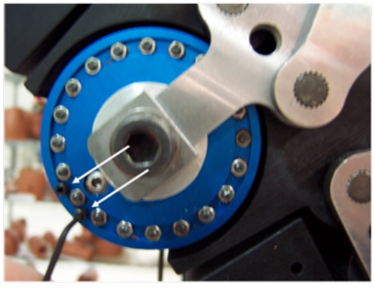 | Figure 28  Back Off Set Screw  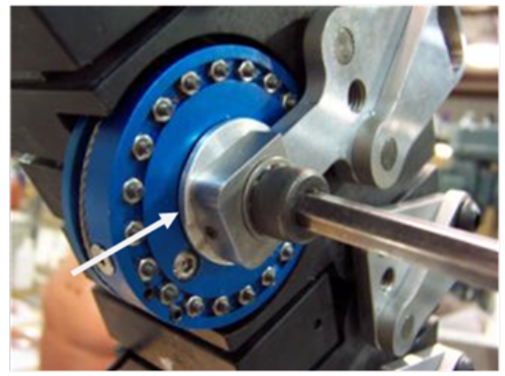
Figure 29  Slide Out Damper  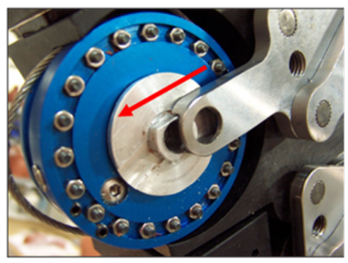  Figure 31  View of Correct Cable Overlap | Figure 30  Turn Damper and Disengage Cable  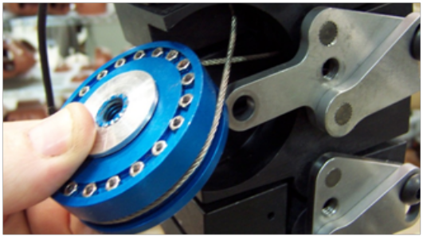  Figure 32  Install Damper
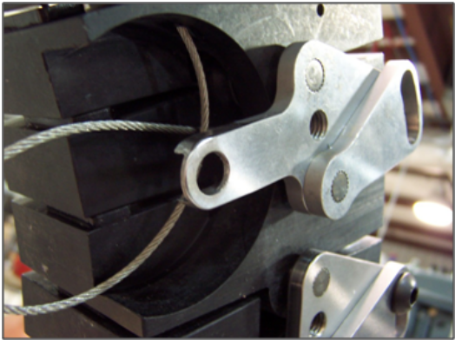 | 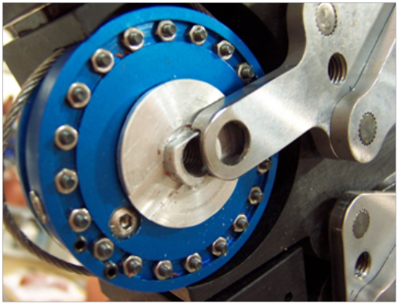

1.4.5. Damper Filling
Open the damper adjustment screw 2 full turns, by first closing the screw (turning it clockwise) to the full extent of its travel, and then opening the screw (turning it anticlockwise) by 720 degrees.
Remove Damper fill hole cover screw, M3 FHCS (Figure 33).
Install the M8 mounting screw and tighten until it is finger tight; this screw will be used for turning the paddle to isolate air pockets in the damper. Turn the M8 mounting screw all the way clockwise. If it is found that the screw loosens during subsequent steps, it may be further tightened with tools.
Using a syringe of ISO 680 damper oil, inject oil until it begins flowing out around the needle. After initial filling, it is then necessary to remove air pockets as follows:
Turn the paddle very slowly anticlockwise while holding the damper in one hand. A steady drag will be felt when oil is passing through the orifice inside the damper, but when an air pocket passes through the orifice, the drag is gone and the paddle suddenly rotates with much less resistance. This is easily felt when turning the damper by hand; even the smallest bubbles of air can be felt as small shock when they pass through the orifice.
After the air is felt to pass through the orifice and the drag suddenly starts again from the oil, stop rotating the paddle, and turn slowly back clockwise; the air will again be felt, but now the air pocket will be directly under the fill hole. Repeat filling with the syringe, and stop when oil flows out around the needle. Repeat this process until the damper is free of air through the entire rotation travel of the damper.
The fill hole cover screw may be installed between each syringe application, at the discretion of the user; this will help avoid accidentally pumping oil out of the damper if it is rotated too fast.
Coat the tapered portion of the cover screw with a silicone sealant or equivalent that is suitable for the temperature range encountered; silicone sealant containing copper is recommended (figure 34). Install the fill hole cover screw tightly and wipe away the excess sealant.

Figure 33.  Remove Oil Fill Screw | Figure 34  Add sealant to the cover screw

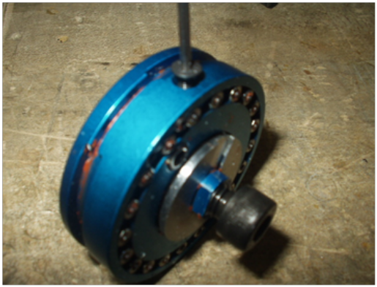 | 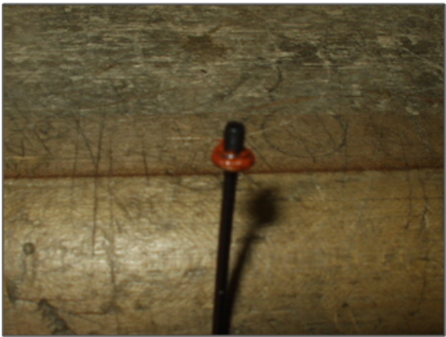
1.5. Static Spine Setup Procedure
The adjustments and tests described within this section shall be performed after any maintenance work (such as servicing or replacement of parts) is done upon the spine, and may be done more regularly (i.e. independent of maintenance work) as required. The procedures within this section are to be done in the sequence presented; it is not permissible to do parts of the process in isolation or in a different order.
1.5.1. Thoracic and Lumbar Spine
Place the spine on a bench top and ensure that all 17 torsion washer locking screws are loose. Insert the thoracic and lumbar vertebra spacer tool into the front of the lower spine as shown in Figure 35. Ensure the inside edge of tool is within 1 mm of the fronts of all thoracic and lumbar vertebrae; use a brass or hard rubber hammer to tap up and down along outer edge of tool to ensure correct location. Use optional attachment handles if necessary to aid installation.
Tighten the locking screws (Figure 36), beginning at the S1 lumbar plate screw on the right side of the spine and continuing upward on right side. Use 15 ft/lbs (20Nm) torque for each screw except for the T1 thoracic plate screw (Figure 37), which only requires 10 ft/lbs (14Nm). After all 9 screws on right side of spine are tight, tighten all 8 screws on left side of spine to 15 ft/lbs (20Nm), beginning at the L5 lumbar screw and continuing upward until all are tight. Hold the bottom of the spacer tool against the pelvis interface plate while tightening the L5 lumbar screw to prevent the spine tilting backward due to the torque.
Remove the spacer tool by tapping with a brass or hard rubber hammer, toward the right side of the spine.

Figure 35.  Thoracic and Lumbar Vertebra Spacer Tool with Optional Handles  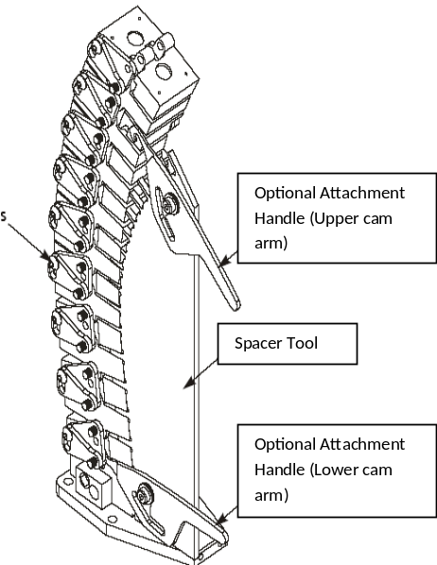  Figure 37  T1 plate screw torque | Figure 36.  Tighten locking screws  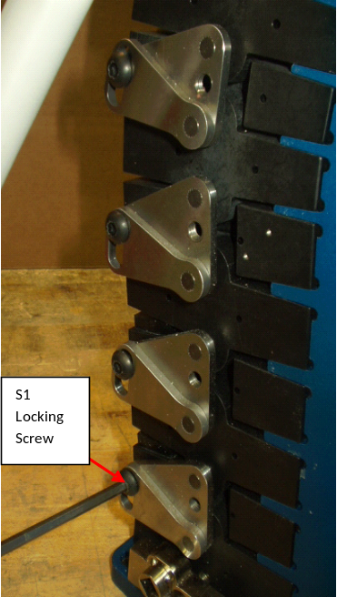
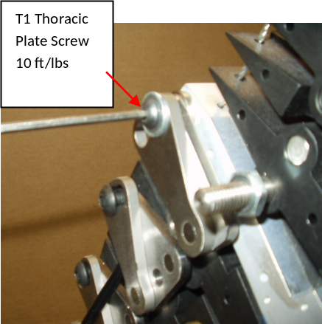

1.5.2. Cervical Spine Set-up (Pretension)
Place the spine on a bench top and ensure that the front and rear upper spring cable adjusters and the damper cable adjusters are set all the way down with the locknuts loose (figure 38), and that the cable is not clamped to the damper.
Adjust the lower spring cable adjuster on the front spring until the bottom is flush with the end of the spring cable stud (the front spring is attached to the front of the O.C. plate, and is the longer spring tube). Adjust the lower spring cable adjuster on the rear spring until the cable stud is protruding out from bottom of adjuster by 16mm (the rear spring is attached to the rear of the O.C. plate, and is the shorter spring tube). This is shown in figure 39.
Check the amount of slack in the spring cables by pulling them up at the point where they exit the upper cable adjusters (Figure 40) and allowing them to drop. Remove slack from the cables by turning the upper front and rear cable adjusters anticlockwise until no slack can be felt. Be careful not to add tension.
After removing all slack, tighten both locknuts onto the upper spring cable adjusters.

Figure 38.  Cable adjuster and locknut  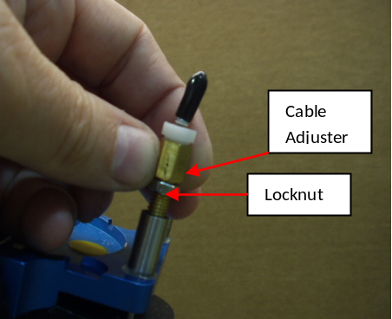 | Figure 39  Front and rear Spring Cable Adjusters 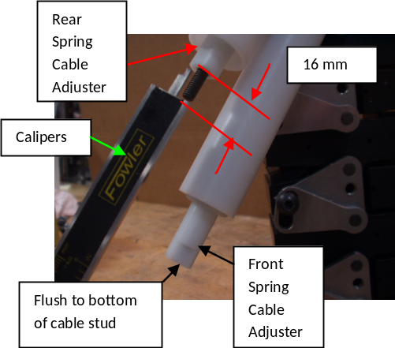
Figure 40
Check for Slack
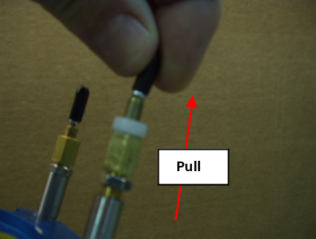

1.5.3. Cervical Spine Setup (Tension)
This procedure is to be used only after removing the slack from the cables as described in 1.2.4.2.
Using digital callipers for measurement, adjust the rear lower spring cable adjuster counter-clockwise (down) 10 mm so that the cable stud is now protruding by 6 mm (Figure 41). At this time there is 10mm free play in the rear cable. Next, adjust the front lower spring cable adjuster clock-wise (up) so that cable stud is now protruding 24 mm instead of flush. (Figure 42). This will leave an overall bias of 14mm (24mm added, 10mm subtracted).
Place locknuts on both cable studs and lock them against the spring cable adjusters, as shown in figure 43, then push up on the ends of both lower cable adjusters to release any twist in the cables that may have resulted from cable adjustments. Check that the length by which the cables protrude remains at 6mm (rear cable) and 24mm (front cable).
Place a digital inclinometer on the top of the spine/pelvis interface plate in the orientation illustrated in figure 44, and zero it. Grasp the O.C plate with both hands and force the plate to tilt it down in the front, such that the front spring and bumpers will force the plate to return upward in the front to settle to a new stationary position. After allowing the O.C. plate to remain in this position for 30 seconds, measure the angle about the y axis (i.e. forward rotation) on the O.C. plate (Figure 45). This angle must be not less than 30 degrees. If this condition is not achieved, reset front and rear springs at lower adjusters to values shown in Figure 46, then repeat the test in this paragraph.
Grasp the O.C plate with both hands and use force to tilt the plate down in the back, to the degree that the rear spring and bumpers will force the plate to return upward in the rear to a new position. After allowing the O.C. plate to remain in this position for 30 seconds, measure the angle about the y axis on the O.C. plate (Figure 47). This angle must be not more than 26 degrees. If this angle cannot be held, reset front and rear springs at lower adjusters to values shown in Figure 48 and repeat the test in this paragraph. If the angle still cannot be held, there is likely to be a problem with the front 8 cervical bumpers (ARA-220). Refer to 1.2.1.3 for bumper maintenance procedures.
Once the O.C. plate is confirmed to be adjusted correctly, re-lock the cable stud locknuts.

Figure 41  Rear Lower Spring Cable adjustment  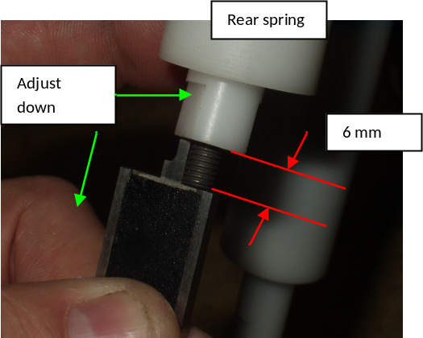 | Figure 42  Front Lower Spring Cable adjustment  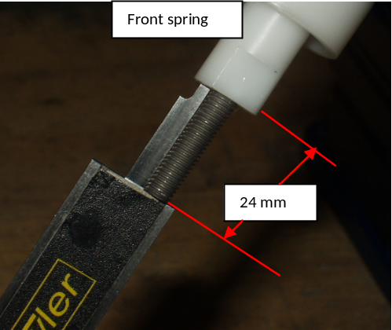
Figure 43  Lock the Spring Cable Adjusters  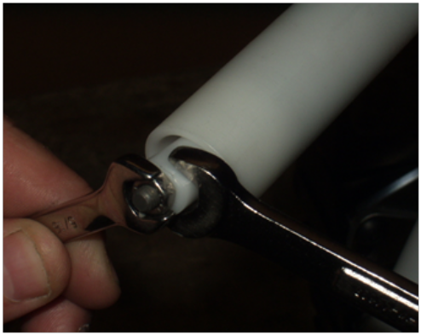  Figure 45  Tilt OC Plate down in front | Figure 44  Zero Digital Inclinometer  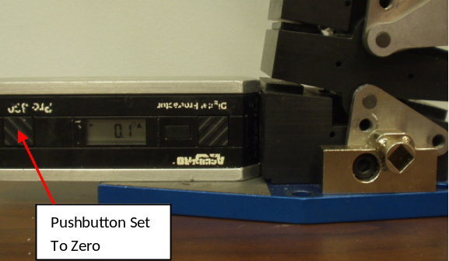  Figure 46  Front (left) and Rear (right) Spring Adjustment if front angle cannot be held with original values
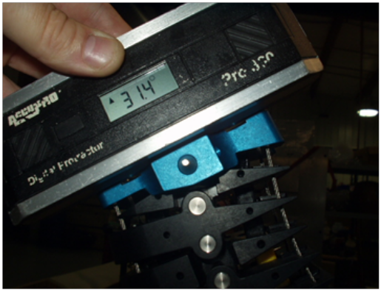  Figure 47  Tilt OC Plate down at the back | 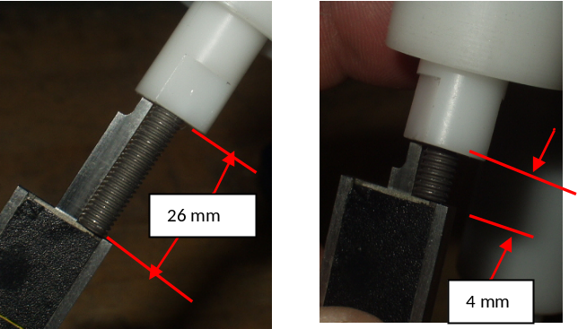  Figure 48  Front and Rear Spring Adjustment if back angle cannot be held
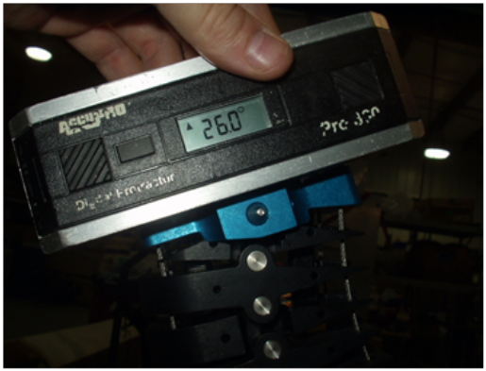 | 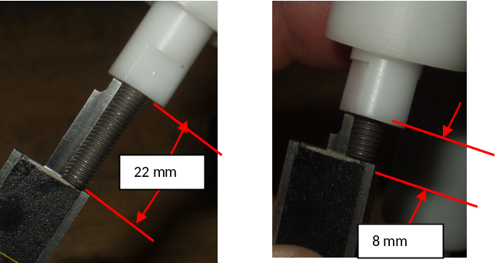
1.5.4. Damper Cable Adjustment
Commence this step with the spine in the position obtained in 1.2.4.3.

Adjust the damper cable adjusters (Figure 49) upward until tension is added to damper cable around damper drum, then clamp the cable to the damper with both M3 set screws (Figure 50).
Place a digital inclinometer laterally across the O.C. plate as shown in figure 51 and add tension to the damper cable using both cable adjusters, until the angle across the O.C. plate is zero +/- 0.5 degrees. Once the angle is correct, tighten both locknuts on the damper cable adjusters and leave the spine in position for the next step.

Figure 49  Damper Cable Adjusters  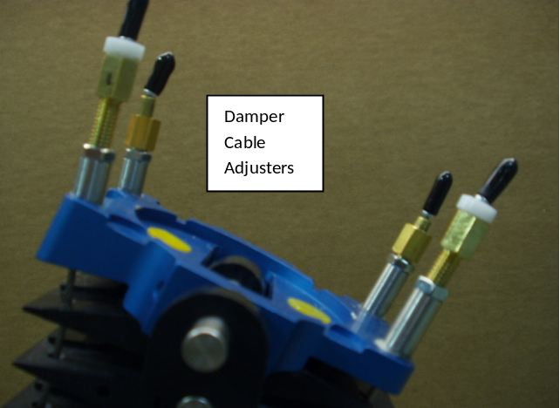 | Figure 50.  Damper Adjustments  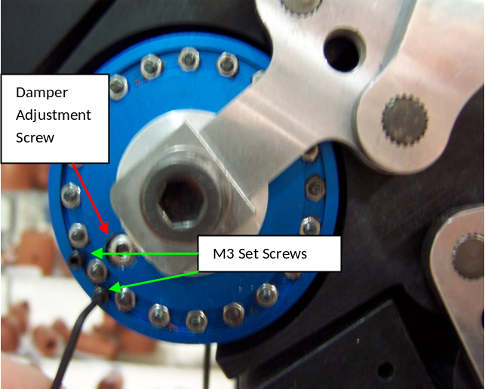
Figure 51
OC Plate Lateral Angle Setting
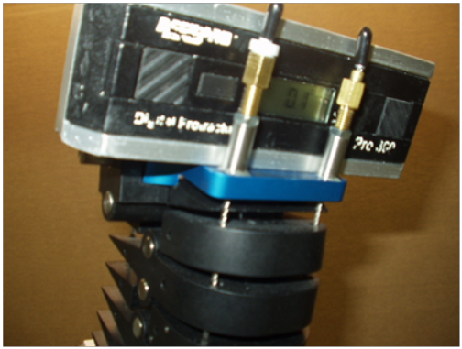

1.5.5. Static Spine Measurements
Static spine measurements are used to ensure that the posture of the dummy is correct; figure 52 shows a summary of these measurements. The measurements shall be verified after any maintenance or adjustment of the spine or muscle substitute assembly, and during certification of the dummy. Record the measurements that are taken.
Commence this step with the dummy in the position obtained during 1.2.4.4. By hand, force O.C. plate to an angle between 29-30 degrees of forward tilt (about the y-axis), using the digital inclinometer to verify. The O.C. plate will hold this angle with the damper in the system (Figure 53).
Measure the Z dimension from the centre of the O.C. pin to the bottom of the spine/pelvis inter-face plate (which contacts the bench top). This dimension shall be 570-580 mm. Alternatively, measure the Z dimension between the O.C. pin and the H-point; this dimension shall be 604-614 mm.
Measure the X dimension from the centre of the O.C. pin to the centre of the H-point tool square insertion hole. This dimension shall be 199-209 mm. Alternatively, measure the X dimension from the centre of the O.C. pin to the H-point; this shall be 151-161 mm.
Figure 54 shows an optional measuring tool that can be used to assist. Figure 55 shows an optional H-point block insert, useful for accurately indicating centre of H-point block square hole.
Using the digital inclinometer, verify the angle on the rear of T2 vertebra at 36.5-37.5 degrees (Figure 56); if this is not achieved, adjust the spine position within the allowable tolerances and repeat the measurements within this section until the correct angle is achieved.
If a spine position satisfying all the required dimensions cannot be achieved, the spine does not conform to the BioRID II UN specification.
Figure 52
Spine Setup Measurements

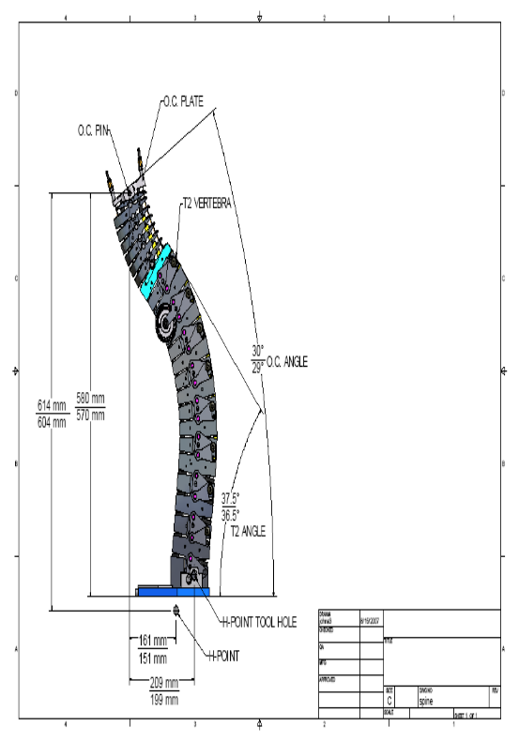 |  | Figure 53  OC Plate angle setting  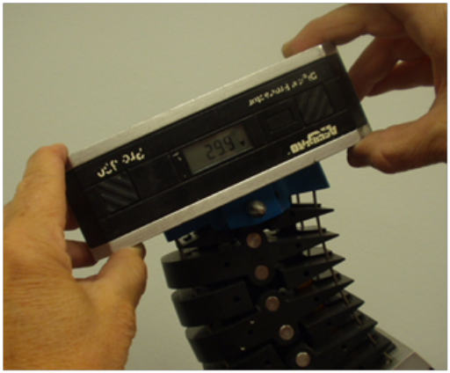
Figure 54  X and Z Measurement Tool  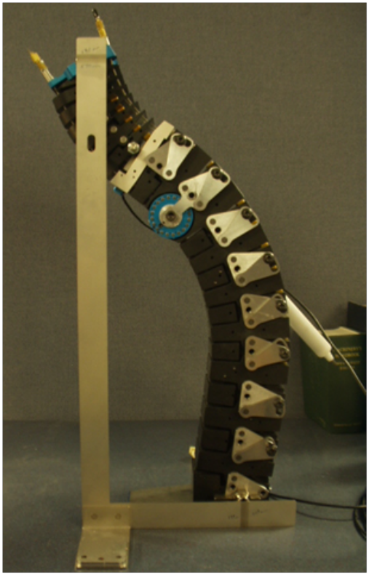 | Figure 55  H-Point Measurement Tool  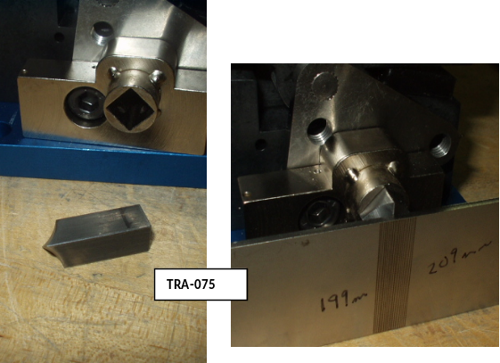  Figure 56  T2 angle setting  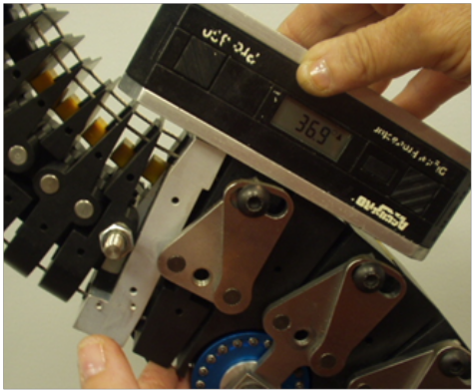

1.6. Torso Flesh and Lifting Bracket
1.6.1. Assembly
Figure 57 shows a breakdown of the jacket and lifting cable assemblies. The components are listed within Annex 2.
Figure 57
Torso Flesh and Lifting Bracket assembly components
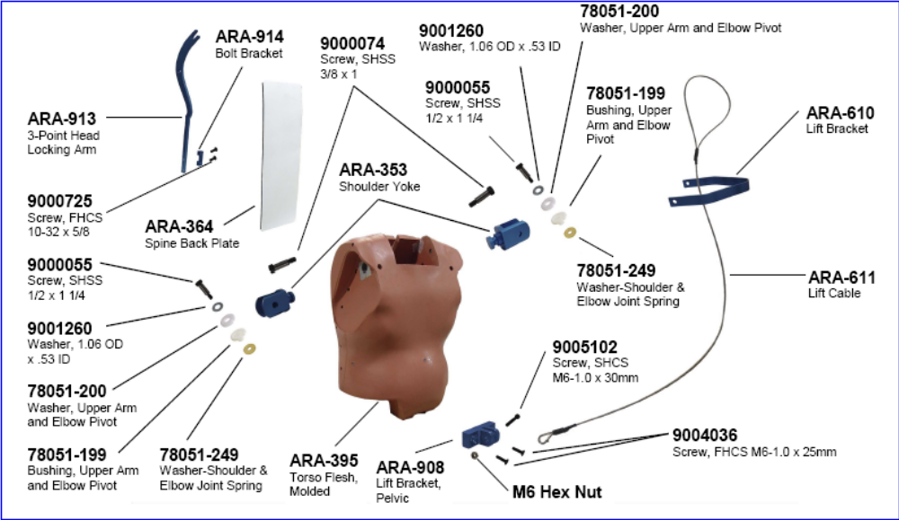
1.6.2. Removal
To separate the upper torso from the pelvis and legs, remove the two M10 X 1.5 X 40 mm SHCS located at the rear of the modified Hybrid III pelvis structure and the M10 X 1.5 X 40 mm SHCS located at the front, accessed through the bottom of the pelvis. The pelvis and legs can then be pulled away from the upper torso
Remove the arms by taking out the 3/8 x 1-1/2" SHSS located on the front of the torso at the shoulder pivot and pull the shoulder yoke and arm assembly away from the upper torso as one unit.
After both arms are removed from the upper torso, the torso flesh can be removed. Take out the back plate from the rear of the torso flesh, remove the two M6 X 1 X 12 SHCS located at the base of the upper torso flesh in the front of the dummy, and take out the interface pins along each side of the torso (these are the fifteen pins that connect the spine and torso). Lay the upper torso on a clean, flat surface with the chest down and loosen the upper four screws (two on each side) with an M6 Allen key, then remove the remaining screws with an M4 Allen key. Pull the spring loaded muscle substitute assemblies (2 pieces) from their holder in the torso flesh, then pull the flesh away from the spine assembly.
1.6.3. Abdomen Filling Procedure
The abdomen shall be filled with 2.06 litres (4.35 lbs) of water through the valve on the left side of the torso flesh (figure 58). A one gallon bottle with a three foot long hose and a 14 gauge (1.7 mm ID) X 1-1/2" long needle is used to fill the abdomen.
Fill the bottle with the required 2.06 litres (4.35 lb) of fresh water. The spigot valve must be closed. Lay the torso down with the abdomen filling valve pointed upward, then remove the plastic cap covering the valve and take out the valve core; this can be achieved using a generic valve core tool.

Insert the needle into the valve opening. Holding the bottle and hose assembly above the abdomen, open the spigot on the bottle. After all the water is emptied from the bottle and the hose into the abdomen, remove the needle from the valve. Do not over fill.
Reinstall the valve core. Depress the core to allow air to escape and gently squeeze the abdomen to remove all the remaining air. Water will be visible in the valve when all the air is removed. It may be necessary to do this step several times while tilting the torso in different directions. Reinstall the plastic valve cap to complete the procedure.
Figure 58
Location of the Abdomen Fluid Valve
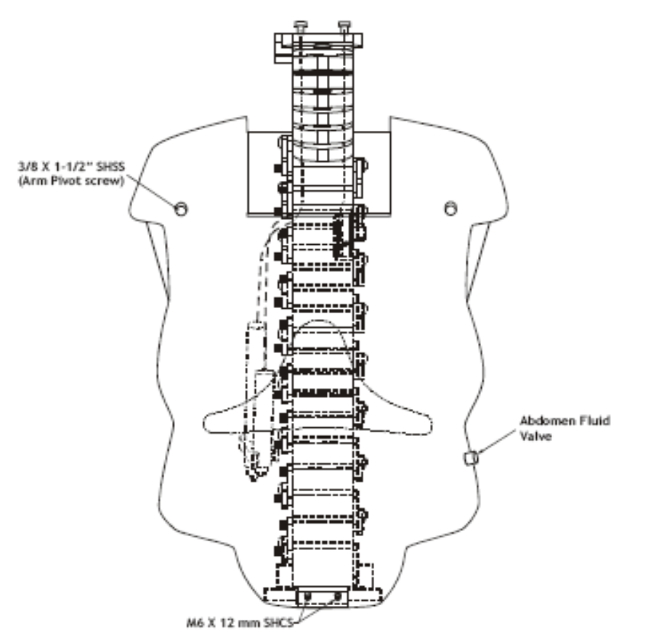

1.7. Pelvic Assembly
1.7.1. Assembly
BioRID II UN uses a modified Hybrid III 50th Percentile pelvis. The assembly consists of the moulded pelvis structure, the femur assemblies (left and right) and two femur friction plungers used to apply force to the femur ball and provide resistance to leg motion. Figure 59 shows a breakdown of the components, which are listed within Annex 2.
Figure 59
Pelvic Assembly components
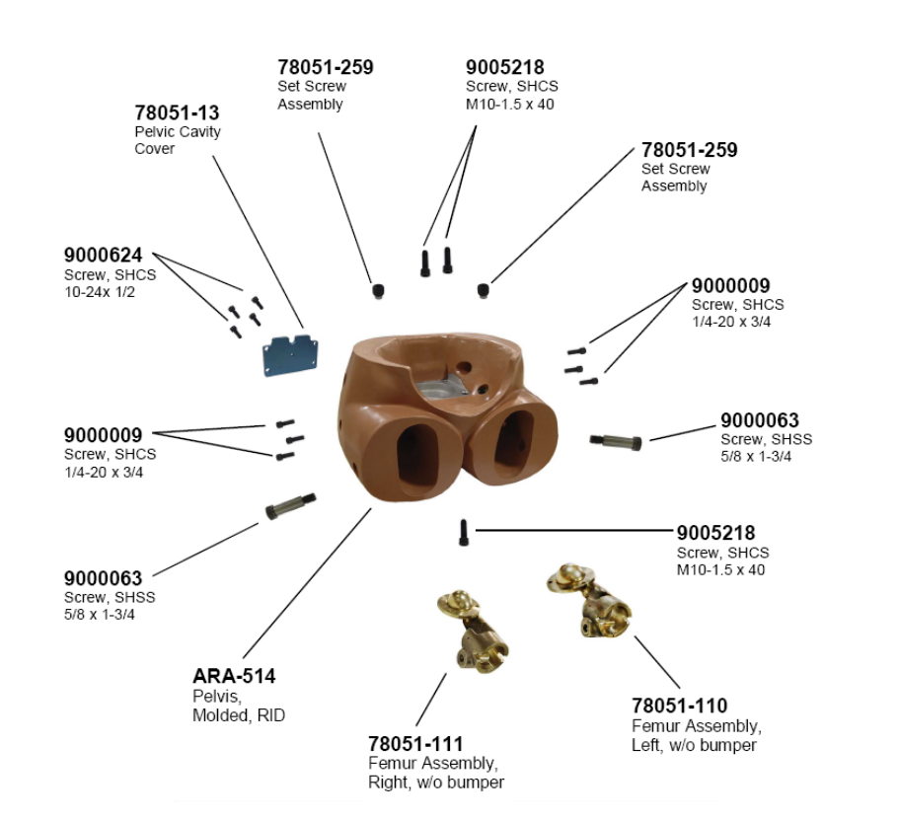

1.7.2. Disassembly
Remove the 5/8 X 1-3/4" SHSS in the pelvis that secure the legs in the femurs, and remove the legs. Take out the three 1/4-20 x 3/4" SHCS that secure each femur flange to the pelvis bone and remove the femur assemblies. Check the femur ball for damage or metal deposit build-up.
1.8. Arms
1.8.1. Assembly
BioRID II UN uses Hybrid III 50th percentile Male Dummy arms. Figure 60 shows a breakdown of the components in a left arm assembly. The components are listed within Annex 2.
Figure 60
Arm Assembly components (left shown)
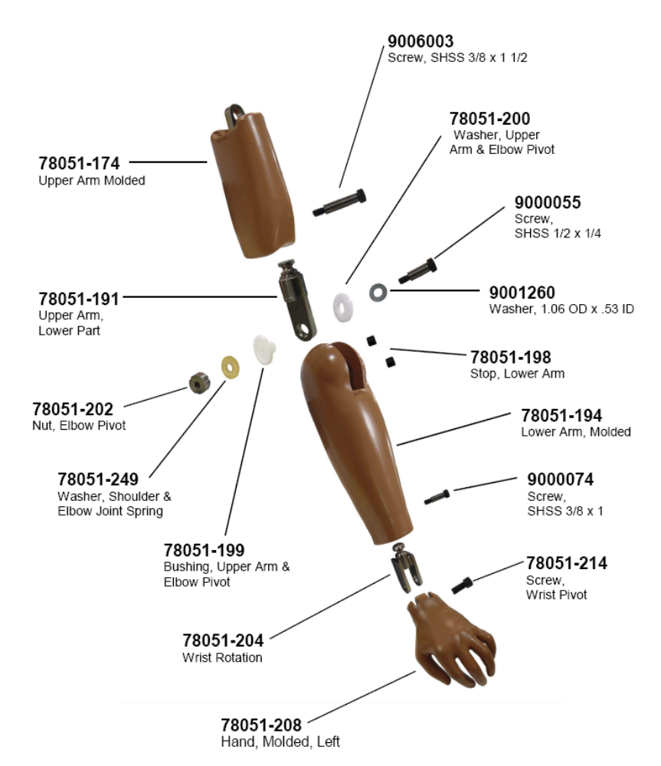
1.8.2. Disassembly
Remove the 1/2 X 1-1/4" SHSS bolt and associated washer at the elbow joint and remove the lower arm assembly by rotating the lower arm rearward. Within the elbow joint are the pivot washer, pivot bushing, pivot nut and spring washer. Check each component for damage, and replace as necessary.
To separate the lower part of the upper arm, take out the 3/8 X 1-1/2" SHSS in the upper arm section, just above the elbow. The upper arm assembly can then be pulled from the upper arm lower part. The upper arm lower part is the component that is inserted into the elbow joint.
The moulded hand is detached from the lower arm assembly by taking out the wrist pivot screw (modified 1/2-20 X 1-1/4" SHCS) and pulling the hand from the wrist assembly. The wrist assembly is removed by taking out the 3/8 X 1" SHSS and pulling the wrist assembly from the lower arm.
1.9. Legs
1.9.1. Assembly
The BioRID II UN dummy uses Hybrid III 50th Male Dummy legs. Figure 61 shows a breakdown of the components in a left leg assembly; a list of these components is within Annex 2.
Figure 61
Leg Assembly components (left shown)
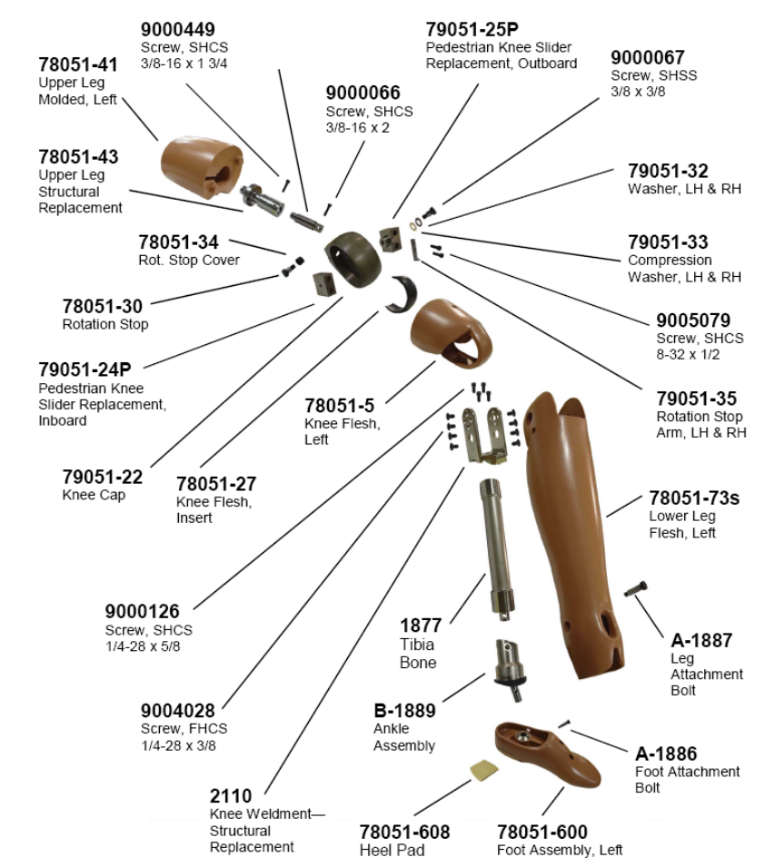
1.9.2. Removal
To detach the upper and lower leg sections, pull the flesh flaps away from the knee section and take out the four modified 1/4-28 X 3/8" FHCS on each side of the knee (i.e. a total of 8 per leg), then slide the knee clevis off the knee assembly.
To disassemble the upper leg assembly, take out the 3/8-16 X 1-3/4" SHCS at the top of the assembly toward the knee end, then pull the knee assembly away from the thigh.
The femur load cell is installed between the knee and thigh and can be removed by taking out the 3/8-16 X 2" SHCS in the knee assembly. With the knee detached, the femur flesh can be slid off the upper femur bone by pushing it toward the knee.
To disassemble the knee assembly, take out the knee pivot bolt (modified 3/8" diameter SHSS) at the pivot centre of the knee slider replacement assembly. There are two washers used with this bolt; one is steel and one is synthetic. The synthetic (compression) washer shall be installed into the outboard (outer surface of the knee) knee slider first, and then the steel one inserted after this. Do not reverse the sequence upon reinstallation, or the synthetic washer will be damaged.
There is also a rotation stop installed on the outboard side of the knee bone. The stop consists of a modified 3/8 X 3/8" SHSS and a rubber sleeve. The stop is removed by taking out the 3/8" screw and pulling the sleeve off the shoulder. Be sure the threads of the screw do not extend into the inboard knee slider replacement rotation path.
The knee flesh is removed by holding the knee bone and peeling the flesh off the outer knee radius (the impact surface). The knee insert (the black rubber part between the flesh and the knee bone) can be taken off the knee bone at the same time as the flesh. Inspect the flesh and insert for damage.
To take off the moulded foot assembly, take out the modified 1/4 X 3/4" SHSS at the foot–ankle joint. With the foot removed, the lower leg flesh may be slid down the tibia toward the ankle to remove it.
Remove the knee clevis by taking out the four 1/4-28 X 5/8" SHCS.
To disassemble the ankle, take out the leg attachment bolt and pull the ankle off the lower leg assembly. Take out the 5/16-18 x 3/8" SSCP and the friction pad to remove the force on the ankle shaft. Remove the two #10-32 x 1/4" SSCPs holding the stop pin retainer in place and pull out the pin retainer, allowing the stop pin to fall out of the assembly. Take out the six #8-32 x 1/2" BHCS that connect the upper and lower ankle shells. Four of these button head screws hold the ankle bumper in place and two are under the pad. Before reassembling the ankle, make sure the ankle shaft and inside surfaces of the shells are clean and free of burrs.
Grease or liquid lubricants shall be avoided inside the ankle assembly. Use graphite or equivalent dry lubricant if necessary.
1.10. Joint Adjustment Procedure
The joints of the Hybrid III dummies shall be adjusted to a "one G suspended setting." This is defined as a torque level on the joint where the friction will allow an assembly to move toward the earth when a small force is applied to the unsupported end of the assembly, but where the friction is sufficient to support the assembly when it is static and no external forces are applied. For example, when the dummy’s arm is fully extended laterally so it is perpendicular to the body, the shoulder yoke clevis bolt must be tight enough to support the weight of the arm, but loose enough so that when the dummy’s wrist is given a light tap, the whole arm will slowly fall towards the dummy. Multiple iterations of the testing and adjustment are likely to be required in each instance.
1.10.1. Joint adjustment - Arms and Hands
Extend complete arm laterally outward to a horizontal position at the side of the dummy. Twist the arm so the elbow faces downward, to ensure the elbow cannot rotate downward under gravity. Tighten the shoulder yoke clevis bolt to achieve a one G suspended setting.
Rotate the complete arm assembly so it points forward and is horizontal (i.e. is parallel to the X coordinate direction). Twist the arm so the elbow cannot rotate downward. Adjust the shoulder yoke rotation hex nut (figure 62) to achieve a one G suspended setting.
Bend the elbow 90 so the lower arm is vertical and pointing upwards, then rotate the arm so that the upper arm is horizontal in front of the chest, maintaining the 90 elbow bend. Adjust the elbow rotation bolt through the access hole in the upper arm (figure 63) to hold the lower arm in a one G suspended setting. Note that the figure shows the arm positioned for convenient bolt access, not in the position for the one G suspended setting test.
Reposition the arm so that the upper arm is pointing downward and slightly forward, and the lower arm is horizontal and facing forward, as shown in figure 64. Adjust the elbow pivot bolt through the access holes in the lower arm flesh at the elbow to achieve a one G suspended setting.
Extend the arm and twist the palm so it faces down. Adjust the wrist pivot bolt at the base of the hand to achieve a one G suspended setting. Rotate the palm to the thumb up position and rotate the wrist 90 so that the palm faces the torso. Adjust the wrist rotation bolt through access in the wrist flesh (figure 65) to achieve a one G suspended setting.
Repeat procedure for other arm and hand.

Figure 62  Shoulder joint setting  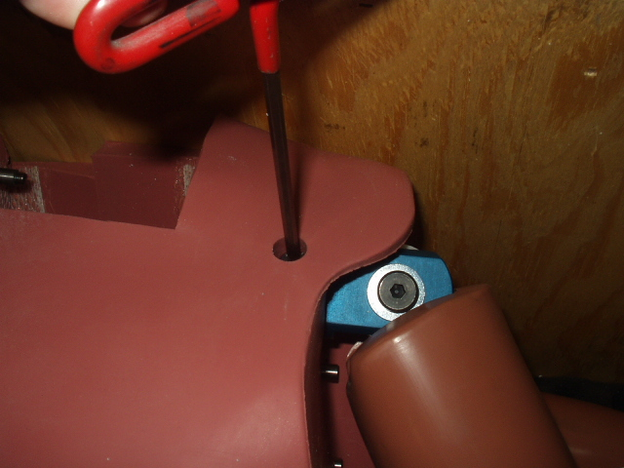 | Figure 63  Access hole for the elbow rotation bolt  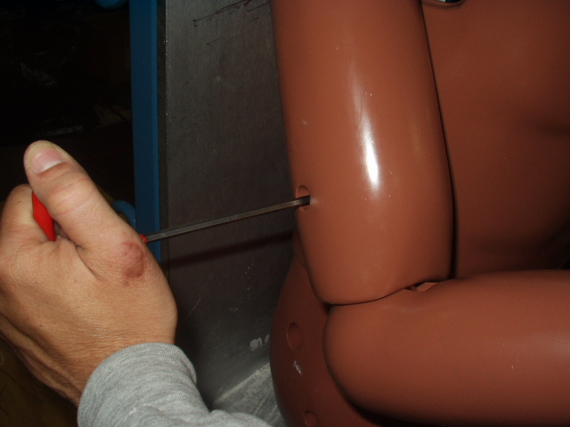
Figure 64  Adjusting the elbow pivot bolt  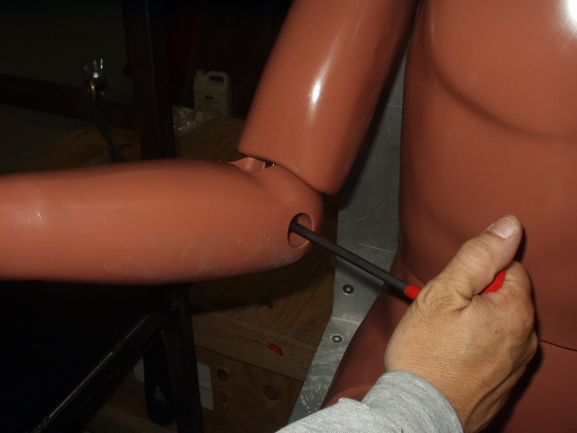 | Figure 65  Adjusting the wrist rotation bolt  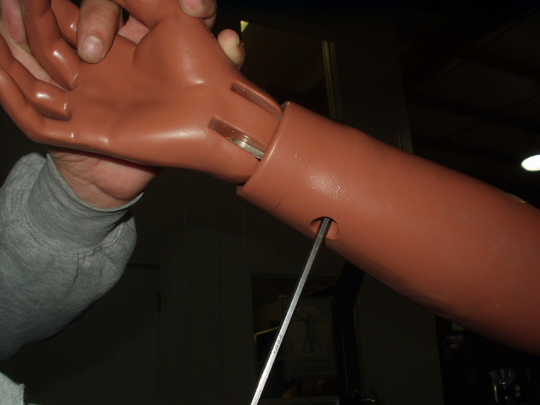

1.10.2. Joint adjustment - Legs and Feet
Remove the abdominal insert. With the lower leg at 90 to the upper leg and the dummy in a seated position, lift the upper leg assembly above horizontal. Adjust the femur ball set screw (figure 66) to achieve a one G suspended setting.
Rotate the lower leg assembly so it is horizontal, i.e. the leg is straight and pointing forwards. Adjust the knee clevis bolt (figure 67) to achieve a one G suspended setting. Adjust the ankle ball joint set screw (figure 68) to achieve a one G suspended setting. The ankle adjustment is not critical and is determined by individual feel, as it will be found that it is difficult to achieve a precise one G suspended setting for this joint in practice.
Repeat procedure on other leg and foot.
Figure 66
Adjusting the Femur Ball Set Screw
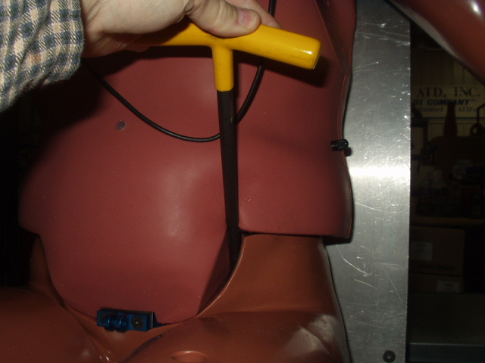  Figure 68  Ankle joint setting | Figure 67  Knee joint setting  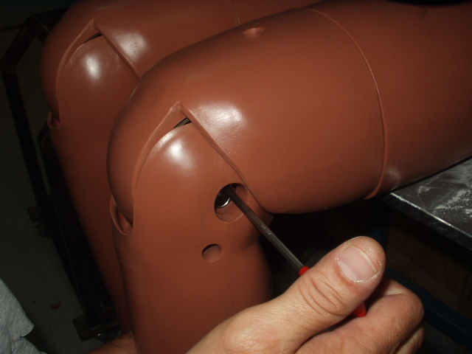
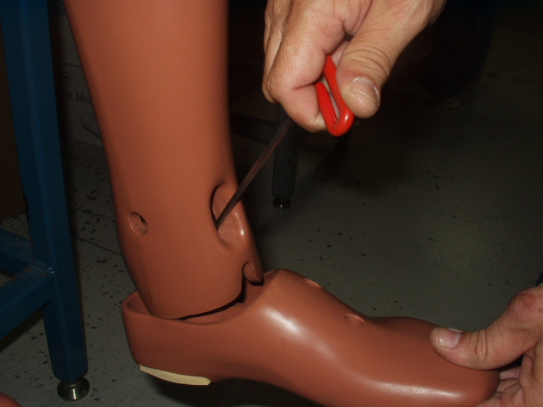

1.11. Clothing
1.11.1. Shirts and Shorts
The BioRID II UN clothing consists of two pairs of shorts and two shirts, made of a stretchable synthetic fabric containing both nylon and an elastomer fibre made from polyurethane; these two fibre types shall account for the majority of the overall fabric. This fabric has a shiny texture on one side and a matt texture on the other. The clothing shall be placed upon the dummy in two layers such that the shiny sides of the materials come face to face with each other.
1.11.2. Shoes
The BioRID II UN Shoes are of the men’s dress oxford type in US size 11 extra wide, meeting military specifications MILS-13192P. Each shoe weighs 0.61 +/-0.02 kg and has an overall length of 320-325mm.
2. Instrumentation
2.1. Head Assembly
2.1.1. Assembly Components
The BioRID II UN Head is equipped to accept three uni-axial accelerometers mounted on a block to measure acceleration in the x, y and z coordinate directions at the head centre of gravity. Table 1 summarizes the parts used for instrumentation in the head. Figure 69 shows the orientation of the accelerometers with respect to the head.
Table 1.
Head instrumentation parts
Part Description | Quantity | Part Number
Uni-axial Piezoresistive Accelerometer | 3 | SA572-S4
#0-80 x 1/8" SHCS | 6 | 9000152
Tri-axial Mount Block | 1 | SA572-S80
#2-56 x 5/8" SHCS | 2 | 9000531
Figure 69
Head accelerometer orientation
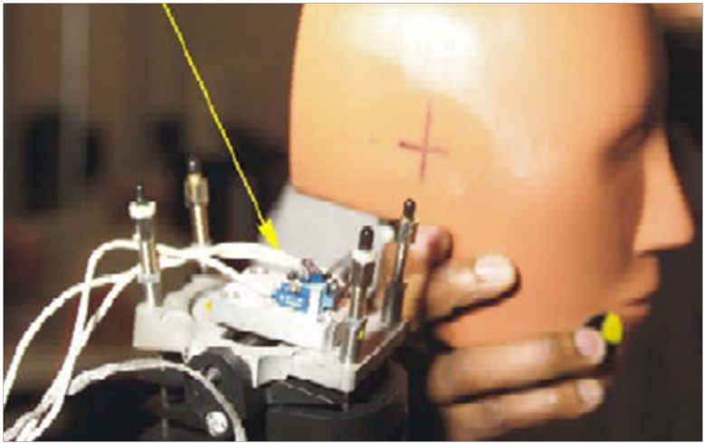
2.1.2. Installation
The three uni-axial piezoresistive accelerometers shall be mounted onto the tri-axial mount block (figure 70) with two #0-80 X 1/8" SHCS per accelerometer (4 total) so that their seismic masses all point to one corner of the block [needs further clarification- see questions emailed to Paul. Point where sensitive axes of accelerometers may need to be better defined, as it clearly affects results and will change if different accelerometers/ suppliers are used]. The tri-axial block shall be attached to the head mounting block using two #2-56 X 5/8" SHCS.
The head mounting block shall be attached to the upper neck load cell (or upper neck load cell structural replacement) using four #10-24 X 7/16" SHCS. The upper neck load cell or upper neck load cell structural replacement shall be inserted into the head cavity.
Figure 70
Head accelerometers installed on triaxial mount block
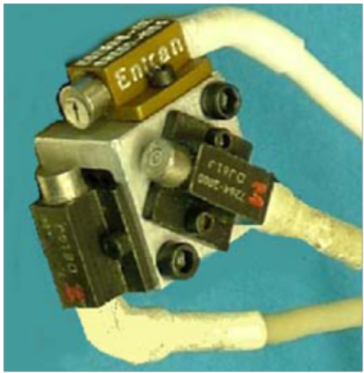

2.1.3. Skull Cap Contact Switch
The BioRID II UN dummy uses a skull cap skin with an electronic switch circuit. This is a direct replacement to the Hybrid III skull cap, and is designed to make electrical contact with an equivalent surface on the test apparatus. Figure 71 shows a skull cap with the contact switch circuit. The skull cap shown has additional holes to attach to the skull cap load cell; these are unacceptable for regulatory use as BioRID II UN does not include the option of using a skull cap load cell.
The BioRID II UN skull features a dowel that mates with a corresponding hole in the BioRID skull cap but prevents the use of a Hybrid III skull cap (which has no corresponding hole).
The BioRID II UN skull cap contains two electrodes, one on each side, which are electrically insulated from each other. The electrodes consist of conductive paint upon the surface of the skull cap skin, with wires connecting to this at the sides of the skull cap, away from the portion that will make contact with the head restraint (the location of these wires can be seen in the figure as rough patches at the outer edges of the electrodes). This method has been chosen as it provides better reproducibility than the use of conductive tape.
For the switch circuit to be closed, the skull cap must make contact with an electrically conductive surface. This surface shall be a conductive fabric placed over the head restraint; the use of conductive tape is not permitted.
Figure 71
Skull Cap Contact Switch
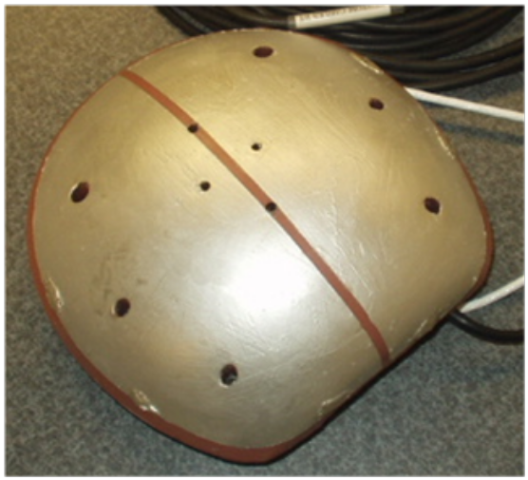

2.2 Spinal Column – Cervical portion
2.2.1. Assembly Components
The BioRID II UN dummy shall be equipped with the following neck instrumentation: an upper neck load cell measuring X, Y and Z forces and moments, two uni-axial piezoresistive accelerometers at C4, a lower neck load cell at T1 measuring Fx, Fz and My, and two uni-axial piesoresistive accelerometers at T1. Accelerometers may be located on the right or left side of the cervical vertebrae. Angular rate sensors may also utilize the accelerometer mounting on the cervical vertebrae.
2.2.2. Mounting of Accelerometers
Cervical spine accelerometers shall be mounted on the sides of the accelerometer block, and shall measure Ax and Az accelerations when the block is mounted on the spine. Two uni-axial piezoresistive accelerometers shall be mounted onto the tri-axial mount block with two each #0-80 X 1/8" SHCS (4 total) such that their seismic masses point to one corner of the block as shown in Figure 72.
2.3. Spinal Column - Thoracic and Lumbar Portions
2.3.1. Assembly Components
The BioRID II UN dummy is equipped with two uni-axial piezoresistive accelerometers located at both the eighth thoracic vertebra and the first lumbar vertebra (4 accelerometers in total), measuring Ax and Az accelerations, and a lumbar load cell measuring X and Y axial forces and moments about Y axis. Accelerometers may be located on the right or left side of the thoracic vertebrae. Angular rate sensors may also utilize the accelerometer mounting on the thoracic vertebrae.

2.3.2. Mounting of Accelerometers
Thoracic spine accelerometers shall only be mounted on the sides of the accelerometer block, and when mounted to the spine shall measure Ax and Az accelerations. Two uni-axial piezoresistive accelerometers shall be mounted onto the tri-axial mount block with two each #0-80 X 1/8" SHCS (4 total) so that their seismic masses all point to one corner of the block as shown in Figure 72 [See note for point 2.1.1.2. This is awaiting further clarification from Paul]. This step is identical for T8 and L1 accelerometer locations.
Figure 72
Thoracic Spine Accelerometer Mount
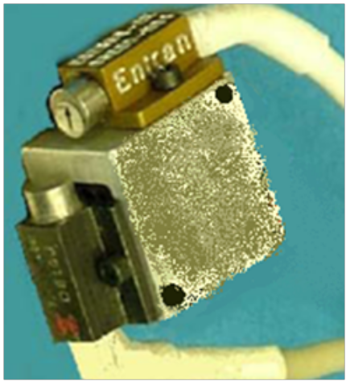
2.4. Pelvis
2.4.1. Assembly components
BioRID II UN is equipped with an instrumentation cavity in the back of the pelvis for the installation of accelerometers, angular rate sensors, and/or tilt sensors to measure the pelvis Ax, Ay and Az accelerations, and also the AVx, AVy and AVz angular rates.
2.4.2. Mounting of accelerometers
Three uni-axial piezoresistive accelerometers shall be mounted onto the tri-axial mount block with two each #0-80 X 1/8" SHCS (6 total) so that their seismic masses all point to one corner of the block.
The tri-axial block shall be attached to the pelvis accelerometer mounting plate using two #2-56 X 5/8" SHCS. The pelvis mounting plate shall be attached to the pelvis instrumentation cavity.
2.5. Cable Routing
The instrumentation cables must be routed in and around the dummy in a manner that ensures that the dummy’s motion is not affected by the cables and that the cables are not in a position where they are susceptible to damage from the test event.
2.5.1. Grounding
To reduce the possibility of static electricity discharge and subsequent noise in the data acquisition system, the metal bodies of the accelerometers and load cells shall be electrically connected to the ground. Figure 73 shows a typical grounding scheme. It shall be ensured that there are no electrical ground loops in the system.
Figure 73
Suggested instrumentation grounding scheme
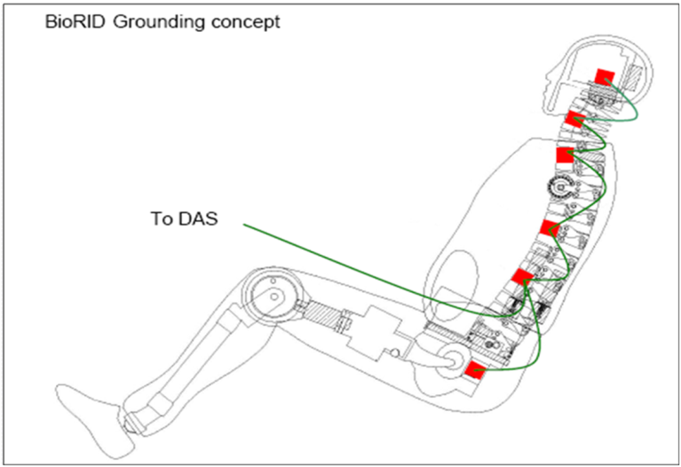
2.5.2. Head and Neck Cable Routing
Bundle together and tie wrap the wiring for the head accelerometers and upper neck load cell. Install the skull cap, ensuring that the wiring bundle is in the recessed area of the skull so that the wiring is not damaged.
Route the cable bundle along the neck and add the C4 accelerometer cables to the bundle near C4. Continue to route cable to the T1 vertebrae, adding the T1 accelerometer and load cell cables to the bundle at the side of T1.
2.5.3. Thoracic Spine Cable Routing.
Figure 74 illustrates the proper cable routing for BioRID II UN, which is used to prevent the instrumentation harness influencing spine movement. The method for installing the cabling is as follows:
Affix self adhesive cable tie bases to the side plates of the spine. Add a cable tie to each base and tighten until the diameter of the tie is 10 mm. No cables are inside this tie loop.
Secure the cable bundle together and to the first set of cable ties with a second set of cable ties, with one tie in the second set linking to each tie from the first set. All the cables will go through the second set of cable ties and none through the first set; the first set is present to provide a flexible link between the cables and the spine.
Add any accelerometer or other instrumentation cables to the bundle as necessary.

Figure 74
Thoracic Spine cable routing
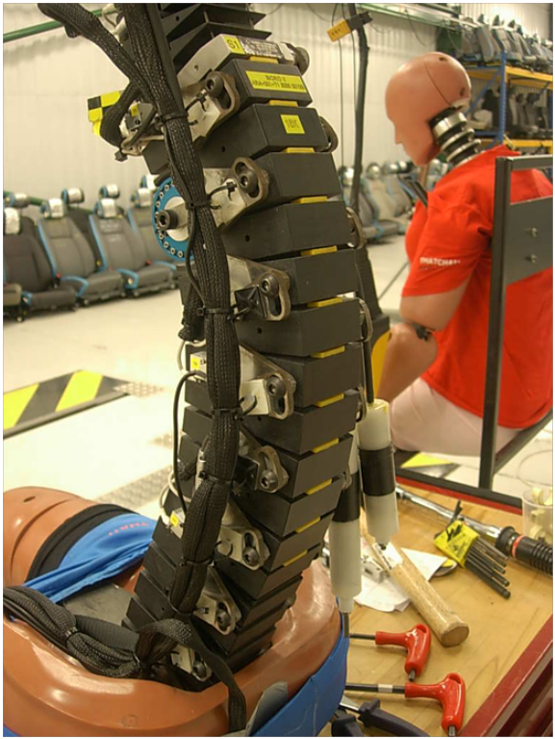
2.5.4. Pelvis Cable Routing
Bundle the instrumentation cables together inside the instrumentation cavity in the back of the pelvis. Route the cable up the back on the top of the pelvis.
Combine all instrumentation bundles on the top of the pelvis and exit the entire bundle between the jacket and the top of the pelvis. Figure 75 shows the cable bundle exiting the dummy.
Figure 75
Cable Bundle Exit
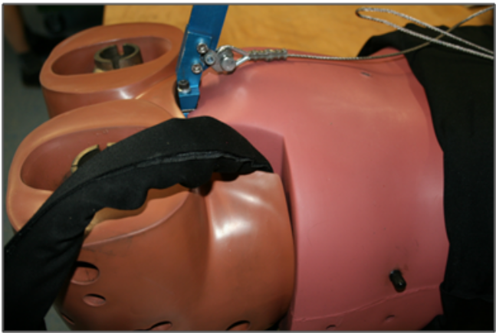
2.6. Accelerometer Handling
2.6.1. Care
Avoid dropping the accelerometer or striking the unit against hard surfaces and keep the unit in its protective sleeve until it is installed.
2.6.2. Preliminary Checks
Before installing accelerometers in the dummy, the accelerometers shall be checked in accordance with the accelerometer manufacturer’s instructions to ensure correct operation and conformity to specified tolerances.
2.6.3. Installation Procedure
The mounting surface shall be clean and free of burrs, with a surface roughness of not more than .813 µm (32 micro inches) rms.
Remove the accelerometer from the protective sleeve. Handling it by the case, not the cable, place the unit on the mounting surface and align the mounting holes. When mounting the accelerometer, use only the materials and parts which are supplied with the accelerometer and use the mounting torque recommended by the accelerometer manufacturer. If applicable, use the supplied mounting washers and screws or mounting stud. Do not over torque the screws or use snap type torque wrenches (which can result in shocks that damage the accelerometer). Do not cement the unit to the mounting structure.
Where practical, tie down the cable within 40 to 60 mm (1.6 to 2.4 in) of the accelerometer to prevent strain upon the join between the cable and accelerometer.
2.6.4. Recalibration
Sensitivity and Zero Measurand Output calibrations shall be performed at intervals of not more than 12 months to ensure conformity with manufacturer tolerances. If the unit has been used beyond its rated specifications, a shorter calibration interval is recommended. Zero measurand output is defined as the output of the accelerometer when the accelerometer is stationary with its sensitive axis perpendicular to the gravitational field.
2.6.5. Cleaning
Dirty units may be wiped clean using a damp cloth and a solvent such as acetone. Do not soak or immerse the unit in any solvent or water. Do not use any sharp tools (such as a screwdriver) to remove dirt or contaminants. If tools such as pliers are needed to handle the accelerometer, cover the jaws with masking tape to prevent metal to metal contact.
3. Bumper Maintenance
3.1. Overview
The cervical region of the spine (vertebrae C1 through C7 plus T1) contains sixteen cube-shaped bumpers. The eight front bumpers are 40A durometer, black in colour and 10mm in height. The eight rear bumpers are split into 2 regions; the uppermost three are the same 40A, 10mm height bumpers as used in the front, and the bottom 5 are 30A durometer, yellow in colour and 9 mm in height.
3.2. Replacement Interval
The dummy shall only be used for certification if the front cervical bumpers were last replaced not more than 4 months before the date of the test. A dummy that is being recertified shall be fitted with replacements for all 8 front bumpers [ongoing discussion point, may need updating]. If the bumpers are not in good condition due to compression, the effect on the calibration data will show a higher amplitude in Pot A and/or Pot B Rotation.
3.3. Replacement Procedure
Remove both lower cable adjusters and muscle substitute springs from the lower ends of the spring cables and tap or push the O.C. pin out of the spine (figure 76).
Pull the spring cables up out of the upper cable adjusters as far as possible and turn the O.C. plate up and over (figure 77). It will not swing in the other direction as the damper cable does not allow enough travel. Slide out the pins from C1 down to C7; these are easily removed and reinstalled by tapping gently or pushing with a punch.
Use a sharp pick to dislodge the bumper from each vertebra, from C1 down to C7, and to remove any glue or bumper residue.
Place one drop of cyanoacrylate adhesive in centre of the bore in the vertebrae. Place the new bumper in the bore while the adhesive is wet, and centre it side-to-side and front-to-back. Press downward on the bumper with one finger for 10 seconds to bond. Repeat for all bumpers from C1 to C7.
Remove the two M2.5 SHCS that retain the T1 pin at the C7-T1 joint (figure 78), using a 2mm Allen key. Slide the T1 pin out of the vertebrae joint and set it aside along with the two M2.5 SHCS for re-installation later.
Use the pick to dislodge the front bumper in the T1 load cell vertebra and to remove any remaining glue or bumper residue (figure 79). Place one drop of cyanoacrylate adhesive in centre of the rectangular cavity in the T1 vertebrae. While the adhesive is still wet, place the new bumper in the cavity and press downward upon it with one finger for 10 seconds to bond. It will be positively located as the cavity is approximately the same shape as the bumper.
Re-install the T1 pin through the C7-T1 joint, taking care to avoid damaging the C7 vertebra or the T1 load cell joint with the threads on the T1 pin. Align the edge of the flat on the pin to the edge of the vertebra , as illustrated in figure 80, and orient the face of flat to be parallel with the back end face of T1 load cell. This must be done to line up the threaded holes for the M2.5 SHCS. The face of the flat on the pin is precisely perpendicular to the threaded holes for two M2.5 SHCS
Re-install both M2.5 SHCS with a 2mm Allen key. Be careful not to over-torque; a torque of 15 inch pounds (1.7 Nm) is advised.
Re-install all pins from C1 to C7 by tapping lightly or pushing with a punch. The ends of the pins will be flush with the vertebrae when finished. Re-install the muscle substitute springs and lower spring cable adjusters onto both spring cables.

Figure 76.  Push out OC Pin  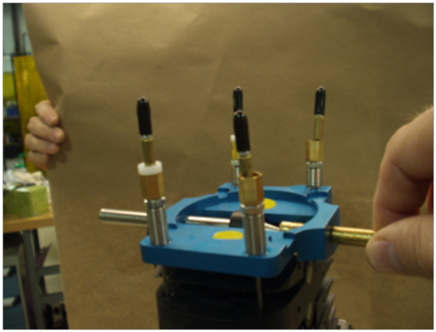 | Figure 77  Remove pin and separate vertebra  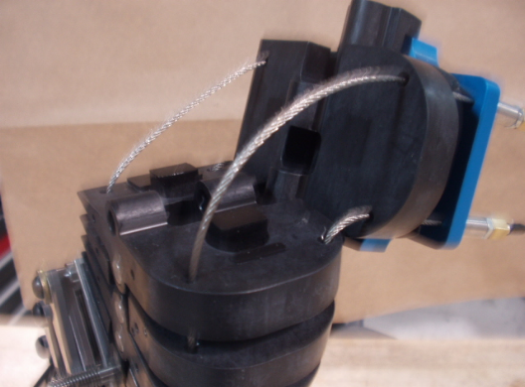
Figure 78  Remove T1 Retaining Screws  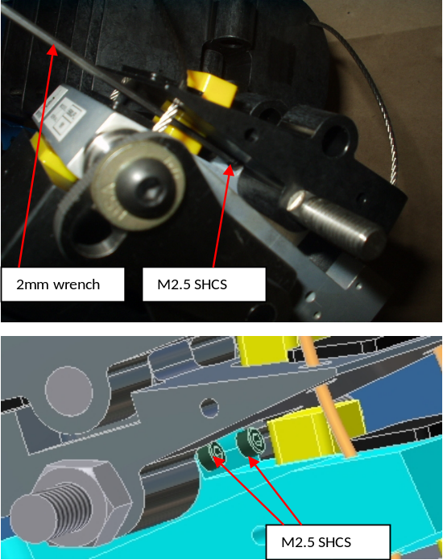 | Figure 79  Use pick to remove bumper  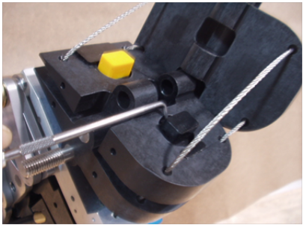  Figure 80  T1 Pin Alignment  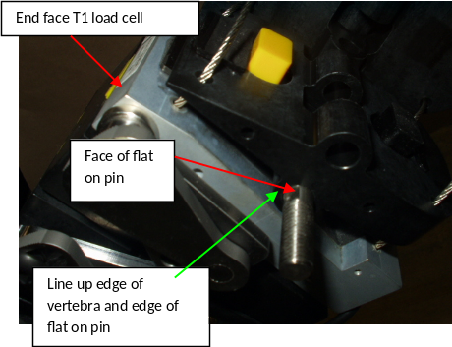
4. Storage and Handling
4.1. Transport Chair
Any chair may be used for transport and storage of the dummy provided that it spreads the load on the jacket and pelvis to avoid damage occurring over time due to compression, and that it allows the spine to rest in a position where minimal loads are placed upon the bumpers.
4.2. Lifting Procedure
To lift the dummy, the pelvis position indicator attachment is used as a point for lift cable attachment. An upper cable bracket is mounted at T-1 with a M8 wing nut on each side (figure 81).
After the dummy is moved and positioned for testing, remove the upper bracket and wing nuts and store them for future use. If the pelvis position indicator attachment interferes with the seatbelt it needs to be removed and replaced with the two M6 X 25 mm SHCS provided.
Figure 81
Lifting Cable and Bracket
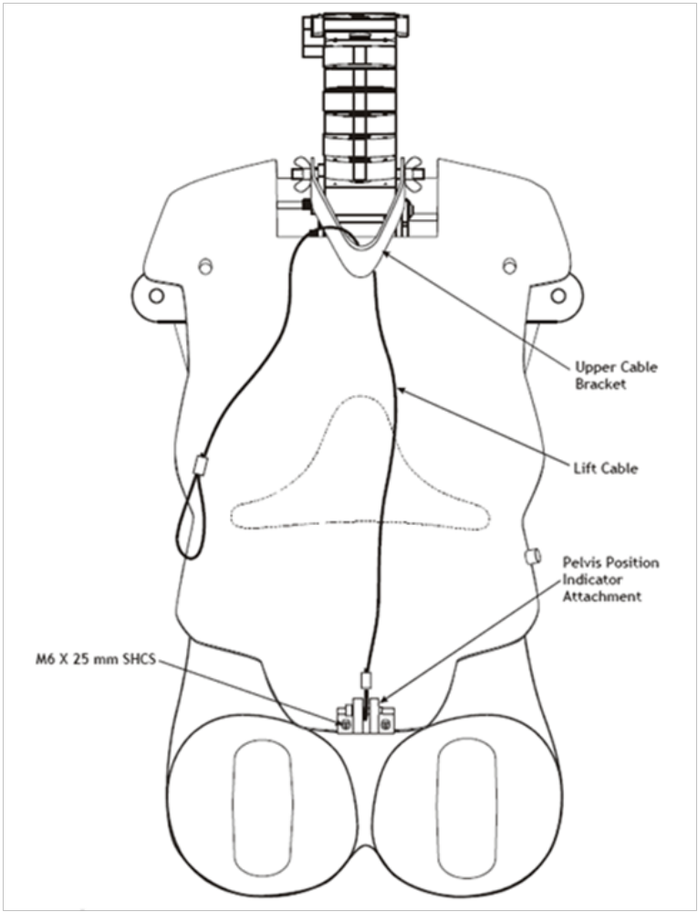
5. Repairing the Vinyl Flesh and Silicone Jacket
5.1. Silicone Jacket
Small repairs to the silicone jacket can be accomplished using Room Temperature Vulcanising (RTV) Silicone. If the tears are large, replace the jacket.
5.2. Vinyl Limb Flesh
The most common types or flesh damage are punctures, tears, and scrapes.
Scrapes can be fixed by rubbing an iron, at low temperature, over the affected area several times. Punctures and tears require patching; the patching material used for this must be of identical composition to the damaged material on the limb flesh.
To bond the dummy’s flesh to patches of repair materials, use an iron similar to a standard electronic soldering iron with an output range from 60 to 90 Watts and a broad, flat paddle tip. For best results, use a variable power supply to control the heat output from the iron, otherwise repairs will be more difficult and may be unsightly due to black flakes of burnt material imbedded in the flesh. These flakes are caused by overheating the flesh when an iron is too hot or remains in one position for too long.
Another cause of black residue in the flesh is improper or infrequent cleaning of the iron tip. The tip should therefore be cleaned frequently during the repair job, between each melting of flesh if possible, by tapping the bit on a buffing wheel.
Conduct all flesh preparations and repairs in a well-ventilated area. When patching, first clear away any loose material which may be hanging from the damaged areas, such as shredded vinyl or foam. Clean the area with 99 per cent solution isopropyl alcohol and dry for fifteen minutes. Any residue from tape or chalk must be removed; if it remains after the initial cleaning, continue to clean with isopropyl alcohol until the area is completely clean. Since isopropyl alcohol is flammable, make sure the surface is dry before applying heat. Do not use soldering flux or any other chemical on the flesh or repair iron.
After preparation, a patch can be bonded to the flesh. Cut a patch of adequate size material from a sheet of identical specification to that used in the original flesh. The patch should be approximately 10 mm (0.5 in) wider than the damaged area on all sides. To check that the iron is at a usable temperature, test it on a small piece of patch material. The flesh should easily melt but not instantly burn. With the patch held over the damaged area, slide the iron between the patch and dummy flesh. Hold the iron in position until you see both materials melting. When both the patch and the flesh look like a gel, move the iron to a new point while holding the patch in place until they have both cooled. Continue this all the way around the damaged area until the patch is completely bonded to the flesh.
For large areas, or areas where the patch must bend to conform to the dummy part, it may be easier to "tack" a few points around the edge of the patch to hold it in place, then return to fill in the un-bonded sections. Once the patch is tacked to the flesh, the two must be blended together; this will eliminate any protruding edges that may later snag and ruin the repair. To blend the patch, work the iron tip around the patch edges in a circular motion, blending the patch material into the flesh as you work your way around the patch. If the iron is too hot, black flakes will appear; if it is too cold, the patch will not readily melt, and the patch is likely to be poorly bonded to the flesh. Continue working the patch into the flesh until the repair is well hidden, then let it cool. If any rough areas are left after cooling, smooth them out by reapplying the hot iron.
6. Torque Value Table
Torque wrenches used shall be set to the values specified in table 2.
Table 2
Specified Torques
Item | Specified Torque (Nm) | Specified Torque (lbf ins)
9003016 — BHCS 10-32 x 5/8 | 3.4 | 30
9005002 — SHCS ¼ - 20 x 1 | 10.8 | 96
9005016 — SHCS ¼ - 20 x 7/8 | 10.8 | 96
9005023 — SHCS ¼ - 28 x 7/8 | 10.8 | 96
9005029 — SHCS 10 – 24 x 3/8 | 3.4 | 30
9005040 — SHCS 5/16 – 18 x ¾ | 22.4 | 198
9005060 — SHCS 5/16 – 18 x ¾ | 22.4 | 198
9005065 — SHCS 5/16 – 24 x 7/8 | 22.4 | 198
9006002 — SHSS 3/8 x 1 | 36.6 | 324
9006027 — SHSS ¼ - ¾ | 7.9 | 70
9007001 — FHCS ¼ - 20 x 1 | 6.8 | 60
78051-30 — SHSS 3/8 x .375 | 36.6 | 324
78051-92 — SHCS 10 – 24 x 1 ½ | 3.4 | 30
78051-94 — SHCS ¼ - 20 x 5/8 | 10.8 | 96
78051-98 — SHCS 3/8 – 16 x 1 | 36.6 | 324
78051-100 — SHCS 3/8 – 16 x 2 | 36.6 | 324
78051-103 — SHCS 10 – 24 x .30 | 3.4 | 30
78051-117 — BHCS 10 – 32 x 5/8 | 3.4 | 30
78051-118 — BHCS 10 – 32 x ½ | 3.4 | 30
78051-226 — FHCS 10 – 32 x .41 | 3.4 | 30
A-1898 — BHCS 8 – 32 x ½ | 2.6 | 23

Annex 2
Engineering Drawings and Parts List
1. Drawings
1.1. Introduction
The 2D engineering drawings contained within this Annex represent the essential dimensions of the assemblies and individual component parts of the BioRID II UN dummy. Reference is made to generic manufacturing processes only.
1.2. Drawing Descriptors
The drawings are listed by discrete body section in individual Appendices for ease of reference. The individual drawings are listed in an Index Table at the front of each Appendix. Each drawing has a UN ECE document reference that follows the standard UN ECE convention. The full document number is extended by a drawing descriptor – "Drg." – followed by a sequential Arabic number, e.g. TRANS/WP.29/78/Add.1/App.1/ Drg. 001, TRANS/WP.29/78/Add.1/App.1/ Drg. 002.
For each separate Appendix to this Annex the first drawing is numbered "1". i.e. TRANS/WP.29/78/Add.1/App.2/ Drg. 001, TRANS/WP.29/78/Add.1/App.3/ Drg. 001. etc.
1.3. Revisions
In accordance with standard engineering practice, the drawings in this Annex have their status identified by a "Revision Level". This is displayed as a capital Roman letter on the drawing and is referenced as " Drg. Rev." in column 4. to the Index Table.
Product and manufacturing advances can result in changes to, for example, dimensional tolerances or manufacturing procedures. This may result in improvements to the precision of the dummy’s response (accuracy, repeatability or reproducibility). In such cases the use of components engineered to a later drawing level than listed in the accompanying tables is accepted.
More significant changes, for example, changes to a material, or the mass distribution about the dummy, may be subject to review before being adopted for regulatory use. These changes require a revised drawing to be registered.
Should a drawing be subject to change, the original drawing is retained in this register and the new drawing number inserted in the table immediately after the original. Identification of this new drawing also follows UN ECE convention, having the same UN ECE number as the original with the addition of the appropriate revision nomenclature, e.g. TRANS/WP.29/78/Add.1/App.1/ Drg. 001/Rev.1
2. Parts
Parts that are of commercial supply, or adequately defined by description, e.g. "Pin, Dowel 1/4" X 1/4"", are listed separately. These parts do not have a UN ECE reference number.
3. Part Numbers
The components that comprise the dummy, whether specified by drawing or by part, are identified in the market by established part numbers. These numbers are also listed in the tables of the Appendices to this Annex. These unique part numbers are not proprietary and are available for use by any commercial company.
4. List of appendices
Appendix 1. Assembly Drawings
Appendix 2. Head
Appendix 3. Cervical Spine
Appendix 4. Thoracic and Lumbar Spine
Appendix 5. Torso and Pelvis
Appendix 6. Muscle Substitute
Appendix 7. Limbs
Appendix 8. Tools
Drawing Appendices
Appendix 1
Assembly Drawings
Table 1
Drawing Index
TRANS/WP.29/78/Add.1/ App.1/… | Part Number | Description | Drg. Rev. | No. of Sheets | QTY Per Assembly | QTY Per Dummy | Common with Addenda
Drg. 1 | 86-5001-001br | Leg Assembly, Left | C | 1 | 1 | 1 | Add. 1  App. 8  Dwg 001
Drg. 2 | 86-5001-002br | Leg Assembly, Right | C | 1 | 1 | 1 | Add. 1  App. 8  Dwg 002
Drg. 3 | ARA-001 | Complete Assembly | J | 1 | 1 | 1
Drg. 4 | ARA-002 | Head & Upper Torso Assembly | C | 1 | 1 | 1
Drg. 5 | ARA-200 | Spine Assembly | P | 2 | 1 | 1
Drg. 6 | ARA-275 | Neck Assembly | - | 1 | 1 | 1
Drg. 7 | ARA-500 | Lower Torso Assembly | B | 1 | 1 | 1

Appendix 2
Head
Table 1
Drawings
TRANS/WP.29/78/Add.1/ App.2/… | Part Number | Description | Drg. Rev. | No. of Sheets | QTY Per Assembly | QTY Per Dummy | Common with Addenda
Drg. 1 | 4947 | Ballast, Skull | C | 1 | 1 | 1
Drg. 2 | 4956 | Assy - S.R. Neck Loadcell | C | 2 | 1 | 1
Drg. 3  (Unable to locate drawing!!!) | 78051-311 | Insert - Threaded - 1/2-20
Drg. 4 | ARA-100 | Plate, Interface-Occipital Condyle | P | 1 | 1 | 1
Drg. 5 | ARA-103 | Head Assembly | D | 1 | 1 | 1
Drg. 6 | ARA-104 | Skull, BioRID | J | 1 | 1 | 1
Drg. 7 | ARA-105 | Assembly, Occipital Condyle Plate | B | 1 | 1 | 1
Drg. 8 | ARA-106 | Cap, Skull | G | 1 | 1 | 1
Drg. 9 | ARA-107 | Accelerometer Mount | F | 1 | 1 | 1
Drg. 10 | ARA-108 | Skin, Head | B | 1 | 1 | 1
Drg. 11 | ARA-110 | Cap Skin, Skull | C | 1 | 1 | 1

Table 2. Parts
Part Number | Description | Drwg. Rev. | No. of Sheets | QTY Per Assembly | QTY Per Dummy | Common with Addenda
9000005 | ¼-20 x 5/8 (UNC) SHCS |  |  | 2 | 2
9000126 | ¼-28 x 5/8 (UNF) SHCS |  |  | 4 | 4
9000824 | 8-32 x ½ (UNC) FHCS |  |  | 3 | 3

Appendix 3
Cervical Spine
Table 1. Drawings
TRANS/WP.29/78/Add.1/ App.3/… | Part Number | Description | Drg. Rev. | No. of Sheets | QTY Per Assembly | QTY Per Dummy | Common with Addenda
Drg. 1 | 8417 | Split Bushing- Rear | B | 1 | 4 | 8? | Add. 1  App. 4  Dwg 006
Drg. 2 | 8418 | Split Bushing- Front | B | 1 | 4 | 8? | Add. 1  App. 4  Dwg 007
Drg. 3 | 8420 | T1 Load Cell Ass'y | B | 1 | 1 | 1
Drg. 4 | ARA-201 | Vertebra, Cervical - C1 | T | 1 | 1 | 1
Drg. 5 | ARA-203 | Vertebrae, Cervical - C3,C5 | R | 1 | 2 | 2
Drg. 6 | ARA-206 | Vertebra, Cervical - C4 | P | 1 | 1 | 1
Drg. 7 | ARA-207 | Vertebrae, Cervical - C2,C6 | R | 1 | 2 | 2
Drg. 8 | ARA-208 | Vertebra, Cervical - C7 | L | 1 | 1 | 1
Drg. 9 | ARA-209 | Pin, Neck C1-C2 | E | 1 | 1 | 1
Drg. 10 | ARA-210 | Pin, Neck-Occipital C1 | G | 1 | 1 | 1
Drg. 11 | ARA-212 | Pin, Neck C2-C7 | E | 1 | 5 | 5
Drg. 12 | ARA-213 | Pin, Neck | F | 1 | 1 | 1
Drg. 13 | ARA-220 | Bumper - Cervical Front And Rear | G | 1 | 12 | 12
Drg. 14 | ARA-221 | Bumper, Cervical – Rear | F | 1 | 9 | 9
Drg. 15 | ARA-222 | Assembly, Cervical Vertebra-C1 | E | 1 | 1 | 1
Drg. 16 | ARA-223 | Assembly, Cervical Vertebra - C2 | J | 1 | 1 | 1
Drg. 17 | ARA-224 | Assembly, Cervical Vertebra - C3 | L | 1 | 1 | 1
Drg. 18 | ARA-225 | Stop, Cervical – Front | D | 1 | 9 | 9
Drg. 19 | ARA-226 | Assembly, Cervical Vertebra - C7 | G | 1 | 1 | 1
Drg. 20 | ARA-227 | Bumper, Cervical – Rear | F | 1 | 6 | 6
Drg. 21 | ARA-228 | Assembly, Cervical Vertebra - C5 | C | 1 | 1 | 1
Drg. 22 | ARA-229 | Assembly, Cervical Vertebra - C6 | C | 1 | 1 | 1
Drg. 23 | ARA-231 | Bumper, Occipital | F | 1 | 2 | 2
Drg. 24 | ARA-261 | Assembly, Cervical Vertebra-C4 | D | 1 | 1 | 1
Drg. 25 | ARA-270 | Washer, Damper | B | 1 | 1 | 1
Drg. 26 | ARA-302 | Sensor - T1 | C | 1 | 1 | 1
Table 2
Parts
Part Number | Description | Drwg. Rev. | No. of Sheets | QTY Per Assembly | QTY Per Dummy | Common with Addenda
9010112 | M4 x 6mm SSFP |  |  | 2 | 2
9002030 | Nut, Hex M8 |  |  | 2 | 2
9005132 | O Ring |  |  | 2 | 2
9010113 | M2.5 x 8mm SHCS |  |  | 2 | 2

Appendix 4
Thoracic and Lumbar Spine
Table 1
Drawings
TRANS/WP.29/78/Add.1/ App.4/… | Part Number | Description | Drg. Rev. | No. of Sheets | QTY Per Assembly | QTY Per Dummy | Common with Addenda
Drg. 001 | 5704 | Spacer For C7, T1, and T2 Ass'y | C | 1 | 1 | 1
Drg. 002 | 6588 | Adaptor, S1 Load Cell To L5 | B | 1 | 1 | 1
Drg. 003 | 6589 | Pelvis Spine Interface Plate | A | 1 | 1 | 1
Drg. 004 | 8701 | Structural Replacement, S1 Load Cell | A | 1 | 1 | 1
Drg. 005 | 8703 | Structural Replacement, S1 Lc Load Cell Ass'y | A | 1 | 1 | 1
Drg. 006 | 8417 | Split Bushing – Rear | B | 1 | 4 | 4 | Add. 1  App. 3  Dwg 001
Drg. 007 | 8418 | Split Bushing – Front | 2 | 1 | 4 | 4 | Add. 1  App. 3  Dwg 002
Drg. 008 | 8419 | T1 Load Cell | A | 1 | 1 | 1
Drg. 009 | ARA-301 | S.R. Load Cell Assembly | B | 1 | 1 | 1
Drg. 010 | ARA-312 | Vertebra, Thoracic - T2 | L | 1 | 1 | 1
Drg. 011 | ARA-319 | Washer, Thoracic – Torsion | B | 1 | 1 | 1
Drg. 012 | ARA-320 | Washer, Torsion Adjustment | F | 1 | 17 | 17
Drg. 013 | ARA-321 | Pin, Torsion | F | 1 | 17 | 17
Drg. 014 | ARA-324 | Washer, Thoracic – Torsion | F | 1 | 9 | 9
Drg. 015 | ARA-325 | Washer, Lumbar – Torsion | F | 1 | 6 | 6
Drg. 016 | ARA-327 | Vertebra, Thoracic - T3 | P | 1 | 1 | 1
Drg. 017 | ARA-328 | Vertebra, Thoracic - T4 | K | 1 | 1 | 1
Drg. 018 | ARA-329 | Vertebra, Thoracic - T5 | J | 1 | 1 | 1
Drg. 019 | ARA-330 | Vertebrae, Thoracic - T6,T7,T9-T12 | J | 1 | 6 | 6
Drg. 020 | ARA-331 | Vertebra, Thoracic - T8 | J | 1 | 1 | 1
Drg. 021 | ARA-332 | Washer, Torsion - T1 Load Cell | D | 1 | 1 | 1
Drg. 022 | ARA-373 | Washer, Torsion - T4 | E | 1 | 1 | 1
Drg. 023 | ARA-379 | Bumper, Thoracic – Rear | - | ? | ? | ?
Drg. 024 | ARA-380 | Bumper, Thoracic – Rear | - | ? | ? | ?
Drg. 025 | ARA-381-30 | Bumper, Thoracic – Rear | E | 1 | 12 | 12
Drg. 026 | ARA-381-37 | Bumper, Thoracic – Front | F | 1 | 12 | 12
Drg. 027 | ARA-384 | Assembly, Thoracic Vertebra - T3 | G | 1 | 1 | 1
Drg. 028 | ARA-385 | Assembly, Thoracic Vertebra - T4 | G | 1 | 1 | 1
Drg. 029 | ARA-386 | Assembly, Thoracic Vertebra - T5 | G | 1 | 1 | 1
Drg. 030 | ARA-387 | Assembly, Thoracic Vertebrae- T6,T10,T12 | H | 1 | 3 | 3
Drg. 031 | ARA-388 | Assembly, Thoracic Vertebrae - T7,T9,T11 | G | 1 | 3 | 3
Drg. 032 | ARA-389 | Assembly, Thoracic Vertebra - T2 | F | 1 | 1 | 1
Drg. 033 | ARA-396 | Assembly, Thoracic Vertebra-T8 | D | 1 | 1 | 1
Drg. 034 | ARA-501 | Vertebra, Lumbar - L1 | J | 1 | 1 | 1
Drg. 035 | ARA-502 | Vertebrae, Lumbar - L2 Thru L5 | J | 1 | 4 | 4
Drg. 036 | ARA-520 | Bumper, Lumbar – Rear | E | 1 | 5 | 5
Drg. 037 | ARA-521 | Bumper, Lumbar – Front | D | 1 | 5 | 5
Drg. 038 | ARA-522 | Assembly, Lumbar Vertebra - L1 | F | 1 | 1 | 1
Drg. 039 | ARA-523 | Assembly, Lumbar Vertebrae - L3,L5 | F | 1 | 2 | 2
Drg. 040 | ARA-524 | Assembly, Lumbar Vertebrae - L3,L5 | E | 1 | 2 | 2
Drg. 041 | ARA-561 | S1interface Plate Assembly | A | 1 | 1 | 1
Drg. 042 | ARA-562 | S1 Vertebra | A | 1 | 1 | 1
Drg. 043 | ARA-563 | Pelvis Spine Interface Plate | C | 1 | 1 | 1
Drg. 044 | ARA-564 | S1 Vertebra with Load Cell | A | 1 | 1 | 1

Table 2
Parts
Part Number | Description | Drwg. Rev. | No. of Sheets | QTY Per Assembly | QTY Per Dummy | Common with Addenda
9005108 | M8 x 25mm SHCS |  |  | 1 | 1
9004036 | M6 x 25mm FCHS |  |  | 4 | 4
4000076 | 5/16 x ¾ Washer |  |  | 2 | 2
9005125 | M8 x 12mm SHCS |  |  | 16 | 16
9010000 | M5 Hex Nut |  |  | 2 | 2
9001447 | M6 x 25mm SHCS |  |  | 1 | 1
9000776 | 9/32 x 5/8 Washer |  |  | 1 | 1
9009285 | 5/16 x 3/4 Washer |  |  | 16 | 16
9010443 | Tension Washer |  |  | 1 | 1
9010454 | M6 Low Head SHCS |  |  | 6 | 6
6588 | Adaptor S1 LC |  |  | 1 | 1
9010051 | M4 x 10mm SHCS |  |  | 6 | 6
9005170 | M2.5 x 12mm SHCS |  |  | 10 | 10
9001445 | M6 x 12mm FHCS |  |  | 2 | 2

Appendix 5
Torso and Pelvis
Table 1
Drawings
TRANS/WP.29/78/Add.1/ App.5/… | Part Number | Description | Drg. Rev. | No. of Sheets | QTY Per Assembly | QTY Per Dummy | Common with Addenda
Drg. 1 | ARA-347 | Spine-Torso Interface – Left | C | 1 | 1 | 1
Drg. 2 | ARA-348 | Pelvis Interface Abdomen Attachment | C | 1 | 1 | 1
Drg. 3 | ARA-349 | Reinforcement, Arm Attachment | D | 1 | 2 | 2
Drg. 4 | ARA-350 | Spine-Torso Interface – Right | B | 1 | 1 | 1
Drg. 5 | ARA-351 | Attachment, Arm | G | 1 | 2 | 2
Drg. 6 | ARA-352 | Arm Attachment Assembly – Right | H | 1 | 1 | 1
Drg. 7 | ARA-353 | Shoulder Yoke | B | 1 | 2 | 2
Drg. 8 | ARA-354-L5 | Spine, Torso Interface Pin Assembly | G | 1 | 1 | 1
Drg. 9 | ARA-354-L8 | Spine, Torso Interface Pin Assembly | G | 1 | 1 | 1
Drg. 10 | ARA-354-Lr3 | Spine, Torso Interface Pin Assembly | G | 1 | 2 | 2
Drg. 11 | ARA-354-Lr4 | Spine, Torso Interface Pin | G | 1 | 2 | 2
Drg. 12 | ARA-354-Lr12 | Spine, Torso Interface Pin Assembly | G | 1 | 4 | 4
Drg. 13 | ARA-354-Lr67 | Spine, Torso Interface Pin Assembly | G | 1 | 4 | 4
Drg. 14 | ARA-354-R5 | Spine, Torso Interface Pin Assembly | G | 1 | 1 | 1
Drg. 15 | ARA-358 | Bushing, Shoulder | D | 1 | 2 | 2
Drg. 16 | ARA-359 | Block, Bushing | F | 1 | 2 | 2
Drg. 17 | ARA-362 | Plate, Back | B | 1 | 1 | 1
Drg. 18 | ARA-363 | Plate, Back | B | 1 | 1 | 1
Drg. 19 | ARA-364 | Plate, Back – Spine | B | 1 | 1 | 1
Drg. 20 | ARA-391 | Arm Attachment Assembly – Left | G | 1 | 1 | 1
Drg. 21 | ARA-395 | Torso Jacket Assembly | F | 1 | 1 | 1
Drg. 22 | ARA-505 | Retainer, Spring Tube | H | 1 | 1 | 1 | Add. 1  App. 6  Dwg 022
Drg. 23 | ARA-510 | Pelvis Interface Abdomen Att. | E | 1 | 1 | 1
Drg. 24 | ARA-513 | Bone, Pelvis | J | 1 | 1 | 1
Drg. 25 | ARA-514 | Pelvis, Moulded | F | 1 | 1 | 1
Drg. 26 | ARA-515 | Gasket, Anti-Slap | C | 1 | 1 | 1
Drg. 27 | ARA-908 | Pelvis Lift Bracket |  |  | 1 | 1
Drg. 28 | ARA-933 | H-Point Left |  |  | 1 | 1
Drg. 29 | ARA-934 | H-Point Right |  |  | 1 | 1

Table 2
Parts
Part Number | Description | Drwg. Rev. | No. of Sheets | QTY Per Assembly | QTY Per Dummy | Common with Addenda
9004036 | M6 x 25mm FHCS |  |  | 2 | 2

Appendix 6
Muscle Substitute
Table 1
Drawings
TRANS/WP.29/78/Add.1/ App.6/… | Part Number |  | Description | Drg. Rev. | No. of Sheets | QTY Per Assembly | QTY Per Dummy | Common with Addenda
Drg. 1 | ARA-326 |  | Body, Rotary Damper | U | 1 | 1 | 1
Drg. 2 | ARA-343 |  | Wheel, Cable Guide | D | 1 | 1 | 1
Drg. 3 | ARA-346 |  | Damper Paddle Clamp Bracket | D | 1 | 1 | 1
Drg. 4 | ARA-355 |  | Cover, Damper | J | 1 | 1 | 1
Drg. 5 | ARA-356 |  | Adjustment, Cable – Attachment | C | 1 | 4 | 4
Drg. 6 | ARA-369 |  | Cable, Muscle Substitute | E | 1 | 2 | 2
Drg. 7 | ARA-372 |  | Calibration Screw | D | 1 | 1 | 1
Drg. 8 | ARA-374 |  | Damper Paddle Wheel | C | 1 | 1 | 1
Drg. 9 | ARA-375 |  | Assembly, Rotary Damper | P | 1 | 1 | 1
Drg. 10 | ARA-376 |  | Biorid Calibration Screw-O-Ring Assy | A | 1 | 1 | 1
Drg. 11 | ARA-377 |  | Damper & Mounting Plate Assembly | - | 1 | 1 | 1
Drg. 12 | ARA-401 | Spring, Anterior Muscle Substitute |  | D | 1 | 1 | 1
Drg. 13 | ARA-402 | Spring, Posterior Muscle Substitute |  | E | 1 | 1 | 1
Drg. 14 | ARA-403 | Tube Spring - Posterior Muscle Substitue |  | D | 1 | 1 | 1
Drg. 15 | ARA-404 | Tube, Spring - Anterior Muscle Substitute |  | D | 1 | 1 | 1
Drg. 16 | ARA-405 | Piston, Muscle Substitute |  | E | 1 | 2 | 2
Drg. 17 | ARA-406 | Adjuster, Cable |  | C | 1 | 4 | 4
Drg. 18 | ARA-409 | Cable, Damper |  | H | 1 | 1 | 1
Drg. 19 | ARA-410 | Sleeve, Cable – Flexible |  | B | 1 | 2 | 2
Drg. 20 | ARA-411 | Terminal, Cable |  | D | 1 | 2 | 2
Drg. 21 | ARA-413 | Cap, Vinyl |  | B | 1 | 4 | 4
Drg. 22 | ARA-505 | Spring Tube Retainer |  |  |  | 1 | 1 | Add. 1  App. 5  Dwg 022
Drg. 23 | ARA-711 | Cable Post Sleeve |  |  |  | 2 | 2

Table 2
Parts
Part Number | Description | Drwg. Rev. | No. of Sheets | QTY Per Assembly | QTY Per Dummy | Common with Addenda
9009091 | Cable Adjuster |  |  | 4 | 4
9010293 | Cable Cap |  |  | 4 | 4

Appendix 7
Arms and Hands
Table 1
Drawings
TRANS/WP.29/78/Add.1/ App.7/… | Part Number | Description | Drg. Rev. | No. of Sheets | QTY Per Assembly | QTY Per Dummy | Common with Addenda
Drg. 1 | 78051‐123 | Arm Assembly, Left |  |  | 1
Drg. 2 | 78051‐124 | Arm Assembly, Right |  |  | 1
Drg. 3 | 78051‐174 | Upper Arm |  |  | 1
Drg. 4 | 78051‐191 | Upper Arm, Lower Part |  |  | 1
Drg. 5 | 78051‐194 | Lower Arm |  |  | 1
Drg. 6 | 78051‐198 | Stop ASM- Lower Arm |  |  | 1
Drg. 7 | 78051‐199 | Bushing, Upper Arm and Elbow | - |  | 2
Drg. 8 | 78051‐200 | Washer, Upper Arm and Elbow | - |  | 2
Drg. 9 | 78051‐202 | Elbow Pivot Nut |  |  | 1
Drg. 10 | 78051‐204 | Wrist Rotation |  |  | 1
Drg. 11 | 78051‐208 | Hand, Left |  |  | 1
Drg. 12 | 78051‐209 | Hand, Right |  |  | 1
Drg. 13 | 78051‐214 | Wrist Pivot Screw
Drg. 14 | 78051‐249 | Washer, Joint Spring |  |  | 2/4

Table 2
Parts
Part Number | Description | Drwg. Rev. | No. of Sheets | QTY Per Assembly | QTY Per Dummy | Common with Addenda
9010283 | M10 x 45mm SHCS |  |  | 3 | 6
9006003 | 3/8 x 1 1/2 SHSS |  |  | 1 | 2
9000055 | 1/2 x 1 1/4 SHSS |  |  | 1 | 2
9001260 | 1.06 x .53 Washer |  |  | 1 | 2
9000074 | 3/8 x 1 SHSS |  |  | 1 | 2
9006003 | 3/8 x 1 1/2 SHSS |  |  | 1 | 2
9000055 | 1/2 x 1 1/4 SHSS |  |  | 1 | 2
9001260 | 1.06 x .53 Washer |  |  | 1 | 2
9000074 | 3/8 x 1 SHSS |  |  | 1 | 2

Appendix 8
Legs and Feet
Table 1
Drawings (Leg Assembly)
TRANS/WP.29/78/Add.1/ App.7/… | Part Number | Description | Drg. Rev. | No. of Sheets | QTY Per Assembly | QTY Per Dummy | Common with Addenda
Drg. 1 | 86-5001-001BR | Leg Assembly, Left |  |  | 1
Drg. 2 | 86-5001-002BR | Leg Assembly, Right |  |  | 1
Drg. 3 | 78051-5 | Knee Flesh, Left |  |  | 1
Drg. 4 | 78051-6 | Knee Flesh, Left |  |  | 1
Drg. 5 | 78051-27 | Knee Insert |  |  | 1
Drg. 6 | 78051-41 | Upper Leg, Moulded |  |  | 1
Drg. 7 | 78051-42 | Upper Leg, Moulded |  |  | 1
Drg. 8 | 78051-43 | Upper Leg Bone |  |  | 1
Drg. 9 | 78051-44 | Upper Leg Bone |  |  | 1
Drg. 10 | 78051-73S | Lower Leg Flesh |  |  | 1
Drg. 11 | 78051-74S | Lower Leg Flesh |  |  | 1
Drg. 12 | 78051-319 | Load Cell Simulator |  |  | 1
Drg. 13 | 78051-600 | Foot Assembly, Left |  |  | 1
Drg. 14 | 78051-601 | Foot Assembly, Right |  |  | 1
Drg. 15 | 78051-608 | Pad, Heel - Foam |  |  | 1
Drg. 16 | 78051-610 | Ankle Bumper |  |  | 1
Drg. 17 | 79051-22 | Knee Cap |  |  | 1
Drg. 18 | 79051-24P | Pedestrian Knee Slider Replacement |  |  | 1
Drg. 19 | 79051-25P | Pedestrian Knee Slider Replacement |  |  | 1
Drg. 20 | 79051-30 | Shoulder Bolt, Modified |  |  | 2
Drg. 21 | 79051-32 | Washer |  |  | 1
Drg. 22 | 79051-33 | Compression Washer |  |  | 1
Drg. 23 | 79051-34 | Rotation Stop Cover |  |  | 1
Drg. 24 | 79051-35 | Rotation Stop Arm |  |  | 1
Drg. 25 | A-1590 | Ankle Shaft |  |  | 1
Drg. 26 | A-1672 | Stop Pin Retainer |  |  | 1
Drg. 27 | A-1886 | Foot Attachment Bolt |  |  | 1
Drg. 28 | A-1887 | Leg Attachment Bolt |  |  | 1
Drg. 29 | A-1888 | Ankle Friction Pad |  |  | 1
Drg. 30 | B-1889 | Ankle Assembly
Drg. 31 | B-2110-D | Knee Structural Replacement |  |  | 1
Drg. 32 | C-1884 | Ankle Upper Shell |  |  | 1
Drg. 33 | C-1885 | Ankle Lower Shell |  |  | 1
Drg. 38  (Drawing not present!!!) | 2110 | Knee Weldment |  |  | 1
Drg. 39  (Drawing not present!!!) | 1877 | Tibia Bone |  |  | 1

Table 4. Parts
Part Number | Description | Drwg. Rev. | No. of Sheets | QTY Per Assembly | QTY Per Dummy | Common with Addenda
9000126 | 1/4]28 x 5/8 SHCS |  |  | 4
9000072 | 3/16 x 1/2 Dowel Pin |  |  | 1
9000073 | 5/16-18 x 3/8 SSCP |  |  | 1
9006010 | 10-32 x 1/4 SSCP |  |  | 2
9000076 | 8-32 x 1/2 BHCS |  |  | 2
9000449 | 3/8-16 x 1 3/4 SHCS |  |  | 1
9000066 | 3/8-16 x 2 SHCS |  |  | 1
9005079 | 8-32 x 1/2 SHCS |  |  | 2
9004028 | 1/4-28 x 3/8 FHCS |  |  | 8

Appendix 9
Tools
Table 1. Drawings
TRANS/WP.29/78/Add.1/ App.8/… | Part Number | Description | Drg. Rev. | No. of Sheets | QTY Per Assembly | QTY Per Dummy | Common with Addenda
Drg. 1 | 3023 | Alignment Tool | D | 1 | 1 | 1
Drg. 2 | ARA-610 | Lift Bracket | C | 1 | 1 | 1
Drg. 3 | ARA-611 | Lift Cable | E | 1 | 1 | 1
Drg. 4 | ARA-907 | Head Levelling Tool | D | 1 | 1 | 1
Drg. 5 | ARA-912 | Head Locking Device | A | 1 | 1 | 1
Drg. 6 | ARA-913 | Locking Arm | B | 1 | 1 | 1
Drg. 7 | ARA-914 | Bolt Bracket | B | 1 | 1 | 1
Drg. 8 | ARA-915 | Assy, Pelvis Angle Indicator | - | 1 | 1 | 1
Drg. 9 | ARA-916 | Arm, Pelvis Angle Indicator | C | 1 | 1 | 1
Drg. 10 | ARA-917 | Bracket, Pelvis Angle Indicator | C | 1 | 1 | 1
Drg. 11 | ARA-920 | Biorid Shorts Pattern And Specifications | B | 1 | 1 | 1
Drg. 12 | ARA-921 | Biorid Shirt | B | 1 | 1 | 1
Drg. 13 | ARA-930 | T1 Angle Indicator Assembly | - | 1 | 1 | 1
Drg. 14 | ARA-931 | T1 Indicator Mounting Bracket | - | 1 | 1 | 1
Drg. 15 | ARA-932 | T1 Angle Indicator Bar | - | 1 | 1 | 1
Drg. 16 | B-5643 | H-point Locator | C | 1 | 1 | 1
Drg. 17 | TRA-042 | Spine Vertebrae Spacing Fixture Assembly | C | 1 | 1 | 1
Drg. 18 | TRA-043 | Vertebrae Spacer Upper Cam Arm | E | 1 | 1 | 1
Drg. 19 | TRA-044 | Vertebrae Spacer Lower Cam Arm | F | 1 | 1 | 1
Drg. 20 | TRA-045 | Vertebrae Spacer | D | 1 | 1 | 1

Table 2
Parts
Part Number | Description | Drwg. Rev. | No. of Sheets | QTY Per Assembly | QTY Per Dummy | Common with Addenda
Annex 3
Certification Procedures

1. Sled Test – without head restraint
2. Sled test – with head restraint
3. Torso Flesh Stiffness.
4. Pelvis stiffness

Appendix 1 – Schematic and General Arrangement of Equipment
Appendix 2 – Certification Corridors

