Development of a World-wide Worldwide harmonized Light duty driving Test Procedure (WLTP)

~ Draft Technical Report (version 3) ~

UN/ECE/WP.29/GRPE/WLTP-IG
DTP subgroup

23 October 2013

Authors:
Iddo Riemersma¹, Heinz Steven ²,

1 Sidekick Project Support (the Netherlands)
2 Data analysis and Consultancy (Germany)

Contents

1 Introduction 6
2 Objective 7
3 Organisation and structure of the project 7
3.1 WLTP Informal Group 7
3.2 DTP subgroups 9
3.2.1 Terms of Reference (ToR) 10
3.2.2 ICE laboratory process (LabProcICE) 10
3.2.3 EV laboratory process (LabProcEV) 12
3.2.4 Particulate mass/Particulate number (PM/PN) 13
3.2.5 Additional pollutants (AP) 14
3.2.6 Reference fuel (RF) 14
4 Test procedure development 16
4.1 General Purpose and Requirements 16
4.2 Approach 16
4.3 Improvements of the GTR 17
4.4 New concepts of the GTR 18
4.4.1 Combined approach 18
4.5 GTR structure [under construction] 21
4.5.1 Annex 3 – Reference fuels 21
4.5.2 Annex 4 - Road and dynamometer load 21
4.5.3 Annex 5 – Instrumentation 21
5 Validation of the test procedure 22
5.1 Validation phase 22
5.1.1 Participant and vehicles, measured parameter 22
5.1.2 Evaluation issues 57
5.2 Validation results 58
5.2.1 Overnight soak temperatures 58
5.2.2 Test cell temperatures 60
5.2.3 Test cell humidity 62
5.2.4 Speed trace violations 64
5.2.5 Monitoring of RCB for ICE vehicles 68
5.2.6 Charge depleting tests for PEV and OVC HEV 69
6 Outlook 85
Annex 1 - Emission legislation: 86
Annex 2 - List of participants to DTP 88

List of Figures

Figure 1: The structure of WLTP-IG 7
Figure 2: Overview of the WLTP development 8
Figure 3: The time schedule for Cycle and Procedure development 8
Figure 4: Structure of the DTP and its subgroups 10
Figure 5: Example for the interpolation method applied in the combined approach for road load relevant vehicle characteristics. 20
Figure 5: Example of overnight soak temperature monitoring 59
Figure 6: Example of soak temperature monitoring for accelerated cooling 59
Figure 7: Ambient temperature variation range of overnight soaks for 1 lab 60
Figure 8: Best case of test cell temperature over all 4 phases of the class 3 WLTC 61
Figure 9: Worst case of test cell temperature over all 4 phases of the class 3 WLTC 61
Figure 10: Test cell temperature variation range during class 3 WLTC, all tests 62
Figure 11: Example for the time history of the test cell humidity over the class 3 WLTC 63
Figure 12: Examples for the time history of the test cell humidity over the class 3 WLTC 63
Figure 13: Test cell humidity variances during the tests 63
Figure 14: Example for speed trace and tolerance band for the class 3 WLTC 64
Figure 15: : Example for speed trace and tolerance band for the class 3 WLTC 65
Figure 16: Example for speed trace and tolerance band for the class 3 WLTC 65
Figure 17: Example for speed trace and tolerance band for the class 3 WLTC 66
Figure 18: Example for speed trace and tolerance band for the class 3 WLTC 66
Figure 19: Example for speed trace and tolerance band for the class 3 WLTC 67
Figure 20: Example for tolerance band violations for the extra high speed phase of the class 3 WLTC 67
Figure 21: Example for tolerance band violations for the extra high speed phase of the class 3 WLTC 68
Figure 22: Cumulative frequency of the battery charging/discharging energy 69
Figure 23: Cumulative discharge energy for CD test 1 for vehicle 58 on the class 2, version 1.4 cycle 70
Figure 24: Cumulative discharge energy for CD test 2 for vehicle 58 71
Figure 25: Time series of the vehicle speed for CD tests 1 and 2 for vehicle 58 71
Figure 26: Time series of the vehicle speed for CD test 1 for vehicle 58 at break off point 72
Figure 27: Time series of the vehicle speed for CD test 2 for vehicle 58 at break off point 72
Figure 28: Cumulative discharge energy for CD test 2 for vehicle 59 73
Figure 29: Time series of the vehicle speed for CD test 2 for vehicle 59 74
Figure 30: Time series of the vehicle speed for CD test 2 for vehicle 59, extra high speed phase 74
Figure 31: Time series of the vehicle speed for CD test 2 for vehicle 59 at break off section 75
Figure 32: Time series of the vehicle speed for CD test 3 for vehicle 84 at break off section 75
Figure 33: Time series of the vehicle speed for CD test 4 for vehicle 84 at break off section 76
Figure 34: Time series of the vehicle speed for the CD test for vehicle 77 at break off section 77
Figure 35: Time series of the vehicle speed for CD test 1 for vehicle 80 at break off section 77
Figure 36: Time series of the vehicle speed for CD test 2 for vehicle 80 at break off section 78
Figure 37: Time series of the vehicle speed for CD test 3 for vehicle 108 at break off section 78
Figure 38: Time series of the vehicle speed for CD test 4 for vehicle 108 at break off section 79
Figure 39: Range of the CD tests for the PEVs versus average speed of the cycles 81
Figure 40: Charge depleting test for OVC HEV vehicle 60, vehicle speed and engine speed 82
Figure 41: Charge depleting test for OVC HEV vehicle 60, vehicle speed and current 82
Figure 42: Charge depleting test for OVC HEV vehicle 65, vehicle speed and engine speed 83
Figure 43: Charge depleting test for OVC HEV vehicle 65, vehicle speed and current 83

Introduction
The development of the WLTP was carried out under a program launched by the World Forum for the Harmonization of Vehicle Regulations (WP.29) of the United Nations Economic Commission for Europe (UN-ECE) through the working party on pollution and energy transport program (GRPE). The aim of this project was to develop a World-wide harmonized Light duty driving Test Procedure (WLTP), to represent typical driving characteristics around the world, and to have a legislative worldwide harmonized type approval test procedure put in place from 2014 onwards. A roadmap for the development of the Global Technical Regulation was presented in August 2009.
Most manufacturers produce vehicles for a global clientele or at least for several regions. Albeit vehicles are not identical worldwide since vehicle types and models tend to cater to local tastes and living conditions, the compliance with different emission standards in each region creates high burdens from an administrative and vehicle design point of view. Vehicle manufacturers therefore have a strong interest in harmonising vehicle emission test procedures and performance requirements as much as possible on a global scale. Regulators also have an interest in global harmonisation since it offers more efficient development and adaptation to technical progress, potential collaboration at market surveillance and facilitates the exchange of information between authorities.
Apart from the need for harmonisation, there was also a common understanding that the test procedure to be developed should have a better representation of normal driving conditions. Increasing evidence exists that the gap between the reported fuel consumption from type approval tests and the fuel consumption during real-world driving conditions has increased over the years. The main driver for this growing gap is the pressure put on manufacturers to reduce CO₂ emissions of the vehicles. As a result, this has led to exploiting the flexibilities available in current test procedures, as well as the introduction of fuel reduction technologies which show greater benefits during the cycle than on the road. Both issues are best managed by a test procedure and cycle that represent the conditions encountered during real-world driving.
It should also be noted that since the beginning of the WLTP process the European Union had a strong political objective set by its own legislation (Regulations (EC) 443/2009 and 510/2011) to implement a new and more realistic test cycle by 2014, which has been a major political driving factor for setting the time frame of phase 1 in WLTP.
There are two main elements that together form the backbone of a procedure for vehicle emission legislation: the driving cycle used for the emissions test and the test procedure which sets the test conditions, requirements, tolerances, etc. The development of the WLTP is structured accordingly, having 2 working groups in parallel. This document is the technical report that describes the development of the test procedure, and explain the elements that are new or improved with respect to existing procedure. The technical report on the development of the driving cycle is presented in a separate document. This report will specifically focus on the development process of the test procedure.

Objective
The objectives of the Development of the worldwide Harmonized test Procedure (DTP) group under the WLTP informal group are to develop a world-wide harmonized light duty vehicle test procedure (WLTP).
This test procedure should provide in a method to determine the levels of gaseous and particulate emissions, CO₂ emissions, fuel consumption, electric energy consumption and electric range from light-duty vehicles in a repeatable and reproducible manner, designed to be representative of real-world vehicle operation. These measurement results shall form the basis for the regulation of these vehicles within regional type approval and certification procedures, as well as an objective and comparable source of information to consumers on the expected fuel/energy consumption (and electric range, if applicable).

Organisation and structure of the project

WLTP Informal Group
The development of the test procedure was tasked to the WLTP Informal Group (WLTP-IG) of the GRPE. Three technical groups were established under this WLTP informal group, each with a specific development task:
- DHC group (Development of the worldwide Harmonized test Cycle) to develop the Worldwide-harmonised Light-duty vehicle Test Cycle (WLTC), including validation test phase 1 to analyse the test cycle and propose amendments.
- DTP group (Development of Test Procedure) to develop the test procedure, and to transpose this into a Global Technical Regulation (GTR)
- VTF group (Validation Task Force team) to manage the validation test phase 2, analyse the test results and making proposed amendments to the test procedure.
Figure 1 shows the structure of WLTP-IG.
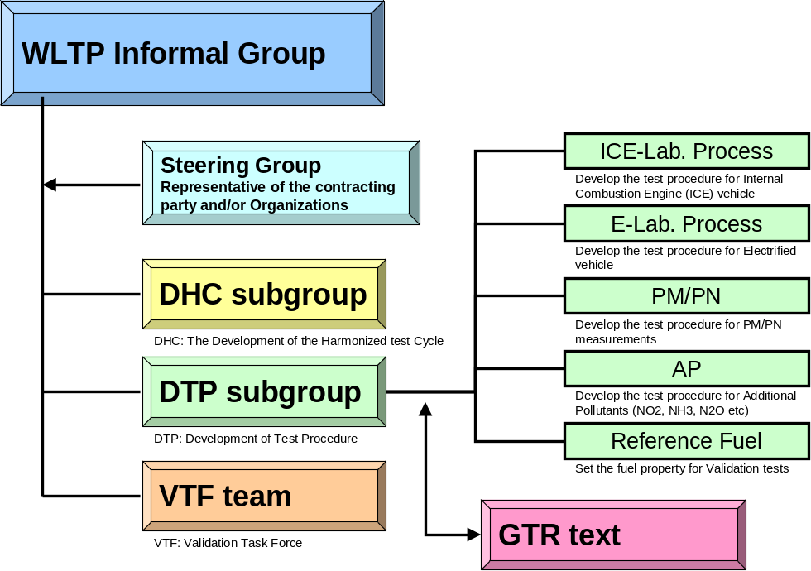
Figure 1: The structure of WLTP-IG

The flow diagram of the WLTP development in phase 1 and the interaction between the technical subgroups/working groups is shown in Figure 2
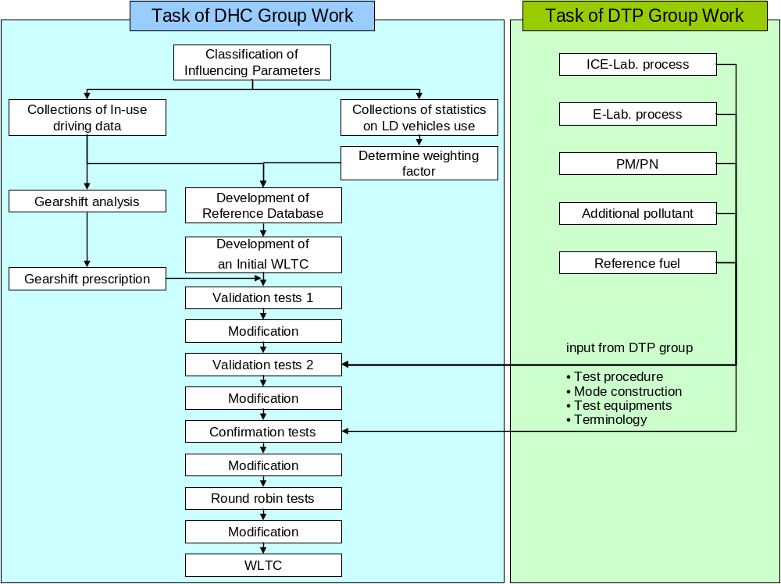
Figure 2: Overview of the WLTP development

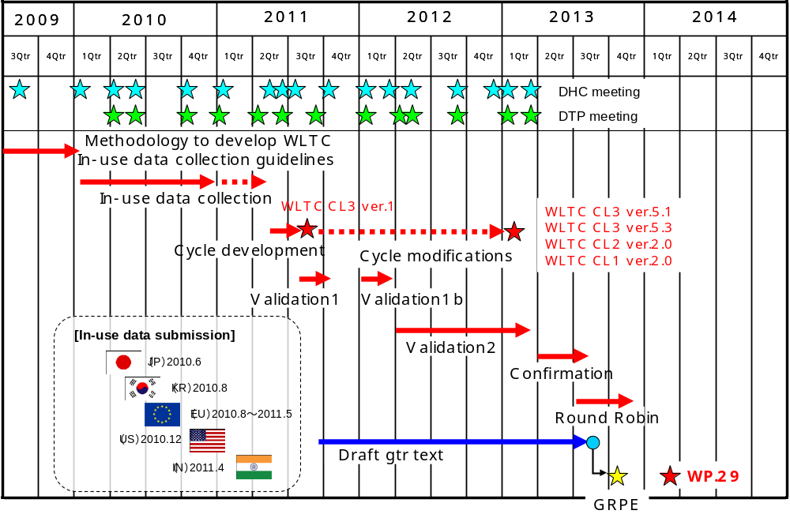
Figure 3: The time schedule for Cycle and Procedure development
Figure 3 shows the road map for the development of WLTP, which started in September 2009.
The DTP group was first chaired by Michael Olechiw (EPA, USA), later to be followed up by Giovanni d’Urbano, (BAFU Switzerland). The first secretary was Norbert Krause (OICA), later to be followed-up by Jakob Seiler (VDA, Germany).

DTP subgroups
As indicated in Figure 1 and 2, there were five working groups established within the DTP group to promote an efficient development process by dealing with specific subjects of the test procedure:
- LabProcICE (Laboratory procedures for Internal Combustion Engine vehicles) to work on the road-load determination and test procedures in the testing laboratory for conventional vehicles
- LabProcEV (Laboratory procedures for Electrified Vehicles) to work on all test procedures that specifically address (hybrid) electric vehicles
- PM/PN (Particulate Mass/Particulate Number) to work on test procedures for the determination of particulate mass and particulate numbers in the exhaust gas.
- AP (Alternative Pollutants) to work on test procedures for gaseous emission compounds other than CO₂, NO_{x}, CO and HC.
- RF (Reference Fuel) to work on specifications for reference fuels used in emission testing.
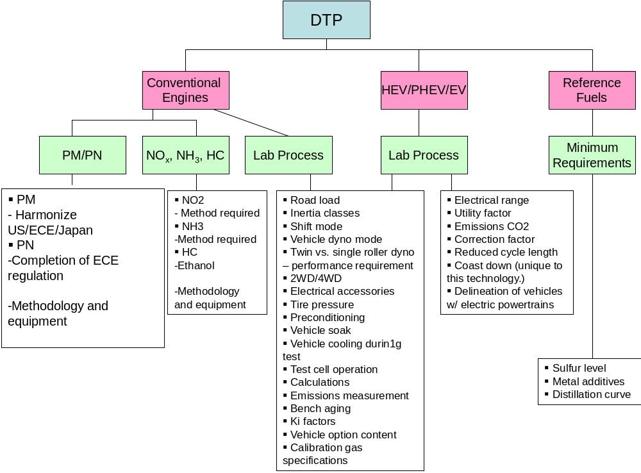
Figure 4: Structure of the DTP and its subgroups
The structure of the work distribution and the allocation of tasks are illustrated in Error: Reference source not found. A more detailed overview for the scope of activities of these subgroups is presented in the next paragraphs.
The first meeting of the DTP subgroup took place at Ann Arbor (USA) from 13. To 15. April 2010. The subgroup leaders were appointed at the 2nd DTP meeting which was held in Geneva in June 2010. A draft proposal for the development of the test procedure was made by OICA. After this meeting the subgroups started their work and the following DTP meetings (14 in total until mid of 2013) were dedicated to discussions about the reports from the subgroups.

Terms of Reference (ToR)
The terms of reference were the same for all subgroups and are listed below:
- The working language of the subgroup will be English.
- All documents and/or proposals shall be submitted to the Chair (in a suitable electronic format) in advance of scheduled meetings/web-conferences. Participants should aim to submit documents 5 working days in advance of meetings/web-conferences.
- An agenda and related documents will be circulated to all subgroup participants in advance of all scheduled meetings/web-conferences.
- Documents will also be uploaded by the Chair to the European Commission’s website and a link provided from the UN-ECE website.
- The progress of the subgroup will be reported to DTP group meetings by the Chair (or other nominated person). Reporting will include a list of “Open Issues” on which agreement has yet to be reached within the subgroup, which will be updated by the Co-chair.
- Following each meeting/web conference the Chair (or other nominated person) will circulate a short status report, along with the list of “Open Issues” to chairs and co-chairs of DHC, DTP and other DTP subgroups.
Another point which is common to all subgroups is the development approach. The development of the measurement procedures was based on a review and comparison of already existing regional regulations in the EU, India, Japan and the US.
The scope of activity was of course dedicated to the issues covered by the tasks of the different subgroups and is further detailed in the following paragraphs.
    - ICE laboratory process (LabProcICE)

Chair: Stephan Redmann – Ministry of Transport (Germany)
Béatrice Lopez de Rodas - UTAC (France)
Co-chair: Dr. Werner Kummer – OICA / Dr. Konrad Kolesa - OICA

The Lab Process ICE subgroup was tasked with developing a test procedure which includes vehicle preparation, vehicle configuration, vehicle operation, measurement equipment and formulae for the measurement of criteria pollutants, CO₂, and fuel consumption for internal combustion engine light duty vehicles. In addition, the Lab Processes ICE subgroup was responsible for the development of the testing specifications that are in common with electrified vehicles.
The scope of activity for this subgroup was described as follows:
- Identify content of Contracting Party legislation relevant to laboratory procedures for conventionally fuelled light duty vehicles excluding PM/PN and additional pollutants measurement procedures.
- Compare relevant content of Contracting Party legislation (US, UNECE, Japanese).
- Decide upon which content to use for WLTP or, where appropriate, to specify alternative requirements for WLTP.
- If necessary improvements shall be conducted on the following principles
    - narrow tolerances / flexibilities to improve reproducibility
    - cost effectiveness
    - physically reasonable results
    - adapted to new cycle
- Draft laboratory procedures for internal combustion engine light duty vehicles and specification text.
The work was started by summarizing and comparing current emission legislation from different regions (EU, India, Japan, US). An overview of this is presented in Annex 1.
In LabProcICE the work was further structured into the following three subjects:
- Road load determination,
- Test procedure,
- Emission measurement/measurement equipment.
The different sections of a first draft GTR proposal, based on GTR’s 2 and 4, were marked according to agreements, proposals and open issues. Not surprisingly, the majority of points was marked as “open issues” at the beginning of the work
The LabProcICE subgroup was responsible for the following annexes of the GTR draft:
- Annex 4 - Road load and dynamometer setting. This Annex describes the determination of the road load of a test vehicle and the transfer of that road load to a chassis dynamometer. Annex 4 has the following appendices:
  - Appendix 1 - Calculation of road load for the dynamometer test,
  - Appendix 2 - Adjustment of chassis dynamometer load setting.
- Annex 5 - Test equipment and calibrations
- Annex 6 - Type 1 test procedure and test conditions. These tests verify the emissions of gaseous compounds, particulate matter, particle number, CO₂ emissions, and fuel consumption, in a representative driving cycle. Annex 6 has the following appendices:
  - Appendix 1 - Emissions test procedure for all vehicles equipped with periodically regenerating systems,
  - Appendix 2 - Test procedure for electric power supply system monitoring.
- Annex 7 – Calculations. All the necessary steps are included to work out the mass emissions, particle numbers and cycle energy demand, based on the test results. CO₂ and fuel consumption are calculated for each individual vehicle within the CO₂ vehicle family.
Those parts of annexes 5 and 6 that are dealing with particles and additional pollutants were developed by the corresponding (PM/PN and AP) subgroups.
[to be completed]
The first meeting of this subgroup took place at 03. to 06.08.2010 in Ingolstadt, Germany.

EV laboratory process (LabProcEV)

Chair: Per Öhlund – Swedish Transport Agency (Sweden) Kazuki Kobayashi - NTSEL (Japan)
Co-chair: Yutaka Sawada - OICA

The LabProcEV subgroup was tasked with developing a test procedure which includes vehicle preparation, vehicle configuration, vehicle operation, measurement equipment and formulae for the measurement of criteria pollutants, CO₂, fuel consumption and electric energy consumption for electrified vehicles.
The scope of activity was described as follows:
- Identify content of Contracting Party legislation relevant to laboratory procedures for Electrified vehicles excluding PM/PN and additional pollutants measurement procedures.
- Compare relevant content of Contracting Party legislation (US, UNECE, Japanese).
- Decide upon which content to use for WLTP or, where appropriate, to specify alternative requirements for WLTP.
- Identify additional performance metrics associated with electrified vehicles that may not be covered by existing regulations. (i.e. battery charging times). Create harmonized test procedures for the new performance metrics.
- If necessary improvements shall be conducted on the following principles
- narrow tolerances / flexibilities to improve reproducibility
- cost effectiveness
- physically reasonable results
- adapted to new cycle
- Draft laboratory procedures for electrified light duty vehicles and specification text.

The LabProcEV subgroup was responsible for annex 8 (Pure and hybrid electric vehicles) of the GTR draft, in which those measurement procedures and equipment are defined that are dedicated to electrified vehicles and which deviate from Annexes 5 and 6.
The first meeting of this subgroup took place at 21.09.2010.

Particulate mass/Particulate number (PM/PN)

Chair: Chris Parkin - UK Department for Transport
Co-chair: Caro Hosier – OICA

The scope of activity was described as follows:
The subgroup will undertake the following tasks:
- Identify content of Contracting Party legislation relevant to PM and PN measurement procedures.
- Compare relevant content of Contracting Party legislation (US, UNECE, Japanese).
- Decide upon which content to use for WLTP or, where appropriate, to specify alternative requirements for WLTP.
- Draft PM and PN measurement procedure and specification text.

The approach taken by the PM/PN group was to start from a detailed comparison of the regulations from EU, US and Japan. PM/PN established a number of small expert teams to review and make recommendations back to the wider team on measurement equipment specifications, particulate mass sampling, weighing and all aspects of particle number measurement.
Particulate mass (PM) measurement is made by collecting the particulate on a filter membrane which is weighted pre and post test in highly controlled conditions. It was decided to update the requirements as far as possible for technical progress and harmonisation but without leading to the need to completely replace the majority of existing particle mass measurement systems. A major aspect of this decision is that particle number is also measured.
Regarding particle number (PN), only the ECE Regulation 83 contains particle number measurement requirements. Particle number measurement is an on-line measurement process to count solid particles in the legislated size range in real time, where the total number of particles per kilometre is reported for the test.
The experts on particle number measurement reviewed the procedure in detail to identify opportunities for tightening the tolerances to improve repeatability / reproducibility as well as improvements to the process and calibration material specifications to adapt this method to recent technical progress.
The work of the PM/PN subgroup was incorporated in relevant parts of Annex 5, 6 and 7 of the GTR.
The PM/PN subgroup started its work by a web/phone conference at 07.07.2010.

Additional pollutants (AP)

Chair: Oliver Mörsch – Daimler AG
Co-chair: Cova Astorga – JRC

The scope of activity for the AP subgroup was described as follows:
The subgroup will undertake the following tasks on the basis of procedures in existing legislation and expert knowledge within the group:
- Agree on additional pollutants to be addressed.
- Identify appropriate measurement methods for each of the pollutants.
- Describe measurement and calibration procedures and calculations based on existing legislation and on output from lab procedure subgroup.
- Drafting of legislation text.

For the development of measurement methods for the additional pollutants the following guidelines have been applied:
- Use or modify existing methods where ever reliable, cost effective and easy to apply technologies are available.
- Reflect state of the art
- Stipulate development of new measurement technologies
- Replace cumbersome offline methods by online methods

The work of the AP subgroup was incorporated in relevant parts of Annex 5, 6 and 7 of the GTR.
The first web/phone meeting of the AP subgroup took place at 20.07.2010.

Reference fuel (RF)
Chair: William (Bill) Coleman – Volkswagen AG
Co-chair: a co-chair has not been nominated

The scope of activity for the RF subgroup was described as follows:
- Defining a set of validation fuels to support the development stages of the WLTP Project (stage 1), and;
- Defining a framework for reference fuels to be used by Contracting Parties when applying the WLTP Regulation (stage 2).

The scope of activity is related to stage 1. The subgroup should undertake the following tasks on the basis of a comparison of reference fuels in existing legislation and expert knowledge within the group:
- Agree a limited number of fuel types and/or blends for which reference fuels are expected to be required in the time frame of implementation of the WLTP project (“conventional” and “alternative” fuels, e.g. BXlow, BXhigh, EXlow, EXhigh, CNG, LPG, H2ICE, H2FC, etc.).
- Identify a list of fuel properties that will be significant to the validation of a future drive cycle and/or test procedure for emissions and/or fuel consumption.
- Propose limits for the variation of these critical properties in order to specify a limited number of candidate validation fuels to assess potential impact of the future drive cycle on emissions and/or fuel consumption.
- Obtain approval from the WLTP Project for the technical scope of the validation fuels described in 3.
- Upon approval of the above mentioned parameter list, develop specifications for candidate validation fuels to be used in the validation of the proposed drive cycles and test procedures. These fuels should be limited in number, available at reasonable cost and are not intended to restrict the decisions regarding reference fuels for the final implementation of WLTP (Stage 2).
- Provide a forum of reference fuel experts who can at relatively short notice provide coordinated advice and support on fuel related project issues to members of other sub-groups of the WLTP Project.
These tasks would imply a fruitful cooperation with experts from the fuel production industry. Since this cooperation could not be established, points 1 to 4 and 6 could not be fulfilled and already defined regional reference fuels were used for the validation tests of the proposed drive cycles and test procedures.
As a consequence, annex 3 of the GTR dedicated to reference fuels consists only of the following two paragraphs
- As there are regional differences in the market specifications of fuels, regionally different reference fuels need to be recognised. Example reference fuels are however required in this GTR for the calculation of hydrocarbon emissions and fuel consumption. Reference fuels are therefore given as examples for such illustrative purposes.
- It is recommended that Contracting Parties select their reference fuels from this Annex and bring any regionally agreed amendments or alternatives into this GTR by amendment. This does not however limit the right of Contracting Parties to define individual reference fuels to reflect local market fuel specifications.
In addition to that, tables with specifications for the following fuel types are included in the GTR draft:
- Liquid fuels for positive ignition engines
  - Gasoline/Petrol (nominal 90 RON, E0)
  - Gasoline/petrol (nominal 91 RON, E0)
  - Gasoline/petrol (nominal 100 RON, E0)
  - Gasoline/petrol (nominal 94 RON, E0)
  - Gasoline/petrol (nominal 95 RON, E5)
  - Gasoline/petrol (nominal 95 RON, E10)
  - Ethanol (nominal 95 RON, E85)
- Gaseous fuels for positive ignition engines
  - LPG (A and B)
  - NG/biomethane
    - "G20" "High Gas" (nominal 100 % Methane)
    - "K-Gas" (nominal 88 % Methane)
    - "G25" "Low Gas" (nominal 86 % Methane)
    - "J-Gas" (nominal 85 % Methane)
- Liquid fuels for compression ignition engines
  - J-Diesel (nominal 53 Cetane, B0)
  - E-Diesel (nominal 52 Cetane, B5)
  - K-Diesel (nominal 52 Cetane, B5)
  - E-Diesel (nominal 52 Cetane, B7)
[meetings?]

Test procedure development

General Purpose and Requirements
Explanation to aim for the most representative conditions for real life vehicle usage, within the restraints of having a test procedure that is practicable, cost-effective, repeatable and reproducible with test conditions that are well defined. Possibly the DTP and/or LabProcICE management team could provide some (additional) input here.
- Is there an official document that lists the general scope and purpose of WLTP? No such reference is given in Part A of the GTR, and neither the Terms of Reference nor the Roadmap are very specific on that.

Approach
For the development of the test procedures, the DTP sub-group took into account existing emissions and energy consumption legislation, in particular those of the UN-ECE 1958 and 1998 Agreements, those of Japan and the US EPA Standard Part 1066. A detailed overview of the regional emission legislations that were studied for the GTR is included in Annex 1. These test procedures were critically reviewed and compared to each other to find the best starting point for the draft text of the GTR. The development process then continued by particularly focusing on the following ways to improve the text:
- To update the specifications for measurement equipment towards the current state-of-art in measurement technology
- To increase the representativeness of the test and vehicle conditions, in order to achieve the best guarantee for similar fuel efficiency on the road as under laboratory conditions.
- To ensure that the GTR is able to deal with current and expected technical progress in vehicle and engine technology in an appropriate and representative way. This particularly involves the section on (hybrid) electric vehicles.
As such, the GTR text was updated and complemented by new elements where necessary. For this technical report it would be too comprehensive to list all the modifications that were introduced, e.g. bringing the accuracy requirements of the instrumentation to the current state of the art needs nu further clarification and falls outside of the scope. Instead, the important changes that have contributed the most in achieving an improved and representative test procedure will be identified and explained where necessary. Paragraph 4.3 generally outlines the main improvements of the GTR. The modifications that need some more clarification or justification will be detailed in Paragraph 4.4.

Improvements of the GTR
It will be illustrated which elements of the DTP have contributed in achieving the goals specified in par. 5.2 (mainly on the point of representativeness). This will be done in a general sense, i.e. a bullet list with brief explanation of the improvement. The advantage to list these improvements here, is that it is not strictly necessary to go into the full details of all small modifications in describing the annexes.
A first (but not conclusive) list of improvements is listed below:
- Instead of declaring one CO₂ value for the entire family of vehicles, each individual vehicle within the family will receive a dedicated CO₂ value, based on the installed vehicle options (this is referred to as the ‘combined approach’, which considers the CO₂ influence of mass, rolling resistance and aerodynamic performance characteristics)
- Raising the test-mass of the vehicle to a more representative level and making this test mass dependent on the payload. Instead of using discrete inertia steps, the test mass is set continuously.
- Monitoring the test cycle development to make sure the WLTC is representative for average driving behaviour with respect to CO₂ determining characteristics.
- Battery state-of-charge at the start of the test is moved from fully charged (NEDC) to a representative start value by a preconditioning cycle.
- The difference in battery state-of-charge over the cycle is monitored and corrected if needed.
- The test temperature in the laboratory is lowered from 25 to 22 °C, and a temperature correction for the average temperature will be applied (only in Europe).
- Improving and strengthening the requirements and tolerances with respect to the road load determination procedure, such as:
  - Demanding that the test vehicle and tyre specifications are similar to those of the vehicle that will be produced;
  - Asking for a more stringent test tyre preconditioning (tread depth, tyre pressure, running-in, shape, no heat treatment allowed, etc.);
  - Strengthening the correction method for wind during the coast-down method (both for stationary wind measurement as for on-board anemometry);
  - Preventing ‘special’ brake preparation;
  - Setting more stringent test track characteristics (inclination).
- Developing a methodology to create a proper revision of the ‘table of running resistances’ (the ‘cookbook’ road load values that can be used if the road load is not tested)
- Making the GTR text on various subjects more robust (e.g. the torque-meter method for road load determination)
- Improving the definitions in the GTR, e.g. on mass, reference speeds, etc.
- Providing a means to include in the soak procedure the positive effect of heat storage/insulation, and safeguarding that the benefit for in-use vehicles is similar.
- Adding NO₂ and NH₃ as an additional emission component to be measured. For NH₃ the measurement from raw gas is introduced as new concept (taken over from heavy duty GTR). As this will influence the measurement of other pollutants, measures have to be taken (i.e. limit lost sample to 0,5 % of raw exhaust)

[to be completed]

New concepts of the GTR
The main new concepts of the GTR can be described here, at least the concept of the combined approach, but also the concept of dealing with EVs should be mentioned, the concept to correct the charge balance, etc. This should be restricted to topics/concepts that need a bit more explanation to understand the underlying ideas.

Combined approach
5.4.1.1 General principle
One of the key requirements of WLTP, as specified in par. 4.2, is to develop the test cycle and test procedure in such a way that the resulting CO₂ emission and fuel consumption is representative for real-life vehicle usage. The DTP group recognised early in the development process as a barrier to achieve that goal the fact that tests are executed on single vehicles, while the results of these tests are used to type-approve a whole family of vehicles. These vehicles would mainly differ from each other in terms of options selected by the customer that lead to differences in mass, tire/wheel rim combinations and vehicle body trim and/or shape. It was considered useful to find a method that would attribute CO₂ to individual vehicles within the family in an appropriate way.
The first prerequisite identified for such a methodology was that testing only one vehicle does not provide sufficient information. At least two different vehicles within the family have to be tested to determine a difference in CO₂ that can be attributed to vehicle characteristics, preferably a ‘worst-case’ vehicle and a ‘best-case’ to allow good coverage of the vehicle family. Within the GTR these test vehicles are referred to as vehicle H and vehicle L respectively. It was also agreed that pollutant emission standards should be met by all vehicles of the family, although that requirement needs to be transposed into the regional legislation.
The next challenge concerned how to attribute the difference found in CO₂ between vehicle H and L to vehicles in between. There is however not a single parameter available that correlates to the increased CO₂ as a result of differences in mass, aerodynamic drag and rolling resistance. As a first candidate, the mass of the vehicle was proposed as a parameter for interpolation between vehicle H and L, assuming that there is some kind of weak correlation between the added mass of options and the increase in aerodynamic drag of those options. Analysis of such an interpolation method lead to unacceptable errors. This is easily understandable by considering that some options only add mass, while others (e.g. spoilers, wider tires) only have a marginal effect on mass but add considerable aerodynamic drag and/or rolling resistance.
The final breakthrough in this discussion arrived when it was recognised that it the energy needed at the wheels to follow the cycle which has a more or less direct effect on the CO₂ of the test vehicle, under the assumption of a relatively constant engine efficiency for vehicle L and H. The cycle energy is the sum of the energy to overcome the total resistance of the vehicle, and the kinetic energy from acceleration:
E_{cycle} = E_{resistance} + E_{kinetic}
With:
E_{resistance} = time integral over the cycle of road load force F(v) multiplied by distance.
E_{kinetic} = time integral over the cycle of vehicle test mass TM multiplied by positive acceleration and distance
(please note that if E_{cydle} is negative, it is calculated as zero).
The total resistance force F(v) follows from the road load determination procedure, as outlined in Annex 4, and is expressed as a second order polynomial with the vehicle speed:
F(v) = f₀ + f₁.v + f₂.v²
The key elements for success of this method are that:
- the difference ΔCO₂ between vehicle L and H correlates well to the ΔE_{cycle}, and
- differences in mass, rolling resistance and aerodynamic drag due to vehicle options can be translated into effects on ΔE_{cycle}.
This last statement can be explained by the following arguments:
- The kinetic energy responds linearly to the mass of the vehicle.
- f₀ responds linearly to the tyre rolling resistance and the mass of the vehicle
- f₁ has nearly no correlation to the mass, rolling resistance and/or aerodynamic drag and can be considered identical for vehicles L and H
- f₂ responds linear to the product of aerodynamic drag coefficient C_{d} and vehicle frontal area A_{f}
Consequently, if the values for mass, rolling resistance and aerodynamic drag are known for vehicles L, vehicle H and individual vehicle, the difference in cycle energy ΔE_{cycle} can be calculated with respect to vehicle L, and from the interpolation curve the ΔCO₂ is derived . This methodology is illustrated in the figure below for an individual vehicle with a ΔE_{cycle} which is 40% of the difference in cycle energy between vehicle L and H.

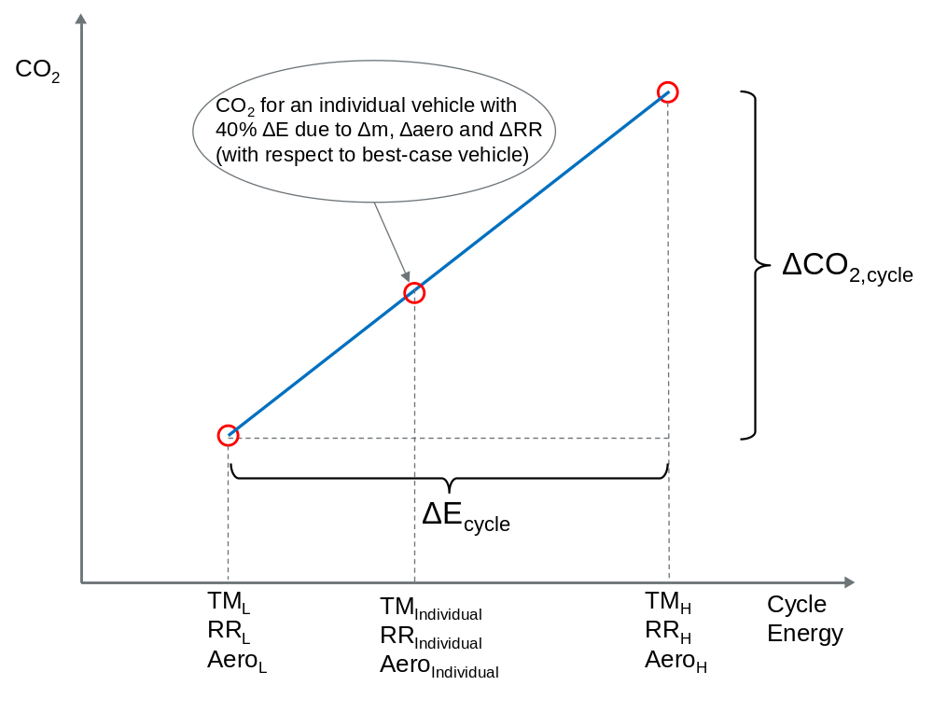
Figure 5: Example for the interpolation method applied in the combined approach for road load relevant vehicle characteristics.

The general principle of this combined approach is described in par. 1.2.3.1 of Annex 6. The mathematical representation is found in the formulas of par. 3.2.2 and section 5 of Annex 7. Please note that the method is applied for each cycle phase separately, as the weighting of these phases may differ between regions.

5.4.1.2 Vehicle selection
In a first attempt to specify test vehicle H for the CO₂ vehicle family, the vehicle with the worst-case mass, the worst-case rolling resistance tyres and the worst-case aerodynamic drag was proposed. This seemed a sensible approach to describe a worst-case vehicle until it was recognised that the vehicle with the highest mass may not be fitted with the worst-case tyres and vice versa. Specifying such a worst-case vehicle would then lead to a non-existing vehicle. The definition for vehicle selection in par. 4.2.1 of Annex 4 was therefore chosen to be described in a more functional way: “A test vehicle (vehicle H) shall be selected from the CO₂ vehicle family … with the combination of road load relevant characteristics (e.g. mass, aerodynamic drag and tyre rolling resistance) producing the highest road load.” So, if in the example above the influence of tyre rolling resistance on the road load is higher than that of the mass, the vehicle with the worst-case tyres is selected as vehicle H. Consequently, the paragraphs dealing with the test mass (in 4.2.1.3.1), tyres (in 4.2.2) and aerodynamics (in 4.2.1.1) will not further specify what to select for test vehicle H.
Of course, a similar approach is followed for the selection of the best-case test vehicle L.

5.4.1.3 Interpolation/extrapolation range
The accuracy of the combined approach has been validated by 2 vehicle manufacturers using their detailed in-house simulation models. The CO₂ and E_{cycle} for a vehicle L and H were determined, and used to interpolate the CO₂ of vehicles in between. Comparing the interpolation results with the simulation results for intermediate vehicles learned that the combined approach is accurate well within 1 g/km of CO₂ up to a ΔCO₂ of more than 30 g/km. [WLTP-DTP-LabProc-238] On the basis of these results the methodology was accepted and the allowed interpolation range was set at 30 g/km or 20% of the CO₂ for vehicle H, whichever is the lower value. The latter was needed to prevent that low CO₂ emitting vehicles would receive a relatively large interpolation range. Also a lower range limit of 5 g/km between vehicle L and H was set to allow sufficient resolution, thereby preventing that measurement inaccuracies have a large influence on the course of the interpolation line. Finally it was also agreed that the interpolation line may be extrapolated to both ends by a maximum of 3 g/km, e.g. to include future vehicle modifications within the same type approval. However, the absolute interpolation range boundaries of 5 and 30 g/km may not be exceeded.
The allowed interpolation/extrapolation range is specified in 1.2.3.2 of Annex 6.

GTR structure [under construction]
This paragraph will guide the reader through the GTR. The basic structure should therefore be similar to that of the GTR, i.e. one subparagraph per Annex. The main purpose is to point out the different steps in the test procedure. Some details to the procedure may be outlined, but when it needs more explanatory text it may be better to shift that topic to par. 5.4. It will not be necessary to go through all of the details of this Annex in separate subparagraphs, but to focus on how the procedure works in practice and the order in which it is executed. Otherwise the technical report will become too detailed and too large.

Annex 3 – Reference fuels
Input required from Reference Fuels Group (Bill Coleman is group leader)

Annex 4 - Road and dynamometer load
This Annex describes the determination of the road load of a test vehicle and the transfer of that road load to a chassis dynamometer. Road load can be determined using coast down or torque meter methods.

Annex 5 – Instrumentation
[to be completed]

Validation of the test procedure
This chapter will give an overview of the activities that were done in the Validation 2 phase to test the new procedure.

Validation phase

Participant and vehicles, measured parameter
The first validation phase aimed at the assessment of the driveability of the WLTP cycles. A second phase was dedicated to procedural issues. This phase was executed between April 2012 and December 2012. All necessary information concerning
- Test plan,
- Parameter list and test procedure,
- Test sequences,
- Driving cycle schedules,
- Gearshift prescriptions for manual transmission vehicles,
- Data collection and delivery
were made available to the participants via JRC’s FTP-server.
For class 1 and class 2 vehicles the cycle versions 1.4 were used, for class 3 vehicles the cycle version 5 was used. At the beginning of the validation 2 phase the gearshift calculation tool from 16.04.2012 was used.
Some modifications on procedural issues needed to be performed during the validation 2 phase, based on the analysis of the results obtained so far. The following table gives an overview of these modifications.
The most important modifications were made by the VP2 information package from 25. July 2012. For class 1 and class 2 vehicles the cycle versions 1.4 were replaced by cycle versions 2 and the gearshift calculation tool from 16.04.2012 was replaced by the version from 09.07.2012. Compared to the previous version the following modifications were made:
- n_min_2 was added as input parameter. n_min_2 is the minimum engine speed in gear 2. n_min_2 was defined as 1,25*idling_speed. It is now recommended to set n_min_2 to 1,15*idling_speed. The minimum value that can be used for the calculation is 1,1*idling_speed.
- n_min_drive, the minimum engine speed for short trips in gears > 2, was limited to 0,125*(rated_speed - idling_speed) + idling_speed. The use of this value is still recommended, but lower values down to n_min_2 can be used for the calculation.
- The safety margin accounting for the difference between stationary wot power curve and the power available during transient conditions could be chosen as input parameter in the previous version. The choice of 90% was recommended. The safety margin was fixed to 90% and could not be changed any more.

No. | Date | Filename | Modification
1 | 19 April 2012 | File_2 - Parameter_List_for_Validation_2_v7_DTP_19-April-2012.xlsx | Item 21:  Proportional fan
2 | 23 April 2012 | File_1 - Validation2 Test Plan_23-April-2012.xls | Addition of TNO as Participating Lab (in box L5 and in Evaluation Item “ICE Vehicle weight”)
3 | 23 April 2012 | File_8 - WLTP_VP2_Participating Labs_list_23-April-2012.docx | Update of the List of Participating Labs (TNO – The Netherlands)
4 | 26 April 2012 | File_6 - Data_collection_template_26-April-2012.xls | Addition of columns (related to adopted Gear Shift strategy) to the “bag results test i *” pages
5 | 15 May 2012 | File_DHC_B_ANNEX_15-May-2012.doc | New file - Addition of a “.doc” file with detailed instructions on how to use the Gear Shift Evaluation Tool
6 | 15 May 2012 | File_3 - LabProc-EV-TestMatrix_from ACEA_15-May-2012.xlsx | New file - Addition of the Test Matrix for EV/HEV
7 | 15 May 2012 | File_0 - Read me_15-May-2012.docx | “Read me” file updated
8 | 09 July 2012 | File_DHC_A - Driving Cycles_09-July-2012.xlsx | New version of Class 1 and Class 2 driving cycles
9 | 09 July 2012 | File_DHC_B_gearshift_calculation_tool_09-July-2012.mdb | Gear Shift calculation tool updated and streamlined
10 | 09 July 2012 | File_DHC_B_ANNEX_09-July-2012.doc | Revised explanatory note on how to use the Gear Shift calculation tool
11 | 23 July 2012 | File_8 - WLTP_VP2_Participating Labs_list_23-July-2012.docx | File updated
12 | 23 July 2012 | File_9 - JRC_ftp_server_Owners_23-July-2012.xlsx | File updated
13 | 25 July 2012 | File_6.1 - Data_collection_template_lab_and_vehicle_info_25-July-2012.xls | New version of the excel template to report test results. The original file has been split in two files, now including also EV/HEV and PM/PN features
13 | 25 July 2012 | File_6.2 - Data_collection_template_test_results_25-July-2012.xls
14 | 25 July 2012 | File_0 - Read me_25-July-2012.docx | File updated
Table 1: Procedural modifications during the validation 2 phase

[IT IS SUGGESTED TO MAKE A SPLIT HERE, AND TO MOVE THE TEXT UNTIL THE NEXT PARAGRAPH INTO AN ANNEX OF THE REPORT]
In total, the following 34 different laboratories, institutions or manufacturers participated in the validation 2 phase:
- AECC
- AFHB, Berner Fachhochschule Technik und Informatik
- ARAI
- Audi
- BMW
- Bosch
- BOSMAL (POLAND)
- Daimler
- DEKRA Automobil GmbH
- Delphi
- Empa, Swiss Federal Laboratories for Materials Science and Technology
- Ford
- IAV
- India 1, Tata Motors
- India 2, Mahindra
- India 3, Hyundai
- India 4, Maruti Suzuki India Pvt. Ltd.
- India 5, Honda
- JAMA A
- JAMA B
- JAMA C
- JAMA D
- JARI
- JRC
- Korea
- NTSEL
- Opel
- PSA
- Renault
- TME (Toyota Motors Europe)
- TNO-Horiba
- TUEV Rheinland
- Volvo
- VW
The results were delivered to the JRC server and then collected in an Access database. The total number of 109 vehicles can be split into subgroups as shown in Table 2.

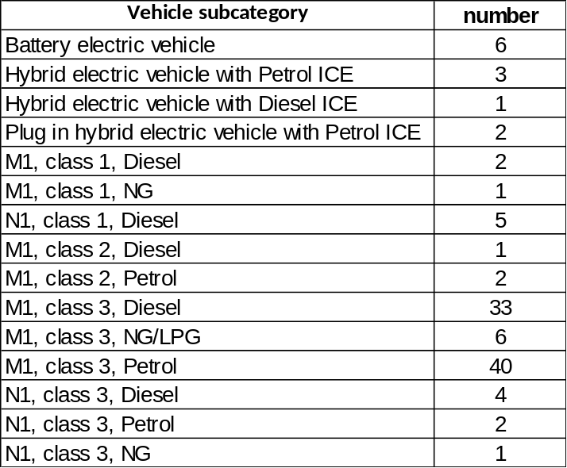
Table 2: Overview of the validation 2 vehicle sample

Information about the dynos was delivered from 33 of the 34 participants. 19 participants were able to measure all 4 phases of the WLTC in one test, because their test benches had 4 bag measuring devices. 14 participants had only 3 bag measuring devices. Most of them measured the first 3 phases (L&M&H) with a cold start and then phases L, M and exH in hot condition in a second test. Some participants measured different phase combinations in addition to the base test.
The technical data of the 109 vehicles are shown in Table 3 to Table 9. Table 10 to Table 16 contain an overview of the measured test parameter like engine speed and temperatures. Table 17 to Table 23 contain information about the measured emissions and Table 24 to Table 30 contain additional information about the tests.
For the major part of the vehicles only the basic tests were performed. For some others parameter variations were performed, in fact:
- 4 bag and one bag tests for particulate mass (vehicles 1 and 3),
- Gearshifts according to GSI and calculation tool (vehicles 4, 5, 8, 10 and 102),
- Test mass and/or road load variations (16 vehicles, from 2 variants up to 4 variants),
- Different preconditioning tests (vehicles 19 and 43),
- Overnight soak with forced cooling (vehicles 43, 44, 53, 61, 67, 68, 69 and 70)

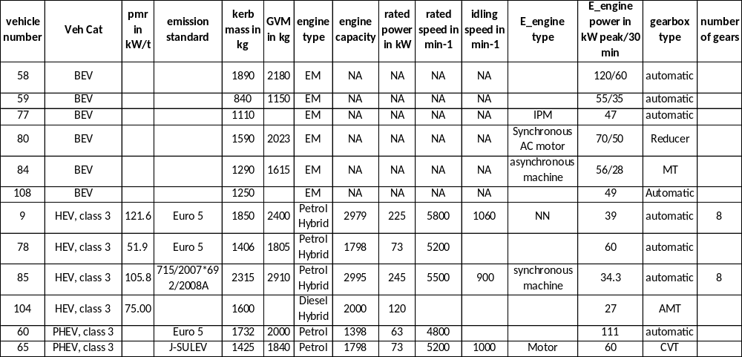
Table 3: Technical data of pure electrical and hybrid vehicles

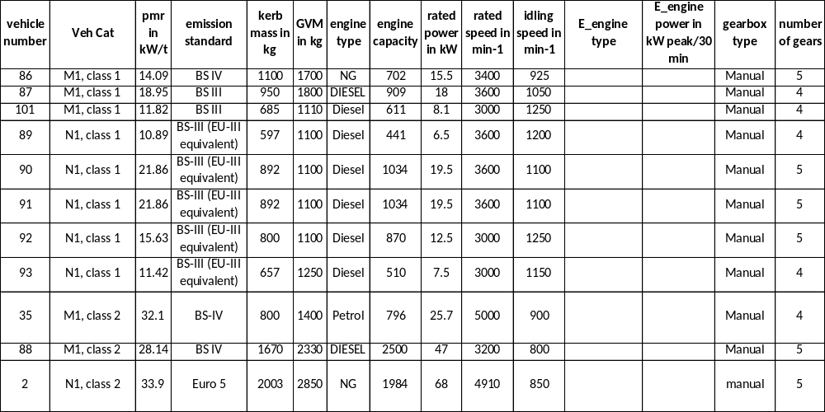
Table 4: Technical data of ICE class 1 and class 2 vehicles

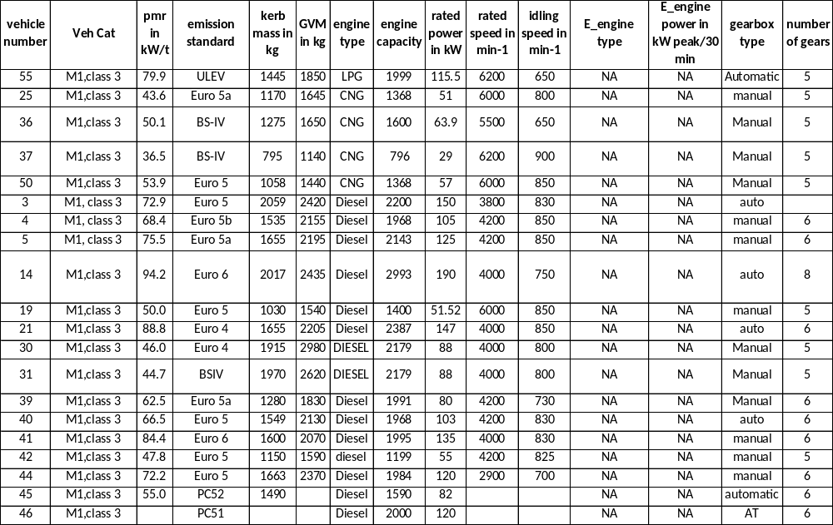
Table 5: Technical data of ICE M1 class 3 vehicles
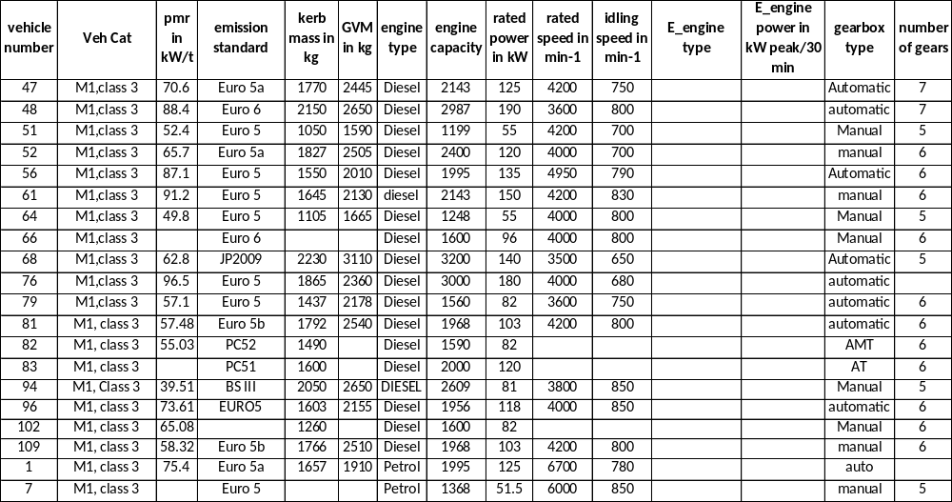
Table 6: Technical data of ICE M1 class 3 vehicles

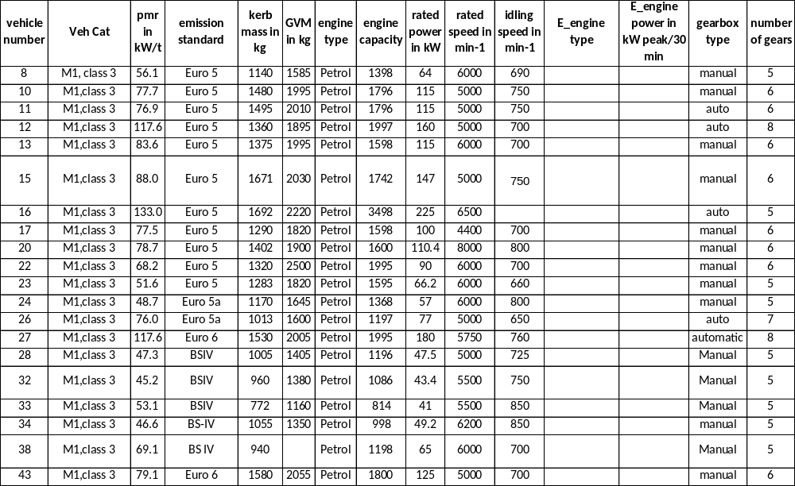
Table 7: Technical data of ICE M1 class 3 vehicles
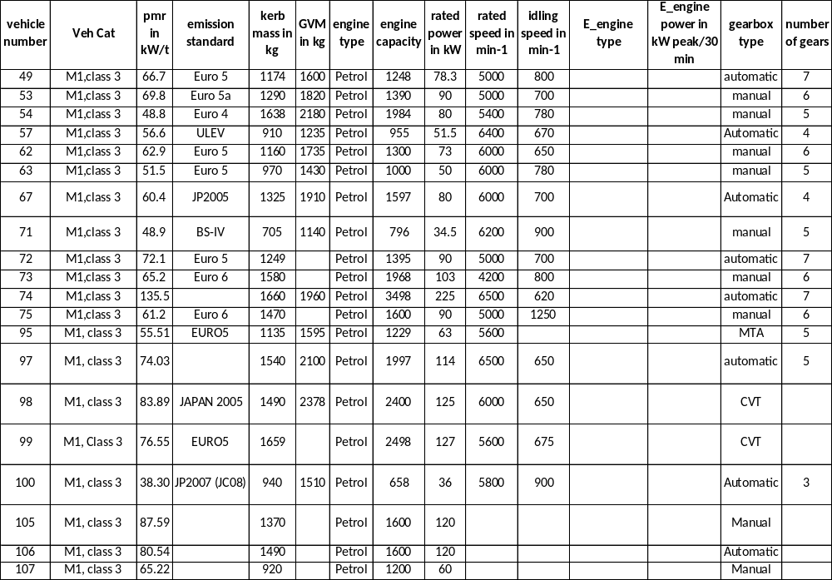
Table 8: Technical data of ICE M1 class 3 vehicles
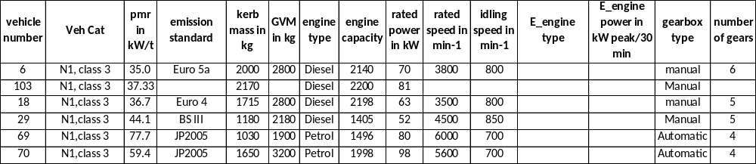
Table 9: Technical data of the ICE N1 class 3 vehicles

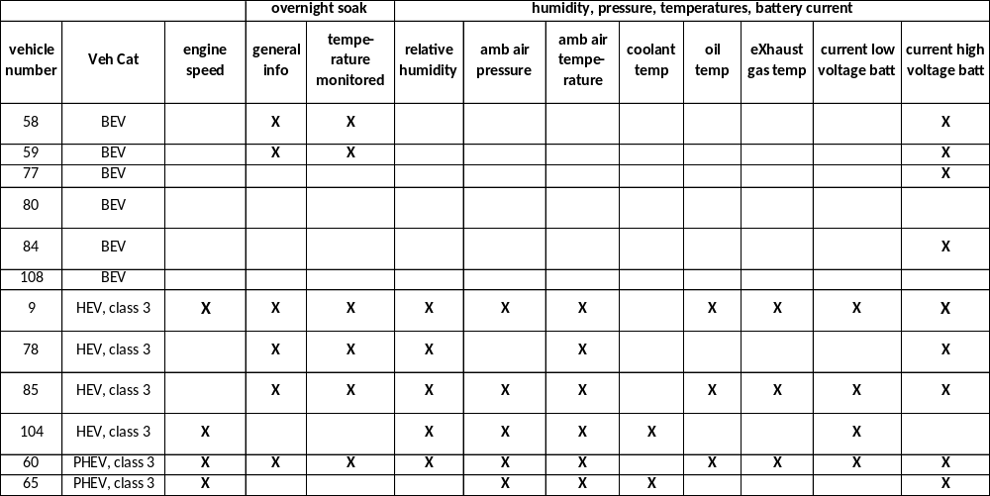
Table 10: Measured parameter for pure electric vehicles (BEV) and hybrid vehicles

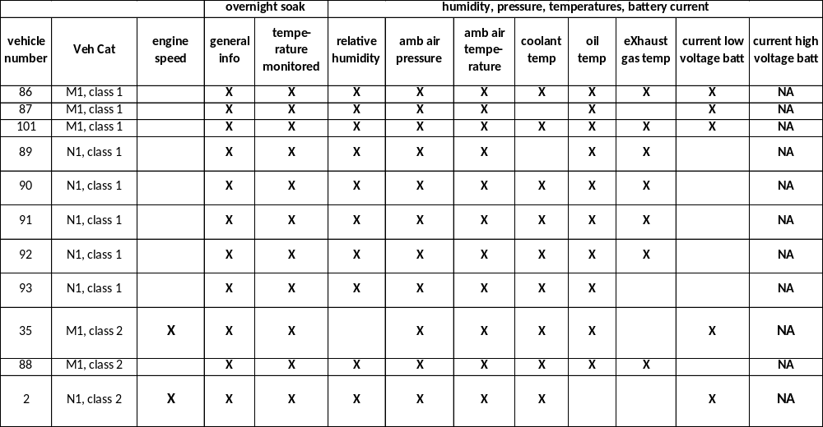
Table 11: Measured parameter for ICE class 1 and class 2 vehicles

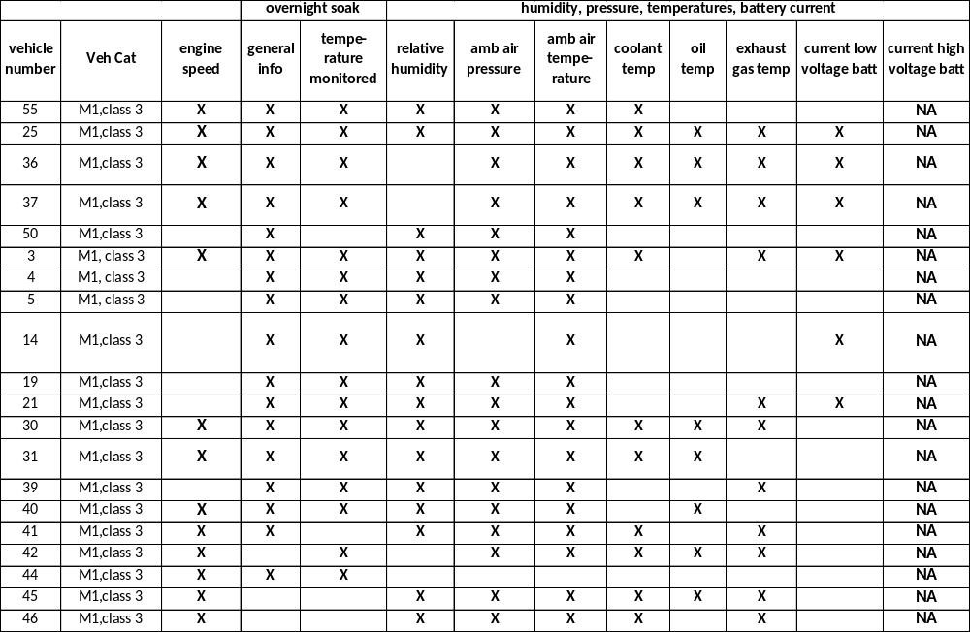
Table 12: Measured parameter for ICE M1 class 3 vehicles
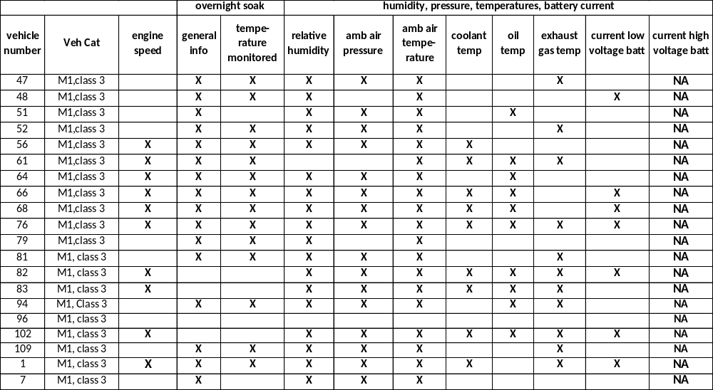
Table 13: Measured parameter for ICE M1 class 3 vehicles

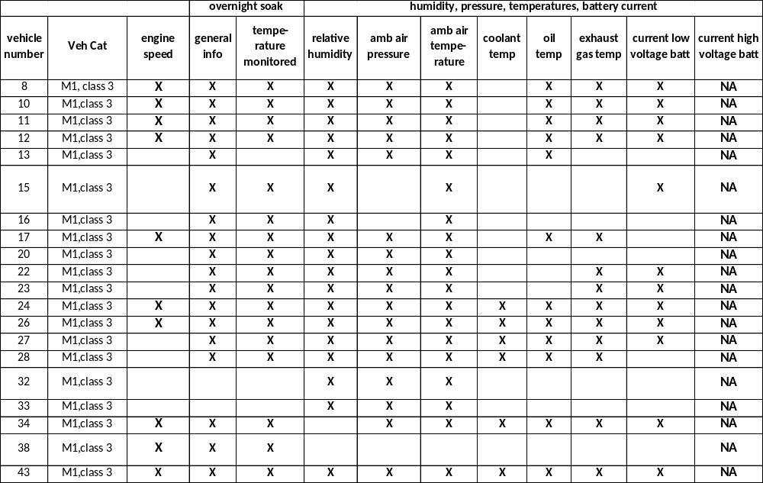
Table 14: Measured parameter for ICE M1 class 3 vehicles
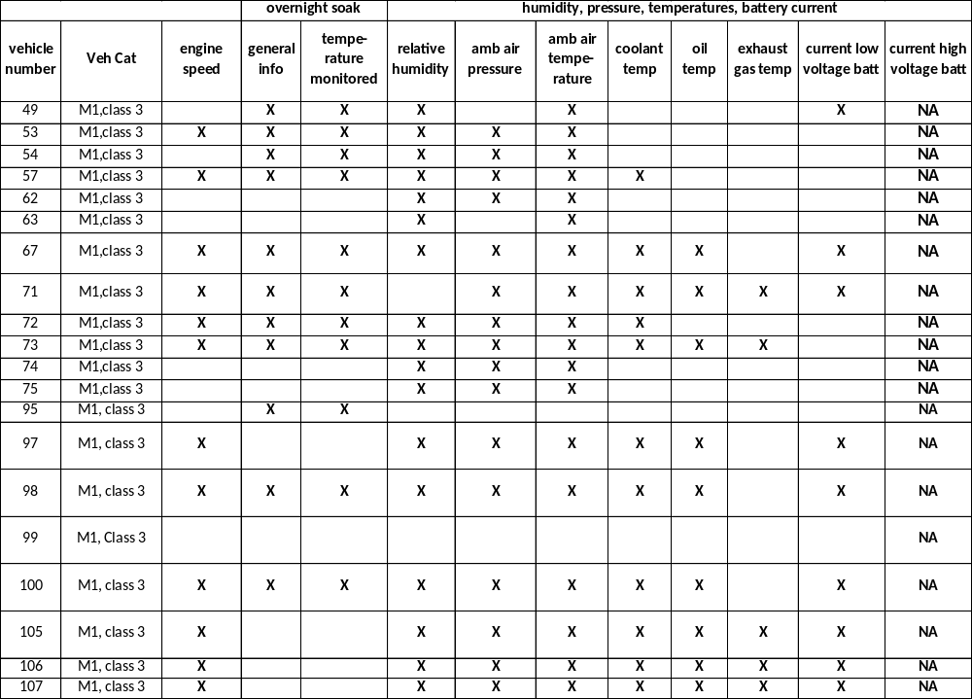
Table 15: Measured parameter for ICE M1 class 3 vehicles
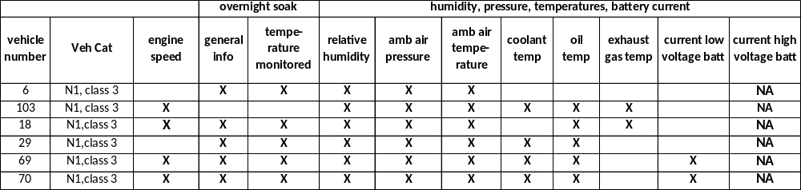
Table 16: Measured parameter for ICE N1 class 3 vehicles

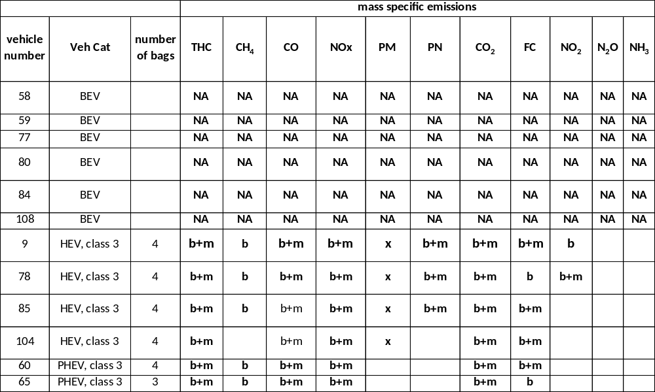
Table 17: Measured emissions for pure electric vehicles (BEV) and hybrid vehicles (b – bag, m – modal)
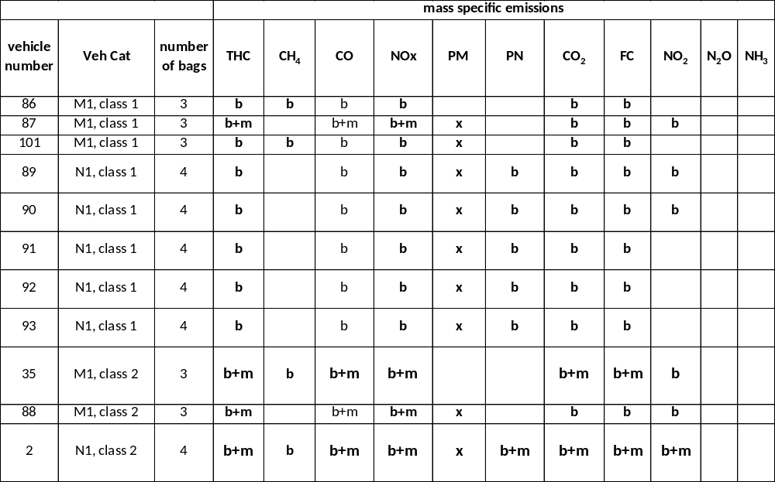
Table 18: Measured emissions for ICE class 1 and class 2 vehicles (b – bag, m – modal)

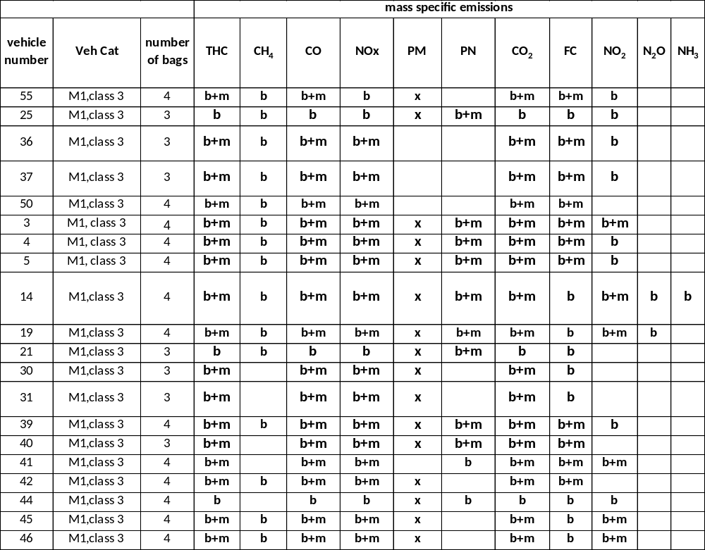
Table 19: Measured emissions for ICE M1 class 3 vehicles (b – bag, m – modal)
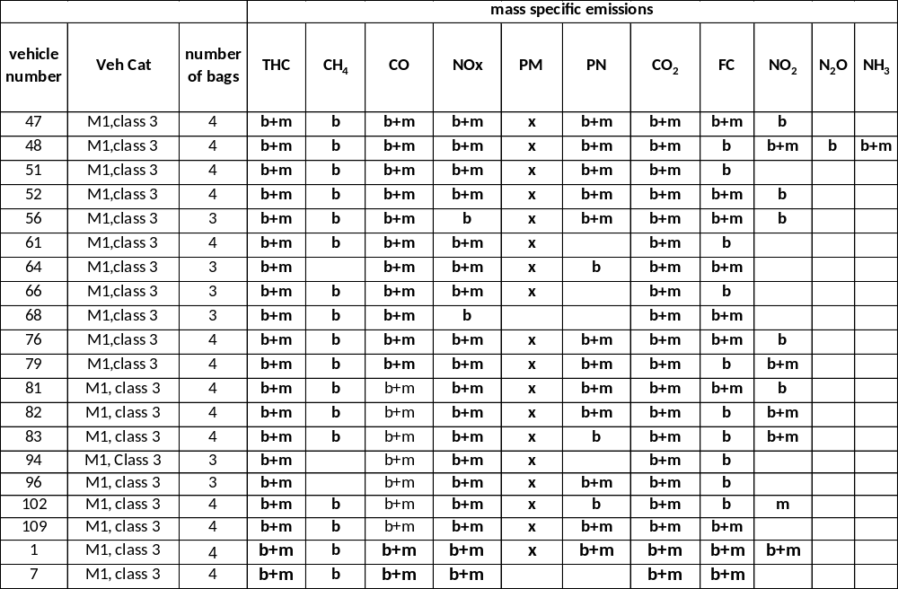
Table 20: Measured emissions for ICE M1 class 3 vehicles (b – bag, m – modal)
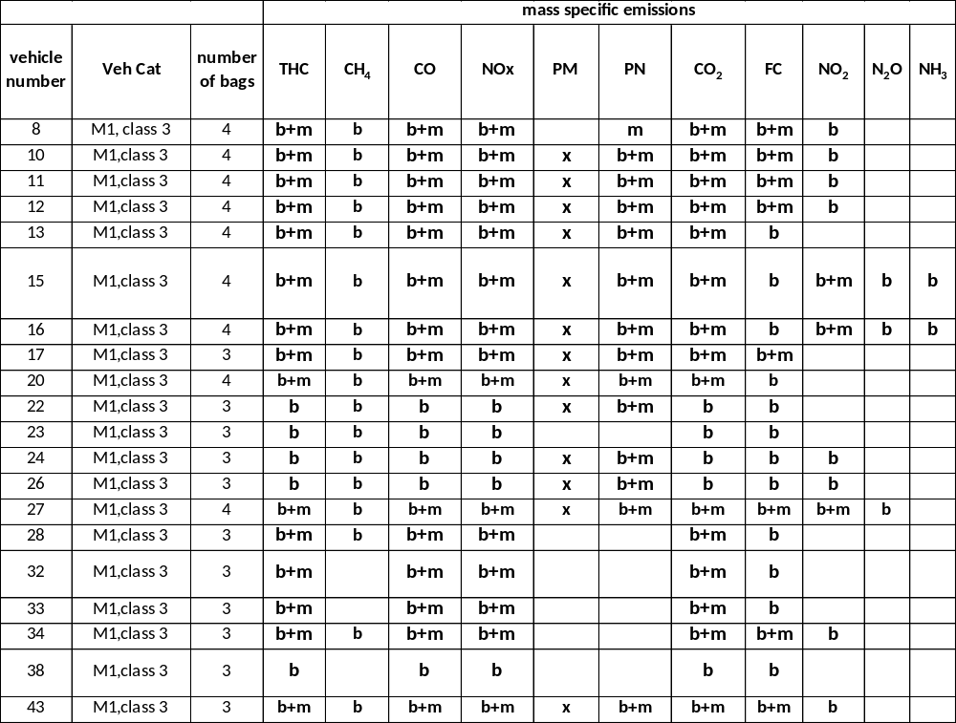
Table 21: Measured emissions for ICE M1 class 3 vehicles (b – bag, m – modal)
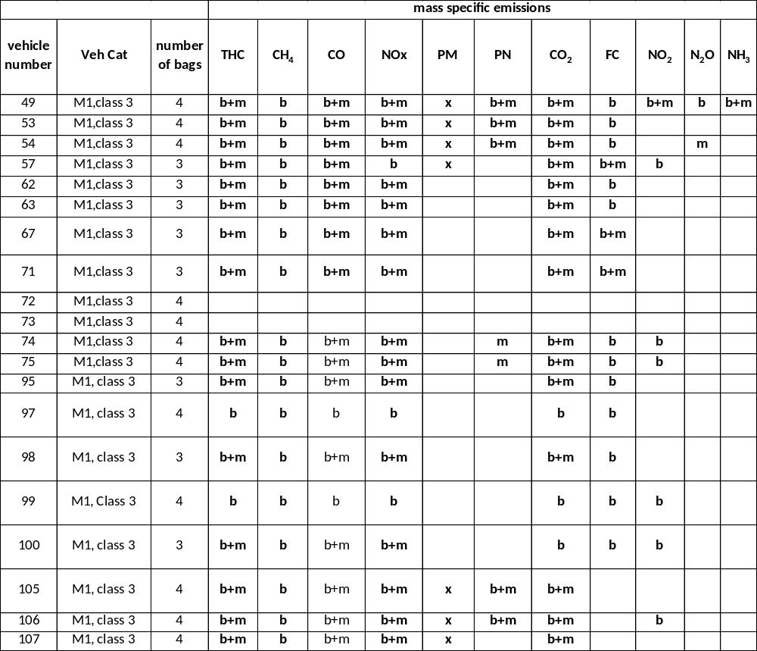
Table 22: Measured emissions for ICE M1 class 3 vehicles (b – bag, m – modal)
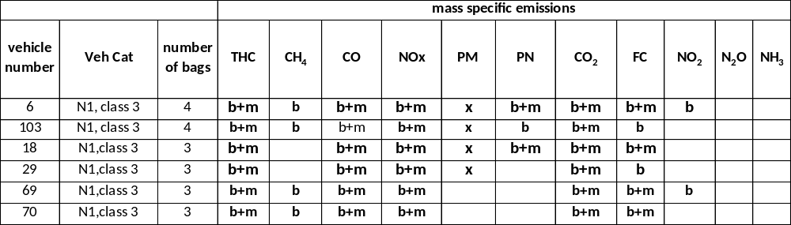
Table 23: Measured emissions for ICE N1 class 3 vehicles (b – bag, m – modal)
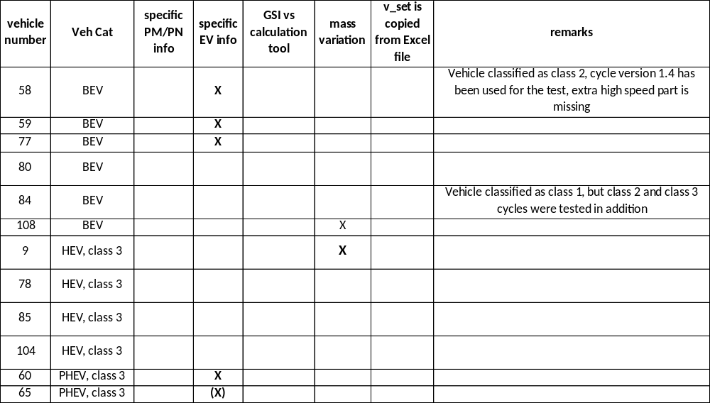
Table 24: Additional information for pure electric vehicles (BEV) and hybrid vehicles
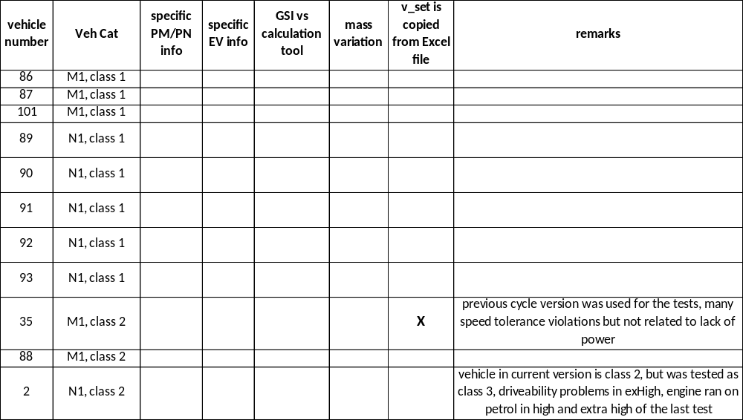
Table 25: Additional information for ICE class 1 and 2 vehicles
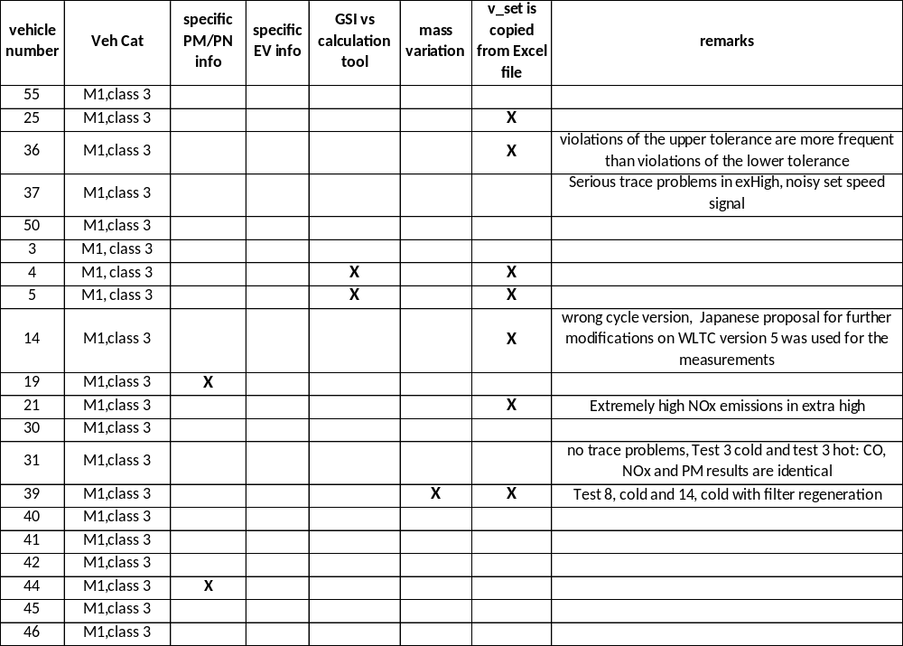
Table 26: Additional information for ICE M1 class 3 vehicles
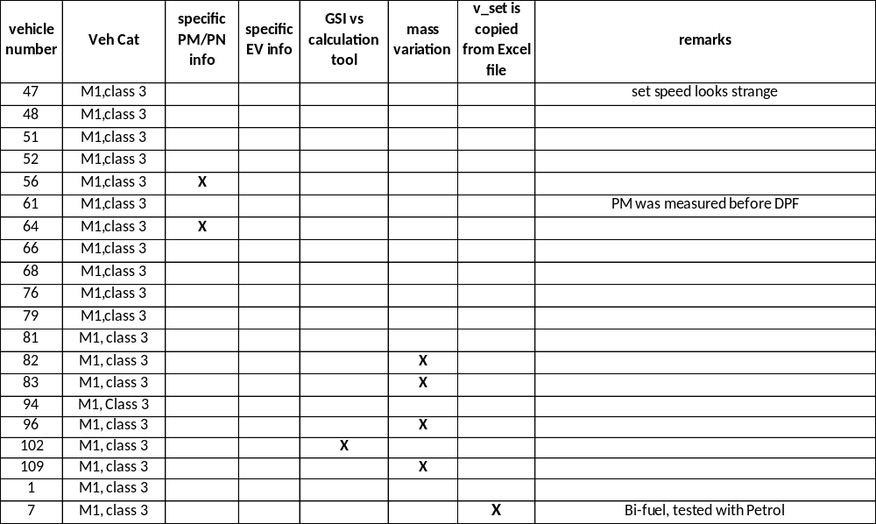
Table 27: Additional information for ICE M1 class 3 vehicles
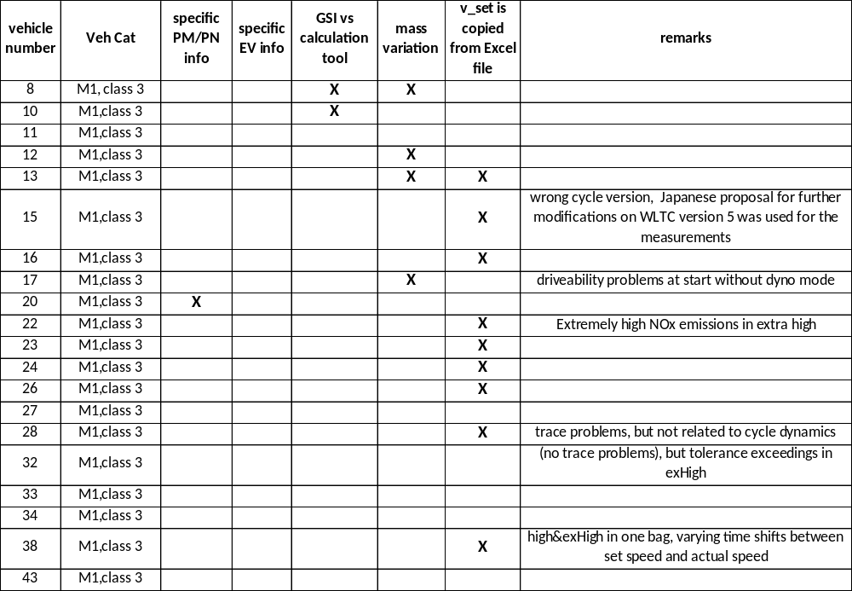
Table 28: Additional information for ICE M1 class 3 vehicles
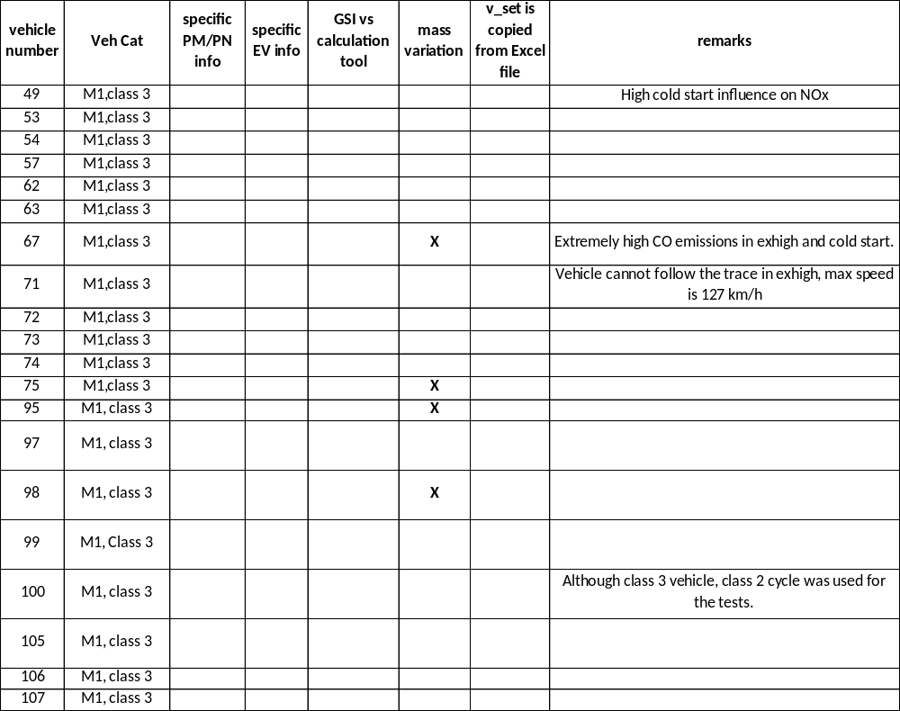
Table 29: Additional information for ICE M1 class 3 vehicles
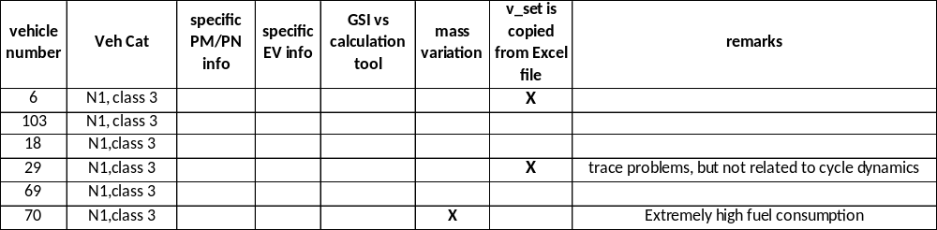
Table 30: Additional information for ICE N1 class 3 vehicles

For 2 vehicles no emission measurement results were delivered at all, for the pure electric vehicles charge depleting tests were performed, in some cases with different cycles or phase combinations.
An overview of the different cycle combinations and number of tests performed is given in the following tables.
Table 311 shows the cycle allocation for PEV’s and hybrids. All hybrids and 4 of the 6 PEV’s were tested with the class 3 cycles. Although its maximum speed was 145 km/h, vehicle 58 was classified as class 2 vehicle because the power to mass ratio was below 34 kW/t, if one uses the 30 minutes power as rated power. Consequently this vehicle was tested with the class 2 cycles.
Vehicle 84 had a 30 minutes power of 28 kW. Using this value the vehicle was classified as class 1 vehicle, although the maximum speed was 130 km/h. Consequently this vehicle was tested first with the class 1 cycles. But since the discussions about the classification of PEV’s was already ongoing at that time, additional tests were performed with the class 2 and class 3 cycles.
The EV subgroup finally decided that a power to mass ratio determination is not yet possible for PEV’s and that therefore all PEV’s should be tested with the class 3 cycles.
All class 1 and class 2 vehicles with ICE are from India. Table 32 shows that 5 of the 8 class 1 vehicles were tested with both cycle phases (low and medium), the remaining 3 were tested with the low phase only, because the maximum speed was below 70 km/h.
All class 2 vehicles were tested with the class 2 cycle but without the extra high speed phase (see Table 33).

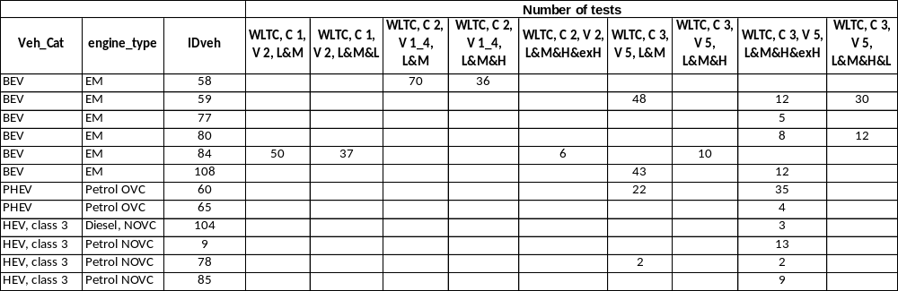
Table 31: Overview of tests for pure electric and hybrid electric vehicles

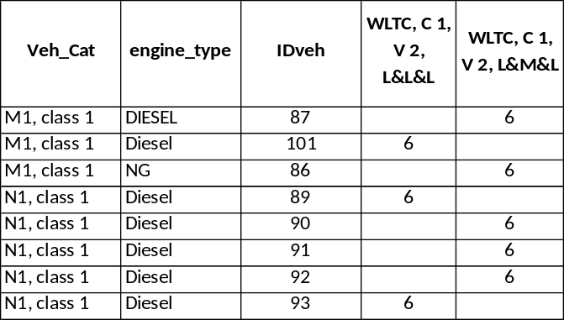
Table 32: Overview of tests for class 1 vehicles with ICE
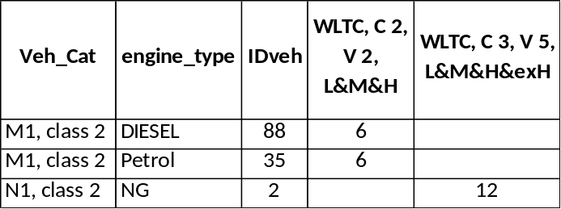
Table 33: Overview of tests for class 2 vehicles with ICE

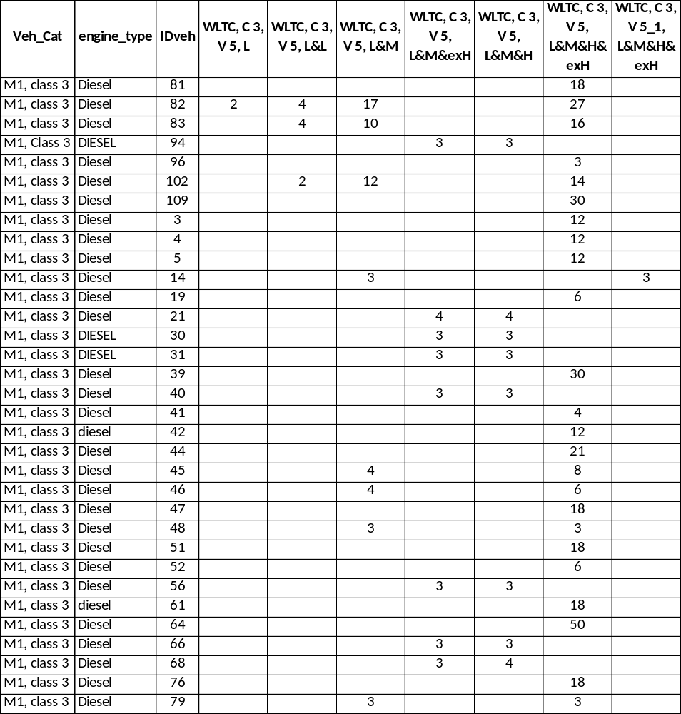
Table 34: Overview of tests for class 3 M1 vehicles with Diesel ICE

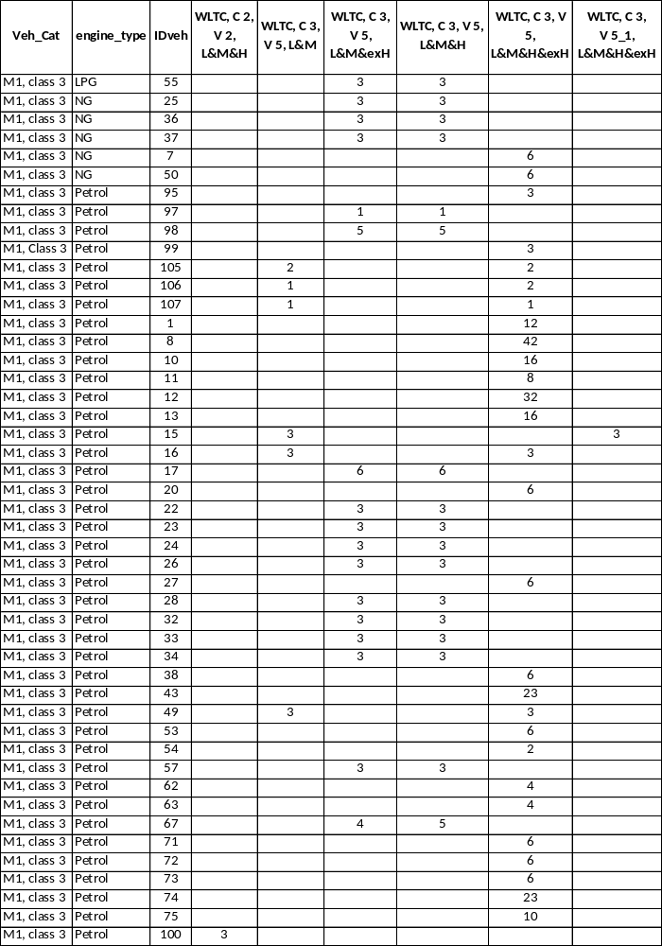
Table 35: Overview of tests for class 3 M1 vehicles with NG or Petrol ICE
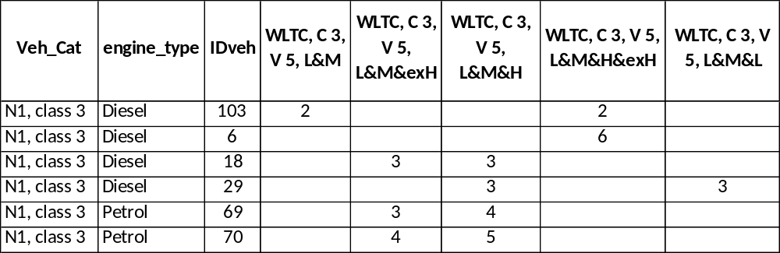
Table 36: Overview of tests for class 3 N1 vehicles

All M1 class 3 vehicles were tested with all 4 cycle phases (see Table 34 and Table 35), while 1 of the 7 N1 class 3 vehicles was tested without the extra high speed phase (see Table 36).
The base test was the test with a cold start and the test mass high (TMH). For 92% of the ICE vehicles additional hot start test were performed.
Some participants did additional tests with parameter variations.

Evaluation issues
The following evaluation issues were discussed in the DTP subgroups on the basis of the validation 2 results:
- Soak Temperature Tolerances
- Soak with forced Cooling down
- Test Cell Temperatures
- Tolerances of Humidity during Test Cycle
- Tolerances of Emission Measurement System
- Preconditioning Cycle
- Preconditioning for Dilution Tunnel
- Speed Trace Tolerances
- Gearshift tolerances for manual transmission vehicles
- Monitoring of RCB of all Batteries
- Cycle Mode Construction
- Required Time for Bag Analysis
- Dilution Factor
- Dyno Operation Mode

The following issues will be discussed in this report:
- Overnight soak temperature,
- Test cell temperature and humidity,
- Speed trace violations,
- Monitoring of RCB for ICE,
- Charge depleting tests for PEV and OVC HEV

Other issues are not mentioned in detail here, like test mass influence, because the tests showed the expected results. The differences between the results for manual transmission vehicles with gearshifts according to the on board GSI and the WLTP calculation tool were rather small and did not show any trends.

Validation results

Overnight soak temperatures
The validation 2 results database contains temperature monitoring for 274 different overnight soaks without and 15 soaks with accelerated cooling. Figure 6 shows an example for coolant and air temperature monitoring of 7 different tests with the same vehicle. Figure 7 shows an example for an overnight soak with accelerated cooling.
The temperature variation range (min - average – max) for more than 50 overnight soaks with a sampling rate of 30 seconds is shown in Figure 8.
The results led to the following specifications in the GTR:
- The soak area shall have a temperature set point of 296 K and the tolerance of the actual value shall be within ± 3 K on a 5 minute running average and shall not show a systematic deviation from the set point. The temperature shall be measured continuously at a minimum of 1 Hz.

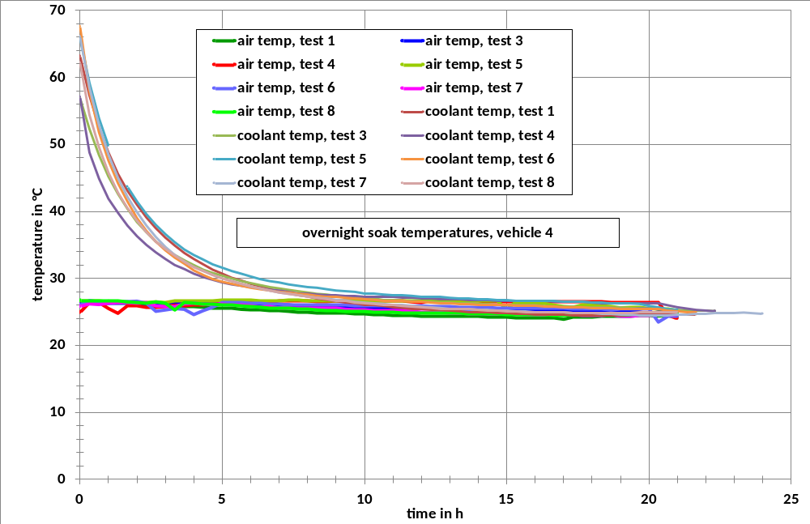
Figure 6: Example of overnight soak temperature monitoring

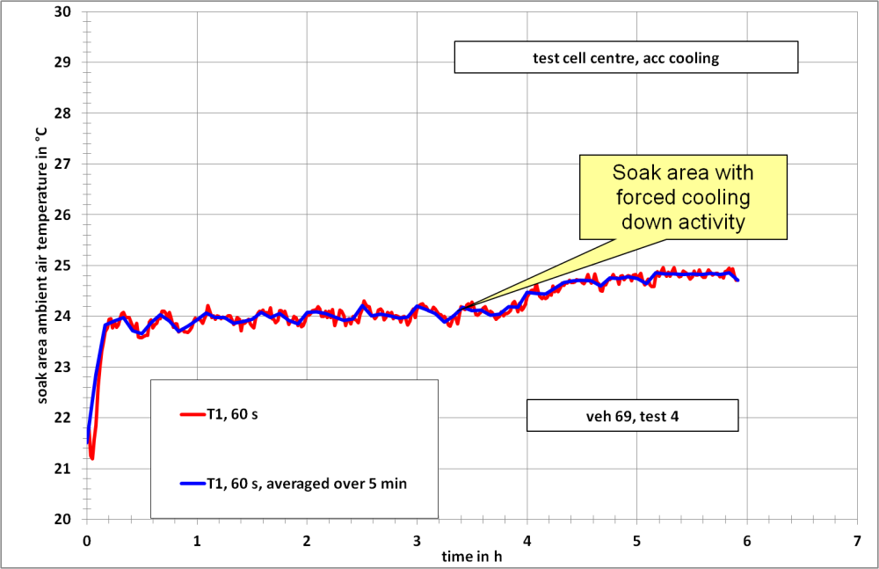
Figure 7: Example of soak temperature monitoring for accelerated cooling

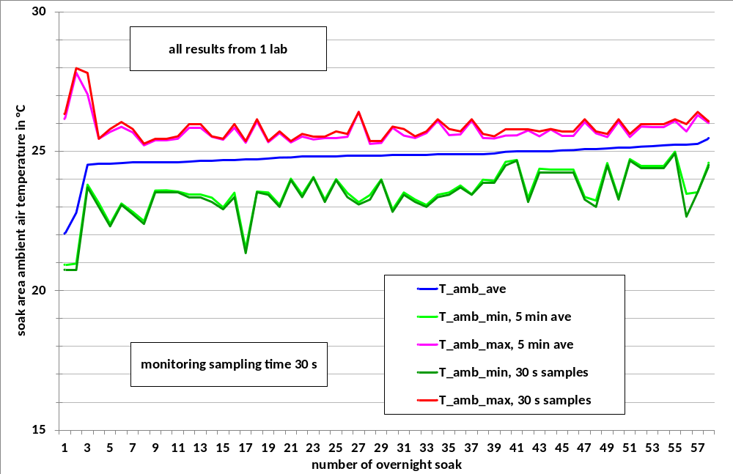
Figure 8: Ambient temperature variation range of overnight soaks for 1 lab

Test cell temperatures
A further validation point was the variation of the test cell temperature during the tests. The class 3 cycle was used for the evaluation. Figure 9 shows the time history of the test cell temperature with the lowest variation, Figure 10 shows the case with the highest variation.
The variation ranges for all tests are shown in Figure 11.
Based on these results the following requirements were drafted for the GTR:
- The test cell shall have a temperature set point of 296 K. The tolerance of the actual value shall be within ± 5 K. The air temperature and humidity shall be measured at the vehicle cooling fan outlet at a rate of 1 Hz.

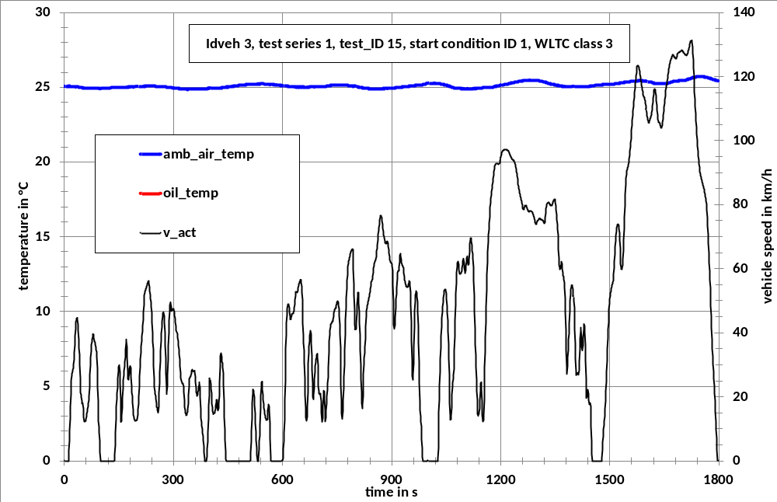
Figure 9: Best case of test cell temperature over all 4 phases of the class 3 WLTC

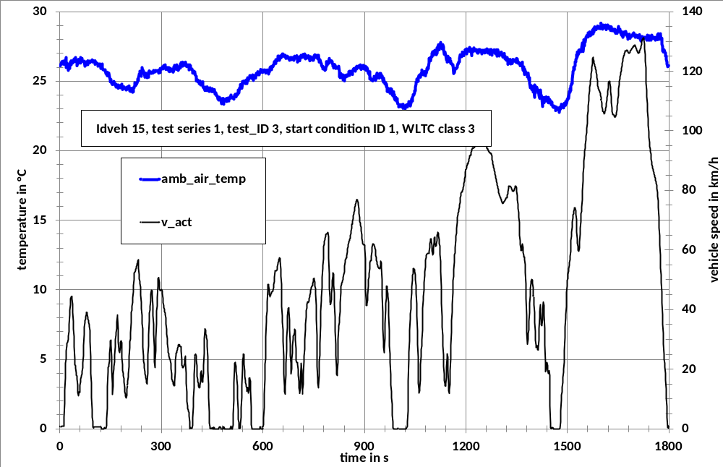
Figure 10: Worst case of test cell temperature over all 4 phases of the class 3 WLTC

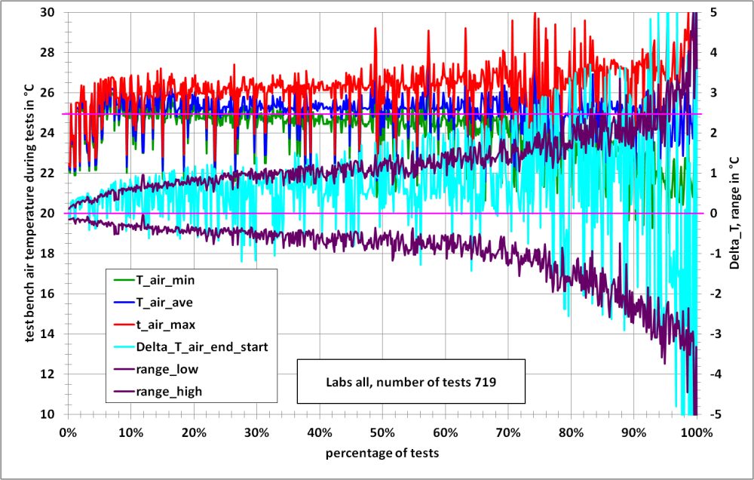
Figure 11: Test cell temperature variation range during class 3 WLTC, all tests

Test cell humidity
Examples for the time history and the variances of test cell humidity are shown in the following figures (Figure 12 to Figure 14).

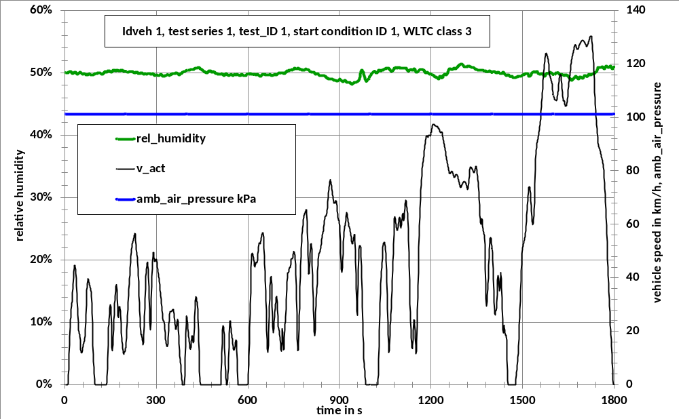
Figure 12: Example for the time history of the test cell humidity over the class 3 WLTC

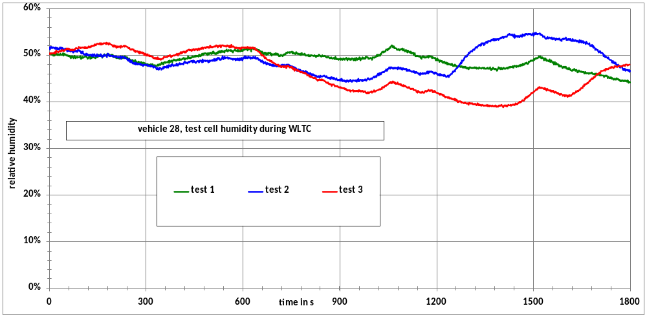
Figure 13: Examples for the time history of the test cell humidity over the class 3 WLTC

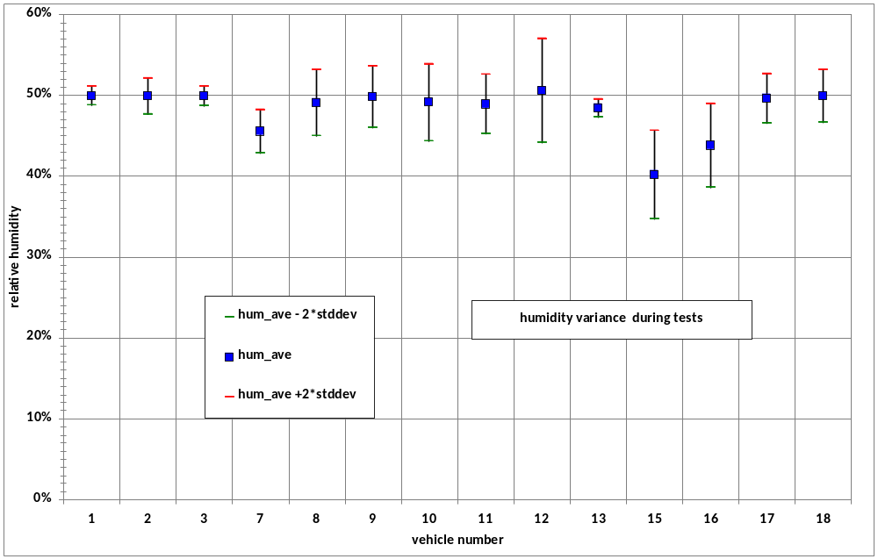
Figure 14: Test cell humidity variances during the tests

Speed trace violations
The participants of the validation 2 phase delivered the time sequences of the measured vehicle speed signal together with the set speed with 1 Hz resolution. The deviations of the measured speed from the set speed were then calculated for all tests and the Two tolerance bands were then calculated around the set speed and compliances/violations were calculated for the following tolerance bands:
- ± 3 km/h, ± 1 s,
- ± 2 km/h, ± 1 s,
The following figures (Figure 15 to Figure 20) show exemplarily the speed traces of 6 tests for a subcompact car with a power to mass ratio of 43,6 kW/t together with the set speed and the tighter of the above listed tolerance bands.
In most cases the drivers did not have problems to keep the actual speed within this tolerance band. In some cases tolerance violations occurred due to lack of power (see Figure 21 and Figure 22).
Figure 21 shows the speed trace of the extra high speed part for a N1 vehicle with a Petrol engine. Running on Petrol, the rated power is 85 kW. With a kerb mass of 2003 kg this leads to a power to mass ratio (pmr) of 42,4 kW/t, so that this vehicle would be a class 3 vehicle, since the borderline between class 2 and class 3 is 34 kW/t.
But this vehicle was tested with natural gas which reduced the rated power to 68 kW, resulting in a pmr value just below the borderline. The tolerance violations shown in Figure 21 would not occur, if the vehicle would have been tested on the class 2 cycle, since this cycle has less demanding accelerations and a lower top speed.
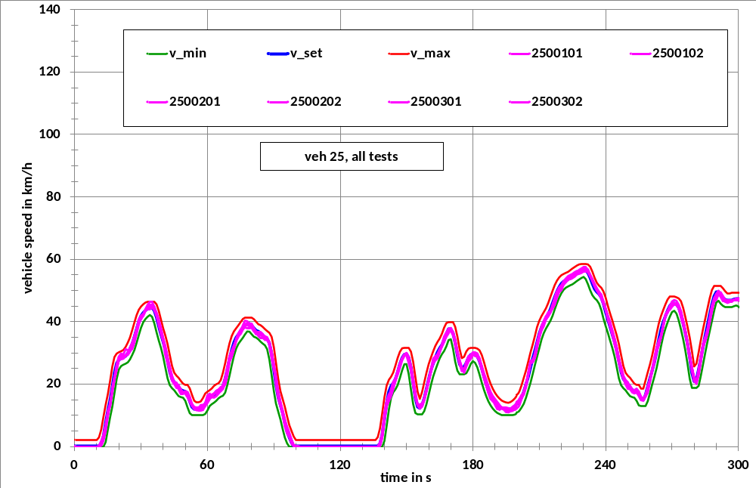
Figure 15: Example for speed trace and tolerance band for the class 3 WLTC

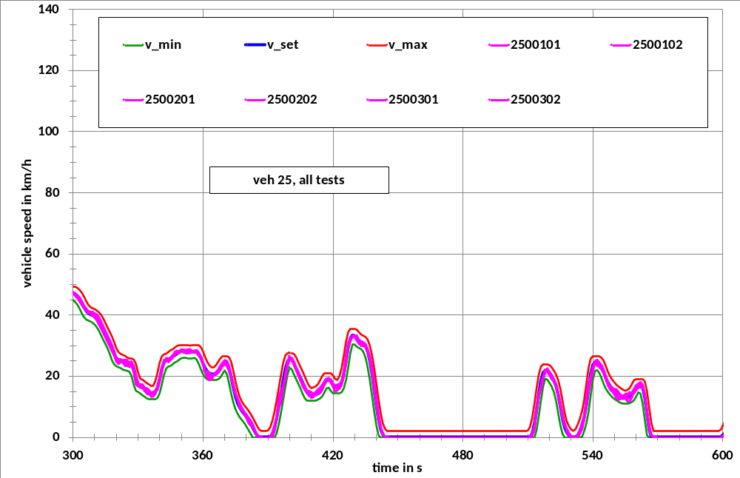
Figure 16: : Example for speed trace and tolerance band for the class 3 WLTC
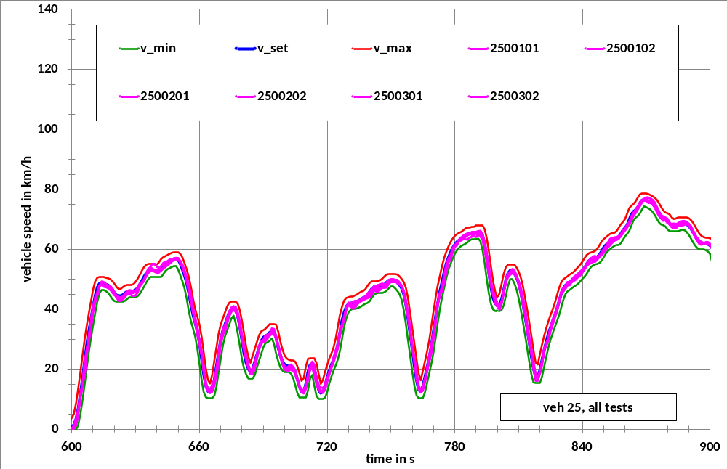
Figure 17: Example for speed trace and tolerance band for the class 3 WLTC

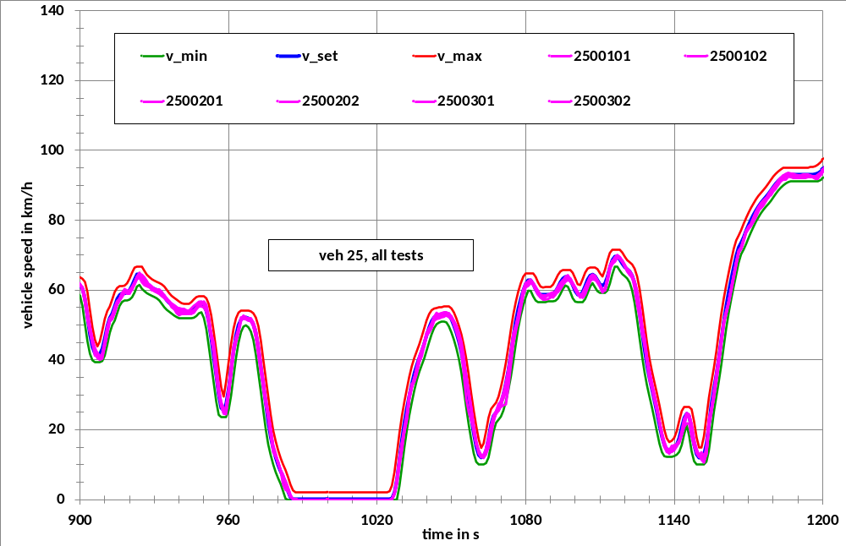
Figure 18: Example for speed trace and tolerance band for the class 3 WLTC

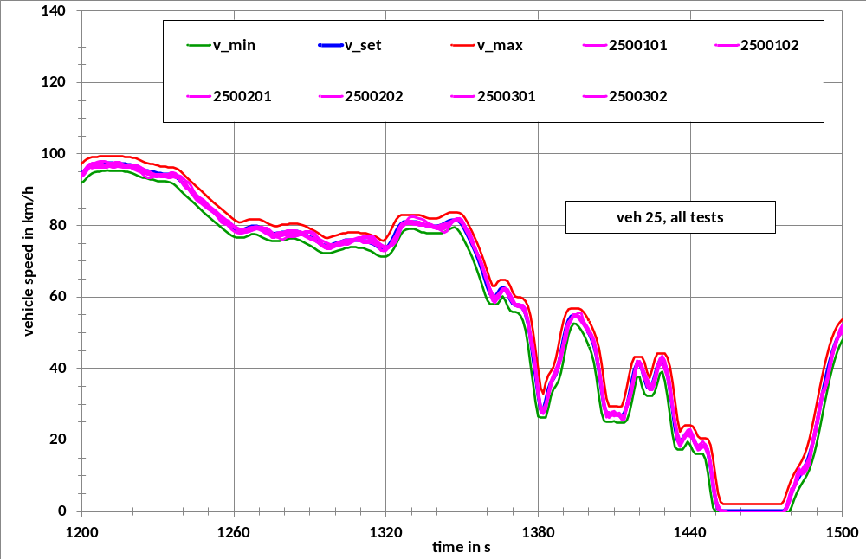
Figure 19: Example for speed trace and tolerance band for the class 3 WLTC

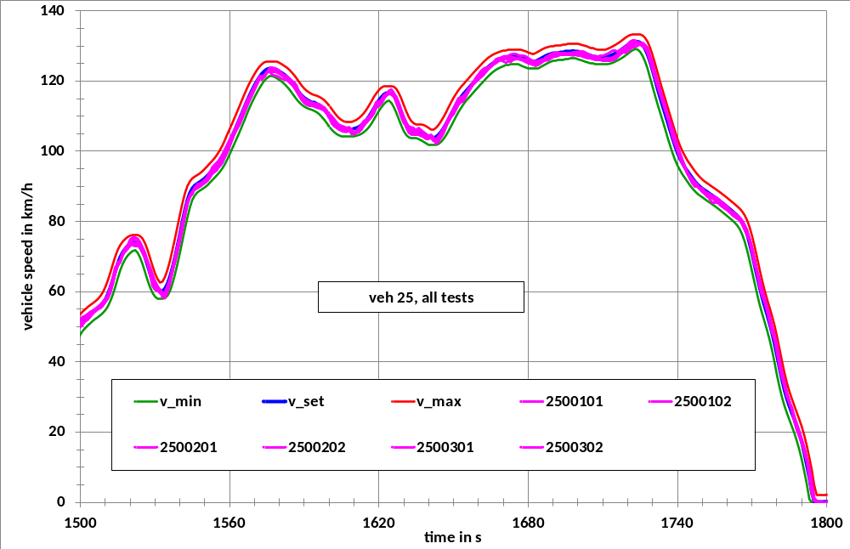
Figure 20: Example for speed trace and tolerance band for the class 3 WLTC

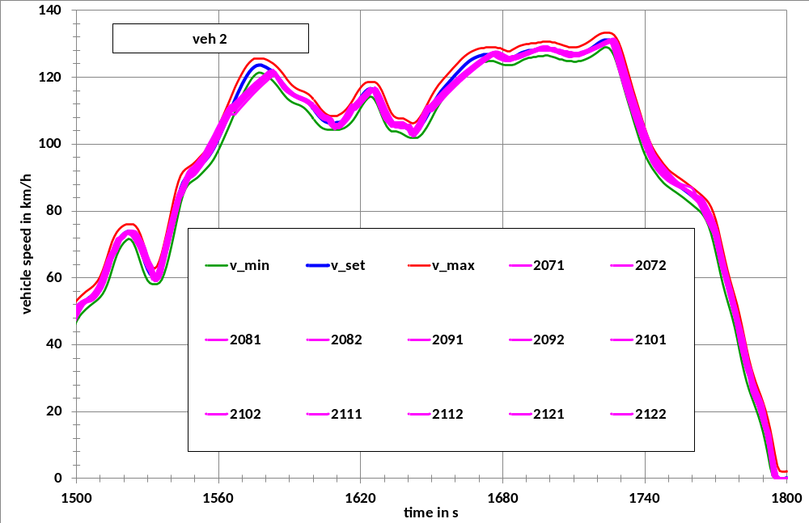
Figure 21: Example for tolerance band violations for the extra high speed phase of the class 3 WLTC

A more severe example is shown in Figure 22. This vehicle from India has a pmr of 36,5 kW/t and was also tested with natural gas, which obviously also would qualify the vehicle as class 2 vehicle. And even in this case it would not be able to reach the top speed of the extra high speed phase of the class 2 cycle (123 km/h).
In addition to that, Figure 22 clearly shows that the driveability problems are not only related to the top speed sections but occur already around the cycle time of 1550 to 1560 s at a vehicle speed of 80 km/h.
A more detailed analysis of such driveability problems led to the downscaling method for low powered vehicles, which is described in detail in the DHC part of the report.
Based on the results of the speed compliance/violation analysis the ± 2 km/h, ± 1 s tolerance was implemented into the GTR:
Gearshifts did not cause driveability problems for manual transmission vehicles.

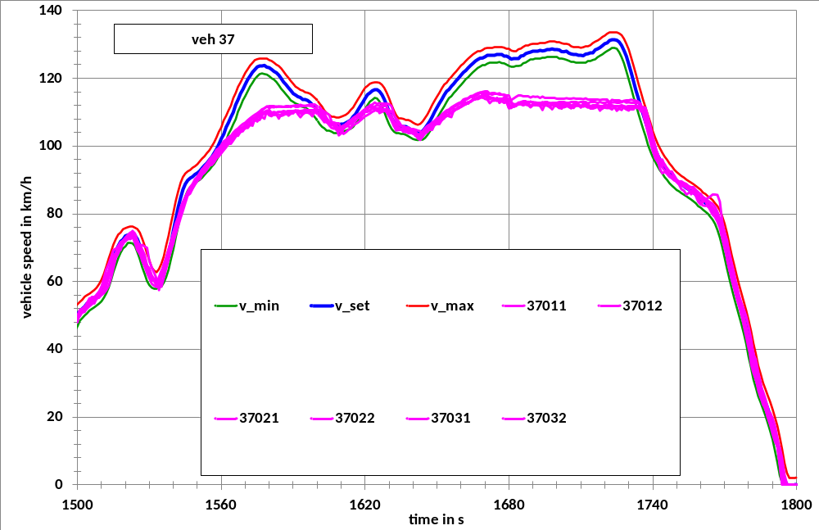
Figure 22: Example for tolerance band violations for the extra high speed phase of the class 3 WLTC

Monitoring of RCB for ICE vehicles
For 26 ICE vehicles the status of the battery was monitored during the tests. In total results for 240 tests could be analysed. The battery charging/discharging energy was calculated from 1 Hz current measurements, the consumed cycle energy was calculated from the measured fuel consumption in l/100 km using the following specific values for heating value and density:
- Petrol: heating value = 42,042 MJ/kg, fuel density = 0,7506 kg/l,
- Diesel: heating value = 42,940 MJ/kg, fuel density = 0,834 kg/l.
The charging/discharging energy was then expressed as percentage of the consumed cycle energy.
The results are shown in Figure 23 as cumulative frequency distribution. For more than 90% of all tests this percentage is below 0,5%.

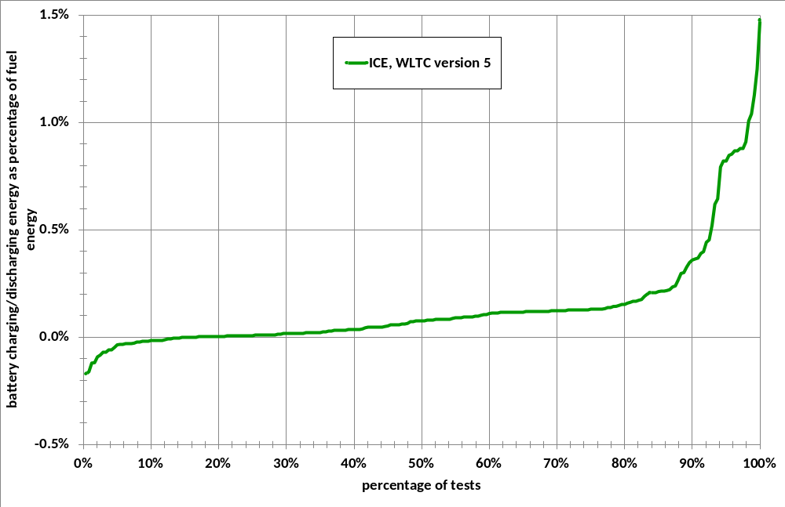
Figure 23: Cumulative frequency of the battery charging/discharging energy

Charge depleting tests for PEV and OVC HEV
As already mentioned, charge depleting tests were performed for 6 pure electric vehicles (PEV) in the validation 2 exercise. Since it was not not quite clear, how to classify PEV with respect to vehicle classes, the cycle version allocation was done differently by different participants. One participant used the 30 minutes maximum power of the electrical motor and classified the vehicles by calculating the power to (kerb) mass ratio based on the 30 minutes maximum power.
This led to the situation that vehicle 58 with a peak power of 120 kW, but a 30 minutes power of only 60 kW, and a kerb mass of 1860 kg was classified as class 2 vehicle, although its maximum speed was 145 km/h. This vehicle could have easily driven the class 3 cycle, but was only tested on the class 2 cycle in the version 1.4, that did not contain an extra high speed part. With the 3 phases low, medium and high of the class 2 version 1.4 cycle the vehicle could drive more than 250 km or more than 17 cycles before the batteries were discharged.
Two CD tests on this cycle were performed with vehicle 58. The cumulative discharge curves are shown in Figure 24 and Figure 25. At the first glance there seems to be a wide spread of the energy consumption per cycle within a charge depleting test. For both tests the difference between maximum and minimum is 0,6 Ah which corresponds to 14% of the average (-6% to +8%) which is reasonably good.
But the break off point (end of charge depleting test) is significantly different in both tests (see Figure 26, Figure 27 and Figure 28), which results in a difference in the driven distance of about 9 km (253,5 km to 263,2 km/h) or +/- 3,5% in relation to the average range.
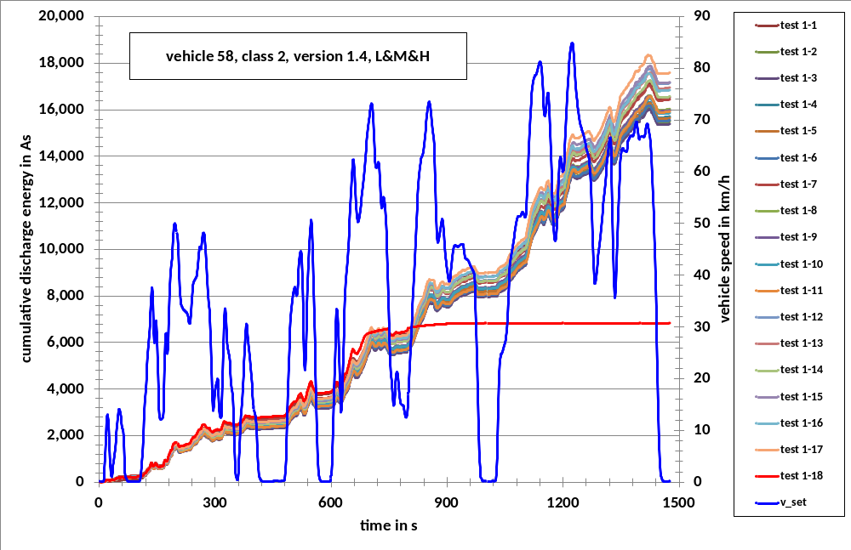
Figure 24: Cumulative discharge energy for CD test 1 for vehicle 58 on the class 2, version 1.4 cycle

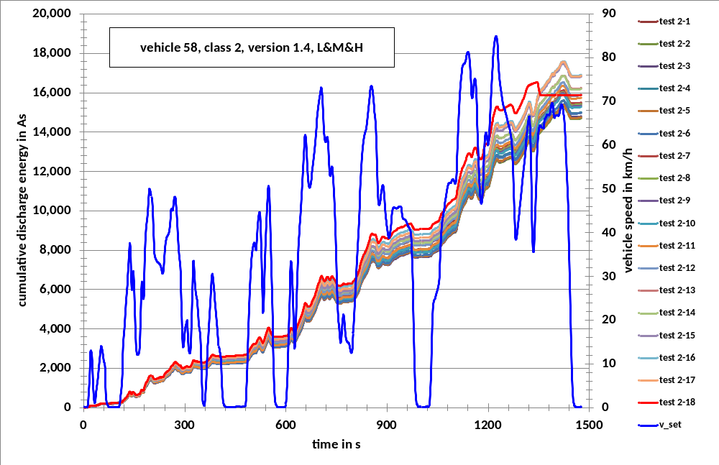
Figure 25: Cumulative discharge energy for CD test 2 for vehicle 58

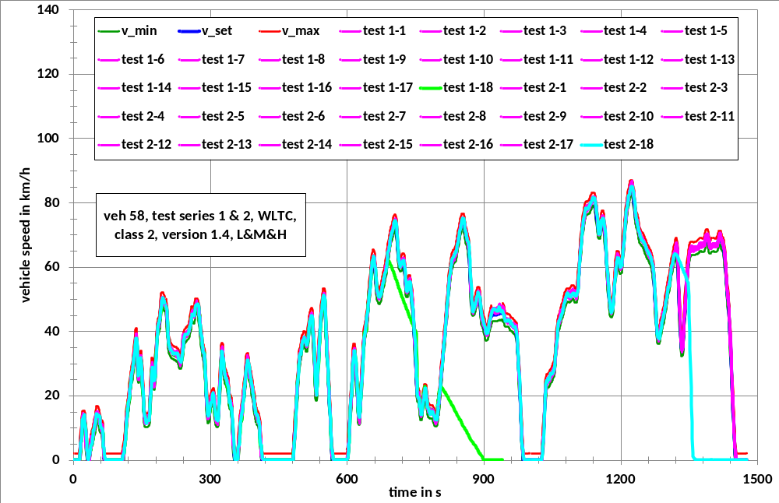
Figure 26: Time series of the vehicle speed for CD tests 1 and 2 for vehicle 58

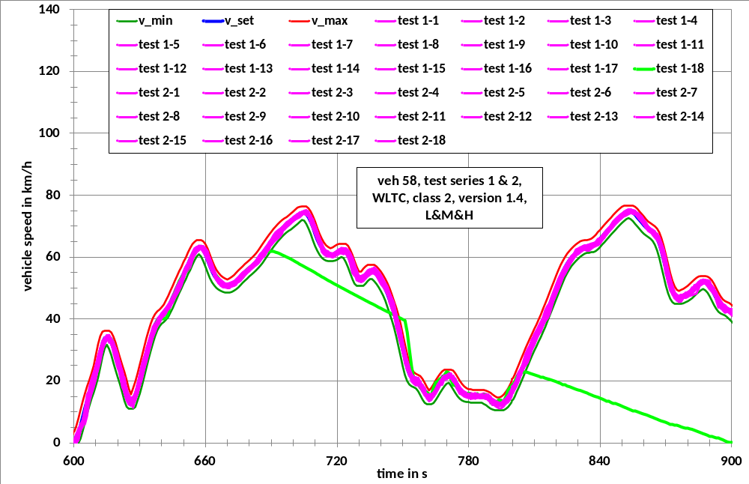
Figure 27: Time series of the vehicle speed for CD test 1 for vehicle 58 at break off point

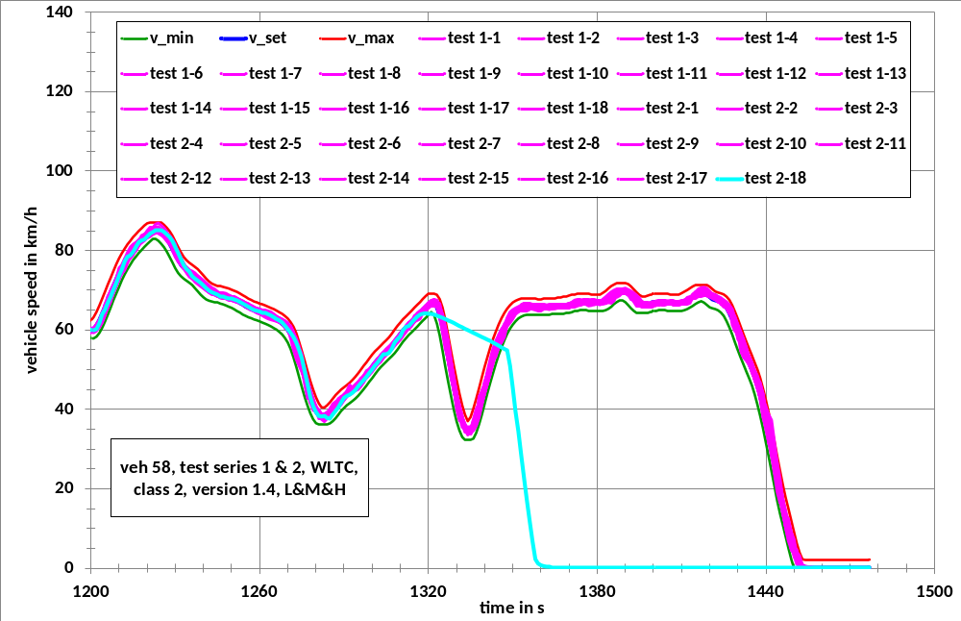
Figure 28: Time series of the vehicle speed for CD test 2 for vehicle 58 at break off point

The driver instruction for the end of a charge depleting test was as follows: If the vehicle speed falls below the tolerance for 4 s or more, the vehicle should be brought to standstill within the following 15 s. As can be seen in Figure 27 and Figure 28, this instruction was not followed at all. And this was also the case for the other vehicles. On the contrary, Figure 28 shows that the driver was aware that the batteries became fully discharged but tried to still drive as long as possible with full power so that the actual speed trace was significantly above the tolerance within a deceleration phase.
So, generally, the charge depleting tests especially at the break off sections were very helpful for the definition of break off criteria for the GTR.
Vehicle 59 was also tested by the same participant. But since this vehicle had a 30 minutes maximum power of 35 kW (55 kW peak power) and a kerb mass of 940 kg, it was classified as class 3 vehicle (pmr > 34 kW/t) and consequently tested on the class 3 cycle, although the maximum speed was only 124 km/h, which is 6 km/h below the maximum speed of the cycle.
The results of the charge depleting test for the whole class 3 cycle (all 4 phases) are shown in Figure 29 to Figure 32.
Another PEV, that was tested by this participant, is vehicle 84. This vehicle had a kerb mass of 1290 kg, a peak power of 56 kW and a 30 minutes power of 28 kW. The vehicle was originally tested on the class 1 version 2 cycle because the power to mass ratio is below 22 kW/t, if the 30 minutes power is used as rated power. But since the vehicle had a maximum speed of 130 km/h, it was also tested on all 4 phases of the class 2 version 2 cycle and on the first 3 phases (L&M&H) of the class 3 cycle. The 4th phase of the class 3 cycle was skipped, because the vehicle could even not reach the maximum speed of the extra high speed phase of the class 2 cycle (see Figure 33). Figure 34 shows the braek off section for the class 3 cycle.
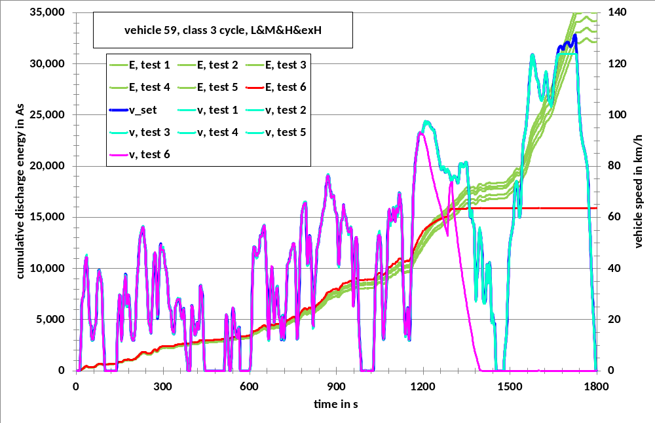
Figure 29: Cumulative discharge energy for CD test 2 for vehicle 59

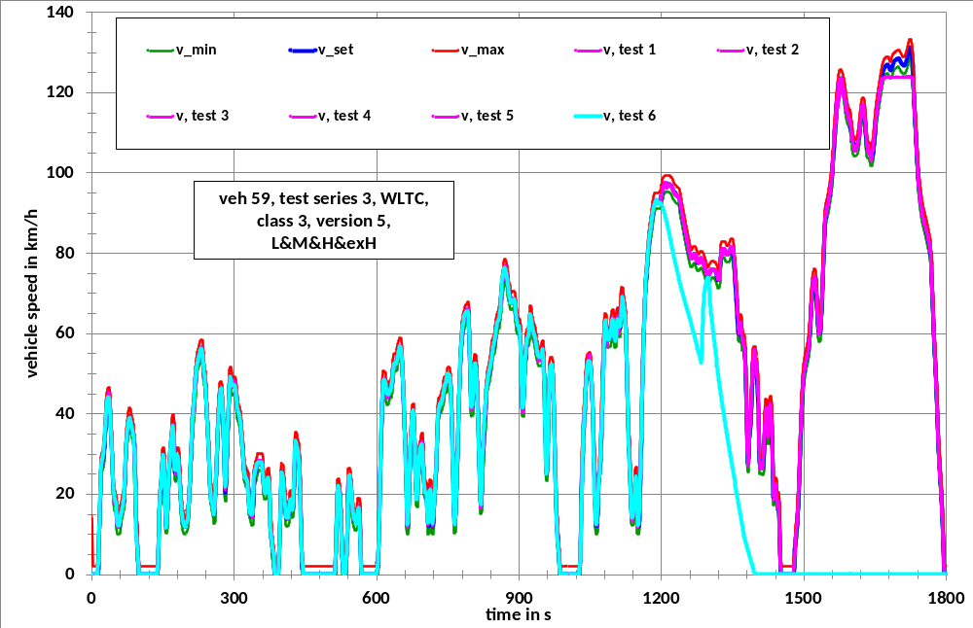
Figure 30: Time series of the vehicle speed for CD test 2 for vehicle 59

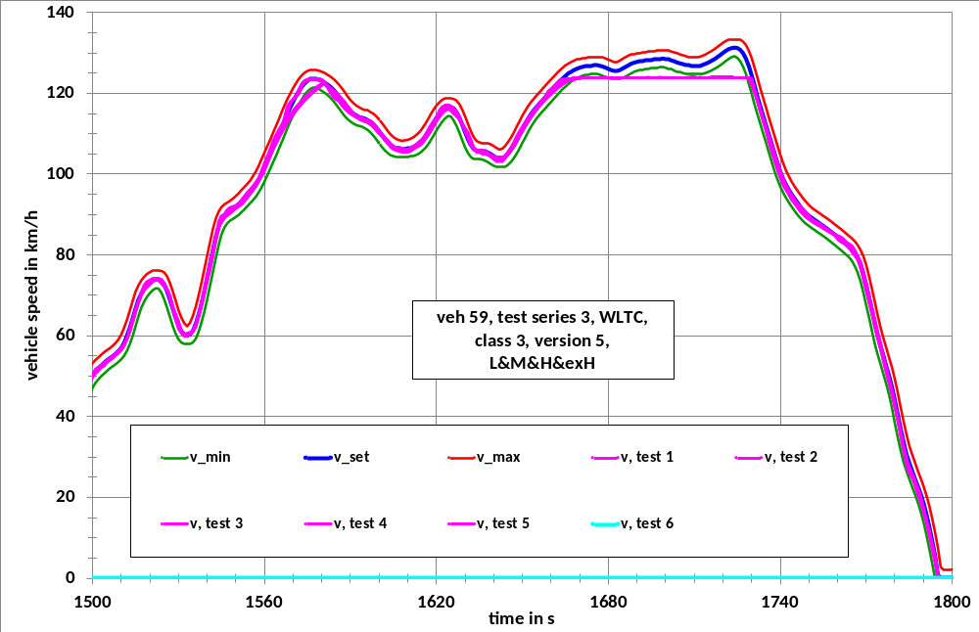
Figure 31: Time series of the vehicle speed for CD test 2 for vehicle 59, extra high speed phase

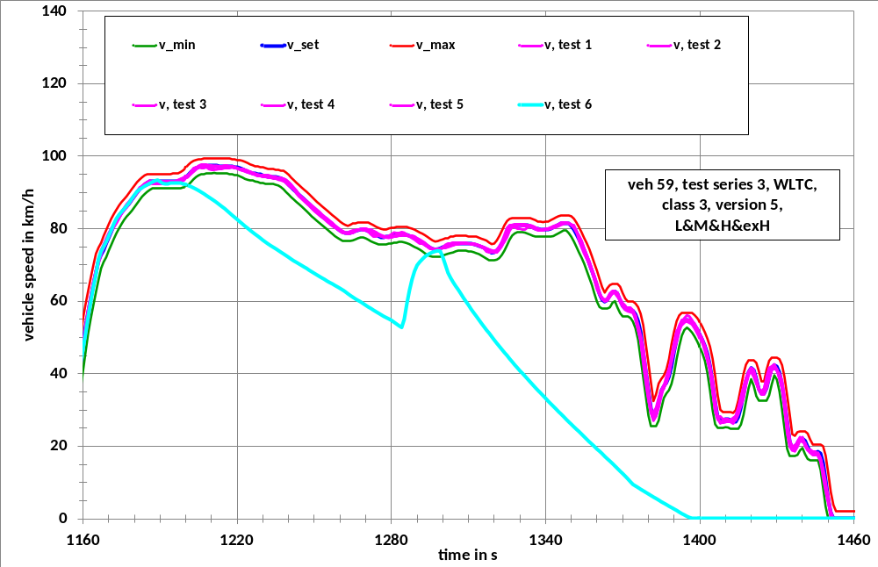
Figure 32: Time series of the vehicle speed for CD test 2 for vehicle 59 at break off section

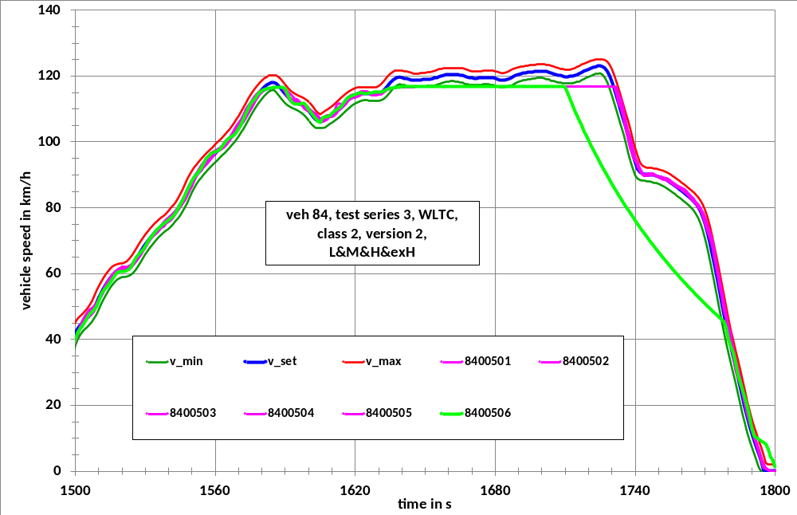
Figure 33: Time series of the vehicle speed for CD test 3 for vehicle 84 at break off section

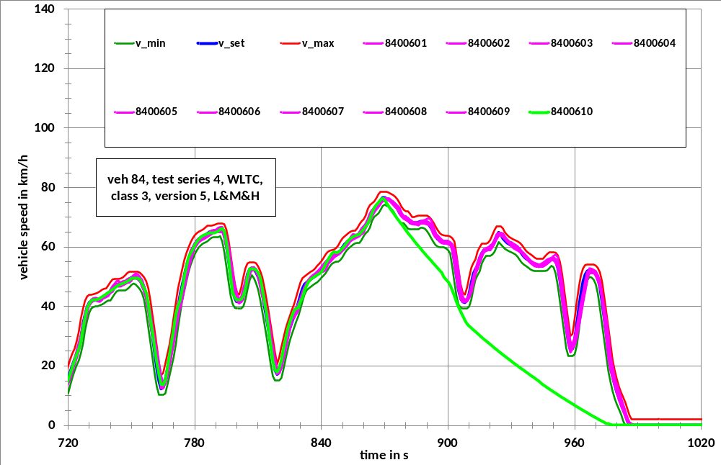
Figure 34: Time series of the vehicle speed for CD test 4 for vehicle 84 at break off section

All other PEV’s were tested on the class 3 cycle.
Vehicle 77 had no problems to drive the extra high phase of the class 3 cycle. The break off section of this vehicle is unambiguous (see Figure 35).
Vehicle 80 had a kerb mass of 1590 kg and a 30 minutes power of 50 kW and would have been classified as class 2 vehicle with these values. But it was tested on the class 3 cycle, once over the whole cycle and once with a second low phase instead of the extra high speed phase.
The break off sections of the vehicle speed pattern of the two CD tests are shown in Figure 36 and Figure 37. The break off criterion (speed tolerance underrun for 4 or more consecutive seconds) is already fulfilled around 780 s, but the vehicle was driven till the final break off at 1400 s.
The break off sections of the vehicle speed pattern of the two CD tests for vehicle 108 over the whole class 3 cycle are shown in Figure 38 and Figure 39. In both cases the break off point was reached at a vehicle speed above 110 km/h, which makes it really tough, to bring the vehicle to a stop within 15 seconds. Consequently this time period was extended to 60 s in the GTR draft.
The results of all CD tests for the PEV’s are summarised in Table 37. There is a dependency of the CD test range and the average speed of the driven cycle but there are of course also significant differences between the vehicles for a given average speed or a given cycle (see Figure 40).

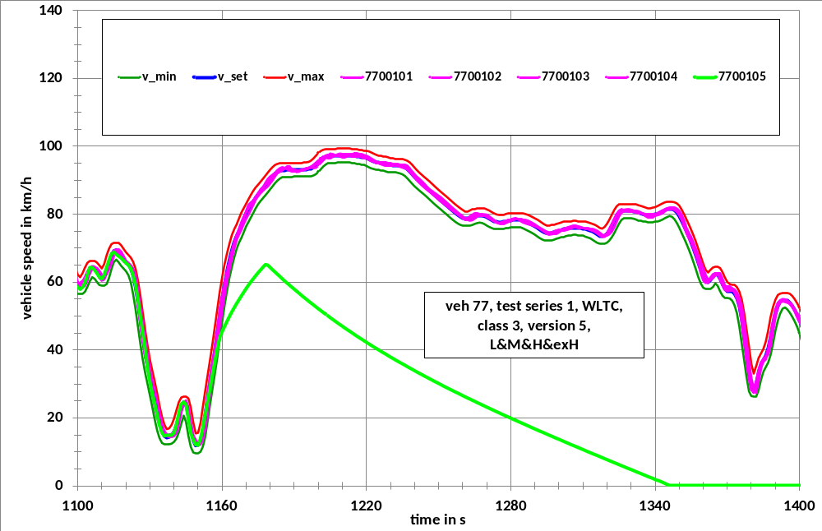
Figure 35: Time series of the vehicle speed for the CD test for vehicle 77 at break off section

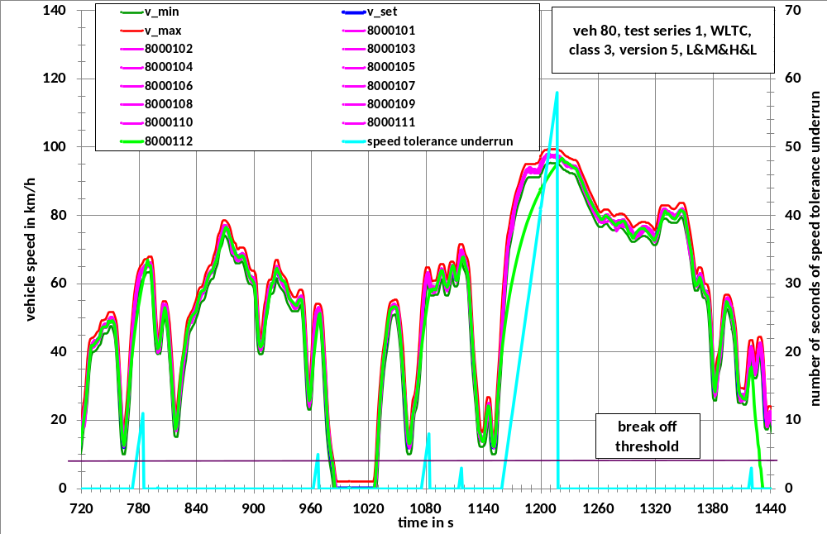
Figure 36: Time series of the vehicle speed for CD test 1 for vehicle 80 at break off section

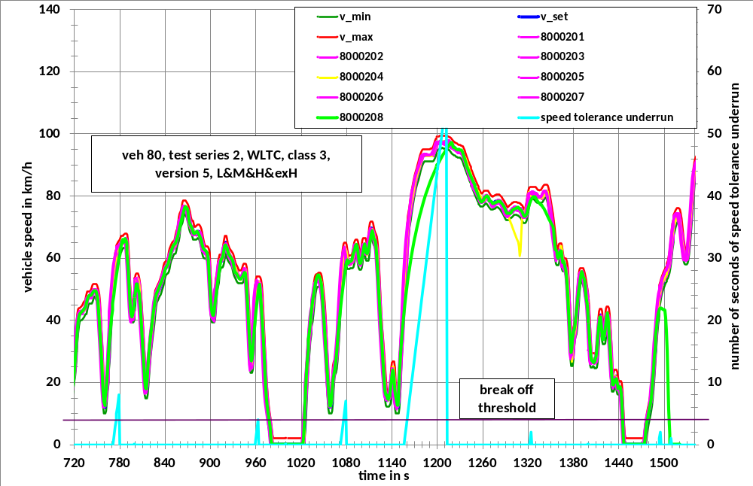
Figure 37: Time series of the vehicle speed for CD test 2 for vehicle 80 at break off section

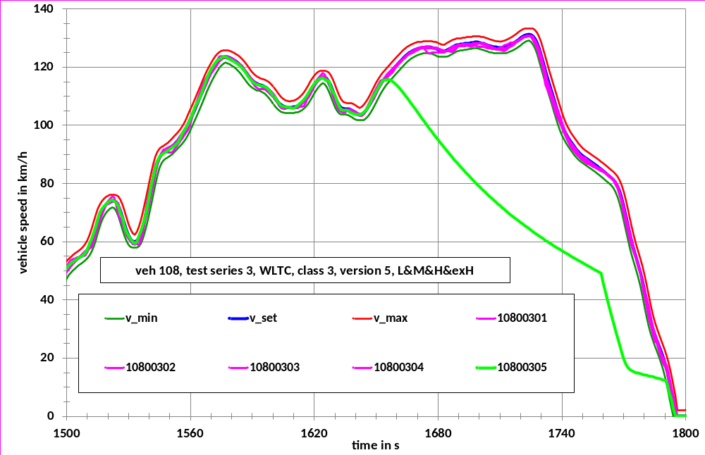
Figure 38: Time series of the vehicle speed for CD test 3 for vehicle 108 at break off section

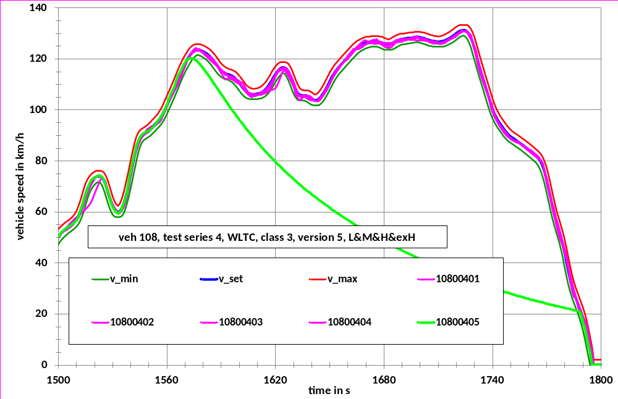
Figure 39: Time series of the vehicle speed for CD test 4 for vehicle 108 at break off section

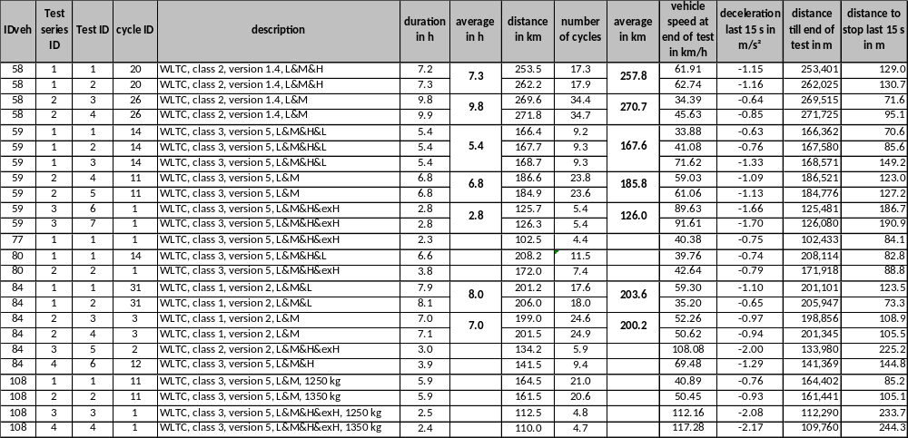
Table 37: Results of charge depleting tests for the 6 pure electric vehicles

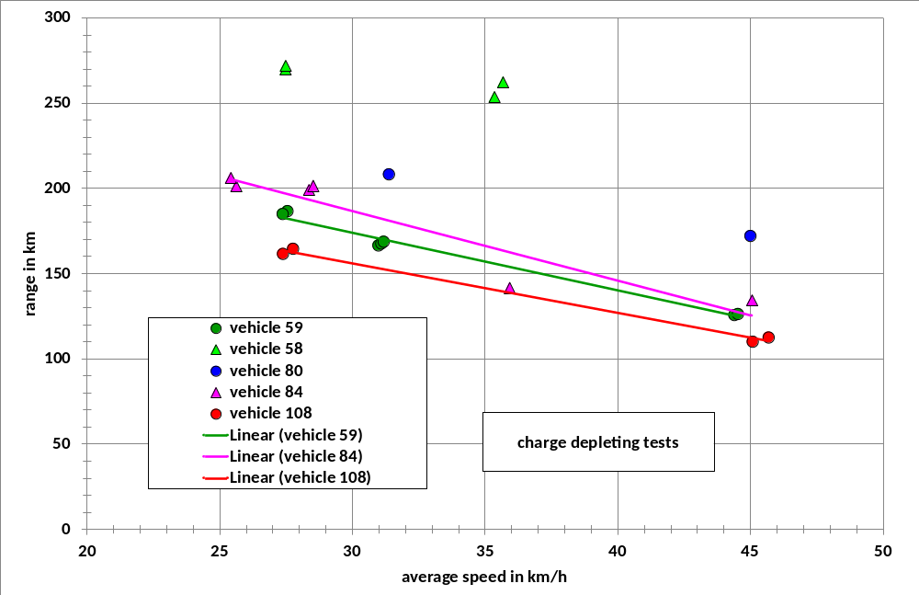
Figure 40: Range of the CD tests for the PEVs versus average speed of the cycles

In addition to the PEVs 2 OVC HEVs were tested on the class 3 cycle (vehicles 60 and 65). Vehicle 60 had a kerb mass of 1730 kg, a 1,4 l Petrol engine with a rated power of 63 kW and an electric motor with a peak power of 111 kW. Vehicle 65 had a kerb mass of 1425 kW, a 1,8 l Petrol engine with a rated power of 73 kW and an electric motor with 60 kW power, which is most probably the peak power. Both vehicles would be classified as class 3 vehicles when considering the rated power of the ICE only. The difference in kerb mass reflects the fact that vehicle 60 had a much higher traction battery capacity than vehicle 65.
This resulted in a much higher electrical range for vehicle 60 compared to vehicle 65 (see Figure 41 to Figure 44). Vehicle 60 could drive almost 3 full class 3 cycles (all 4 phases) without assistance of the ICE, while vehicle 60 could only drive the low, medium and high speed part of one class 3 cycle in electrical mode (see Figure 41 and Figure 43).
Another difference was, that the traction battery was recharged to a certain extend during following CS tests, which was not the case for vehicle 65 (see Figure 42 and Figure 44).

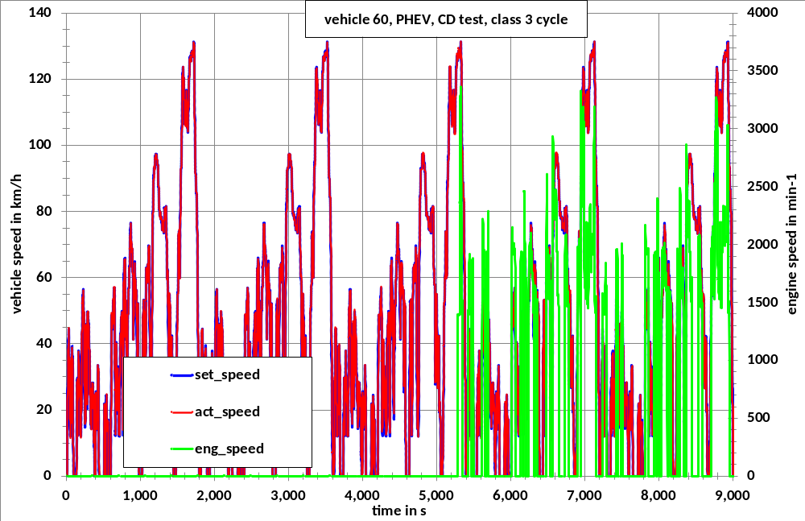
Figure 41: Charge depleting test for OVC HEV vehicle 60, vehicle speed and engine speed

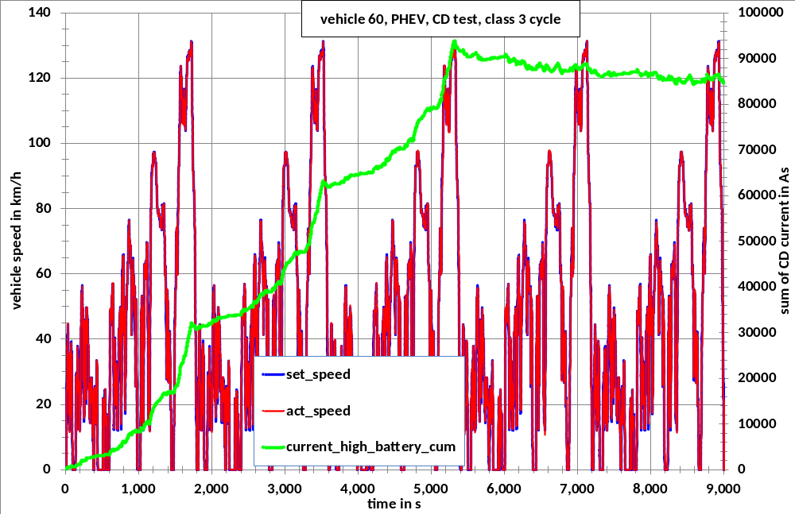
Figure 42: Charge depleting test for OVC HEV vehicle 60, vehicle speed and current

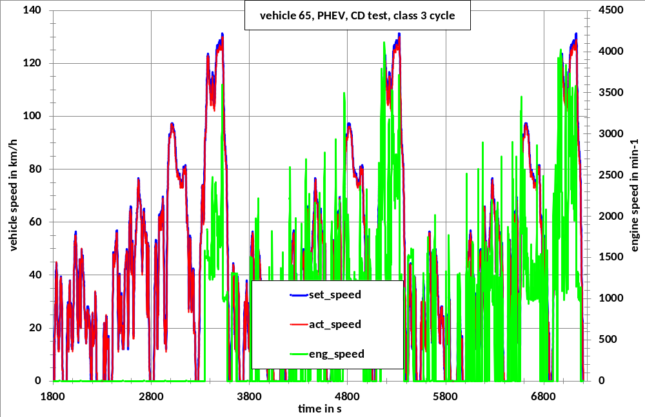
Figure 43: Charge depleting test for OVC HEV vehicle 65, vehicle speed and engine speed

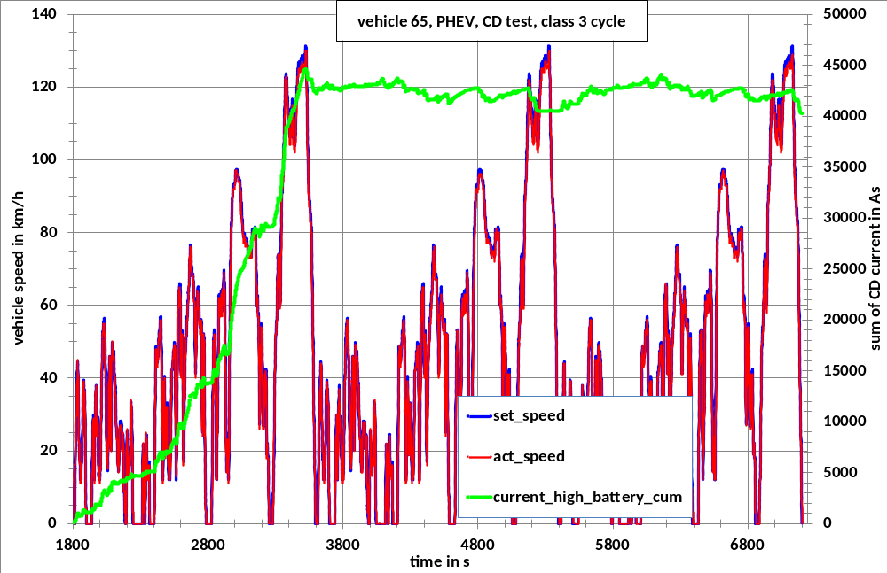
Figure 44: Charge depleting test for OVC HEV vehicle 65, vehicle speed and current

Outlook
This chapter will provide an overview of the topics that are not addressed in this GTR version, but which will be dealt with in Phase 1b respectively Phase 2 of WLTP, including the current version of the roadmap.

Annex 1 - Emission legislation:

The following emission and fuel consumption legislation was reviewed as a basis for the GTR:

US-Regulations (EPA and ARB)
CFR-2009-title40-part86-Volume18
CFR-2009-title40-part86-Volume19
CFR-2009-titel40-part1065-Volume32
CFR-2010-title40-part86-Volume18
CFR-2010-title40-part86-Volume19
CFR-2010-titel40-part1065-Volume32
CFR-2010-titel40-part600
California non-methane organic gas test procedures
Compliance guidance letters
Advisory Circulars
US CARB

UNECE (comparable to EC 715/2007, EC 692 /2008)
ECE-R 83 series 06
ECE R-101
ECE-R24
ISO 10521-1
ISO 10521-2
GTR no.2 (Two-wheeled motorcycles)
GTR no.4 (Heavy duty vehicles)

Japan
Automobile Type Approval Handbook for Japanese Certification

Brazil
ABNT NBR 15598 (Brazilian Standard for Ethanol)

[TO BE COMPLETED]

Annex 2 - List of participants to DTP
Germany
- Stephan Redmann, Ministry of Transport
- Christoph Albus, Ministry of Transport
- Oliver Eberhardt, Ministry of Environment
- Helge Schmidt, TÜV Nord

France
- Beatrice Lopez, UTAC
- Celine Vallaude, UTAC

Japan
- Kazuki Kobayashi, NTSEL
- Hajime Ishii, NTSEL
- Yuki Toba, JASIC
- J. Ueda, MLIT
- Kazuyuki Narusawa. NTSEL

Sweden
- Per Öhlund, Swedish Transport Agency

India
- H.A. Nakhawa, ARAI
- S. Marathe, ARAI
- Atanu Ganguli, SIAM
- Anoop Bhat, Maruti

Netherlands
- Andrej Rijnders
- Henk Baarbe, VROM
- Henk Dekker, TNO

Poland
- Stanislaw Radzimirski, ITS

Austria
- Werner Tober, TU Wien

South Korea
- Junhong Park, Ministry of Environment

USA
- Michael Olechiw, EPA

Switzerland
- Giovanni D’Urbano

UK
- Chris Parkin, DFT

Canada
- Jean-Francois Ferry , Environment Canada

European Commission
- Cova Astorga-llorens, JRC
- Nikolaus Steininger, DG ENTR
- Maciej Szymanski, DG ENTR
- Alessandro Marotta, JRC
- Alois Krasenbrink, JRC

Independent Experts
- Serge Dubuc, Drafting Coordinator
- Heinz Steven, Fige
- Iddo Riemersma, Sidekickprojects
- Christian Vavra, Maha
- Alexander Bergmann, AVL
- Less Hill, Horiba
- Greg Archer, T&E
- Christian Bach, EMPA

OICA
- Nick Ichikawa, Toyota
- Yuichi Aoyama, Honda
- Oliver moersch, Daimler
- Walter Pütz, Daimler
- Konrad Kolesa, Audi
- Caroline Hosier, Ford
- Wiliam Coleman, Volkswagen
- Wolfgang Thiel, TRT Engineering
- Dirk Bäuchle, Daimler
- Stephan Hartmann, Volkswagen
- Alain Petit, Renault
- Eric Donati, PSA
- Bertrand Mercier, PSA
- Laura Bigi, PSA
- Toshiyasu Miyachi, JAMA Europe
- Toshihisa Yamaguchi, Honda
- Thomas Mayer, Ford
- Kamal Charafeddine, Porsche
- Klaus Land, Daimler
- Daniela Leveratto, OICA
- Giovanni Margaria, Iveco
- Christoph Lueginger, BMW
- Andreas Eder, BMW
- Markus Bergmann, Audi
- Thorsten Leischner, Daimler
- Thomas Vercammen, Honda
- Christoph Mayer, BMW
- Arjan Dijkhuizen, Toyota
- Paul Greening, ACEA
- Jakob Seiler, VDA

AECC
- Dirk Bosteels
- John May
- Cecile Favre

ICCT
- Peter Mock

CLEPA
- Matthias Tappe, Bosch
- Danitza Fedeli, Delphi
- Pierre Laurent, CLEPA

See document ECE/TRANS/WP.29/2009/131
Development of a World-wide Worldwide harmonized Light duty driving Test Cycle (WLTC) - Technical Report, UN/ECE/WP.29/GRPE/WLTP-IG DHC subgroup, Monica Tutuianu et al., [DATE]
see document WLTP-DTP-01-14
see WLTP-DTP-02-03
see WLTP-DTP-02-04
see WLTP-DTP-LabProcICE-002-ToR-V3
see WLTP-DTP-E-LabProc-001-ToR._V2
see WLTP-DTP-PMPN-01-02 Rev.2
see WLTP-DTP-AP-01-01
Formaldehyde emissions from light-duty are measured with a methodology based on Federal Test Procedure as set forth in subpart B, 40 CFR Part Subpart B, 40 CFR Part 86, and modifications located in “CALIFORNIA EXHAUST EMISSION STANDARDS AND TEST PROCEDURES FOR 2001 AND SUBSEQUENT MODEL PASSENGER CARS, LIGHT-DUTY TRUCKS, AND MEDIUM-DUTY VEHICLES” page II-1 and II-16 respectively. The Formaldehyde test method used in CALIFORNIA EXHAUST EMISSION STANDARDS AND TEST PROCEDURES FOR 2001 AND SUBSEQUENT MODEL PASSENGER CARS, LIGHT-DUTY TRUCKS, AND MEDIUM-DUTY VEHICLES is the DNPH impinger method or DNPH cartridge. After collecting Formaldehyde using DNPH impinger or DNPH cartridge, the sample is send to the Lab to do analysis, such as HPLC.

