UN/SCETDG/45/INF.8/Add.3
UN/SCEGHS/27/INF.5/Add.3

Committee of Experts on the Transport of Dangerous Goods
and on the Globally Harmonized System of Classification
and Labelling of Chemicals 10 April 2014
Sub-Committee of Experts on the  Transport of Dangerous Goods | Sub-Committee of Experts on the Globally Harmonized System of Classification and Labelling of Chemicals
Forty-fifth session | Twenty–seventh session
Geneva, 23 June – 2 July 2014  Item 11(i) of the provisional agenda  Issues relating to the Globally Harmonized System of Classification and Labelling of Chemicals: miscellaneous | Geneva, 2–4 July 2014  Item 3 (a) (ii) of the provisional agenda  Classification criteria and related hazard communication:  Work of the Sub-Committee of Experts on the Transport of Dangerous Goods (other relevant issues)
Use of the Manual of Tests and Criteria in the context of the GHS: Proposed amendments to Part II of the Manual
Note by the secretariat
1. Reference is made to document ST/SG/AC.10/C.3/2014/61– ST/SG/AC.10/C.4/2014/8.
2. This document contains the suggested amendments to Part II (Sections 20 to 28) of the Manual

Annex

“PART II
CLASSIFICATION PROCEDURES,
TEST METHODS AND CRITERIA
RELATING TO
SELF-REACTIVE SUBSTANCES AND MIXTURES (
TRANSPORT DIVISION 4.1)
AND ORGANIC PEROXIDES (TRANSPORT DIVISION 5.2)

CONTENTS OF PART II

NOTE 1: The country or organisation of origin of each test method is indicated in brackets after each test name.

NOTE 2: The test method recommended for use with each test type is indicated in bold and by an asterisk (see section 1.6 of the General Introduction).

Page

Chapter 20. INTRODUCTION TO PART II
20.1 PURPOSE
20.2 SCOPE
20.3 PRELIMINARY PROCEDURE
20.3.1 General description
20.3.2 Test types
20.3.3 Application of the test methods
20.4 CLASSIFICATION PROCEDURES
20.4.1 General description
20.4.2 Classification of self-reactive substances
20.4.3 Classification of organic peroxides
20.4.4 Test types
20.4.5 Application of the test methods
20.5 EXAMPLE OF A TEST REPORT

Chapter 21. TEST SERIES A
21.1 INTRODUCTION
21.2 TEST METHODS
21.3 TEST CONDITIONS
21.4 SERIES A TEST PRESCRIPTIONS
21.4.1 Test A.1 BAM 50/60 steel tube test (D)
21.4.2 Test A.2 TNO 50/70 steel tube test (NL)
21.4.3 Test A.5 UN gap test (UN)
21.4.4 Test A.6 * UN detonation test (UN)

Chapter 22. TEST SERIES B
22.1 INTRODUCTION
22.2 TEST METHODS
22.3 TEST CONDITIONS
22.4 SERIES B TEST PRESCRIPTION
22.4.1 Test B.1 * Detonation test in package (NL)

CONTENTS OF PART II (continued)

Page

Chapter 23. TEST SERIES C
23.1 INTRODUCTION
23.2 TEST METHODS
23.3 TEST CONDITIONS
23.4 SERIES C TEST PRESCRIPTIONS
23.4.1 Test C.1 * Time/pressure test (GB)
23.4.2 Test C.2 * Deflagration test (NL)

Chapter 24. TEST SERIES D
24.1 INTRODUCTION
24.2 TEST METHOD
24.3 TEST CONDITIONS
24.4 SERIES D TEST PRESCRIPTION
24.4.1 Test D.1 * Deflagration test in the package (NL)

Chapter 25. TEST SERIES E
25.1 INTRODUCTION
25.2 TEST METHODS
25.3 TEST CONDITIONS
25.4 SERIES E TEST PRESCRIPTIONS
25.4.1 Test E.1 * Koenen test (D)
25.4.2 Test E.2 * Dutch pressure vessel test (NL)
25.4.3 Test E.3 United States pressure vessel test (USA)

Chapter 26. TEST SERIES F
26.1 INTRODUCTION
26.2 TEST METHODS
26.3 TEST CONDITIONS
26.4 SERIES F TEST PRESCRIPTIONS
26.4.1 Test F.1 Ballistic mortar Mk.IIId test (GB)
26.4.2 Test F.2 Ballistic mortar test (F)
26.4.3 Test F.3 BAM Trauzl test (D)
26.4.4 Test F.4 * Modified Trauzl test (USA)
26.4.5 Test F.5 High pressure autoclave (NL)
CONTENTS OF PART II (continued)

Page

Chapter 27. TEST SERIES G
27.1 INTRODUCTION
27.2 TEST METHODS
27.3 TEST CONDITIONS
27.4 SERIES G TEST PRESCRIPTIONS
27.4.1 Test G.1 * Thermal explosion test in package (NL)
27.4.2 Test G.2 Accelerating decomposition in the package test (USA)

Chapter 28. TEST SERIES H
28.1 INTRODUCTION
28.2 TEST METHODS
28.3 TEST CONDITIONS
28.4 SERIES H TEST PRESCRIPTIONS
28.4.1 Test H.1 * United States SADT test (USA)
28.4.2 Test H.2 * Adiabatic storage test (NL)
28.4.3 Test H.3 Isothermal storage test (NL)
28.4.4 Test H.4 * Heat accumulation storage test (D)

CHAPTER 20
INTRODUCTION TO PART II

20.1 Purpose

20.1.1 Part II of the Manual presents the United Nations schemes for the classification of self-reactive substances and mixtures (transport Division 4.1) (see Chapter 2.8, section 2.8.2 in the GHS and Chapter 2.4, and sub-section 2.4.2.3 in the Model Regulations) and organic peroxides (transport Division 5.2) (see Chapter 2.15, section 2.15.2 in the GHS and Chapter 2.5, section 2.5.3 of the Model Regulations). It includes a description of the procedures, test methods and criteria considered to be the most suitable for providing competent authorities with the necessary information to arrive at a proper classification of these substances. It should be used in conjunction with the classification principles given in paragraphs 20.4.2 (self-reactive substances and mixtures)) and 20.4.3 (organic peroxides) and the flow chart given in Figure 20.1.For self-reactive substances and mixtures, see also Chapter 2.8, paragraph 2.8.2.2 of the GHS and Chapter 2.4, paragraph 2.4.2.3.3 in the Model Regulations. For organic peroxides see also Chapter 2.15, paragraph 2.15.2.2 and Chapter 2.5, paragraph 2.5.3.3 in the Model Regulations.

20.1.2 Self-reactive substances and mixtures and organic peroxides are classified into seven types according to the hazard. The scheme for classifying these substances is illustrated in Figure 20.1. The tests are performed in two stages. In the first stage, for the safety of laboratory workers, preliminary small scale tests should be performed to ascertain the stability and sensitivity of the substance or mixture. In the second stage, classification tests should be performed.

20.2 Scope

20.2.1 New substances or mixtures, capable of exothermic decomposition, offered for transport should be subjected to the classification procedures for self-reactive substances or mixtures as set out in this section unless:

(a) They are explosives according to the criteria for the class of explosives (transport Class 1);

(b) They are oxidizing according to the classification procedure for oxidizing liquids and solids (transport Division 5.1) (see section 34) except that mixtures of oxidizing liquids or solids which contain 5.0% or more of combustible organic substances shall be subjected to the classification procedure defined in the NOTE below;

NOTE: Mixtures of oxidizing substances meeting the criteria for classification as oxidizing substances (transport Division 5.1) which contain 5.0% or more of combustible organic substances, which do not meet the criteria mentioned in (a), (c), (d) or (e) above, shall be subjected to the self-reactive substance classification procedure.

A mixture showing the properties of a self-reactive substance, type B to F, shall be classified as a self-reactive substance (transport Division 4.1).

A mixture showing the properties of a self-reactive substance, type G, according to the principle of 20.4.2 (g) shall be considered for classification as an oxidizing solid or liquid (transport Division 5.1) (see section 34).

(c) They are organic peroxides according to the criteria for organic peroxides (transport Division 5.2);

(d) Their heat of decomposition (see 20.3.3.3) is less than 300 J/g; or

(e) Their self-accelerating decomposition temperature is greater than 75 °C for a 50 kg package.

20.2.2 New organic peroxides offered for transport should be subjected to the classification procedures as set out in this section unless the organic peroxide formulation contains:

(a) Not more than 1.0% available oxygen from the organic peroxides when containing not more than 1.0% hydrogen peroxide; or
(b) Not more than 0.5% available oxygen from the organic peroxides when containing more than 1.0% but not more than 7.0% hydrogen peroxide.
20.2.3 In this context a new substance is one which, in the opinion of the competent authority, involves any of the following:

(a) A new self-reactive substance or mixture which meets the definition given in Chapter 2.8 paragraph 2.8.1 of the GHS or Chapter 2.4, paragraph 2.4.2.3.1.1 of the Model Regulations, or a mixture of already classified self-reactive substances which is considered to be significantly different from those already classified;
(b) An activator is added to an already classified self-reactive substance or mixture (see paragraphs 2.4.2.3.2.1 and 2.4.2.3.2.2 of the Model Regulations) which decreases the thermal stability or alters the explosive properties; or
(c) A new organic peroxide which meets the definition given in Chapter 2.15, paragraph 2.15.1.1 of the GHS or Chapter 2.5, paragraph 2.5.1 (b) of the Model Regulations, or a mixture of already classified organic peroxides which is considered to be significantly different from those already classified.
20.2.4 Mixtures of organic peroxide formulations currently assigned to a generic entry in the Dangerous Goods List of the Model Regulations may be classified as the same type of organic peroxide as that of the most dangerous component and be transported under the conditions of transport given for this type. However, as two components can form a thermally less stable mixture, the self-accelerating decomposition temperature (SADT) of the mixture should be determined and, if necessary, the control and emergency temperature derived from the SADT in accordance with Chapter 2.5, paragraph 2.5.3.4 of the Model Regulations.

20.2.5 The classification procedure should be undertaken before a new product is offered for transport.

20.2.6 Any substance or mixture which shows the properties of a self-reactive substance or mixture (except type G) should be classified as such, even if this substance or mixture gives a positive test result according to the test method for self-heating substances or mixtures (transport Division 4.2) (see section 32.5.2 of this Manual and Chapter 2.11 of the GHS or Chapter 2.4 of the Model Regulations).

20.3 Preliminary procedure

20.3.1 General description

It is essential for the safety of laboratory workers that small-scale preliminary tests are performed before attempting to handle larger quantities. This involves tests for determining the sensitiveness of the substance or mixture to mechanical stimuli (impact and friction), and to heat and flame.

20.3.2 Test types

Generally four types of small scale test may be used to make a preliminary safety assessment:

(a) A falling weight test to determine sensitiveness to impact;
(b) A friction or impacted friction test to determine the sensitiveness to friction;
(c) A test to assess thermal stability and the exothermic decomposition energy; and
(d) A test to assess the effect of ignition.
20.3.3 Application of the test methods

20.3.3.1 For safety, it is usual to perform the tests requiring the smallest quantity of material first.

20.3.3.2 Impact and friction sensitiveness may be assessed using one of the tests in series 3 of the explosives (transport Class 1) acceptance procedure (see Part I).

20.3.3.3 Thermal stability may be estimated using a suitable calorimetric technique such as differential scanning calorimetry or adiabatic calorimetry. Exothermic decomposition energy may be estimated using a suitable calorimetric technique such as differential scanning calorimetry. In using such techniques, special care should be taken in interpreting the results when:

(a) Sampling and testing mixtures;

(b) The material of the sample vessel may influence the result;

(c) Endotherms immediately precede exotherms;

(d) Evaporation of constituents will lower the exothermicity (sealed sample vessels should normally be used);

(e) The presence of air may critically affect the measured decomposition energy;

(f) There is a large difference between the specific heats of the reactants and products; and

(g) Using rapid heating rates (when differential scanning calorimetry is used, the heating rates should normally be in the range of 2 to 5 K/min).

If differential scanning calorimetry is used, the extrapolated onset temperature is defined as being the point of intersection of the tangent drawn at the point of greatest slope on the leading edge of the peak with the extrapolated baseline.
(Ref.Doc: ST/SG/AC.10/11/Rev.5/Amend.2)

20.3.3.4 Any suitable method may be used to assess the effect of ignition provided it adequately identifies those materials which react violently under little or no confinement.

Figure 20.1 (a): Flow-chart scheme for self-reactive substances and mixtures and organic peroxides

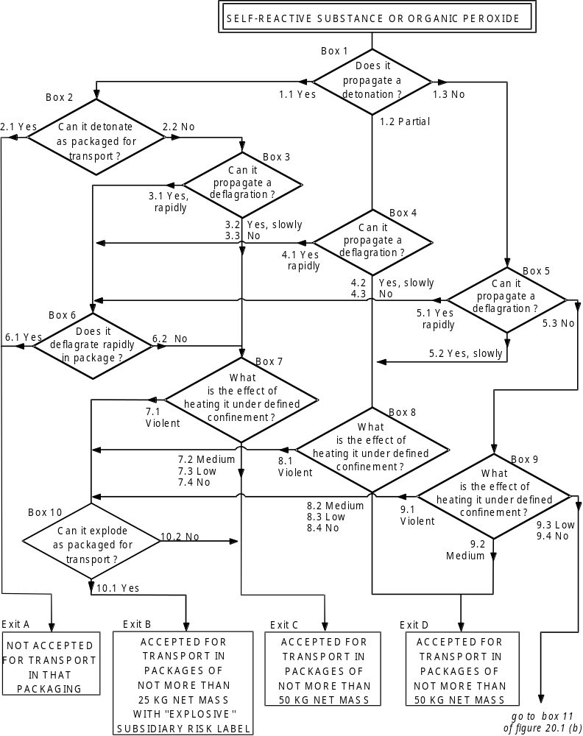
None
None
None

Figure 20.1 (b): Flow-chart scheme for self-reactive substances and mixtures and organic peroxides (cont’d)

(Ref.Doc: ST/SG/AC.10/11/Rev.5/Amend.2)

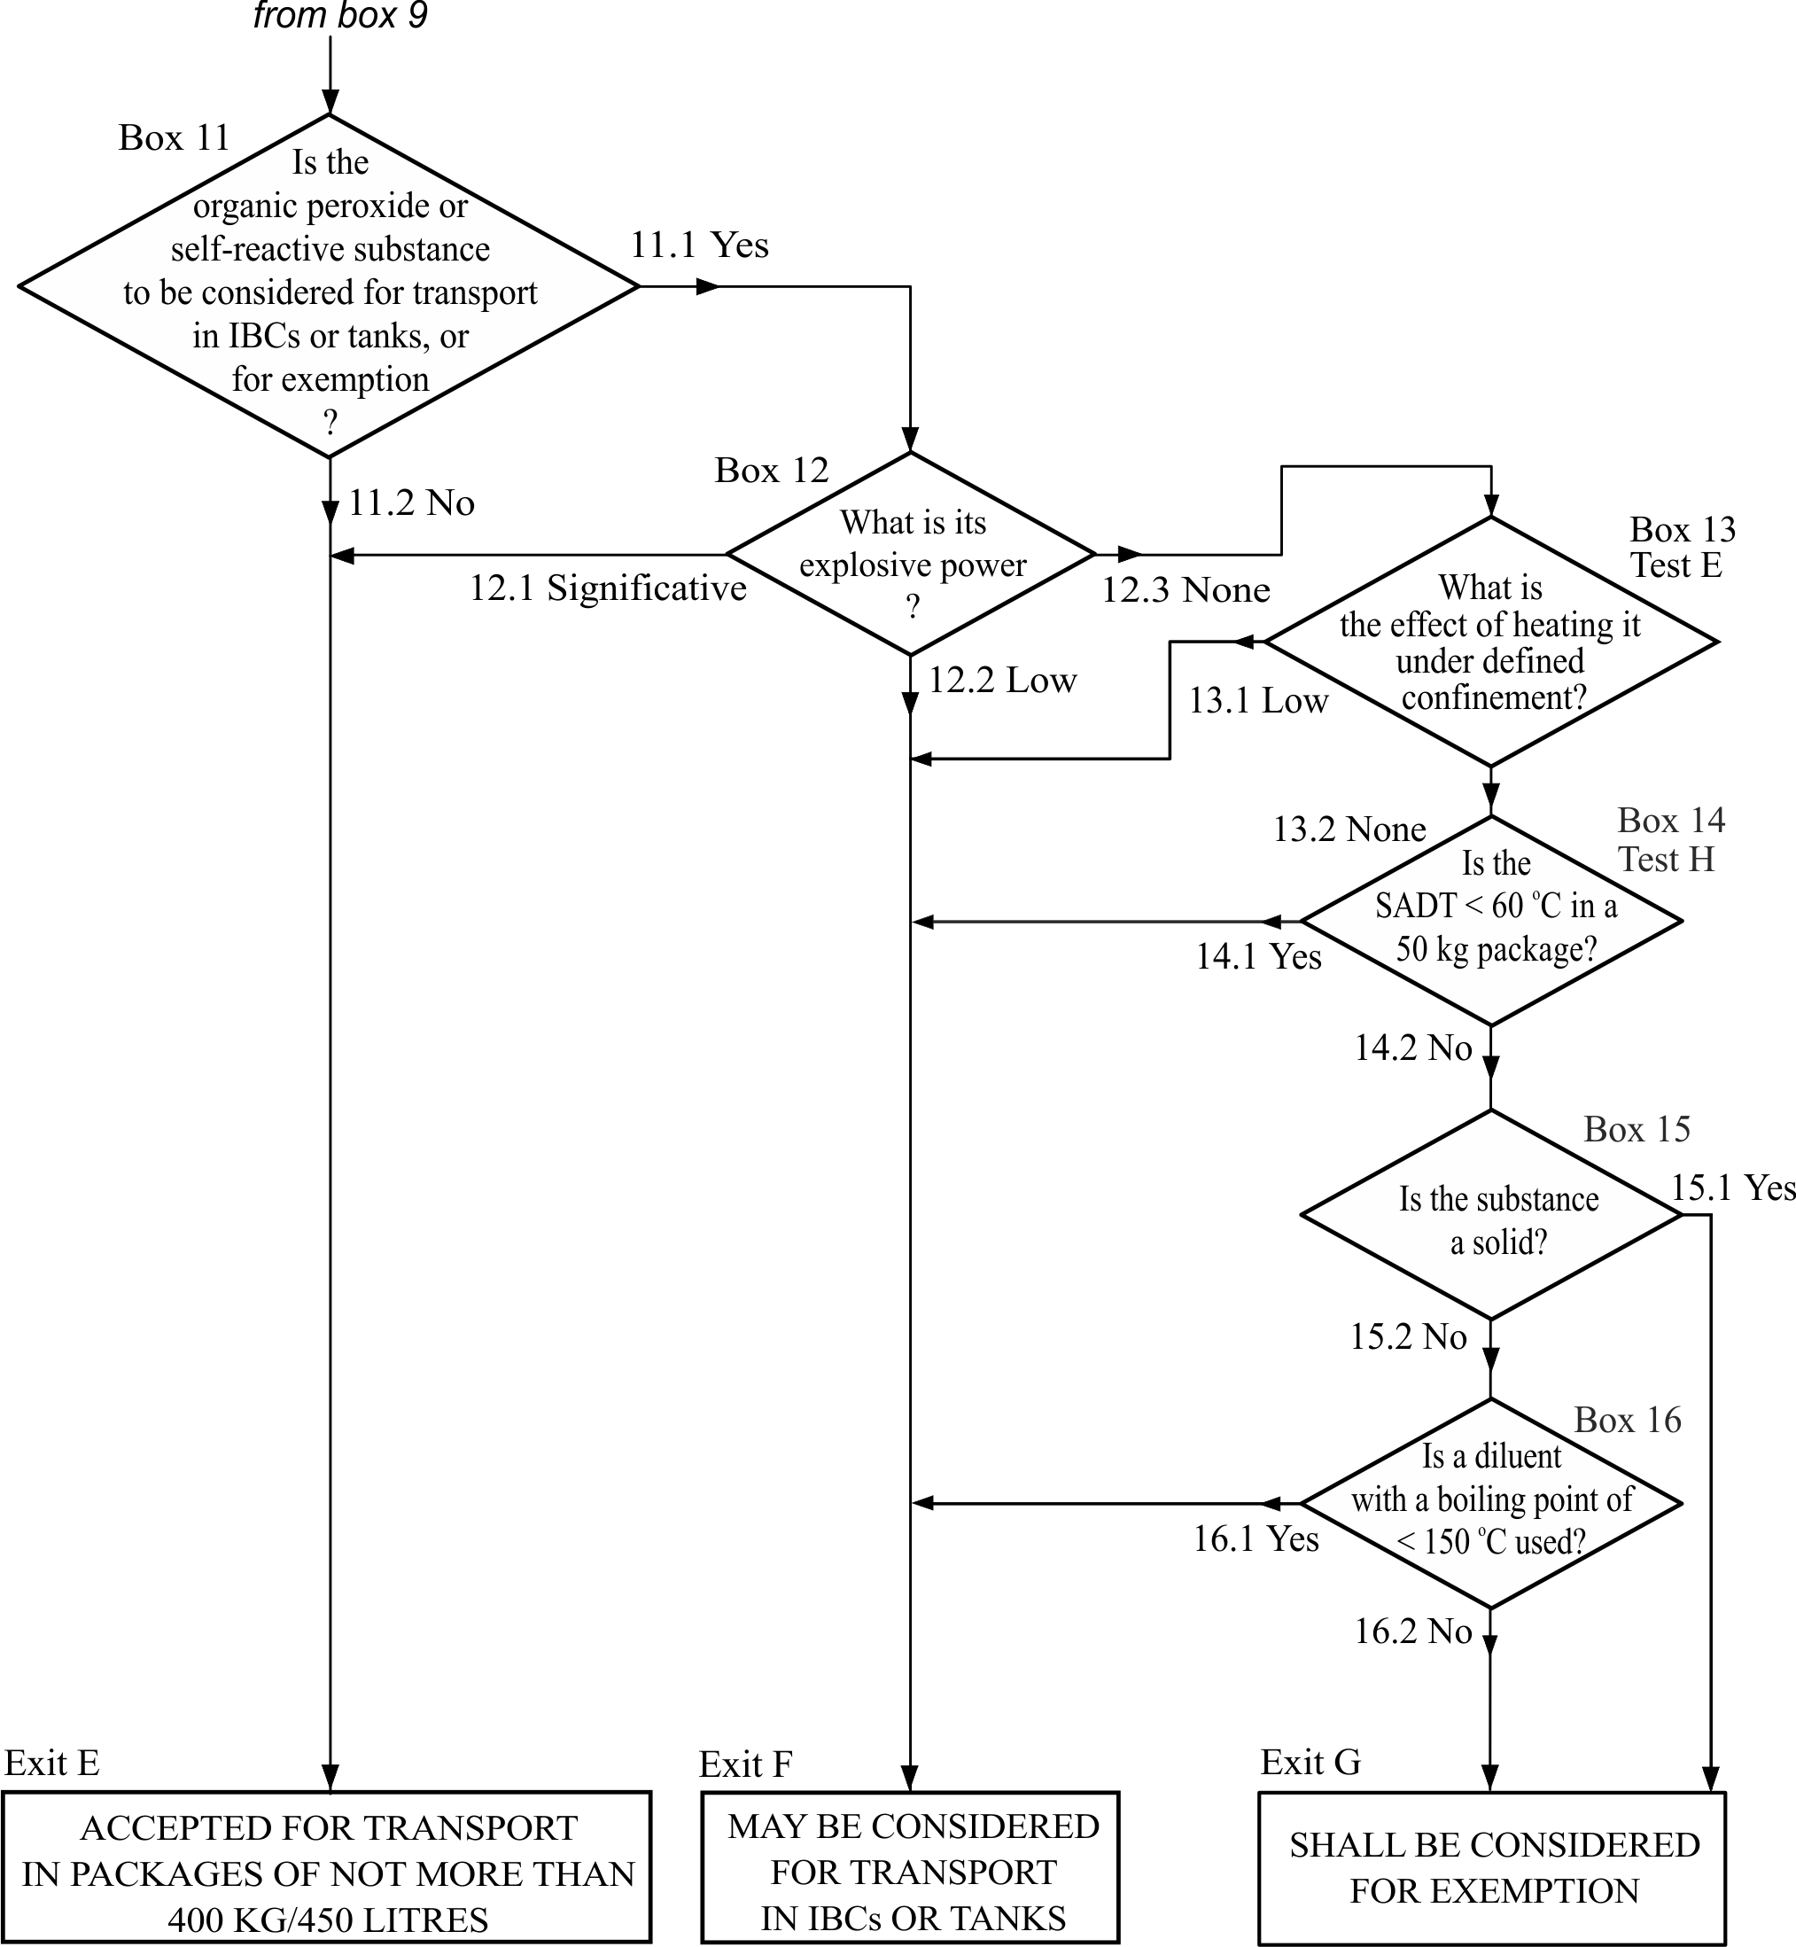

20.4 Classification procedures

20.4.1 General description

20.4.1.1 The principles of classification of self-reactive substances and mixtures and organic peroxides are given in sub-sections 20.4.2 and 20.4.3 respectively (For self-reactive substances and mixtures, see also Chapter 2.8, paragraph 2.8.2.2 of the GHS and Chapter 2.4, paragraph 2.4.2.3.3 in the Model Regulations. For organic peroxides see also Chapter 2.15, paragraph 2.15.2.2 of the GHS and Chapter 2.5, paragraph 2.5.3.3 in the Model Regulations. The general scheme for classification (flow chart) is shown in Figure 20.1. Self-reactive substances and mixtures and organic peroxides are classified into seven types according to the hazard. In order to determine the substance or mixture type, it is necessary to determine the properties as requested in the boxes of the flow chart and the additional requirements in the classification principles. The types range from type A, which is not accepted for transport in the packaging in which it is tested, to type G which is exempted from the provisions for self-reactive substances and mixtures (transport Division 4.1) or organic peroxides (transport Division 5.2). The classification of types B to F is directly related to the maximum quantity allowed in one packaging.

20.4.1.2 A self-reactive substance or mixture or organic peroxide formulation should be regarded as possessing explosive properties when in laboratory testing the formulation is liable to detonate, to deflagrate rapidly or to show a violent effect when heated under confinement.

20.4.1.3 The self-accelerating decomposition temperature (SADT) is defined as the lowest ambient temperature at which self-accelerating decomposition may occur in a substance in the packaging as used in transport (see Chapter 2.5, sub-section 2.5.3.4 of the Model Regulations). An SADT should be determined in order to decide if:

(a) A substance or mixture should be subjected to temperature control during transport;

(b) When appropriate, a substance or mixture conforms to the requirements of type G; or

(c) When appropriate, a substance or mixture meets the SADT criterion for self-reactive substances or mixtures.

20.4.1.4 When appropriate, the physical form of the substance or mixture should be determined as set out under definition of liquids in Chapter 1.2, paragraph 1.2.1 of the Model Regulations.

20.4.1.5 The substance or mixture type, physical form and whether or not temperature control is required are used to make the assignment of the substance or mixture to the appropriate generic entry.

20.4.2 Classification of self-reactive substances and mixtures

The following principles should be applied to the classification of self-reactive substances and mixtures not listed in Chapter 2.4, paragraph 2.4.2.3.2.3 of the Model Regulations.

(a) Any self-reactive substance or mixture which can detonate or deflagrate rapidly, as packaged will be defined as self-reactive substance type A ( exit box A of Figure 20.1). Such a self-reactive substance or mixture, as packaged for transport, is prohibited from transport under the provisions for self-reactive substances or mixtures of transport Division 4.1 in that packaging;

(b) Any self-reactive substance or mixture possessing explosive properties and which, as packaged, neither detonates nor deflagrates rapidly, but is liable to undergo a thermal explosion in that package will be defined as self-reactive substance type B (exit box B of Figure 20.1) and, should also bear an "EXPLOSIVE" pictogram (for transport, a subsidiary risk label conforming to Model No.1 in Chapter 5.2, paragraph 5.2.2.2.2 of the Model Regulations). Such a self-reactive substance or mixture may be packaged in amounts of up to 25 kg unless the maximum quantity has to be limited to a lower amount to preclude detonation or rapid deflagration in the package;

(c) Any self-reactive substance or mixture possessing explosive properties when the substance or mixture as packaged cannot detonate or deflagrate rapidly or undergo a thermal explosion will be defined as self-reactive substance or mixture type C (exit box C of Figure 20.1), and may be transported without an "EXPLOSIVE" pictogram (subsidiary risk label for transport) in packages of not more than 50 kg net mass.
(d) Any self-reactive substance or mixture which in laboratory testing:

(i) detonates partially, does not deflagrate rapidly and shows no violent effect when heated under confinement; or

(ii) does not detonate at all, deflagrates slowly and shows no violent effect when heated under confinement; or

(iii) does not detonate or deflagrate at all and shows a medium effect when heated under confinement;

will be defined as self-reactive substance or mixture type D (exit box D of Figure 20.1) and may be accepted for transport in packages of not more than 50 kg net mass;

(e) Any self-reactive substance or mixture which, in laboratory testing, neither detonates nor deflagrates at all and shows low or no effect when heated under confinement wil be defined as self-reactive substance type E (exit box E of Figure 20.1) and may be accepted for transport in packages of not more than 400 kg/450 litres;

(f) Any self-reactive substance or mixture which, in laboratory testing, neither detonates in the cavitated state nor deflagrates at all and shows only a low or no effect when heated under confinement as well as low or no explosive power will be defined as self-reactive substance type F (exit box F of Figure 20.1) and may be considered for transport in IBCs or tanks. For additional provisions, see Model Regulations, sub-section 4.1.7.2.2 and 4.2.1.13;

(g) Any self-reactive substance or mixture which, in laboratory testing, neither detonates in the cavitated state nor deflagrates at all and shows no effect when heated under confinement nor any explosive power, will be defined as self-reactive substance type G (exit box G of Figure 20.1) provided that:
– it is thermally stable (self-accelerating decomposition temperature is 60 °C to 75 °C for a 50 kg package); and
– for liquid mixtures, a diluent (meeting the requirements of Chapter 2.4, paragraph 2.4.2.3.5 of the Model Regulations) having a boiling point greater than or equal to 150°C is used for desensitization,
For transport, such a self-reactive substance or mixture shall be exempted from classification in transport Division 4.1.
If the mixture is not thermally stable or a compatible diluent having a boiling point less than 150 °C is used for desensitization, the mixture shall be defined as self-reactive substance type F.

20.4.3 Classification of organic peroxides

The following principles should be applied to the classification of organic peroxides not listed in the Table in Chapter 2.5, paragraph 2.5.3.2.4 of the Model Regulations:

(a) Any organic peroxide which can detonate or deflagrate rapidly, as packaged, will be defined as organic peroxide type A (exit box A of Figure 20.1) and should be prohibited from transport in that packaging under transport Division 5.2;

(b) Any organic peroxide possessing explosive properties and which, as packaged, neither detonates nor deflagrates rapidly, but is liable to undergo a thermal explosion in that package will be defined as organic peroxide type B (exit box B of Figure 20.1), and should bear an "EXPLOSIVE" pictogram (for transport, a subsidiary risk label conforming to Model No.1 in Chapter 5.2, paragraph 5.2.2.2.2 of the Model Regulations). Such an organic peroxide may be packaged in amounts of up to 25 kg unless the maximum quantity has to be limited to a lower amount to preclude detonation or rapid deflagration in the package;

(c) Any organic peroxide possessing explosive properties when the substance or mixture as packaged cannot detonate or deflagrate rapidly or undergo a thermal explosion will be defined as organic peroxide type C (exit box C of Figure 20.1) and may be transported without an "EXPLOSIVE" subsidiary risk label in packages of not more than 50 kg net mass;

(d) Any organic peroxide which in laboratory testing:

(i) detonates partially, does not deflagrate rapidly and shows no violent effect when heated under confinement; or

(ii) does not detonate at all, deflagrates slowly and shows no violent effect when heated under confinement; or

(iii) does not detonate or deflagrate at all and shows a medium effect when heated under confinement,

will be defined as organic peroxide type D (exit box D of Figure 20.1) and is acceptable for transport in packages of not more than 50 kg net mass;

(e) Any organic peroxide which, in laboratory testing, neither detonates nor deflagrates at all and shows low or no effect when heated under confinement will be defined as organic peroxide type E (exit box E of Figure 20.1) and is acceptable for transport in packages of not more than 400 kg/450 litres;

(f) Any organic peroxide which, in laboratory testing, neither detonates in the cavitated state nor deflagrates at all and shows only a low or no effect when heated under confinement as well as low or no explosive power will be defined as organic peroxide type F (exit box F of Figure 20.1) and may be considered for transport in IBCs or tanks; for additional provisions, see Chapter 4.1, section 4.1.7 and Chapter 4.2, paragraph 4.2.1.13 of the Model Regulations;

(g) Any organic peroxide which, in laboratory testing, neither detonates in the cavitated state nor deflagrates at all and shows no effect when heated under confinement nor any explosive power will be defined as organic peroxide type G (exit box G of Figure 20.1), provided that:
– the formulation is thermally stable (self-accelerating decomposition temperature is 60 °C or higher for a 50 kg package); and
– for liquid mixtures, diluent type A is used for desensitization.
For transport, such an organic peroxide shall be exempted from transport Division 5.2.

If the mixture is not thermally stable or a diluent other than type A is used for desensitization, the mixture should be defined as organic peroxide type F.

20.4.4 Test types

20.4.4.1 Paragraphs 20.4.2 and 20.4.3 refer only to those properties of self-reactive substances mixtures and organic peroxides which are decisive for their classification. These properties should be determined experimentally.

20.4.4.2 The test methods for determining the type of self-reactive substance or mixture or organic peroxide are grouped into eight series, lettered A to H, designed to provide the information necessary to answer the questions in the flow chart given in Figure 20.1 and to apply the principles for classification.

20.4.4.3 Test series A comprises laboratory tests and criteria concerning propagation of detonation as requested in box 1 of the flow chart.

20.4.4.4 Test series B comprises a test and criteria concerning the propagation of detonation of the substance as packaged, as requested in box 2 of the flow chart.

20.4.4.5 Test series C comprises laboratory tests and criteria concerning propagation of deflagration as requested in boxes 3, 4 and 5 of the flow chart.

20.4.4.6 Test series D comprises a test and criteria concerning the propagation of a rapid deflagration of the substance as packaged, as requested in box 6 of the flow chart.

20.4.4.7 Test series E comprises laboratory tests and criteria concerning the determination of the effect of heating under defined confinement, as requested in boxes 7, 8, 9 and 13 of the flow chart.

20.4.4.8 Test series F comprises laboratory tests and criteria concerning the explosive power of substances and mixtures which are considered for transport in Intermediate Bulk Containers (IBCs) or tanks, or for exemption (see box 11 of the flow chart), as requested in box 12 of the flow chart.

20.4.4.9 Test series G comprises tests and criteria concerning the determination of the effect of a thermal explosion of the substance or mixture as packaged, as requested in box 10 of the flow chart.

20.4.4.10 Test series H comprises tests and criteria concerning the determination of the self-accelerating decomposition temperature of organic peroxides and self-reactive, or potentially self-reactive substances or mixtures.

20.4.5 Application of the test methods

20.4.5.1 The ordering of test series A to H relates more to the sequence of assessing results than to the order in which tests are conducted. The recommended sequence of laboratory scale testing is test series E, H, F, C and then A. Some tests may not be required - see the introduction to each test series.

20.4.5.2 The package tests of test series B, D and G need be performed only if indicated by the results from the corresponding tests in test series A, C and E.

20.5 Example of a test report

20.5.1 Examples of a test report and a classification are illustrated in figures 20.2 and 20.3 respectively.

20.5.2 To allow for analytical uncertainties, the concentration of the substance or mixture to be transported may be up 2% higher than the concentration tested. If an organic peroxide is tested, the available oxygen content should be given in the general data section of the report. Similarly, if a self-reactive substance or mixture is tested, the activator type and concentration, if any, should be given.

20.5.3 If the preliminary test results indicate that the substance or mixture is very sensitive to initiation (e.g. by impact, friction or sparks), the results should be recorded in the report.

Figure 20.2: Example of a test report

1. Name of substance : tert-BUTYL PEROXYBENZOATE, technically pure

2. General data

2.1 Composition : 98% tert-butyl peroxybenzoate
2.2 Molecular formula : C₁₁H₁₄O₃
2.3 Available oxygen content : 8.24%
2.4 Activator content : Not applicable
2.5 Physical form : Liquid
2.6 Colour : Colourless
2.7 Apparent density : 1 040 kg/m³
2.8 Particle size : Not applicable

3. Detonation (test series A)
Box 1 of the flow chart : Does the substance propagate a detonation?

3.1 Method : BAM 50/60 steel tube test (test A.1)
3.2 Sample conditions : Ambient temperature
3.3 Observations : 30 cm of tube fragmented, unreacted substance remained in the tube
3.4 Result : Partial
3.5 Exit : 1.2

4. Deflagration (test series C)
Box 4 of the flow chart : Does the substance propagate a deflagration?

4.1 Method 1 : Time/pressure test (test C.1)
4.2 Sample conditions : Ambient temperature
4.3 Observations : Time 2.5 s
4.4 Result : Yes, slowly
4.5 Method 2 : Deflagration test (test C.2)
4.6 Sample conditions : Temperature 50 °C
4.7 Observations : Deflagration rate 0.65 mm/s
4.8 Result : Yes, slowly
4.9 Overall result : Yes, slowly
4.10 Exit : 4.2

5. Heating under confinement (test series E)
Box 8 of the flow chart : What is the effect of heating it under defined confinement?

5.1 Method 1 : Koenen test (test E.1)
5.2 Sample conditions : Mass 26.0 g
5.3 Observations : Limiting diameter 3.5 mm
(time to reaction 19 s, duration of reaction 22 s)
5.4 Result : Violent
5.5 Method 2 : Dutch pressure vessel test (test E.2)
5.6 Sample conditions : 10.0 g
5.7 Observations : Limiting diameter 10.0 mm
(time to reaction 110 s, duration of reaction 4 s)
5.8 Result : Violent
5.9 Overall result : Violent
5.10 Exit : 8.1

6. Explosion in package (test series E)
Box 10 of the flow chart : Can the substance explode as packaged for transport?

6.1 Method : Thermal explosion test in the package (test G.1)
6.2 Sample conditions : 25 kg of substance in packaging type 6HG2 with a capacity of 30 litres
6.3 Observations : Fume off only, no fragmentation of the package
6.4 Result : No explosion (packing method OP5)
6.5 Exit : 10.2

7. Thermal stability (test series H)

7.1 Method : United States SADT test (test H.1)
7.2 Sample conditions : 20 litres of substance in packaging type 6HG2 with a capacity of 25 litres
7.3 Observations : Auto-accelerating decomposition at 63 °C, no auto-
accelerating decomposition at 58 °C, self-accelerating
decomposition temperature 63 °C
7.4 Result : No temperature control required

8. Additional data (see 20.5.3)

8.1 Method : BAM fallhammer test (test 3 (a) (ii))
8.2 Sample conditions : Ambient temperature
8.3 Observations : Limiting impact energy 5 J
8.4 Result : Sensitive to impact

9. Proposed assignment

9.1 Proper shipping name : ORGANIC PEROXIDE TYPE C, LIQUID
9.2 UN number : 3103
9.3 Transport Division : 5.2
9.4 Technical name : tert-Butyl peroxybenzoate
9.5 Concentration : ≤ 100%
9.6 Diluent(s) : None
9.7 Subsidiary risks : None
9.8 Packing group : II
9.9 Packing method : OP5
9.10 Control temperature : Not required
9.11 Emergency temperature : Not required

Figure 20.3: Classification of tert-butyl peroxybenzoate

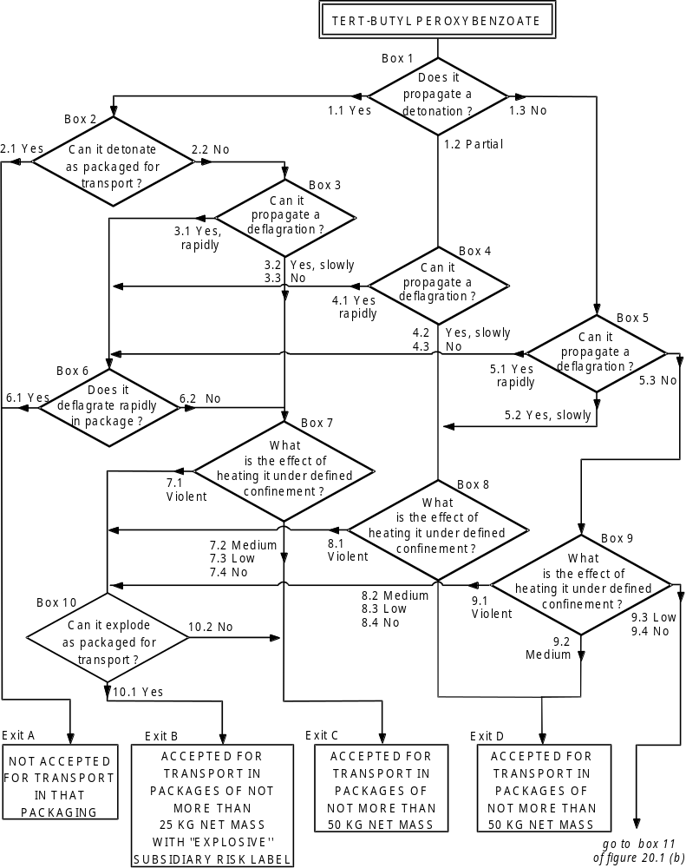
None
None
None

CHAPTER 21
TEST SERIES A

21.1 Introduction

20.1.1 Test series A comprises laboratory tests and criteria concerning propagation of detonation as requested in box 1 of Figure 20.1.

21.2 Test methods

21.1.2 The question "Does it propagate a detonation?" (box 1 of Figure 20.1) is answered on the basis of the results of one of the test methods in Table 21.1. If a liquid is being considered for transport in tank-containers or IBCs with a capacity exceeding 450 litres, a cavitated version of a Series A test may be used (see Appendix 3).

Table 21.1: test methods for Test Series A

Test code | Name of test | Section
A.1 | BAM 50/60 steel tube test | 21.4.1
A.2 | TNO 50/70 steel tube test | 21.4.2
A.5 | UN gap test | 21.4.3
A.6 | UN detonation testª | 21.4.4
ª Recommended test

All tests are considered to be equivalent and only one test method has to be used.

21.2.2 For organic peroxides and self-reactive substances and mixtures, a combination of a test for explosive power (any test of series F except test F.5 for organic peroxides, and any test of series F except tests F.4 and F.5 for self-reactive substances and mixtures) with two tests for the effects of heating under confinement may be used as a screening procedure for assessing the ability to propagate a detonation. A test of series A need not be performed if:

(a) A "No" result is obtained from the explosive power test; and

(b) A "No" or "Low" result is obtained from test E.2 and either test E.1 or E.3.

For transport in packages (excluding IBCs), if the screening procedure indicates that a Series A test is not needed, the question in box 1 is answered with a "No". However, if the substance or mixture is being considered for transport in tank containers or IBCs, or for exemption, then a series A test is required unless the result of a series A test on a formulation of the substance or mixture with a higher concentration and the same physical state is "No".

21.3 Test conditions

21.3.1 As the apparent density of the substance or mixture has an important effect on the results from series A tests, it should always be recorded. The apparent density of solids should be determined from measurement of the tube volume and sample mass.

21.3.2 If a mixture can separate out during transport, the test should be performed with the initiator in contact with the potentially most explosive part.

21.3.3 The tests should be performed at ambient temperature unless the substance or mixture is to be transported under conditions where it may change its physical state or density. Organic peroxides and self-reactive substances and mixtures which require temperature control should be tested at the control temperature if below ambient temperature.
21.3.4 The preliminary procedure should be performed before performing these tests (see section 20.3).

21.3.5 When a fresh batch of steel tubes is used, calibration tests using water (for tests on liquids) and an inert, organic solid (for tests on solids) should be performed to determine the average blank fragmentation length. The "No" / "Partial" criteria should be set to 1.5 times the average blank fragmentation length.

21.4 Series A test prescriptions

21.4.1 Test A.1: BAM 50/60 steel tube test

21.4.1.1 Introduction

This test is used to measure the ability of a substance or mixture to propagate a detonation by subjecting it to a detonating booster charge under confinement in a steel tube. It may be used to answer the question in box 1 of Figure 20.1.

21.4.1.2 Apparatus and materials

A seamless drawn steel tube of 500 mm length, 60 mm external diameter and 5 mm wall-thickness (e.g. according to DIN 2448) should be used, made from steel St 37.0 with tensile strength of 350 to 480 N.mm⁻² (e.g. according to DIN 1629). The tube is closed by a malleable cast iron screwing cap or by an appropriate plastic cap, put over the open end of the tube. The booster consists of a cylindrical pellet of 50 g RDX/wax (95/5) compressed to a pressure of 1 500 bar and with dimensions shown in Figure 21.4.1.1. The upper part of the booster has an axial recess of 7 mm diameter and 20 mm depth which accepts a detonator of sufficient strength to initiate the booster reliably. Substances and mixtures which may react dangerously with steel St. 37.0 are tested in tubes with an internal polythene coating1.

21.4.1.3 Procedure

21.4.1.3.1 Normally, the steel tube is filled with the substance or mixture as received, the sample mass determined and, if solid, the apparent density calculated using the measured internal tube volume. However, lumps are crushed and paste-like or gel-type substances or mixtures are carefully packed to eliminate voids. In all cases, the final density of the substance or mixture in the tube should be as close as possible to its shipping density. The booster is placed centrally in the upper end of the tube, so that it is surrounded by the substance. When liquids are tested, the booster is separated from the liquid by wrapping it in a thin foil of aluminium or an appropriate plastic material. The wrapped booster is then attached to the malleable iron cap by means of thin wires passing through four additional drillings in the cap. The cap is carefully screwed onto the tube and the detonator inserted into the booster through the central hole in the screw cap. The detonator is then initiated.

21.4.1.3.2 At least two tests, which may be instrumented (e.g. by a continuous velocity probe), are performed unless detonation of the substance or mixture is observed. An instrumented third test may be necessary if no conclusion can be drawn from two uninstrumented tests.

21.4.1.4 Test criteria and method of assessing results

21.4.1.4.1 The test results are assessed on the basis of:

(a) The type of fragmentation of the tube;

(b) The completeness of the reaction of the substance or mixture; and

(c) If the occasion arises, the measured rate of propagation in the substance or mixture.

The test giving the most severe assessment should be used for classification.

21.4.1.4.2 The test criteria are as follows:

"Yes": | The tube is fragmented completely; or
"Yes": | The tube is fragmented at both ends; or
"Yes": | A velocity measurement shows that the rate of propagation in the non-fragmented part of the tube is constant and above the velocity of sound in the substance or mixture.
"Partial": | The tube is fragmented only at the initiator end and the average tube fragmentation length (average over two tests) is greater than 1.5 times the average fragmentation length found with an inert material having the same physical state; and
"Partial": | A significant portion of unreacted substance or mixture remains or a velocity measurement shows that the rate of propagation in the non-fragmented part of the tube is lower than the velocity of sound in the substance or mixture.
"No": | The tube is fragmented only at the initiator end and the average fragmentation length (average of two tests) not more than 1.5 times the average fragmentation length found with an inert material having the same physical state; and
"No": | A significant portion of unreacted substance or mixture remains or a velocity measurement shows that the rate of propagation in the non-fragmented part of the tube is lower than the velocity of sound in the substance or mixture.

21.4.1.5 Examples of results

Substance/Mixture |  | Apparent density (km/m³) | Fragmented length (cm) | Result
Azodicarbonamide |  | 627 | 15 | No
2,2'-Azodi(2,4-dimethylvaleronitrile) |  | 793 | 16 | No
Benzene-1,3-disulphohydrazide |  | 640 | 50 | Yes
Benzene sulphohydrazide |  | 630 | 17 | No
tert-Butyl peroxybenzoate |  | – | 30 | Partial
tert-Butyl peroxy-2-ethylhexanoate |  | – | 18 | No
3-Chloroperoxybenzoic acid, not more than  86% with 3-chlorobenzoic acid |  | 610 | 24, 6ª | Yes
Cumyl hydroperoxide, 84% in cumene |  | – | 15 | No
Cyclohexanone peroxide(s) |  | 620 | 50 | Yes
2-Diazo-1-naphthol-5-sulphochloride |  | 690 | 20 | No^{b}
Dibenzoyl peroxide |  | 730 | 30, 12ª | Yes
Dibenzoyl peroxide, 75% with water |  | 740 | 20 | No
Di-tert-butyl peroxide |  | – | 16 | No
Dicetyl peroxydicarbonate |  | 590 | 13 | No
Dicumyl peroxide |  | 520 | 14 | No
Diisopropyl peroxydicarbonate |  | 790 | 50 | Yes
Dilauroyl peroxide |  | 580 | 25 | Partial
Dimyristyl peroxydicarbonate |  | 460 | 20 | No
Dimyristyl peroxydicarbonate, 42% stable  dispersion in water |  | – | 15 | No
N,N'-Dinitrosopentamethylene tetramine,  90% with mineral oil |  | 590 | 50 | Yes^{c}
N,N'-Dinitrosopentamethylene tetramine,  80% with 17% inorganic solid and 3% mineral oil |  | 500 | 50 | Yes
N,N'-Dinitrosopentamethylene tetramine,  75% with 15% calcium carbonate  and 10% mineral oil |  | – | 26 | Partial
Inert substances: | Air | 682 | 8
 | Dimethyl phthalate | 682 | 13
 | Icing sugar | 682 | 14
 | Sand | 682 | 13
 | Water | 682 | 14
ª Both ends fragmented.
^{b} Substance completely reacted by deflagration.
^{c} Detonation velocity 3 040 m/s.

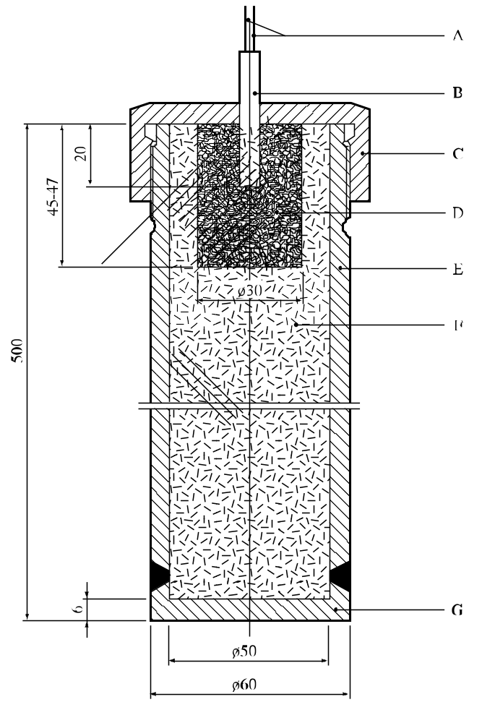

(A) | Detonator wires | (B) | Detonator inserted 20 mm into the booster charge
(C) | Screw cap of malleable cast iron or a plastics cap | (D) | Booster charge of RDX/wax (95/5) with 30 mm diameter and length of approximately 46 mm
(E) | Steel tube 500 mm long with internal diameter 50 mm, external diameter 60 mm | (F) | Sample under investigation
(G) | Welded steel based 6 mm thick
Figure 21.4.1.1: BAM 50/60 steel tube test

21.4.2 Test A.2: TNO 50/70 steel tube test

21.4.2.1 Introduction

This test is used to measure the ability of a substance or mixture to propagate a detonation by subjecting it to a detonating booster charge under confinement in a steel tube. It may be used to answer the question in box 1 of Figure 20.1.

21.4.2.2 Apparatus and materials

21.4.2.2.1 Solids

The apparatus consists of a seamless steel tube (e.g. material St. 35 in accordance with DIN 1629/P3), inner diameter 50 mm, wall thickness 10 mm, and length 1 160 mm (tube type A). At one end (which will be called the bottom), it is closed by welding a 20 mm-thick steel plate to the tube (see Figure 21.4.2.1). The tube is instrumented, e.g. by a continuous wire velocity probe, to measure the velocity of propagation in the substance or mixture. The booster charge consists of four RDX/wax (95/5) booster charges of 50 mm diameter, mass 50 g and length 16.4 mm.

21.4.2.2.2 Liquids

The detonability of liquids is determined with the aid of a tube similar to the tube used for solids but with a length of 750 mm. One end of the tube (called the bottom) is closed by a 0.5 mm metal plate under which the four boosters are positioned (tube type B), see Figure 21.4.2.2. The tube is held upright by means of a holder or three supports welded onto the tube. For corrosive liquids and liquids which decompose on contact with St. 35, a tube of stainless steel 316 (passivated if necessary) is used with a length of 750 mm, an internal diameter of 50 mm and an external diameter of 63 mm (tube type C).

21.4.2.3 Procedure

21.4.2.3.1 Solids

The substance or mixture should be tested at ambient temperature or at the control temperature, if below ambient. After fitting the velocity probe, the solid substance or mixture under investigation is introduced via the open end of the tube while the tube is continuously tapped. After filling up to 60 mm below the upper rim of the tube, the sample mass is determined and the apparent density calculated using the measured internal tube volume. The four booster charges are inserted, the final booster charge provided with a detonator and the charge detonated. Two tests are performed unless detonation of the substance or mixture is observed.

21.4.2.3.2 Liquids

For tests on liquids the booster charge, which is identical to that used for solids, should be positioned under the metal plate after which the tube is completely filled with the liquid and its mass determined. Subsequently, the procedures used for solids and liquids are the same.

21.4.2.4 Test criteria and method of assessing results

21.4.2.4.1 The test results are assessed on the basis of the fragmentation pattern of the tube and, in some cases, on the measured propagation velocity. The test giving the most severe assessment should be used for classification.

21.4.2.4.2 The test criteria are as follows:

"Yes": | The tube is fragmented completely; or
"Yes": | A velocity measurement shows that the rate of propagation in the non-fragmented part of the tube is constant and above the velocity of sound in the substance or mixture.
"Partial": | In all tests, the substance or mixture failed to detonate but the average fragmentation length (average over two tests) is greater than 1.5 times the average fragmentation length found with an inert material with the same physical state.
"No": | In all tests, the substance or mixture failed to detonate and the average fragmentation length (average over two tests) is not more than 1.5 times the average fragmentation length found with an inert material with the same physical state.

21.4.2.5 Examples of results

Substance/Mixture | Tube type | Apparent density  (kg/m³) | Fragmented length  (cm) | Result
tert-Butyl peroxybenzoate | B | – | 20 | Partial
tert-Butyl peroxy-2-ethylhexanoate | B | – | 14 | No
tert-Butyl peroxy isopropyl carbonate | B | – | 17 | Partial
Dibenzoyl peroxide, 75% with water | A | 770 | 30 | Partial
1,1-Di-(tert-butylperoxy)-3,3,5-  trimethylcyclohexane | C | – | 7 | No
Dicyclohexyl peroxydicarbonateª | A | 630 | 33^{b} | Yes
Dicyclohexyl peroxydicarbonate,  with 10% water ª | A | 640 | 33^{c} | Yes
2,5-Diethoxy-4-morpholinobenzene-  diazonium zinc chloride, 90% | A | – | 17 | No
2,5-Diethoxy-4-(phenylsulphonyl)-  benzenediazonium zinc chloride, 67% | A | – | 25 | No
Dilauroyl peroxide | A | 610 | 34 | Partial
3-Methyl-4-(pyrrolidin-1-yl)benzene-  diazonium tetrafluoroborate, 95% | A | – | 19 | No
Di-n-octanoyl peroxide (liquid) | B | – | 10 | No
ª Performed at the control temperature.
^{b} Propagation velocity, 660 m/s, greater than the sound velocity in the substance or mixture.
^{c} Propagation velocity, 690 m/s, greater than the sound velocity in the substance or mixture.

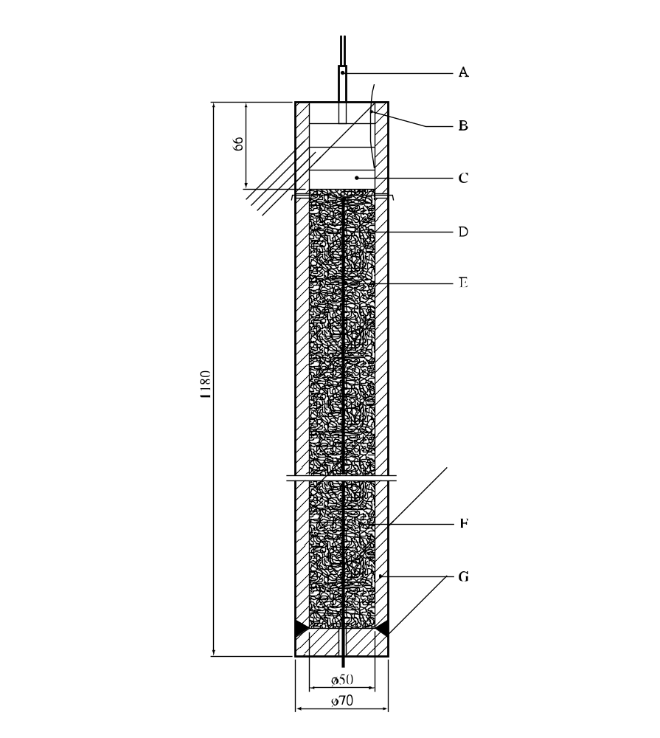

(A) | Detonator | (B) | Ionization probe
(C) | 4 RDX/wax cartridges | (D) | Eye
(E) | Velocity probe | (F) | Substance or mixture under investigation
(G) | Tube, steel
Figure 21.4.2.1: TNO 50/70 steel tube test for solids (tube type A)

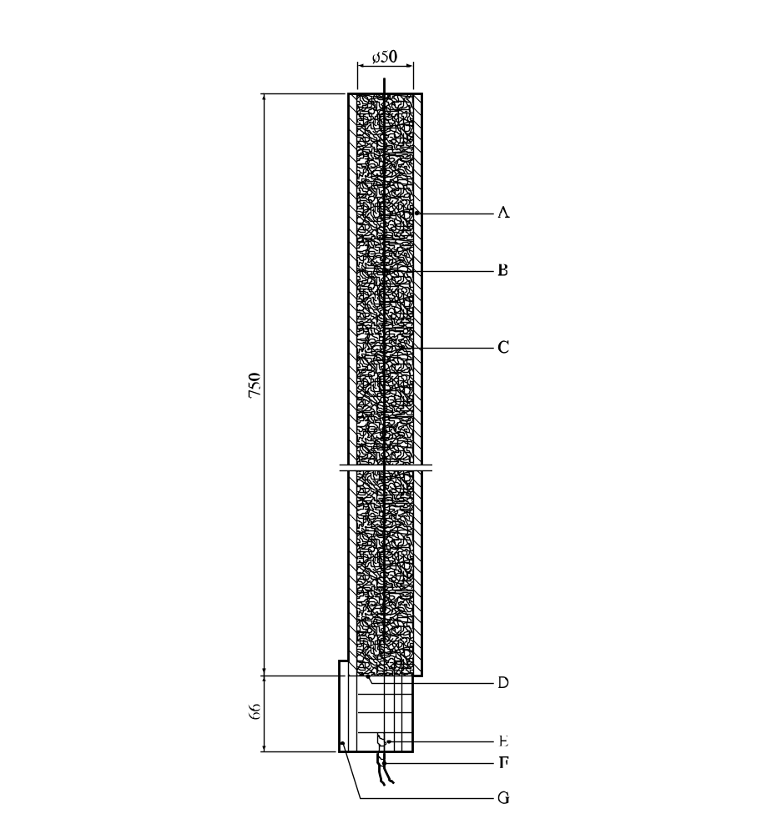

(A) | 63.5 (C) or 70 mm (B) outer diameter steel tube | (B) | Velocity probe
(C) | Substance or mixture under investigation | (D) | Steel disc
(E) | 4 RDX/wax cartridges | (F) | Detonator
(G) | Supports
Figure 21.4.2.2: TNO 50/70 steel tube test for liquids (tube types B and C)

21.4.3 Test A.5: UN gap test

21.4.3.1 Introduction

This test is used to measure the ability of a substance or mixture to propagate a detonation by subjecting it to a detonating booster charge under confinement in a steel tube. It may be used to answer the question in box 1 of Figure 20.1.

21.4.3.2 Apparatus and materials

The apparatus is shown in Figure 21.4.3.1. The test sample is contained in cold-drawn, seamless, carbon steel tube with an external diameter of 48 ± 2 mm, a wall thickness of 4.0 ± 0.1 mm and a length of 400 ± 5 mm. If the test sample may react with the steel, the inside of the tube may be coated with fluorocarbon resin. The bottom of the tube is closed with two layers of 0.08 mm thick polythene sheet pulled tightly (so that it plastically deforms) over the bottom of the tube and held in place with rubber bands and insulating tape. For samples which affect polythene, polytetrafluoroethylene sheet can be used. The booster charge consists of 160 g RDX/wax (95/5) or PETN/TNT (50/50), 50 ± 1 mm in diameter with a density of 1 600 ± 50 kg/m³ giving a length of about 50 mm. The RDX/wax charge may be pressed in one or more pieces, as long as the total charge is within the specifications, and the PETN/TNT charge is cast. A mild steel witness plate, 150 ± 10 mm square and 3.2 ± 0.2 mm thick, is mounted at the upper end of the steel tube and separated from it by spacers 1.6 ± 0.2 mm thick.

21.4.3.3 Procedure

21.4.3.3.1 The sample is loaded to the top of the steel tube. Solid samples are loaded to the density attained by tapping the tube until further settling becomes imperceptible. The sample mass is determined and, if solid, the apparent density calculated using the measured internal volume of the tube. The density should be as close as possible to the shipping density.

21.4.3.3.2 The tube is placed in a vertical position and the booster charge is placed in direct contact with the sheet which seals the bottom of the tube. The detonator is fixed in place against the booster charge and initiated. Two tests should be performed unless detonation of the substance is observed.

21.4.3.4 Test criteria and method of assessing results

21.4.3.4.1 The test results are assessed on the basis of the fragmentation pattern of the tube. The witness plate is used only to provide supplemental information on the violence of the reaction. The test giving the most severe assessment should be used for classification.

21.4.3.4.2 The test criteria are as follows:

"Yes": The tube is fragmented over its entire length.

"Partial": The tube is not fragmented over its entire length but the average tube fragmentation (average over the two tests) is greater than 1.5 times the average fragmentation length found with an inert material with the same physical state.

"No": The tube is not fragmented over its entire length and the average tube fragmentation (average over the two tests) is not more than 1.5 times the average fragmentation length found with an inert material with the same physical state.

21.4.3.5 Examples of results

Substance/Mixture | Apparent density  (kg/m³) | Fragmented length  (cm) | Result
2,2'-Azodi(isobutyronitrile) | 366 | 40 | Yes
tert-Butyl peroxybenzoate |  | 25 | Partial
tert-Butyl peroxy-2-ethylhexanoate |  | 25 | Partial
Dibenzoyl peroxide, 75% with water | 685 | 40 | Yes
2,5-Di-(tert-butylperoxy)-2,5-dimethylhexyne-3 |  | 34 | Partial
Dilauroyl peroxide | 564 | 28 | No

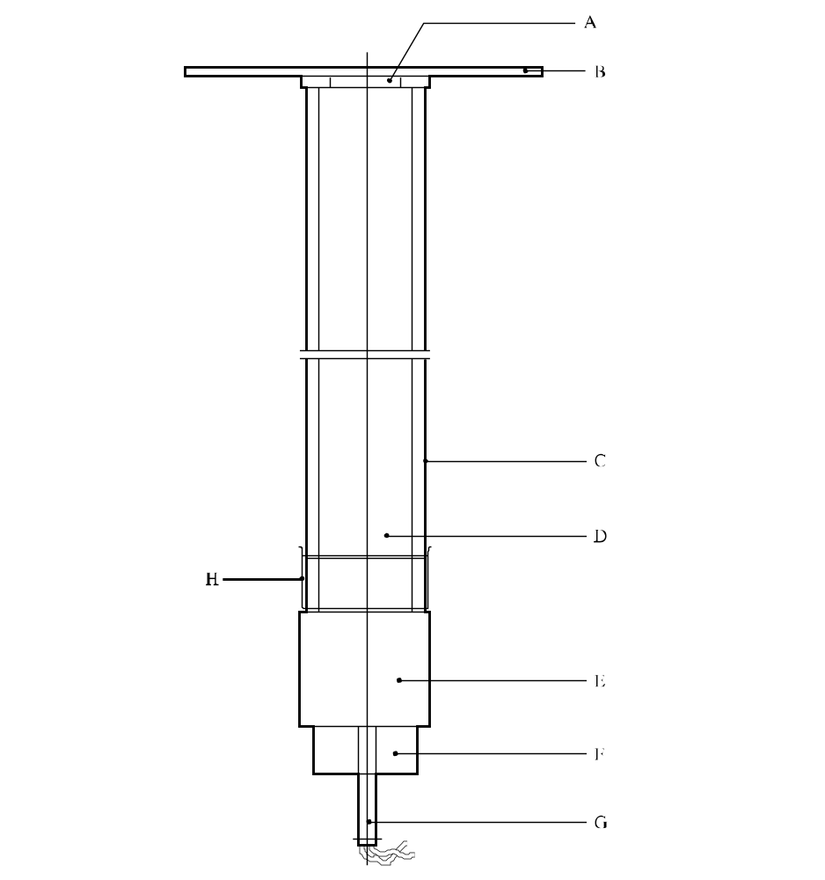

(A) | Spacers | (B) | Witness plate
(C) | Steel tube | (D) | Sample under investigation
(E) | RDX/wax or PETN/TNT booster charge | (F) | Detonator holder
(G) | Detonator | (H) | Plastics membrane
Figure 21.4.3.1: UN gap test

21.4.4 Test A.6: UN detonation test

21.4.4.1 Introduction

This test is used to measure the ability of a substance or mixture to propagate a detonation by subjecting it to a detonating booster charge under confinement in a steel tube. It may be used to answer the question in box 1 of Figure 20.1.

21.4.4.2 Apparatus and materials

The apparatus is shown in Figure 21.4.4.1 and is identical for solids and liquids. The test sample is contained in cold-drawn, seamless, carbon steel tube with an external diameter of 60 ± 1 mm, a wall thickness of 5 ± 1 mm and a length of 500 ± 5 mm. If the test sample may react with the steel, the inside of the tube may be coated with fluorocarbon resin. The bottom of the tube is closed with two layers of 0.08 mm thick polythene sheet held in place with rubber bands and insulating tape. For samples which affect polythene, polytetrafluoroethylene sheet can be used. The booster charge is a 200 g RDX/wax (95/5) or PETN/TNT (50/50), 60 ± 1 mm in diameter and about 45 mm long with a density of 1 600 ± 50 kg/m³. The RDX/wax charge may be pressed in one or more pieces as long as the total charge is within the specifications and the PETN/TNT charge is cast. The tube may be instrumented, e.g. by a continuous wire velocity probe, to measure the velocity of propagation in the substance or mixture. Additional information on the explosive behaviour of the test sample can be gained by the use of a witness plate, as shown in Figure 21.4.4.1. The mild steel witness plate, 150 mm square and 3.2 mm thick, is mounted at the upper end of the tube and separated from it by spacers 1.6 mm thick.

21.4.4.3 Procedure

The sample is loaded to the top of the steel tube. Solid samples are loaded to the density attained by tapping the tube until further settling becomes imperceptible. The sample mass is determined and, if solid, the apparent density calculated. The density should be as close as possible to the shipping density. The tube is placed in a vertical position and the booster charge is placed in direct contact with the sheet which seals the bottom of the tube. The detonator is fixed in place against the booster charge and initiated. Two tests should be performed unless detonation of the substance or mixture is observed.

21.4.4.4 Test criteria and method of assessing results

21.4.4.4.1 The test results are assessed on the basis of:

(a) The type of fragmentation of the tube; and

(b) If the occasion arises, the measured rate of propagation in the substance or mixture.

The test giving the most severe assessment should be used for classification.

21.4.4.4.2 The test criteria are as follows:

"Yes": The tube is fragmented completely.
"Partial": The tube is not fragmented over its entire length but the average tube fragmentation (average over the two tests) is greater than 1.5 times the average fragmentation length found with an inert material with the same physical state.
"No": The tube is not fragmented over its entire length and the average tube fragmentation (average over the two tests) is not more than 1.5 times the average fragmentation length found with an inert material with the same physical state.
21.4.4.5 Examples of results
Substance/Mixture | Apparent density  (kg/m³) | Fragmented length  (cm) | Result
2,2'-Azodi(isobutyronitrile) | 346 | 50 | Yes
tert-Butyl peroxybenzoate |  | 28 | Partial
tert-Butyl peroxy-2-ethylhexanoate |  | 23 | No
Dibenzoyl peroxide, 75% with water | 697 | 22 | No
2,5-Di-(tert-butylperoxy)-2,5-dimethylhexyne-3 | 870 | 30 | Partial
Dilauroyl peroxide | 580 | 32 | Partial

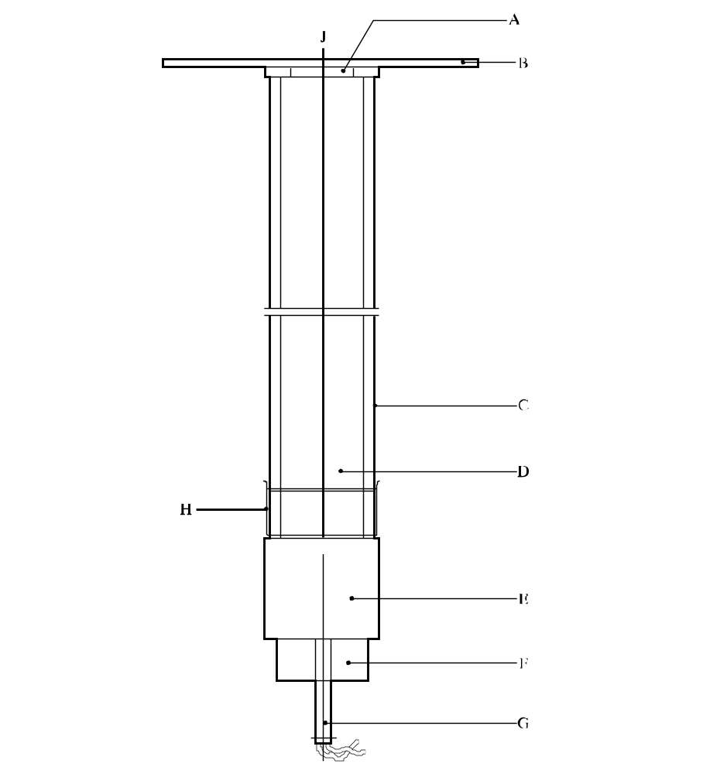

(A) | Spacers | (B) | Witness plate
(C) | Steel tube | (D) | Sample under investigation
(E) | RDX/wax or PETN/TNT booster charge | (F) | Detonator holder
(G) | Detonator | (H) | Plastics sheet
(J) | Velocity probe
Figure 21.4.4.1: UN detonation test

CHAPTER 22
TEST SERIES B

22.1 Introduction

Test series B comprises a test and criteria concerning the propagation of detonation of a substance as packaged. The test is required only for substances or mixtures which propagate detonation (box 1 of Figure 20.1).

22.2 Test methods

The question "Can it detonate as packaged?" (box 2 of Figure 20.1) is answered on the basis of the results of the test method in Table 22.1.

Table 22.1: test method for Test Series B

Test code | Name of test | Section
B.1 | Detonation test in packageª | 22.4.1
ª Recommended test.

22.2.2 The test is required only for substances or mixtures for which the answer to the question in box 1 of Figure 20.1 is "Yes".

22.3 Test conditions

22.3.1 The test from series B should be applied to packages (not larger than 50 kg) of substance or mixture in the condition and form in which they are offered for transport.

22.3.2 The preliminary procedure should be performed before performing these tests (see section 20.3).

22.4 Series B test prescription

22.4.1 Test B.1: Detonation test in package

22.4.1.1 Introduction

This test is used to measure the ability of a substance or mixture to propagate a detonation when packaged. It involves subjecting the substance or mixture in a package to the shock from a detonating booster charge. It is used to answer the question in box 2 of Figure 20.1.

22.4.1.2 Apparatus and materials

A detonator, detonating cord, plastic explosive and suitable confining material are required. A mild steel sheet of about 1 mm thickness, with a minimum size in each direction of 0.2 m larger than that of the bottom dimensions of the package, serves as a witness plate beneath the package.

22.4.1.3 Procedure

The test is applied to packed substances or mixtures in the condition and form in which they are offered for transport. The package is placed on the steel witness plate from which the edges are supported by bricks or other suitable material so that there is sufficient free air space below the witness plate that puncture is not impeded. Two charges of plastic explosive (each maximum 100 g but in total not more than 1% by mass of the substance or mixture in the package) are placed on top of the substance or mixture in the package. For liquids, metal-wire support may be needed to ensure that the two explosive charges are located correctly in the middle of each of the two semicircular or triangular parts of the top surface (see Figure 22.4.1.1). Each charge is initiated by the detonator through a detonating cord. Both pieces of detonating cord should be of equal length. The preferred method of confinement is loose sand placed around the test package with a minimum thickness of 0.5 m in every direction. Alternative methods of confinement are to use boxes, bags or drums filled with earth or sand placed around and on top of the package with the same minimum thickness. The test is performed in duplicate unless a detonation is observed. An instrumented third test may be necessary if no conclusion can be drawn from two uninstrumented tests.

22.4.1.4 Test criteria and method of assessing results

22.4.1.4.1 The test results are assessed on the basis of evidence of a detonation of the substance or mixture under investigation by:

(a) A crater at the test site;

(b) Damage to the witness plate beneath the product;

(c) Disruption and scattering of most of the confining material; and

(d) When appropriate, the measured rate of propagation in the substance or mixture.

22.4.1.4.2 The test criteria are as follows:

"Yes": Formation of a crater at the test site or perforation of the witness plate beneath the product; both in combination with a disruption and scattering of most of the confining material; or the propagation velocity in the lower half of the package is constant and is above the velocity of sound in the substance or mixture.
"No": No formation of a crater at the test site, no perforation of the witness plate beneath the product, a velocity measurement (if made) shows that the rate of propagation is lower than the velocity of sound in the substance or mixture and, for solids, retrieval of unreacted substance or mixture after the test.
22.4.1.5 Examples of results

Substance/Mixture | Apparent density  (kg/m³) | Packaging | Result
Dibenzoyl peroxide | 730 | 1G, 25 kg | Yesª
Dicyclohexyl peroxydicarbonate | 600 | 1G, 5 kg | No^{b}
Dicyclohexyl peroxydicarbonate,  with 10% water | 600 | 1G, 5 kg | No^{b}
ª Tests performed in duplicate. Detection of detonation by formation of crater.
^{b} Tests performed in duplicate. Propagation velocity measured instead of using a witness plate.

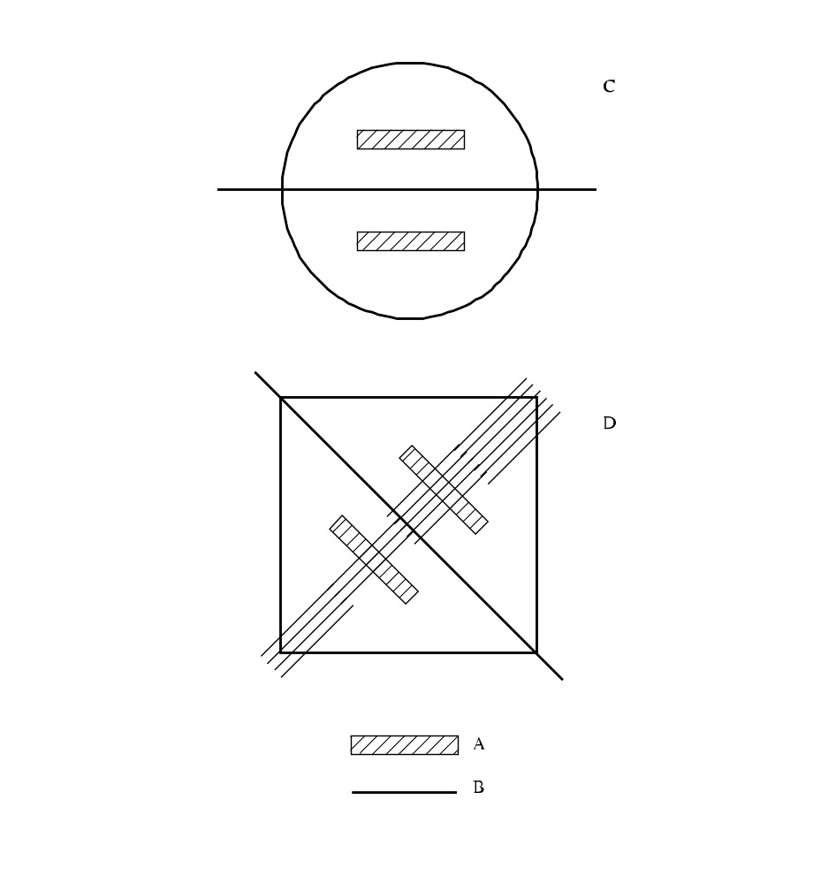

(A) | Explosive charges | (B) | Line of symmetry
(C) | Top view of cylindrical package | (D) | Top view of rectangular package
Figure 22.4.1.1: Detonation test in package

CHAPTER 23
TEST SERIES C

23.1 Introduction

Test series C comprises laboratory tests and criteria concerning propagation of deflagration as requested in boxes 3, 4 and 5 of Figure 20.1.

23.2 Test methods

23.2.1 The question "Does it propagate a deflagration?" (boxes 3, 4 and 5 of Figure 20.1) is answered on the basis of the results of one, or if necessary both, of the test methods in Table 23.1.

Table 23.1: Test methods for test series C
Test code | Name of test | Section
C.1  C.2 | Time/pressure testª  Deflagration testª | 23.4.1  23.4.3
ª Recommended test.

23.2.2 The answer is "Yes, rapidly" if shown to be so by either test. The answer is "Yes, slowly" if the deflagration test result is "Yes, slowly" and the time/pressure test result is not "Yes, rapidly". The answer is "No" if the deflagration test result is "No" and the time/pressure test is not "Yes, rapidly".

23.3 Test conditions

23.3.1 The preliminary procedure (see section 20.3) should be carried out before performing these tests.

23.4 Series C test prescriptions

23.4.1 Test C.1: Time/pressure test

23.4.1.1 Introduction

This test is used to measure the ability of a substance or mixture1 under confinement to propagate a deflagration. It may be used to answer the question in boxes 3, 4 and 5 of Figure 20.1.

23.4.1.2 Apparatus and materials

23.4.1.2.1 The time/pressure apparatus (Figure 23.4.1.1) consists of a cylindrical steel pressure vessel 89 mm in length and 60 mm in external diameter. Two flats are machined on opposite sides (reducing the cross-section of the vessel to 50 mm) to facilitate holding whilst fitting the firing plug and vent plug. The vessel, which has a bore of 20 mm diameter, is internally rebated at either end to a depth of 19 mm and threaded to accept 1" British Standard Pipe (BSP). A pressure take-off, in the form of a side-arm, is screwed into the curved face of the pressure vessel 35 mm from one end and at 90° to the machined flats. The socket for this is bored to a depth of 12 mm and threaded to accept the 1/2" BSP thread on the end of the side-arm. A washer is fitted to ensure a gas-tight seal. The side-arm extends 55 mm beyond the pressure vessel body and has a bore of 6 mm. The end of the side-arm is rebated and threaded to accept a diaphragm type pressure transducer. Any pressure-measuring device may be used provided that it is not affected by the hot gases or decomposition products and is capable of responding to rates of pressure rise of 690 to 2 070 kPa in not more than 5 ms.

23.4.1.2.2 The end of the pressure vessel furthest from the side-arm is closed with a firing plug which is fitted with two electrodes, one insulated from and the other earthed to the plug body. The other end of
the pressure vessel is closed by an aluminium bursting disc 0.2 mm thick (bursting pressure approximately 2 200 kPa) held in place with a retaining plug which has a 20 mm bore. A soft lead washer is used with both plugs to ensure a good seal. A support stand (Figure 23.4.1.2) holds the assembly in the correct attitude during use. This comprises a mild steel base plate measuring 235 mm × 184 mm × 6 mm and a 185 mm length of square hollow section (S.H.S.) 70 × 70 × 4 mm.

23.4.1.2.3 A section is cut from each of two opposite sides at one end of the length of S.H.S. so that a structure having two flat sided legs surmounted by an 86 mm length of intact box section results. The ends of these flat sides are cut at an angle of 60° to the horizontal and welded to the base plate.

23.4.1.2.4 A slot measuring 22 mm wide × 46 mm deep is machined in one side of the upper end of the base section such that when the pressure vessel assembly is lowered, firing plug end first, into the box section support, the side-arm is accommodated in this slot. A packing piece of steel 30 mm wide and 6 mm thick is welded to the lower internal face of the box section to act as a spacer. Two 7 mm thumb screws, tapped into the opposite face, serve to hold the pressure vessel firmly in place. Two 12 mm wide strips of 6 mm thick steel, welded to the side pieces abutting the base of the box section, support the pressure vessel from beneath.

23.4.1.2.5 The ignition system consists of an electric fusehead of the type commonly used in low tension detonators, together with a 13 mm square piece of primed cambric. Fuseheads with equivalent properties may be used. Primed cambric consists of a linen fabric coated on both sides with a potassium nitrate/silicon/sulphurless gunpowder pyrotechnic composition2.

23.4.1.2.6 The procedure for the preparation of the ignition assembly for solids starts with separation of the brass foil contacts of an electric fusehead from its insulator, (see Figure 23.4.1.3). The exposed portion of insulation is then cut off. The fusehead is then fixed onto the terminals of the firing plug by means of the brass contacts such that the tip of the fusehead is 13 mm above the surface of the firing plug. A 13 mm square piece of primed cambric is pierced through the centre and positioned over the attached fusehead around which it is then folded and secured with fine cotton thread.

23.4.1.2.7 For liquids samples, leads are fixed onto the contact foils of the fusehead. The leads are then threaded through an 8 mm length of 5 mm outer diameter and 1 mm inner diameter silicone rubber tubing and the tubing is pushed up over the fusehead contact foils as shown in Figure 23.4.1.4. The primed cambric is then wrapped around the fusehead and a single piece of thin PVC sheathing, or equivalent, is used to cover the primed cambric and the silicone rubber tubing. The sheathing is sealed in position by twisting a length of thin wire tightly round the sheathing and rubber tubing. The leads are then fixed onto the terminals of the firing plug such that the tip of the fusehead is 13 mm above the surface of the firing plug.

23.4.1.3 Procedure

23.4.1.3.1 The apparatus assembled, complete with pressure transducer but without the aluminium bursting disc in position, is supported firing plug end down. 5.0 g3 of the sample is introduced into the apparatus so as to be in contact with the ignition system. Normally no tamping is carried out when filling the apparatus unless it is necessary to use light tamping in order to get the 5.0 g charge into the vessel. If, even with light tamping, it is impossible to get all the 5.0 g of sample in, then the charge is fired after filling the vessel to capacity. Note should be taken of the charge weight used. The lead washer and aluminium bursting disc are placed in position and the retaining plug is screwed in tightly. The charged vessel is transferred to the firing support stand, bursting disc uppermost, which should be contained in a suitable, armoured fume cupboard or firing cell. An exploder dynamo is connected to the external terminals of the firing plug and the charge is fired. The signal produced by the pressure transducer is recorded on a suitable system which allows both evaluation and a permanent record of the time/pressure profile to be achieved (e.g. transient recorder coupled to a chart-recorder).

23.4.1.3.2 The test is carried out three times. The time taken for the pressure to rise from 690 kPa to 2 070 kPa above atmospheric is noted. The shortest time interval should be used for classification.

23.4.1.4 Test criteria and method of assessing results

23.4.1.4.1 The test results are interpreted in terms of whether a gauge pressure of 2 070 kPa is reached and, if so, the time taken for the pressure to rise from 690 kPa to 2 070 kPa gauge.

23.4.1.4.2 The test criteria are as follows:

"Yes, rapidly": The time for a pressure rise from 690 kPa to 2 070 kPa is less than 30 ms.
"Yes, slowly": The time for a pressure rise from 690 kPa to 2 070 kPa is greater than or equal to 30 ms.
"No": A pressure rise to 2 070 kPa above atmospheric is not achieved.

NOTE: If necessary, the deflagration test, Test C.2, should be performed to distinguish between "Yes, slowly" and "No".

23.4.1.5 Examples of results

Substance/Mixture | Maximum pressure  (kPa) | Time for a pressure rise from 690 to 2 070 kPa (ms) | Result
Azodicarbonamide | > 2 070 | 63 | Yes, slowly
Azodicarbonamide, 67% with zinc oxide | > 2 070 | 21 | Yes, rapidly
2,2'-Azodi(isobutyronitrile) | > 2 070 | 68 | Yes, slowly
2,2'-Azodi(2-methylbutyronitrile) | > 2 070 | 384 | Yes, slowly
tert-Butyl hydroperoxide, 70% with water | 1 380 | – | No
tert-Butyl peroxybenzoate | > 2 070 | 2 500 | Yes, slowly
tert-Butyl peroxy-2-ethylhexanoate | > 2 070 | 4 000 | Yes, slowly
Cumyl hydroperoxide, 80% with cumene | < 690ª | – | No
2-Diazo-1-naphthol-5-sulphohydrazide | > 2 070 | 14 | Yes, rapidly
Dibenzoyl peroxide | > 2 070 | 1 | Yes, rapidly
Di-tert-butyl peroxide | > 2 070 | 100 | Yes, slowly
Dicetyl peroxydicarbonate | < 690 | – | No
Dicumyl peroxide | < 690ª | – | No
Dicumyl peroxide, with 60% inert solid | < 690ª | – | No
2,5-Diethoxy-4-morpholinobenzene-  diazonium tetrafluoroborate, 97% | > 2 070 | 308 | Yes, slowly
Dilauroyl peroxide | 990 | – | No
2,5-Dimethyl-2,5-di-(tert-butylperoxy)-  hexyne-3 | > 2 070 | 70 | Yes, slowly
Magnesium monoperoxyphthalate hexahydrate, 85% with magnesium phthalate | 900 | – | No
4-Nitrosophenol | > 2 070 | 498 | Yes, slowly
ª No ignition.

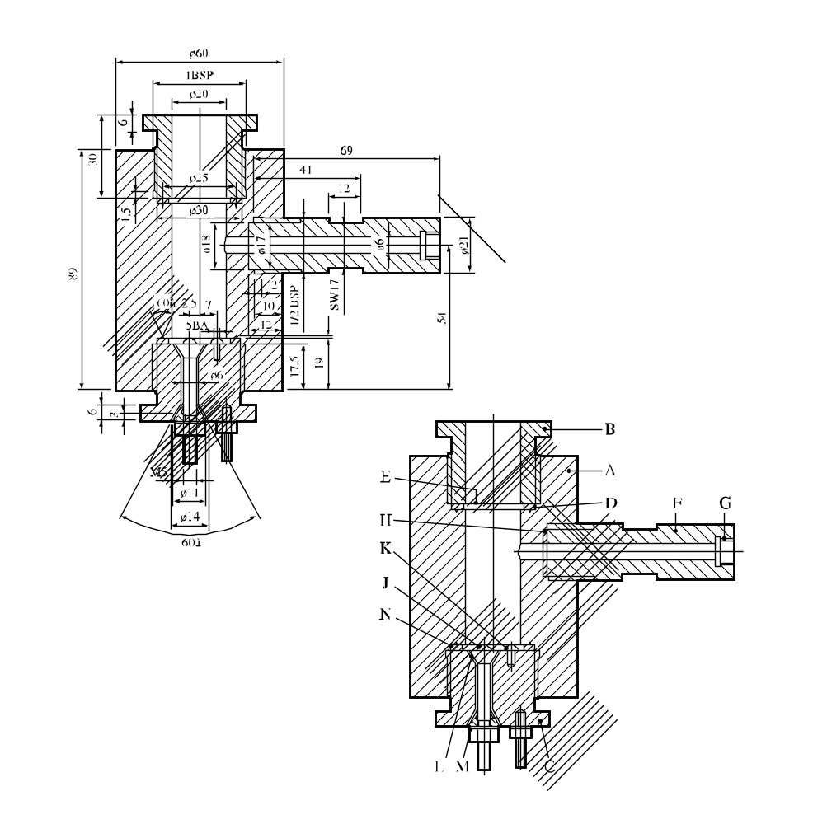
60°
60°
(A) | Pressure vessel body | (B) | Bursting disc retaining plug
(C) | Firing plug | (D) | Soft lead washer
(E) | Bursting disc | (F) | Side arm
(G) | Pressure transducer thread | (H) | Washer
(J) | Insulated electrode | (K) | Earthed electrode
(L) | Tufnol insulation | (M) | Steel cone
(N) | Washer distorting groove
Figure 23.4.1.1: Apparatus

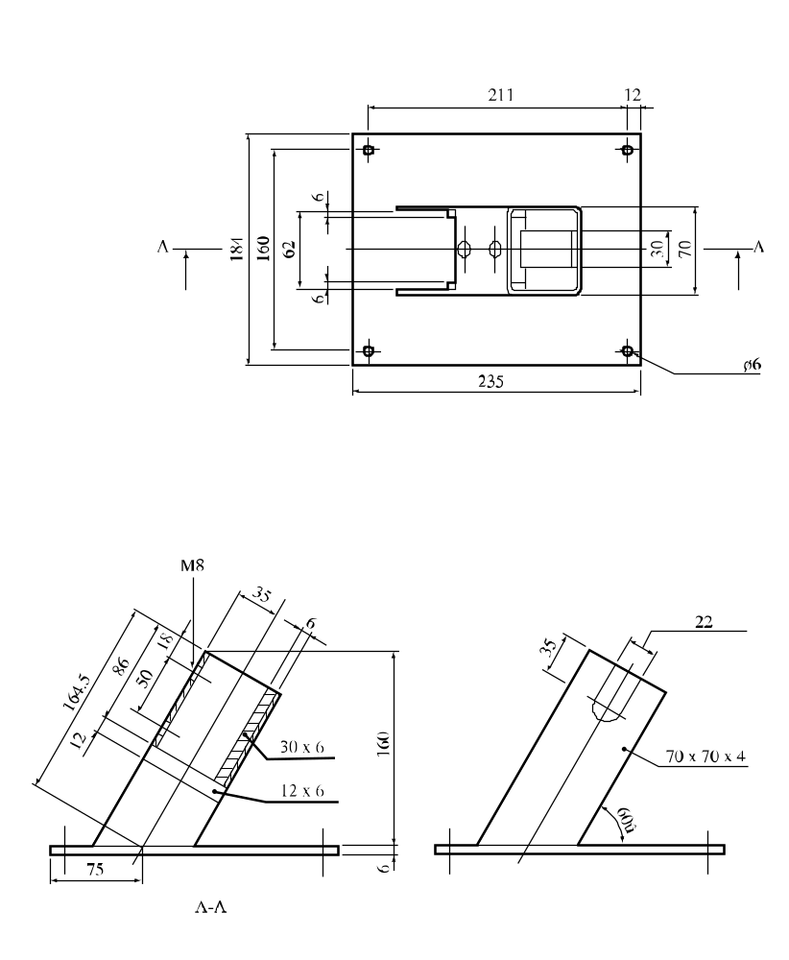
60°

Figure 23.4.1.2: Support stand

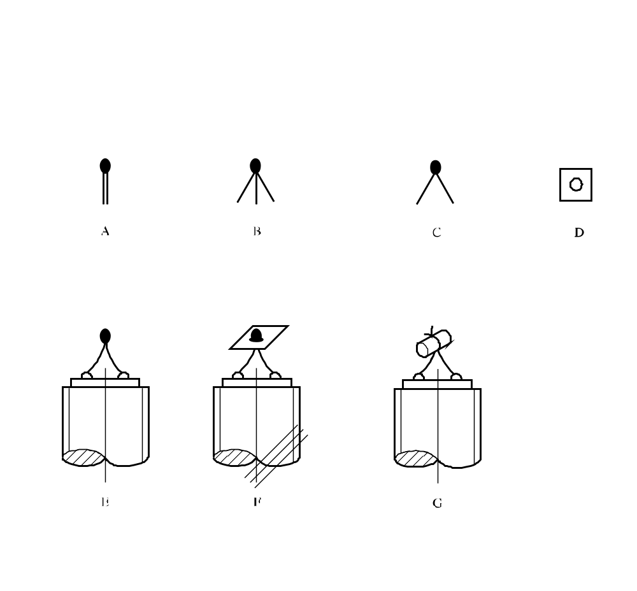

(A) | Electrically ignited fusehead as manufactured | (B) | Brass foil contacts parted from card insulator
(C) | Insulating card cut off | (D) | Primed cambric SR252 13 mm square with centre hole
(E) | Fusehead fixed to pins on firing plug | (F) | Cambric positioned on fusehead
(G) | Cambric folded around and tied with thread
Figure 23.4.1.3: Ignition system for solids

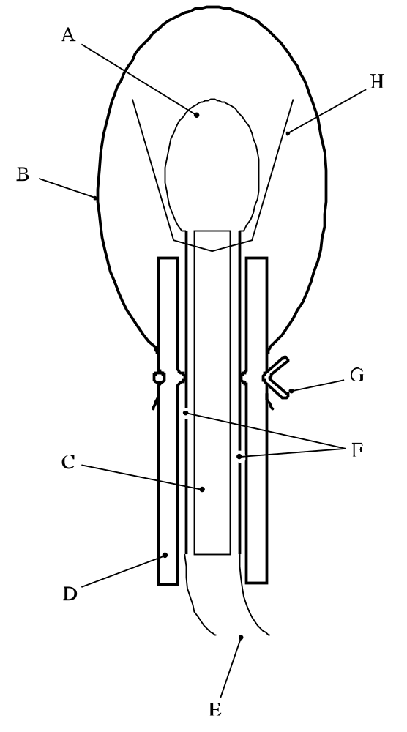

(A) | Fusehead | (B) | PVC sheath
(C) | Insulating card | (D) | Silicone rubber tubing
(E) | Firing leads | (F) | Foil contacts
(G) | Wire to make liquid-tight seal | (H) | Primed cambric
Figure 23.4.1.4: Ignition system for liquids

23.4.2 Test C.2: Deflagration test

23.4.2.1 Introduction

This test is used to measure the ability of a substance or mixture to propagate a deflagration. It may be used to answer the question in boxes 3, 4 and 5 of Figure 20.1.

23.4.2.2 Apparatus and materials

23.4.2.2.1 The test is performed with a Dewar vessel (see Figure 23.4.2.1) which is provided with vertical observation windows on opposite sides. A timer with an accuracy of 1 second is used to measure the deflagration rate.

23.4.2.2.2 The Dewar vessel has a volume of about 300 cm³, an internal diameter of 48 ± 1 mm, an external diameter of 60 mm and a length between 180 and 200 mm. The half-time of cooling with 265 cm³ of water in the Dewar vessel, closed by a cork, should be longer than 5 hours. Horizontal graduation marks are drawn at 50 and 100 mm from the top of the Dewar vessel. The time it takes for the decomposition front to propagate from the 50 mm mark to the 100 mm mark yields the deflagration rate. A glass thermometer with an accuracy of 0.1 °C is used to measure the temperature of the test substance or mixture prior to ignition. Alternatively, the deflagration rate and sample temperature may be determined by using two thermocouples at distances of 50 mm and 100 mm from the top of the Dewar vessel.

23.4.2.2.3 Any gas flame with a flame length of at least 20 mm can be used for igniting the substance or mixture.

23.4.2.2.4 For personal protection, the test is performed in an explosion-proof fume-chamber or in a well-ventilated test-cell. The capacity of the exhaust fan shall be large enough to dilute the decomposition products to the extent that no explosive mixtures with air can be obtained. A shield is placed between the observer and the Dewar vessel.

23.4.2.3 Procedure

23.4.2.3.1 If preliminary safety-in-handling tests (e.g. heating in a flame) or a small scale burning test (e.g. the series 3 type (d) test) indicate that a rapid reaction is likely to occur, exploratory tests in borosilicate glass tubes should be performed, with suitable safety precautions, prior to the Dewar vessel test. In this case, it is recommended that the test be performed in a 14 mm diameter tube first and subsequently in a 28 mm diameter tube. If the deflagration rate in any of these exploratory tests exceeds 5 mm/s, the substance or mixture can forthwith be classified as a rapidly deflagrating substance or mixture and the main test, using a Dewar vessel, can be omitted.

23.4.2.3.2 The Dewar vessel and the substance or mixture are brought to the emergency temperature as defined in Chapter 7.1, paragraph 7.1.5.3.1.1 of the Model Regulations. If the substance or mixture is sufficiently stable as to require no emergency temperature, a test temperature of 50 °C is used. The Dewar vessel is filled with 265 cm³ of the substance or mixture. Granular substances or mixtures are filled into the Dewar vessel in such a way that their bulk density will be comparable with that in transport and there are no lumps.

23.4.2.3.3 Pasty materials are introduced into the Dewar vessel in such a way that no air pockets will be present in the sample to be tested. The height of filling should be about 20 mm below the rim of the Dewar vessel. The mass and the temperature of the substance or mixture are recorded. The Dewar vessel is placed in the test-cell or fume-chamber behind a shield, after which the substance or mixture is heated at the top by means of a gas burner. At the moment when ignition is observed or, alternatively, if no ignition occurs within five minutes, the gas burner is removed and extinguished. The period of time that is required for the reaction zone to pass the distance between the two marks is measured with the timer. If the reaction stops before reaching the lower mark, the substance or mixture is considered to be non-deflagrative. The test is performed in duplicate and the shortest time interval is used for the calculation of the deflagration rate. Alternatively, the rate may be determined by locating thermocouples down the centre of the Dewar at distances 50 mm and 100 mm from the top of the Dewar vessel. The thermocouple outputs are monitored continuously. The passage of the reaction front causes a steep increase in output. The time between the increases in output is determined.
23.4.2.4 Test criteria and method of assessing results

23.4.2.4.1 The test results are interpreted in terms of whether a reaction zone will propagate downwards through the substance or mixture and, if so, the rate of propagation. The participation of oxygen from the air in the reaction at the sample surface is negligible after the reaction zone has propagated over a distance of 30 mm. The reaction zone will extinguish if the substance or mixture does not deflagrate under the test conditions. The propagation velocity of the reaction zone (deflagration rate) is a measure of the susceptibility of the substance or mixture to deflagration under atmospheric pressure.

23.4.2.4.2 The test criteria are as follows:

"Yes, rapidly": the deflagration rate is greater than 5.0 mm/s.

"Yes, slowly": the deflagration rate is less than or equal to 5.0 mm/s and greater than or equal to 0.35 mm/s.

"No": the deflagration rate is less than 0.35 mm/s or the reaction stops before reaching the lower mark.

NOTE: The time/pressure test, test C.1, is carried out if "Yes, rapidly" is not obtained.

23.4.2.5 Examples of results

Substance/Mixture | Sample mass (g) | Temperature (°C) | Propagation rate (mm/s) | Result
Azodicarbonamide | 174 | 50 | 0.35 | Yes, slowly
2,2'-Azodi(isobutyronitrile) | 101 | 45 | ª | No
tert-Butyl peroxybenzoate | 276 | 50 | 0.65 | Yes, slowly
tert-Butyl peroxy-2-ethylhexanoate | 237 | 25 | 0.74 | Yes, slowly
tert-Butyl peroxy-3,5,5-trimethylhexanoate,  75% in solvent | 238 | 50 | 0.27 | No
Cumyl hydroperoxide, 80% with cumene | 273 | 50 | 0.12 | No
Dibenzoyl peroxide | 158 | 20 | 100^{b} | Yes, rapidly
Di-tert-butyl peroxide | 212 | 50 | 0.27 | No
Di-(4-tert-butylcyclohexyl)  peroxydicarbonate | 123 | 35 | 4.3 | Yes, slowly
Dicetyl peroxydicarbonate | 159 | 35 | No ignition | Yes, slowly
Dicumyl peroxide | 292 | 50 | No ignition | No
Dicyclohexyl peroxydicarbonate | – | 26 | 26 | Yes, rapidly
Dicyclohexyl peroxydicarbonate, 90%  with water | – | 15 | 13 | Yes, rapidly
Dilauroyl peroxide | 130 | 45 | No ignition | No
Dilauroyl peroxide, 42% stable  dispersion in water | 265 | 45 | No ignition | No
2,5-Dimethyl-2,5-di-(tert-butylperoxy)-  hexyne-3 | 235 | 50 | 2.9 | Yes, slowly
2,5-Dimethyl-2,5-di-(benzoylperoxy)-  hexane | 231 | 50 | 6.9 | Yes, rapidly
4-Nitrosophenol | 130 | 35 | 0.90 | Yes, slowly
ª Pulsating flame followed by extinguishing of flame; no stable propagation under test conditions.
^{b} Performed with an exploratory test using a glass tube with a diameter of 14 mm at 20 °C instead of 50 °C.

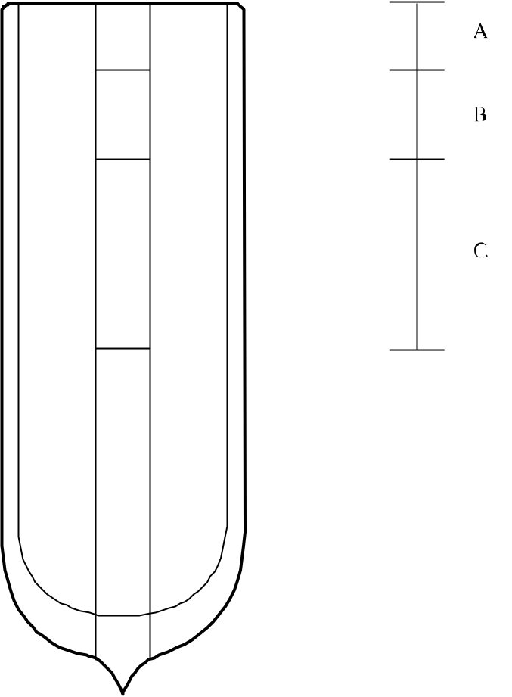

(A) | Height of filling 20 mm below rim | (B) | 30 mm region for deflagration to be established
(C) | 50 mm region for measuring the deflagration rate
Figure 23.4.2.1: DEWAR vessel with observation windows

CHAPTER 24
TEST SERIES D

24.1 Introduction

Test series D comprises a test and criteria concerning the propagation of a rapid deflagration of a substance or mixture as packaged. The test is required for substances or mixtures which deflagrate rapidly in a series C test.

24.2 Test method

24.2.1 The question "Does it deflagrate rapidly in package?" (box 6 of Figure 20.1) is answered on the basis of the results of the test method in Table 24.1.

Table 24.1: Test method for Test Series D

Test code | Name of test | Section
D.1 | Deflagration test in packageª | 24.4.1
ª Recommended test.

24.2.2 The test is only required for substances or mixtures for which the answer from the series C test is "Yes, rapidly".

24.3 Test conditions

24.3.1 The test of series D should be applied to packages (not larger than 50 kg) of substance or mixture in the condition and form in which they are offered for transport.

24.3.2 The preliminary procedure (see section 20.3) should be carried out before performing these tests.

24.4 Series D test prescription

24.4.1 Test D.1: Deflagration test in the package

24.4.1.1 Introduction

This test is used to measure the ability of a substance or mixture to rapidly propagate a deflagration when packaged as for transport. It may be used to answer the question in box 6 of Figure 20.1.

24.4.1.2 Apparatus and materials

An igniter just sufficient to ensure ignition of the substance or mixture (e.g. a squib with maximum 2 g of a slow burning pyrotechnic composition wrapped in thin plastics foil) and suitable confining material are required.

24.4.1.3 Procedure

The test is applied to packaged substances or mixtures in the condition and form in which they are offered for transport. The package is placed on the ground and the igniter is placed in the centre of the substance or mixture. For liquids, a support of metal wires may be needed to fix the igniter in the desired place. The igniter should be protected against the liquid. The test is performed under confinement. The preferred method of confinement is loose sand placed around the test package with a minimum of 0.5 m in every direction. Alternative methods of confinement are to use boxes, bags or drums filled with earth or sand placed around and on top of the package with the same minimum thickness. The test is performed in triplicate, unless an explosion is observed. If no deflagration is observed after ignition, the package should not be approached for at least 30 minutes. It is recommended that a thermocouple be inserted near the igniter to allow monitoring of its operation and to check when it is safe to approach the package.

24.4.1.4 Test criteria and method of assessing results

24.4.1.4.1 The test results are assessed on the basis of the evidence of a rapid deflagration of the substance or mixture under investigation by:

(a) Fragmentation of the packaging; and

(b) Disruption and scattering of most of the confining material.

24.4.1.4.2 The test criteria are as follows:

"Yes" : Fragmentation of inner or outer packaging into more than three pieces (excluding the bottom and top parts of the packaging) shows that the substance or mixture under investigation deflagrated rapidly in that package.
"No" : No fragmentation or a fragmentation of the inner or outer packaging into not more than three pieces (excluding the bottom and top parts of the packaging) shows that the substance or mixture under investigation did not deflagrate rapidly in that package.

24.4.1.5 Examples of results

Substance/Mixture | Packaging | Number of fragments | Result
Dibenzoyl peroxide | 1A2, 25 kg | >40 | Yes
Dibenzoyl peroxide | 4G, 25 kg | >40 | Yes
Dibenzoyl peroxide, 94% with water | 1A2, 25 kg | >40 | Yes
Dibenzoyl peroxide, 75% with water | 4G, 25 kg | No fragmentation | No

CHAPTER 25
TEST SERIES E

25.1 Introduction

25.1.1 Test series E comprises laboratory tests and criteria concerning the determination of the effect of heating under defined confinement as requested in boxes 7, 8, 9 and 13 of Figure 20.1.

25.2 Test methods

25.2.1 The question "What is the effect of heating it under defined confinement?" (boxes 7, 8, 9 and 13 of Figure 20.1) is answered on the basis of combinations of the results from the test methods in Table 25.1.

Table 25.1: Test methods for test series E
Test code | Name of test | Section
E.1  E.2  E.3 | Koenen testª  Dutch pressure vessel test^{b}  USA pressure vessel test | 25.4.1  25.4.2  25.4.3
ª Recommended test for self-reactive substances and mixtures in combination with one of the other tests.
^{b} Recommended test for organic peroxides in combination with one of the other tests.

25.2.2 The combination of the Koenen test and either the Dutch pressure vessel or USA pressure vessel test should be used for self-reactive substances and mixtures. The combination of the Dutch pressure vessel test and either the Koenen test or the USA pressure vessel test should be used for organic peroxides. For classification, the highest hazard rating should be applied.

25.3 Test conditions

25.3.1 The preliminary procedure (see section 20.3) should be carried out before performing these tests.

25.4 Series E test prescriptions

25.4.1 Test E.1: Koenen test

25.4.1.1 Introduction

This test is used to determine the sensitiveness of substances or mixtures to the effect of intense heat under high confinement. It may be used, in conjunction with an additional heating under confinement test, to answer the question in boxes 7, 8, 9 and 13 of Figure 20.1.

25.4.1.2 Apparatus and materials

25.4.1.2.1 The apparatus consists of a non-reusable steel tube, with its re-usable closing device, installed in a heating and protective device. The tube is deep drawn from sheet steel conforming to specification DC04 (EN 10027-1), or equivalent A620 (AISI/SAE/ASTM), or equivalent SPCEN (JIS G 3141). The dimensions are given in Figure 25.4.1.1. The open end of the tube is flanged. The closing plate with an orifice, through which the gases from the decomposition of the test substance or mixture escape, is made from heat-resisting chrome steel and is available with the following diameter holes: 1.0 - 1.5 - 2.0 - 2.5 - 3.0 - 5.0 - 8.0 - 12.0 - 20.0 mm. The dimensions of the threaded collar and the nut (closing device) are given in Figure 25.4.1.1.

For quality control of the steel tubes, 1% of the tubes from each production lot shall be subjected to quality control and the following data shall be verified:

(a) The mass of the tubes shall be 26.5 ± 1.5 g, tubes to be used in one test sequence shall not differ in mass by more than 1 g;

(b) The length of the tubes shall be 75 ± 0.5 mm;

(c) The wall thickness of the tubes measured 20 mm from the bottom of the tube shall be 0.5 ± 0.05 mm; and
(d) The bursting pressure as determined by quasi-static load through an incompressible fluid shall be 30 ± 3 MPa.

25.4.1.2.2 Heating is provided by propane, from an industrial cylinder fitted with pressure regulator, via a flow meter and distributed by a manifold to the four burners. Other fuel gases may be used provided the specified heating rate is obtained. The gas pressure is regulated to give a heating rate of 3.3 ± 0.3 K/s when measured by the calibration procedure. Calibration involves heating a tube (fitted with a 1.5 mm orifice plate) filled with 27 cm³ of dibutyl phthalate. The time taken for the temperature of the liquid (measured with a 1 mm diameter thermocouple centrally placed 43 mm below the rim of the tube) to rise from 135 °C to 285 °C is recorded and the heating rate calculated.

25.4.1.2.3 Because the tube is likely to be destroyed in the test, heating is undertaken in a protective welded box, the construction and dimensions of which are given in Figure 25.4.1.2. The tube is suspended between two rods placed through holes drilled in opposite walls of the box. The arrangement of the burners is given in Figure 25.4.1.2. The burners are lit simultaneously by a pilot flame or an electrical ignition device. The test apparatus is placed in a protected area. Measures should be taken to ensure that the burner flames are not affected by any draughts. Provision should be made for extracting any gases or smoke resulting from the test.

25.4.1.3 Procedure

25.4.1.3.1 Normally substances or mixtures are tested as received although in certain cases it may be necessary to test the substance or mixture after crushing it. For solids, the mass of material to be used in each test is determined using a two-stage dry run procedure. A tared tube is filled with 9 cm³ of substance or mixture and the substance or mixture tamped1 with 80 N force applied to the total cross-section of the tube. If the material is compressible then more is added and tamped until the tube is filled to 55 mm from the top. The total mass used to fill the tube to the 55 mm level is determined and two further increments, each tamped with 80 N force, are added. Material is then either added, with tamping, or taken out as required to leave the tube filled to a level 15 mm from the top.

A second dry run is performed, starting with a tamped increment a third of the total mass found in the first dry run. Two more of these increments are added with 80 N tamping and the level of the substance or mixture in the tube adjusted to 15 mm from the top by addition or subtraction of material as required. The amount of solid determined in the second dry run is used for each trial filling being performed in three equal increments, each compressed to 9 cm³ by whatever force is necessary. (This may be facilitated by the use of spacing rings.) Liquids and gels are loaded into the tube to a height of 60 mm taking particular care with gels to prevent the formation of voids. The threaded collar is slipped onto the tube from below, the appropriate orifice plate is inserted and the nut tightened by hand after applying some molybdenum disulphide based lubricant. It is essential to check that none of the substance is trapped between the flange and the plate, or in the threads.

25.4.1.3.2 With orifice plates from 1.0 mm to 8.0 mm diameter, nuts with an orifice of 10.0 mm diameter should be used; if the diameter of the orifice is above 8.0 mm, that of the nut should be 20.0 mm. Each tube is used for one trial only. The orifice plates, threaded collars and nuts may be used again provided they are undamaged.

25.4.1.3.3 The tube is placed in a rigidly mounted vice and the nut tightened with a spanner. The tube is then suspended between the two rods in the protective box. The test area is vacated, the gas supply turned on and the burners lit. The time to reaction and duration of reaction can provide additional information useful in interpreting the results. If rupture of the tube does not occur, heating is continued for at least five minutes before the trial is finished. After each trial the fragments of the tube, if any, should be collected and weighed.

25.4.1.3.4 The following effects are differentiated:

"O": Tube unchanged;
"A": Bottom of tube bulged out;
"B": Bottom and wall of the tube bulged out;
"C": Bottom of tube split;
"D": Wall of tube split;
"E": Tube split into two2 fragments;
"F": Tube fragmented into threeError: Reference source not found or more mainly large pieces which in some cases may be connected with each other by a narrow strip;
"G": Tube fragmented into many mainly small pieces, closing device undamaged; and
"H": Tube fragmented into many very small pieces, closing device bulged out or fragmented.

Examples for the effect types "D", "E" and "F" are shown in Figure 25.4.1.3. If a trial results in any of the effects "O" to "E", the result is regarded as "no explosion". If a trial gives the effect "F", "G" or "H", the result is evaluated as "explosion".

25.4.1.3.5 The series of trails is started with a single trial using an orifice plate of 20.0 mm. If, in this trial, the result "explosion" is observed, the series is continued with trials using tubes without orifice plates and nuts but with threaded collars (orifice 24.0 mm). If at 20.0 mm "no explosion" occurs, the series is continued with single trials using plates with the following orifices 12.0 - 8.0 - 5.0 - 3.0 - 2.0 - 1.5 and finally 1.0 mm until, at one of these diameters, the result "explosion" is obtained. Subsequently, trials are carried out at increasing diameters, according to the sequence given in 25.4.1.2.1, until only negative results in three tests are obtained at the same level. The limiting diameter of a substance or mixture is the largest diameter of the orifice at which the result "explosion" is obtained. If no "explosion" is obtained with a diameter of 1.0 mm, the limiting diameter is recorded as being less than 1.0 mm.

25.4.1.4 Test criteria and method of assessing results

25.4.1.4.1 The test criteria are as follows:

"Violent": The limiting diameter is greater than or equal to 2.0 mm.

"Medium": The limiting diameter is equal to 1.5 mm.

"Low": The limiting diameter is equal to or less than 1.0 mm and the effect in any test is different from type "O".

"No": The limiting diameter is less than 1.0 mm and the effect in all tests is of type "O".

25.4.1.5 Examples of results

Substance/Mixture | Sample mass (g) | Limiting diameter (mm) | Type of fragmentationª | Result
Azodicarbonamide | 20.0 | 1.5 | "F" | Medium
Azodicarbonamide, 67% with zinc oxide | 24.0 | 1.5 | "F" | Medium
2,2'-Azodi(2,4-dimethylvaleronitrile) | 17.5 | < 1.0 | "O" | No
2,2'-Azodi(isobutyronitrile) | 15.0 | 3.0 | "F" | Violent
Benzene-1,3-disulphohydrazide |  | 12.0 | "F" | Violent
Benzene-1,3-disulphohydrazide,  70% with mineral oil |  | 2.0 | "F" | Violent
Benzene sulphohydrazide | 18.5 | 1.0 | "F" | Low
tert-Butyl peroxybenzoate | 26.0 | 3.5 | "F" | Violent
tert-Butyl peroxy-2-ethylhexanoate | 24.2 | 2.0 | "F" | Violent
Cumyl hydroperoxide, 84.1% in cumene | 27.5 | 1.0 | "F" | Low
2-Diazo-1-naphthol-5-sulphochloride | 19.0 | 2.5 | "F" | Violent
Dibenzoyl peroxide | 17.5 | 10.0 | "F" | Violent
Dibenzoyl peroxide, 75% with water | 20.0 | 2.5 | "F" | Violent
Di-tert-butyl peroxide | 21.5 | <1.0 | "O" | No
Dicetyl peroxydicarbonate | 16.0 | <1.0 | "O" | No
2,4-Dichlorobenzoyl peroxide | 21.0 | 6.0^{b} | "F" | Violent
Dicumyl peroxide | 18.0 | <1.0 | "O" | No
Diisopropyl peroxydicarbonate | 21.0 | 8.0 | "F" | Violent
Dilauroyl peroxide | 14.0 | <1.0 | "O" | No
2,5-Dimethyl-2,5-di(tert-butylperoxy)-hexane | 23.0 | 1.5 | "F" | Medium
Dimyristyl peroxydicarbonate | 16.0 | <1.0 | "O" | No
N,N'-Dinitroso-N,N'-dimethyl-  terephthalamide 70%, with mineral oil | 18.0 | 4.0 | "F" | Violent
Diperoxy isophthalic acid | 18.0 | 24.0 | "H" | Violent
Disuccinic acid peroxide | 18.0 | 6.0 | "F" | Violent
4-Nitrosophenol | 17.0 | <1.0 | "A" | Low
ª At the limiting diameter.
^{b} With a sample mass of 13 g the limiting diameter is < 1.0 mm

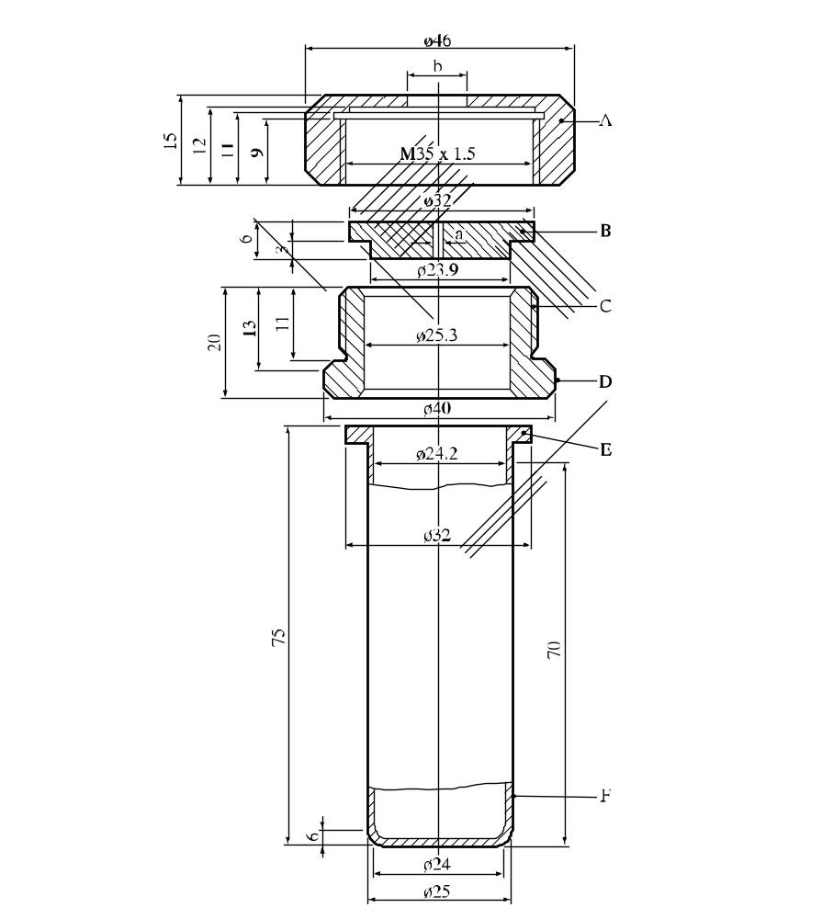

(A) | Nut (b = 10.0 or 20.0 mm) with flats for size 41 spanner | (B) | Orifice plate (a = 1.0 to 20.0 mm diameter)
(C) | Threaded collar | (D) | Flats for size 36 spanner
(E) | Flange | (F) | Tube
Figure 25.4.1.1: Test tube assembly

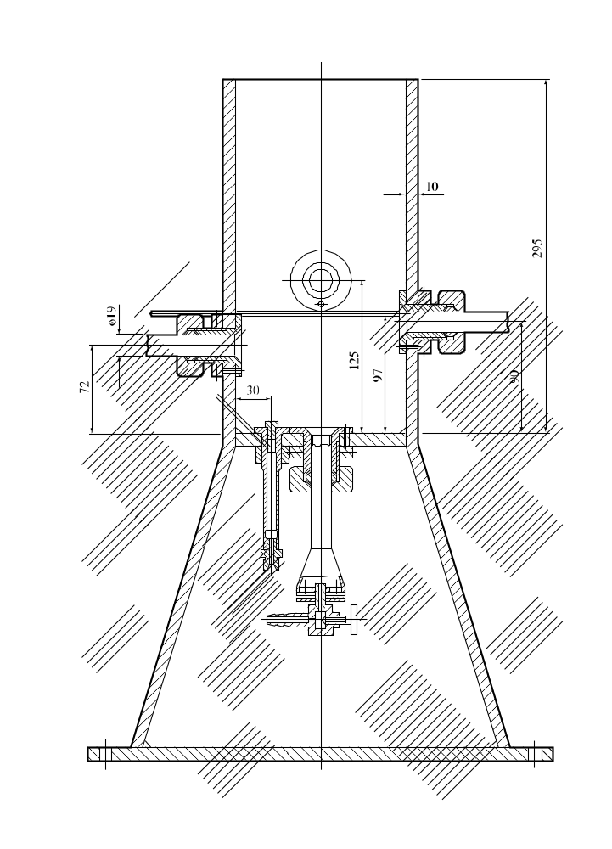

Figure 25.4.1.2: Heating and protective device

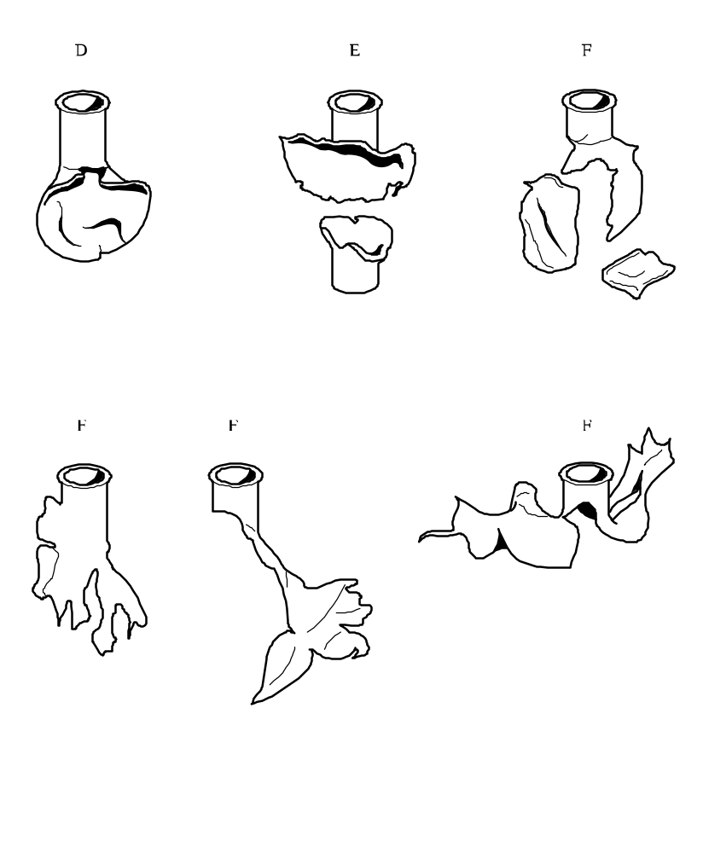

Figure 25.4.1.3: Examples of effect types “D”, “E” and “F”

25.4.2 Test E.2: Dutch pressure vessel test

25.4.2.1 Introduction

This test is used to determine the sensitiveness of substances or mixtures to the effect of intense heat under defined confinement. It may be used, in conjunction with an additional heating under confinement test, to answer the question in boxes 7, 8, 9 and 13 of Figure 20.1.

25.4.2.2 Apparatus and materials

25.4.2.2.1 Description of the pressure vessel

Figure 25.4.2.1 shows the apparatus used. The vessel is made of stainless steel, type AISI 316. 8 aperture discs are used, the diameters of the orifices being: 1.0 - 2.0 - 3.5 - 6.0 - 9.0 - 12.0 - 16.0 and 24.0 mm. These discs have a thickness of 2.0 mm ± 0.2 mm. The bursting discs are 38 mm diameter aluminium discs rated to burst at 620 ± 60 kPa at 22 °C (see Figure 25.4.2.2).

25.4.2.2.2 Heating device

The pressure vessel is heated by technical-grade butane taken from a cylinder fitted with a pressure regulator. A Teclu burner is used. Other gases may be used, with a suitable burner, provided that a heating rate of 3.5 ± 0.3 K/s is obtained. The heating rate should be checked by heating 10 g of dibutyl phthalate in the pressure vessel and measuring its temperature. The time taken for the temperature of the oil to rise from 50 °C to 200 °C is recorded and the heating rate calculated.

25.4.2.3 Procedure

25.4.2.3.1 For a normal test, 10.0 g of the substance or mixture should be placed in the vessel. The bottom of the vessel should be evenly covered with the substance or mixture. The 16.0 mm orifice plate is used first. The bursting disc, central orifice plate and retaining ring are then put in place. The wing nuts are tightened by hand and the box nut with a spanner. The bursting disc is covered by enough water to keep it at a low temperature. The pressure vessel is placed on a tripod (with an inside ring diameter of 67 mm) which is inside a protective cylinder. The ring at the middle of the vessel rests on the tripod.

25.4.2.3.2 The burner is lit, the flow of gas is set to the required rate and the flow of air adjusted so that the colour of the flame is blue and the inner cone of the flame light blue. The tripod should be of such a height that the inner cone just touches the bottom of the vessel. The burner is then placed under the vessel through an opening in the protective casing. The test area should be very well ventilated and entry prohibited during the test. The vessel is observed from outside the test area either by mirrors or by an aperture in the wall fitted with armoured glass. The time to reaction and duration of reaction can provide additional information useful in interpreting the results. Finally the receptacle is cooled in water and cleaned.

25.4.2.3.3 If there is no rupture of the disc with a 16.0 mm orifice, experiments are performed in sequence with the diameters 6.0, 2.0 and 1.0 mm (one experiment at each diameter) until rupture of the disc occurs. In cases where no disc rupture is observed with an orifice of 1.0 mm, the next test with an orifice of 1.0 mm is carried out with 50.0 g of the substance instead of 10.0 g. If still no rupture of the disc is observed the experiment is repeated until three successive experiments without rupture are obtained. In the event of rupture of the disc, the experiments are repeated at the next higher level (10 g instead of 50 g or next higher diameter of the orifice) until the level is found at which there are no ruptures in three successive experiments.

25.4.2.4 Test criteria and method of assessing results

25.4.2.4.1 The relative degree of sensitivity of a substance or mixture to heating in a pressure vessel is expressed by the limiting diameter. This being the orifice with the largest diameter in millimetres with which, in three tests, the bursting disc is broken at least once, while having remained unbroken during three tests with the next larger diameter.

25.4.2.4.2 The test criteria are as follows:

"Violent": Rupture of the disc with an orifice of 9.0 mm or greater and a sample mass of 10.0 g.

"Medium": No rupture of the disc with an orifice of 9.0 mm but rupture of the disc with an orifice of 3.5 mm or 6.0 mm and a sample mass of 10.0 g.

"Low": No rupture of the disc with an orifice of 3.5 mm and a sample mass of 10.0 g but rupture of the disc with an orifice of 1.0 mm or 2.0 mm and a sample mass of 10.0 g or rupture of the disc with an orifice of 1.0 mm and a sample mass of 50.0 g.

"No": No rupture of the disc with an orifice of 1.0 mm and a sample mass of 50.0 g.

25.4.2.5 Examples of results

Substance/Mixture | Limiting diameter (mm) | Result
Azodicarbonamide | 1.5 | Low
2,2'-Azodi-(2,4-dimethylvaleronitrile) | 6.0 | Medium
2,2'-Azodi(isobutyronitrile) | 5.5 | Medium
2,2'-Azodi(2-methylbutyronitrile) | 6.0 | Medium
tert-Butyl peroxybenzoate | 9.0 | Violent
tert-Butyl peroxy-2-ethylhexanoate | 6.0 | Medium
Cumyl hydroperoxide, 80% with cumene | 1.0 | Low
Dibenzoyl peroxide, 75% with water | 6.0 | Medium
Di-tert-butyl peroxide | 3.5 | Medium
Dicetyl peroxydicarbonate | 1.0 | Low
Dicumyl peroxide | 3.5 | Medium
2,5-Diethoxy-4-morpholinobenzenediazonium  zinc chloride, 90% | < 1.0ª | No
2,5-Diethoxy-4-morpholinobenzenediazonium  tetrafluoroborate, 97% | < 1.0 | No
2,5-Diethoxy-4-(phenylsulphonyl)-benzenediazonium  zinc chloride, 67% | < 1.0ª | No
Dilauroyl peroxide | 2.0 | Low
Dilauroyl peroxide, 42%, stable dispersion in water | < 1.0ª | No
3-Methyl-4-(pyrrolidin-1-yl)benzene-  diazonium tetrafluoroborate, 95% | < 1.0ª | No
4-Nitrosophenol | 1.0ª | Low
ª Test carried out with a 50 g sample.

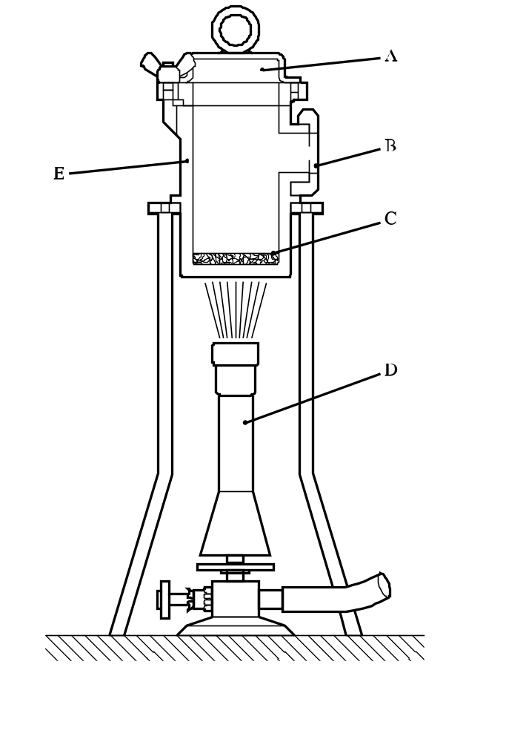

(A) | Bursting disc | (B) | Orifice plate
(C) | Test sample (10 g or 50 g) | (D) | Teclu burner
(E) | Pressure vessel with an internal diameter of 50 mm and internal height of 94.5 mm
Figure 25.4.2.1: Dutch pressure vessel test

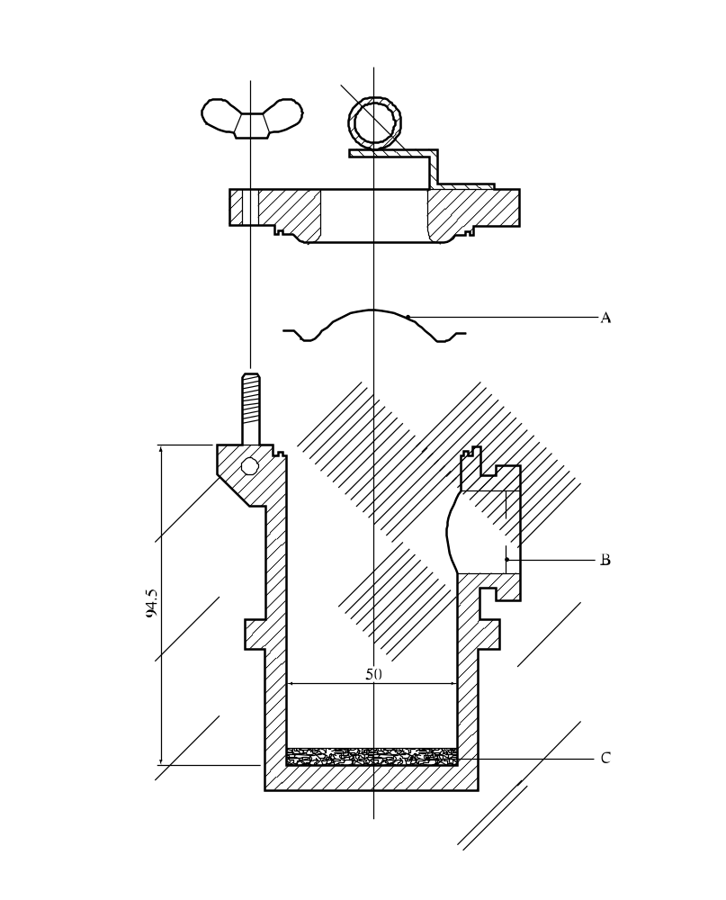
(A) | Bursting disc | (B) | Orifice plate
(C) | Test sample
Figure 25.4.2.2: Bursting disc assembly

25.4.3 Test E.3: United States pressure vessel test

25.4.3.1 Introduction

This test is used to determine the sensitiveness of substances or mixtures to the effect of intense heat under defined confinement. It may be used, in conjunction with an additional heating under confinement test, to answer the question in boxes 7, 8, 9 and 13 of Figure 20.1.

25.4.3.2 Apparatus and materials

The following apparatus and materials are used:

(a) Test-vessel: 316 stainless steel cylindrical pressure vessel (see Figure 25.4.3.1);

(b) Pressure vessel holder (see Figure 25.4.3.2);

(c) Electrical heater (e.g. 700 W);

(d) Sample holder: aluminium cup 28 mm × 30 mm;

(e) Rupture discs: 38 mm aluminium rupture discs rated 620 ± 50 kPa at 22 °C;

(f) 2 mm thick orifice plates with the following orifice diameters (mm): 1.0, 1.2, 2.0, 3.0, 3.5, 5.0, 6.0, 8.0, 9.0, 12.0, 16.0 and 24.0.

25.4.3.3 Procedure

25.4.3.3.1 The general assembly of the apparatus is shown in Figure 25.4.3.1. The heating rate should be checked by heating 5.0 g of dibutyl phthalate in a sample cup in the pressure vessel and measuring the temperature of the dibutyl phthalate. The time taken for the temperature of the dibutyl phthalate to rise from 50 °C to 200 °C is recorded and the heating rate calculated. The heating rate should be 0.5 ± 0.1 K/s. An orifice plate, with an orifice diameter larger than the expected vent needed to cause rupture, is selected and inserted into the side port.

25.4.3.3.2 A 5.0 g sample of the substance or mixture to be tested is weighed accurately into an aluminium cup. The cup is than lowered and positioned with the aid of forceps in the centre of the pressure vessel. The rupture disc is positioned and secured tightly by the flange bolts. Water is poured over the rupture disc to keep the disc relatively cool. The heating is switched on to the correct setting at least 30 minutes prior to the start of the test. The test-vessel is inserted into the pressure vessel holder onto the heater. This plate holder prevents the test-vessel from falling over. It also prevents escaping vent vapours from reaching the hot plate. The time to decomposition is noted.

25.4.3.3.3 If the disc does not rupture, the experiment is repeated using a smaller orifice diameter until rupture of the disc occurs. In the event of a rupture of the disc, the experiment is repeated at the next higher diameter of the orifice until the level is found at which there are no ruptures in three successive experiments.

25.4.3.4 Test criteria and method of assessing results

25.4.3.4.1 The smallest orifice diameter which does not cause a rupture disc to burst during decomposition is designated as the USA-PVT number. This value is used as a measure of the effects of heating a substance or mixture under defined confinement. USA-PVT ratings for all substances and mixtures are based on the same test conditions and heating rate.

25.4.3.4.2 The effect of heating under confinement of the substance or mixture is defined by the following criteria:

"Violent": Substances and mixtures having USA-PVT numbers 9.0 to 24.0.
"Medium": Substances and mixtures having USA-PVT numbers 3.5 to 8.0.
"Low": Substances and mixtures having USA-PVT numbers 1.2 to 3.0.
"No": Substances and mixtures having USA-PVT number 1.0.

25.4.3.5 Examples of results

Substance/Mixture | USA-PVT No | Result
tert-Butyl hydroperoxide, 70% with water | 1.0 | No
tert-Butyl peroxy acetate, 75% in solution | 8.0 | Medium
tert-Butyl peroxybenzoate | 8.0 | Medium
tert-Butyl peroxy isopropyl carbonate, 75% in solution | 2.0 | Low
tert-Butyl peroxypivalate, 75% in solution | 4.5ª | Medium
Cumyl hydroperoxide, 85% with cumene | 1.0 | No
Dibenzoyl peroxide | 18.0ª | Violent
Di-tert-butyl peroxide | 1.0 | No
Dicumyl peroxide | 2.0 | Low
Dicumyl peroxide, with 60% inert solid | 1.0 | No
Dilauroyl peroxide | 6.0 | Medium
2,5-Dimethyl-2,5-di-(tert-butylperoxy) hexyne-3 | 9.0 | Violent
ª Intermediate diameters, no longer used.

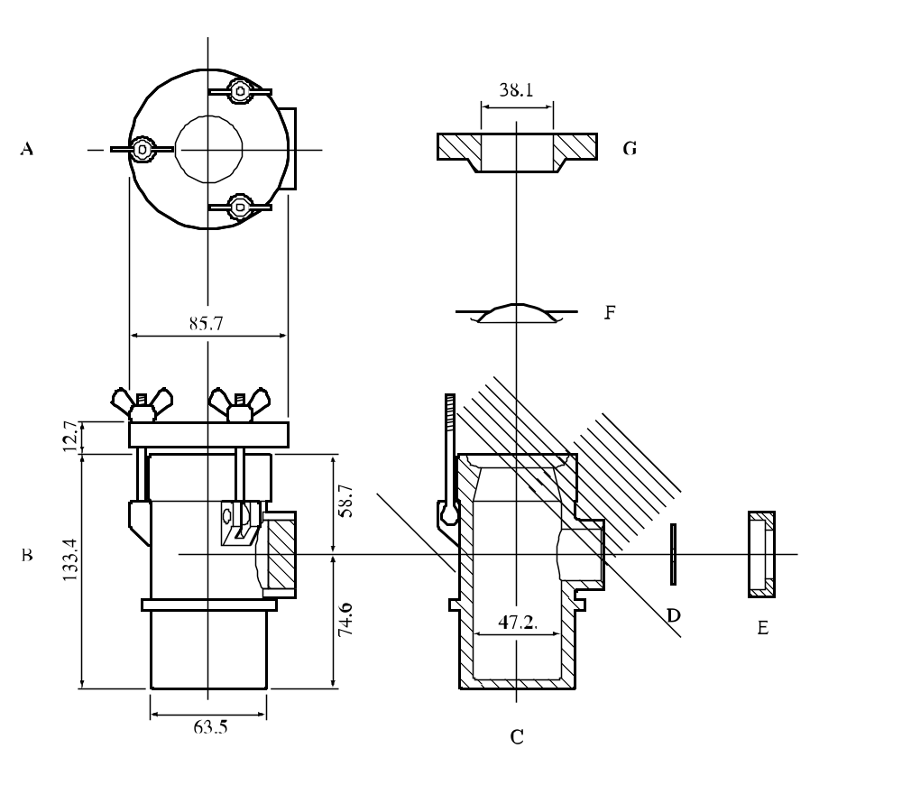

(A) | Top view of lid | (B) | Side view of assembly
(C) | Body of pressure vessel | (D) | Orifice plate
(E) | Orifice plate retaining nut | (F) | Bursting disc
(G) | Cap
Figure 25.4.3.1: UNITED STATES pressure vessel test

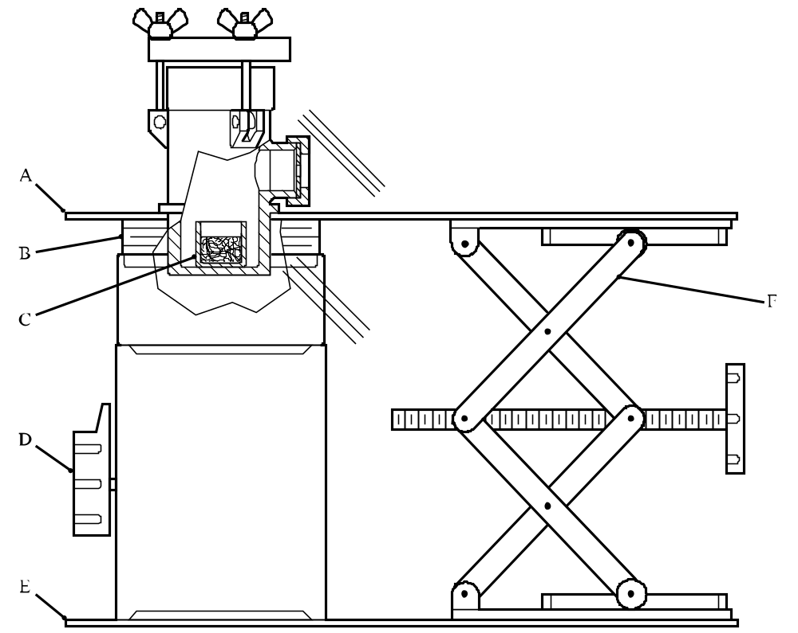

(A) | Shield | (B) | Thermal insulation
(C) | Sample cup | (D) | Electrical heater
(E) | Base | (F) | Laboratory jack
Figure 25.4.3.2: Test apparatus and stand (side view)

CHAPTER 26
TEST SERIES F

26.1 Introduction

26.1.1 Test series F comprises laboratory tests and criteria concerning the explosive power of substances and mixtures as requested in box 12 of Figure 20.1. It is applicable to those substances and mixtures which are being considered for transport in Intermediate Bulk Containers (IBCs) or tank-containers or for exemption from the provisions for self-reactive substances or mixtures (transport Division 4.1) or organic peroxides (transport Division 5.2) (see box 11 of Figure 20.1). Substances and mixtures not being considered for these may be assigned to type E without further testing.

26.1.2 All the tests, except test F.5, may also be used for those substances or mixtures which are being screened for their ability to propagate detonation (see 21.2.2).

26.2 Test methods

The question "What is its explosive power?" (box 12 of Figure 20.1) is answered on the basis of the results of one of the test methods in Table 26.1.

Table 26.1: Test methods for test series F
Test code | Name of test | Section
F.1 | Ballistic mortar Mk.IIId test | 26.4.1
F.2 | Ballistic mortar test | 26.4.2
F.3 | BAM Trauzl test | 26.4.3
F.4 | Modified Trauzl testª | 26.4.4
F.5 | High-pressure autoclave | 26.4.5
ª Recommended test.

26.3 Test conditions

26.3.1 The preliminary procedure (see section 20.3) should be performed before carrying out these tests.

26.3.2 The results obtained in tests F.1 to F.4 depend on the sensitivity to detonative shock of the substance or mixture and the strength of the detonator used. If the results are much lower than those obtained with similar substances or mixtures, a more powerful initiation system may be used with a suitable adjustment (e.g. by firing with inert samples) to the test criteria.

26.3.3 The tests should be performed at ambient temperature. However, if the control temperature is below ambient temperature, adequate safety precautions should be taken. If the substance or mixture is transported under temperature control as a solid but is liquid at ambient temperature then the test should be performed just below the melting point.

26.4 Series F test prescriptions

26.4.1 Test F.1: Ballistic mortar Mk.IIId test

26.4.1.1 Introduction

This test is used to measure the explosive power of a substance or mixture. A detonator is initiated in the substance or mixture whilst the substance or mixture is confined in the bore of a mortar. The recoil (swing) of the mortar is measured and, after allowing for the effect of the detonator, the power is calculated as a percentage equivalence of picric acid - the explosive standard. The test may be used to answer the question in box 12 of Figure 20.1.

26.4.1.2 Apparatus and materials

26.4.1.2.1 The mortar consists of a steel tube 457 mm long by 203 mm external diameter, closed at one end and having a bore 229 mm long with an internal diameter of 25 mm, flaring out at the open end. The mortar is suspended by 4 stainless steel cables attached at either end by bottle screws and pivots, thus allowing it to swing freely. The total weight is approximately 113.2 kg and the suspension length is 2,080 mm. A pen, secured at the extremity of a hinged trailing arm attached to the mortar, scribes on a horizontal table a line equal to the horizontal swing of the mortar. The mortar body is made in two pieces, an outer casing of mild steel and an inner cylinder of Vibrac V30 steel heat-treated to a proof stress of 772 MPa. This cylinder is held in place by a retaining annular plate (Figure 26.4.1.1).

26.4.1.2.2 The sand used for stemming is clean, dry, quartz sand sieved to pass a BS 600 micron sieve and to be retained on a BS 250 micron sieve. The picric acid is in the form of pure, dry crystals sieved in the same manner. Boric Acid (analytical grade) is sieved to pass a BS 500 micron sieve. Charge bags are cylindrical, 25 mm in diameter and made of thin paper. The inner charge bag is 90 mm long and the outer charge bag 200 mm long.

26.4.1.2.3 The detonator used is a flat-based aluminium sheathed detonator containing 0.6 g PETN.

26.4.1.3 Procedure

26.4.1.3.1 Impact, friction and electric spark tests are normally carried out on the substance or mixture before it is tested in the mortar. 10.00 ± 0.01 g of the substance or mixture is tamped into the inner charge bag. The detonator is inserted into a 6 mm cavity made in the substance or mixture with a phosphor-bronze rod and the neck of the bag is twisted around the detonator. The charge is then inserted in the outer bag and pressed down to the bottom with a special tool. 57 g of sieved sand is poured into the outer bag and gently compacted by tapping. The neck of the outer bag is twisted around the detonator wires and the whole charge is inserted into the bore of the mortar and rammed with the special tool. The detonator is fired and the total horizontal swing (S) is measured. The test is performed three times and the average swing (S_{m}) for the substance calculated.

26.4.1.3.2 Liquids are tested by using a cylindrical glass vessel¹ of approximately 16 ml volume instead of the paper charge bag. The open end of the vessel is reduced to a narrow tube 8 mm in diameter and 8 mm in length. The standard detonator sheathed in a suitable length of polythene tubing makes a push fit seal in the neck of the vessel. The vessel is then inserted into the outer charge bag, as for solids.

26.4.1.3.3 The picric acid standard value and the detonator standard value established with paper charge bags may be employed in the power equivalence calculation for liquids fired in glass vessels.

26.4.1.3.4 When a new inner cylinder is inserted into the outer casing of the mortar, the mean swing (average of 10 shots) given by boric acid (B_{m}) and picric acid (P_{m}) are found.
26.4.1.4 Test criteria and method of assessing results

26.4.1.4.1 The explosive power (P) is calculated from 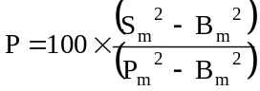 as a percentage (rounded to the nearest whole number) of the value given by picric acid.

26.4.1.4.2 The test criteria are as follows:

"Not Low": Explosive power values of 7% or greater of that given by picric acid.
"Low": Explosive power values of less than 7% of that given by picric acid but more than 1 % of that given by picric acid.
"No": Explosive power values of 1% or less of that given by picric acid.

26.4.1.5 Examples of results

Substance/Mixture | Mean % of picric acid | Result
tert-Butyl hydroperoxide, 70% with water | 2 | Low
tert-Butyl peroxybenzoate | 13 | Not low
tert-Butyl peroxy-2-ethylhexanoate | 8 | Not low
Cumyl hydroperoxide, 80% in cumene | 4 | Low
Dibenzoyl peroxide | 8 | Not low
Dibenzoyl peroxide, 75% with water | 6 | Low
Di-tert-butyl peroxide | 8 | Not low
Dicetyl peroxydicarbonate | 1 | No
Dicumyl peroxide, with 60% inert solid | 1 | No
Dilauroyl peroxide | 1 | No
2,5-Dimethyl-2,5-di-(tert-butylperoxy)hexyne-3 | 17 | Not low
Magnesium monoperoxyphthalate hexahydrate,  85% with magnesium sulphate | 1 | No

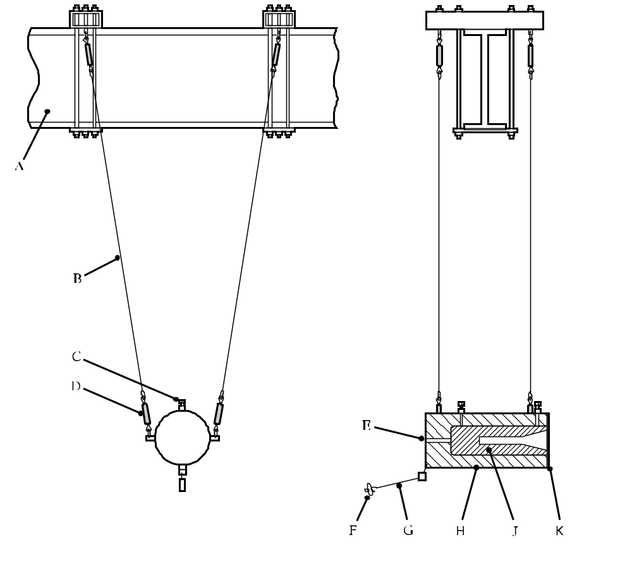

(A) | Suspension beam | (B) | Suspension wire
(C) | Liner set-screws | (D) | Bottle screws
(E) | Hole to aid liner removal | (F) | Stylus holder
(G) | Hinged trailing stylus arm | (H) | Mortar body outer casing
(J) | Inner liner | (K) | Annular retaining plate
Figure 26.4.1.1: Ballistic mortar MK.IIID

26.4.2 Test F.2: Ballistic mortar test

26.4.2.1 Introduction

This test is used to measure the explosive power of a substance or mixture. A detonator is initiated in the substance or mixture whilst the substance or mixture is confined in the bore of a mortar by a steel projectile. The recoil of the mortar is measured and the power is calculated as a percentage equivalence of picric acid - the explosive standard. The test may be used to answer the question in box 12 of Figure 20.1.

26.4.2.2 Apparatus and materials

26.4.2.2.1 Mortar

The mortar is made of chrome-nickel steel with a mass of 248.50 ± 0.25 kg. It is cylindrical and the axial cavity consists, from front to rear, of the projectile holder, the firing chamber and access for the detonator lead wires. The dimensions of the mortar will change during use (in particular, the firing chamber is enlarged) resulting in diminished recoil with the firing of a given charge. The reference charge used is 10.00 g picric acid (see 26.4.2.2.7). The used mortar is replaced by a new one when the average energy released in the last 10 firings is less than 90 per cent of the average energy produced in the first 10 firings (for similar temperatures and using a projectile in good condition).

26.4.2.2.2 Ballistic Pendulum

The mortar is suspended by steel arms from a roller-bearing mounted horizontal axis. The mortar pendulum is rendered ballistic by attaching a steel weight underneath it. Figure 26.4.2.1 is a representation of the ballistic mortar-pendulum, which has the following principal characteristics:

oscillation period 3.47 s
oscillating mass 479 kg
distance between axis of rotation and axis of mortar 2.99 m

A cursor on the graduated sector displaced by a lateral arm attached to the mortar is used to measure the recoil. The scale marked on the sector is proportional to (1 - cos A), A being the angle of recoil of the pendulum, i.e. proportional to the work performed.

26.4.2.2.3 Projectile

The projectile is a steel cylinder. The diameters (diameter 127 mm, length 162 mm) are in practice adjusted to meet the following conditions:

(a) The gap between the projectile, when new, and its housing in the mortar should be less than 0.1 mm;

(b) The mass of the projectile, when new, should be 16.00 ± 0.01 kg.

A worn projectile should be replaced when the gap between it and its housing in the mortar exceeds 0.25 mm. On firing, the projectile is normally expelled at a speed of between 100 and 200 km/h. The use of a receptacle lined with shock absorbing material enables it to be stopped without being damaged.

26.4.2.2.4 Sample vessels

When liquids are tested, glass ampoules of 16 g mass with a filling orifice and a recess to take the detonator (see Figure 26.4.2.3) are used to contain the test samples. Other substances or mixtures (solid, granular, pastes, etc.) are loaded in cylindrical sample vessels, 20 mm in diameter, made of tinfoil of thickness 0.03 mm and mass about 2 g. This applies, for instance, to picric acid charges.

26.4.2.2.5 Supports

A steel-wire ring support with three feet, shown in Figure 26.4.2.2, is used to centre the charge in the firing chamber (to reduce wear on the mortar).

26.4.2.2.6 Detonators

These are European standard detonators charged with 0.6 g PETN, as shown in Appendix 1.

26.4.2.2.7 Picric acid (reference substance)

This is pure crushed picric acid, grain size less than 0.5 mm, dried at 100 °C and kept in a tightly-stoppered flask.

26.4.2.3 Procedure

26.4.2.3.1 Preparation of charge

26.4.2.3.1.1 Compact solids have to be tested in the form of cylindrical blocks, diameter 20 mm ± 1 mm, with at one end an axial cavity (diameter 7.3 ± 0.2 mm, depth 12 mm) to accommodate the detonator. The mass of the block should be 10.0 ± 0.1 g. To prepare the charge, the block is wrapped in tinfoil, thickness 0.03 mm, mass approximately 2 g. The detonator is placed in its housing and the end of the foil wrapping pressed around the head of the detonator (see Figure 26.4.2.3).

26.4.2.3.1.2 Substances or mixtures other than liquids are packed at normal density in tinfoil wrappings, each test charge weighing 10.0 ± 0.1 g. The detonator is inserted to a depth of approximately 12 mm in the substance. The end of the wrapping is twisted around the head of the detonator (see Figure 26.4.2.3).

26.4.2.3.1.3 For liquids, a charge of 10.0 ± 0.1 g of the test substance or mixture is placed in a glass ampoule. The detonator is placed in its housing. If necessary, metal wire can be used to hold it in place (but under no circumstances combustible material).

26.4.2.3.1.4 Charges of 10.0 ± 0.1 g of picric acid, at normal density, are also prepared in foil wrappings. The detonator is inserted to a depth of approximately 12 mm in the picric acid. The end of the wrapping is twisted around the head of the detonator.

26.4.2.3.2 Trial run

26.4.2.3.2.1 The charge, placed in a charge holder (see 26.4.2.2.5) is pressed home in the firing chamber, the detonator head being in contact with the rear surface of the chamber (see Figure 26.4.2.3).

26.4.2.3.2.2 The projectile is greased with a consistent quality lubricant, inserted and pushed home in its housing in the mortar. To avoid any scatter in the results, due to possible distortion of the mortar or projectile, the position of the projectile in relation to the mortar housing is checked and recorded.

26.4.2.3.2.3 The cursor (see 26.4.2.2.2) is placed in contact with the moving arm so that the recoil of the pendulum can be measured. After firing, the deviation (D) of the pendulum is noted, i.e. the point at which the cursor remains on the graduated sector at the end of the swing.

26.4.2.3.2.4 The projectile and bore should then be carefully cleaned.

26.4.2.4 Procedure

26.4.2.4.1 Four firings are first carried out with picric acid. The average of the four deviations obtained is calculated. This average should have a value around 100, in the arbitrary unit of power adopted for the scale of the sector on which the pendulum recoil is measured. The results of the four firings should not vary by more than one unit, and if that is the case, the value D_{o} will be the average of the four deviations measured. If one of the results varies by more than one unit from the average, it is discarded and the value D_{o} is the average of the other three results.

26.4.2.4.2 The ambient temperature is recorded.

26.4.2.4.3 The procedure is then repeated with the test substance or mixture, for not less than three firings, the deviations obtained being D₁, D₂, D₃ etc. The corresponding powers, expressed as a percentage of the finding for picric acid, are calculated by the equation:

T_{k} = 100 × D_{k}/D_{o}, where k = 1, 2, 3, ...,

or, for liquids fired in glass ampoules:

T_{k} = 200 × D_{k}/D_{o}, where k = 1, 2, 3, ...

26.4.2.4.4 The average value of T_{k} is then calculated. The result, rounded to the nearest whole number, is called the "ballistic mortar power" (BMP) of the substance or mixture.

NOTE: When several substances or mixtures are to be tested in succession during the same half-day, only one series of four firings with picric acid is made in the half-day.

26.4.2.5 Test criteria and method of assessing results

26.4.2.5.1 The result of the test is presented in detail by giving the results T₁, T₂, T₃ ... and the value of BMP and the ambient temperature. In summary form, only the BMP value is given.

26.4.2.5.2 The test criteria are as follows:

"Not Low": BMP values of 7 or more.

"Low": BMP values less than 7 but more than 1.

"No": BMP values of 1 or less.

26.4.2.6 Examples of results

Substance/Mixture | BMP value | Result
2,2'-Azodiisobutyronitrile | 13 | Not low
tert-Butyl peroxybenzoate | 16 | Not low
tert-Butyl peroxy-2-ethylhexanoate | 7 | Not low
Dibenzoyl peroxide | 16 | Not low
Dibenzoyl peroxide, 75% with water | 8 | Not low
Di-tert-butyl peroxide | 7 | Not low
Dilauroyl peroxide | 5 | Low
p-Menthyl hydroperoxide, 55% in p-menthane | 3 | Low
Peroxyacetic acid, 36% in a mixture with 19% water, 36% acetic acid  and 6% hydrogen peroxide, with stabiliser | 27 | Not low
Pinanyl hydroperoxide, 54% in pinane | 2 | Low
Picric acid | 100
Trinitrotoluene | 95
Sand | 1

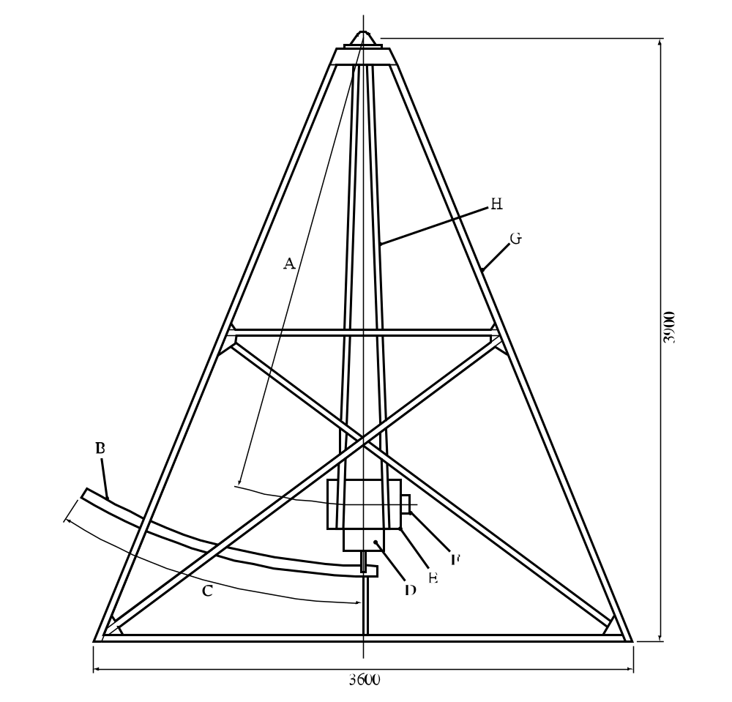

(A) | 2 905 mm distance between axes | (B) | Graduated scale
(C) | 30° swing angle | (D) | Weight
(E) | Mortar | (F) | Projectile
(G) | Frame | (H) | Swinging arm
Figure 26.4.2.1: Ballistic mortar test

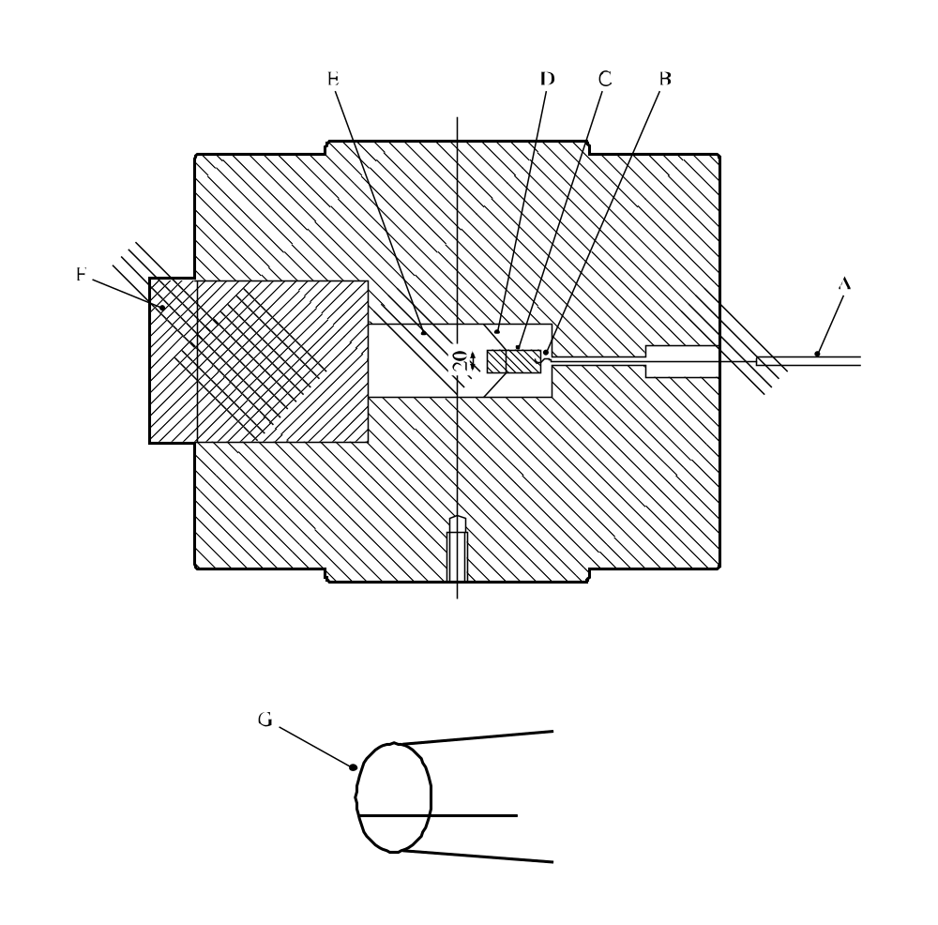

(A) | To igniter | (B) | Detonator
(C) | 20 mm diameter charge | (D) | Charge holder
(E) | Firing chamber | (F) | Projectile
(G) | Expanded view of charge holder
Figure 26.4.2.2: Mortar (top) and charge holder (bottom)

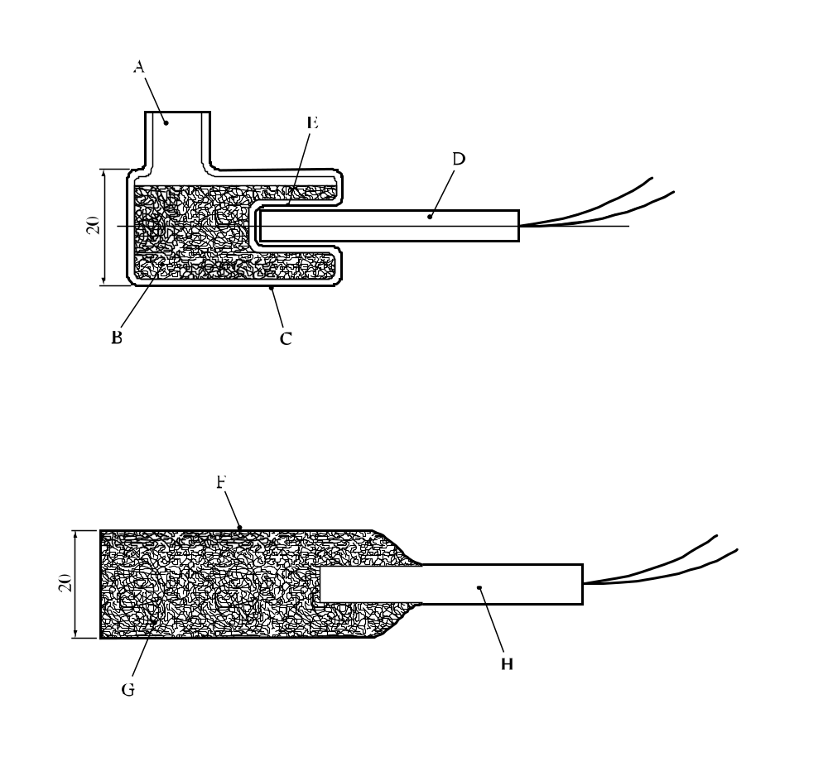

(A) | Filling orifice | (B) | 20 mm diameter charge containing 10 g of substance or mixture
(C) | Glass ampoule (16 g) | (D) | 0.6 g PETN detonator
(E) | Detonator housing | (F) | 2 g foil wrapping
(G) | 20 mm diameter charge containing 10 g of substance or mixture | (H) | 0.6 g PETN detonator
Figure 26.4.2.3: Charge for liquids (top) and substances other than liquids (bottom)

26.4.3 Test F3: BAM Trauzl test

26.4.3.1 Introduction

This test is used to measure the explosive power of a substance or mixture. A detonator is initiated in the substance or mixture whilst the substance or mixture is confined in a hole in a lead block. The explosive power is expressed in the form of the increase in volume of the cavity in the lead block per 10 g of substance or mixture. The test may be used to answer the question in box 12 of Figure 20.1.

26.4.3.2 Apparatus and materials

26.4.3.2.1 Initiation of the substance or mixture is achieved by a European standard detonator with 0.6 g of PETN (see Appendix 1).

26.4.3.2.2 For the test, standardized Trauzl lead blocks of cylindrical shape are used with a height of 200 mm and a diameter of 200 mm. They have an axial recess of 25 mm diameter and 125 mm depth with a volume of 61 cm³, see Figure 26.4.3.1. The lead blocks are made by casting pure soft lead into moulds at a casting temperature of 390 °C to 400 °C. The quality of a casting series of lead blocks is checked by three test explosions each using 10 cm³ of crystallized picric acid (loading density 1.0 g/cm³). The mean of the three net expansion values obtained should be between 287 cm³ and 300 cm³.

26.4.3.3 Procedure

26.4.3.3.1 Solid substances or mixtures are shaped to cylindrical test charges with a volume of 10 cm³ by wrapping in a weighed piece of tinfoil and the mass of the charge determined. The test charges have an external diameter of 24.5 mm, a height of 22.2 mm, and a coaxial recess of 7 mm diameter and 12 mm depth to take the detonator. The test charge is prepared in a device consisting of a piston, a two-part matrix, a clamping frame and a base piece (Figure 26.4.3.2). For this, a trapezoidal piece of tinfoil (thickness approx. 0.01 mm) 55 mm wide is wound round the piston. The die with its tinfoil sheath is then introduced into the matrix until it reaches the backstop of the base. The matrix is clamped with the aid of the frame and the piston is slowly drawn out of the tinfoil tube after pressing it firmly against the base piece. The bottom of the tinfoil tube is carefully pierced in its centre using a thin wooden rod. From the side of the clamping frame, the standard detonator PETN 0.6 g is inserted into the base piece so that the detonator wires are drawn through the hole in the adjusting screw until the detonator touches the screw. The screw is so adjusted that the detonator projects 12.0 mm from the base piece. The substance or mixture to be tested is put into the tinfoil tube, compressing it lightly by means of a wooden rod. The projecting tinfoil edge is folded inwards and the piston is pressed into the matrix up to the collar. After withdrawing the piston, the prepared test charge, in the tinfoil tube, with the inserted detonator, is carefully taken out of the matrix.
(Ref.Doc: ST/SG/AC.10/11/Rev.5/Corr.1)

26.4.3.3.2 Liquid substances or mixtures are tested in thin-walled glass cylinders of similar shape and of such a capacity as to take the sample volume of 10 cm³ and that of the detonator, when it is introduced to a depth of 12 mm into the liquid. The neck of the vessel is of such a length that it keeps the detonator in a central position. After having determined the sample mass, the test charge is carefully introduced into the recess of the lead block right to the bottom. The lead blocks are stored in a temperature-controlled room, so that the temperature, measured in the depth of the recess, immediately before introducing the charge, is in the range 10 °C and 20 °C. For the test, the lead block should rest on a flat, massive support of steel laid on the ground. For stemming, the remaining space in the recess is filled with dry quartz sand, passed through a sieve of 144 meshes per cm², with a gravimetric density of 1.35 g/cm³. The lead block is then hit at the side three times with a hammer of 2 kg mass and the excess of sand is removed from the upper surface.

26.4.3.3.3 The detonator is fired and the block emptied of any residues. The volume of the enlarged cavity is measured using water and the expansion which would be caused by a 10 g sample calculated using the expression:

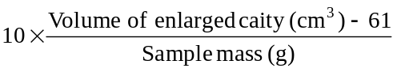

26.4.3.3.4 Normally, the test is conducted in duplicate and the highest expansion value obtained used for the assessment.

26.4.3.4 Test criteria and method of assessing results

26.4.3.4.1 The explosive power is expressed in the form of the increase in volume of the cavity in the lead block per 10 g of substance or mixture. At a given strength of initiation, the explosive power increases with the volume of expansion.

26.4.3.4.2 The test criteria are as follows:

"Not Low": - The expansion of the lead block is 25 cm³ or more per 10 g of sample.

"Low": - The expansion of the lead block is less than 25 cm³ but more than or equal to 10 cm³ per 10 g of sample.

"No": - The expansion of the lead block is less than 10 cm³ per 10 g of sample.

26.4.3.5 Examples of results

Substance/Mixture | Sample mass (g) | Expansion  (cm³/10g) | Result
Azodicarbonamide |  | 9 | No
2,2'-Azodi(isobutyronitrile) |  | 26ª | Not low
Benzene-1,3-disulphohydrazide |  | 50ª | Not low
Benzene-1,3-disulphohydrazide,  70% with mineral oil |  | 11ª | Low
Benzene sulphohydrazide | 8.4 | 8 | No
tert-Butyl peroxybenzoate | 9.1 | 32ª | Not low
tert-Butylperoxy-2-ethylhexanoate | 7.2 | 28ª | Not low
3-Chloroperoxybenzoic acid, not more than 86%  with 3-chlorobenzoic acid | 7.1 | 42ª | Not low
Cumyl hydroperoxide, 84.1% with cumene | 9.3 | 10 | Low
Cyclohexanone peroxide(s) | 6.4 | 50ª | Not low
Dibenzoyl peroxide | 8.0 | 31ª | Not low
Dibenzoyl peroxide, 75% with water | 8.0 | 21ª | Low
Di-tert-butyl peroxide | 7.2 | 28ª | Not low
Dicetyl peroxydicarbonate | 7.3 | 5ª | No
Dicumyl peroxide | 6.9 | 12ª | Low
Diisopropyl peroxydicarbonate | 7.8 | 78ª | Not low
Dilauroyl peroxide | 8.0 | 11ª | Low
Dimyristyl peroxydicarbonate | 7.4 | 11 | Low
Dimyristyl peroxydicarbonate, 42%, stable  dispersion in water | 7.8 | 5ª | No
N,N'-Dinitrosopentamethylene tetramine |  | 147ª | Not low
N,N'-Dinitrosopentamethylene tetramine  80%, with 17% inorganic solid and  3% mineral oil | 10.2 | 7^{b} | No
Diperoxy isophthalic acid | 8.7 | 144 | Not low
4-Nitrosophenol | 7.3 | 11 | Low
Boric acid |  | 0
Dimethyl phthalate |  | 5
Water |  | 6
ª Determined by using test charges of 11 cm³ volume and a slightly stronger test blasting cap with a copper tube of 6.85 mm external diameter and 45 mm length, with flat bottom containing 0.5 g PETN with 10% wax, 0.2 g tetryl, and 0.5 g mercury fulminate as explosive charge, all pressed at 400 bar.

^{b} Initiation with 3 detonators gives 123 cm³/10 g, Not low

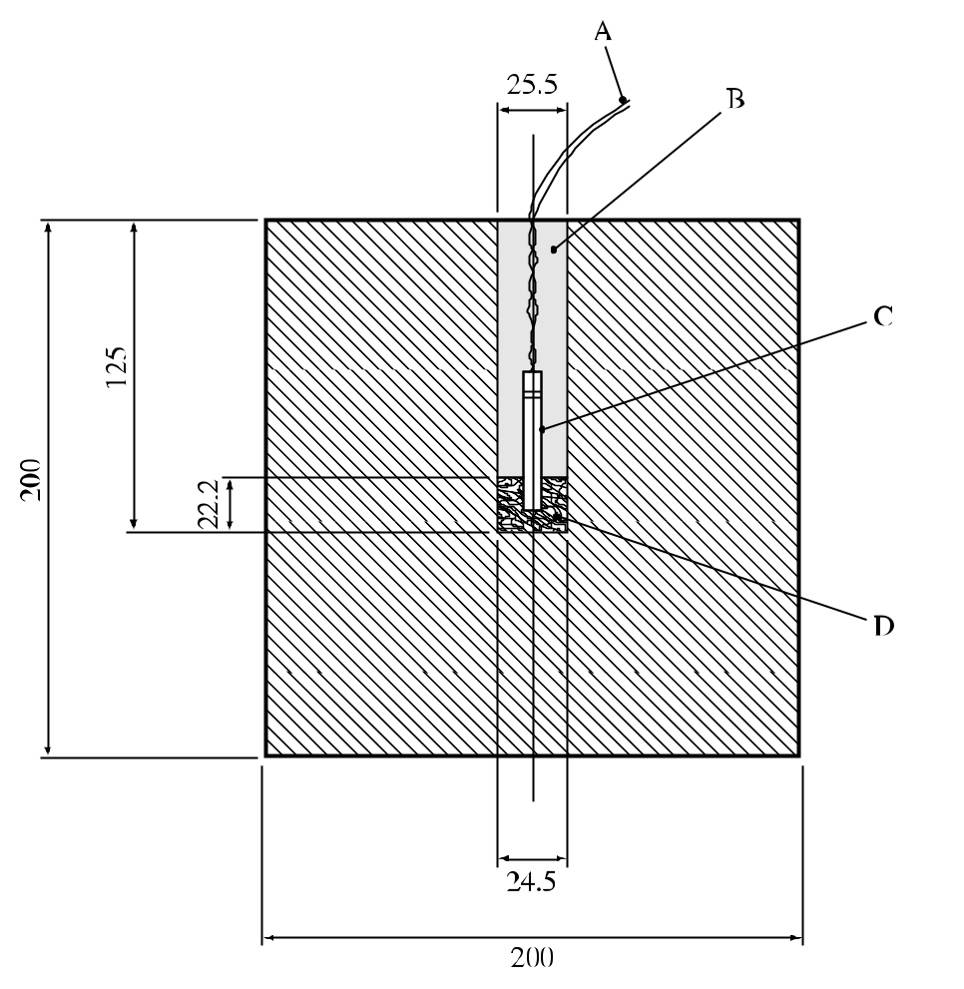

(A) | Detonator wires | (B) | Dry sand stemming
(C) | European standard detonator | (D) | Test sample
Figure 26.4.3.1: BAM trauzl test

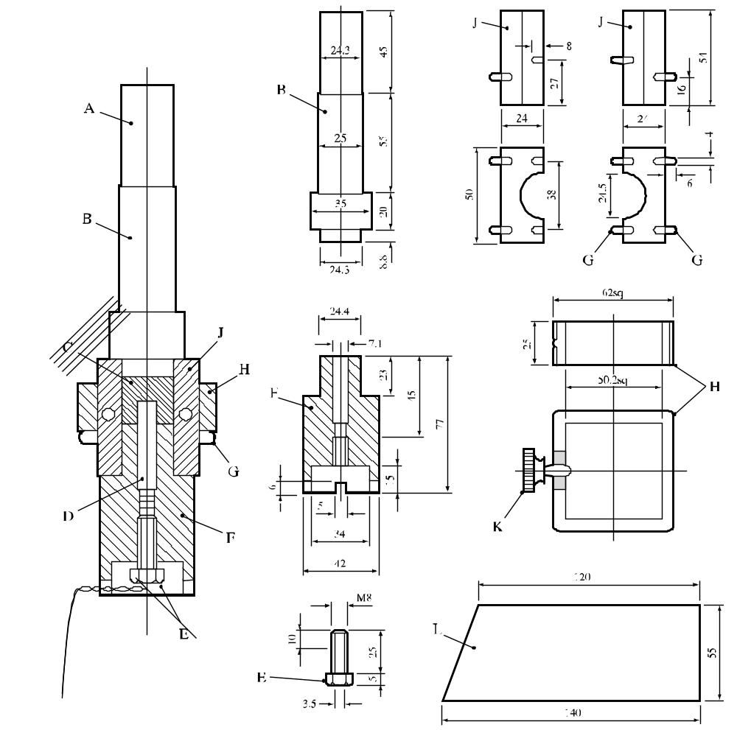

(A) | End part of piston for preparing the tinfoil tube | (B) | Piston
(C) | Test sample | (D) | Detonator
(E) | Adjusting screw (axial bore 3.5 mm, slot 1 mm, 100 mm long) | (F) | Base piece
(G) | Pins | (H) | Clamping frame
(J) | Matrix | (K) | Knurled screw
(L) | Tin foil

Figure 26.4.3.2: device for making the charges (10 cm³ volume, 24.6 mm diameter and 22.2 mm height) for the BAM trauzl test

26.4.4 Test F.4: Modified Trauzl test

26.4.4.1 Introduction

This test is used to measure the explosive power of a substance or mixture. A detonator is initiated in the substance or mixture whilst the substance or mixture is confined in a hole in a lead block. The explosive power is expressed in the form of the average increase in volume of the cavity in the lead block over the value obtained from an inert substance or mixture with similar physical properties. The test may be used to answer the question in box 12 of Figure 20.1.

26.4.4.2 Apparatus and materials

The lead block is machined from cast or extruded lead rod 50 ± 1 mm diameter by 70 mm long with a cavity 25.4 mm in diameter and 57.2 mm long as shown in Figure 26.4.4.1. The cavity is cut with a flat-tipped drill to prevent puncture of the lead block. The blasting cap used is a standard No. 8 (USA) detonator (see Appendix 1). Assembly A is used for liquids and pastes and assembly B for solids (see Figure 26.4.4.2). The sample vial used for assembly A is a commercial 12 ml, 21 mm outer diameter vial. The sample vial used for assembly B is a commercial 16 ml, 24.9 mm outer diameter vial. The polyethylene stoppers are the standard ones supplied with the vials. The glass tube used to locate the blasting cap in assemblies A and B is a borosilicate glass culture tube. It is 10 mm outer diameter × 75 mm long. A 10 mm diameter hole drilled in the centre of the polyethylene stopper gives a tight fit which holds the tube secure. Two rubber "0" rings (16.5 mm inner diameter, 2.5 mm diameter cross section) are used to centre the vial in the cavity in the lead block in assembly A.

26.4.4.3 Procedure

A 6.0 g sample is placed in the sample vial which is assembled as required and placed in the lead block. The lead block is placed on a solid surface in a protected area, the blasting cap is fully inserted and, when the area is vacated, the cap is fired. The volume of the cavity in the lead block is measured accurately, to the nearest 0.2 ml, using water before and after the test. Three tests are conducted on the substance or mixture and on the inert reference substance using the same type of assembly.

26.4.4.4 Test criteria and method of assessing results

26.4.4.4.1 The explosive power of the test sample is expressed in terms of the average increase of the volume of the cavity in the lead block over that given by the inert reference substance.

26.4.4.4.2 The test criteria are as follows:

"Not low": The average net block expansion is equal to or greater than 12 cm³.

"Low": The average net block expansion is less than 12 cm³ but greater than 3 cm³.

"No": The average net block expansion is 3 cm³ or less.

26.4.4.5 Examples of results

Substance/Mixture | Average net expansion (cm³) | Result
2,2'-Azodi(isobutyronitrile) | 18 | Not low
2,2'-Azodi(2-methylbutyronitrile) | 14 | Not low
tert-Butyl hydroperoxide, 72% with water | 7 | Low
tert-Butyl peroxyacetate, 75% in solution | 25 | Not low
tert-Butyl peroxybenzoate | 19 | Not low
tert-Butyl peroxy-2-ethylhexanoate | 10 | Low
Cumyl hydroperoxide, 85% with cumene | 5 | Low
Dibenzoyl peroxide | 16 | Not low
Di-tert-butyl peroxide | 12 | Not low
Di-sec-butyl peroxydicarbonate | 23ª | Not low
Diisopropyl peroxydicarbonate | 45ª | Not low
2,5-Dimethyl-2,5-di-(tert-butylperoxy)hexyne-3 | 31 | Not low
2,5-Dimethyl-2,5-di-(benzoylperoxy) hexane | 9 | Low
Di-n-propyl peroxydicarbonate | 32ª | Not low

Expansion with inert reference substances in assembly A

Air | 6
Dimethyl phthalate | 10
Mineral spirits | 10.5
Paste of 60% CaCO3 + 40% dimethyl phthalate | 8
Water | 10
Expansion with inert reference substances in assembly B

Air | 5.5
Benzoic acid | 7
Calcium carbonate (powder) | 5
Kaolin clay | 6
ª Performed at ambient temperature.

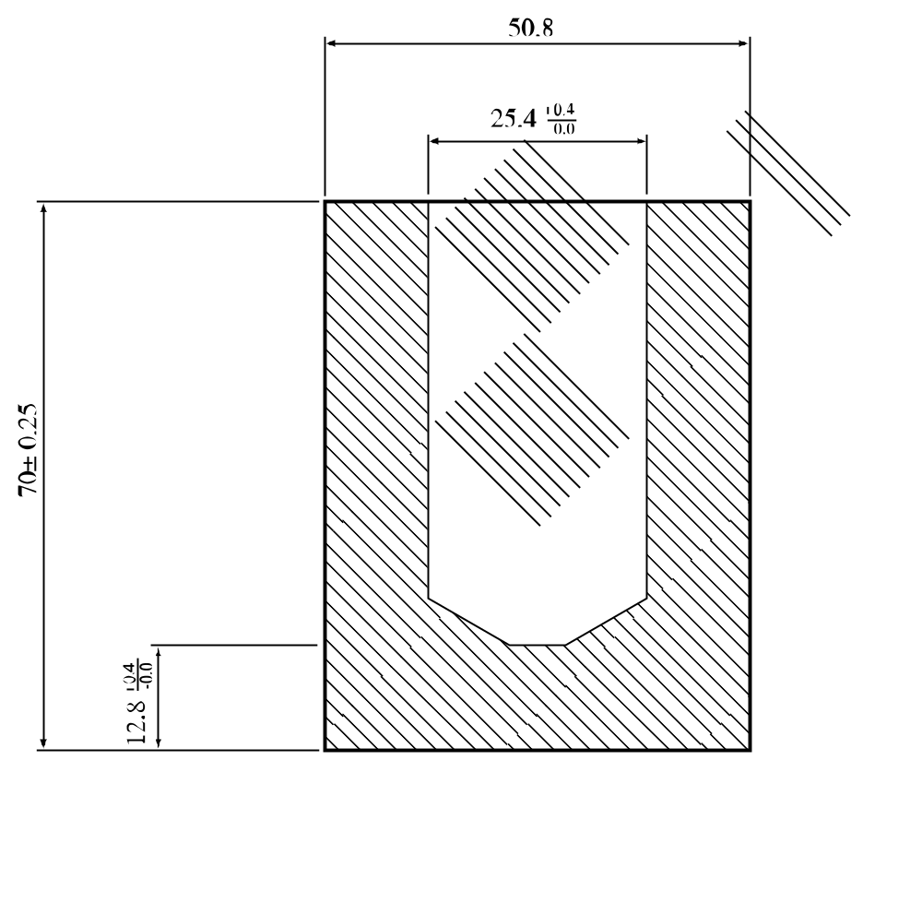

Figure 26.4.4.1: Modified Trauzl test

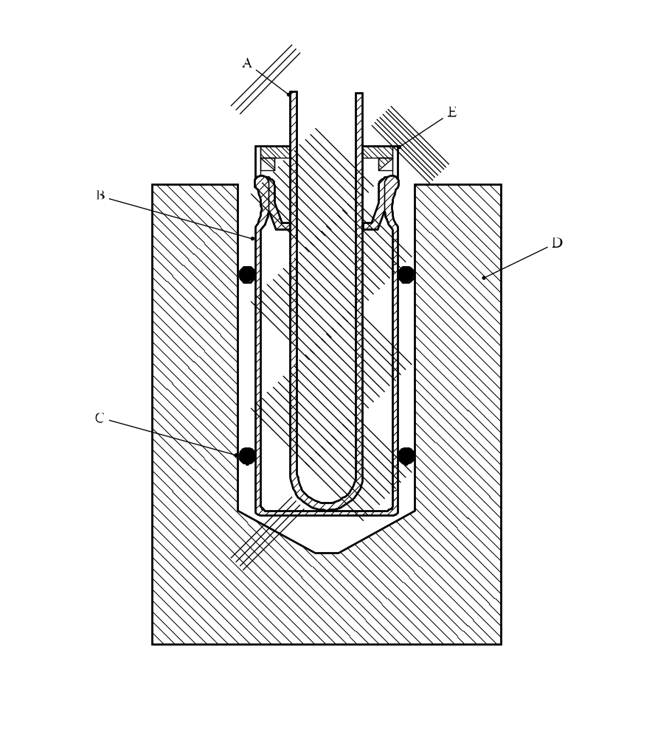
(A) | Glass tube | (B) | Glass vial (12 ml assembly A, 16 ml assembly B)
(C) | "O"-ring (assembly A only) | (D) | Lead block
(E) | Stopper
Figure 26.4.4.2: Assemblies A and B

26.4.5 Test F.5: High pressure autoclave

26.4.5.1 Introduction

This test is used to measure the specific energy of a substance or mixture. Varying quantities of substance or mixture are heated in a sealed vessel and the maximum pressure rise obtained for each sample size measured. The specific energy is a function of the maximum pressure rise. The test may be used to answer the question in box 12 of Figure 20.1.

26.4.5.2 Apparatus

The high pressure autoclave (Figure 26.4.5.1) is a cylindrical stainless steel vessel with a capacity of 96 ml and a working pressure of 150 MPa at a temperature of 473 K. The vessel is made from stainless steel type AISI 431, has an internal diameter of 38 mm and an internal height of 84 mm. An inner sample vessel (stainless steel type AISI 316, internal diameter 32 mm and internal height 77 mm) is used inside the autoclave. A coated Ni/Cr resistance wire (specific resistance of approximately 10 ohms/m), skip-wound around a piece of glass tube, is used to heat the sample by means of a constant current supply; a heating power of 50-150 W is supplied. Owing to the use of the inner vessel, the heat transfer from the substance to the autoclave is relatively small compared to the heat transfer that would exist in the situation without inner vessel. Therefore rapid heating will take place which will lead to an exothermic reaction involving self-heating and explosion. The pressure-time history of the explosion is determined. The pressure is registered by means of a piezo-electric transducer.

26.4.5.3 Procedure

The required amount of substance or mixture is weighed into the sample vessel after which the sample vessel is placed in the autoclave. The heating coil is connected to the lid of the autoclave which is then closed. Provisions are made to ensure that the whole heating coil is completely immersed in the substance or mixture. The ends of the heating wire are then connected to the power supply electrodes by low-resistance wire. The sample is then heated until explosion occurs. Experiments are normally performed using 5, 10, 15, 20 and 25 g of substance or mixture and the maximum pressure recorded. However, these quantities may need to be varied according to the bulk density and detonability of the substance or mixture.

26.4.5.4 Test criteria and method of assessing results

26.4.5.4.1 The results are assessed on the basis of the specific energy (F) which is a function of the maximum pressure rise (P_{m}). The initial sample mass (M_{o}) and the volume (V) of the reaction vessel are required to calculate the specific energy using the following equation:

V/M_{o} = F/Pm + C

Where V = internal volume of pressure vessel - volume of steel of inner sample vessel;
C = constant under the test conditions; and
F = determination from the slope of the plot of V/M_{o} versus 1/P_{m}.

The explosive power of a substance or mixture is based on the value of the specific energy F only.

26.4.5.4.2 The test criteria are as follows:

"Not Low": Specific energy greater than 100 J/g.

"Low": Specific energy ≥ 5 J/g and ≤ 100 J/g.

"No": Specific energy less than 5 J/g.

26.4.5.5 Examples of results

Substance | F-value  (J/g) | Result
2,2'-Azodi(isobutyronitrile) | 101 | Not low
tert-Butyl peroxybenzoate | 110 | Not low
tert-Butyl peroxy-2-ethylhexanoate | 56 | Low
Cumyl hydroperoxide, 80% in cumene | 60 | Low
Dibenzoyl peroxide, 75% with water | 41 | Low
Di-tert-butyl peroxide | 140 | Not low
Dicetyl peroxydicarbonate | No reaction | No
Dicumyl peroxide, 40% with inert solid | No reaction | No
Dilauroyl peroxide | 8 | Low
Dilauroyl peroxide, 42%, stable dispersion, in water | 1.3 | No

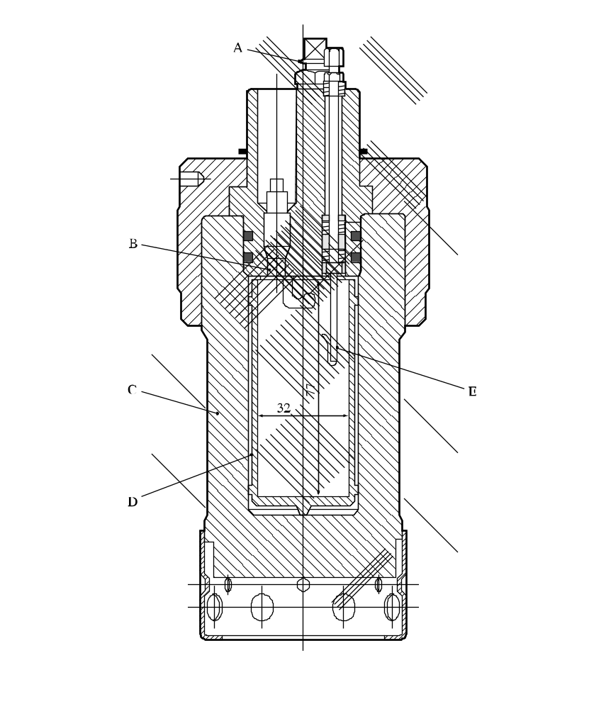
(A) | Valve | (B) | Pressure transducer
(C) | Autoclave | (D) | Inner sample vessel
(E) | Electrodes
Figure 26.4.5.1: High-pressure autoclave

CHAPTER 27
TEST SERIES G

27.1 Introduction

27.1.1 Test series G comprises tests and criteria concerning the determination of the effect of a thermal explosion of a substance mixture as packaged, requested in box 10 of Figure 20.1. The test is only needed for substances which show a violent effect in tests involving heating under defined confinement (test series E).

27.2 Test methods

27.2.1 The question "Can it explode as packaged?" (box 10 of Figure 20.1) is answered on the basis of the results of one of the test methods in Table 27.1.

Table 27.1: Test methods for test series G

Test code | Name of test | Section
G.1 | Thermal explosion test in packageª | 27.4.1
G.2 | Accelerating decomposition test in package | 27.4.2
ª Recommended test.

27.2.2 Both tests are considered equivalent for all substances and mixtures excluding water-wetted solids. For water-wetted solids, in the event that the results of the two tests are not in agreement, the results of test G.1 have precedence over the results of test G.2.

27.3 Test conditions

27.3.1 The test of Series G should be applied to packages of substances or mixture (of not more than 50 kg) in the condition and form in which they are offered for transport.

27.3.2 The preliminary procedure (see section 20.3) should be performed before carrying out these tests.

27.4 Series G test prescriptions

27.4.1 Test G.1: Thermal explosion test in package

27.4.1.1 Introduction

This test is used to determine the potential for thermal explosion in a package. It may be used to answer the question in box 10 of Figure 20.1.

27.4.1.2 Apparatus and materials

27.4.1.2.1 Packaging (not larger than that needed for 50 kg of substance or mixture), substance or mixture, a suitable heating device (e.g. 2 kW for 25 kg of substance) and equipment for measuring temperatures.

27.4.1.3 Procedure

The test is applied to packed substances or mixtures in the condition and form in which they are offered for transport. The method of obtaining the thermal explosion is by heating the substance or mixture as homogeneously as possible with an electric heating coil within the package. The surface temperature of the heating coil should not be so high that premature ignition of the substance or mixture can take place. It may be necessary to use more than one heating coil. The package should be mounted on a stand to keep it upright. The heating system is switched on and the temperature of the substance or mixture continuously recorded. The heating rate should be about 60 °C/hour. The difference in temperature between the substance or mixture at the top and bottom of the package should be as small as possible. It is advisable to make provision in advance for the remote destruction of the package in the event of heater failure. The test is performed in duplicate unless an explosion is observed.

27.4.1.4 Test criteria and method of assessing results

27.4.1.4.1 Observations are made on the evidence of an explosion of the package under investigation by fragmentation of the package. The results obtained are only valid for the package tested.

27.4.1.4.2 The test criteria are as follows:

"Yes": A fragmentation of inner and/or outer packaging(s) into more than three pieces (excluding bottom and top parts of the packaging(s) show(s) that the substance or mixture under investigation can give an explosion of that package.

"No": No fragmentation or a fragmentation into not more than three pieces shows that the substance or mixture under investigation does not explode in the package.

27.4.1.5 Examples of results

Substance/Mixture | Packagings | Number of fragments ª | Result
2,2'-Azodi-(isobutyronitrile) | 4G, 30 kg | N.F. | No
tert-Butyl peroxybenzoate | 1B1, 25 litres | > 30 | Yes
tert-Butyl peroxybenzoate | 6HG2, 30 litres | N.F. | No
tert-Butyl peroxy-2-ethylhexanoate | 1B1, 25 litres | > 5 | Yes
tert-Butyl peroxy-2-ethylhexanoate | 6HG2, 30 litres | N.F. | No
tert-Butyl peroxy isopropyl carbonate | 1B1, 25 litres | > 80 | Yes
tert-Butyl peroxy isopropyl carbonate | 6HG2, 30 litres | > 20 | Yes
tert-Butyl peroxypivalate, 75% in solution | 6HG2, 30 litres | N.F. | No
Dibenzoyl peroxide, 75% with water | 4G, 25 kg | N.F. | No
2,2-Di-(tert-butylperoxy)butane, 50% in solution | 3H1, 25 litres | N.F. | No
2,2-Di-(tert-butylperoxy)butane, 50% in solution | 6HG2, 30 litres | N.F. | No
ª N.F. means no fragmentation.

27.4.2 Test G.2: Accelerating decomposition in the package test

27.4.2.1 Introduction

This test is used to determine the potential for thermal explosion in a package. It may be used to answer the question in box 10 of Figure 20.1.

27.4.2.2 Apparatus and materials

The equipment for this test is a typical SADT test cell as represented in Figure 27.4.2.1 and as described for test H.1 in section 28.

27.4.2.3 Procedure

The test is carried out in accordance with the procedure described for test H.1 in section 28. The temperature of the test cell may be set approximately 10 °C above the SADT, if known. The SADT test cell is designed to readily vent any significant pressure developed during the decomposition of a test sample. The cell covers are simply set in place and held by gravity alone.

27.4.2.4 Test criteria and method of assessing results

27.4.2.4.1 The condition of the sample, the package, the test cell, and the immediate surroundings provide a measure of the violence of the decomposition reaction of the product/package configuration tested.

27.4.2.4.2 The test criteria are defined in terms of the condition of the test cell, the package and the occurrence of an explosion and are as follows:

"Yes": Significant disruption of the inside of the test cell would be noted. The outer cover may be lifted off and carried at least two metres indicating significant internal cell pressure. The test package would be severely damaged, breaking into at least three fragments.

"No": Slight to no disruption of the test cell. The outer cover may be lifted off but not carried further than two meters from the cell. The test package may be disrupted and damaged e.g. split inner packaging, torn carton.

27.4.2.5 Examples of results

Substance/Mixture | Package | Result
tert-Butyl peroxyacetate, 75% in solution | 6HG2, 20 litres | Yes
tert-Butyl peroxybenzoate | 6HG2, 20 litres | No
tert-Butyl peroxy-2-ethylhexanoate | 6HG2, 20 litres | No
tert-Butyl peroxy isopropyl carbonate, 75% in solution | 6HG2, 20 litres | No
tert-Butyl peroxypivalate, 75% in solution | 6HG2, 20 litres | No
Dibenzoyl peroxide | 4G, 0.454 kg | Yes
2,5-Dimethyl-2,5-di-(tert-butylperoxy)-hexyne-3 | 6HG2, 20 litres | Yes

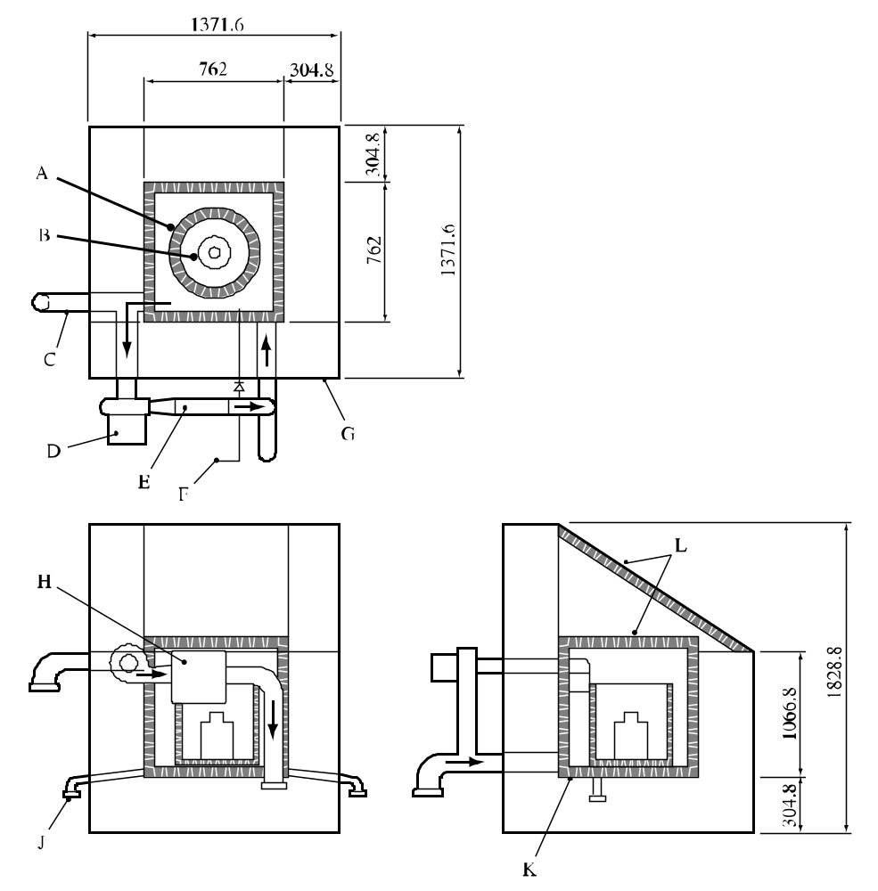

(A) | Test container | (B) | Test package
(C) | Air duct | (D) | Fan
(E) | Heater | (F) | Carbon dioxide
(G) | Frame | (H) | Recirculator
(J) | Pipe drains with caps | (K) | Insulation
(L) | Insulated covers
Figure 27.4.2.1: Accelerating decomposition test in the package

CHAPTER 28
TEST SERIES H

28.1 Introduction

This test series contains test methods for the determination of the self-accelerating decomposition temperature (SADT). The SADT is defined as the lowest temperature at which self-accelerating decomposition may occur with a substance or mixture in the packaging as used in transport. The SADT is a measure of the combined effect of the ambient temperature, decomposition kinetics, package size and the heat transfer properties of the substance or mixture and its packaging. To assist in interpreting the results, models can be used in which the main resistance to heat flow is:

(a) At the boundary i.e. packaging (Semenov model);

(b) Within the substance (Frank-Kamentskii model); or

(c) A combination of these (Thomas model).

The text should be used in conjunction with the temperature control requirements given in Chapter 2.15, sub-section 2.15.2.3 of the GHS and Chapter 2.5, sub-section 2.5.3.4 of the Model Regulations.

References: N.N. Semenov, Z. Physik, 48, 1928, 571.
D.A. Frank-Kamentskii, Zhur. Fiz. Khim., 13, 1939, 738.
P.H. Thomas, Trans. Faraday Soc., 54, 1958, 60.

28.2 Test methods

28.2.1 Test series H comprises tests and criteria concerning the thermal stability of substances and mixtures at transport temperatures or concerning the determination of whether a substance or mixture meets the definition of self-reactive substances and mixtures.

28.2.2 Each test involves either storage at a fixed external temperature and observation of any reaction initiated or storage under near adiabatic conditions and measurement of the rate of heat generation versus temperature. The test methods included in test series H are given in Table 28.1. Each of the methods listed is applicable to solids, liquids, pastes and dispersions.

Table 28.1: test methods for test series H

Test code | Name of test | Section
H.1 | United States SADT testª | 28.4.1
H.2 | Adiabatic storage test (AST)^{b} | 28.4.2
H.3 | Isothermal storage test (IST) | 28.4.3
H.4 | Heat accumulation storage test^{c} | 28.4.4
ª Recommended test for substances and mixtures transported in packagings.
^{b} Recommended test for substances and mixtures transported in packagings, IBCs or tanks.
^{c} Recommended test for substances and mixtures transported in packagings, IBCs or small tanks.

The list of tests is not exhaustive; other tests may be used provided that they give the correct SADT of the substance or mixtures as packaged for transport.

28.2.3 When necessary (SADT ≤ 50 °C for organic peroxides, SADT ≤ 55 °C for self-reactive substances and mixtures), control and emergency temperatures may be derived from the SADT using Table 28.2.

Table 28.2: Derivation of control and emergency temperatures

Type of receptacle | SADT ª | Control temperature | Emergency temperature
Single packagings and IBCs | ≤ 20 °C | 20 °C below SADT | 10 °C below SADT
Single packagings and IBCs | over 20 °C to 35 °C | 15 °C below SADT | 10 °C below SADT
Single packagings and IBCs | over 35 °C | 10 °C below SADT | 5 °C below SADT
Portable tanks | < 50 °C | 10 °C below SADT | 5 °C below SADT

ª i.e. the SADT of the substance or mixture as packaged for transport.
(Ref.doc: ST/SG/AC.10/11/Rev.5/Corr.1)

28.2.4 If a substance or mixture is being tested to determine whether it is a self-reactive substance of mixture (transport Division 4.1), a test of series H, or a suitable alternative test, should be performed to determine if its SADT would be less than or equal to 75 °C when transported in a 50 kg package.

28.2.5 The results obtained for the largest commercial package are applicable to smaller packages of similar construction and material provided that the heat transfer per unit mass is no smaller than from the larger package.

28.3 Test conditions

28.3.1 The preliminary procedure (see section 20.3) should be performed and the effect of heating under confinement (test series E) determined before performing SADT tests. Safety precautions should be taken which allow for the possibility of catastrophic failure of the test vessel and for the hazards arising from the ignition of secondary fuel-air mixtures and the evolution of toxic decomposition products. Substances and mixtures liable to detonate should only be tested with special precautions.

28.3.2 The test selected should be conducted in a manner which is representative, both in size and material, of the package to be transported. For transport in metal packagings, IBCs or tanks, it may be necessary to include a representative amount of the metal in the sample tested i.e. representative of both the metal(s) and the area of contact.

28.3.3 Extra care should be taken when handling samples which have been tested since changes may have occurred rendering the substance or mixtrure more unstable and more sensitive. Tested samples should be destroyed as soon as possible after the test.

28.3.4 Samples which have been tested at a particular temperature and are apparently unreacted may be used again, for screening purposes only, provided extra care is taken. Fresh samples should be used for the actual determination of the SADT.

28.3.5 If the complete package is not tested, the heat loss data used for the determination of the SADT should be representative of the package, IBC or tank offered for transport. The heat loss per unit of mass of the package, IBC or tank may be determined by calculation (taking account of the quantity of substance or mixture, dimensions of the package, heat transfer in the substance or mixture and the heat transfer through the packaging to the environment) or by measuring the half-time of cooling of the package filled with the substance or mixture or another substance or mixture having similar physical properties. The heat loss per unit mass, L (W/kg.K), can be calculated from the half-time of cooling, t_{1/2} (s), and the specific heat, C_{p} (J/kg.K), of the substance or mixture using the formula:

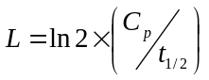

(Ref.Doc: ST/SG/AC.10/11/Rev.5/Amend.2)

28.3.6 The half-time of cooling can be determined by measuring the period of time in which the temperature difference between the sample and surroundings is decreased by a factor of 2. For example, for liquids, the packaging may be filled with dibutyl phthalate or dimethyl phthalate and this heated to about 80 °C. Water should not be used as erratic results may be obtained through evaporation/condensation. The temperature drop is measured at the centre of the package over the temperature range which includes the expected SADT. For scaling, it may be necessary continuously to monitor the temperature of the substance or mixture and surroundings and then use linear regression to obtain the coefficients of the equation:

ln {T - T_{a}} = c_{o} + ct

where: T = substance/mixturetemperature (°C);
T_{a} = ambient temperature (°C);
c_{o} = ln{Initial substance/mixture temperature - initial ambient temperature}; and
c = L/C_{p};
t = time (s).

28.3.7 Examples of the heat loss characteristics of some typical packages are given in Table 28.3. The actual value obtained will depend on the shape, wall thickness, surface coating etc. of the packaging.

Table 28.3: heat loss per unit mass from packages, IBCs and tanks

Type of receptacle | Normal capacity (litres) | Filling | Heat loss per unit mass (L) (mW/K.kg)
For liquids:
1A1 | 50 | 47.5 kg DMPª | 63
1H1 | 50 | 47.5 kg DMPª | 94
1H1 | 200 | 200 kg water | 56
3H1 (black) | 60 | 47.5 kg DMPª | 105
6HG2 | 30 | 35.0 kg DMPª | 69
IBC 31 HA1 | 500 | 500 kg water | 51
Tank | 3 400 | 3 400 kg water | 18^{b}
Tank container (insulated) | 20 000 | 14 150 kg isododecane | 1.7
For solids:
1G | 38 | 28.0 kg DCHP^{c} | 35
1G | 50 | 37.0 kg DCHP^{c} | 29
1G | 110 | 85.0 kg DCHP^{c} | 22
4G | 50 | 32.0 kg DCHP^{c} | 27
ª DMP = dimethyl phthalate.
^{b} Calculated using a heat transfer coefficient of 5 W/m².K.
^{c} Dicyclohexyl phthalate (solid).
28.4 Series H test prescriptions

28.4.1 Test H.1: United States SADT test

28.4.1.1 Introduction

This method determines the minimum constant temperature air environment at which auto-accelerative decomposition occurs for a substance or mixture in a specific package. Packages of up to 220 litres may be tested by this method. An indication of the explosion hazard from the decomposition reaction can also be obtained.

28.4.1.2 Apparatus and materials

28.4.1.2.1 The test substance or mixture and packaging should be representative of that intended for commercial use. The packaging forms an essential part of the test.

28.4.1.2.2 The apparatus consists of a test chamber in which the air surrounding the package under test can be maintained at a constant temperature for a period of at least ten days.

28.4.1.2.3 The test chamber should be constructed such that:

(a) It is well insulated;

(b) Thermostatically controlled air circulation is provided so as to maintain a uniform air temperature within ± 2 °C of the desired temperature; and

(c) The minimum separation distance from the package to the wall is 100 mm.

Any type of oven may be used provided that it is capable of meeting the temperature control requirements and will not ignite any decomposition products. Examples of a suitable small-package and large-package oven are given in 28.4.1.2.4 and 28.4.1.2.5 respectively.

28.4.1.2.4 A small-package oven may be constructed from an open head 220 litre steel drum. This will readily accommodate packages of up to 25 litres capacity. Construction details are shown in Figure 28.4.1.1. Larger packages may be tested as long as a 100 mm clearance between the package and the oven wall is maintained.

28.4.1.2.5 An expendable large-package oven may be made from 50 mm × 100 mm lumber formed into a cubic frame 1.2 m on each side, which is lined inside and out with 6 mm thick waterproof plywood and insulated all around with 100 mm fibreglass insulation. Construction details are shown in Figure 28.4.1.2. The frame should be hinged on one side to permit loading and unloading of test drums. The floor should be provided with 50 mm × 100 mm lumber on edge, spaced 200 mm on centres to keep the test container off the floor and allow free air circulation around the package. Cleats should run normal to the door to permit a fork-lift to move the drums. A circulating fan should be located on the side opposite the door. The air flow should be from the upper corner of oven to the fan discharge at the diagonally opposite lower corner. An electric heater of 2.5 kW is suitable for heating the air. Thermocouples should be placed in the air intake and outflow ducts as well as the top, middle and bottom of the oven. For substances and mixtures with an SADT below ambient temperature, the test should be performed in a cooling chamber or solid carbon dioxide should be used for cooling the oven.

28.4.1.2.6 The package should be equipped with a thermowell which positions the thermocouple at the package mid-point. The thermowell may be constructed of glass, stainless steel or other suitable material but should be introduced in a manner which does not reduce package strength or venting capability.

28.4.1.2.7 Continuous temperature-measuring and recording equipment, which is protected from fire and explosion hazards, is required.
28.4.1.2.8 The tests should be performed in an area which provides adequate protection from fire and explosion hazards, and from toxic fumes. A safety distance, e.g. 90 m, from public roads and occupied buildings is recommended. If there may be toxic fumes, longer safety distances may be required.

28.4.1.3 Procedure

28.4.1.3.1 The package is weighed. A thermocouple is inserted in the package to be tested such that the temperature in the centre of the sample can be monitored. If the required oven temperature is below ambient, the oven is switched on and the inside of the oven cooled to the desired temperature before placing the package in the oven. If the required oven temperature is at or above ambient temperature, the package is inserted in the oven at ambient temperature and the oven then switched on. There should be a minimum clearance of 100 mm between the package and the sides of the oven.

28.4.1.3.2 The sample is heated and the temperature of the sample and test chamber continuously monitored. The time is noted at which the sample temperature reaches a temperature 2 °C below the test chamber temperature. The test is then continued for a further seven days or until the sample temperature rises to 6 °C or more above the test chamber temperature if this occurs sooner. Note the time taken for the sample to rise from the 2 °C below the test chamber temperature to its maximum temperature.

28.4.1.3.3 When the test is completed, cool the sample and remove it from the test chamber. Note the variation of temperature with time. If the package remains intact, note the percentage mass loss and determine any changes in composition. Dispose of the sample as soon as possible.

28.4.1.3.4 If the temperature of the sample does not exceed the oven temperature by 6 °C or more then repeat the test with a new sample in an oven at a 5 °C higher temperature. The self-accelerating decomposition temperature (SADT) is defined as the lowest oven temperature at which the sample temperature exceeds the oven temperature by 6 °C or more. If the substance or mixture is being tested to determine if temperature control is necessary, perform sufficient tests to determine the SADT to the nearest 5 °C or to determine if the SADT is greater than or equal to 60 °C. If the substance or mixture is being tested to determine if it meets the SADT criterion for a self-reactive substance or mixture, perform sufficient tests to determine if the SADT for a 50 kg package is 75 °C or less.

28.4.1.4 Test criteria and method of assessing results

28.4.1.4.1 The SADT is reported as the lowest temperature at which the sample exceeds the oven temperature by 6 °C or more. If the sample temperature does not exceed the oven temperature by 6 °C or more in any test, the SADT is recorded as being greater than the highest oven temperature used.

28.4.1.5 Examples of results

Substance/Mixture | Sample mass (kg) | Packaging | SADT (°C)
tert-Amyl peroxybenzoate | 18.2 | 6HG2, 22.8 litres | 65
tert-Butyl peroxyacetate (60%) | 7.2 | 6HG2, 22.8 litres | 75
Dibenzoyl peroxide | 0.45 | 1G | 70
Di-(4-tert-butylcyclohexyl) peroxydicarbonate | 43 | 1G | 40
2,5-Diethoxy-4-morpholinobenzene-  diazonium zinc chloride (66%) | 30 | 1G, 50 litres | 50
2-(N-ethoxycarbonyl-N-phenylamino)-  3-methoxy-4-(N-methyl-N-cyclohexyl-  amino)benzenediazonium zinc  chloride (62 %) | 10 | 6HG1, 25 litres | 50

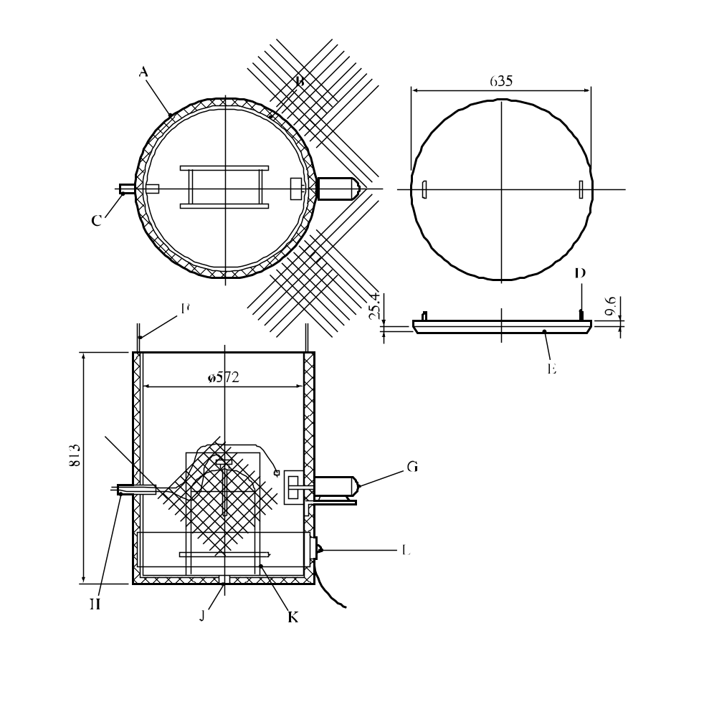

(A) | Insulation 25 mm thick | (B) | 220 litres open top drum
(C) | 19 mm pipe | (D) | 9.6 mm eye bolt in steel cover
(E) | Insulation on steel cover | (F) | 3 mm control cable
(G) | Fan | (H) | Thermocouples and controls
(J) | Drain | (K) | 25 mm angle stand
(L) | 2 kW drum heater
Figure 28.4.1.1: Small package oven

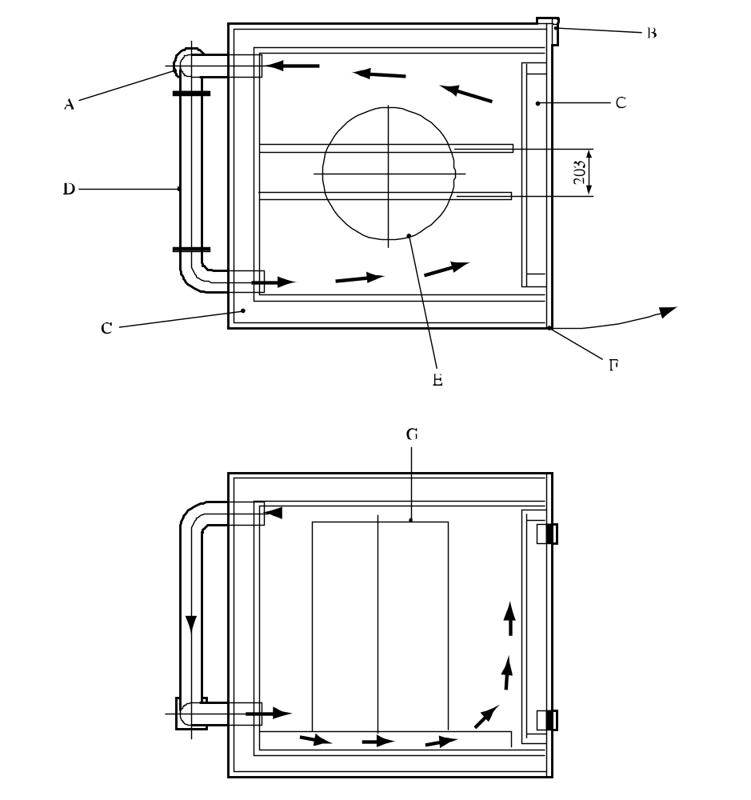

(A) | Fan | (B) | Hinges (2)
(C) | Insulation | (D) | Heater
(E) | Drum | (F) | Latch
(G) | Drum (e.g. 0.58 m × 0.89 m)
Figure 28.4.1.2: Large package oven (top view and side view)

28.4.2 Test H.2: Adiabatic storage test

28.4.2.1 Introduction

28.4.2.1.1 This test method determines the rate of heat generation produced by a reacting substance or mixture as a function of temperature. The heat generation parameters obtained are used with the heat loss data relating to the package to determine the SADT of a substance or mixture in its packaging. The method is appropriate for every type of packaging, including IBCs and tanks.

28.4.2.1.2 Measurements can be performed in the temperature range from -20 °C to 220 °C. The smallest temperature rise that can be detected corresponds to a rate of heat generation of 15 mW/kg. The upper limit is determined by the capacity of the cooling system to safely cool the substance or mixture (up to 500 W/kg if water is used as the coolant). Although the test is not perfectly adiabatic, the heat losses are less than 10 mW. The maximum error is 30% at 15 mW/kg and 10% from 100 mW/kg to 10 W/kg.

28.4.2.1.3 If the cooling system is activated at a stage where the rate of heat generation exceeds the cooling capacity, an explosion may occur. The test site should therefore be carefully selected to reduce to a minimum the possible hazards from an explosion and of a possible subsequent gas explosion of the decomposition products (secondary explosion).

28.4.2.2 Apparatus and materials

28.4.2.2.1 The apparatus consists of a glass Dewar vessel (1.0 or 1.5 litre) to contain the sample, an insulated oven with a differential control system to keep the temperature in the oven to within 0.1 °C of the sample temperature and an inert lid for the Dewar vessel. In special cases, sample holders of other construction materials may have to be used. An inert heating coil and cooling tube pass through the lid into the sample. Pressure build-up in the Dewar vessel is prevented by a 2 m long PTFE capillary tube which passes through the insulated lid. A constant power heating unit is used for internal heating of the substance or mixture to a pre-set temperature or for calibration. Internal heating and cooling may be stopped or started automatically at pre-set temperatures. In addition to the cooling system, a secondary safety device is fitted which disconnects the power supply to the oven at a pre-set temperature. A schematic drawing of the AST is given in Figure 28.4.2.1.

28.4.2.2.2 The temperature of the substance or mixture is measured at its centre by means of thermocouples or platinum resistance sensors placed in a steel or glass tube. The temperature of the surrounding air is measured at the same height as the sample temperature, also with thermocouples or platinum resistance sensors. Continuous temperature measuring and recording equipment is required to monitor the temperature of substance or mixture and the air in the oven. This equipment should be protected from fire and explosion. For substances and mixtures with an SADT below ambient temperature, the test should be performed in a cooling chamber or solid carbon dioxide should be used for cooling the oven.

28.4.2.3 Procedure

28.4.2.3.1 Calibration procedure

The calibration procedure is as follows:

(a) Fill the Dewar vessel with sodium chloride, dibutyl phthalate or with a suitable oil and place it in the vessel holder of the AST oven;

(b) Heat the sample in 20 °C steps using the internal heating system at a known power rating, e.g. 0.333 or 1.000 W, and determine the heat losses at 40 °C, 60 °C, 80 °C and 100 °C;

(c) Use the data to determine the heat capacity of the Dewar vessel using the method given in 28.4.2.4.
28.4.2.3.2 Test procedure

The test procedure is as follows:

(a) Fill the Dewar vessel with the weighed sample, including a representative amount of packaging material (if metal), and place it in the vessel holder of the AST oven;

(b) Start the temperature monitoring and then increase the sample temperature using the internal heater to a pre-set temperature at which detectable self-heating may occur. The specific heat of the substance or mixture can be calculated from the temperature rise, heating time and heating power;

(c) Stop the internal heating and monitor the temperature. If no temperature rise due to self-heating is observed within 24 hours, increase the temperature by 5 °C. Repeat this procedure until self-heating is detected;

(d) When self-heating is detected, the sample is allowed to heat up under adiabatic conditions to a pre-set temperature where the rate of heat generation is less than the cooling capacity, upon which the cooling system is activated;

(e) On cooling, determine the loss in mass, if any, and determine the change in composition (if desired).

28.4.2.4 Test criteria and method of assessing results

28.4.2.4.1 Calculate the rate of temperature drop, A (°C/h), of the Dewar vessel at the different temperatures used in the calibration procedure. Plot a graph through these values in order to allow determination of the rate of temperature drop at any temperature.

28.4.2.4.2 Calculate the heat capacity, H (J/°C), of the Dewar vessel using the formula:

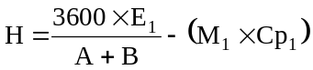

where: E₁ = power applied to the internal heater (W)
A = rate of temperature drop at the temperature of calculation (°C/h)
B = slope of the curve on internal heating (calibration substance) at the temperature of calculation (°C/h)
M₁ = mass of calibration substance (kg)
Cp₁ = specific heat of calibration substance (J/kg.°C)

28.4.2.4.3 Determine the heat loss, K (W), using:

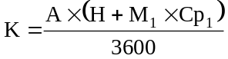

at each desired temperature and draw a graph through these values.

28.4.2.4.4 Calculate the specific heat, Cp₂ (J/kg.°C) of the substance or mixture using:

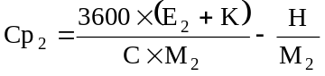

where: E₂ = power applied to the internal heater (W)
C = slope of the curve on internal heating (sample) at the temperature of calculation (°C/h)
M₂ = mass of sample (kg)

28.4.2.4.5 Calculate the heat generation, Q_{T} (W/kg), of the substance or mixture at intervals of 5 °C using the following formula for each temperature:

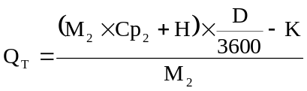

where: D = slope of the curve during the self-heating at the temperature of calculation (°C/h)

28.4.2.4.6 Plot the calculated rates of heat generation per unit of mass as a function of the temperature in a graph with linear scales and draw the best-fit curve through the plotted points. Determine the heat losses per unit of mass, L (W/kg.°C) of the specific package, IBC or tank (see 28.3.5). Draw a straight line of gradient L tangential to the heat generation curve. The intersection of the straight line and the abscissa is the critical ambient temperature i.e. the highest temperature at which the substance or mixture as packaged does not show self-accelerating decomposition. The SADT is the critical ambient temperature (°C) rounded to the next higher multiple of 5 °C. An example is given in Figure 28.4.2.2.

28.4.2.5 Examples of results

Substance/Mixture | Mass  (kg) | Packaging | Heat loss per unit mass (mW/kg.K) | SADT  (°C)
Azodicarbonamide | 30 | 1G | 100 | > 75
tert-Butyl peroxybenzoate | 25 | 6HG2 | 70 | 55
tert-Butyl peroxy-2-ethylhexanoate | 25 | 6HG2 | 70 | 40
tert-Butyl peroxypivalate | 25 | 6HG2 | 70 | 25

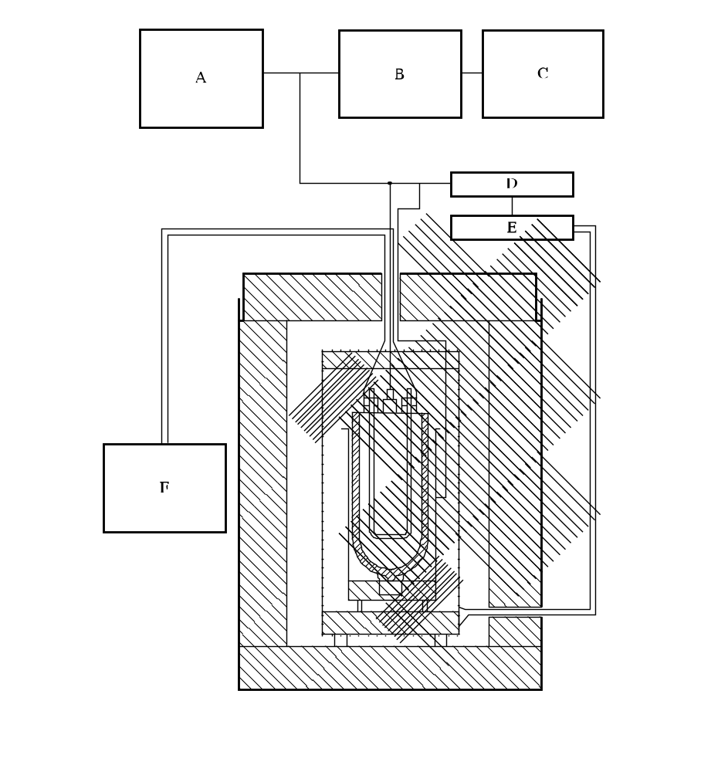

(A) | Multi-point recorder and temperature controller (10 mV) | (B) | External zero set
(C) | Recorder set for greatest accuracy | (D) | Control
(E) | Relay | (F) | Internal pre-heater
Figure 28.4.2.1: Adiabatic storage test

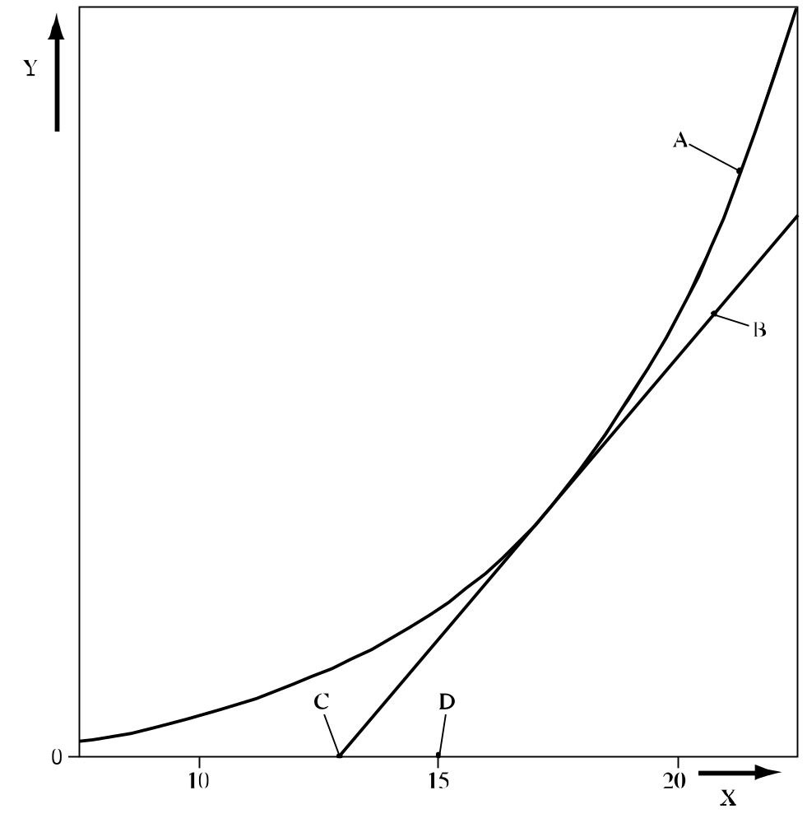

(A) | Heat generation curve
(B) | Line with gradient equal to the rate of heat loss and tangential to the heat generation curve
(C) | Critical ambient temperature (intercept of heat loss line with the abscissa)
(D) | Self-accelerating decomposition temperature (SADT) - critical ambient temperature rounded up to next higher multiple of 5 °C
(X) | Temperature
(Y) | Heat flow (generation or loss) per unit mass
Figure 28.4.2.2: Example of determination of SADT

28.4.3 Test H.3: Isothermal storage test (IST)

28.4.3.1 Introduction

28.4.3.1.1 This method determines the rate of heat generation produced by reacting or decomposing substances or mixtures as a function of time at constant temperature. The heat generation parameters obtained are used with the heat loss data relating to the package to determine the SADT of a substance or mixture in its packaging. The method is appropriate for every type of packaging including IBCs and tanks. Some substances and mixtures may show an increase in the rate of heat generation with increasing decomposition (e.g. due to autocatalysis or induced decomposition). This property is also taken into account by this test method.

28.4.3.1.2 Measurements can be performed in the temperature range of -20 °C to 200 °C. Heat generation values can be measured from 5 mW/kg to 5 W/kg. The thermal resistance between the sample holder and aluminium block via the heat flow meters is about 0.1 W/°C. The apparatus is able to measure rates of heat generation from 15 mW/kg to 1 500 mW/kg with a maximum error of 30% at 15 mW/kg and 5% from 100 to 1 500 mW/kg.

28.4.3.1.3 The robust construction of the apparatus, the relatively small sample size and the well-defined operating conditions enable the test to be performed in an ordinary laboratory. The effects of a thermal explosion, e.g. fragmentation of the sample holder and generation of pressure, should be contained within the apparatus.

28.4.3.2 Apparatus and materials

28.4.3.2.1 The apparatus consists of an air-insulated heat sink (an aluminium block) which is kept at a constant temperature by means of controlled heating. A cryostat is used to maintain temperatures below 40 °C. The heat controller is capable of maintaining the temperature to within 0.2 °C of the set temperature. The temperature of the heat sink is measured with a platinum-resistance sensor. The two holes drilled in the block contain heat flow meters (e.g. Peltier elements). A schematic drawing of the IST is given in Figure 28.4.3.1. For substances and mixtures with an SADT below ambient temperature, the test should be performed in a cooling chamber or solid carbon dioxide should be used for cooling the oven.

28.4.3.2.2 Holders are placed on both heat flow meters: one with the sample and one with an inert substance. Both holders are identical and have a volume of 70 cm³. The amount of substance or mixture in each holder is about 20 g. The holders are made of glass or stainless steel. The steel must be compatible with the test substance or mixture. When using a glass holder, it is provided with a long capillary tube which prevents pressure build-up in the holder and evaporation of the sample.

28.4.3.2.3 The voltage difference resulting from the difference in heat flow from sample holder to the heat sink and inert substance holder to the heat sink is continuously recorded as a function of time (differential measurement) by a recorder or computer.

28.4.3.3 Procedure

28.4.3.3.1 Calibration procedure

Before a measurement can be performed, the blank signal and the sensitivity of the heat flow meter need to be determined by the following calibration procedure.

(a) Set the IST at the selected test temperature;

(b) Insert a heating coil in the sample holder. Fill the sample and reference holders with inert material (e.g. sodium chloride or milled glass beads) ensuring that the heating coil is completely covered with material. Place both holders in the IST;

(c) Determine the blank signal (the output of the recorder when no electric power is applied to the heating coil);

(d) Determine the sensitivity of the heat flow meter using two or three different electrical heating powers which lie within the expected range of heat generation of the sample to be tested.

28.4.3.3.2 Test procedure

The test procedure is as follows:

(a) Set the IST for the desired test temperature;

(b) Fill the sample holder with the weighed sample and with a representative quantity of packaging material (if metal) and insert the holder into the apparatus. The amount of sample should be sufficient to give a rate of heat generation between 5 mW to 1 500 mW per kg of substance;

(c) Start monitoring the rate of heat production. The results from the first 12 hours of the test should not be used because this period is required for temperature equilibration. The duration of each test depends on the test temperature and on the rate of heat production. The test should last for at least 24 hours after the 12 hour equilibration period but can then be stopped if the rate of heat generation is falling from the maximum or if the rate of heat generation is greater than 1.5 W/kg;

(d) At the end of the test the change in sample mass should be determined;

(e) The test is repeated with new samples at temperature intervals of 5 °C so that there are seven results with a maximum heat generation rate between 15 and 1 500 mW/kg.

28.4.3.4 Test criteria and method of assessing results

28.4.3.4.1 Calculate the sensitivity, S (mW/mV), of the instrument at the various electrical powers used in the calibration procedure using the following formula:

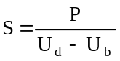

where: P = electric power (mW)
U_{d} = dummy signal (mV)
U_{b} = blank signal (mV)

28.4.3.4.2 Use these values and the test data to calculate the maximum rate of heat generation, Q (mW/kg), at the different test temperatures using the formula:

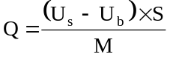

where: U_{s} = sample signal (mV)
M = mass (kg)

28.4.3.4.3 Plot the calculated maximum rate of heat generation per unit of mass as a function of the test temperature on a graph with linear scales and draw the best-fit curve through the plotted points. Determine the heat losses per unit of mass, L (W/kg.°C) of the specific package, IBC or tank (see 28.3.5). Draw a straight line of gradient L tangential to the heat generation curve. The intersection of the straight line and the abscissa is the critical ambient temperature i.e. the highest temperature at which the substance or mixture as packaged does not show self-accelerating decomposition. The SADT is the critical ambient temperature (°C) rounded to the next higher multiple of 5 °C. An example is given in Figure 28.4.3.2.

28.4.3.5 Examples of results

Substance | Mass  (kg) | Packaging | Heat loss per unit mass (mW/kg.K) | SADT  (°C)
Azodicarbonamide | 30 | 1G | 100 | > 75
tert-Butyl peroxybenzoate | 25 | 6HG2 | 70 | 55
tert-Butyl peroxy-2-ethylhexanoate | 25 | 6HG2 | 70 | 40
tert-Butyl peroxypivalate | 25 | 6HG2 | 70 | 25
2,5-Diethoxy-4-morpholinobenzenediazonium  zinc chloride (90%) | 25 | 1G | 150 | 45
2,5-Diethoxy-4-morpholinobenzenediazonium  tetrafluoroborate (97%) | 25 | 1G | 15 | 55
2,5-Diethoxy-4-(phenylsulphonyl)-  benzenediazonium zinc chloride (67%) | 25 | 1G | 15 | 50
2-(N-ethoxycarbonyl-N-phenylamino)-3-  methoxy-4-(N-methyl-N-cyclohexylamino)-  benzenediazonium zinc chloride (62%) | 25 | 1G | 15 | 45
3-Methyl-4-(pyrrolidin-1-yl) benzenediazonium  tetrafluoroborate (95%) | 25 | 1G | 15 | 55

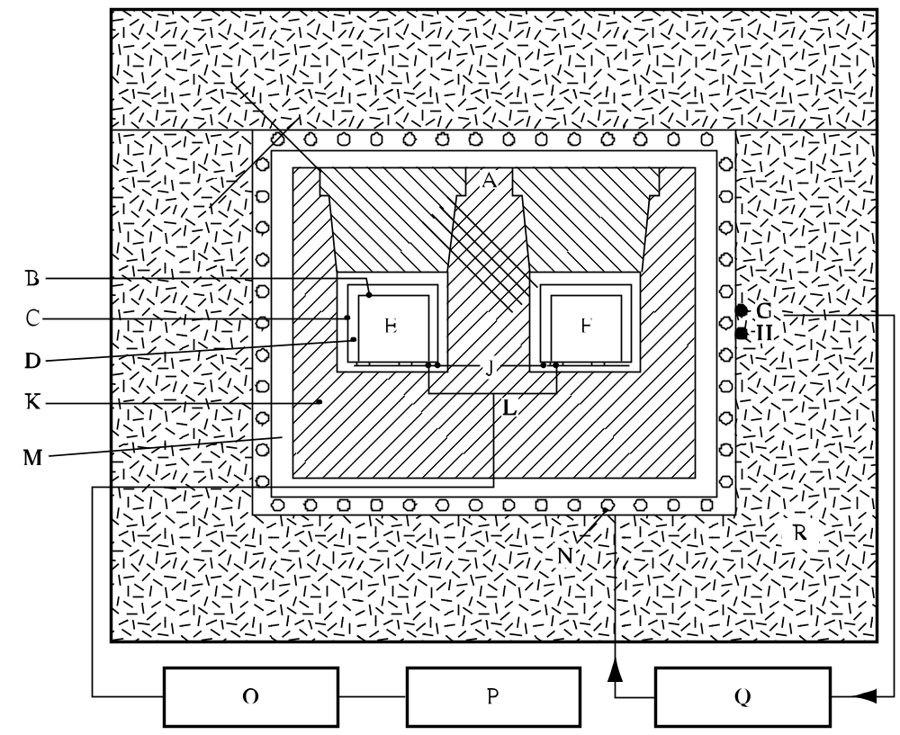

(A) | Platinum resistance thermometer | (B) | Sample vessel
(C) | Cylindrical holder | (D) | Air spaces
(E) | Sample | (F) | Inert material
(G) | Platinum resistance sensor | (H) | Platinum resistance sensor for temperature control for safety control
(J) | Peltier elements | (K) | Aluminium block
(L) | Electric circuit | (M) | Air space
(N) | Heating wires | (O) | Amplifier
(P) | Recorder | (Q) | Temperature controller
(R) | Glass wool
Figure 28.4.3.1: Isothermal storage test

(A) | Heat generation curve
(B) | Line with gradient equal to the rate of heat loss and tangential to the heat generation curve
(C) | Critical ambient temperature (intercept of heat loss line with the abscissa)
(D) | Self-accelerating decomposition temperature (SADT) - critical ambient temperature rounded up to next higher multiple of 5 °C
(X) | Temperature
(Y) | Heat flow (generation or loss) per unit mass
Figure 28.4.3.2: Example of determination of SADT

28.4.4 Test H.4: Heat accumulation storage test

28.4.4.1 Introduction

28.4.4.1.1 This method determines the minimum constant air environment temperature at which thermally unstable substances or mixtures undergo exothermic decomposition at conditions representative of the substance or mixture when packaged as for transport. The method is based on the Semenov theory of thermal explosion i.e. the main resistance to heat flow is considered to be at the vessel walls. The method can be used for the determination of the SADT of a substance or mixture in its packaging, including IBCs and small tanks (up to 2 m³).

28.4.4.1.2 The effectiveness of the method depends on selecting a Dewar vessel with heat loss per unit mass characteristics similar to the package offered for transport.

28.4.4.2 Apparatus and materials

28.4.4.2.1 The experimental equipment consists of a suitable test chamber, appropriate Dewar vessels with closures, temperature probes and measuring equipment.

28.4.4.2.2 The test should be performed in a test cell capable of withstanding fire and overpressure and, preferably, should be fitted with a pressure relief system e.g. a blow out panel. The recording system should be housed in a separate observation area.

28.4.4.2.3 For tests at temperatures up to 75 °C, a double walled metal chamber (ca. 250 mm inner diameter, 320 mm outer diameter and 480 mm high made from 1.5 to 2.0 mm thick stainless steel sheet) is used with fluid from a temperature-controlled circulating bath passed between the walls at the desired temperature. The test chamber is loosely closed by an insulated lid (e.g. made from 10 mm thick polyvinyl chloride). The temperature control should allow the desired temperature for a liquid inert sample in the Dewar vessel to be maintained with a deviation of not more than ± 1 °C for up to 10 days.

28.4.4.2.4 Alternatively, and particularly for tests at temperatures above 75 °C, a thermostatically controlled drying oven (which may be fan-assisted) large enough to allow air circulation on all sides of the Dewar vessel may be used. The air temperature in the oven should be controlled so that the desired temperature for a liquid inert sample in the Dewar vessel can be maintained with a deviation of not more than ± 1 °C for up to 10 days. The air temperature in the oven should be measured and recorded. It is recommended that the door of the oven be fitted with a magnetic catch or replaced by a loosely fitting insulated cover. The oven may be protected by an appropriate steel liner and the Dewar vessel housed in a wire mesh cage.

28.4.4.2.5 For tests at sub-ambient temperatures, a double walled chamber (e.g. a freezer) of suitable size provided with a loose door or lid (e.g. with a magnetic closure) may be used. The temperature of the air in the chamber should be controlled to ± 1 °C of the set temperature.

28.4.4.2.6 Dewar vessels, with their closure system, are used with heat loss characteristics which are representative of the maximum size of package offered for transport. The closure of the Dewar vessel should be inert. Particularly for solids, cork or rubber bungs may used. A closure system for use with liquids with low or medium volatility is illustrated in Figure 28.4.4.1. Samples which are highly volatile at the test temperature should be tested in a pressure-tight metal vessel fitted with a pressure relief valve. The pressure vessel is placed in the Dewar vessel and the effect of the heat capacity of the metal vessel taken into account by calculation.

28.4.4.2.7 The heat loss characteristics of the system used, i.e. Dewar vessel and closure, should be established (see 28.3.6) prior to performance of the test. Since the closure system has a significant effect on the heat loss characteristics, these can be adjusted to some extent by varying the closure system. In order to achieve the required level of sensitivity, Dewar vessels with sample capacities below 0.5 litres should not be used.

28.4.4.2.8 Dewar vessels, filled with 400 ml of substance or mixture, with a heat loss of 80 to 100 mW/kg.K are normally suitable for representing a 50 kg package. For larger packages, IBCs or small tanks larger Dewar vessels with lower heat losses per unit mass should be used. For example, spherical 1 litre Dewar vessels having heat loss characteristics in the range 16 to 34 mW/kg.K may be suitable for IBCs and small tanks.

28.4.4.3 Procedure

28.4.4.3.1 Set the test chamber at the selected storage temperature. Fill the Dewar vessel, to 80% of its capacity, with the substance or mixture under test and note the mass of the sample. Solids should be moderately compressed. Insert the temperature probe into the centre of the sample. Seal the lid of the Dewar in place and insert the Dewar vessel in the test chamber, connect the temperature recording system and close the test chamber.

28.4.4.3.2 The sample is heated and the temperature of the sample and test chamber continuously monitored. The time is noted at which the sample temperature reaches a temperature 2 °C below the test chamber temperature. The test is then continued for a further seven days or until the sample temperature rises to 6 °C or more above the test chamber temperature if this occurs sooner. Note the time taken for the sample to rise from 2 °C below the test chamber temperature to its maximum temperature.

28.4.4.3.3 If the sample survives, cool and remove it from the test chamber and carefully dispose of it as soon as possible. The percentage mass loss and change in composition may be determined.

28.4.4.3.4 Repeat the test with fresh samples, varying the storage temperature in 5 °C steps. If the substance or mixture is being tested to determine if temperature control is necessary, perform sufficient tests to determine the SADT to the nearest 5 °C or to determine if the SADT is greater than or equal to 60 °C. If the substance or mixture is being tested to determine if it meets the SADT criterion for a self-reactive substance or mixture, perform sufficient tests to determine if the SADT for a 50 kg package is 75 °C or less.

28.4.4.4 Test criteria and method of assessing results

28.4.4.4.1 The SADT is reported as the lowest temperature at which the sample undergoes exceeds the test chamber temperature by 6 °C or more. If the sample temperature does not exceed the test chamber temperature by 6 °C or more in any test, the SADT is recorded as being greater than the highest storage temperature used.

28.4.4.5 Examples of results

Substance/Mixture | Sample mass (kg) | Dewar heat loss (mW/kg.K) | SADT  (°C)
Azodicarbonamide | 0.28 | 74 | > 75
Azodicarbonamide, 90% with 10% activator | 0.21 | 70 | 55
2,2'-Azodi(isobutyronitrile) | 0.18 | 62 | 50
Benzene-1,3-disulphohydrazide, 50% | 0.52 | 81 | 70
tert-Butyl hydroperoxide, 80%  with 12% di-tert-butyl peroxide | 0.30 | 72 | 100ª
tert-Butyl peroxyneodecanoate, 40% | 0.42 | 65 | 25
tert-Butyl peroxy-3,5,5-trimethylhexanoate | 0.38 | 79 | 60
Dibenzoyl peroxide, 50% | 0.25 | 91 | 60
Di-(4-tert-butylcyclohexyl) peroxydicarbonate | 0.19 | 79 | 45
2,2-Di-(tert-butylperoxy)butane, 50% | 0.31 | 88 | 80
Di-(2-ethylhexyl) peroxydicarbonate | 0.39 | 64 | 0
2,5-Diethoxy-4-morpholinobenzenediazonium  zinc chloride (66%) | 0.25 | 58 | 45
Diisotridecyl peroxydicarbonate | 0.38 | 80 | 10
Peroxyacetic acid, 15%, with 14% hydrogen peroxide  (type F) | 1.00 | 33 | > 50^{b}
ª In a pressure vessel contained with a 2 litres Dewar vessel.
^{b} In a spherical, 1 litre Dewar vessel.

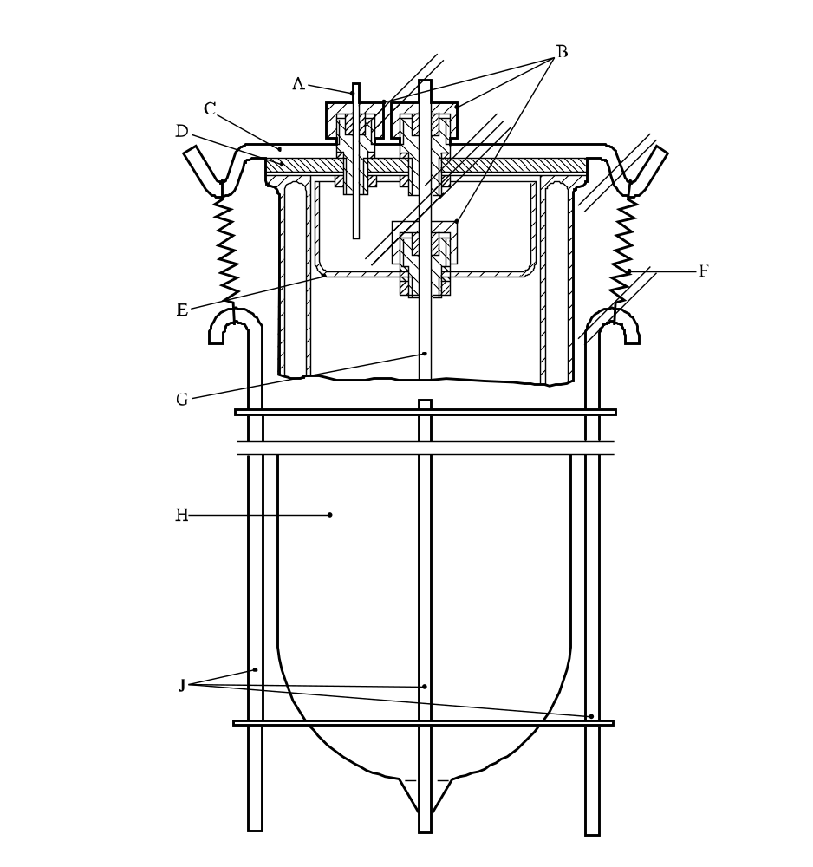

(A) | PTFE capillary tube | (B) | Special screw fittings (PTFE or Al) with O-ring seal
(C) | Metal strip | (D) | Glass lid
(E) | Glass beaker base | (F) | Spring
(G) | Glass protective tube | (H) | Dewar vessel
(J) | Steel retaining device
Figure 28.4.4.1: DEWAR vessel with closure for testing liquids and wetted solid”

1 In special cases, pure aluminium or steel 1.4571 according to DIN 17440 may be used as tube material.
1 When testing liquids, variable results may be obtained because the substance or mixture may give two pressure peaks.
2 Obtainable from the national contact for test details in United Kingdom (see Appendix 4).
3 If preliminary safety-in-handling tests (e.g. heating in a flame) or [burning] tests (e.g. a series 3 type (d) test) indicate that a rapid reaction is likely to occur, then the sample size should be reduced to 0.5 g until the severity of the confined reaction is known. If it is necessary to use a 0.5 g sample size, the sample size is gradually increased until either a "Yes, rapidly" result is obtained or the test is performed with a 5.0 g sample.
1 For reasons of safety, e.g. the substance or mixture is friction sensitive, the substance or mixture need not be tamped. In cases where the physical form of the sample can be changed by compression or compression of the sample is not related to the transport conditions, e.g. for fibrous materials, more representative filling procedures may be used.
2 The upper part of the tube remained in the closing device is counted as one fragment.
1 The use of glass vessels with powerful explosives can damage the mortar liner. Test firings with picric acid in glass vessels caused severe wear but produced the same results as picric acid fired in paper charge bags.

