 | United Nations | ST/SG/AC.10/C.3/2014/24
 | Secretariat |  | Distr.: General  28 March 2014  Original: English
Committee of Experts on the Transport of Dangerous Goods
and on the Globally Harmonized System of Classification
and Labelling of Chemicals
Sub-Committee of Experts on the Transport of Dangerous Goods
Forty-fifth session
Geneva, 23 June – 02 July 2014
Item 7 (f) of the provisional agenda
Miscellaneous proposals for amendments to the Model Regulations
on the Transport of Dangerous Goods: marking and labelling
Marking of portable tanks
Transmitted by the European Chemical Industry Council (CEFIC)
Introduction
1. Compliance with the general requirements on placarding and marking of cargo transport units causes substantive issues considering the specific properties of small portable tanks, which are not being presented as a single cargo transport unit. Regarding a global harmonization of transport of dangerous goods regulations with the Model Regulations, this issue was discussed at the forty-third meeting of the Sub-Committee of Experts on the Transport of Dangerous Goods resulting in a request to CEFIC for an official document on this topic.
2. Based on a related proposal (DSC 17/3/6) to the IMO DSC meeting in September 2012, which was adopted and included to the amendments for the IMDG-Code, CEFIC submitted the informal document INF.37 (44th session) to be discussed at the forty-fourth session of the Sub-Committee.
3. Several experts supported the proposal to authorize placards of reduced size for small portable tanks. For the forty-fifth session CEFIC was invited to submit a working document, taking into account certain editorial comments received during the discussion of the informal document.

Discussion
4. According to the Model Regulations, Chapter 5.3, the following sizes apply for the placarding and marking of cargo transport units:
(a) Placards shall be not less than 250 mm x 250 mm;
(b) The UN number shall be displayed in digits not less than 65 mm high;
(c) The sides of the triangular shaped elevated temperature mark shall be at least
250 mm; and
(d) The environmentally hazardous substance mark shall have a minimum dimension of 250 mm x 250 mm.
5. These requirements are integrally applicable even to small portable tanks, which are not being presented as a cargo transport unit. However, due to the small size and sometimes to the shape of such tank units it is very difficult or impossible to comply with these requirements. The example below clearly illustrates this problem:
Example of a small cylindrical portable tank:
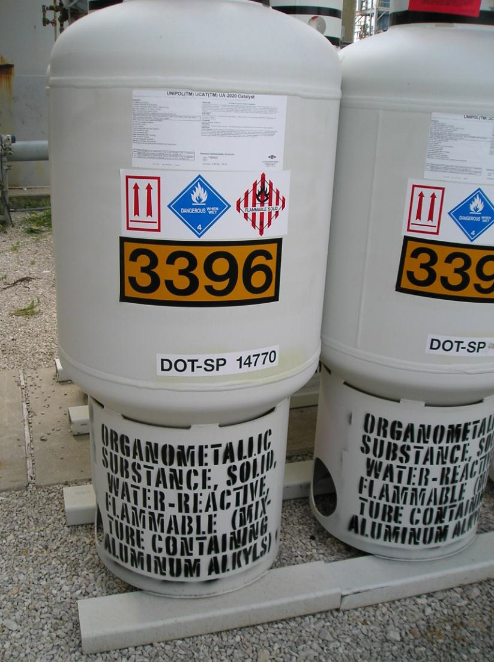
The label size (100 mm x 100 mm) is not in compliance with the placarding requirements (250 mm x 250 mm, four sides) of the Model Regulations, however are in compliance with CFR 49 §172 514 (c)(1); permitting labels as an alternative to placards.
Proposal
6. In consideration of the above, the following amendment is proposed to chapter 5.3. (new text underlined):
5.3.1.1.4 Cargo transport units carrying dangerous goods or the residue of dangerous Goods in unpurged tanks or empty uncleaned bulk containers shall display placards clearly visible on at least two opposing sides of the units and in any case in such a position as may be seen by all those involved in the loading or unloading process. Where the cargo transport unit has a multiple compartment tank which is carrying two or more dangerous goods and/or the residues of dangerous goods, appropriate placards shall be displayed along each side at the position of the relevant compartments. Portable tanks having a capacity of 3000 litres or less which have insufficient area to allow the fixing of placards, may be labelled following 5.2.2 instead of placarded.
5.3.2.1.2 The UN number for goods shall be displayed in black digits not less than 65 mm high, either:
(b) On an orange rectangular panel not less than 120 mm high and 300 mm wide, with a 10 mm black border, to be placed immediately adjacent to each placard (see Figure 5.3.3). For portable tanks having a capacity of 3000 litres or less the UN number shall be displayed on an orange rectangular panel with appropriately reduced size on the external surface of the tank in characters not less than 12 mm high.
5.3.2.2 Elevated temperature substances (second paragraph)
The marking shall be an equilateral triangle. The colour of the mark shall be red. The minimum dimensions of the sides shall be 250 mm x 250 mm. For portable tanks having a capacity of 3000 litres or less the minimum dimensions may be reduced to 100 mm x 100mm. Where dimensions are not specified, all features shall be in approximate proportion to those shown.
5.3.2.3.2 The environmentally hazardous substance mark for cargo transport units shall be as described in 5.2.1.6.3 and Figure 5.2.2, except that the minimum dimensions shall be 250 mm x 250 mm. For portable tanks with a capacity of 3000 litres or less the minimum dimensions may be reduced to 100 mm x 100 mm.
Justification
7. Reduction of the prescribed minimum size for placards and markings as proposed for small portable tanks, which are not being presented as a cargo transport unit, does not result in a loss of information and also does not impair the warning effect of the required hazard symbols. The proposed amendment considers the specific properties of small portable tanks and allows being compliant with the placarding and marking requirements for cargo transport units in any case.

In accordance with the programme of work of the Sub-Committee for 2013-2014 approved by the Committee at its sixth session (refer to ST/SG/AC.10/C.3/84, para. 86 and ST/SG/AC.10/40, para. 14).

