 | United Nations | ST/SG/AC.10/C.3/2012/91
 | Secretariat |  | Distr.: General  17 September 2012  Original: English
Committee of Experts on the Transport of Dangerous Goods
and on the Globally Harmonized System of Classification
and Labelling of Chemicals
Sub-Committee of Experts on the Transport of Dangerous Goods
Forty-second session
Geneva, 3 – 11 December 2012
Item 2 (b) of the provisional agenda
Recommendations made by the Sub-Committee on its thirty-ninth,
fortieth and forty-first sessions and pending issues: listing, classification and packing
Adsorbed gas classification and packaging
Transmitted by the Council on Safe Transportation of Hazardous Articles (COSTHA)
Introduction
- The classification of gases adsorbed onto solid porous materials (adsorbents) was discussed at the forty-first (41st) session of the Sub-Committee (ST/SG/AC.10/C.3/2012/36).
- A number of comments were received during the discussion. Based on these comments, COSTHA has revised the proposed language and has included discussion of relevant changes below.
New entries versus existing entries
- During the previous session, the Sub-Committee indicated through vote a general support for new entries versus adopting changes to existing entries. Therefore COSTHA is proposing new entries to the Dangerous Goods List. However, to assist the Sub-Committee in agreeing to new entries, the following arguments are presented.
- Adding new entries for adsorbed gases is a less complex and unambiguous approach than the alternative of using the existing entries for compressed and liquefied gases. The fundamental problem using the existing entries is that they are inextricably linked to a material that requires packaging under pressure contrary to an adsorbed gas which is essentially pressureless. This difference in pressure affects many aspects of the dangerous goods transportation lifecycle including packaging, hazard communication and emergency response. Careful analysis of the Regulations reveals conflicts and technical inaccuracies if the existing entries are applied to adsorbed gases. Several examples how the new entries overcome the shortcomings of using existing entries are as follows:
Hazard communication example
- There are many gases that can be adsorbed on a solid adsorbent which are not specifically mentioned by name in the Dangerous Goods List. For example, the logical existing N.O.S. entry that would be selected for germanium tetrafluoride adsorbed on a solid is UN 3308, LIQUEFIED GAS, TOXIC, CORROSIVE, N.O.S. The problem using this entry is miscommunication of the physical state of the gas. Although an adsorbed gas is not a liquefied gas, using this entry would communicate it as such. A simple demonstration of this conflict would be if one were to invert a cylinder of liquefied germanium tetrafluoride and then open the cylinder valve; germanium tetrafluoride liquid and vapor would rapidly be expelled from the cylinder. The germanium tetrafluoride liquid in itself represents a unique hazard as it can evaporate rapidly and cools the surface it is in contact with. In the event of an emergency response it may be necessary to protect the responder from the danger of frostbite where special personal protective equipment would be required. Additional emergency response equipment may be necessary to contain, neutralize and dispose of the liquid.
- If one were to repeat the same demonstration with adsorbed germanium tetrafluoride, no liquid is expelled from the cylinder and the frostbite and liquid spill hazard is eliminated. Therefore an emergency response to an adsorbed gas can be streamlined if one knows the difference between an absorbed gas and a liquefied gas.
- Based on the preceding argument it is clear a more appropriate entry for adsorbed germanium tetrafluoride would be one that does not include the term “Liquefied”. The only other alternative in the Dangerous Goods List would be to use UN 3304, COMPRESSED GAS, TOXIC, CORROSIVE, N.O.S. Again this is an inadequate choice as adsorbed germanium tetrafluoride is not compressed, but at a pressure less than 1 atmosphere (101.3 kPa).
- Therefore a new entry specifically describing the condition of the adsorbed gas is warranted. An example of the new entry that would apply to adsorbed germanium tetrafluoride is as follows:
“UN 3EEE, ADSORBED GAS, TOXIC, CORROSIVE, N.O.S.
(Germanium tetrafluoride adsorbed on porous carbon)”
Additional emergency response examples
- If existing entries are used, the responder will treat an adsorbed gas package as if it were a compressed or liquefied gas which could result in inappropriate or inefficient response. For example:
- Release rates and quantities from a potential leaking adsorbed gas cylinder are much less than those for compressed and liquefied gas cylinders. The new entries would facilitate creation of new isolation and protective action distances for adsorbed gases commensurate with their release amounts and emission rates. This type of emergency guidance is normally indexed by UN number in national emergency response guidebooks. If the existing UN entries are used, the emergency guidance will likely remain the same and more restrictive than necessary.
- An adsorbed gas package does not contain gas under pressure and therefore does not present the same physical hazards associated with a compromised compressed or liquefied gas package. For example, protection from shrapnel, cryogenic liquid, and missile projection of a compromised adsorbed gas package is not necessary.
- Containment vessels used for adsorbed gas packages have different specifications than those used for compressed and liquefied gases. The new UN entries would promote an appropriate level of differentiation between adsorbed gas and gas under pressure so that the proper containment equipment can be selected during an emergency response.
Additional justification for new adsorbed gas entries based on 2.0.2.5 of the Regulations
- Based on the preceding arguments describing the change in properties and differences in emergency response procedures for an adsorbed gas vs. liquefied and compressed gases it follows from 2.0.2.5 of the Model Regulations that adsorbed gases should be treated as a dangerous substance not specifically listed by name in the Dangerous Goods List.
- To further substantiate this interpretation, a review of 2.0.2.5 as it relates to adsorbed gases is as follows:
2.0.2.5 A mixture or solution meeting the classification criteria of the Regulations composed of a single predominant substance identified by name in the Dangerous Goods List and one or more substances not subject to these Regulations (e.g. the adsorbent) and/or traces of one or more substances identified by name in the Dangerous Goods List, shall be assigned the UN number and proper shipping name of the predominant substance in the Dangerous Goods List unless:
- The mixture or solution is identified by name in the Dangerous Goods List;
- The name and description of the substance named in the Dangerous Goods List specifically indicate that they apply only to the pure substance;
- The hazard class or division, subsidiary risk (s), packing group, or physical state of the mixture or solution is different from that of the substance named in the Dangerous Goods List; or
- The hazard characteristics and properties of the mixture or solution necessitate emergency response measures that are different from those required for the substance identified by name in the Dangerous Goods List.
In those other cases, except the one described in (a), the mixture or solution shall be treated as a dangerous substance not specifically listed by name in the Dangerous Goods List.
- Since the physical state, properties, hazard characteristics of an adsorbed gas are different than for the gas in the liquefied or compressed state, then it follows from 2.0.2.5 (c) & (d) and the last sentence in 2.0.2.5 that adsorbed gases should be treated as a dangerous substance not specifically listed by name in the Dangerous Goods List. Since there are no adequate exiting N.O.S entries for an adsorbed gas, it is logical to create new entries as suggested in this proposal.
Alternative to creating new entries for adsorbed gases
- An alternative route to include adsorbed gases in the Regulations is to use existing entries in the Dangerous Goods List combined with a new packing instruction and special provisions specific to adsorbed gases. If existing entries are used in combination with a new packing instruction and special provisions, there will be a significant burden in the revision process as ~150 entries in the Dangerous Goods List would have to be revised to include the new packing instruction and special provision. Compartmentalizing the listing for adsorbed gases into 9 separate new entries minimizes the revision burden and eliminates introducing ambiguity and error opportunities into the Regulations by combining requirements of adsorbed gases with compressed and liquefied gases.
Number of needed new entries for adsorbed gases
- During the previous session several commenters noted that the proposed six new entries for adsorbed gases did not include all possible combinations of class/division/subsidiary risk that can be assigned for gases of class 2. In order to identify all possible combinations, a review of the dangerous goods entries for gases was conducted. The review identified nine class/division/subsidiary risk combinations for COMPRESSED GAS N.O.S. entries and nine class/division/subsidiary risk combinations for the LIQUFIED GAS N.O.S. entries. Therefore 3 new entries were added to the previous list of six new entries for adsorbed gases.
Simplification of shipping name for sdsorbed gases
- An additional comment related to the new entries suggested a simplified name for adsorbed gases. COSTHA agrees with the comment and therefore have changed the new entry shipping name for adsorbed gases from “GAS ADSORBED ONTO A POROUS SOLID” to “ADSORBED GAS”. The simplified name is consistent with other gas related N.O.S. entries such as “LIQUEFIED GAS” and “COMPRESSED GAS”.
Quality control of adsorbents
- A commenter during the 41st session suggested that a statement be added to the new special provision XYZ that provides assurance the adsorbent will perform properly after repeated use. Therefore a new statement has been added to special provision XYZ that requires a method for verifying the quality of the adsorbent at the time of each fill and prior to offering the package for transportation.
Competent Authority approved cylinders
- A comment was made during the 41st session that competent authority approved compressed gas cylinders and receptacles should not be included in the new packing instruction P2YY as the Model Regulations include only UN pressure receptacles which are designed, constructed and tested in accordance with specific ISO standards. COSTHA agrees that it is inappropriate to include competent authority approved compressed gas cylinders and receptacles in the Model Regulations and therefore have removed this statement from the new packing instruction P2YY.
Approved cylinders per packing instruction P2YY
- A comment was made regarding the wording of the following statement in the new packing instruction P2YY:
- Cylinders constructed in accordance with ISO 11513:2011 and ISO 9809-1:1999
- The commenter suggested that the word “and” be changed to “or”, acknowledging the fact that these standards may be exclusive of each other COSTHA agrees with this comment and therefore have revised the proposal accordingly.
Pressure vs. temperature behaviour of adsorbed gases
- During the 41st Session, at least one delegation questioned whether other adsorbed gases not shown on the chart showing the pressure of several types of adsorbed gas packages as a function of temperature would have similar behaviour. The answer to this question is yes. The reason why other gases will have similar pressure vs. temperature characteristics is because of the controls included in the new special provision XYZ that are applicable to adsorbed gases.
- These special provisions limit the maximum pressure the adsorbed gas package can attain under several circumstances as follows:
- Adsorbed gas packages, regardless of gas type cannot exceed 101.3 kPa (1.013 bar) or 1 standard atmosphere of pressure at 20 °C;
- At 50 °C, adsorbed gas packages cannot exceed 300 kPa (3 bar);
- At 65 °C, adsorbed gas packages cannot exceed the test pressure of the adsorbed gas pressure receptacle.
22. The chart presented in formal paper ST/SG/AC.10/C.3/2012/36 during the 41st session has been modified to better explain the pressure vs. temperature requirements for adsorbed gases as shown in Figure 1.
23. The red shaded areas of the chart show regions where the pressure vs. temperature curve for any adsorbed gas package cannot intersect in accordance with special provision XYZ. The three example adsorbed gas package curves for UN 1008, UN 2199 and UN 2188 all meet this requirement as their pressure vs. temperature curves are completely contained in the green shaded area (“allowed region”) in the chart.
24. In practice, any adsorbed gas package can be made to comply with the maximum allowable pressure requirements in special provision XYZ and fit within the green region of the chart by controlling the amount of gas that is filled into an adsorbed gas package.
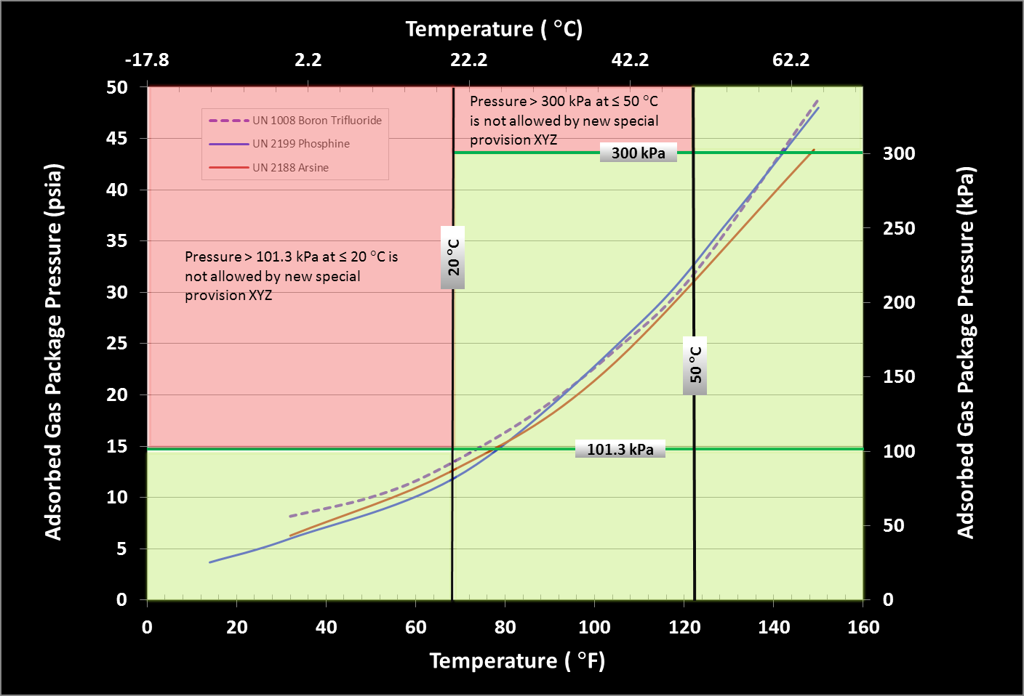
Figure 1—Adsorbed Gas Package Pressure as a Function of Temperature
Update of ISO Standard ISO 9809-1: 2010
25. During the 41st session, the Sub-Committee adopted the reference to the new ISO 9809-1 standard. The new standard, ISO 9809-1:2010 is now referenced in the proposed packing instruction P2YY.
Introduction of ISO 11513:2011 into the Model Regulations
26. ISO has developed a new standard addressing welded cylinders containing an adsorbent material. It is appropriate to include the new standard in Model Regulations and in the proposed new packing instruction P2YY. Therefore COSTHA proposes to introduce ISO 11513:2011 into an appropriate new sub-section of the Model Regulations in Chapter 6.2.
27. Therefore the proposal introduces ISO 11513:2011 in the new sub section, 6.2.2.1.6. Additionally, COSTHA proposes to add ISO 11513:2011 to the list of standards applicable to the periodic inspection and test of UN cylinders in subsection 6.2.2.4.
Justification for minimum test pressure and burst pressure
28. During the 41st session, the Sub-Committee requested clarification as to why the test pressure and burst pressure proposed in the packing instruction P2YY were chosen. The justification for selecting the test pressure and burst pressure are as follows:
Test pressure justification
29. The minimum test pressure for adsorbed gas pressure receptacles proposed in the new packing instruction P2YY is 21.7 bar. The units of bar are used as that is customarily the units used in the Regulations for test pressure. The proposed test pressure is supported by the following arguments:
(a) The test pressures specified in P200 for liquefied gas pressure receptacles are ~1.5-7 times the vapor pressure of the gas at 20 °C. For example arsine (UN2188) has a vapor pressure of 15 bar at 20 °C and P200 requires a test pressure of 42 bar for pressure receptacles used to package arsine. Phosphine (UN2199) has vapor pressure of 35 bar at 20 °C and requires pressure receptacles with test pressures of either 225 or 250 bar depending on fill ratio. In the case of an adsorbed gas package, the vapor pressure of the adsorbed gas at 20 °C must be less than 1.013 bar (1 standard atmosphere) in accordance with the new packing instruction P2YY. A test pressure of 21.7 represents a test pressure/vapor pressure ratio of >20 which is at least 2X higher than the ratio required for liquefied gases in P200 and significantly higher than the minimum 1.5 test pressure/working pressure ratio required for compressed gases.
(b) Furthermore, new special provision XYZ specifies that the adsorbed gas package cannot exceed the test pressure of the adsorbed gas pressure receptacle at 65 °C.
(c) 21.7 bar is the test pressure for more than 20,000 competent authority approved adsorbed gas pressure receptacles in service since 2004. Experience gained during operation of this fleet indicates 21.7 bar is a sufficient test pressure as there have been zero incidents in the fleet and no evidence of degradation in the receptacles upon reinspection.
30. In order to be consistent with the level of precision used in the Model Regulations for test pressure, the test pressure of 21.7 bar specified in packing instruction P2YY has been revised to 21 bar. This change still maintains a safety factor greater than 20X.
Burst pressure justification
31. The minimum burst pressure of 94.5 bar is derived from ISO 11513:2011. This burst pressure rating provides a greater safety margin compared to compressed and liquefied gas packagings where burst pressure/service pressure ratio range from 3-12. An adsorbed gas package will have a minimum burst pressure/service pressure ratio of more than 90 at 20 °C, and more than 35 at 50 °C by virtue of its low package pressure and a relatively robust packaging design.
Periodic inspection period
32. The periodicities for the periodic inspection and test of pressure receptacles used to package Class 2 gases are listed in packing instruction P200 of the Model Regulations. The list in P200 includes gases in the compressed, liquefied and dissolved state and several substances not in class 2. P200 assigns a 5 year or 10 year test period interval depending on the classification code assigned to the gas. Gases without a toxic classification are assigned a 10 year testing period and gases with a toxic classification (Division 2.3) are assigned a 5 year testing period.
33. The current proposal requests extension of the test period for Division 2.3 adsorbed gases from 5 years to 10 years based on the following justification:
34. Periodic inspection and test of pressure receptacles is done to insure that the performance level of the receptacle has not degraded after a period of use. In service, steel pressure receptacles can degrade due to general corrosion, pitting corrosion, stress corrosion, metal fatigue, and degradation of mechanical properties, heat or fire damage, and physical damage (denting etc.) which may lead to failure of the receptacle during service. The negative consequences of a pressure receptacle failure include the release of the hazardous gaseous contents and the dangerous physical hazard when a pressurized receptacle fails (i.e. ruptures). To prevent unexpected failures of pressure receptacles in service they are designed with a sufficient safety factor.
35. The safety factor can be expressed as the ratios of test pressure to service (working) pressure (P_{T}/P_{S}) and burst pressure to service pressure P_{B}/P_{S} which provide a margin for degradation of a pressure receptacle during service. Some typical safety factors for compressed, liquefied and adsorbed gas receptacles are listed in Table 1.
Table 1
P_{T}/P_{S} and P_{B}/P_{S} for Pressure Receptacles Containing Liquefied,
Compressed and Adsorbed Gases
Packaging Type | Typical Minimum P_{T}/P_{S} | Typical Minimum P_{B}/P_{S}
Liquefied Gas | 1.5-7 | 3-12
Compressed Gas¹ | 1.5 | 3-6
Adsorbed Gas | >20 | >90
¹ UN 1045, UN 1660 & UN 2190 require P_{T}/P_{S} > 1.5.
36. Periodic inspection and test may include hydraulic pressure testing of the cylinder, internal and external visual inspection, pneumatic pressure testing, acoustic emission testing (AE) or a combination of acoustic emission and ultrasonic examination (UE). The application of these tests and verifications serves to identify any cylinders that are damaged or degraded so that they can be removed from service.
37. Adsorbed gas packages have been manufactured and shipped for over 20 years. Approximately 160,000 units have been shipped and returned, many internationally, without incident. Ultrasonic examination of a large number of adsorbed gas receptacles in the fleet over five years old supports an extended test period interval. There has not been a single cylinder rejected by ultrasonic examination in the fleet of ~160,000 cylinders requiring reinspection.
38. When adsorbed, as in this application, gases meeting the requirements of the proposed condition of transport are less reactive and more stable with respect to corrosive interactions with the cylinder and/or decomposition than gases in a pressurized state.
39. The low operating pressure (< 1 bar) and greater safety margin of the sub-atmospheric package combined with negligible mechanical or chemical degradation mechanisms reduces the probability a container will fail relative to a gas packaged in the compressed or liquefied state.
40. If an adsorbed gas receptacle were to fail, the lack of any significant pressure avoids the dangerous physical hazard that happens when compressed gas cylinders fail (e.g. rupture). Furthermore, the release of the receptacle contents is greatly reduced; both rate of loss of the inventory, as well as, the actual percentage vented. Without pressure as a driver, estimated losses would be 0.1- 5% of the total inventory during extreme transportation temperatures and/or altitudes and ~ 0% at normal temperature and pressure. The time lapse photos below of simulated cylinder failures (punctured by a bullet) visually show the difference in hazard characteristics between a liquefied carbon dioxide (CO₂) package and adsorbed gas CO₂ cylinder. The pictures show that the liquefied CO₂ receptacle rapidly releases its pressurized contents and the attendant energy violently launches the receptacle from the ground. The adsorbed gas package shows no visual sign of a gas release and the cylinder gently falls on to its side due to the impact of the bullet.
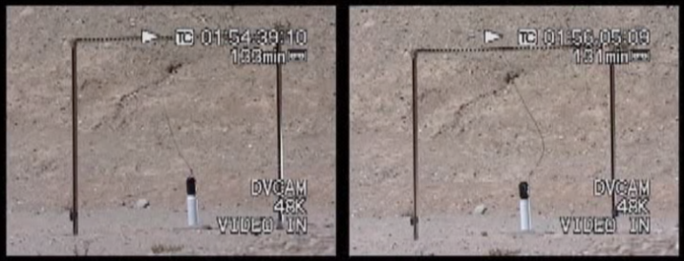

Liquefied CO₂
0 Seconds
Adsorbed CO₂
0 Seconds

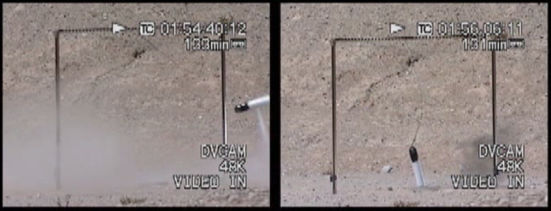

Liquefied CO₂ 1 Second after Puncture
Adsorbed CO₂ 1 Second after Puncture

Figure 2—Time Lapse Photos of Puncture to Liquefied and Adsorbed CO₂ Packages

41. Therefore, extending the test period for periodic inspection and test of division 2.3 adsorbed gas cylinders from 5 to 10 years is justifiable based on the significantly higher design safeguards [Table 2] and reduced probability of failure and severity of consequences between an adsorbed gas package and gases packaged under pressure.
42. The U.S. DOT took these points into consideration when it allowed a re-test interval of 10 years when granting permission to ship adsorbed gases in competent authority approved pressure receptacles in 2003.
43. It is also worth noting that the Regulations should provide incentive to utilize packaging technology that reduces the risk of a hazardous material transportation incident. Extending the test period for Division 2.3 adsorbed gases from 5 years to 10 years helps in this regard.
Proposals
44. Amend 2.2.1.2 to include a new transport condition of a gas as follows:
“ (e) Adsorbed gas—a gas which when packaged for transport is adsorbed onto a solid porous material resulting in an internal receptacle pressure of < 101.3 kPa at 20 °C and less than 300 kPa at 50 °C.”
45. Add nine new entries (UN 3XXX, UN 3YYY, UN 3AAA, UN 3BBB, UN 3CCC, UN 3DDD, UN 3EEE, UN 3FFF, 3GGG) in Class 2.
(a) Add nine new entries to the Dangerous Goods List, as follows:
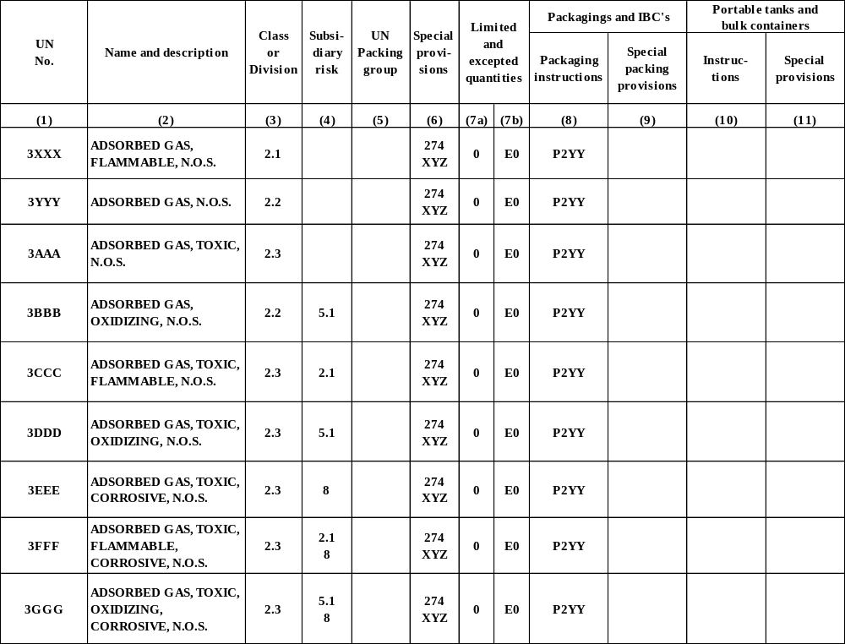
    - Add the nine new N.O.S. entries to Appendix A
46. Add a new special provision XYZ in Chapter 3.3
XYZ: This entry applies to gases of class 2 adsorbed onto a solid porous material inside a pressure receptacle with a closure.
The pressure receptacle containing the adsorbed gas shall be at a pressure less than 101.3 kPa at the time the filled pressure receptacle is closed and thermally equilibrated to 20 °C. The internal pressure of the filled pressure receptacle shall not exceed 300 kPa at 50 °C. At any time during the normal condition of transport, the internal pressure of the pressure receptacle cannot exceed the working pressure of the receptacle. In no case shall the internal pressure at 65 °C exceed the test pressure of the pressure receptacle.
The adsorbent material shall be compatible with the pressure receptacle and does not form harmful or dangerous compounds with the gas to be adsorbed.
The gas in combination with the adsorbent material shall not affect or weaken the pressure receptacle or cause a dangerous effect (e.g. catalyzing a reaction).
The quality of the adsorbent shall be verified at the time of each fill to assure the pressure and chemical stability requirements of special provision XYZ are met each time an adsorbed gas package if offered for transportation.
The adsorbent material shall not meet the definition of any of the hazard classes in the Model Regulations.
Each cylinder shall be leak tested using a helium leak test as specified in ISO 11513:2011
The filling procedure shall be in accordance with Annex A of ISO 11513:2011
Periodic inspection and test shall be in accordance with Annex B of ISO 11513:2011
47. Add a new packing instruction P2YY as follows:
P2YY PACKING INTRUCTION P2YY
This instruction applies to UN 3XXX, UN 3YYY, UN 3AAA, UN 3BBB, UN 3CCC, UN 3DDD, UN 3EEE, UN 3FFF, UN 3GGG
- The following packagings are authorized provided the general packaging requirements of 4.1.6.1 are met.

- Cylinders constructed in accordance with ISO 11513:2011 or ISO 9809-1:2010

- The pressure of each filled gas cylinder or receptacle shall be less than 101.3 kPa at 20 °C.

- The minimum test pressure of the cylinder is 21 bar.

- The burst pressure of the cylinder shall not be less than 94.5 bar.

- Requirements for adsorbed gas packages containing toxic gases with an LC₅₀ less than or equal to 200 ml/m³ (ppm).

  - Valve outlets shall be fitted with pressure retaining gas-tight plugs or caps having threads matching those of the valve outlets.
  - Each valve shall either be of the packless type with non-perforated diaphragm, or be of a type which prevents leakage through or past the packing.
  - Each pressure receptacle shall be tested for leakage after filling.
  - Each valve shall be capable of withstanding the test pressure of the pressure receptacle and be directly connected to the pressure receptacle by either a tapered thread or other means which meets the requirements of ISO 10692-2:2001.
  - Pressure receptacles shall not be fitted with a pressure relief device.

- Adsorbed gas packages containing pyrophoric gases shall be fitted with gas-tight plugs or caps having threads matching those of the valve outlets.

- The material compatibility special packaging provisions of P200 (a, b, c and d) apply to adsorbed gas packagings for the specific gas being adsorbed.

- The interval between test periods for periodic inspection shall be 10 years.
48. Amend 6.2.1.1.5 as follows:
The test pressure of cylinders, tubes, pressure drums and bundles of cylinders shall be in accordance with packing instructions P 200, or, for a chemical under pressure, with packing instruction P206. The test pressure of a closed cryogenic receptacle shall be in accordance with packing instruction P203. The test pressure of a metal hydride storage system shall be in accordance with packing instruction P205. The test pressure of the cylinder for a gas adsorbed on a solid shall be in accordance with P2YY.
49. Add ISO 11513:2011 to the list of UN pressure receptacles in sub section 6.2.2.1 in the new sub section 6.2.2.1.6 as follows:
“6.2.2.1.6 The following standard applies for the design, construction and initial inspection and test of UN cylinders for gases adsorbed onto a porous solid. The inspection requirements related to the conformity assessment system and approval for cylinders shall be in accordance with 6.2.2.5.
Reference | Title
ISO 11513:2011 | Gas cylinders — Refillable welded steel cylinders containing materials for sub-atmospheric gas packaging (excluding acetylene) — Design, construction, testing, use and periodic inspection
50. Amend the list of standards for periodic inspection and test in 6.2.2.4 to include ISO 11513:2011 by adding the standard to the end of the list as follows:
ISO 11513:2011 | Gas cylinders — Refillable welded steel cylinders containing materials for sub-atmospheric gas packaging (excluding acetylene) — Design, construction, testing, use and periodic inspection

In accordance with the programme of work of the Sub-Committee for 2011-2012 approved by the Committee at its fifth session (refer to ST/SG/AC.10/C.3/76, para. 116 and ST/SG/AC.10/38, para. 16).

