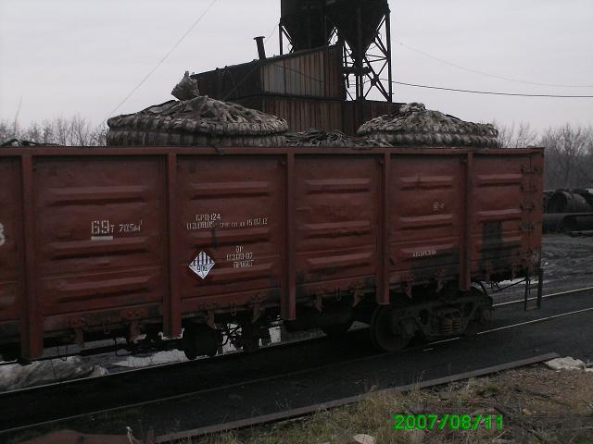
Picture 1: FBC loaded with coal-tar asphalt UN3077 in a railway car
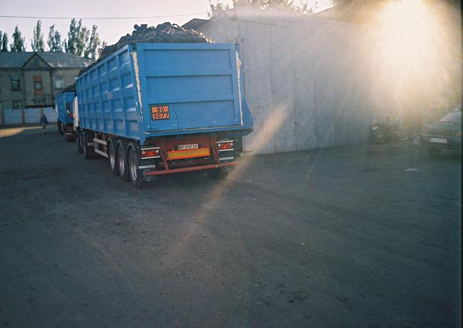
Picture 2: FBC loaded with coal-tar asphalt UN3077 in a truck
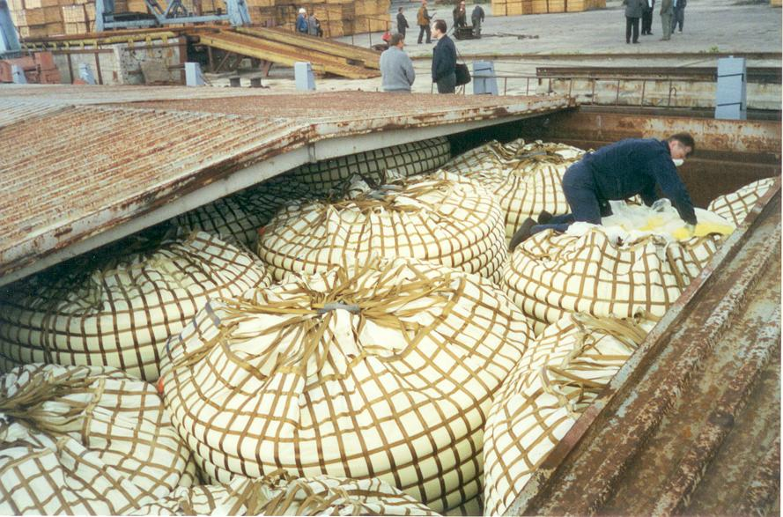
Picture 3: FBC loaded with sulphur UN1350 in a vessel hold
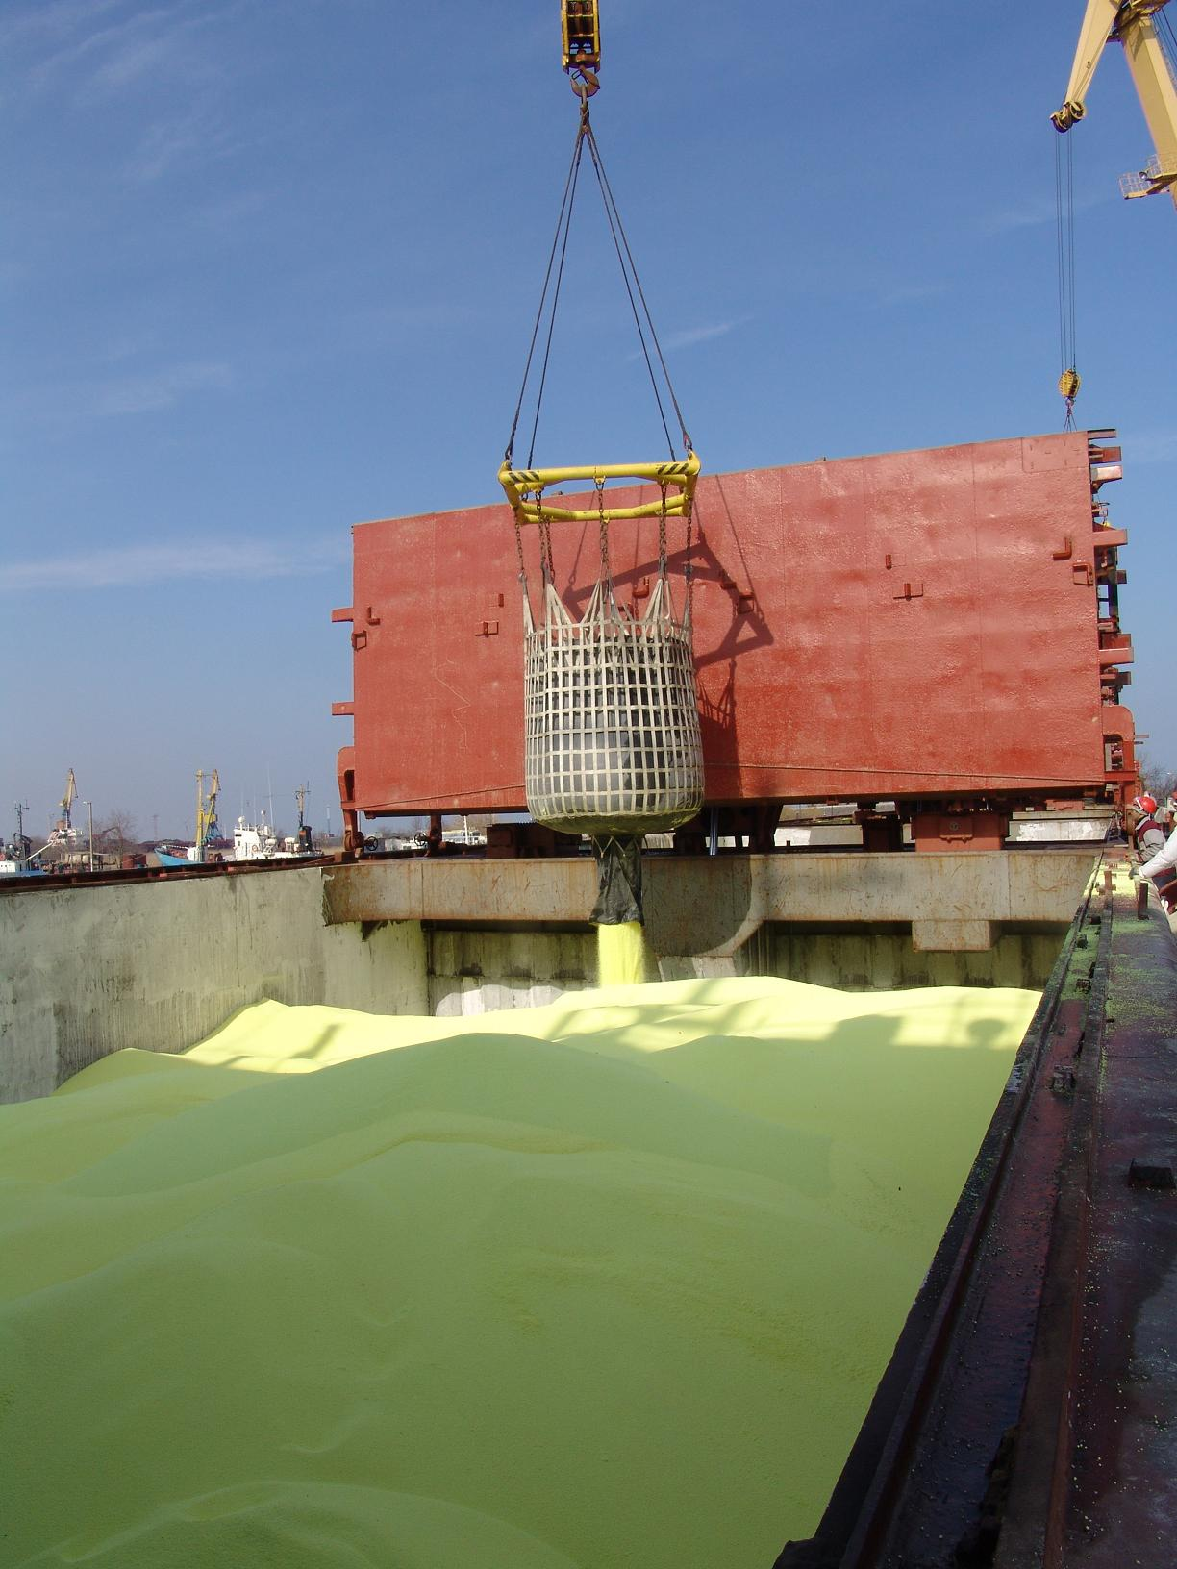
Picture 4: Sulphur unloading from FBC into a vessel hold 2
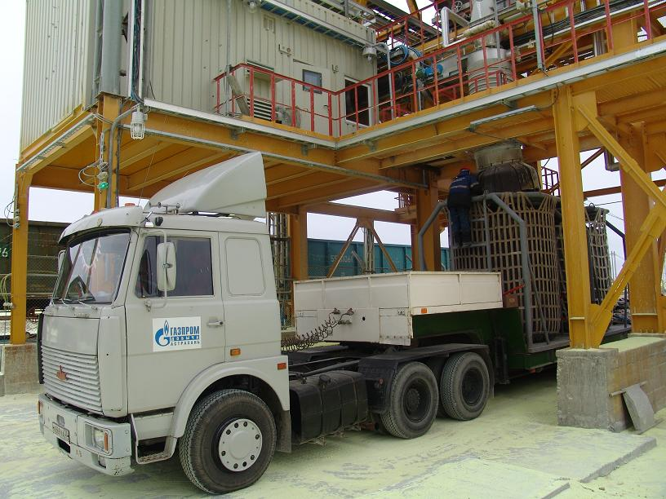
Picture 5: Sulphur UN1350 loading into FBC in a holding car
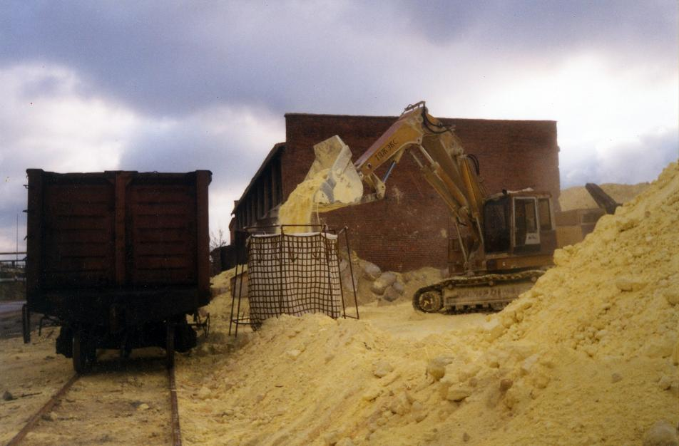
Picture 6: Sulphur UN1350 loading into FBC
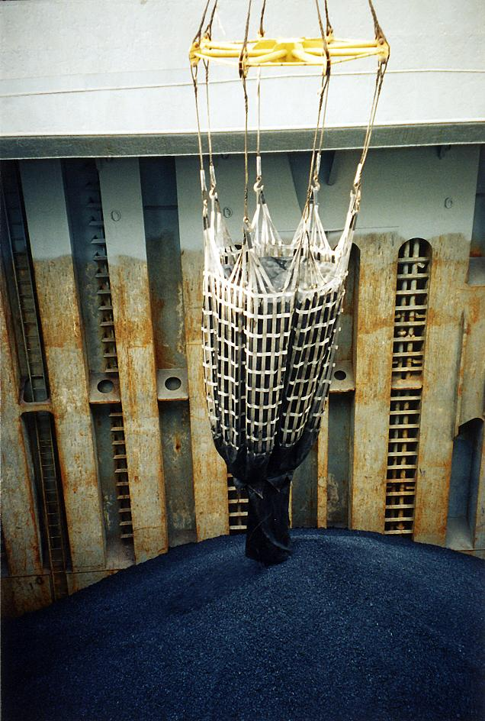
Picture 7: Unloading of coal-tar asphalt UN3077 from FBC to vessel hold
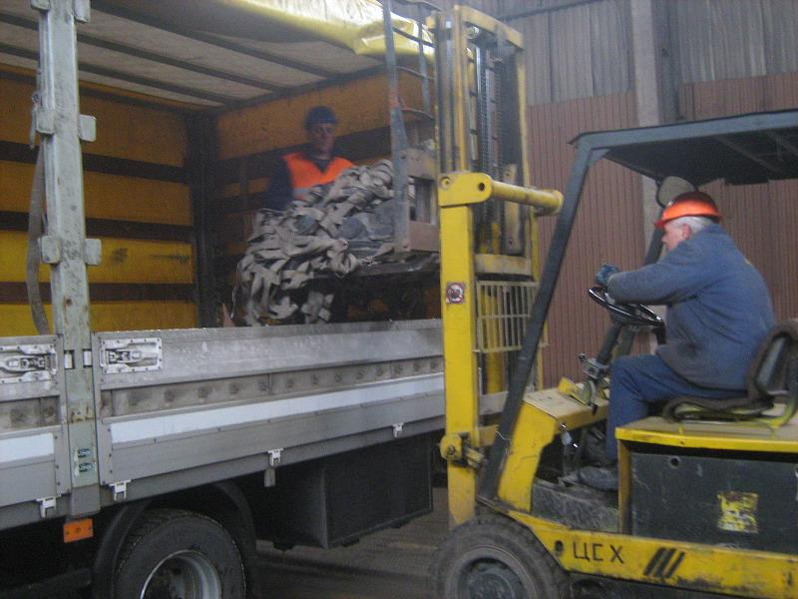
Picture 8: Tightly folded FBC being loaded into a truck with a lifter
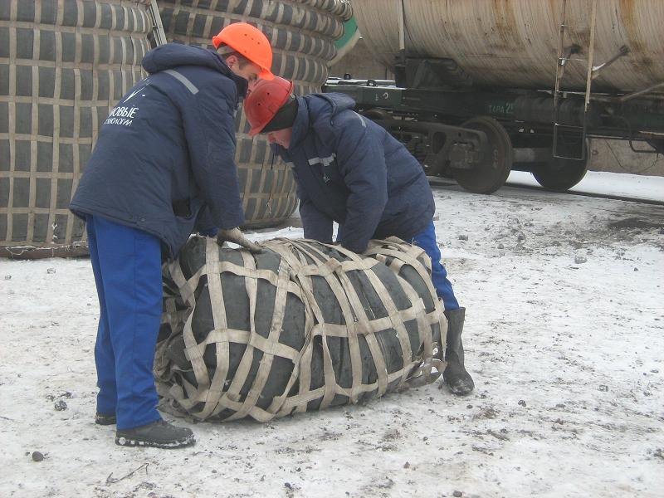
Picture 9: Tightly folded FBC
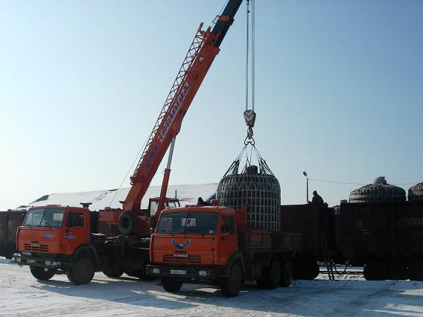
Picture 10: FBC lifting from a truck
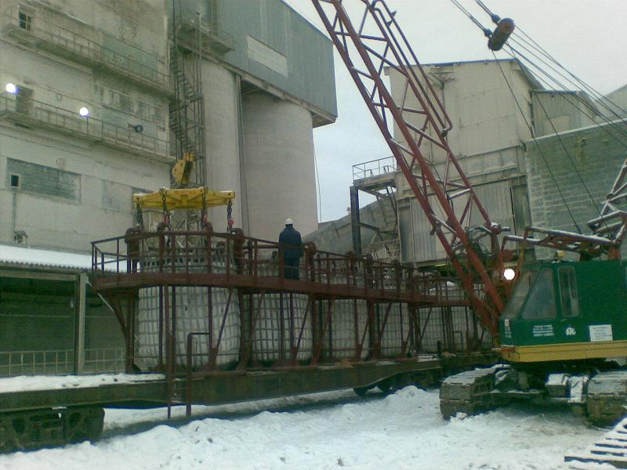
Picture 11: FBC lifting from the basket with 8-hook crane spreader. 2

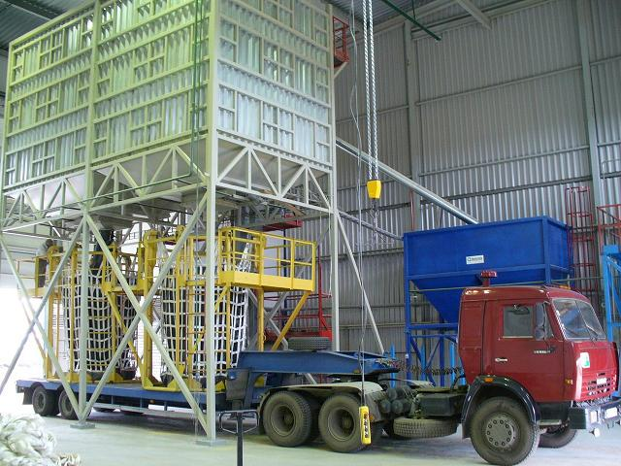
Picture 12: FBC loading in a basket at a car platform 2

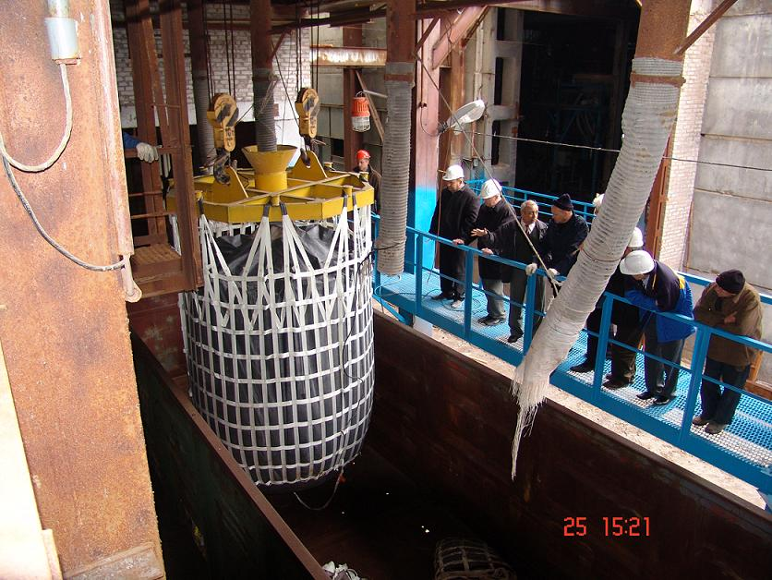
Picture 13: FBC loading in the suspended position above the railway car. 1
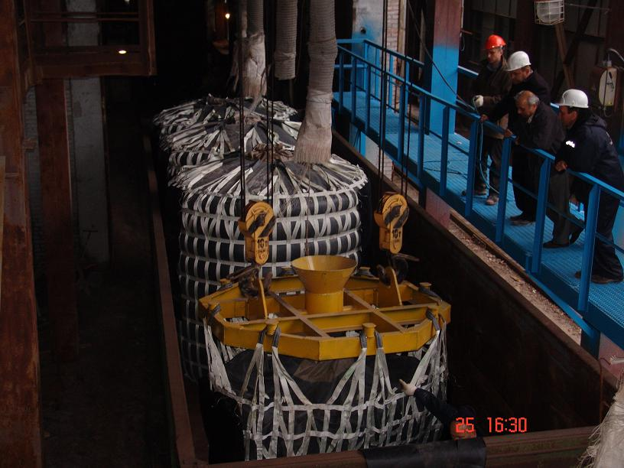
Picture 14: FBC loading in the suspended position above the railway car. 2
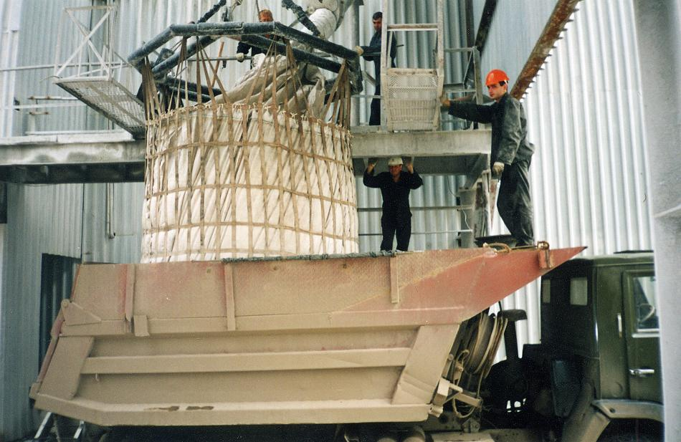
Picture 15: FBC loading in the suspended position above the truck
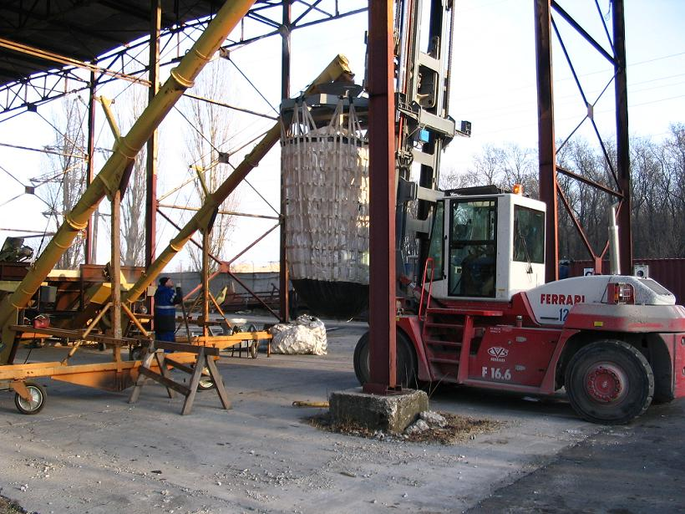
Picture 16: FBC loading in the suspended position at a fork lifter
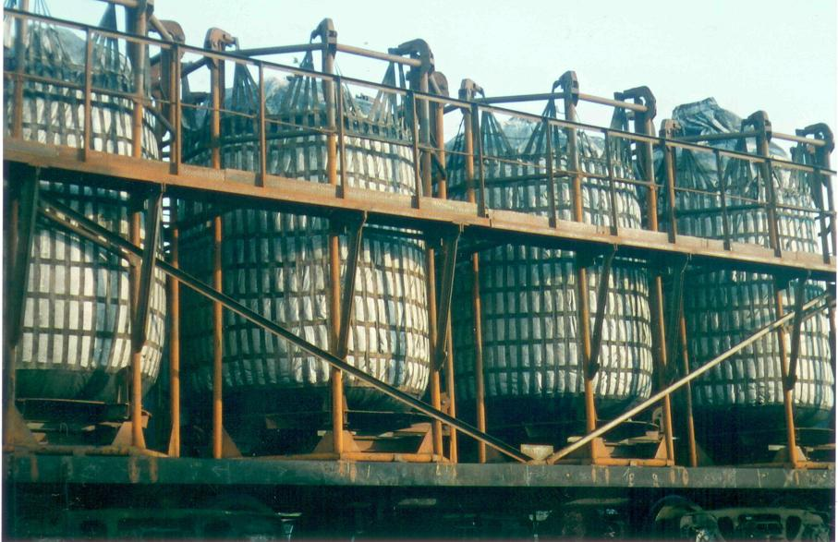
Picture 17: Loaded FBCs in a basket at a railway platform
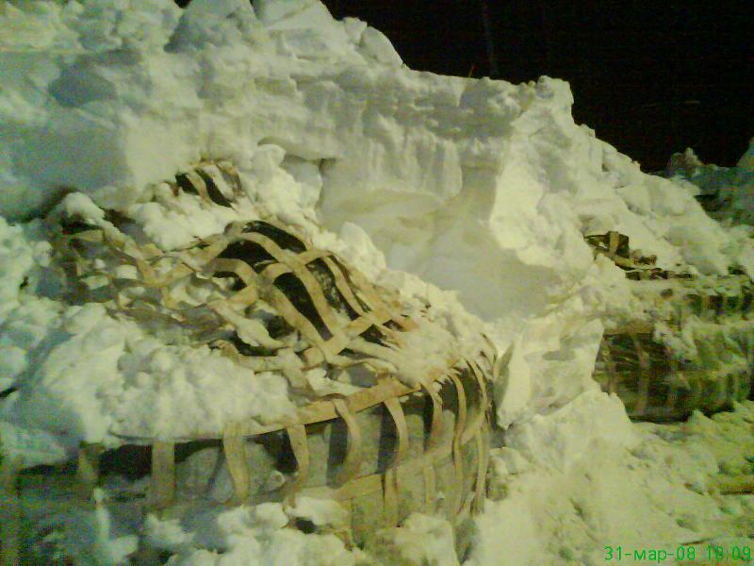
Picture 18: Use of FBC in polar regions. 1
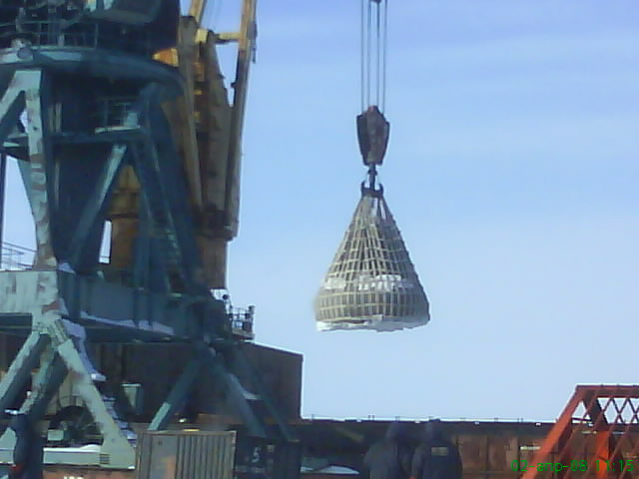
Picture 19: Winter landscape of polar regions. 2
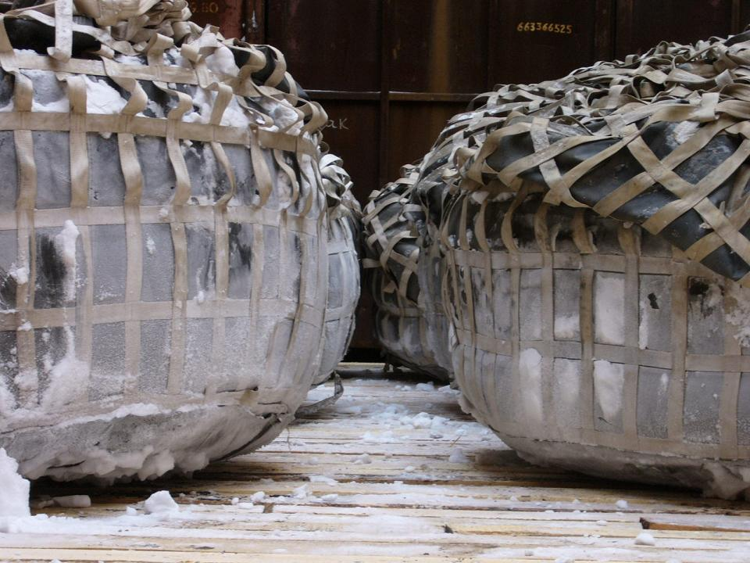 Picture 20: Winter landscape of polar regions. 3
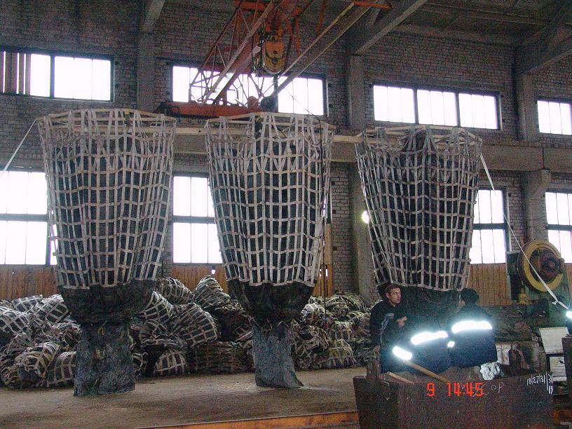
Picture 21: FBC inspection prior to further use

