UN/SCETDG/37/INF.42
Committee of Experts on the Transport of Dangerous Goods
and on the Globally Harmonized System of Classification
and Labelling of Chemicals
Sub-Committee of Experts on the Transport of Dangerous Goods 8 June 2010
Thirty-seventh session
Geneva, 21–30 June 2010
Item 2 of the provisional agenda
Explosives and related matters

On the use of the ARC technique as an alternative to Series 3 Test 3(c) and Series 8 Test 8(a)
Transmitted by the expert from Canada
Introduction
1. In the modern era, explosives are frequently transported in bulk. The Series 3 Test 3(c) (75°C test) is not representative of such large scale inventories. Since the test is not adiabatic (i.e., the oven does not track the temperature of the sample) and the sample is not insulated, the heat losses from the sample to its environment are typically 100 to 200 times larger than for Series 8 Test 8(a) (Dewar Test) [1]. For example, if one assumes an activation energy of 200 kJ mol⁻¹ and an onset temperature of 200°C, which are typical of ammonium nitrate-based explosives, one can evaluate that the test would have to be performed at least 50°C above the transport temperature to be representative of bulk transport.
2. The current Series 8 Test 8(a) is generally much more adequate, as it addresses the issue of scale by using a Dewar vessel that has heat loss characteristics similar to a vessel of approximately the same volume as large road tankers used for bulk transport. Heat loss is also minimized by maintaining the vessel in a heated oven. The test is carried out at 20°C above the maximum transport temperature which should provide an adequate margin of safety. There are some difficulties with Test 8(a), however. Firstly, several hundred grams of material are tested, requiring that the procedure be carried out remotely in a robust test cell. Clearly a test requiring much smaller amounts of material could be carried out more conveniently. Secondly, Test 8(a) takes at least a week to complete, tying up facilities and slowing down the process. A quicker test would be helpful. Finally, both the 3(c) and 8(a) Tests are pass/fail tests that give no indication of the margin of safety. When a test is negative at 100°C, it would be useful to know if thermal runaway would start at 105°C or 150°C, for example.
3. Many of the inadequacies of Test 3(c) and Test 8(a) can be overcome using accelerating rate calorimetry (ARC). At the Canadian Explosives Research Laboratory (CERL), we have been using ARC to test the thermal stability of a wide variety of energetic materials for many years. ARC is a well-established technique for assessing the thermal hazards of energetic chemicals [2] and has a fully developed ASTM procedure [3]. Many other laboratories have commercial ARC instruments. ARC experiments typically require 0.3 to 3 g of energetic material, depending on the expected level of energy release, and can be carried out in a normal laboratory environment. The experiments take only 1-2 days and have the further advantage that they provide a measured onset temperature. Furthermore, as ARC is an adiabatic technique, it simulates bulk quantities of material and generates less waste energetic material for which disposal is often an issue. We have demonstrated that ARC gives comparable thermal onset temperatures to Dewar calorimetry for blasting explosives [4].
Experimental
4. Figure 1 shows a schematic diagram of one of the ARC instruments we currently have at CERL. This calorimeter has top and bottom sections, each having integrated heaters and thermocouples.
Figure 1. Schematic diagram of an ARC instrument
5. The sample is usually contained into a small and thin-walled spherical vessel (about 10 mL internal volume) made of titanium or stainless steel. This vessel is securely mounted under the top section of the calorimeter. A manifold which connects the vessel to a pressure transducer passes through the body of the top section. Throughout the experiment, the temperature of the sample is probed by a thermocouple whose tip is attached to the bottom of, or inserted within, the sample vessel. When the sample has been installed, the top section is lowered onto the bottom section, thus placing the sample vessel in a rugged steel jar installed within the bottom section of the calorimeter. In this jar, a circular radiant heater is positioned so as to heat up the sample vessel uniformly. All heaters and thermocouples are interfaced with a controller that ensures that the sample and both calorimeter sections are always held at the same temperature. The instrument is housed in a protective enclosure so that experiments can be performed in a laboratory environment.
6. For the purpose of determining the onset temperature for thermal runaway, T_{o}, the apparatus is operated in what is known as the Heat-Wait-Search mode (HWS). The calorimeter and sample are first brought up to the desired starting temperature. Once the temperature is stable, the system looks for self-heating of the sample, as measured by the thermocouple attached to the sample vessel. Self-heating is defined by a self-heating rate (R) greater than a pre-selected threshold value (usually 0.02 °C min⁻¹). The temperature of the system is then raised by increments (typically 5°C every 30 minutes) until self-heating is detected; experiments typically take 1-2 days. Once self-heating is detected, the temperature of the calorimeter is increased to match the temperature of the sample. In this way, no heat is lost to heating the bulk of the instrument i.e. the experiment is adiabatic. Some heat is lost to raising the temperature of the sample vessel, but this can be corrected for relatively simply [2]. As a result of these adiabatic conditions, the onset temperatures measured by ARC using 0.3 to 3 grams of sample material are generally quite representative of those that would be experienced at full industrial scales.
7. Since the sample vessels have relatively long and narrow necks, care is needed to make sure that the sample rests at the bottom of the vessel, where the sample thermocouple tip is positioned. As a result, we have developed various simple techniques to introduce energetic materials of widely varied rheologies correctly into the sample vessels. For example, liquids are generally slowly syringed into the vessel using large-bore needles depending upon sample viscosity; for powder samples, the inner diameter of the vessel neck is sufficiently wide to allow use of standard size lab spatula or funnel. In our experience, the introduction of the sample is not a practical impediment to the use of the ARC.
Results
8. Figure 2 shows the results of a typical ARC experiment with pentaerythritol tetranitrate (PETN). The sample is initially heated to 100°C. The temperature is then raised in 5°C increments until self-heating is detected at just over 150°C. The temperature of the sample is then allowed to rise, tracked by the temperature of the calorimeter. It should be noticed that the negative slope observed just before this happens is due to the melting of the sample. The reaction was quenched by rapid cooling once the self-heating rate exceeded 1°C min⁻¹.
9. In this particular case, the system was closed and the pressure build-up monitored; experiments can also be carried out in an open configuration, where the sample vessel is vented to atmosphere. In closed experiments, we have the additional flexibility of being able to change the initial pressure and the atmosphere used.

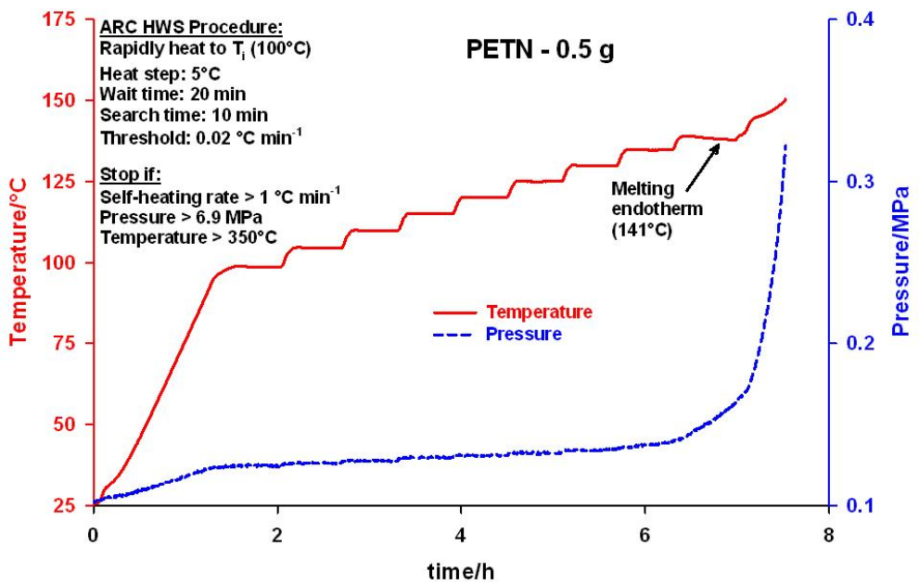
10. Figure 3 shows the thermal runaway from Figure 2, plotted as self-heating rate vs. temperature. Plots of this kind clearly demonstrate the accelerating nature of the self-heating as the temperature increases. They also allow a short extrapolation to a “zero” self-heating rate. We use this extrapolated value as the onset for thermal runaway. The rate vs. temperature information can also be used to extract information on the kinetics of the reaction, although we typically are mostly interested in the onset temperature: with most operations involving energetic materials, it is assumed that runaway is inevitable once the onset temperature is reached.
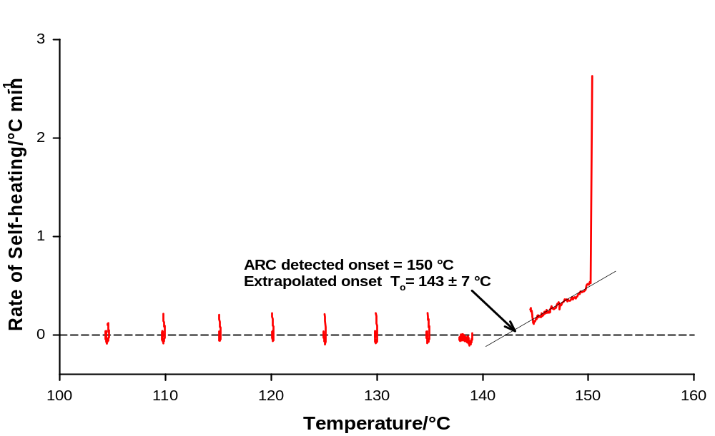
Figure 3. Plot of the self-heating rate vs. temperature for the experiment of Figure 2. on PETN

11. For slightly energetic chemicals, ARC experiments are generally allowed to run to completion (i.e. recording of the complete exotherm). For explosives, this is not advisable, as the runaway reaction can be very violent, resulting in the rupture of the sample vessel and damage to the apparatus. At CERL, we minimize the probability of runaway reactions by limiting sample sizes and quenching the reaction with compressed air cooling once the pre-set threshold self-heating rate or the maximum pressure has been reached. We carry out over 100 experiments a year and have done so for many years, with only occasional explosions in the apparatus. The damage is rarely serious and usually requires only the replacement of inexpensive and readily available parts (mostly the radiant heater and the sample thermocouple), and recalibration of the apparatus. Any runaway events are easily contained within the apparatus and pose no hazard to operators.
12. Other examples of ARC results for some variety of energetic materials are shown in Figure 4. Black powder (a) is a granular powder used in a wide variety of applications. In particular it is very often used as a lift charge for fireworks. RDX (b) (1,3,5- trinitro- 1,3,5- triazacyclohexane) is a fine crystalline powder. It is a very powerful explosive used mostly in military applications. Sample (c) is a so-called double-base propellant composed of high-nitrogen-content nitrocellulose (NC) and nitroglycerine (NG). It was tested in the form of flakes. Sample (d) is a low-viscosity, unsensitized bulk emulsion product (19 mass % of water). Duplicate testing has demonstrated good reproducibility of the onset temperatures, within the stated precision of the measurements [4].
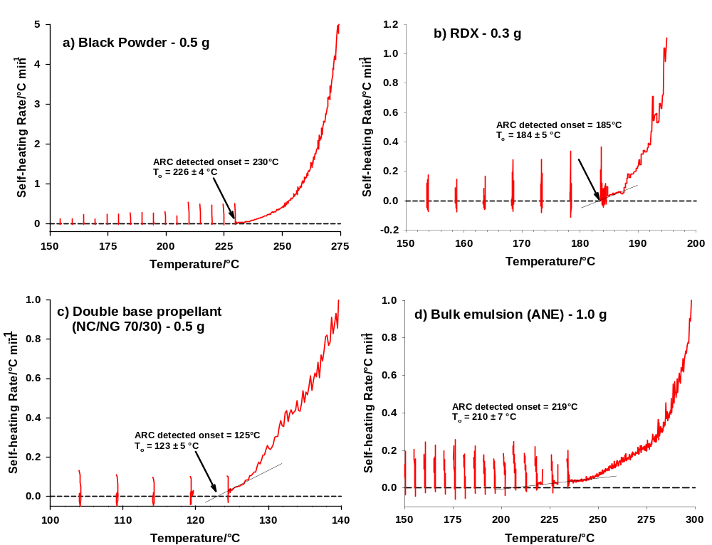
Figure 4. Typical examples of ARC results for some variety of energetic materials: (a) black powder; (b) RDX; (c) Double-base propellant; (d) Unsensitized bulk emulsion.

Proposal
13. We propose that the Explosives Working Group considers the ARC for addition to the list of Series 3 and Series 8 tests, as an alternative to Test 3(c) and Test 8(a), respectively; we would welcome feedback from the Working Group.
References
[1] Barton, J., and Rogers, R., “Chemical Reaction Hazards – A Guide to Safety”, Second Edition, Institution of Chemical Engineers, Rugby, Warwickshire, UK, 1997.
[2] Townsend, D.I., and Tou, J.C., “Thermal Hazard Evaluation by an Accelerating Rate Calorimeter”, Thermochimica Acta, 37 (1980) 1.
[3] ASTM E 1981-98, “Standard Guide for Assessing the Thermal Stability of Materials by Methods of Accelerating Rate Calorimetry”, American Society for Testing Material, West Conshohocken. PA, USA.
[4] Turcotte, R., Lightfoot, P.D., Fouchard, R., and Jones, D.E.G., “Thermal Hazards Assessment of AN and AN-based Explosives”, Journal of Hazardous Materials, A101 (2003) 1.

