Transmitted by the expert from Japan | Informal document No. GRSP-45-10  (45th GRSP, 25-29 May 2009,  agenda item 4(a))

ECE/TRANS/180/Add.9
26 January 2009

GLOBAL REGISTRY

Created on 18 November 2004, pursuant to Article 6 of the
AGREEMENT CONCERNING THE ESTABLISHING OF GLOBAL TECHNICAL REGULATIONS FOR WHEELED VEHICLES, EQUIPMENT AND PARTS WHICH CAN BE FITTED AND/OR BE USED ON WHEELED VEHICLES
(ECE/TRANS/132 and Corr.1)

Done at Geneva on 25 June 1988

Addendum

Global technical regulation No. 9

PEDESTRIAN SAFETY

(Established in the Global Registry on 12 November 2008)


UNITED NATIONS

TABLE OF CONTENTS

Page

A STATEMENT OF TECHNICAL RATIONALE AND JUSTIFICATION 5

1. Safety need 5

2. Summary: description of the proposed regulation 7

3. Procedural background 9

4. Existing regulations, directives, and international voluntary standards 10

5. General issues 12

6. Pedestrian head protection 1718

7. Pedestrian leg protection 23

8. Other issues 2729

9. Regulatory impact and economic effectivenes 2930

10. Method of introducing the FlexPLI 31

1011. Appendix 3132

B. TEXT OF THE REGULATION 3738

1. Purpose 3738

2. Application / scope 3738

3. Definitions 3738

4. General requirements 4749
4.1. Legform test to bumper 4749
4.2. Child headform impact 4749
4.3. Adult headform impact 4749

5. Performance requirements 4850
5.1. Legform to bumper 4850
5.2. Headform tests 4850

TABLE OF CONTENTS

Page

6. Test specifications 4951
6.1. General test conditions 4951
6.2. Preparation of the vehicle 5052
6.3. Test impactor specifications 5052

7. Test procedures 5968
7.1. Legform to bumper test procedures 5968
7.2. Headform test procedures 6173
7.3. Child headform test procedure 6274
7.4. Adult headform test procedure 6374

8. Certification of impactors 6375

8.1. RIGID/TRL Llower legform impactor certification 6475
8.2. FlexPLI certification 79
8.23. Upper legform impactor certification 6783
8.34. Child and adult headform impactors certification 6884

A. STATEMENT OF TECHNICAL RATIONALE AND JUSTIFICATION

1. SAFETY NEED

1. Each year, thousands of pedestrians and cyclists are struck by motor vehicles. Most of these accidents take place in urban areas where serious or fatal injuries can be sustained at relatively low speed, particularly in the case of children. This global technical regulation (gtr) will significantly reduce the levels of injury sustained by pedestrians involved in frontal impacts with motor vehicles.

2. This gtr is based on data from a number of sources, including the International Harmonized Research Activities (IHRA) / Pedestrian Safety working group (IHRA/PS). The data was sourced from Australia, Germany, Japan and the United States of America. Data from IHRA /, Germany /, Italy /, the UNECE /, Spain /, Canada /, the Netherlands /, Sweden /, and Korea / indicate that, annually: in the European Union about 8,000 pedestrians and cyclists are killed and about 300,000 injured; in North America approximately 5,000 pedestrians are killed and 85,000 injured; in Japan approximately 3,300 pedestrians and cyclists are killed and 27,000 seriously injured; and in Korea around 3,600 pedestrians are killed and 90,000 injured.

3. The IHRA/PS study indicates the following:

(a) Distribution of the injuries

4. Comparing the ages of those involved, statistics show the highest frequency of accidents is for children of five to nine years old, and for adults over 60 years old. Children (aged 15 and under) account for nearly one-third of all injuries in the dataset, even though they constitute only 18 percent of the population in the four countries included in the IHRA data.

5. The frequency of fatal and serious injuries (Abbreviated Injury Scale: AIS 2-6) is highest for the child and adult head and adult leg body regions (INF GR/PS/3).

(b) Crash speeds

6. Crash speeds between vehicles and pedestrians were collected from pedestrian accident data. The cumulative frequency of the crash speeds shows that a crash speed of up to 40 km/h can cover more than 75 percent of total pedestrian injuries (AIS 1+) in all regions.

(c) Target population for this gtr

7. The IHRA injury data indicate the injury distribution by body regions. Fatal and serious head injuries (AIS2+) of children and adults as well as AIS2+ adult leg injuries were extracted from the IHRA data base for clearly identified injury causing parts on the vehicle and on the road (INF GR/PS/131 and 169). It was found that bonnet/wing contacts caused 41 percent of child head injuries of AIS2+ and 19 percent of the adult AIS2+ head injuries. Bumper contacts lead to 64 percent of adult AIS2+ leg injuries. The cumulative frequency curves versus vehicle impact speed for these injuries and their respective injury causing parts show that 58 percent of the child head AIS2+ injuries are addressed to a vehicle impact speed up to 40 km/h, 40 percent to adult head AIS2+ injuries and 50 percent of the adult leg AIS2+ injuries respectively. Based on these figures of injuries by injury source and vehicle contact area, the target population of the above-mentioned AIS2+ injuries for this proposed gtr is 24 percent of child pedestrian head injuries, 8 percent of adult pedestrian head injuries, and 32 percent of adult leg injuries.

8. Each of these body regions, i.e. head of child/adult and adult leg, covers more than 30 percent of total fatal and severe injuries (INF GR/PS/3). This gtr focuses on protecting these body regions.

9. The major source of child head injuries is the top surface of the bonnet/wing, while adult head injuries result from impacts to the top surface of bonnet/wing and windscreen area. For adult leg injuries, the major source is the front bumper of vehicles.

(d) Applicability to motor vehicle categories

10. The maximum benefit from making vehicles pedestrian friendly would occur if all types of vehicles comply with these technical provisions, but it is recognized that their application to heavier vehicles (large trucks and buses) as well as to very small and light vehicles could be of limited value and may not be technically appropriate in their present form. The tests proposed in this gtr have been developed on the basis of current light vehicles, taking into account the pedestrian kinematics when impacted by such vehicles. For this reason, the scope of application is limited to passenger cars, sport utility vehicles (SUV), light trucks and other light commercial vehicles. Since these vehicle categories represent the vast majority of vehicles currently in use, the proposed measures will have the widest practicable effect in reducing pedestrian injuries.

2. SUMMARY: DESCRIPTION OF THE PROPOSED REGULATION

(a) Introduction

11. It is generally accepted that in the most representative pedestrian to car accident the pedestrian is in normal walking posture, meaning that the pedestrian is standing sideways to the vehicle, and is struck by the vehicle from the side. This scenario is therefore also the basis for this gtr.

12. When an adult pedestrian is struck by vehicles addressed by this gtr, the first impact is generally between the pedestrian knee region and the vehicle's front bumper. Because this initial contact is usually below the pedestrian's centre of gravity, the upper body in such a case begins to rotate toward the vehicle. The pedestrian's body accelerates linearly relative to the ground because the pedestrian is being carried along by the vehicle. The second contact is usually between the upper part of the grille or front edge of the bonnet and the pedestrian's pelvic area. The pedestrian's legs and pelvis have reached the linear velocity of the vehicle at this point and the upper body (head and thorax) are still rotating toward the vehicle. The final phase of the collision involves the head and thorax striking the vehicle with a linear velocity approaching that of the initial striking velocity of the vehicle. IHRA research has shown that the linear head impact velocity averages about 80 percent of the initial contact velocity.

13. Through the pedestrian accidents analysis, it has been concluded that child and adult heads and adult legs are the body regions most affected by contact with the front end of vehicles. On vehicles, the bumper, the bonnet top and the windscreen area, including the A-pillars, are the vehicle regions mostly identified with a high potential for contact. According to the IHRA/PS study, the above-mentioned areas can cover more than 65 percent of the fatal and serious injuries.

14. Based on these study results, the informal group prioritized the development of approaches to simulate a pedestrian impact and encourage countermeasures that will improve pedestrian protection. This gtr would improve pedestrian safety by requiring vehicle bonnets and bumpers to absorb energy more efficiently when impacted in a 40 kilometre per hour (km/h) vehicle-to-pedestrian impact, which accounts for more than 75 percent of the pedestrian injured accidents (AIS 1+) reported by IHRA/PS of the injury frequency.

15. During the activities of the gtr informal group, headform to windscreen testing was proposed to be included in the gtr. IHRA accident studies mentioned above identify the windscreen, windscreen frame and A-pillars as injury causing parts of the vehicle in pedestrian to car collisions.

16. After several discussions on this issue the group decided not to include these kinds of tests into the gtr at this stage for the following reasons:

(i) The group recognized that the A-pillars, windscreen roof and lower frame have to be very stiff vehicle parts due to their functional requirements. As an example in the lower windscreen area, the required deformation space to meet a head impact requirement is restricted by the instrument panel. Some components that are required to meet governmental safety standards, such as defrost/demist etc., make it impossible to lower the dashboard significantly. In addition, the structural components of the dashboard represent important load paths in front or side crashes. On the other hand, the entire windscreen frame would need to be softened extremely to pass any HIC (Head Injury Criterion) requirement. This strongly contradicts roll over requirements and other existing legal and consumer demands (see INF GR/PS/059 and INF GR/PS/035). In addition the group received detailed data showing that extremely high HIC measurements are frequently obtained in these difficult areas (see INF GR/PS/072, 094, 102 and 103) and agreed that there are no technical design solutions or countermeasures available so far to drastically reduce HIC levels.
(ii) The windscreen glass itself does not produce severe injuries and therefore the amount of saved casualties will be very low. The effectiveness of testing the windscreen inner part is seen as very questionable.
(iii) In addition, it was noted that vehicle manufacturers believed that there are problems related to scatter of HIC when performing tests in the windscreen and that the reasons for the scatter are not yet fully understood (see INF GR/PS/134, 163 and 164).

17. However, some delegates expressed interest in having domestic regulations that apply head protection requirements to the windscreen area. The informal group did not believe the gtr would foreclose any jurisdiction from applying head protection requirements to the windscreen area by way of domestic regulations.

(b) Overview

18. This gtr consists of two sets of performance criteria applying to: (a) the bonnet top and wings; and (b) the front bumper. Test procedures have been developed for each region using sub-system impacts for adult and child head protection and adult leg protection. /

19. The head impact requirements will ensure that bonnet tops and wings will provide head protection when struck by a pedestrian. The bonnet top and wings would be impacted with a child headform and an adult headform at 35 kilometres per hour (km/h). The HIC must not exceed 1,000 over one half of a child headform test area and must not exceed 1,000 over two thirds of a combined child and adult headform test areas. The HIC for the remaining areas must not exceed 1,700 for both headforms.

20. The leg protection requirements for the front bumper would require bumpers to subject pedestrians to lower impact forces. This gtr specifies that the vehicle bumper is struck at 40 km/h with a legform that simulates the impact response of an adult's leg. Vehicles with a lower bumper height of less than 425 millimetre (mm) are tested with a lower legform, while vehicles with a lower bumper height of more than 500 mm are tested with an upper legform test device. Vehicles with a lower bumper height between 425 mm and 500 mm are tested with either legform chosen by the manufacturer. In the lower legform to bumper test, vehicles must meet limits on lateral knee bending angle, knee shearing displacement, and lateral tibia acceleration. In the upper legform to bumper test, limits are placed on the instantaneous sum of the impact forces with respect to time and the bending moment of the test.

21. The performance requirements, test procedures and supplementary information explaining the rationale for this gtr are discussed in detail in later sections of this preamble.

3. PROCEDURAL BACKGROUND

22. During the one-hundred-and-twenty-sixth session of WP.29 in March 2002, AC.3 concluded their considerations of priorities for developing future global technical regulations. WP.29 adopted the 1998 Global Agreement Programme of Work, which included pedestrian safety, and decided to start the work on pedestrian safety at the thirty-first session of GRSP in May 2002, by establishing an informal group to draft the gtr. The formal proposal to develop a gtr (TRANS/WP.29/AC.3/7) was considered and adopted by the AC.3 at its tenth session, in March 2004. It is based on document TRANS/WP.29/2004/26, which had been submitted by the European Community, the technical sponsor of the project.

23. Informal document No. 10 of the thirty-first session of GRSP lays down the terms of reference of the group and the document was adopted by GRSP (INF GR/PS/2).

24. Informal document No. 7 of the thirty-second session of GRSP reported on the result of the first meeting of the informal group (INF GR/PS/9).

25. Informal document No. 2 of the thirty-third session of GRSP (INF GR/PS/47 Rev.1) was the first preliminary report of the informal group and responds to paragraph 5 of documents TRANS/WP.29/2002/24 and TRANS/WP.29/2002/49 as adopted by AC.3 and endorsed during the one-hundred-and-twenty-seventh session of WP.29. The documents were consolidated in the final document TRANS/WP.29/882. The preliminary report was adopted as TRANS/WP.29/2003/99 by AC.3 in November 2003.

26. Informal document No.GRSP-34-2 of the thirty-fourth session of GRSP reported on the action plan of the informal group (INF GR/PS/62).

27. Informal document No. GRSP-35-5 of the thirty-fifth session of GRSP was the second preliminary report of the informal group (INF GR/PS/86 Rev2 and PS/88). This report was considered by AC.3 in June 2004 as informal document No. WP.29-133-7.

28. Informal document No. GRSP-36-1 of the thirty-sixth session of GRSP was the first draft gtr of the informal group (INF GR/PS/116).

29. TRANS/WP.29/GRSP/2005/3 was proposed at the thirty-seventh session of GRSP and was a revised draft gtr including the preamble, of the informal group (INF GR/PS/117).

30. The group had held the following meetings:
(a) 4-5 September, 2002, Paris, France
(b) 10 December, 2002, Geneva, Switzerland
(c) 15-16 January, 2003, Santa Oliva, Spain
(d) 15-16 May, 2003, Tokyo, Japan
(e) 10-12 September, 2003, Ottawa, Canada
(f) 24-26 February, 2004, Paris, France
(g) 28-30 September, 2004, Paris, France
(h) 11-13 July, 2005, Brussels, Belgium
(i) 5-6 December, 2005, Geneva, Switzerland
(j) 16-19 January, 2006, Washington DC, USA

31. The meetings were attended by representatives of:

32. Canada, France, Germany, European Community (EC), Italy, Japan, Korea, the Netherlands, Spain, Turkey, the United States of America (USA), Consumers International (CI), the European Enhanced Vehicle-safety Committee (EEVC) /, the European Association of Automotive Suppliers (CLEPA) and the International Organization of Motor Vehicle Manufacturers (OICA).

33. The meetings were chaired by Mr. Mizuno (Japan) and Mr. Friedel/Mr. Cesari (EC), while the secretariat was provided by Mr. Van der Plas (OICA).

4. EXISTING REGULATIONS, DIRECTIVES, AND INTERNATIONAL VOLUNTARY STANDARDS

34. At the present time, there are no regulations concerning the provision of improved protection for pedestrians and other vulnerable road users in the Compendium of Candidates.

35. The following is a summary of national and regional legislation and of work in international forums:

36. The Japanese Government has established a regulation on pedestrian protection. The regulation addresses the issues of providing protection for the child and adult heads. It applies to passenger cars with up to 9 seats and to small trucks of up to 2,500 kg Gross Vehicle Mass (GVM) with application from 2005 for new vehicle types and from 2010 for existing vehicle types (certain other vehicles have a timetable which is postponed by two years). The regulation requires compliance with test requirements using representative head impactors.

37. The European Parliament and Council adopted the Directive 2003/102/EC which provides for the introduction of requirements for leg injuries, and adult and child head injuries. The Directive and its requirements are incorporated into Community legislation under the European Union (EU) whole vehicle type approval system set up by EU Framework Directive 70/156/EEC. It applies to passenger cars of category M₁ and to light commercial vehicles derived from passenger cars of M₁ category, both up to 2,500 kg gross vehicle mass, with application dates in two phases starting in 2005 and 2010. The requirements and the tests are based on the research results that were published by EEVC in the 1990's and that were introduced in a less severe form for the first phase and intended to be introduced in the originally proposed form for the second phase. However, since EEVC results have never been fully accepted by all involved parties, the Directive provided for a feasibility review of the requirements for the planned second phase in 2004. This feasibility review has taken place and may result in amendments to the European requirements in its second phase, starting in 2010.

38. Canada is currently reviewing its bumper regulation. The Canadian bumper regulation is one of the most stringent in the world (all the safety features of the vehicle have to be functional after an 8 km/h impact). In addition, Canada and the USA are conducting a preliminary investigation of the effects of bumper design on different leg test devices (Transport Research Laboratory (TRL) legform impactor; Polar dummy and flexible pedestrian legform impactor (Flex-PLI)).

39. The United States research programmes have addressed how vehicles could be modified to reduce the severity of head and leg impacts. / / The current US pedestrian protection research programme supports the IHRA objectives. Current activities include (1) pedestrian field data analysis to develop test conditions, (2) evaluation of pedestrian head and leg test tools, (3) experimental impact testing of vehicle structures to assess aggressivity, (4) pedestrian case reconstructions using a combination of field data, computer simulation, and testing to better understand injury mechanisms, (5) computer model development using available biomechanical literature, and (6) completion of other IHRA Pedestrian Safety Working Group action items.

40. The IHRA Pedestrian Safety working group has conducted in-depth accident studies based on pedestrian accident data collected from the member countries. In addition, this group carefully studied the front shape of passenger vehicles including SUVs, and used best available computer simulation models to study the effective head mass, adult and child head impacting speed during the impact with vehicles and the impact angles.

41. Based on these research results, the IHRA group developed test procedures and test devices for adult and child head protection and for adult leg protection.

42. The International Organization for Standardization (ISO) created the pedestrian protection working group (ISO/TC22/SC10/WG2) in 1987 to develop test methods for the reduction of serious injuries and fatalities for pedestrian to car accidents. The mandate for ISO/WG2 was to produce test methods, covering crash speeds up to 40 km/h, which will contribute to make cars pedestrian friendly. Since then, the WG2 has developed pedestrian test procedures and has described the necessary test tools. The study results were fully used in the IHRA/PS group when IHRA/PS developed the adult and child impactors.

43. The ISO standards and draft standards are:
(a) ISO 11096 2002 Road vehicles - Pedestrian protection - Impact test method for pedestrian thigh, leg and knee,
(b) ISO/DIS 14513 2006 Road vehicles - Pedestrian protection - Head impact test method,
(c) ISO 16850 2007 Road vehicles - Pedestrian protection - Child head impact test method.

5. GENERAL ISSUES

(a) Scope

44. From the review of pedestrian fatality and injury statistics from several countries, it was shown that the head and the legs are the most frequently injured body regions in pedestrian accidents. It was recommended that the gtr would encompass tests for the adult head and leg, and the child head. The studies also showed that the majority of pedestrian injuries are occurring in urban environments. Therefore, the gtr should test those vehicles found in this environment, including passenger vehicles, vans, and light trucks.

45. As suggested by the terms of reference of the informal group, consideration was given to the use of the best available technology and improvements in technology that will provide significant steps in developing methods and in achieving and improving benefits, including both active and passive safety measures (TRANS/WP.29/GRSP/30). There was a discussion on whether the proposed pedestrian gtr should regulate passive and/or active safety systems. Active safety systems, such as brake assist, anti-lock brakes and day-light running lights were suggested as solutions for the reduction of pedestrian injuries, but it was ultimately counselled by GRSP and WP.29 to concentrate on passive systems for this gtr, as this is the main domain of expertise of the GRSP working party, and only to provide advice on the use of active systems.

46. The group understood that active safety and infrastructure measures were not within the remit of the group, but determined that it could be useful and efficient to inform WP.29/AC.3 as well as other authorities of the need to take these issues into account for real world safety improvements. The group also noted the importance of educational measures and the need to enforce existing road traffic legislation. Some experts noted that consideration of other safety measures, if properly balanced with the passive safety requirements, might help in ensuring that the vehicle passive safety requirements are kept at a realistic and feasible level.

47. OICA, in particular, mentioned brake assist systems which can, in emergency situations, substantially improve the braking performance and consequently reduce the impact speed when the impact is unavoidable. A study on the effectiveness of such a system was presented by OICA using the German In-Depth Accident Studies (GIDAS) database (INF GR/PS/25). This showed that if the vehicle speed is 50 km/h at the start of braking, the collision speed (car versus pedestrian) would be reduced to 40 km/h in general, to 35 km/h for an experienced driver and to 25 km/h for cars equipped with brake assist systems. Another study performed by the Technical University of Dresden on behalf of the European Automobile Manufacturers' Association (ACEA) was presented by OICA (INF GR/PS/92). This study confirmed the positive effect of brake assist systems on pedestrian fatalities and injuries.

48. As for infrastructure measures that could improve pedestrian safety, OICA presented the results of a 1998 study conducted on behalf of ACEA by the consultants ORIENTATIONS (France) and TMS Consultancy (United Kingdom) (INF GR/PS/29). This study, which evaluated the effect of infrastructural measures based on real data evaluations, concluded that such measures could dramatically reduce the number of pedestrian victims (fatalities/injuries) at low cost.

(b) Applicability

49. The application of the requirements of this gtr refers, to the extent possible, to the revised vehicle classification and definitions outlined in the 1998 Global Agreement Special Resolution No. 1 (S.R.1) concerning the common definitions of vehicle categories, masses and dimensions.

50. Difficulties, due to differing existing regulations and divergent vehicle fleets, were encountered in determining which vehicles would be included in the scope. The Japanese regulation applies to passenger cars for up to nine occupants and commercial vehicles up to a GVM of 2,500 kg. The IHRA recommends tests and procedures for passenger vehicles of GVM 2,500 kg or less. The European Union (EU) Directive applies to M₁ vehicles up to 2,500 kg and N₁ vehicles up to 2,500 kg, which are derived from M₁. The ISO recommendations are for M₁ and N₁ vehicles that have a GVM of 3,500 kg or less. In addition, some countries, taking into account their current fleet composition, wanted to ensure that larger vehicles, such as light trucks and sport utility vehicles with a GVM of 4,500 kg or less, were not excluded.

51. The group originally reviewed in detail the IHRA recommendation in detail to take into account the shape of the front of the vehicle as an important parameter when discussing the types of pedestrian injuries to be mitigated. IHRA specifies three groups of vehicle shape: sedan, SUV, and 1-box. For the adult and child head impacts, IHRA foresees different impact test speeds and different impact angles. The Japanese legislation is based on the IHRA recommended method. The EU requirements, on the contrary, do not differentiate between the various test speeds and impact angles.

52. The group compared these various considerations and, on the basis of simulations (INF GR/PS/129), concluded that the EU requirements in effect are more severe than the Japanese proposals. For safety reasons, the group therefore uses the EU approach, not taking into account the shape of the vehicle front in defining the requirements. Furthermore, the group also determined that the IHRA recommendations would be difficult to put in place in the context of a regulatory and certification approach.

53. There was considerable discussion over the mass of vehicles to which this gtr should apply. Using the categories described in S.R.1, several options were examined. Some delegates wanted to limit application of the gtr to vehicles in category 1-1 with a vehicle mass of less than 2,500 kg GVM. Other delegates did not agree with a 2,500 kg limit on GVM, believing that since the front-end structure of vehicles with a mass up to 4,500 kg GVM is usually similar to that of lighter vehicles, the application of the gtr should include the heavier vehicles. In addition, some delegates sought to limit application of the gtr to vehicles of a GVM of more than 500 kg, while other delegates expressed concern about having a lower mass limit, believing that a particular jurisdiction might determine there is a need to apply the gtr requirements in that jurisdiction to vehicles with a GVM of less than 500 kg. There was a suggestion that the gtr should also apply to vehicles in category 2 that had the "same" general structure and shape forward of the A-pillars as vehicles in category 1-1. However, some were concerned that it would be unfeasible to define objectively what was meant by "same".

54. After considering these issues, it was recommended that the gtr should be drafted to have a wide application to vehicles, to maximize the ability of jurisdictions to effectively address regional differences in pedestrian accident crash characteristics. The gtr would establish that if a jurisdiction determines that its domestic regulatory scheme is such that full applicability is inappropriate, it may limit domestic regulation to certain vehicle categories or mass limits. The jurisdiction could also decide to phase-in the requirements for certain vehicles. A footnote was added to the gtr text to make it clear that jurisdictions can decide to limit the applicability of the regulation. This approach recognizes that niche vehicles that are unique to a jurisdiction would best be addressed by that jurisdiction, without affecting the ability or need for other jurisdictions to regulate the vehicles. When a Contracting Party proposes to adopt the gtr into its domestic regulations, it is expected that the Contracting Party will provide reasonable justification concerning the application of the standard.

55. While this approach maximizes the discretion of jurisdictions to decide whether vehicles should be excluded from the gtr for feasibility or practical reasons, or because there is no safety need to regulate the vehicles, the group also decided to recommend excluding one unique vehicle type from the regulation. The test procedures in the gtr are based largely on the classic vehicle shape with a long bonnet. Certain vehicles, generally cargo vehicles, have a very short bonnet and a front shape that is very close to the vertical. The pedestrian kinematics with these vehicles may be very different, and, in addition, there are difficulties in applying the tests to these vehicles, particularly with regard to determination of test zone reference lines. For these reason, the group recommends that those vehicles of category 1-2 and category 2, where the distance, measured longitudinally on a horizontal plane, between the transverse centre line of the front axle and the R-point of the driver's seat is less than 1,000 mm, be exempt from the requirements of the regulation. In addition, some of the group members raised a concern that this exemption could create inconsistancies in the market if category 1-1vehicles were not treated in a similar manner and thus, consideration should be given to the inclusion of this category of vehicles in the recommended exemption.

56. For these reasons, with the exception of the exemption discussed above, the gtr is recommended to apply to category 1-1 vehicles with a GVM exceeding 500 kg; and to category 1-2 and category 2 vehicles with a GVM exceeding 500 kg but not exceeding 4,500 kg. In addition, the group recommends that a Contracting Party may restrict application of the requirements in its domestic legislation if it decides that such restriction is appropriate.

57. Regarding the applicability of this gtr, it should be noted that the requirements of the draft gtr are substantially more severe than any existing legislation at the time of adoption of the gtr. In addition, many countries do not yet have pedestrian safety requirements. It is therefore recommended that Contracting Parties implementing this gtr allow adequate lead time before full mandatory application, considering the necessary vehicle development time and product lifecycle.

58. Furthermore, during the development phase of this gtr, the main focus was on vehicles of a GVM of 2,500 kg or less, that are also addressed in all existing legislation. The later extension to other vehicles however needs to recognise that some additional lead-time may be necessary, because many current vehicles, exempted from existing national or regional requirements, are now included. In addition, while the test procedures and requirements of this gtr were based on requirements originally developed for "classical" (sedan type) passenger cars, the gtr now also covers vehicles with specific shapes or features (High Front Vehicles, special purpose vehicles, etc.), for which it is recognised that special consideration may be needed.

(c) Implementation generally

59. The informal group considers all tests in this proposed gtr to be technically feasible and able to evaluate objectively the ability of vehicle bonnets and bumpers to absorb energy more efficiently. However, pedestrian accident crash characteristics and vehicle baseline performance may differ regionally. It will be the decision of each jurisdiction to determine whether the benefits achieved by requiring these tests justify the costs. Based on this determination, a jurisdiction can choose to limit the application in its own regulation to specific vehicle categories, specific tests, and/or it may decide to phase in the regulations over time.

(d) Points tested

60. The informal group considered whether to specify both the number of test points and the minimum spacing of such test points. On consideration, the group determined that the specification of such points did not have a place within this proposed gtr for the following reasons:

(i) For governments that use a self-certification regulatory framework, it was not considered necessary to mention the number of tests required for testing or their spacing, as it would be incumbent on vehicle manufacturers to ensure that vehicles comply with all the impact zone requirements defined within this proposed gtr when tested by the regulating authority.

(ii) For type approval, the number of tests that need to be carried out to satisfy the relevant authority that vehicles meet the requirements is an issue for that authority, which may specify the number of tests and the spacing between the test points.

(iii) The mention of a minimum number of tests or a minimum distance apart between tests could result in manufacturers being burdened with unnecessary tests and/or authorities being unnecessarily restricted in test programs, as it would be difficult to set a target that would encompass both the largest and smallest test zones, and the situation could arise where test zones could be smaller than the minimum number of tests required that could be fitted into that zone.

(e) Vehicle design position

61. As vehicles come in many variants and modifications, the ride height may vary greatly. Taking into account the differences between type approval and self certification, it is recommended that Contracting Parties take this into account upon national implementation of the gtr. As guidance to Contracting Parties, the EU addresses this issue by defining the concept of "primary reference marks". This definition (paragraph 2.2 of EU Commission Decision of 23 December 2003) reads: "Primary reference marks" means holes, surfaces, marks and identification signs on the vehicle body. The type of reference mark used and the vertical (Z) position of each mark relative to the ground shall be specified by the vehicle manufacturer according to the running conditions specified in paragraph 2.3. These marks shall be selected such as to be able to easily check the vehicle front and rear ride heights and vehicle attitude.

62. If the primary reference marks are found to be within ± 25 mm of the design position in the vertical (Z) axis, then the design position shall be considered to be the normal ride height. If this condition is met, either the vehicle shall be adjusted to the design position, or all further measurements shall be adjusted, and tests performed, to simulate the vehicle being at the design position.

(f) Future consideration

63. During the discussions, it became clear that some issues could not be fully resolved within the timeframe of the terms of reference for the informal group. The group determined that the following issues should be considered further beyond this gtr.

(i) Lower legform impactor

64. The lower legform impactor currently used for testing in Europe was designed by the Transport Research Laboratory (TRL) in the United Kingdom. However, it is known to also have certain limitations regarding the biofidelity and the repeatability of the test results. Therefore, Japan proposed to use a completely new legform, the so-called Flexible Pedestrian Legform Impactor (FlexPLI). As the FlexPLI legform is considered by some to have high biofidelity and an excellent ability to assess potential leg injuries, the FlexPLI should be considered to replace the TRL lower legform impactor in the future. However, because of the lack of experience in using the FlexPLI as a certification tool, a further confirmation process is needed. Therefore, a Technical Evaluation Group (TEG) was established to evaluate the reliability of the FlexPLI as a certification tool (TRANS/WP.29/GRSP/36). The TEG is currently assessing the FlexPLI and will advise GRSP by the end of 2007 as to the suitability of the FlexPLI for testing and compliance verification purposes (TRANS/WP.29/GRSP/37). The TEG is also expected to provide its recommendation as to the effective date of entry into force and the date on which the FlexPLI could replace the rigid lower legform impactor. TEG will also consider a transitional period during which the FlexPLI and the rigid lower legform impactor can be used as alternatives.
Several years passed after the above situation, then the TEG finalised their technical evaluation on the FlexPLI by a majority of the TEG members in [2009], therefore, this gtr also includes the FlexPLI requirements as well as the RIGID/TRL legform impactor requirements.

(ii) Upper legform impactor to high bumper test

65. Some delegates had concerns about the biofidelity of the upper legform impactor and the limitations of the test tool in assessing injury. IHRA/PS is working on recommendations for an improved upper legform impactor for possible future use.

(iii) Upper legform impactor to bonnet leading edge test

66. Several accident studies from some regions comparing modern "streamline" vehicle fronts registered in or after 1990 and old vehicles from the eighties or seventies indicate a decrease in AIS 2+ upper leg and pelvis injuries caused by the bonnet leading edge. The accident studies were performed by the LAB using French data (INF GR/PS/30), and by the University of Dresden using German GIDAS data (INF GR/PS/92). In addition, EEVC Working Group 17 (WG17) summarized in their 1998 report that no serious (AIS 2+) upper leg or pelvis injuries caused by the bonnet leading edge were found for post-1990 car models impacting a pedestrian at a speed up to 40 km/h (INF GR/PS/187 Rev.1). In contrast, data from the United States of America indicate a high incidence of above-the-knee injuries due to the prevalence of light trucks and vans in the United States fleet, and that consideration should be given to evaluating thigh, hip, and pelvis injuries in future test procedures.

67. Despite the desire to address any potential injuries in the upper leg or pelvic area, the group was also concerned that there was a serious lack of biofidelity for the existing test device and the respective test procedure to assess injury caused by the bonnet leading edge of high profile vehicles. Therefore, the group recommended excluding the upper legform impactor to bonnet leading edge test at this stage. IHRA/PS is carrying out further research into an improved impactor and test procedures for this test.

6. PEDESTRIAN HEAD PROTECTION

68. IHRA data show that a major source of child and adult pedestrian head injuries is the top surface of the bonnet/wing of the striking vehicle. As explained in this section, this gtr requires the bonnet/wing to perform at levels that decrease the likelihood that head impact with the bonnet/wing in a 40 kilometre per hour (km/h) pedestrian-to-vehicle impact will result in fatal or serious injury.

69. The bonnet/wing would be impacted with a headform at 35 km/h. The bonnet/wing would be divided into a "child headform test area" and an "adult headform test area". The child headform test area is the area of the bonnet/wing that is likely to be impacted by the head of a 6-year-old child in a pedestrian impact. A child headform is used to evaluate the bonnet/wing in that area. Likewise, the adult headform test area corresponds to the area of the bonnet/wing that the head of a mid-size adult male pedestrian is likely to impact. An adult headform is used to test the bonnet/wing in the latter area.

(a) Test areas

70. The bonnet top is an area bounded by reference lines corresponding to the bonnet leading edge, the sides of the vehicle, and the rear of the bonnet (all terms are objectively defined in this gtr). The gtr divides the bonnet top into test areas using a parameter called the "wrap around distance" (WAD). The WAD is the distance from a point on the ground directly below the bumper's leading edge to a designated point on the bonnet, as measured with a flexible device, such as a cloth tape measure. A WAD of a specified distance, measured as described in the gtr, defines points on the vehicle's bonnet from which test areas can be determined.

71. The WAD is a good indicator of where head impacts are likely to occur on the bonnet. Head impact locations on the bonnet are largely explained by the standing height of the pedestrian and the frontal geometry of the striking vehicle. The WAD measurement is based on both pedestrian height and vehicle configuration. By use of the WAD, it can reasonably be estimated where on a vehicle a child or adult pedestrian's head may impact.

72. The WAD boundaries were selected based in large part on accident data from Australia, Europe, Japan and the United States of America of areas commonly struck by the head of a child and adult pedestrian. They were also selected considering the technical feasibility of regulating within a test area. The child headform test area is bounded in the front by a boundary determined by a WAD of 1,000 mm, and at the rear by a WAD of 1,700 mm line. A WAD of 1,000 mm was selected for the front boundary of the child headform test area because accident data show that most child pedestrian head contacts are above a WAD of 1,000 mm. Discussion also took place on possibly using a WAD of 900 mm. However, it was concluded that for many vehicles, a WAD of 900 mm would be located in the headlamp assembly area, where there would be feasibility problems in meeting the head protection requirements of this gtr.

73. Based on accident studies of adult pedestrian head impacts to the bonnet area, the adult headform test area begins in the front at a wraparound distance of 1,700 mm, and ends at the rear with a boundary determined by a WAD of 2,100 mm (or the rear edge of the bonnet for shorter vehicles). The child and adult headform test zones cover approximately 62 percent of the pedestrian cases (United States of America). Although 35 percent of the cases (United States of America) occurred at WADs exceeding 2,100 mm, many of these occurred in impacts greater than 40 km/h (Three percent occurred below WAD 1,000). An overlap area was also considered with a WAD of 1,400 mm to 1,700 mm, where both adults and children have received head injuries in actual accidents. However, a defined boundary at 1,700 mm was determined to be more suitable, because little difference in the life-saving rate was perceived between the two approaches and because the boundary method provided a clearer approach.

(b) Head Injury criterion

74. The majority of pedestrian fatalities in road accidents are caused by head injuries. The informal group determined that the head protection performance should be based on the Head Injury Criterion (HIC) /, given the ability of HIC to estimate the risk of serious to fatal head injury in motor vehicle crashes. An HIC value of 1,000 is equivalent to approximately a 15 percent risk of AIS 4+ head injury.

75. The gtr specifies that HIC must not exceed 1,000 over one half of the child headform test area and must not exceed 1,000 over two thirds of the combined child and adult headform test areas. The HIC for the remaining areas must not exceed 1,700 for both headforms (The need for "relaxation zones," in which the HIC limit is 1,700, is discussed in the next section of this preamble).

76. HIC would be calculated within a 15 ms interval. The main reason that a longer interval was not used was that head impacts to external car structures are very short, occurring within a few milliseconds of contact. As the pulse itself is so short in time, there is no risk to lose part of the pulse during the HIC calculation--and no risk of a lower calculated HIC value--if a 15 ms interval were used rather than a longer interval (INF GR/PS/168). Accordingly, using either a 15 ms or a 36 ms pulse window will provide the same HIC value. Moreover, the test is not intended to record more than one impact. A short time duration avoids the risk that a second impact could be recorded after rebound. A longer duration for the time interval could result in distortions in the data recorded by the headform, which may lead to inaccurate HIC values.

(c) Relaxation zones

77. Within the child and adult headform test areas are "relaxation zones" in which the HIC threshold is 1,700 instead of 1,000. Virtually all bonnets have hard substructures (e.g., shock struts) beneath them that prevent attainment of a 1,000 HIC performance criterion at all areas within the test area. The feasibility study detailed in INF GR/PS/91 and 101 showed the problem areas on the bonnet. Also, the feasibility study conducted on behalf of the European Commission (INF GR/PS/89) acknowledged the need to define an area on the bonnet for which a higher HIC limit is needed. As the problems on the bonnet are not the same for every vehicle model, it was felt necessary to set a maximum area with relaxed requirements that could be defined for every vehicle by the manufacturer.

78. The informal group considered the feasibility of applying the relaxation zone separately for the child and adult headform test areas, i.e., applying an HIC 1700 limit to a maximum of one third of the child test zone. It was determined that, because the location of necessary under-bonnet components, such as locks and suspension towers, cannot be fundamentally changed; they need to be located in the child headform test area. For vehicle types with small child headform test areas, the under bonnet components which are essential for functionality will be located in this test area. As a result, the relaxation zone for the child headform test area may be greater than one third of the zone (see illustrations 1 and 2 of INF GR/PS/158). /

79. The relaxed value of 1,700 HIC was the subject of much discussion within the informal group. It was noted that IHRA/PS recognized the technical infeasibility of a headform test area without a relaxation zone with a HIC of more than 1,000 (INF GR/PS/5). The group also considered that current regulations in Japan and Europe, as enforced since 2005, limit the HIC in the relaxation zone to 2000. Although the European legislation also defines a Phase 2, beginning in 2010 and containing the original EEVC WG17 requirements, that does not allow any relaxation in the headform test area, the European legislation has provided for a review of the Phase 2 requirements. This review is ongoing, and has led to the conclusion that the Phase 2 requirements (that specify no relaxation zone) are technically infeasible (INF GR/PS/89, 91, 92 and 120). The European legislation also requires any new requirements replacing the existing ones to be more effective than those proposed by the EEVC WG17. The feasibility study performed on behalf of the European Commission (INF GR/PS/120) has determined that, among other requirements, a HIC of 1,700 in the relaxation zone not only represents the maximum achievable criterion, but will also lead to higher effectiveness, taking also into account feasibility aspects, whereas HIC values of less than 1,700 would bring back the feasibility problems. The group therefore decided to adopt the most demanding and maximum achievable criterion for the relaxation zone, a HIC of 1,700.

(d) Headform

80. A child headform is used to test the bonnet in the child headform test area, and an adult headform is used in the adult headform test area. The appropriate headform impactor size and mass, determined based on the characteristics of the human body, are explained below (INF GR/PS/46, 74 and 93).

(i) Headform diameter

81. The diameter of the child headform is 165 mm. Due to the fact that the majority of child pedestrian victims are 5 or 6 years old, this value was determined based on the average head diameter of a 6-year-old child (by averaging the diameter obtained from the circumference of the head and the longitudinal and lateral measurements of the head).

82. The diameter of the adult headform is 165 mm, which is the same diameter used in the test procedures of EEVC and ISO. The value was considered to represent the diameter mainly of the forehead portion of the 50th percentile adult male, rather than the maximum outer diameter of the head. The average height and weight of all adult pedestrian victims in the IHRA dataset is about the same as those of the 50th percentile male.

83. Thus the diameter of both the child and adult headforms is 165 mm. Although the diameter is different from the diameter of actual child and adult human heads, the diameter and moment of inertia are appropriately designed so that the child and adult headforms can properly estimate severity of injury to actual child and adult human heads (see IHRA/PS N231).

84. Testing experience with the headforms show them to be highly repeatable and reproducible.

(ii) Headform mass and moment of inertia

85. Computer simulations conducted in the IHRA study show that the effective mass of the head in an impact with vehicles is identical to the actual mass of the head. Accordingly, the headform mass was therefore determined as follows:
a. The mass of the child headform is 3.5 kilograms (kg), representing the mass of the head of a 6-year-old child.
b. The mass of the adult headform is 4.5 kg, representing the mass of the head of a 50th percentile adult male.

86. This proposed gtr specifies the moment of inertia of the child and adult headforms as analyzed by IHRA (INF GR/PS/177) based on the EEVC/WG17 proposal (INF GR/PS/148) and the Japanese proposal (INF GR/PS/149). The IHRA proposal is 0.0084 – 0.0102 kgm² for the child headform and 0.0103 – 0.0127 kgm² for the adult headform. The informal working group on pedestrian safety adopted the proposal using the following rounded numbers: 0.008 – 0.010 kgm² for the child headform and 0.010 – 0.013 kgm² for the adult headform at the tenth informal meeting. Some members wanted to check these new limits and, after that meeting, it was revealed the above moment of inertia requirement is difficult to achieve for a child headform impactor which is developed in Europe. Therefore, the informal group slightly adjusted the upper limit for the child head impactor and finally adopted following values for the gtr headform impactors: 0.008 – 0.012 kgm² for the child headform and 0.010 – 0.013 kgm² for the adult headform.

87. The informal group noted that the mass of the child headform impactor (3.5 kg) differs from that specified in the corresponding EU Directive (2.5 kg) and that the European Commission intends to modify the latter to provide consistency.

(iii) Headform accelerometer

88. This proposed gtr recommends a damped accelerometer (as specified in INF GR/PS/133) in the adult and child headform impactors. As explained in INF GR/PS/96, in a research program in 2002 using the Japanese New Car Assessment Program (J-NCAP) headform test with undamped accelerometers, abnormal acceleration signals with high HIC values were recorded frequently in windshield impacts, and also in bonnet impacts. It was determined that this was due to the resonance vibration of the undamped accelerometer, which would occur if the spectrum of the impact waveform was near to the resonance frequency of the accelerometer. Once a high resonance, over the Channel Amplitude Class (CAC) setting level, occurs, it has a high chance to deform the acceleration waveform, i.e. one cannot obtain a correct acceleration waveform from the undamped accelerometer.

(e) Headform test speed and angle

89. The head impact conditions (speed and angle) were considered together. The head impact test is representative of a vehicle-to-pedestrian impact at 40 km/h.

90. The gtr specifies that the child headform impacts the bonnet top at 35 km/h at an angle of 50 degrees to the horizontal. The adult headform impacts the bonnet at 35 km/h at a 65 degree angle.

91. In determining test speeds and angles of impact, the informal group considered the findings of IHRA and the EEVC. IHRA had explored whether various vehicle shapes influenced the angle at which a pedestrian's head impacted the bonnet top. Computer simulations were conducted, as part of the IHRA study, by the Japan Automobile Research Institute (JARI), the United States National Highway Traffic Safety Administration (NHTSA), and the Road Accident Research Unit of Adelaide University (RARU). The simulations used a 50th percentile adult male model and a 6-year-old child model. The distribution of headform impact speeds and angles in various impacts was obtained by simulating head impacts using three types of walking positions, three types of vehicle frontal shapes and two types of bonnet stiffness as parameters. The studies showed that the same headform impact speed could be used for any type of vehicle frontal shape. Further, the interpretation of the results indicated an average speed of 32 km/h, which is 0.8 times the vehicle impact speed of 40 km/h. In addition, various angles for adult and child impact conditions and for the three different shapes were defined as well.

92. In contrast, EEVC had concluded that one set of angles (50 degrees for the child headform test and 65 degrees for the adult headform test) for all vehicles is reasonable, simplifying any head test procedure dramatically. EEVC's decisions concerning head impact angles for child and adult tests were based on two reports used as working documents: Glaeser K.P. (1991), "Development of a Head Impact Test Procedure for Pedestrian Protection," BASt Report under contract N° ETD/89/7750/M1/28 to the E.C. (INF GR/PS/150); and Janssen E.G., Nieboer J.J. (1990), "Protection of vulnerable road users in the event of a collision with a passenger car, part 1 – computer simulations," TNO Report N° 75405002/1.

93. The EEVC values were based on post-mortem human subject (PMHS) tests and simulation results. The PMHS tests indicated a peak of the distribution of adult head impact angles to be 60 degrees, with all the results falling between 50° and 80°. Simulations gave a result around 67 degrees for adults, and indicated that vehicle shape had little influence on the angle of impact. EEVC chose a value of 65 degrees, which was close to the 67 degree angle resulting from the simulation and to the average of the PMHS results.

94. For child head impacts, EEVC considered simulations of a small adult female (close in anthropometry to a 12-year-old child) and of a 6-year-old child. Results of the small adult female simulations were very close to the results of the simulations for the 50th percentile male adult, while the simulations involving the 6-year-old child suggested a value around 50 degrees. EEVC picked the value of 50 degrees, believing that the simulations of a 6-year-old child were more relevant than those of a 12-year-old child for child pedestrian protection.

95. The informal group noted that the one set of angles from EEVC involves a different (higher) impact speed than that specified by IHRA. The group considered which of the two approaches of EEVC and IHRA was most stringent and thus offering the most protection to pedestrians. Working paper INF GR/PS/129 showed, by both numerical calculation and by simulation, that the set of requirements defined by EEVC is more severe than the requirements defined by IHRA. The group thus decided to use the EEVC 50 degrees and 65 degrees impact angle for child and adult head testing while maintaining the higher EEVC impact speed to the bonnet of 35 km/h (compared to the IHRA speed of 32 km/h).

96. The informal group noted that the headform velocity, at the time of impact, was lower than specified in the corresponding EU Directive and that the European Commission intends to modify the latter to provide consistency.

7. Pedestrian Leg Protection

(a) General

(i) Purpose

97. This proposed gtr would specify minimum performance requirements for vehicle bumpers to provide leg protection by subjecting pedestrians to lower impact forces. As the majority of victims of leg injuries are adults, this proposed gtr specifies use of a legform impactor that simulates the leg of a mid-size adult male. The performance of the bumper would be evaluated by impacting the bumper with either of the two legforms, a lower legform impactor or an upper legform impactor, depending on the height of the bumper. The impact speed for both legform tests is the same as that of the striking vehicle in a 40 km/h impact, and thus determined to be 40 km/h.

98. The lower legform impactor is used to test vehicles with low bumpers, i.e., bumpers of heights less than 425 mm to a reference line on the lower surface of the bumper. The large majority of current passenger cars of the sedan type, as well as monospace (mini-van) type vehicles, have a lower bumper height around 200 to 250 mm above the ground. Therefore, these vehicles will be tested using the lower legform test procedure. Upper legform to bumper tests shall be carried out if the lower bumper height is more than 500 mm, typically represented by vehicles with off-road capabilities (SUVs). For vehicles that have a lower bumper height between 425 mm and 500 mm, the vehicle manufacturer can elect to perform either a lower legform test or an upper legform test.

(ii) Rationale for limiting the lower legform test

- The reason that the lower legform test would not be applied to certain vehicles is due to the height limitations of the impactor, and the feasibility limitations of high-bumper vehicles to meet the test. The contact point between impactor and bumper should be below the knee, due to the impactor's structure and characteristics. / The EEVC WG17 states in its report, paragraph 7.2.1. (INF GR/PS/159):

Some vehicles, like off-road vehicles, have high bumpers for certain functional reasons. These high bumpers will impact the femur part of the legform impactor, where no acceleration is measured to assess the risk of fractures. Moreover, there is often no structure below the bumper to restrain the tibia part of the legform, for instance because an off-road vehicle needs a certain ramp angle and ground clearance. Therefore WG17 decided to include an optional, alternative horizontal upper legform test with an impact speed of 40 km/h, when the lower bumper height is more than 500 mm above the ground.

100. The informal group concurs with the determination of WG17 that the lower leg impactor test would be inappropriate for vehicles with high bumpers /.

101. At the same time, the informal group believes that high bumpers should be more energy absorbing, and for that reason adopts in this gtr the upper legform test for vehicles with a lower bumper height of more than 500 mm.

102. For vehicles that have a lower bumper height between 425 mm and 500 mm, the gtr provides that the vehicle manufacturer can elect to perform either a lower legform test or an upper legform test. Investigations conducted with vehicles with lower bumper heights between 400 and 500 mm indicate that a large majority of these vehicles have features for off-road capability. For these off-road vehicles, it is technically not feasible to have a countermeasure that will enable the vehicle to support the tibia part of the lower legform. That is, data show (see INF GR/PS/175/Rev.2) that the absence of a lower structure to support the lower part of the leg, due to the necessary off road capacities, make it very difficult for these vehicles to meet the proposed lower leg criteria, especially the bending angle. Therefore, the group recommends to use the upper legform to bumper test as an optional alternative to the lower legform to bumper test for these vehicles. The test methods for high bumper vehicles can be applied not only to the case of using the RIGID/TRL lower legform impactor but also to the case of using the FlexPLI.

103. The group recognizes that excluding vehicles from the lower legform test will affect the target population of a lower extremity pedestrian regulation, and will reduce the benefits of the leg protection requirements, particularly with regard to knee injuries.

(iii) Handling procedures

104. Delegates to the informal group were concerned about the effects of humidity on the foam flesh used in the legforms, recognizing that the material can vary significantly in performance depending on the humidity to which it is exposed. These concerns are addressed by specific controls in the regulatory text of this gtr regarding the humidity and other conditions (such as soaking time and a maximum time between removal from the soaking room and testing) under which the legform tests should be performed.

105. In addition, the group noted that legforms must also be carefully handled, as handling of the legform can affect variability in the bending angle, shearing displacement, and acceleration measured by the impactors due to the sensitivity to humidity. The group believed that handling instructions generally were not necessary to be specified in the gtr text, because the impactors are usually provided with handling instructions, which are the normal working tools for test houses and are therefore believed to be sufficient to cover the normal handling procedures. Nonetheless, the informal group emphasized that careful and controlled handling procedures, such as those developed by the German Federal Highway Research Institute BASt (INF GR PS/154/Rev.1), are highly important to ensure reliable test results.

(b) Lower legform test

(i) Impactor

106. It was agreed to recommend using the legform impactor developed by TRL, for the time being, to evaluate the performance of vehicles in protecting the lower leg. However, it was also recommended to consider the possible future use of the Flex-PLI, which is considered by some to be more biofidelic and expected to be highly usable and repeatable, following the evaluation to be conducted by the Technical Evaluation Group (TEG) (INF GR/PS/106) /. Several years passed, then the TEG finalised their technical evaluation on the FlexPLI by a majority of the TEG members in [2009], therefore, this gtr also includes the FlexPLI requirements as well as the RIGID/TRL legform impactor requirements.

107. The TRL legform is able to estimate human knee injury risk and has been shown to be a durable and repeatable test tool, provided that handling procedures for the legform are carefully followed /.

(ii) Injury criteria

108. Knee injuries, which are one of the typical leg injuries in pedestrian to car collisions, most frequently involve the elongation or rupture of knee ligaments, and/or crush of knee articulation surfaces (tibia plateau and/or femur condyle). Lower leg injuries are not typically fatal, but leg injuries generally involve longer periods of recuperation. Knee injuries can be permanently debilitating. The most common mechanism causing pedestrian knee injury is a latral bending between the thigh and the leg, which can be associated with shearing motion (horizontal displacement between the tibia top and the femur lower extremity in the direction of impact).

109. The 2001 Report of the IHRA/PS Working Group and the September 2002 Report of EEVC WG 17 / discuss several experimental research programs that were conducted in Europe, Japan and the United States of America using PMHS components during the last decade. There were also numerical simulations conducted to understand better what happens inside the knee joint during the loading process.

110. These studies suggest a bending limit in the range of 15° to 21° for knee protection. The informal group determined that a value close to the upper limit (21°) of this range should be considered, and not the average. The absence of muscle tone in the PMHS tests reduced the knee stiffness of the subjects, and the high rigidity of the impactor bones transferred to the knee joint a part of the impact energy normally absorbed by the deformation of human long bones. For these reasons, a bending limit of 19º for the RIGID/TRL lower legform was selected for this gtr. As for the Flex-PLI, a limit of medial collateral ligament (MCL) elongation at the knee was set as [20 mm] based on the TEG discussions.

111. With regard to knee shearing limits, the informal group selected a limit of 6 mm for the RIGID/TRL lower legform impactor, based on the analysis of PMHS by EEVC WG17 and WG10 that showed that a 6 mm shear displacement corresponds to a 4 kN shear force. The 4 kN shear force in the TRL device approximates the 3 kN average peak shearing force acting at the knee joint level that was found associated in the PMHS tests with diaphysis/metaphysis failure. As for the FlexPLI, a limit of anterior cruciate ligament (ACL) elongation and a limit of posterior cruciate ligament (PCL) elongation at the knee are both set as [12.7] mm only for monitoring purposes because ACL or PCL injury without MCL rupture is very rare in car-pedestrian accidents.

112. With regard to limiting the maximum acceleration on the tibia, results of a series of pedestrian PMHS tests performed with modern cars suggests that the maximum tibia acceleration for the PMHS sustaining a tibia fracture was 170g to 270g, with the average value of 222g. A value of 200g would correspond to a 50 percent injury risk. To protect a higher proportion of the population at risk, the informal group recommends a maximum lateral tibia acceleration limit of 170g for the RIGID/TRL lower legform impactor. As for the FlexPLI, the limit of tibia bending moment is set as [312] Nm based on the TEG discussions.

113. In summary, it was concluded that the acceptance levels for the lower legform test should be set at the following limits:

For RIGID/TRL lower legform impactor
Maximum lateral knee bending angle ≤ 19.0°;
Maximum lateral knee shearing displacement ≤ 6.0 mm;
Maximum lateral tibia acceleration ≤ 170g.

For FlexPLI
Maximum MCL elongation ≤ [20] mm;
Maximum Tibia bending moment ≤ [312] Nm;
Maximum ACL and PCL elongation ≤ [12.7] mm only for monitoring purposes.

114. These values are identical to those under consideration by the EC in its review of the Phase 2 requirements of the European directive.

(iii) Relaxation of acceleration limit

115. In order for the vehicle to provide adequate occupant protection in frontal crashes, portions of the vehicle bumper structure will have to be stiff enough to enable the vehicle to absorb a sufficient amount of the impact energy. In addition, the bumper structure contains towing hooks and other devices. Because of these factors, certain portions of the bumper will not be able to meet the maximum lateral tibia acceleration limit of 170g across the full length of the bumper. For feasibility reasons, this gtr allows manufacturers to nominate bumper test widths up to 264 mm in total where the acceleration measured at the upper end of the tibia of the RIGID/TRL lower legform impactor shall not exceed 250g. The relaxation zone of 264 mm corresponds to an area that is twice the width of the legform. [As for the FlexPLI, for feasibility reasons, TEG proposed to allow manufacturers to nominate bumper test widths up to 264 mm in total where the tibia bending moment of the FlexPLI shall not exceed TBD Nm and the MCL elongation of the FlexPLI shall not exceed TBD mm].

(c) Upper legform test for high bumpers

116. As discussed above, the informal group recognized that the lower leg impactor test would be inappropriate for vehicles whose bumpers strike the legs above knee level, but the group believed that vehicles with high bumpers should be subject to a test that would require the bumper to be more energy absorbing. For that reason, the informal working group recommends an upper legform test for vehicles with a lower bumper height of more than 500 mm.

117. Data provided in INF GR/PS/175 Rev.2 indicate that, in order to meet the proposed criteria for the upper legform test, energy absorbing foam will have to be added to the bumper; such modifications are expected to reduce the risk of fractures which also constitutes an important injury risk.

(i) Impactor

118. As the majority of victims of upper leg injuries are adults, the informal group generally agreed to recommend a subsystem test using a legform impactor that represents an upper adult leg. The impactor specifications in this proposed gtr are those used in the EU Directive 2003/102/EC for the upper legform impactor.

(ii) Injury criteria

119. The gtr specifies that the instantaneous sum of the impact forces with respect to time shall not exceed 7.5 kN and that the bending moment on the test impactor shall not exceed 510 Nm. Biomechanical research of WG17 has found an upper leg tolerance in the range of 4 to 7 kN peak force, and 300 to 600 Nm bending moment. These values are based on PMHS test results, for a three-point bending in the middle of the femur. The absence of muscle tone in the PMHS tests and the difference in the impact point between the PMHS tests and the car impact would support a higher tolerance, especially for the peak force value. Accordingly, the informal group decided to recommend a 7.5 kN peak force limit, and a limit on bending moment of 510 Nm. These limits are the same as those under consideration by the EC for Phase 2 of the European directive.

(iii) Limits of the upper legform test

120. Some delegates to the informal group were concerned that, although a test that encourages high bumpers to be more energy absorbing has merit, the benefits resulting from the existing upper legform test for high bumpers should be more quantified and the suitability of the existing upper legform as a test device should be further examined. Interest was also expressed in developing a test device that could be used to test high bumpers to assess their potential for knee, thigh, hip, and pelvis injuries. Research is continuing in this area.

8. OTHER ISSUES

(a) Systems or components that change position

121. Any vehicle system or component which could change shape or position, such as pop-up headlights or headlamp cleaners, other than active devices to protect pedestrians, were considered by the informal group to possibly create additional injury risks for pedestrians. It was therefore discussed whether such systems need to meet the requirements in their "normal position of use" or in any other possible position. During the discussion it became clear that currently, due to the fact of the latest developments in lighting technology, no vehicles with pop-up headlights exist on the market. Other systems such as headlamp cleaners move back to their stowed position under a small preload. Finally, the informal group decided to recommend such active systems to be set to their stowed position when determining the test areas. When performing the tests, the vehicle shall comply with the requirements with the components in each fixed shape or position (e.g. stowed and popped-up).

(b) Active devices to protect pedestrians

122. The issue of active devices to protect pedestrians, such as deployable bonnets, was also discussed in detail. The group fully agreed that such devices must not create a higher risk of injuries for the pedestrians. A document entitled "Certification Standard for Type Approval Testing of Active Deployable Systems of the Bonnet/Windscreen Area," proposed by the industry (INF GR/PS/141) was found to be acceptable as a guideline for certification of deployable devices, but the deployable devices clearly also need to satisfy all other requirements of this gtr. Contracting Parties who wish to implement national test procedures for these deployable devices may use the certification standard as its basis.

(c) Impact on existing standards

123. During the discussions of the informal group, it was generally recognized that any proposed legislative requirements on pedestrian protection should be assessed against other vehicle parameters.

124. It was pointed out that both existing and future vehicle requirements should be taken into account, internationally as well as nationally, to ensure that potential conflicts are reduced as much as possible. The group also stressed that, in addition to legislative requirements, other vehicle parameters also need verification, in terms of customer satisfaction, repairability, insurance classification, comfort, handling, etc. A list of all necessary parameters was drafted for evaluation (INF GR/PS/35). Impacts of these standards and requirements were taken into account amongst others in the feasibility studies detailed in working papers INF GR/PS/91 and 101.

9. REGULATORY IMPACT AND ECONOMIC EFFECTIVENESS

125. This global technical regulation is expected to reduce the number of pedestrian fatalities and injuries resulting from head impacts against the bonnet and leg impacts with the bumper. It will also maximize economic effectiveness of pedestrian protection regulations globally.

126. It should not, however, be allowed to impose any restrictions on other measures, either active or passive, which may be utilised by any Contracting Party to provide additional benefits for the safety of vulnerable road users.

(a) Benefits

127. The informal working group recognizes that there are many variables affecting the potential benefits of this gtr, such as region-to-region differences in vehicle fleet composition, in driver behaviour, in the degree to which existing vehicles now meet the pedestrian protection requirements of this gtr or are otherwise equipped with safety features beneficial to pedestrians, and in the prevalence of pedestrian-friendly infrastructure. The group also recognizes that in estimating the potential benefits of this gtr, jurisdictions differed to a degree in their methodology and assumptions so that a direct comparison of benefits between regions was not possible. However, various delegates have made very preliminary estimates of benefits based on limited data currently available to the informal working group.

128. It is estimated that this gtr will prevent between 1 and 5 percent of all pedestrian fatalities, depending on the region. Based on preliminary data, it is estimated that, mainly due to the head protection requirements, the measures would result in the following reduction in pedestrian fatalities annually: in the European Union, about 320 lives saved; in Republic of Korea, 175 lives saved; in Japan, 111 lives saved; and in the United States of America, between 61 to 92 lives saved. It is also expected that the head protection requirements would be beneficial for pedal-cyclists. In the European Union, an estimated 46 pedal-cyclist lives would be saved. Additionally, it is expected that the gtr will provide some level of benefit in impacts with speeds greater than 40 km/h because of a reduction in injury levels ( i.e. severe/serious injuries will become moderate/minor injuries).

129. In addition to the fatality estimates, the European Union also provided estimates for the impact of this gtr on serious injuries. In 2003, there were an estimated 68,016 to 160,504 serious pedestrian injuries and 46,286 to 109,226 pedal-cyclist injuries in the 25 European Union countries.

130. The estimated proportional savings in fatalities and injuries are based on data from the GIDAS and IHRA databases and an examination of the European Union vehicle fleet composition. The final resulting analysis estimates an annual reduction of 18,893 serious pedestrian injuries and 5,168 serious pedal-cyclist injuries. /

(b) Costs

131. The European Union analysis also provides cost estimates to implement necessary changes to the vehicles to meet the gtr leg and head requirements (Table 1). These costs include the price of parts and the costs to the manufacturer for tooling and assembly line outlays. These costs are dependant on lead time to implement the regulation and advancements in technologies developed to address the gtr requirements. It is expected that some of these costs will decrease with time.

Table 1

Vehicle Style | Cost per vehicle (Euros)
Super Mini | 45.98
Small Family Car | 27.76
Large Family Car | 36.93
Executive Car | 37.64
Sports Car | 85.77
Small MPV | 30.80
Large MPV | 34.53
Large Off-Roader | 47.41

(c) Other Analysis

132. The group did not have separate assessments of the potential leg/knee injury benefits and costs from each of the other regions. Other countries are currently conducting such studies and will consider the results when the gtr is established in their national legislation. The preamble may be amended to incorporate the completed analyses.

10. METHOD OF INTRODUCING THE FLEX-PLI

- As for the new lower legform impactor, FlexPLI, introduction to the each contracting party, the TEG provided its recommendation as follows;

Effective date of the amendment 1 to the original version entry into force at each contracting party: from the date when this gtr is adopted by the [WP29].

TEG also proposed to finish the period of alternative using impactors of RIGID/TRL lower legform impactor or FlexPLI by [20XX] [[ＸＸ] months after the date of entry into force].

1011. APPENDIX – REFERENCE DOCUMENTS USED BY THE WORKING GROUP

A list of working papers used by the informal working group is listed and available on the UNECE WP.29 website (http://www.unece.org/trans/main/welcwp29.htm).
Number of working paper | Title of informal document
INF GR/PS/1 and Rev 1 | Agenda 1st meeting
INF GR/PS/2 | Terms of reference
INF GR/PS/3 | IHRA accident study presentation
INF GR/PS/4 and Rev 1 | JMLIT proposed legislation
INF GR/PS/5 | IHRA feasibility study
INF GR/PS/6 | Japan information on possible scope
INF GR/PS/7 | Attendance list 1st meeting
INF GR/PS/8 and Rev 1 | Draft Meeting Minutes 1st meeting
INF GR/PS/9 and Rev 1 | Report to GRSP 32 inf doc
INF GR/PS/10 | Draft action plan
INF GR/PS/11 | Agenda 2nd meeting
INF GR/PS/12 | GIDAS accident data
INF GR/PS/13 | GIDAS accident data graphs
INF GR/PS/14 | Italian accident data
INF GR/PS/15 | UN accident data
INF GR/PS/16 | Spanish accident data
INF GR/PS/17 | ACEA accident data
INF GR/PS/18 | Draft Meeting Minutes 2nd meeting
INF GR/PS/19 | Agenda 3rd meeting
INF GR/PS/20 | Canadian accident data
INF GR/PS/21 | Netherlands accident data
INF GR/PS/22 | Scope overview
INF GR/PS/23 | Draft content table preliminary report
INF GR/PS/24 | Attendance list 3rd meeting
INF GR/PS/25 | GIDAS presentation
INF GR/PS/26 | Leg injuries ITARDA
INF GR/PS/27 and Rev 1 | Draft Meeting Minutes 3rd meeting
INF GR/PS/28 | Technical feasibility general
INF GR/PS/29 | Infrastructure effectiveness
INF GR/PS/30 | Pelvis / Femur fracture
INF GR/PS/31 | IHRA/PS-WG Pedestrian accident data
INF GR/PS/32 | ESV summary paper on IHRA/PS-WG report
INF GR/PS/33 | Introduction of the regulation of pedestrian head protection in Japan; Nishimoto, Toshiyuki
INF GR/PS/34 | Proposal for a directive of the European Parliament and the Council relating to the protection of pedestrians and other vulnerable road users in the event of a collision with a motor vehicle and amending Directive 70/156/EEC; Commission of the European Communities, Brussels, February 2003
INF GR/PS/35 | List of conflicts with existing legislation / requirements
INF GR/PS/36 | Draft preliminary report
INF GR/PS/37 | Agenda 4th meeting
INF GR/PS/38 | Technical prescriptions concerning test provisions for pedestrian safety
INF GR/PS/39 and Rev 1 | Vehicle safety standards report 1
INF GR/PS/40 | US Cumulative 2002 Fleet GVMR
INF GR/PS/41 | Swedish accident data
INF GR/PS/42 | TRANS/WP.29/GRSG/2003/10 proposal for common definitions
INF GR/PS/43 | Category 1-1 GVM
INF GR/PS/44 | Light duty truck
INF GR/PS/45 | EURO-NCAP results and what they mean in relation to EU Phase 1
INF GR/PS/46 | JAMA / JARI child and adult head impactors
INF GR/PS/47 and Rev 1 | Preliminary report to GRSP 33
INF GR/PS/48 and Rev 1 | Draft meeting minutes 4th meeting
INF GR/PS/49 | IHRA child head test method
INF GR/PS/50 | IHRA adult head test method
INF GR/PS/51 | Attendance list 4th meeting
INF GR/PS/52 | Provisional agenda for the 5th meeting
INF GR/PS/53 | Draft gtr format
INF GR/PS/54 | gtr proposal to WP.29
INF GR/PS/55 | Draft gtr
INF GR/PS/56 and Rev 1 | Comparison table
INF GR/PS/57 | Proposed schedule of the group
INF GR/PS/58 | Presentation on vehicle shape, boundary line, ...
INF GR/PS/59 | A-pillar IHRA OICA presentation
INF GR/PS/60 | ISO/TC22/SC10/WG2 N613
INF GR/PS/61 | IHRA PS 237
INF GR/PS/62 | Action plan from 5th meeting
INF GR/PS/63 | Attendance list 5th meeting
INF GR/PS/64 and Rev 1 | Draft meeting minutes 5th meeting
INF GR/PS/65 and Rev 1 | Provisional agenda for the 6th meeting
INF GR/PS/66 | AUS-NCAP pedestrian data
INF GR/PS/67 | Test-method - active hood / bonnet systems
INF GR/PS/68 | Target population head injuries - US
INF GR/PS/69 and Rev 1 | Working paper draft gtr
INF GR/PS/70 | Korean information
INF GR/PS/71 | Head test area windscreen + A-pillar
INF GR/PS/72 | Head test data on windscreen
INF GR/PS/73 | Head impact angle / speed re-assessment based on vehicle geometry
INF GR/PS/74 | IHRA/PS/270 headform impactor specification
INF GR/PS/75 | Powerpoint explanation of PS/67
INF GR/PS/76 | IHRA legform discussions
INF GR/PS/77 | Corridors proposed by UVA (lower legform)
INF GR/PS/78 | Bio rating method: Maltese
INF GR/PS/79 | IHRA antropometric proposal
INF GR/PS/80 | IHRA/PS/278
INF GR/PS/81 | Schedule for legform impactor for gtr
INF GR/PS/82 | Injury threshold for ped legform test
INF GR/PS/83 | Decided items and action items of the 6th meeting
INF GR/PS/84 | Draft meeting minutes of the 6th meeting
INF GR/PS/85 | Attendance list of the 6th meeting
INF GR/PS/86 and Rev 1 / 2 | Draft gtr EU working document
INF GR/PS/87 | IHRA PS 273 Development of FlexPLI2003
INF GR/PS/88 | Second interim report to GRSP 35
INF GR/PS/89 | EU Feasibility Study Phase 2
INF GR/PS/90 | Provisional agenda for the 7th meeting
INF GR/PS/91 | ACEA feasibility study Phase 2
INF GR/PS/92 | ACEA equal effectiveness study Phase 2
INF GR/PS/93 | Design of head impactor
INF GR/PS/94 | Front windshield
INF GR/PS/95 | JPN comment on PS 86 Rev 2 + English text of Japanese technical standard
INF GR/PS/96 | Problem of undamped accelerometer
INF GR/PS/97 | Durability and repeatability of headform skin
INF GR/PS/98 | IHRA PS 310 decision for legform test
INF GR/PS/99 | Skin aging of head impactor
INF GR/PS/100 | OICA proposed amendments to PS/95
INF GR/PS/101 | JAMA feasibility study Phase 2
INF GR/PS/102 | OICA windscreen testing according to EURO-NCAP protocol
INF GR/PS/103 | CLEPA windscreen testing on one car model
INF GR/PS/104 | Draft CLEPA / OICA document on active bonnet testing
INF GR/PS/105 | Lower leg research for developing corridors
INF GR/PS/106 | J-MLIT proposal for FlexPLI answering item 9 of PS/83
INF GR/PS/107 | NHTSA proposal for guidelines of preamble
INF GR/PS/108 | JAMA information on high bumper definition
INF GR/PS/109 | Chairman proposal for FlexPLI and rigid impactor use in gtr
INF GR/PS/110 | OICA proposal for side and rear windscreen reference line
INF GR/PS/111 and Rev 1 | Guideline for preamble
INF GR/PS/112 | Action plan
INF GR/PS/113 | Revision of draft gtr
INF GR/PS/114 | Attendance list
INF GR/PS/115 and Rev 1 | Draft meeting minutes of the 7th meeting
INF GR/PS/116 | Cleaned up version of draft gtr
INF GR/PS/117 | Preamble and draft gtr off doc for GRSP 37
INF GR/PS/118 and Rev 1 | Provisional agenda for the 8th meeting
INF GR/PS/119 | ISO Activities for Pedestrian Safety
INF GR/PS/120 | EC final feasibility study
INF GR/PS/121 | GRSP/2005/3 as amended during GRSP/37
INF GR/PS/122 | GRSP-37-18
INF GR/PS/123 | GRSP-37-15
INF GR/PS/124 | GRSP-37-16
INF GR/PS/125 | Short report on comments received during GRSP-37
INF GR/PS/126 | July meeting task list
INF GR/PS/127 | Presentation on EU Phase 2
INF GR/PS/128 | The need for harmonized legislation on pedestrian protection
INF GR/PS/129 | Comparison between the J standard and the EU Phase 2 proposal for head testing
INF GR/PS/130 | List of references for EU / EEVC on head impact angles
INF GR/PS/131 | Analysis of pedestrian accident situation and portion addressed by this gtr
INF GR/PS/132 | gtr testing and what it means for the US situation
INF GR/PS/133 and Rev 1 | Proposal to solve the undamped accelerometer problem
INF GR/PS/134 | Concerns on §7.4 with testing on the centre of the windscreen
INF GR/PS/135 | OICA proposal for §3.33
INF GR/PS/136 | OICA proposal for a mass for the upper leg impactor
INF GR/PS/137 | OICA proposal on definition of high bumper vehicles
INF GR/PS/138 | Economic effectiveness study from Korea
INF GR/PS/139 | Action list of 8th meeting
INF GR/PS/140 | IHRA Injury breakdown background document for PS/131
INF GR/PS/141 | Update of PS67 on certification standard for deployable systems
INF GR/PS/142 | Relative humidity of Korea
INF GR/PS/143 and Rev 1 | Draft gtr based on INF GR/PS/121 as amended during the 8th meeting
INF GR/PS/144 and Rev 1 | Draft meeting minutes of the 8th meeting
INF GR/PS/145 | Attendance list 8th meeting
INF GR/PS/146 | Flex-TEG Activities updating PS/124
INF GR/PS/147 | Actions 1 3 4 6 9 of 8th meeting
INF GR/PS/148 | Action 9 of 8th meeting doc FTSS_4[1].5kg_headform
INF GR/PS/149 | Adult headform moment of inertia
INF GR/PS/150 | Development of a head impact test, Glaeser
INF GR/PS/151 | gtr preamble for accelerometer
INF GR/PS/152 | Provisional agenda for the 9th meeting
INF GR/PS/153 | Explanation of amendments from PS/143 to PS/143 Rev. 1
INF GR/PS/154 and Rev 1 | Handling guide for the TRL leg
INF GR/PS/155 | LWRL definition
INF GR/PS/156 | Impact angles for headform to windscreen tests
INF GR/PS/157 | HIC limits for headform to windscreen tests
INF GR/PS/158 | Headform to bonnet tests
INF GR/PS/159 | Definition high bumper vehicles
INF GR/PS/160 | Revised preamble replacing the preamble in PS/143 Rev. 1
INF GR/PS/161 and Rev 1 / 2 | EU proposed amendments to PS/143 Rev. 1
INF GR/PS/162 | Explanation of EU proposals to amend PS/143 Rev. 1
INF GR/PS/163 | Windscreen impact testing
INF GR/PS/164 | Windscreen fracture modes
INF GR/PS/165 | Leg feasibility testing
INF GR/PS/166 | Relaxation zone and GVWR application
INF GR/PS/167 | EU field data on crossbeam height
INF GR/PS/168 | HIC15 vs HIC36 headaccel analysis
INF GR/PS/169 | Revising PS/131 ~ Analysis of Pedestrian Accident and gtr Application
INF GR/PS/170 | Target population for this gtr
INF GR/PS/171 | Draft meeting minutes of the 9th meeting
INF GR/PS/172 | Attendance list 9th meeting
INF GR/PS/173 | Provisional agenda for the 10th meeting
INF GR/PS/174 and Rev 1 | Lower leg tests - EuroNCAP data - OICA presentation for Jan 06 meeting
INF GR/PS/175 and Rev 1 / 2 | Bumper Reference Lines - OICA presentation for Jan 06 meeting
INF GR/PS/176 and Rev 1 / 2 | Headform test results - OICA presentation for Jan 06 meeting
INF GR/PS/177 | IHRA/PS Proposal for the Moment of Inertia of gtr Adult-Child Headform Impactors
INF GR/PS/178 | Expected life-saving effect_gtr_Head_Japan
INF GR/PS/179 | Ongoing Researches on Pedestrian Leg Injuries Assessment
INF GR/PS/180 | OICA position on the change of the definition of the ble reference line
INF GR/PS/181 | Comparison lower leg injuries for different AIS levels
INF GR/PS/182 | Foam memory for changing humidity
INF GR/PS/183 | OICA position on bonnet leading edge 165 mm exemption zone
INF GR/PS/184 | Final draft gtr (without preamble)
INF GR/PS/185 | Mr Saul letter dated on 3/1/2006
INF GR/PS/186 | NHTSA revision of preamble PS/160
INF GR/PS/187 | EEVC WG17 report
INF GR/PS/188 | Draft meeting minutes of the 10th meeting
INF GR/PS/189 | Attendance list 10th meeting
B. TEXT OF THE REGULATION

1. PURPOSE

1.1. The purpose of this global technical regulation is to bring about an improvement in the construction of certain parts of the front of vehicles which have been identified as causing injury when in collision with a pedestrian or other vulnerable road user.

1.2. The vehicles to be tested under the regulation are representative of the majority of vehicles in circulation in the urban environment, where there is a greater potential for collision with pedestrians and other vulnerable road users, and include passenger cars, vans and light trucks.

2. APPLICATION / SCOPE

2.1. This global technical regulation (gtr) shall apply to the frontal surfaces of power driven vehicles of category 1-1 with a gross vehicle mass exceeding 500 kg; and of category 1-2 with a gross vehicle mass exceeding 500 kg but not exceeding 4,500 kg; and of category 2 with a gross vehicle mass exceeding 500 kg but not exceeding 4,500 kg 1/. However, power driven vehicles of category 1-2 and category 2, where the distance, measured longitudinally on a horizontal plane, between the transverse centre line of the front axle and the R-point of the driver's seat is less than 1,000 mm, are exempt from the requirements of this regulation. All definitions of Special Resolution No. 1 shall apply as necessary.

3. DEFINITIONS

When performing measurements as described in this Part, the vehicle should be positioned in its normal ride attitude.

If the vehicle is fitted with a badge, mascot or other structure, which would bend back or retract under an applied load of maximum 100 N, then this load shall be applied before and/or while these measurements are taken.

Any vehicle component which could change shape or position, other than suspension components or active devices to protect pedestrians, shall be set to their stowed position.

For the purposes of this regulation:

3.1. "Adult headform test area" is an area on the outer surfaces of the front structure. The area is bounded, in the front, by a wrap around distance (WAD) of 1,700 mm and, at the rear, by the rear reference line for adult headform and, at each side, by the side reference line.

3.2. "A-pillar" means the foremost and outermost roof support extending from the chassis to the roof of the vehicle.
3.3. "Bonnet leading edge" means the edge of the front upper outer structure of the vehicle, including the bonnet and wings, the upper and side members of the headlight surrounds and any other attachments. The reference line identifying the position of the bonnet leading edge is defined by its height above the ground reference plane and by the horizontal distance separating it from the bumper (bumper lead).

3.4. "Bonnet leading edge height" means, at any point on the bonnet leading edge, the vertical distance between the ground reference plane and the bonnet leading edge reference line at that point.

3.5. "Bonnet leading edge reference line" means the geometric trace of the points of contact between a straight edge 1,000 mm long and the front surface of the bonnet, when the straight edge, held parallel to the vertical longitudinal plane of the car and inclined rearwards by 50° from the vertical and with the lower end 600 mm above the ground, is traversed across and in contact with the bonnet leading edge (see Figure 1).

For vehicles having the bonnet top surface inclined at 50°, so that the straight edge makes a continuous contact or multiple contacts rather than a point contact, determine the reference line with the straight edge inclined rearwards at an angle of 40° from the vertical.

For vehicles of such shape that the bottom end of the straight edge makes first contact with the vehicle then that contact is taken to be the bonnet leading edge reference line, at that lateral position.

For vehicles of such shape that the top end of the straight edge makes first contact with the vehicle then the geometric trace of 1,000 mm wrap around distance, will be used as bonnet leading edge reference line at that lateral position.

The top edge of the bumper shall also be regarded as the bonnet leading edge if it is contacted by the straight edge during this procedure.

3.6. "Bonnet rear reference line" means the geometric trace of the most rearward points of contact between a 165 mm diameter sphere and the front structure of the vehicle when the sphere is traversed across the front structure of the vehicle while maintaining contact with the windscreen (see Figure 2). The wiper blades and arms are removed during this process.

Where the bonnet rear reference line and the side reference line do not intersect, the bonnet rear reference line should be extended and/or modified using a semi-circular template, of radius 100 mm. The template should be made of a thin flexible sheet material that easily bends to a single curvature in any direction. The template should, preferably, resist double or complex curvature where this could result in wrinkling. The recommended material is a foam backed thin plastic sheet to allow the template to "grip" the surface of the vehicle. The template should be marked up with four points "A" through "D", as shown in Figure 3, while the template is on a flat surface.

The template should be placed on the vehicle with Corners "A" and "B" coincident with the side reference line. Ensuring these two corners remain coincident with the side reference line, the template should be slid progressively rearwards until the arc of the template makes first contact with the bonnet rear reference line. Throughout the process, the template should be curved to follow, as closely as possible, the outer contour of the vehicle's bonnet top, without wrinkling or folding of the template. If the contact between the template and bonnet rear reference line is tangential and the point of tangency lies outside the arc scribed by points "C" and "D", then the bonnet rear reference line is extended and/or modified to follow the circumferential arc of the template to meet the bonnet side reference line, as shown in Figure 4.

If the template cannot make simultaneous contact with the bonnet side reference line at points "A" and "B" and tangentially with the bonnet rear reference line, or the point at which the bonnet rear reference line and template touch lies within the arc scribed by points "C" and "D", then additional templates should be used where the radii are increased progressively in increments of 20 mm, until all the above criteria are met.

3.7. "Bonnet top" is the area which is bounded by (a), (b) and (c) as follows:
(a) the bonnet leading edge reference line;
(b) the bonnet rear reference line;
(c) the side reference lines.

3.8. "Bumper" means the front, lower, outer structure of a vehicle. It includes all structures that are intended to give protection to a vehicle when involved in a low speed frontal collision and also any attachments to this structure. The reference height and lateral limits of the bumper are identified by the corners and the bumper reference lines.

3.9. "Bumper lead" means for any longitudinal section of a vehicle, the horizontal distance in the vehicle longitudinal plane between the upper bumper reference line and the bonnet leading edge reference line

3.10. "Bumper test area" means the frontal surface of the bumper limited by two longitudinal vertical planes intersecting the corners of the bumper and moved 66 mm parallel and inboard of the corners of the bumpers.

3.11. "Centre of the knee" of the lower legform impactor is defined as the point about which the knee effectively bends.

3.12. "Child headform test area" is an area on the outer surfaces of the front structure. The area is bounded, in the front, by the front reference line for child headform, and, at the rear, by the WAD1700 line, and by the side reference lines.

3.13. "Corner of bumper" means the vehicle's point of contact with a vertical plane which makes an angle of 60° with the vertical longitudinal plane of the car and is tangential to the outer surface of the bumper (see Figure 5).

3.14. "Femur" of the lower legform impactor is defined as all components or parts of components (including flesh, skin covering, damper, instrumentation and brackets, pulleys, etc. attached to the impactor for the purpose of launching it) above the level of the centre of the knee.

3.15. "Front reference line for child headform" means the geometric trace as described on the vehicle front structure using a WAD1000 line. In the case of vehicles where the wrap around distance to the bonnet leading edge reference line, is more than 1,000 mm at any point, then the bonnet leading edge reference line will be used as the front reference line for child headform at that point.

3.16. "Front structure" means all outer structures of the vehicle except the windscreen, the windscreen header, the A-pillars and structures rearward of these. It therefore includes, but is not limited to, the bumper, the bonnet, wings, scuttle, wiper spindles and lower windscreen frame.

3.17. "Ground reference plane" means a horizontal plane, either real or imaginary, that passes through the lowest points of contact for all tyres of a vehicle while the vehicle is in its normal ride attitude. If the vehicle is resting on the ground, then the ground level and the ground reference plane are one and the same. If the vehicle is raised off the ground such as to allow extra clearance below the bumper, then the ground reference plane is above ground level.

3.18. "Head Injury Criterion (HIC)" means the calculated result of accelerometer time histories using the following formula:

HIC = | 

Where:
a is the resultant acceleration measured in units of gravity "g" (1 g = 9.81 m/s²);
t₁ and t₂ are the two time instants (expressed in seconds) during the impact, defining an interval between the beginning and the end of the recording period for which the value of HIC is a maximum (t₂ - t₁ ≤ 15 ms)

3.19. "Impact point" means the point on the vehicle where initial contact by the test impactor occurs. The proximity of this point to the target point is dependent upon both the angle of travel by the test impactor and the contour of the vehicle surface (see point B in Figure 6).

3.20. "Lower bumper height" means the vertical distance between the ground reference plane and the lower bumper reference line, with the vehicle positioned in its normal ride attitude.

3.21. "Lower bumper reference line" means the lower limit to significant points of pedestrian contact with the bumper. It is defined as the geometric trace of the lowermost points of contact between a straight edge 700 mm long and the bumper, when the straight edge, held parallel to the vertical longitudinal plane of the car and inclined forwards by 25° from the vertical, is traversed across the front of the car, while maintaining contact with the ground and with the surface of the bumper (see Figure 7).

3.22. "Normal ride attitude" means the vehicle positioned on a flat horizontal surface with its mass in running order (as defined in Annex 3, paragraph 3 of Special Resolution No. 1), with the tyres inflated to manufacturer recommended pressures, the front wheels in the straight-ahead position and with a passenger mass (as defined in Annex 3, paragraph 6.2. of Special Resolution No. 1) placed on the front passenger seat. The front seats are placed at the nominal mid-track position. The suspension shall be set in normal running condition as specified by the manufacturer for a speed of 40 km/h.

3.23. "Rear reference line for adult headform" means a geometric trace as described on the front structure of the vehicle using a WAD2100 line.

3.24. "Side reference line" means the geometric trace of the highest points of contact between a straight edge 700 mm long and the sides of the vehicle, when the straight edge, held parallel to the transverse vertical plane of the vehicle and inclined inwards by 45°, is traversed down, and maintains contact with the sides of the front structure (see Figure 8).

3.25. "Target point" means the intersection of the projection of the headform longitudinal axis with the front surface of the vehicle (see point A in Figure 6.).

3.26. "Tibia" of the lower legform impactor is defined as all components or parts of components (including flesh, skin covering, instrumentation and brackets, pulleys, etc. attached to the impactor for the purpose of launching it) below the level of the centre of the knee. Note that the tibia as defined includes allowances for the mass, etc., of the foot.

3.27. "Upper bumper reference line" means the upper limit to significant points of pedestrian contact with the bumper. For vehicles with an identifiable bumper structure it is defined as the geometric trace of the uppermost points of contact between a straight edge and the bumper, when the straight edge, held parallel to the vertical longitudinal plane of the car and inclined rearwards by 20° to the vertical, is traversed across the front of the car, while maintaining contact with the surface of the bumper (see Figure 9).

For vehicles with no identifiable bumper structure it is defined as the geometric trace of the uppermost points of contact between a straight edge 700 mm long and the bumper area, when the straight edge, held parallel to the vertical longitudinal plane of the car and inclined rearwards by 20° from the vertical is traversed across the front of the car, while maintaining contact with the ground and with the surface of the bumper area (see Figure 9).

3.28. "Wrap Around Distance (WAD)" means the geometric trace described on the outer surface of the vehicle front structure by one end of a flexible tape, when it is held in a vertical longitudinal plane of the vehicle and traversed across the front structure. The tape is held taut throughout the operation with one end held at ground reference level, vertically below the front face of the bumper and the other end held in contact with the front structure (see Figure 10). The vehicle is positioned in the normal ride attitude.

This procedure shall be followed, using alternative tapes of appropriate lengths, to describe wrap around distances of 1,000 mm (WAD1000), of 1,700 mm (WAD1700) and of 2,100 mm (WAD2100).

3.29. "Windscreen" means the frontal glazing of the vehicle situated between the A-pillars.

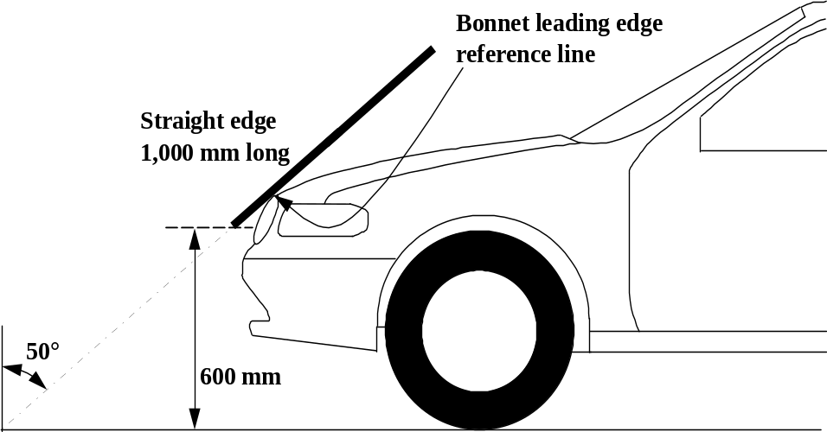

Figure 1: Bonnet leading edge reference line (see paragraph 3.5.)

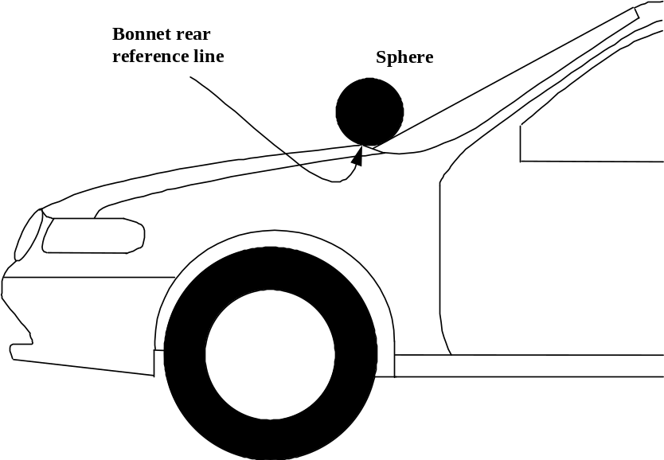

Figure 2: Bonnet rear reference line. (see paragraph 3.6.)

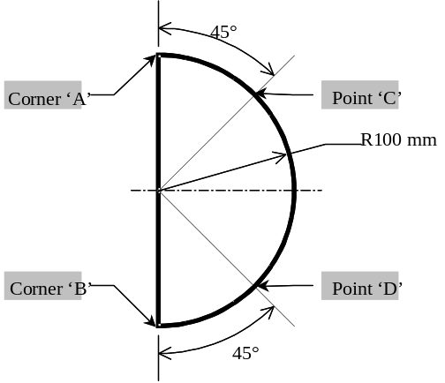

Figure 3: Template (see paragraph 3.6.)

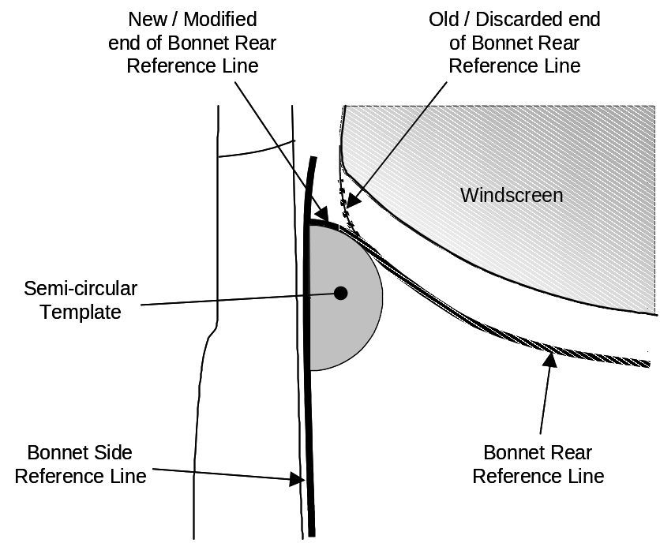

Figure 4: Marking of intersection between bonnet rear and side reference lines
(see paragraph 3.6.)

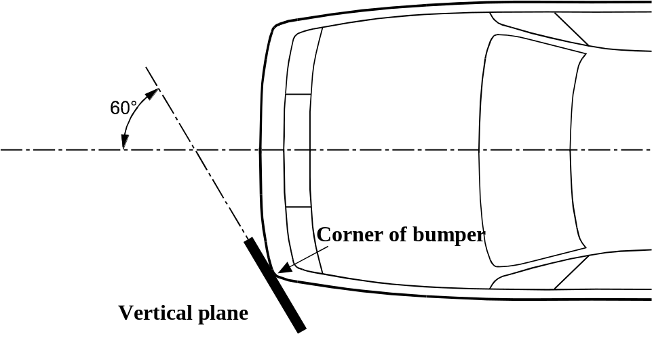

Figure 5: Corner of bumper (see paragraph 3.13.)

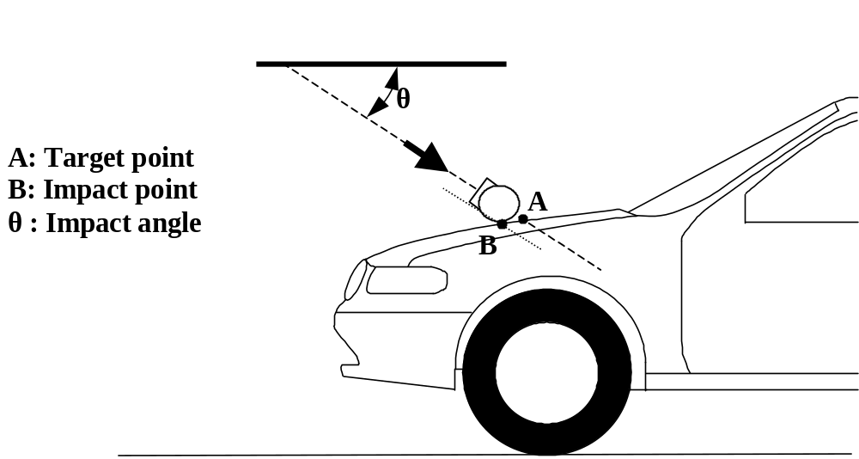

Figure 6: Impact and target point (see paragraphs 3.19. and 3.25.)

LBRL
LBRL
LBRL
25°
Straight edge
700mm Long

Figure 7: Lower bumper reference line, LBRL (see paragraph 3.21.)

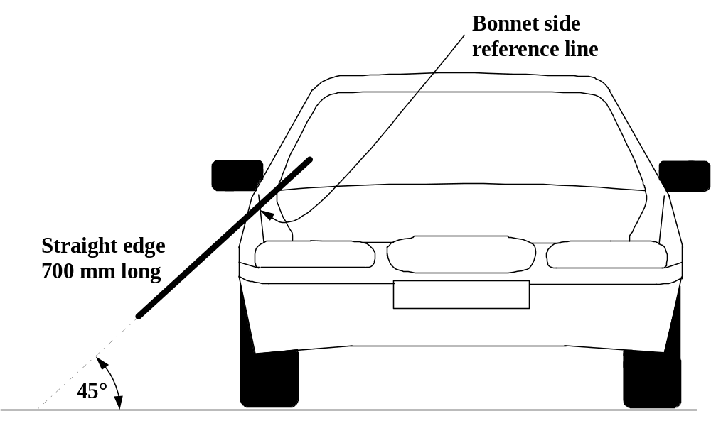

Figure 8: Side reference line (see paragraph 3.24.)

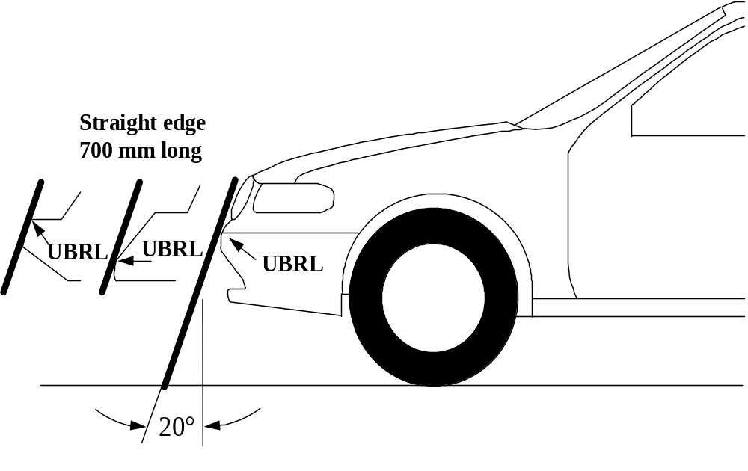

Figure 9: Upper bumper reference line, UBRL (see paragraph 3.27.)

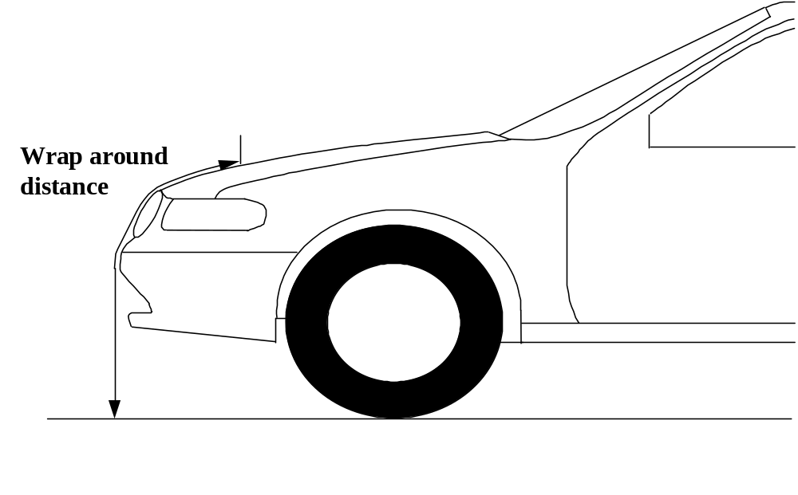

Figure 10: Wrap around distance measurement (see paragraph 3.28.)
4. GENERAL REQUIREMENTS

This global technical regulation specifies the following tests to verify compliance of vehicles.

4.1. Legform test to bumper:

For vehicles with a lower bumper height of less than 425 mm the requirements of paragraph 4.1.1. shall be applied.

For vehicles with a lower bumper height which is both greater than, or equal to 425 mm and less than 500 mm the requirements of either paragraph 4.1.1. or 4.1.2., at the choice of the manufacturer, shall be applied.

For vehicles with a lower bumper height of greater than, or equal to, 500 mm the requirements of paragraph 4.1.2. shall be applied.

4.1.1. Lower legform to bumper:

To verify compliance with the performance requirements as specified in paragraph 5.1.1., both the test impactor specified in paragraph 6.3.1.1. and the test procedures specified in paragraph 7.1.1. shall be used.

4.1.2. Upper legform to bumper:

To verify compliance with the performance requirements as specified in paragraph 5.1.2., both the test impactor specified in paragraph 6.3.1.2. and the test procedures specified in paragraph 7.1.2. shall be used.

4.2. Child headform impact:

To verify compliance with the performance requirements as specified in paragraph 5.2.1., both the test impactor specified in paragraph 6.3.2.1. and the test procedures specified in paragraphs 7.2. and 7.3. shall be used.

4.3. Adult headform impact:

To verify compliance with the performance requirements as specified in paragraph 5.2.2., both the test impactor specified in paragraph 6.3.2.2. and the test procedures specified in paragraphs 7.2. and 7.4. shall be used.

5. PERFORMANCE REQUIREMENTS

5.1. Legform to bumper:

    - When tested in accordance with paragraph 7.1.1. (RIGID/TRL lower legform to bumper) or paragraph 7.1.2. (Flex-PLI to bumper) according to the choice of manufacturers, the results shall comply with 5.1.1.1 or 5.1.1.2 respectively.

      - When tested in accordance with paragraph 7.1.1., the maximum dynamic knee bending angle shall not exceed 19°, the maximum dynamic knee shearing displacement shall not exceed 6.0 mm, and the acceleration measured at the upper end of the tibia shall not exceed 170g. In addition, the manufacturer may nominate bumper test widths up to a maximum of 264 mm in total where the acceleration measured at the upper end of the tibia shall not exceed 250g.

5.1.1.2 When tested in accordance with paragraph 7.1.2., the maximum dynamic medial collateral ligament elongation at knee shall not exceed [20 mm], and the dynamic bending moments at tibia shall not exceed [312 Nm]. The maximum dynamic anterior cruciate ligament and posterior cruciate ligament elongation shall be monitored with a reference value of [12,7] mm. [In addition, the manufacturer may nominate bumper test widths up to a maximum of 264 mm in total where the tibia bending moment of the FlexPLI shall not exceed TBD Nm and the MCL elongation of the FlexPLI shall not exceed TBD mm]

5.1.2. When tested in accordance with paragraph 7.1.23. (upper legform to bumper), the instantaneous sum of the impact forces with respect to time shall not exceed 7.5 kN and the bending moment on the test impactor shall not exceed 510 Nm.

5.2. Headform tests

5.2.1. Child headform to the front structure:

When tested in accordance with paragraphs 7.2. and 7.3. the HIC shall comply with paragraph 5.2.3.

5.2.2. Adult headform to the front structure:

When tested in accordance with paragraph 7.2. and 7.4. the HIC shall comply with paragraph 5.2.3.

5.2.3. The HIC recorded shall not exceed 1,000 over a minimum of one half of the child headform test area and 1,000 over two thirds of the combined child and adult headform test areas. The HIC for the remaining areas shall not exceed 1,700 for both headforms.

In case there is only a child headform test area, the HIC recorded shall not exceed 1,000 over two thirds of the test area. For the remaining area the HIC shall not exceed 1,700.

5.2.4. Splitting of headform test zone

5.2.4.1. The manufacturer shall identify the zones of the bonnet top where the HIC must not exceed 1,000 (HIC1000 Zone) or 1,700 (HIC1700 Zone) (see Figure 11).

HIC1000 Zone
HIC1700 Zone
Figure 11: Example of marking of HIC1000 zone and HIC1700 zone

5.2.4.2. Marking of the "bonnet top" impact area as well as "HIC1000 Zone" and "HIC1700 Zone" will be based on a drawing supplied by the manufacturer, when viewed from a horizontal plane above the vehicle that is parallel to the vehicle horizontal zero plane. A sufficient number of x and y co-ordinates shall be supplied by the manufacturer to mark up the areas on the actual vehicle while considering the vehicle outer contour in the z direction.

5.2.4.3. The areas of "HIC1000 Zone" and "HIC1700 Zone" may consist of several parts, with the number of these parts not being limited.

5.2.4.4. The calculation of the surface of the impact area as well as the surface areas of "HIC1000 Zone" and "HIC1700 Zone" shall be done on the basis of a projected bonnet when viewed from a horizontal plane parallel to the horizontal zero plane above the vehicle, on the basis of the drawing data supplied by the manufacturer.

6. TEST SPECIFICATIONS

6.1. General test conditions

6.1.1. Temperature and humidity

At the time of testing, the test facility and the vehicle or sub-system shall have a relative humidity of 40 percent ± 30 percent and stabilized temperature of 20 + 4 ºC.

6.1.2. Impact test site

The test site shall consist of a flat, smooth and hard surface with a slope not exceeding 1 percent.

6.2. Preparation of the vehicle

6.2.1. Either a complete vehicle, or a cut-body, adjusted to the following conditions shall be used for the test.

6.2.1.1. The vehicle shall be in its normal ride attitude, and shall be either securely mounted on raised supports or at rest on a flat horizontal surface with the parking brake applied.

6.2.1.2. The cut-body shall include, in the test, all parts of the vehicle front structure, all under-bonnet components and all components behind the windscreen that may be involved in a frontal impact with a vulnerable road user, to demonstrate the performance and interactions of all the contributory vehicle components. The cut-body shall be securely mounted in the normal vehicle ride attitude.

6.2.2. All devices designed to protect vulnerable road users when impacted by the vehicle shall be correctly activated before and/or be active during the relevant test. It shall be the responsibility of the manufacturer to show that any devices will act as intended in a pedestrian impact.

6.2.3. For vehicle components which could change shape or position, other than active devices to protect pedestrians, and which have more than one fixed shape or position shall require the vehicle to comply with the components in each fixed shape or position.

6.3. Test impactor specifications

6.3.1. Legform impactors:

6.3.1.1. RIGID/TRL Llower legform impactor:

The lower legform impactor shall consist of two foam covered rigid segments, representing femur (upper leg) and tibia (lower leg), joined by a deformable, simulated knee joint. The overall length of the impactor shall be 926 ± 5 mm, having a required test mass of 13.4 ± 0.2 kg (see Figure 12).

Brackets, pulleys, etc. attached to the impactor for the purpose of launching it, may extend the dimensions shown in Figure 12.

6.3.1.1.1. The diameter of the femur and tibia shall be 70 ± 1 mm and both shall be covered by foam flesh and skin. The foam flesh shall be 25 mm thick foam type CF-45 or equivalent. The skin shall be made of neoprene foam, faced with 0.5 mm thick nylon cloth on both sides, with an overall thickness of 6 mm.

6.3.1.1.2. The knee joint shall be fitted with deformable knee elements from the same batch as those used in the certification tests.

6.3.1.1.3. The total masses of the femur and tibia shall be 8.6 ± 0.1 kg and 4.8 ± 0.1 kg respectively, and the total mass of the impactor shall be 13.4 ± 0.2 kg. The centre of gravity of the femur and tibia shall be 217 ± 10 mm and 233 ± 10 mm from the centre of the knee respectively. The moment of inertia of the femur and tibia, about a horizontal axis through the respective centre of gravity and perpendicular to the direction of impact, shall be 0.127 ± 0.010 kgm² and 0.120 ± 0.010 kgm² respectively.

6.3.1.1.4. For each test the impactor shall be fitted with new foam flesh cut from one of up to four consecutive sheets of foam type CF-45 flesh material or equivalent, produced from the same batch of manufacture (cut from one block or 'bun' of foam), provided that foam from one of these sheets was used in the dynamic certification test and the individual weights of these sheets are within ± 2 percent of the weight of the sheet used in the certification test.

6.3.1.1.5. The test impactor or at least the foam flesh shall be stored during a period of at least four hours in a controlled storage area with a stabilized humidity of 35 percent ± 15 percent and a stabilized temperature of 20 ± 4°C prior to impactor removal for calibration. After removal from the storage the impactor shall not be subjected to conditions other than those pertaining in the test area.

6.3.1.1.6. Lower legform instrumentation

6.3.1.1.6.1. A uniaxial accelerometer shall be mounted on the non-impacted side of the tibia, 66 ± 5 mm below the knee joint centre, with its sensitive axis in the direction of impact.

6.3.1.1.6.2. A damper shall be fitted to the shear displacement system and may be mounted at any point on the rear face of the impactor or internally. The damper properties shall be such that the impactor meets both the static and dynamic shear displacement requirements and prevents excessive vibrations of the shear displacement system.

6.3.1.1.6.3. Transducers shall be fitted to measure knee bending angle and knee shearing displacement.

6.3.1.1.6.4. The instrumentation response value channel frequency class (CFC), as defined in ISO 6487:2002, shall be 180 for all transducers. The CAC response values, as defined in ISO 6487:2002, shall be 50° for the knee bending angle, 10 mm for the shearing displacement and 500g for the acceleration. This does not require that the impactor itself be able to physically bend and shear to these angles and displacements.

6.3.1.1.7. Lower legform certification

6.3.1.1.7.1. The lower legform impactor shall meet the performance requirements specified in paragraph 8.

6.3.1.1.7.2. The certified impactor may be used for a maximum of 20 impacts before re-certification. With each test new plastically deformable knee elements should be used. The impactor shall also be re-certified if more than one year has elapsed since the previous certification, if any impactor transducer output, in any impact, has exceeded the specified CAC or has reached the mechanical limits of the leg impactor deformation capability.
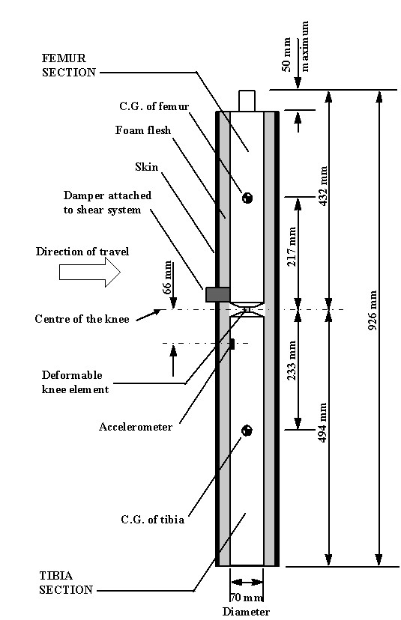
Figure 12: RIGID/TRL Llower legform impactor (see paragraph 6.3.1.1.)

6.3.1.2. Flexible pedestrian lower legform impactor (FlexPLI):

The lower legform impactor shall consist of flesh, flexible long bone segments (representing femur and tibia), and a knee joint as shown in Figure 13.

The overall length of the impactor shall be 928 ± [3] mm, having a required mass of 12.95 ± [0.4] kg including flesh. The length of the femur, knee joint, and tibia shall be 339 ± [2] mm, 185 ± [1] mm, and 404 ± [2] mm respectively. The knee joint centre position shall be 94 ± [1] mm from the top of the knee joint.

Brackets, pulleys, protectors, etc. attached to the impactor for the purpose of launching and/or protecting may extend beyond the dimensions shown in Figure 13.

6.3.1.2.1. The cross-sectional shape perpendicular to the Z axis of the femur and tibia main bodies shall be 90 ± [2] mm in width along the Y axis, and 84 ± [1] mm in width along the X axis as shown in Figure 14 (a). The impact face shall be 30 ± [1] mm in radius, 30 ± [1] mm in width along the Y axis, and 48 ± [1] mm in width along the X axis as shown in Figure 14 (a).

6.3.1.2.2. The cross-sectional shape perpendicular to the Z axis of the knee joint shall be 108 ± [2] mm in width along the Y axis, and 118 ± [1] mm in width along the X axis as shown in Figure 14 (b). The impact face shall be 103 ± [1] mm in radius, 12 ± [1] mm in width along the Y axis, and 86 ± [1] mm in width along the X axis as shown in Figure 14 (b).

6.3.1.2.3. The masses of the femur and tibia without flesh, including the connection part to the knee joint, shall be 2.45 ± [0.05] kg and 2.63 ± [0.05] kg respectively. The mass of the knee joint without flesh shall be 4.28 ± [0.1] kg. The total mass of the femur, knee joint, and tibia shall be 9.36 ± [0.2] kg.

The centre of gravity of the femur and tibia without flesh, including the connection part to the knee joint, shall be 167 ± [3] mm and 200 ± [3] mm respectively from the top, but not including the connection part to the knee joint, of each part as shown in Figure 13. The centre of gravity of the knee shall be 93 ± [3] mm from the top of the knee joint as shown in Figure 13.

The moment of inertia of the femur and tibia without flesh, including the connection part inserted to the knee joint, about the X axis through the respective centre of gravity shall be 0.0288 ± [0.002] kgm² and 0.0456 ± [0.002] kgm² respectively. The moment of inertia of the knee joint about the X axis through the respective centre of gravity shall be 0.018 ± [0.0015] kgm².

6.3.1.2.4. For each test, the impactor (femur, knee joint, and tibia) shall be covered by flesh composed of synthetic rubber sheets (R1, R2) and neoprene sheets (N1F, N2F, N1T, N2T, N3) as shown in Figure 15. The sheets are required to have a compression characteristic as shown in Figure 16. The compression characteristic shall be checked using the same batch of sheets as those used for the impactor flesh. The size and weight of the sheets shall be within the requirements described in Figure 16.

6.3.1.2.5. The test impactor or at least the flesh shall be stored for at least four hours in a controlled storage area with a stabilised temperature of 20 ± 4°C prior to impactor removal for calibration. After removal from the storage, the impactor shall not be subjected to conditions other than those pertaining in the test area.

6.3.1.2.6. Lower legform instrumentation

6.3.1.2.6.1. Four transducers shall be installed in the tibia to measure bending moments applied to the tibia. The sensing locations of each of the transducers are as follows: tibia-1: 134 ± [1] mm, tibia-2: 214 ± [1] mm, tibia-3: 294 ± [1] mm, and tibia-4: 374 ± [1] mm below the knee joint centre respectively as shown in Figure 17. The measurement axis of each transducer shall be the X axis of the impactor.

6.3.1.2.6.2. Three transducers shall be installed in the knee joint to measure elongations of the medial collateral ligament (MCL), anterior cruciate ligament (ACL), and posterior cruciate ligament (PCL). The measurement locations of each transducer are shown in Figure 17. The measurement locations shall be within ± [3] mm along the X axis from the knee joint centre.

6.3.1.2.6.3. The instrumentation response value channel frequency class (CFC), as defined in ISO 6487:2002, shall be 180 for all transducers. The CAC response values, as defined in ISO 6487:2002, shall be 30 mm for the knee ligament elongations and 350 Nm for the tibia bending moments. This does not require that the impactor itself be able to physically elongate or bend until these values.

6.3.1.2.7. Lower legform certification

6.3.1.2.7.1. The lower legform impactor shall meet the performance requirements specified in paragraph 8.

6.3.1.2.7.2. The certified impactor can be used for up to [20] impacts before requiring re-certification in dynamic certification [tests] which [are] described [in 8.1.2.2 and 8.1.2.3.] The impactor shall be re-certified by these tests if more than one year has elapsed since the previous dynamic certification tests, if any impactor transducer output has exceeded the specified CAC. If the impactor fails the tests, it shall be re-certified by using the static test described in 8.1.2.1. in order to detect which parts shall be changed to new parts.

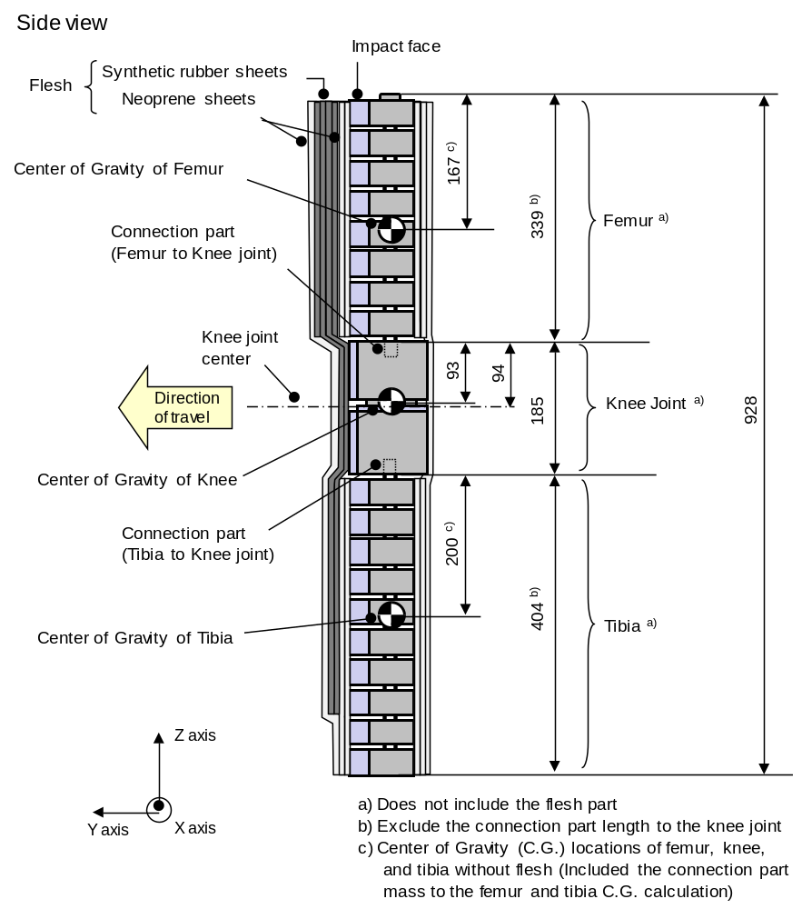
Figure 13: Flex-PLI; Dimensions and C.G. locations of femur, knee joint, and tibia
(Side view)
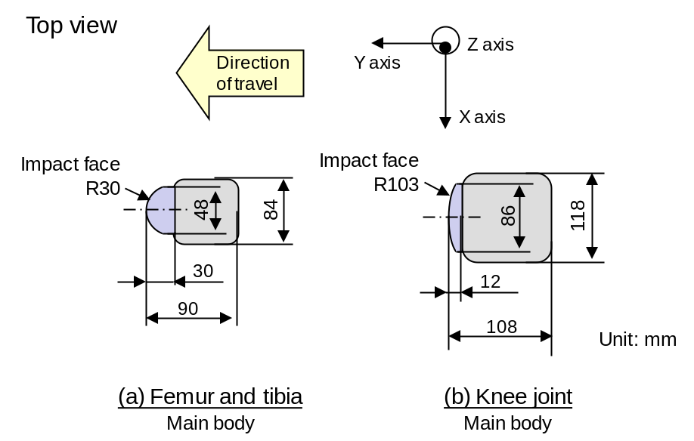
Figure 14: Flex-PLI; femur, tibia, and knee dimensions (Top view)

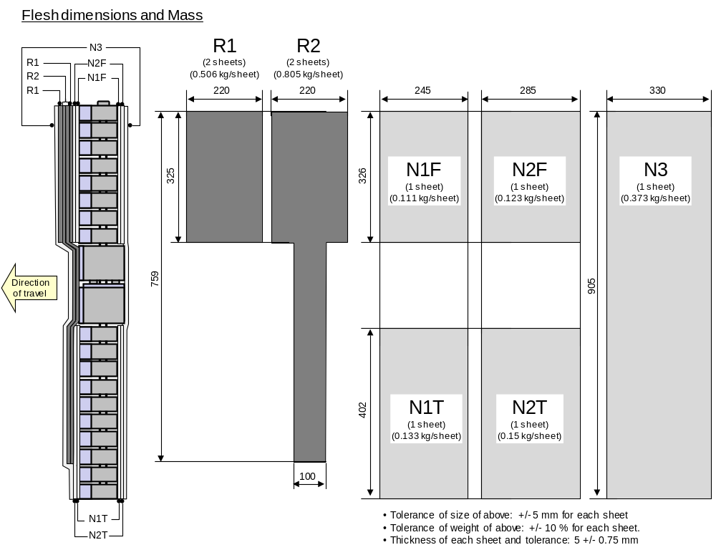

Figure 15: Flex-PLI; flesh dimensions and mass
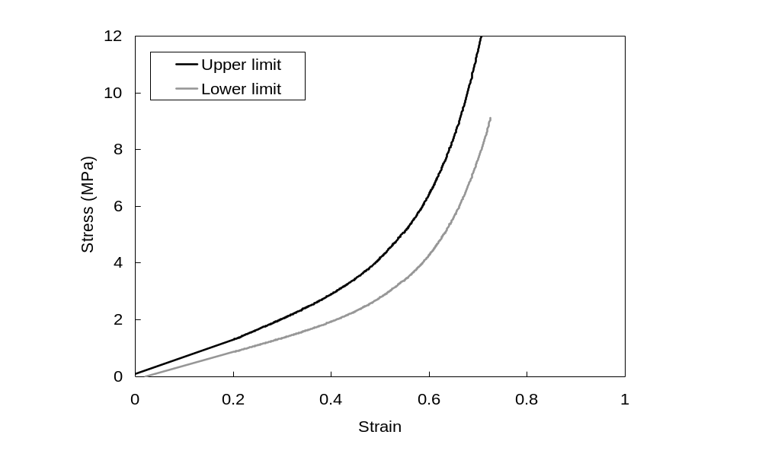
(a) Synthetic rubber sheets
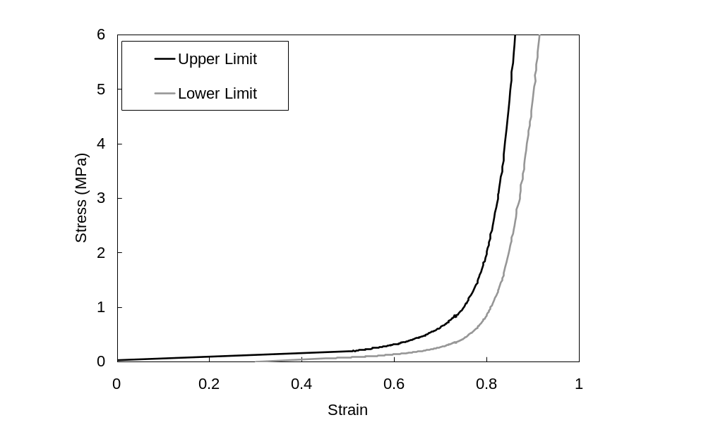
(b) Neoprene sheets

Figure 16: Flex-PLI; flesh compression characteristics
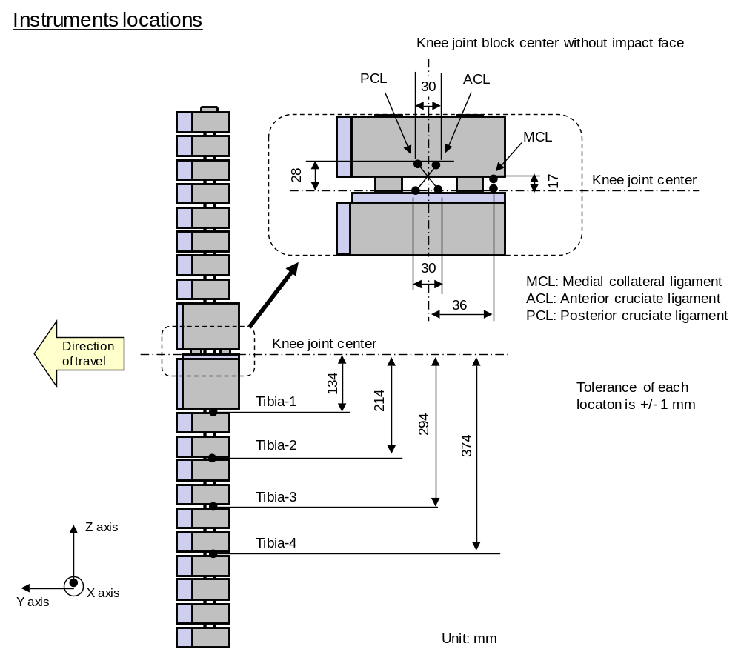

Figure 17: Flex-PLI; instrument locations

6.3.1.23. Upper legform impactor:

The upper legform impactor shall be rigid, foam covered at the impact side, and 350 ± 5 mm long (see Figure 138).

6.3.1. 23.1. The total mass of the upper legform impactor including those propulsion and guidance components which are effectively part of the impactor during the impact shall be 9.5 kg ± 0.1 kg.

6.3.1. 23.2. The total mass of the front member and other components in front of the load transducer assemblies, together with those parts of the load transducer assemblies in front of the active elements, but excluding the foam and skin, shall be 1.95 ± 0.05 kg.

6.3.1. 23.3. The upper legform impactor for the bumper test shall be mounted to the propulsion system by a torque limiting joint and be insensitive to off-axis loading. The impactor shall move only in the specified direction of impact when in contact with the vehicle and shall be prevented from motion in other directions including rotation about any axis.

6.3.1. 23.4. The torque limiting joint shall be set so that the longitudinal axis of the front member is vertical at the time of impact with a tolerance of ± 2°, with the joint friction torque set to 675 Nm ± 25 Nm.

6.3.1. 23.5. The centre of gravity of those parts of the impactor which are effectively forward of the torque limiting joint, including any weights fitted, shall lie on the longitudinal centre line of the impactor, with a tolerance of ± 10 mm.

6.3.1. 23.6. The length between the load transducer centre lines shall be 310 ± 1 mm and the front member diameter shall be 50 ± 1 mm.

6.3.1. 23.7. For each test the foam flesh shall be two new sheets of 25 mm thick foam type CF-45 or equivalent, which shall be cut from the sheet of material used for the dynamic certification test. The skin shall be a 1.5 mm thick fibre reinforced rubber sheet. The mass of the foam and the rubber skin together shall be 0.6 + 0.1 kg (this excludes any reinforcement, mountings, etc. which are used to attach the rear edges of the rubber skin to the rear member). The foam and rubber skin shall be folded back towards the rear, with the rubber skin attached via spacers to the rear member so that the sides of the rubber skin are held parallel. The foam shall be of such a size and shape that an adequate gap is maintained between the foam and components behind the front member, to avoid significant load paths between the foam and these components.

6.3.1. 23.8. The test impactor or at least the foam flesh shall be stored during a period of at least four hours in a controlled storage area with a stabilized humidity of 35 percent ± 15 percent and a stabilized temperature of 20 ± 4 °C prior to impactor removal for calibration. After removal from the storage the impactor shall not be subjected to conditions other than those pertaining in the test area.
6.3.1. 23.9. Upper legform instrumentation

6.3.1. 23.9.1. The front member shall be strain gauged to measure bending moments in three positions, as shown in Figure 138, each using a separate channel. The strain gauges are located on the impactor on the back of the front member. The two outer strain gauges are located 50 ± 1 mm from the impactor's symmetrical axis. The middle strain gauge is located on the symmetrical axis with a ± 1 mm tolerance.

6.3.1. 23.9.2. Two load transducers shall be fitted to measure individually the forces applied at either end of the upper legform impactor, plus strain gauges measuring bending moments at the centre of the upper legform impactor and at positions 50 mm either side of the centre line (see Figure 138).

6.3.1. 23.9.3. The instrumentation response value CFC, as defined in ISO 6487:2002, shall be 180 for all transducers. The CAC response values, as defined in ISO 6487:2002, shall be 10 kN for the force transducers and 1,000 Nm for the bending moment measurements.

6.3.1. 23.10. Upper legform certification

6.3.1. 23.10.1. The upper legform impactor shall meet the performance requirements specified in paragraph 8.

6.3.1. 23.10.2. The certified impactor may be used for a maximum of 20 impacts before re-certification (this limit does not apply to propulsion or guidance components). The impactor shall also be re-certified if more than one year has elapsed since the previous certification or if any impactor transducer output, in any impact, has exceeded the specified CAC.

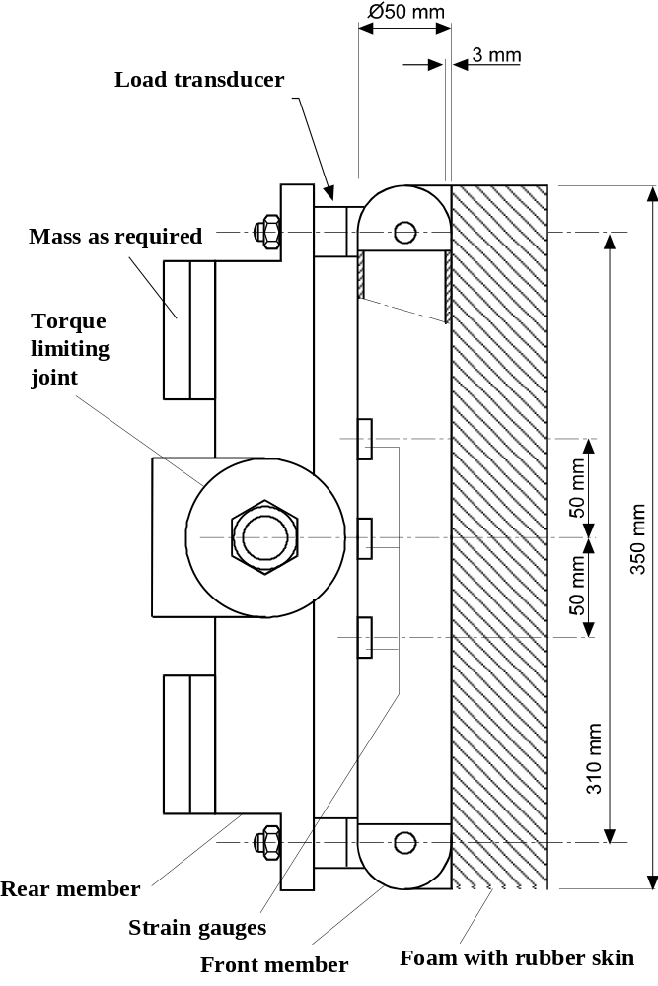

Figure 13: Upper legform impactor (see paragraph 6.3.1. 23.)
6.3.2. Child and adult headform impactors

6.3.2.1. Child headform impactor (see Figure 1419)

The child headform impactor shall be made of aluminium, be of homogenous construction and be of spherical shape. The overall diameter shall be 165 ± 1 mm. The mass shall be 3.5 ± 0.07 kg. The moment of inertia about an axis through the centre of gravity and perpendicular to the direction of impact shall be within the range of 0.008 to 0.012 kgm². The centre of gravity of the headform impactor including instrumentation shall be located in the geometric centre of the sphere with a tolerance of ± 2 mm.

The sphere shall be covered with a 14 ± 0.5 mm thick synthetic skin, which shall cover at least half of the sphere.

6.3.2.1.1. Child headform instrumentation

A recess in the sphere shall allow for mounting one triaxial or three uniaxial accelerometers within ± 10 mm seismic mass location tolerance from the centre of the sphere for the measurement axis, and ± 1 mm seismic mass location tolerance from the centre of the sphere for the perpendicular direction to the measurement axis.

If three uniaxial accelerometers are used, one of the accelerometers shall have its sensitive axis perpendicular to the mounting face A (see Figure 1419) and its seismic mass shall be positioned within a cylindrical tolerance field of 1 mm radius and 20 mm length. The centre line of the tolerance field shall run perpendicular to the mounting face and its mid-point shall coincide with the centre of the sphere of the headform impactor.

The remaining accelerometers shall have their sensitive axes perpendicular to each other and parallel to the mounting face A and their seismic mass shall be positioned within a spherical tolerance field of 10 mm radius. The centre of the tolerance field shall coincide with the centre of the sphere of the headform impactor.

The instrumentation response value CFC, as defined in ISO 6487: 2002, shall be 1,000. The CAC response value, as defined in ISO 6487:2002, shall be 500g for the acceleration.

6.3.2.1.2. First natural frequency

The first natural frequency of the headform impactor shall be over 5,000 Hz.
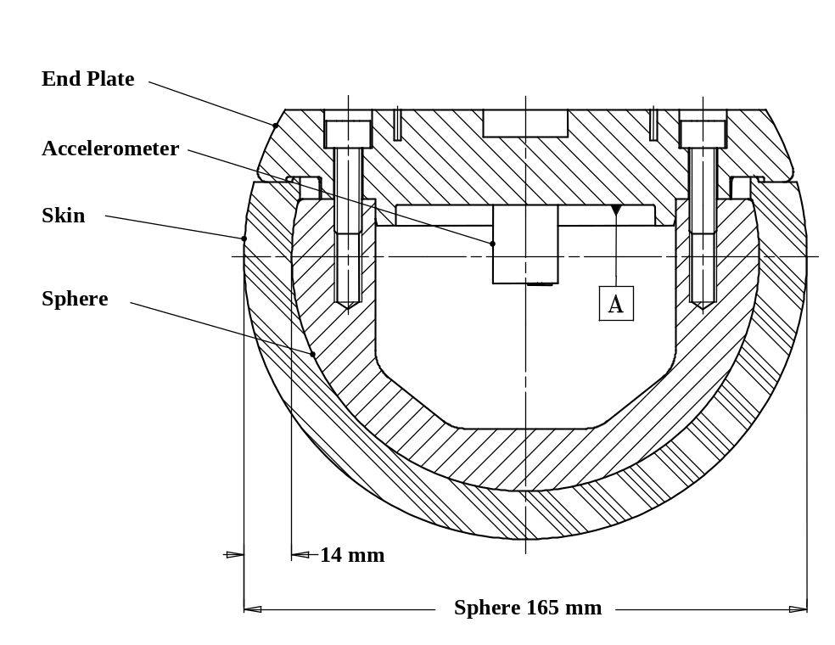
Figure 1419: Child headform impactor (see paragraph 6.3.2.1.)

6.3.2.2. Adult headform impactor (see Figure 1520)

The adult headform impactor shall be made of aluminium, be of homogenous construction and be of spherical shape. The overall diameter is 165 ± 1 mm as shown in Figure 15. The mass shall be 4.5 ± 0.1 kg. The moment of inertia about an axis through the centre of gravity and perpendicular to the direction of impact shall be within the range of 0.010 to 0.013 kgm². The centre of gravity of the headform impactor including instrumentation shall be located in the geometric centre of the sphere with a tolerance of ± 5 mm.

The sphere shall be covered with a 14 ± 0.5 mm thick synthetic skin, which shall cover at least half of the sphere.
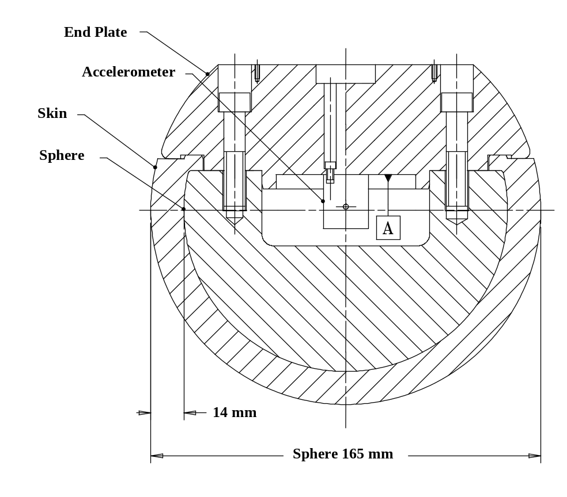

Figure 1520: Adult headform impactor (see paragraph 6.3.2.2)

6.3.2.2.1. Adult headform instrumentation

A recess in the sphere shall allow for mounting one triaxial or three uniaxial accelerometers within ± 10 mm seismic mass location tolerance from the centre of the sphere for the measurement axis, and ± 1 mm seismic mass location tolerance from the centre of the sphere for the perpendicular direction to the measurement axis.

If three uniaxial accelerometers are used, one of the accelerometers shall have its sensitive axis perpendicular to the mounting face A (see Figure 1520) and its seismic mass shall be positioned within a cylindrical tolerance field of 1 mm radius and 20 mm length. The centre line of the tolerance field shall run perpendicular to the mounting face and its mid-point shall coincide with the centre of the sphere of the headform impactor.

The remaining accelerometers shall have their sensitive axes perpendicular to each other and parallel to the mounting face A and their seismic mass shall be positioned within a spherical tolerance field of 10 mm radius. The centre of the tolerance field shall coincide with the centre of the sphere of the headform impactor.

The instrumentation response value CFC, as defined in ISO 6487: 2002, shall be 1,000. The CAC response value, as defined in ISO 6487: 2002, shall be 500g for the acceleration.

6.3.2.2.2. First natural frequency

The first natural frequency of the headform impactor shall be over 5,000 Hz.

6.3.2.3. Rear face of the headform impactors

A rear flat face shall be provided on the outer surface of the headform impactors which is perpendicular to the direction of travel, and typically perpendicular to the axis of one of the accelerometers as well as being a flat plate capable of providing for access to the accelerometers and an attachment point for the propulsion system.

6.3.2.4. Certification of the headform impactors

The headform impactors shall meet the performance requirements specified in paragraph 8. The certified impactors may be used for a maximum of 20 impacts before re-certification. The impactors shall be re-certified if more than one year has elapsed since the previous certification or if the transducer output, in any impact, has exceeded the specified CAC.

7. TEST PROCEDURES

7.1. Legform to bumper test procedures

7.1.1. RIGID/TRL Llower legform to bumper test procedure:

Each test shall be completed within two hours of when the impactor to be used is removed from the controlled storage area.

7.1.1.1. The selected target points shall be in the bumper test area.

7.1.1.2. The direction of the impact velocity vector shall be in the horizontal plane and parallel to the longitudinal vertical plane of the vehicle. The tolerance for the direction of the velocity vector in the horizontal plane and in the longitudinal plane shall be ± 2° at the time of first contact. The axis of the impactor shall be perpendicular to the horizontal plane with a tolerance of ± 2° in the lateral and longitudinal plane. The horizontal, longitudinal and lateral planes are orthogonal to each other (see Figure 1621).

7.1.1.3. The bottom of the impactor shall be at 25 mm above ground reference plane at the time of first contact with the bumper (see Figure 1722), with a ± 10 mm tolerance. When setting the height of the propulsion system, an allowance must be made for the influence of gravity during the period of free flight of the impactor.

7.1.1.3.1. The lower legform impactor for the bumper tests shall be in 'free flight' at the moment of impact. The impactor shall be released to free flight at such a distance from the vehicle that the test results are not influenced by contact of the impactor with the propulsion system during rebound of the impactor.

The impactor may be propelled by an air, spring or hydraulic gun, or by other means that can be shown to give the same result.

7.1.1.3.2. At the time of first contact the impactor shall have the intended orientation about its vertical axis, for the correct operation of its knee joint, with a tolerance of ± 5° (see Figure 1621).

7.1.1.3.3. At the time of first contact the centre line of the impactor shall be within a ± 10 mm tolerance to the selected impact location.

7.1.1.3.4. During contact between the impactor and the vehicle, the impactor shall not contact the ground or any object which is not part of the vehicle.

7.1.1.4. The impact velocity of the impactor when striking the bumper shall be 11.1 ± 0.2 m/s. The effect of gravity shall be taken into account when the impact velocity is obtained from measurements taken before the time of first contact.

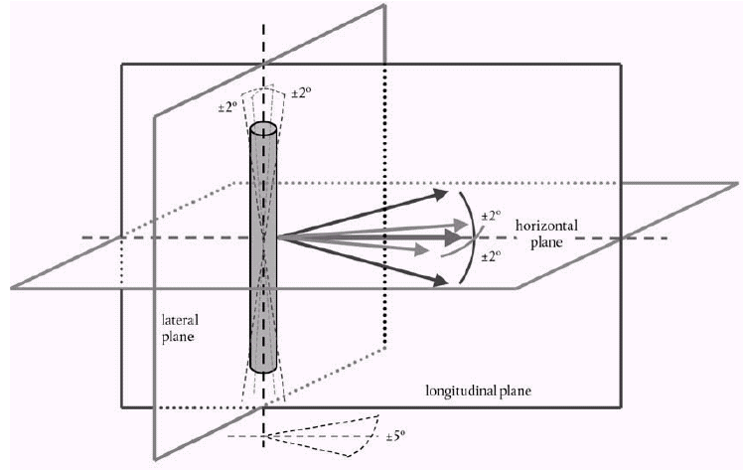

Figure 1621: Tolerances of angles for the lower legform impactor at the time of the
first impact (see paragraphs 7.1.1.2 and 7.1.1.3.2.)

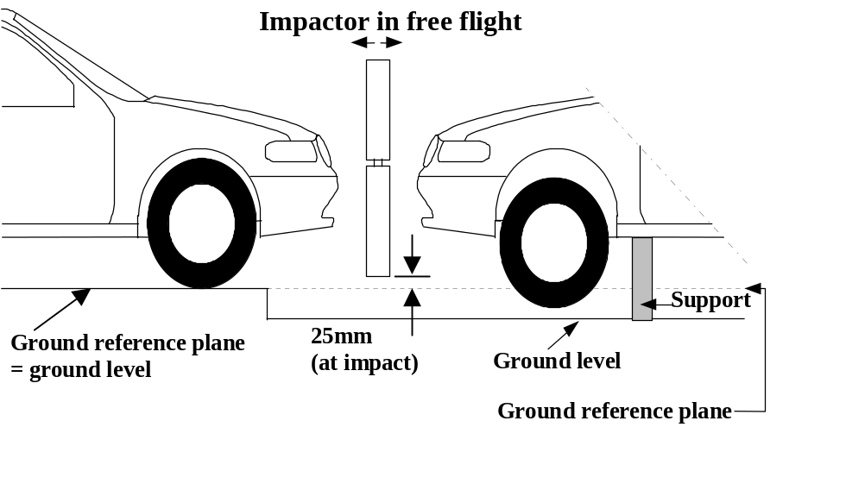

Figure 1722: Lower legform to bumper tests for complete vehicle in normal ride attitude (left) and for cut-body mounted on supports (right) (see paragraph 7.1.1.3)

7.1.2. FlexPLI to bumper test procedure

Each test shall be completed within two hours of when the impactor to be used is removed from the controlled storage area.

7.1.2.1. The selected target points shall be in the bumper test area.

7.1.2.2. The direction of the impact velocity vector shall be in the horizontal plane and parallel to the longitudinal vertical plane of the vehicle. The tolerance for the direction of the velocity vector in the horizontal plane and in the longitudinal plane shall be ± 2° at the time of first contact. The axis of the impactor shall be perpendicular to the horizontal plane with a tolerance of ± 2° in the lateral and longitudinal plane. The horizontal, longitudinal and lateral planes are orthogonal to each other (see Figure 23).

7.1.2.3. The bottom of the impactor shall be at 75 mm above ground reference plane at the time of first contact with the bumper (see Figure 24), with a ± 10 mm tolerance. When setting the height of the propulsion system, an allowance must be made for the influence of gravity during the period of free flight of the impactor.

7.1.2.3.1. The lower legform impactor for the bumper tests shall be in 'free flight' at the moment of impact. The impactor shall be released to free flight at such a distance from the vehicle that the test results are not influenced by contact of the impactor with the propulsion system during rebound of the impactor.

The impactor may be propelled by an air, spring or hydraulic gun, or by other means that can be shown to give the same result.

7.1.2.3.2. At the time of first contact the impactor shall have the intended orientation about its vertical axis, for the correct operation of its knee joint, with a tolerance of ± 5° (see Figure 23).

7.1.2.3.3. At the time of first contact the centre line of the impactor shall be within a ± 10 mm tolerance to the selected impact location.

7.1.2.3.4. During contact between the impactor and the vehicle, the impactor shall not contact the ground or any object which is not part of the vehicle.

7.1.2.4. The impact velocity of the impactor when striking the bumper shall be 11.1 ± 0.2 m/s. The effect of gravity shall be taken into account when the impact velocity is obtained from measurements taken before the time of first contact.

Figure 23: Tolerances of angles for the lower legform impactor at the time of the
first impact (see paragraphs 7.1.2.2. and 7.1.2.3.2.)

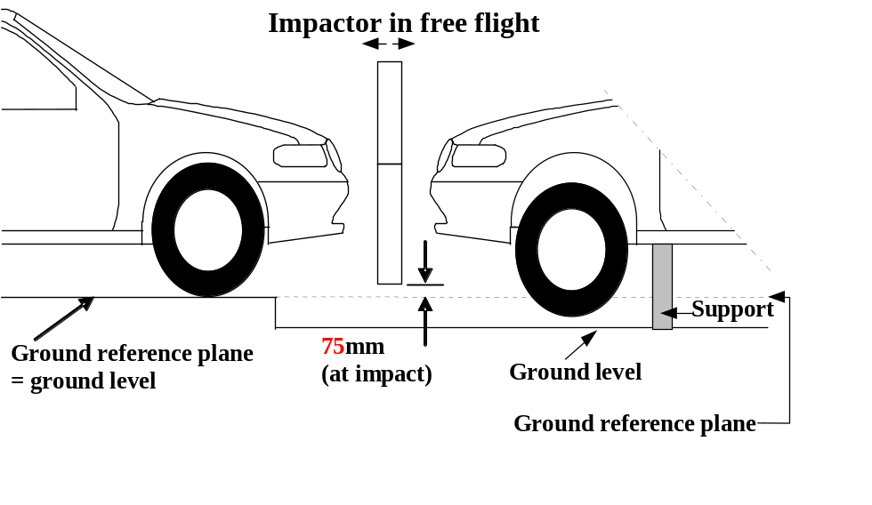

Figure 24: Flex-PLI to bumper tests for complete vehicle in normal ride attitude (left) and for cut-body mounted on supports (right) (see paragraph 7.1.2.3.)

7.1.23. Upper legform to bumper test procedure:

Each test shall be completed within two hours of when the impactor to be used is removed from the controlled storage area.

7.1. 23.1. The selected target points shall be in the bumper test area as defined in paragraph 3.10.

7.1. 23.2. The direction of impact shall be parallel to the longitudinal axis of the vehicle, with the axis of the upper legform vertical at the time of first contact. The tolerance to this direction is ± 2°.

At the time of first contact the impactor centre line shall be vertically midway between the upper bumper reference line and the lower bumper reference line with a + 10 mm tolerance and the impactor vertical centre line shall be positioned laterally with the selected impact location with a tolerance of ± 10 mm.

7.1. 23.3. The impact velocity of the upper legform impactor when striking the bumper shall be 11.1 ± 0.2 m/s.

7.2. Headform test procedures

7.2.1. Propulsion of the headform impactors

The headform impactors shall be in "free flight" at the moment of impact, at the required impact velocity (as specified in paragraphs 7.3.4. and 7.4.4.) and the required direction of impact (as specified in paragraphs 7.3.5. and 7.4.5.).
The impactors shall be released to "free flight" at such a distance from the vehicle that the test results are not influenced by contact of the impactor with the propulsion system during rebound of the impactor.

7.2.2. Measurement of impact velocity

The velocity of the headform impactor shall be measured at some point during the free flight before impact, in accordance with the method specified in ISO 3784:1976. The accuracy of velocity measurement shall be ± 0.01 m/sec. The measured velocity shall be adjusted considering all factors which may affect the impactor between the point of measurement and the point of impact, in order to determine the velocity of the impactor at the time of impact. The angle of the velocity vector at the time of impact shall be calculated or measured.

7.2.3. Recording

The acceleration time histories shall be recorded, and HIC shall be calculated. The first point of contact on the front structure of the vehicle shall be recorded. Recording of test results shall be in accordance with ISO 6487:2002.

7.3. Child headform test procedure

This test procedure is applicable with respect to the requirements of paragraphs 5.2.1. and 5.2.3.

7.3.1. Tests shall be made to the front structure within the boundaries as defined in paragraph 3.12. For tests on the rear area of the bonnet top, the headform impactor shall not contact the windscreen or A-pillar before impacting the bonnet top.

7.3.2. No impact point shall be located so that the impactor will impact the test area with a glancing blow resulting in a more severe second impact outside the test area.

Selected impact points on the bonnet for the child headform impactor shall be, at the time of first contact:
(a) a minimum of 82.5 mm inside the defined side reference lines, and;
(b) forward of the WAD1700 line, or,
a minimum of 82.5 mm forwards of the bonnet rear reference line,
- whichever is most forward at the point of measurement, and;
(c) be rearward of the WAD1000 line, or,
a minimum of 82.5 mm rearwards of the bonnet leading edge reference line,
- whichever is most rearward at the point of measurement.

These minimum distances are to be set with a flexible tape held tautly along the outer surface of the vehicle.

7.3.3. The point of first contact of the headform impactor shall be within a ± 10 mm tolerance to the selected impact point.

7.3.4. The headform velocity at the time of impact shall be 9.7 ± 0.2 m/s.

7.3.5. The direction of impact shall be in the longitudinal vertical plane of the vehicle to be tested at an angle of 50 ± 2° to the horizontal. The direction of impact of tests to the front structure shall be downward and rearward.

7.4. Adult headform test procedure:

This test procedure is applicable with respect to the requirements of paragraphs 5.2.2. and 5.2.3.

7.4.1. Tests shall be made to the front structure within the boundaries as defined in paragraph 3.1. For tests at the rear of the bonnet top, the headform impactor shall not contact the windscreen or A-pillar before impacting the bonnet top.

7.4.2. No impact point shall be located so that the impactor will impact the test area with a glancing blow resulting in a more severe second impact outside the test area.

Selected impact points on the bonnet for the adult headform impactor shall be, at the time of first contact:
(a) a minimum of 82.5 mm inside the defined side reference lines, and;
(b) forward of the WAD2100 line, or,
a minimum of 82.5 mm forward of the bonnet rear reference line,
whichever is most forward at the point of measurement, and;
(c) rearward of the WAD1700 line.

These minimum distances are to be set with a flexible tape held tautly along the outer surface of the vehicle.

7.4.3. The point of first contact of the headform impactor shall be within a ± 10 mm tolerance to the selected impact point.

7.4.4. The headform velocity at the time of impact shall be [9.7 ± 0.2 m/s].

7.4.5. The direction of impact shall be in the longitudinal vertical plane of the paragraph of the vehicle to be tested at an angle of 65° ± 2° to the horizontal. The direction of impact of tests to the front structure shall be downward and rearward.

8. CERTIFICATION OF IMPACTORS

The impactors that are used in the tests described in this gtr are required to comply with the following performance requirements.

The requirements for the lower legform impactor are specified in paragraph 8.1. or 8.2., the upper legform impactor requirements are specified in paragraph 8.28.3. and the adult and child headform impactors requirements are specified in paragraph 8.38.4.

8.1. RIGID/TRL Llower legform impactor certification

8.1.1. Static tests

8.1.1.1. The lower legform impactor shall meet the requirements specified in paragraph 8.1.1.2. when tested as specified in paragraph 8.1.1.4. and the requirements specified in paragraph 8.1.1.3. when tested as specified in paragraph 8.1.1.5.

For both tests the impactor shall have the intended orientation about its longitudinal axis, for the correct operation of its knee joint, with a tolerance of ± 2°.

The stabilized temperature of the impactor during certification shall be 20° ± 2°C.

The CAC response values, as defined in ISO 6487:2002 shall be 50° for the knee bending angle and 500 N for the applied force when the impactor is loaded in bending in accordance with paragraph 8.1.1.4., and 10 mm for the shearing displacement and 10 kN for the applied force when the impactor is loaded in shearing in accordance with paragraph 8.1.1.5. For both tests low-pass filtering at an appropriate frequency is permitted, to remove higher frequency noise without significantly affecting the measurement of the response of the impactor.

8.1.1.2. When the impactor is loaded in bending in accordance with paragraph 8.1.1.4., the applied force/bending angle response shall be within the limits shown in Figure 1825. Also, the energy taken to generate 15.0° of bending shall be 100 ± 7 J.

8.1.1.3. When the impactor is loaded in shearing in accordance with paragraph 8.1.1.5., the applied force/shearing displacement response shall be within the limits shown in Figure 1926.

8.1.1.4. The impactor, without foam covering and skin, shall be mounted with the tibia firmly clamped to a fixed horizontal surface and a metal tube connected firmly to the femur, as shown in Figure 2027. The rotational axis of impactor knee joint shall be vertical. To avoid friction errors, no support shall be provided to the femur section or the metal tube. The bending moment applied at the centre of the knee joint, due to the mass of the metal tube and other components (excluding the legform itself), shall not exceed 25 Nm.

A horizontal normal force shall be applied to the metal tube at a distance of 2.0 + 0.01 m from the centre of the knee joint and the resulting angle of knee deflection shall be recorded. The load shall be increased at a rate between 1.0 and 10°/s until the angle of deflection of the knee is in excess of 22º. Brief excursions from these limits due, for instance, to the use of a hand-pump shall be permitted.

The energy is calculated by integrating the force with respect to the bending angle in radians, and multiplying by the lever length of 2.0 + 0.01 m.

8.1.1.5. The impactor, without foam covering and skin, shall be mounted with the tibia firmly clamped to a fixed horizontal surface and a metal tube connected firmly to the femur and restrained at 2.0 m from the centre of the knee joint, as shown in Figure 2128.

A horizontal normal force shall be applied to the femur at a distance of 50 mm from the centre of the knee joint and the resulting knee shearing displacement shall be recorded. The load shall be increased between 0.1 and 20 mm/s until the shearing displacement of the knee is in excess of 7.0 mm or the load is in excess of 6.0 kN. Brief excursions from these limits due, for instance, to the use of a hand-pump shall be permitted.

8.1.2. Dynamic tests

8.1.2.1. The lower legform impactor shall meet the requirements specified in paragraph 8.1.2.3. when tested as specified in paragraph 8.1.2.4.

8.1.2.2. Calibration

8.1.2.2.1. The foam flesh for the test impactor shall be stored during a period of at least four hours in a controlled storage area with a stabilized humidity of 35 ± 10 percent and a stabilized temperature of 20 ± 2°C prior to impactor removal for calibration. The test impactor itself shall have a temperature of 20° ± 2°C at the time of impact. The temperature tolerances for the test impactor shall apply at a relative humidity of 40 ± 30 percent after a soak period of at least four hours prior to their application in a test.

8.1.2.2.2. The test facility used for the calibration test shall have a stabilized humidity of 40 ± 30 percent and a stabilized temperature of 20 ± 4°C during calibration.

8.1.2.2.3. Each calibration shall be completed within two hours of when the impactor to be calibrated is removed from the controlled storage area.

8.1.2.2.4. Relative humidity and temperature of the calibration area shall be measured at the time of calibration and recorded in a calibration report.

8.1.2.3. Requirements

8.1.2.3.1. When the impactor is impacted by a linearly guided certification impactor, as specified in paragraph 8.1.2.4., the maximum upper tibia acceleration shall be not less than 120g and not more than 250g. The maximum bending angle shall be not less than 6.2° and not more than 8.2°. The maximum shearing displacement shall be not less than 3.5 mm and not more than 6.0 mm.

For all these values, the readings used shall be from the initial impact with the certification impactor and not from the arresting phase. Any system used to arrest the impactor or certification impactor shall be so arranged that the arresting phase does not overlap in time with the initial impact. The arresting system shall not cause the transducer outputs to exceed the specified CAC.

8.1.2.3.2. The instrumentation response value CFC, as defined in ISO 6487:2002, shall be 180 for all transducers. The CAC response values, as defined in ISO 6487:2002, shall be 50° for the knee bending angle, 10 mm for the shearing displacement and 500g for the acceleration. This does not require that the impactor itself be able to physically bend and shear to these angles and displacements.

8.1.2.4. Test procedure

8.1.2.4.1. The impactor, including foam covering and skin, shall be suspended horizontally by three wire ropes of 1.5 ± 0.2 mm diameter and of 2000 mm minimum length, as shown in Figure 2229. It shall be suspended with its longitudinal axis horizontal, with a tolerance of ± 0.5°, and perpendicular to the direction of the certification impactor motion, with a tolerance of ± 2°. The impactor shall have the intended orientation about its longitudinal axis, for the correct operation of its knee joint, with a tolerance of ± 2°. The impactor must meet the requirements of paragraph 6.3.1.1., with the attachment bracket(s) for the wire ropes fitted.

8.1.2.4.2. The certification impactor shall have a mass of 9.0 ± 0.05 kg, this mass includes those propulsion and guidance components which are effectively part of the impactor during impact. The dimensions of the face of the certification impactor shall be as specified in Figure 2330. The face of the certification impactor shall be made of aluminium, with an outer surface finish of better than 2.0 micrometers.

The guidance system shall be fitted with low friction guides, insensitive to off-axis loading, that allow the impactor to move only in the specified direction of impact, when in contact with the vehicle. The guides shall prevent motion in other directions including rotation about any axis.

8.1.2.4.3. The impactor shall be certified with previously unused foam.

8.1.2.4.4. The impactor foam shall not be excessively handled or deformed before, during or after fitting.

8.1.2.4.5. The certification impactor shall be propelled horizontally at a velocity of 7.5 ± 0.1 m/s into the stationary impactor as shown in Figure 2330. The certification impactor shall be positioned so that its centreline aligns with a position on the tibia centreline of 50 mm from the centre of the knee, with tolerances of ± 3 mm laterally and ± 3 mm vertically.
8.2. Flex-PLI certification

8.2.1. Static certification tests

8.2.1.1. The femur and tibia of the lower legform impactor shall meet the requirements respectively specified in paragraph 8.2.1.2. when tested as specified in paragraph 8.2.1.4. The knee joint of the lower legform impactor shall meet the requirements specified in paragraph 8.2.1.3. when tested as specified in paragraph 8.2.1.5. The stabilised temperature of the impactor during the certification tests shall be 20° ± 2°C.

The CAC response values, as defined in ISO 6487:2002, shall be 30 mm for the knee ligament elongations and 5 kN for the applied external load. For these tests low-pass filtering at an appropriate frequency is permitted, to remove higher frequency noise without significantly affecting the measurement of the response of the impactor.

8.2.1.2. When the femur and tibia of the impactor are loaded in bending in accordance with paragraph 8.2.1.4., the applied moment and generated deflection at the centre of the femur and tibia (M_{c} and D_{c}) shall be within the corridors shown in Figure 31.

8.2.1.3. When the knee joint of the impactor is loaded in bending in accordance with paragraph 8.2.1.5., the MCL, ACL, and PCL elongations and applied bending moment or force at the centre of the knee joint (M_{c} or F_{c}) shall be within the corridors shown in Figure 32.

8.2.1.4. The edges,of the femur and tibia, not bending parts, shall be mounted to the support rig firmly as shown in Figure 33. The Y axis of the impactor shall be parallel to the loading axis within 180 ± 2° tolerance. In order to avoid friction errors, roller plates shall be set underneath the support rigs. To avoid impactor damage, a neoprene sheet shall be set underneath the loading ram. The neoprene sheet used in this test shall have compression characteristics as shown in Figure 16.

The centre of the loading force shall be applied at the centre of the femur and tibia within ± [2°] tolerance along the Z axis. The force shall be increased at a rate between 10 and 100 mm/minute until the bending moment at the centre part (M_{c}) of the femur or tibia reaches 312 Nm.

8.2.1.5. The edges of the knee joint, not bending parts, shall be mounted to the support rig firmly as shown in Figure 35. The Y axis of the impactor shall be parallel to the loading axis within 180 ± 2°. In order to avoid friction errors, roller plates shall be set underneath the support rigs. To avoid impactor damage, a neoprene sheet shall be set underneath the loading ram and shall be removed the impactor face of the knee joint which is described in the Figure 14. The neoprene sheet used in this test shall have compression characteristics as shown in Figure 16.

The centre of the loading force shall be applied at the centre of the Knee joint within ± [2]° tolerance along the Z axis. The external load shall be increased at a rate between 10 and 100 mm/minute until the bending moment at the centre part of the knee joint (M_{c}) reaches 300 Nm.

8.2.2. Dynamic certification tests (Pendulum Type)

8.2.2.1. The lower legform impactor (femur, knee joint, and tibia are connected/assembled firmly) shall meet the requirements specified in paragraph 8.2.2.3. when tested as specified in paragraph 8.2.2.4.

8.2.2.2. Calibration

8.2.2.2.1. The test facility used for the calibration test shall have a stabilised temperature of 20 ± 4°C during calibration.

8.2.2.2.2. The temperature of the calibration area shall be measured at the time of calibration and recorded in a calibration report.

8.2.2.3. Requirements

8.2.2.3.1. When the lower legform impactor is used for a test as specified in paragraph 8.1.2.2.4., the maximum bending moment of the tibia at tibia-1 shall be not less than [267] Nm and not more than [218] Nm, the maximum bending moment at tibia-2 shall be not less than [221] Nm and not more than [181] Nm, the maximum bending moment at tibia-3 shall be not less than [172] Nm and not more than [141] Nm, and the maximum bending moment at tibia-4 shall be not less than [119] Nm and not more than [97] Nm. The maximum elongation of MCL shall be not less than [24.6] mm and not more than [20.0] mm, the maximum elongation of ACL shall be not less than [9.0] mm and not more than [7.4] mm, and the maximum elongation of PCL shall be not less than [5.4] mm and not more than [4.4] mm.

For all these values, the readings used shall be from the initial impact timing to 250 ms after the impact timing.

8.2.2.3.2. The instrumentation response value CFC, as defined in ISO 6487:2002, shall be 180 for all transducers. The CAC response values, as defined in ISO 6487:2002, shall be 30 mm for the knee ligament elongations and 350 Nm for the tibia bending moments. This does not require that the impactor itself be able to physically elongate and bend to these values.

8.2.2.4. Test procedure

8.2.2.4.1. The impactor, excluding flesh, shall be suspended from the dynamic certification test rig 15 ± 1° upward from the horizontal as shown in Figure 36. The impactor shall be released from the suspended position, whereupon the impactor falls freely against the pin joint of the test rig as shown in Figure 36.

8.2.2.4.2. The stopper block, attached to the front of the stopper bar, shall have compression characteristics as shown in Figure 16 or shall generate maximum compression force from 3.5 to 4 kN when it is subjected to the drop test shown in Figure 37.

8.2.2.4.3. The knee joint centre of the impactor shall be 30 ± [1] mm below the bottom line of the stopper bar, and the tibia impact face shall be located 13 ± [1] mm from the front upper edge of the stopper bar when the stopper block is removed from the stopper bar and then hung from the impactor without any contact (see Figure 36).

8.2.3. Dynamic certification tests (Inverse Type)

8.2.3.1. The lower legform impactor with flesh (femur, knee joint, and tibia are connected/assembled firmly) shall meet the requirements specified in paragraph 8.2.3.3. when tested as specified in paragraph 8.2.3.4.

8.2.3.2. Calibration

8.2.3.2.1. The test facility used for the calibration test shall have a stabilised temperature of 20 ± 4°C during calibration.

8.2.3.2.3. The temperature of the calibration area shall be measured at the time of calibration and recorded in a calibration report.

8.2.3.3. Requirements

8.2.3.3.1. When the lower legform impactor is used for the test specified in paragraph 8.2.3.4., the maximum bending moment of the tibia at tibia-1 shall be not less than [270] Nm and not more than [230] Nm, the maximum bending moment at tibia-2 shall be not less than [230] Nm and not more than [200] Nm, the maximum bending moment at tibia-3 shall be not less than [170] Nm and not more than [150] Nm, and the maximum bending moment at tibia-4 shall be not less than [110] Nm and not more than [80] Nm. The maximum elongation of the MCL shall be not less than [20] mm and not more than [18] mm, that of the ACL shall be not less than [12.5] mm and not more than [8] mm, and that of the PCL shall be not less than [5] mm and not more than [3] mm.

For all these values, the readings used shall be from the initial impact timing to 50 ms after the impact timing.

8.2.3.3.2. The instrumentation response value CFC, as defined in ISO 6487:2002, shall be 180 for all transducers. The CAC response values, as defined in ISO 6487:2002, shall be 30 mm for the knee ligament elongations and 350 Nm for the tibia bending moments. This does not require that the impactor itself be able to physically elongate and bend to these values.

8.2.3.4. Test procedure

8.2.3.4.1. The impactor covered by flesh shall be hung vertically as shown in Figure 38. The impactor shall be impacted by a moving ram of 8.1 ± 0.1 kg mass, at an impact speed of 11.1 ± 0.2 m/s. The impactor shall be released from the hanging system within 5 ms after the moving ram impacts the impactor.

8.2.3.4.2. The honeycomb, which is attached in front of the moving ram, shall have a crash strength of 75 ± 7.5 psi, and it shall have the dimensions shown in Figure 38.

8.2.3.4.3. The honeycomb shall be set in front of the moving ram with its top line matching the knee joint centre line within a tolerance of 0 ± 3 mm along the vertical axis at the impact timing. The top line of the impact face of the moving ram also shall match the knee joint centre line within a tolerance of 0 ± 3 mm along the vertical axis at the impact timing.

The honeycomb shall not be excessively handled or deformed before the impact test.

8.2.3.4.4. The impact direction of the moving ram shall be parallel to the horizontal axis with a tolerance of ± 2°.

8.23. Upper legform impactor certification

8. 23.1. The upper legform impactor shall meet the requirements specified in paragraph 8. 23.3. when tested as specified in paragraph 8. 23.4.

8. 23.2. Calibration

8. 23.2.1. The foam flesh for the test impactor shall be stored during a period of at least four hours in a controlled storage area with a stabilized humidity of 35 ± 10 percent and a stabilized temperature of 20° ± 2°C prior to impactor removal for calibration. The test impactor itself shall have a temperature of 20° ± 2°C at the time of impact. The temperature tolerances for the test impactor shall apply at a relative humidity of 40 ± 30 percent after a soak period of at least four hours prior to their application in a test.

8. 23.2.2. The test facility used for the calibration test shall have a stabilized humidity of 40 ± 30 percent and a stabilized temperature of 20° ± 4°C during calibration.

8. 23.2.3. Each calibration shall be completed within two hours of when the impactor to be calibrated is removed from the controlled storage area.

8. 23.2.4. Relative humidity and temperature of the calibration area shall be measured at the time of calibration, and recorded in a calibration report.

8. 23.3. Requirements

8. 23.3.1. When the impactor is propelled into a stationary cylindrical pendulum the peak force measured in each load transducer shall be not less than 1.20 kN and not more than 1.55 kN and the difference between the peak forces measured in the top and bottom load transducers shall not be more than 0.10 kN. Also, the peak bending moment measured by the strain gauges shall not be less than 190 Nm and not more than 250 Nm on the centre position and not less than 160 Nm and not more than 220 Nm for the outer positions. The difference between the upper and lower peak bending moments shall not be more than 20 Nm.

For all these values, the readings used shall be from the initial impact with the pendulum and not from the arresting phase. Any system used to arrest the impactor or pendulum shall be so arranged that the arresting phase does not overlap in time with the initial impact. The arresting system shall not cause the transducer outputs to exceed the specified CAC.

8. 23.3.2. The instrumentation response value CFC, as defined in ISO 6487:2002, shall be 180 for all transducers. The CAC response values, as defined in ISO 6487:2002, shall be 10 kN for the force transducers and 1000 Nm for the bending moment measurements.

8. 23.4. Test procedure

8. 23.4.1. The impactor shall be mounted to the propulsion and guidance system, by a torque limiting joint. The torque limiting joint shall be set so that the longitudinal axis of the front member is perpendicular to the axis of the guidance system, with a tolerance of ± 2°, with the joint friction torque set to 675 ± 25 Nm. The guidance system shall be fitted with low friction guides that allow the impactor to move only in the specified direction of impact, when in contact with the pendulum.

8. 23.4.2. The impactor mass shall be adjusted to give a mass of 12 ± 0.1 kg, this mass includes those propulsion and guidance components which are effectively part of the impactor during impact.

8. 23.4.3. The centre of gravity of those parts of the impactor which are effectively forward of the torque limiting joint, including the extra masses fitted, shall lie on the longitudinal centreline of the impactor, with a tolerance of ± 10 mm.

8. 23.4.4. The impactor shall be certified with previously unused foam.

8. 23.4.5. The impactor foam shall not be excessively handled or deformed before, during or after fitting.

8. 23.4.6. The impactor with the front member vertical shall be propelled horizontally at a velocity of 7.1 ± 0.1 m/s into the stationary pendulum as shown in Figure 2437.

8. 23.4.7. The pendulum tube shall have a mass of 3 ± 0.03 kg, a wall thickness of 3 ± 0.15 mm and an outside diameter of 150 mm ^{+1 mm}/_{-4 mm}. Total pendulum tube length shall be 275 ± 25 mm. The pendulum tube shall be made from cold finished seamless steel (metal surface plating is permissible for protection from corrosion), with an outer surface finish of better than 2.0 micrometer. It shall be suspended on two wire ropes of 1.5 ± 0.2 mm diameter and of 2.0 m minimum length. The surface of the pendulum shall be clean and dry. The pendulum tube shall be positioned so that the longitudinal axis of the cylinder is perpendicular to the front member (i.e. level), with a tolerance of ± 2°, and to the direction of impactor motion, with a tolerance of ± 2°, and with the centre of the pendulum tube aligned with the centre of the impactor front member, with tolerances of ± 5 mm laterally and ± 5 mm vertically.

8.34. Child and adult headform impactors certification

8.34.1. Drop test

8.34.1.1. Performance criteria

The headform impactors shall meet the requirements specified in paragraph 8. 34.2. when tested as specified in paragraph 8. 34.3.

8.34.2. Requirements

8.34.2.1. When the headform impactors are dropped from a height of 376 ± 1 mm in accordance with paragraph 8.3.3. the peak resultant acceleration measured by one triaxial (or three uniaxial) accelerometer (accelerometers) in the headform impactor shall be:
(a) for the child headform impactor not less than 245g and not more than 300g;
(b) for the adult headform impactor not less than 225g and not more than 275g.
The acceleration time curve shall be uni-modal.

8.34.2.2. The instrumentation response values CFC and CAC for each accelerometer shall be 1,000 Hz and 500g respectively as defined in ISO 6487:2002.

8.34.2.3. Temperature conditions

The headform impactors shall have a temperature of 20 ± 2°C at the time of impact. The temperature tolerances shall apply at a relative humidity of 40 ± 30 percent after a soak period of at least four hours prior to their application in a test.

8.34.2.4. After complying with the certification test, each headform impactor can be used for a maximum of 20 impact tests.

8.34.3. Test procedure

8.34.3.1. The headform impactor shall be suspended from a drop rig as shown in Figure 2538.

8.34.3.2. The headform impactor shall be dropped from the specified height by means that ensure instant release onto a rigidly supported flat horizontal steel plate, over 50 mm thick and over 300 x 300 mm square which has a clean dry surface and a surface finish of between 0.2 and 2.0 micrometers.

8.34.3.3. The headform impactor shall be dropped with the rear face of the impactor at the test angle specified in paragraph 7.3.5. for the child headform impactor and in paragraph 7.4.5. for the adult headform impactor with respect to the vertical as shown in Figure 2537. The suspension of the headform impactor shall be such that it does not rotate during the fall.

8.34.3.4. The drop test shall be performed three times, with the headform impactor rotated 120° around its symmetrical axis after each test.
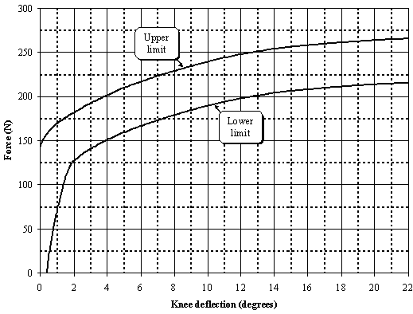
Figure 1825: Force versus angle requirement in static lower legform impactor bending certification test (see paragraph 8.1.1.2.)
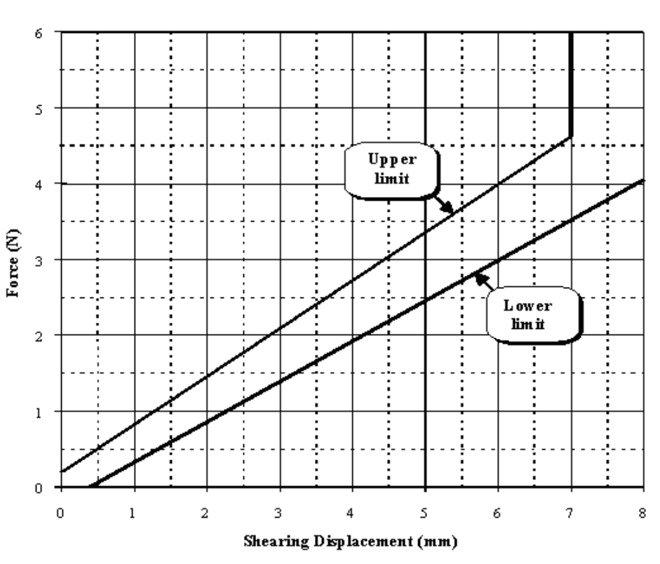
Figure 1926: Force versus displacement requirement in static lower legform impactor shearing certification test (see paragraph 8.1.1.3.)

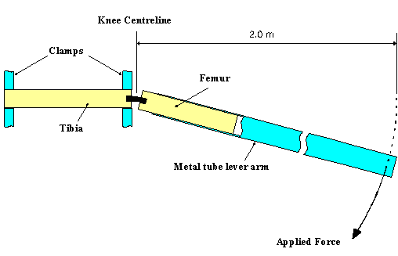
Figure 2027: Top View of Test set-up for static lower legform impactor bending certification test (see paragraph 8.1.1.4.)

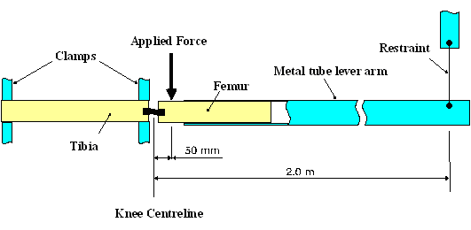
Figure 2128: Top View of Test set-up for static lower legform impactor shearing certification test (see paragraph 8.1.1.5.)

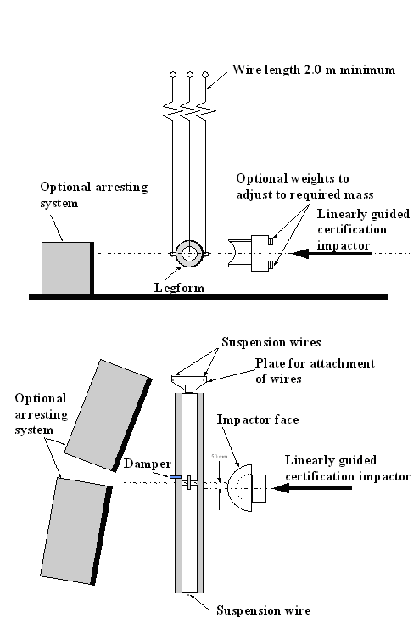
Figure 2229: Test set-up for dynamic lower legform impactor certification test (side view top diagram, view from above bottom diagram) (see paragraph 8.1.2.4.1.)

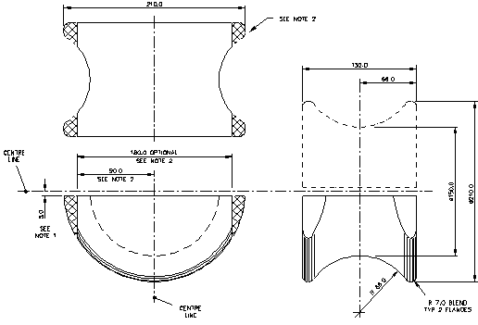

Figure 2330: Details of dynamic lower legform certification impactor face
(see paragraph 8.1.2.4.2.)

Notes:

1. Saddle may be made as a complete diameter and cut as shown to make two components.
2. The shaded areas may be removed to give the alternative form shown.
3. Tolerance on all dimensions is ± 1.0 mm.
Material: Aluminium alloy.
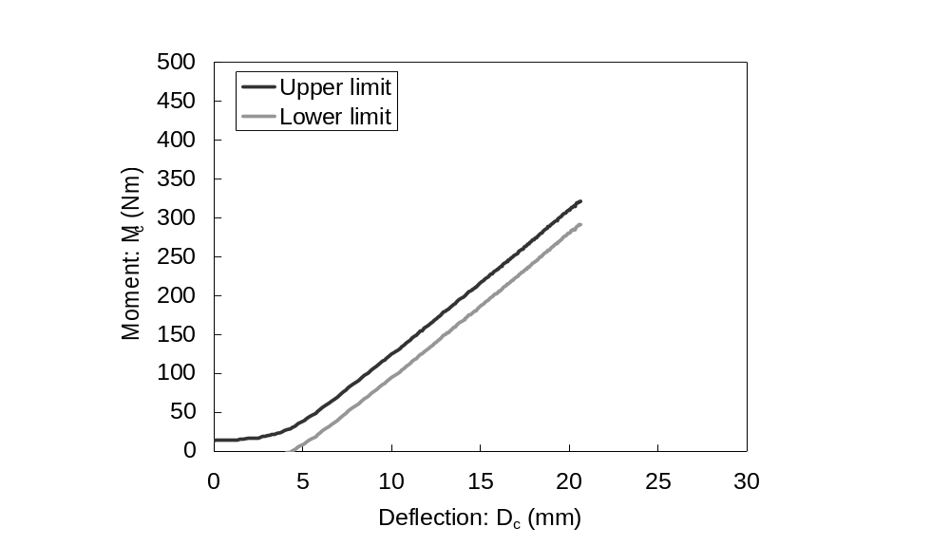
- Femur bending corridor

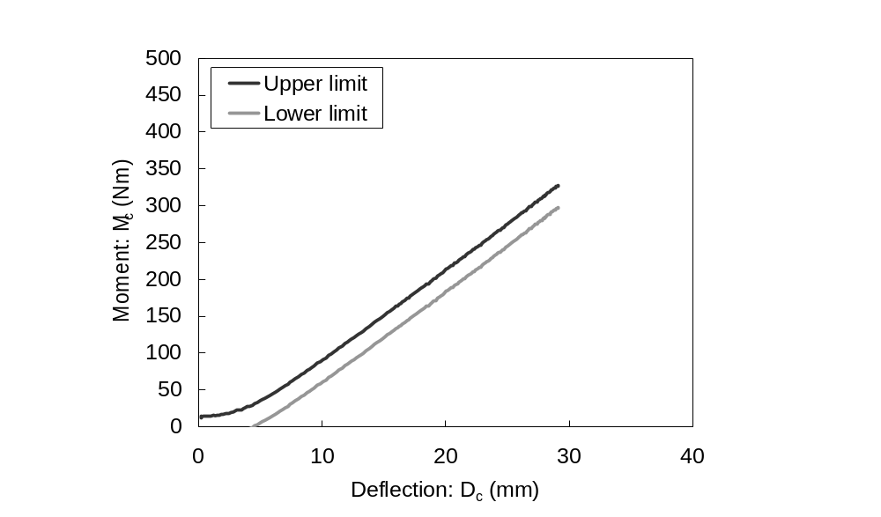
- Tibia bending corridor

Figure 31: Requirement corridor of femur and tibia in static certification test
(see paragraph 8.2.1.2.)
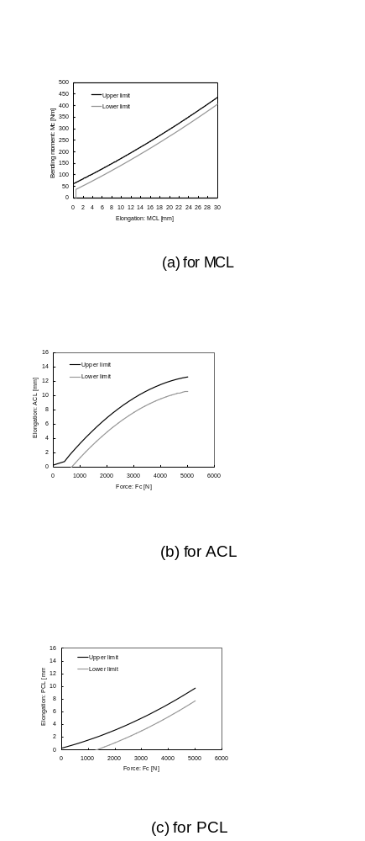
Figure 32: Requirement corridors for knee joint in static certification test
(see paragraph 8.2.1.3.)

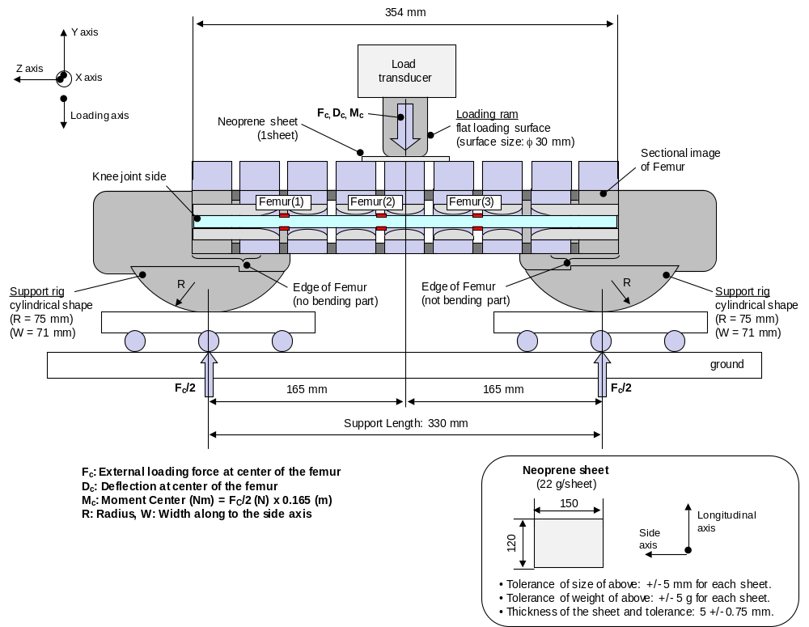

Figure 33: Test set-up for femur in static certification tests
(see paragraph 8.2.1.4.)

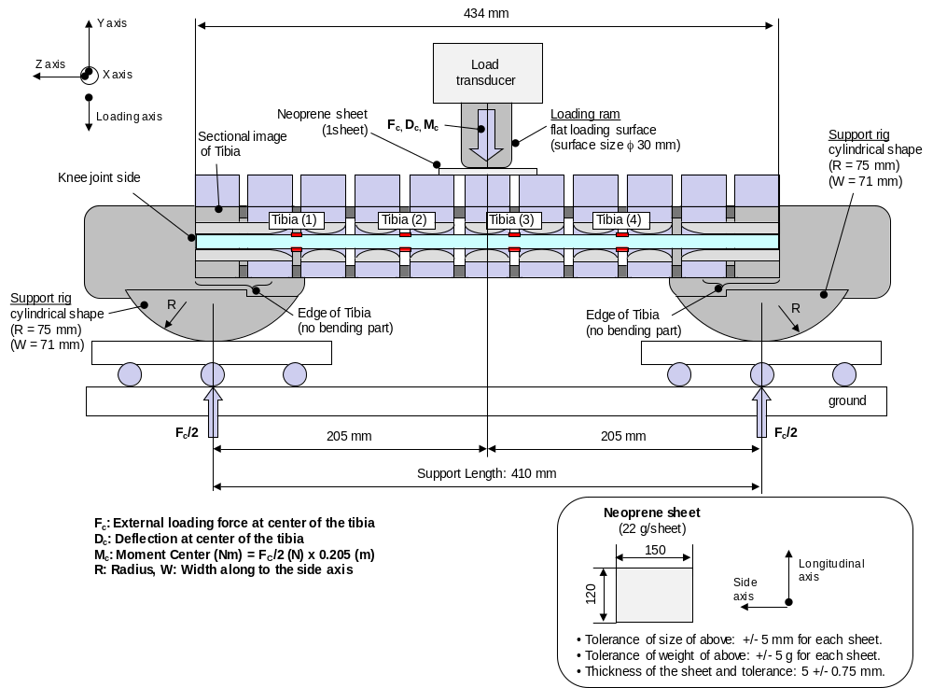
Figure 34: Test set-up for tibia in static certification tests
(see paragraph 8.2.1.4.)
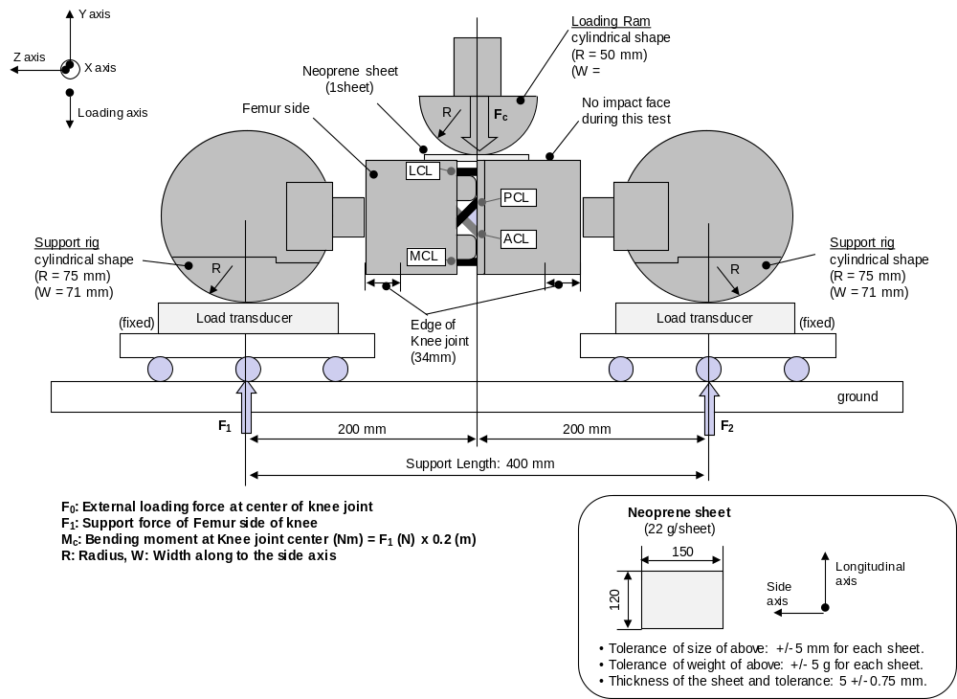
Figure 35: Test set-up for knee joint in static certification test
(see paragraph 8.2.1.5.)
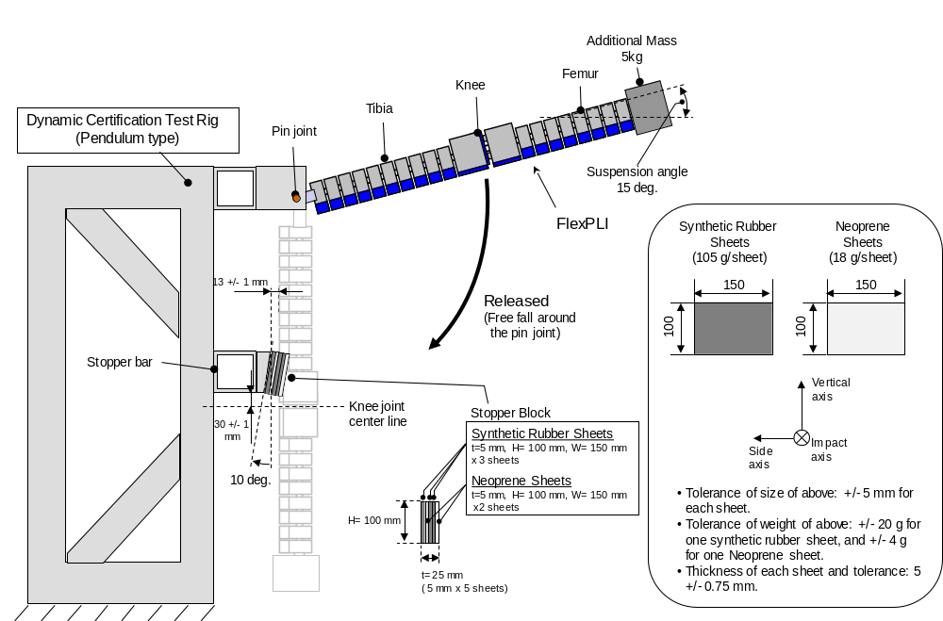
Figure 36: Test set-up for dynamic lower legform impactor certification test,
Pendulum type (see paragraph 8.2.2.4.)

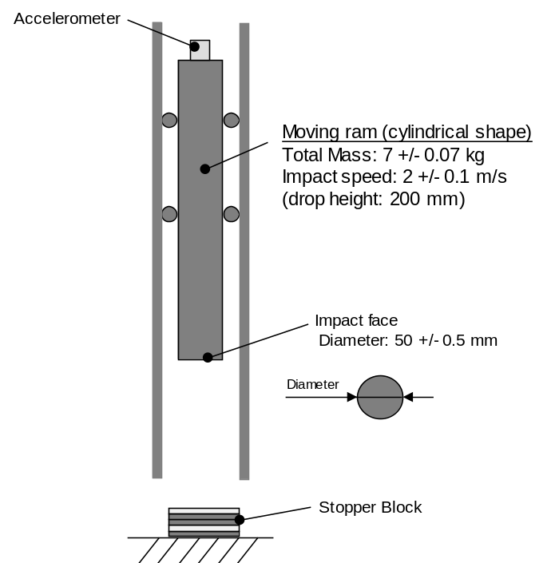
Figure 37: Test set-up for stopper block certification test
(see paragraph 8.2.2.4.)

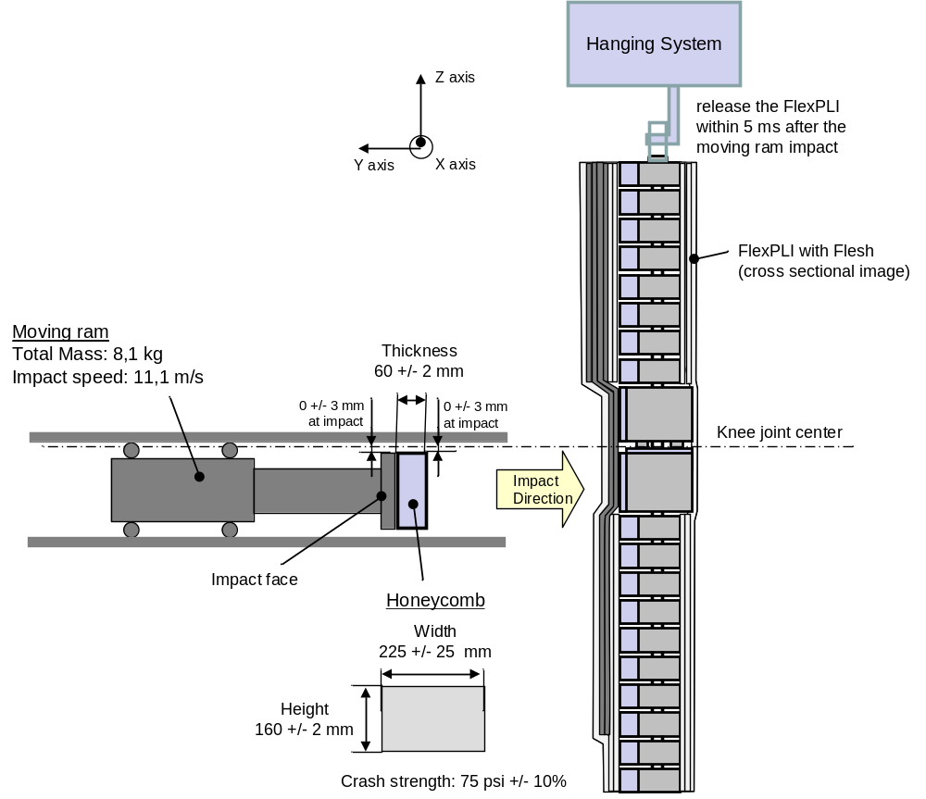
Figure 38: Test set-up for dynamic lower legform impactor certification test,
Inverse type (see paragraph 8.2.3.4.)

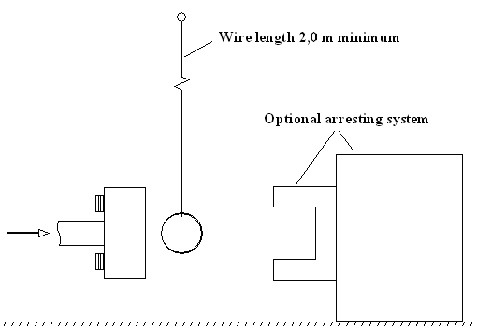
Figure 2439. Test set-up for dynamic upper legform impactor certification test
(see paragraph 8.2.4.6)

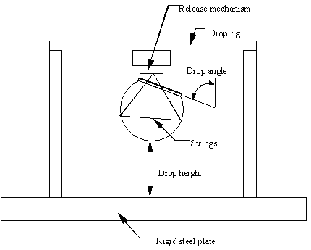
Figure 2540. Test set-up for dynamic headform impactor biofidelity test
(see paragraph 8.3.3.1.)

- - - - -

/ IHRA is an inter-governmental initiative that aims to facilitate greater harmony of vehicle safety policies through multi-national collaboration in research.
/ A number of reference documents is listed in the appendix to this global technical regulation. The documents are available on the UNECE WP.29 website at the address: http://www.unece.org/trans/main/welcwp29.htm. IHRA data are set forth in working paper No. 3 of the informal group on pedestrian safety (INF GR/PS/3) at http://www.unece.org/trans/doc/2002/wp29grsp/inf-gr-ps-3e.ppt#262,1, 1st meeting of the Informal Group on Pedestrian Safety, and in working paper No. 31 (INF GR/PS/31).
/ INF GR/PS/12, /13 and /25
/ INF GR/PS/14
/ INF GR/PS/15
/ INF GR/PS/16
/ INF GR/PS/20
/ INF GR/PS/21
/ INF GR/PS/41
/ INF GR/PS/70
/ To develop these test procedures, the group carefully studied the availability of the pedestrian dummy as an alternative method for the test procedures. The group concluded that there is no test dummy presently available that could be considered suitable for regulatory use. Accordingly, the informal group decided to select subsystem test methods which are readily available, and which have the necessary reliability, repeatability and simplicity.
/ The steering committee of the EEVC is composed of representatives from European national governments. The EEVC conducts research in motor vehicle safety and develops recommendations for test devices and procedures that governments can decide to adopt into national regulations.
/ Saul, R.A., Edlefson, J.F., Jarrett, K.L., Marcus, J.R.; "Vehicle Interactions with Pedestrians," Accidental Injury: Biomechanics and Prevention, New York: Springer-Verlag, 2002.
/ "Report to Congress: Pedestrian Injury Reduction Research," NHTSA Report DOT HS 808 026, June 1993.
/ The resultant acceleration at the location of the accelerometer mounted in the headform will be limited so that, for any two points in time, t₁ and t₂, during the event which are separated by not more than a 15 millisecond time interval and where t₁ is less than t₂, the maximum calculated head injury criterion (HIC) shall not exceed 1,000, determined using the resultant head acceleration at the centre of gravity of the headform, a_{r}, expressed as a multiple of g (the acceleration of gravity), calculated using the expression: 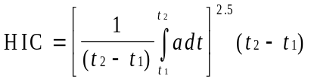
/ While the example in working paper INF GR/PS/158 shows a needed relaxation zone of around 40 percent in the child headform test area, the example represents only one vehicle. The informal group determined that a maximum 50 percent relaxation area in the child headform test area is a reasonable approach taking into account all envisaged vehicle types.
/ There is also a concern that the lower leg test could readily be met by simply allowing the lower legform to slide and/or rotate beneath the high bumper. This could have an unintended consequence of encouraging high bumpers as a way to meet the requirements, and lead to more pedestrian injury due to run-over.
/ WG17 stated that the alternative legform test should be available for vehicles with a lower bumper height of more than 500 mm. However, WG17 referenced a value that WG10 had associated with the upper (rather than lower) bumper reference line. Also, since pedestrians are usually wearing shoes, the bottom of the legform impactor was determined to be 25 mm above the ground, the same height as the sole of a shoe (INF GR/PS/98). Accordingly, the informal group believes that the value of 425 mm (not 500 mm), measured to the lower bumper reference line is consistent with WG17's provision.
/ The size and mass of both the present rigid lower legform and the Flex-PLI were determined to be equivalent to those of a 50th percentile adult male (INF GR/PS/79). The results of computer simulation analyses and experimental data indicate that the mass of the upper body need not be taken into consideration for those impacts where the bumper strikes the legs below knee level (INF GR/PS/105).
/ "Use of the TRL Legform to Assess Lower Leg Injury Risk," Stammen and Mallory, NHTSA VRTC, February 2006. INF GR/PS/XX
/ EEVC Working Group 17 Report: "Improved Test Methods to Evaluate Pedestrian Protection Afforded by Passenger Cars (December 1998 with September 2002 updates)," available at www.eevc.org
/ http://ec.europa.eu/enterprise/automotive/pagesbackground/pedestrianprotection/final_trl_2006.pdf
1/ A Contracting Party may restrict application of the requirements in its domestic legislation if it decides that such restriction is appropriate.

