UNITED NATIONS |  | E
 | Economic and Social Council | Distr.  GENERAL  ECE/TRANS/2008/7  21 December 2007  ENGLISH  Original: ENGLISH AND FRENCH ONLY
ECONOMIC COMMISSION FOR EUROPE
INLAND TRANSPORT COMMITTEE
Seventieth session
Geneva, 19-21 February 2008
Item 10(a)(ii) of the provisional agenda

Issues of informative character and
formal approval by the Committee

Transport trends and economics
Studies on transport economics and track costs undertaken by other organizations
Note by the Organisation for Economic Co-operation and Development (OECD)
and the International Transport Forum (ITF) ∗/

Appendix 1: 17th International Symposium on Transport Economics and Policy
25-27 October 2006, Berlin
Appendix 2: Round Table 139: Biofuels Linking Support to Performance
7-8 June 2007, Paris.
Appendix 1

17th International Symposium on Theory and Practice in
Transport Economics and Policy
Berlin, 25-27 October 2006

SUMMARY OF DISCUSSIONS

The OECD/ECMT Joint Transport Research Centre held the 17th International Symposium on “Theory and Practice in Transport Economics and Policy” in Berlin on 25 to 27 October 2006, the latest in a series of such events first launched by the ECMT. The central theme of this Symposium, attended by over 300 people, was “Benefiting from globalisation: transport sector contribution and policy challenges”. Some twenty introductory papers were presented, prompting a wide-ranging debate among transport and globalisation experts and the floor. While the issues addressed covered a vast domain – ranging from the data available and discernible trends to the problems of infrastructure decision-making in a globalising world and the influence of globalisation on regional and national policies -- this summary of discussions will focus on two major themes, namely:

-- The role of transport in the globalisation process;
-- The challenges for transport policy and the response of policy-makers.

Each of these themes is itself structured around a few points which are intended to highlight key concepts. Using these as the basis for discussions, the Symposium provided an opportunity to take stock of the research topics which the OECD/ECMT Research Centre has worked on during the first few years following its creation in 2004.

1. THE ROLE OF TRANSPORT IN THE GLOBALISATION PROCESS

1.1. Transport and economic productivity

As well as being a determining factor in the level of productivity of our economies and societies, transport also helps to shape their spatial structure in that, by increasing the geographical size of market areas, it allows production units to specialise. Without transport, it would be impossible for a company located in Spain to supply customers in Germany and equally impossible to maintain the current transformation of China into a workshop supplying the world with an increasing number of primary consumer goods.

More specifically, enlargement of a firm’s coverage area enables it to increase its productivity both in terms of learning and in terms of economies of scale or scope each time that it increases production to serve new markets. Transport is responsible for the increased specialisation of firms, which is itself responsible for gains in productivity and gains from technical progress. Classical economic thinkers, such as Adam Smith and David Ricardo, demonstrated that productivity gains from activity specialisation acted as a driver, and it was transport that enabled such large-scale specialisation. It goes without saying that because goods are produced in areas offering the best economic conditions for their production, the world economy is prospering. Accordingly, as a result of the proliferation of flows and the opening-up to world trade that transport has made possible, we are currently seeing an increase in wealth in those economies which have been able to integrate themselves into that world trade.

Transport is therefore a factor in economic and social change and plays a key role in the process of urbanisation by making it possible to deliver food and goods to the heart of densely populated areas such as large conurbations and by allowing people to move around in, and have access to, these urban areas in order to establish the contacts that drive the prosperity of large cities and that are a necessary condition for achieving economies of agglomeration. This brings us to the fact that not all of the changes brought by transport are necessarily positive: for instance, the infrastructure congestion encountered in urban areas together with increasing sprawl, both of which cause considerable environmental nuisance. It is also clear that by allowing activities in different geographical areas which do not necessarily have comparable economic and social conditions to compete with each other, transport is also a factor in social change which can lead to the destruction of the traditional economic fabric as industry and businesses in new areas of the world gain in strength. Transport is a vector which exports an economy’s industrial and innovation capacity to distant places, while at the same time importing and creating competition with that same capacity from other economies. This is the reason why some societies dispute the benefits of globalisation. If the economy as a whole stands to gain, provided that the price paid for resources used is at all commensurate with their scarcity, then some sectors of the population may well be hit hard by the process of change. Clearly, if the economy as a whole is a winner, compensation mechanisms should be set up for those who lose out.

One particular consequence of the impact of transport on economic productivity and more generally of its impact in terms of changing economic and social conditions, is that it is difficult to grasp all of the effects that new infrastructure may have. With a new infrastructure project, the challenge is to identify all of the effects and, above all, to take into account transport’s dynamic influence on economic conditions. The challenge for the research community would be to come up with methods of improving classic cost-benefit analyses in order to restore to transport its role of transforming the productivity of the economic system and shaping production processes over the long term. This challenge was given special emphasis at the Symposium.

1.2. Transport time as a barrier to trade

In industrial economics, the price of transport is generally considered to be a determining factor, for instance, in modal choice. In actual fact, closer analysis of the reasons for the choice of transport by industry and business show that qualitative factors and the quality aspects of a transport option are at least as important as price. This underscores the findings of an innovative area of research in international trade: the importance of time as an explanatory variable in a country’s export performance. For instance, in landlocked areas of Sub-Saharan Africa, the journey from factory to ship takes over two months, which in itself reduces export capacity to practically zero given the very high cost of setting up a continuous export flow capable of absorbing a two-month lag under such conditions. In addition, end consumers -- the majority of whom are in developed countries -- have become impatient and consider the rapid availability of goods ordered to be very important, hence the need for fast production and delivery procedures. A further point is that goods are subject to changing fashions and advances in technology which often render some of them -- and their number of rising – rapidly obsolete. In addition, both the unit value of goods and the amount of know-how they incorporate are rising, driving the cost of their unavailability during transport even higher. The end result of this is that the time taken by transport operations, for example, can become a barrier to trade that is even more of a deterrent than taxes or customs duties. That, at any rate, is what the latest research on export performance in selected countries presented at the Symposium shows. Then there is the issue of relative performance, since transport time in one economic area compared with transport time for similar goods in another will be a decisive factor. The development of air freight transport bears this out. While admittedly prices have fallen in relative terms, air freight transport is currently experiencing major growth: in the United States over 40 per cent (in value) of foreign trade is carried by this mode of transport. Among other things, air transport offers a way of testing new export markets: it has the speed and flexibility to respond to any success on new markets, always remembering that, with the exception of world famous brands, export successes are almost always short-lived, hence the importance of a speedy response.

In order to grasp how important transport time can be for export trade performance, it is worth considering that a large share of the imports to small countries which do not have a fully developed industrial base consists of goods used as inputs for products that are subsequently processed and re-exported, with the result that time can cause friction either way and is equally important for imports and exports.

1.3. From transport to logistics

Logistics, which can take a wide variety of forms, acts as the interface between transport and trade, particularly international trade. As a result of transport firms extending their activities to include warehousing, packaging, customs clearance, processing, etc., all managed by very sophisticated information technologies, goods are no longer produced for stock but in direct response to orders placed by the end customer.
One of the consequences of this trend is that industrial and commercial firms are hiving off certain operations to firms able to offer logistics services as part of a process of outsourcing anything that is not their core business. As international trade flows proliferate – in the European Union, for instance, international transport is expanding at twice the rate of internal transport -- organising transport becomes more difficult, making the turnkey services offered by logistics providers more attractive. These services are fully customised solutions which ensure a seamless transport and processing chain with no loss of time and high reliability.

While within Europe, logistics chains rely essentially on the speed, responsiveness, adaptability and flexibility of road freight transport, at global level we are seeing steady growth in air freight and maritime transport, particularly container transport. At this level, it appears that major carriers are attempting to control the entire logistics chain through mergers – or the acquisition of firms – resulting in the elimination of intermediaries and a redefinition of the role of port authorities and their room for manoeuvre faced with this concentration of actors in the logistics chain. It is also clear that, with regard to the choice of industrial sites on an international scale, ports have a stake in the ongoing competition between logistics chains. This is where port hinterland services play a key role, which only serves to show that transport modes are complementary and heightens the need for transport actors, particularly public authorities, to think in terms of logistics requirements and not modal development in isolation. With this aim in view, it would be useful to achieve co-operation between ports at European level in order to avoid chronic overcapacity and, more specifically, the subsidisation of that overcapacity by public authorities at a time when port authorities are losing power as players in the logistics chain are increasingly concentrated in the hands of a few extremely powerful transport groups which have managed to acquire quite substantial market power.

It is nonetheless foreseeable that, with rising energy prices and the fact that the preferred transport modes, although fastest in terms of avoiding lost time, are also the heaviest energy consumers and indeed the ones most affected by rising infrastructure congestion, we will see these logistics organisations reconfigure. This is because the possibility that we are at the end of the process of decreasing transport prices cannot be ruled out and any increase would mean a new trade off between transport time and transport cost. At intra-European level this may work to the advantage of inland waterways, for instance, or the highways of the sea, while at intercontinental level, maritime transport could see speeds decrease in order to reduce fuel consumption by ships and the unprecedented growth in air transport could come to an end. Environmental constraints, of course, only make it more likely that existing logistics systems will reach a turning point, say, when transport is included in emissions under pollution rights systems. In the longer term, the spatial distribution of activities could be affected when this negative impact of transport on climate change and energy consumption is taken into account.

On this point, the Symposium pointed out the desirability of so-called “freight villages” which centralise all the operators in the transport chain in one location, thereby facilitating, at least potentially, intermodal solutions. It is essential in this respect that each mode of transport comes up to a reliability standard that enables the synchronisation of each stage in the production and distribution process. Indeed, it could be said that reliability as a requirement counts just as much as the speed of transport. Often when this point is raised, just-in-time logistics organisations – in the automobile sector, for instance -- are mentioned, to show how responsive the latter are to time-sensitive delivery of components when production is split between several different countries.

2. TRANSPORT POLICY CHALLENGES AND RESPONSES

2.1. Globalisation and transport infrastructure

The first point that springs to mind when considering the challenges that politicians have to face when taking transport policy decisions is one that was already mentioned in the first part of this summary of discussions at the Symposium, namely the absolute necessity of properly assessing the effects of new infrastructure. The discussions at the Symposium showed that it is precisely this issue of infrastructure investment that is fundamental to any discussion on economic globalisation.

The Symposium demonstrated that although international trade routes had historically remained unchanged -- sometimes for over a thousand years (the Silk Road, for example, or the part played by maritime currents in the Mediterranean) -- we were currently witnessing the emergence of a new pattern of international routes in response, for example to Eastern Asia’s role in world trade, the trade induced by the NAFTA in North America or the single market and its single currency in Europe. Basically, what we are seeing is an acceleration in the processes of global economic change, which has led to an unprecedented degree of mobility in transport hubs and networks. In addition to these issues relating specifically to trade in goods, other factors such as the part played by population migration and, even more significantly the exponential increase in contacts between people of different nationalities triggered by economic globalisation and made possible by air transport, all give some idea of the new country-to-country connectivity that is emerging.

One of the indisputable consequences of the above phenomena is that investment in transport infrastructure is a necessity. However, the aim is not to support mega-projects by completing the Trans-European Networks -- most of which had been only projects on a national scale to meet specifically national needs -- which came in for some criticism at the Symposium, but to focus on missing or inadequate links from the perspective of the new geography of trade being mapped out before our very eyes. In purely practical terms, this consists in planning airport extensions, promoting the motorways of the sea, seeking to increase the capacity of ports to handle container traffic and to adapt this capacity to ship size, improving the quality of port hinterland services for increased activity in ports, promoting information technologies as a determining factor in improving the performance and operation of transport systems and investing in equipment that could appreciably cut waiting times at certain borders or enable rail interoperability.

Even though international trade is growing rapidly, borders still matter. Most companies still serve only domestic markets, distance plays a major role in the composition and direction of trade, national borders seem to have a negative impact on trade and, most importantly, planning still takes place mostly inside national borders. Evidence from the papers presented at the Symposium would suggest that there are major institutional barriers for improving international trade. Development of trade in the NAFTA area, for example, is still held up by trade barriers for international freight transport.

Furthermore, some of the papers presented during the Symposium clearly suggest that a more coherent investment policy would indeed be needed. Both the provision and financing of infrastructure should involve much more regional and international co-operation among policy-makers. There is a strong need for either unilateral or bi-lateral solutions to infrastructure investment at borders. The impacts of targeted intra-regional investment would bring obvious benefits for other countries in the same region as well. However, borders seem to matter especially in decision-making, as many of the investments also need to fulfill political needs. It should perhaps be a task for international co-operation to overcome this and to oversee that decisions on infrastructure investments take a look at the intra-border impacts of investments as well.

Finally, the growing importance of the air industry and airports in overcoming the border issue seems quite obvious. Air transport is highly flexible in the range of spatial services that it can offer, overcoming physical border problems encountered by other modes. Air transport's comparative advantage lies in situations where long-distance, fast and reliable transport is required for the movement of people and relatively low bulk commodities. However, at the same time, the important policy and research dimension of international trade should relate to the externalities, particularly in air transport.

The role of investment in infrastructure as such was confirmed by research work presented throughout the Symposium, which tended to demonstrate that the long-run rate of social and economic return from investment in transport infrastructure was higher than it appeared to be in the short run, but also higher than most private investment because of its dynamic effects and, in particular, spillovers from one country to another in the case of international infrastructure. In fact, a country which had little infrastructure might, perhaps, consider investment in international infrastructure to be a sub-optimal option, since building the infrastructure would be a substantial drain on its resources in the short term and any benefits would only be apparent in the long term, long after the end of the term of office of the politicians who had supported the investment. For countries which were better off in infrastructure terms, the dynamic effects and spillovers beyond the strictly national framework unquestionably call for international co-ordination: spillover effects could bring benefits to countries other than the one which actually bore the costs of a project to remove barriers to international transport.

While these assertions were on occasion challenged at the Symposium, the conclusion it finally reached was that it was crucial to focus, not on the total figures allocated to infrastructure investment, but on whether it was the right investment i.e., the right kind of investment at the right time and in the right place. This therefore brings us back to the issue of using international investment to support the process of economic globalisation. It was proposed, for example, that international financial support should be reserved exclusively for projects that furthered this process, in which case the importance of transit infrastructure was an additional factor that should allow them to be eligible for such finance. Managing to involve the private sector in partnerships seemed, in many respects, to be a solution to the scarcity of public funds and also appeared to offer a further guarantee of the relevance of the choices made or, more simply, of project cost control. However, the main point to emerge from the discussions at the Symposium was the need for a stable paradigm for government involvement and policy so that international investors could evaluate the suitability of projects and gauge the risks.

As an illustration of the specific characteristics of international transport, the Symposium heard, for instance, that in the Rhône valley in France, the elasticity of international road traffic was greater than 1 while the elasticity of transit traffic was even higher, at over 2 with respect to economic growth. This clearly showed the need for new infrastructure to keep up with the increase in international flows and raised the issue of policy, in this case European policy, capable of meeting those needs. While it was true that, at European level, limited possibilities of international public finance, in the strict sense of the term, had brought about a shift from taxpayer funding to user funding -- which made total sense economically speaking, particularly the Eurovignette which, although it was not perfect, had been a positive step in this direction –- we also needed standardised, co-ordinated methods for evaluating infrastructure projects for compatibility and for ranking them in order of priority.

Lastly, the example of work conducted for the World Bank showed, in this case for road infrastructure, that quality itself has an impact on a country’s capacity to participate in international trade. The gains from road infrastructure improvements are reported to be higher than those that could be expected from a reduction in customs duties or an improvement in customs procedures. Even though the available statistics apparatus dictates that some caution should be exercised and needs more work before these findings for the easternmost countries of Europe can be regarded as totally reliable, the participants at the Symposium did not question the strategic role that infrastructure and upgrades to meet needs can play in the development of trade. For less developed countries, as shown by the example of the North-East Asia region featured in other work presented at the Symposium, the flexibility and versatility of road infrastructure allowed it to play a far more important role than that of any rail alternative.

2.2. National regulation and international transport

Work presented at the Symposium tended to prove that a sector such as transport, which serves as both vector and intermediary in international trade, must be perfectly competitive if we specifically want to avoid that sector absorbing all of the benefits of international trade. The issue here was the impact on international trade of deregulation of an intermediate service industry. The studies presented showed that the structure of the transport sector was important and above all carried the risk that international trade gains would be reduced and not fairly distributed unless international transport was competitive through competitive structuring of the sector. Thus the volume of trade between any two countries is inversely related to the concentration of the transport services sector. The structure of the transport sector influences the volume of trade and who benefits from it, with the risk that transport actors will capture the producer’s rent. If institutional trade barriers are weak, the role of transport is even more pronounced. Hence, transport can become an even more serious problem after the removal of trade barriers and the less economically developed the countries concerned, the greater the impact of transport. An imperfectly competitive transport sector can actually have the same impact as strong trade barriers.

The above analysis shows how important it is to have a competitively organised freight transport sector at a time when we are seeing large international groups formed through mergers and acquisitions appearing on the international scene with their tendency to incorporate the different aspects of the logistics chain, giving it an oligopolistic structure. This is therefore a question that touches on the regulation of a sector such as transport which has a strong international dimension.

Another area where the public authorities need to be particularly vigilant with regard to the transport sector relates to the role and importance of state-owned enterprises. In certain economic areas – ASEAN, which was mentioned at the Symposium, is a case in point – it is almost impossible to achieve the competitive structure referred to above in the transport sector, given the role and importance of state-owned enterprises. To a certain extent, the role of sector regulator has been captured by these companies which take their own interests to be the interests of the sector itself. They have advantages that their commercial competitors do not, such as automatic coverage of any losses they make, investment financed out of public funds, income from public service provision, the benefit of cross-subsidies which may enable them to crowd out the competition in certain markets, government guarantees on loans, exemptions from certain regulations and obligations, etc. In short, the presence of these companies can end up by distorting competition, providing a real-life example of the analysis above, which aims to demonstrate that a transport sector in which competition is poor could affect the volume of trade and exactly who benefits from it.
Here, the issue raised is indeed the operation of a sector in which state-owned enterprises and private enterprises exist alongside each other and whose development must work towards regulation by market mechanisms in order to avoid being a barrier to trade and to provide services at the least cost. In practice, rushing the deregulation of a sector in which state-owned enterprises receive preferential treatment is more likely to strengthen their position than it is to create a workable competitive structure.

A further point to note is that regulations are needed to ensure that the market thereby obtained operates on a competitive basis matched as closely as possible to the ideal theoretical model. In addition to instituting regulations on safety, working conditions and other statutory functions for which governments are responsible and have a duty to issue regulations that apply to all enterprises, there are three guidelines that should give states some insight into how to make the transport sector competitive:

-- the institution of a code of practice and guidelines on corporate governance, applicable primarily to state-owned enterprises so as to halt the capture of regulatory power by those subject to the law;
-- the establishment of regulations so that, for instance, loss-making public services are provided by the lowest bidder, thus making the process transparent, and not systematically to the historical state-owned operator, as well as the establishment of competition regulations in order to avoid abuse of dominant position or cartels between firms, for instance;
-- clear definition of the role, organisation and powers of the regulatory authorities in the sector.

As regards regulatory authorities in the sector, in an area such as transport where enterprises of different nationalities are competing on an international market (air transport is one case that comes to mind) one issue that was raised was the need for supranational authorities. Clearly, the aim in the air sector, for instance, is the efficient operation of transport. Yet, from this standpoint, there may be a conflict between what appears to be the optimum at national level and what the optimum at international level requires. The example given at the Symposium was the case of a merger between companies in two different countries which had been approved by the regulatory authorities of both countries but which, despite the fact that it was in order from an economic standpoint, was later rejected by one country, not on grounds to do with the merger itself but because of procedural differences in the processing of the economic documentation for the merger, which was in the air transport sector as it happens. What this example did, primarily, was to introduce the idea that what was best at national level was not necessarily best at international level and that while in Europe, for instance, the high degree of economic integration made a case for having a European regulatory agency for certain transport sectors, it was nevertheless true that national interests could be harmed to a certain extent and that compensation mechanisms should therefore be explicitly considered so that such a development would one day be possible. A first step in this direction -- one which, furthermore is already seen as essential -- is the exchange of experience and analyses among regulators of different countries working in the same field or even neighbouring fields.

A simpler example of the type of question raised at the Symposium concerns road haulage in Europe. Some countries are currently concerned about the deterioration of their market share in international transport, and their hauliers tend to fall back on the domestic market. The question one might ask was whether the nationality of the haulier was more relevant than ensuring, independently of nationality, that hauliers comply with all of the regulations -- on the environment, safety and working conditions – thereby ensuring that transport services are provided at least cost, which inevitably benefits the economy as a whole.

On another level, the example of the North American Free Trade Agreement which was given at the Symposium – an agreement that does not explicitly cover maritime cabotage -- shows that in order for this type of transport to measure up to our expectations, changes to customs, regulatory, fiscal, technological and administrative provisions are needed and these are only possible within the framework of agreements that have not excluded transport from negotiations. One may arguably conclude that transport must not be excluded from negotiations that touch on the terms of international trade.

Lastly, the issue of security in transport, of course, requires an evaluation of the costs and benefits of the measures under consideration but it also requires a harmonised framework across transport modes, whether passenger or freight. From this standpoint, it also raises questions such as the financing of measures and non-discrimination between countries and firms, all of which are important for a multilateral framework in which the exchange of experience is of the utmost importance.

2.3. International transport and environmental pressures

There can be no discussion on transport and globalisation without examining one of the major challenges for civilisation, climate change caused by greenhouse gases. Allowing for the potential economic growth of our economies to the year 2050, the target of stabilising atmospheric CO₂ emissions at a level lower than 450 particles per million will require a 75 per cent reduction in emissions per unit of GDP.

Nevertheless, it is important to note that the transport industry accounts for approximately 20 per cent of greenhouse gas emissions worldwide. By the same token, this means that 80 per cent are generated outside the transport sector. This said, transport emissions are on the increase owing to the growth in air transport and to emerging countries, such as China and to a lesser extent India, entering the automobile age as a result of higher standards of living.

However, the experts at the Symposium were at pains to point out that international transport accounted for a very minor share of total transport movements: more than 80 per cent of transport was over short and medium distances, which also explained why road transport had assumed such proportions as it was particularly suited to this pattern of transport needs. International transport in and of itself was therefore not the major contributor to greenhouse gas emissions.

Thinking that the challenge facing society was to use transport to reap the benefits of globalisation and international trade on an economic level, while taking care to contain CO₂ emissions, was therefore not misguided. The challenge therefore was not to drastically restrict transport activity, particularly international transport. The priority was to increase the “efficiency” of the transport system. The overall change would be to move from a policy that up to now has been more of transport supply policy to a proper demand management policy.

This could be achieved by efficient pricing of the resources used by transport, be it through infrastructure user charges or fuel taxes reflecting the non-renewability of this form of energy. Pricing should also reflect potential damage from transport’s contribution to greenhouse gases, just as for any emission-producing economic activity. Here, the question raised was the possible inclusion of transport -- for instance, air transport -- in the tradeable emissions market.

It is very tempting to say that environmental problems should be approached through rational analysis: why, for instance, should transport taxes be any higher than the costs of the likely damage from climate change that the activity generates? As the market in tradeable emission permits now stands in the EU, the cost per tonne of CO₂ emitted works out at EUR 10 to 20. This figure, converted into centimes per litre of fuel used for road transport is much lower than the usual level of tax in Europe for oil-based fuels. Road transport is therefore paying more than is necessary to ensure the avoidance of damage at the level set in international commitments. In actual fact, the mechanism which set up emission permits is not based on the evaluation of damage but on a price for avoiding such damage through the gradual rationing of emission rights. On the other hand, it is quite possible, though not proven, that the harmful effects of greenhouse gases may carry a very high cost for society, chiefly because the changes it induces will be irreversible. These figures should therefore be viewed with extreme caution and, in any case, simply paying for damage does not make that damage acceptable. From a theoretical standpoint, the approach which holds that the costs of damage, particularly the costs of avoiding it, must be covered cannot be disputed. However, we still need to take a close look at the relevance of the figures for evaluating potential damage, for example, and the emission targets that need to be achieved to avoid causing precisely that damage. On that basis, there is no doubt that the transport sector should come under the scope of application of emissions permits in the long run inasmuch as these permits would appear to be the most appropriate way, compared with a carbon tax, say, of reaching the targets set in international agreements. From infrastructure user charging to the prospect of emissions permit trading, these are the very principles of efficient resource use which must be implemented.
Independently of its current share in the global pollution process, the fact that transport is growing strongly -- particularly modes with the highest greenhouse gas emissions -- is also very clear. On this issue, the opinions of the experts at the Symposium were somewhat mixed. There is vast scope, particularly in the freight sector, for increasing transport productivity by reducing part loads or consolidating transport supply, not to mention the fact that the freight transported was changing too. For example, Finland is exporting much less timber, which has been replaced by exports of mobile telephones, a particularly light product. For the same level of trade in market value, very different transport solutions are being put in place. What all of this comes down to is that an increase in trade does not necessarily mean a very sharp increase in international transport. However, what it does seem to mean is that the international division of labour looks set to continue – for some experts, we are only at the very start of the process – and that international trade is therefore going to increase. The prediction that transport will grow to the same proportion on that basis alone is by no means certain.

Another essential approach to cutting greenhouse gas emissions is the contribution that advances in technology can make in eliminating environmental problems. In actual fact, substantial progress has been made by manufacturers of both industrial vehicles and cars in reducing the level of emissions – primarily as a result of standards imposed by government. Progress in this same direction has also been made within the framework of the ECMT, which linked an increase in its multilateral licence quota for road freight transport to the use of clean vehicles. A whole host of incentives, both fiscal and regulatory, can be considered with a view to setting transport firmly on the road to significant environmental progress, even though at the present time some commitments given by vehicle manufacturers, for example, will probably not be met in their entirety or within the set timeframe.

There is one field in which it is proving difficult to promote progress and that is spatial planning: transport, particularly road transport which the majority of the population can afford, has led to the spatial dispersal of activity at a time when current pressures tend to confirm that what is needed is for spatial distribution that makes economical use of transport. While some participants at the Symposium thought that transport prices that reflect the costs generated by transport were enough to work towards in this direction, this was a view not shared by all. The difficulty of formulating spatial policies that are in line with sustainability and affect territorial governance, is all too obvious.

3. CONCLUSIONS

The Berlin Symposium provided a wide-ranging overview of themes relating to the implications of the globalisation process at work throughout the world. While there is no doubt about the fact that participating in world trade in goods and services can be a source of wealth for a country, it is equally true that social structures will have to adjust so that those left behind by the process do not polarise the debate and obscure the benefits, quite apart from the human problems to which it is only right to seek acceptable solutions.

Issues relating to the regulation of the transport sector were also raised and it will be important for public authorities not to confine themselves to a domestic perspective on these policies but to grasp the implications at a higher level, for example, a Europe-wide level. There remains the issue of the environment and therefore that of keeping at least the international commitments that have been made in this respect: some of those attending the Symposium pointed out that this issue would have warranted a full session on its own. That would be to forget that there is no challenge that specifically relates to international transport as regards environmental constraints since although international transport is growing, it accounts for nowhere near the major share of transport. Moreover, the environmental issue had been raised in many of the papers presented at the Symposium and could be the basis for drawing a series of conclusions, which have informed part 2.3. (“International transport and environmental constraints”) of this summary. Right now, it was quite legitimate to see the main issue as being how to reap the potential economic benefits of globalisation while still ensuring the rational use of an intermediate sector such as transport, particularly in the light of the major challenges that the world will have to meet.

Appendix 2

JOINT TRANSPORT RESEARCH CENTRE
Round Table, 7-8 June 2007, Paris
Biofuels: Linking Support to Performance

SUMMARY AND CONCLUSIONS
Contents
1. Energy and greenhouse gas impacts 2
Uncertainties 7
Ecosystem Impacts 9
2. Subsidies, cost-effectiveness of support to biofuels and
indirect economic impacts 10
3. Second generation fuels – performance and potential 15
4. Potential for Brazilian ethanol exports 17
Trade in biofuels 19
5. Certification – the potential for linking support to performance 20
6. Outlook for biofuels production 23
7. Conclusions and messages for policy makers 24
Government support for the production of biofuels has been motivated primarily by agricultural and energy policies with the aim of substituting biofuels for imported oil and supporting farm incomes and agricultural sector industries. More recently support for biofuels has become a core part of many national policies for reducing transport sector CO₂ emissions. The relative importance of each driver differs between governments.
Subsidies for biofuels are growing rapidly and are estimated to have reached around USD 15 billion in 2007 for the OECD as a whole. Many Governments have also imposed biofuel quotas for oil distributors. The European Union requires Member States to take measures to ensure that biofuels account for 2% of the demand for transport fuels, rising to 5.75% in 2010. The European Commission proposes increasing the target to 10% by 2020. The US Government set a target of 4 billion gallons of ethanol for 2006, nearly 3% of the gasoline market, and has proposed a target of 35 billion gallons of biofuels production by 2017, which is expected to account for about 9% of transport sector fuel consumption.
However, all biofuels are not equally effective in substituting for oil or in cutting greenhouse gas emissions and promoting their production can have unintended consequences. Subsidies for biofuels, and the resultant increase in demand for grain and oil seeds, appears to have contributed to sharp increases in food and livestock feed prices in world markets, in a context of rising demand for these commodities for traditional uses. Also, depending on feedstock and farming practices, biofuels production can have significant environmental costs. These include degradation of biodiversity and soil fertility and increased rates of soil erosion, excessive water abstraction and water pollution. In some circumstances, biofuel feedstock production can even result in a net increase in greenhouse gas emissions.
The Round Table brought together 50 leading researchers on the science and economics of biofuels to examine the potential for these fuels to fulfil the policy expectations underlying their promotion, to analyse the economics of biofuels supply and to assess the potential to limit the environmental costs of large-scale production. In this context the Round Table reviewed progress on certification systems designed to limit unintended environmental damage from producing and promoting biofuels.
The discussions, chaired by Lyn Martin of the Australian Bureau of Transport and Regional Economics, focused on the following themes:

the energy and greenhouse gas impacts of producing biofuels and substituting them for oil products in the transport sector;

the economics of biofuels;

the potential of second generation fuels;

the potential for Brazilian ethanol exports;

certification and the potential for linking support to performance;

the policy implications of the discussions.
The debate was structured around five papers, each addressing one of these themes. Presentations based on each of the papers are available at http://www.cemt.org/JTRC/EconomicResearch/RoundTables/index.htm.

1. Energy and Greenhouse gas Impacts
The Round Table began with a review of the research on the life-cycle energy balance and greenhouse gas emissions of producing biofuels for transport markets. Discussions were launched by Professor Alex Farrell of the University of California Berkeley who highlighted the mixed results of the research and identified the critical parameters on which the results depend.
The team at Berkeley’s Energy and Resources Group (ERG) undertook a detailed comparison of six representative studies of US corn-ethanol greenhouse gas and energy balances (Farrell et al. 2006), with the results first reported in the journal Science in 2006. Four of the six studies found that producing and consuming biofuels for transport results in higher greenhouse gas emissions than producing and consuming gasoline (see light coloured circles above the horizontal line in Figure 1). Average impacts ranged from a 20% decrease to a 32% increase in greenhouse gas emissions. In terms of net energy balance, two of the studies found that corn ethanol required more fossil fuel to produce than the energy it contains (light circles to the left of the vertical line in Figure 1). Though all of the studies found net oil savings, a lot of gas or coal was consumed in processing biomass to produce ethanol.
The comparison set out to standardise the reported results by normalizing the assumptions on which the studies were based. The key differences identified concern the boundary conditions employed in the studies (i.e. decisions on which parts of the overall production system to include or exclude from the analysis) and assumptions regarding:
- the prime energy used in bio-refineries – natural gas, oil, electricity or coal, with widely differing thermal efficiencies and associated CO₂ emissions;
- soil erosion and oxidation of soil carbon as a result of crop cultivation;
- lime application on crop land; and.
- the treatment of co-product energy (the energy content of non-fuel co-products).
The primary energy source used in the production of biofuels, and particularly for distilling ethanol, is a major determinant of greenhouse gas impact. Boiler efficiencies, which vary widely, also account for some of the variation in performance. In most locations natural gas or electricity provides the energy for process heat. However, high prices for gas have resulted in some new ethanol facilities using coal in the American Midwest, with large associated greenhouse gas emissions. In Brazil, bagasse (sugar cane waste) is burnt to provide process heat and electric power and this is in large part responsible for the superior performance of Brazilian ethanol production (see the paper prepared for the Round Table by Professor Almeida).
The ERG team developed a meta-model to compare the results of all the studies on the basis of consistent assumptions. Adjustments were made in relation to:
- primary energy inputs;
- system boundaries (by adding missing parameters such as effluent processing energy and dropping some extraneous parameters); and
- co-product energy content.
Adjusting for the different assumptions brings the results of the US corn-ethanol studies closer to convergence (see dark circles in Figure 1). However, it does not alter their absolute position. Except in one case, studies that found negative energy balances and higher greenhouse gas emissions compared with producing and using gasoline (to the left of and above the red lines) maintain these negative results after correction. Half the studies show negative greenhouse gas emission balances after correction.
Figure 1. Greenhouse gas and energy balances for corn ethanol production pathways as reported in the literature and adjusted for consistency
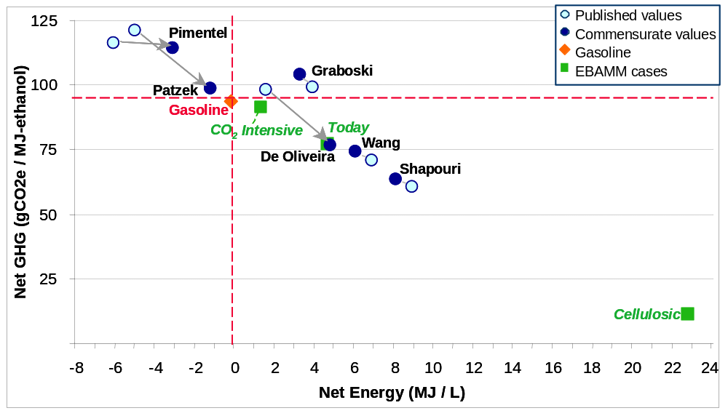
Note: EBAMM = UC Berkeley Energy Resources Group (ERG) Biofuel Analysis Meta-Model.
Farrell et al, Science 2006 (see References for original study sources).

The ERG team selected what it viewed as the best data from the original studies to create three case-studies with their model (Figure 1):
- Ethanol Today using typical values for current US corn-ethanol production;
- CO₂-Intensive based on plans to ship Nebraska corn to a lignite-powered ethanol plant in North Dakota;
- Cellulosic using data from Wang’s study for ligno-cellulosic ethanol produced from switchgrass.
These additional points were used to show that greenhouse gas emissions can differ tenfold according to the feedstock used to produce ethanol. The case studies also illustrate the strong sensitivity of the results to the carbon intensity of the fuel used to heat the processing and distillation processes, with coal-fired and transport-intensive production labelled ‘CO₂ intensive’. This scenario includes the long-distance shipping of corn by rail with diesel traction. Transport becomes an increasingly important aspect of life-cycle analysis as the size of biofuel plants increases and feedstock has to be transported from an increasingly large area. For instance, some of the large plants on the Gulf of Mexico rely on corn brought from the Midwest by rail. Residual animal feedstock (distillers grain) also often has to be transported long distances to cattle farms.
More generally, the average results presented in Figure 1 from each of the original studies masks a very wide range of results at the level of individual production sites.
One of the most recent and most comprehensive environmental assessments of biofuels was prepared for the Swiss government by the Empa Research Institute (Zah et al 2007). This developed comprehensive indicators for environmental impacts along with life-cycle assessments for greenhouse gas emissions for a wide range of biofuels and biofuel production systems. Biofuels produced in a range of countries were examined. The study assumed the fuels were for use in Switzerland but, as the transport-to-market component of overall greenhouse gas emissions for finished fuels is relatively small, this affects the figures only slightly.
The results, summarised in Figures 2 and 3, illustrate the importance of emissions during cultivation in determining life-cycle greenhouse gas emissions, together with the amount of carbon in the organic matter returned to the soil after harvesting. They confirm a number of the points made by Farrell et al.:
- the large range in greenhouse gas performance between different fuels and feedstocks;
- corn-ethanol and ethanol produced from rye and potatoes appears to provide no greenhouse gas benefits; and
- ligno-cellulosic ethanol produced from both grass and wood offers potentially far superior greenhouse gas benefits.
The study also finds favourable greenhouse gas performance for ethanol produced from whey and for biodiesel produced from recycled vegetable oil. The other fuels that provide unambiguous greenhouse gas benefits (over 50% reductions compared to gasoline or diesel) are ethanol from Brazilian sugar cane, from Canadian sorghum and from sugar beet. Biodiesel from US soy, Malaysian palm-oil and Swiss rapeseed also perform reasonably well with 30-40% reductions of greenhouse gas emissions compared to conventional diesel. Rapeseed biodiesel produced in the European Union performs less well according to the study (indicated as 100% Rape ME RER in Figure 3).
Figure 2. Comparison of the greenhouse gas emissions from biofuels and oil products broken down by process in the production and distribution chain.

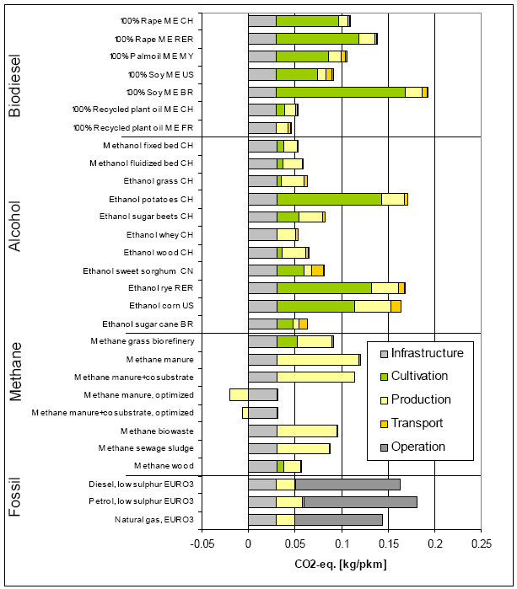
Notes: Vehicle operation is CO₂ neutral in the case of the pure biofuels because the CO₂ emitted in combustion is absorbed from the atmosphere during plant growth.
Global warming potential is here expressed as kilograms CO₂-equivalent per passenger km using a load factor of 1.59 passengers per vehicle. The infrastructure figures include emissions from the production and maintenance of
both the car and of the road.
RER = European Union.
Source: Zah et al. 2007.
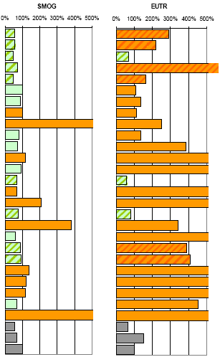
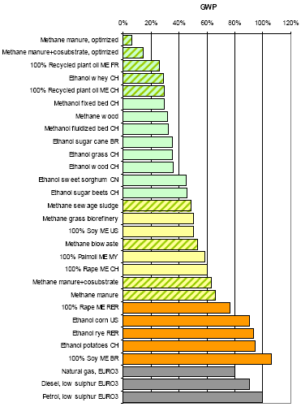
Figure 3. Environmental life-cycle assessments of biofuels in comparison to reference oil products

Notes: GWP = greenhouse warming potential, SMOG = summer smog potential, EUTR = excessive fertilizer use. RER = European Union.
Biofuels are ranked by their respective GHG emission reductions. In the left hand diagram, fuels with total GHG emission reductions of more than 50% compared to petrol are shown in green, those with GHG emissions reductions of more than 30% in yellow, those with GHG emissions reductions of less than 30% in orange. In the other diagrams green = better than reference; orange = worse than reference. Cross-hatched fields = production paths from waste materials or residues.
Source: Zah et al. 2007.

Uncertainties
Discussions at the Round Table confirmed the wide range of uncertainty in the estimation of life-cycle energy and greenhouse gas emission balances for biofuels. Most of the uncertainties relate to feedstock production, whilst processing of feedstock into fuel is much better understood and can be more readily measured.
Almost all biofuels today are produced on fertile land that competes with other agricultural production. Many Round Table participants felt that the uncertainties surrounding greenhouse gas emissions from this type of biofuel are so large that no firm conclusions can be drawn on the climate costs and benefits of biofuels.
Other participants concluded that large uncertainties concern only a few parameters (mainly land-use change and emissions of nitrous oxide) and that emission ranges can be adequately quantified. In their view, for biofuels offering only small greenhouse gas emission benefits (such as corn-based ethanol) the uncertainties are sufficient that greenhouse gas emissions may in fact exceed those associated with gasoline. Most biofuels, however, achieve net emissions reductions, even if these are sometimes small.
A recent study by Tad Patzek, using an estimate of the impact of typical US corn farming practices, finds that emissions from humus oxidation in soil eroded by wind may be the second largest component of emissions from corn ethanol production, after emissions from the fuel used for biorefinery process energy (Patzek 2007). New scientific research will be essential in order to produce figures specific to other crops and farming practices. New crops and new farming methods might reduce greenhouse gas emissions and other environmental impacts significantly.
A large part of the difference between the highest and lowest values for greenhouse gas emissions in the data analysed by Farrell and the ERG team are due to differences in the assumed rate of lime application in farming corn and they observe that the data on lime application is poor.
Much of the uncertainty in the analysis of life-cycle greenhouse gas emissions concerns land-use change. Changes in land use due to the production of biofuels can result in large changes in the amount of carbon in biomass and soils. There is a great deal of variation in soil-carbon levels but forest, wetland, and grassland soils generally contain significantly more carbon than do typical agricultural soils (Delucchi 2006). Converting forests or grasslands to agriculture for the purpose of producing biofuel crops can result in emissions of soil carbon equivalent to several decades of emissions from fossil-fuel use.
Another large source of uncertainty arises in estimating emissions of nitrous oxide (N₂O) from cultivated soil and indirectly from fertilizer application. This may account for as much as 50% of total greenhouse gas emissions on a CO₂ equivalence basis for some biofuels production. A recently completed unpublished report for the German Environment Agency found that when N₂O emissions are included, biodiesel produced from rapeseed in Germany is associated with three times the greenhouse gas emissions of conventional diesel. Mark Delucchi at University of California Davis found similar results for soybean biodiesel in the USA (Delucchi 2006).
Farming practices are an important determinant of emissions and the difference between ‘good’ and ‘bad’ practice can be sufficient to shift the balance from positive to negative. Soil types also matter. Emissions of greenhouse gases from the soil from farming crops on humus rich soils, such as prevail in northern Europe, are estimated to be around a hundred times emissions from farming crops on the more mineral soils typical of Spain or the main sugar cane areas of Brazil. Crop yields also have a major impact on life-cycle energy and greenhouse gas emissions balances.

Ecosystem impacts
Using waste products as the raw material for biofuel production avoids many of the problems associated with cultivating biofuel crops. At the same time many agricultural wastes have an opportunity cost and sustainable agricultural practices would see them returned to the soil to maintain organic matter content. As it is, levels of soil humus are diminishing rapidly in many regions of the world with current agricultural practices. Extracting straw, manure and other biomass for vary large scale production of ligno-cellulosic fuels could exacerbate the trend depending on the proportion of residues removed.
Where excess manure concentrations from intensive farming are currently a problem, conversion to biofuel would be beneficial, even if a comparison with resolving the problem through less intensive production is difficult to make. More generally, producing biofuels from wastes that would otherwise be dumped in landfill sites might be expected to show net environmental benefits given a shortage of suitable landfill sites.
The potential for the use of degraded lands, normally abandoned agricultural land, for biofuel feedstock production was discussed briefly at the Round Table. This is not common practice today and when degraded lands have been converted to biofuel production, such as on some Conservation Reserve Program lands in the United States, traditional crops such as maize have usually been used, causing all of the problems discussed above. Alternatives have been proposed that would establish perennial crops to restore land quality and sequester carbon in soils at the same time as producing biofuels, using existing species such as prairie grasses or genetically modified biofuel crops such as elephant grass (miscanthus). These approaches have not yet been demonstrated and would produce biofuels on only a limited scale because of the relatively low productivity of such land and feedstocks.
The categorisation of almost all biofuels as ‘renewable’ was challenged at a fundamental level. Turning biomass into fuels takes material out of natural ecosystems (when wild growing plants and trees are converted into fuel), replaces a natural ecosystem with crop land or intensifies production from existing farmland. The net result, as with much modern farming, is the destruction of natural ecosystems, a loss of biodiversity and a simplification of modified farmland ecosystems that is irreversible except on a geological time-scale. Increased production of biomass represents consumption of a resource that can not be replaced. With even present-scale production of biofuels these losses are not trivial. Taking a very long-term perspective it was argued that large-scale biofuel production is not ‘sustainable’ and biofuels cannot be regarded as ‘renewable’ fuels (see Patzek 2007a for a full discussion of this point). Of course the same holds for the ‘renewability’ of much food production.

2. Subsidies, Cost-Effectiveness of Support to Biofuels and Indirect Economic Impacts.
Debate was launched by a presentation from Ron Steenblik, Director of Research for the Global Subsidies Initiative of the International Institute for Sustainable Development, which examined:
- the size and extent of subsidies;
- prospects for commercial viability in relation to oil and feedstock prices;
- market interactions and the impact of biofuel subsidies on food and animal feedstock markets.
He began by noting that if it were not for the existence of large and growing subsidies and volumetric production targets for biofuels, the complicated and costly task of calculating life-cycle performance for the certification of fuels would probably not be required. Few if any biofuels are currently produced without direct or indirect government support.
In the United States, the cost to taxpayers of just the federal volumetric tax credits for biofuels is expected to be almost USD 4 billion in 2007 (Table 1), equivalent to one third of the total USD 12 billion expected to be paid out in farm support in 2007. Federal tax credits for biofuels could grow to USD 16 billion if the US Congress were to adopt the Bush Administration’s proposed expanded ’alternative fuels’ target of 35 billion gallons (132 billion litres) a year by 2017 (Figure 5).
In the European Union, reduced excise tax rates for biofuels are estimated to have cost around Euro 3 billion (USD 4 billion) in tax revenues foregone in 2006, up from Euro 1.8 billion in 2005 (Kutas et al. 2007).
For the OECD as a whole, Mr Steenblik estimated overall support for biofuels at 13 to 15 billion dollars in 2007.
Table 1. Estimates for the major tax subsidies for biofuels in the USA in 2007
(Billion USD)
 | Federal blender’s tax credits (Revenue loss from Volumetric Excise Tax Credits) | Federal small-producer income tax credits | State fuel excise tax exemptions | Total
Ethanol | 3.2 | 0.1 | 0.2 | 3.5
Biodiesel | 0.5 | 0.1 | 0.1 | 0.7
Total | 3.7 | 0.2 | 0.3 | 4.2
Source: Koplow 2007.
Table 2. Estimates for major tax subsidies in the European Union
(Excise tax exemptions - revenue loss)
 | 2005 |  | 2006
 | Billion Euro | Billion USD | Billion Euro | Billion USD
Ethanol | 0.5 | 0.7 | 0.8 | 1.2
Biodiesel | 1.3 | 1.8 | 2.1 | 3.0
Total | 1.8 | 2.5 | 3.0 | 4.1

Notes: Euros in current prices; Dollars converted from Euros at interbank exchange rate of 12 September 2007.
Source: Kutas et al 2007.
Figure 5. Total of farm payments and biofuel tax subsidies in the United States: 2002-2016

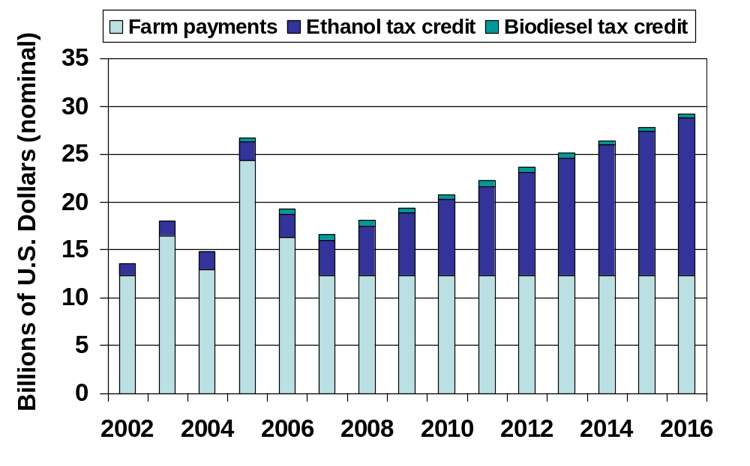
Note: projection based on the Bush Administration’s 35 billion gallon ethanol target for 2017, assuming farm support payments remain constant in nominal value; the peak in support in 2005 was due to price support and counter-cyclical payments triggered by low crop prices in the wake of Hurricane Katrina.
Source: Prepared by Ron Steenblik, GSI, for this report.

Much cheaper ways of saving fuel and CO₂ emissions are available in the transport sector and elsewhere in the economy. Putting to one side those circumstances where the use of ethanol increases, rather than reduces, greenhouse gas emissions, support for ethanol was estimated to cost USD 520/tCO_{2-eq} (Euro 390) for the greenhouse gas emissions saved through production of ethanol at the best performing US plants. The cost of emissions avoided rises to over USD 10 000/tCO_{2-eq} (Euro 7 400) in the case of hypothetical production of ethanol in Oregon from feedstock transported from the Midwest. At these levels of cost it is inconceivable that using life-cycle analysis to help improve even the best performing US ethanol plants and corn production practices could make ethanol a more cost effective way of reducing greenhouse gas emissions than alternatives such as supporting improved vehicle fuel efficiency.
Research for the Global Subsidies Initiative (Kutas et al. 2007) suggests that the same is true for biofuels produced in Europe, even though greenhouse gas emission balances are generally much better than is the case for US corn ethanol. For ethanol produced from sugar beet in Europe the cost of subsidies per ton of CO_{2-eq} avoided is estimated to lie between Euro 450 and Euro 620; for biodiesel produced from rapeseed the range is estimated to be Euro 750 to Euro 990; and for biodiesel produced from used cooking oil around Euro 270 (USD 370).
Table 3. Greenhouse gas mitigation costs: Subsidies per ton of CO_{2-eq}
Average performance | Euros per ton CO_{2-eq} | USD per ton CO_{2-eq}
US corn-ethanol | 390 | 520
EU sugar-beet ethanol | 450—620 | 610—840
EU rapeseed biodiesel | 750—990 | 1 000—1 340
Note Currency conversions at interbank exchange rates of 7 September 2007.
Sources: Koplow 2007; Kutas et al 2007.
These subsidies for biofuels are an extremely costly way of reducing greenhouse gas emissions. For example, the implicit subsidy from the excise tax exemption for biodiesel of Euro 0.70 per litre in Germany is equivalent to 10 000 Euros (USD 13 000) per car on the basis of average kilometres driven over a car’s lifetime. Investing this amount in improved vehicle efficiency could massively improve the fuel efficiency of average cars.
In some cases biofuel subsidies can significantly exceed the price of the fossil fuel for which they substitute. Pennsylvania, for example, is contemplating providing subsidies for biodiesel that, combined with federal subsidies, would amount to USD 2.37 per gallon against a pre-tax price for mineral diesel oil of around USD 2.00 per gallon. Fossil fuels also receive subsidies, but not at such high rates per unit of fuel produced. In OECD countries there are tax subsidies to oil production but these have only a small effect on prices at the pump. (Fuel subsidies tend to be found mainly in OPEC member countries and a few lower income countries.)
Figure 6. The impact of corn and crude oil prices on the competitiveness of corn-ethanol and gasoline.
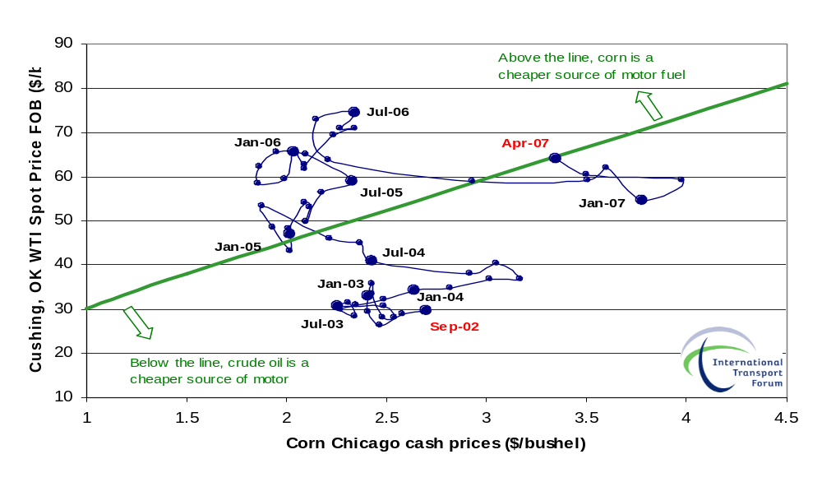

Data sources : Corn price USDA; Oil price US EIA; Break even line Tyner 2007.
Food and fibre production is also heavily subsidised in many countries, but biofuels subsidies are particularly poorly structured, with no cap and no differentiation according to performance. Although the purpose of biofuel subsidies might be expected to be to make biofuels competitive with oil products, they are only rarely linked to the price of oil, and subsidies continue to be paid when oil prices rise to levels that should make biofuels competitive. It was noted that biofuel subsidies in France are currently calculated on the basis of an oil price of USD 30 a barrel. With current prices at USD 60 a barrel this represents a massive transfer from the taxpayer to the biofuels industry. Whilst capital grants for building biorefineries can be terminated relatively easily, subsidies to production always prove very difficult to reform.
Few markets have been as distorted by government intervention as biofuels. Moreover, biofuel subsidies are lending legitimacy to calls for subsidies for other ‘alternative’ fuels. US politicians that would like to see new coal-to-liquid plants located in their States are arguing for a production tax credit (51 cents per litre) that matches that currently benefiting ethanol. Two bills were presented to Congress and defeated in June 2007 seeking similar subsidies for coal-to-liquid fuels production. The logic is that other fuels providing the same environmental or energy security benefit should be accorded the same level of subsidy. In this way subsidies tend to proliferate. A simple increase in fuel excise duty to reflect its carbon content would be a more direct, less open-ended and more transparent way of encouraging the development of low-carbon fuels.
There were suggestions that Brazil demonstrates that subsidies can be temporary. Brazilian ethanol production comes closest to commercial viability. However, as explained in detail in Professor de Almeida’s paper, it is exempt from fuel excise duty, and in sugar cane growing states it is also exempt from VAT. Without these tax subsidies production would not be viable. Support amounts to around USD 1 billion a year.
Any notion that conventional ethanol production requires infant industry support is difficult to accept as the production process is identical to the fermentation of grain for ethanol in making beer and other alcoholic beverages, a process operated commercially over thousands of years. Moreover, ethanol for gasoline blending has been produced in the USA for 20 years. Support for wind power generation was advocated on an ‘infant’ industry basis because costs are on a trajectory towards commercial viability. Biofuels, however, appear to be on the opposite trajectory with land and grain prices increasing as a consequence of subsidizing their production.
It was suggested that the lack of substitutes for liquid hydrocarbon transport fuels justifies specific support to biofuels, but given the large potential for reducing CO₂ emissions and saving oil in other sectors at much lower cost, this view did not command general support. Moreover, transforming biomass into complicated hydro-carbon molecules is inevitably much less efficient than simply burning it for heating or electricity generation.
The strategic goals of subsidies to biofuels production are:
- reducing greenhouse gas emissions;
- improving energy security; and
- promoting rural employment.
Much greater contributions to all of these goals can be achieved at much lower cost by other means: promoting energy efficiency, developing transport demand management strategies and providing direct income support to farmers.
Support to commodity production has proved an ineffective way to deliver social policy in the farm sector as any benefits are almost always captured by large agro-industrial companies rather than the targeted farm labourers or small farmers. The same is true with biofuels production where most production is accounted for by large corporations.
In relation to energy security, price volatility is usually a good indicator of supply security problems. Prices increase in times of shortage and fall when there is a glut. Grain prices fluctuate more widely than oil prices due, in part, to dependence on the weather. Even if all arable land were diverted to the production of biofuels it would not ensure energy security and could increase price volatility.
The high cost of subsidies to biofuels has the potential to divert resources from energy efficiency measures with much higher returns in terms of greenhouse gas emission reductions. Overall, the current level and structure of support for biofuel production would appear to weaken our ability to achieve any of the strategic goals.

3. Second Generation Fuels – Performance and Potential
Discussions followed a presentation by Professor Birgitte Ahring of the Technical University of Denmark, founder of the BioGasols Company that produces ligno-cellulosic ethanol from a pilot plant in Denmark. The paper covers:
- energy performance by feedstock and process;
- economic performance to date;
- design of subsidies; and
- future performance and scale of production from wastes and dedicated crops.
Ligno-cellulosic ethanol demonstration plants are under development in Denmark with production expected to start in the next year or two at a scale of around 10 million litres a year per plant. These plants will be designed to demonstrate flexibility of feedstock capability rather than produce fuel at the lowest cost. Around 2010 the next generation of small full-scale plants of around 70 million litre a year capacity is foreseen. Fully commercial plants would be bigger again, around 100 million litres per year, and expected to break even at an oil price of USD 35/bbl. Despite that, Professor Ahring’s paper argues for continuing subsidies for production.
The capital costs of ligno-cellulosic plants were reported to be around 50% higher than for conventional ethanol production; nevertheless the critical factor for commercial viability is the cost of biomass feedstock. The main feedstock in Denmark will be straw, despite its relatively high price of USD 85/t, but a variety of feedstocks are expected to be used eventually including waste paper, household wastes and the fibrous residues of pig manure. The potential value of diverting wastes from landfill was stressed against a background of rapid growth in the generation of household waste. Producing fuels from some kinds of waste reduces land use impacts to zero but the potential volume of production from these kinds of waste remains to be quantified.
The great variety of feedstocks that can potentially be used for ligno-cellulosic ethanol production provides for a very wide range of performance in terms of life-cycle greenhouse gas emissions. Results are more likely to be positive than with much conventional ethanol production. For straw fed plants in Denmark, emission reductions of 80% compared to gasoline are expected. There is no figure available for the cost per tonne of CO₂ saved.
The relatively high capital costs of producing ligno-cellulosic ethanol imply important scale economies. Large plant, processing large volumes of biomass, are therefore probably required for commercial viability. This means that either that large quantities of feedstock have to be available locally or feedstock has to be brought to the plant over long distances. This is the case for low yield crops such as switchgrass grown on marginal land. Transporting feedstock, however, has a cost in both financial and energy terms and severly undermines the greenhouse gas balance of producing ethanol this way. Large-scale plantations of dedicated crops on reasonably fertile land would be required to produce quantities of ethanol sufficient to substitute for more than one or two percent of transport sector oil demand. Ethanol yields from ligno-cellulosic production are higher per hectare of land used than conventional ethanol production because more of the feedstock is converted to fuel. Substituting for conventional production could reduce pressure on land to some degree, albeit at the expense of higher production costs.
Distiller’s grain, a co-product in conventional ethanol plants, could be used as feedstock for ligno-cellulosic production (although it is 30% protein and 9% fat and probably more valuable as animal feed) and could be used to increase overall ethanol output 20% in an integrated production system. Professor Ahring thought that producing ethanol from bagasse in Brazil would enable it to become competitive with gasoline without tax subsidies. It was noted that in Australia sugar cane is selected for greater leafiness and cane burning is being reduced to provide more material for bagasse.
Again a number of questions were raised about the material and energy balances of diverting some waste streams for ethanol production. Bagasse in Brazil is usually used to fire the boilers for distilling ethanol whilst co-producing ethanol, diverting it to ligno-cellulosic ethanol production would sacrifice income from electricity sales to the grid and require other (fossil) fuels to provide process heat and electricity. Since straw normally gets ploughed back into the soil, using large quantities to produce ethanol would be detrimental to soil quality.
It was reported that prospects for commercial operation of the world’s first large-scale demonstration ligno-cellulosic ethanol plant, the Iogen plant in Canada, continue to be uncertain. There was speculation that early starts like Iogen might not prove to be the way forward in the long run. A number of small private companies are developing new enzymes that could reduce costs, and the costs of the enzymes themselves are falling. One technology being trialled in the USA is to feed algae in tanks with carbon dioxide sequestered from fossil-fuel power stations. Although this doesn’t dispose of the CO₂ it results in some incremental energy production through photosynthesis. A note of caution was sounded with regard to the potential of bioengineering to radically increase the efficiency of producing biofuels. Although enzymes are superior to chemical catalysts in their selectivity, this comes at a cost in terms of speed and thermal efficiency, where catalysts do much better.
Small scale subsidies for technical innovation were regarded as generally useful, with a role in supporting research into the technologically innovative forms of second generation biofuels. But some second generation biofuels are counterproductive. Converting wood to liquids by processes generally known as BTL (biomass-to-liquid) is around 50% efficient whereas burning the wood directly in an efficient boiler can achieve 80% efficiency; 30% of the energy content of the wood is foregone by converting it to liquid instead of burning it. Replacing domestic heating oil with wood for industrial and domestic heating would release oil for motor diesel at four times the efficiency of producing biodiesel.
There are potentially other fuels that might be produced from second generation technologies, including other alcohols (e.g. biobutanol), hydrocarbons and hydrogen. These alternatives were not discussed in detail at the Round Table but a variety of pathways need to be explored.

4. Potential for Brazilian Ethanol Exports

Discussions were launched by Professor Edmar de Almeida of the Institute of Economics of the Federal University of Rio De Janeiro, examining:
- the performance of current production;
- environmental issues;
- the potential size of exports;
- the impact on energy, environment and economic performance of scaling up for export; and
- trade and trade barriers.
Professor de Almeida’s paper examines the performance of Brazilian ethanol and biodiesel in detail, including energy and CO₂ balances, quantifying subsidies and examining the direct and indirect environmental impacts of producing biofuels. The discussions focused on ethanol, reflecting the relative significance of ethanol and biodiesel in Brazil.
The most comprehensive body of research on ethanol in Brazil, led by Professor de Macedo, finds ethanol produced from sugar cane achieving 30% to 80% greenhouse gas savings compared with gasoline, depending on the efficiency of feedstock production and the operation of plants, with most towards the upper end of performance. Professor Almeida’s thorough review of the literature confirms the superior performance of Brazilian ethanol production, although the he was not able to assess all of the uncertainties discussed above surrounding such estimates. The advantages for Brazilian ethanol production are as follows:
- sugar is a better feedstock than starch (from grain) as starch must first be broken down with enzymes into sugar before it can be fermented, which requires heat;
- the use of bagasse (cane residue) to produce process heat and electricity avoids the use of fossil fuel;
- co-generation of surplus electricity sold to the grid, improving both financial and energy balances;
- at least some of the soils used for sugar cane in Brazil are low in organic matter and produce relatively little N₂O and CO₂ when cultivated;
- cane is largely rain-fed in Brazil rather than irrigated, reducing the need to pump water and reducing stress on water resources;
- farm labour costs are low, aiding financial performance;
- a sustained government funded research effort into plant breeding and selection has improved yields substantially, a trend that is set to continue.
Ethanol prices have traditionally been closely linked to sugar prices because of the flexibility of producers to switch production between sugar and ethanol. However, high oil prices mean that ethanol prices are increasingly linked to the price of oil.
The potential indirect impacts of cane growing on greenhouse gas emissions through the displacement of agriculture as a result of the expansion of cane growing are not well documented. There is likely to be some effect because of interconnections between land markets. Expanding cane plantations onto land famed for other purposes will create pressure for more intensive production of the displaced crops or expansion into virgin lands somewhere in the world, if demand for these other crops remains unchanged.
There are a number of factors that complicate the picture. Incremental cane plantations in Brazil generally replace extensive cattle rearing, which is associated with widespread soil erosion. In these conditions replacing cattle with cane may reduce soil carbon loss. Around Sao Paolo, in the heart of cane country, some cattle have been moved indoors as cane planting expands. Greenhouse gas emissions from stall-fed cattle can be much higher than from free-range herds depending on the feed types they are given. The overall impact of cane expansion on greenhouse gas emissions is difficult to determine. It is also possible that some cattle rearing has been displaced to the North where it encroaches on rainforest. The main incentive for felling forest in the Amazon is extracting timber, which has a very high cash value. Cattle-rearing yields very little, around $100 per hectare per year, and simply follows where timber has been exploited – legally or illegally.
The link between forest destruction and biofuel production may be stronger in the case of soybeans for biodiesel as this crop is suited to the North and grown on very large plantations. Soybean production has expanded rapidly recently due to growing international demand. The spread of the crop is replicating the initial development of land for sugar cane plantations, which resulted in massive deforestation in earlier centuries. Whilst the government has passed laws to protect the Amazon rainforest, enforcement is difficult across the vast and sparsely populated territory of the North.
Biofuels subsidies in Brazil were initially aimed at providing jobs for unskilled labour in rural areas and at combating local air pollution. (Ethanol is used as an octane enhancer in lead-free petrol and as a fuel oxygenate to reduce carbon monoxide emissions). Although mechanisation is gradually reducing employment in sugar cane plantations, the industry provides one million jobs, and at a higher rate of pay than the rural average. There are similar motivations for supporting the development of biodiesel production. The first goal is rural development through support to small scale production in poor areas. Biodiesel is also free of sulphur and can be blended with conventional diesel to reduce emissions of both sulphur dioxide and particulates, which are major environmental health problems in Brazil’s main cities. There has, however, been no analysis of whether subsidies for biofuels are an efficient way of encouraging rural development.

Trade in biofuels
Debate on trade in biofuels was initiated by a short presentation from Ron Steenblik noting an important distinction between the trade treatment of biodiesel and ethanol. The World Customs Organisation (WCO) classifies biodiesel as a chemical product and as such it attracts low tariffs. Ethanol is classified by the WCO as an agricultural good, as most production has been for beverages, and as such it can be subject to much higher tariffs. Import tariffs vary widely in OECD countries, from 6% in Canada to 51% in Australia on an ad-valorem basis. The USA and EU levy tariffs with ad valorem equivalent rates of 23% and 38% respectively. Trade diplomacy on environmental goods under the World Trade Organisation (WTO) negotiations on access to markets for agricultural products only ever covered biodiesel, and biodiesel has now been removed from the list of proposed environmental goods. Negotiators are reluctant to address ethanol as they believe this would inevitably lead to demands for a wide range of agricultural products to receive special treatment.
The potential of Brazil to export ethanol is severely constrained by import tariff policies. Brazil’s current 2 billion litres annual exports to the USA mainly enter the country via Central American and Caribbean countries under the Caribbean Basin Initiative trade agreement. Major expansion would require negotiation of favourable tariffs. There has been speculation that ethanol might provide a reason for reopening the current stalled round of WTO negotiations, but no country appears ready to change its present position.

5. Certification – the Potential for Linking Support to Performance
Certification schemes have been developed for a variety of agricultural and forest products in order to differentiate products that meet certain environmental standards from others that do not. Organic food labelling is a familiar example. Some of the schemes are operated by government, some by voluntary consumer or producer organisations. All have to create confidence in the reliability of the endorsement they provide. This requires an assurance system that sets the standards to be met, inspects farms and processing plants to determine if standards are being met, and grants accreditation to independent bodies that issue certificates to producers confirming their products meet the standards. Confidence in the integrity of the assurance system may rely on government oversight, involvement of environmental campaign groups and public reporting of inspection activities and standard setting.
Certification and assessment of biofuels was introduced by a summary of developments in California from Professor Alex Farrell and a detailed presentation from Professor Jeremy Woods of Imperial College London covering:
- the design of certification and assurance schemes;
- the environmental impacts of farming biomass;
- national and international certification schemes; and
- the cost-effectiveness and feasibility of auditing and inspection.
The very great range of performance in terms of greenhouse gas emissions of different biofuels production pathways was stressed in the presentations. Around 130 combinations of feedstock and process have been evaluated to date. Taking just one, ethanol produced from wheat, research suggests performance when compared to gasoline ranges from higher emissions to an 80% reduction in greenhouse gas emissions, on a life-cycle basis.
As noted already, the role of soil carbon is particularly poorly understood. This applies to both the soil-carbon content of natural ecosystems compared to farmland (for example if peat-lands or wetlands are cleared and drained for biofuel crops) and to the soil-carbon impacts of different farming techniques. Research suggests that good farming practice can result in an increase in carbon trapped in organic matter in the soil, in some cases even when grazing land or savannah is planted. Poor farming practice can result in significant emissions and loss of soil carbon. Poor practice currently dominates and farming practice is costly to monitor for certification purposes. At the same time, biofuels production is so far only a small sub-set of the different uses to which land is put. As knowledge about the impacts of soil-carbon on greenhouse gas emissions increases estimates for emissions from other types of land use will also need to be revised.
Certification is a difficult task, not least because of the effort required in building consensus over the methodologies employed and the validity of results.
Despite the difficulties and gaps in research certification is critical if subsidies and volumetric targets for biofuels production are to continue to be employed. Without certification, such targets are likely to result in a ‘race to the bottom’; producing the largest quantity at the lowest cost and at the lowest capital intensity, which tends to be associated with the highest greenhouse gas emissions. The first goal of certification is to counter this tendency.
In response to EU biofuel targets the UK government will introduce a Renewable Transport Fuel Obligation (RTFO) from April 2008 under which fuel suppliers will be required to submit monthly carbon and sustainability reports to the Administrator of the scheme. The reports will identify the volume and type of biofuel supplied with detail on the feedstock type, any environmental and social standards to which the feedstock has been grown, any land use change that has occurred and the carbon intensity of the biofuel supplied. Targets have been set that indicate the level of performance Government expects from suppliers but there will be no penalty or sanction for not meeting these targets. Companies will supply an annual report that provides a summary of this information which will be made publicly available. The Administrator will also publish an annual report that will include an assessment of each supplier’s performance against the targets.
Technical guidance is being developed (by E4tech) that will provide the information and instructions suppliers need in order to comply with these requirements. Direct land use change is included within the boundaries of the carbon intensity calculation. Indirect land-use change is not addressed within the well-to-wheel carbon intensity calculation but the Administrator will assess these potential impacts on an ex-post basis and report to Parliament.
In June, the UK Government announced that it intends to move to a scheme that rewards fuels on the basis of their greenhouse gas performance from 2010, and that only biofuels that meet specific sustainability standards will qualify for incentives from 2011. The proposals for a mandatory carbon-based RTFO with minimum sustainability standards are subject to a number of provisos. The changes must be: compatible with World Trade Organisation rules and EU Technical Standard requirements; consistent with the policy framework being developed by the European Commission as part of the review of the Biofuels Directive; subject to consultation on environmental and economic impacts; and subject to the appropriate development of sustainability standards for feedstocks. The scheme design must also be in line with the proposals developed under the European Fuel Quality Directive.
The Netherlands has scheduled introduction of a reporting system in 2008, similar to that adopted in the UK. Technical guidance is being developed (by Ecofys) in alignment, as far as possible, with UK guidance.
The German government planned to introduce certification in June 2007. Although introduction has been delayed in Germany, certification there is expected to be compulsory without a long lead-in period of voluntary reporting. Germany plans to organise workshops in Asia and South America to build support for certification with local Non-Governmental Organisations (NGOs) and local communities as well as governments and biofuel producers.
A number of voluntary agreements between producers and environmental NGOs have improved farming practices for palm oil in mature plantations. However, such schemes are unlikely to be effective in preventing the destruction of primary forest for new plantations of palm oil. Certification systems are designed to influence the supply chain and are not well suited to addressing the indirect impacts of producing biofuel feedstocks. While the policy is for German certificates not to be awarded to fuels produced from areas designated for protection, it remains to see how effectively this can be enforced.
The State of California has begun developing a policy to reduce the carbon intensity of transport fuels, which could provide strong linkage between the support for biofuels used in the State and performance in terms of greenhouse gas emissions. The policy will require the net greenhouse gas emissions of transportation fuels (measured in grams of CO₂ equivalent per MJ) distributed in the State to decline over time. While other transportation energy sources may compete to meet this standard, including, for instance electricity, biofuels will be strongly affected, in part because Californian gasoline already contains about 6% ethanol by volume.
The European Commission has proposed a similar instrument to reduce the carbon intensity of transport fuels in a draft Directive under consideration by the European Council and the European Parliament. If adopted this might replace the existing volumetric biofuel targets. The Commission is developing a framework for the certification of fuels that would be required for implementation of a carbon intensity regulation.
International consensus building on greenhouse gas calculation methodologies and sustainability standards is important if certification is to be successful in influencing the way imported fuels are produced and at the same time avoid simply acting as a trade barrier. Moreover, given the relatively poor understanding of the impact of different farming techniques, sustainability criteria have to be developed with local experts and can not be simply transposed from practices in other regions. The transaction costs involved suggest that, without complementary measures, certification will make it harder for small farmers to supply the market.
It was noted that a potential shortcoming of certification systems is that once a producer qualifies for certification there is no further incentive to improve performance. Subsidies provided to certified fuels need therefore to be linked to a life-cycle assessment of greenhouse gas emissions, with the attendant monitoring costs.
In summary, the following issues need to be addressed in designing certification systems:
- agreement is required on the boundaries to life-cycle analysis and on the approach to addressing land-use change;
- more research is required on soil carbon and N₂O emissions from farming to reduce scientific uncertainties in life-cycle analysis;
- the potential for certification to be used as a barrier to imports from lower income countries needs to be minimised.
The costs of certifying production processes and farming practices, of monitoring compliance and of achieving consensus between stakeholders that certification is both fair and effective are not trivial and need to be contained. There is nevertheless a compelling argument for developing the business case for a certification process that can reduce the risks of subsidies encouraging environmentally-destructive feedstock production and promote biofuels production in proportion to the greenhouse gas emissions savings actually achieved. This is particularly true for governments so long as markets for biofuels remain almost entirely dependent on public subsidies.

6. Outlook for biofuels production
Discussions at the Round Table suggested that projections that biofuels production will grow to contribute a large share of energy supply are unrealistic. For example the projection by the University of Texas of solid and liquid fuels derived from biomass covering 25% of US energy supply by 2025 would require 50% of all ecosystem production in the US (natural ecosystems as well as food and fibre crops) to be replaced with biofuel crops.
The 2007 Inter-Governmental Panel on Climate Change (IPCC) 4th Assessment Report on climate change mitigation policies foresees a potential for biofuels from agricultural crops and wastes to replace 5% to 10% of road transport fuels by 2030, with an economic potential for net greenhouse gas reductions ranging from 0.6 to 1.5 Gt CO_{2-eq} at carbon prices of up to $US 25/t CO_{2-eq}. It bases these projections on assessments of the life-cycle greenhouse gas emissions by the IEA, EUCAR-CONCAWE-JRC (Figure 7), GM-ANL and Toyota (see references).
The uncertainties surrounding estimates of the greenhouse gas emissions reduction potential identified at the Round Table suggest that the IPCC forecast needs to be viewed with circumspection. The forecast does assume significant advances in biofuel production but the figures for corn-ethanol production in the studies reviewed by Farrell et al. suggest more radical change would be required, with the abandonment of current land-intensive feedstocks such as corn and wheat.
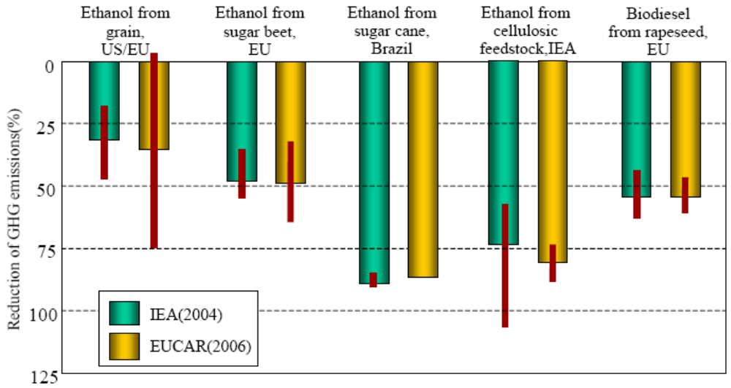
Figure 7. Reduction of well-to-wheels greenhouse gas emissionsfrom biofuels compared to conventionally fuelled vehicles
IPCC 2007.

Even if the IPCC’s assumption that biofuels could be competitive with oil in 2030 proves to be the case, the discussion of the economics of biofuels at the Round Table suggests that hundreds of billions of dollars of subsidy will be spent on the production of biofuels in the interim, if proposed EU and US targets to cover 10% of transport sector fuel consumption before 2020 are to be met. Only very small quantities of biofuels are currently produced without support and even the best performing biofuel industry, Brazilian sugar cane ethanol production, requires around USD 1 billion a year in support through excise tax and VAT exemptions.

7. Conclusions and Messages for Policy Makers
The final session discussed the key points that need to be brought to the attention of policy makers. While this summary cannot pretend to present a unanimous or negotiated position for the Round Table participants, a number of conclusions did enjoy broad support.
Performance of biofuels in reducing greenhouse gas emissions
Discussions at the Round Table underlined the wide range of performance of biofuels in terms of life-cycle energy and greenhouse gas emission balances. Performance differs between fuels and even for a single fuel and feedstock, performance varies greatly according to production process and farming practice. In the worst cases biofuels result in significantly higher emissions of greenhouse gases than gasoline or diesel.
The discussions also identified a wide range of uncertainty in the estimation of emissions of CO₂ from the soil and emissions of N₂O in the cultivation of feedstocks. These emissions vary according to soil type and farming technique and can account for a large part of the overall greenhouse gas emissions for some conventional biofuels.
For biofuels that provide relatively low greenhouse gas abatement (up to around 30%), such as ethanol produced from corn and many other grains, the range of uncertainty can be larger than the average expected benefit. Therefore there is a risk that such fuels provide no benefit or even produce higher rates of greenhouse gas emissions than oil products.
On a small scale, biofuels are currently produced from whey and waste cooking oil with relatively large greenhouse gas savings compared to fossil fuels, of around 70%. The only large-scale production of biofuels to approach this level of performance is Brazilian sugar cane ethanol. However, it requires tax subsidies to be viable, amounting to around USD 1 billion a year.
Most other large-scale biofuel production (ethanol from sugar beet and sorghum; biodiesel from rape, soy and palm oil) achieves around 30% to 50% greenhouse gas savings, but require large subsidies.
Costs and alternative policies
Views differed over just how much biofuel could be produced sustainably. But most biofuels are expensive, particularly when environmental costs are factored in. Only at sustained high oil prices are biofuels likely to be produced commercially. With subsidies restricted to a level that reflects their contribution to greenhouse gas mitigation, much production would cease.
Improving energy efficiency in transport has much greater potential, and at lower cost, than promoting biofuels for reducing energy supply vulnerability and reducing greenhouse gas emissions.
Taxes related to the carbon content of fuels, including for biofuels, would also be more cost-effective than subsidies or biofuel targets as they target CO₂ emissions directly. Fuel-excise tax systems are very similar to a tax on the carbon content of fuels, albeit at a high rate in some cases. In Europe, current excise rates are roughly equivalent to a carbon tax on petrol and diesel of around Euro 200/t CO_{2-eq}, around ten times the current cost of CO₂ in the European emissions trading system. Support for ethanol in the USA is currently estimated to cost double this level at the country’s best performing ethanol plants. The same is true for rapeseed biodiesel produced in the EU.
Advanced biofuels
Future generations of biofuel feedstocks and production processes are likely to have lower greenhouse gas emissions and may be more cost-effective. Such biofuels may be able to meet up to 10% or 20% of current transport energy demand, but no more than this without major advances in technology (Jones 2007).
Ligno-cellulosic ethanol produced from some feedstocks in pilot plants already performs much better than most conventional biofuels in terms of greenhouse gas emissions and performs as well as ethanol from the best Brazilian sugar cane production. However, the economics are unproven and for large-scale production the potential supply of ligno-cellulosic ethanol is limited by cost and the land available for energy crops.
There is a rationale for supporting research on advanced biofuels but this does not extend to open-ended support.
Effectiveness of subsidies
Subsidising large-scale production and consumption of conventional biofuels fails to deliver a significant contribution to the strategic goals of reducing greenhouse gas emissions or improving the security of supply of fuels for transport. It is an inefficient way of providing income support to rural communities and it consumes large amounts of taxpayers’ money (USD 4 billion in 2007 in the USA in tax subsidies alone; USD 4 billion in 2006 in the European Union in tax subsidies; and between USD 13 billion and USD 15 billion in the OECD as a whole for support overall), without commensurate benefits. Germany has now begun to reduce subsidies for biofuels and the United Kingdom is expected to reduce the current excise duty differential of 20p/litre (Euro 0.29/litre) over time.
Policy reform
Volumetric production targets for biofuels fail to provide incentives to contain costs, to avoid environmental damage or even to ensure greenhouse gas emission reductions are delivered. Carbon content targets for fuels, accompanied by certification, are a better alternative.
California, the Netherlands, Germany, Switzerland, the United Kingdom and the European Commission are developing systems of certification to regulate the market for biofuels. These systems are aimed at improving environmental outcomes. If governments continue to promote biofuels, then greater selectivity is needed in the choice of producers and processes to be subsidised. Without this refinement of policy, through certification linked to subsidies, although there may be progress towards targets for production and consumption of biofuels, there will be disappointment in the higher level objective of reducing greenhouse gas emissions. Moreover there are likely to be unwelcome side effects for other sustainability goals.
It should be noted that certification systems are not well suited to addressing the indirect impacts of biofuel production. Certification can only guarantee to influence the supply chain. It can be used to modify farming and biomass harvesting methods in order to limit the environmental impacts of farming. But certification can not be used to control any displacement of existing farming activities induced by an expansion of biofuel production, with consequent land-use change outside the area farmed to produce biofuel. Separate measures will be required to protect valued natural and semi-natural ecosystems, from all kinds of development.
The range and sometimes poor performance of today’s biofuels in terms of greenhouse gas emissions is in part a result of the absence of regulations or incentives to select biofuels according to their environmental profile. The challenge for the development of biofuel certification systems is to provide such incentives cost-effectively.
References
Delucchi 2006 Lifecycle Analysis of Biofuels. Delucchi, Mark A. ITS-Davis. May 2006. Draft Manuscript Publication No. UCD-ITS-RR-06-08. www.its.ucdavis.edu/people/faculty/delucchi
De Oliveira Ethanol as Fuel: Energy, Carbon Dioxide Balances and Ecological Footprint, MarceloE, Dias de Oliveira, Buron E. Vaughan and Edward J. Rykiel Jr., Bioscience 55(7), 2005.
EUCAR/CONCAWE/JRC 2006 Well-to-Wheels Analysis of Future Automotive Fuels and Powertrains in the European Context, www.jrc.ec.europa.eu/wtw.
Farrell et al 2006 Ethanol Can Contribute to Energy and Environmental Goals, Alexander E. Farrell, Richard J. Plevin, Brian T. Turner, Andrew D. Jones, Michael O'Hare, Daniel M. Kammen, Science, Vol. 311 no. 5760, 27 January 2006.
GM/ANL 2005 Well-to-Wheels Analysis of Advanced Fuel / Vehicle Systems: A North American Study of Energy Use, Greenhouse gas emissions and Criteria Pollutant Emissions www.transportation.anl.gov/pdfs/TA/339.pdf.
Graboski Fossil Energy Use in the Manufacture of Corn Ethanol, Michael S. Graboski, Colorado School of Mines, prepared fro the National Corn Growers Association, 2002.
IEA 2004 Biofuels for Transport: An International Perspective, International Energy Agency, Paris.
IPCC 2007 Climate change 2007: Mitigation. Contribution of Working group III to the Fourth Assessment Report of the Intergovernmental Panel on Climate Change [B. Metz, O. R. Davidson, P. R. Bosch, R. Dave, L. A. Meyer (eds)], Cambridge University Press, Cambridge, United Kingdom and New York, NY, USA.
Jones 2007 Biofuel Boundaries: Estimating the Medium-Term Supply Potential of Domestic Biofuels, Andrew D. Jones, University of California Berkeley. Transportation Sustainability Research Center Working paper UCB-ITS-TRSRC-RR-2007-4, August 2007.
Koplow 2007 Biofuels - At What Cost? Government support for ethanol and biodiesel in the United States 2007 Update, Doug Koplow (Earth Track), Global Subsidies Initiative, International Institute for Sustainable Development, Geneva, forthcoming.
Kutas et al 2007 Biofuels - At what cost? Government support for ethanol and biodiesel in the European Union, Geraldine Kutas, Carina Lindberg and Ronald Steenblik, Global Subsidies Initiative, International Institute for Sustainable Development, Geneva, forthcoming.
Patzek Thermodynamics of the Corn-Ethanol Biofuel Cycle, T.W. Patzek, Critical Reviews in Plant Sciences 23(6), 2004.
Patzek 2007 A First-Law Thermodynamic Analysis of the Corn- Ethanol Cycle, Tad W. Patzek, Natural Resources Research, Vol. 15, No. 4, 255-270, 2007
Patzek 2007a Earth, Humans and Energy, Tad W. Patzek, 2007, University of California Berkeley, forthcoming.
Pimentel Ethanol Production Using Corn, Switchgrass and Wood; Biodiesel production Using Soybean and Sunflower, David Pimentel and Tad W. Patzek, Natural Resource Research, 14(1), 2005.
Shapouri The Energy Balance of Corn Ethanol: An Update, Hosein Shapouri, James A. Duffield and Michael Wang, US Department of Agriculture, Agricultural Economic Report
No. 814, 2002.
Toyota 2004 Well-to Wheel Analysis of Greenhouse gas emissions of Automotive Fuels in the Japanese Context, Mizuho, Tokyo.
Tyner 2007 US Ethanol Policy, W. Tyner, Purdue University, 2007
Wang The Greenhouse gasses, regulated Emissions, and Energy Use in Transportation (GREET) Model, version 1.6, Michael Wang, Transportation Technology R&D Centre, Argonne National Laboratory,
Zah et al. 2007 Life-cycle Assessment of Energy Products: Environmental Assessment of Biofuels, Rainer Zah, Heinz Böni, Marcel Gauch, Roland Hischier, Martin Lehmann and Patrick Wäger, Empa Technology and Society Laboratory, Gallen, Switzerland.
_________

 / The information in this document is reproduced in the form in which it was received by the Secretariat.
The European Council has endorsed the proposal subject to the development of sustainability standards, second generation biofuels becoming commercially available and amendment of the Fuel Quality Directive to allow for adequate levels of blending.
Very recently, some European ethanol producers have introduced semi-permeable membrane technology to replace distillation, with large energy savings.
Incorporating the full range of subsidies provided by federal and state administrations: import tariffs, volumetric excise tax credits, State excise tax exemptions, corporate tax credits, capital grants, etc.
Burning makes harvesting easier and empties the fields of snakes and other pests.

