UNITED  NATIONS |  | E
 | Economic and Social Council | Distr.  GENERAL  ECE/TRANS/WP.29/GRPE/2007/12  26 March 2007  Original: ENGLISH  ENGLISH AND FRENCH ONLY

ECONOMIC COMMISSION FOR EUROPE

INLAND TRANSPORT COMMITTEE

World Forum for Harmonization of Vehicle Regulations

Working Party on Pollution and Energy

Fifty-fourth session
Geneva, 5-8 June 2007
Item 6(b) of the provisional agenda

AMENDMENTS TO UNECE REGULATIONS

REGULATION No. 110

Proposal for draft amendments to Regulation No. 110
(Specific components for CNG)

Submitted by the expert from the International Organization of Motor Vehicle Manufacturers

The text reproduced below was prepared by the expert from the International Organization of Motor Vehicle Manufacturers (OICA) to amend the text of the Regulation with regard to the requirements for control valves.

The modifications to the current text of the Regulation are marked in bold characters.
A. PROPOSAL

Paragraphs 6.3.1. to 6.3.1.4., amend to read:

"6.3.1. The container shall be equipped at least with the following components, which may be either separate or combined:

6.3.1.1. manual valve, or another device to manually close the cylinder

6.3.1.2. automatic cylinder valve,

6.3.1.3. pressure relief device,

6.3.1.4. excess flow limiting device."

Paragraphs 17.5.1. to 17.5.1.2., amend to read:

"17.5.1. Automatic valve

17.5.1.1. An automatic cylinder valve shall be installed directly on each container. However, if the cylinder is equipped with automatic admission-pressure control or OBD-monitoring, the automatic valve may be positioned separately from the container.

17.5.1.2. The automatic cylinder valve shall be operated such that the fuel supply is cut off when the engine is switched off, irrespective of the position of the ignition switch, and shall remain closed while the engine in not running. A delay of 2 seconds is permitted for diagnostic. However, if a temperature or pressure increase is detected, for example in case of fire, de-fuelling by opening the automatic shut-off valve shall be permitted."

B. JUSTIFICATION

New compressed natural gas (CNG) fuel system concepts, such as the example described below, provide an opportunity to reduce cost and weight while improving the performance and safety, by reducing the number of high-pressure-exposed components, providing variable control of engine admission pressure and facilitating OBD monitoring.

Example:

Current System Concept
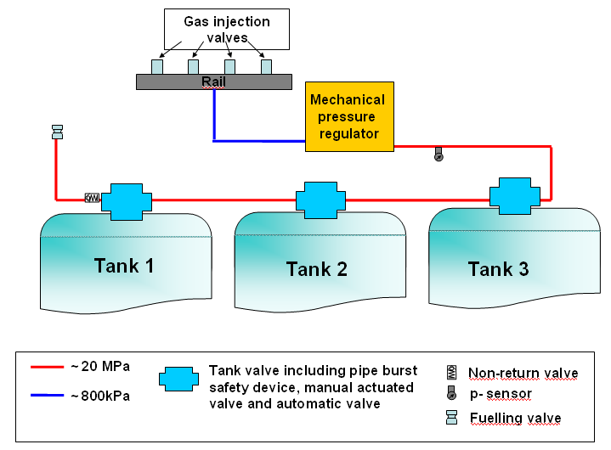

Current systems are heavy and expensive and are not diagnosable.

New System Concept
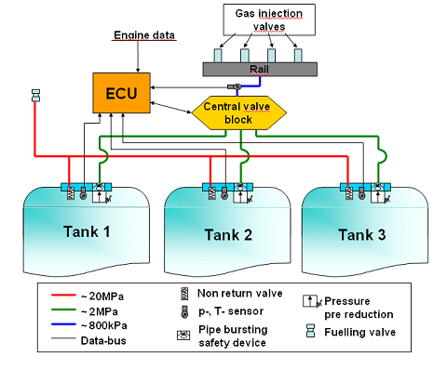
The new system will have three pressure areas with a very simple mechanical pressure regulator integrated in the tank valve, and an electronic pressure regulator near the engine:
(a) High pressure area: 20 MPa
(b) Medium pressure area: about 2 MPa
(c) Low pressure area: about 800 kPa (depending on engine demand)

Advantages:
(a) Reduced number of high pressure-exposed components
(b) Variable control of the engine admission pressure
(c) Monitoring of pressure regulator
(d) OBD monitoring
(e) Simpler fittings and connections
(f) Cost and weight reduction

A new tank valve has been developed for this system:

Current Valve New Valve
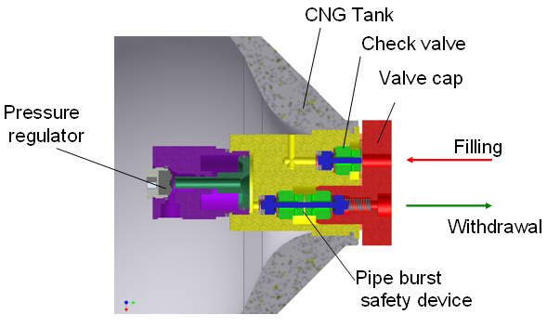

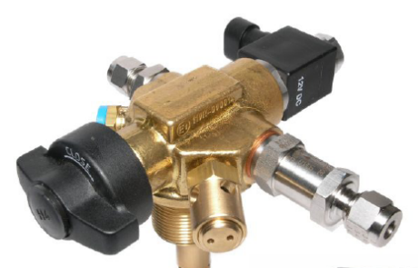

With the new tank valve there is no manually actuated valve, but there is still the possibility to manually close the cylinder.

Also there is no automatic valve on the tank, but there are automatic valves positioned in a central valve block at some distance from the tank.

- - - - -

