PROPOSED DRAFT GLOBAL TECHNICAL REGULATION (GTR)
on
PEDESTRIAN PROTECTION.

This document is a working document circulated for discussion and comments. It is only submitted with the intention to facilitate discussion by the GRSP Informal Group.

Note: Square brackets ‘[]’ are used in this document to indicate items or sections which require further discussion or clarification which may include changes of values or complete revision of the contents.

Note: This document is distributed to the Experts on Passive Safety Provisions only.

GLOBAL TECHNICAL REGULATION NO. Y

on

UNIFORM PROVISIONS CONCERNING THE APPROVAL OF VEHICLES WITH REGARD TO THEIR construction in order to improve the protection and mitigate the severity of injuries to pedestrians and other vulnerable road users in the event of a collision

A. Introduction.

[Preamble, Technical rationale and justification for measures to be added].
B. Text of the Regulation

Purpose and Scope.

1.1 The purpose of this regulation is to bring about an improvement in the construction of the fronts of vehicles and, in particular, those areas which have been most frequently identified as causing injury when in collision with a pedestrian or other vulnerable road user. The tests required are limited to those elements of the child and adult body most frequently identified as sustaining injury, i.e. the adult head and leg and the child head. To achieve the required improvements in construction of vehicles, the tests are based on sub-system component impactors representing those body regions and impacted at speeds representative of that below which the majority of injuries occur.

1.2 The vehicles to be tested under the regulation are representative of the majority of vehicles in circulation in the urban environment, where there is a greater potential for collision with pedestrians and other vulnerable road users, and include passenger cars, vans and light trucks.

Application.

2.1 This global technical regulation requires specified tests to be completed for the purpose of qualifying vehicles, including passenger cars, vans and light trucks, with respect to the safety of pedestrians and other vulnerable road users.

2.2 This global technical regulation applies to those categories of vehicles as detailed in Table 1 below. All contracting parties agreeing to this global technical regulation will indicate, in the table, the vehicle categories and test requirements to be applied in their region.

2.3 Regular reviews will be instituted to ensure the eventual application of this global technical regulation to all vehicles in a reduced set of suitable vehicle categories, on the basis of technical and economic feasibility, for all contracting parties.

2.4 Regular reviews will be instituted to ensure that the specifications of the test requirements will be harmonised into a single set of requirements accepted by all contracting parties.

2.5 At the time of acceptance of the regulation by any party contracting to the regulation, that contracting party will be required to accept the alternatives available at that time.

2.6 Those tests accepted by any contracting party may be phased in with respect to the date of acceptance of the GTR by that contracting party. The details of the phasing in periods shall be stated and appended to the regulation

 |  | Vehicle Categories
 |  | (a) | (b) | (c) | (d) | (e) | (f)
Procedure Application |  | Category 1-1  Vehicle Mass  < 2500 kg | Category 1-1  Vehicle Mass  > 2500 kg | Category 2  Vehicle Mass  < 2500 kg | Category 2  Vehicle Mass  > 2500 kg | Category 2  Vehicle Mass  < 3500 kg | …
Legform  to Bumper |  | Region x  Region y  Region z | Region y | … | … | … | …
Upper Legform  to Bumper |  | Region x  Region y | Region z | … | … | … | …
Upper Legform  to BLE |  | … | Region x | … | … | Region z | …
Child Headform |  | … | … | … | … | … | …
…………. |  | … | … | … | … | … | …

Table 1: Agreed Scope and Application for the purposes of this Regulation.

[Notes: Examples of Region: Region x covers all European Member states, Region y covers Japan, Region z covers the US, etc. for other contracting parties.

The column of tests will continue for each potential agreed alternative test.

The use of this approach still requires some guidance and approval from WP.29.]
3. Definitions.

[Note: The definitions contained in this section are not yet necessarily complete and may be altered or added to when the full document is further reviewed.]

When performing measurements on a vehicle as described in this Part, the vehicle should be positioned in its normal ride attitude as described in paragraph 3.20. If the vehicle is fitted with a badge, mascot or other structure which would bend back or retract under a low applied load, then such a load shall be applied before and/or while these measurements are taken. Any vehicle component which could change shape or position, such as ‘pop-up' headlights, other than suspension components or active devices to protect pedestrians, shall be set to a shape or position, [based on a determination by each contracting party or regional economic integration organisation,] considered to be the most appropriate while taking these measurements.

For the purposes of this regulation:

3.1 “Adult Headform Test Area” means the outer surfaces of the front structure, the windscreen, the A-pillars and the windscreen header.
It is bounded, in the front, by a wrap around distance of 1700mm, as defined in paragraph 3.32, and, at the rear, by the rear reference line for adult headform, as defined in paragraph 3.21, and, at each side, by the side reference line as defined in paragraph 3.24

3.2 “A-pillar” means the foremost and outermost roof support extending from the chassis to the roof of the vehicle.

3.3 “Bonnet angle” means …

[Note: This definition will be taken from IHRA definitions.]

3.4 “Bonnet leading edge (BLE)” means the front upper outer structure including the bonnet and wings, the upper and side members of the headlight surrounds and any other attachments. The reference line identifying the position of the bonnet leading edge is defined by its height above the ground reference plane and by the horizontal distance separating it from the bumper (bumper lead), as determined in accordance with paragraph 3.10.

3.5 “Bonnet leading edge height (BLEH)” means the vertical distance between the ground reference plane and the bonnet leading edge reference line, defined in point 3.6, with the vehicle positioned in its normal ride attitude.

3.6 “Bonnet leading edge reference line” means the geometric trace of the points of contact between a straight edge 1000 mm long and the front surface of the bonnet, when the straight edge, held parallel to the vertical longitudinal plane of the car and inclined rearwards by 50° and with the lower end 600 mm above the ground, is traversed across and in contact with the bonnet leading edge (See Figure 1.).
For vehicles having the bonnet top surface inclined at essentially 50°, so that the straight edge makes a continuous contact or multiple contacts rather than a point contact, determine the reference line with the straight edge inclined rearwards at an angle of 40°.
For vehicles of such shape that the bottom end of the straight edge makes first contact with the vehicle then that contact is taken to be the bonnet leading edge reference line, at that lateral position.
For vehicles of such shape that the top end of the straight edge makes first contact with the vehicle then the geometric trace of 1000 mm wrap around distance, as defined in point 3.32, will be used as bonnet leading edge reference line at that lateral position.
The top edge of the bumper shall also be regarded as the bonnet leading edge for this Regulation, if it is contacted by the straight edge during this procedure.

3.7 “Bonnet rear reference line (BRL)” means the geometric trace of the most rearward points of contact between a 165 mm diameter sphere and the rear of the bonnet when the sphere is traversed across the bonnet while maintaining contact with the windscreen (see Figure 2.)

Where the bonnet rear reference line and the side reference line do not intersect, the bonnet rear reference line should be extended and/or modified using a semi-circular template, of radius 100 mm. The template should be made of a thin flexible sheet material that easily bends to a single curvature in any direction. The template should, preferably, resist double or complex curvature where this could result in wrinkling. The recommended material is a foam backed thin plastic sheet to allow the template to ‘grip’ the surface of the vehicle. The template should be marked up with four points ‘A’ through ‘D’, as shown in Figure 3, while the template is on a flat surface.
The template should be placed on the vehicle with Corners ‘A’ and ‘B’ coincident with the side reference line. Ensuring these two corners remain coincident with the side reference line, the template should be slid progressively rearwards until the arc of the template makes first contact with the bonnet rear reference line. Throughout the process, the template should be curved to follow, as closely as possible, the outer contour of the vehicle’s bonnet op, without wrinkling or folding of the template. If the contact between the template and bonnet rear reference line is tangential and the point of tangency lies outside the arc scribed by points ‘C’ and ‘D’, then the bonnet rear reference line is extended and/or modified to follow the circumferential arc of the template to meet the bonnet side reference line, as shown in Figure4.
If the template cannot make simultaneous contact with the bonnet side reference line at points ‘A’ and ‘B’ and tangentially with the bonnet rear reference line, or the point at which the bonnet rear reference line and template touch lies within the arc scribed by points ‘C’ and ‘D’, then additional templates should be used where the radii are increased progressively in increments of 20 mm, until all the above criteria are met.

3.8 “Bonnet top” is the area which is bounded by (a), (b) and (c) as follows:
(a) the bonnet leading edge reference line, as defined in paragraph 3.6;
(b) the bonnet rear reference line as defined in paragraph 3.7.
(c) the bonnet side reference lines as defined in paragraph 3.24;

3.9 “Bumper” means the front, lower, outer structure of a vehicle. It includes all structures that are intended to give protection to a vehicle when involved in a low speed frontal collision with another vehicle and also any attachments to this structure. The reference height and lateral limits of the bumper are identified by the corners and the bumper reference lines as defined in points 3.12, 3.18, 3.19, 3.28 and 3.29.

3.10 “Bumper lead” for any section of a car is the horizontal distance in the vehicle longitudinal plane between the upper bumper reference line, as defined in point 3.29 and the bonnet leading edge reference line, as defined in point 3.6.

3.11 “Child Head form Test Area” means the outer surfaces of the front structure that are bounded, in the front, by the front reference line for child headform, defined in paragraph 3.13, and, at the rear, by the rear reference line for child headform, as defined in paragraph 3.22, and by the side reference lines as defined in paragraph 3.24.

3.12 “Corner of bumper” means the vehicle’s point of contact with a vertical plane which makes an angle of 60° with the vertical longitudinal plane of the car and is tangential to the outer surface of the bumper (see Figure 3.).

3.13 “Front reference line for Child Headform (CFL)” means the geometric trace as described on the vehicle front structure using a wrap around distance of 1000 mm.
In the case of vehicles where the wrap around distance to the bonnet leading edge reference line, as defined in paragraph 3.6, is more than 1000 mm at any point, then the bonnet leading edge reference line will be used as the front reference line for child headform at that point.

3.14 “Front structure” means all parts of the vehicle including the windscreen, the windscreen header, the A-pillars and all parts of the vehicle forward of these. It therefore includes, but is not limited to, the bonnet, wings, scuttle (cowl), wiper spindles, windscreen and lower windscreen frame.

3.15 “Ground reference plane” means a horizontal plane, either real or imaginary, that passes through the lowest points of contact for all tyres of a vehicle while the vehicle is in its normal ride attitude. If the vehicle is resting on the ground, then the ground plane and the ground reference plane are one and the same. If the vehicle is raised off the ground such as to allow extra clearance below the bumper, then the ground reference plane is above the ground plane.

3.16 “Head Injury Criterion (HIC)” means the calculated result of accelerometer time histories using the following formula:

HIC = | 

Where:
a is the resultant acceleration measured in units of gravity “g” (1g = 9.81m/s²);

t₁ and t₂ are the two time instants (expressed in seconds) during the impact, defining an interval between the beginning and the end of the recording period for which the value of HIC is a maximum (t₂ - t₁ ≤ 15 msec )

3.17 “Impact point” means the point on the vehicle where initial contact by the test impactor occurs. The proximity of this point to the target point is dependent upon both the angle of travel by the test impactor and the contour of the vehicle surface (see point B on Figure 4.).

3.18 “Lower bumper height” means the vertical distance between the ground and the lower bumper reference line, defined in point 3.19, with the vehicle positioned in its normal ride attitude.

3.19 “Lower bumper reference line” means the lower limit to significant points of pedestrian contact with the bumper. It is defined as the geometric trace of the lowermost points of contact between a straight edge 700 mm long and the bumper, when the straight edge, held parallel to the vertical longitudinal plane of the car and inclined forwards by 25°, is traversed across the front of the car, while maintaining contact with the ground and with the surface of the bumper (see Figure 7.).

3.20 “Normal ride attitude” means the vehicle attitude in driving order positioned on the ground, with the tyres inflated to recommended pressures, the front wheels in the straight-ahead position, with maximum capacity of all fluids necessary for operation of the vehicle, with all standard equipment as provided by the vehicle manufacturer, with a 75 kg mass placed on the driver’s seat , and with a 75 kg mass placed on the front passenger’s seat , and the suspension set in normal running condition as specified by the manufacturer (especially for vehicles with an active suspension or a device for automatic levelling).

3.21 “Rear reference line for Adult Headform (ARL)” means a geometric trace as described on the front structure of the vehicle using a wrap around distance of 2100mm.

In the case of vehicles where the wrap around distance to the rear windscreen reference line, as defined in paragraph 3.23, is less than 2100mm at any point, the rear windscreen reference line will be used as the rear reference line for the adult headform at that point.

For vehicles where the wrap around distance to the rear reference line for the adult headform is over the vertical limit reference line, as defined in paragraph 3.31, at any point, then the vertical limit reference line will be used as the rear reference line for the adult headform at that point.

3.22 “Rear reference line for Child Headform (CRL)” means a geometric trace as described on the vehicle front structure by a wrap around distance of 1700 mm.
In the case of vehicles where the wrap around distance to the bonnet rear reference line, as defined in paragraph 3.7, is less than 1700 mm at any point, then the bonnet rear reference line will be used as the rear reference line for the child headform at that point.

3.23 “Rear windscreen reference line (RWL)” means the geometric trace of the most forward points of contact between a sphere and the windscreen, when a sphere of diameter 165mm is traversed across the windscreen header, including any trim, while maintaining contact with the windscreen (see Figure 8.).

3.24 “Side reference line (SL)” means the geometric trace of the highest points of contact between a straight edge and the sides of the front structure, A-pillars or roof, when the straight edge, held parallel to the transverse vertical plane of the vehicle and inclined inwards by 45° is traversed down the sides of the front structure, A-pillars or roof, while maintaining contact with the surface of the body shell (see Figure 9.).

3.25 “Target Point” means the intersection of the projection of the headform longitudinal axis with the front surface of the vehicle (see point A on Figure 6).

3.26 “Third of the bonnet top” means the geometric trace between the bonnet side reference lines, as defined in point 3.24, measured with a flexible tape following the outer contour of the bonnet top, divided into three equal parts.

3.27 “Third of the bumper” means the geometric trace between the corners of the bumper, as defined in point 3.12, measured with a flexible tape following the outer contour of the bumper, divided into three equal parts.

3.28 “Upper bumper height” means the vertical distance between the ground and the upper bumper reference line, defined in point 3.29, with the vehicle positioned in its normal ride attitude.

3.29 “Upper bumper reference line” means the upper limit to significant points of pedestrian contact with the bumper. It is defined as the geometric trace of the uppermost points of contact between a straight edge 700 mm long and the bumper, when the straight edge, held parallel to the vertical longitudinal plane of the car and inclined rearwards by 20°, is traversed across the front of the car, while maintaining contact with the ground and with the surface of the bumper (see Figure 10.). Where necessary the straight edge shall be shortened to avoid any contact with structures above the bumper.

3.30 “Vehicle mass” means the mass of the vehicle in full driving order, with the maximum capacity of all fluids necessary for the operation of the vehicle, fitted with the standard equipment as provided by the vehicle manufacturer and with no driver or passengers on board.

[Note: This definition may change with reference to the development of the expected resolution to be agreed to the 1998 agreement concerning the definition of categories of vehicle. If this resolution is accepted then the definition could be as follows:

3.30 “Vehicle mass” means the mass of the vehicle in full driving order as defined in Resolution no. xxx to the 1998 Agreement.]

3.31 “Vertical limit reference line (VLL)” means a horizontal line on the vehicle at a vertical height of 1900mm from the ground reference plane (see Figure 11).

3.32 “Wrap Around Distance” is the geometric trace described on the frontal upper surface by one end of a flexible tape, when it is held in a vertical fore and aft plane of the vehicle and traversed across the front surfaces of the bonnet and bumper. The tape is held taut throughout the operation with one end held at ground reference level, vertically below the front face of the bumper and the other end held in contact with the frontal upper surface (see Figure 12.). The vehicle is positioned in the normal ride attitude.
This procedure shall be followed, using alternative tapes of appropriate lengths, to describe 1000 mm, 1700 mm and 2100 mm wrap around distances.

3.33 “Windscreen” means the frontal glazing of the vehicle situated between the A-pillars.

3.34 “Windscreen side reference line (SWL)” means the geometric trace of the most outward points of contact between a sphere and the windscreen, when a sphere of diameter 165mm is rolled down the A-pillar, including any trim, while maintaining contact with the windscreen.

3.35 “Windscreen lower reference line (LWL)” means the geometric trace of the uppermost points of contact between a sphere and the windscreen, when a sphere of diameter 165mm is traversed across the rear edge of the bonnet, while maintaining contact with the windscreen.

3.36 “Windscreen test area” means an area of the windscreen bordered as follows:
(a) towards the windscreen top, by a line 82.5 mm forwards of the rear windscreen reference line as defined in paragraph 3.23.
(b) towards each windscreen side, by a line 82.5 mm inside the windscreen side reference line as defined in paragraph 3.34.
(c) towards the base of the windscreen, by a line 82.5 mm inside the windscreen lower reference line as defined in paragraph 3.35.
(See Figure 13)

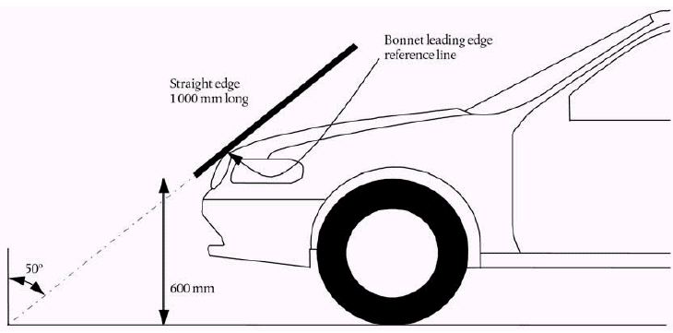

Figure 1: Bonnet Leading Edge Reference Line.

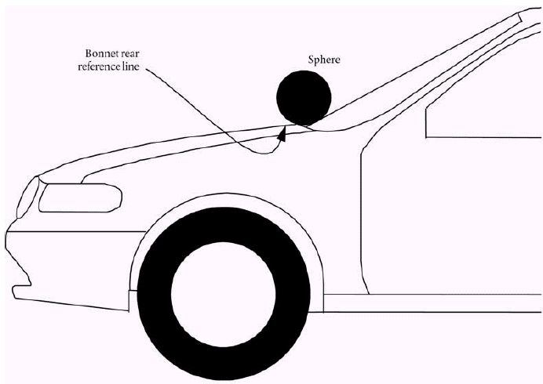

Figure 2: Bonnet Rear Reference Line.

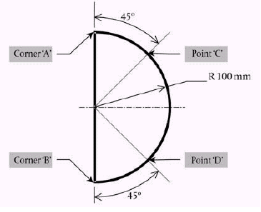

Figure 3: Template.

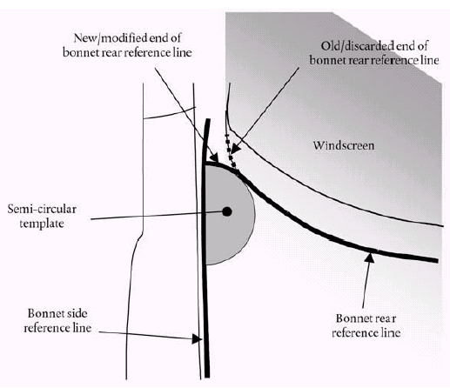

Figure 4: Marking of intersection between bonnet rear and side reference lines.

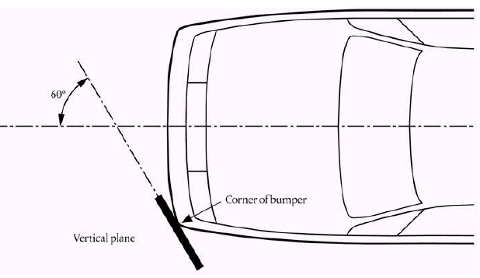

Figure 5: Corner of Bumper

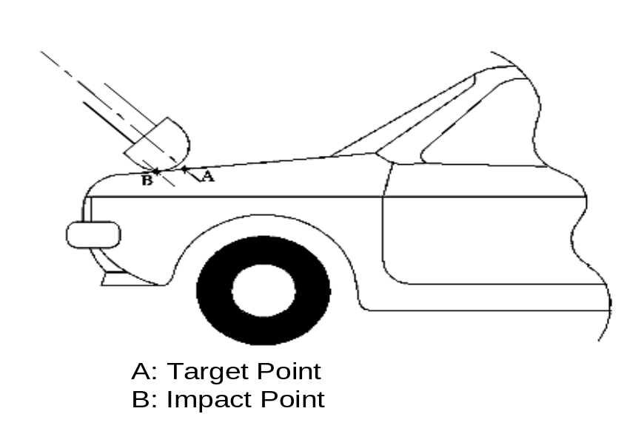

Figure 6: Impact Point.

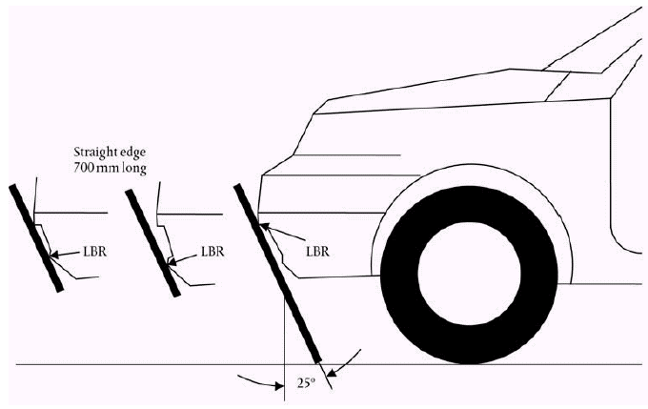

Figure 7: Lower Bumper Reference Line.

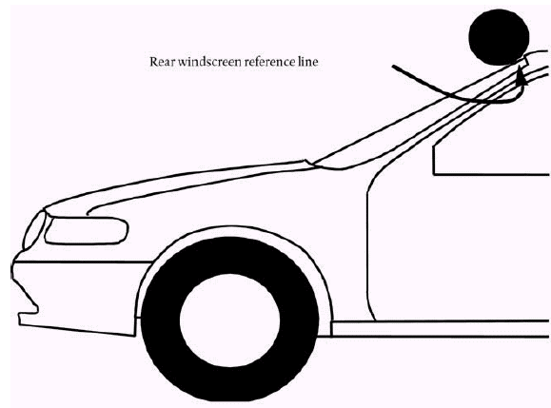

Figure 8: Rear Windscreen Reference Line.
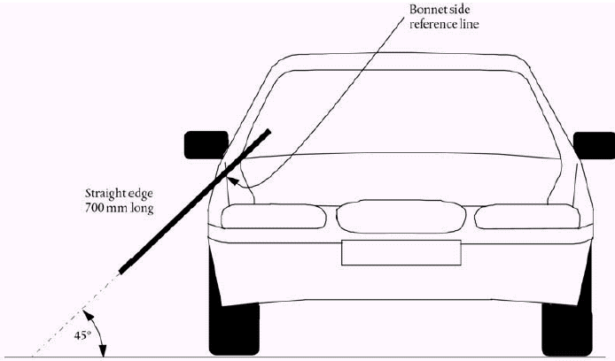

Figure 9: Side Reference Line.

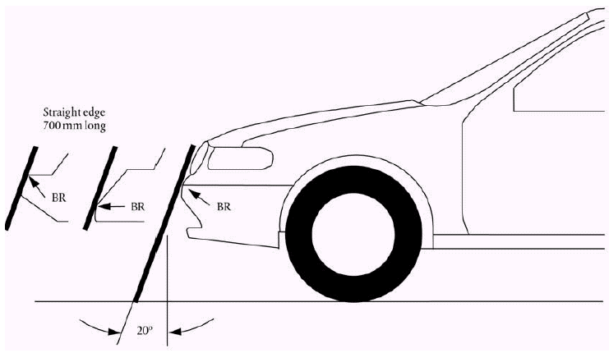

Figure 10: Upper Bumper Reference Line.

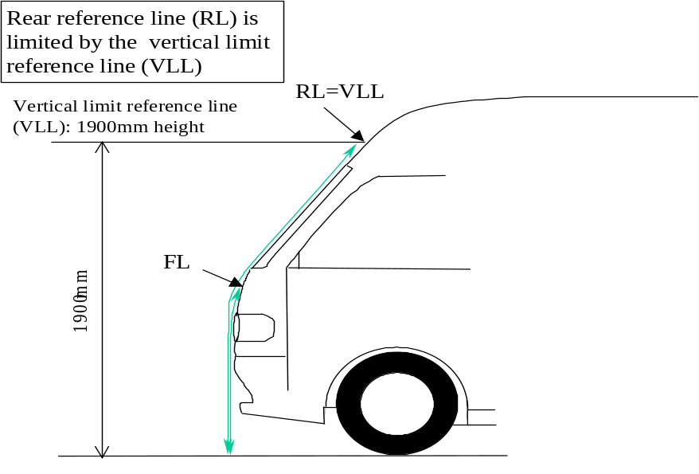

Figure 11: Vertical limit reference line.

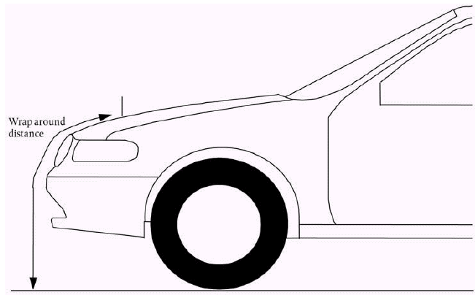

Figure 12: Wrap Around Distance Measurement.

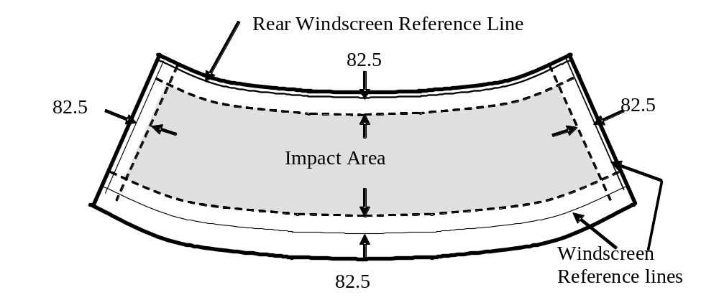

Figure 13: Windscreen test area.
4. General Requirements.

This Global Technical Regulation specifies the following tests to verify compliance of vehicles

[Comment: The group agreed that inclusion of the upper leg test to the bonnet leading edge needed further review. In particular, it must be verified whether this test is actually needed on the basis of accident data, technical feasibility, test procedure repeatability, reproducibility, etc. The group however agreed not to include this test for the time being, but also agreed to review this issue at a later stage on the basis of any new available information.]

4.1 Legform test to bumper:

One of the following legform tests are required to be performed:

4.1.1 Lower leg form to bumper:
To comply with the performance requirements as specified in section 5.1.1, the test conditions specified in sections 6.1 and 6.3.1.1 and the test procedures specified in section 7.1.1.

4.1.2 Upper legform to bumper:
To comply with the performance requirements as specified in section 5.1.2, the test conditions specified in sections 6.1 and 6.3.1.2 and the test procedures specified in section 7.1.2.

4.2 Child headform impact:
To comply with the performance requirements as specified in section 5.2.1, the test conditions specified in sections 6.1 and 6.3.2.1 and the test procedures specified in section 7.2.

4.3 Adult headform impact:
To comply with the performance requirements as specified in section 5.2.2, the test conditions specified in sections 6.1 and 6.3.2.2 and the test procedures specified in section 7.3.

5. Performance Requirements.

5.1 Legform to Bumper:

5.1.1 When tested in accordance with section 7.1.1.(lower legform to bumper), the maximum dynamic knee bending angle shall not exceed [21.0°], the maximum dynamic knee shearing displacement shall not exceed [6.0mm], and the acceleration measured at the upper end of the tibia shall not exceed [200g]

[Note: The following alternative may be required if a decision is agreed to use the flexible legform impactor now being developed;

5.1.1 When tested in accordance with section 7.1.1.(lower legform to bumper), the maximum dynamic knee bending angle shall not exceed [20.0°], the maximum dynamic knee shearing displacement shall not exceed [6.0mm], the acceleration measured at the upper end of the tibia shall not exceed [200g] and the tibia bending moment shall not exceed [350]Nm.]

5.1.2 When tested in accordance with section 7.1.2. (Upper legform to bumper), the instantaneous sum of the impact forces with respect to time shall not exceed [7.5kN] and the bending moment on the test impactor shall not exceed [510Nm].

5.2 Headform tests

5.2.1 Child headform to front structure:
When tested in accordance with section 7.2 the Head Injury Criterion (HIC) shall not exceed [1000] ⁽¹⁾ over the child headform test area as defined in paragraph 3.11. For impact points in the windscreen area, the requirements of paragraph 5.2.3 shall apply.

5.2.2 Adult head form to the front structure:
When tested in accordance with section 7.3 the Head Injury Criterion (HIC) shall not exceed [1000] ⁽¹⁾ over the adult headform test area as defined in paragraph 3.1. For impact points in the windscreen area, the requirements of paragraph 5.2.3 shall apply.

[Footnote: ⁽¹⁾ the group agreed that the area required to meet HIC 1000 may need revision and some consideration given to allow some exemption zones.]

5.2.3 If the tested front structure as impacted by the child or adult headforms includes parts of the windscreen area, the Head Injury Criterion (HIC) shall not exceed 1000 for all the selected impact points within the windscreen test area, defined in paragraph 3.36.

6. Test Conditions

6.1 General Site Conditions

6.1.1 Temperature and humidity
The stabilised temperature of the test tools and of the vehicle or sub-system at the time of testing shall be [20° ± 4°]C. The relative humidity of the test area where all equipment is held should be [10 to 70]% after a stabilised period of at least four hours prior to the application of any test.

6.1.1.1 Sufficient time must be allowed before testing for the temperature of all vehicle components to stabilise to the required temperature range.

6.1.1.2 Relative humidity and temperature shall be measured at the time of the test, and recorded in the test report.

6.1.2 Impact test site
The test site shall consist of a flat, smooth and hard surface with a slope not exceeding 1 %.

6.2 Preparation of the vehicle

6.2.1 Either a complete vehicle or a cut-body adjusted to the following conditions, shall be used for the test.

6.2.1.1 The vehicle shall be in its normal ride attitude and shall be either securely mounted on raised supports or at rest on a flat surface. The parking brake shall be applied, or the cut-body shall be securely mounted.

6.2.1.2 The cut-body shall include all parts of the vehicle front structure and under bonnet components, or behind windscreen components, that may be involved in a frontal impact with a vulnerable road user in the test, to demonstrate the performance and interactions of all the contributory vehicle components.

6.2.1.2.1 The cut-body shall be securely mounted in the normal vehicle ride attitude.

6.2.2 All devices designed to protect vulnerable road users shall be correctly activated before and/or be active during the appropriate test. It shall be the responsibility of the manufacturer to show that any devices will act as intended in a pedestrian impact.

6.2.3 Any vehicle component which could change shape or position, such as ‘pop-up’ headlights, other than active devices to protect pedestrians, shall be set to a shape or position that the test institutes in consultation with the manufacturer consider to be the most appropriate for these tests.

6.3 Test impactor specifications

6.3.1 Legform impactors:

[Note: The following description of the lower legform impactor is based on the presently known and used impactor. The further development and acceptance of a flexible legform impactor may require the complete replacement of the following section 6.3.1.1.]

6.3.1.1 Lower legform impactor:

The lower legform impactor shall consist of two foam covered rigid segments, representing femur (upper leg) and tibia (lower leg), joined by a deformable, simulated knee joint. The overall length of the impactor shall be 926 ± 5 mm, having a required test mass of 13,4 ± 0,2 kg (see Figure 14).
Brackets, pulleys, etc. attached to the impactor for the purpose of launching it, may extend the dimensions shown in Figure 14.

6.3.1.1.1 The diameter of the femur and tibia shall be 70 ± 1 mm and both shall be covered by foam ‘flesh' and skin. The foam flesh shall be 25 mm thick Confor™ foam type CF-45. The skin shall be made of neoprene foam, faced with ½ mm thick nylon cloth both sides, with an overall thickness of 6 mm.

6.3.1.1.2 The ‘centre of the knee' is defined as the point about which the knee effectively bends.

6.3.1.1.3 The ‘femur' is defined as all components or parts of components (including flesh, skin covering, damper, instrumentation and brackets, pulleys, etc. attached to the impactor for the purpose of launching it) above the level of the centre of the knee.

6.3.1.1.4 The ‘tibia' is defined as all components or parts of components (including flesh, skin covering, instrumentation and brackets, pulleys, etc. attached to the impactor for the purpose of launching it) below the level of the centre of the knee. Note that the tibia as defined includes allowances for the mass, etc., of the foot.

6.3.1.1.5 The total mass of the femur and tibia shall be 8,6 ± 0,1 kg and 4,8 ± 0,1 kg respectively, and the total mass of the impactor shall be 13,4 ± 0,2 kg. The centre of gravity of the femur and tibia shall be 217 ± 10 mm and 233 ± 10 mm from the centre of the knee respectively. The moment of inertia of the femur and tibia, about a horizontal axis through the respective centre of gravity and perpendicular to the direction of impact, shall be 0,127 ± 0,010 kg/m² and 0,120 ± 0,010 kg/m² respectively.

6.3.1.1.6 The impactor shall be fitted with foam flesh cut from one of up to four consecutive sheets of Confor™ foam flesh material produced from the same batch of manufacture (cut from one block or bun of foam), provided that foam from one of these sheets was used in the dynamic certification test and the individual weights of these sheets are within ± 2 % of the weight of the sheet used in the certification test.

6.3.1.1.7 Lower legform instrumentation

6.3.1.1.7.1 A uniaxial accelerometer shall be mounted on the non-impacted side of the tibia, 66 ± 5 mm below the knee joint centre, with its sensitive axis in the direction of impact.

6.3.1.1.7.2 The impactor shall be instrumented to measure the bending angle and the shearing displacement between femur and tibia.

6.3.1.1.7.3 A damper shall be fitted to the shear displacement system and may be mounted at any point on the rear face of the impactor or internally. The damper properties shall be such that the impactor meets both the static and dynamic shear displacement requirements and prevents excessive vibrations of the shear displacement system.

6.3.1.1.7.4 Transducers shall be fitted to measure knee bending angle and knee shearing displacement. One uni-axial accelerometer shall be fitted to the non-impacted side of the tibia, close to the knee joint, with its sensitive axis in the impact direction.

6.3.1.1.7.5 The instrumentation response value CFC, as defined in ISO 6487:2000, shall be 180 for all transducers. The CAC response values, as defined in ISO 6487:2000, shall be 50° for the knee bending angle, 10 mm for the shearing displacement and 500 g for the acceleration. This does not require that the impactor itself be able to physically bend and shear to these angles and displacements.

6.3.1.1.8 Lower legform certification

6.3.1.1.8.1 The lower legform impactor shall meet the performance requirements specified in section 8, and shall be fitted with deformable knee elements from the same batch as those used in the certification tests.

6.3.1.1.8.2 The certified impactor may be used for a maximum of 20 impacts before re-certification. With each test new plastically deformable knee elements should be used. The impactor shall also be re-certified if more than one year has elapsed since the previous certification or if any impactor transducer output, in any impact, has exceeded the specified CAC.

6.3.1.1.9 The lower legform impactor for the bumper tests shall be in ‘free flight' at the moment of impact. The impactor shall be released to free flight at such a distance from the vehicle that the test results are not influenced by contact of the impactor with the propulsion system during rebound of the impactor.
The impactor may be propelled by an air, spring or hydraulic gun, or by other means that can be shown to give the same result.

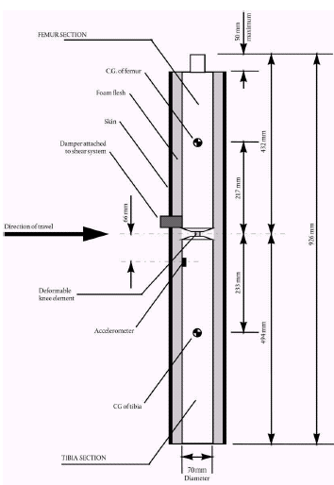

Figure 14: Lower legform impactor.

6.3.1.2 Upper legform impactor:

The upper legform impactor shall be rigid, foam covered at the impact side, and 350 ± 5 mm long (see Figure 15).

6.3.1.2.1 The total mass of the upper legform impactor including those propulsion and guidance components which are effectively part of the impactor during the impact shall be 9,5 kg ± 0,1 kg. The upper legform impactor mass may be adjusted from this value by up to ± 1 kg, provided the required impact velocity is also changed using the formula:

V = √ (1 170/M)

Where:

V = impact velocity (m/s)

M = mass (kg), measured to an accuracy of better than ± 1 %

6.3.1.2.2 The total mass of the front member and other components in front of the load transducer assemblies, together with those parts of the load transducer assemblies in front of the active elements, but excluding the foam and skin, shall be 1,95 ± 0,05 kg.

6.3.1.2.3 The torque limiting joint shall be set so that the longitudinal axis of the front member is perpendicular to the axis of the guidance system, with a tolerance of ± 2°, with the joint friction torque set to a minimum of 650 Nm.

6.3.1.2.4 The centre of gravity of those parts of the impactor which are effectively forward of the torque limiting joint, including any weights fitted, shall lie on the longitudinal centre line of the impactor, with a tolerance of ± 10 mm.

6.3.1.2.5 The length between the load transducer centre lines shall be 310 ± 1 mm and the front member diameter shall be 50 ± 1 mm.

6.3.1.2.6 The foam flesh shall be two sheets of 25 mm thick ConforTM foam type CF-45. The skin shall be a 1,5 mm thick fibre reinforced rubber sheet. The foam and rubber skin together shall weigh 0,6 ± 0,1 kg (this excludes any reinforcement, mountings, etc. which are used to attach the rear edges of the rubber skin to the rear member). The foam and rubber skin shall be folded back towards the rear, with the rubber skin attached via spacers to the rear member so that the sides of the rubber skin are held parallel. The foam shall be of such a size and shape that an adequate gap is maintained between the foam and components behind the front member, to avoid significant load paths between the foam and these components.

6.3.1.2.7 Upper legform instrumentation

6.3.1.2.7.1 The front member shall be strain gauged to measure bending moments in three positions, as shown in Figure 15, each using a separate channel. The strain gauges are located on the impactor on the back of the front member. The two outer strain gauges are located 50 ± 1 mm from the impactor's symmetrical axis. The middle strain gauge is located on the symmetrical axis with a ± 1 mm tolerance.

6.3.1.2.7.2 Two load transducers shall be fitted to measure individually the forces applied at either end of the upper legform impactor, plus strain gauges measuring bending moments at the centre of the upper legform impactor and at positions 50 mm either side of the centre line, (see Figure 15).

6.3.1.2.7.3 The instrumentation response value CFC, as defined in ISO 6487:2000, shall be 180 for all transducers. The CAC response values, as defined in ISO 6487:2000, shall be 10 kN for the force transducers and 1 000 Nm for the bending moment measurements.

6.3.1.2.8 Upper legform certification

6.3.1.2.8.1 The upper legform impactor shall meet the performance requirements specified in section 8.

6.3.1.2.8.2 The certified impactor may be used for a maximum of 20 impacts before re-certification (this limit does not apply to propulsion or guidance components). The impactor shall also be re-certified if more than one year has elapsed since the previous certification or if any impactor transducer output, in any impact, has exceeded the specified CAC.

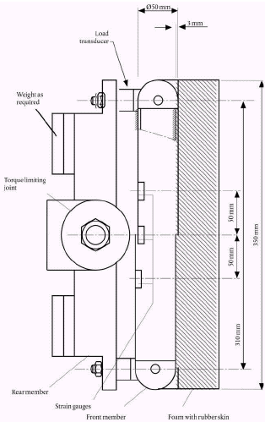

Figure 15: Upper legform impactor

6.3.2 Child and Adult headforms

6.3.2.1 Child headform impactor

The child headform impactor shall be made of aluminium, be of homogenous construction and be of spherical shape. The diameter shall be [165±1] mm as shown in Figure 16. The mass shall be [3,5 ± 0,07] kg. The moment of inertia about an axis through the centre of gravity and perpendicular to the direction of impact shall be with in the range of [0,0075 to 0,0200] kgm². The centre of gravity of the headform impactor including instrumentation shall be located in the geometric centre of the sphere with a tolerance of ±[5] mm.
[Note: Possibly to be corrected as per INF GR PS 74]
The sphere shall be covered with a [13.9 ± 0.5] mm thick synthetic skin, which shall cover at least half of the sphere.

6.3.2.1.2 Child headform instrumentation

A recess in the sphere shall allow for mounting one triaxial or three uniaxial accelerometers within ± [10] mm seismic mass location tolerance from the centre of the sphere for the measurement axis, and ± [1] mm seismic mass location tolerance from the centre of the sphere for the perpendicular direction to the measurement axis.

[Note: The following description may be replaced by a proposal from Japan.]

One of the accelerometers shall have its sensitive axis perpendicular to the mounting face A (see figure 16) and its seismic mass shall be positioned within a cylindrical tolerance field of 1 mm radius and 20 mm length. The centre line of the tolerance field shall run perpendicular to the mounting face and its mid-point shall coincide with the centre of the sphere of the headform impactor.
The remaining accelerometers shall have their sensitive axes perpendicular to each other and parallel to the mounting face A and their seismic mass shall be positioned within a spherical tolerance field of 10 mm radius. The centre of the tolerance field shall coincide with the centre of the sphere of the headform impactor.

The instrumentation response value CFC, as defined in ISO 6487: 2002, shall be 1000. The CAC response value, as defined in ISO 6487: 2002, shall be 500 g for the acceleration.

6.3.2.1.2 First natural frequency

The first natural frequency of the headform impactor shall be over 5000 Hz.

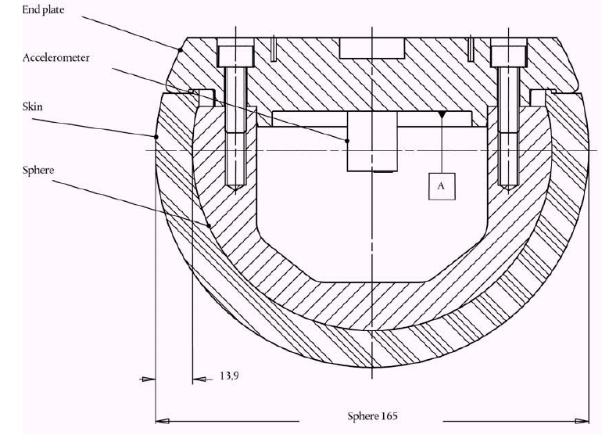
Figure 16: Child headform impactor

6.3.2.1.3 The child headfrom test procedures are detailed in paragraph 7.2 below.

6.3.2.2 Adult headform impactor

The adult headform impactor shall be made of aluminium, be of homogenous construction and be of spherical shape. The diameter is [165±1] mm as shown in Figure 17. The mass shall be [4,5 ± 0,1] kg. The moment of inertia about an axis through the centre of gravity and perpendicular to the direction of impact shall be with in the rage of [0,0075 to 0,0200] kgm². The centre of gravity of the headform impactor including instrumentation shall be located in the geometric centre of the sphere with a tolerance of ± [5] mm.
[Note: Possibly to be corrected as per INF GR PS 74]
The sphere shall be covered with a [13.9 ± 0.5] mm thick synthetic skin, which shall cover at least half of the sphere.
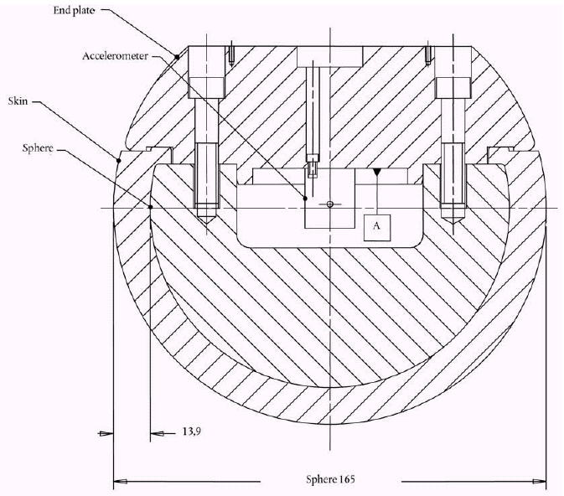

Figure 17: Adult headform impactor

6.3.2.2.1 Adult headform instrumentation

A recess in the sphere shall allow for mounting one triaxial or three uniaxial accelerometers within ± [10] mm seismic mass location tolerance from the centre of the sphere for the measurement axis, and ± [1] mm seismic mass location tolerance from the centre of the sphere for the perpendicular direction to the measurement axis.

[Note: The following description may be replaced by a proposal from Japan.]

One of the accelerometers shall have its sensitive axis perpendicular to the mounting face A (see figure 17) and its seismic mass shall be positioned within a cylindrical tolerance field of 1 mm radius and 20 mm length. The centre line of the tolerance field shall run perpendicular to the mounting face and its mid-point shall coincide with the centre of the sphere of the headform impactor.
The remaining accelerometers shall have their sensitive axes perpendicular to each other and parallel to the mounting face A and their seismic mass shall be positioned within a spherical tolerance field of 10 mm radius. The centre of the tolerance field shall coincide with the centre of the sphere of the headform impactor.

The instrumentation response value CFC, as defined in ISO 6487: 2002, shall be 1000. The CAC response value, as defined in ISO 6487: 2002, shall be 500 g for the acceleration.

6.3.2.2.2 First natural frequency

First natural frequency of the headform impactor shall be over 5000 Hz.

6.3.2.3 Rear face of the headform impactors

A rear flat face shall be provided on the outer surface of the headform impactor which is perpendicular to the direction of travel, and typically perpendicular to the axis of one of the accelerometers as well as being a flat plate capable of providing for access to the accelerometers and an attachment point for the propulsion system.

6.3.2.4 Certification of the headform impactors

The headform impactors shall meet the performance requirements specified in section 8. The certified impactor may be used for a maximum of 20 impacts before re-certification. The impactor shall be re-certified if more than one year has elapsed since the previous certification or if the transducer output, in any impact, has exceeded the specified CAC.

6.3.2.5 Propulsion of the headform impactors

The headform impactors shall be in 'free flight' at the moment of impact, at the required impact velocity (see paragraphs 7.2.5 and 7.3.5) and the required direction of impact (see sections 7.2.6 and 7.3.6).
The impactors shall be released to free flight at such a distance from the vehicle that the test results are not influenced by contact of the impactor with the propulsion system during rebound of the impactor.

6.3.2.6 Measurement of impact velocity

The velocity of the headform impactor shall be measured at some point during the free flight before impact, in accordance with the method specified in ISO 3784: 1976. The accuracy of velocity measurement shall be ± 0,01 m/sec. The measured velocity shall be adjusted considering all factors which may affect the impactor between the point of measurement and the point of impact, in order to give the velocity of the impactor at the time of impact. The angle of the velocity vector at the time of impact shall be calculated or measured.

6.3.2.7 Recording

The acceleration time histories shall be recorded, and HIC shall be calculated.
The first point of contact on the front structure of the vehicle shall be recorded.
Recording of test results shall be in accordance with ISO 6487:2002.

7. Test Procedures.

7.1 Legform to Bumper Test Procedures

7.1.1 Lower leg form to bumper test procedure:

7.1.1.1 A minimum of three lower legform to bumper tests shall be carried out, one each to the middle and the outer thirds of the bumper at positions judged to be the most likely to cause injury. Tests shall be to different types of structure, where they vary throughout the area to be assessed. The selected test points shall be a minimum of 132 mm apart, and a minimum of 66 mm inside the defined corners of the bumper. These minimum distances are to be set with a flexible tape held tautly along the outer surface of the vehicle. The positions tested by the laboratories shall be indicated in the test report.

7.1.1.1.1 Manufacturers might apply for derogation concerning an exemption zone for a removable towing hook.

7.1.1.2 The direction of the impact velocity vector shall be in the horizontal plane and parallel to the longitudinal vertical plane of the vehicle. The tolerance for the direction of the velocity vector in the horizontal plane and in the longitudinal plane shall be ± 2° at the time of first contact. The axis of the impactor shall be perpendicular to the horizontal plane with a tolerance of ± 2° in the lateral and longitudinal plane. The horizontal, longitudinal and lateral planes are orthogonal to each other (see Figure 18).

7.1.1.3 The bottom of the impactor shall be at ground reference level at the time of first contact with the bumper (see Figure 19), with a ± 10 mm tolerance. When setting the height of the propulsion system, an allowance must be made for the influence of gravity during the period of free flight of the impactor.

7.1.1.3.1 At the time of first contact the impactor shall have the intended orientation about its vertical axis, for the correct operation of its knee joint, with a tolerance of ± 5° (see Figure 18).

7.1.1.3.2 At the time of first contact the centre line of the impactor shall be within a ± 10 mm tolerance to the selected impact location.

7.1.1.3.3 During contact between the impactor and the vehicle, the impactor shall not contact the ground or any object which is not part of the vehicle.

7.1.1.4 The impact velocity of the impactor when striking the bumper shall be 11,1 ± 0,2 m/s. The effect of gravity shall be taken into account when the impact velocity is obtained from measurements taken before the time of first contact.

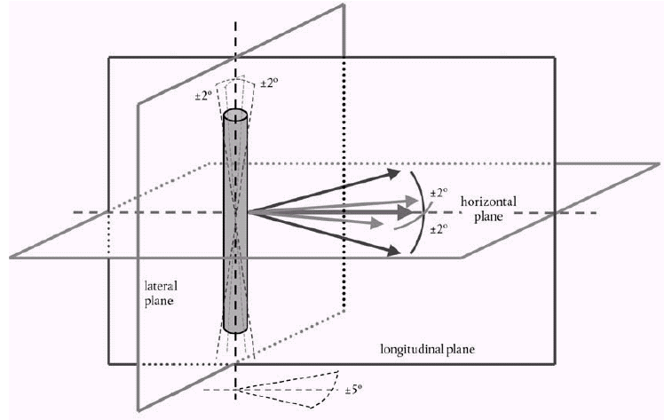

Figure 18: Tolerances of angles for the lower legform impactor at the time of first impact

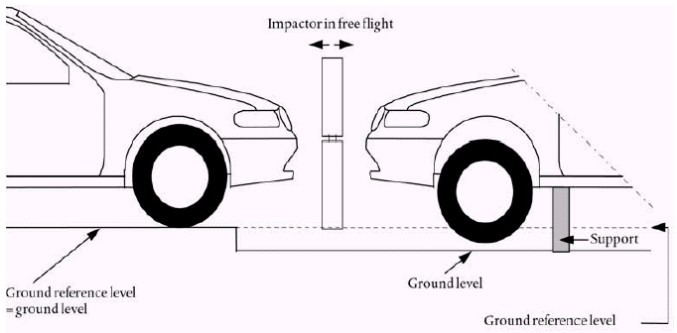

Figure 19: Lower legform to bumper tests for complete vehicle in normal ride attitude (left) and for cut-body mounted on supports (right)

7.1.2 Upper legform to bumper test procedure:

7.1.2.1 If the lower bumper height at the test position is more than 500 mm and the manufacturer elects to perform an upper legform test instead of a lower legform test, a minimum of three lower legform to bumper tests shall be carried out, one each to the middle and the outer thirds of the bumper at positions judged to be the most likely to cause injury. Tests shall be to different types of structure, where they vary throughout the area to be assessed. The selected test points shall be a minimum of 132 mm apart, and a minimum of 66 mm inside the defined corners of the bumper. These minimum distances are to be set with a flexible tape held tautly along the outer surface of the vehicle. The positions tested by the laboratories shall be indicated in the test report.

7.1.2.1.1 Manufacturers might apply for derogation concerning an exemption zone for a removable towing hook.

7.1.2.2 The direction of impact shall be parallel to the longitudinal axis of the vehicle, with the axis of the upper legform vertical at the time of first contact. The tolerance to this direction is ± 2°.

7.1.2.2.1 At the time of first contact the impactor centre line shall be midway between the upper bumper reference line and the lower bumper reference line with a ± 10 mm tolerance and laterally with the selected impact location with a tolerance of ± 10 mm.

7.1.2.3 The impact velocity of the upper legform impactor when striking the bumper shall be 11,1 ± 0,2 m/s.

7.2 Child headform Test Procedure

This test procedure is applicable with respect to the requirements of paragraph 5.2.1 of this Regulation.

7.2.1 Tests shall be made to the front structure within the boundaries as defined in paragraph 3.11. For tests on the rear area of the bonnet top, the headform impactor shall not contact the windscreen or A-pillar before impacting the bonnet top.

7.2.2 A minimum of eighteen tests shall be carried out with the child headform impactor, six tests each to the middle and the outer thirds of the bonnet top, as described in paragraph 3.26 at positions judged to be the most likely to cause injury. Tests shall be to different types of structure, where these vary throughout the area to be assessed.

7.2.3 The test points shall be located so that the impactor is not expected to impact the test area with a glancing blow resulting in a more severe second impact. The selected test points for the child headform impactor shall, at the time of first contact:

- be a minimum of 165 mm apart,
- be a minimum of 82.5 mm inside the defined bonnet side reference lines, as defined in paragraph 3.24.
- be a minimum of 82.5 mm forwards of the rear reference line as defined in paragraph 3.22.

Each selected test point for the child headform shall also be a minimum of 165 mm rearwards of the bonnet leading edge reference line defined in paragraph 3.6.

7.2.3.1 These minimum distances are to be set with a flexible tape held tautly along the outer surface of the vehicle. If, however, the vehicle configuration does not allow the number of eighteen impact points to be reached while maintaining the minimum spacing between impact points, then less than eighteen tests may be performed.

7.2.3.2 The points selected for testing shall be indicated in the test report.

7.2.4 The point of first contact of the headform impactor shall be within a ± 10 mm tolerance to the selected impact location.

7.2.5 The headform velocity at the time of impact shall be [8.9 ± 0.2 m/s (32km/h)] [which simulates the vehicle impact speed of 40 km/h, the shape category of the vehicle under test and the location of each selected test point.].

[Note: The method of determining the impact speed is to be reviewed further]
The effect of gravity shall be taken into account when the impact velocity is obtained from measurements taken before the time of first contact.

7.2.6 The direction of impact shall be as specified as follows:

7.2.6.1 The direction of impact shall be in the longitudinal vertical plane of the vehicle to be tested. The tolerance for this direction is ± 2°. The direction of impact of tests to the front structure shall be downward and rearward.

[7.2.6.2 For vehicles where the bonnet angle, as defined in paragraph 3.3, is not lower than 30°, the angle of impact on the bonnet shall be 25° ± [2]° to the Ground Reference Level.

7.2.6.3 For vehicles where the bonnet angle, as defined in paragraph 3.3, is lower than 30°:

7.2.6.3.1 If the bonnet leading edge height (BLEH), as defined in paragraph 3.5, is not lower than 835 mm, the angle of impact on the bonnet shall be 60° ± [2]° to the Ground Reference Level.
7.2.6.3.2 If the bonnet leading edge height (BLEH), as defined in paragraph 3.5, is lower than 835 mm, the angle of impact on the bonnet shall be 65° ± [2°] to the Ground Reference Level.]
[Note: Sections 7.2.6.2 and 7.2.6.3 may be replaced]

7.2.6.4 The effect of gravity shall be taken into account when the impact angle is obtained from measurements taken before the time of first contact

7.3 Adult headform test procedure

This test procedure is applicable with respect to the requirements of paragraph 5.2.2 of the performance requirements of this Regulation.

7.3.1 Tests shall be made to the front structure within the boundaries as defined in paragraph 3.1 above. For tests at the rear of the bonnet top, the headform impactor shall not contact the windscreen or A-pillar before impacting the bonnet top

7.3.2 A minimum of eighteen tests shall be carried out with the adult headform impactor, six tests each to the middle and the outer thirds of the test area, as described in paragraph 3.26, at positions judged to be the most likely to cause injury. Tests shall be to different types of structure, where these vary throughout the area to be assessed.

7.3.3 The test points shall be located so that the impactor is not expected to impact the test area with a glancing blow resulting in a more severe second impact. The selected test points for the adult headform impactor shall, at the time of first contact:

- be a minimum of 165 mm apart,
- be a minimum of 82.5 mm inside the defined bonnet side reference lines, as defined in paragraph 3.24.
- be a minimum of 82.5 mm forwards of the rear reference line, as defined in paragraph 3.21.

Each selected test point for the adult headform shall also be a minimum of 165 mm rearwards of the bonnet leading edge reference line defined in paragraph 3.6.

7.3.3.1 These minimum distances are to be set with a flexible tape held tautly along the outer surface of the vehicle. If however the vehicle configuration does not allow the number of eighteen impact points to be reached while maintaining the minimum spacing between impact points, then less than eighteen tests may be performed.

7.3.3.2 The points selected for testing shall be indicated in the test report.

7.3.4 The point of first contact of the headform impactor shall be within a ± 10 mm tolerance to the selected impact location.

7.3.5 The headform velocity at the time of impact shall be [8.9 ± 0.2 m/s (32km/h)] [which simulates the vehicle impact speed of 40 km/h, the shape category of the vehicle under test and the location of each selected test point.].

[Note: The method of determining the impact speed is to be reviewed further]
The effect of gravity shall be taken into account when the impact velocity is obtained from measurements taken before the time of first contact

7.3.6 The direction of impact shall be as specified as follows

7.3.6.1 The direction of impact shall be in the fore and aft vertical plane of the paragraph of the vehicle to be tested. The tolerance for this direction is ± 2°. The direction of impact of tests to the front structure shall be downward and rearward.

[7.3.6.2 For vehicles where the bonnet angle, as defined in paragraph 3.3, is not lower than 30°, the angle of impact shall in all case be 50° ± [2]° to the Ground Reference Level.

7.3.6.3 For vehicles where the bonnet angle, as defined in paragraph 3.3, is lower than 30°:

7.3.6.3.1 If the bonnet leading edge height (BLEH), as defined in paragraph 3.5, is not lower than 835 mm, the angle of impact on the bonnet shall be 90° ± [2]° to the Ground Reference Level.
7.3.6.3.2 If the bonnet leading edge height (BLEH), as defined in paragraph 3.5, is lower than 835 mm, the angle of impact on the bonnet shall be 65° ± [2°] to the Ground Reference Level.]
[Note: Sections 7.3.6.2 and 7.3.6.3 may be replaced]

7.3.6.4 The effect of gravity shall be taken into account when the impact angle is obtained from measurements taken before the time of first contact

8. Certification of Impactors.

[Note: Section to be developed and added.]

