SUMMARY OF IHRA PEDESTRIAN SAFETY WG ACTIVITIES ( 2003 ) – PROPOSED TEST METHODS TO EVALUATE PEDESTRIAN PROTECTION OFFERED BY PASSENGER CARS

Yoshiyuki Mizuno,

Chairman on behalf of IHRA / P. S. WG
Japan Automobile Standards Internationalization Center (JASIC)
Japan
Paper Number 580

INTRODUCTION

This is the Summary Report of IHRA Pedestrian Safety Working Group activity, which are completed in the past and will be completed in the near future.
Back in May 1996, the 15th ESV International Conference was held at Melbourne, Australia.
Antecedent this Conference, six items of International Harmonized Research Activities (IHRA) were proposed and endorsed in the ESV Government Focal Point Meeting under the initiative of the U.S.DOT/NHTSA and these items were formally presented to the 15th ESV International Conference. As a result, six projects were launched with an aim to propose harmonized test procedures reflecting the latest traffic accidents condition.
For each project, a leading country was designated and ESV participating countries formed a working group (WG) to achieve assignments within the timeframe of five years.
In 2001, prior to the 17th ESV Conference, IHRA Steering Committee reviewed each WG activities and decided to continue their WG activities except one WG.
IHRA/SC agreed continuation of Pedestrian Safety Group activities for further study to complete their tasks.
The members of the IHRA Pedestrian Safety Working Group (IHRA-PS-WG) is comprised of experts selected by the governments of Australia, Europe (EC/EEVC), Japan and the U.S.A., experts selected by the industrial organization of OICA and the chairperson selected by Japan.
The primary tasks assigned to the IHRA-PS-WG were:
- Investigating and analyzing the latest pedestrian accident data in the IHRA member countries, and
- Establishing harmonized test procedures that would reflect such accident condition and would induce fatalities and alleviation of severe injuries in pedestrian vs. passenger car crashes.
These tasks would be carried out with the cooperation of all IHRA member countries.
Biomechanics in the aspect of pedestrian accident and

development of test devices based on such biomechanics are still in the process of research.
Because a suitable pedestrian dummy was not available at the beginning of this project and it would need enormous time and/or fund for its development, the IHRA-PS-WG had to give up the idea of using a pedestrian dummy after consulting with the IHRA/Bio-WG.
Also, pedestrian dummies have disadvantages when used as part of test methods to require protection for all statures of pedestrians.
Therefore, the IHRA-PS-WG decided to make use of the idea of the existing sub-systems method employed by the ISO (TC22/SC10/WG2) and EEVC/WG17, while being ready to research into areas not covered by these test methods.
As one of the two primary tasks assigned to the IHRA-PS-WG was gather the results of detailed research into the accident data to an agreed format has been collected from Europe, Japan and USA with Australian data to follow.
The current dataset has been analyzed to determine the impact areas of vehicles, accident frequency and injured regions of pedestrian vs. passenger car crashes and to decide research priorities from these findings.
According to the priorities thus decided, the IHRA-PS-WG embarked on its research activities to develop adult and child head test methods, and adult lower leg/knee test methods.
The end of 2002,the WG has completed adult and child head test methods.
Now experts focusing on the development of lower leg/knee test method.

ACCIDENT DATA

At the first meeting of the IHRA pedestrian safety-working group, it was agreed that development of harmonized test procedures would be based upon real world crash data. Pertinent pedestrian and vehicle information contained in accident survey databases was accumulated. Pedestrian information included age, stature, gender, injured body region, and injury severity. Vehicle information included vehicle type, make, and year, mass, pedestrian contact location, damage pattern, and impact velocity. Other general accident information such as pedestrian crossing pattern, weather conditions, vehicle and pedestrian trajectories, alcohol use, etc. were also of interest if collected. Bicycle or motor-driven cyclists were not included in the study. Four injury databases from Australia, Germany, Japan, and United States were identified as containing much of this information. Multiple injuries per case were included in the dataset.
In Japan, pedestrian accident data collected by JARI between 1987 and 1988, and in-depth case study data of pedestrian accidents conducted by ITARDA between 1994 and 1998 were combined for inclusion into the IHRA accident dataset. A total of 240 cases were acquired in the cities surrounding the Japan Automobile Research Institute (JARI).
In Germany, investigation teams from both the Automotive Industry Research Association and Federal Road Research Institute collected accident information in a jointly conducted project called the German In-Depth Accident Study (GIDAS). A total of 783 cases collected between 1985 and 1998 were included from the cities of Dresden and Hanover and their surrounding rural areas. Accident investigation took place daily during four six-hour shifts in two-week cycles. The respective police, rescue services, and fire department reported all accidents continuously to the research teams. The teams then selected accidents according to a strict selection process to avoid any bias in the database. Accidents where a passenger car collided with more than one pedestrian or one pedestrian collides with more than one passenger car were not considered. Furthermore, accidents in which the car ran over the pedestrian or the impact speed could not be established were not considered. The study included information such as environmental conditions, accident details, technical vehicle data, impact contact points, and information related to the people involved, such as weight, height, etc.
Detailed information from pedestrian crashes was collected in the United States through the Pedestrian Crash Data Study (PCDS),. In this non-stratified study, a total of 521 cases were collected between 1994 and 1999. Cases were collected from six urban sites during weekdays. If, within 24 hours following the accident, the pedestrian could not be located and interviewed or the vehicle damage patterns documented, the case was eliminated from the study. In order for a case to qualify for the study, the vehicle had to be moving forward at the time of impact; the vehicle had to be a late model passenger car, light truck, or van; the pedestrian could not be sitting or lying down; the striking portion of the vehicle had to be equipped with original and previously undamaged equipment; pedestrian impacts had to be the vehicle’s only impact; and the first point of contact between the vehicle and the pedestrian had to be forward of the top of the A-pillar.
The Australian data is from at-the-scene investigations in 1999 and 2000 of pedestrian collisions in the Adelaide metropolitan area, which has a general speed limit of 60 km/hr. Ambulance radio communications were monitored from 9 am to 5 pm, Monday to Friday, and from 6 pm to midnight on two nights per week. Ambulance attendance at a pedestrian accident was the only criterion for entry into the study. The sample consists of 80 pedestrian/vehicle collisions, including 64 with passenger cars, SUV and 1-box type vehicles, where the pedestrian was standing, walking, or running, and where the main point of contact with the pedestrian on the vehicle was forward of the top of the A-pillar. Pedestrians and drivers were interviewed, wherever practicable, as part of the investigation process. The reconstruction of the impact speed of the vehicle was based on physical evidence collected at the scene. Injury information was obtained from hospital and coronial records, the South Australian Trauma Registry and, in minor injury cases, from an interview with the pedestrian.
Data from these four studies were combined into a single database for further analysis to develop a better basis for worldwide pedestrian impact conditions. From each of these studies, seven fields of information were identified which were common to all four studies and were crucial to providing guidance in test procedure development. For each injury, these seven fields of data were collected and input into the unified pedestrian accident database. The seven fields were country, case number, pedestrian age, impact speed, AIS injury level, body region injured, and vehicle source causing the injury. Injury body region and vehicle source were categorized as shown in Table 1. The number of cases and total injuries represented in this combined database are shown in Table 2. Throughout the remainder of this report, this dataset is denoted as the IHRA Pedestrian Accident Dataset.
It is recognized that pedestrian injuries in developing countries are not represented in this dataset; however, this data is the most comprehensive pedestrian accident database available to guide pedestrian safety test procedure development. A total of 3,305 injuries of AIS 2-6 severity were observed, and there were 6,158 AIS=1 injuries observed (Table 2).

Table 1.
Injury Body Region and Vehicle Sources

Injury Body Regions |  | Injury Sources
Head |  | Front Bumper
Face |  | Bonnet/Wing
Neck |  | Leading Edge
Chest |  | Windscreen Glass
Abdomen |  | Windscreen Frame/A-pillars
Pelvis |  | Front Panel
Arms |  | Other Vehicle Source
Leg Overall |  | Non- Contact
Femur |  | Road Surface
Knee |  | Unknown Source
Lower Leg
Foot
Unknown Injury

Table 2. IHRA Pedestrian Accident Dataset

Region | Cases | Injuries | AIS 1 | AIS2-6
Australia | 65 | 345 | 182 | 163
Germany | 782 | 4056 | 2616 | 1440
Japan | 240 | 883 | 523 | 360
U.S.A. | 518 | 4179 | 2837 | 1342
Total | 1605 | 9463 | 6158 | 3305

These minor (AIS=1) injuries were excluded in the following analysis because they were not believed to be crucial in test procedure development.
IHRA pedestrian injuries of AIS 2-6 severity are shown in Table 3 according to the part of the body that was injured. As shown in this table, head (31.4%) and legs (32.6%) each accounted for about one-third of the AIS 2-6 pedestrian injuries. Of the 3,305 AIS 2-6 injuries, 2,790 (84%) were caused by contact with portions of the striking vehicle, with head and legs being the most frequently injured (Table 5). Head injury accounted for 824 occurrences, and legs a total of 986 injuries when combining overall, femur, knee, lower leg, and foot body regions. Windscreen glass was the most frequent vehicle source of head injury, with the windscreen frame/A-pillars and top surface of bonnet/wing both being substantial additional sources of injury to the head. A further breakdown of the injuries and vehicle sources for children and adults is shown in Tables 6 and 7. For children, the top surface of the bonnet is the leading cause of head injury, while a substantial number of child head injuries also occur from windscreen glass contact. For adults, the windscreen glass is the leading source of head injury, followed by windscreen frame/A-pillars and top surface of leading source for both child and adult pedestrian leg injury.
Distribution of pedestrian accident victims by age (all AIS levels) is shown in Table 4 and illustrated in Figure1.
Table 3.
Distributions of Pedestrian Injury (AIS 2-6)

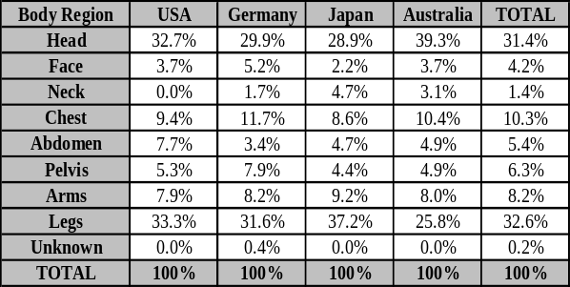

When broken into five-year age segments, Table 4 indicates that the 6–10 year old age group has the highest frequency of accident involvement at nearly 14% of all cases. In Japan, this age segment accounts for 20% of the cases, while the other three regions have lower involvements in this age group. The percentage involvement in the 11-15 year old group for Japan, however, drops considerably and is lower than for Germany, the U.S., or Australia. It is unclear why this sudden drop occurs in Japan and not in the other regions. In summary, over 31% of all cases involved pedestrians age 15 and younger. This percentage is 13% higher than the average overall population of individuals in this age group in the four countries (18%), which demonstrates the magnitude of the child pedestrian problem.
The age distribution data contained in Figure 1 also provides an opportunity to demonstrate that the IHRA Pedestrian Accident Dataset is representative of the pedestrian crash situation in the United States. In addition to the Germany, Japan, U.S., and Australian pedestrian datasets, data from the FARS and GES are also included. FARS is the Fatal Analysis Reporting System, which contains every fatal traffic accident in the U.S. The GES is the General Estimates System, and is obtained from a nationally representative sampling of police-reported crashes. In general, the age distribution of the GES data is similar to the others in Figure 1.

Table 4.
Distribution of Pedestrian Crashes
by Age and Country
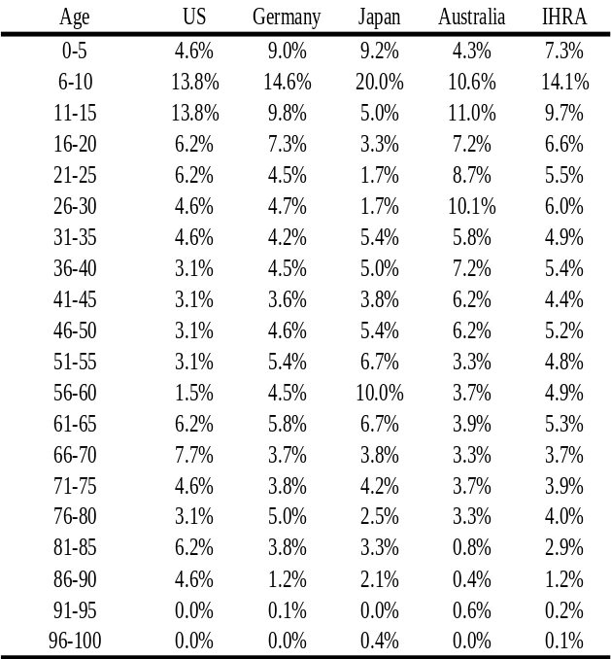

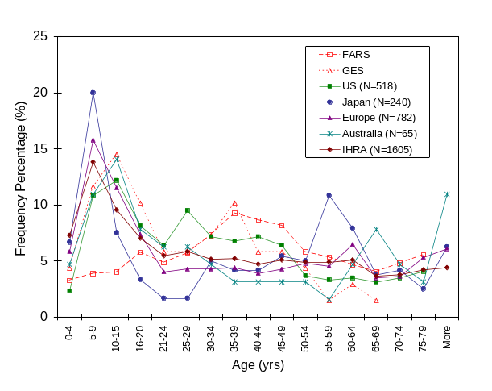
Figure 1. Frequency of Accidents by Age and Country
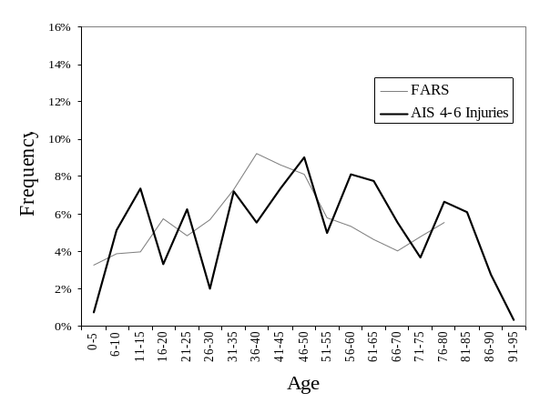
Figure 2. IHRA AIS 4-6 Injuries vs. FARS Data by Age

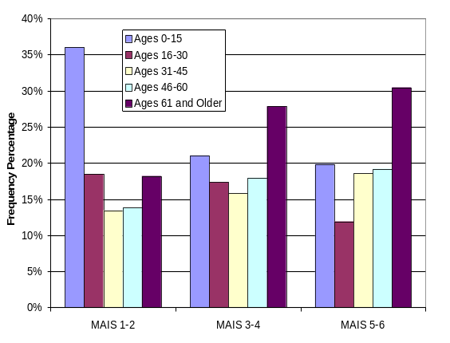
Figuer3. Distributions of MAIS Levels by Age

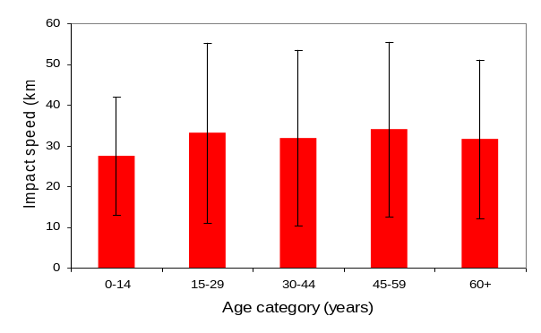
Figure 4. Average Impact Velocities by Age Group (MAIS 1-6)
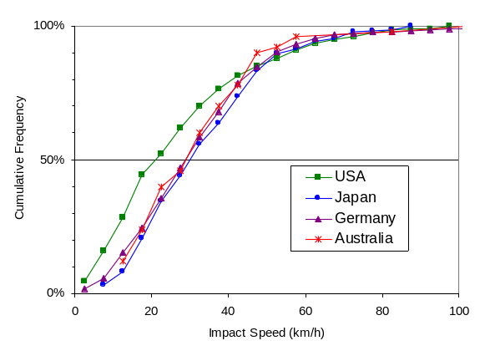
Figure 5. Impact Velocities by Country

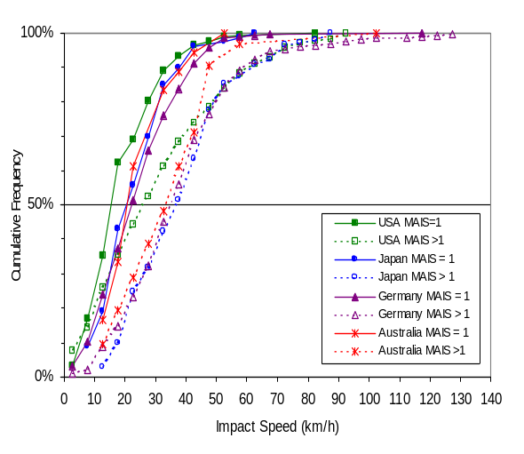
Figure 6. Impact Velocities by MAIS Level

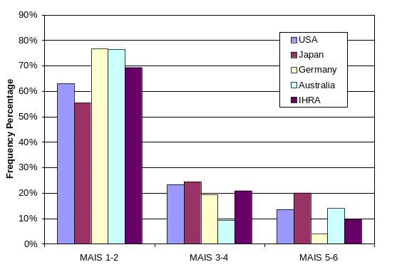
Figure 7. MAIS Injury by Country

Since the GES is designed to be a statistically representative sample, and since the U.S. PCDS and GES distributions are similar, this would imply that the PCDS is fairly statistically representative despite the non-stratified sampling scheme used to collect PCDS cases. However, the FARS distribution differs significantly from any of the others in Figure 1. Because FARS contains only fatal accidents, this may be an indication that the distribution of fatal and non-fatal injuries differs from each other. An ideal comparison for the FARS data would have been with the IHRA pedestrian fatalities. But since the number of fatal cases is quite limited in the IHRA data, the FARS distribution was compared to the serious and fatal AIS≥4 injuries as shown in Figure 2.
Although there is considerable variability remaining in this distribution due to small sample sizes, the FARS distribution has reasonable agreement with the IHRA data.
Analysis of the injury level by age group is shown in Figure 3. This figure shows that children aged 15 and younger tend to have a higher proportion (25%) of AIS 1 and 2 injuries than adults, and persons aged 61 and older have the highest proportion (near 30%) of moderate and serious injuries. These observations are likely the result of two factors. First of all, exposure levels may differ for the various age groups. For example, younger children tend to be involved in pedestrian collisions with lower impact velocities. As shown in Figure 4, the average impact velocity for children aged 0-15 is about 28 km/h. This is approximately 5 km/h lower than for the other age groups. A second cause of the injury distribution observed in Figure 3 may be that those aged 61 years and older are generally more frail and less resilient, leading to higher severity injury for a given impact velocity.
Figures 5 and 6 provide insight into the impact velocity distribution associated with pedestrian impacts. In Figure 5, the cumulative frequency of impact velocities on a per case basis for each country is similar although the U.S. has a larger percentage of injuries at lower velocities than the other three countries. This is broken down further in Figure 6, where lower MAIS injuries occur at lower velocities for all four countries. In Figure 7, the MAIS injuries are broken into three categories for the four countries. For MAIS 1-2 injuries, Japan has the lowest frequency (55%) and Germany has the highest (77%). For MAIS 3-4 injuries, Australia has the lowest frequency percentage (9%) and Japan has the highest (24%). Finally, for the most severe injuries (MAIS 5-6), Germany has the lowest frequency (4%) and Japan has the highest likelihood of a life-threatening injury (20%).
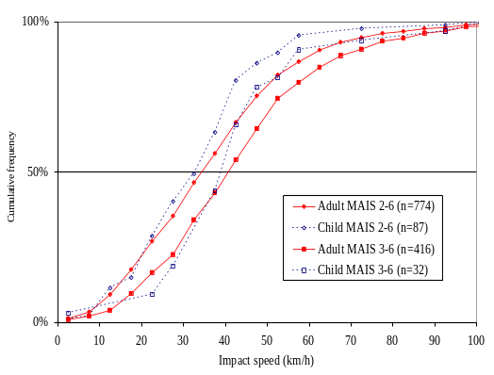
Figure 8. Impact Velocities by MAIS Level
– All Body Regions

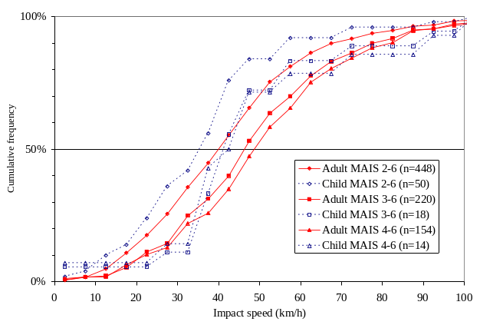
Figure 9. Impact Velocities by MAIS Level
- Head Injuries

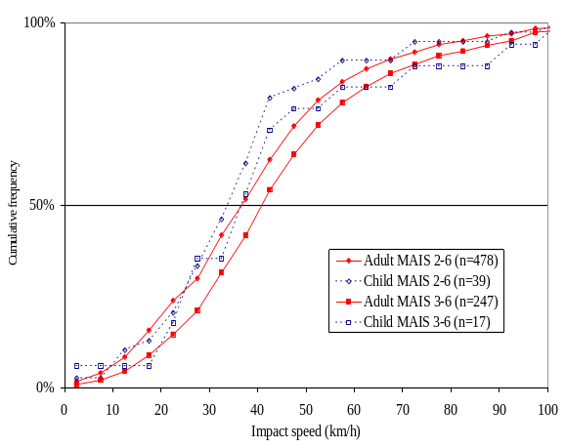

Figure 10. Impact Velocities by MAIS Level – Leg Injuries

The cumulative MAIS injury distributions are further broken down by age, body region, and injury severity in Figures 8 – 10. Age classifications are grouped as children (age 15 years and younger) and adults (age 16 years and older). All body regions are included for both children and adults in Figure 8, with distributions shown for MAIS 2-6 and MAIS 3-6 injuries. The injury distribution distinction between
children and adults is evident in this figure. Children (ages 15 and under) are injured at slightly lower impact velocities than
adults in most cases.
Head injury distributions are shown in Figure 9. For adults, the MAIS 3-6 and MAIS 4-6 injury distributions are almost identical, while the MAIS 2-6 distribution occurs at lower velocities. For children, there is similar separation between the MAIS 2-6, 3-6, and 4-6 injury curves, and the distributions are roughly the relationship between injury severity and impact velocity.
Injury distributions for children and adult leg injuries are shown in Figure 10. This figure shows that for leg injuries, injury severity is affected less by impact velocity than for head injuries. Once again, children suffer leg injuries at lower velocities than do adults.
The major conclusions from this analysis are:
- The head and legs each account for almost one-third of the 9,463 injuries in the IHRA dataset.
- For children, the top surface of the bonnet is the leading cause of head injury, while for adults the windscreen glass is the leading source of head injury.
- Children (ages 15 and under) account for nearly one-third of all injuries in the dataset, even though they constitute only 18% of the population in the four countries.
- Older individuals are more likely to suffer severe injuries in pedestrian crashes.
- Children (ages 15 and under) are injured at lower impact velocities than are adults

This compilation of pedestrian accident data from Australia, Germany, Japan, and U.S.A. provides a unique and important dataset. Issues such as the need for weighting the information included in this dataset and the problems associated with weighting are discussed in other section. In this section, MAIS for each case was used instead of all injuries in Figures 3. – 10. to eliminate the possibility of cases with more injuries skewing the data. The cumulative injury distribution data will provide a basis for establishing component pedestrian protection test procedures, priorities, and potential benefits assessments.

Table 5.
IHRA Pedestrian Injuries by Body Region and Vehicle Contact Source – All Age Groups; AIS 2-6
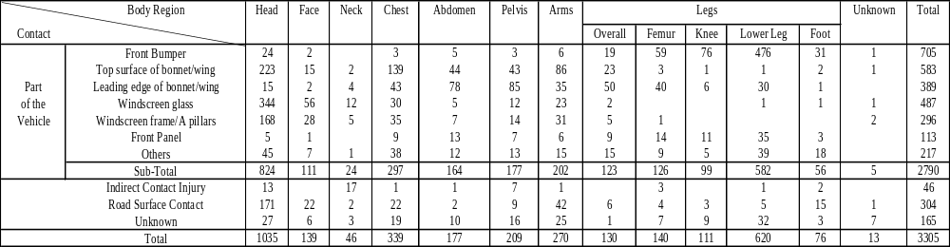

Table 6.
IHRA Pedestrian Injuries by Region and Vehicle Contact Source – Ages ＞15; AIS 2-6

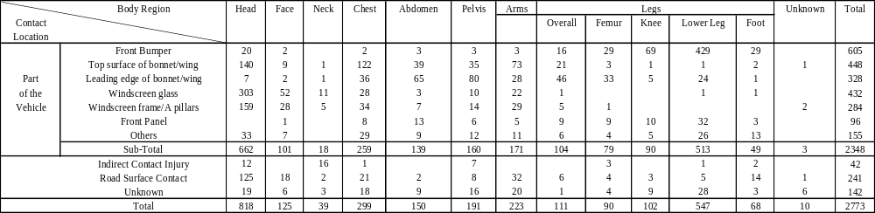

Table 7.

IHRA Pedestrian Injuries by Body Region and Vehicle Contact Source – Ages < 16; AIS 2-6

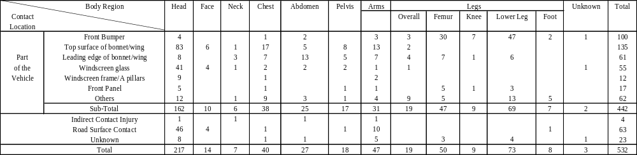

VEHICLE SHAPES AND CATEGORIES

Front shape of passenger car was investigated and
categorized into three groups, Sedan, SUV (Sport
Utility Vehicle) and 1-Box (One Box Vehicle), so that the effect of vehicle front shape on the pedestrian impact was studied with computer simulations focusing on the head impact velocity, head impact angle, WAD (Wrap Around Distance) and head effective mass.
Figure 10 shows the car front shape corridors for the three groups obtained from current production cars in Europe, Japan and U.S.A. Each corridor consists of upper and lower boundaries of the bonnet and windscreen glass with the front skirt corridors.
Figure 11 shows the definitions of the measuring points for the bumper lead (BL), bumper center height (BCH), leading edge height (LEH), bonnet length, bonnet angle, windscreen angle and the bottom depth and height of the front skirt. These positions and angles for the lower, middle and upper boundaries of the corridors for each group are summarized in Table 8.

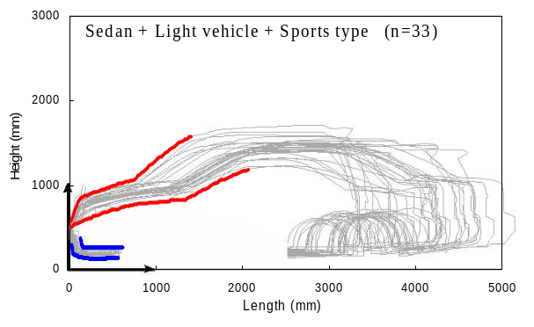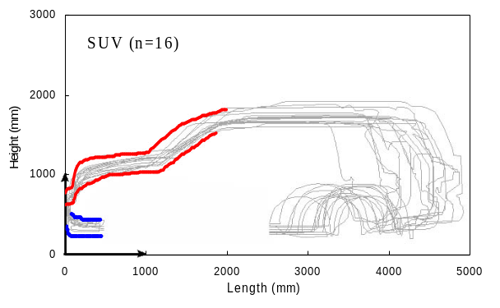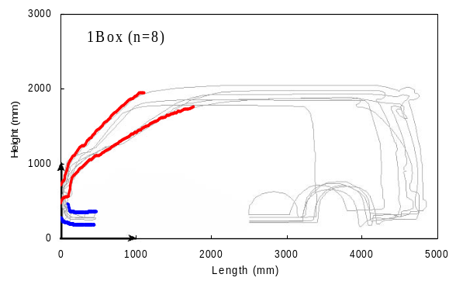
Figure 10. Car Front Shape Corridors

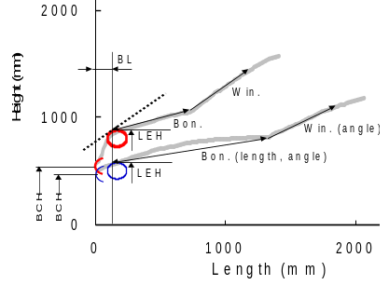
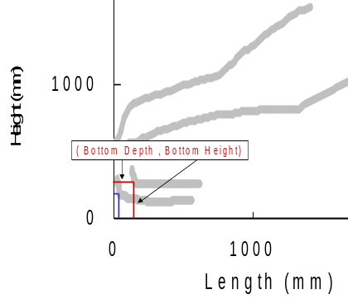
Figure 11. Definitions of Car Front Shape

Table 8.
Car Fron Shape Corridors
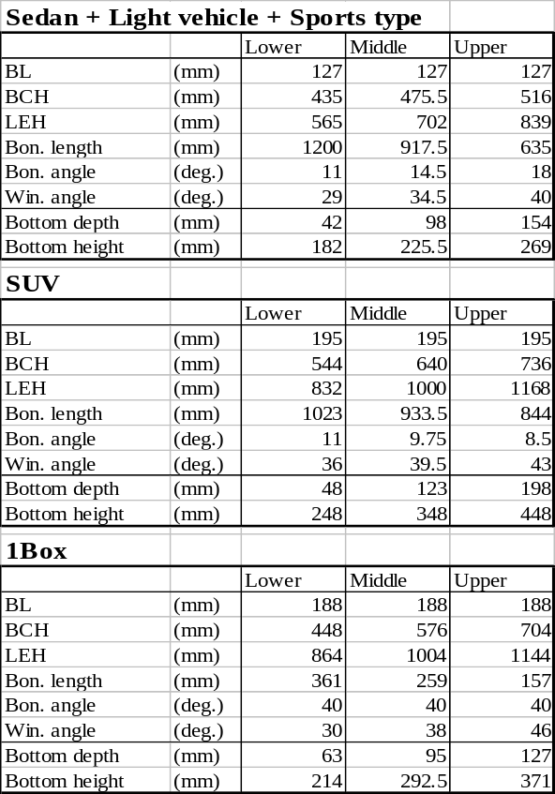

BIOMECHANICS

Head Injury Biomechanics
For the purposes of the IHRA-PS-WG, emphasis has been placed on pedestrian head injuries resulting from head impact with the vehicle frontal structure, including the windscreen and A-pillars. The Head Injury Criterion (HIC) has been selected as the measure of the risk of brain injury resulting from such an impact. It is recognized that HIC does not allow for the influence of some factors, such as rotational acceleration of the head, but it has been selected here because, at present, it is used almost universally in crash injury research and prevention. The time window for the calculation of HIC has been set at 15 ms, and the value of HIC shall not exceed 1000.
Two head forms are proposed for use in subsystem testing, one representing the head of a 50th percentile adult and the other the head of a 6 year old child. The diameter of each head form is 165 mm and the mass is 4.5 kg for the adult head form and 3.5 kg for the child. The head forms are subject to performance, rather than design, criteria (see IHRA documents PS/113 and 118). The head impact test areas on the vehicle for the child and adult head forms correspond to the areas commonly struck by the head of a child and an adult pedestrian, respectively.

COMPUTER SIMULATIONS

Table 6 Pedestrian Injuries by Body Region and Vehicle Contact Source – Ages > 15; AIS 2-6

Car to Pedestrian Impact Model

Figure 12 shows three pedestrian models currently used for the IHRA computer simulation study. These are JARI, NHTSA and RARU (Road Accident Research Unit of Adelaide University) pedestrian simulation models. The validity of these adult models was evaluated by comparing results from
their computer simulations and published PMHS (Post Mortem Human Subject) tests, and child model was developed with scaling method. Figure 13 shows a typical overall pedestrian kinematics from computer simulation and PMHS test at impact speed of 40 km/h. The lateral rotation of the upper body segments and the leg bending motion were well predicted. The trajectories of body segments relative to the car body were also compared at different impact velocities between the model and the PMHS as shown in Figure 14. These comparisons indicate the good reliability of the computer simulation model.

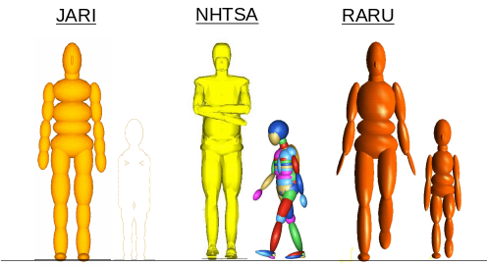

Figure 12. Pedestrian Models (AM50, 6 year)

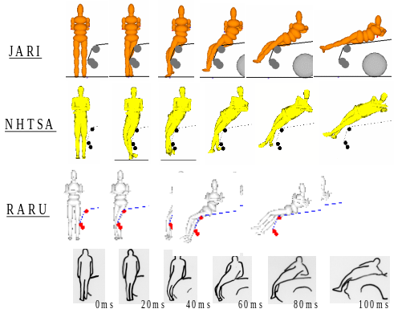

Figure 13. Validation Result on Overall Pedestrian Kinematics

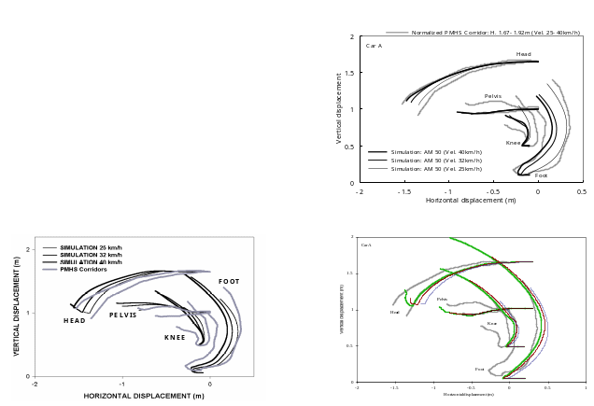

Figure 14. Validation Results on Pedestrian Trajectory

Parameter Study

A parameter study was conducted to understand the influence of pedestrian size, waling position, vehicle shape, vehicle stiffness, and vehicle impact speed onto the pedestrian impact condition such as head impact velocity, head impact angle, and head impact location (Wrap Around Distance: WAD) as shown in Table 9.
Three walking position was used for the parameter study as shown in Figure 15, and its definition and applied values are shown in Figure 16 and Table 10. Two vehicle stiffness, hard and friendly, was used as shown in Figure 17, and the definition of the head impact velocity and the head impact angle are illustrated in Figure 18. WAD was obtained as shown in Figure 19.
Table 9 Input Parameters
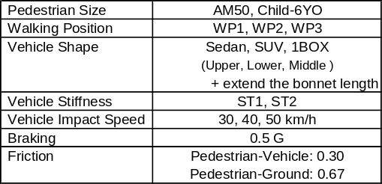

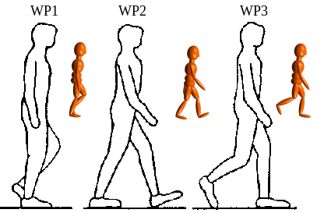

Figure 15 Pedestrian’s Walking Position

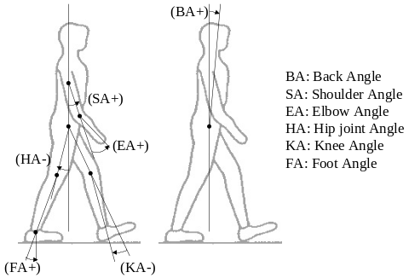

Figure 16. Pedestrian’s Walking Position
Definition Angle

Table 10
Value of Pedestrian’s Walking Position
Definition Angle
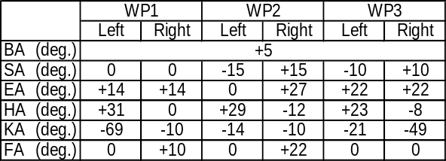

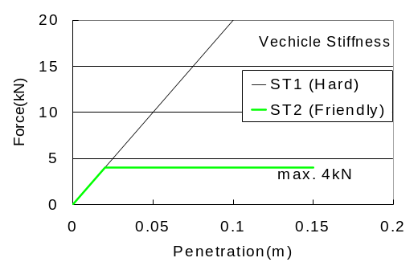

Figure 17. Vehicle Stiffness

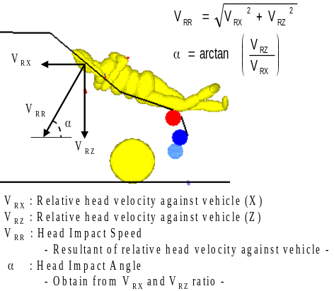
Figure 18. Definition of Head Impact Velocity and Head Impact Angle

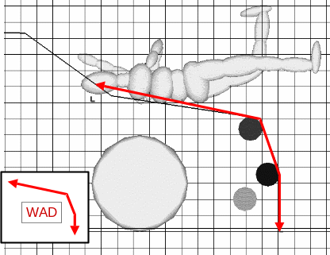

Figure 19 Definition of Wrap Around Distance (WAD)

Simulation Results

Figure20 shows the several pedestrian head impact conditions getting from the parameter study. It is clear that the pedestrian size and the vehicle category affects to the head impact condition, especially for the head impact angle. Figure 21 shows some other simulation results. The results indicate the head impact location also affects the head impact condition.
It is therefore the IHRA/PS working group decided to obtain the head impact condition by pedestrian size, vehicle category, head impact location for the each vehicle impact speed as

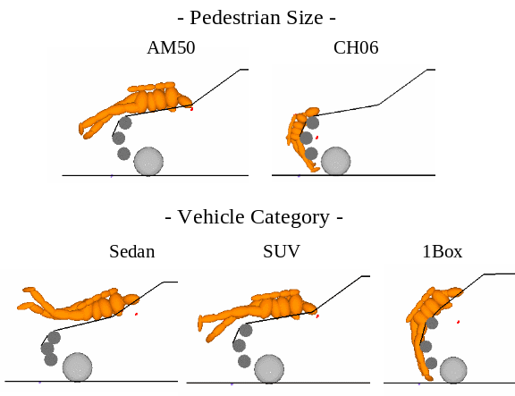

Figure 20 Difference of the Pedestrian head Impact Condition (Pedestrian Size, Vehicle Category)

Table 11 .
Summary of Parameter Study for Adult
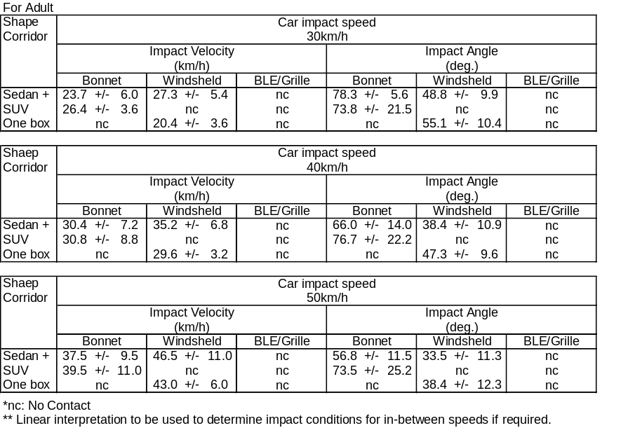

Shown in Table 11 and Table 12. These values were utilized for the development of the Japanese regulation for the pedestrian head protection, which has a plan to be issued by Japan Ministry of Land, Infrastructure and Transportation (J-MLIT) in 2003 in Japan.

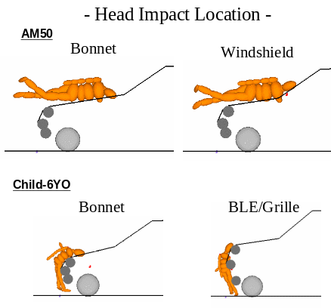

Figure 21 Difference of the Pedestrian head Impact Condition (Head Impact Location)

(Car Impact Speed: 30, 40 and 50 Km/h)

Table 12. Summary of Parameter Study for Child
(Car Impact Speed: 30,40, and 50 Km/h)
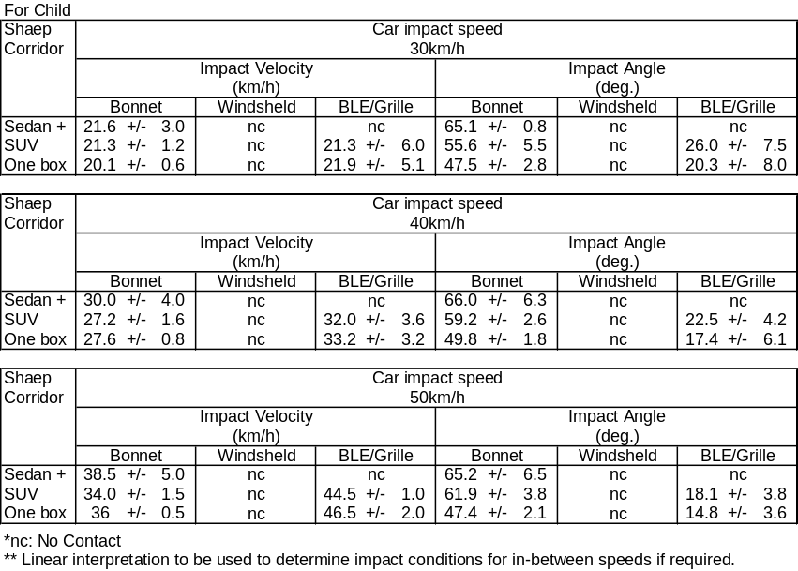

EXISTING METHODS AND TOOLS

EEVC test methods
The European Enhanced Vehicle-safety Committee (the former European Experimental Vehicles Committee) performed several studies and proposed various recommendations on test methods to assess pedestrian protection. In the spring of 1987 the EEC ad-hoc working group ‘ERGA Safety’ discussed one of these proposals . It was concluded that the basis of the proposal was promising, however, additional research was needed to fill up some gaps. The EEVC was asked to coordinate this research and at the end of 1987 EEVC Working Group 10 ‘Pedestrian Protection’ was set-up.
The mandate of this group was to determine test methods and acceptance levels for assessing the protection afforded to pedestrians by the fronts of cars in an accident. The test methods should be based on sub-system tests, essentially to the bumper, bonnet leading edge and bonnet top surface. The test methods should be considered to evaluate the performance of each part of the vehicle structure with respect to both child and adult pedestrians, at car to pedestrian impact speed of 40 km/h.
EEVC/WG10 started its activities in January 1988 to develop the required test methods as described by the mandate. These development studies were performed by a European consortium consisting of BASt, INRETS, LAB/APR, TNO and TRL acting under contract to the European Commission and under the auspices of EEVC. In 1994 EEVC/WG10 was dissolved and its final report was published focusing especially on the changes and improvements with respect to the previous version of the proposed test methods. In 1997 a new EEVC working group - WG 17 Pedestrian Safety – was set up with two main tasks:
- Review of the EEVC/WG10 test methods and propose possible adjustments taking into account new and existing data in the field of accident statistics, biomechanics and test results.
- Prepare the EEVC contribution to the IHRA working group on pedestrian safety.
The EEVC WG17 activities with respect to task 1 were finalized early 1999 and reported to the EC. Improvements were proposed with respect to the test procedure, definitions, tools and requirements. The EEVC/WG 17 methods were used by the European Commission as basis for further discussions on an EC Directive in this field.
Figure 22 shows the EEVC pedestrian sub-system tests. The EEVC test methods include in order of priority:
- Child head form to bonnet top test
- Adult head form to bonnet top test
- Leg form to bumper test (up to 500 mm bumper height, above that height optional, alternative upper leg form to bumper test)
- Adult upper leg form to bonnet leading edge test
The EEVC test methods fully describe the procedures for testing, the tools (including certification) and (proposed) test requirements.

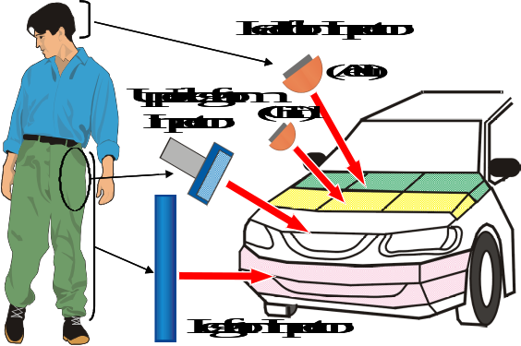

Figure 22. EEVC Pedestrian Sub-system Tests

ISO test methods

The International Organization for Standardization (ISO) created a pedestrian protection-working group (ISO/TC22/SC10/WG2) in 1987. The working group has been focusing on the adult leg form test and the child/adult head form tests. The proposed test methods were also utilized subsystem test methods. The mandate for the WG2 is to produce test methods considering with biodiversity and suitable for reproducing an accident at any car-impact speed up to 40-km/h. ISO and EEVC basic aim are similar but study results are different at several points. ISO head form tests make use of a free-flight head form, which mass, is intended to match the effective mass of a human head, when the head impacts a vehicle in a pedestrian accident. However, the ISO adult head form mass of 4.5 kg differs from the EEVC. The ISO study from computer simulations concluded that the effective mass for adult head is nearly same as the head mass itself Also ISO made a different conclusion for the child head form mass that the effective mass for child head representing a 6-year old is same as the head mass itself and is decided to select 3.5kg.
These mass of the head forms are finally decided based on the recommendation from ISO/TC22/SC12/WG5.
The EEVC and ISO studies using computer simulations indicated that the effective mass for both the adult and child heads impacting a vehicle is greatly affected by the impact conditions, such as vehicle shape and stiffness. The ISO/WG2 concluded that an average value of effective head mass from a large number of computer simulation runs is almost identical with their respective head mass itself for both the adult and child heads impacting a vehicle, as shown in Figure 21.

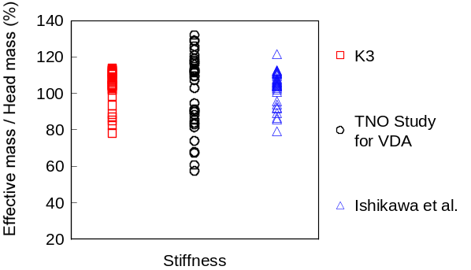
(Bonnet stiffness used for the parameter study with experimental test data)
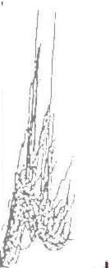
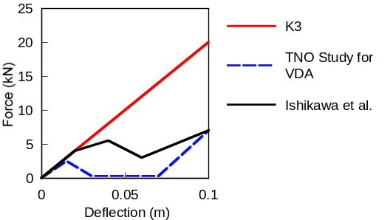
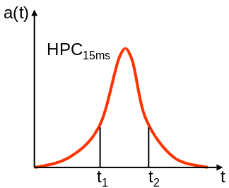
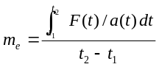(An equation used to obtain effective mass)
Figure 21 Head Effective Mass vs Head Mass for 6-Year Old Child by Bonnet Stiffness (PS/166)

Pedestrian dummy

Using sub-system test, the performance of a specific vehicle part can be evaluated by impacting a specific impactor against the body part at different locations and impact velocities. But with sub-system test, it is almost impossible to obtain an integrated result of the change in response of the whole body to changes in design of a specific vehicle. Changes in the bumper may effect or affect how the rest of the body will interact with the vehicle. Thus there is a need for the development of a pedestrian dummy.
Dummies have been used in pedestrian safety research, including modified versions of Hybrid II and III, the Rotationally Symmetrical Pedestrian Dummy (RSPD) and so on.
However, they produced kinematics that were different from that observed in PMHS tests. In addition, there were some problems with durability and repeatability.
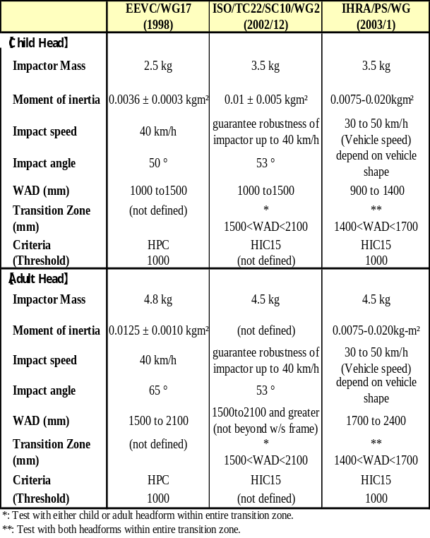
A pedestrian dummy, called Polar (See Figure 24), has been recently developed in a joint collaboration of GESAC, Honda R&D, and JARI. The first version of Polar, now called Polar I, was modified from Thor, the NHTSA frontal dummy. The modifications were specially designed to improve the kinematics response during lateral impact with a vehicle at different impact speeds. The latest version of the dummy is known as Polar II and includes a human-like representation of the knee, a flexible tibia, and a more compliant shoulder. Polar II has been recently tested in full-scale impacts by NHTSA and the results will be presented at the IHRA-PS-WG.
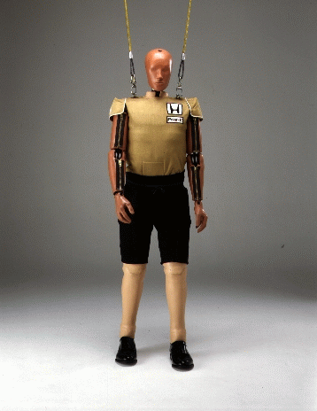
Figure 24 Frontal View of Polar

IHRA-PS-WG TEST METHODS

As has already been noted when the IHRA Pedestrian Safety working group started their mandate, suitable pedestrian dummies were not available. Hence, the IHRA Biomechanics working group was inquired of the possibility of development of dummies for pedestrians. Their reply was that this possibility was very low because of taking too much time and due also to extensive costs. Also, pedestrian dummies have many disadvantages for use in test methods intended for use in regulations to require pedestrian protection. The most significant disadvantage is the need for a whole family of dummies to represent the range of real life statures found. The dummy statures would need to cover from small child through to large adult if the whole of the area of the car likely to be hit by the head is to be tested. Consequently, the group decided to adopt the sub-system method, as already used in other test procedures, such as ISO/TC22/SC10/WG2 and EEVC/WG17. It was also decided to establish specifications for impactors for each of these sub-systems. Three subsystem test procedures (adult head form, child head form and leg form) are proposed in high priority identified in the analysis of pedestrian accidents in the IHRA member countries. Table 13 shows a comparison of head form test conditions proposed by EEVC, ISO and IHRA. Based on above mentioned parameters were used for computer simulations and done to check the interrelationships between the different subsystem tests.
Table 13.
Comparison of Headform Test Conditions Proposed by EEVC, ISO and IHRA

IMPLICATIONS FOR REGULATION

Societal Benefits

The aim of this section is to estimate the potential benefits in terms of casualty reductions, from vehicles that have been made to meet the pedestrian impact test requirements under development by this Working Group. Measures to protect pedestrians will also be of benefit to other vulnerable road users such as pedal cyclists and motorcyclists.
The Working Group is producing test methods and test tools suitable for the whole of the vehicle front likely to strike a pedestrian. Protection is therefore assumed for all impact locations in frontal impacts.
As protection requirements for the vehicle and the potential savings of pedestrian injuries are very dependent on the impact velocity selected for the test methods, benefits for three speeds (30, 40 and 50 km/h) have been estimated. These are vehicle equivalent speeds, which will not necessarily be the actual sub-system test speeds.
Benefits have been estimated for fatalities and seriously injured casualties. The latter are defined here as casualties of MAIS 2 to 5 who are not fatally injured.
The global accident dataset was the primary data source, but as it did not identify fatalities, this information was sought and gratefully received from the organizations that had originally contributed the data. Where necessary, national statistics from Great Britain were also used.
The estimates of the proportions saved are derived from a chain of estimates, starting with all the pedestrians fatally or seriously injured. A proportion of these will be injured by vehicles within the scope of the test procedures, mainly by cars. Of these, a proportion will be injured by the impact type that the test procedures are simulating, namely a frontal impact. Of these, a proportion will be injured at a speed at which the test procedures can provide protection. Of these, a proportion of casualties will be injured by the vehicle rather than by the ground.
For each speed, two methods were used to calculate the proportions injured at speeds at which the test procedures could provide protection: a) A simplified assumption that those saved above the test speed will match those not saved below, similar to the method of Lawrence et al . b) An assumption that the safety measures will shift the whole injury distribution downward, similar to the method of Davies and Clemo . They assumed that a speed of 25 km/h was ‘safe’ with current cars; the same speed is used in this current study.
Preventing some injuries to a pedestrian will not necessarily benefits the pedestrian; if they should receive a fatal injury from the ground contact then the result will be the same, however much improved is the vehicle. Fatalities were assumed to be saved if all injuries could be potentially prevented for which the AIS severity was the maximum (MAIS) for that casualty. For seriously injured casualties it was assumed that the serious casualty could be potentially saved if all the AIS 2 to 5 injuries were caused by car contact. However, casualties with both car contact and ground contact injuries in the AIS 2-5 range were counted as being 20 percent ‘saved’, to reflect that there was some benefit in reducing the number of serious injuries.
It is assumed in the estimates shown in Table 14 that fatalities saved would still be seriously injured.
Table 14
Potential reductions in pedestrian fatal and serious casualties due to cars passing IHRA test methods, as a percentage of pedestrians injured by all vehicle types
Method | Test Speed (km/h) | Fatal  (%) | Serious (%)
Safe within test speed | 30 | 5 | 17
Safe within test speed | 40 | 14 | 27
Safe within test speed | 50 | 26 | 33
Speed-shift | 30 | 13 | 7
Speed-shift | 40 | 35 | 19
Speed-shift | 50 | 48 | 29

Discussion: The estimates by the two methods differ markedly, particularly in their relative benefits for the two severities, demonstrating that estimates of this type are not precise. The ‘safe within the test speed’ method will tend to underestimate the potential for saving lives, as most fatalities occur above the test speed. Conversely, the speed shift method tends to over-estimate the potential for saving lives, as cars are likely to be optimised to just pass at the test speed, with little in-hand to provide protection at higher speeds.

OTHER MEASURES

It is recognised that improvement of the level of pedestrian protection provided by the design of the front of the car is only one of many ways of reducing pedestrian casualties. Road and traffic engineering measures, such as reducing vehicle travelling speeds by lower speed limits, can also be expected to reduce the frequency of collisions with pedestrians and the severity of those collisions that do occur. ASV (Advanced Safety Vehicle) technologies on active safety, such as pedestrian detection warning system, collision avoidance automatic brake, nighttime pedestrian monitoring system and so on, could prevent the pedestrian accidents or minimize the pedestrian injuries by decreasing the vehicle impact speed.
However, even with advances in road and traffic engineering, and other measures, there will still be a need to minimise the severity of injury sustained by a pedestrian struck by a car.

RECOMMENDATION

Achievements

This project has run for six years since July 1997, when the first IHRA-PS-WG was held, until the ESV International Conference in May 2003. twelve experts meetings have been held so far. The know-how of experts has been fully used and research in new areas has been conducted.
Over this period, detailed information on pedestrian-involved traffic accidents in member countries was gathered and analyzed, and other relevant information from investigations conducted to date has also been gathered and analyzed. Data for traffic accidents in member countries reveal that although the percentages of pedestrian-involved accidents vary with each country, the percentages are relatively high.
Since some member countries and WP29 intend to introduce technical regulations like those in the EU, Japan and some others, the IHRA-PS-WG is conscious of the urgent need to propose appropriate, harmonized test procedures as a potential basis for harmonized regulations. Pedestrian protection is a comparatively new field and so the available information is not yet completely adequate for the development of comprehensive and validated test procedures.
Pedestrian crash test dummies are not generally available at present, although a pedestrian dummy is being developed by the private sector. An inquiry was made to the IHRA/Bio WG, but they replied that dummies couldn’t be developed yet due to the time and cost required. It is also the opinion of some members of the IHRA-PS-WG that the kinematics of the vehicle/pedestrian collision may prove to be too difficult to reproduce in a valid and repeatable manner with a pedestrian crash test dummy. Accordingly, it was decided to use subsystem test procedures, which, at least at this stage, are more practical and repeatable. Interactions between the results of the subsystem tests will be studied using computer simulation of the collision events once a comparison of existing computer simulation programs has been completed.
Proposals for head impact subsystem test procedures for adults and children are completed. These are top-priority issues. Proposals for test procedures for the adult leg are also being considered. Other areas of the human body will be researched in the future.

Continuation of IHRA/PS Activities

The aim of the IHRA-PS-WG is to prepare test procedures for the child and adult head, and the adult leg, for presentation at the ESV Conference in 2003, also recommendations for research activities that will be needed to develop other test procedures for the further improvement of pedestrian protection after IHRA/P.S. experts will be discussed and conclude near future.
In the field of pedestrian crash injury biomechanics, there are still areas, which must be investigated, and their practical applications explored. The IHRA-PS-WG plans to first clarify the issues, necessities and research responsibilities through detailed investigations. The following issues will be studied.
- Comparative evaluation of the results of, and interactions between, subsystem test procedures and test procedures employing a Computer simulation program based on the best such programs currently available.
- Regarding leg impacts on the pedestrian, the IHRA-PS-WG started to confirm the injury mechanisms and tolerance of the leg to impact. This has been following by evaluation of available and proposed impactors and development of test procedures based on the results.
- Clarification of the importance of injury mechanisms to arrears other than the head and legs, also, R & D on impactors to confirm such injury mechanisms.
This work will be greatly facilitated if member countries are prepared to cooperate and share the cost, conduct further studies, and assist in the development of essential test procedures.

References: ? Isenberg, R.A., Walz, M., Chidester, C., Kaufman, R.; “Pedestrian Crash Data Study-An Interim Evaluation,” Fifteenth International Technical Conference on the Enhanced Safety of Vehicles, Paper No. 96-S9-O-06, 1996.
Isenberg, R.A., Chidester, C., Mavros, S.; “Update on the Pedestrian Crash Data Study,” Sixteenth International Technical Conference on the Enhanced Safety of Vehicles, Paper No. 98-S6-O-05, 1998.
United States Bureau of the Census, International Population Database (2001).
Commission of the European Communities; “Frontal Surfaces in the Event of Impact With a Vulnerable Road User,” Ad-hoc Working Group ERGA Safety, document ERGA S/60, Brussels.
Kajzer, J., Aldman, B., Mellander, H., Planath, I. and Jonasson K.; “Bumper System Evaluation Using an Experimental Pedestrian Dummy,” 12th International Technical Conference on the Experimental Safety of Vehicles, 1989.
Kallieris, D. and Schmidt, G.; “New Aspect of Pedestrian Protection Loading and Injury Pattern in Simulated Pedestrian Accidents,” 32nd Stapp Car Crash Conference, SAE 881725, 1988.
Akiyama, A., et al.; “Development of a Simulation 1999-01-0082.
Lawrence, G J L, B J Hardy and R W Lowne. ; “Costs and benefits of the EEVC pedestrian impact requirements,” Project Report 19, Crowthorne, UK: TRL Limited, 1993.
Davies R G and K C Clemo ; “Study of research into 97-456502-01 under Contract No. ETD/96/84099 to the Commission of the European Communities. Nuneaton, UK: Motor Industry Research Association, 1997.
Members of IHRA Pedestrian Safety WG * Predecessor, contributed to the IHRA/P.S.-WG. NameOrganizationChairperson Mr. Yoshiyuki MizunoJASIC Japan Mr. Jack McLeanUniversity of Adelaide Australia Mr. Dominique CesariINRET EEVC Mr. Graham LawrenceTR L EEVC Mr. Bruce DonnellyNHTSA U.S.A. Mr. Oskar Ries ACEA Mrs. Françoise Brun-CassanLAB PSA Peugeot Citroen Renault ACEA Mr. Sukhbir BilkhuDaimler Chrysler AAM Mr. Hirotoshi IshikawaJARI Japan Mr. Atsuhiro KonosuJARI Japan Mr. Masaaki TanahashiHonda R&D JAMA Mr. Yoshihiro YazawaJASIC Japan Mr. Akira Sasaki* (1996-2000)Honda R&D JAMA Mr. Roger Saul* (1996-2000)NHTSA U.S.A.Mr. Hiroshi Ishimaru* (1996-2000) JSAE Japan Mr. Norbert Jaehn* (1996-2000)ACEA Mr. Manuel Bartolo* (1996-2000)Ford AAM Mr. Jacques Provensal* (1999-2001)ACEA

