UNITED

NATIONS
STSTE


Distr.
Secretariat

GENERAL

ST/SG/AC.10/29/Add.2
17 February 2003

ENGLISH

ORIGINAL: ENGLISH and FRENCH

COMMITTEE OF EXPERTS ON THE TRANSPORT OF

DANGEROUS GOODS AND ON THE GLOBALLY

HARMONIZED SYSTEM OF CLASSIFICATION

AND LABELLING OF CHEMICALS

REPORT OF THE COMMITTEE OF EXPERTS ON THE TRANSPORT OF

DANGEROUS GOODS AND ON THE GLOBALLY HARMONIZED SYSTEM OF CLASSIFICATION AND LABELLING OF CHEMICALS
ON ITS FIRST SESSION

(Geneva, 11-12 December 2002)

Addendum 2

Annex 2

Amendments to the third revised edition of the Recommendations on the Transport of Dangerous Goods, Manual of Test and Criteria

This annex contains amendments to the third revised edition of the Recommendations on the Transport of Dangerous Goods, Manual of Tests and Criteria (ST/SG/AC.10/11/Rev.3), adopted by the Committee at its first session.

AMENDMENTS TO THE THIRD REVISED EDITION OF THE RECOMMENDATIONS ON THE TRANSPORT OF DANGEROUS GOODS, MANUAL OF TESTS AND CRITERIA
(Refer to ST/SG/AC.10/11/Rev.3)

Section 1

1.2.2 In Table 1.1, replace "1-7" with "1-8" in the first row under "Test series".

1.6 In Table 1.2, add the following:

Test series | Test type | Test code | Test name
8 | (a) | 8(a) | Thermal stability test for ANE
8 | (b) | 8(b) | ANE gap test
8 | (c) | 8(c) | Koenen test
8 | (d) | 8(d) | Vented pipe test */

*/ This test is intended for evaluating the suitability for transport in tanks.

Section 10

10.1.1 Amend the last sentence to read as follows: "…in figures 10.1, 10.2, 10.3 and 10.4, the general…(unchanged) ... in sections 11 to 18 of this test manual.".

Figure 10.2 Amend this figure as shown in page 3 of this document.

Figure 10.4 Insert a new figure 10.4, as shown in page 4 of this document, immediately after the existing Figure 10.3 and renumber the Figures 10.4 to 10.8 consequently.

Figure 10.2: PROCEDURE FOR PROVISIONAL ACCEPTANCE OF A SUBSTANCE OR ARTICLE IN CLASS 1*
19
TEST SERIES 8
(go to figure 10.4)
PROVISIONALLY ACCEPT INTO
CLASS 1
(go to figure 10.3)
TEST SERIES 2
Yes
5
14
ARTICLE FOR CLASSIFICATION
Is
the substance
manufactured with the
view to producing a practical
explosive or pyrotechnic
effect ?
2
TEST SERIES 1*
3
Yes
Substance to be considered for Class 1
8
TEST SERIES 3
9
the substance
too dangerous
Is
for transport in the form
in which it was
tested ?
11
No
Encapsulate and/or
package the substance
13
TEST SERIES 4
15
18
REJECT
Substance not stable enough for transport
12
NOT CLASS 1
7
18
Yes
REJECT
Article, packaged article or packaged substance banned from transport in the form tested
17
No
the article,
packaged article
or packaged substance too
dangerous for
transport ?
16
Is
SUBSTANCE FOR CLASSIFICATION
1
No
intermediate for blasting
ammonium nitrate emulsion
suspension or gel,
2 a
Is
the substance
a candidate for
explosive, ANE?

Yes
No
Is it
an explosive
substance ?
4
No
No
the substance
too insensitive for
acceptance into
Class 1 ?
6
Is
Yes
Yes
No
Is
the substance
thermally stable ?
10
Yes
Figure 10.4
Test 8 (b)
ANE Large Scale Gap Test
Is the substance too sensitive to shock
to be accepted in Division 5.1 ?
Test Series 8
Test 8 (a)
Thermal Stability Test
Is the substance thermally stable ?
Test 8 (c)
Koenen Test
Is the substance too sensitive
to the effect of intense heat
confinement ?
under
Substance accepted in Division 5.1
as an ammonium nitrate emulsion, suspension or gel, intermediate
for blasting explosives (ANE)
No
Yes
No
REJECT
Substance not stable for transport
Substance to be considered for inclusion into Class 1
Substance to be considered as a candidate for Division 1.5, proceed with Test Series 5
No
Yes
Yes
10.4.2.5 Add a new section to read as follows:

"10.4.2.5 The question "Is the substance a candidate for "ammonium nitrate emulsion or suspension or gel, intermediate for blasting explosives (ANE)?" (box 2(a) of figure 10.2) is answered by series 8 tests and any candidate should pass each of the three tests comprising the series. The three test types are:

Type 8 (a) - a test to determine the thermal stability;

Type 8 (b) - a shock test to determine sensitivity to intense shock;

Type 8 (c) - a test to determine the effect of heating under confinement;

Test series 8 (d) has been included in this section as one method to evaluate the suitability for the transport in tanks."

10.4.3.7 Insert a new 10.4.3.7 to read as follows:

"10.4.3.7 Test types 8 (a) to 8 (c) should be used to establish whether an ammonium nitrate emulsion or suspension or gel, intermediate for blasting explosives (ANE) may be assigned to Class 5.1. Substances failing any of the tests may be considered as a candidate for Class 1 in accordance with figure 10.4."

Renumber the existing 10.4.3.7 as new 10.4.3.8.

10.5.1 Amend the end of the paragraph to read: "…figures 10.5 to 10.8.".

10.5.2 Replace "figure 10.8" with "figure 10.9.".

Section 18 Insert a new Section 18, as follows:

"SECTION 18

TEST SERIES 8

18.1 Introduction

The assessment whether a candidate for "ammonium nitrate emulsion or suspension or gel, intermediate for blasting explosives (ANE)" is insensitive enough for inclusion in Division 5.1 is answered by series 8 tests and any such candidate for inclusion in Division 5.1 should pass each of the three types of tests comprising the series. The three test types are:

Type 8 (a) : a test to determine the thermal stability;
Type 8 (b) : a shock test to determine sensitivity to intense shock;
Type 8 (c) : a test to determine the effect of heating under confinement.

Test series 8 (d) has been included in this section as one method to evaluate the suitability for the transport in tanks.

18.2 Test methods

The test methods currently used are listed in table 18.1.

Table 18.1: TEST METHODS FOR TEST SERIES 8

Test code | Name of Test | Section
8 (a)  8 (b)  8 (c)  8 (d) | Thermal Stability Test for ANE */  ANE Gap Test */  Koenen test */  Vented pipe test **/ | 18.4  18.5  18.6  18.7

*/ This test is intended for classification.
**/ This test is intended for evaluating the suitability for transport in tanks.

18.3 Test conditions

18.3.1 The substance should be tested as offered for transport, at the highest transport temperature (see 1.5.4 of this Manual).

18.4 Series 8 Type (a) test prescription

18.4.1 Test 8(a) : Thermal stability test for ammonium nitrate emulsions, suspensions or gels

18.4.1.1 Introduction

18.4.1.1.1 This test is used to measure the stability of a candidate for "ammonium nitrate emulsion, suspension or gel, intermediate for blasting explosives" when subjected to elevated thermal conditions to determine if the emulsion is too dangerous to transport.

18.4.1.1.2 This test is used to determine whether the emulsion, suspension or gel is stable at temperatures encountered during transport. In the way this type of test is normally carried out (see 28.4.4), the 0.5 litre Dewar vessel is only representative for packagings, IBC's and small tanks. For the transport of ammonium nitrate emulsions, suspensions or gels the test can be used to measure its stability during tank transport if the test is carried out at a temperature 20 °C higher than the maximum temperature which may occur during transport, including the temperature at the time of loading.

18.4.1.2 Apparatus and materials

18.4.1.2.1 The experimental equipment consists of a suitable test chamber, appropriate Dewar vessels with closures, temperature probes and measuring equipment.

18.4.1.2.2 The test should be performed in a test cell capable of withstanding fire and overpressure and, preferably, should be fitted with a pressure relief system e.g. a blow out panel. The recording system should be housed in a separate observation area.

18.4.1.2.3 A thermostatically controlled drying oven (which may be fan-assisted) large enough to allow air circulation on all sides of the Dewar vessel may be used. The air temperature in the oven should be controlled so that the desired temperature for a liquid inert sample in the Dewar vessel can be maintained with a deviation of not more than  1 °C for up to 10 days. The air temperature in the oven should be measured and recorded. It is recommended that the door of the oven be fitted with a magnetic catch or replaced by a loosely fitting insulated cover. The oven may be protected by an appropriate steel liner and the Dewar vessel housed in a wire mesh cage.

18.4.1.2.4 Dewar vessels with a volume of 500 ml with a closure system are used. The closure of the Dewar vessel should be inert. A closure system is illustrated in figure 18.4.1.1.

18.4.1.2.5 The heat loss characteristics of the system used, i.e. Dewar vessel and closure, should be established prior to performance of the test. Since the closure system has a significant effect on the heat loss characteristics, these can be adjusted to some extent by varying the closure system. The heat loss characteristics can be determined by measuring the half time of cooling of the vessel filled with an inert substance having similar physical properties. The heat loss per unit of mass, L (W/kg.K) can be calculated from the half time of cooling, t_{1/2} (s), and the specific heat, Cp (J/K), of the substance using the formula:

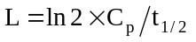

18.4.1.2.6 Dewar vessels filled with 400 ml of substance, with a heat loss of 80 to 100 mW/kg.K are suitable.

18.4.1.2.7 The Dewar vessel shall be filled to about 80% of its capacity. In case of a sample with very high viscosity it may be required to have the sample provided with a shape which just fits into the Dewar vessel. The diameter of such a preshaed sample shall be just under the inner diameter of the Dewar vessel. The hollow lower end of the Dewar vessel may be filled with an inert solid substance prior to loading the sample into the vessel to facilitate the use of cylindrically shaped sample substances.

18.4.1.3 Procedure

18.4.1.3.1 Set the test chamber at a temperature which is 20 °C higher than the maximum temperature which may occur during transport or, if higher, the temperature at the time of loading. Fill the Dewar vessel with the substance under test and note the mass of the sample. Make sure the sample is filled to about 80% of its height. Insert the temperature probe into the centre of the sample. Seal the lid of the Dewar in place and insert the Dewar vessel in the test chamber, connect the temperature recording system and close the test chamber.

18.4.1.3.2 The sample is heated and the temperature of the sample and test chamber continuously monitored. The time is noted at which the sample temperature reaches a temperature 2 °C below the test chamber temperature. The test is then continued for a further seven days or until the sample temperature rises to 6°C or more above the test chamber temperature if this occurs sooner. Note the time taken for the sample to rise from 2 °C below the test chamber temperature to its maximum temperature.

18.4.1.3.3 If the sample survives, cool and remove it from the test chamber and carefully dispose of it as soon as possible. The percentage mass loss and change in composition may be determined.

18.4.1.4 Test criteria and method of assessing results

18.4.1.4.1 If the sample temperature does not exceed the test chamber temperature by 6 °C or more in any test, the ammonium nitrate emulsion, suspension or gel is considered to be thermally stable and can be further tested as a candidate for "ammonium nitrate emulsion, suspension or gel, intermediate for blasting explosives".

18.4.1.5 Examples of results

Substances | Sample  mass (g) | Test T (°C) | Result | Comments
Ammonium nitrate | 408 | 102 | - | slight discolouration, hardened into lump Mass loss 0.5%
ANE-1 Ammonium nitrate 76%, water 17%, fuel/emulsifier 7% | 551 | 102 | - | separation of oil and crystallized salts.  Mass loss 0.8%
ANE-2 (sensitized) Ammonium nitrate 75%, water 17%, fuel/emulsifier 7% | 501 | 102 | - | Some discolouration  Mass loss 0.8%
ANE-Y Ammonium nitrate 77%,  water 17%, fuel/emulsifier 7% | 500 | 85 | - | Mass loss 0.1%
ANE-Z Ammonium nitrate 75%,  water 20%, fuel/emulsifier 5% | 510 | 95 | - | Mass loss 0.2%
ANE-G1 Ammonium nitrate 74%,  sodium nitrate 1%, water 16%,  fuel/emulsifier 9% | 553 | 85 | - | no rise in temperature
ANE-G2 Ammonium nitrate 74%,  sodium nitrate 3%, water 16%,  fuel/emulsifier 7% | 540 | 85 | - | no rise in temperature
ANE-J1 Ammonium nitrate 80%,  water 13%, fuel/emulsifier 7% | 613 | 80 | - | Mass loss 0.1%
ANE-J2 Ammonium nitrate 76%,  water 17%, fuel/emulsifier 7% | 605 | 80 | - | Mass loss 0.3%
ANE-J4 Ammonium nitrate 71%,  sodium nitrate 11%, water 12%,  fuel/emulsifier 6% | 602 | 80 | - | Mass loss 0.1%

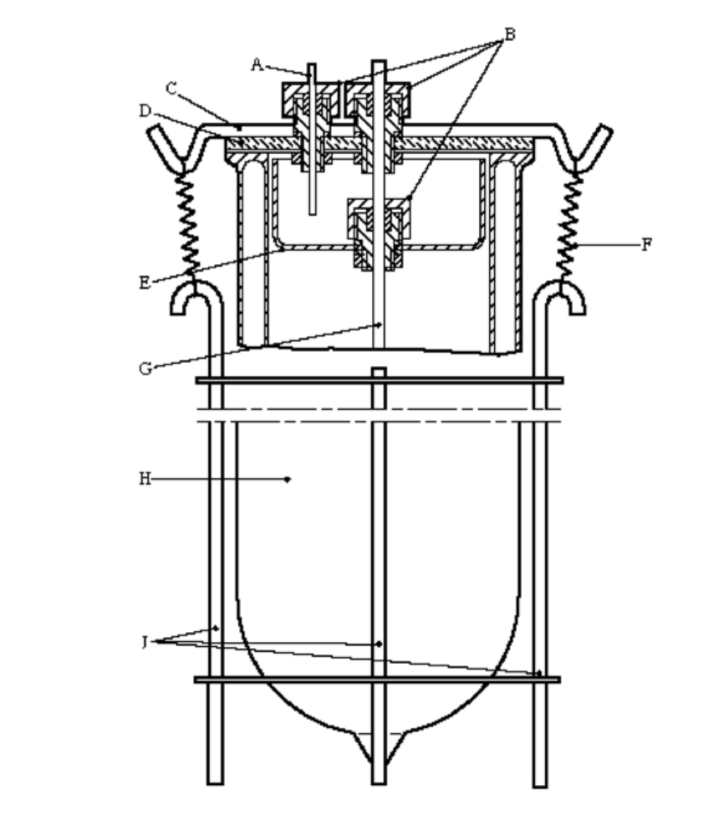

(A) | PTFE capillary tube | (B) | Special screw fittings (PTFE or Al) with O-ring seal
(C) | Metal strip | (D) | Glass lid
(E) | Glass beaker base | (F) | Spring
(G) | Glass protective tube | (H) | Dewar vessel
(J) | Steel retaining device

Figure 18.4.1.1: DEWAR VESSEL WITH CLOSURE

18.5 Series 8 Type (b) Test prescription

18.5.1 Test 8 (b): ANE Gap Test

18.5.1.1 Introduction

This test is used to measure the sensitivity of a candidate for "ammonium nitrate emulsion or suspension or gel, intermediate for blasting explosives" to a specified shock level, i.e. a specified donor charge and gap.

18.5.1.2 Apparatus and materials

18.5.1.2.1 The set-up for this test consists of an explosive charge (donor), a barrier (gap), a container holding the test charge (acceptor), and a steel witness plate (target).

The following materials are to be used:

(a) United Nations Standard detonator or equivalent;

(b) 95 mm diameter by 95 mm long pressed 50/50 pentolite or 95/5 RDX/WAX pellet with a density of 1600 kg/m³ ± 50 kg/m³;

(c) Tubing, steel, cold drawn seamless, 95 mm outer diameter, 11.1 mm wall thickness ± 10% variations, by 280 mm long having the following mechanical properties:

- tensile strength = 420 MPa (± 20% variation)
- elongation (%) = 22 (± 20% variation)
- Brinell hardness = 125 (± 20% variation)

(d) Sample substances, with a diameter which is just under the inner diameter of the steel tubing. The air gap between the sample and tubing wall should be as small as possible;

(e) Cast polymethyl methacrylate (PMMA) rod, of 95 mm diameter by 70 mm long. A gap length of 70 mm results in a shock pressure applied to the emulsion somewhere between 3.5 and 4 GPa, depending on the type of donor used (see table 18.5.1.1 and figure 18.5.1.2);

(f) Mild steel plate, 200 mm × 200 mm × 20 mm, having the following mechanical properties:

- tensile strength = 580 MPa (± 20% variation)
- elongation (%) = 21 (± 20% variation)
- Brinell hardness = 160 (± 20% variation)

(g) Cardboard tubing, 97 mm inner diameter by 443 mm long;

(h) Wood block, 95 mm diameter and 25 mm thick, with a hole drilled through the centre to hold the detonator.

18.5.1.3 Procedure

18.5.1.3.1 As shown in figure 18.5.1.1, the detonator, donor, gap and acceptor charge are coaxially aligned above the centre of the witness plate. Care should be taken to ensure good contact between the detonator and donor, donor and gap and gap and acceptor charge. The test sample and booster should be at ambient temperature for the test.

18.5.1.3.2 To assist in collecting the remains of the witness plate, the whole assembly may be mounted over a container of water with at least a 10 cm air gap between the surface of the water and the bottom surface of the witness plate which should be supported along two edges only.

18.5.1.3.3 Alternative collection methods may be used but it is important to allow sufficient free space below the witness plate so as not to impede plate puncture. The test is performed three times unless a positive result is observed earlier.

18.5.1.4 Test criteria and method of assessing results

A clean hole punched through the plate indicates that a detonation was initiated in the sample. A substance which detonates in any trial at a gap length of 70 mm is not to be classified as "ammonium nitrate emulsion or suspension or gel, intermediate for blasting explosives" and the result is noted as "+".

18.5.1.5 Examples of results

Substances | Density g/cm³ | Gap mm | Result | Comments
Ammonium nitrate (low density) | 0.85 | 35 | - | Tube fragmented  (large fragments) Plate bent  VOD 2.3-2.8 km/s
Ammonium nitrate (low density) | 0.85 | 35 | - | Tube fragmented  (large fragments)  Plate fractured
ANE-FA Ammonium nitrate 69%, sodium nitrate 12%, water 10%, fuel/emulsifier 8% | 1.4 | 50 | - | Tube fragmented  (large fragments)  Plate not perforated
ANE-FA | 1.44 | 70 | - | Tube fragmented  (large fragments)  Plate not perforated
ANE-FB Ammonium nitrate 70%, sodium nitrate 11%, water 12%, fuel/emulsifier 7% | ca 1.40 | 70 | - | Tube fragmented  (large fragments)  Plate not perforated
ANE-FC (sensitized) Ammonium nitrate 75%, water 13%, fuel/emulsifier 10% | 1.17 | 70 | + | Tube fragmented  (fine fragments)  Plate perforated
ANE-FD (sensitized) Ammonium nitrate 76%, water 17%, fuel/emulsifier 7% | ca 1.22 | 70 | + | Tube fragmented  (fine fragments)  Plate perforated
ANE-1 Ammonium nitrate 76%, water 17%, fuel/emulsifier 7% | 1.4 | 35 | - | Tube fragmented into large pieces.  Plate dented VOD: 3.1 km/s
ANE-2 (sensitized) Ammonium nitrate 76%, water 17%, fuel/emulsifier 7% | 1.3 | 35 | + | Tube fragmented into small pieces.  Plate perforated.  VOD: 6.7 km/s
ANE-2 (sensitized) Ammonium nitrate 76%, water 17%, fuel/emulsifier 7% | 1.3 | 70 | + | Tube fragmented into small pieces.  Plate perforated.  VOD: 6.2 km/s
ANE-G1 Ammonium nitrate 74%,  sodium nitrate 1%, water 16%, fuel/emulsifier 9% | 1.29 | 70 | - | Tube fragmented .  Plate indented.  VOD 1968m/s
ANE-G2 Ammonium nitrate 74%, sodium nitrate 3%, water 16%, fuel/emulsifier 7% | 1.32 | 70 | - | Tube fragmented  Plate indented.
ANE-G3 (sensitized by gassing) Ammonium nitrate 74%, sodium nitrate 1%, water 16%, fuel/emulsifier 9% | 1.17 | 70 | + | Tube fragmented  Plate punctured.
ANE-G4 (sensitized by microballoons) Ammonium nitrate 74%, sodium nitrate 3%, water 16%, fuel/emulsifier 7% | 1.23 | 70 | + | Tube fragmented  Plate punctured.
ANE-G5 Ammonium nitrate 70%, Calcium nitrate 8%, water 16%, fuel/emulsifier 7% | 1.41 | 70 | - | Tube fragmented  Plate indented.  VOD 2061m/s
ANE-J1 Ammonium nitrate 80%, water 13%, fuel/emulsifier 7% | 1.39 | 70 | - | Tube fragmented.  Plate indented.
ANE-J2 Ammonium nitrate 76%, water 17%, fuel/emulsifier 7% | 1.42 | 70 | - | Tube fragmented.  Plate indented.
ANE-J4 Ammonium nitrate 71%, sodium nitrate 11%, water 12%, fuel/emulsifier 6% | 1.40 | 70 | - | Tube fragmented.  Plate indented.
ANE-J5 (sensitized by microballoons) ammonium nitrate 71%, sodium nitrate 5%, water 18%, fuel/emulsifier 6% | 1.20 | 70 | + | Tube fragmented.  Plate perforated.  VOD 5.7 km/s
ANE-J6 (sensitized by microballoons) ammonium nitrate 80%, water 13%, fuel/emulsifier 7% | 1.26 | 70 | + | Tube fragmented.  Plate perforated.  VOD 6.3 km/s

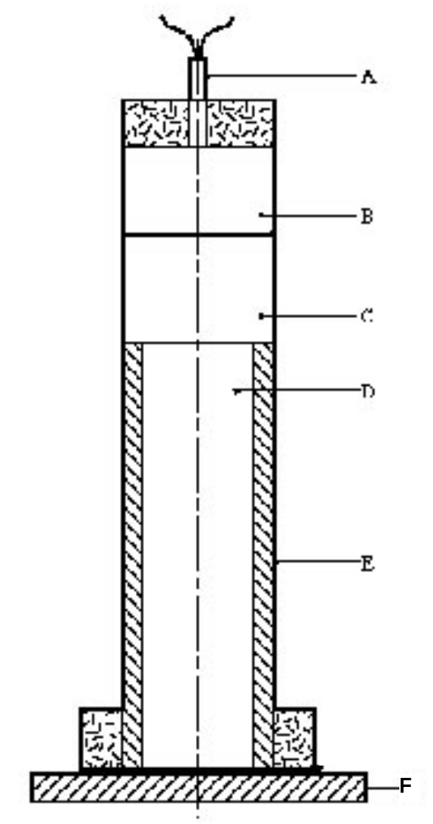

(A) | Detonator | (B) | Booster charge
(C) | PMMA gap | (D) | Substance under test
(E) | Steel tube | (F) | Witness plate

Figure 18.5.1.1: ANE GAP TEST
Table 18.5.1.1 ANE GAP TEST CALIBRATION DATA

PENTOLITE 50/50 DONOR |  |  | RDX/WAX/GRAPHITE DONOR
Gap length (mm) | Barrier pressure  (GPa) |  | Gap length (mm) | Barrier pressure  (GPa)
10 | 10.67 |  | 10 | 12.53
15 | 9.31 |  | 15 | 11.55
20 | 8.31 |  | 20 | 10.63
25 | 7.58 |  | 25 | 9.76
30 | 6.91 |  | 30 | 8.94
35 | 6.34 |  | 35 | 8.18
40 | 5.94 |  | 40 | 7.46
45 | 5.56 |  | 45 | 6.79
50 | 5.18 |  | 50 | 6.16
55 | 4.76 |  | 55 | 5.58
60 | 4.31 |  | 60 | 5.04
65 | 4.02 |  | 65 | 4.54
70 | 3.53 |  | 70 | 4.08
75 | 3.05 |  | 75 | 3.66
80 | 2.66 |  | 80 | 3.27
85 | 2.36 |  | 85 | 2.91
90 | 2.10 |  | 90 | 2.59
95 | 1.94 |  | 95 | 2.31
100 | 1.57 |  | 100 | 2.04
 |  |  | 105 | 1.81
 |  |  | 110 | 1.61
 |  |  | 115 | 1.42
 |  |  | 120 | 1.27

Figure 18.5.1.2 : ANE Gap test calibration data
0
2
4
6
8
10
12
14
0
20
40
60
80
100
120
140
Gap Length (mm)
Pressure (GPa)
0
2
4
6
8
10
12
14
0
20
40
60
80
100
120
140
RDX/WAX/GRAPHITE DONOR
PENTOLITE 50/50 DONOR
18.6 Series 8 Type (c) Test prescription

18.6.1 Test 8(c): Koenen test

18.6.1.1 Introduction

This test is used to determine the sensitiveness of a candidate ammonium nitrate emulsion or suspension or gel, intermediate for blasting explosive, to the effect of intense heat under high confinement.

18.6.1.2 Apparatus and materials

18.6.1.2.1 The apparatus consists of a non-reusable steel tube, with its re-usable closing device, installed in a heating and protective device. The tube is deep drawn from sheet steel of suitable quality. The mass of the tube is 25.5 ± 1.0 g. The dimensions are given in figure 18.6.1.1. The open end of the tube is flanged. The closing plate with an orifice, through which the gases from the decomposition of the test substance escape, is made from heat-resisting chrome steel and is available with the following diameter holes: 1.0 - 1.5 - 2.0 - 2.5 - 3.0 - 5.0 - 8.0 - 12.0 - 20.0 mm. The dimensions of the threaded collar and the nut (closing device) are given in figure 18.6.1.1.

18.6.1.2.2 Heating is provided by propane, from an industrial cylinder fitted with a pressure regulator, via a flow meter and distributed by a manifold to the four burners. Other fuel gases may be used providing the specified heating rate is obtained. The gas pressure is regulated to give a heating rate of 3.3 ± 0.3 K/s when measured by the calibration procedure. Calibration involves heating a tube (fitted with a 1.5 mm orifice plate) filled with 27 cm³ of dibutyl phthalate. The time taken for the temperature of the liquid (measured with a 1 mm diameter thermocouple centrally placed 43 mm below the rim of the tube) to rise from 50 °C to 250 °C is recorded and the heating rate calculated.

18.6.1.2.3 Because the tube is likely to be destroyed in the test, heating is undertaken in a protective welded box, the construction and dimensions of which are given in figure 18.6.1.2. The tube is suspended between two rods placed through holes drilled in opposite walls of the box. The arrangement of the burners is given in figure 18.6.1.2. The burners are lit simultaneously by a pilot flame or an electrical ignition device. The test apparatus is placed in a protective area. Measures should be taken to ensure that any draughts does not affect the burner flames. Provision should be made for extracting any gases or smoke resulting from the test.

18.6.1.3 Procedure

18.6.1.3.1 The substance is loaded into the tube to a height of 60 mm taking particular care to prevent the formation of voids. The threaded collar is slipped onto the tube from below, the appropriate orifice plate is inserted and the nut tightened by hand after applying some molybdenum disulphide based lubricant. It is essential to check that none of the substance is trapped between the flange and the plate, or in the threads.

18.6.1.3.2 With orifice plates from 1.0 mm to 8.0 mm diameter, nuts with an orifice of 10.0 mm diameter should be used; if the diameter of the orifice is above 8.0 mm, that of the nut should be 20.0 mm. Each tube is used for one trial only. The orifice plates, threaded collars and nuts may be used again provided they are undamaged.
18.6.1.3.3 The tube is placed in a rigidly mounted vice and the nut tightened with a spanner. The tube is then suspended between the two rods in the protective box. The test area is vacated, the gas supply turned on and the burners lit. The time to reaction and duration of reaction can provide additional information useful in interpreting the results. If rupture of the tube does not occur, heating is to be continued for at least five minutes before the trial is finished. After each trial the fragments of the tube, if any, should be collected and weighed.

18.6.1.3.4 The following effects are differentiated:

"O": Tube unchanged;
"A": Bottom of tube bulged out;
"B": Bottom and wall of the tube bulged out;
"C": Bottom of tube split;
"D": Wall of tube split;
"E": Tube split into two1 fragments;
"F": Tube fragmented into three¹ or more mainly large pieces which in some cases may be connected with each other by a narrow strip;
"G": Tube fragmented into many mainly small pieces, closing device undamaged; and
"H": Tube fragmented into many very small pieces, closing device bulged out or fragmented.

Examples for the effect types "D", "E" and "F" are shown in figure 18.6.1.3. If a trial results in any of the effects "O" to "E", the result is regarded as "no explosion". If a trial gives the effect "F", "G" or "H", the result is evaluated as "explosion".

18.6.1.3.5 The series of trials is started with a single trial using an orifice plate of 20.0 mm. If, in this trial, the result "explosion" is observed, the series is continued with trials using tubes without orifice plates and nuts but with threaded collars (orifice 24.0 mm). If at 20.0 mm "no explosion" occurs, the series is continued with single trials using plates with the following orifices 12.0 - 8.0 - 5.0 - 3.0 - 2.0 - 1.5 and finally 1.0 mm until, at one of these diameters, the result "explosion" is obtained. Subsequently, trials are carried out at increasing diameters, according to the sequence given in 18.6.1.2.1, until only negative results in three tests at the same level are obtained. The limiting diameter of a substance is the largest diameter of the orifice at which the result "explosion" is obtained. If no "explosion" is obtained with a diameter of 1.0 mm, the limiting diameter is recorded as being less than 1.0 mm.

18.6.1.4 Test criteria and method of assessing results

The result is considered "+" and the substance should not be classified in Division 5.1 if the limiting diameter is 2.0 mm or more. The result is considered "—" if the limiting diameter is less than 2.0 mm.

18.6.1.5 Examples of results

Substances | Result | Comments
Ammonium nitrate (low density) | - | Limiting diameter: <1 mm
ANE-F1 Ammonium nitrate 71%, water 21%, fuel/emulsifier 7% | -
ANE-F2 Ammonium nitrate 77%, water 17%, fuel/emulsifier 7% | -
ANE-F3 Ammonium nitrate 70%, sodium nitrate 11%, water 12%, fuel/emulsifier 7% | -
ANE-F4 Ammonium nitrate 42%, Calcium nitrate 35%, water 16%, fuel/emulsifier 7% | -
ANE-F5 Ammonium nitrate 69%, sodium nitrate 13%, water 10%, fuel/emulsifier 8% | -
ANE-F6 Ammonium nitrate 72%, sodium nitrate 11%, water 10%, fuel/emulsifier 6% | -
ANE-F7 Ammonium nitrate 76%, water 13%, fuel/emulsifier 10% | -
ANE-F8 Ammonium nitrate 77%, water 16%, fuel/emulsifier 6% | -
ANE-1 Ammonium nitrate 76%, water 17%, fuel/emulsifier 7% | - | Limiting diameter: 1.5 mm
ANE-2 (sensitized by microballoons) Ammonium nitrate 75%, water 17%, fuel/emulsifier 7% | + | Limiting diameter: 2 mm
ANE-4 (sensitized by microballoons) Ammonium nitrate 70%, sodium nitrate 11%, water 9%, fuel/emulsifier 5.5% | + | Limiting diameter: 2 mm
ANE-G1 Ammonium nitrate 74%,  sodium nitrate 1%, water 16%, fuel/emulsifier 9% | -
ANE-G2 Ammonium nitrate 74%, sodium nitrate 3%, water 16%, fuel/emulsifier 7% | -
ANE-J1 Ammonium nitrate 80%, water 13%, fuel/emulsifier 7% | - | Effect type "O"
ANE-J2 Ammonium nitrate 76%, water 17%, fuel/emulsifier 7% | - | Effect type "O"
ANE-J4 Ammonium nitrate 71%, sodium nitrate 11%, water 12%, fuel/emulsifier 6% | - | Effect type "A"

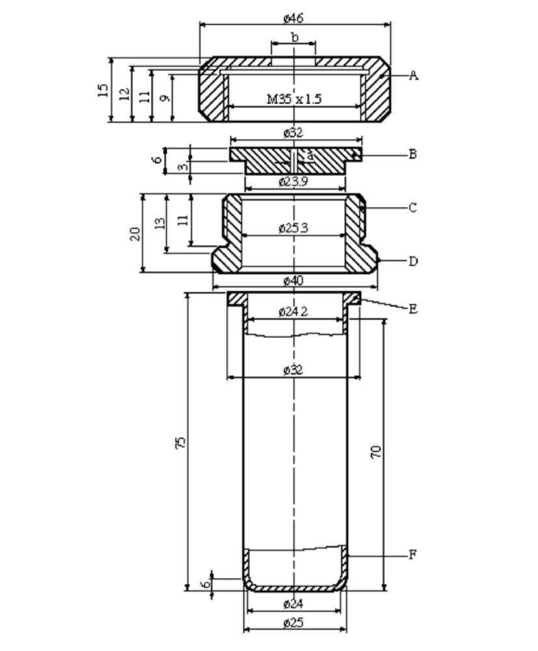
(A) | Nut (b =10.0 or 20.0 mm)  with flats for size 41 spanner | (B) | Orifice plate  (a = 1.0 20.0 mm diameter)
(C) | Threaded collar | (D) | Flats for size 36 spanner
(E) | Flange | (F) | Tube

Figure 18.6.1.1: TEST TUBE ASSEMBLY
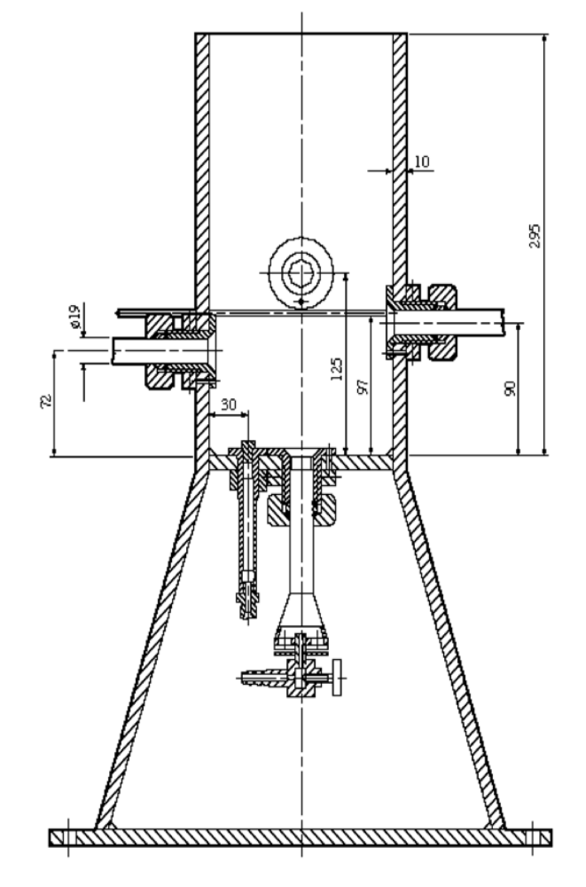

Figure 18.6.1.2: HEATING AND PROTECTIVE DEVICE
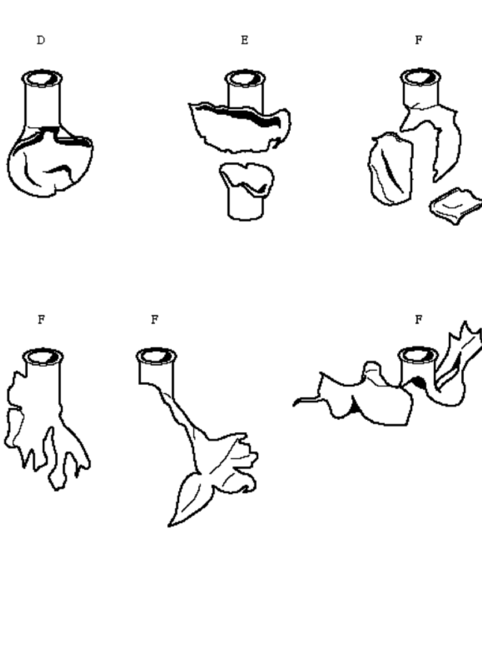Figure 18.6.1.3 EXAMPLES OF EFFECT TYPES D, E AND F
18.7 Series 8 Type (d) Test prescription

18.7.1 Test 8 (d): Vented pipe test

18.7.1.1 Introduction

This test is not intended for classification but is included in this Manual for evaluating the suitability for transport in tanks.
The vented pipe test is used to assess the effect of exposure of a candidate for "ammonium nitrate emulsion or suspension or gel, intermediate for blasting explosives" to a large fire under confined, vented conditions.

18.7.1.2 Apparatus and materials

The following items are needed:

(a) A steel pipe 31 ± 1 cm diameter and 61 ± 1 cm long, welded close at the bottom with a 38 cm square, 10 ± 0.5 mm thick mild steel plate. The top of the pipe is welded to a 38 cm square, 10 ± 0.5 mm thick mild steel plate that contains a 78 mm diameter vent hole centrally located in the plate to which a 152 mm long steel pipe nipple of 78 mm internal diameter is welded. (See figure 18.7.1.1).

(b) A metal grid to support the filled pipe above the fuel and allow adequate heating. If a wooden crib fire is used, the grid should be 1.0 m above the ground and if a liquid hydrocarbon pool fire is used then the grid shall be 0.5 m above the ground;
(c) Enough fuel to keep a fire burning for at least 30 minutes or, if necessary, until the substance has clearly had enough time to react to the fire;
(d) Suitable means of ignition to ignite the fuel from two sides e.g. for a wood fire, kerosene to soak the wood and pyrotechnic igniters with wood wool;
(e) Cine or video cameras, preferably high speed and normal speed, to record events in colour;
(f) Blast gauges, radiometers and associated recording equipment may also be used.
18.7.1.3 Procedure

18.7.1.3.1 The pipe is filled with the substance under test without tamping during loading. The substance is carefully packed to prevent adding voids. The steel pipe is placed vertically on the grid and secured from tipping over. fuel is placed beneath the grid so that the fire will engulf the pipe. Precautions against side winds may be required to avoid dissipation of the heat. Suitable methods of heating include a wood fire using a lattice of wooden laths, a liquid or gas fuel fire that produces a flame temperature of at least 800 °C.

18.7.1.3.2 One method is to use a wood fire which has a balanced air/fuel ratio, thereby avoiding too much smoke which would obscure the events, and which burns with sufficient intensity and duration to bring the substance to a possible reaction. A suitable method involves using air-dried pieces of wood (approximately 50 mm square section), stacked to form a lattice beneath the grid (1 m off the ground), and up to the base of the grid supporting the pipe. The wood should extend beyond the pipe to a distance of at least 1.0 m in every direction and the lateral distance between the laths should be about 100 mm.

18.7.1.3.3 A receptacle filled with suitable liquid fuel, a combination of both wood and liquid fuel fire may be used as an alternative to the wood fire providing it is as severe. If a liquid pool fire is used, the receptacle should extend beyond the pipe to a distance of at least 1.0 m in every direction. The distance between the grid platform and the receptacle should be approximately 0.5 m. Before using this method, consideration should be given to whether any quenching action or adverse interaction between the substance and the liquid fuel can occur such as might bring the results into question.

18.7.1.3.4 If gas is to be used as a fuel, the burning area must extend beyond the pipe to a distance of 1.0 m in every direction. The gas must be supplied in such a manner to ensure that the fire is evenly distributed around the pipe. The gas reservoir should be large enough to keep the fire burning for at least 30 minutes. Ignition of the gas may be accomplished either by remotely ignited pyrotechnics or by remote release of the gas adjacent to a pre-existing source of ignition.

18.7.1.3.5 The ignition system should be put into place and the fuel ignited on two sides, one up wind, simultaneously. The test should not be performed under conditions where the wind speed exceeds 6 m/s. The fire shall be started from a safe place. If the pipe does not rupture, the system should be allowed to cool down before carefully dismantling the test set-up and emptying the pipe.

18.7.1.3.6 Observations are made on the following:

(a) evidence of explosion;
(b) loud noise; and
(c) projection of fragments from the fire area.

18.7.1.4 Test criteria and method of assessing results

The test result is considered "+" and the substance should not be transported in tanks if an explosion and/or fragmentation of the pipe is observed. If no explosion and/or fragmentation of the pipe is observed then the result is considered "-".

18.7.1.5 Examples of results

(Reserved)

∅ 33.0
∅ 31.0
∅ 8.8
∅ 7.8
1.0
15.2
1.2
61.0
1.2
A
B
C
38.0
D
a

(A) | Top plate (Schedule 40 carbon (A53 grade B))
(B) | Bottom plate (Schedule 40 carbon (A53 grade B))
(C) | Steel pipe nipple (a = 0.5 cm), Schedule 40 carbon (A53 grade B)
(D) | Steel pipe (Schedule 40 carbon (A53 grade B))

Figure 18.7.1.1: VENTED PIPE TEST

Section 30

30.1.1 Insert the following two new subparagraphs:

"(a) Flammable aerosols (see section 31 of this Manual and special provision 63 of Chapter 3.3 of the Model Regulations);"

Existing (a) to (e) become (b) to (f), respectively.

"(f) Corrosive properties of substances of class 8 (see section 37 of this Manual and Chapter 2.8 of the Model Regulations);".

Existing (f) and (g) become (h) and (i), respectively.

30.1.2 Amend the last sentence as follows: "Sections 35 and 36 are reserved, to allow….for Classes 6 and 7 respectively.".

Section 31

Replace the existing text between brackets in page 307 (English text) with the following:

"SECTION 31

CLASSIFICATION PROCEDURES, TEST METHODS AND CRITERIA
RELATING TO FLAMMABLE AEROSOLS OF CLASS 2

31.1 Purpose

31.1.1 This section presents the United Nations scheme for the classification of flammable aerosols. The text shall be used in conjunction with the classification principles given in Chapters 2.2 and 3.3 (special provision 63) of the Model Regulations, the flow charts given here in figures 31.1, 31.2 and 31.3 and the tests prescriptions given in sub-sections 31.4, 31.5 and 31.6 of this Manual.

31.1.2 The test procedures outlined here adequately assess the relative hazard of flammable aerosols so that an appropriate classification can be made.

31.1.3 For the purposes of this section the following definitions apply:

Aerosols or aerosol dispensers are non-refillable receptacles meeting the requirements of section 6.2.4 of the Model Regulations, made of metal glass or plastics and containing a gas, compressed, liquefied or dissolved under pressure, with or without a liquid, paste or powder, and fitted with a release device allowing the contents to be ejected as solid or liquid particles in suspension in a gas, as a foam, paste or powder or in a liquid state or in a gaseous state.

Flammable components are flammable liquids, flammable solids or flammable gases and gas mixtures. This designation does not cover pyrophoric, self-heating or water-reactive substances.

NOTE 1: A flammable liquid means a liquid having a flash point of not more than 93 °C. Test methods for determining the flash point are given in sub-section 32.4 of this Manual;

NOTE 2: For the definition of flammable solids, see paragraph 2.4.2.2 of the Model Regulations. Classification procedures, test methods and criteria relating to flammable solids of Division 4.1 are given in sub-section 33.2 of this Manual;

NOTE 3: A flammable gas is a gas having a flammable range with air at 20 °C and a standard pressure of 101.3 kPa.

31.2 Scope

31.2.1 Aerosols offered for transport shall be subjected to the classification procedures as set out in special provision 63 of Chapter 3.3 of the Model Regulations and, for flammability, shall be subjected to the classification procedures as set out in this section. The classification procedure shall be undertaken before a new product is offered for transport.

NOTE: Aerosol dispensers not submitted to flammability classification procedures in this section shall be classified as extremely flammable.

31.3 Classification procedure for flammable aerosols

31.3.1 Aerosols shall be classified as flammable or extremely flammable according to their heat of combustion and to their flammable component contents, as follows:

(a) The aerosol product is classified as extremely flammable if the product contains 85% or more flammable components and the chemical heat of combustion exceeds or is equal to 30 kJ/g;

(b) The aerosol product is classified as non-flammable if the product contains 1% or less flammable components and the chemical heat of combustion is less than 20 kJ/g.

31.3.2 In the case of spray aerosols the classification shall be made taking into account the chemical heat of combustion and on the basis of the results of the ignition distance test, as follows:

(a) If the chemical heat of combustion is less than 20 kJ/g:

(i) The aerosol is classified as flammable if ignition occurs at a distance equal or greater than 15 cm but less than 75 cm;
(ii) The aerosol is classified as extremely flammable if ignition occurs at a distance of 75 cm or more;
(iii) If no ignition occurs in the ignition distance test, the enclosed space test shall be performed and in this case, the aerosol is classified as flammable if the time equivalent is less than or equal to 300 s/m³ or the deflagration density is less than or equal to 300 g/m³; otherwise the aerosol is classified as non-flammable;

(b) If the chemical heat of combustion is equal to or more than 20 kJ/g, the aerosol is classified as extremely flammable if ignition occurs at a distance of 75 cm or more; otherwise the aerosol is classified as flammable.

31.3.3 The chemical heat of combustion shall be determined following one of the methods described in the following standards: ASTM D 240, ISO/FDIS 13943:1999 (E/F) 86.1 to 86.3 and NFPA 30B.

31.3.4 In the case of foam aerosols, the classification shall be made on the basis of the results of the foam flammability test (see sub-section 31.6 of this Manual).

(a) The aerosol product shall be classified as extremely flammable if:

(i) The flame height is 20 cm or more and the flame duration is 2 s or more; or

(ii) The flame height is 4 cm or more and the flame duration is 7 s or more.

(b) The aerosol product which does not meet the criteria in (a) is classified as flammable if the flame height is 4 cm or more and the flame duration is 2 s or more.

31.3.5 The classification criteria for aerosols, spray aerosols and foam aerosols is summarized in figures 31.1, 31.2 and 31.3 respectively.

FIGURE 31.1: OVERALL PROCEDURE FOR CLASSIFICATION
OF FLAMMABLE AEROSOLS

Does it contain 85% or more flammable components and does it have a heat of combustion ≥ 30 kJ/g?
Extremely flammable
Yes
For spray aerosols, go to Figure 31.2
For foam aerosols, go to Figure 31.3
Does it contain 1% or less flammable components and does it have a heat of combustion < 20 kJ/g?
No
Yes
No
Not classified as flammable aerosol
Aerosol

FIGURE 31.2: PROCEDURE FOR CLASSIFICATION OF SPRAY AEROSOLS

No
Does it have a heat of combustion < 20 kJ/g?
Yes
In the ignition distance test, does ignition occur at a distance ≥ 75 cm?
Spray aerosol
Yes
Extremely flammable
No
Flammable
In the ignition distance test, does ignition occur at a distance ≥ 75 cm?
Yes
Extremely flammable
In the ignition distance test, does ignition occur at a distance ≥ 15 cm?
Yes
Flammable
No
In the enclosed space ignition test,
is the time equivalent ≤ 300 s/m³ or
the deflagration density ≤ 300 g/m³?
Yes
Flammable
No
No
Not classified as flammable aerosol

FIGURE 31.3: PROCEDURE FOR CLASSIFICATION OF FOAM AEROSOLS

In the foam flammability test, is
the flame height ≥ 20 cm and the flame duration ≥ 2 s, or the flame height ≥ 4 cm and the flame duration ≥ 7 s?
Yes
Extremely flammable
In the foam flammability test, is the flame height ≥ 4 cm and the flame duration ≥ 2 s?
Yes
Flammable
No
Foam aerosol
No
Not classified as flammable aerosol

31.4 Ignition distance test for spray aerosols

31.4.1 Introduction

31.4.1.1 This test standard describes the method to determine the ignition distance of an aerosol spray in order to assess the associated flame risk. The aerosol is sprayed in the direction of an ignition source at intervals of 15 cm to observe if ignition and sustained combustion of the spray takes place. Ignition and sustained combustion is defined as when a stable flame is maintained for at least 5 s. The ignition source is defined as a gas burner with a blue, non-luminous flame 4-5 cm in height.

31.4.1.2 This test is applicable to aerosol products with a spray distance of 15 cm or more. Aerosol products with a spray distance of less than 15 cm such as dispensing foams, mousses, gels and pastes or fitted with a metering valve, are excluded from this test. Aerosol products that dispense foams, mousses, gels or pastes are subject to testing under the aerosol foam flammability test.

31.4.2 Apparatus and material

31.4.2.1 The following apparatus is required:

water bath maintained at 20°C accurate to ± 1 °C
Calibrated laboratory scales (balance) accurate to ± 0.1 g
Chronometer (stopwatch) accurate to ± 0.2 s
Graduated scale, support and clamp graduations in cm
Gas burner with support and clamp
Thermometer accurate to ± 1 °C
Hygrometer accurate to ± 5 %
Pressure gauge accurate to ± 0.1 bar

31.4.3 Procedure

31.4.3.1 General requirements

31.4.3.1.1 Before testing, each aerosol dispenser shall be conditioned and then primed by discharging for approximately 1 s. The purpose of this action is to remove non-homogeneous material from the diptube.

31.4.3.1.2 The instructions of use shall be strictly followed, including whether the dispenser is intended to be used in the upright or inverted position. When shaking is required, shake immediately before testing.

31.4.3.1.3 The test shall be carried out in a draught-free environment capable of ventilation, with the temperature controlled at 20 °C ± 5 °C and relative humidity in the range 30 - 80%.

31.4.3.1.4 Each aerosol dispenser is to be tested:

(a) when full according to the complete procedure, with the gas burner in the range of 15 – 90 cm distance from the actuator of the aerosol can;

(b) when 10 - 12% full nominal (% by mass) only one test, either at 15 cm distance from the actuator when the spray from a full can did not ignite at all, or at the flame ignition distance of the spray of a full can plus 15 cm.

31.4.3.1.5 During the test, the can shall be positioned as indicated by label instructions. The ignition source shall be positioned accordingly.

31.4.3.1.6 The following procedure requires testing the spray at intervals of 15 cm between the burner flame and the aerosol actuator, in the range of 15 - 90 cm. It is efficient to start at 60 cm distance between burner flame and aerosol actuator. The distance between burner flame and aerosol actuator shall be increased by 15 cm in the case of an ignition of the spray at 60 cm distance. The distance shall be decreased by 15 cm in the case of no ignition at 60 cm distance between burner flame and aerosol actuator. The aim of the procedure is to determine the maximum distance between aerosol actuator and burner flame that leads to sustained combustion of the spray or to determine that ignition could not be obtained at 15 cm distance between the burner flame and the aerosol's actuator.

31.4.3.2 Test procedure

(a) A minimum of 3 full aerosol dispensers per product shall be conditioned to 20 °C ± 1 °C with at least 95% of the dispenser immersed in the water for at least 30 min before each test (if the aerosol is fully immersed, 30 min conditioning is sufficient);

(b) Comply with general requirements. Record the temperature and relative humidity of the environment;

(c) Weigh an aerosol dispenser and note its mass;

(d) Determine the internal pressure and initial discharge rate at 20 °C ± 1 °C (to eliminate faulty or partly filled aerosol dispensers);

(e) Support the gas burner on a flat horizontal surface or fix the burner to a support by means of a clamp;

(f) Ignite the gas burner; the flame shall be non-luminous and approximately 4-5 cm high;

(g) Place the actuator's exit orifice at the required distance from the flame. The aerosol shall be tested in the position it is designed to be used, e.g. upright or inverted;

(h) Level the actuator's orifice and burner flame, ensuring that the orifice is properly directed towards and aligned with the flame (see Figure 31.4.1). The spray shall be expelled through the top half of the flame;

(i) Comply with the general requirements regarding shaking of the dispenser;

(j) Actuate the valve of the aerosol dispenser, to discharge its contents for 5 s, unless ignition occurs. If ignition occurs, continue discharging and time the duration of the flame for 5 s, from the start of ignition;

(k) Note the ignition results for the distance between the gas burner and the aerosol dispenser in the table provided;

(l) If no ignition occurs during step (j), the aerosol shall be tested in alternative orientations, e.g. inverted for upright use products, to check if ignition is obtained;

(m) Repeat steps (g) to (l) twice more (a total of 3) for the same can at the same distance between the gas burner and the aerosol actuator;

(n) Repeat the test procedure for another two aerosol cans of the same product at the same distance between gas burner and aerosol actuator;

(o) Repeat steps (g) to (n) of the test procedure at a distance between 15 and 90 cm between the actuator of the aerosol can and the burner flame depending on the outcome of each test (see also 31.4.3.1.4 and 31.4.3.1.5);

(p) If no ignition occurs at 15 cm, the procedure is finished for initially full cans. The procedure is also finished when ignition and sustained combustion is obtained at a distance of 90 cm. If ignition could not be obtained at 15 cm distance, record that ignition did not occur. The maximum distance between burner flame and the aerosol's actuator for which an ignition and sustained combustion was observed is noted as the "ignition distance", in all other circumstances;

(q) One test shall also be conducted on 3 cans of 10 - 12% nominal fill level. These cans shall be tested at a distance between the aerosol's actuator and the burner flame of "the flame ignition distance of full cans + 15 cm";

(r) Discharge an aerosol can to a 10 - 12% nominal fill level (by mass) in bursts of 30 s maximum. Observe a 300 s minimum time period between bursts. During this interim period dispensers shall be placed in the water bath for conditioning;

(s) Repeat steps (g) to (n) for 10 - 12% nominal fill aerosol cans, omitting steps (l) and (m). This test shall only be performed with the aerosol in one position, e.g. upright or inverted, corresponding with that which produced the ignition (if any) for filled cans;

(t) Record all results in the Table 31.4 as shown below.

31.4.3.2.1 All experiments shall be performed in a fume hood in a room that may be well ventilated. Ventilation of the fume hood and room can be applied for at least 3 min after each test. Take all necessary safety precautions to prevent the inhalation of combustion products.
31.4.3.2.2 The cans with a 10 - 12% nominal fill level shall be tested only once. The result tables need only one result per can indicated.

31.4.3.2.3 When the test in the position in which the dispenser is designed to be used gives a negative result, the test shall be repeated in the position of the dispenser most likely to result in a positive result.

31.4.4 Test criteria and method of assessing results

31.4.4.1 All the results shall be recorded. Table 31.4 below shows the model of "result table" to be used.

Table 31.4

Date |  | Temperature  Relative humidity | °C  %
Name of product

Net volume |  | Can 1 | Can 2 | Can 3
Initial level  of filling |  | % | % | %
Dispenser distance | Test | 1 2 3 | 1 2 3 | 1 2 3
15 cm | Ignition?  Y or N
30 cm | Ignition?  Y or N
45 cm | Ignition?  Y or N
60 cm | Ignition?  Y or N
75 cm | Ignition?  Y or N
90 cm | Ignition?  Y or N
Observations – including can position

31.4.4.2 Spray aerosols shall be classified as flammable, extremely flammable or non
flammable according to the following criteria:

(a) An aerosol with a chemical heat of combustion less than 20 kJ/g is classified as flammable if ignition occurs at a distance equal or greater than 15 cm but less than 75 cm;

(b) An aerosol with a chemical heat of combustion less than 20 kJ/g is classified as extremely flammable if ignition occurs at a distance of 75 cm or more;

(c) If for an aerosol with a chemical heat of combustion less than 20 kJ/g, no ignition occurs in the ignition distance test, the enclosed space ignition test described in sub-section 31.5 of this Manual shall be performed;

(d) An aerosol with a chemical heat of combustion equal to or more than 20 kJ/g is classified as extremely flammable if ignition occurs at a distance of 75 cm or more. Otherwise the aerosol is classified as flammable.

Figure 31.4.1
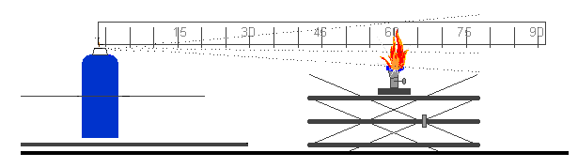
31.5 Enclosed space ignition test

31.5.1 Introduction

31.5.1.1 This test standard describes the method to assess the flammability of products emerging from aerosol dispensers due to their propensity to ignite in an enclosed or confined space. The contents of an aerosol dispenser are sprayed into a cylindrical test vessel containing a burning candle. If an observable ignition occurs, the elapsed time and amount discharged is noted.

31.5.2 Apparatus and material

31.5.2.1 The following apparatus is required:

Chronometer (stopwatch) accurate to ± 0.2 s
water bath maintained at 20 °C accurate to ± 1 °C
Calibrated laboratory scales (balance) accurate to ± 0.1 g
Thermometer accurate to ± 1 °C
Hygrometer accurate to ± 5%
Pressure gauge accurate to ± 0.1 bar
Cylindrical test vessel as detailed below

31.5.2.2 Preparation of test apparatus

31.5.2.2.1 A cylindrical vessel approximately 200 dm³ (55 gallons) volume, approximately 600 mm in diameter and approximately 720 mm long and open at one end shall be modified as follows:

(a) A closure system consisting of a hinged cover shall be matched to the open end of the receptacle; or

(b) A plastic film 0.01 to 0.02 mm thick may be used as a closure system. If the test is carried out with a plastic film this must be used as described below:

Stretch the film over the open end of the drum and hold it in place with an elastic band. The strength of the band shall be such that when placed around the drum resting on its side, it stretches by only 25 mm when a mass of 0.45 kg is attached to its lowest point. Cut a 25 mm slit in the film, starting 50 mm from the edge of the drum. Ensure that the film is taut;

(c) At the other end of the drum drill a 50 mm diameter hole 100 mm from the edge in such a way that the orifice is uppermost when the receptacle is laid down and ready for the test (Figure 31.5.1);

(d) On a 200 × 200 mm metal support place a paraffin wax candle 20 to 40 mm in diameter and 100 mm high. The candle shall be replaced when having a height of less than 80 mm. The candle's flame is protected from the action of the spray by a 150 mm wide, 200 mm high deflector. This includes the plane inclined at 45° produced 150 mm from the base of the deflector (Figure 31.5.2);

(e) The candle placed on the metal support shall be positioned midway between the two ends of the drum (Figure 31.5.3);

(f) The drum is laid on the ground or on a support at a spot where the temperature is between 15 °C and 25 °C. The product to be tested will be sprayed within the drum of roughly 200 dm3 in which there will be a source of ignition.

Figure 31.5.1
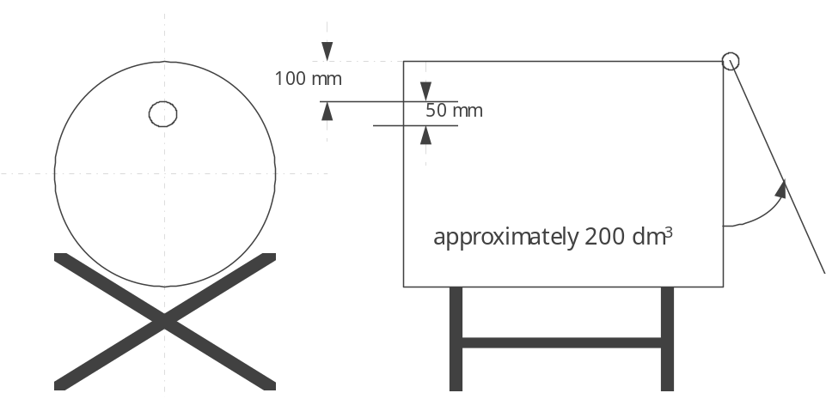

Figure 31.5.2
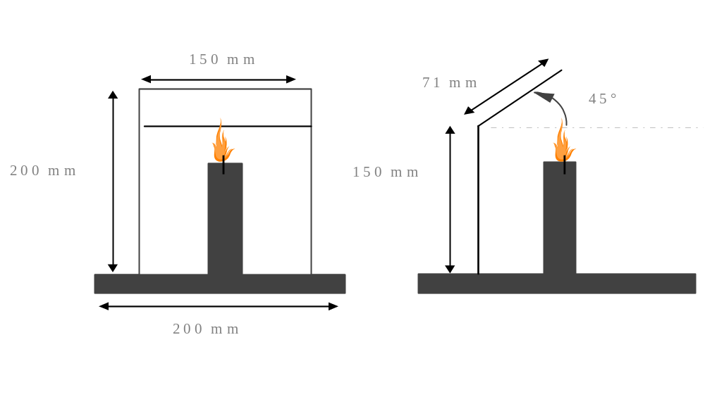
Figure 31.5.3
100 mm
200 mm

31.5.2.2.2 Usually, the product leaves the aerosol can at an angle of 90° relevant to the vertical axis of the can. The layout and procedure described refers to this kind of aerosol product. In the case of unusually operating aerosols (e.g. vertical-spray aerosol dispensers) it will be necessary to record changes to equipment and procedures in accordance with good laboratory practice, such as ISO/IEC 17025:1999 General requirements for the competence of testing and calibration laboratories.

31.5.3 Procedure

31.5.3.1 General requirements

31.5.3.1.1 Before testing, each aerosol dispenser shall be conditioned and then primed by discharging for approximately 1 second. The purpose of this action is to remove non-homogeneous material from the diptube.

31.5.3.1.2 The instructions of use shall be strictly followed, including whether the dispenser is intended to be used in the upright or inverted position. When shaking is required, shake immediately before testing.

31.5.3.1.3 The tests shall be carried out in a draught-free environment capable of ventilation, with the temperature controlled at 20 °C ± 5 °C and relative humidity in the range 30 - 80%.

31.5.3.2 Test procedure

(a) A minimum of 3 full aerosol dispensers per product shall be conditioned to 20 °C ± 1 °C in a water bath with at least 95% of the dispenser immersed in the water for at least 30 min (if the aerosol is fully immersed, 30 min conditioning is sufficient);

(b) Measure or calculate the actual volume of the drum in dm³;

(c) Comply with general requirements. Record the temperature and relative humidity of the environment;

(d) Determine the internal pressure and initial discharge rate at 20 °C ± 1 °C (to eliminate faulty or partly filled aerosol dispensers);

(e) Weigh one of the aerosol dispensers and note its mass;

(f) Light the candle and apply the closure system (cover or plastic film);

(g) Place the aerosol dispenser actuator orifice 35 mm or closer for a wide spray product, from the centre of the entrance hole in the drum. Start the chronometer (stopwatch) and following the instructions for use of the product; direct the spray towards the centre of the opposite extremity (cover or plastic film). The aerosol shall be tested in the position it is designed to be used, e.g. upright or inverted;

(h) Spray until ignition occurs. Stop the chronometer and note the time elapsed. Re-weigh the aerosol dispenser and note its mass;

(i) Ventilate and clean the drum removing any residue likely to affect subsequent tests. Allow the drum to cool if necessary;

(j) Repeat the test procedure steps (d) to (i) for another two aerosol dispensers of the same product (3 in total, note: each dispenser is only tested once);

31.5.4 Test criteria and method of assessing results

31.5.4.1 A test report containing the following information shall be drawn up:

a) The product tested and its references;

b) The internal pressure and discharge rate of the aerosol dispenser;

c) The temperature and relative air humidity of the room;

d) For each test, the discharge time (s) needed to achieve ignition (if the product does not ignite, state this);

e) The mass of the product sprayed during each test (in g);

f) The actual volume of the drum (in dm³).

31.5.4.2 The time equivalent (t_{eq}) needed to achieve ignition in one cubic metre can be calculated as follows:
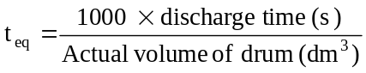

31.5.4.3 The deflagration density (D_{def}) needed to achieve ignition during the test may also be calculated as follows:

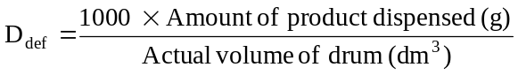

31.5.4.4 An aerosol with a chemical heat of combustion less than 20 kJ/g for which no ignition occurs in the ignition distance test (see sub-section 31.4 of this Manual) is classified as flammable if the time equivalent is less than or equal to 300 s/m³ or the deflagration density is less than or equal to 300 g/m³. Otherwise the aerosol is classified as non-flammable.

31.6 Aerosol foam flammability test

31.6.1 Introduction

31.6.1.1 This test standard describes the method to determine the flammability of an aerosol spray emitted in the form of a foam, mousse, gel or paste. An aerosol, which emits a foam, mousse, gel or paste is sprayed (approx. 5 g) on a watchglass and an ignition source (candle, wax taper, match or lighter) is placed at the base of the watchglass to observe if ignition and sustained combustion of the foam, mousse, gel or paste occurs. Ignition is defined as a stable flame maintained for at least 2 s and a minimum 4 cm in height.

31.6.2 Apparatus and material

31.6.2.1 The following apparatus is required:

Graduated scale, support and clamp gradations in cm
Fire-resistant watchglass roughly 150 mm in diameter
Chronometer (stopwatch) accurate to ± 0.2 s
Candle, wax taper, match or lighter
Calibrated laboratory scales (balance) accurate to ± 0.1 g
water bath maintained at 20 °C accurate to ± 1 °C
Thermometer accurate to ± 1 °C
Hygrometer accurate to ± 5%
Pressure gauge accurate to ± 0.1 bar

31.6.2.2 The watchglass is placed on a fire-resistant surface within a draught-free area that may be ventilated after each test. The graduated scale is positioned exactly behind the watchglass and held vertically by means of a support and clamp.

31.6.2.3 The scale is positioned in such a way that its origin is on a level with the watchglass base in a horizontal plane.

31.6.3 Procedure

31.6.3.1 General requirements

31.6.3.1.1 Before testing, each aerosol dispenser shall be conditioned and then primed by discharging for approximately 1 second. The purpose of this action is to remove non-homogeneous material from the diptube.

31.6.3.1.2 The instructions of use shall be strictly followed, including whether the dispenser is intended to be used in the upright or inverted position. When shaking is required, shake immediately before testing.

31.6.3.1.3 The tests shall be carried out in a draught-free environment capable of ventilation, with the temperature controlled at 20 °C ± 5 °C and relative humidity in the range of 30–80%.

31.6.3.2 Test procedure

(a) A minimum of four full aerosol dispensers per product shall be conditioned to 20°C ± 1°C with at least 95% of the dispenser immersed in the water for at least 30 min before each test (if the aerosol is fully immersed, 30 min conditioning is sufficient);

(b) Comply with general requirements. Record the temperature and relative humidity of the environment;

(c) Determine the internal pressure at 20 °C ± 1 °C (to eliminate faulty or partly filled aerosol dispensers);

(d) Measure the discharge or flow rate of the aerosol product to be examined, so that the amount of test product dispensed can be more accurately gauged;

(e) Weigh one of the aerosol dispensers and note its mass;

(f) On the basis of the measured discharge or flow rate and following the manufacturer's instructions, release approximately 5 g of the product onto the centre of the clean watchglass with the aim of producing a mound no higher than 25 mm;

(g) Within 5 s of completion of discharge, apply the source of ignition to the edge of the sample at its base and at the same time start the chronometer (stopwatch). If necessary, the ignition source shall be removed from the edge of the sample after approximately two seconds, in order to clearly observe if ignition has occurred. If no ignition of the sample is apparent, the ignition source shall be reapplied to the edge of the sample;

(h) If ignition occurs note the following points:

(i) The maximum height of the flame in cm above the base of the watchglass;

(ii) The flame duration in s;

(iii) Dry and re-weigh the aerosol dispenser and calculate the mass of the released product;

(i) Ventilate the test area immediately after each test;

(j) If ignition is not obtained and the released product remains in the form of a foam or paste throughout its period of use, steps (e) to (i) shall be repeated. Allow the product to stand for 30 sec, 1 min, 2 min or 4 min before applying the ignition source;

(k) Repeat the test procedure steps (e) to (j) twice more (a total of 3) for the same can;

(l) Repeat the test procedure steps (e) to (k) for another two aerosol cans (3 cans in total) of the same product.

31.6.4 Test criteria and method of assessing results

31.6.4.1 A test report containing the following information shall be drawn up:

(a) whether the product ignites;

(b) maximum flame height in cm;

(c) duration of flame in s;

(d) the mass of the product tested.

31.6.4.2 The aerosol product shall be classified as extremely flammable if the flame height is 20 cm or more and the flame duration is 2 s or more; or if the flame duration is 7 s or more and the flame height is 4 cm or more."
Section 33

33.4.1.3.1 Replace the second sentence with the following:
"In case a pyrophoric substance is tested, the test should be executed under nitrogen atmosphere."

Section 37

Replace the text between brackets in page 353 (English version) with the following:

"SECTION 37

CLASSIFICATION PROCEDURES, TEST METHODS AND CRITERIA RELATING
TO SUBSTANCES OF CLASS 8

37.1 Purpose

37.1.1 This section presents the United Nations scheme for the classification of corrosive substances of Class 8 (see sections 2.8.1 and 2.8.2 of the Model Regulations). The test method for corrosion is given in sub-section 37.4 of this Manual. The method for determining corrosion to skin is provided in OECD Guideline 404 and the criteria are provided in Chapter 2.8 of the Model Regulations. If a substance is shown to be corrosive to skin, then it is not necessary to conduct the tests for metal corrosion for the purposes of classification.

37.2 Scope

37.2.1 New products offered for transport shall be subjected to the classification procedures as set out in 2.8.2.5 (c) (ii) of the Model Regulations unless it is impracticable (e.g. because of the physical properties) to perform the tests. Substances which cannot be tested shall be classified by analogy with existing entries. The classification procedure shall be undertaken before a new product is offered for transport.

37.3 Classification procedure
The following test procedures are designed to assess the corrosion hazard for an appropriate classification for transport.

37.4 Test methods for corrosion to metals

37.4.1 Introduction

37.4.1.1 Test C.1: Test for determining the corrosive properties of liquids and solids that may become liquid during transport as dangerous goods of Class 8, packing group III.

37.4.1.2 Apparatus and material

For exposure to the medium being classified the specimens shall consist of 2 mm thick plates and shall be made of the following materials:

- Aluminium, non-clad types 7075-T6 or AZ5GU-T6 and

- Steel type S235JR+CR (1.0037 resp. St 37-2), S275J2G3+CR (1.0144 resp. St 44-3), ISO 3574, Unified Numbering System (UNS) G10200 or SAE 1020. (See Figure 37.4.1).

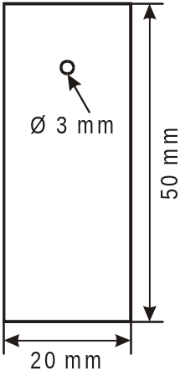
Figure 37.4.1: specimen

At least 3 sets of specimens shall be used for each metal (aluminium, steel). A cup-like reaction receptacle (of glass or PTFE) as shown in figure 37.4.2 with three necks of suitable size (e.g. NS 29/32 as well as one neck NS 14) to accommodate the specimen as illustrated in figure 37.4.1 and a fourth neck of sufficient size to accommodate a reflux condenser shall be used. The entrance of air into the receptacle shall be ensured. Aluminium and steel specimens shall be tested in different reaction receptacles. To prevent liquid lost a reflux condenser shall be attached (See figure 37.4.2).
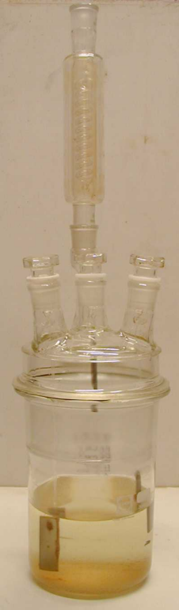
Fig. 2: receptacle

Figure 37.4.2: Exposure receptacle with reflux condenser

In order to carry out the test, the substance being classified shall have a minimum volume of 1.5 l to ensure enough reactive agent during the whole exposure time. Very long testing periods without changing the solution will sometimes give negative results. To get correct results and to avoid re-testing, the following items should be taken into account:

(a) Fresh solutions shall be provided during the course of the test;

(b) The volume should be large enough to avoid any appreciable change in its corrosivity during the test;

NOTE: If problems are expected, the composition should be checked by analysis at the end of the test to determine the extent of change in composition, such as might result from evaporation or depletion.

37.4.1.3 Procedure

Metal sheets shall be polished with grinding paper of 120 grit. After removing the grinding remainings with alcohol in an ultrasound bath and degreasing with acetone, the metal specimens shall be weighed out to ± 0.0002 g. No chemical surface preparation (pickling, etching etc.) shall be performed to prevent surface "irritations" (inhibition, passivation). Specimens shall be fixed inside the receptacle by non-extruded PTFE-threads. Metal wire shall not be used. The test with the so prepared metals shall be initiated the same day to prevent reformation of oxide layer unless appropriate measures are taken to preserve the samples for further testing. For each test one metal specimen shall be dipped into the solution, another one only half way and a third one shall hang in the gas phase. The distance between the upper edge of the completely inserted specimen and the surface of the liquid shall be 10 mm. Losses of liquid shall be avoided.

The test temperature of 55 °C ± 1 shall be maintained throughout the test including the vapour phase as well.

Sheets shall be exposed at these stable conditions for at least one week (168 ± 1 hour).
After finishing the test, the metal specimens shall be rinsed off and cleaned with a brush with synthetic or natural bristles (no metal). For non-mechanically removable remainings (adherent corrosion product or depositions) inhibited pickling solutions should be used. In those cases an unexposed reference specimen needs to be treated in the same manner (time, temperature, concentration, surface preparation) to determine the mass loss caused by the pickling solution. This value needs to be subtracted before evaluating the corrosion rate. After final cleaning with alcohol and acetone in an ultrasound bath, and once dry, the metal samples shall be weighed. The resulting mass under consideration of the specific mass of the metal leads to the corrosion rate.

37.4.1.4 Test criteria and method of assessing results

Two types of corrosion behaviour need to be distinguished.

37.4.1.4.1 Test evaluation at uniform corrosion

In case of uniform corrosion attack the mass loss of the most corroded sample shall be used. The test is considered positive if for any specimen the mass loss on the metal specimen is more than the amount stated in the following table:

Table 37.4.1.4.1: Minimum mass loss of specimens after different exposure times

exposure time | mass loss
7 days | 13.5 %
14 days | 26.5 %
21 days | 39.2 %
28 days | 51.5 %

NOTE: These values are calculated based on a 6.25 mm/year corrosion rate.

37.4.1.4.2 Test evaluation at localised corrosion

When localised corrosion occurs besides or instead of uniform corrosion attack of surface, the depth of the deepest hole respectively the strongest thickness reduction will be added or only be used to determine the intrusion. If the deepest intrusion (to be determined metallographically) exceeds the values shown in the following table, the result is considered positive.

Table 37.4.1.4.2: Minimum intrusion depths after exposure time

exposure time | min. intrusion depth
7 days | 120 µm
14 days | 240 µm
21 days | 360 µm
28 days | 480 µm

----------------------------------------

* For classification purposes start with test series 2.
1 The upper part of the tube remaining in the closing device is counted as one fragment.

