JFSQ 2018

User Manual

Questionnaire Response Table
This table is to help understand which countries should complete Joint Forest Sector Questionnaires (JFSQ). The √ symbol indicates that the questionnaire should be submitted.

Region | Country | JQ1  JQ2  JQ3 | ECE/EU | EU1¹ EU2 | ITTO1 ITTO2 ITTO3
EU/EFTA  (return to Eurostat, Luxembourg and ECE, Geneva) | Austria | √ | √ | √ | √*
 | Belgium | √ | √ | √ | √
 | Bulgaria | √ | √ | √ | √
 | Croatia | √ | √ | √ | √
 | Cyprus | √ | √ | √ | √*
 | Czechia | √ | √ | √ | √*
 | Denmark | √ | √ | √ | √
 | Estonia | √ | √ | √ | √*
 | Finland | √ | √ | √ | √*
 | France | √ | √ | √ | √*
 | Germany | √ | √ | √ | √*
 | Greece | √ | √ | √ | √
 | Hungary | √ | √ | √ | √*
 | Iceland | √ | √ | √
 | Ireland | √ | √ | √ | √*
 | Italy | √ | √ | √ | √
 | Latvia | √ | √ | √ | √*
 | Liechtenstein | √ | √ | √
 | Lithuania | √ | √ | √ | √*
 | Luxembourg | √ | √ | √ | √*
 | Malta | √ | √ | √ | √*
 | Netherlands | √ | √ | √ | √*
 | Norway | √ | √ | √ | √*
 | Poland | √ | √ | √ | √*
 | Portugal | √ | √ | √ | √*
 | Romania | √ | √ | √ | √*
 | Slovakia | √ | √ | √ | √*
 | Slovenia | √ | √ | √ | √*
 | Spain | √ | √ | √ | √*
 | Sweden | √ | √ | √ | √*
 | Switzerland | √ | √ | √ | √*
 | UK | √ | √ | √ | √*
Other ECE  (return to ECE, Geneva) | Albania | √ | √ |  |  | √
 | Andorra | √ | √
 | Armenia | √ | √
 | Azerbaijan | √ | √
 | Belarus | √ | √
 | Bosnia and Her. | √ | √
 | Canada | √ | √
 | Georgia | √ | √
 | Israel | √ | √
 | Kazakhstan | √ | √
 | Kyrgyzstan | √ | √
 | Moldova | √ | √
 | Monaco | √ | √
 | Montenegro | √ | √
 | Russian Fed | √ | √
 | San Marino | √ | √
 | Serbia | √ | √
 | Tajikistan | √ | √
 | FYR Macedonia | √ | √
 | Turkey | √ | √
 | Turkmenistan | √ | √
 | Ukraine | √ | √
 | United States | √ | √ |  |  | √*
 | Uzbekistan | √ | √
ITTO producer members not part of EU/EFTA or ECE  (return ITTO, Yokohama) |  | √ | √ |  |  | √
Rest of World (return FAO, Rome) |  | √

JFSQ Item codes
Below are algebraic expressions of the relationships of items in the JFSQ. These are to help in understanding and filling out the JFSQ in a way to minimize inconsistencies.

1 = 1.1 + 1.2

1.1 = 1.1.C + 1.1.NC
1.2 = 1.2.1 + 1.2.2 + 1.2.3
= 1.2.C + 1.2.NC
= 1.2.1.C + 1.2.1.NC + 1.2.2.C + 1.2.2.NC + 1.2.3.C + 1.2.3.NC
1.2.C = 1.2.1.C + 1.2.2.C + 1.2.3.C
1.2.NC = 1.2.1.NC + 1.2.2.NC + 1.2.3.NC
1.2.NC ≥ 1.2.NC.T
1.2.1 = 1.2.1.C + 1.2.1.NC
1.2.2 = 1.2.2.C + 1.2.2.NC
1.2.3 = 1.2.3.C + 1.2.3.NC
1.2.NC.T >= 1.2.NC

3 = 3.1 + 3.2

5 = 5.1 + 5.2

6 = 6.C + 6.NC
6.NC ≥ 6.NC.T

7 = 7.C + 7.NC
7.NC ≥ 7.NC.T

8 = 8.1 + 8.2 + 8.3
8.1 = 8.1.C + 8.1.NC
8.1.NC ≥ 8.1.NC.T

8.2 ≥ 8.2.1
8.3 = 8.3.1 + 8.3.2 + 8.3.3

9 = 9.1 + 9.2 + 9.3
9.2 = 9.2.1 + 9.2.2
9.2.1 >= 9.2.1.1

10 = 10.1 + 10.2

12 = 12.1 + 12.2 + 12.3 + 12.4
12.1 = 12.1.1 + 12.1.2 + 12.1.3 + 12.1.4
12.3 = 12.3.1 + 12.3.2 + 12.3.3 + 12.3.4

13.1 = 13.1.C + 13.1.NC
13.1.NC >= 13.1.NC.T

14.5 >= 14.5.1 + 14.5.2 + 14.5.3

Product Components

Note that only aggregates with more than two subproducts are shown here.

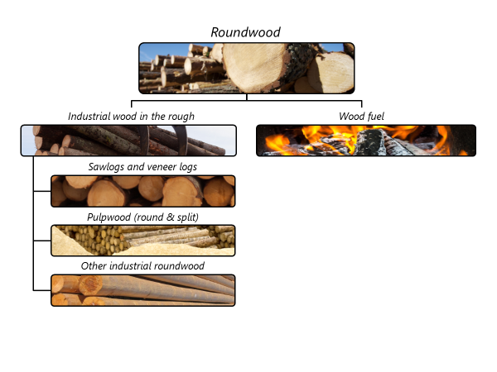

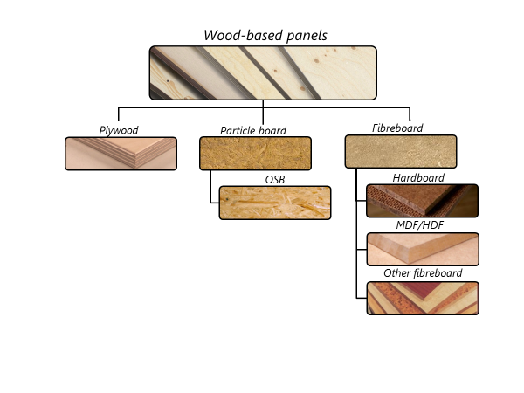

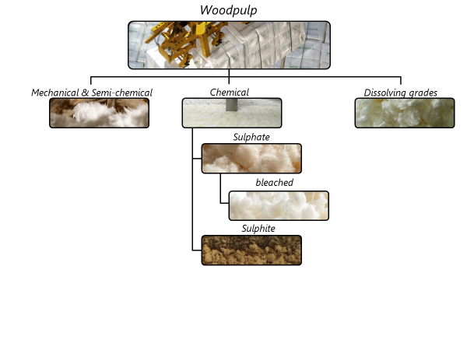

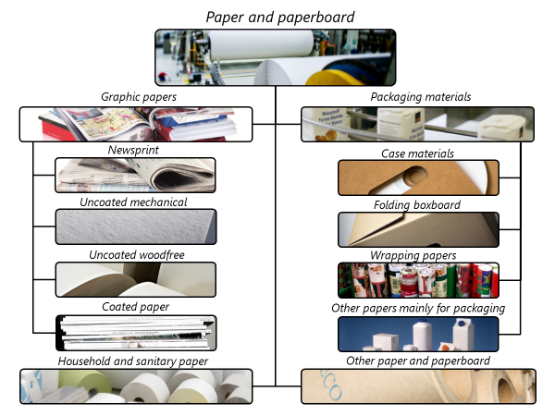

Symbol usage
We urge respondents to fill in the questionnaire completely. If, however, this is not possible, please try to use the following symbols. Blank spaces leave us unsure whether the data are not available or whether they are zero.

… = not available (please make an estimate!)

0 = nil or less than half the unit indicated

+++ = confidential

Conversion Factors

A page of conversion factors is included in the JFSQ and in the general notes that accompany the JFSQ. The same page can be found in the FAO Yearbook of Forest Products. This now includes a column showing information from the latest UNECE/FAO work on conversion factors. Please note that these factors are very general and should only be used if you find it impossible to locate country- or product-specific factors. For example the conversion from tonnes of roundwood to m³ varies by 15% between coniferous and non-coniferous and even greater variations can be found between species.

A frequent area of difficulty is converting the square meters often available in wood-based panels to the cubic meters required by the JFSQ. Please determine the standard conventional thickness for the products in your country. Usually the best source for this is the national panel association, mills within your country or international panel associations.

Changes from JQ2017 to JQ2018

Below is a complete list of all changes to JQ2018.

- Definitions
  - Revised definition of production to be more specific about inclusion of intermediate production of pulp and other products.
  - Added specific use of pulpwood in panels in title to make it more clear (item 1.2.2)
  - Excluded continuously produced wood chips (item 3.1)
  - Excluded bamboo from secondary processed products (items 13.3, 13.4, 13.7).
  - Excluded sanitary napkins from ready to use household and sanitary paper (item 14.3).
- Questionnaires – there were no changes

For EU/EFTA countries JQ2, JQ3, EU1 and ECE/EU can be pre-filled by Eurostat from Comext database.
It is not necessary to reply to ITTO1 if the country will reply to the Committee on Forests and the Forest Industry forecast questionnaire by October 2019. Members of ITTO should fill out ITTO2 and 3. Countries that provided forecast data in 2018 are indicated with a *.
UNECE/FAO Timber and Forest Discussion Paper No. 49 available at http://www.unece.org/fileadmin/DAM/timber/publications/DP-49.pdf

