JFSQ 2017

User Manual

Questionnaire Response Table
This table is to help understand which countries should complete Joint Forest Sector Questionnaires (JFSQ). The √ symbol indicates that the questionnaire should be submitted.

Region | Country | JQ1  JQ2  JQ3 | ECE/EU | EU1¹ EU2 | ITTO1 ITTO2 ITTO3
EU/EFTA  (return to Eurostat, Luxembourg and ECE, Geneva) | Austria | √ | √ | √ | √*
 | Belgium | √ | √ | √ | √
 | Bulgaria | √ | √ | √ | √*
 | Croatia | √ | √ | √ | √
 | Cyprus | √ | √ | √ | √*
 | Czechia | √ | √ | √ | √*
 | Denmark | √ | √ | √ | √*
 | Estonia | √ | √ | √ | √*
 | Finland | √ | √ | √ | √*
 | France | √ | √ | √ | √*
 | Germany | √ | √ | √ | √*
 | Greece | √ | √ | √ | √*
 | Hungary | √ | √ | √ | √
 | Iceland | √ | √ | √
 | Ireland | √ | √ | √ | √*
 | Italy | √ | √ | √ | √*
 | Latvia | √ | √ | √ | √*
 | Liechtenstein | √ | √ | √
 | Lithuania | √ | √ | √ | √*
 | Luxembourg | √ | √ | √ | √*
 | Malta | √ | √ | √ | √
 | Netherlands | √ | √ | √ | √*
 | Norway | √ | √ | √ | √*
 | Poland | √ | √ | √ | √*
 | Portugal | √ | √ | √ | √*
 | Romania | √ | √ | √ | √*
 | Slovakia | √ | √ | √ | √*
 | Slovenia | √ | √ | √ | √*
 | Spain | √ | √ | √ | √*
 | Sweden | √ | √ | √ | √*
 | Switzerland | √ | √ | √ | √*
 | UK | √ | √ | √ | √*
Other ECE  (return to ECE, Geneva) | Albania | √ | √ |  |  | √
 | Andorra | √ | √
 | Armenia | √ | √
 | Azerbaijan | √ | √
 | Belarus | √ | √
 | Bosnia and Her. | √ | √
 | Canada | √ | √
 | Georgia | √ | √
 | Israel | √ | √
 | Kazakhstan | √ | √
 | Kyrgyzstan | √ | √
 | Moldova | √ | √
 | Monaco | √ | √
 | Montenegro | √ | √
 | Russian Fed | √ | √
 | San Marino | √ | √
 | Serbia | √ | √
 | Tajikistan | √ | √
 | FYR Macedonia | √ | √
 | Turkey | √ | √
 | Turkmenistan | √ | √
 | Ukraine | √ | √
 | United States | √ | √ |  |  | √*
 | Uzbekistan | √ | √
ITTO producer members not part of EU/EFTA or ECE  (return ITTO, Yokohama) |  | √ | √ |  |  | √
Rest of World (return FAO, Rome) |  | √

JFSQ Item codes
Below are algebraic expressions of the relationships of items in the JFSQ. These are to help in understanding and filling out the JFSQ in a way to minimize inconsistencies. As the item codes in the 2017 JFSQ have changed, a number of these expressions have changed as well.

1 = 1.1 + 1.2

1.1 = 1.1.C + 1.1.NC
1.2 = 1.2.1 + 1.2.2 + 1.2.3
= 1.2.C + 1.2.NC
= 1.2.1.C + 1.2.1.NC + 1.2.2.C + 1.2.2.NC + 1.2.3.C + 1.2.3.NC
1.2.C = 1.2.1.C + 1.2.2.C + 1.2.3.C
1.2.NC = 1.2.1.NC + 1.2.2.NC + 1.2.3.NC
1.2.NC ≥ 1.2.NC.T
1.2.1 = 1.2.1.C + 1.2.1.NC
1.2.2 = 1.2.2.C + 1.2.2.NC
1.2.3 = 1.2.3.C + 1.2.3.NC
1.2.NC.T >= 1.2.NC

3 = 3.1 + 3.2

5 = 5.1 + 5.2

6 = 6.C + 6.NC
6.NC ≥ 6.NC.T

7 = 7.C + 7.NC
7.NC ≥ 7.NC.T

8 = 8.1 + 8.2 + 8.3
8.1 = 8.1.C + 8.1.NC
8.1.NC ≥ 8.1.NC.T

8.2 ≥ 8.2.1
8.3 = 8.3.1 + 8.3.2 + 8.3.3

9 = 9.1 + 9.2 + 9.3
9.2 = 9.2.1 + 9.2.2
9.2.1 >= 9.2.1.1

10 = 10.1 + 10.2

12 = 12.1 + 12.2 + 12.3 + 12.4
12.1 = 12.1.1 + 12.1.2 + 12.1.3 + 12.1.4
12.3 = 12.3.1 + 12.3.2 + 12.3.3 + 12.3.4

Product Components

Note that only aggregates with more than two subproducts are shown here.

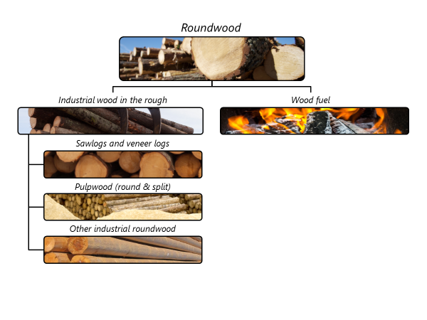

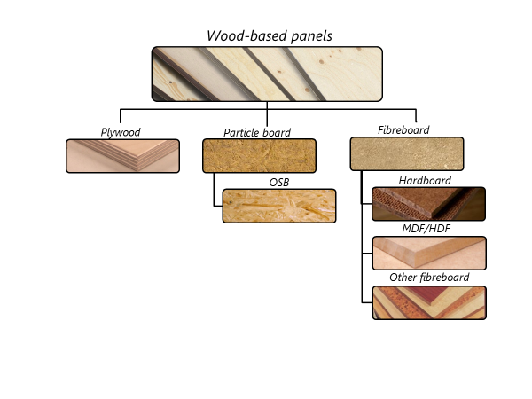

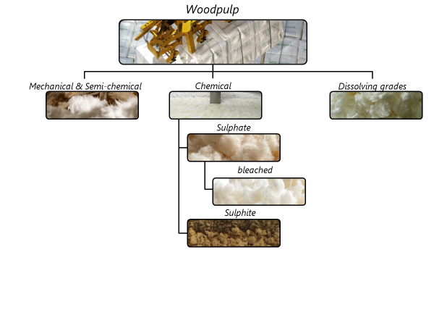

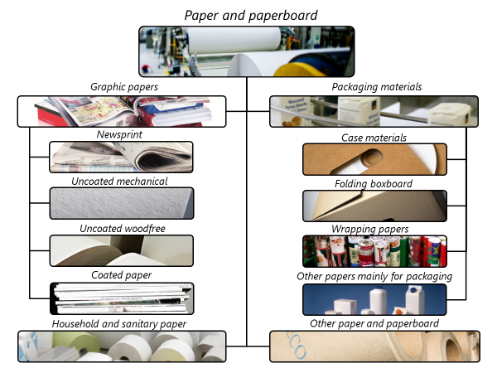

Symbol usage
We urge respondents to fill in the questionnaire completely. If, however, this is not possible, please try to use the following symbols. Blank spaces leave us unsure whether the data are not available or whether they are zero.

… = not available (please make an estimate!)

0 = nil or less than half the unit indicated

+++ = confidential

Conversion Factors

A page of conversion factors is included in the JFSQ and in the general notes that accompany the JFSQ. The same page can be found in the FAO Yearbook of Forest Products. This now includes a column showing information from the latest UNECE/FAO work on conversion factors. Please note that these factors are very general and should only be used if you find it impossible to locate country- or product-specific factors. For example the conversion from tonnes of roundwood to m³ varies by 15% between coniferous and non-coniferous and even greater variations can be found between species.

A frequent area of difficulty is converting the square meters often available in wood-based panels to the cubic meters required by the JFSQ. Please determine the standard conventional thickness for the products in your country. Usually the best source for this is the national panel association, mills within your country or international panel associations.

Changes from JQ2016 to JQ2017

Below is a complete list of all changes to JQ2017. These are more extensive than in the past five years due to the revision of the Harmonised System classification and adaptation of the questionnaire to current technologies. The more significant changes are in bold.

- Definitions
  - Added treated logs (item 1, C/NC)
  - Added definition for recovered post-consumer wood (item 4)
  - Added sleepers to definition of sawnwood (item 6)
  - Revised veneer sheets definition to include all veneer sheets, including those produced for plywood (item 7)
  - Added chipboard to particleboard (item 8.2)
  - Other fibreboard to include both wet and dry process fibreboard (item 8.3.3)
  - Dissolving grade wood pulp includes high-purity cellulose (item 9.3)
  - Other manufactured wood products (item 13.7) now includes hoopwood, split poles, piles, pickets; wood wool, wood flour and densified wood.
  - Other articles of paper now includes carbon and copying paper (item 14.5).
- Questionnaires
  - JQ1
    - Dropped removals of coniferous and non-coniferous roundwood (items 1.C and 1.NC)
    - Added removals of tropical industrial roundwood (item 1.2.NC.T)
  - JQ1 & JQ2
    - Created item for recovered post-consumer wood on JQ1 (and also Q2 (new item 4)
    - Removed veneer sheets as part of wood-based panels and created as stand-alone item (new item 7)
    - Combined mechanical and semi-chemical pulp into single item (new item number 9.1)
    - Removed unbleached sulphate pulp
    - Removed breakdown of sulphite pulp into bleached and unbleached
  - JQ3
    - Removed item for prefabricated buildings
    - Removed item for carbon and copying paper
    - Rearranged sequence of items on secondary wood products (item 13)
  - ECE-EU
    - Removed item for logs and pulpwood for 1.2.NC (oak and beech)

For EU/EFTA countries JQ2, JQ3, EU1 and ECE/EU can be pre-filled by Eurostat from Comext database.
It is not necessary to reply to ITTO1 if the country will reply to the Committee on Forests and the Forest Industry forecast questionnaire by October 2018. Members of ITTO should fill out ITTO2 and 3 however. Countries that provided forecast data in 2017 are indicated with a *.
UNECE/FAO Timber and Forest Discussion Paper No. 49 available at http://www.unece.org/fileadmin/DAM/timber/publications/DP-49.pdf

