Draft Improving leverage of existing Global PRTR portal websites

Analysis and proposals for the improvement and synergies of the global PRTR webs

Prepared by the Chair of ICG in consultation with ECE, OECD and UNITAR

INDEX
1.- Introduction 1
1.1. Goals 1
2.-Methodology 2
2.1. Questions to be answered 2
2.2. Color code 2
3.- Global PRTR web sites assessed 3
3.1. OECD PRTR Portal 3
3.2. UNITAR PRTR PLATFORM 10
3.3 - IOMC toolbox on PRTR 14
3.4.- PRTR.net 16
4.- Assessment Outcomes 23
5. Conclusions and recommendations 25

1.- Introduction
PRTRs have become over the years one of the most useful tools in evaluating the environmental management and the sustainable development on a global scale. In this context, not only the development of criteria which enable the comparability and the common understanding across the existing PRTR systems but also ensuring a proper awareness and ease of use of information provided is still a great challenge. This fact is recognised by different stakeholders, decision-makers and international organizations, and has let to numerous works dealing with these issues so far.
Despite work carried out by the international organizations related to PRTRs; mainly UNECE, OECD, UNITAR, the available resources and the insights gained by countries which have already implemented PRTRs, another challenge that can be addressed also through global web portals is the basics of correct interpretation of data provided through PRTR systems, making them more understandable for users and comparing what is comparable.
The present document wants to be a first exercise of discussion focusing on how to enhance the current international resources of information in PRTR with the aim of avoiding overlaps and getting comprehensive online tools in this regards, to the extent possible.

1.1. Goals
Following-up the discussion and the mandate given by participants during the 11th ICG meeting, held on New York in 2017, this is a first paper prepared by the Chair on how to improve leverage of the existing online sources of information related to PRTRs. The aim of this paper is to improve the usefulness of the existing network of informative PRTR websites.
The following portals have been analysed in this document:
- PRTR.net: (Global portal on PRTR), managed by UNECE and OECD.
- OECD PRTR: OECD website on PRTR, including the Centre for PRTR Data (managed with the support of the Japanese Government) and the Resource Centre for Release Emission Techniques (RETs) (supported by the Finnish Government).
- UNITAR PRTR Platform: United Nations: website of PRTR UNITAR (United Nations Institute for Training and Research).
- IOMC Toolbox for Decision Making in Chemical Management (PRTR): managed by the Inter-Organization Programme for the Sound Management of Chemicals.

2.-Methodology
A straightforward, intuitive methodology has been tailored to compare these different websites identifying their common and unique features. It is based on the following elements:
- Asking simple questions about the websites’ content and how it is provided.
- Establishing a colour code highlighting the characteristic per each element assessed.
These elements are explained in more detail in the sections below.

2.1. Questions to be answered
Because the aims and target audience of each website analysed are different and, therefore, their designs, contents, sections and viewing do not have necessarily to follow the same criteria, an attempt has been made to identify possible common and differentiating website features by raising the following key questions:
- Which topics are covered by the website? | What PRTR is; goals, aims, benefits, uses, why PRTRs, key/core elements, data/statistics’ of user/visits/queries, etc…
- What type of information is shown? | Technical data, search options, documentary background… (legal, guidelines/guidance’s, technical/training documents,…)
- How is the information provided? | Is it understandable? well organised?, user-friendly?,…  On-line, download options, formats, aggregated/disaggregated….
- Is the site available in different world languages? | Only one?, two? More than three? Which ones?,  the whole site?, only some/part of the information?...
- What organizations/institutions are in charge of the website? | Public/private, are they international, global?,

2.2. Color code
In order to carry out an exhaustive analysis of these web portals, all and each one of the corresponding pages and sections have been systematically visualised. In addition to answering the key questions indicated above, for the different websites identifying their key features. A colour code has been developed to classify them in the following way:
COLOR USED | MEANING
Common part
Green means: the section/content discussed is a common aspect in all websites, even though not necessarily descriptions verbatim match.
Description part
Text in black, without color, means: descriptive information on the respective section/content.
The most specific information
Red means: specific sections/contents of the analysed web portal. From the point of view of the study carried out, the information offered in these sections is what is deemed to be of "greatest interest" or "most relevant" and what, where appropriate, should be particularly visualised as the "most specialised and distinctive information" of the website.

3.- Global PRTR web sites assessed

3.1. OECD PRTR Portal
The OECD's PRTR Web Portal is posted as a specific section in the area of Chemical Safety and Biosafety.
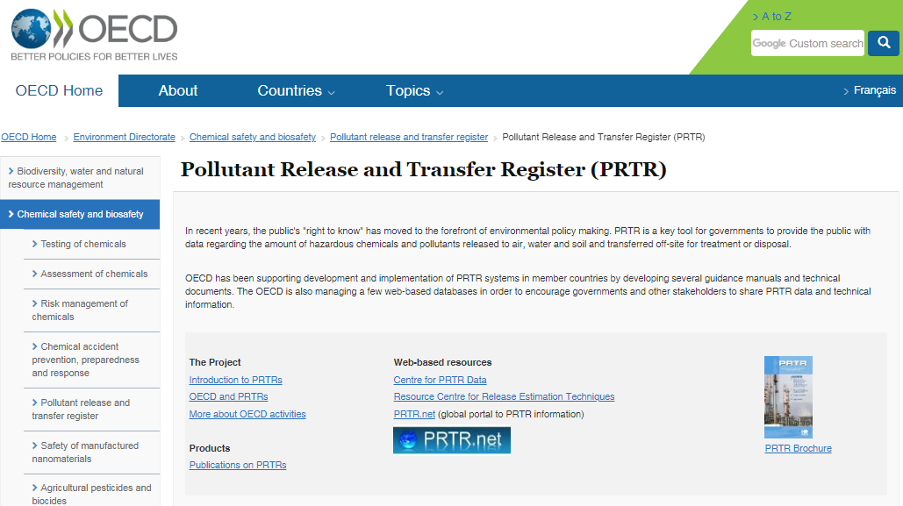
Reference: OECD PRTR Portal 02/07/2019 9:5
The home page of PRTRs is quite schematic from which different sections of information are accessed, namely:
The Project  Introduction to PRTRs  OECD and PRTRs  More about OECD activities  Products  Publications on PRTRs | Web-based resources  Centre for PRTR Data  Resource Centre for Release Estimation Techniques  PRTR.net (global portal to PRTR information) | 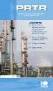‌  PRTR Brochure
Reference: OECD PRTR Portal 02/07/2019 9:5
The page is only available in two languages: English and French.
The content of each of these sections is discussed below.

3.1.1.-Introduction to PRTRs
In this section two main topics are addressed (*):
`What is a PRTR?:  PRTR definition, main characteristics and benefits. | 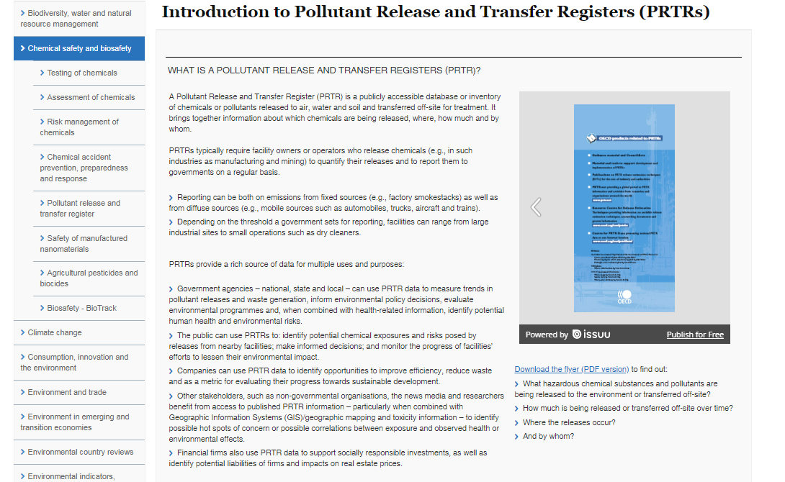
History of PRTR at the OECD:  Information about the OECD role in the promotion and implementation of PRTRs. | 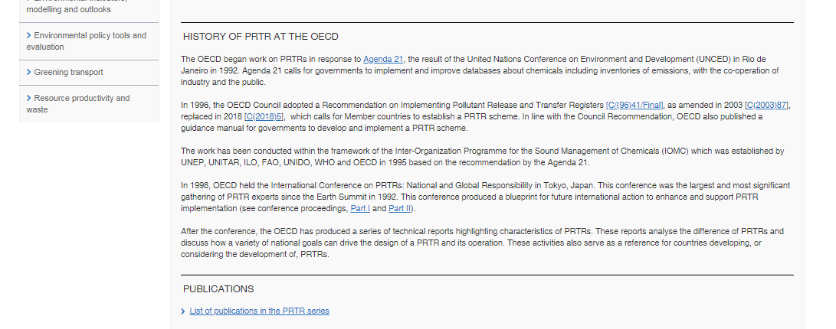
(*) see section 2.2 of this document to know more about the green colour used

3.1.2.- OECD and PRTRs
This section (*) provides more information with the role of the OECD particularly on the Council´s Recommendation on PRTRs and other interesting information related to this topic
Beginning on the Work- OECD Council´s Recommendation  Implementation of the Council Recommendation | 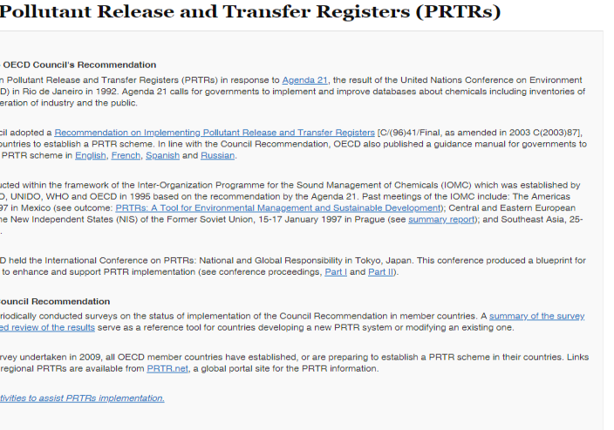
(*) see section 2.2 of this document to know more about the green colour used

Although the information provided focuses on the process of implementation of PRTRs in OECD member countries, it may be very interesting not only for the other OECD countries that have not yet implemented a PRTR but also for other non-OECD countries.

3.1.3.- More about the OECD activities on PRTRs:
In this section (*) specific information about the ongoing activities carried about at the OECD is given. The main aim of these activities is to develop practical tools to help countries to establish and implement a PRTR, focusing on some of the most important challenges of the PRTRs such as improving data quality, PRTR data application and harmonization of PRTRs globally
Ongoing activities  - Improving data quality  - PRTR data applications  - Harmonization of PRTRs across the countries | 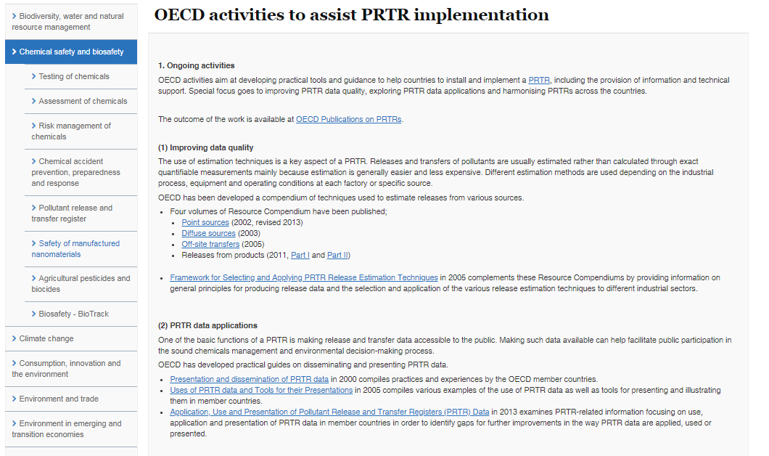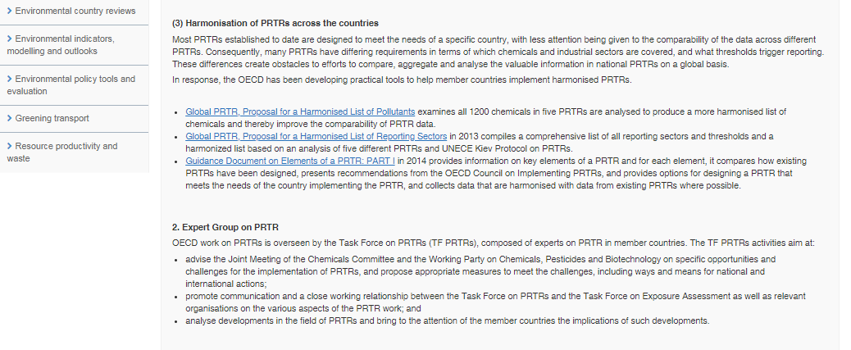
Expert Group on PRTR
Information about the body in charge of overseeing the OECD PRTR activities.
(*) see section 2.2 of this document to know more about the green colour used
All the information shown in this part is exclusive to the OECD and is based on the different experiences of the countries with PRTRs and therefore constitutes an essential source of information for those others that are in the process of implementing a PRTR or considering it. That is why this section is classified as “red” one, in terms of the aim of this study.

3.1.4.- Web-based resources
This is another specific piece of information only provided by the OECD portal. There are two main topics:
- Centre for PRTR Data, and
- Resource Centre for PRTRs

A).- Centre for PRTR data (*).
Centre for PRTR Data.  The aim of this database is to share PRTR data as widely as possible within the OECD area. PRTR data included is compiled on a national or regional level. Information at facility level is not shown.  It is regularly updated based on voluntarily submitted data as there is no any mandatory requirement to any OECD country to submit its data.  (Japan serves as a lead country in this activity) | 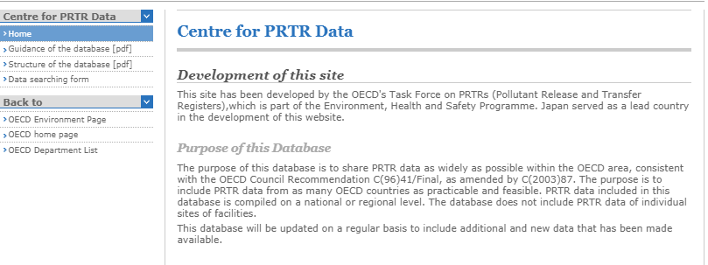
Search options:  - By country  - By pollutant  - By sector  - By type of source  - By year  - By type of emissions/transfers | 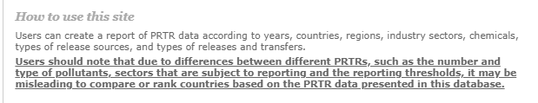  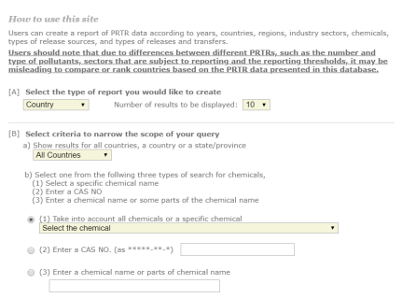  Information from 40 countries.
(*) see section 2.2 of this document to know more about the green colour used
This database is the only one in which data from different countries on a global scale can be consulted. Somehow, it complements the two regional registries that currently exist, the E-PRTR and the North American PRTR managed by the Commission for Environmental Cooperation (CEC).
This remarkable section should be made more visible worldwide, precisely because of its uniqueness in which comparable information from many countries are shared, even further bearing in mind that it is built on a voluntary basis.

B).- Resource Centre for PRTRs (*).
This sub-section is also an OECD specific compilation. There are many of documentary repositories in almost all the existing PRTRs websites, usually considering its particularities. So, the advantage of having such a "general compilation on Release Estimation Techniques (RETs)" is that it could be served as the reference site to display all the available information in this regard could be accessible for everyone who could need it. It would also be helpful in terms of moving forward to a greater comparability globally through applying and naming the specific RETs employed to prepare PRTR data.
Canada was the first leader of this project, followed by the Finish Government (Finnish Environment Institute SYKE) who currently handle the Resource Centre for PRTRs. It is updated on a regular basis to include additional and new documents.
As in the previous case (Centre for PRTR data), this sub-section should be made more visible worldwide.
Options available:  - RETs documents available from the OECD member countries and international organizations.  - PRTR guidance documents.  - Emission Scenario Documents.  - Country-Specific PRTR website and international organizations. | 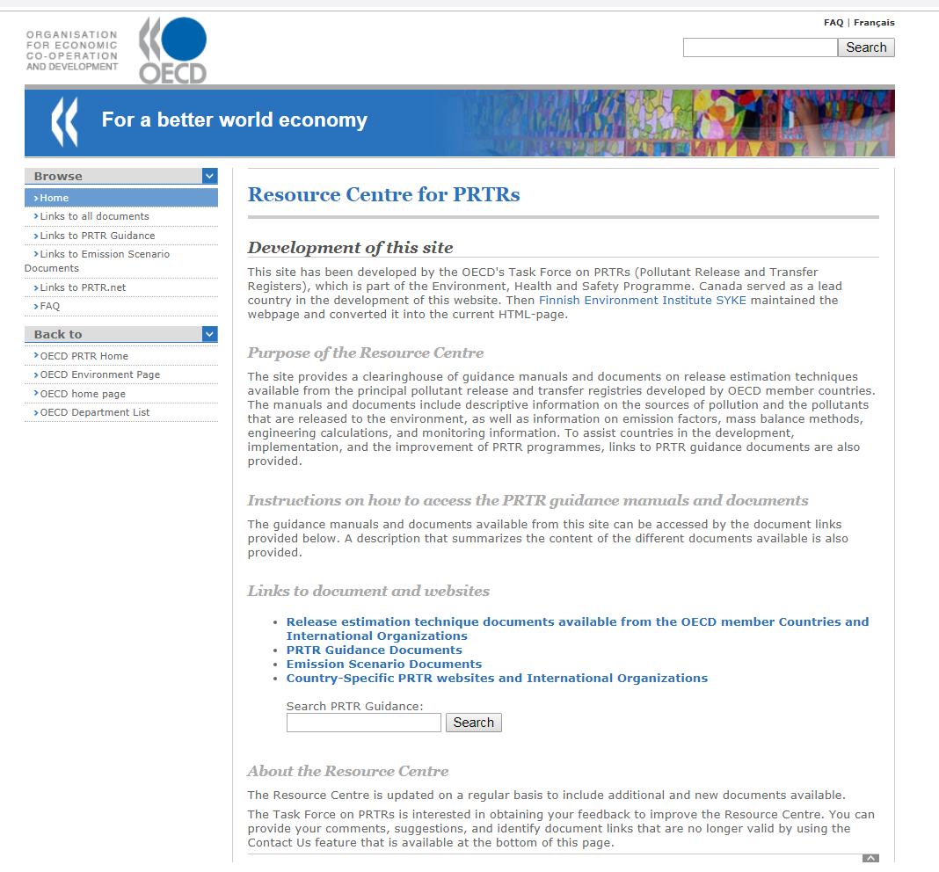
(*) see section 2.2 of this document to know more about the green colour used
A third topic is covered by the Web-based resources section, that is the inclusion of a direct link to PRTR.NET, which is also described later in this document.

3.1.5.- Products: Publications on PRTRs (*).
“Products” mainly means “documents”. In this section, all PRTR documents produced by the OECD can be consulted and downloaded. Essentially they refer to guidance documents on several PRTR related issues.
Three types of publications:  - Council Acts  - Guidance Manuals:  - Global PRTRs  - PRTR data Applications  - RETs  - Workshop Report  - Other publications | 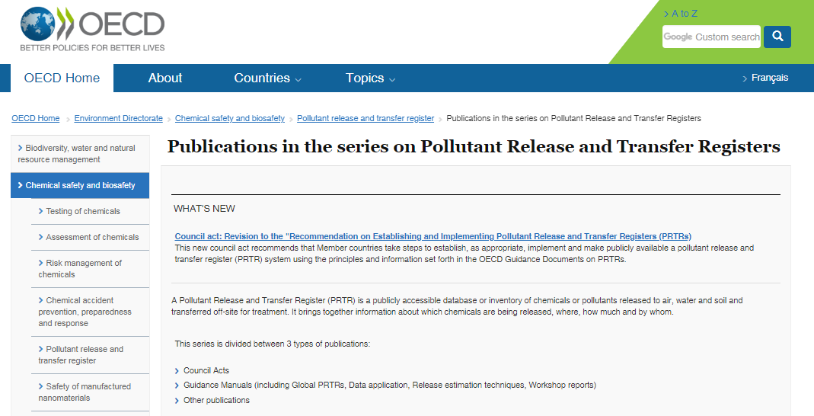
(*) see section 2.2 of this document to know more about the green colour used
Once again, this is a very noteworthy section of the OECD website. It would be quite appropriate to say that it is certainly one of the best-known sections consulted, since these manuals are frequently used as a reference for those countries that are in the process of implementing a PRTR.

3.2. UNITAR PRTR PLATFORM
The UNITAR (United Nations Institute for Training and Research) PRTR Platform is a website developed under the UNITAR’s Chemicals and Waste Management Programme framework focused on providing institutional, technical and legal infrastructure support and capacities for sound management of chemicals. The aim of this PRTR Platform is to provide specific information about the main activities carried out by UNITAR in promoting PRTRs as helpful tools for countries to comply with the reporting requirements under the international environmental conventions related to the management of chemicals.
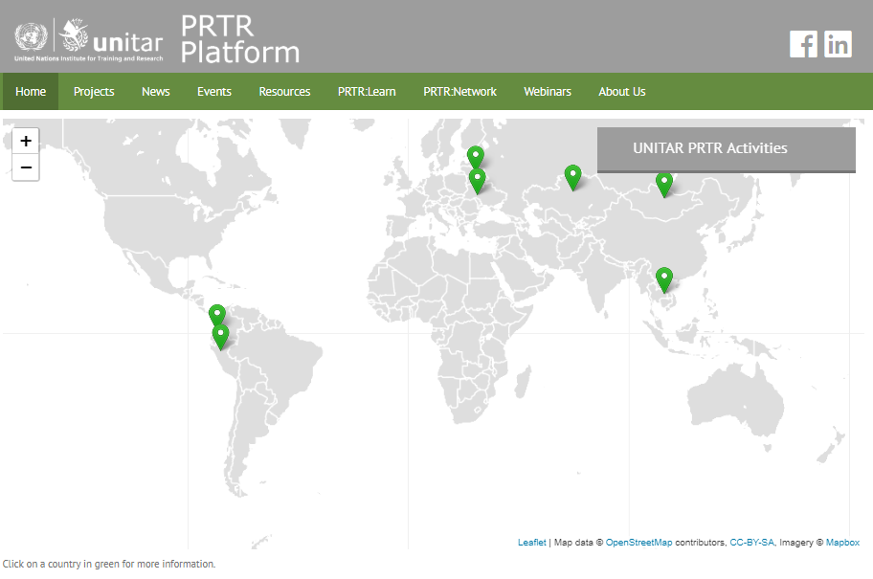
Besides the horizontal browser bar linking to the main sections of the web, the home page is dominated by a mapa mundi displaying the UNITAR ongoing activities in PRTRs. Also in this homepage are presented general ideas about PRTRs and its valuable information is shown:

`What is a PRTR?:  PRTR definition, main characteristics and benefits, using simple questions to point out the reader´s interest.  Summarizing windows:  with the latest in each section and links to “see/read more” | 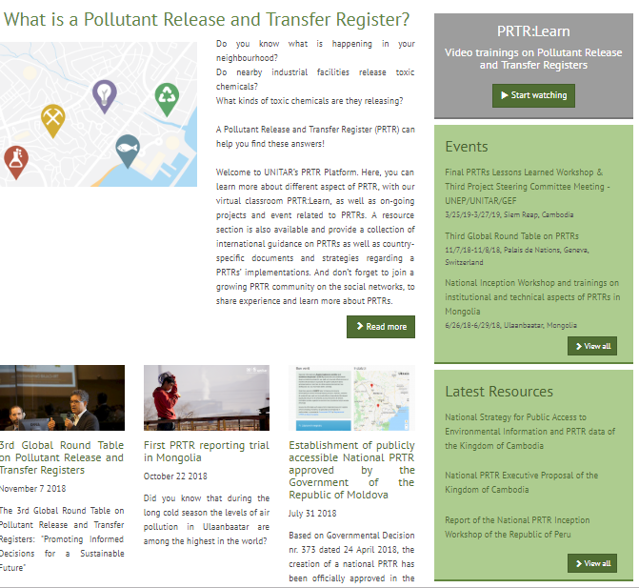
(*) see section 2.2 of this document to know more about the green colour used
The UNITAR PRTR Platform is only accessible in English

3.2.1.- UNITAR PRTR descriptive sections
The following site´s sections provide mostly information focused on the various ongoing UNITAR projects, the latest activities and the most relevant developments. These sections have therefore been classified as "descriptive" (*) for the purposes of this work.
Projects  UNITAR ongoing or terminated country projects | 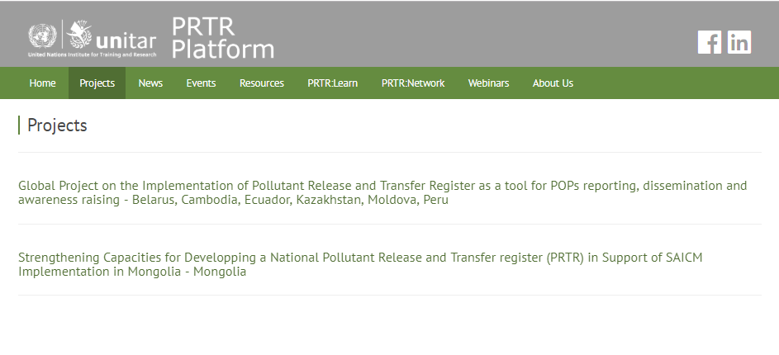
News  Latest news related to PRTR meetings, events, publications, articles, etc. | 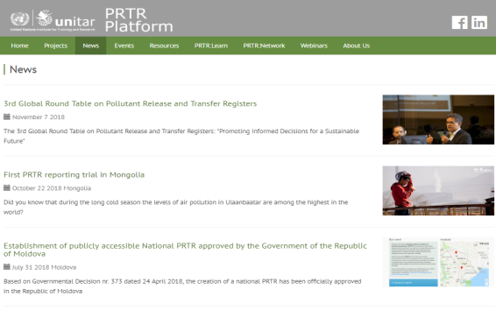
Events  Information on international and national events (workshops, conferences, meetings) related to PRTRs | 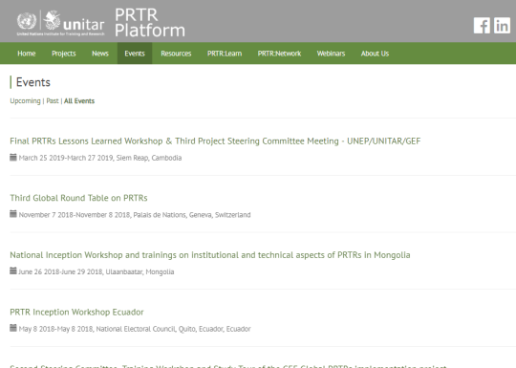
Resources  PRTR guidelines and documents produced by national institutions and international organizations. Materials organized: By theme; by organization; by country. | 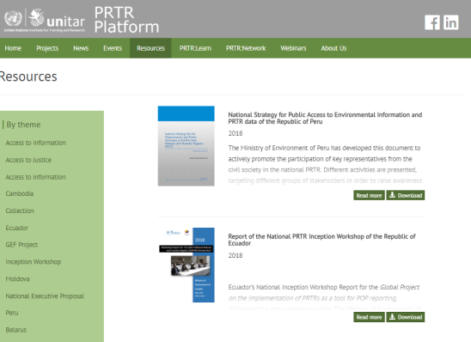
Webinars  Virtual PRTR classroom where users can access information such as topic and link of the next scheduled webinar. Webinars are usually open, free and the address specific PRTR topics, with the participation of international PRTR experts. | 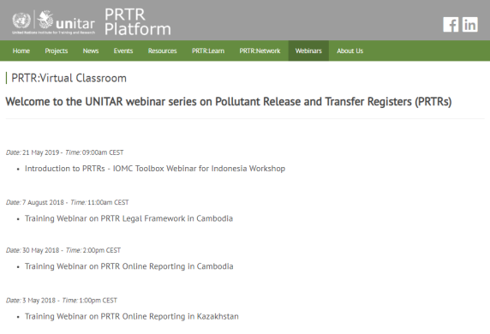
Though this section is mainly a “descriptive” one, it could be also very useful to use it in a broader context
(*) see section 2.2 of this document to know more about the green colour used

3.2.2.- PRTR:Learn and PRTR:network
Especially interesting from the perspective of this work are the sections called PRTR:Learn and PRTR:network, which should be more exploited and visible to the global PRTR community.
PRTR:Learn (*)  Explanatory videos about different topics:  - communication and data formulation,  - legal implementation,  - RETs  - Data Standardization  - Online Reporting Systems  (and the corresponding instructions) | 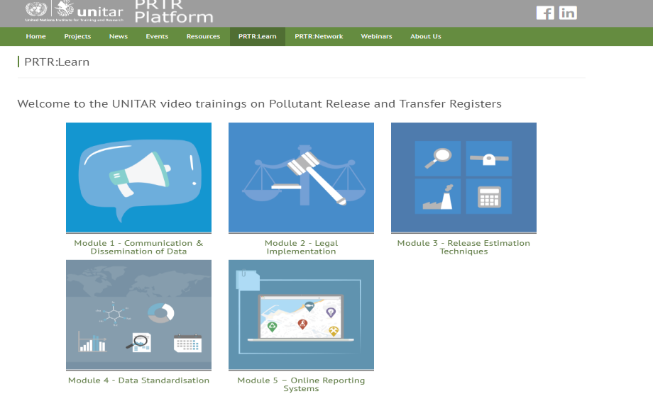
PRTR:Network (*)  Using the social networks to connect the global PRTR community:  - Facebook group to reach out to the more general audience  - LinkedIn group to facilitate the creation of a network of international PRTR experts | 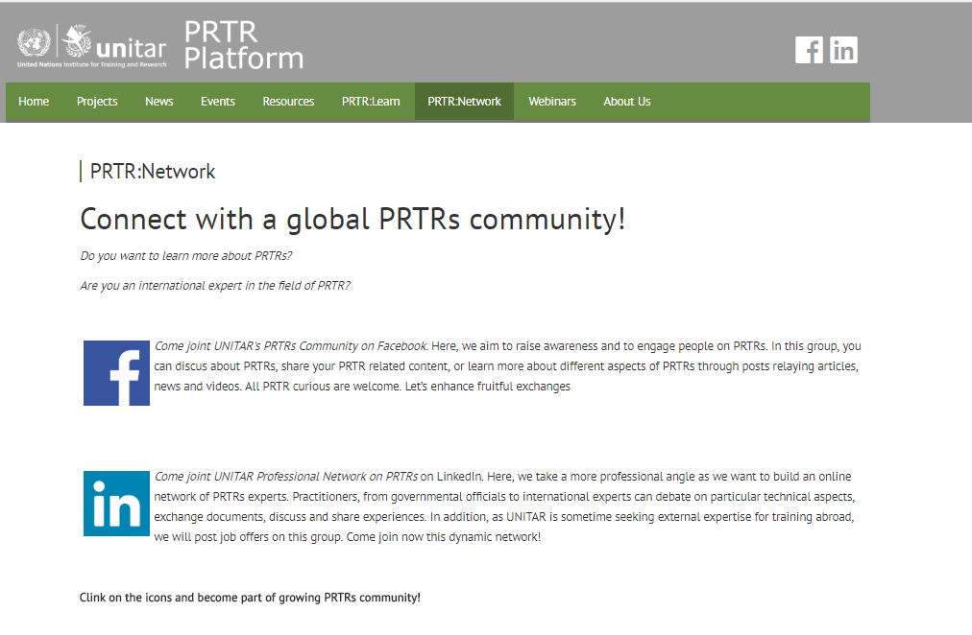
(*) see section 2.2 of this document to know more about the green colour used

3.3 - IOMC toolbox on PRTR
The third global portal in PRTR assessed is the IOMC Toolbox on PRTR, handled by the Inter-Organization Programme for the Sound Management of Chemicals (IOMC) - a collaborative agreement between FAO, ILO, UNDP, UN Environment, UNIDO, UNITAR, WHO, the World Bank and the OECD.
Actually, the IOMC Toolbox scheme on PRTR constitutes one of the possible options in the more general IOCM platform developed to facilitate countries in their implementation and decision making processes in chemicals management:
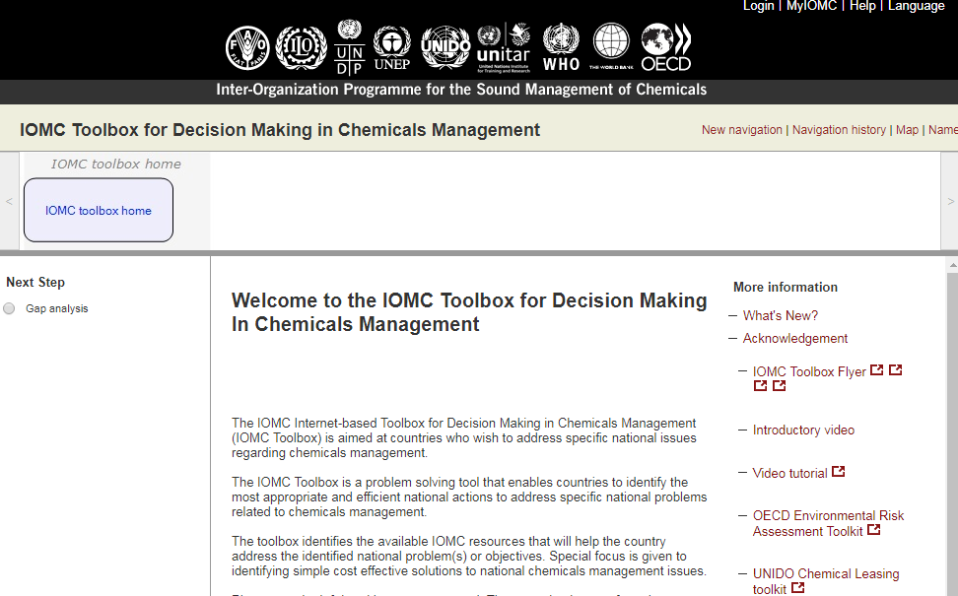
This website is available in three languages: English, Spanish and French.
The site is currently under revision and will be promptly replaced by a new one. The new image of this new site can be seen in this link:
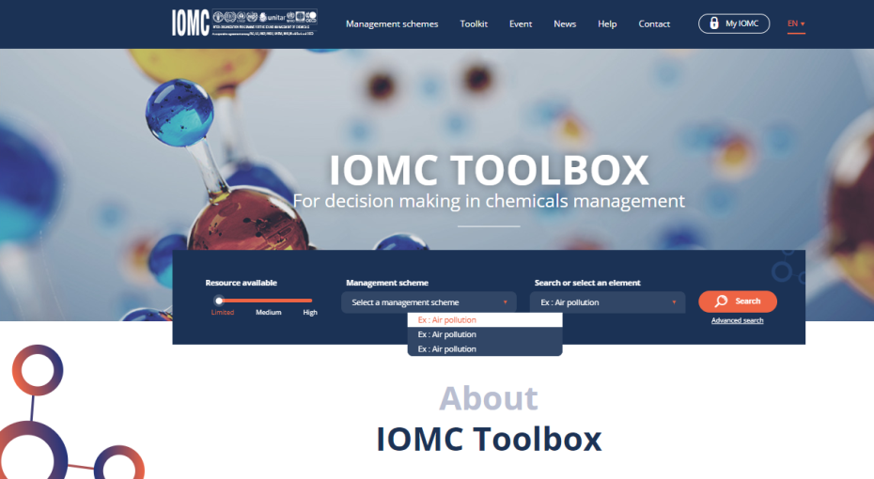
The IOMC Toolbox includes 8 chemicals management schemes. Among those, the Toolbox provides a dedicated PRTR scheme to help countries that are in the initial phase of PRTR design, or in a more advanced implementation phase, to find the relevant PRTR documents and guidelines published by IOMC organizations. Trying to summarize the way the current version works, the tool is developing a customized flowchart, depending on the selected options in each step. For each one of these choices, a series of recommendations on how to move the process forward are offered.
IOMC Toolbox for Decisión Making in Chemical Managements:  National Management Scheme for PRTR (IOMC Toolbox for PRTRs) (*) | 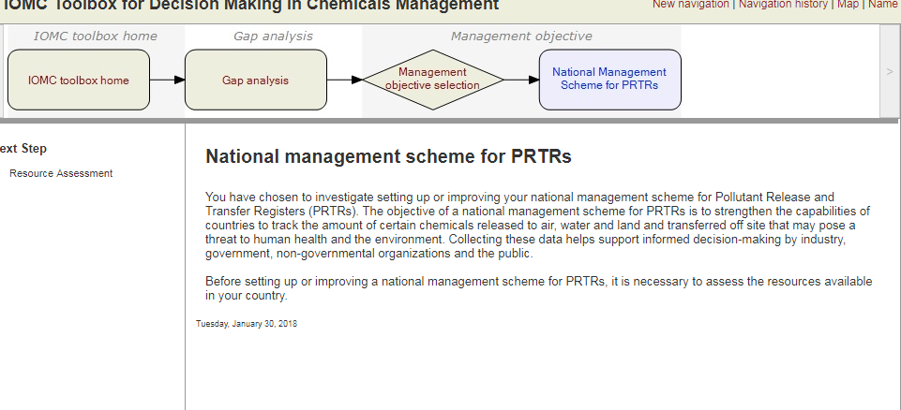  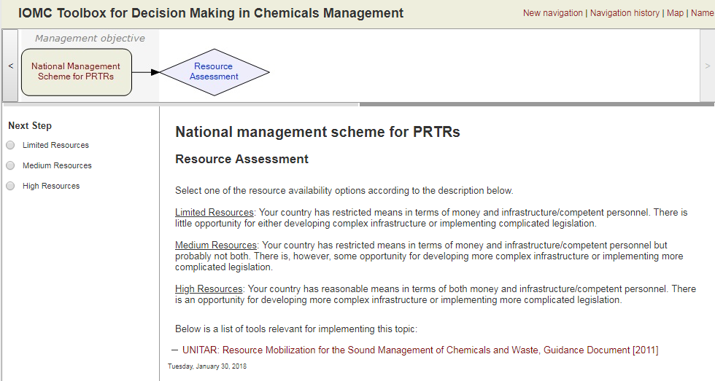  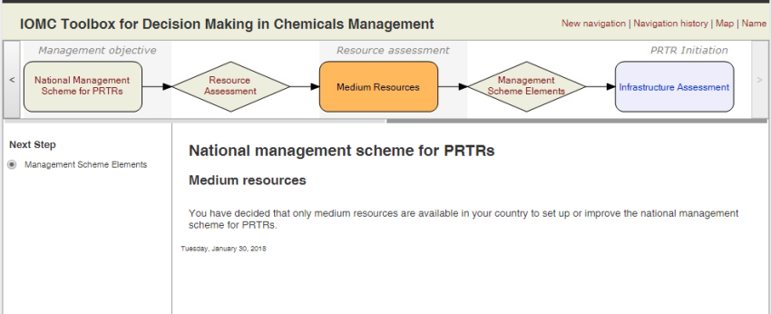  …
(*) see section 2.2 of this document to learn more about the green colour used
Though the information used to develop the flowchart is based on both the OECD and UNITAR guidance materials, this section is clasifyed as “red” one for the purpose of this exercise, since it is a user-friendly way of proceeding.

3.4.- PRTR.net
This PRTR portal is the one with the most global perspective of all the websites analysed.
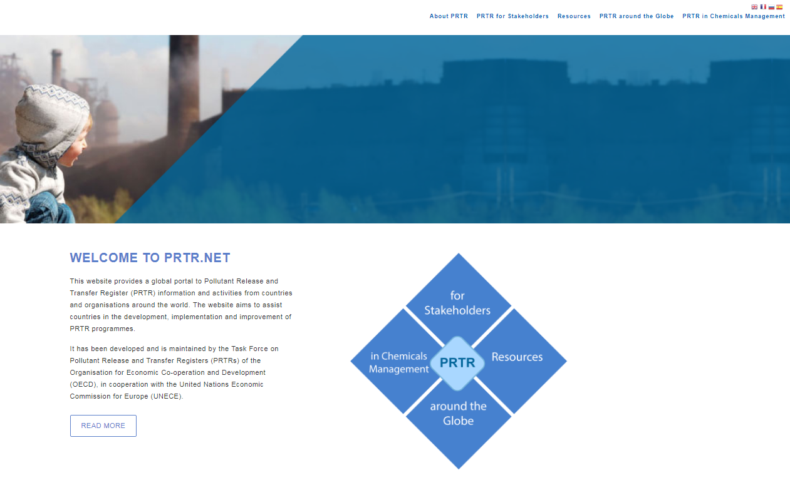
It has been designed to serve as the main showcase in relation to PRTR information and activities worldwide. Assisting countries in their implementation and/or improvement of PRTR programmes is the final goal of this website.
Currently the website is hosted and maintained by the UNECE and is managed substantively jointly by UNECE and OECD.
The information provided on the website is available, so far, in four languages: English, French, Russian and Spanish.
Besides the corresponding browser bar and quick access to several sections, the latest news and resources on PRTRs are also summarized in the home page.
In following chapters is analysed a little bit more deeply into how this page is structured and its contents.

3.4.1.- About PRTR section.
This section is common to other websites, while including specific aspects, such as PRTR vs sustainability and frequent asking questions (F.A.Q.):
About PRTR (*):  PRTR definition, core elements and benefits for stakeholder…  In this section also: | 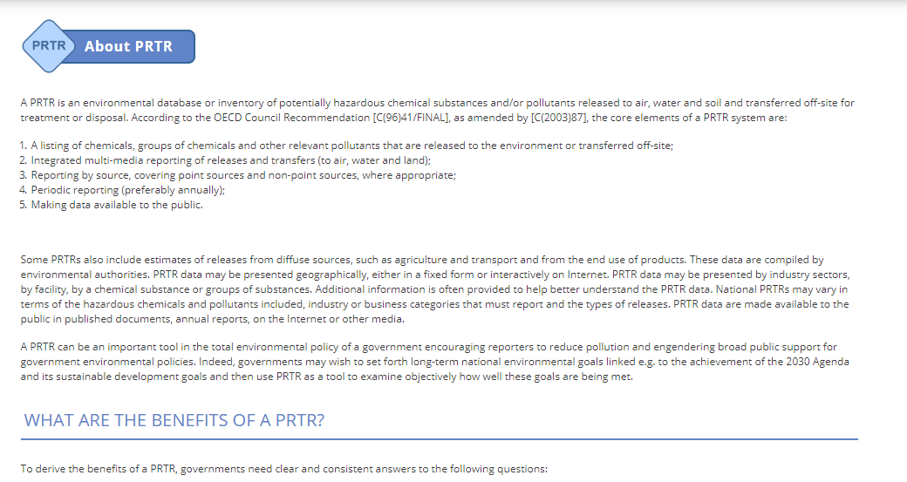
Information about the role of PRTR in sustainable development… | 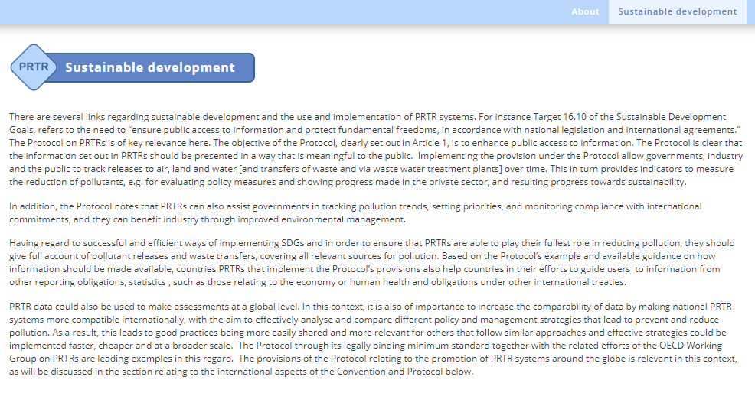
…  F.A.Q. | 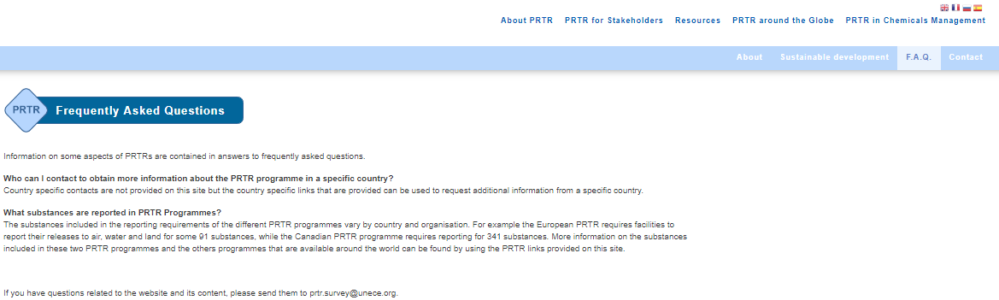
(*) see section 2.2 of this document to know more about the green colour used

3.4.2.- PRTR for Stakeholders
Though this information is similar on some of the other website, not so how to present it:
PRTR for Stakeholders (*):  Who stakeholders are and how they can use PRTR data… | 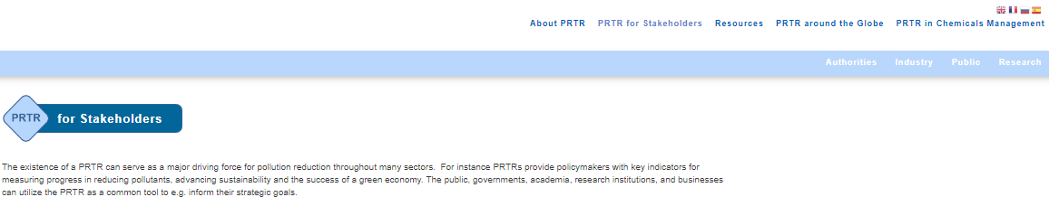
Authorities | 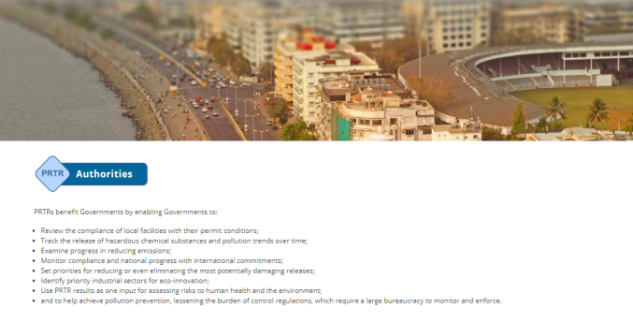
Industry | 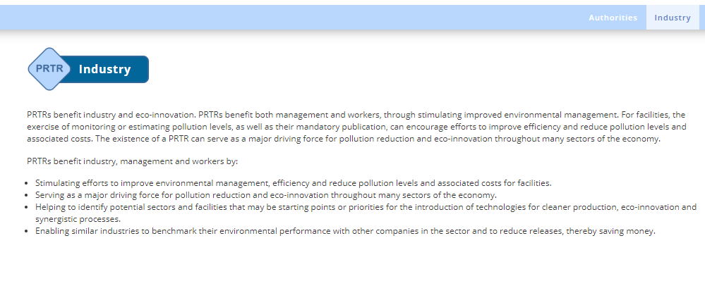
Public in general | 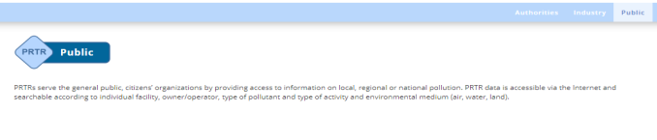
Research | 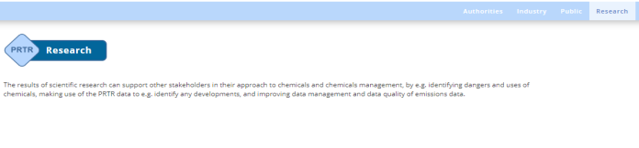
(*) see section 2.2 of this document to know more about the green colour used

3.4.3.- Resources
A worthwhile section since it is not a compendium of technical documents and manuals but a list of links in which such information can be found. In addition, potential site visitors are also invited to contribute with new sources of information or updating the existing ones, through the possibility of contacting directly the different website administrators.
Resources (*):  Focus on materials from the implementing authority´s perspective | 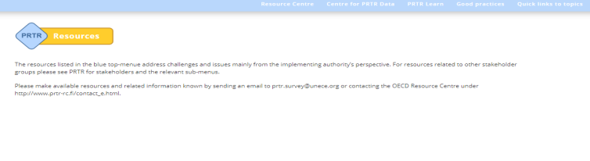
Links to:
- OECD Resource Centre for PRTR
- OECD Centre for PRTR Data
- PRTR Learn

Other specific sub-sections are:
Good Practices (*):  Dataset and compendium of good practices based on the information provided by stakeholders sharing their experiences in implementation PRTR programmes, structured in several topics:  - Organization of work at the national level  - Data design  - Data quality  - Pollutants, activities and emissions from diffuses sources  - Website design and improved usability  Search options given | 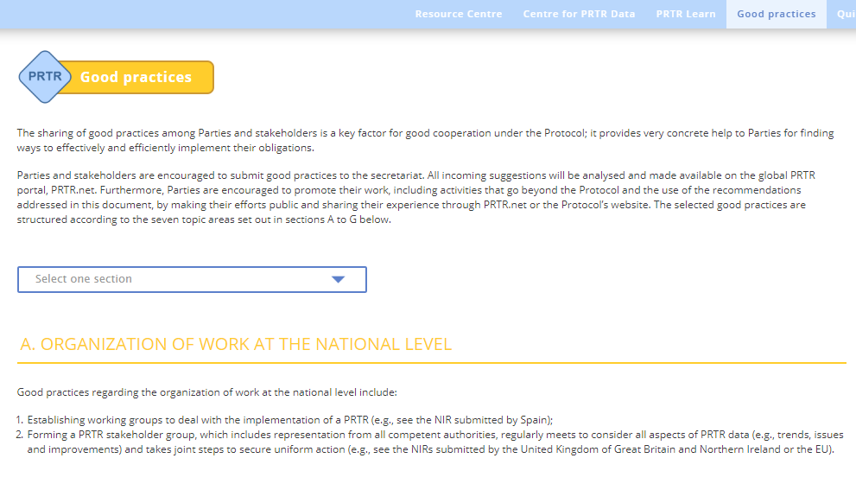
(*) see section 2.2 of this document to know more about the green colour used

Quick links to topics (*):  Additional interesting materials such as:  - Videos  - Global round table presentations  Search options given | 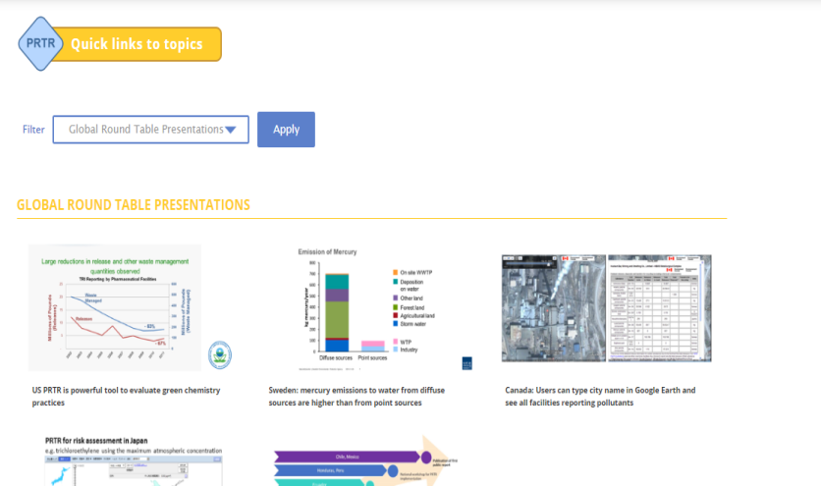
(*) see section 2.2 of this document to know more about the green colour used
The way this "Resources" section is structured and designed, constitutes a really good example on how to leverage the information and contents from the different global portals. The only outstanding issue would be to gain greater visibility of these actions so that all stakeholders could take better advantage from them.

3.4.4.- PRTR around the Globe
Yet again, this is a specific section of this site, partly at least. Certainly, other portals also provide links to the several implemented PRTRs and other international organizations. The global PRTR map is an original and extremely handy way to show how PRTRs are being implemented globally.

PRTR around the Globe (*) | 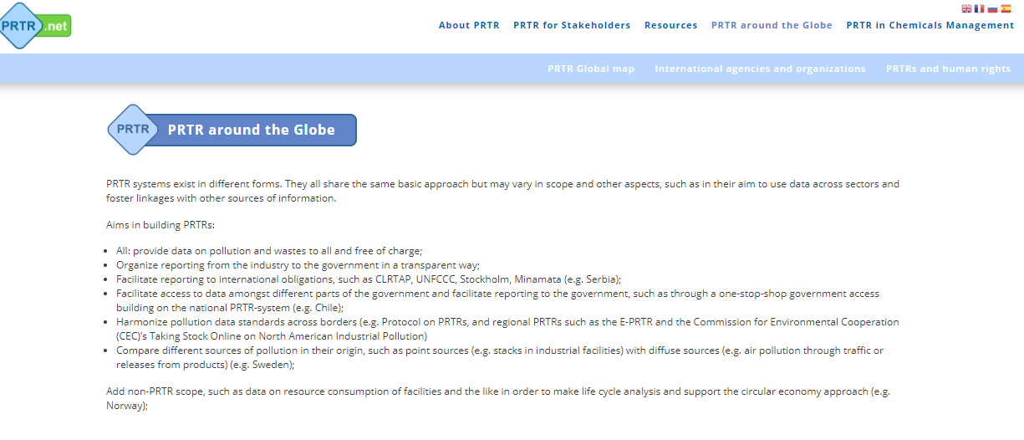
PRTR Global map (*)  Direct access to national PRTR clicking on the map (“green” countries).  A table below the map with additional information is also provided | 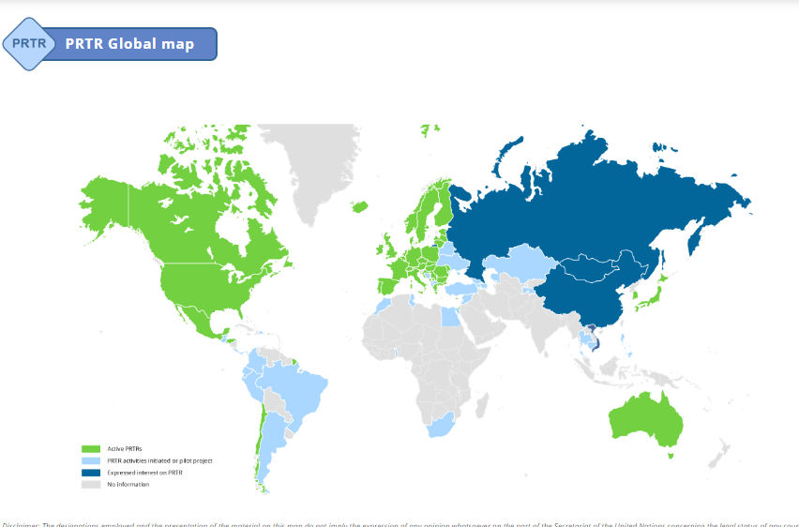
Links to other international agencies and organizations | 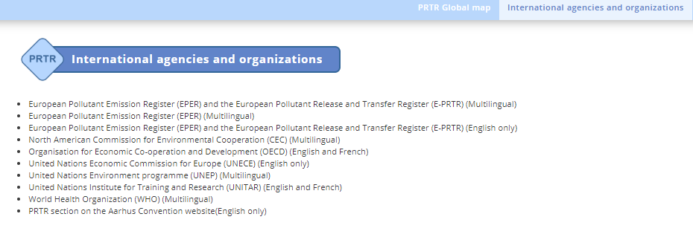
PRTR and human rights | 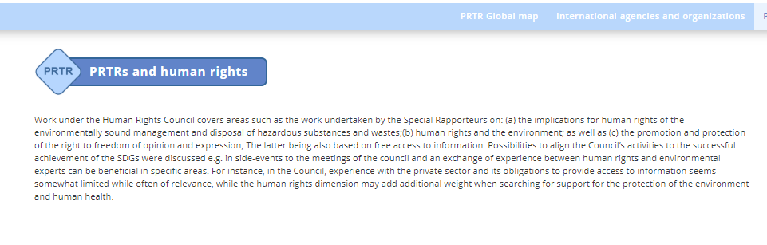
(*) see section 2.2 of this document to know more about the green colour used
The PRTR Global map should be significantly more visible, maybe using it as the image on the homepage

3.4.5.- PRTR in chemical management
This is again a specific section, at least in terms of how the information is presented.
PRTR in chemical management (*)  Two main sub-sections | 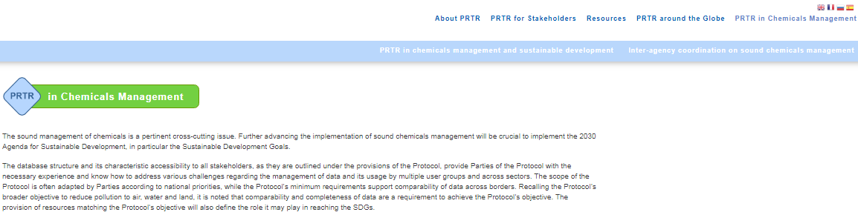
PRTR in chemical management and sustainable development | 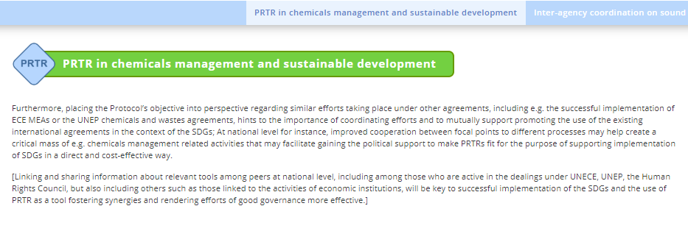
PRTR Inter-agency coordination on sound chemical managent  (link to IOCM Toolbox on PRTR) | 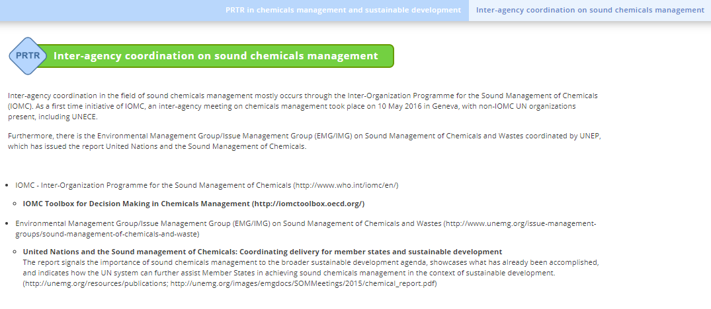
(*) see section 2.2 of this document to know more about the green colour used

The way this section is structured and designed, is another good example on improving leverage of the different global PRTR portals.

4.- Appraisal Outcomes
The following table sums up the main findings of the evaluation carried out on the existing PRTR global portals, taking into account the methodology described in the chapter 2 of this document and bearing in mind the primary objective of which is to improve the exchange of information on the use and good practices in the implementation of PRTR systems at a global level.
TOPIC/ELEMENT | OECD PRTR | UNITAR PRTR | IOMC toolbox | PRTR.net
Explains what PRTR is | X | X | X | X
Describes PRTR goals/core elements | X | X | X | X
Describes PRTR benefits | X | X | X | X
Search options/tools | X⁽¹⁾ | X⁽¹⁾ | X⁽¹⁾ | X⁽¹⁾
Provides aggregated information on releases/transfers data (Centre for PRTR data, OECD) | X
Gives information using social network | X | X
Provides technical documents, guidance, capacity building and, training materials, manuals, webinars, explanatory videos and/or other type of documentation. | X | X | X | X
Describes the PRTR implementation process step by step |  |  | X
Show a global view about the PRTR state of implementation. |  |  |  | X
Contains a “Frequently Asked Question” section |  |  |  | X
Gives specific information addressed to different stakeholders | X⁽²⁾ | X⁽²⁾ | X⁽²⁾ | X⁽²⁾
Links to PRTRs, international organization, etc. | X |  |  | X
Available in one language |  | X
Available in two languages | X⁽³⁾
Available in three or more languages. |  |  | X | X⁽⁴⁾
- Mainly in those sections relating to compiled data/documents.
- PRTR.net is the best example on this issue.
- Some documents (Resource Centre for RETs) are feasibly in other languages than English
- Generally speaking is recommended to use the international language acronyms instead of specific flags to identify the available languages.

In addition to the likeness and differences listed in the table above, certain weaknesses or common shortcomings to all of these websites can be pinpointed from this thorough analysis:
- With the exception of PRTR.net, the rest of the sites are very specific and much focused on "their" target audience.
- Only PRTR.net is available in over three languages, in all its sections and tools. In this regard, it should also be noted that most of the technical documents and guidelines available are just in English.
- It seems that these global portals hardly have any impact on those who are not working directly on PRTRs and are more known as potential resources for technical documents or for guidance to authorities involved in PRTR implementation and management. Also, it seems that the public in general does not know about these portals, therefore it is difficult for the public to consult them and be aware of the benefits these records provide for the community.
- Neither do any of them provide information on visitors’ statistics and accessions nor its provenance or about the information and documents, if any, downloaded and the number of times.
Therefore, while valuable information on PRTR issues can be extracted and consulted from all these portals, it could be said that the existing websites are not streamlined sufficiently and the global PRTR.net website, which experts and general public could first refer to, is not enhanced enough. Moreover, it should be the gateway to access, subsequently, to more specific, technical or local information according to the users interests and needs.

5. Conclusions and recommendations
In view of the need to have in place a proper global website, which could be served as the main reference concerning PRTRs but also capable of pointing out the interest of the public in general on PRTRs, and taking into account the findings derived from this work, PRTR.net is the best placed of all 4 websites studied to become the main entrance to the PRTR world, due to the more PRTR umbrella term used and what is more important its potential target audience.
In order to achieve this objective, emphasis should be focused on three fundamental pillars considering the current site design and structure:
- Being global: that is, “accessible from anywhere to everyone” through the best user-friendly way as possible, showing the “PRTR concept” globally and making it accessible promoting the multilingualism as possible, i.e. offering the information in many languages as possible using the international language acronyms instead of specific county flags. Maybe also using the global PRTR map as a lure from the home page.
- Provide general information about PRTR and promote actively its uses and applications. That is, on one hand improving the basic information through answering essential questions about PRTRs, like definitions, goals, uses, applications, advantages, benefits, stakeholders involved but illustrating with some examples and good practices, using an easy language, etc. On the other hand giving information about the visitor/user statistics providing also data on the most frequent queries requested, document/information downloads, PRTR visitor ranking worldwide. Finally promoting the active participation of the public/visitors through boosting the contact tools including the social networks. This would also help to constantly improve this global portal but also the rest of PRTR websites worldwide. Provide comprehensive and clear information and link to PRTR.net from other websites.
- Provide specific information: the proposal is based on the idea that the purpose of PRTR.net as the reference concerning PRTRs should be strengthened. In this context, with the aim to increase the visibility of the huge and valuable work that is undertaking by the international organizations like OECD, UNECE, UNITAR, UNEP, etc. and also by countries it is proposed to streamline the use of the PRTR.net as the main bridging and dissemination tool to make it know. Specific links to all these websites giving brief information on what the user can expect to find.
Last but not least, in order to keep alive the public interest and the utility of any website platform it is essential to carry out periodically but frequently updating actions accompanied by informative ones provoking in this way the constant interest in accessing the website seeking the latest news or whatever…
In short, the proposal for consideration can be graphically summarized as follows: Where could I find information about PRTR? ….just go to PRTR.net (1):

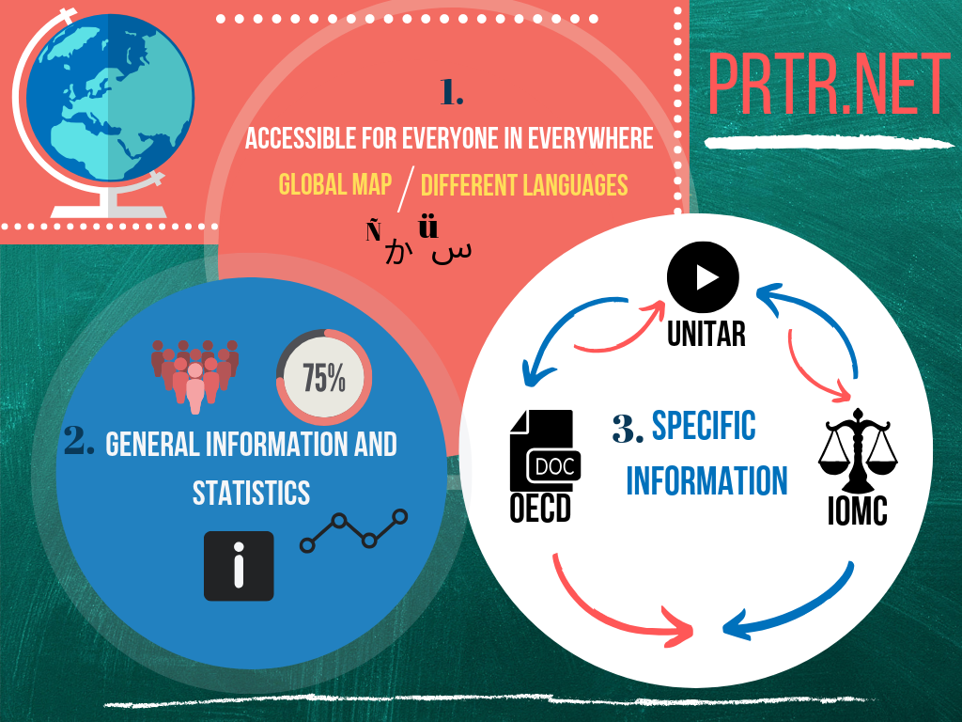
Infographic designed by the Chair in collaboration of PRTR-España team (2019).

