Scientific rationale for the River Dee candidate Special Area of Conservation and the proposal to extend into those tributaries accessible to salmon.

- Introduction

Three species listed in Annex II of the Habitats Directive have been identified as qualifying interests: Atlantic salmon (Salmo salar), otter (Lutra lutra) and freshwater pearl mussel (Margaritifera margaritifera).

The River Dee was selected as a candidate Special Area of Conservation (cSAC) due to the significant and important populations of the three above species that the river supports. This paper is intended as an explanation of the scientific rationale behind the selection of the River Dee as a cSAC for Atlantic salmon. At present the boundary of the cSAC extends along the length of the main stem from Aberdeen harbour to White Bridge, approximately 13km west of Braemar. The proposal is now to extend the boundary of the site to include all relevant tributaries. The inclusion of tributaries is based on salmon use and includes all those that best represent the physical and biological factors essential for the life and reproduction of salmon (Habitats Directive, Article 4.1). The extended site also fully caters for the needs of freshwater pearl mussel which are almost entirely confined to the main stem. Although the proposed extension to the boundary of the cSAC is not comprehensive in terms of its coverage of otter habitats (which range widely across the Dee catchment and into neighbouring catchments), it is representative of the areas of key importance, particularly for otter holts.

- Proposed Qualifying Interests

Annex III of the Habitats Directive sets out the criteria for selecting eligible sites: these are summarised below. The status of the Atlantic salmon, otter and freshwater pearl mussel populations have been assessed against these criteria.

Annex III criteria for selecting sites for species

- Size and density of the population of the species present on the site in relation to the populations present within national territory.

- Degree of conservation of the features of the habitat which are important for the species concerned and restoration possibilities.

- Degree of isolation of the population present in relation to the natural range of the species.

- Global assessment of the value of the site for conservation of the species.
2.1 Atlantic salmon

- Size and density of the population
In almost all Scottish river systems, including the River Dee, it is not possible to determine the actual adult Atlantic salmon population size, as the necessary systematic and comprehensive population survey data are lacking. The selection of rivers in relation to size and density of population must, therefore, be based on indicative and comparative data. In Scotland, the only nationally available dataset on which to base comparisons is the `Statistical Bulletin of Scottish salmon and sea trout catches’ which is published annually by the Scottish Executive. This bulletin reports catch data provided from 62 Salmon Fishery Statistical Districts, of which the Dee Fishery District is one. For each district the bulletin collates catch returns from three fishing methods: fixed engine, net and coble, and rod and line. These data represent the best information available on a Scottish scale, but have a number of limitations, including some inaccurate or incomplete reporting; the absence of a rigorous means of relating catches to fishing effort; the uncertain link between abundance and susceptibility to exploitation (catchability); differing policies towards catch and release by angling managers; that some Salmon Fishery Districts, including the Dee, include catch returns for more than one river system, and the publicly available data do not allow each individual river system to be distinguished, and the fact that fixed engine fisheries operate in coastal areas and may, therefore, be catching adult fish destined for rivers beyond the reporting Fishery District.

Notwithstanding these limitations, the catch returns do provide an indication of the exploited adult population size associated with the major river systems which is useful for comparative purposes. The inherent limitations of the publicly available data described above prevent a valid manipulation of the data to provide any greater precision beyond straight comparison. For example, the Dee Fishery District includes returns from two much smaller fisheries on the Rivers Cowie and Carron. While it may be desirable to dissociate the catch returns for these rivers from those for the River Dee per se, the numbers are very low in comparison with those for the Dee. The degree of precision that would be gained is still more than offset by the broad limits of confidence applied to the data as a whole when used to indicate population size. This is particularly evident when considering that the sometimes considerable catch returns from the coastal fixed engine fisheries cannot be dissociated from the ‘in river’ fisheries. The comparisons between rivers are accordingly based on the broad unaltered catch returns for each Fishery District.

Indications of relative population size derived from the comparison of catch returns for the Scottish Salmon Fishery Districts indicate that the River Dee Fishery District is consistently one of the top 10 for numbers of caught Atlantic salmon. The second round of site selection for Atlantic salmon, which included the River Dee, was based on the most up to date published catch returns then available, which were for 1998. In that year the Dee Salmon Fishery District had a catch of 4,399 wild salmon and grilse amounting to 4.2% of the Scottish total. Table 1 shows the relative catch of the Dee District for five years ending in 1998, compared with other Scottish east coast District Fisheries that include large cSAC rivers where Atlantic salmon is a primary qualifying feature. The catch returns are complicated by the closure of some netting stations, and thus a reduction in fishing effort, but do indicate that the Dee Fishery District has, throughout the five years to 1998 supported a relatively large and significant salmon population.

Table 1: All wild salmon and grilse caught in East coast Scottish Fishery Districts with cSAC sites where salmon is a primary qualifier. Figures (in thousands, rounded to nearest hundred) include fish killed and those caught and released.

 | 1994 | 1995 | 1996 | 1997 | 1998
Tweed | 16.0 | 18.8 | 17.5 | 16.1 | 15.2
Spey | 13.1 | 11.1 | 9.5 | 7.4 | 8.8
Tay | 24.8 | 28.1 | 21.5 | 8.7 | 8.5
South Esk | 12.6 | 9.5 | 7.0 | 5.6 | 5.9
Dee | 17.0 | 15.4 | 11.5 | 6.2 | 4.4
Total Scottish | 190.0 | 180.0 | 134.3 | 97.7 | 104.9
Dee as % of Scottish catch | 8.9% | 8.5% | 8.6% | 6.3% | 4.2%

In relation to the total Scottish catch over the 5 years 1994 to 1998, the River Dee Fishery District accounts for an average percentage catch of 7.3%. Subsequent to the reference year of 1998 catch statistics are currently available for 1999, 2000 and 2001. These figures show that from the most recent set of available data the Dee Fishery District had a catch of 4,654 wild salmon and grilse (4.5% of the Scottish total). Figures for all the rivers listed previously are shown in Table 2 and confirm that the Dee continues to support an important component of the total Scottish Atlantic salmon resource.
Table 2: All wild salmon and grilse caught in East coast Scottish Fishery Districts with cSAC sites where salmon is a primary qualifier based on size of catch including fish killed and those caught and released (figures in thousands, rounded to nearest hundred)

 | 1999 | 2000 | 2001
Tweed | 14.9 | 14.6 | 12.5
Spey | 6.4 | 8.7 | 7.7
Tay | 7.2 | 9.3 | 9.9
South Esk | 2.3 | 5.8 | 9.6
Dee | 2.9 | 3.0 | 4.7
Total Scottish | 70.4 | 101.2 | 104.6
Dee as % of Scottish catch | 4.1% | 2.9% | 4.5%

The figures presented in Tables 1 and 2 are for catches by all three methods in each of the cited Salmon Fishery Districts and can include catches from outwith the cSAC boundary. This is the case for the Dee Salmon Fishery District (the figures include salmon caught by the fixed engine fishery along the coast and by other methods in the Rivers Cowie and Carron), but the figures are judged by SNH to give a broad and fair comparative representation of the size of the salmon populationin the River Dee catchment (and hence cSAC).

The main stem and tributaries of the Dee catchment exhibit considerable ecological variety. This results in the Dee supporting the range of life-history types found in Scotland, with sub-populations of spring and summer salmon and grilse all being present. The spring salmon and spring grilse population is ecologically important as it is composed of fish that spawn in the furthest reaches of the catchment. Historically the River Dee has been renowned as a leading spring salmon river in the UK. While there has been a marked decline in this component, the River Dee’s spring salmon population is still an important part of the conservation interest. Table 3 shows how the sub-populations are distributed within the different parts of the river system (from Laughton & Smith, 1992; Webb, 1998).
Table 3: Sub-catchment utilisation by Salmon life history types in the River Dee

 | Spring/early summer mostly multi-sea winter,  Some Early Grilse | Summer/autumn  Some multi-sea winter,  Mostly Late Grilse
Water of Feugh |  | +
Burn of Canny |  | +
Water of Tanar | + | +
River Muick | + | +
River Gairn | +
Girnock Burn | +
Clunie Water | +
Quoich Water | +
Ey Burn | +
Upper main stem Dee | +
Lower main stem Dee | + (in transit) | +

b. Degree of conservation of habitat features

In UK terms, the Dee drains a relatively large catchment of about 2100km². The waters of the Dee catchment are generally of the highest quality although localised pollution problems exist, particularly at the river mouth. The upper catchment also tends to have a low buffering capacity resulting in locations such as the highest reaches of the River Dee and Loch Muick being vulnerable to acidification. But in some upper catchment areas, such as burns flowing from Morvern (near Braemar), the watercourses are less vulnerable to acidification owing to base rich soils/geology. The extensive size and distribution of its catchment; with large areas of gravel beds, shallows over boulders and small stones, fast flowing water and deep pools, provides a wide range of salmon habitats for different stages of the salmon life-cycle.

There are few barriers to salmon migration in the River Dee catchment. On most tributaries Atlantic salmon are able to migrate into the upland headwaters, with the limits of access being set by natural gradient or size of water course. Throughout most of the catchment water quality is excellent, and the river is oligotrophic but with a nutrient gradient along its length.

There has been a long record of salmon management throughout the Dee catchment underpinned by research and monitoring. This work is complemented by a range of other management initiatives which contribute to the river’s well being. For example, in 1995 the Dee District Salmon Fishery Board was the first District Salmon Fishery Board to establish a catch and release policy, with fisheries managers asking that all salmon caught throughout the fishing season be returned to the river. Riparian habitat improvement measures have also been undertaken and are still in progress. Work by the Fishery Board also helps to prevent poaching of wild stocks.

Almost all the funding for the policing and stock and habitat conservation and restoration works is funded by the Dee salmon rod fishery. Without this funding, which depends upon the continuation of a viable salmon rod fishery, rapid degradation of the salmon stock could result from poaching and reduced habitat enhancement/protection works.

c. Degree of isolation of the population (including contribution to range)

The suite of SACs in Scotland which have salmon as a qualifier numbers 17 and is shown in Map 1 . In addition to the Dee, the large East coast rivers are represented by the Tweed, Teith, Tay, South Esk and Spey. The inclusion of the Dee contributes to the range representation in North- East Scotland given the significant distance between the South Esk and the Spey.
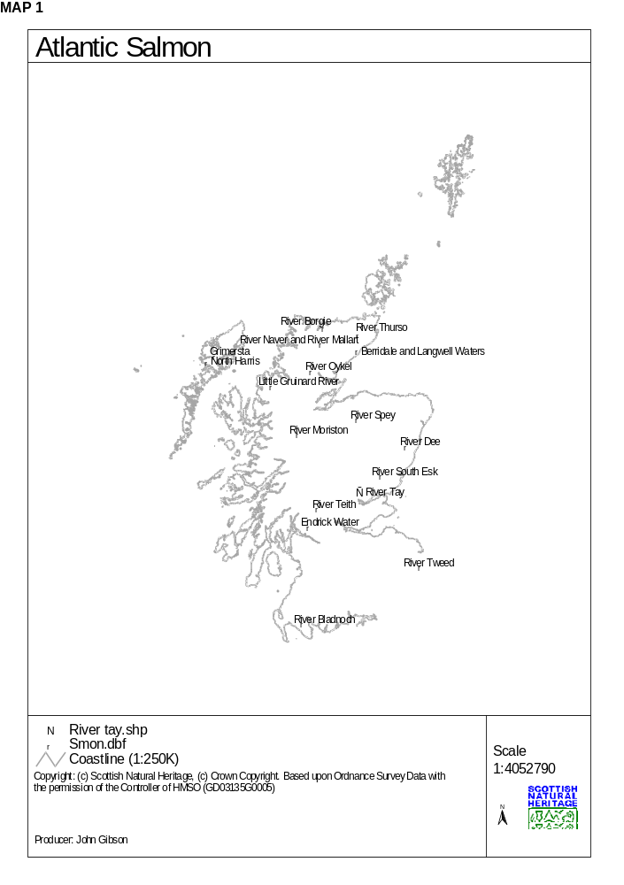

The distinct genetic integrity of the Atlantic salmon population of the River Dee system, including the sub populations in the tributaries, has been maintained. There are no local salmon farms so there is only a small risk to genetic distinctiveness from farm escapes. Any restocking of water courses with fry or parr undertaken by the Fishery Board is careful to ensure that they originate from the appropriate brood stock.

d. Global assessment of the criteria

On the basis of application of the Annex III criteria it is considered that the Dee adds a significant contribution to range representation and contributes significantly to the overall resource with a large accessible upland catchment. In 1994 -1998 it formed an average of 7.3% of the Scottish catch.

The river also contains the full range of variants of salmon types. Any stocking of tributaries from hatcheries is careful to use local substocks to minimise any genetic modifications of the sub-populations. The absence of salmon farms from around the Dee has also minimised the risks to the stocks from escaped salmon and diseases. The river also benefits from research and management initiatives which are likely to be increased under the auspices of the Dee catchment management initiative which has recently been started.

Overall, the case for the Dee is strong, and the overall assessment is that the River Dee is one of the best areas in the UK for Atlantic salmon.

- Tributaries

It is proposed that the boundary of the SAC will be extended from along the main stem of the River Dee to include all key tributaries that are accessible to Atlantic salmon in the Dee system, and represent the physical and biological factors essential for their life and reproduction.

The River Dee is a relatively straightforward system with a single main stem and a number of tributaries which are generally occupied by adult salmon around spawning time. The main stem and upper tributaries are alpine in character with melting snow sustaining high flow rates into late spring and early summer. They are typically low in nutrients and, apart from some localised areas, the waters are of the very highest quality. The catchment includes a varied geology and shows a wide range of water chemistries.

Juvenile salmon are widely distributed within the Dee catchment with the productivity highest in those streams draining catchments enriched by basic rocks or moderate agricultural input. Salmon productivity is lowest in those headwater streams that have granite catchments (Shackley and Donaghy, 1992) but many of those streams such as the Bynack Burn, Lui and Quoich provide important spawning and juvenile habitat for early running salmon and grilse. In the lower catchment habitat degradation in some tributaries means that those watercourses have lower salmon productivity than may be expected.

Summer running salmon and grilse predominate in the lower sub-catchments such as the Feugh tributaries and the lower Beltie Burn, but have been estimated to spawn as far upstream as the confluence of the mainstem with the Gairn (Laughton and Smith, 1992) and into the Muick (Webb, 1998). Upstream of this point the tributaries of the Dee support populations of early running salmon, with particularly productive sub-catchments being the Clunie Water and Girnock Burn (Shackley and Donaghy, 1992).

Overall, the inclusion of key waters in the Dee tributaries that are accessible to salmon will mean all the areas normally utilised by the Dee’s varied salmon population will be included within the SAC boundary. The inclusion of the tributaries will help increase management opportunities and take full account of the Dee’s unique and valuable capacity to produce large numbers of very early running salmon. The essential needs of the other two qualifying interests in the River Dee cSAC (otter and freshwater pearl mussel) will be accommodated by the proposed boundary extension. The lateral boundary along the tributaries will include riparian habitats important to otter, and freshwater pearl mussel populations are unable to extend beyond river reaches accessible to Atlantic salmon.

References

Laughton, R. and Smith, G.W. 1992. The relationship between the date of river entry and estimated spawning position of Adult salmon (Salmo salar L.) in two major Scottish east coast rivers. In: Priede, I.G. and Swift, S.M. (eds). Wildlife telemetry: remote monitoring and tracking of animals. New York: Ellis Horwood 423-433.
Shackley, P.E. and Donaghy, M.J. 1992. The distribution and growth of juvenile salmon and trout in the major tributaries of the River Dee catchment (Grampian region). Scottish Fisheries Report 51.
Webb, J.H. 1998. Catch and Release: the survival and behaviour of Atlantic Salmon angled and returned to the Aberdeenshire Dee, in Spring and Early Summer. Scottish Fisheries Research Report 62.
Youngson, A.F., MacLean, J.C. and Fryer, R.J. 2002. Rod catch trends for early-running MSW salmon in Scottish rivers (1952-1997): divergence among stock components. ICES Journal of Marine Science, 59: 836-949.

