**Economic Commission for Europe**

Inland Transport Committee

**Working Party on the Transport of Dangerous Goods**

**115th session 22 March 2024**

Geneva, 2-5 April 2024

Item 5 (a) of the provisional agenda

**Proposals for amendments to annexes A and B of ADR:  
Construction and approval of vehicles**

Report from the informal working group on the reduction of the risk of a BLEVE

Transmitted by the Government of Spain on behalf of the informal working group

Automatic fire suppression system for engine compartments

1. As stated in informal document INF.4, the informal working group on the reduction of the risk of a BLEVE is working on the reduction of the risk of a Boiling Liquid Expanding Vapor Explosion (BLEVE) happening in the specific case of vehicles transporting dangerous goods.

2. As a result of the effort carried out by this group, the BLEVE informal working group presents a first draft named “Automatic fire suppression systems for engine compartments of FL and EX/III vehicles –requirements and test methods”, that aims to include the requirements for engine fire suppression systems for specific vehicles into Regulation No.105 or No.107, making it possible for ADR to reference these requirements as mandatory requirements.

3. The draft has been also been presented as an informal document for the next WP.29 GRGS meeting (15-19 April).

4. We encourage other delegations to participate in this working group and appreciate further comments and suggestions.

**5.** The draft is attached as an annex.

Annex

Draft Automatic fire suppression system   
for engine compartments of FL and EX/III   
vehicles - requirements and test methods

Content

Content 1

1 Introduction 3

1.1 Installation of the automatic fire suppression system 3

1.1.1 Test report 3

1.1.2 Calculation of minimum Extinguishing Agent Quantity 4

1.1.3 Fire hazard analysis 4

1.1.4 Scaling of the system 5

1.1.5 Fire detection system 5

1.2 Modification of a tested system 6

2 Suppression performance tests 6

2.1 Test lab accreditation 6

2.2 Tolerances 6

2.3 Test scenarios 6

2.4 Fire sources 7

2.5 Suppression system 7

2.5.1 Nozzle positioning 7

2.6 Verification 9

2.7 Test procedure 9

2.8 Temperature measurement 9

2.9 Test criteria 9

2.10 Disclaimer 10

Appendix A: 1

Test apparatus, test fires and general test specifications 1

A1 Test Apparatus 1

A1.1 General 1

A1.2 Framework 3

A1.3 Apertures 4

A1.4 Doors and sides 5

A1.5 Floor 5

A2 Test apparatus objects 6

A2.1 Engine and exhaust system 7

A2.2 Obstruction 1 8

A2.3 Obstructions 2 and 3 8

A2.4 Obstruction 4 9

A2.5 Ventilation 10

A2.6 Temperature measurement 11

A2.7 Propane burner 11

Appendix B: Fire sources 1

B1 Fire sources 1

B1.1 Fire source #1 1

B1.2 Fire source #2 1

B1.3 Fire source #3 2

B1.4 Fire source #4 2

B1.5 Fire source #5 3

B1.6 Fire source #6 3

B1.7 Fire source #7 3

B2 Fuel specifications 4

B2.1 Diesel oil 4

B2.2 Engine oil 4

B2.3 Heptane 4

B2.5 Fibre board 4

Appendix C: Fire test procedures 5

C1. Test scenario 1: High fire load test at minimum operating temperature 5

C2 Test scenario 2: High fire load with 1.5 m3/s ventilation 7

C3 Test scenario 3: Low fire load with 1.5 m3/s ventilation 9

C4 Test scenario 4: Re-ignition test 11

# Introduction

This document describes the technical requirements and test method for installing and testing of a fixed automatic fire suppression system in the engine compartment where the internal combustion engine propelling the vehicle is located for vehicles listed under ADR 9.7.9.1.

## Installation of the automatic fire suppression system

Before an automatic fire suppression system is installed in the vehicle it needs to undergo testing for various scenarios, including high-load fire at minimum operating temperature, low-load fire, high-load fire with a fan, and re-ignition. All tests are performed with an open floor in the test apparatus.

The installation of the automatic fire suppression system shall comply with the following requirements:

1. The system supplier shall provide a comprehensive test report showing the system’s ability to extinguish the various fire test scenarios presented in this [regulation/technical code], see 1.1.1.
2. Calculations of the minimum mass of extinguishing agent shall be documented and presented by the system supplier, see 1.1.2.
3. A fire hazard analysis of the vehicle, where the system will be installed, shall be documented, and presented by the system supplier, see 1.1.3.
4. For engine compartments with a different gross volume other (smaller or larger) than the standard 4 m³ used in the test apparatus, the system may be scaled using the equation in paragraph, see 1.1.4.
5. The automatic fire suppression system shall be automatically activated through a fire detection system, see 1.1.5.

### Test report

The test report shall as a minimum include the following information:

* Name and address of the testing laboratory.
* Date and identification number of the test report.
* Name and address of manufacturer.
* Date of test.
* Name or other identification marks of the tested product.
* Description and drawing of the test setup.
* Photos from the tests and test setup.
* Specification, description and drawing of the suppression system.
* Configuration of the suppression system used in the tests.
* Mass of extinguishing agent, (minimum required for a 4 m³ engine compartment).
* Length of discharge tube, (minimum required for a 4 m³ engine compartment).
* Number of discharge points, (minimum required for a 4 m³ engine compartment).
* Minimum operation temperature.
* Identification of the test equipment and used instruments.
* Deviations from the test method, if any.
* Graph showing the temperatures during the reignition test.
* Test results.
* Date and signature.

### Calculation of minimum Extinguishing Agent Quantity

Based on the mass of extinguishing agent presented in the test report from the fire suppression tests, the minimum mass of extinguishing agent and the mass of the propellant gas, if applicable, in the installed system shall be calculated using the equation *Qy =* 1.5 *× y*

Table 1: Nomenclature for equation

|  |  |
| --- | --- |
| *Qy* | Minimum mass of extinguishing agent |
| *y* | Mass of extinguishing agent established by the fire suppression tests for 4 m³ |

For engine compartments with a different gross volume other (smaller or larger) than the standard 4 m³ used in the test apparatus, the system may be scaled after calculating the minimum required mass of extinguishing agent for the 4 m³ standard system. Scaling of the system is made using the equation found in paragraph 1.1.4.

### Fire hazard analysis

A risk analysis shall be conducted prior to the installation in order to determine the location and direction of the extinguishing agent discharge point(s) (e.g. nozzles, extinguishing agent generators or extinguishing agent discharge tube or other distribution points). Potential fire hazards within the engine compartment shall be identified and the discharge point(s) located such that the extinguishing agent will be distributed to cover the fire hazard when the system activates. The spray pattern and direction of discharge point(s), as well as the discharge distance shall be configured to cover identified fire hazards. The system shall also be designed to work properly regardless of the vehicle’s attitude.

The fire hazard analysis shall, as a minimum, take into account the following components:

1. Those whose surface may reach temperatures above the auto-ignition temperature for fluids, gases or substances that are present within the engine compartment.
2. Electrical components and cables with a current or voltage high enough for an ignition to occur.
3. Hoses and containers with flammable liquid or gas (and in particular, if those are pressurized).

The analysis of the fire hazards shall be fully documented and stored for future reference.

### Scaling of the system

Measurement and calculation of engine compartment gross volume is made before scaling a tested suppression system. The volume of components in the engine compartment should not be subtracted. In cases where the engine compartment is not fully enclosed, the boundaries shall be set to 500 mm from the nearest component to be protected, alternatively the outer frame of the engine compartment, whichever distance is shortest. The calculated gross volume shall be rounded to one decimal point place when expressed in m3.

The suppression system may be scaled for engine compartments with a gross volume in between 2 and 6 m3 using equation $S_{x}=0.1×x + 0.6$.

Table 2: Nomenclature for equation

|  |  |
| --- | --- |
| $$S_{x}$$ | Scaling factor for suppression system |
| $$x$$ | The gross volume of the engine compartment, [m3] |

The equation gives a scaling factor that may be used for scaling the tested suppression system. This includes the calculated minimum mass of the extinguishing agent, all discharge points, and the mass of the propellant gas, if applicable.

Total quantity for the scaled system is Qtotal= Qy × Sx

The total discharge time of the system shall, as a minimum, remain the same.

The scaled number of nozzles shall be rounded up to the next integer.

The mass of extinguishing agent is rounded to one decimal place when expressed in kg.

For engine compartments with a volume smaller than 2 m3, the system shall be designed for a volume of at least 2 m3.

For engine compartments with a volume larger than 6 m3, a separate risk assessment must justify either extending the scaling model or employing an alternative scaling model.

### Fire detection system

The vehicle must be equipped with a fire detection system capable of detecting temperatures in the engine compartment exceeding those encountered during normal operation.

Upon detection, the system shall provide the driver with both audible and visual alerts in the driver's compartment, and simultaneously activate the hazard warning lights and the automatic fire suppression system.

The fire detection system, audible and visual alerts and the automatic fire suppression system must still be operational with device for de-energizing the electrical circuits in the off position. In this case, the hazard warning lights need not be operational with the device in the off position.

## Modification of a tested system

Every modification of any of the components of the tested automatic fire suppression system must be well documented and a risk analysis of the impact of the change is to be retained for future reference.

In those cases where the modifications made are unlikely to have an appreciable adverse effect and that, in any case, the vehicle, bodywork or automatic fire suppression system still complies with the requirements, the risk analysis shall reflect this. This information must be included with the test report and other technical documentation for all new installations after the change has come into force.

Changes that have impact on the performance of the automatic fire suppression system, such as changes of the extinguishing agent used, change of nozzle types or changes that have an impact on the total discharge time of the system, requires new fire suppression tests of the system.

Scaling of a system according to the scaling rules in paragraph 1.1.4 is not considered as a modification.

# Suppression performance tests

The objective of the tests is to ensure system coverage of a complete engine compartment and to test the capability of the suppression system under varying ventilation conditions.

The installation of the suppression system shall be the same through all tests. The suppression system must be restored to its original condition before each test, with all parts installed as intended. Broken or consumable parts must be replaced.

The tests are to be performed in an engine compartment test apparatus. Description of the test apparatus is found in Appendix A.

## Test lab accreditation

In order to ensure the reproducibility of the test and facilitate its adoption in different laboratories, the method utilizes a standardised test apparatus. The testing laboratory shall be accredited according to EN ISO/IEC 17025:2018.

## Tolerances

The tolerances shall the following:

* ±5 s for time values
* ±5 % for dimensions, positions, temperatures and other measurements unless explicitly stated otherwise.

## Test scenarios

There are four different test scenarios. The test scenarios are described in Appendix C and are summarized in Table 3.

Table 3: Test scenarios

|  |  |  |  |
| --- | --- | --- | --- |
| **Test scenario** | **Description** | **Ventilation**  **(m³/s)** | **Remarks** |
| 1 | High fire load | 0 | At minimum operating temperature |
| 2 | High fire load | 1.5 |  |
| 3 | Low fire load | 1.5 |  |
| 4 | Re-ignition | 0 | Minimum time to re-ignition: 300 s |

## Fire sources

Seven different fire sources are to be used in various configurations in the fire scenarios.

Descriptions of the fire sources are found in Appendix B.

Diesel oil, heptane, semi-synthetic engine oil and fibre board are used as fuels.

Table 4: Fire sources

|  |  |
| --- | --- |
| **Fire source** | **Description** |
| #1 | Pool fire 300 mm × 300 mm |
| #2 | Pool fire 300 mm × 300 mm and fibreboards |
| #3 | Pool fire 200 mm × 300 mm |
| #4 | Pool fire Ø 150 mm |
| #5 | Spray fire 0.73 kg/min |
| #6 | Spray fire 0.19 kg/min |
| #7 | Dripping oil fire, 40 droplets/min |

## Suppression system

To obtain the minimum discharge rate, a suppression system is to be assembled using its maximum piping limitations with respect to the number of fittings, sizes and lengths of pipes. The extinguising agent cylinder is to be filled to its rated capacity and the cylinder or gas cartridge pressurized with the expellant gas to the normal operating pressure. Other technical suppression system solutions shall be filled or charged to its minimum installation design.

### Nozzle positioning

The nozzles may only be positioned inside the test apparatus, in two different areas.

#### Nozzle area 1

At the top side and at the rear side. Nozzles positioned at the top side must be positioned so that the nozzle outlet is 750 mm or more above floor level. Nozzles shall not be installed inside Obstruction 1 (see Appendix A.2). Nozzles shall not be positioned where they prevent the execution of the tests. Nozzles positioned at the rear side must be positioned so that the nozzle outlet is within 350 mm of the rear side (y ⩾ 1150 mm) and 450 mm or more above floor level, see Figure 1 and Figure 2 below.

#### Nozzle area 2

Inside the rear box (referred to as Obstruction 4, see Appendix A.2) in the rear side of the test apparatus. Nozzles should be located at the top side of the box, so that the nozzle outlet is 290 mm or more above floor level, see Figure 2 below.

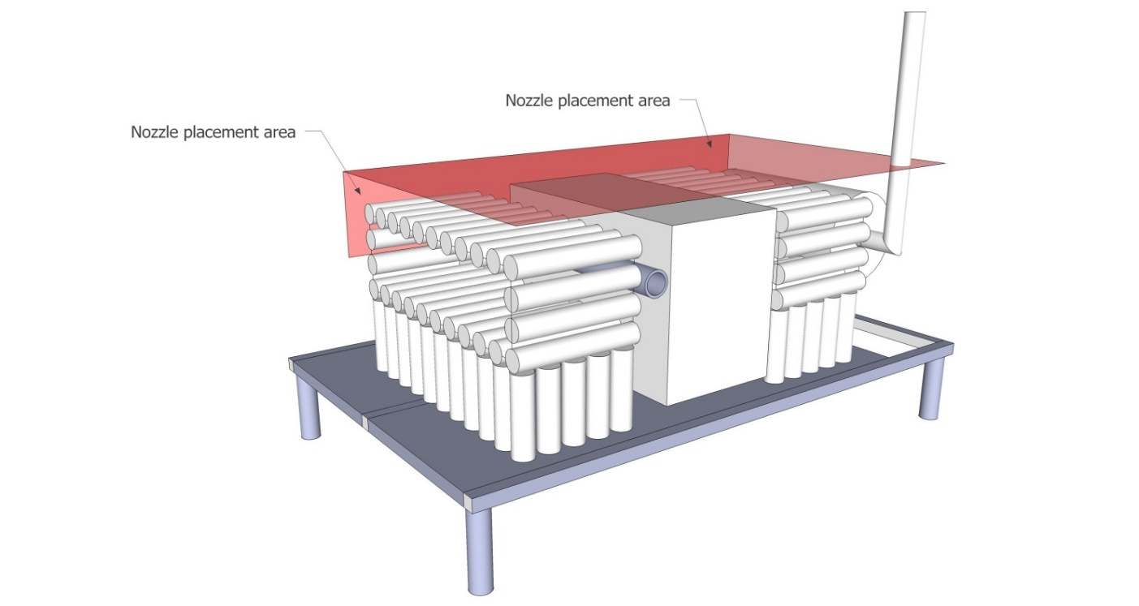

Figure 1 Nozzle positioning seen from the front side of test apparatus

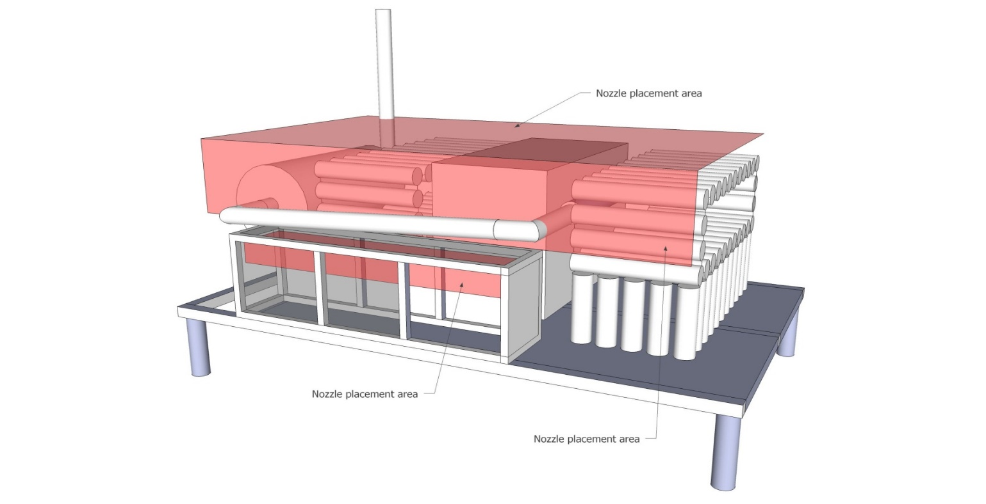

Figure 2 Nozzle positioning seen from the rear side of test apparatus

## Verification

The system setup and configuration such as number, type and location of nozzles, length and dimensions of pipes/hoses, number and type of fittings, type and mass of extinguishing agent, propellant gas and system pressure shall be documented prior to the test. All the parts used in the installed suppression system must be verified to be in compliance with the manufacturers drawings and specifications.

## Test procedure

The suppression system is to be restored to its original condition before each test with all parts installed as intended without any modifications made to the installation.

The fire sources are prepared according to specifications in Appendix B.

The fire sources are placed in the locations as specified in Appendix C for each test scenario.

A pre-burn time is required before the suppression system is activated. The time for pre-burn starts from the time when the first fire source is ignited. All fire sources in the test scenario must be ignited within the time limit for ignition; specifications for each test scenario are found in Appendix C.

In test scenarios where ventilation is required, the ventilation shall remain active until the test has been terminated.

In test scenarios with spray fire, the spray shall be active until the test has been terminated.

The testing setup must use the one providing the minimum discharge rate, as defined in 2.5.

Minimum operating temperature fire test (see scenario 1, Appendix C) is performed with extinguishing agent and propellant gas cooled to a temperature lower or equal to -20 ºC.

In the test scenario for re-ignition, the exhaust manifold test apparatus tube is pre-heated in accordance with, Test scenario 4 Appendix C, prior to the test. A sustained flame on the tube must be observed before the suppression system is activated. The oil shall continue to drip for 300 s after flames are extinguished or until re-ignition occurs.

The tests can be performed in an arbitrary sequence without any changes to the installation between the tests.

## Temperature measurement

The temperatures listed for the re-ignition test, Test scenario 4 Appendix C, shall be measured and recorded during the entire re-ignition test from start of the preheating phase to end of the test.

## Test criteria

Pool fires shall be extinguished within 60 s after activation of the suppression system or upon end of the discharge of the suppression system if discharge time exceeds 60 s.

Spray fires shall be extinguished within 60 s after activation of the suppression system,

or upon end of the discharge of the suppression system if discharge time exceeds 60 s.

The spray shall be active until test is terminated.

Fibre board fires shall be extinguished within 60 s after activation of the suppression system or upon end of the discharge of the suppression system if discharge time exceeds 60 s.

Glowing at termination of test is acceptable for fibre board fires.

Dripping oil fire shall be extinguished within 15 s after activation of the suppression system and not re-ignite within 300 s after fire is supressed to be considered as no re-ignition.

A test scenario is considered as passed if the first attempt to test it is successful.

If a test scenario is not passed, the system has to be redesigned and all other scenarios that have been passed before need to be retested with the new design.

Technical problems caused by the testing facility during a test will make the test invalid; only the affected test scenario needs to be repeated.

## Disclaimer

The results relate to the performance of the automatic fire suppression system against a variety of tests based on some of the operating conditions and fire hazards associated with engine compartments. The test method is designed to provide some information about the fire suppression performance of the product. This information should be used as input to a risk assessment for real applications but is not intended to be the sole criterion for assessing the potential fire hazard protection of the product in use. It is the responsibility of the automatic fire protection system provider, in collaboration with the vehicle supplier or owner, to carry out a full risk assessment for and of each application and accept full responsibility for the overall performance of the installed suppression system.

Users of this test method should observe the following warning:

Safety warning – in order that suitable precautions may be taken to safeguard health, the attention of all engaged in fire tests shall be drawn to the possibility that toxic or harmful gases may be evolved during combustion of the test fires as well as by activating the suppression system. The potential heat released from the test fires should be considered before the test starts and measures must be taken to avoid any risk of explosion or uncontrolled fire development.

**Appendix A:**

**Test apparatus, test fires and general test specifications**

# A1 Test Apparatus

## A1.1 General

The test apparatus is constructed of steel plate with an open floor constructed of steel grating. The thickness of the steel plate shall be in accordance with Table A3. Figure A1 shows the test apparatus from the front side and Figure A2 from the rear side. Note that the front side of the test apparatus simulates the rear side of a real engine compartment.

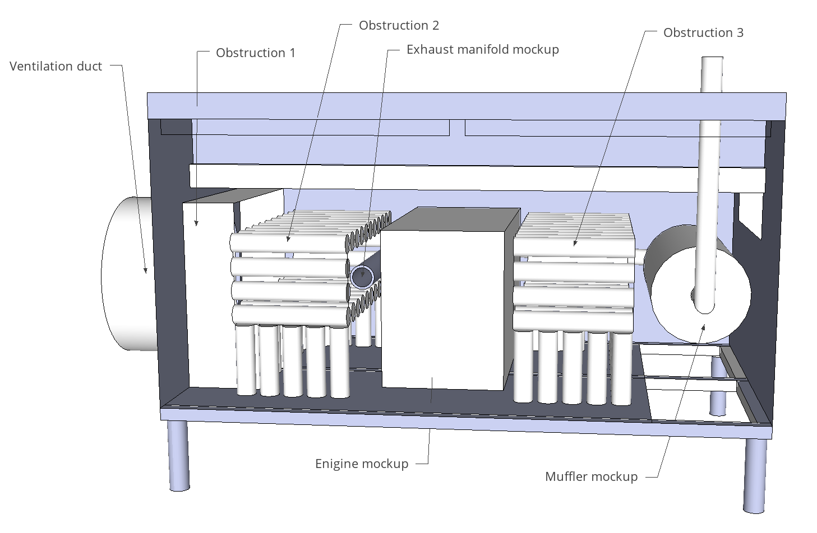

Figure A1 Test apparatus as seen from the front side.

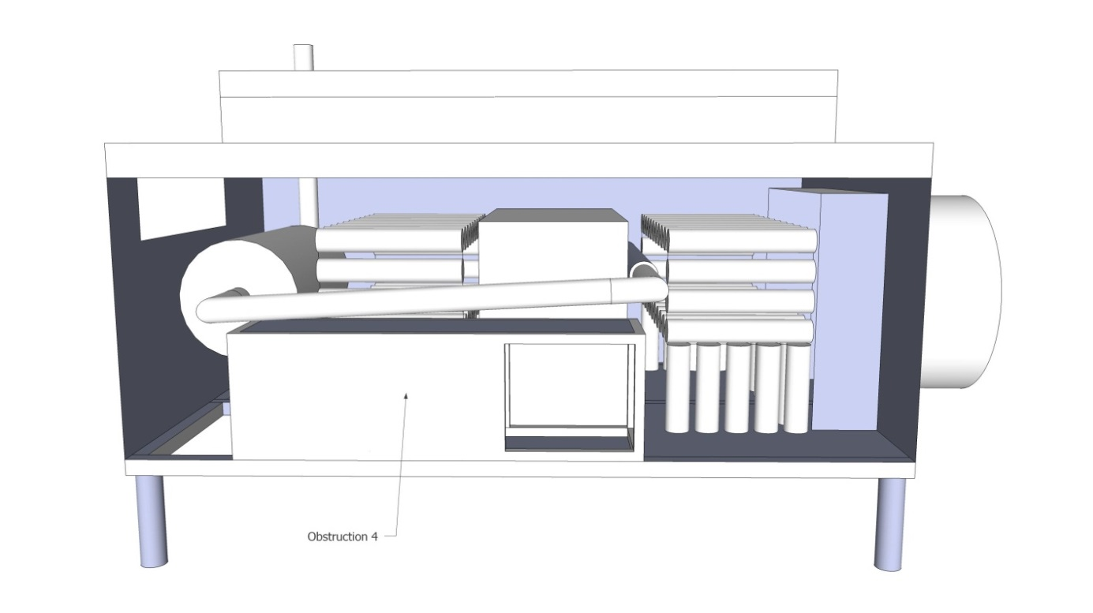

Figure A2 Test apparatus as seen from the rear side.



Figure A3 Test apparatus as seen from above.

## A1.2 Framework

The framework of the test apparatus shall be constructed according to Figure A4. The sizes of the beams are 50 mm × 50 mm and 100 mm × 50 mm respectively.

Figure A4 Framework for the test apparatus.

## A1.3 Apertures

In addition to the opening for the ventilation, the test apparatus includes four apertures, it should be noted that all objects inside the test apparatus are hidden in order to more clearly show the apertures. The dimensions and positions of the apertures are according to the coordinates in Table A1.

The positions are given by referring to two diagonally opposite corners as all aperturesare rectangular in shape.

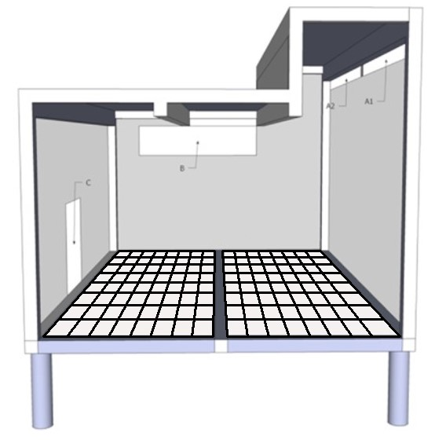

Figure A5 Apertures in the test apparatus.

Table A1: Coordinates of apertures in the test apparatus (refer to coordinate system in Appendix A, A2).

|  |  |  |
| --- | --- | --- |
| **Aperture** | **Coordinates, mm (x, y, z – x, y, z)** | **Area of aperture** |
| A1 | 30, 0, 1080 – 1180, 0, 1130 | 0.06 m2 |
| A2 | 1220, 0, 1080 – 2370, 0, 1130 | 0.06 m2 |
| B | 2400, 500, 700 – 2400, 1300, 900 | 0.16 m2 |
| C | 850, 1500, 30 – 1240, 1500, 360 | 0.13 m2 |
|  | Total area of apertures: | 0.41 m2 |

Note: The area values are only for information purpose.

## A1.4 Doors and sides

The front and rear side of the test apparatus shall be equipped with doors. The front doors shall include windows enabling observation of the progress of extinguishment during the tests. The remaining framework shall be covered with the sides and the top side of steel sheet, and an open floor constructed of steel grating as specified in Table A3.

Sides and the top side or parts of them may be in the form of closable hatches. The doors and hatches are to be mounted on the outside of the framework in such a way that no parts extend to the interior of the test apparatus defined as:

0 < x < 2400 mm; 0 < y < 1500 mm; 0 < z < 1250 (if y < 500 mm) and 0 < z < 950 mm (if y > 500 mm). The doors shall extend no further than 60 mm from the test apparatus.

## A1.5 Floor

To create an open floor design the floor in the test apparatus shall be constructed from steel rods, diameter 2-3 mm, with 20 - 30 mm in between to support the pool fires placed at floor level and to create an open floor design.

Figure A6 Example of steel grating for floor design.

# A2 Test apparatus objects

All objects in the test apparatus are positioned according to coordinates with reference to the lower left corner as in Figure A5. X - from left side, Y – from front side, Z – from floor level. Coordinates of components in the test apparatus are found in Table A2.

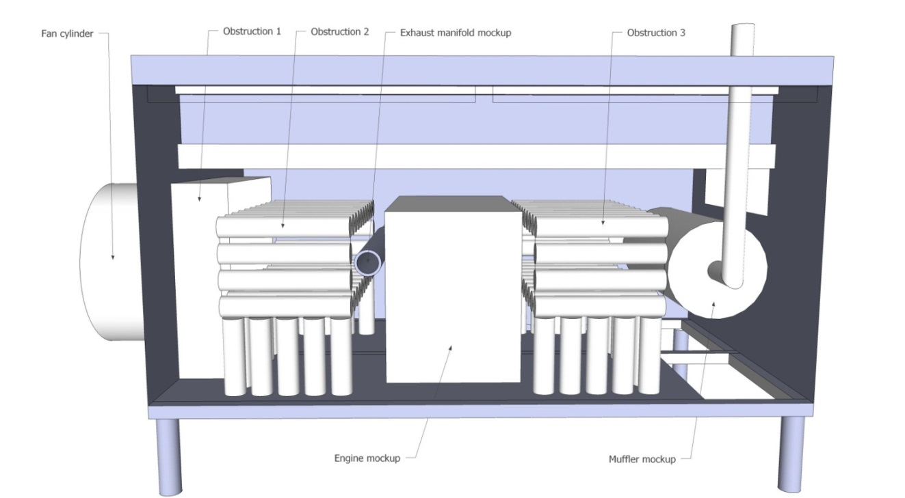

x

z

y

Figure A7 Coordinate system for the position of objects in test apparatus.

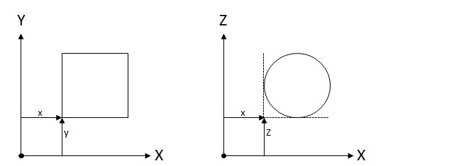

Figure A8 Measuring principle of coordinates.

Table A2: Coordinates of objects

|  |  |
| --- | --- |
| **Object** | **Coordinates (x,y,z) (mm)** |
| Ventilation duct | (-600, 400, 100) |
| Obstruction 1 | (0, 260, 0) |
| Obstruction 2 | (260, 50, 20) |
| Exhaust manifold | (760, 50, 470) |
| Engine | (870, 50, 40) |
| Obstruction 3 | (1440, 50, 20) |
| Obstruction 4 | (820, 1200, 0) |
| Muffler | (2000, 280, 230) |

Table A3: Steel thickness of objects

|  |  |
| --- | --- |
| **Object** | **Plate thickness (mm)** |
| Ventilation duct | 1.5 – 3 |
| Obstructions | 1.5 – 3 |
| Exhaust manifold | 8 |
| Engine | 2 – 3 |
| Muffler | 2 – 3 |
| Exhaust pipe | 2 – 3 |
| Connection pipe | 2 – 3 |
| Vertical sides and top side | 1.5 – 3 |
| Floor | Steel grating constructed by steel rods, diameter 2-3 mm, with 20 - 30 mm in between to create an open floor design |

## A2.1 Engine and exhaust system

The dimension of the Engine is 1000 mm × 650 mm × 500 mm. The dimension of the Muffler is Ø 400 mm × 800 mm. The Muffler and the Engine shall be hollow. The Exhaust manifold tube has an inner diameter of Ø 80 mm and a length of 900 mm. The Exhaust manifold tube is connected to the centre of the Muffler through a connection pipe with an outer diameter of Ø 76 mm, running at a y = 1400 mm. The bends on the connection pipe and exhaust pipe should have a radius of 165±10 mm. A pipe with outer diameter of Ø 76mm shall be used to transport the hot gases vertically up and out from the Muffler. It shall be connected to the centre of the Muffler front side and run at a y = 120 mm, see Figure A9. The whole exhaust gas system from the propane burner inlet to the exhaust gas outlet should be smoke tight.

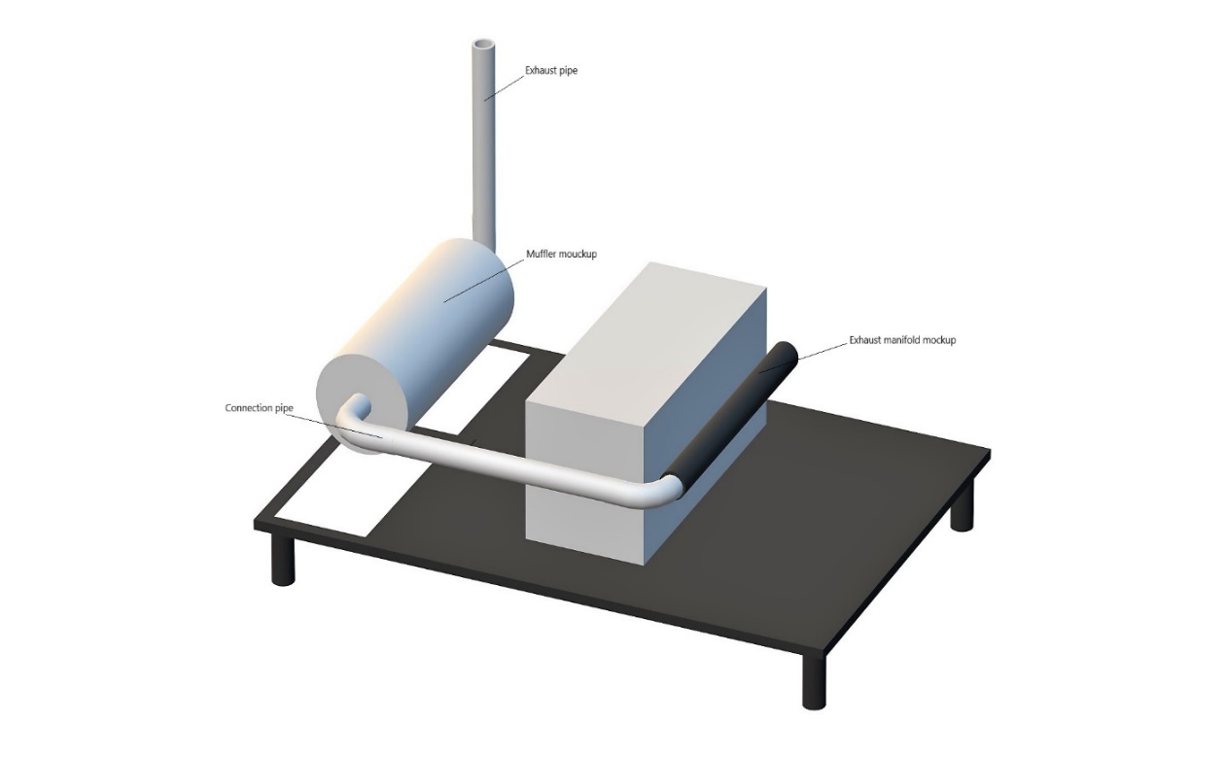

Figure A9 The exhaust system to be pre-heated for the re-ignition test.

## A2.2 Obstruction 1

Obstruction 1 has the dimensions of 230 mm × 900 mm × 840 mm, see Figure A10.

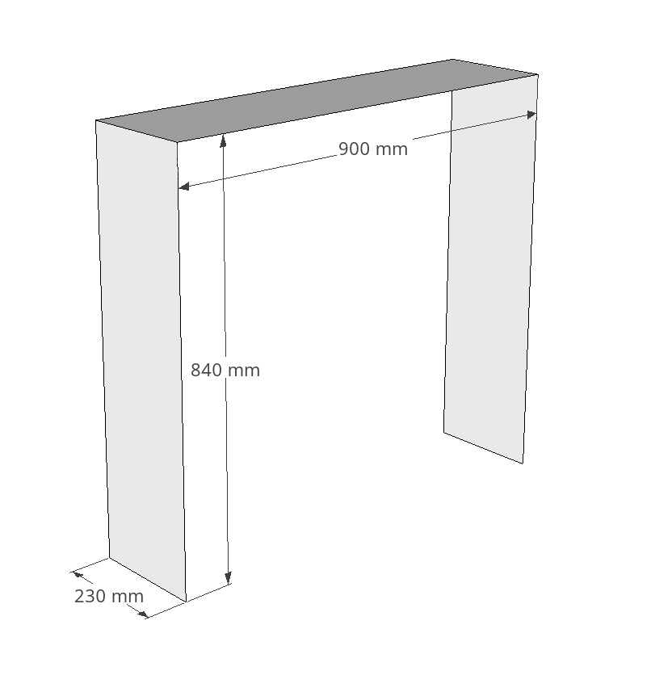

Figure A10 Obstruction 1

## A2.3 Obstructions 2 and 3

Obstructions 2 and 3 consist of tubes as shown in Figure A11. The outer diameter of the tubes is 80 mm and wall thickness is 2.5 mm. The horizontal obstruction tubes are closed in both ends and have a length of 480 mm. The vertical tubes are only closed in the top and have a height of 230 mm. The open distance between each tube (both horizontal and vertical) is 20 mm. The distance between the open bottom of the vertical tubes and apparatus floor is 20 mm. The distance between top of the vertical tubes and the horizontal tubes is 30 mm. The first horizontal tube layer from the bottom forms a storey which is 360 mm above the apparatus floor level.

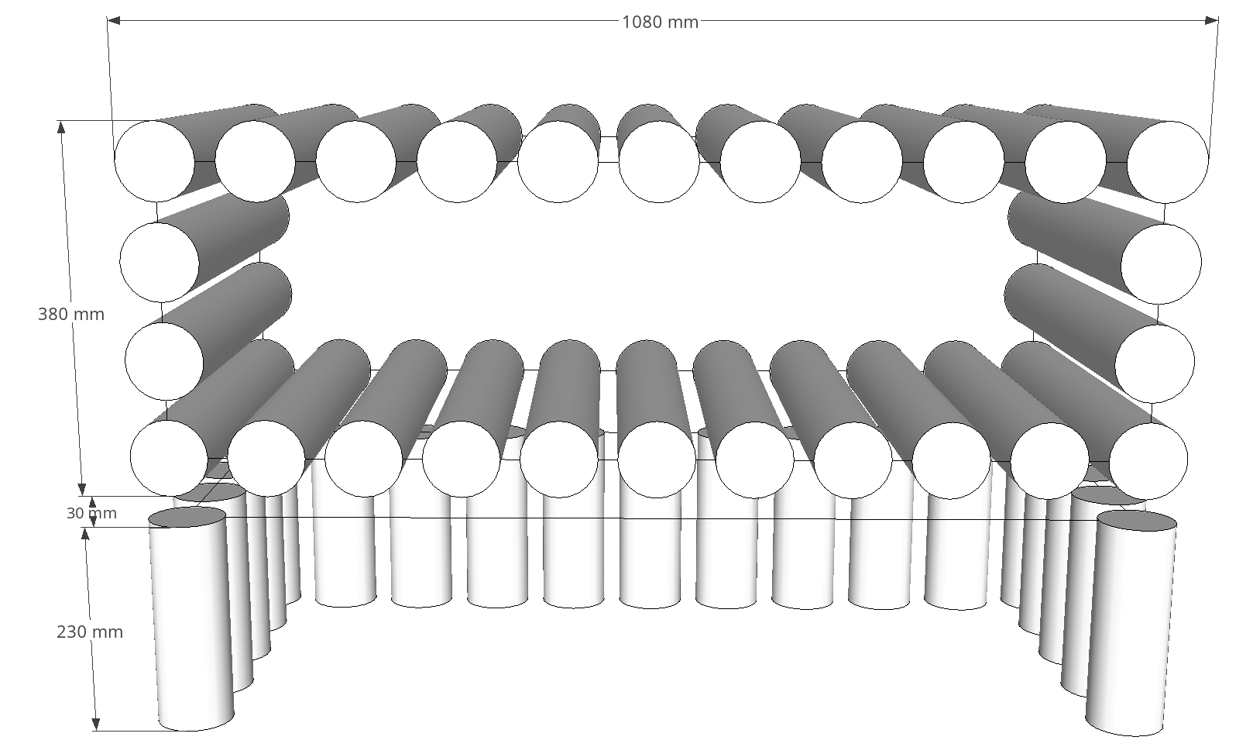

Figure A11 Obstructions 2 and 3

## A2.4 Obstruction 4

Obstruction 4 is a box measuring 1250 mm × 300 mm × 390 mm, see Figure A12. Obstruction 4 includes two openings. The first, on the right short side (240 mm x 330 mm) is open to the interior of the test apparatus, while the other on the rear long side (390 mm x 330 mm) is in conjunction with test apparatus Aperture C, thus being an opening to the outside, see Figure A12.

Figure A12 Obstruction 4, view from backside

## A2.5 Ventilation

A ventilation duct with inner diameter of 710 mm and a length of 600 mm is installed to the ventilation opening on the test apparatus, see Figure A13. An axial fan with a diameter of 710 mm (+0 mm, -3 mm) shall be mounted to the ventilation duct. The fan shall produce a certain air flow rate through the duct according to the test scenarios in Appendix C. Frequency converter may be used to adjust the fan speed. In tests without ventilation the duct and fan should be left in its installed position, alternatively a concealing plate with the same diameter as the ventilation opening may be positioned in front of the ventilation duct opening at a distance not closer than 50 mm.

Figure A13 Ventilation duct

## A2.6 Temperature measurement

Seven thermocouples shall be mounted on the exhaust manifold pipe. The thermocouples are installed in 2 mm deep holes on the outside of the pipe. The location of the thermocouples shall be in accordance with Figure A14 and Figure A15. Tc1 – Tc4 shall be located on top of the tube and Tc5 – Tc7 around the tube, on the same distance from the tube opening as Tc2 (300 mm).

Figure A14 Thermocouples on the exhaust manifold test apparatus

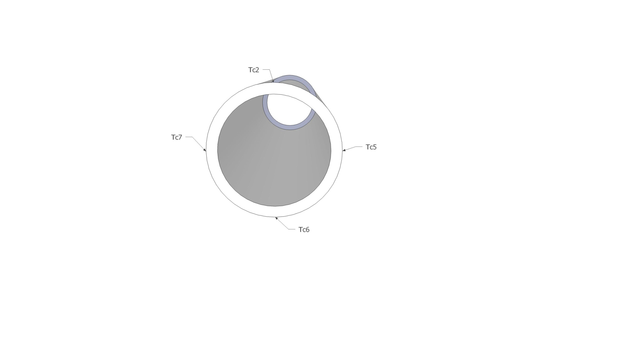

Figure A15 Thermocouples on the exhaust manifold test apparatus, viewed from inlet side.

## A2.7 Propane burner

A propane burner is used to pre heat the exhaust system and shall be capable of fulfilling the requirements of achieved temperatures specified in Appendix C. Pressurized air may be added to the flame for better combustion and to create higher volume flowrate through the exhaust manifold.

# Appendix B: Fire sources

# B1 Fire sources

Diesel oil, engine oil, heptane, and fibre board are used as fuels in the test sources described in Table B1.

Table B1: The fire sources used in the test scenarios.

|  |  |
| --- | --- |
| **Fire source** | **Description** |
| #1 | Pool fire 300 mm × 300 mm |
| #2 | Pool fire 300 mm × 300 mm and 2 fibreboards |
| #3 | Pool fire 200 mm × 300 mm |
| #4 | Pool fire Ø 150 mm |
| #5 | Spray fire 0.73 kg/min |
| #6 | Spray fire 0.19 kg/min |
| #7 | Dripping oil fire, 40 droplets/min |

## B1.1 Fire source #1

Fire tray of 1.5 mm thick steel.

Table B2: Tray for fire source #1

|  |  |  |  |  |
| --- | --- | --- | --- | --- |
| Dimension  (mm) | Rim height (mm) | Water  (l) | Diesel  (l) | Heptane  (l) |
| 300 × 300 | 70 | 1.0 | 0.5 | 0.2 |

## B1.2 Fire source #2

Fire tray of 1.5 mm thick steel. Two fibre boards.

Table B3: Tray for fire source #2

|  |  |  |  |  |
| --- | --- | --- | --- | --- |
| Dimensions  (mm) | Rim height (mm) | Water  (l) | Diesel  (l) | Heptane  (l) |
| 300 × 300 | 70 | 1.0 | 0.5 | 0.2 |

The fibre boards shall be conditioned prior to the test at a temperature of 105 °C (±5 °C) for not less than 16 h.

Fibre boards with dimensions 190 mm × 290 mm and thickness of 12 mm are completely immersed in diesel oil for at least 10 min prior to the test.

After being immersed in diesel oil, the fibre boards are mounted vertically in the pool fire tray not more than 10 min before the start of the test, see Figure B1. Supports for keeping the fibre boards in position in the fire tray are needed.

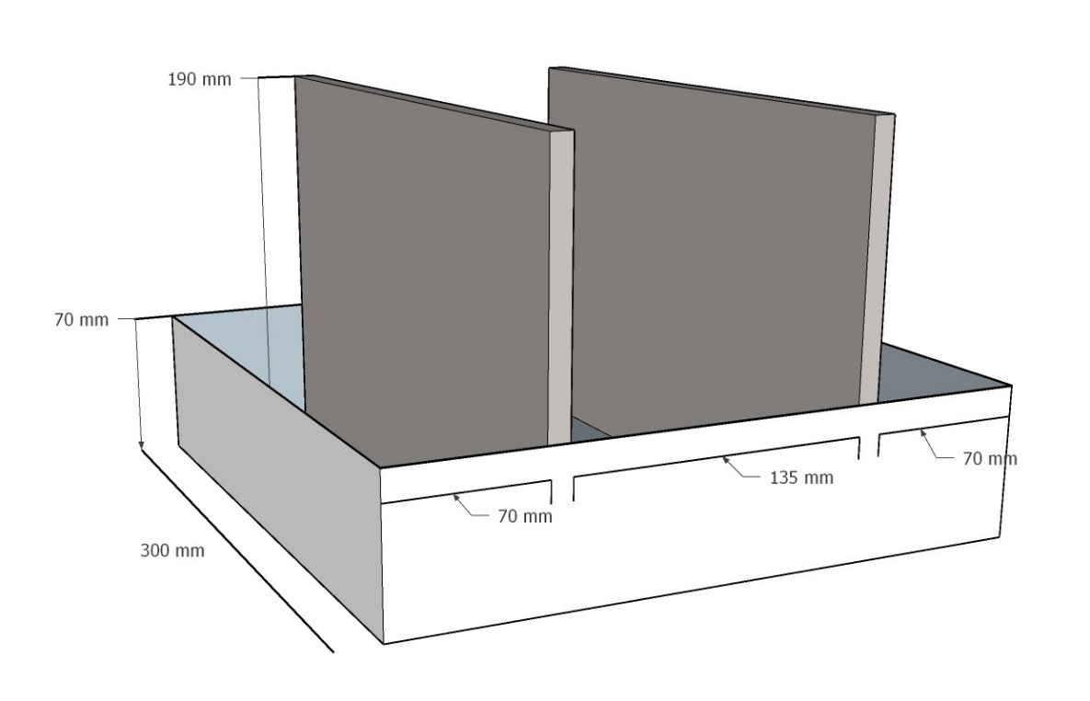

Figure B1: Perpendicular orientation of the fire tray with fibreboards.

## B1.3 Fire source #3

Fire tray of 2.0 mm thick steel.

Table B4: Tray for fire source #3

|  |  |  |  |  |
| --- | --- | --- | --- | --- |
| Dimension  (mm) | Rim height (mm) | Water  (l) | Diesel  (l) | Heptane  (l) |
| 200 x 300 | 70 | 0.5 | 0.5 | 0.2 |

## B1.4 Fire source #4

Fire tray of 1.5 mm thick steel.

Table B5: Tray for fire source #4

|  |  |  |  |  |
| --- | --- | --- | --- | --- |
| Diameter  (mm) | Rim height (mm) | Water  (l) | Diesel  (l) | Heptane  (l) |
| 150 | 100 | 0.2 | 0.2 | 0.1 |

## B1.5 Fire source #5

Spray fire: Nozzle with 120 ° full cone spray

Table B6: Spray fire properties for fire source #5

|  |  |  |  |
| --- | --- | --- | --- |
| Mass flow rate  (kg/min) | Tolerance (%) | Nominal pressure  (bar) | Fuel |
| 0.73 | ±10 | 4.5 | Diesel |

Table B7: Reference nozzle Lechler 490.368 with 120 ° full cone spray

|  |  |  |  |
| --- | --- | --- | --- |
| Flow rate  (l/min) | Tolerance (%) | Nominal pressure  (bar) | Media |
| 0.74 | ±10 | 3.0 | Water |
| 0.91 | ±10 | 5.0 | Water |

## B1.6 Fire source #6

Spray fire: Nozzle with 80° axial flow hollow cone spray.

Table B8: Spray fire properties for fire source #6

|  |  |  |  |  |
| --- | --- | --- | --- | --- |
| Mass flow rate  (kg/min) | Tolerance (%) |  | Nominal pressure  (bar) | Fuel |
| 0.19 | ±10 |  | 4.5 | Diesel |

Table B9: Reference nozzle Lechler 212.245, 80° axial flow hollow cone spray

|  |  |  |  |
| --- | --- | --- | --- |
| Flow rate  (l/min) | Tolerance (%) | Nominal pressure  (bar) | Media |
| 0.202 | ±10 | 3.0 | Water |
| 0.261 | ±10 | 5.0 | Water |

## B1.7 Fire source #7

Dripping oil fire: Danfoss 0.60X80H or equivalent

Table B10: Dripping oil fire properties for fire source #7

|  |  |  |  |
| --- | --- | --- | --- |
| Frequency  (drops/min) | Tolerance (%) | Mass flow (g/min) | Fuel |
| 40 | -0/ +10 | > 2.7 | Engine oil |

# B2 Fuel specifications

## B2.1 Diesel oil

Commercial fuel oil or light diesel oil with a density of 0.81 kg/l - 0.85 kg/l.

## B2.2 Engine oil

Semi-synthetic engine oil 15W-40 intended use in diesel engine.

Reference oil: Statoil MaxWay 15W-40

Base: Mineral oil

Density: 884 kg/m3 at 15 °C

Viscosity: 107 mm2/s at 40 °C

Flash point COC: 230 °C

## B2.3 Heptane

Product name: Hydrocarbons C7, n-alkanes, iso alkanes, cyclics

Synonyms, tradenames: Exxsol heptane, Heptane shell, Petrosol D heptane, SBP 94/99, Eversol n-paraffin 7, Heptane, Solane 80-110, Essence 80-110.

CAS number: 64742-49-0

Relative density: 0.68 – 0.78 g/cm3

Initial boiling point and boiling point interval: 83 °C – 105 °C

Auto ignition temperature: >200 °C

Flash point: -5 °C

## B2.5 Fibre board

Fibreboards with a dry density of 300 kg/m3 (±10 %). The nominal dimensions of the fibreboards shall be 12 mm × 290 mm × 190 mm. The fibreboards shall consist of at least 90 % raw material from wood. The fibre boards shall be conditioned prior to the test at a temperature of 105 °C (±5 °C) for not less than 16 h. The fibre boards should be used within 8 h after been removed from conditioning.

# Appendix C: Fire test procedures

## C1. Test scenario 1: High fire load test at minimum operating temperature

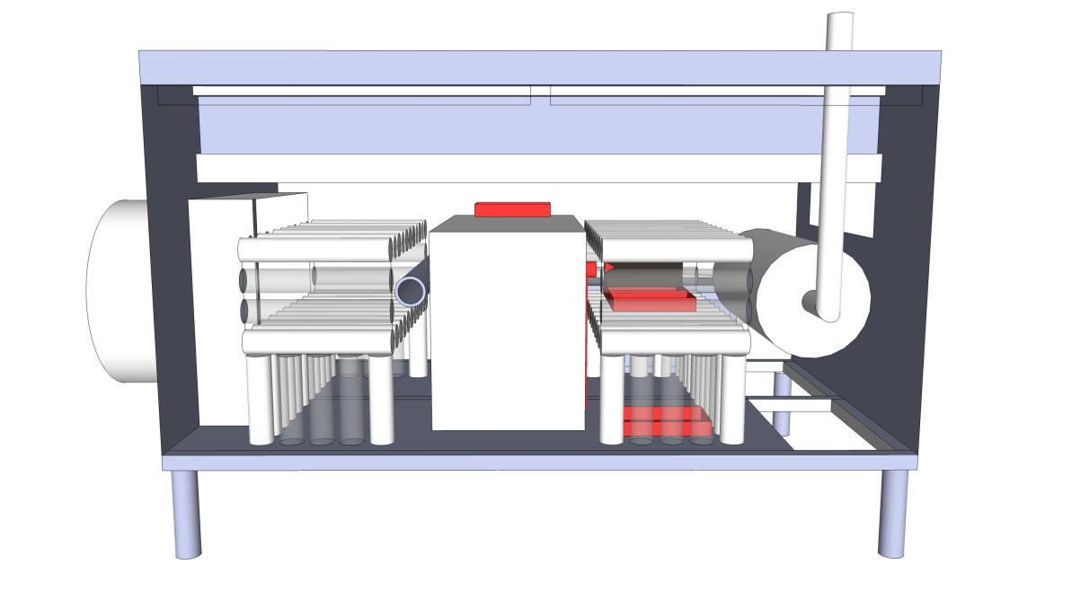

Figure C1: Test scenario 1

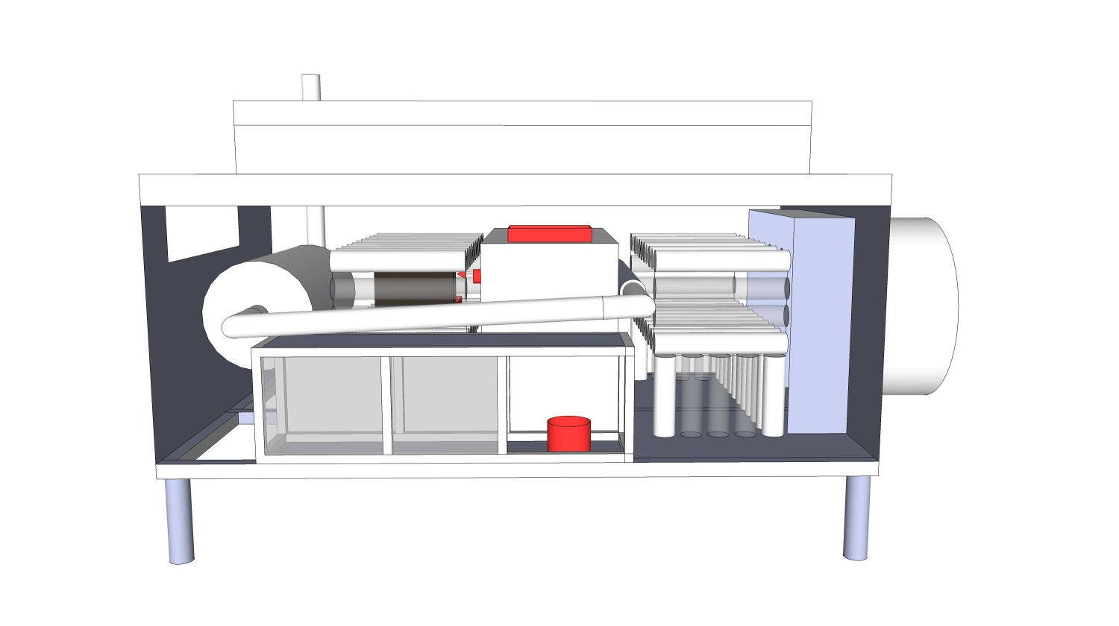

Figure C2: Test scenario 1

**Fire source setup:**

Table C1: Fire source locations in test scenario 1

|  |  |  |  |
| --- | --- | --- | --- |
| **Fire source** | **Description** | **Placement** | **Position coordinate (x,y,z) (mm)** |
| #2 | Pool fire  300 mm × 300 mm with 2 Fibre boards | Obstruction 3  right-rear-upper | (1540, 770, 360) |
| #3 | Pool fire 200 mm × 300 mm | Engine test apparatus  central-rear-top | (970, 850, 700) |
| #3 | Pool fire 200 mm × 300 mm | Obstruction 3  right-central-upper | (1540, 570, 360) |
| #3 | Pool fire 200 mm × 300 mm | Obstruction 3  right-front-bottom | (1540, 130, 0) |
| #4 | Pool fire Ø 150 mm | Obstruction 4  central-rearmost-bottom | (970, 1280, 0) |
| #6 | Spray fire 0.19 kg/min | Obstruction 3  right spray fire | (1470, 730, 460) |

**Ventilation:**

No ventilation.

**Test procedure:**

The extinguishing agent container and propellant gas vessel or extinguishing agent generator are conditioned at ta temperature lower or equal to -20 ºC for at least 16 h prior to test.

Table C2: Time sequence in test scenario 1

|  |  |
| --- | --- |
| Time | Action |
| -05:00 | Extinguishing agent container and propellant gas vessel or extinguishing agent generator is picked out from the cold chamber |
| 00:00 | Start test/ measurement time |
| 01:20 | Start igniting pool fires |
| 01:40 | All pool fires ignited |
| 01:50 | Start spray fire |
| 02:00 | Activate suppression system |

## C2 Test scenario 2: High fire load with 1.5 m3/s ventilation

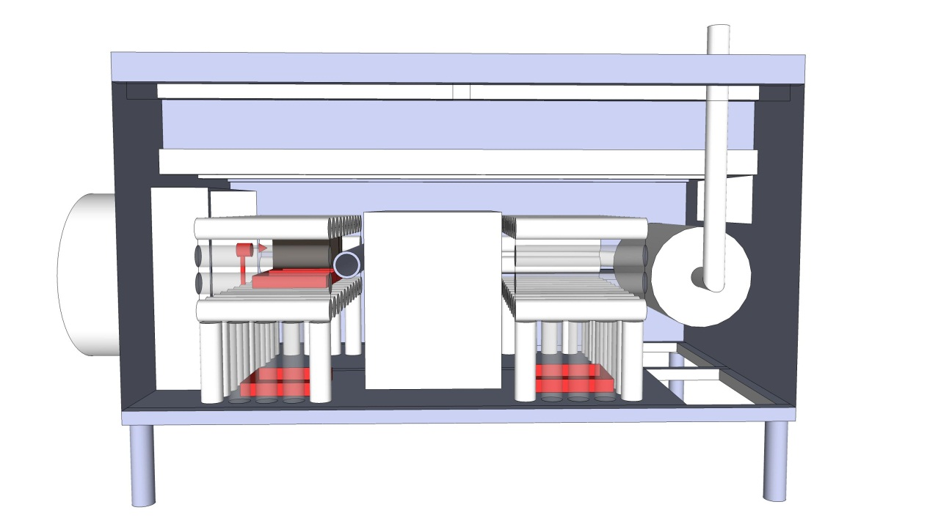

Figure C3: Test scenario 2

**Fire source setup:**

Table C3: Fire source locations in test scenario 2

|  |  |  |  |
| --- | --- | --- | --- |
| **Fire source** | **Description** | **Placement** | **Position coordinate (x,y,z) (mm)** |
| #1 | Pool fire  300 mm × 300 mm | Obstruction 2  left-central-upper | (370, 470, 360) |
| #1 | Pool fire  300 mm × 300 mm | Obstruction 2  left-front-bottom | (370, 130, 0) |
| #1 | Pool fire 300 mm × 300 mm | Obstruction 3  right-front-bottom | (1540, 130, 0) |
| #2 | Pool fire  300 mm × 300 mm  with 2 Fibre boards | Obstruction 2  left-rear-upper | (370, 770, 360) |
| #5 | Spray fire 0.73 kg/min | Obstruction 2  left spray fire | (370, 700, 460) |

**Ventilation:**

Air volume flow 1.5 m3/s

**Test procedure:**

The fire trays with fibreboards shall have parallel orientation in relation to the forced air flow.

Table C4: Time sequence in test scenario 2

|  |  |
| --- | --- |
| Time | Action |
| 00:00 | Start test/ measuring time |
| 01:00 | Ignite pool fires |
| 01:20 | All poolfires ignited |
| 01:30 | Start ventilation |
| 01:50 | Start spray fire |
| 02:00 | Activate suppression system |

## C3 Test scenario 3: Low fire load with 1.5 m3/s ventilation

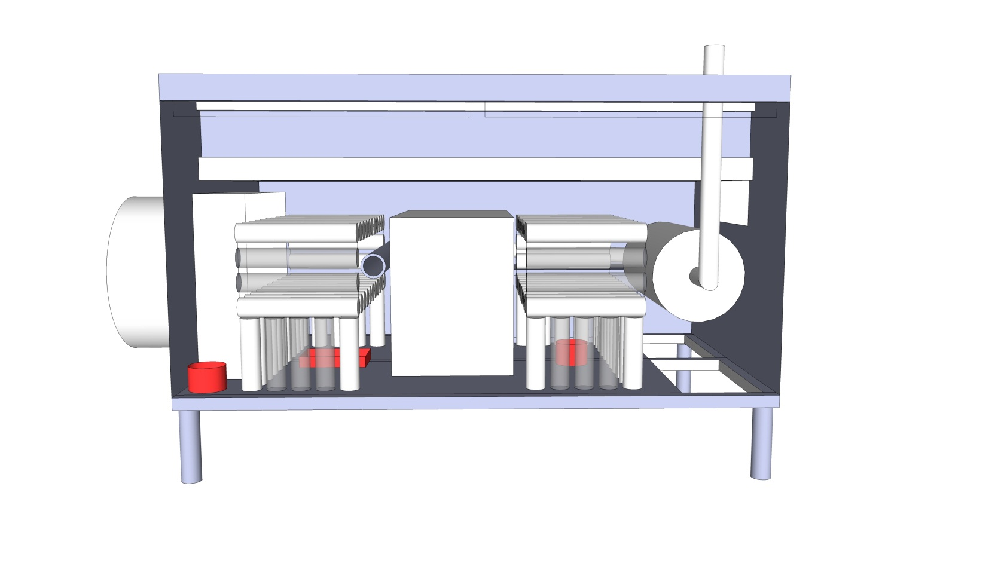

Figure C4: Test scenario 3

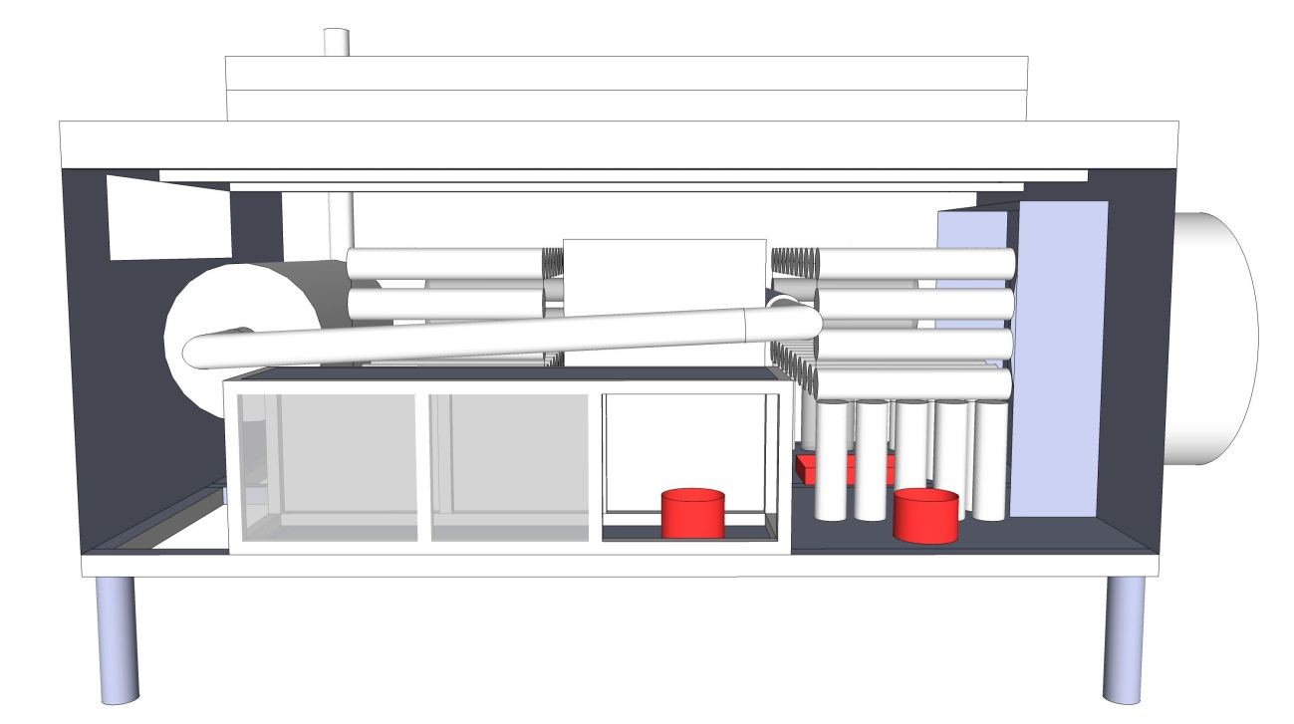

Figure C5: Test scenario 3

**Fire source setup:**

Table C5: Fire source locations in test scenario 3

|  |  |  |  |
| --- | --- | --- | --- |
| **Fire source** | **Description** | **Placement** | **Position coordinate (x,y,z) (mm)** |
| #3 | Pool fire  300 mm × 200 mm | Obstruction 2  left-central-bottom | (370, 570, 0) |
| #4 | Pool fire Ø 150 mm | Corner  left-front-bottom corner | (20, 80, 0) |
| #4 | Pool fire Ø 150 mm | Obstruction 2  left-rearmost-bottom, just outside the rear side | (450, 1200, 0) |
| #4 | Pool fire Ø 150 mm | Obstruction 4  central-rearmost-bottom | (970, 1280, 0) |
| #4 | Pool fire Ø 150 mm | Obstruction 3  right-central-bottom | (1540, 570, 0) |

**Ventilation:**

Air volume flow 1.5 m3/s

**Test procedure:**

Table C6: Time sequence in test scenario 2

|  |  |
| --- | --- |
| Time | Action |
| 00:00 | Start test/ measurement time |
| 01:00 | Ignite pool fires |
| 01:30 | All pool fires ignited |
| 01:30 | Start ventilation |
| 02:00 | Activate suppression system |

## C4 Test scenario 4: Re-ignition test

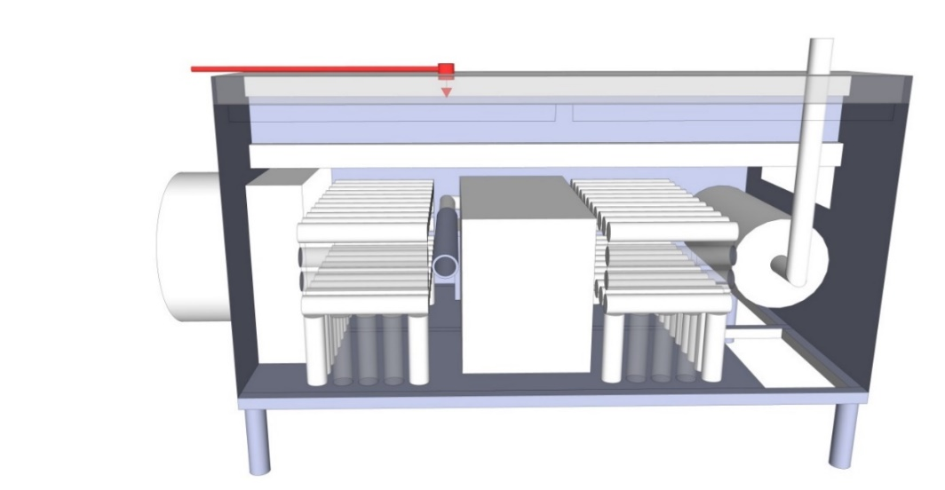

Figure C6: Test scenario 4

**Fire source setup:**

Table C7: Fire source location at re-ignition test

|  |  |  |  |
| --- | --- | --- | --- |
| **Fire source** | **Description** | **Placement** | **Position coordinate (x,y,z) (mm)** |
| #7 | 40 droplets oil/ minute | -- | (820, 280, 1220) |

**Ventilation:** No ventilation.

**Test procedure:**

Prior to test: The area on exhaust pipe where drops fall shall be cleaned with emery cloth.

Preheating: The tube shall be heated from the inner side until the temperature of Tc2 > 600°C, Tc1 > 570 °C and Tc5, Tc6 & Tc7 > 520°C. When the predefined temperatures are reached the pre-heating procedure stops and the burner is removed (time 0:00).

Table C8: Time sequence in test scenario for determining re-ignition delay.

|  |  |
| --- | --- |
| Time | Action |
| -15:00 ±5 min | Start of pre-heating the tube and measuring the temperature |
| t(T=600°C)=  0:00 | End of pre-heating |
| 00:30 | Start of dripping oil |
| 00:40 | Sustained flaming must have commenced |
| 00:45 | Activate suppression system |
| *t* ext | Extinction of flames |
| *t* reignition | Time of re-ignition, no re-ignition allowed |
| *t* ext +05:00 | End of test |