|  |  |  |  |
| --- | --- | --- | --- |
|  | United Nations | ECE/TRANS/WP.29/2024/14 | |
| _unlogo | **Economic and Social Council** | | Distr.: General  21 December 2023  Original: English |

**Economic Commission for Europe**

Inland Transport Committee

**World Forum for Harmonization of Vehicle Regulations**

**192nd session**

Geneva, 5–8 March 2024

Item 4.8.4 of the provisional agenda

**1958 Agreement:**

**Consideration of draft amendments to existing**

**UN Regulations submitted by GRSG**

Proposal for 06 series of amendments to UN Regulation No. 46 (Devices for indirect vision)

Submitted by the Working Party on General Safety Provisions[[1]](#footnote-2)\*

The text reproduced below was adopted by the Working Party on General Safety Provisions (GRSG) at its 126th session (ECE/TRANS/WP.29/GRSG/105, para. 9). It is based on ECE/TRANS/WP.29/GRSG/2023/23, as amended by annex III to the report. It is submitted to the World Forum for Harmonization of Vehicle Regulations (WP.29) and to the Administrative Committee (AC.1) for consideration at their March 2024 sessions.

*Insert new Paragraphs 2.7. to 2.8.*, to read:

"2.7. "*external original surface*" means the outside of the vehicle including the bonnet, the lid of the luggage compartment, the doors, the wings, the roof, the lighting and light-signalling devices, the visible strengthening components and additional external original design surfaces defined by the manufacturer excluding protruding supports for devices of indirect vision.

2.8. "*impact point*" is the position of the hammer, described in paragraphs 6.3.2.2.3. and 6.3.2.2.4., independent of where first contact occurs."

*Paragraph 5.2.,* amend to read:

"5.2. An approval number shall be assigned to each approved type in accordance with Schedule 4 of the Agreement (E/ECE/TRANS/505/Rev.3).

*Paragraph 6.1.1.2.,* amend to read:

"6.1.1.2. (a) Rear-view mirrors (Classes II to VII)

When the edge of the reflecting surface is enclosed in a protective housing, the radius of curvature "c" on the housing’s perimeter shall be not less than 2.5 mm at all points and in all directions, figure below (i).

When the reflecting surface projects beyond the protective housing in any adjustment position (figure below (ii)), the radius of curvature "c" on the edge of the projecting part shall be not less than 2.5 mm and the reflecting surface shall return into the protective housing under a force of 50 N applied to the point of greatest projection, relative to the protective housing, in a horizontal direction, approximately parallel to the longitudinal median plane of the vehicle.

When the edge of the reflecting surface is not enclosed by the protective housing independent from any adjustment position, the radius of curvature "c" on its perimeter shall be not less than 2.5 mm at all points and in all directions and shall apply to the edge of the projecting part, figure below (iii).

1. Edge of the reflecting surface enclosed in a protective housing
2. Reflecting surface projects beyond the protective housing in a specific adjustment position

(iii) Edge of the reflecting surface not enclosed by the protective housing

(b) Rear-view mirrors (Class I)

In cases where the edge of the reflecting surface is enclosed in a protective housing (holder, etc.), the radius of curvature "c" on its perimeter shall be not less than 2.5 mm at all points and in all directions. In cases, where the edge of the reflecting surface projects beyond the protective housing, this requirement shall apply to the edge of the projecting part.

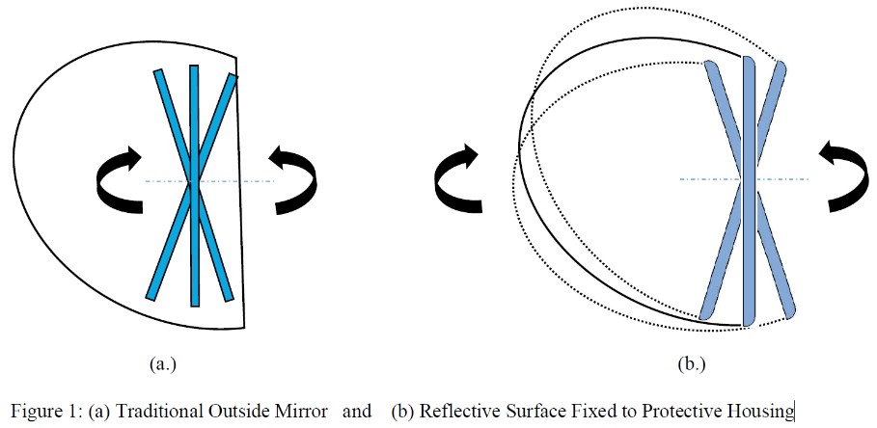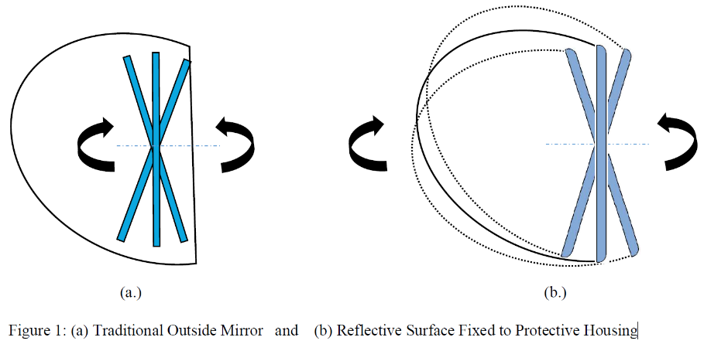

(i)

(ii)

(iii)"



*Paragraph 6.1.1.6.,* amend to read:

"6.1.1.6. The device for the attachment of mirrors to the vehicle shall be so designed that a cylinder with a 70 mm radius (50 mm in the case of an L-category vehicle), having as its axis the axis, or one of the axes, of pivot or rotation which ensures deflection of the mirror in the direction of impact concerned, passes through at least part of the external original surface where the device is protruding from."

*Paragraph 6.3.1.1.,* amend to read:

"6.3.1.1. The test provided for in paragraph 6.3.2. below shall not be required in the case of any Class II to VI exterior device for indirect vision of which no part is less than 2 m from the ground, regardless of the adjustment position, when the vehicle is under a load corresponding to its maximum technically permissible mass.

This derogation also applies to the attachments of devices for indirect vision (attachment plates, arms, swivel joints, etc.) which are situated less than 2 m from the ground and which do not project beyond the overall width of the vehicle, measured in the transverse plane passing through the lowest ~~mirror~~ device for indirect vision attachments or any other point forward of this plane if this configuration produces a greater overall width.

In such cases, a description specifying that the device for indirect vision shall be mounted so as to conform to the above-mentioned conditions for the positioning of its attachments on the vehicle shall be provided.

Where advantage is taken of this derogation, the arm shall be indelibly marked with the symbol

and the type approval certificate shall be endorsed to this effect."

*Paragraph 6.3.2.,* amend to read:

"6.3.2. Impact test

The test according to this paragraph is not to be carried out for ~~devices~~

(a) exterior devices not projecting beyond the overall width and length of the vehicle and providing a frontal deflecting area of an angle not more than 45° measured in relation to the longitudinal median plane of the vehicle, or

(b) devices not protruding more than 100 mm measured at the attachment point beyond the circumscribing external original surface of the vehicle according to Regulation No. 26."

See Annex 9."

*Paragraph 6.3.2.1.1.,* amend to read:

"6.3.2.1.1. The test rig consists of a pendulum capable of swinging about two horizontal axes at right angles to each other, one of which is perpendicular to the plane containing the "release" trajectory of the pendulum.

The end of the pendulum comprises a hammer formed by a rigid sphere with a diameter of165± 1mmand a 5 ± 1 mm thick rubber covering of Shore A hardness 50.

A device is provided which permits determination of the maximum angle assumed by the arm in the plane of release.

A support firmly fixed to the structure of the pendulum serves to hold the specimens in compliance with the impact requirements specified in paragraph ~~6.1.3.2.2.6.~~ **6.3.2.2.7.** below.

…"

*Paragraph 6.3.2.2.2.1*., amend to read:

"6.3.2.2.2.1. Devices for indirect vision shall be positioned on the pendulum impact rig in such a way that the axes which are horizontal and vertical when the ~~mirror~~ device for indirect vision is installed on a vehicle in accordance with the applicant's mounting instructions are in a similar position;"

*Paragraph 6.3.2.2.2.,* amend to read:

"6.3.2.2.2.2. When a device for indirect vision is adjustable with respect to the base, the test position shall be that in which any pivoting device is least likely to operate, within the limits of adjustment provided by the applicant. When the edge of the reflecting surface is not enclosed by the protective housing according to paragraph 6.1.1.2. (iii) the worst case test positions for both impact directions shall be identified by the Technical Service in consultation with the manufacturer;"

*Paragraph 6.3.2.2.5.,* amend to read:

"6.3.2.2.5. When, under the conditions governing adjustment laid down in paragraphs 6.3.2.2.1. and 6.3.2.2.2. above parts of the device for indirect vision limit the return of the hammer, the point of impact shall be displaced in a direction perpendicular to the axis of rotation or pivoting in question.

The displacement shall be no greater than is strictly necessary for the execution of the test; it shall be limited in such a way that:

1. Either the sphere delimiting the hammer remains at least tangential to the cylinder as defined in paragraph 6.1.1.6.;
2. Or, in the case of mirrors, the impact point of the hammer is located on the reflecting surface at least 10 mm from the periphery of the reflecting surface."

*Insert new paragraphs 12.7. to 12.9.,* to read:

"12.7. "*Centre-steered* *vehicle*" means a vehicle that is steered from a central driving position."

12.8. "*Central driving position*" is defined when Y coordinate of the "R" point1 is in Y0 position within ±60 mm.

12.9. "S*ide-steered vehicle*" means a vehicle which is not a centre-steered vehicle."

*Paragraph 14.2.,* amend to read:

"14.2. An approval number shall be assigned to each approved type in accordance with Schedule 4 of the Agreement (E/ECE/TRANS/505/Rev.3)."

*Paragraph 15.2.1.1.1*., amend to read:

"15.2.1.1.1. The fields of vision prescribed in paragraph 15.2.4. below shall be obtained from the minimum number of mandatory mirrors or camera-monitor devices set out in the following table.

A minimum number of camera-monitor systems is undefined, but they shall provide the same field of vision as given in the table below and the provision on the minimum mounting height does not apply.

In the case of camera-monitor systems, the maximum number of monitors shall not exceed the corresponding number of mirrors.

| *Vehicle category* | *Rear-view Class I* | *Main rear-view Class II* | *Main rear-view Class III* | *Wide-angle view Class IV* | *Close-proximity view Class V* | *Front-view Class VI* |
| --- | --- | --- | --- | --- | --- | --- |
| M1 | Compulsory Unless the vehicle is fitted with anything other than safety glazing material in the field of vision prescribed in paragraph 15.2.4.1. | Optional | Compulsory  1 on the driver's side and  1 on the passenger's side Class II devices for indirect vision may be fitted as an alternative. | Optional 1 on the driver's side  and/or  1 on the passenger's side | Optional 1 on the driver's side  and 1 on the passenger's side  (both shall be fitted at least 2 m above the ground) | Optional 1 device for indirect vision (a front mirror shall be fitted at least 2 m above the ground) |
| M2 | Optional  (no requirements for the field of view) | Compulsory  1 on the driver's side and 1 on the passenger's side | Not permitted | Optional 1 on the driver's side  and/or  1 on the passenger's side | Optional 1 on the driver's side and 1 on the passenger's side (both shall be fitted at least 2 m above the ground) | Optional 1 device for indirect vision (a front mirror shall be fitted at least 2 m above the ground) |
| M3 | Optional  (no requirements for the field of view) | Compulsory 1 on the driver's side and 1 on the passenger's side | Not permitted | Optional 1 on the driver's side  and/or 1 on the passenger's side | Optional 1 on the driver's side  and 1 on the passenger's side (both shall be fitted at least 2 m above the ground) | Optional 1 device for indirect vision (a front mirror shall be fitted at least 2 m above the ground) |
| N1 | Compulsory Unless the vehicle is fitted with anything other than safety glazing material in the field of vision prescribed in paragraph 15.2.4.1. | Optional | Compulsory  1 on the driver's side and 1 on the passenger's side Class II devices for indirect vision may be fitted as an alternative. | Optional 1 on the driver's side  and/or 1 on the passenger's side | Optional 1 on the driver's side  and 1 on the passenger's side (both shall be fitted at least 2 m above the ground) | Optional 1 device for indirect vision (a front mirror shall be fitted at least 2 m above the ground) |
| N2  ≤ 7.5 t | Optional (no requirements for the field of view) | Compulsory 1 on the driver's side  and 1 on the passenger's side | Not permitted | Compulsory  For both sides if a Class V mirror can be fitted  Optional  For both sides together if not  In addition according to paragraphs 15.2.4.5.6. to 15.2.4.5.11. for vehicles with a mounting height of the Class V mirror of not less than 2.4 m (see paragraph 15.2.4.5.12.): the required field of vision (paragraphs 15.2.4.5.6. to 15.2.4.5.9.) may be viewed using a combination of direct view and indirect vision devices (of Classes IV, V, VI). | Compulsory  (see paragraphs 15.2.2.7. and 15.2.4.5.5.)  1 on the passenger's side  For centre-steered vehicles  (see paragraphs 15.2.2.7. and 15.2.4.5.5.) on both sides  Optional 1 on the driver's side  (both shall be fitted at least 2 m above the ground). A tolerance of +10 cm may be applied  In addition according to paragraphs 15.2.4.5.6. to 15.2.4.5.11. for vehicles with a mounting height of the Class V mirror of not less than 2.4 m (see paragraph 15.2.4.5.12.): the required field of vision (paragraphs 15.2.4.5.6. to 15.2.4.5.9.) may be viewed using a combination of direct view and indirect vision devices (of Classes IV, V, VI). | Optional 1 ~~front mirror~~ device for indirect vision (a front mirror shall be fitted at least 2 m above the ground)  In addition according to paragraphs 15.2.4.5.6. to 15.2.4.5.11. for vehicles with a mounting height of the Class V mirror of not less than 2.4 m (see paragraph 15.2.4.5.12.): the required field of vision (paragraphs 15.2.4.5.6. to 15.2.4.5.9.) may be viewed using a combination of direct view and indirect vision devices (of Classes IV, V, VI). |
| N2  > 7.5 t | Optional (no requirementsfor the field of view) | Compulsory 1 on the driver's side and 1 on the passenger's side | Not permitted | Compulsory 1 on the driver's side and 1 on the passenger's side  In addition according to paragraphs 15.2.4.5.6. to 15.2.4.5.11. for vehicles with a mounting height of the Class V mirror of not less than 2.4 m (see paragraph 15.2.4.5.12.): the required field of vision (paragraphs 15.2.4.5.6. to 15.2.4.5.9.) may be viewed using a combination of direct view and indirect vision devices (of Classes IV, V, VI). | Compulsory (see paragraph 15.2.2.7. and 15.2.4.5.5) 1 on the passenger's side For centre-steered vehicles  (see paragraphs 15.2.2.7. and 15.2.4.5.5.) on both sides  Optional 1 on Driver's side  (both shall be fitted at least 2 m above the ground)  In addition according to paragraphs 15.2.4.5.6. to 15.2.4.5.11. for vehicles with a mounting height of the Class V mirror of not less than 2.4 m (see paragraph 15.2.4.5.12.): the required field of vision (paragraphs 15.2.4.5.6. to 15.2.4.5.9.) may be viewed using a combination of direct view and indirect vision devices (of Classes IV, V, VI). | Compulsory (see paragraph 15.2.1.1.2  1 ~~front mirror~~ device for indirect vision (a front mirror shall be fitted at least 2 m above the ground) In addition according to paragraphs 15.2.4.5.6. to 15.2.4.5.11. for vehicles with a mounting height of the Class V mirror of not less than 2.4 m (see paragraph 15.2.4.5.12.): the required field of vision (paragraphs 15.2.4.5.6. to 15.2.4.5.9.) may be viewed using a combination of direct view and indirect vision devices (of Classes IV, V, VI). |
| N3 | Optional (no requirementsfor the field of view) | Compulsory 1 on the driver's side and 1 on the passenger's side | Not permitted | Compulsory 1 on the driver's side and 1 on the passenger's side  In addition according to paragraphs 15.2.4.5.6. to 15.2.4.5.11. for vehicles with a mounting height of the Class V mirror of not less than 2.4 m (see paragraph 15.2.4.5.12.): the required field of vision (paragraphs 15.2.4.5.6. to 15.2.4.5.9.) may be viewed using a combination of direct view and indirect vision devices (of Classes IV, V, VI). | Compulsory (see paragraph 15.2.2.7. and 15.2.4.5.5)  1 on the passenger's side  For centre-steered vehicles  (see paragraphs 15.2.2.7. and 15.2.4.5.5.) on both sides  Optional 1 on driver's side (both shall be fitted at least 2 m above the ground)  In addition according to paragraphs 15.2.4.5.6. to 15.2.4.5.11. for vehicles with a mounting height of the Class V mirror of not less than 2.4 m (see paragraph 15.2.4.5.12.): the required field of vision (paragraphs 15.2.4.5.6. to 15.2.4.5.9.) may be viewed using a combination of direct view and indirect vision devices (of Classes IV, V, VI). | Compulsory (see paragraph 15.2.1.1.2  1 ~~front mirror~~ device for indirect vision (a front mirror shall be fitted at least 2 m above the ground)  In addition according to paragraphs 15.2.4.5.6. to 15.2.4.5.11. for vehicles with a mounting height of the Class V mirror of not less than 2.4 m (see paragraph 15.2.4.5.12.): the required field of vision (paragraphs 15.2.4.5.6. to 15.2.4.5.9.) may be viewed using a combination of direct view and indirect vision devices (of Classes IV, V, VI). |

*Paragraph 15.2.1.1.2.,* re-positioned after the tables andamend to read:

"15.2.1.1.2. In the case a camera-monitor system is used for rendering (the) field(s) of vision, the relevant field(s) of vision shall be permanently visible to the driver when the ignition is on or the vehicle master control switch is activated (whichever is applicable) and if the camera-monitor system is available (see paragraph 16.1.2.) and not used for other information. However, when the vehicle is moving forward at a speed above 10 km/h or backwards, the monitor or the part of the monitor intended for rendering the Class VI field of vision may be used for other information. Multiple images may be used or displayed provided that the monitor has been approved in this mode."

*Paragraphs 15.2.1.1.3.,* remain unchanged and re-positioned after the tables

*Paragraph 15.2.2.6.,* amend to read:

"15.2.2.6. Where the lower edge of a Classes II to VII device for indirect vision is less than 2 m above the ground when the vehicle is loaded to its technically permissible maximum laden mass, this device shall not project more than 250 mm beyond the overall width of the vehicle measured without these devices."

*Paragraph 15.2.3.2.,* amend to read:

"15.2.3.2. If a Class II, III, IV or VII mirror is fitted on the driver's side, it shall be capable of being adjusted from inside the vehicle while the door is closed, although the window may be open. The mirror may, however, be locked in position from the outside. In case of a centre-steered vehicle this provision applies to mirrors on both sides."

*Paragraph 15.2.4.5.12*., amend to read:

"15.2.4.5.12. The field of vision prescribed in paragraphs 15.2.4.5.1. to 15.2.4.5.4. may be viewed using a combination of a close-proximity view device (Class V) and a wide-angle view device (Class IV).

In such cases the close-proximity view device for indirect vision (Class V) shall provide at least 90 per cent of the field of vision prescribed in paragraphs 15.2.4.5.1 to 15.2.4.5.4. and the device for indirect vision (Class IV) shall be adjusted in a way that it simultaneously provides the field of vision prescribed in paragraph 15.2.4.4.2."

*Paragraph 15.2.4.6.1*., amend to read:

"15.2.4.6.1. The field of vision shall be such that the driver can see at least a flat horizontal portion of the road, which is for side-steered vehicles bounded by:

(a) A transverse vertical plane through the outermost point of the front of the vehicle;

(b) a transverse vertical plane 2,000 mm in front of the plane defined in (a);

(c) a longitudinal vertical plane parallel to the longitudinal vertical median plane going through the outermost side of the vehicle at the driver's side;

(d) a longitudinal vertical plane parallel to the longitudinal vertical median plane 2,000 mm outside the outermost side of the vehicle opposite to the driver's side; and

(e) the front of this field of vision opposite to the driver's side may be rounded off with a radius of 2,000 mm (see Figure 9.1).

The field of vision shall be such that the driver can see at least a flat horizontal portion of the road, which is for centre-steered vehicles bounded by:

(f) A transverse vertical plane through the outermost point of the front of the vehicle;

(g) a transverse vertical plane 2,000 mm in front of the plane defined in (a);

(h) a longitudinal vertical plane parallel to the longitudinal vertical median plane 2,000 mm outside the outermost side of both sides of the vehicle; and

(i) the front of this field of vision on both sides may be rounded off with a radius of 2,000 mm (see Figure 9.2).

For the defined field of vision, see also paragraph 15.2.4.9.2. below.

The provisions for Class VI front-view devices are compulsory for forward controlled (as defined in paragraph 12.5. of this Regulation) vehicles of categories N2 > 7.5 t and N3.

If vehicles of these categories cannot fulfil the requirements by using a front-view device, a vision support system shall be used. In the case of a vision support system this device shall be able to detect an object of 50 cm height and with a diameter of 30 cm within the field defined in Figure 9.1 and Figure 9.2."

*Figure 9,* renumber as Figure 9.1. and amend to read:

"Figure 9.1

**Class VI field of vision for side-steered vehicle"**

Ground level

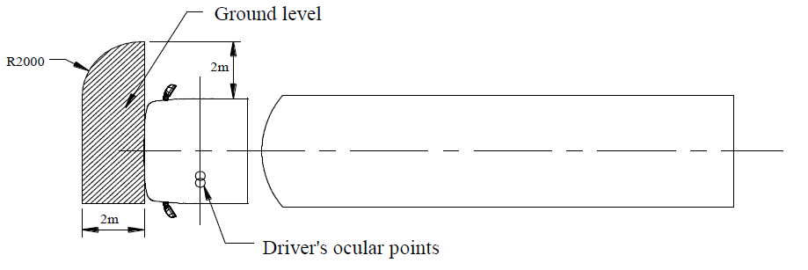

Driver's ocular points

"

*Insert a new figure 9.2*., to read:

"Figure 9.2

**Class VI field of vision for centre-steered vehicle"**

Ground level

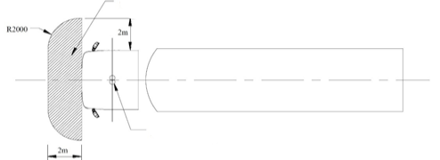

Driver's ocular points

*Paragraph 15.2.4.6.2*., amend to read:

"15.2.4.6.2. However, if the driver can see, taking into account the obstructions by the A-pillars, a straight line 300 mm in front of the vehicle at a height of 1,200 mm above the road surface and which is in case of a side steered vehicle situated between a longitudinal vertical plane parallel to the longitudinal vertical median plane going through the outermost side of the vehicle at the driver's side and a longitudinal vertical plane parallel to the longitudinal vertical median plane 900 mm outside the outermost side of the vehicle opposite to the driver's side and for centre-steered vehicles a longitudinal vertical plane parallel to the longitudinal vertical median plane 900 mm outside the outermost side of the vehicle on both sides , a Class VI device for indirect vision is not mandatory."

*Paragraph 15.2.4.9.2*., amend to read:

"15.2.4.9.2. Classes II, III, IV, V, and VI devices for indirect vision and Class VII mirrors

In the fields of vision specified above, obstruction due to the bodywork and its components, such as other cab devices for indirect vision, door handles, outline marker lights, direction indicators and front and rear bumpers, as well as reflective-surface cleaning components, shall not be taken into account if they are responsible for a total obstruction of less than 10 per cent of the specified field of vision. In the case of a vehicle designed and constructed for special purposes where, due to its special features, it is not possible to meet this requirement, the obstruction of the required field of vision of a Class VI device for indirect vision caused by the special features may be more than 10 per cent but not more than necessary for its special function."

*Paragraph 16.1.2.*, amend to read:

"16.1.2. Operating readiness (System availability)

Non-operation of the system (e.g. CMS failure or CMS in a folded position) shall be recognizable to the driver and indicated by e.g. warning indication, display information, absence of status indicator. The information for the driver shall be explained in the operator's manual."

*Paragraph 16.1.3.1*., amend to read:

"16.1.3.1. Magnification factor

The minimum and the average magnification factors of the CMS, in both

horizontal and vertical directions shall not be lower than the magnification factors indicated below."

*Insert new paragraphs 16.1.3.1.1*. *to 16.1.3.1.3*., to read:

"16.1.3.1.1. The minimum magnification factor for side-steered vehicles of classes M and N shall not be less than:

(a) For Class I: 0.31;

(b) For Class II (driver's side): 0.26;

(c) For Class III (driver's side): 0.29;

(d) For Class IV (driver's side): 0.054;

(e) For Class II (passenger's side): 0.13;

(f) For Class III (passenger's side): 0.19;

(g) For Class IV (passenger's side): 0.016.

The average magnification factor for side-steered vehicles shall not be less than:

(h) For Class I: 0.33;

(i) For Class II (driver's side): 0.31;

(j) For Class III (driver's side): 0.31;

(k) For Class IV (driver's side): 0.091;

(l) For Class II (passenger's side): 0.16;

(m) For Class III (passenger's side): 0.20;

(n) For Class IV (passenger's side): 0.046.

16.1.3.1.2. The minimum magnification factor for centre-steered vehicles of classes M1 and N1 shall not be less than:

(a) For Class I: 0.31;

(b) For Class II (driver centre): 0.26;

(c) For Class III (driver centre): 0.29;

(d) For Class IV (driver centre): 0.054.

The average magnification factor for centre-steered vehicles shall not be less than:

(e) For Class I: 0.33;

(f) For Class II (driver centre): 0.31;

(g) For Class III (driver centre): 0.31;

(h) For Class IV (driver centre): 0.046."

16.1.3.1.3. The minimum magnification factor for centre-steered vehicles of classes M2, M3, N2 and N3 shall not be less than:

(a) For Class I: 0.31;

(b) For Class II (driver centre): 0.22;

(c) For Class IV (driver centre): 0.043.

The average magnification factor for centre-steered vehicles shall not be less than:

(d) For Class I: 0.33;

(e) For Class II (driver centre): 0.23;

(f) For Class IV (driver centre): 0.068."

*Paragraph 16.1.4*., amend to read:

"16.1.4 Magnification aspect ratio

In the required field of view, the difference between the average magnification factor for horizontal and vertical direction of a CMS shall satisfy the following equations depending on the individual classes.

…"

*Insert new paragraphs 22.26. to 22.33.*, to read:

"22.26. As from the official date of entry into force of the 06 series of amendments, no Contracting Party applying this Regulation shall refuse to grant or refuse to accept type approvals under this Regulation as amended by the 06 series of amendments.

22.27. As from 1 September 2025, Contracting Parties applying this Regulation shall not be obliged to accept type approvals to the preceding series of amendments, first issued after 1 September 2025.

22.28. Until 1 September 2027, Contracting Parties applying this Regulation shall accept type approvals to the preceding series of amendments, first issued before 1 September 2025.

22.29. As from 1 September 2027, Contracting Parties applying this Regulation shall not be obliged to accept type approvals issued to the preceding series of amendments to this Regulation.

22.30. Notwithstanding paragraph 22.29., Contracting Parties applying this Regulation shall continue to accept type approvals issued according to the preceding series of amendments to this Regulation, for the vehicles anddevices for indirect vision which are not affected by the changes introduced by the 06 series of amendments.

22.31. Contracting Parties applying this Regulation may grant type approvals according to any preceding series of amendments to this Regulation.

22.32. Contracting Parties applying this Regulation shall continue to grant extensions of existing approvals to any preceding series of amendments to this Regulation."

*Annex 5,* amend to read:

"Annex 5

Arrangement of approval mark of a device for indirect vision

(See paragraph 5.4. of the Regulation)



062439

a = 5 mm minimum

The above approval mark affixed to a device for indirect vision indicates that the device is a main rear-view device, of Class II, which has been approved in the Netherlands (E 4) pursuant to Regulation No. 46 and under approval number 062439. The first two digits of the approval number indicate that Regulation No. 46 already included the 06 series of amendments when the approval was granted.

*Note*: The approval number and the additional symbol shall be placed close to the circle and either above or below the "E" or to the left or right of that letter. The digits of the approval number shall be on the same side of the "E" and point in the same direction. The additional symbol shall be directly opposite the approval number. The use of Roman numerals as approval numbers shall be avoided so as to prevent any confusion with other symbols."

*Annex 9,* amend to read:

"Figure 1

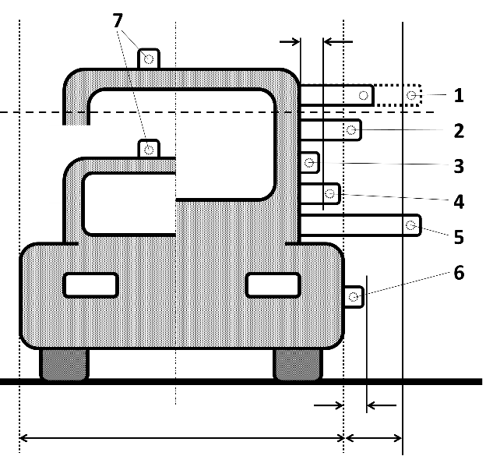

250 mm

100 mm

100 mm

PENDULUM

IMPACT TEST

Device for indirect vision CLASS II-VII

1 NO TEST (15.2.2.6.)

2 COMPULSORY

3 NO TEST (6.3.2.b))

4 NO TEST (6.3.2.a))

5 not permitted (15.2.2.6.)

6 NO TEST (6.3.2.b))

Camera of CLASS I (CMS)

7 NO TEST (6.3.2.b)

Δ2m

Overall width of the vehicle

"

1. \* In accordance with the programme of work of the Inland Transport Committee for 2024 as outlined in proposed programme budget for 2024 (A/78/6 (Sect. 20), table 20.5), the World Forum will develop, harmonize and update UN Regulations in order to enhance the performance of vehicles. The present document is submitted in conformity with that mandate. [↑](#footnote-ref-2)