|  |  |  |  |
| --- | --- | --- | --- |
|  | United Nations | ECE/TRANS/WP.29/2024/25 | |
| _unlogo | **Economic and Social Council** | | Distr.: General  20 December 2023  Original: English |

**Economic Commission for Europe**

Inland Transport Committee

**World Forum for Harmonization of Vehicle Regulations**

**192nd session**

Geneva, 5–8 March 2024

Item 4.9.10 of the provisional agenda

**1958 Agreement:**

**Consideration of draft amendments to existing**

**UN Regulations submitted by GRE**

Proposal for Supplement 3 to the 01 series of amendments to UN Regulation No. 149 (Road illumination devices)

Submitted by the Working Party on Lighting and Light-Signalling[[1]](#footnote-2)\*

The text reproduced below was adopted by the Working Party on Lighting and Light-Signalling (GRE) at its eighty-ninth session (ECE/TRANS/WP.29/GRE/89, paras. 10, 29, 30 and 31). It is based on ECE/TRANS/WP.29/GRE/2023/15, ECE/TRANS/WP.29/GRE/2023/18, ECE/TRANS/WP.29/GRE/2023/23 and ECE/TRANS/WP.29/GRE/2023/17, as amended by informal document GRE-89-28. It is submitted to the World Forum for Harmonization of Vehicle Regulations (WP.29) and to the Administrative Committee (AC.1) for consideration at their March 2024 sessions.

*Paragraph 1.,* amend to read:

“1. Scope

This Regulation applies to the following road illumination devices (lamps):

* Headlamps emitting a driving-beam and/or an asymmetrical passing-beam for vehicles of categories L, M, N and T
* Adaptive front-lighting systems (AFS) for vehicles of categories M, N and L3
* Adaptive Driving-Beam (ADB) for vehicles of category L3
* Headlamps emitting a driving-beam and/or a symmetrical passing-beam for vehicles of categories L and T
* Front fog lamps for vehicles of categories L3, L4, L5, L7, M, N and T
* Cornering lamps for vehicles of categories M, N and T.”

*Paragraph 3.1.2.2.2. (g),* amend to read:

“3.1.2.2.2. …

(g) The indication(s) according to the provision of paragraph 5.3.5.1. with respect to paragraph 6.22. of UN Regulation No. 48 or paragraph 6.18. of UN Regulation No. 53;

…”

*Paragraph 3.2.,* amend to read*:*

“3.2. Approval

A separate approval is required for each lamp listed in paragraph 1.

When two or more lamps are part of the same assembly of grouped, combined or reciprocally incorporated lamps, approval is granted only if each of these lamps satisfies the requirements of this Regulation or of another Regulation. Lamps not satisfying any one of those Regulations shall not be part of such an assembly of grouped, combined or reciprocally incorporated lamps.”

*Paragraph 3.2.2.,* amend to read:

“3.2.2. An approval number shall be assigned to each type approved and shall be marked on the device following the requirements of paragraph 3.3. The same Contracting Party shall not assign the same number to another type of device covered by this Regulation except in the case of an extension of the approval to a front fog lamp differing only in the colour of the light emitted by the lamp.”

*Paragraph 3.2.4.,* amend to read:

“3.2.4.If approval is sought for an AFS which is not intended to be included as part of the approval of a vehicle type according to UN Regulation No. 48 or if approval is sought for an ADB or AFS for vehicles of category L3 which is not intended to be included as part of the approval of a vehicle type according to UN Regulation No. 53,”

*Paragraph 3.2.4.1.,* amend to read:

“3.2.4.1. The applicant shall submit sufficient documentation to prove the capability of the system to comply with the provisions of paragraph 6.22. of the UN Regulation No. 48 or paragraph 6.16. and 6.18. of UN Regulation No. 53 when correctly installed, and”

*Paragraph 3.2.5., Table 1,* amend to read:

“Table 1

**List of symbols/combinations**

| *Lamp (function)* | *Symbol* | *Symbol if device is part of a matched pair* |
| --- | --- | --- |
| Driving-beam headlamp of Class A | R | YR |
| Passing-beam headlamp of Class V (asymmetrical) | V | YV |
| Driving-beam headlamp of Class B | HR | YHR |
| Passing-beam headlamp of Class C (asymmetrical) | C | YC |
| Auxiliary Driving-Beam of Class RA | RA | - |
| Adaptive Front lighting System (Class AFS-C): basic passing-beam | XC3 | - |
| Adaptive Front lighting System (Class AFS-E): motorway passing-beam | XCE[[2]](#footnote-3), [[3]](#footnote-4) | - |
| Adaptive Front lighting System (Class AFS-V): town passing-beam | XCV3, 4 | - |
| Adaptive Front lighting System (Class AFS-W): adverse weather passing-beam | XCW3, 4 | - |
| Adaptive Front lighting System for vehicle of category L3 (Class AFS-C): basic passing-beam | MXC3 |  |
| Adaptive Front lighting System for vehicle of category L3 (Class AFS-E): motorway passing-beam | MXCE3, 4 |  |
| Adaptive Front lighting System for vehicle of category L3 (Class AFS-V): town passing-beam | MXCV3, 4 |  |
| Adaptive Front lighting System for vehicle of category L3 (Class AFS-W): adverse weather passing-beam | MXCW3, 4 |  |
| Adaptive Front lighting System (Class AFS-R): driving-beam | XR3 | - |
| Passing-beam headlamp of Class AS (symmetrical) | C-AS | YC-AS |
| Passing-beam headlamp of Class BS (symmetrical) | C-BS | YC-BS |
| Passing-beam headlamp of Class CS (symmetrical) | WC-CS | YC-CS\* |
| Passing-beam headlamp of Class DS (symmetrical) | WC-DS | YC-DS\* |
| Driving-beam headlamp of Class BS | R-BS | YR-BS\* |
| Secondary driving-beam headlamp of Class CS | WR-CS | YR-CS\* |
| Secondary driving-beam headlamp of Class DS | WR-DS | YR-DS\* |
| Adaptive driving-beam for vehicles of category L3 | ADB | YADB |
| Front fog lamp of Class F3 | F3 | YF3 |
| Cornering lamp of Class K | K | - |

\* The symbol “W” is not indicated because deemed unnecessary for these classes as part of a matched pair.”

*Paragraph 4.5.3.6.,* amend to read:

“4.5.3.6. In case of an AFS incorporating light sources and/or light source modules producing the basic passing-beam and having a total objective luminous flux of the lighting units as indicated under item 9.2.3.(a) of the communication form which exceeds 2.00·103 lumen per side, a reference shall be made in the communication form in Annex 1. This information is not necessary in case the AFS is intended for a vehicle of category L3.”

*Paragraph 5.3.2.1.,* amend to read:

“5.3.2.1. For each side of the system (vehicle) or in the case of AFS for vehicles of category L3 for the system the passing-beam in its neutral state shall produce from at least one lighting unit a “cut-off” as defined in Annex 5 or,”

*Paragraph 5.3.2.2.*, amend to read:

“5.3.2.2. The system or part(s) thereof shall be aimed according to the requirements of Annex 5 paragraph 3.2. including the allowed specific tolerances of paragraph 4 so that the position of the cut-off complies with the requirements indicated in Table 8. For AFS for vehicles of category L3 the system or part(s) thereof shall be aimed according to the requirements of Annex 5 paragraph 3.3.

If, however, the vertical adjustment cannot be performed repeatedly to the required position within the allowed tolerances, the instrument method of Annex 6, paragraph 2. shall be applied to the test compliance with the required minimum quality of the asymmetric “cut-off” line or of the symmetric “cut-off” line for AFS for vehicles of category L3 and to perform the beam vertical adjustment.”

*Paragraph 5.3.2.4.,* amend to read:

“5.3.2.4. When emitting a specified mode of the passing-beam, the system shall meet the requirements in the respective section (C, V, E, W) of part A of the Table 7 (photometric values) and in Table 8 (Imax and “cut-off” positions), as well as paragraph 2.1. (asymmetric “cut-off” definition) of Annex 5. For AFS for vehicles of category L3, when emitting a specified mode of the passing-beam, the system shall meet the requirements for passing-beam of Class DS specified in paragraph 5.4. of this Regulation.”

*Paragraph 5.3.3.4.*, amend to read:

“5.3.3.4. The system shall be so made that the lighting unit(s) of the right side and of the left side each provide at least 1.60∙104 cd at the point HV. In case of ADB for vehicles of category L3, each installation unit shall provide at least 1.60∙104 cd at the point HV.”

*Paragraphs 5.6.2., 5.6.3. and related sub-paragraphs*, delete.

*Paragraphs 5.6.4., 5.6.4.1. and 5.6.4.2.,* renumber as 5.6.2., 5.6.2.1. and 5.6.2.2., respectively.

*Table 36, Part B*, amend to read:

*“…*

| Part B | ***Element a*** | ***Angular coordinates***  ***in deg.*** | | ***Min. luminous intensity b in cd*** | | |
| --- | --- | --- | --- | --- | --- | --- |
| ***Column A*** | ***Column B*** | ***Column C*** |
| ***vertical*** | ***horizontal*** | ***≙ 0% CoP*** | ***≙ 20% CoP*** | ***≙ 30% CoP*** |
| 50L | 0.86°D | 3.43°L | 2.55∙103 | 2.04∙103 | 1.79∙103 |
| 50V | 0.86°D | 0° | 5.10∙103 | 4.08∙103 | 3.57∙103 |
| 50R | 0.86°D | 1.72°R | 5.10∙103 | 4.08∙103 | 3.57∙103 |
| 25LL | 1.72°D | 16°L | 1.18∙103 | 9.44∙102 | 8.26∙102 |
| 25RR | 1.72°D | 11°R | 1.18∙103 | 9.44∙102 | 8.26∙102 |

…”

*Paragraph 6.2.1.1.4.4.*, amend to read:

“6.2.1.1.4.4. As an alternative to the re-alignment procedure as described in paragraph 4.1. of Annex 5, the intensity requirement of column A, B or C of Tables 21 to 36 for a particular direction of observation shall be deemed to be satisfied if that requirement is met in a direction deviating by not more than one-quarter of a degree from the direction of observation.”

*Figure A13-III*, *marking examples 3-a and 3-b*, replace examples to read:

**“Marking example 3-a**

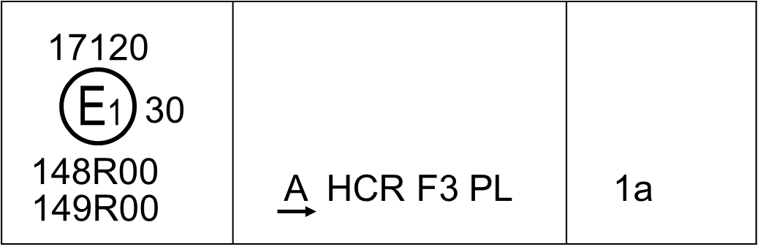

**Marking example 3-b**

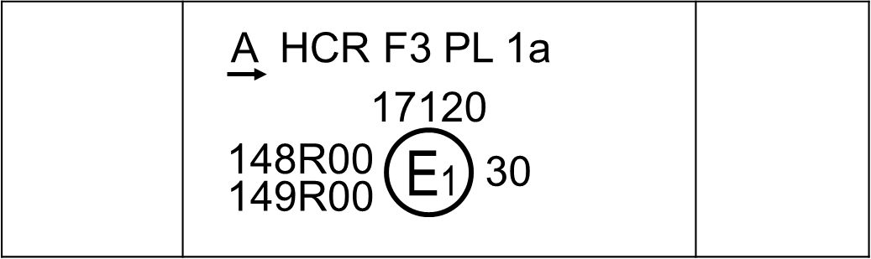

”

*Annex 1,*

*Item 9.2.9., insert a new footnote 6* to read:

“6 for AFS for vehicle of category L3 the information through 9.2.9.2. to 9.2.10.5. are not necessary.”

*Footnotes 6 to 8,* renumber as 7 to 9 accordingly.

*Item 9.4.7*., amend to read:

“9.4.7. Luminous flux of the light source (see paragraph 4.5.3.5. of this Regulation)

greater than 2.00∙103 lumens: yes/no2 ”

*Annex 10, Table A10-1*, amend to read:

“Table A10-1

**Points in time for additional testing**

|  |  |  |
| --- | --- | --- |
| *Lamp (function)* | *Time after activation (seconds)* | *Test point* |
| Driving-beam *(Headlamp producing only driving-beam)* | 1 | HV |
| Passing-beam a | 4 | 25V(V, 1.72°D) |
| AFS class C a | 4 | 25V(V, 1.72°D) |
|  |  |  |
| Front fog | 4 | V, 2.5°D |
| Cornering lamp | 1 | 45°L 2.5°D  resp.  45°R 2.5°D |

a After 1 second it shall meet at least 25 % of the requirement at the test point.”

*Annex 14,*

*Footnote 2 (d),* amend to read:

“(d) Signal status when the respective conditions according to paragraph 6.22.7.4. of UN Regulation No. 48 or 6.18.6.3. of UN Regulation No. 53 are fulfilled.”

*Footnote 5,* amend to read:

“5 Relevant to provisions of paragraph 6.22.6.1.2. of UN Regulation No. 48 or 6.18.5.1. of UN Regulation No. 53.”

1. \* In accordance with the programme of work of the Inland Transport Committee for 2024 as outlined in proposed programme budget for 2024 (A/78/6 (Sect. 20), table 20.5), the World Forum will develop, harmonize and update UN Regulations in order to enhance the performance of vehicles. The present document is submitted in conformity with that mandate. [↑](#footnote-ref-2)
2. In the case of a single installation unit the symbol "XC" or “MXC” is marked only once. [↑](#footnote-ref-3)
3. In the case of more installation units each providing one or more AFS function(s) each unit is marked with the symbol "X" or “MX” followed by the identification symbol(s) of the specific AFS function(s) provided. [↑](#footnote-ref-4)