|  |  |  |  |
| --- | --- | --- | --- |
|  | United Nations | ECE/TRANS/WP.11/2023/3 | |
| United Nations logo | **Economic and Social Council** | | Distr.: General  3 August 2023  English  Original: French |

**Economic Commission for Europe**

Inland Transport Committee

**Working Party on the Transport of Perishable Foodstuffs**

**Eightieth session**

Geneva, October 24–27 2023

Item 5 (a) of the provisional agenda

## **Proposals for amendments to ATP:**

**Pending proposals**

Proposed amendments to annex 1, appendix 2, paragraph 7.3.7

Transmitted by the Government of France

|  |
| --- |
| *Summary* |
| **Executive summary:** Proposal to supplement annex 1, appendix 2, paragraph 7.3.7 with a definition of different types of internal dividing walls. |
| **Action to be taken:** Amend annex 1, appendix 2, paragraph 7.3.7. |
| **Related documents:** None. |
|  |

Introduction

1. Loading/unloading constraints, the varying quantities of goods to be transported and the different transport temperature classes required by ATP according to the types of foodstuffs transported have made it necessary to modify refrigerated equipment to offer greater flexibility of use. Dividing transport equipment loads is a way to deal with multi‑temperature transport.

2. The images below show different types of dividers offered by equipment manufacturers and dividing wall suppliers:

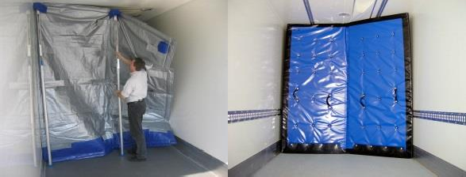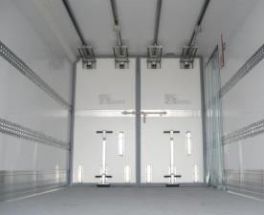

3. The certification of multi-temperature equipment requires an assessment of the ability of internal dividing walls within the equipment to maintain the physical and thermal separation of two adjacent compartments during the transport of perishable goods.

4. Annex 1, appendix 2, paragraph 7 refers to the thermal losses through internal dividing walls with only two types represented, using the terms “longitudinal” and “transversal”. As a result, the acceptance criteria for these internal dividing walls are not sufficiently clear in ATP to rule out technical solutions that do not meet the objective of certification or to prevent differences in interpretation between competent authorities that could lead to the acceptance in one country of multi-temperature equipment that is rejected in another country.

5. The aim of this proposal is to introduce a series of three proposals on the subject of dividing walls with the aim of standardizing certification methods for multi-temperature equipment between competent authorities, firstly by providing a definition of the different types of dividing walls found on the market, and by supplementing annex 1, appendix 2, paragraph 7.3.1, with a proposal to define movable dividing walls and to formally exclude the use of “removable” dividing walls in the multi-temperature certification of temperature‑controlled transport equipment.

I. Proposal

6. Introduce the following definitions in annex 1, appendix 2, paragraph 7.3.1 (translations into English for the underlined terms are at the end of the proposal):

(a) Dividing wall: Interior wall that restricts the flow of air between two compartments;

(b) Insulated dividing wall: A wall composed of insulating material making it possible to restrict the flow of air and limit heat exchange between two compartments:

(c) Longitudinal dividing wall: A dividing wall along the partial or total length of the compartment;

(d) Transversal dividing wall: A dividing wall along the partial or total width of the compartment;

(e) Fixed dividing wall: A dividing wall with no degree of free movement;

(f) Movable dividing wall: A wall composed of one or more panels mechanically attached to the equipment and that can be placed in different positions.

7. Since a dividing wall is an inside wall of the equipment, the term “internal” in “internal dividing wall” used in the ATP Agreement is redundant. It is proposed to delete the word “internal” before “dividing walls “ in:

* Paragraph 7.3.1
* Paragraph 7.3.3
* Paragraph 7.3.4
* Paragraph 7.3.5
* Paragraph 7.3.6
* Paragraph 7.3.7
* Model No. 14

8. The suggested translations for the underlined technical terms are:

* Cloison: Dividing wall
* Cloison isotherme: Insulated dividing wall
* Cloison longitudinale: Longitudinal dividing wall
* Cloison transversale: Transversal dividing wall
* Cloison fixe: Fixed dividing wall
* Cloison isotherme: Insulated dividing wall

II. Impact

|  |  |
| --- | --- |
| Cost: | No impact. |
| Environment: | This proposal aims to harmonize interpretation of ATP and reduce distortions of competition. |
| Feasibility: | The proposed amendment can easily be introduced into ATP.  A transitional period is not needed. |
| Enforceability: | No problems are expected. |