|  |  |  |  |
| --- | --- | --- | --- |
|  | United Nations | ECE/TRANS/WP.11/2021/11/Rev.1 | |
| United Nations logo | **Economic and Social Council** | | Distr.: General  5 August 2022  English  Original: French |

**Economic Commission for Europe**

Inland Transport Committee

**Working Party on the Transport of Perishable Foodstuffs**

**Seventy-ninth session**

Geneva, 25–28 October 2022

Item 6 of the provisional agenda

**ATP Handbook**

Amendment to paragraph 7.3.6 of Annex 1, Appendix 2 of the ATP Handbook: Treatment of specific application cases using the multi-temperature equipment dimensioning tool

Transmitted by the Government of France

**Revision**

Introduction

1. Under the new provisions of the version of ATP of 6 July 2020 and included in its version of 1 June 2022, all applications for ATP certificates for multi-temperature equipment manufactured after 1 October 2020 must include the declaration of conformity that is to be attached to the certificate.

2. Equipment manufacturers use an automated multi-temperature equipment dimensioning tool to justify the correct dimensioning of equipment. This tool covers the vast majority of cases, but the treatment of some specific cases makes it necessary to use an appropriate dimensioning method.

3. The purpose of this document is to specify the operating procedures for specific cases.

I. Proposed amendment to the ATP Handbook

4. It is proposed to add the following text to the ATP Handbook, in paragraph 7.3.6 of Annex 1, Appendix 2:

*“The following provisions are intended to clarify the method for dimensioning equipment in specific cases.”*

***Case of multi-compartment equipment with a variable number of compartments***

*All configurations must be calculated to verify the correct dimensioning of the equipment.* *However, only the most relevant configuration should be presented in the annex to the certificate.* *The sketch showing the configuration corresponding to the configuration of the application for certification must be attached.* *Prior to applying for certification, the manufacturer or fitter shall check the correct dimensioning in the most unfavourable case.* *The most unfavourable case corresponds to the configuration with the position of the partitions and the number of compartments that require the greatest refrigeration capacity.* *These different calculated configurations shall be kept by the applicant, to be verified during audits.*

*Example : case of a "J" configuration (the size of the compartments is defined by the position of the stops or markings on the walls of the body)*

• *The dimensioning is checked for the* most *unfavourable case*

|  |  |  |  |  |  |
| --- | --- | --- | --- | --- | --- |
|  | STAGE 1A |  |  | STAGE 1B |  |
| Front |  | Back | Front |  | Back |

• *The supporting document presents all configurations*

|  |  |  |
| --- | --- | --- |
|  | STAGE 2 |  |
| Front |  | Back |

*The compartments are numbered starting from the front left compartment of the equipment.* *In the above example, according to this rule, the compartment numbers differ depending on whether the longitudinal bulkhead is connected to the front or the rear of the equipment.* *However, the dimensioning method does not change.*

***Case of equipment with a mono-temperature unit and a multi-temperature unit***

*The height and width of the compartment must be set and the length in the tool adjusted so that the resulting area is equal to the area of the body’s insulation.*

*The equipment must be dimensioned in two stages.* *In the case below, compartment 2 (C2) and compartment 3 (C3) are equipped with a multi-temperature thermal appliance sharing the same refrigeration unit.* *The appliance must therefore have a dimensioning calculation and supporting documentation.*

*Compartment 1 (C1), with a mono-temperature thermal appliance, must be considered separately, so as to ensure that the volume of the compartment can be covered by the refrigeration unit.*

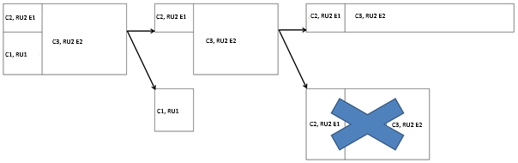

*\*C: Compartment*

*\*RU: Refrigeration unit*

*\*E: Evaporator*

*The resulting area is brought to that of the area of an equivalent parallelepiped.*

***Case of equipment with integrated insulation (non-parallelepipedic insulation shapes), or case of equipment with an integrated box***

*The height and width of the compartment must be set and the length in the tool adjusted so that the resulting area is equal to the area of the body’s insulation.*

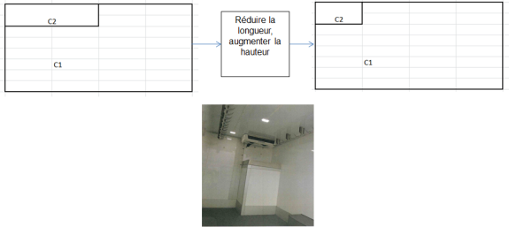

Reduce the length, increase the height

*The resulting area is brought to that of the area of an equivalent parallelepiped.*

***Non-independent equipment***

*In the case of non-independent equipment, the same dimensioning method as for independent equipment should be used.*

*A class without the X extension (e.g. FRC) displayed on the declaration of conformity will be different from the class displayed on the certificate (e.g. FRCX), but this difference does not call into question the dimensioning of the equipment.*

***Case of mono-temperature multi-compartment equipment equipped with non-removable fixed partitions (e.g. FRC-IR, FRC-IR-IR)***

*The unit should be dimensioned only according to the internal area and isotherm of the temperature-controlled compartment in which the evaporator is installed.* *The insulation coefficient of the compartment is in this case composed of the insulation coefficient of the panels and the partition that delimit the compartment.*

*Note: Not applicable if a multi-temperature unit is used with just one evaporator.*

II. Impact

5. This amendment specifies the methods for dimensioning multi-temperature equipment.