Submitted by IMMA | Informal document GRBP-71-10  (71st GRBP, January 2020,  agenda item 2)

Proposal for amendments to the 04 series of amendments
to UN Regulation No.41 (Noise of L3 category of vehicles)
The proposed amendments to UN Regulation No. 41, submitted by the expert from the International Motorcycle Manufacturers Association, are marked in bold for new or strike-through for deleted characters.
I. Proposal
Annex 3, paragraph 2.4.1., amend to read:
2.4.1 Positioning of the microphone (see Appendix 2)
The microphone shall be located at a distance of 0.5 ± 0.01 m from the reference point of the exhaust pipe defined in Figure 1 and at an angle
of 45 ± 5° to the vertical plane containing the flow axis of the pipe termination. The microphone shall be at the height of the reference point, but not less than 0.2 m from the ground surface. The reference axis of the microphone shall lie in a plane parallel to the ground surface and shall be directed towards the reference point on the exhaust outlet.
The reference point shall be the highest point satisfying the following conditions:
(a) The reference point shall be at the end of the exhaust pipe,
(b) The reference point shall be on the vertical plane containing the exhaust outlet centre and the flow axis of the exhaust pipe termination.
If two microphone positions are possible, the location farthest laterally from the vehicle longitudinal centreline shall be used.
If the flow axis of the exhaust outlet pipe is at 90° ± 5° to the vehicle longitudinal centreline, the microphone shall be located at the point that is the furthest from the engine.
If a vehicle has two or more exhaust outlets spaced less than or equal to 0.3 m apart and connected to a single silencer, only one measurement shall be made. The microphone shall be located relative to the outlet furthest the farthest from the vehicle's longitudinal centreline, or, when such outlet does not exist, to the outlet that is highest above the ground. The 0.3 m measurement is to be made along a single plane perpendicular to the flow axis of the exhaust gases.
If a vehicle has two or more exhaust outlets spaced less than or equal to 0.3 m apart and connected to separate silencers, only one measurement shall be made. The microphone shall be located relative to the outlet furthest from the vehicle's longitudinal centreline, or, when such outlet does not exist, to the outlet that is highest above the ground.
For vehicles having an exhaust provided with outlets spaced more than 0.3 m apart, one measurement is made for each outlet as if it were the only one, and the highest sound pressure level shall be noted. For the purpose of roadside checking, the reference point may be moved to the outer side of the body.

Annex 3 – Appendix 2, amend to read:
Positioning of the microphones for the stationary noise test
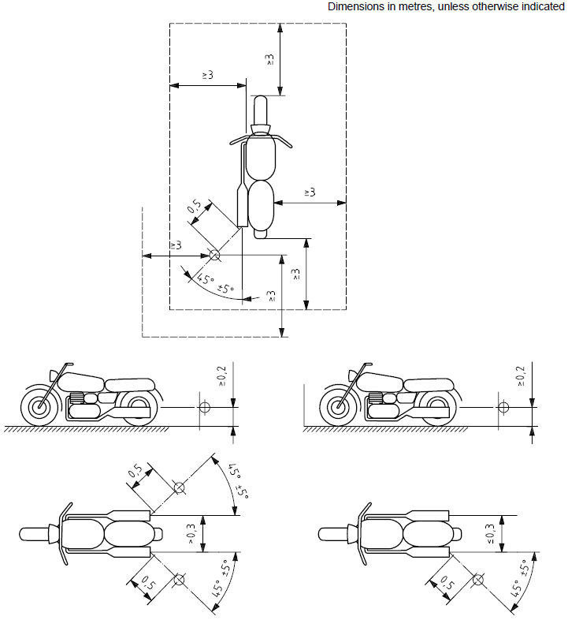

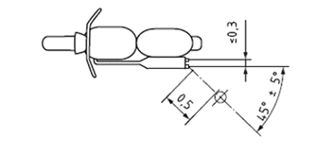
II. Justification

Introduction
The reason of proposing to align UN R41-04 and ISO 5130 stationary microphone positioning is to prevent the regular misinterpretation that happens because of ambiguity in the language. This causes improper stationary noise measurements leading to: customer satisfaction complaints, false reports of non-compliance and enforcement issues.

Justification
Stationary noise measurements on a single sided dual exhaust system can vary by approximately 4dB from the lower to upper muffler. Without clear language in the regulation on which muffler to measure, it is often interpreted incorrectly. The current language does not address single sided dual exhaust systems which have separate silencers, does not address systems that are spaced at 0.3 m, and does not address how to measure the 0.3 m spacing.

Problem Statement
The current language R41-04 and ISO 5130 (paragraph 6.3) listed below does not adequately describe the single sided dual exhaust system found on many motorcycles. There are two deficiencies in this language. First, there is no clear language on how the 0.3 m distance is to be made. Second, it does not address exhaust outlets connected to separate silencers.
Annex 3, paragraph 2.4.1,
Current regulation reads:
“If a vehicle has two or more exhaust outlets spaced less than 0.3 m apart and connected to a single silencer, only one measurement shall be made. The microphone shall be located relative to the outlet furthest from the vehicle's longitudinal centreline, or, when such outlet does not exist, to the outlet that is highest above the ground”.
IMMA proposal for clarification (additions are highlighted in red and bold):
“If a vehicle has two or more exhaust outlets spaced less than or equal to 0.3 m apart and connected to a single silencer, only one measurement shall be made. The microphone shall be located relative to the outlet furthest from the vehicle's longitudinal centreline, or, when such outlet does not exist, to the outlet that is highest above the ground. The 0.3 m measurement is to be made along a single plane perpendicular to the flow axis of the exhaust gases.
If a vehicle has two or more exhaust outlets spaced less than or equal to 0.3 m apart and connected to separate silencers, only one measurement shall be made. The microphone shall be located relative to the outlet furthest from the vehicle's longitudinal centreline, or, when such outlet does not exist, to the outlet that is highest above the ground.”

Annex 3, Appendix 2:
To correct an inconsistence between the text and the figure (ISO 5130 figure 1a) following changes should be incorporated:
Bottom left illustration (top view): distance between silencer outlets should be ≥ > 0.3
Bottom right illustration (top view): distance between silencer outlets to be kept as ≤ 0.3

Figures
- Problem: to define how the measurement of 0.3 m is to be made:
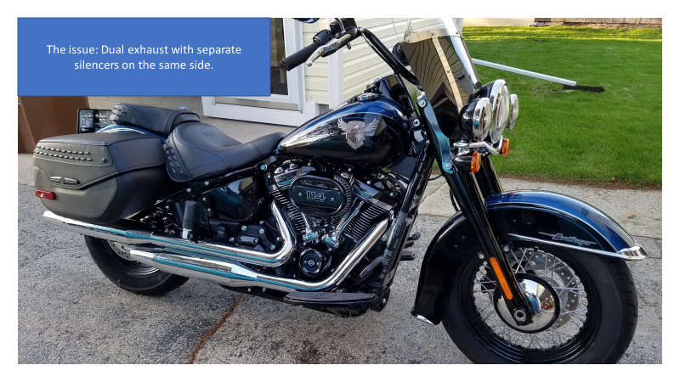
B

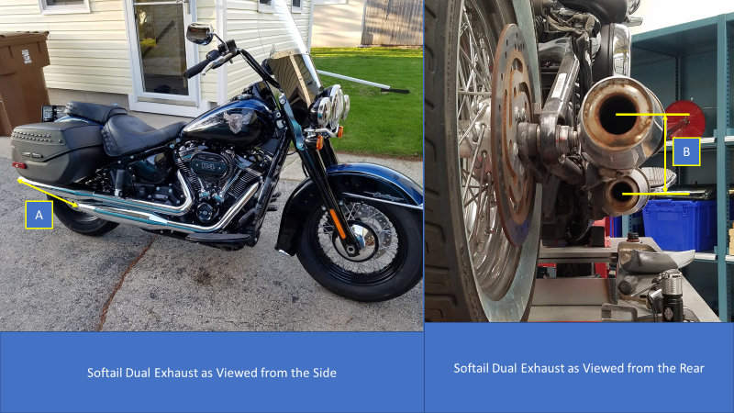

- Which viewpoint should for the 0.3 m threshold be considered?
- IMMA recommends the measurement as viewed from the rear (shown in illustration B), as this is the flow axis of the exiting gases and sound.
___________________________

