Proposal for amendments to ECE/TRANS/WP.29/GRVA/2019/9
The text reproduced below was prepared by the expert of Germany on the basis of the working document GRVA/2019/9, which was submitted by the by the expert from France. Modifications are marked in bold green for new or green strikethrough for deleted characters.
I. Proposal
UN Regulation No. 79, insert a new sentence within paragraph 5.6.2.1.1. to read:
"5.6.2.1.1. The activated system shall at any time, within the boundary conditions, ensure that the vehicle does not cross a lane marking for lateral accelerations below the maximum lateral acceleration specified by the manufacturer ay_{smax}.
The system may exceed the specified value ay_{smax} by not more than 0.3 m/s², while not exceeding the maximum value specified in the table in paragraph 5.6.2.1.3. of this Regulation.
Irrespective of the values specified in the table in paragraph 5.6.2.1.3. of this Regulation, the lateral acceleration of the system may exceed the specified value ay_{smax} by not more than 1.5 m/s² for a limited time period of not more than 2 s within a rolling interval of 4 s."

Annex 8, paragraph 2.4., amend to read:
"2.4. Lateral acceleration
The position representing the centre of gravity, at which the lateral acceleration shall be measured, shall be determined in agreement between the vehicle manufacturer and the Technical Service. The position at which the lateral acceleration is measured and the centre of gravity of the vehicle shall be identified in the test report.
The lateral acceleration shall be measured without taking into account the additional effects due to the movements of the vehicle body (e.g. roll of sprung mass).
The lateral acceleration and the lateral jerk at vehicle's center of gravity shall be determined. The raw lateral acceleration data shall be measured closest as possible to the position of the vehicle's center of gravity. The position at which the lateral acceleration is measured and the centre of gravity of the vehicle shall be identified in the test report. The sampling rate shall be at least 100 Hz.
To determine the lateral acceleration, the raw data shall be filtered by applying a fourth order Butterworth filter with a cut-off frequency of 1Hz.
To determine the lateral jerk, the 500ms moving average of the time derivation of the filtered lateral acceleration shall be considered.
The lateral acceleration data at the vehicle center of gravity shall be determined by removing additional effects due to the movements of the vehicle body (e.g. roll of sprung mass) and by correcting for sensor placement via the use of coordinate transformation. As reference, the vehicle coordinate system as described in ISO 8855:2011 shall be used."
Annex 8, insert a new paragraph 2.5., to read:
"2.5. Overriding force
The measurement of the overriding force during the test can be performed by two methods: either through the internal driver torque signal or by an external device fitted on the steering wheel [which doesn’t induce any deactivation of the system].
Prior to performing the overriding force test, by the internal driver torque signal, it shall be verified by an external measurement steering wheel that there are no relevant differences between the both measured values. with a tolerance below less than or equal to 3N. Differences shall be less than or equal to 3N. This requirement is deemed to be fulfilled if the correlation between the values of the internal driver torque signal and the external measurement device was determined and is applied in the overriding force test. "
Annex 8, paragraph 3.2.1.1. and 3.2.1.2., amend to read:
"3.2.1.1. The vehicle speed shall remain in the range from V_{smin} up to V_{smax}.
The test shall be carried out for each speed range specified in paragraph 5.6.2.1.3. of this Regulation separately or within contiguous speed ranges where the ay_{smax} is identical.
The vehicle shall be driven without any force applied by the driver on the steering control (e.g. by removing the hands from the steering control) with a constant speed or with a predefined initial speed (e.g. for vehicles automatically decelerating in curves) on a curved track with lane markings at each side.
The necessary lateral acceleration to follow the curve shall be between 80 and 90 % of the maximum lateral acceleration specified by the vehicle manufacturer ay_{smax}. The measured lateral acceleration during the test execution can be outside of the above-mentioned limits.
The lateral acceleration and the lateral jerk shall be recorded during the test.
3.2.1.2. The test requirements are fulfilled if:
No outside edge of the tyre tread of the vehicle’s front wheel does cross the outside edge of The vehicle does not cross any lane marking.
The recorded acceleration is within the limits specified in paragraph 5.6.2.1.3. of this Regulation.
The system does not exceed the specified value ay_{smax} specified according to 5.6.2.1.1. of this Regulation.
The moving average over half a second of the lateral jerk does not exceed 5 m/s³."
Annex 8, paragraph 3.2.2.2., amend to read:
3.2.2.2. The test requirements are fulfilled if:
The recorded acceleration is within the limits specified in paragraph 5.6.2.1.1. 5.6.2.1.3. of this Regulation.
The system does not exceed the specified value aysmax specified according to 5.6.2.1.1 of this Regulation by more than 0.3 m/s².
The moving average over half a second of the lateral jerk does not exceed 5 m/s³."
Annex 8, insert new paragraphs 3.2.5. to 3.2.5.2., to read:
"3.2.5. Lane Crossing Warning Test for M₁ N₁ and for M₂ M₃ N₂ and N_{3,} if not equipped with a Lane Departure Warning System (LDWS) fulfilling the technical requirements of Regulation No. 130.
3.2.5.1. The vehicle shall be driven with activated ACSF with a vehicle test speed between V_{smin} and V_{smax}.
The vehicle shall be driven without any force applied by the driver on the steering control (e.g. by removing the hands from the steering control) on a curved track with lane markings at each side.
The technical service defines a test speed and a radius which would provoke a lane crossing. The test speed and radius shall be defined such that the necessary lateral acceleration to follow the curve is in between ay_{smax} + 0.1 m/s² and ay_{smax} + 0.4 m/s².
3.2.5.2. The test requirements are fulfilled if:
The optical warning signal and additionally the acoustic or haptic warning signal was given at the latest when the outside edge of the tyre tread of the vehicle’s front wheel has crossed the outside edge of the lane marking."
The system continues to provide assistance as required in paragraph 5.6.2.2.3.
II. Justification
A. Annex 8, paragraph 2.4., "Lateral acceleration"
1. For keeping a traceability, it could be interesting to indicate in the report both the position at which the lateral acceleration was measured and the position of the centre of gravity of the vehicle.
2. For dynamical tests the usual value of sampling rate is at least 100 Hz.
3. The figures below show the shapes of the lateral acceleration signals versus the value of the cut-off frequency: No filter, filter at 2Hz, filter at 1 Hz and filter at 0.2 Hz.
4. The results show that the best representation of the dynamical behavior is obtained when the used filter is 1Hz.
Figure 1
Lateral Acceleration Filtering: Comparison of tests led on 4 vehicles in the same curve
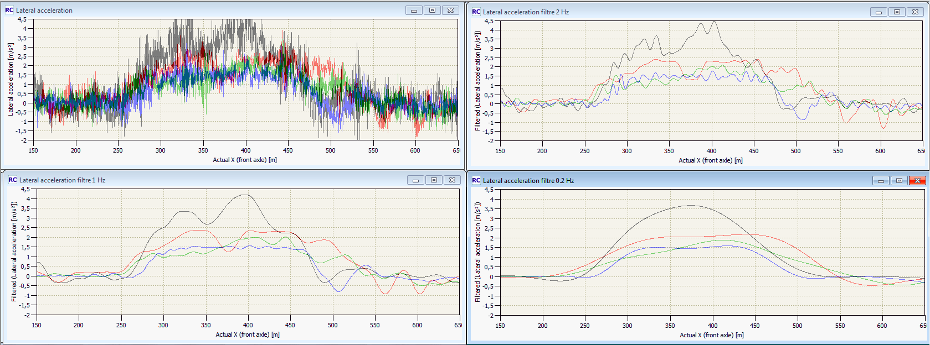
Explanation:
Quadrant 1 shows the raw data (no filtered)
Quadrant 2 shows the signal filtered at 2Hz
Quadrant 3 shows the signal filtered at 1Hz
Quadrant 4 shows the signal filtered at 0.2hz.

Figure 2
Lateral Acceleration Filtering: Comparison between the 2 proposals for a vehicle near the limits
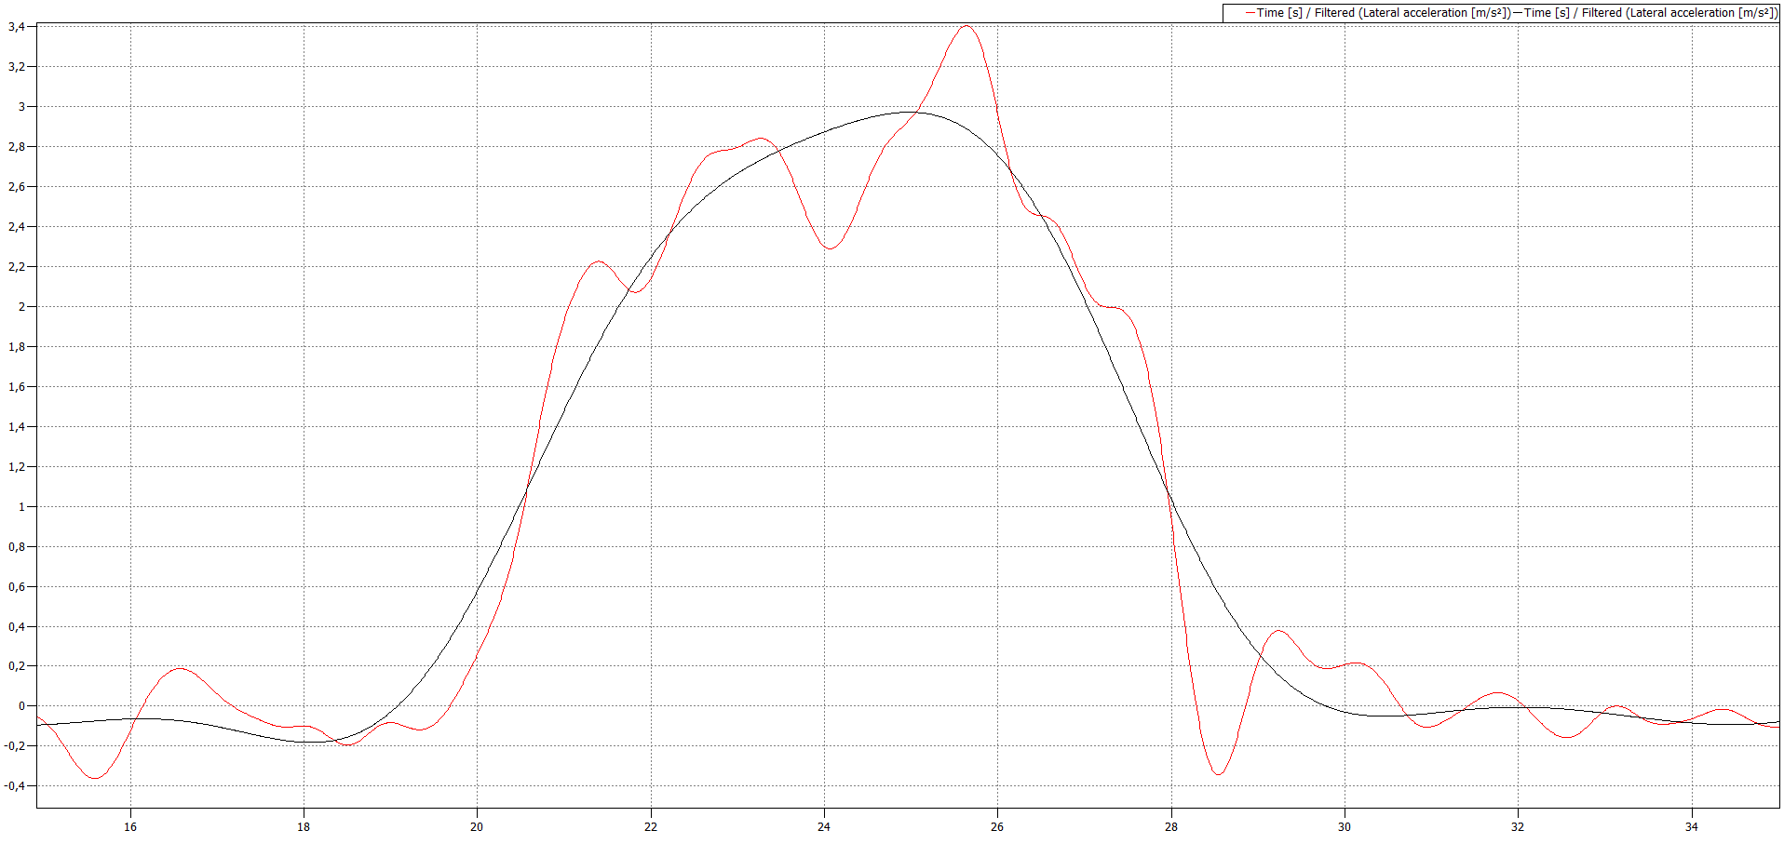
Note:
Blue line (0.2hz) and red line (1 Hz) as proposed in this document. In the first case the vehicle passes the test (Maximum value: 3 m/s²) while in the second case the vehicle fails the test (maximum value: 3.4m/s²).
When introducing filtering in Annex 8 it has to be ensured that noise, transitional overshooting issues or the filtering itself do not influence the test result. Introducing a filter with a cutoff frequency of 1 Hz makes it at the same time necessary to specify other tolerances in the Regulation for the lateral acceleration, so that the thresholds for the lateral acceleration can be exceeded for short time periods. This is done in paragraph 5.6.2.1.1. of the Regulation.
B. Annex 8, paragraph 2., "Overriding Force Test"
5. The intention is to offer the possibility for measuring the torque either with the internal sensor or with an external mean. A driving robot, an additional steering wheel torque system or a force sensor fitted smoothly on the steering wheel, which does not influence the steering of the vehicle, should be usable. The no influence can be checked, for instance, by driving the vehicle on a straight road, and/or in a curve, hand-off, with and without additional system. If in the both cases, the first optical warning signal appears at the same time after driver left the steering wheel, it can be considered there is no effect of the external equipment.
C. Annex 8, paragraphs 3.2.1.1. and 3.2.1.2. and 3.2.2.2.
6. The fact to accept that the lateral acceleration can reach aysmax whilst the test is performed between 80 and 90 per cent of aysmax provides already a tolerance. It is not necessary to give an additional tolerance of 0.3 m/s².
The test in section 3.2.1 of Annex 8 is only for demonstration of the lane keeping capabilities of the system. Issues with regard to the maximum lateral acceleration are tested according to 3.2.2.
In addition paragraph 3.2.2.2. only needs one pass criterion for the lateral acceleration, namely to stay in the limits given by paragraph 5.6.2.1.1. of the Regulation.
D. Annex 8, new paragraphs 3.2.5. to 3.2.5.2.
7. It is added in paragraph 3.2.5.2. a condition to be checked before declaring the test requirement fulfilled such as defined in paragraph 5.6.2.2.3.

