 | INF.32
Economic Commission for Europe  Inland Transport Committee  Working Party on the Transport of Dangerous Goods  Joint Meeting of Experts on the Regulations annexed to the  European Agreement concerning the International Carriage  of Dangerous Goods by Inland Waterways (ADN)  Thirty-fifth session  Geneva, 26-30 August 2019  Item 4 (b) of the provisional agenda  Proposals for amendments to the Regulations annexed to ADN:  other proposals |  | 19 August, 2019  English
Request for discussion on entries in Table C containing more than 10% benzene and those identified by a star
Transmitted by CEFIC and FuelsEurope
Summary
Executive Summary: The * positions for substances containing more than 10% Benzene as well as those which have a reference to the IBP in Column (2), Table C under UN 1203, 1267, 1268, 1863, 1993, 3295 can be simplified.
Action to be taken: Start a discussion within the informal working group on substances.
Related documents: Multilateral Agreement ADN/M 021
ECE/ADN/45 – Chapter 3.2, Table C: p.49-69
ECE/TRANS/WP.15/AC.2/2018/68, IV, A, item 14
Attached: VNCI paper (link)
I. Introduction
1. Effective ADN 2017, substances containing more than 10% Benzene were specific positions with a specific barge type in Table C, as a result of which many of these products would have to be transported in C-1-1 tankers which are not available. This change with unintended side effects was fixed with Multilateral Agreement ADN/M 021, which ended 30.06.2019.
2. With the introduction of the * positions for substances containing more than 10 % Benzene and the introduction of the 3rd indent under 3.2.3.1 effective 1.1.2019, the minimum tanker requirement can now be established by means of the flowcharts, schemes and criteria in 3.2.3.3. Those positions with a Benzene content of more than 10% having a reference to the IBP in Column (2) of Table C remain unchanged.
3. Whereas first ADN/M 021 and later ADN 2019 solved the issues which arose as a result of ADN 2017, Table C has become very complicated as a result of these changes. It also appears that introduction of the 3rd indent under 3.2.3.1 goes against the classification hierarchy as described in Ch. 2.1 of ADN.
4. ADN 3.2.3.1, third indent indicates that:
“If a cell contains an asterisk, “*”, the applicable requirements should be determined by applying 3.2.3.3. The determination of the applicable requirements by applying 3.2.3.3 should take precedence over using the entries for mixtures for which no sufficient data is available.”
II Topics for discussion
5. CEFIC and FuelsEurope see possibilities for a simplification of Table C by:
(a) Introducing specific entries to replace the star positions for those entries with more than 10 %;
(b) Considering the deletion of those entries with more than 10 % Benzene having a reference to the IBP in Column (2).
III. Rationale
6. The classification hierarchy as described in ADN 2.1 would be restored.
7. The entries with more than 10% Benzene having a reference to the IBP are in practice a duplication of what is reported in ADN 3.2.3.3, Scheme A.
8. In fact, starting from an entry where a * is assigned, one can use the flow chart of ADN 3.2.3.3 and Scheme A and end up with exactly the same barge requirements as for the entries in Table C, where an IBP is mentioned.
9. The attached industry guidance document, issued by the Royal Association of the Dutch Chemical Industry (VNCI) demonstrates that the formula of ADN 3.2.3.3 leads to a cargo pressure at liquid temperature of 30 °C higher than 50 kPa only if the vapor pressure of the substance at 50 °C is equal to or higher than 175 kPa. The document concludes that as long as the vapor pressure of a substance is lower than 175 kPa at 50 °C a C 2 2 barge with sprinklers, and a relief valve set pressure of 50 kPa can be conservatively selected.
IV. Request to the ADN Safety Committee
10. CEFIC and FuelsEurope invite the ADN Safety Committee to take note of the above as well as the attached VNCI guidance document, and to give its opinion;
11. The Safety Committee is then invited to submit the matter to the informal working group on “Substances”.

in

Guidance on barge selection for ADN (*) positions
Version : july 2019

Purpose
To assure compliance with ADN 2019 for a number of products classified as (*) positions in Table C, aligned with the responsibilities of a filler and a consignor.
The following entries with at least an asterisk (*) in Column (10) are in scope:
UN 1202, UN 1203; UN 1224, UN 1265, UN 1267, UN 1268, UN 1719; UN 1760, UN 1863,
UN 1986, UN 1987, UN 1989, UN 1992, UN 1993, UN 2735, UN 2810, UN 2922, UN 2924,
UN 2927, UN 2929, UN 3082, UN 3256, UN 3257, UN 3264, UN 3265, UN 3266, UN 3267,
UN 3271, UN 3272, UN 3286, UN 3287, UN 3289, UN 3295, UN 3494, ID 9001, ID 9002, ID
9003, ID 9005, ID 9006

Scope
Selection of correct barge for specific and general N.O.S. UN entries, according to ADN 2019.

Approach
  - Introduction
For products which are classified within ADN 2019 as (*) positions (example below)

the provision of chapter 3.2.3.3 are applicable for those columns which contain an asterisk (*)
In particular, the type of tank vessel, cargo tank design, cargo tank type and opening pressure of the pressure relief valve/high velocity vent-valve as referred to in Columns (6), (7), (8), (9) and (10) need to be selected based on Scheme A or Schema B of 3.2.3.3.
Note that in some entries, columns (6), and/or (7) and/or (8) already contains a value in which case ADN 3.2.3.3 refers to those columns which contain a * and the determination of the applicable requirements by applying 3.2.3.3 should take precedence over using the entries of mixtures for which no sufficient data is available (ADN 3.2.3.1)

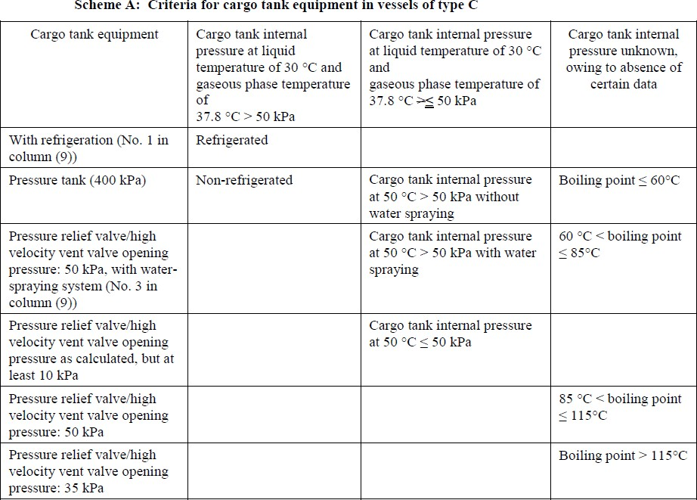

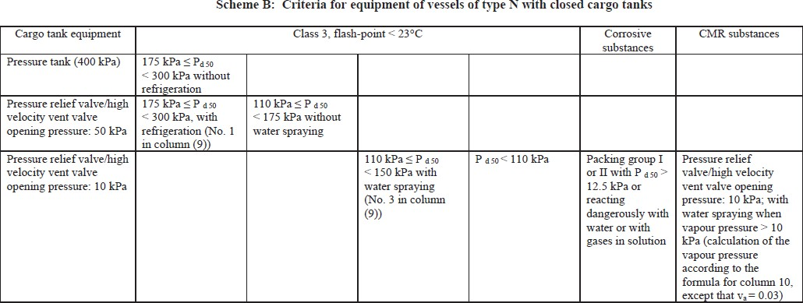

In both schemes the cargo tank internal pressure at various liquid temperatures and gaseous phase temperature of 37.8 °C is estimated according to ADN 3.2.3.3:

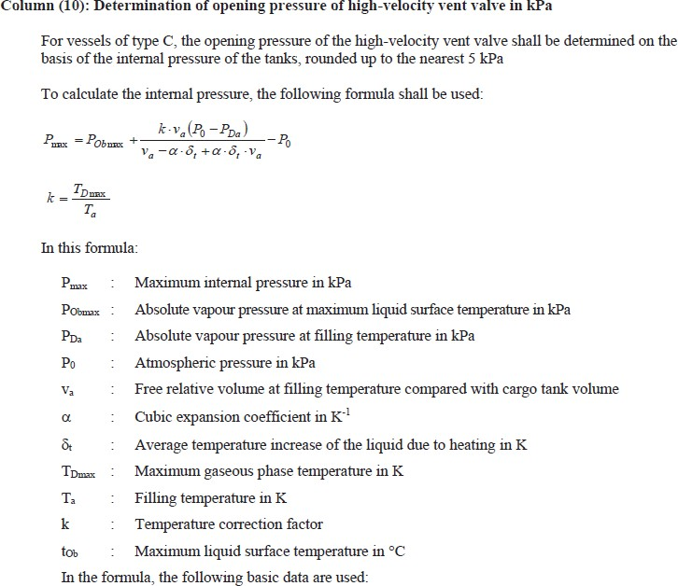
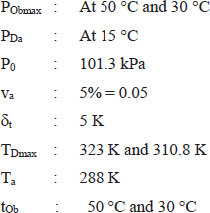

Scheme A
In the event of a C type tanker, the following applies:
For all (*) positions the industry is in state of estimating or measuring vapor pressure, so the column on the right of Schema A is not applicable.

If the vapor pressure is known at two different temperatures, it is possible to calculate the Antoine coefficients A and B:
𝐿𝑛(𝑃 (𝑇)) = 𝐴 − 𝐵

𝑉 𝑇+273
and extrapolate the vapor pressure at 15 °C, 30 °C and 50 °C.
Assuming conservatively a cubic coefficient of 0.00125 1/K (for pure benzene), one can calculate through the formula in ADN 3.2.3.3 the cargo tank internal pressure at liquid temperature of 30 °C and with gaseous phase temperature of 37.8 °C.
The below matrix shows the cargo pressure at liquid temperature of 30 °C calculated from various couples of vapor pressures at 25 °C and 50 °C.

Pv (kPa) @ 50 °C
 |  | 50 | 75 | 100 | 110 | 125 | 150 | 175 | 180 | 190 | 200 | 225 | 250 | 275 | 300 | 325 | 350 | 400 | 500
 | 10 | 31 | 33 | 35 | 35 | 36 | 37 | 38 | 38 | 38 | 38 | 39 | 40 | 40 | 41 | 41 | 42 | 42 | 44
Pv (kPa) @ 25 °C | 20 | 31 | 36 | 39 | 40 | 42 | 44 | 45 | 46 | 46 | 47 | 48 | 49 | 50 | 51
 | 30 | 27 | 35 | 40 | 42 | 44 | 47 | 50 | 50 | 51 | 52 | 54 | 56 | 57
 | 40 | 20 | 32 | 39 | 41 | 44 | 49 | 52
 | 50 | 12 | 26 | 36 | 39 | 43 | 49
 | 60 |  | 19 | 31 | 35 | 40 | 47
 | 70 |  |  | 25 | 30 | 36 | 44
 | 80 |  |  | 18 | 23 | 31

It is clear that the formula of ADN 3.2.3.3 leads to a cargo pressure at liquid temperature of 30
°C higher than 50 kPa only if the vapor pressure of the substance at 50 °C is higher than or equal to 175 kPa. It should be noticed that this is inherent with the application of the formula.
It can be concluded that as long as:
𝑃𝑉 (50℃) < 175 𝑘𝑃𝑎
The third column of Schema A is applicable.
A similar exercise can be done to estimate the cargo tank internal pressure at liquid temperature of 50 °C and with gaseous phase temperature of 37.8 °C. The use of the formula of ADN 3.2.3.3 leads to the below matrix.

Pv (kPa) @ 50 °C
 |  | 50 | 75 | 100 | 110 | 125
Pv (kPa) @ 25 °C | 5 | 33 | 44 | 55 | 65 | 75
 | 10 |  | 38 | 50 | 61 | 71
 | 15 |  | 31 | 44 | 55 | 66
 | 20 |  |  | 36 | 49 | 61
 | 25 |  |  |  |  | 54
 | 30 |  |  |  |  | 47

From this analysis it can be observed that the pressure estimated tends to decrease by increasing the vapor pressure at the lower temperature and at constant vapor pressure at high temperature. This is counterintuitive and derives from the fact that the thermal expansion term of the pressure formula becomes prevalent. In this case the conservative assumption on the thermal expansion coefficient is not useful anymore and the exact value needs to be used, and the pressure needs to be calculated without any short cut.

In this case an estimate of the vapor pressure at two temperatures, together with an estimate of the thermal expansion coefficient should be handed over to the consignor by the product manufacturer.
The consignor will then estimate vapor pressures at 50 °C and the cargo pressure at 50 °C and decide if water sprinklers are needed or not, based on Scheme A.
In any case the consignor can decide to conservatively choose barges with sprinklers if no reliable data for the thermal expansion coefficient is available.

Scheme B
In the event of an N-x-x tanker, the following applies.
In case of CMR products, for which the transport is allowed in N tankers, Scheme B may require to use the formula for column 10 to determine the opening pressure, and hence to determine if water spraying is needed (column 6, last one). The cut off point is a cargo tank internal pressure of 10 kPa.
For products with low vapor pressure the formula of ADN 3.2.3.3 shows that a cargo pressure lower than 10 kPa is hardly calculated. In fact, also setting vapor pressures to zero kPa, in the pressure equation of ADN 3.2.3.3, in order for Pmax to be greater than 10 kPa a value for α of 0.0001 or lower is necessary, which is one order of magnitude lower than the typical values for hydrocarbons1.
Hence if column 6 of Scheme B is applicable, the formula leads in practice to choosing cargoes with set pressure of 10 kPa and equipped with water spraying.
In all other cases the knowledge of the vapor pressures at 50 °C is sufficient to choose the barge following Scheme B and no special calculation is necessary.

Conclusion
Scheme A
If the vapor pressure of a substance is lower than 175 kPa at 50 °C, a C 2 2 barge with water spraying, and a relief valve set pressure of 50 kPa can be conservatively selected.
Scheme B
In case of CMR substances where column 6 of Scheme B is applicable, a barge with water spraying, and a relief valve set pressure of 10 kPa can be selected.
In all other cases the vapor pressure at 50 °C should be used to verify the choice of the barge.
This data should be provided by the product manufacturer to the consignor.

Retention of data
Data relative to the vapor pressure of the product at 50 °C shall be provided by the manufacturer. A method of providing this information is adding the data to the SDS, section 9.

1 https://www.engineeringtoolbox.com/cubical-expansion-coefficients-d_1262.html

The data mentioned in paragraph 4 can be retained in various form, but it is recommended that it accompanies the transport document. Whether this information is part of the transport document or not is responsibility of the consignor.
The following sentence could be used to account for the choice of barge according to schema A:
Cargo tank internal pressure at liquid temperature of 30 °C and gaseous phase temperature of 37.8 °C is calculated to be lower than 50 kPa.

These Guidelines to determine the Barge selection for AND (*) positions have been developed by the Royal VNCI in 2019.
Although these are established with utmost care, any errors or omissions cannot be guaranteed and therefor author(s), editor(s) and publisher do not accept any liability, nor for damages of any kind, which are the direct or indirect result of actions and / or decisions which were (partly) based on the information in this booklet. All rights reserved. They may not be used, stored or published for commercial purposes in any form or by any means, electronic, mechanical, by photocopying, recording or otherwise, without the prior written permission of the publisher: VNCI, PO Box 443, 2260 AK Leidschendam, The Netherlands.

Version : july 2019

