Economic Commission for Europe
Inland Transport Committee
Working Party on the Transport of Dangerous Goods 13 September 2019
Joint Meeting of the RID Committee of Experts and the
Working Party on the Transport of Dangerous Goods
Geneva, 17–27 September 2019
Item 2 of the provisional agenda:
Tanks
Request for opinion regarding Autogas LPG Supply Quality & Contamination Issue
Transmitted by the Government of Poland
1. Poland would like to obtain the opinion of the Working Group on Tanks with respect to the Autogas LPG Supply Quality & Contamination Issue.
2. Polish entrepreneurs have reported a problem with LPG (described below):
Brief account of incident: In a recent road tanker incident on a BP retail site, 940 kilograms of LPG product was released uncontrolled into the atmosphere. The release resulted in the emergency closure of the site and the adjacent main road. Emergency services attended and set up a water curtain to minimize risks of any ignition. The fire brigade and fitters from the truck company were eventually able, through replacement of the pump set, to prevent further loss and the truck was allowed to return to its depot for unloading and inspection.
The leak occurred as a result of the failure of the mechanical pump seal. The leak could not be controlled and limited as the foot valve seal was also damaged / obstructed preventing its closure.
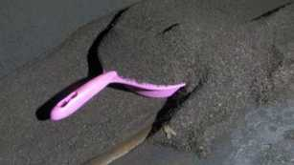
Both the pump shaft and foot valve seal failures were caused by abrasion by iron particles in the liquid gas flow over an extended period. The particles had been transferred into the tanker over multiple loadings from a variety of facilities in the country. During an examination of the tanker after the incident approximately 94 Kg of particles in the vessel were discovered and removed.

What went well:
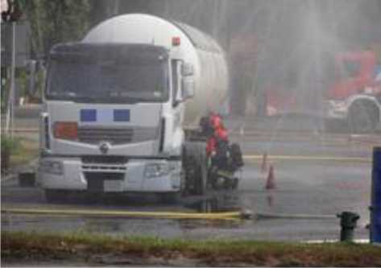
- The driver initiated correct shut down and emergency procedures on first identifying the leak.
- Site staff executed emergency procedures, calling emergency services, closing and evacuating the site and helping cover pits and other low level areas where gas might collect.
- Fire and police services responded quickly and effectively to establish a safe perimeter, set up a water curtain to reduce vapour spread and minimize ignition risk and supported efforts to restore the tanker to a safe operating condition.
What could have been better:
- Mechanisms for safe isolation of leaking components on the road tanker;
- Procedures for inspection and maintenance of road tanker;
- Recognition of the implications of presence of particulate matter the in supply chain;
- Measures to eliminate the transfer of particulate matter through the supply chain;
- Industry expectations and requirements in relation to particulate contamination.
The investigation team identified a number of lessons which it believes would help mitigate parts of the immediate risks and, through sharing with industry, start to address the underlying issues and reduce the risk of recurrence of this type of event.
- Road tanker design: An additional control valve should be added between the foot valve and the pump to support isolation of components.
- Road Tanker Operations: Enhanced inspections, triggered by filter inspections, should be introduced by road tanker operators to identify particle accumulation and enable removal before it begins to compromise tanker safety.
- Distribution Terminal Operations: Terminals should recognize the risk and hazard of iron contaminants in the supply chain and develop monitoring processes and filtering procedures to eliminate any transfer to road tankers and the downstream retail infrastructure.
- National Industry Standards: Standard industry quality specifications should include specific reference to limits on particulates in supplied products.
- International Standards: Requirements and testing methods in EN 589 should be developed to specify limits and methods of testing for compliance.
Poland asks for the opinion of the Working Group on Tanks with respect to the Autogas LPG Supply Quality & Contamination Issue.

