Economic Commission for Europe
Inland Transport Committee
Working Party on the Transport of Dangerous Goods
Joint Meeting of the RID Committee of Experts and the
Working Party on the Transport of Dangerous Goods 13 March 2019
Bern, 18-22 March 2019
Item 6 of the provisional agenda
Reports of informal working groups
Explosion proof tanks: Information for the BLEVE working group
Proposal transmitted by the governments of Spain and France
Introduction
1. In the early stages of the Bleve WG a solution for preventing an explosion in a tank consisting of aluminium alloys foils or balls inside the tank has been considered (see "http://www.unece.org/fileadmin/DAM/trans/doc/2008/wp15ac1/ECE-TRANS-WP15-AC1-08-BE-inf05e.pdf, measure A1.4). This solution has not been studied much further because of a lack of information. Also the working group failed to identify companies that would produce such material that would have been able to provide such information.
2. It has recently been brought to the attention of the Spanish and French governments that a company named "TECHNOKONTROL" produces and has good experience with the use of such alloys to protect containments of flammable liquids and gases from exploding. Specific information, on testing, and use of this material concerning the behaviour of tanks and receptacles fitted with such alloys foils can be provided by them.
3. Unfortunately this information was not available before the last meeting of the working group. We felt it would be interesting for the Joint Meeting to get this information as soon as possible.
4. A description of the system is attached to this document and a presentation by TECHNOKONTROL will be provided during the meeting.
5. It is proposed to add the consideration of such measure to the working program concerning the prevention of BLEVEs. The Joint meeting may also wish to decide upon some specific issues to be verified in relation with the use of such alloy foils..
Annex
6. In the annex specific information on this product manufactured by Technokontrol is provided.

Annex
What are and how do TK 3D Alloy Technologies work?
Technokontrol TK Safety Alloy is a mesh, sphere, panel or textile made of an aluminum alloy that has multiple uses, but which greatly increases the internal surface of the product, and therefore allows to conduct and distribute the heat:
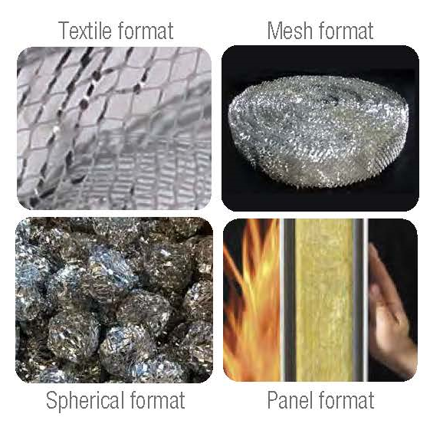
TK Safety Alloys work effectively and safely in any fuel or chemical scenario whether it’s gasoline or a more sophisticated Jet Fuel like JP-8, Rocket Propellant (RP-1), hydrogen, chemicals and/or liquid gases LPG/GNL, including compressed and non-compressed enclosures.
This includes our TK Safety & Technology Alloys with over 23 different formulations, 8 cutting edge designs which are high-tech passive safety technologies, products and systems which eradicate the risk of explosion in storage fuel tanks as well as in highly inflammable product transformation, distribution, consumable systems.
TK Safety Alloys work effectively and safely in any fuel or chemical scenario whether it’s gasoline or a more sophisticated Jet Fuel like JP-8, Rocket Propellant (RP-1), hydrogen, chemicals and/or liquid gases LPG/GNL, including compressed and non-compressed enclosures.
Other operational benefits which we can adapt to our clients technical, production, efficiency, environmental and/or HSE needs are that of a drastic reduction in fuel vaporization, emissions levels of up to 98% (JP1) and the drastic reduction of fuel tank corrosion created by water condensation-based chemicals found inside fuels/chemicals stored in fuel tanks over time. Another important benefit is also the reduction of algae growth which again is also extremely important where algae growth has already contaminated the physical fuel tank for example.
How do Explosions Happen & Types
Explosions happen when oxygen and any type of fuel comes into contact with an ignition point such as static charges, sparks or fames. The most catastrophic type of explosion is known as the BLEVE effect (Boiling Liquid Expanding Vapor Explosion) and a typical explosion can lead to massive physical and human loss. Other types of explosions which are related are known as Vapor Cloud Explosions (VCE), Boil Overs and Froth Overs which again are catastrophic in level of destruction.
To avoid this explosive reaction, it is necessary to use our special Technokontrol© Safety Alloy which increases the internal surface of the tank by 4,200% - 6,500%, however, only occupying a maximum of 0.7%-1.5% of its total volume. This in turn means that our HSE technology can completely eradicate the risk of explosion. This increase is created by applying specific formulated alloys and their 3D cutting edge design inside the entire tank. This increased 3D alloy contact surface intervenes in the thermal radiation wave, absorbs all its thermal radiation energy thus inhibiting its progress and preventing an explosion.
TK 3D Alloy Technology QSSHE Benefits
- TK Safety Alloys are extreme light weight, flexible and resistant to high temperatures of up to 1200ºC depending on its final design and usage mainly designed for thermal radiation protection panels.
- TK alloys only occupy between 0.7 to 1.5% of the volume, they have extremely high thermal and electromagnetic conductivity, a special degree of elasticity, these being suitable for multiple applications and are free or very low of maintenance depending on their final usage or installation, even in the most demanding conditions they are resistant to humidity, corrosion, heat and electromagnetic waves.
- TK Safety Alloys work according to physical properties and not chemical, mechanical or electronic, thus the risk of failure is nonexistent in normal or high operational usage.
- 98% reduction of emissions, losses caused by vapor emissions, therefore evaporation and loses are reduced depending of fuel type and usage. (Protecting the environment and also saving fuel losses).
- Liquid fuels are stabilized in all types of tanks during road, railway, maritime and air transport preventing fuel movement (sloshing) during sudden breaking, vehicle overturns, acceleration and skidding accidents.
- Oxidation inside metal tanks and cathodic erosion are reduced, avoided by means of the action of galvanic anodes, preventing losses from leaks, fuel tank stress and minimizing maintenance costs.
- TK 3D Alloys are fully environmentally certified and totally recyclable and transferable allowing long term operational usage.
- Electrostatic charges and the effects of high frequency mobile telephone systems, such as GSM, GPS, 4G and 5G are neutralized, transformed depending on design and installation.
- Lightweight: only 18 to 33 grams per liter of tank volume capacity depending on final design and usage.
- Fully compatible with any type of liquid or gas fuel, without altering any of their chemical properties.
- Fully transferable for further usage if required.
- Prevents oxidation and the growth of algae inside fuel tanks.
- TK 3D Alloys don’t deteriorate. Compression resistant. (LNG)
Service Stations Fuel tankers and fuel transfers
- By installing our products in distribution tanks with safety valves, fuel evaporation is significantly reduced.
- The risk of explosion or loss of product losses due to evaporation during fuel loading and unloading is avoided, by preventing vapor generation during movements that take place along the route.
- The water hammer/sub-sonic wave effect which can be caused by unexpected traffic conditions is prevented and thus avoids any possible road accidents. (Main cause of the Concorde aircraft accident).
- Protects against electrical charges and EMPS pulses.
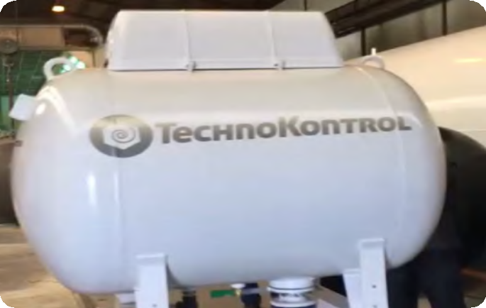

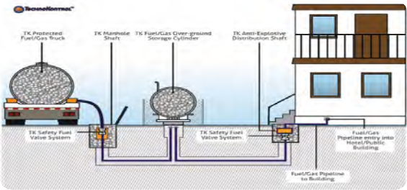
Images of underground industrial fuel and gas storage / gas cylinders showing a fuel/gas tanker at unloading position

HOW AND WHY TECHNOKONTROL WORKS  The explosions take place because a great amount of energy at a very brief moment of time is freed. This effect happens by a chain reaction that does that the energy released by a small element of volume, causes the combustion of the following ones and these simultaneously of the surrounding ones. This multiplicative effect is of exponential type with which it is arrived very quickly at the total combustion with a very abrupt contribution of energy, that is translated in an increase of calories and pressure leading towards an EXPLOSION.  This effect, macroscopically speaking, is known by speed of reaction and is what you have to get controlled to avoid the explosion.  TECHNOKONTROL, works exclusively mechanically and without altering to the chemical properties of the fuel.  Its geometry in form of polyhedral mesh fulfills the following assignments:  - The kinetic energy of gases is restrained in its radial advance from the starting point of inflammation. So the progression in spherical layers (well-known in the technique by “onion layers”) is destroyed.  - The calorific energy that contributes to the chain reaction is cushioned by the great heat absorption that offers the surface of the mesh.  In order to obtain this effect it has been studied the relation of increased surface, by volume treated [of the order of 4,200% a un 6,500% centimeters square ($cm^{2}$) by liter] as well as the minimum thickness of the mesh settling down this one in 0,06 mm.  The surface of the material determines the speed of absorption of calories but it is also necessary to obtain that the material has the sufficient volume, so that the heat capacity is enough to admit the initial calories (Energy of Activation) and the chain reaction is avoided. Actually these objectives are obtained giving a thickness to the raw material of 0.06 mm.  It is important to emphasize that described previously is only valid for the initial moment where the objective is to avoid the chain reaction. Just after the inflammation, the material and the fuel equal their temperature of which the gradient becomes zero and no longer there is no heat accumulation; the gas locked up in the deposit moves away of the stoichiometric mixture and when becoming scarce the air, the explosion danger disappears completely.  It is arrived then, to a permanent regime in which the product works of analogous form to the one of a “wick”, that allows that the gas only becomes inflamed in the fuel filling mouths, as well as in the possible fissures that could cause in a hypothetical accident or shock, overpressure, fatigue or overheat. As the gas is consumed in its combustion, the liquid evaporates and the gas is consumed until its total extinction.  To these beneficial points the following ones are due to add:  Due to the potential of oxidation of the aluminum mesh of 1.66 volts, opposed to 0.763 volts of zinc, this material becomes a very effective anode protection, that guarantees not electro corrosion of the deposit.  Then the mesh constitutes in itself a set of screens that avoid the fast movements of the liquids, water hammers (violent movements of the liquid in the deposit) and also the accumulation of static loads, being able therefore to recalculate the thicknesses, as much as, the corresponding reinforcements in tanks with the consequent reduction in price of cost in its construction.  REDUCES the EVAPORATION IN the FUEL TANKS  When the fuel within the tank evaporates produce a change of state generating a decrease of the temperature in the boundary layer. This decrease of temperature is lead quickly from the surface of the liquid, through the alloy of the Aluminum mesh that has a great heat conductivity (208 Watios/m ºC) reason for which the steam is condensate again when being in contact with the cold surface of aluminum avoiding the evaporation of the most volatile components, but powerful, and more poisonous of organic fuels. | COMO Y POR QUE FUNCIONA TECHNOKONTROL  Las explosiones se producen debido a que se libera una gran cantidad de energía en un instante muy breve de tiempo. Este efecto ocurre por una reacción en cadena que hace que la energía liberada por un pequeño elemento de volumen, provoca la combustión de los siguientes y estos a la vez de los circundantes. Este efecto multiplicativo es de tipo exponencial con lo que se llega muy rápidamente a la combustión total con un aporte de energía muy brusco, que se traduce en un aumento de calorías y presión conduciendo a la EXPLOSIÓN.  Dicho efecto, macroscópicamente hablando, se conoce por velocidad de reacción y es lo que se debe controlar para evitar la explosión  TECHNOKONTROL, funciona de una forma, exclusivamente mecánica y sin alterar las propiedades químicas del combustible  Su geometría en forma de malla poliédrica cumple los siguientes cometidos:  - La energía cinética de los gases es frenada en su avance radial desde su punto inicial de inflamación. De esta forma, la progresión en capas esféricas (conocida como la técnica por “capas de cebolla”) es destruida.  - La energía calorífica que contribuye a la reacción en cadena es amortiguada por la gran absorción de calor que ofrece la superficie de la malla.  Para conseguir este efecto se ha estudiado la relación de superficie incrementada, por volumen tratado (del orden de 4.200% a un 6.500% centímetros cuadrados por litro) así como el espesor mínimo de la malla estableciéndose éste en 6 centésimas de milímetro.  La superficie del material determina la velocidad de absorción de calorías pero es también necesario conseguir que el material tenga el suficiente volumen, de forma que la capacidad calorífica sea lo bastante grande para que admita las calorías iniciales (Energía de Activación) y se evite la reacción en cadena. En la práctica estos objetivos se consiguen dando un espesor a la materia base de 0,06 mm.  Es importante recalcar que lo descrito anteriormente ´solo es válido para el instante inicial donde el objetivo es evitar la reacción en cadena. Justo después de la inflamación, el material y el combustible igualan su temperatura con lo que el gradiente se hace cero y ya no hay ninguna acumulación de calor; el gas encerrado en el depósito se aleja de la mezcla estequiométrica y al enrarecerse el aire, el peligro de explosión desaparece por completo.  Se llega pues, a un régimen permanente en el que el producto funciona de forma análoga al de una “mecha”, que permite que el gas se inflame solamente en las bocas de llenado de combustible, así como en las posibles fisuras que pudieran ocasionarse en un hipotético accidente ya sea choque, sobrepresión, fatiga o sobrecalentamiento. A medida que el gas se va consumiendo en su combustión, el líquido se va consumiendo hasta su total extinción.  A estos puntos beneficiosos se deben añadir los siguientes:  Al ser el potencial de oxidación de la malla de 1,66 voltios, frente a 0,763 voltios del zinc, este material se convierte en una protección anódica muy eficaz, que garantiza la no electro corrosión del depósito.  Por último la malla constituye en sí misma un conjunto de mamparas que evitan los movimientos rápidos de los líquidos, golpes de ariete y también la acumulación de cargas estáticas, pudiéndose por tanto recalcular tanto los espesores como los refuerzos correspondientes en tanques con el consiguiente abaratamiento de costo en su construcción.  DISMINUCIÓN DE LA EVAPORACIÓN EN LOS TANQUES DE COMBUSTIBLE  Cuando se evapora el combustible dentro del tanque, en la capa límite, se produce un cambio de estado generando una disminución de la temperatura. Esta disminución de temperatura es conducida rápidamente desde la superficie del líquido, a través de la aleación de la malla de Aluminio que tiene una gran conductividad de calor (208 Watios/m ºC) razón por la cual los vapores del líquido al encontrarse con la superficie fría del aluminio, se condensan de nuevo evitando la evaporación de los componentes más volátiles, más energéticos, y más venenosos de los combustibles orgánicos.

