Suggestion for changes to ECE/TRANS/WP.29/GRSG/2018/17, proposed amendments to UN Regulation No. 26 (External projection for passenger cars) submitted by France

Based on feedbacks from different experts and further detailed technical inputs concerning the working document ECE/TRANS/WP.29/GRSG/2018/17, the experts from France propose to amend the proposal as mentioned below. The additions and deletions are shown in bold red text to facilitate identification of these proposed changes within the existing proposal.

I. Proposal

Text of the Regulation,

Paragraph 6.4., amend to read:

"6.4. Windscreen wipers

6.4.1. The windscreen wiper fittings shall be such that the wiper shaft and the wiper holder (numbers 1, 2 [and 3] on figure 0) is are designed or furnished with a protective casing which has with a radius of curvature meeting the requirements of paragraph 5.4. above and an end surface area of not less than 150 mm². In the case of rounded covers, these shall have a minimum projected area of 150 mm² when measured not more than 6.5 mm from the point projecting furthest. These requirements shall also be met by rear window wipers and headlamp wipers.

6.4.2. Paragraph 5.4. shall not apply to the wiper blades (number 1 5 on figure 0) or to any supporting members (numbers 2 4 on figure 0). However, these units shall be so made as to have no sharp angles or pointed or cutting parts.

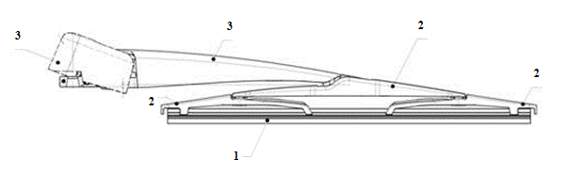

1
2
3
4
4
5

1 – Wiper shaft (with protective casing)
2 – Wiper holder (with protective casing)
3 – Wiper holder (without protective casing)
4 – Supporting members
5 – Wiper blades

Figure 0 – Example of parts distribution"

II. Justification

In order to avoid any misunderstanding on which requirement apply to which part of the windscreen wiper, a simple generic drawing presenting the concerned areas seems to be the best way for a safe application. Geometrical requirements are only applicable on contactable parts (sphere protocol).

______________

