**COLLISION PROTECTION OF THE FRONT SECTION ON BUSES**

In 2009, ECE/TRANS/WP.29/GRSG/2007/33 was initiated as a new draft UN Regulation in the field of the front protection in buses. The reason for this was that there is no good front protection to protect the driver and tourist guide in a situation where a front collision should occur:

<http://www.unece.org/fileadmin/DAM/trans/doc/2007/wp29grsg/ECE-TRANS-WP29-GRSG-2007-33e.pdf>

However, at that time, GRSG was of the opinion that this problem could be safeguarded by other systems in the vehicle. For that reason, the issue was closed.

Norway considers that the absence of requirements for protection of the driver in case of frontal collisions in the current regulations is a shortcoming that should be addressed. In Norway, a number of traffic accidents have occurred where the front of the bus was hit in a way that caused serious injury and death to the driver and tourist guide. Active security measures have proven to have limited effect in such cases. Therefore, other measures need to be taken to increase safety.

Experience shows that special protection devices need to be designed for the driver protection in the front of the coach since driver safety is not adequately considered in current regulations. Research is needed to define the requirements for front structures, a suitable test for buses and to modify the actual designs to preserve the integrity of drivers in frontal of front-lateral impacts.

The question now is whether this also is a problem in other countries and, if so, how it is taken care of?

Norway proposes to resume the work on the draft UN Regulation or to develop an amendment to UN R107.

Based on this informal presentation, the Norwegian Public Roads Administration wishes to receive GRSG's views on the issue and any proposals for amendments to the current UN Regulation.

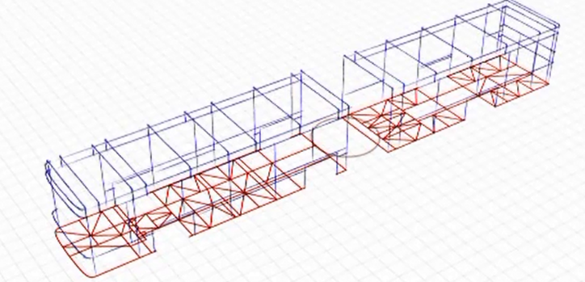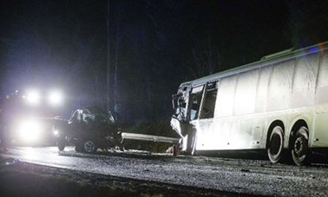

No protection of the driver Active security measures have proven to have limited effect in such cases

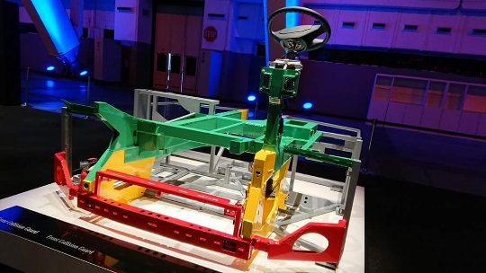 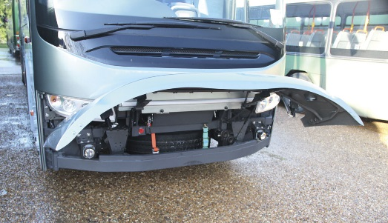

Examples of front protection

___________________