Proposal for amendments to ECE/TRANS/WP29/GRRF/2018/10
Proposal for a Supplement to UN Regulation No. 79
(Steering equipment)
The text reproduced below was prepared by the expert from the United Kingdom of of Great Britain and Northern Ireland proposing to introduce provisions in UN Regulation No. 79 (Steering equipment) for the approval of Remote Control Manoeuvring (RCM) systems. The modifications to the existing text of the Regulation are marked in tracked changes. The modifications to the original proposal are noted as follow:

 | Black text | Purple text
Normal | R79 original text | R79 original text
Bold | Proposed added text to R79  by the UK in GRRF/2018/10 | Proposed added text to R79  by OICA
Strikethrough Normal | NA | Proposed deleted text from R79  by OICA
Strikethrough bold | NA | Proposed deleted text  from GRRF/2018/10 by OICA
I. Proposal
For the best understanding of the GRRF experts, the definitions 2.3.4.1 and 2.3.4.1.1 from R79.02 are copy-pasted below, but without any request for amendment:
"2.3.4.1. "Automatically commanded steering function (ACSF)" means a function within an electronic control system where actuation of the steering system can result from automatic evaluation of signals initiated on-board the vehicle, possibly in conjunction with passive infrastructure features, to generate control action in order to assist the driver.
2.3.4.1.1. "ACSF of Category A" means a function that operates at a speed no greater than 10 km/h to assist the driver, on demand, in low speed or parking manoeuvring.
Paragraph 2.4.8., amend to read:
"2.4.8. "Remote Controlled Parking (RCP)" means an ACSF of category A, actuated by the driver, providing automatic parking or low speed manoeuvring. The actuation is made by remote control in close proximity to the vehicle.
Insert a new paragraph 2.4.18., to read:
"2.4.18. "Remote Control Manoeuvring (RCM)" means an ACSF of Category A, actuated by the driver, which may provide providing a direct control on steering angle, value of acceleration and deceleration for low speed manoeuvring for off-road use. The actuation is made by remote control in close proximity to the vehicle."
Insert a new paragraph 2.4.19., to read:
2.4.19. "Specified maximum RCM operating range (SRCMmax)" means the maximum distance between the nearest point of the motor vehicle and the remote control device up to which ACSF is designed to operate.
Paragraph 5.6.1.1.4., amend to read:
5.6.1.1.4. In case the system includes accelerator and/or braking control of the vehicle, the vehicle shall be equipped with a means to detect an obstacle (e.g. vehicles, pedestrian) in the manoeuvring area and to bring the vehicle immediately to a stop to avoid a collision.* In the case of a RCM used to control the vehicle, the vehicle does not need to stop automatically.
5.6.1.1.5. Whenever the system becomes operational, this shall be indicated to the driver. Any termination of control shall produce a short but distinctive driver warning by an optical warning signal and either an acoustic warning signal or by imposing a haptic warning signal (except for the signal on the steering control in parking manoeuvring).
For RCP, the requirements for driver warning shown above shall be fulfilled by the provision of an optical warning signal at least at the remote control device.
For RCM, the requirements for driver warning shown above are not applicable.
Insert a new paragraph 5.1.6.3., to read:
(and renumber former paragraph 5.6.1.3. as 5.6.1.4.)
"5.6.1.3. Special provisions for RCM
5.6.1.3.1. Category G (off-road) vehicles may be equipped with a Remote Control Manoeuvring (RCM) function provided it is restricted by technical means to operate only in an off-road environment.
The RCM system shall be so designed that its activation can only be achieved when the vehicle is off-road. The system shall be capable of confirming that the vehicle is off-road at any time of activation and this shall be achieved by at least two independent means. If navigation maps are used for this purpose, the RCM function shall be disabled if the map data have not been updated in the previous 12 months.
The requirements of paragraphs 5.6.1.2.2. to 5.6.1.2.8. regarding Remote Control Parking (RCP) shall apply equally to an RCM function.
The vehicle shall detect if, while the RCM function is active, the vehicle leaves an off-road environment. In such a case the vehicle shall stop immediately and the RCM function shall be de-activated.
Operation of the system shall only be possible if it is ensured by technical means or by confirmation by the driver that the vehicle is:
- off road (e.g. in a forest, in a caravan site, in-door) or
- in a secured area (e.g. working or construction zones) or
- coupled to a trailer (e.g. for reverse manoeuvring).
5.6.1.3.2. A continuous actuation of the remote control device by the driver is required during each manoeuvre.
5.6.1.3.3. If the continuous actuation is interrupted or the distance between vehicle and remote control device exceeds the specified maximum RCM operating range (S_{RCMmax}) or the signal between remote control and vehicle is lost, the vehicle shall stop immediately.
5.6.1.3.4. If a door or trunk of the vehicle is opened during the manoeuvre, the vehicle shall stop immediately.
[5.6.1.3.5. If the start/run switch is in the off position, the parking braking system shall be automatically engaged.]
5.6.1.3.6. At any time during a manoeuvre that the vehicle becomes stationary, the RCM function shall prevent the vehicle from rolling away.
5.6.1.3.7. The specified maximum RCM operating range shall not exceed 10m for vehicles of category M1, M2, M3 and N1, and 15m for vehicles of category N2 and N3.
5.6.1.3.8. The system shall be designed to be protected against unauthorized activation or operation of the RCM systems and interventions into the system.
Paragraph 5.1.6.3, renumber 5.1.6.4. and amend to read:
5.6.1.34. System information data
5.6.1.34.1. Following data shall be provided together with the documentation package required in Annex 6 of this Regulation to the Technical Service at the time of type approval :
5.6.1.34.1.1. The value for the specified maximum RCP and RCM operating range (respectively S_{RCPmax} and S_{RCMmax});
5.6.1.34.1.2. The conditions under which the system can be activated, i. e. when the conditions for operation of the system are fulfilled;
5.6.1.34.1.3. For RCP and RCM systems the manufacturer shall provide the technical authorities with an explanation how the system is protected against unauthorized activation.
II. Justification
1. Category G vehicles (defined in the Consolidated Resolution on the Construction of Vehicles (R.E.3)) have specific characteristics that enable them to achieve traction on, and to traverse over, off-road terrain that would defeat and/or damage conventional road vehicles. The operation of vehicles under these conditions requires the driver to have a particular skill level beyond that of the conventional vehicle user. However, in some cases, and despite those skills, situations present themselves for which it would be safer for the driver to be able to manoeuvre the vehicle from outside.
2. This proposal seeks to permit remote manoeuvring capability provided that the vehicle is designed to operate in this environment and the off-road location is confirmed throughout the whole period that the function is in use. The use of the function in any other environment must be suppressed by technical means that cannot be overridden by the vehicle user. The proposal is deliberately non-prescriptive about how the off-road environment is identified but if map data are used then an up to date map is required to ensure that the function does not become available on newly constructed roads, i.e. roads built on land formerly identified as off-road by mapping data.

Justification of OICA proposals:

General:

The proposal from the UK does not cover all existing or close to market applications using a remote control for low speed manoeuvring. For example, passenger car or light vehicles systems providing remote assistance when driving reverse with a trailer are not covered or may face difficulties to implement some of the proposed requirements. Truck specific applications are also planned to be used by professionals, either off-road (e.g. forestry applications) or on-road (e.g. asphalt spreader in construction areas).

For the sake of simplicity, the principle of the proposal is that RCM should be considered as an ACSF A, even though RCM does not provide any automatic low speed manoeuvring, but a remote direct control / influence on steering angle, value of acceleration and/or deceleration. This principle may be reconsidered when ACSF requirements will be reshuffled between R79 and a possible future AD regulation.

The structure of the requirement is based on the following:
- 5.6.1.1 specifies general requirements applicable to all ACSF A (amended)
- 5.6.1.2 specifies additional provisions for RCP (no change)
- 5.6.1.3 specifies additional provisions for RCM (added)
- 5.6.1.4 specifies system information data for ACSF A (RCP, RCM…) (amended)

Detailed justifications:

- Paragraph 2.4.8: the word “automatic” is added to make clear that RCP is reserved to “automatic manoeuvres” actuated by the driver with an “on/off” control. The vehicle is equipped with sensors able to drive the vehicle to the selected parking place (for example), following a calculated trajectory.

- Paragraph 2.4.18: RCM is reserved to manoeuvres actuated by the driver with direct influence/control on steering, accelerator and/or brakes. RCM can be used off-road or on-road (provided it is aimed to be used in a secured area). Safety level should not differ between on-road and off-road.

- Paragraph 2.4.19: a new definition for SRCMmax is added, to avoid any confusion with SRCPmax of paragraph 2.4.9 of R79 series 02.

- Paragraph 5.6.1.1.4: the automatic stop of the vehicle is proposed to be deleted from the requirements applicable to a RCM, on the following basis:
- With a RCM, the vehicle is still directly controlled by the user. It means the user is remotely driving the vehicle, as he would do from the driver’s seat. Unlike with an RCP (where the manoeuver is automatically performed by a “push-button” control from the driver), the driver of a RCM cannot misuse the functionality.
- The remote control by RCM provides a safety benefit, especially in reverse mode, since permitting the driver to monitor the rear of the vehicle directly, instead of relying on e.g. rear mirrors available from the driver’s seat.
The safety improvement is even more obvious when a trailer or a caravan is coupled, due to reduced visibility from the driver’s seat and increased difficulty for the driver to perform the right steering and counter steering actions to keep the trailer in the desired path.
- Additionally, The presence of a trailer will make any rear sensors of the motor vehicle blind, this at least until sensors are installed on trailers and communication with motor vehicle standardized and/or regulated.
- When used off road, automatic braking should be deactivated to prevent inappropriate interventions caused by the flora or terrain.
- For typical truck use cases like forestry applications, cherry-pickers, asphalt spreader, the installation of sensors on such vehicles may be quite difficult (exposed areas) and would require communication between truck and equipment.

- Paragraph 5.6.1.1.5: the control terminates only when the driver stops actuating the remote control, so there is no need to warn

- Paragraph 5.6.1.3.1: requiring 2 independent means is likely to mean GPS is needed. The issues with GPS are that:
- Signal may be difficult to obtain in a number of the RCM use cases: indoors (end of vehicle production line / loading bays), location where GPS signal is not available etc.
- When available, the signal may be useless in a number of other use cases; e.g. for truck applications which can be used off-road or on-road (e.g. in working or construction zones), geo-fencing is not possible: in a lane protected by cones, the GPS will still detect the vehicle is on road. Here, the operation of the RCM is the responsibility of a professional user.
To avoid these shortcomings, an alternative with “confirmation by the driver” is proposed.

- Paragraph 5.6.1.3.2: identical to RCP requirements 5.6.1.2.2

- Paragraph 5.6.1.3.3: identical to RCP requirements 5.6.1.2.3

- Paragraph 5.6.1.3.4: identical to RCP requirements 5.6.1.2.4

- Paragraph 5.6.1.3.5: similar to RCP requirements 5.6.1.2.5.
- The changes are justified by that the end of the manoeuver cannot be automatic, since the driver has full control via the remote device. At the end of each manoeuvring sequence, the driver may make another sequence until the wanted position. The system has no way to know if the wanted position is reached, until the ignition is switched off.
- Furthermore, this requirement may not be necessary, since safety during the manoeuver is already ensured by 5.6.1.3.6.

- Paragraph 5.6.1.3.6: identical to RCP requirements 5.6.1.2.6

- Paragraph 5.6.1.3.7: similar to RCP requirements 5.6.1.2.7.
- It is proposed to increase the maximum distance from 6m for RCP, up to 10m for RCM on M1 M2 M3 N1, and 15m for N2 N3.
- The purpose is to cover the complete vehicle combination, in order to permit the driver to stand behind the rear of the trailer when using RCM in reverse direction.
- Additionally, there is no technical standard for an antenna in the trailer nor communication to the motor vehicle.
- Below the example of typical M1 N1 vehicle with a trailer (justifying the need for 10 m)

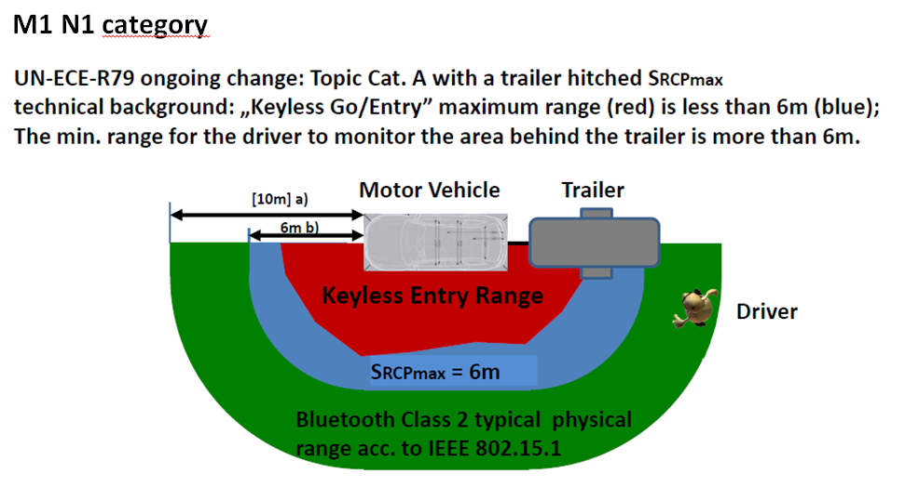

- N2 N3 potentially have longer trailers, thus 15 m is needed.

- Paragraph 5.6.1.3.8: identical to RCP requirements 5.6.1.2.8

- Paragraph 5.6.1.4: identical to RCP requirements 5.6.1.3. (in series 02).

