Submitted by the experts from Germany and the Republic of Korea | Informal document GRRF-86-13  86th GRRF, 12-16 February 2018  Agenda item 9(b)

Proposal for amendments to Regulation No.79 (Steering equipment)

The text reproduced below was prepared by the experts from Germany and the Republic of Korea with the aim to solve measurement problems regarding the test requirements for ACSF of Category B1 and C.
The proposal has the following objectives:
    - Tackle the discovered issues focusing on Annex 8.
    - Increase the reproducibility and robustness.
    - Add missing test cases.
    - Clarify measuring equipment and test execution.

The modifications to the existing text are marked in bold for new or strikethrough for deleted characters.

I. Proposal

Annex 8, paragraph 2.4., amend to read:
“2.4. Lateral acceleration
The position representing the centre of gravity, at which the lateral acceleration shall be measured, shall be determined in agreement between the vehicle manufacturer and the Technical Service. This position shall be identified in the test report.
The lateral acceleration shall be measured without taking into account the additional effects due to the movements of the vehicle body (e.g. roll of sprung mass).
The lateral acceleration and the lateral jerk at vehicle's center of gravity shall be determined. The raw lateral acceleration data shall be measured close to the position of the vehicle's center of gravity. The sampling rate shall be at least 40Hz.
To determine the lateral acceleration, the raw data shall be filtered by applying a 4th order Butterworth filter with a cut-off frequency of 0.2 Hz.
To determine the lateral jerk, the 500 ms moving average of the time derivation of the filtered lateral acceleration shall be considered.
The lateral acceleration data at the vehicle center of gravity shall be determined by removing additional effects due to the movements of the vehicle body (e.g. roll of sprung mass) and by correcting for sensor placement via the use of coordinate transformation. As reference, the vehicle coordinate system as described in ISO 8855:2011 shall be used.”

Annex 8, insert a new paragraph 2.5., to read:
“2.5. Overriding force
Prior to performing the overriding force test, the internal driver torque signal shall be verified by an external measurement device with a tolerance below 3N.
During the overriding force test, only the internal driver torque signal shall be recorded and used for the evaluation if an external device on the steering wheel would manipulate the measurement.”

Annex 8, paragraph 3.2.1.1. and 3.2.1.2., amend to read:
“3.2.1.1. The vehicle speed shall remain in the range from V_{smin} up to V_{smax}.
The test shall be carried out for each speed range specified in paragraph 5.6.2.1.3. of this Regulation separately or within contiguous speed ranges where the ay_{smax} is identical.
The vehicle shall be driven without any force applied by the driver on the steering control (e.g. by removing the hands from the steering control) with a constant speed or with a predefined initial speed (e.g. for vehicles automatically decelerating in curves) on a curved track with lane markings at each side.
The necessary lateral acceleration to follow the curve shall be between 80 and 90 % of the maximum lateral acceleration specified by the vehicle manufacturer ay_{smax}. The measured lateral acceleration during the test execution can be outside of the above mentioned limits.
The lateral acceleration and the lateral jerk shall be recorded during the test.
3.2.1.2. The test requirements are fulfilled if:
No outside edge of the tyre tread of the vehicle’s front wheel does cross the outside edge of The vehicle does not cross any lane marking.
The recorded acceleration is within the limits specified in paragraph 5.6.2.1.3. of this Regulation.
The system does not exceed the specified value ay_{smax} specified according to 5.6.2.1.1 of this Regulation by more than 0.3 m/s².
The moving average over half a second of the lateral jerk does not exceed 5 m/s³.”

Annex 8, paragraph 3.2.2.2., amend to read:
3.2.2.2. The test requirements are fulfilled if:
The recorded acceleration is within the limits specified in paragraph 5.6.2.1.3. of this Regulation.
The system does not exceed the specified value ay_{smax} specified according to 5.6.2.1.1 of this Regulation by more than 0.3 m/s².
The moving average over half a second of the lateral jerk does not exceed 5 m/s³.”

Annex 8, insert new paragraphs 3.2.5. to 3.2.5.2., to read:
“3.2.5. Lane Crossing Warning Test for M1 N1 and for M2 M3 N2 and N3 if not equipped with a LDWS fulfilling the technical requirements of Regulation No. 130.
3.2.5.1. The vehicle shall be driven with activated ACSF with a vehicle test speed between V_{smin} and V_{smax}.
The vehicle shall be driven without any force applied by the driver on the steering control (e.g. by removing the hands from the steering control) on a curved track with lane markings at each side.
The technical service defines a test speed and a radius which would provoke a lane crossing. The test speed and radius shall be defined such that the necessary lateral acceleration to follow the curve is in between ay_{smax} + 0.1 m/s² and ay_{smax} + 0.4 m/s².
3.2.5.2. The test requirements are fulfilled if:
The optical warning signal and additionally the acoustic or haptic warning signal was given at the latest when the outside edge of the tyre tread of the vehicle’s front wheel has crossed the outside edge of the lane marking.”

II. Justification

Annex 8: 2.4. Lateral acceleration
The reference coordinate system has an impact on the cancellation of additional effects.
- Vehicle coordinate system described in ISO 8855:2011 is recommended.
Definition of reference coordinate system clarifies required transformation.

The sample rate and the filtering of the lateral acceleration data should be precisely defined:
- Minimum sample rate of 40 Hz recommended.
- 4th order Butterworth filter with a cut-off frequency of 0.2 Hz recommended.

Proposed filter is designed to ensure that:
- Noise effects are cancelled.
- A stable signal is generated which can be used for a robust evaluation.
- The intention of the lateral control requirements is reflected, i.e., clear system limitations, no lane crossing and no harsh interventions.
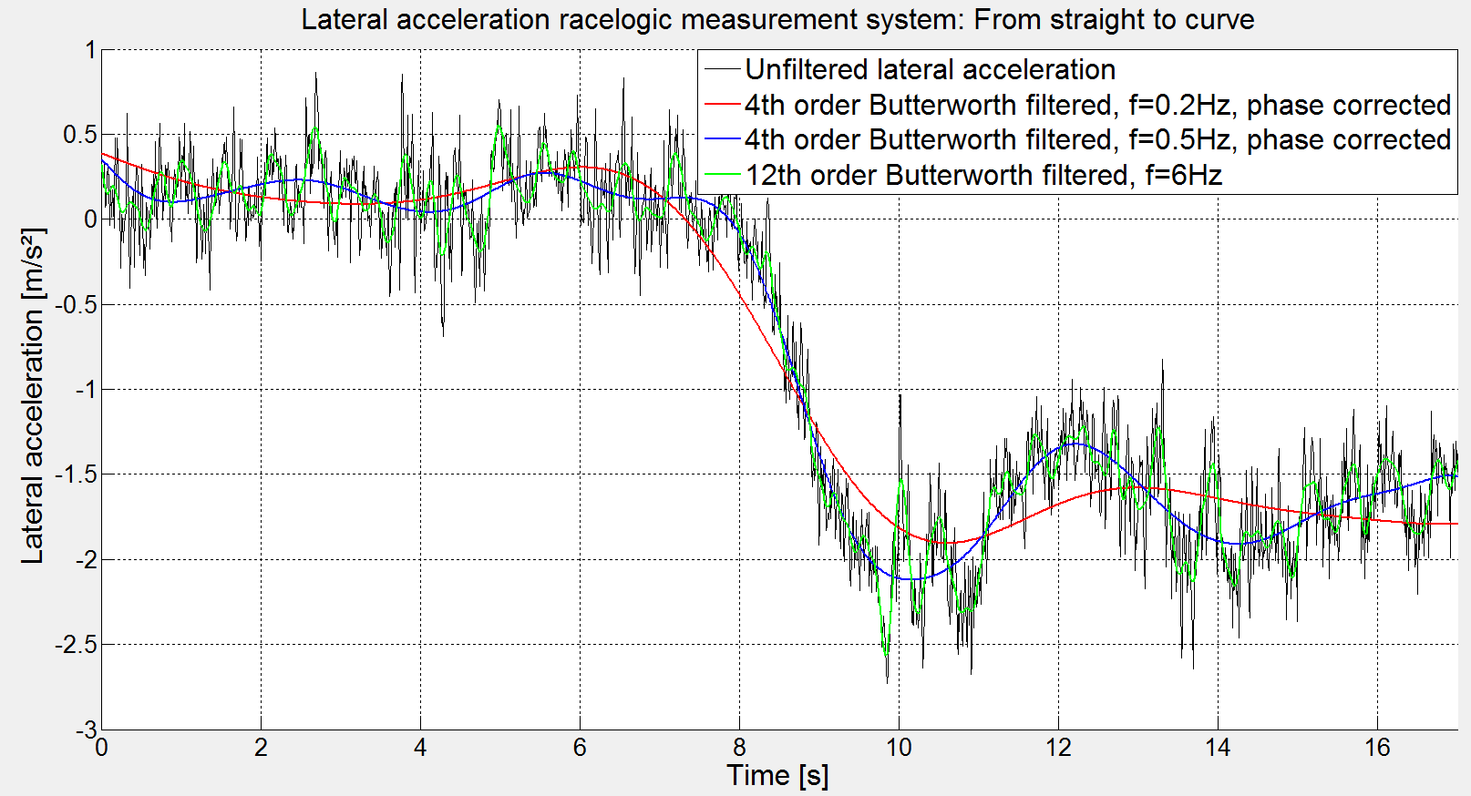
Figure “Lateral Acceleration Filtering”: Comparison between raw data, filtered raw data according to UN R13H and filtered raw data according to proposed filter design.

Annex 8: 2.5 Overriding Force Test
During the overriding force test, the internal driver torque signal shall be recorded and used for the evaluation if an external device on the steering wheel would manipulate the measurement.

Annex 8: 3.2.1.1.
The computed lateral acceleration of the curvature and initial speed shall be within the limits.
The measured lateral acceleration does not have to be within the limits, e.g., to consider systems which decelerate in curves

Annex 8: 3.2.1.2.
“No outside edge of the tyre tread of the vehicle’s front wheel does cross the outside edge of The vehicle does not cross any lane marking.”
Clarification recommended to take sensor and controller accuracy's into account and to enable an emergency lane at low speeds.

Annex 8: 3.2.1.2.
§5.6.2.1.1.: “(…) The system may exceed the specified value ay_{smax} by not more than 0.3m/s², (…).”
This section of §5.6.2.1.1. is not covered by any test case.

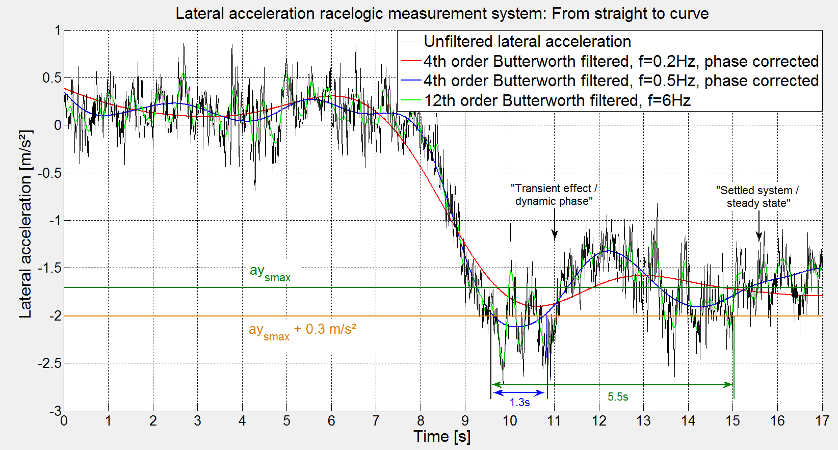
Figure “Transient Effect”: Filtered lateral acceleration for driving hands off from a straight road into a curve.

Annex 8: 3.2.2.2.
§5.6.2.1.1.: “(…) The system may exceed the specified value ay_{smax} by not more than 0.3m/s², (…).”
This section of §5.6.2.1.1 is not covered by any test case.

Annex 8, 3.2.5.
§5.6.2.2.3.: When the system reaches its boundary conditions set out in paragraph 5.6.2.3.1.1. of this Regulation (e.g. the specified maximum lateral acceleration ay_{smax}) and both in the absence of any driver input to the steering control and when any front tyre of the vehicle starts to cross the lane marking, the system shall continue to provide assistance and shall clearly inform the driver about this system status by an optical warning signal and additionally by an acoustic or haptic warning signal.
For vehicles of categories M₂ M₃ N₂ and N₃, the warning requirement above is deemed to be fulfilled if the vehicle is equipped with a Lane Departure Warning System (LDWS) fulfilling the technical requirements of Regulation No. 130.
§5.6.2.2.3. is not covered by any test case.
The test shall only by required for M1 N1 and for M2 M3 N2 and N3 if not equipped with a LDWS fulfilling the technical requirements of Regulation No. 130.
Regulation No. 130 requires that the acoustic warning shall be issued no later than 0.3 m after the outer side of the vehicle’s front tire has crossed the outer side of the lane marking.
For M1 N1 and for M2 M3 N2 and N3 if not equipped with a LDWS fulfilling the technical requirements of Regulation No. 130, the distance from outside edge to inside edge of the lane marking can be considered as a tolerance and this tolerance is required to account for the system latency.
The considered lateral velocity shall be limited in the test case by limiting the required maximum lateral acceleration.

