Transmitted by the co-Chairs of the GRE Task Force “Headlamp Switching” (TF HS) | Informal document GRE-80-09  (80th GRE, 23-26 October 2018  agenda item 6 (b))

The present document correct some editorial errors in the official document ECE/TRANS/WP.29/GRE/2018/44, we discovered after its publication. The following paragraphs shall replace the corresponding paragraphs in the above cited official document or are added to it.

Paragraph 4.2., amend to read:
“4.2. An approval number shall be assigned to each type approved. Its first two digits (at present 07, corresponding to the 07 series of amendments) shall indicate the series of amendments incorporating the most recent major technical amendments made to the Regulation at the time of issue of the approval. The same Contracting Party shall not assign this number to another vehicle type or to the same vehicle type submitted with equipment not specified in the list referred to in paragraph 3.2.2. above, subject to the provisions of paragraph 7. of this Regulation.”
Paragraph 5.11. and related sub paragraphs, amend to read:
"5.11. The electrical connections shall be such that the front and rear position lamps, the end-outline marker lamps, if they exist, the side-marker lamps, if they exist, and the rear registration plate lamp can only be switched ON and OFF simultaneously.
5.11.1. This condition requirement does not apply while one or more of the following conditions exist:
5.11.1.1. (a) When front and rear position lamps are switched ON, as well as side-marker lamps when combined or reciprocally incorporated with said lamps, are switched ON as parking lamps; or
5.11.1.2. (b) When side-marker lamps flash in conjunction with direction indicators; or
(c) daytime running lamps are switched ON;
5.11.2. (d) To front position lamps when their function is substituted under the provisions of paragraph 5.12.1. below.
5.11.32. In the case of an interdependent lamp system, all light sources shall be switched ON and OFF simultaneously."

Paragraph 6.1.7.1., amend to read:
“6.1.7.1. Except when they are used to give intermittent luminous warnings at short intervals, the main-beam headlamps may be switched ON only when the master light switch is in headlamps ON position or in "AUTO" (automatic) position and the dipped-beam headlamps are manually activated or the conditions for automatic activation switching ON of dipped-beam headlamps exist. In the latter case, Consequently, the main beam headlamps shall be switched OFFoff automatically when the dipped-beam headlamps are manually deactivated or the conditions for automatic activation switching ON of dipped-beam headlamps ceased to exist.”

Paragraphs 6.2.7. and its subparagraphs, amend to read:
……
6.2.7.7. The automatic operation of the dipped-beam headlamps shall be resumed as soon as the conditions described in paragraph 6.2.7.5.1. no longer exist. The driver shall at all times be able to engage the automatic operation.
6.2.7.8. Without prejudice to paragraph 6.2.7.6.1., Irrespective of the requirements of paragraph 6.2.7.5., the dipped-beam headlamps may switch ON and OFF automatically relative to other factors such as time or ambient conditions (e.g. time of the day, vehicle location, rain, fog, etc.).

Paragraph 6.3.7. does not need any amendment; consequently it has to be deleted from document ECE/TRANS/WP.29/GRE/2018/44.

Paragraph 6.9.8, amend to read:
6.9.8. Tell-tale
Circuit-closed tell-tale mandatory.
This tell-tale shall be non-flashing and shall not be required if the instrument panel lighting can only switched ON simultaneously with the front position lamps.
This requirement does not apply when light signalling system operates according to paragraph 6.19.7.5.
However, a tell-tale indicating failure is mandatory if required by the component regulation.

Annex 2 amend to read:
Arrangements of approval marks

Model A

(See paragraph 4.4. of this Regulation)

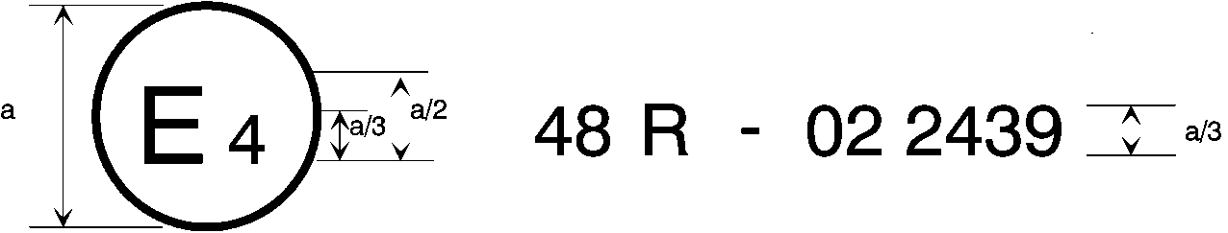
07
a = 8 mm min.
The above approval mark affixed to a vehicle shows that the vehicle type concerned has, with regard to the installation of lighting and light-signalling devices, been approved in the Netherlands (E 4) pursuant to Regulation No. 48 as amended by the 07 series of amendments. The approval number indicates that the approval was granted in accordance with the requirements of Regulation No. 48 as amended by the 07 series of amendments.

Model B

(See paragraph 4.5. of this Regulation)

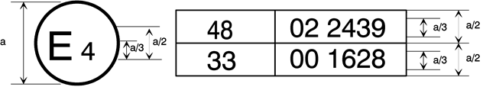
0706
a = 8 mm min.
The above approval mark affixed to a vehicle shows that the vehicle type concerned has been approved in the Netherlands (E 4) pursuant to Regulation No. 48 as amended by the 07 series of amendments and Regulation No. 33. The approval number indicates that, at the dates when the respective approvals were given, Regulation No. 48 was amended by the 07 series of amendments and Regulation No. 33 was still in its original form.

----------------------------------------

The second number is given merely as an example.

