|  |  |  |  |
| --- | --- | --- | --- |
|  | United Nations | ECE/TRANS/WP.29/GRE/2018/26 | |
| Description: _unlogo | **Economic and Social Council** | | Distr.: General  9 February 2018  Original: English |

**Economic Commission for Europe**

Inland Transport Committee

**World Forum for Harmonization of Vehicle Regulations**

**Working Party on Lighting and Light-Signalling**

**Seventy-ninth session**

Geneva, 24-27 April 2018

Item 7 (c) of the provisional agenda  
**Other Regulations:**

**Regulation No. 53 (Installation of lighting and light-signalling devices for L3 vehicles)**

Proposal for a draft amendment to Regulation No. 53 (Installation of lighting and light-signalling devices for L3 category vehicles)

Submitted by the expert from the International Motorcycle Manufacturers Association (IMMA) [[1]](#footnote-2)\*

The text reproduced below was prepared by the expert from IMMA, to allow exterior courtesy lamps being fitted on motorcycles. The modifications to the existing text of the Regulation are marked in bold for new or strikethrough for deleted characters.

I. Proposal

*Insert a new paragraph 2.34.,* to read:

**"2.34. "*Exterior courtesy lamp*" means a lamp used to provide supplementary illumination to assist the mounting and dismounting of the vehicle driver and passenger or in loading operations. "**

*Paragraph 5.9.,* amend to read:

"5.9. ~~No red light shall be visible towards the front and no white light shall be visible towards the rear. Compliance with this requirement shall be verified as shown hereunder~~ **No red light which could give rise to confusion shall be emitted from a lamp as defined in paragraph 2.5. in a forward direction and no white light which could give rise to confusion, shall be emitted from a lamp as defined in paragraph 2.5. in a rearward direction. No account shall be taken of lighting devices fitted for the interior lighting of the vehicle. In case of doubt, this requirement shall be verified as follows** (see drawing in Annex 4)…"

*Paragraph 5.13.,* amend to read:

"5.13. Colours of the lights

…

Emergency stop signal: amber or red

**Exterior courtesy lamp: white**"

*Insert a new paragraph 5.15.6.,* to read:

"**5.15.6. Exterior courtesy lamp (paragraph 6.15.).**"

*Insert a new paragraph 6.14.,* to read:

"**6.15.** **Exterior courtesy lamp**

**6.15.1.**  **Presence**

**Optional for motorcycles.**

**6.15.2.**  **Number**

**One or two; however further exterior courtesy lamps to illuminate footrest are permitted. Each footrest shall be illuminated by not more than one lamp.**

**6.15.3.** **Arrangement**

**No special requirement, however the requirements of paragraph 6.15.9.3. apply.**

**6.15.4.** **Position**

**No special requirement.**

**6.15.5.** **Geometric visibility**

**No special requirement.**

**6.15.6.** **Orientation**

**No special requirement.**

**6.15.7.** **Electrical connections**

**No special requirement.**

**6.15.8. Tell-tale**

**No special requirement.**

**6.15.9.** **Other requirements**

**6.15.9.1. The exterior courtesy lamp shall not be activated unless the vehicle is stationary and one or more of the following conditions is satisfied:**

**(a) The device which starts and/or stops the engine (propulsion system) is set in a position which makes it impossible for the engine (propulsion system) to operate; or**

**(b) A load compartment is opened for access.**

**The provisions of paragraph 5.9. shall be met in all fixed positions of use.**

**6.15.9.2. Approved lamps emitting white light with the exception of main beam headlamps and day time running lamps may be activated as courtesy lamp function. They may also be activated together with the exterior courtesy lamps and the condition of paragraphs 5.10. and 5.11. above may not apply.**

**6.15.9.3. The technical service shall, to the satisfaction of the Type Approval Authority, perform a visual test to verify that there is no direct visibility of the apparent surface of the exterior courtesy lamps, if viewed by an observer moving on the boundary of a zone on a transverse plane 10 m from the front of the vehicle, a transverse plane 10 m from the rear of the vehicle, and two longitudinal planes 10 m from each side of the vehicle; these four planes to extend from 1 m to 3 m above and perpendicular to the ground as shown in Annex 7.**

**At the request of the applicant and with the consent of the Technical Service this requirement may be verified by a drawing or simulation."**

*Annex 1, insert a new item 9.22.,* to read:

"**9.22.　 Exterior courtesy lamp: yes/no2**"

*Insert a new Annex 7,* to read:

"**Annex 7**

**Observing area towards the apparent surface of exterior courtesy lamps**

**Zones of observation**

**This drawing shows the zone from one side, the other zones are from the front, the rear and from the other side of the vehicle.**

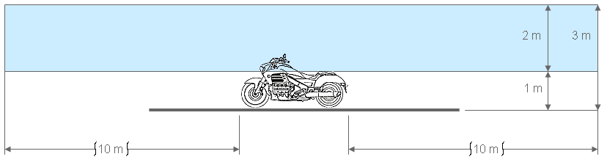

**Boundaries of the zones**

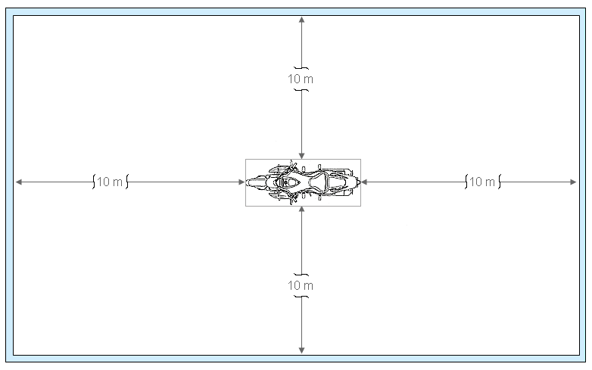"

II. Justification

1. This proposal aims to allow exterior courtesy lamps being fitted on motorcycles.
2. Regarding Regulation No. 48, the exterior courtesy lamps have been explicitly allowed since 2009.
3. Some motorcycles are currently available with courtesy lamps. However, it is not clear whether the scope of Regulation No. 53 covers such courtesy lamps or not. Therefore, this proposal amends Regulation No. 53 to explicitly include the definition and requirements of exterior courtesy lamps by aligning the text with Regulation No. 48.

1. \* In accordance with the programme of work of the Inland Transport Committee for 2014–2018 (ECE/TRANS/240, para. 105 and ECE/TRANS/2014/26, programme activity 02.4), the World Forum will develop, harmonize and update Regulations in order to enhance the performance of vehicles. The present document is submitted in conformity with that mandate. [↑](#footnote-ref-2)