INF.14
Economic Commission for Europe
Inland Transport Committee
Working Party on the Transport of Dangerous Goods
105th session 22 October 2018
Geneva, 6-9 November 2018
Item 8 of the provisional agenda:
Any other business
Supervision of vehicles, Chapter 8.5
Transmitted by the Government of Sweden
Summary
Executive summary: The additional requirements S1, S16 and S21 in Chapter 8.5 stipulate supervision of vehicles at all times. Sweden would like to discuss what minimum level of supervision is considered acceptable and how this could be clarified in ADR.
Action to be taken: Discussion
Related documents: Informal document INF.7 from the 103rd session of the Working Party, ECE/TRANS/WP.15/239 (report from the 103rd session), paragraphs 61-65, Informal document INF.16 from the 104th session and ECE/TRANS/WP.15/242 (report from the 104th session), paragraphs 55-57.
Introduction
1. At the two last sessions of the Working Party, Sweden has raised questions in relation to the supervision of vehicles. At the May meeting, the question specifically concerned Chapter 8.5 and what is intended when the additional requirements in S1, S16 and S21 state that a vehicle shall be “supervised at all times”. Naturally, opinions differed and it was also made clear that some countries have national provisions or guidelines on supervision. The majority of the delegations that spoke agreed that the requirements on supervision should be clarified.
2. In order to create a base for further discussion on the same topic, Sweden volunteered to lead an informal correspondence group to gather information concerning the specific situation within each Contracting Party. For this reason, Sweden prepared a questionnaire that, in July, was sent to all Contracting Parties whose email address are available on the UNECE Website.
3. Among the 50 Contracting Parties, 10 lacked an e-mail address and were therefore not reached. However, we have received answers from 20 countries (including Sweden) and would like to thank the following Contracting Parties for their contributions: Austria, Belarus, Czech Republic, Denmark, Estonia, Finland, France, Germany, Iceland, Ireland, Latvia, Luxembourg, Malta, the Netherlands, Norway, Russia, Romania, Spain and the United Kingdom.
4. We would also like to thank the International Federation of Freight Forwarders Associations (FIATA) in Germany, Slovakia and in the United Kingdom for their information as well as for the comments and views received from the European Chemical Industry Council (CEFIC). Furthermore, the European Commission has provided helpful information concerning Regulation (EC) No 561/200 and Directive 2002/15/EC (concerning the working time of persons performing mobile road transport activities).
5. We find the information shared very helpful and a compilation of the received answers is presented in this document.
Background
Complex of problems
There are many factors, apart from ADR, that play part when parking a vehicle safe and secure. Naturally, the conditions differ between individual drivers and between countries. In addition, there might be international or national legislation that limits the possibility for the owner of a parking area to set up a secure parking, e.g. infrastructure, special permits for camera surveillance etc. Irrespective of all these factors, the driver still has to fulfil the provisions in ADR, where Chapter 8.5 requires that the vehicle shall be supervised at all times. This means that the vehicle must be supervised when parked, nationally as well as in any other ADR country. However, since the meaning of the requirement is not clear, each individual driver has to make an interpretation. This situation is very unfortunate, and if we are not able to specify what is meant, the importance of such a requirement could be questioned and as a result safety and security could be compromised.
Set-up of the questionnaire
In the sent out questionnaire, we tried to cover as many factors as possible that might affect the driver’s possibility to park safe and secure. We are aware that some of the questions are difficult to give a definite answer to, e.g. the number of secure parking areas. Since there are no international definition of a safe and secure parking, the basis for the respective countries’ estimation also varies. Consequently, the level of safety and security that are available on those parking places also differs.
Some countries have taken into account private terminals while others might only have included areas available to commercial traffic. Irrespective of this, we believe that any estimation that has been done and shared, gives valuable input about the situation. In the end, the most important thing is that the driver knows where to stop and that such stops are actually available when it is time for the driver’s required rest. Of course, if that place also meets an acceptable level of safety, security and service, this would be the best possible situation.
As far as we are concerned, the questions did not require any confidential information. On the contrary, it is probably in each country’s interest to have this information ready available to whoever it may concern. Nevertheless, since we cannot ascertain that its content is read and understood in the correct or same way, e.g. by persons unaware of the foregoing discussions, we have chosen to leave out the complete answers in this informal paper. For the same reason, we have decided to not specify which country that has given a certain information (except for the estimated number of parking areas), but instead present a de-identified result. However, if agreed by the Contracting Parties, the answers could of course be sent out via email to the same recipients as the questionnaire.

Questionnaire - presentation of the result
The answers received on the questionnaire are presented as follows:
- The circle diagrams are based on the number of received answers (20 countries). However, all countries have not answered all questions why the sum in some diagrams might be less than 20 (100 %).
- To keep down the volume of this document, we have chosen not to reproduce all the individual comments. However, some comparable comments have been reflected to give an overview of how the situation looks in general.
- Information from the EU-Commission as well as from organizations are presented separately.
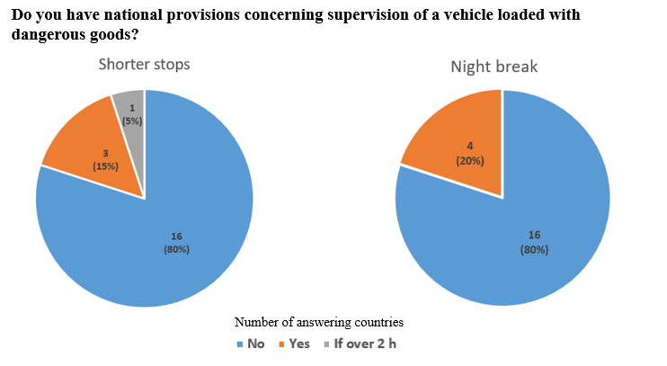

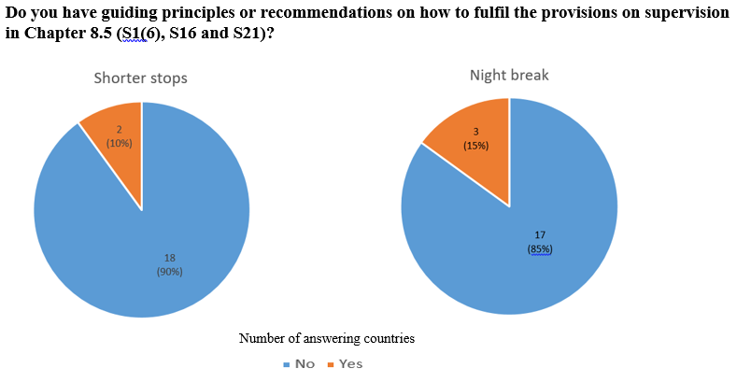

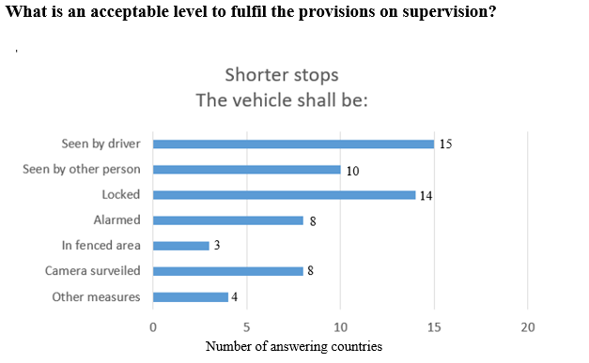

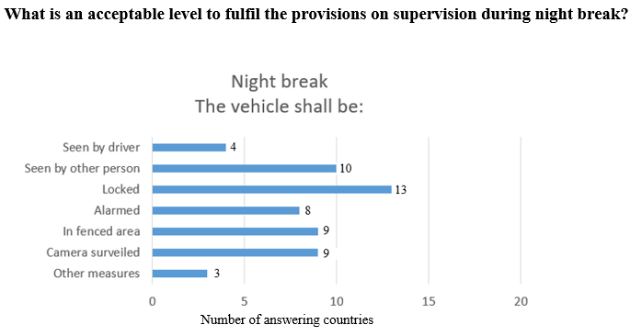

Comment: The EU-Commission has provided the following information: “The option that the driver must see the vehicle at all times is not acceptable from the point of view of the coherence with the applicable social rules. Article 4 (d) stipulates that ”‘break’ means any period during which a driver may not carry out any driving or any other work and which is used exclusively for recuperation”. The EU-Commission also included references to the EU social legislation in road transport, in particular Regulation (EC) No 561/2006 and Directive 2002/15/EC lays down the minimum requirements for driving and working times of professional drivers, as well as breaks at work and daily and weekly rest periods.
Regulation 561/2006 also provides clear definitions of “break” and “rest”.
“Break” is defined in Article 4(d) as any period during which a driver may not carry out any driving or any other work and which is used exclusively for recuperation.
“Rest” is defined in Article 4(f) as any uninterrupted period during which a driver may freely dispose of his time. It follows from these definitions that during break or rest periods drivers may not be involved in monitoring a vehicle or its cargo, as these activities are part of the working time as defined in Article 3(a) of Directive 2002/15 on the organisation of the working time of road transport mobile workers.”

General questions related to all kind of breaks and rests

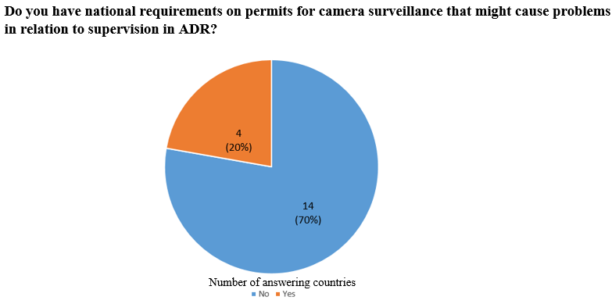
Comment: The result indicates that it would be problematic to introduce requirements related to camera surveillance in ADR since such parking areas are still very few within the countries. Furthermore, there are some difficulties regarding the establishment of such sites. (GDPR) General Data Protection Regulation as well as other provisions makes the development of camera surveiled parking areas challenging.

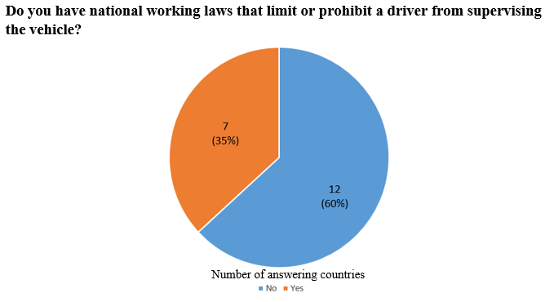
Comment: Many countries have indicated that, even though they do not have any national regulations, EU Regulation 561/2006 has to be applied. Sweden has also received information from the Swedish Transport Agency that according to EU Regulation 561/2006, only shorter rests are allowed in a moving vehicle. This means that a two-driver system would not be a sufficient solution during night breaks.

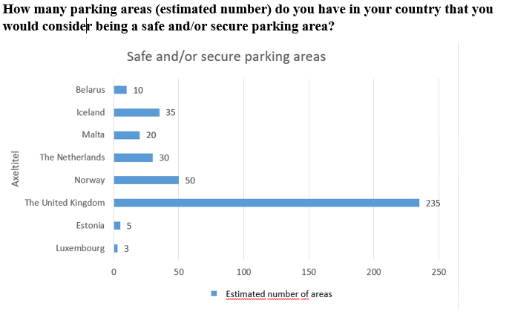
Comment: Among the countries who have answered the questionnaire but are not listed in the diagram above (Spain, Latvia, Germany, France, Denmark, Czech Republic, Austria, Russia, Romania, Finland, Ireland and Sweden) the majority have answered that they do have safe and/or secure parking areas, but that the number is unknown or too uncertain to estimate.
The EU-Commission has provided information that a study on “Safe and Secure Parking Areas” is currently being drafted at the Commission’s request. The outcome is expected by the end of this year. EU Member States will be informed accordingly as soon as information is available. For information on this topic, please visit: https://ec.europa.eu/transport/themes/its/road/action_plan/intelligent-truck-parking_en

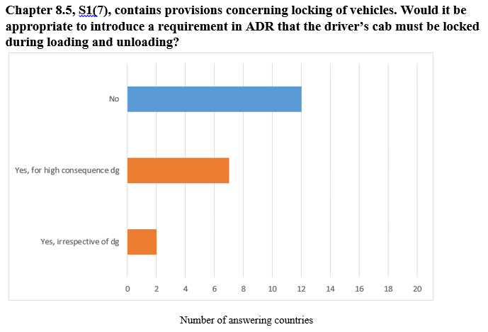

Comment: This question has been answered in different ways. Some countries have not given any answer while others have marked more than one alternative but in relation to different dangerous goods classes. Several countries have also pointed out that locking the vehicles cab might not always be feasible or beneficial. During loading and unloading of some goods, quick access to control panels in the cab is highly recommended for the safety of the operation. Another comment expressed by several countries is that for such transports where locking of the vehicles’ cab would promote safety and/or security, this should rather be covered by the security plan, required in sub-section 1.10.3.2.
Information received by organizations
Below follows an extract of the answers received from FIATA and CEFIC:
FIATA Slovakia: There are no national provisions or recommendations in Slovakia concerning supervision of a vehicle loaded with dangerous goods. Precautions to be taken to minimize theft or misuse of dangerous goods are covered by the security plan according to 1.10.3.2 fulfilling all requirements of Chapters 8.4 and 8.5. The estimated number of safe and/or secure parking areas is 300, based on consultation by the Ministry of Transport, National Highway Society. Regarding the question whether it would be appropriate to introduce a requirement that the driver’s cab must be locked during loading and unloading, they find this sufficient for high consequence dangerous goods according to Chapter 1.10.
FIATA UK: There is no definition of “supervision”. However, various Insurance Companies may specify certain conditions. The events listed as A-G (the list of different measures to be taken during shorter stops and breaks) have no practical application in the transport chain. Regarding the question whether it would be appropriate to introduce a requirement that the driver’s cab must be locked during loading and unloading, they do not consider this appropriate for other Classes than Class 1.
FIATA Germany: On the question what is an acceptable level to fulfil the provisions on supervision during shorter stops, all alternatives but “G Other measures” have been marked. Additional information is given that it should be considered that the driver may diverge from the vehicle for a short time (e.g. to buy food) but that the vehicle should be locked in such cases. Other opportunities for supervision are parking at closed compound or, if not closed compound, electronic immobilizers and an alarm equipment with a connection to the mobile. All the alternatives listed in the questionnaire but “A” (The driver must see the vehicle at all times) has been marked as an acceptable level of supervision during night break. “Other measure” is that the driver is present in the driver-cabin. Regarding the question whether it would be appropriate to introduce a requirement that the driver’s cab must be locked during loading and unloading, they do not consider this appropriate
CEFIC: CEFIC has had an exchange of views among CEFIC members. A majority was of the view that current national requirements have to be listed by the Competent Authorities. On the question what is an acceptable level to fulfil the provisions on supervision during shorter stops, they have stated that the vehicle must be locked and alarmed.

Discussion
Since the threat level within each country is different, specifying a minimum level of safety and security might be the most suitable solution. It should be kept in mind that each country, in addition, always has the possibility to introduce (or maintain) national provisions on security. Considering the result of the questionnaire, Sweden believes that this further indicates that a clarification of “supervision” stating the minimum required level is necessary and a step in the right direction.
To facilitate the discussion, we would like to hear the meetings’ view on the following:
For shorter stops;
1. Would it be an acceptable minimum level of supervision if the driver can see the vehicle at all times during the stop (visually or via camera)?
Attendent question: If another person would be appointed by the driver/the carrier to supervise the vehicle, would this require that this person is trained in accordance with Chapter 1.3?
2. If neither the driver nor any appointed person can see the vehicle during the rest or part of the rest, would it be an acceptable minimum level of supervision if the vehicle (cab and load compartment) is locked and alarmed?
3. Would it be appropriate to require that the vehicle’s cab is locked when the driver’s rest does not take place inside the vehicle? Alternatively, would it be reasonable to include a reference to the provisions concerning security plans in sub-section 1.10.3.2 for high consequence dangerous goods? Concerning the locking of load compartments for EX/II- and EX/III-vehicles, see S1(7) in Chapter 8.5.
For night breaks;
4. Would it be an acceptable minimum level of supervision if the vehicle (cab and load compartment) is locked and/or alarmed during night break?
5. Would it be reasonable to include a reference to the provisions concerning security plans in sub-section 1.10.3.2 for high consequence dangerous goods? Concerning the locking of load compartments for EX/II- and EX/III-vehicles, see S1(7) in Chapter 8.5.
General question
- We should also think about how clarifying text should be included in the provisions, for example by introducing a definition, a note or by a footnote giving guidance on how this requirement could be fulfilled.
- With the result of the questionnaire as a basis, Sweden is interested to hear the meeting’s view on this matter and is, depending on the outcome, willing to prepare a formal proposal to the next meeting of the Working Party (May 2019). If the meeting believes it would be helpful to take part of each individual answer on the questionnaire, these could be forwarded via e-mail after the meeting.
Justification
The driver has no choice but to meet the provisions concerning supervision in Chapter 8.5 as well as any other regulation surrounding the transport. For this reason, we find it necessary to specify what is meant by « supervision » in ADR, and agree on a minimum level of safety and security that we find acceptable.
Naturally, an introduction of requirements on e.g. alarm or locking of vehicles is not likely to prevent the more advanced or goal-oriented perpetrators from stealing the load or high jacking the vehicle, but it might prevent the more impulsive or less advanced criminals. It might also contribute to delaying the crime process.
In any case, since Chapter 8.5 in ADR requires supervision, it must be clear how this should be fulfilled. Otherwise the requirement does not fulfil a purpose and should be removed. Clarifying what is required by “supervision” in Chapter 8.5 would help drivers and others involved in the transport process to apply the provision, which might also lead to a generally higher level of safety and security.
___________________

