United Nations Economic Commission for Europe

Draft 2
08 May 2017

EURO-ASIAN TRANSPORT LINKS
Phase III
Expert Group Report

Geneva
2017
TABLE OF CONTENTS

ABBREVIATIONS 5
INTRODUCTION 7
EXECUTIVE SUMMARY 12
PART I. EURO-ASIAN TRADE ROUTES AND FREIGHT FLOWS 20
I.1. Economics and trade current situation in EATL Region 20
I.1.1. General overview 20
I.1.2. Asia and Pacific region 23
I.1.3. Central and Eastern Europe 29
I.1.4. CIS member-states 30
I.2. Euro-Asian trade flows 33
I.2.1. Main trade partners 33
I.2.2. Main commodity groups 49
I.3. Euro-Asian transport flows 54
I.3.1. EATL transport flows general overview 54
I.3.2. Liner Shipping situation 54
I.3.3. Railway transport 60
I.3.4. Road transport 101
I.3.5. Air transport 106
I.4. Transport Infrastructure of EATL routes development 112
I.4.1. Sea ports and their hinterland connections role in EATL corridors 112
I.4.2. Infrastructure of EATL railway routes 117
I.4.3. Infrastructure of EATL road routes 135
I.4.4. Air transport infrastructure 141
I.4.5. Logistic centers and dry ports in the EATL system 141
1.5. Comparative analysis of the duration and expenses of different modes of transport between Europe and Asia on selected Euro-Asian routes 145
PART II. CURRENT INITIATIVES, PROJECTS AND STUDIES IN EATL REGION 163
II.1. Overview of international studies, programmes and initiatives on Euro-Asian transport links development 163
II.1.1. UN ECE 163
II.1.2. UN ESCAP 167
II.1.3. UN OHRLLS 169
II.1.4. UNCTAD 171
II.1.5. UN SPECA 172
II.1.6. European Union 173
II.1.7. Eurasian Economic Union 175
II.1.8. Silk Road Economic BELT Initiative 177
II.1.9. OSCE 178
II.1.10. OSJD 180
II.1.11. BSEC 183
II.1.12. TRACECA 184
II.1.13. ECO 187
II.1.14. GUAM 187
II.1.15. World Bank 188
II.1.16. ADB and CAREC Program 189
II.1.17. IDB 191
II.1.18. EBRD 192
II.1.19. IRU 193
II.1.20. UIC 195
II.1.21. CCTT 196
II.1.22. GPST 196
II.2. Joint Initiatives and projects implrmrnted by International organisations 198
II.3. Most important national level programmes and projects 199
PART III. MAIN OBSTACLES HAMPERING THE EURO-ASIAN TRANSPORT LINKS DEVELOPMENT 206
III.1. General overview 206
III.2. Border Crossing Points as bottlenecks 209
III.3. Barriers concerning goods transported 211
III.4. Barriers concerning border crossing technologies and procedures 212
III.5. Road transportation specific barriers 214
III.6. Rail transportation specific barriers 215
III.7. Intermodal transportation specific barriers 219
III.8. Mismatch of public and private interests 220
PART IV. EATL: LOOKING INTO THE FUTURE 221
PART V. CONCLUSIONS AND RECOMMENDATIONS 236
REFERENCES 245
ANNEXES 248

ABBREVIATIONS

ADB | Asian Development Bank
AIIB | Asian Infrastructure Investment Bank
ASEAN | Association of Southeast Asian Nations
BSEC | Organization of the Black Sea Economic Cooperation
BSEC-URTA | BSEC Union of Road Transport Associations
CAREC | Central Asian Regional Economic Development Program
CCTP | Coordinating Council on Trans-Siberian Transportation International Association
CEFIR | Centre for Economic and Financial Research at the New Economic School
CIM | Uniform Rules concerning the Contract of International Carriage of Goods by Rail
CIS | Commonwealth of Independent States
COSCO | China Ocean Shipping Company
COTIF | Convention concerning International Carriage by Rail
EAEU | Eurasian Economic Union
EATL | Euro-Asian Transport Links
EBRD | European Bank for Reconstruction and Development
ECO | Economic Cooperation Organization
EDB | Euro-Asian Development Bank
EECCA | Eastern Europe, Caucasus and Central Asia
EU | European Union
FAS | FESCO Amur Shuttle
FASw | FESCO Amur Shuttle westbound
FBS | FESCO Baltic Shuttle service
FELB | Far East Land Bridge
FESCO | Far East Shipping Company
FMS | FESCO Moscow Shuttle
FMSe | FESCO Moscow Shuttle eastbound
FOB | free on board
FOS | FESCO Ob Shuttle
FSS | FESCO Siberian Shuttle
FSSe | FESCO Siberian Shuttle eastbound
FUS | FESCO Ural Shuttle
GDP | gross domestic product
GIS | Geographical Information System
GPST | Global Partnership for Sustainable Transport
GUAM | Organization for Democracy and Economic Development
GVC | Global value chain
IBRD | International Bank for Reconstruction and Development
ICT | information and communication technology
IDA | International Development Association
IDB | Islamic Development Bank
IGC | Intergovernmental Commission
IM | Infrastructure Manager
IMF | International Monetary Fund
IRF | International Road Federation
ISIC | International Road Transport Union
ISIC | International Standard Industrial Classification
KTZ | Kazakhstan Railways
LDC | Least developed countries
LHV | long and heavy vehicles
LLDC | Landlocked developing countries
MLA | Multilateral Agreement
OBOR | One Belt – One Road Initiative
OECD | Organisation for Economic Co-operation and Development
OSCE | Organization for Security and Co-operation in Europe
OSJD | Organization for Cooperation of international Railways
OTIF | Intergovernmental Organisation for International Carriage by Rail
PETC | Pan-European Transport Corridors
RZD | Russian Railways
RZDL | Russian Railways (RZD) Logistics
SDGs | Sustainable Development Goals
SITC | Standard International Trade Classification
SMGS | Agreement on Direct International Goods Transport by Rail
SPECA | United Nations Special Programme for the Economies of Central Asia
SREB | Silk Road Economic Belt
TAR | Trans-Asian Railway Network
TEL | Trans Eurasia Logistics
TEM | Trans-European Motorways Project
TEN-T | Trans-European Network - Transport
TER | Trans-European Railways Project
TEU | Twenty-foot equivalent unit
TRACECA | Transport Corridor Europe – Caucasus – Asia
TSR | Trans-Siberian Railway
TWG | Thematic Working Group
UIC | International Union of Railways
UNCTAD | United Nations Conference on Trade and Development
UN DESA | United Nations Department of Economic and Social Affairs
UNDP | United Nations Development Program
UNECE | United Nations Economic Commission for Europe
UN OHRLLS | United Nations Office of the High Representative for the Least Developed Countries, Landlocked Developing Countries and the Small Island Developing States
UNESCAP | United Nations Economic and Social Commission for Asia and Pacific
UNWTO | United Nations World Tourism Organization
UTLC | United Transport and Logistics Company
WCM | World Container Model
WCO | World Customs Organization
WTO | World Trade Organization
XUAR | Xinjiang Uyghur Autonomous Region, China

INTRODUCTION
Previous phases of the EATL project
The Euro-Asian Transport Links (EATL) project is a part of long-term collaborative work carried out during recent decades by many countries of the Eurasia with support of international institutions to improve the conditions for trade and socio-economic development on the continent.
At the moment EATL is supported by 38 countries: Afghanistan, Armenia, Azerbaijan, Belarus, Belgium, Bosnia and Herzegovina, Bulgaria, China, Croatia, Cyprus, Finland, France, Georgia, Germany, Greece, Iran (Islamic Republic of), Italy, Kazakhstan, Kyrgyzstan, Latvia, Lithuania, Luxembourg, Malta, Mongolia, Pakistan, Poland, Portugal, Republic of Moldova, Romania, Russian Federation, Serbia, Spain, Tajikistan, The former Yugoslav Republic of Macedonia, Turkey, Turkmenistan, Ukraine and Uzbekistan.
EATL started in 2002 as a joint undertaking between the United Nations Economic Commission for Europe (UNECE) and the United Nations Economic and Social Commission for Asia and the Pacific (UNESCAP).
Phase I of the project (2002-07) had selected the main Euro-Asian road, rail and inland water transport routes, transshipment points and ports. The projects prioritized implementation of initiatives in order to improve transport on the selected routes. The first analysis of physical and non-physical barriers to transport and cargo flows on those routes was undertaken. An Expert Group established under the Phase I proved to be the effective cooperation platform for the coordinated development of coherent Euro-Asian inland transport links.
Phase II of the EATL project (2008 to 2013) was coordinated by UNECE. Within this phase the Expert Group identified nine rail and nine road corridors (EATL corridors) which should be considered as principle transport links between Europe and AsiaThe participating countries had proposed 311 initiatives for the development of thosecorridors, which hadbeen evaluated from the standpoint of their relevance and importance for international traffic and their value to connect Asia and Europe by the Expert Group. The assessment of transport investment needs along these corridors at the multi-county level had been also undertaken by the Group. It had formed the basis of the updated EATL Investment Plan. Finally, the Expert Group had identified administrative impediments to transport and trade .
Phase II provided the following outputs: :
- comperative analysis of the Euro–Asian railway transport versus maritime transport offering a basis for starting railway reforms to improve railway services for cargo flows across the two continents;
- comperative scenario analysis of cargo flow on nine door-to-door routes in terms of time and cost proving the rail transport outperforming maritime transport in terms of cost and time infive out of the nine scenarios, and in terms of timein all nine scenarios;
- review of transport and border-crossing facilitation offering solutions to improving it;
- SWOT analysis of the EATL corridors.
Finally, the Phase II report formulates a number of recommendations in the areas of infrastructure development, facilitation and sectorial policies. It argues that well-functioning EATL corridors, efficient customs transit regimes, the implementation of international trade and transport conventions, elimination of rent-seeking as well as the overall improvement of transport and logistics services can shorten the economic development gap between the most and least developed EATL countries.
Within Phase II UNECE also created and made freely available the Geographical Information System (GIS) interactive application that gives access to the database related to the EATL corridors. UNECE is ready to maintain this database in collaboration with the participating governments with the intention to help the governments and the international institutions to coordinate and accelerate their collaborative investment activities.
The Second EATL Ministerial Meeting (26 February 2013) endorsed the Phase II final report and supported the next phase of the project in its Joint Declaration.
The EATL Project had identified the rail, inland water and road transport linkages that are of central importance in tackling the following interrelated problems:
- to develop transport options alternative to maritime transport between Asia and Europe;
- to better connect the landlocked countries of Central Asia and the Caucasus with the global markets;
- to improve conditions for trade within EATL area itself, primarily – in the Central Asian region.
The identified EATL routes therefore not only aim at improving connectivity amongst EATL countries, but also at connecting the EATL with other existing transport networks in Europe and Asia. Among them are the Trans-European Transport network (TEN-T network), the Pan-European Transport Corridors (PETC), the TRACECA and the rail and road networks in Asia.
The nine rail and nine road routes constitute the core infrastructure network for the transport links between Europe and Asia across Central Asia and the Caucasus. The routes stretch over more than 10 000 kilometers in the East-West direction, and cross over 15 countries.
Specifically, the EATL rail routes extend the Trans-European Railway (TER) network eastward and connect it with the Trans-Asian Railway Network (TAR).
The EATL road routes connect the Trans-Asian Highways (TAH) with the TEN-T routes. Many of the EATL routes also coincide, either fully or partially, with other road networks and corridors, such as the TRACEA, PECT, the six Central Asia Region Economic Cooperation Program (CAREC) corridors, and the Organization for Cooperation of international Railways (OSJD) rail corridors.
Main goals of the EATL project
The Euro-Asian Transport Links project is aimed at three main interconnected goals, or three project domains:
- Developing the Euro-Asian inland transport.
This aspect of work is focused on providing conditions for increasing volumes of Euro-Asian cargo via inland routes, primarily railway. The basic idea is to benefit from potentially shorter travel time - in comparison with the maritime routes - that would attract the time-sensitive high-value commodity segment of Euro-Asian trade. Since this idea was formulated during the St. Petersburg International Euro-Asian Conference on Transport in 1998, much had changed in Eurasian trade and transport. The trade volumes had significantly increased as had the capacity of container ships operating on Eurasian routes. That, in turn, had led to lower freight rates and the prospects for inland transport deteriorated. At the same time, the idea of intercontinental container trains that once had looked as a very distant prospect had become the everyday reality for many shippers who started to see these services as an attractive alternative to sea transport in particular for high-value commodities or in response to the “slow steaming” concept adopted by maritime operators.
- Addressing challenges of the landlocked countries.
Thirteen of the EATL countries - Afghanistan, Armenia, Azerbaijan, Belarus, Kazakhstan, Kyrgyzstan, The former Yugoslav Republic of Macedonia, Moldova, Mongolia, Serbia, Tajikistan, Turkmenistan and Uzbekistan – do not have direct territorial access to the sea and hence to theworld markets. For these countries, fragmentation of the supply chain in a poorly regulated transit process can add up to 50 per cent to transport costs between a landlocked country and a nearest foreign port. According to the World Bank, countries’trade and incomes lag far behind those of transit countries and the global average.
The international community constantly pays special attention to needs of landlocked countries. The Almaty Programme of Action: Addressing the Special Needs of LLDCs within a New Global Framework for Transit Transport Cooperation for Landlocked and Transit Developing Countries, adopted in 2003, reflected the strong commitment of all actors to address the special development needs and challenges faced by LLDCs and to promote their effective integration into the global economy through the implementation, inter alia, of specific actions in the areas of fundamental transit policy issues, infrastructure development and maintenance as well as trade facilitation.
When this report was being worked out, the Vienna Programme of Action for Landlocked Developing Countries for the Decade 2014-2024 was under implementation. This innovative, holistic and results-oriented 10-year programme is based on renewed and strengthened partnerships to accompany LLDCs. This Programme envisaged individual and concerted efforts by the organizations and bodies of the United Nation system, and othter relevant international organizations, who were invited to give priority to requests for technical assistance and capacity-building from LLDCs in a well-coordinated and coherent manner, within their respective mandates.
Some of the specific goals and objectives of the Vienna Programme, among them: (i) promotion of efficient and cost-effective access to and from the sea by all means of transport, (ii) reduction of trade transaction costs and transport costs and improvement of international trade services, (iii) development of adequate transit transport infrastructure networks, and (iv) completion of missing links connecting landlocked developing countries, are fully consistent with the EATL project.
- Improving the environment for regional trade between the EATL countries, primarily in the Central Asian area.
The region of Central Asia had recovered from the transitional recession in the late 1990s, and during the 2000s emerged as one of the most dynamic economic regions in the world. Kyrgyzstan, Tajikistan and Kazakhstan became WTO members in 1998, 2013 and 2015 respectively.
The region met the previous decade with strong trade links with Europe the CIS. During the last decade, China has emerged as an important trading partner for Central Asia, particularly in natural resources while ties with Turkey have also intensified.
However, trade in the region is still below its potential, with limitations in connectivity, market access, limited bilateral engagement and difficult trade and transport facilitation. Further development is limited by transport-geographical- as well as by the institutional factors. Despite a long history as a center for global trade, the economic structure of Central Asia is currently characterized by low economic density and long distances.
It should be noted that the average level of economic development of the Central Asian countries makes the large-scale infrastructure investments very burdensome for their national budgets. In the context of the current economic situation, this fact becomes even more important.
At the same time, trade policy regimes throughout Central Asia are uneven and often far from good international practice. They vary from liberal in the Kyrgyzstan, to fairly liberal in Kazakhstan and Tajikistan and to quite restrictive in Uzbekistan. While tariffs are not particularly restrictive by global standards, tariff structures are complex and changes are not transparent or predictable and non-tariff measures are extensive and pervasive [18].
That is why adjusted “point-focused” investment projects undertaken together with institutional improvements seems to be the principal vector of connectivity development in the region.
The development of EATL is fully consistent with the Sustainable Development Goals (SDG) adopted in 2015 by the UN General Assembly Resolution 70/1 “Transforming our world: the 2030 Agenda for Sustainable Development” including SDG 2, 3, 7, 8, 9, 11, 12 and 13.
Ministers of transport and high representatives of 58 countries as well as European Commissioner for Transport signed the Ministerial Resolution “Embracing the new era for sustainable inland transport and mobility” during 70th anniversary of the UNECE Inland Transport Committee on 21 February 2017, agreeing to “…work towards improved regional and inter-continental connectivity with special attention to the Euro-Asia Transport Links project … through policy coordination, and facilitation of seamless transport”.
Goals of the phase III of the EATL project
The principle goal of Phase III of the EATL project was to identify the measures to make the EATL inland links operational.
In order to achieve this goal the following activities were undertaken by an Expert Group:
analysis of the current situation of transport and trade in and between EATL countries;
- review of current studies, programmes and initiatives on development Euro-Asian transport links recently undertaken at both national and international levels;
- identification of main obstacles in transport, trade, border-crossing, customs and transit hampering cargo flows along EATL routes;
Based on the activities The Expert Group formulated recommendations that should help countries to address barriers and further develop the trade across the EATL area.
These recommendations should help policymakers and operators to establish a platform for improving the situation and enhance opportunities for the inland transport in the future. The outcomes of Phase III of the EATL project are also expected to boost political support for often painful reforms in the transport sector, border crossing facilitation, as well as in the management of large-scale transport investment programs, implementation of modern customer oriented freight services and digital technologies in area of land transport and transit.

EXECUTIVE SUMMARY
General description of the project
The Euro-Asian Transport Links (EATL) project is a part of long-term collaborative work carried out during recent decades by international institutions and particular countries of the Eurasia to improve the conditions for trade and socio-economic development on the continent. The EATL initiative is aimed at three main interconnected goals, or three project domains:
- developing the Euro-Asian inland transport
- addressing the challenge of landlock countries
- improving the environment for regional trade between the EATL countries.
The project was undertaken in three phases.
Phase I (2002-07) had selected and prioritized the main Euro-Asian road, rail and inland water transport routes, transshipment points and ports. The first analysis of physical and non-physical obstacles hampering the trade via the inland Euro-Asian routes was undertaken.
Phase II (2008 to 2013) identified nine rail and nine road corridors (EATL corridors) which should be considered as principle transport links between Europe and Asia. Main projects linked with the EATL corridors were proposed by the participating countries.
The principle aim of Phase III was to identify the measures that will make the EATL inland links operational. The report contains:
- the overview of the current situation along EATL routes,
- the analysis of the main transport, trade, border-crossing, customs and transit obstacles hampering transportation and trade along EATL routes;
- the recommendations to overcome the identified barriers and further develop the trade across the EATL area.

General economic and trade situation
Global recovery continues at a slow pace, with momentum created by growth rate reduction in China and other Asian developing economies. Other factors – namely, lower commodity and oil price levels, eroding terms of trade in many commodity and oil-exporting countries, weaker global demand and investment levels, geopolitical tensions and political unrest – contribute to increasing uncertainty, growing downside risks and challenging the outlook for merchandise trade and transport between Europe and Asia. Because of that, growth of international trade would not be the main driver for the Euro–Asian transport flows and transport links, as it was during Phase I and Phase II of the EATL Project.
As regards the continental Euro-Asian links, these pre-conditions have their negative impact in several aspects:
- the general slow-down of transport demand
- decrease of the “critical mass” of traffic in landbridge corridors to keep the transport services across them sustainable
- limitations of the investment potential for infrastructure projects implementation
- growing gap between the shipping rates and the railway rates (which is one of the main disadvantages of the Euro-Asian landbridge).
At the same time, the current situation has some potential opportunities for the EATL transport routes development. A portion of time-sensitive transit cargo can be redirected through inland EATL routes due to introduction of the “slow steaming” concept on the maritime routes. Besides that, such events as creation of the Eurasian Economic Union (EAEU), accession of the Russian Federation, Tajikistan and Kazakhstan to the WTO, the start of ”One Belt – One Road” Initiative, the WTO Trade Facilitation Agreement (TFA) entered into force on 22 February 2017 following its ratification by two-thirds of the WTO members improve the general political and economic climate across the EATL area.

Competitiveness of Inland Euro-Asian Trasnport Links
Maritime transport is the dominating mode for moving cargo between Europe and Asia. There are certain factors that make its market position stronger: flexible tariff policy, absence of borders, well functioning logistics, facilitation and digitalization of procedures in ports, energy efficiency shipping alliances development, etc.
For objective reasons the Euro-Asian inland bridge will likely never compete in volume with maritime trasnport. It may, however, well establish itself as complementary to shipping services increasing the reliability of high-value and time-sensitive supply chains.
The inland Euro-Asian transport system has been already formed to a major extent and continues to develop. Container services provided on some of the Eurasian surface routes by state owned and private suppliers of transport and logistics services are demonstrating the different opportunities of expensive and time-sensitive cargo delivery serving as a complement to maritime routes.
EATL transport routes combine the functions and features of different types of transport corridors: transport and trade transit corridors, access corridors and developing corridors. This gives wide development opportunities to EATL routes as the instrument of regional trade and development.
Competition of transport corridors on the Euro-Asian continent is not about the simple choice between transport routes and/or transport modes. It is the competition of logistic decisions based on intermodal services and value-added services and focused at the needs of particular supply chains. Main supply chains requirements are regular services, high punctuality, flexible costs, availability of value added services, delivery speed appropriate for certain types of cargo. These requirements do not apply to particular sections of Euro-Asian routes, but to entire transport-logistic chains.
Decision making in supply chains, in particular – choosing the routes and modes – is made usually not by shippers themselves but by logistic operators: freight forwarders, 3 PL – providers, etc., who combine the understanding of the needs of a particular supply chain with deep knowledge of transport market and ability to put together the interests of numerous market players: carriers, terminal operators, infrastructure owners, etc.
In view of the above, any transport route within the Eurasian continent will attract cargo flows only when it will be competitive in the context of supply chains. No political decisions or investment projects developed beyond this context will be successful in this sense. For the same reasons the attempts to bind the freight flows within the corridors to particular fixed routes, points or to selected transport modes seem counterproductive.
Further development of EATL continental links needs improvement or modernizations of the infrastructure and elimination of non-physical barriers influencing the trade and transport flows.

Comparison of maritime and overland transit routes
Comparative analysis of maritime and overland routes connecting Europe and Asia is undertaken constantly in numerous studies in order to:
- demonstrate the principle advantages of particular overland transit corridors;
- choose the most competitive overland route among several options;
- evaluate the volumes of cargo that can be attracted to the overland routes.
During EATL Phase III project comperative anslysis between sea and overland routes are presented, in particular:
- the updated fragment of the analysis undertaken during Phase II of the EATL research;
- the study undertaken by the Russian Centre for Economic and Financial Research at the New Economic School (CEFIR);
- the research provided by PLASKE – freight forwarding company involved into the Euro-Asian intermodal container transportation;
- the studies by Eurasian Development Bank.
The analyses show that there are segments of undisputed “maritime domination”, but under certain conditions regular railway transit can be an attractive alternative for shippers. Therefore competitive railway services in EATL transit corridors can develop under the following conditions:
a) location of Asian terminal points in Central and North-Western China
b) location of European terminal points in Eastern Europe, Black Sea and Baltic regions
c) existence of guaranteed flow of high-value and time-sensitive cargo (automotive parts, electronics, etc.) from one shipper or a limited group of “anchor” shippers as a basis for sustainable regular service. Besides, the service should be better operated not by pure railway carrier but by market-oriented logistic operator experienced in a design of transport-logistic chains.
Railway transport.
Railway transport should play the leading role within the EATL transport links, primarily, in the sector of intermodal services. To achieve that, the railways should:
- cooperate widely with freight forwarders, terminal operators, trucking companies and logistic providers;
- offer cost-based competitive tariffs and have the opportunity to adjust them according to the market situation;
- be flexible in the choice of routes and schedules and;
- cooperate internationally to provide long-haul services.
All this needs a liberalized market-oriented environment across the entire international railway routes. Such an environment can be created as a result of railway structural reforms.
More competitive transport is one of main objectives of railway reforms that seem necessary to make inland routes effective and inclusive into global supply chains. In different groups of EATL countries the reforms are undertaken according to different models and proceed at a different pace.
The first group of countries - Belgium, Bulgaria, Croatia, Finland, France, Germany, Greece, Italy, Latvia, Lithuania, Luxembourg, Poland, Portugal, Romania, and Spain - is formed by the EU member states which follow the EC railway reform directives also known as EC railway packages.
The second group is formed by the EATL countries that have expressed their intention to join the EU: Bosnia and Herzegovina, The Former Yugoslav Republic of Macedonia, Montenegro, Serbia, and Turkey. Being under the Stabilization and Association Process which precedes the country’s accession to the European Union they are also developing their railway structural policy according to the principles of the EC railway packages.
The third group of countries includes the former republics of Soviet Union: Armenia, Azerbaijan, Belorussia, Georgia, Kazakhstan, Kyrgyzstan, Moldova, Russian Federation, Tajikistan, Turkmenistan, Ukraine, and Uzbekistan. They, in turn, can be separated according to the achieved reforms progress:
- countries that have made certain progress in reforms developing the “Russian-specific” reform model: Russian Federation and Kazakhstan;
- countries, where reforms are widely discussed and some legal acts are adopted, although practical steps seem to be moderate: Ukraine and Uzbekistan;
- countries, where reforms had not been yet planned: Armenia, Azerbaijan, Belarus, Kyrgizstan, Moldova, Tajikistan, Georgia, Turkmenistan.
Group four includes Asian countries that do not belong to neither of the previous three groups. They are characterized by completely different situation in the railway industry and railway reforms: Afghanistan, China, Iran, Mongolia, and Pakistan.
Whichever model is chosen, the market transformations of the railway industry should be among the main priorities for EATL countries.

Road transport
It can be assumed that the role of road transport will grow in the most of the EATL countries following the demand for high quality and flexible logistic services.
The road transport within the EATL corridors should be developed to complement railway services rather than to directly compete with them. In particular, road transport should be developed for:
- short-run cross border trade;
- long haul transportation on the routes where railway links do not exist or can not provide effective services for certain commodities (perishable, expensive, etc.);
- “road section” of intermodal rail-road transport service. This section connecting the consignor (consignee) and intermodal terminal or logistic center can be hundreds or even thousands kilometers long.
The last option is the most important one from the point of view of logistic supply chains transport provision and improving the competitiveness of EATL links.
For effective long-haul road transport it is important to provide harmonized weight and dimensions standards for trucks along the main EATL routes. Besides that, the option of the long/heavy road vehicles was analyzed. It seems useful to use the experience of numerous countries of opening certain routes with low traffic density and appropriate profile for road trains which could substantially increase the efficiency of road transportation in the EATL region.

Sea ports
According to the contemporary logistic approach, sea ports should not be analyzed or developed as isolated units. Development plans should consider also the port hinterland connections and the infrastructural objects located in the hinterland and directly linked to sea ports (logistic centers, dry ports, inland intermodal terminals). Such an approach should be used while developing national transport policies and infrastructure development plans, as well as in the regional documents adopted by EATL countries.
The analysis showed that the most important sea ports from the point of view of the EATL system development are ports of Baltic, Black and Caspian seas.
These ports have a relatively high throughput, demonstrate good progress in throughput during 2010-2014 period and/or provide direct ocean access on the foreland side.

Logistic centers and dry ports
Logistic centers developed within the EATL network should become the modern market-oriented nodes of supply chains improving the competitiveness of the entire EATL system carrying on the following functions:
- act as the points of local integration/distribution of goods;
- serve as effective warehouse zones directly connected to transport services;
- be points of seamless transshipment between rail and road (as well as between different railway links) within intermodal transport services;
- act as platforms for industrial zones linking transport-logistic network;
- offer the possibility for provision of value-added services within the supply chains;
- be located nearby the borders – provide infrastructure for effective border check procedures;
- be located on the connection points of different rail gauges – give opportunity to combine boogies exchange or freight transshipment with intermediate warehousing and/or value-added services.

Main obstacles hampering the Euro-Asian transport links development
The existence of high-level transport infrastructure – railways, roads, inland waterways - is a necessary, but not a sufficient condition for efficient and competitive transport routes serving the trade routes. Numerous obstacles and bottlenecks along transport routes occur disrupting the traffic and goods flows. These obstacles can be divided into physical and non-physical barriers.
Non-physical barriers seem to be the main problem for Euro-Asian links especially in the Central Asian region, where numerous legal and administrative procedures have been established. This leads to very high level fragmentation of transport and trade routes.
The obstacles hampering the Euro-Asian trade and transport manifest themselves primarily at the border crossing points. The main non-physical barriers concern transit and border crossing technologies and procedures (inadequate infrastructure, process inefficiencies, customs procedures, export and import documents, etc.).

Main recommendations
The SWOT-analysis of the EATL transport communications was developed which, in turn, gave the opportunity to create the “The Roadmap for further EATL development”. The roadmap is designed in the form of “Strengths - Weaknesses - Opportunities- Threats (SWOT) matrix.
The principle solutions indicated in the matrix are presented in the form of the recommendations in the following spheres:
- transport policy;
- facilitation, procedures, and institutions;
- infrastructure.
In this context, it is relevant to identify the best options and mechanisms for EATL development by governments and inter-governmental international organisations from one side and the business community and non-governmental international organisations from another side.
The main recommendations in the transport policy area are formulated as follows:
- Continuation of activities within the EATL project in co-ordination with other similarly focused initiatives (UNECE, UNESCAP, SPECA, OSJD, ECO, CCTT, UIC, IRU, GPST etc.) with the aim to increase the Euro-Asian land transport links efficiency
- Analysis and dissemination of best decisions and models in the sphere of international trade and transport (UNECE – OSCE Handbook of best practices at border crossings, WCO standards, etc.)
- Development of bilateral and multilateral forms of cooperation in the field of transport between EATL countries. Implementation of integration initiatives aimed at EATL development, such as a project of Merging of Eurasian integration and the Economic Belt of the Silk Road”. Improvement of the monitoring and high-level coordination of regional initiatives, programs and projects
- Development co-operation at the administrative and business level together with intergovernmental cooperation
- Encouraging development of the freight-forwarding and logistic providers segment (3PL and higher)
- Railway reforms as a highest policy priority. Creation of competitive market of rail transport operations between Europe and Asia
The main recommendations in the area of facilitation, procedures and institutions are formulated as follows:
- Consistent implementation of trade and transit facilitation measures, paperless technologies of transport and border crossing. Movement towards the universal legal regimes and administrative procedures across the Eurasian area based on best international practices
- Implementation of best international practices by accession of EATL countries to international agreements and UN conventions in the field of transport and transit and strict implementation of their provisions
- Inter-harmonization of provisions on transport, trade and transit facilitation in the framework of regional and bilateral agreements
- Development of institutions and procedures facilitating the long-haul container block trains operation and related services and activities
- Paying special attention to procedures and paperless technologies accelerating trade and transport operations
- Introduction of best international experience in newly adopted railway legislation
The main recommendations in the area of infrastructure are formulated as follows:
- Elimination of bottlenecks and missing links on the potentially most effective overland transit routes and trade routes in the EATL area
- Encouraging introduction of public-private cooperation and other market-oriented and innovative forms of infrastructure projects financing
- Coordination of infrastructure programs and projects. “System approach” application for infrastructure programs developing the transport and logistic infrastructure in the framework of regional cooperation and unions of economic integration
- Advanced development of railway and logistic infrastructure providing effective container transportation
- Special attention to infrastructure projects providing time-effective transportation, creation of dry ports network, border crossing points infrastructure modernization
- Introduction of effective mechanisms of railway infrastructure development in reform programs.
***

PART I. EURO-ASIAN TRADE ROUTES AND FREIGHT FLOWS

I.1. Economics and trade current situation in EATL Region

I.1.1. General overview
Achieving the general goals of the EATL mission is more complicated under the economic downturn condition and the tactical priorities selection needs balanced analysis of possibilities.
Like global economic activity, international trade remains subdued. Between 2012 and 2014, the rate of growth of world merchandise trade (by volume) oscillated between 2 and 2.6 per cent. These growth rates are significantly below the average annual rate of 7.2 per cent recorded during the 2003–2007 pre-crisis period.
Falling short of expectations and below the prefinancial crisis levels, growth in world GDP expanded by 2.5 per cent in 2015, the same rate as in 2014 (table 1.1). Diverging individual country performances unfolded against the background of lower oil and commodity price levels, weak global demand and a slowdown in China. China’s transition from an investment and export led-growth model has had an impact on global manufacturing activity, aggregate demand, investment and commodity prices.
Developing country growth decelerated from 4.4 per cent in 2014 to 3.9 per cent in 2015, although still accounting for 70 per cent of global expansion (International Monetary Fund, 2016). China’s economy has slowed over the past few years, although it is still growing at a relatively high rate (GDP growth decelerated from 7.2 per cent in 2014 to 6.9 per cent in 2015). China may be said to be growing at two speeds, with its manufacturing sector facing overcapacity and limited growth, while its consumer-driven services sector is growing at a rapid pace (The Economist Intelligence Unit, 2016a). India is now growing faster than China, as its GDP growth, supported by factors such as infrastructure investment, accelerated to 7.2 per cent in 2015. Apart from developments in China and continuing weak demand conditions, other trends have also affected many developing countries, namely, the recession in Brazil, the low commodity and energy price environment, and geopolitical tensions and domestic conflicts in a number of countries.
Some estimates suggest that a sustained one percentage point decline in China, India and the Russian Federation could reduce growth in other emerging and developing economies by around 0.8 percentage points and global growth by 0.4 percentage points (World Bank, 2016).
GDP in countries of Eastern Europe and Central Asia declined by 2.8 per cent, owing to the recessions in the Russian Federation and Ukraine, as well as low commodity prices, net capital outflows, falling real wages, conflicts and unilateral coercive measures. While still fragile, the recovery in developed economies continued in 2015, with GDP expanding by 2.0 per cent, up from 1.7 per cent in 2014.
Growth in the European Union improved to 2.0 per cent, supported in particular by higher domestic consumption and investment levels and by falling energy prices.
Global merchandise trade by volume (that is, trade in value terms, adjusted to account for inflation and exchange rate movements) increased by 1.4 per cent in 2015, down from 2.3 per cent in 2014 (table 1.2).

Figure 1.1.
Organization for Economic Cooperation and Development industrial production index and indices for world gross domestic product, seaborne trade and merchandise trade, 1975–2015
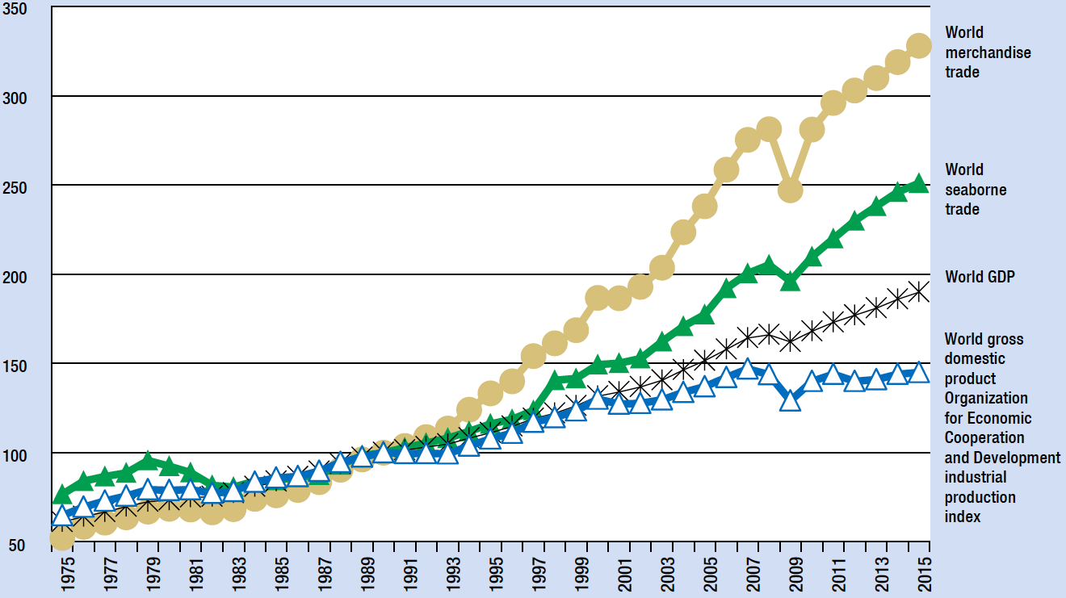
Source:
UNCTAD (2016) Review of Maritime Transport,
UNCTAD secretariat calculations, based on Organization for Economic Cooperation and Development, 2016; World Trade Organization, 2016.
Note:
1990=100. Indices calculated based on GDP and merchandise trade in dollars and seaborne trade in metric tons.
Trade in volumes held up relatively well, compared with trade in value, which recorded a decline of 13 per cent, due to fluctuations in commodity prices and exchange rates (World Trade Organization, 2016).

Table 1.1
World economic growth by main trade partners in Europe and Asia, 2013–2016 (Percentage change)
 | 2013 | 2014 | 2015 | 2016 (est.)
World | 2.2 | 2.5 | 2.5 | 2.3
Developed economies | 1.1 | 1.7 | 2.0 | 1.5
- EU-28 | 0.3 | 1.4 | 2.0 | 1.8
- Germany | 0.3 | 1.6 | 1.7 | 1.7
- France | 0.7 | 0.2 | 1.2 | 1.5
- Italy | -1.8 | -0.3 | 0.8 | 0.8
- United Kingdom | 2.2 | 2.9 | 2.2 | 1.8
- Japan | 1.4 | 0.0 | 0.5 | 0.7
Developing economies | 4.6 | 4.4 | 3.9 | 3.8
- Asia | 5.5 | 5.5 | 5.1 | 5.1
- China | 7.7 | 7.3 | 6.9 | 6.7
- India | 6.3 | 7.0 | 7.2 | 7.6
Transition economies | 2.0 | 0.9 | -2.8 | 0.0
- Russian Federation | 1.3 | 0.7 | -3.7 | -0.3
Source:
UNCTAD (2016) Review of Maritime Transport 2016
Note: Calculations for country aggregates based on GDP in constant 2005 dollars.
Together, the slow recovery in Europe, weaker global investment and the slowdown in large developing economies have depressed global trade. Overall, the impact of Asia, which had contributed more than any other region to the recovery of world merchandise trade after the 2008-2009 financial crisis, appears to give over.
The contribution to the growth of global import from Eastern Asia dropped significantly, from an average of 27 per cent in the previous decade to 8.4 per cent in 2015 (United Nations Department of Economic and Social Affairs, 2016). In comparison, Europe contributed 59 per cent to the growth of global import, in contrast to the negative contribution in 2012 and 2013. With regard to global export growth, Europe contributed 44 per cent and Asia, 35 per cent (World Trade Organization, 2016). Other regions had limited contributions.
Trade in developing countries was particularly weak in 2015, with export and import volumes, respectively, expanding at the marginal rate of 0.4 per cent, a significant drop from previous years. The contraction of both exports and imports in Eastern Asia had negative impacts on the trade of other developing economies, in particular manufacturing export-dependent economies in developing Asia. China accounted for about 20 per cent of the slowdown in import growth of developing economies and countries with economies in transition in 2014–2015 (United Nations Department of Economic and Social Affairs, 2016).
In contrast, India experienced a surge in its import demand (10.1 per cent).
For the second consecutive year, developed economies were more active in driving global trade, with exports rising slightly (2.2 per cent) while imports grew at a faster pace, by 3.3 per cent. United States exports declined marginally (-0.2 per cent) while in Japan, modest growth, a weaker currency and a slowdown in key trading partners in Eastern Asia dampened both exports and imports. Import demand in the United States and Europe held up relatively well (4.8 per cent and 3.6 per cent, respectively), owing to a stronger dollar and relatively solid economic growth in the Unites States and, arguably, due to recovery in intra-European Union trade.
In recent years, world merchandise trade has been expanding at a relatively slow pace, either matching or going below world GDP growth levels, while in earlier years, on average, international trade was growing significantly faster than the world GDP. The trade to GDP growth ratio was estimated at 0.62 in 2015, down from 0.94 in 2014 and 1.4 in 2013. While international trade is still influenced by the Great Recession (2009), the question is whether the continued slowdown in merchandise trade is a result of cyclical factors (weaker GDP growth and macroeconomic cycles) or a break in the long-term trade–GDP relationship, indicating that structural factors are at play, such as the potential start of a deglobalization pattern.

Table 1.2
Growth in merchandise trade volume by selected country grouping, 2013–2015
(Percentage change)
 | Export |  |  | Import
 | 2013 | 2014 | 2015 | 2013 | 2014 | 2015
World | 3.3 | 2.3 | 1.4 | 2.7 | 2.4 | 1.6
Developed economies | 2.2 | 1.9 | 2.2 | 0.0 | 2.8 | 3.3
EU-28 | 1.8 | 1.7 | 3.2 | -0.9 | 3.3 | 3.6
Japan | -1.5 | 0.6 | -1.0 | 0.3 | 0.6 | -2.8
Developing economies | 4.6 | 3.1 | 0.4 | 5.3 | 2.5 | 0.4
Asia | 5.6 | 3.3 | -0.1 | 5.8 | 2.6 | 0.7
China | 7.7 | 6.8 | -0.9 | 9.9 | 3.9 | -2.2
Eastern Asia | 6.7 | 4.9 | -0.5 | 8.9 | 2.8 | -1.6
India | 8.5 | 3.5 | -2.1 | -0.3 | 3.2 | 10.1
Transition economies | 2.3 | 0.5 | 0.9 | -0.5 | -7.6 | -19.4
Source:
UNCTAD (2016) Review of Maritime Transport 2016
UNCTAD secretariat calculations, based on UNCTADstat and national sources.
Note: Trade volumes derived from international merchandise trade values deflated by UNCTAD unit value indices.

Figure 1.2.
Growth in volume of world merchandise trade and real GDP, 2005-2015 (percentage change)
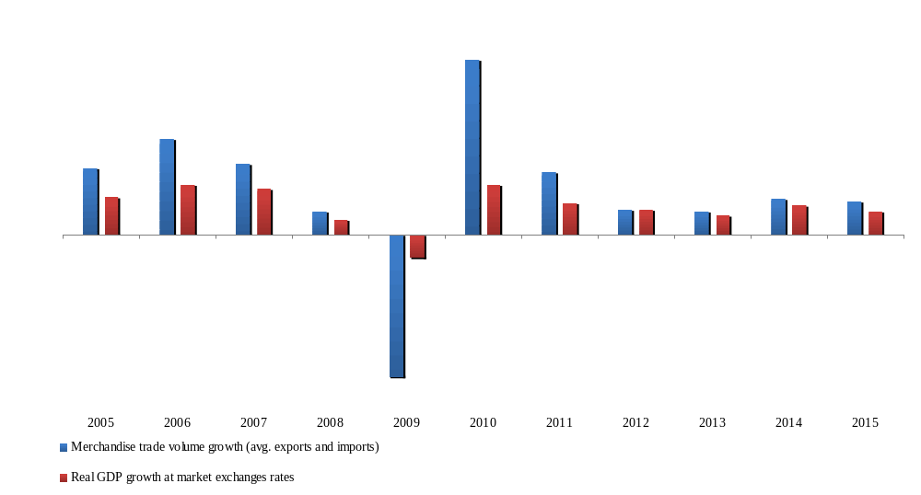

Source:
WTO (2016) World Trade Statistics Review 2016,
WTO Secretariat for trade figures, IMF and WTO Secretariat calculations for GDP
In conclusion, global recovery continues, however, at a slow pace, with momentum created by growth rate reduction in China and other Asian developing economies (UNCTAD (2016) Review of Maritime Transport 2016). Developments in the economy of China and related spillover effects on other large developing countries impact all countries, both developed and developing. Other factors – namely, lower commodity and oil price levels, eroding terms of trade in many commodity and oil-exporting countries, weaker global demand and investment levels, geopolitical tensions and political unrest – contribute to increasing uncertainty, growing downside risks and challenging the outlook for merchandise trade and transport between Europe and Asia.
The economic slowdown in Asia is influencing the global economy and trade sharply and probably will for a long enough period stay as the dominating external factor. Because of that, growth of international trade would not be the main driver for the Euro–Asian transport flows and transport links, as it was during Phase I and Phase II of the EATL Project.

I.1.2. Asia and Pacific region
During 2012-2016 the Asia-Pacific region’s trade growth has performed below the pre-financial crisis levels. Such a long and uninterrupted trade slowdown is unprecedented, and is a cause for concern that a “new trend” of a weaker trade growth is being reached. Trade between Asia-Pacific region and Europe contracted noticeably in 2015-2016. The contraction occurred despite GDP growth in the European Union. The growth in traditional export markets for Asia did not transfer to increased demand for its goods.
Developed markets in general were traditionally the main sources of demand for goods from Asia-Pacific region, although in more recent years.
It comes as no surprise that declining growth among regional and world developing countries in 2015 adversely affected the Asia-Pacific region’s trade. In particular, China’s continued transition to a “new economic growth trend” was associated with GDP growth slowdown to 6.9% in 2015, from 7.3% in 2014 and 7.7% in 2013.
Some economies in the region that rely largely on commodity exports have been particularly hit, both by China’s continued slowdown and the persistent decreases in commodity prices through 2015.
The relative success in the Asia-Pacific region in “outperforming” the global economy in 2015, with an export reduction of only 9.7% compared with the global decline of 13.1%, is largely explained by the relatively good performance of China, whose exports declined by only 2.9%. Excluding China, which accounted for 34% of the region’s merchandise exports, the Asia-Pacific region registered a 13% decline in exports, which was similar to the world average (figure 1.3).

Figure 1.3
Flattening of merchandise trade growth across Asian and Pacific economies, 2007-2015
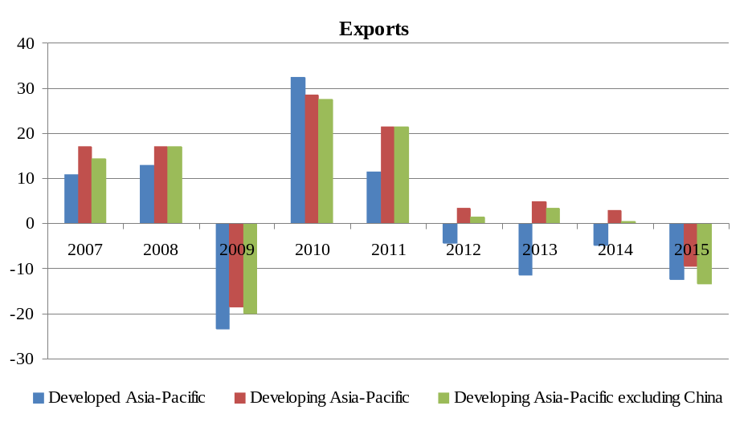
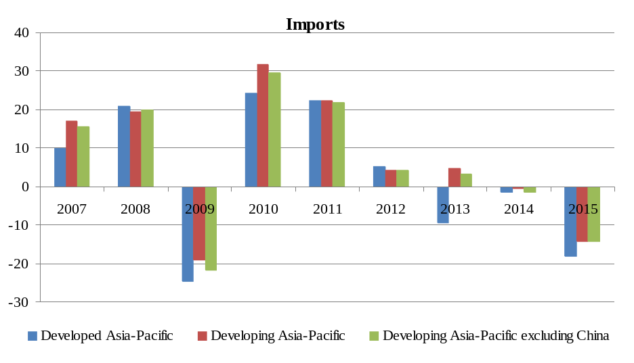
Sources:
UNESCAP (2016) Asia-Pacific Trade and Investment Report 2016. Recent Trends and Developments
ESCAP calculation based on country data from WTO International Trade Statistics Database (accessed June 2016).

The physical volume of exports still grew at 3% in 2015 (a similar annual rate to that recorded since 2012). The fall in export value has thus been driven primarily by a sharp fall in prices in 2015, due in turn to slower demand growth by regional powers (in particular China) and elsewhere.
As stated, Asia-Pacific imports contracted by much more than its exports in 2015. This amounted to a 15% fall overall, including a 14.2% decline for China (the largest drop since 1976), a 14.4% fall among other regional developing economies and a 19.1% decrease among regional developed economies.
Consequently, the Asia-Pacific region experienced a substantial improvement in the regional surplus, which more than doubled from $291 billion in 2014 to $635 billion in 2015.
The deceleration of trade growth is worrying for the whole region given that the rapid growth of China and developing Asia-Pacific economies during the past 25 years is often considered to be the result of an export-led strategy. In addition, a structural rebalance towards domestic demand-led growth in China will have knock-on effects for other developing countries in the region, for which exports and production have been highly integrated with China’s economy through both forward and backward linkages in global value chains (GVCs). China has been the largest individual trading partner in the region; in 2015, the rest of the Asia-Pacific region exported 19.8% of their goods to China (compared with 11.3% to the United States).
These linkages also mean that Asia-Pacific economies participating in GVCs will be adversely affected if China’s internal rebalancing includes a shift to higher domestic content in its production and exports. This is particularly worrying given the fact that imports by China have fallen more than exports since early 2014.
China’s economic slowdown is expected to continue in 2016, with the projected annual growth rate declining further to 6.6%.12 In addition, the IMF (IMF, 2016) has forecasted that the United States economy will grow only 1.6% in 2016, a significant decrease compared with 2015. The expected resulting reduction in demand for regional exports to China and the United States may be countered somewhat by a better picture emerging in the European Union. Despite uncertainties stemming from the United Kingdom’s decision to leave the European Union, the growth in Euro-zone countries is expected to be resilient at 1.6% in 2016, which is only slightly less than in 2015. Of all regional economies, only India is expected to experience dynamic growth performance in 2016, at 7.6%, and might have an increase of import demand.
This may provide a boost to exports from countries in South and South-West Asia, which are linked to India through a network of preferential trade agreements.
The Asia-Pacific region retained its position as the world’s largest trading region in 2015, despite the large trade contraction noted above. Overall, due to an even greater global reduction in trade, the region increased its share of world exports to 40% in 2015 from 38.6% in 2014 while its share of global imports fell slightly to 35.6% from 36.9% in the previous year. This dominance was again driven primarily by the trade performance of the economies of the East and North-East Asia subregion, which accounted for more than 64% of total Asia-Pacific trade with the world (table 1.3). In other words, exports by this subregion are considerably higher than those by other subregions – from more than tripple that of South-East Asia, to 18 times of the Pacific subregion.
In 2015, China was the main force behind the dominant position of East and North-East Asia in regional trade, with its world export and import share of 13.8% and 10%, respectively. East and North-East Asia increased its regional export share by 3.3 percentage points in 2015, a substantial change reflecting this subregion’s disproportionately small export contraction of 4.8% (in turn, driven largely by the small export decline by China of only 2.9%, as stated above). This increased share came mainly at the expense of North and Central Asian economies, whose export share fell sharply from 8.8% to 6.6%. This was largely due to the massive fall in values of exports and imports by the Russian Federation in 2015 (31% and 37%, respectively), as the result of declining oil prices and political sanctions.As the Russian Federation is the dominant economy in the subregion (accounting for 78% of North and Central Asia’s exports and 71% of its imports), this translates into a large fall in the world trade share for this subregion.

Table 1.3
Shares in Asia-Pacific total trade, by subregion, 2013-2015
Subregion | Exports |  |  | Imports
 | 2013 | 2014 | 2015 | 2013 | 2014 | 2015
East and North-East Asia | 60.2 | 60.8 | 64.1 | 59.4 | 59.8 | 60.1
South-East Asia | 17.7 | 17.7 | 17.6 | 17.6 | 17.6 | 18.3
South and South-West Asia | 8.6 | 8.7 | 8.2 | 12.5 | 12.6 | 12.7
North and Central Asia | 9.4 | 8.8 | 6.6 | 6.3 | 5.8 | 4.6
Pacific | 4.2 | 4.0 | 3.5 | 4.2 | 4.2 | 4.3
Sources:
UNESCAP (2016) Asia-Pacific Trade and Investment Report 2016. Recent Trends and Developments
ESCAP calculation based on country data from WTO International Trade Statistics Database (accessed July 2016).
Note:
Calculations in United States dollar values. Import data are not available for Guam and Nauru. Although Taiwan Province of China is not a member of ESCAP, it is included in calculations for East and North-East Asia due to its share in the region’s trade.
South-East Asia’s share of the region’s total exports remained large and fairly stable. Compared with other subregions, trade is relatively well-distributed among subregion’s economies, although still driven primarily by the performances of five members of the Association of Southeast Asian Nations (ASEAN), i.e. Indonesia, Malaysia, Singapore, Thailand and Viet Nam. The shares held by the South and South-West Asia as well as Pacific subregions declined by 0.5 percentage points from an already low base; trade performance is highly dependent on a few economies of those two subregions. Trade by South and South-West Asia remained dominated by India, which captured 50% of the areas exports and imports. Hit by the commodity price plunge, those two countries experienced a 17% and 10% decline, respectively, in merchandise export value in 2015. Similarly, exports by the Pacific subregion, dominated by Australia and New Zealand, have also shown a stagnant, and even slightly declining, share of world exports and imports.
While intraregional trade continues to dominate region’s trade, trade with countries in the European Union and the United States remains important, as they accounted for 29% of regional exports and 21% of regional imports in 2015 (figures 1.4 and 1.5).
Driven primarily by the slowdown of exports to advanced markets since the 2008-2009 global financial crisis, the share of exports to developing Asia-Pacific economies, especially to China, increased steadily from 43% in 2008 to a peak of 48.2% in 2013, before falling slightly to 47.6% in 2015.

Figure 1.4
Destinations of merchandise exports from Asia and the Pacific, 2002-2015
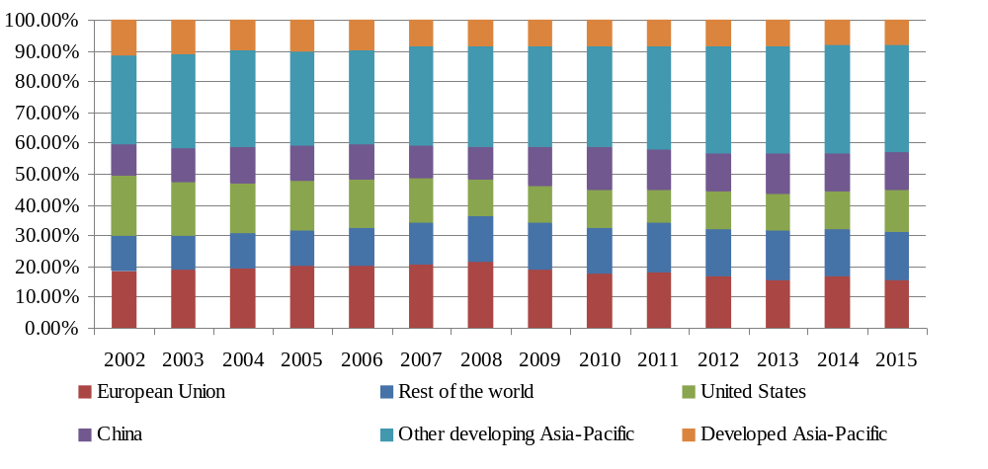
Source:
UNESCAP (2016) Asia-Pacific Trade and Investment Report 2016. Recent Trends and Developments,
ESCAP calculation based on IMF Direction of Trade Statistics (accessed August 2016). Country data are available from the ESCAP online statistics database.
Figure 1.5
Sources of Asia-Pacific merchandise imports, 2002-2015
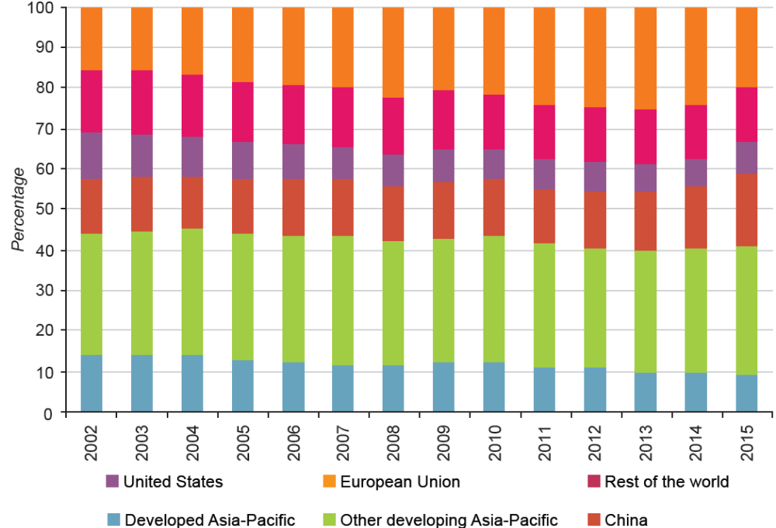
Source:
UNESCAP (2016) Asia-Pacific Trade and Investment Report 2016. Recent Trends and Developments,
ESCAP calculation based on IMF Direction of Trade Statistics (accessed August 2016). Country data are available from the ESCAP online statistics database.
Absolute values of exports in 2015 fell for each destination in figure 1.3, except the United States, although not symmetrically. Exports to the European Union saw the largest decline in absolute value; hence its share of region’s exports declined by 1 percentage point in 2015, continuing a decline that started after 2008. Similarly, the share of exports to developed Asia-Pacific countries fell by 0.4 percentage points, continuing a trend that had been evident since 2002. Exports to China also fell substantially in value terms, although given the decline of exports to all main markets that fall translates into a small decline in the share of exports, from 12.8% in 2014 to 12.6% in 2015, thus reflecting the impact of China’s economic new normal on the rest of the region in 2015. Since reaching its peak in 2010, the share of regional exports to China has consistently fallen, demonstrating China’s slowdown in regional integration. The share of exports going to other developing Asia-Pacific economies did not change much in 2015 following a long growth period, with the difference being made up by an increase in the share of exports to the United States (12.3% in 2014 to 13.8% in 2015) and to the rest of the world (15.2% in 2014 to 15.4% in 2015).
The intraregional import share increased in 2015 to 59% of total imports in the Asia-Pacific region, a slightly higher level than that seen during 2002-2015. While the share of imports from developed Asia-Pacific countries declined slightly (continuing a long downward trend), China and other developing Asia-Pacific countries increased their share by 2.4 and 1.3 percentage points, respectively. This was mainly at the expense of the import share of the rest of the world, which shrank from 24.1% in 2014 to 20.1% in 2015 (figure 1.4).
As global economic growth remains more anaemic, intraregional South-South cooperation is in a better position and carries greater potential than cooperation with countries outside the region. The increase in the intraregional import share reflects the fact the while the absolute value of intraregional imports fell in 2015, it did so by less than the overall contraction in imports into the region. This is particularly the case for imports from China, which fell only slightly in 2015.
Hence the severe contraction in world trade in 2015 and the reduced output among several extraregional developing countries has produced the opportunity for relatively more intraregional trade. However, the risk that China’s demand for imports from the region will fall further (as stated above, Asia-Pacific exports to China have declined in relative terms since 2010) is looming with its move to a lower growth model that has an increased focus on services and domestic production, rather than manufacturing and product assembly for export.

I.1.3. Central and Eastern Europe
Economic growth in the region of Central and Eastern Europe covered Balkan states, Eastern EU Member states (Bulgaria, Chezh Republic, Croatia, Hungary, Poland, Romania, Slovakia, Serbia) and Turkey accelerated from 0.5 percent in 2015 to 1.2 percent in 2016, in line with expectations, due mainly to an easing of the recession in the Russian Federation as oil prices stabilized. Excluding the Russian Federation, regional growth slowed to 2.4 percent in 2016 from 3.5 percent in 2015.
In 2016 it was expected thet regional economic growth will rise to 2.8 percent on average in 2018-19, driven mainly by a recovery in commodity exporters and Turkey. Risks remained tilted to the downside, and included the possibility of further weakness in commodity prices, disruptions in financial markets, slower-than-expected Euro Area growth. Key policy challenges included ensuring macroeconomic stability during the adjustment to lower commodity prices and dealing with sizable macroeconomic and financial vulnerabilities.
Growth accelerated in Albania, Croatia, Romania, and Serbia reflecting strong domestic demand supported by low energy prices, faster investment growth helped by the disbursement of EU structural funds, labor market improvements, particularly in Albania, and the VAT tax cut in Romania. Strong exports of goods and services to the Euro Area were additional supportive factors in Croatia and Romania. In contrast, easing of domestic demand weighed on growth in Hungary, Poland, and Turkey (Figure 1.6).
Growth in the region was expected to accelerate to 2.7 percent on average in 2017-19, driven by improved confidence. The outlook for countries Eastern and Central Europe is mixed. On average, growth is expected to remain steady in Central Europe, despite lower trading partner growth and gradually rising prices for commodity imports. Differences in prospects among countries stem from domestic factors.

Figure 1.6
Main economic trends in selected Central and Eastern European countries, 2012-2016
Turkey | Poland
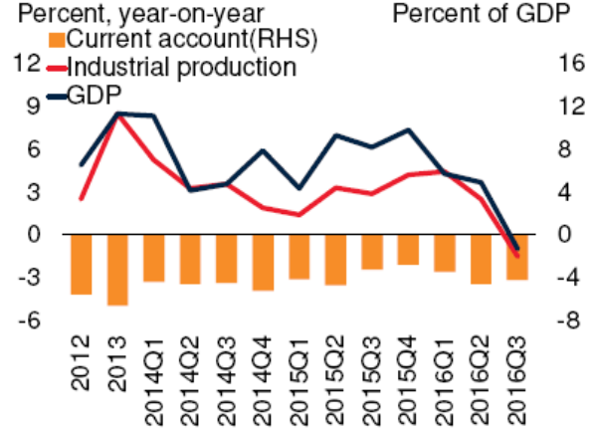 | 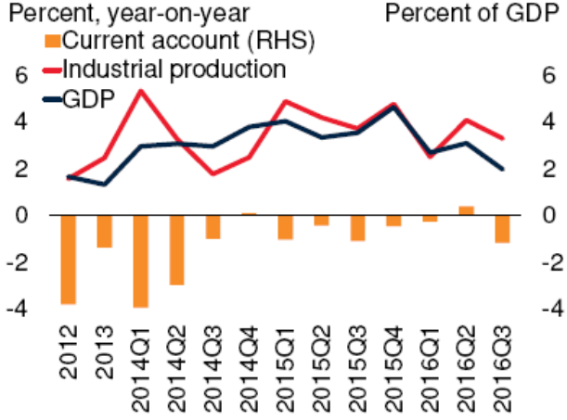
Source: World Bank (2016). Europe and Central Asia main developments and outlook
Romania’s strong growth in 2016, boosted by procyclical VAT cut, was expected to stabilize in 2017. In Hungary, growth was projected to accelerate to 2.7 percent on average reflecting a recovery of public investment, including the infrastructure projects financed by EU funds. In Turkey, growth was projected to recover to 3.0 percent in 2017 and 3.6 percent, on average, in 2018-19 helped by improved confidence. Growth in Poland was projected to remain around 3.3 percent in 2017-19, supported by robust domestic demand, especially private consumption. Weak demand from main trading partners, including the United Kingdom and Euro Area, could limit the prospects of further acceleration.

I.1.4. CIS member-states
Since the collapse of the Soviet Union, the successor states that formed the Commonwealth of Independent States (CIS) have suffered from various cyclical crises. Although the latest recession that began in 2015 has not yet finished, the economic situation is improving (IMF, 2016).
The economies of these countries differ in size and industry composition. Most of the CIS countries have gone through transition from centrally planned to market economies reaching different transformation results.Turkmenistan and Uzbekistan are still characterised by relatively closed markets.
With Tajikistan’s accession to the WTO in March 2013 eight CIS countries are now WTO members and five are observer members. Belarus, Kazakhstan and the Russian Federation form a Customs Union that is the central pillar of the single economic space of the Eurasian Economic Union (EEU or EAEU), and Kyrgyzstan and Armenia have signed accession agreements to this Customs Union. CIS countries have also signed multiple bilateral and multilateral trade agreements, among them the CIS Free Trade Agreement (CISFTA)(see table 1.5).
Several of the 12 EATL CIS countries are “oil exporters”, meaning that energy commodities, such as oil or natural gas, account for a large share of their total exports.
CIS countries have seen a continued growth of their economic output in the past years. The Kyrgyz economy has grown by 10.5 per cent from 2010 to 2014, Turkmenistan by 10.2 percent and Uzbekistan by 8 per cent during the same period.
As can be seen from table 1.4, the Russian Federation is not only the biggest economy of the CIS in terms of GDP but also in terms of merchandise trade. Russia’s exports accounted for 523’294 million US$ in 2013, while Tajikistan only exported goods with a value of 1,163 million US$. Armenia and Tajikistan have the lowest export and import volumes, and are at the bottom of the export (117 and 123 rank respectively) and import ranking (106 and 108 rank respectively) established by the WTO.

Table 1.4
EATL countries economic parameters
 | Population | GDP | Trade to GDP ratio | Growth rate 2010-2014 | Export (FOB) value | Import (CIF) value) | Exports Ranking (excl. intra EU Trade) | imports Ranking (excl. intra EU Trade)
Unit | Thousand | USS (million) | USS (million) |  | USS (million) | USS (million)
China | 1357380 | 9240270 | 51,9 | 7,70% | 2209007 | 1949992 | 2 | 3
Russian Federation | 143500 | 2096777 | 51,5 | 1,30% | 523294 | 342980 | 7 | 11
Iran | 77447 | 368904 | 44,5 | -5,80% | 82000 | 49000 | 31 | 36
Turkey | 74933 | 820207 | 57,3 | 4,10% | 151787 | 251650 | 22 | 13
Ukraine | 45490 | 177431 | 108,9 | 1,90% | 63312 | 76962 | 37 | 26
Uzbekistan | 30241 | 56796 | 49,5 | 8,00% | 12643 | 12998 | 60 | 64
Kazakhstan | 17038 | 224415 | 72 | 6,00% | 82512 | 48873 | 30 | 37
Belarus | 9466 | 7170 | 147,7 | 0,90% | 37232 | 42999 | 44 | 41
Azerbaijan | 9417 | 73560 | 78 | 5,80% | 31776 | 11156 | 45 | 76
Tajikistan | 8208 | 8508 | 85,5 | 7,40% | 1163 | 4139 | 123 | 108
Kyrgyzstan | 5720 | 7226 | 140,6 | 10,50% | 1791 | 6070 | 113 | 95
Turkmenistan | 5240 | 41851 | n,a, | 10,20% | 18000 | 10000 | 52 | 78
Georgia | 4477 | 16127 | 95,9 | 3,30% | 2909 | 7874 | 96 | 84
Moldova | 3559 | 7935 | 126,8 | 8,90% | 2399 | 5493 | 103 | 100
Armenia | 2977 | 10432 | 74,9 | 3,50% | 1480 | 4477 | 117 | 106
Source: UNECE, WP.5 GE2 Informal Doc #1

Table 1.5
EATL countries bilateral and multilateral trade agreements
Countries | WTO | EEU¹⁵ | CISFTA | EAEC¹⁶ | Bilateral trade Agreements with EATL countries
Armenia (AM) | 2003 |  | Yes |  | KZ, MD, RU,TK, UK, GE, KZ
Azerbaijan (AZ) | Observer |  |  |  | RU, GE; UK
Belarus (BY) | Observer | Yes | Yes | Yes | UK, RU
China (CH) | 2001
Georgia (GE) | 2000 |  |  |  | AM, AZ, KZ, TR, TM, RU, UZ
Iran (IR) | Observer
Kazakhstan (KZ) | 2015 | Yes | Yes | Yes | AM, GE, UK, RU, KZ,
Kyrgyzstan (KY) | 1998 |  | Yes | Yes | AM, KZ, MD, RU, UZ, UK
Moldova (MD) | 2001 |  | Yes |  | KY, AM, UK, RU
Russia (RU) | 2012 | Yes | Yes | Yes | AM, GE, BY, AZ, KZ, MD, TJ, TK, UK, UZ,
Tajikistan (TJ) | 2013 |  | Yes | Yes | RU, UK
Turkey (TR) | 1995 |  |  |  | GE
Turkmenistan (TK) | No |  |  |  | AM, GE, UK, RU
Ukraine (UK) | 2008 |  |  |  | AM, GE, KY, AZ, BY, KZ, MD, RU, TJ, KZ, TK, TR, UZ
Uzbekistan (UZ) | Observer |  | Yes |  | KY, RU, UK
Source: UNECE, WP.5 GE2 Informal Doc #1
The economic recession in 2015–2016 was caused by a combination of external and domestic factors. The rapid depreciation of the Russian ruble and of the currencies of other CIS countries in 2015 and 2016 revived worries of macroeconomic instability in the region—a fear that has arisen several times since the Soviet Union’s collapse in 1991. As with previous currency crises, particularly those of 1998–1999 and 2008–2009, the most recent episode was caused by a combination of global, regional and country-specific factors.
In 2016, the economy of CIS countries continued to adjust to a new reality of low commodity prices, geopolitical risks and subdued global growth. Economists estimate that the region’s economy shrank 0.3% in 2016, which was its second year in recession. The economic downturn was less severe than in 2015 as the latest data show that economic activity began to revive in the second half of the year. However, against a backdrop of recovering commodities prices, weak economic growth is expected to continue in the coming quarters and this year will be challenging for most economies in the region. The Consensus view among economists is that the CIS economy will expand 1.4% in 2017, which was revised down 0.1 percentage points from last month’s forecast. Going forward, economists forecast regional economic growth to pick up to 1.9% in 2018, supported by higher commodities prices and the correction of the macroeconomic imbalances observed since 2015.
The region’s projected improvement in 2017 is mainly the result of better prospects for the Russian economy, which is expected to rebound this year as oil prices gradually recover. Meanwhile, in Central Asia—a region closely linked to the Russian Federation — economic growth is projected to gain momentum in 2017, after a slowdown in 2016. In the Caucasus, economic activity is expected to rebound strongly, mainly due to Azerbaijan’s return to growth.
Belarus’ economy suffered a broad-based decline in the third quarter of 2016, with private consumption, investment and government spending all falling compared to the same period in the previos year. The country was negatively impacted by the continuing recession in the Russian Federation, its largest trading partner, as well as by weak domestic bank balance sheets, which impeded private lending. Belarus’ economic advancement depends in large part on the implementation of the government’s 2016-2020 action plan, which aims to break up monopolies, improve governance and prepare the country for accession to the World Trade Organization.
Belarus’ economy should return to growth in 2017, aided by expansion in the Russian Federation and funding from the World Bank and the European Bank for Reconstruction and Development, although the economy will continue to be hampered by low prices for commodity exports (IMF, 2016).
A stabilization in the Kazakhstan's financial conditions and higher oil prices led to an improvement in economic activity in the second half of 2016. Industrial production increased for a third consecutive month in November, which suggests that economic growth shifted into a higher gear in the final quarter of 2016.
The outlook for Kazakhstan is bright as higher oil production is expected to growth in the oil and non-oil sectors in 2017. Analysts agree that the government’s commitment to cut oil output will not impact the GDP growth forecast. They left the country’s 2017 GDP growth forecast unchanged from last month’s 2.1% and see the economy accelerating further to a 2.8% expansion in 2018 (IMF, 2016).
After two years in recession, Russian economy return to growth is in sight. GDP contracted at the slowest pace in the third quarter of 2016 since the recession began nearly two years earlier. The data from industrial production and business survey results signaled a further strengthening of economic activity in the final quarter of 2016. That said, the return to growth is expected to be gradual and uneven, given the absence of fiscal or monetary policy support. Moreover, the shock to Russian industry from low oil prices and international sanctions was substantial in 2016.
While GDP was expected to grow, the plans to reduce the fiscal deficit would prevent a faster pickup in economic activity. The analysts expected therefore the economy to expand 1.2% in 2017, before accelerating to a 1.6% expansion in 2018.
Ukraine’s recovery picked up steam in the third quarter of 2016, as GDP grew at the fastest pace in almost three years. Surging fixed investment due to an improving business climate and higher household consumption fueled the economy’s acceleration. Data for the fourth quarter of 2016 suggested that the economy continued on a modest recovery path with industrial production expanding at the fastest pace in eight months in November. The government also adopted a 2017 budget which met the IMF’s requirement of a 3.0% fiscal deficit. These moves should have allowed the country to receive a crucial USD 1.3 billion in aid to replenish the Central Bank’s and governemnt reserves.
The government’s cooperation with the IMF boded well for Ukraine’s outlook and the economy was expected to continue on an upward trajectory. Experts saw GDP rising by 2.4% in 2017,and picking up to 3.0% in 2018 (IMF, 2016).

I.2. Euro-Asian trade flows

I.2.1. Main trade partners
For the purposes of this report, the matrix of corresponding European and Asian countries was developed.
All countries participating in the EATL Project, were separated into 2 groups:
- Countries participating in the Euro-Asian trade from the side of Asian continent (Afghanistan, Armenia, Azerbaijan, China, Iran, Kazakhstan, Kyrgyz Republic, Mongolia, Pakistan, Russian Federation, Tajikistan, Turkey, Turkmenistan, Uzbekistan, India, Japan and Republic of Korea);
- Countries participating in the Euro-Asian trade from the side of European continent (EU member states, Republic of Belarus, Bosnia and Herzegovina, Georgia, the Former Yugoslav Republic of Macedonia, Republic of Moldova, Russian Federation, Serbia, Switzerland, Turkey and Ukraine).
Thus, the Euro-Asian trade flows, gravitating towards land transport routes can be calculated in the form of correspondence of two matrices - matrices Asian exports to Europe and Asian import from Europe.
The specifics of the these matrices are as follows:
- Trade flows of all European EU-member states participating in the EATL project, aggregated with the total European Union trade flows represented in the matrix,
- Three countries that do not participate in the EATL Project, are also included in the matrix due to their gravity (potential gravity) to the Euro-Asian land transit: India, Japan and the Republic of Korea,
- Two countries – the Russian Federation and Turkey – are included twice, both in the European part of the matrix, and in its Asian part. This is done due to the fact that these countries, being at the crossroads of continents, conduct trade from Europe as well from Asia and both trade flows are oriented to Euro-Asian land transit.
In accordance with the Comtrade database, the total volume of trade between Europe and Asia, which can be served by inland transport routes, is estimated 2 094 billion US Dollars in 2014. Asian exports to Europe amounted to 1 188.5 billion US Dollars, imports of goods from Europe to Asia reached 905.5 billion US Dollars (Figure 1.7).
The share of trade between Europe and Asia, which can be served by inland transport routes, declined from 2011 to 2014: it amounted to 11.0% in 2014 in comparison with 11.9% in 2011 (Figure 1.8).
The matrix of trade flows between the selected European and Asian countries are presented in Tables 1.6-1.17 and matrix flows for certain types of commodity nomenclature – in the Annex.

Figure 1.7
Dynamics of trade in goods between selected European and Asian countries in 2010-2015, billion US Dollars
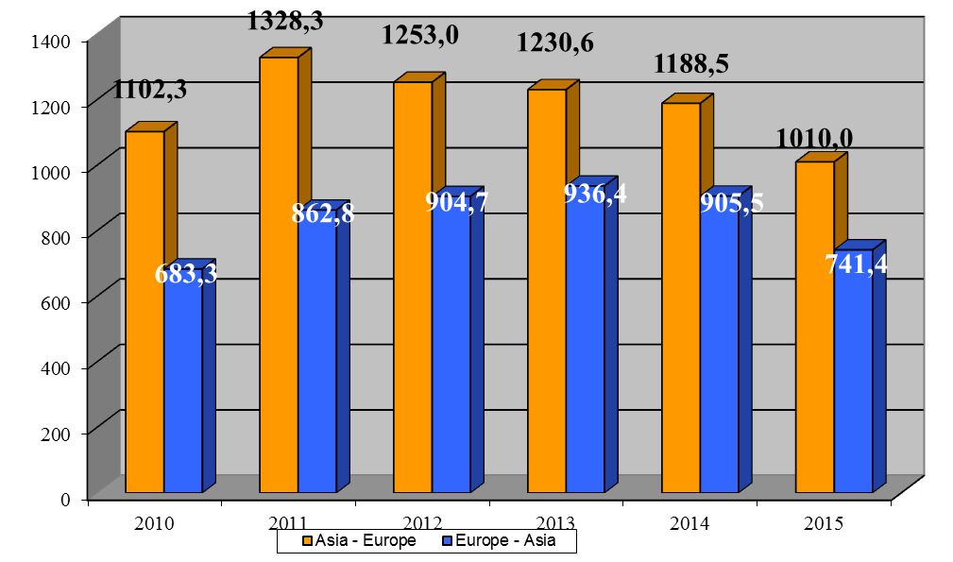
Source: UN Comtrade database
Figure 1.8
Share of volume of trade in goods between selected European and Asian countries in world merchandise trade in 2011-2014, %
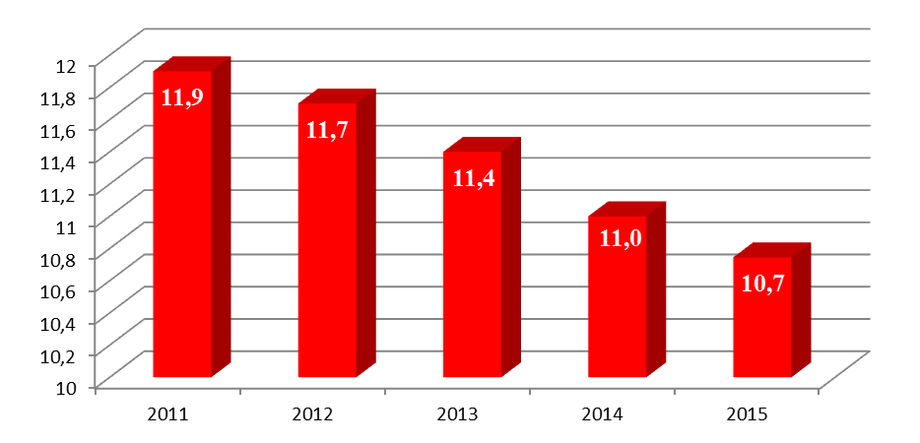
Sources:
UN Comtrade database,
WTO (2016) World Trade Statistics Review 2016

Table 1.6
Import of goods to Asia from selected European countries in 2010, million US dollars
Countries of Asia  (Importers) | Countries of Europe (exporters)
Countries of Asia  (Importers) | Belarus | Bosnia and  Herzegovina | Georgia | EU-28 | FYR  Macedonia | Moldova | Russian  Federation | Serbia | Switzerland | Turkey | Ukraine | TOTAL
Afghanistan | 14.7 | 1.2 | 0.0 | 1024.8 | 0.1 | 0.6 | 539.0 | 28.4 | 5.3 | 259.9 | 14.0 | 1888.0
Armenia | 42.1 | 0.0 | 160.2 | 732.9 | 0.1 | 1.4 | 396.1 | 0.6 | 33.9 | 0.0 | 201.3 | 1568.6
Azerbaijan | 140.2 | 0.4 | 244.0 | 3106.6 | 1.7 | 7.5 | 1476.9 | 5.8 | 136.6 | 1551.2 | 610.8 | 7281.7
China | 475.8 | 5.0 | 24.3 | 149968.7 | 89.2 | 2.3 | 19783.0 | 7.3 | 7178.1 | 2259.8 | 1316.6 | 181110.1
Iran | 97.2 | 30.3 | 12.1 | 14975.8 | 1.8 | 3.1 | 3359.0 | 32.3 | 674.9 | 3043.4 | 1030.7 | 23260.6
Kazakhstan | 464.8 | 0.0 | 47.9 | 6918.8 | 0.3 | 30.5 | 10690.4 | 4.6 | 168.3 | 819.9 | 1300.5 | 20446.0
Kyrgyzstan | 85.5 | 0.0 | 3.1 | 278.9 |  | 2.5 | 975.4 |  | 7.3 | 129.2 | 75.0 | 1556.9
Mongolia | 13.2 | 0.1 | 0.1 | 319.6 |  | 0.2 | 936.6 | 0.3 | 2.7 | 11.2 | 33.3 | 1317.3
Pakistan | 33.7 | 0.1 | 0.0 | 4938.5 | 0.1 | 0.1 | 104.3 | 1.2 | 283.9 | 248.2 | 113.0 | 5723.1
Russian Federation | 9953.6 | 25.7 | 33.9 | 114019.1 | 26.7 | 404.0 | - | 534.7 | 2585.7 | 4631.5 | 13431.9 | 145646.8
Tajikistan | 42.1 | 0.0 | 2.5 | 191.0 |  | 0.7 | 672.6 | 1.5 | 3.4 | 144.1 | 74.7 | 1132.6
Turkey | 104.8 | 55.0 | 216.0 | 81219.9 | 50.9 | 67.5 | 13958.6 | 88.0 | 2030.2 | - | 3026.6 | 100817.5
Turkmenistan | 87.2 | 0.0 | 12.2 | 956.7 | 0.1 | 1.0 | 717.5 | 2.8 | 16.0 | 1139.2 | 208.9 | 3141.6
Uzbekistan | 95.1 | 0.0 | 6.7 | 1646.6 |  | 4.5 | 1663.5 | 1.5 | 96.1 | 283.0 | 228.5 | 4025.5
India *) | 330.8 | 26.3 | 12.0 | 46159.0 | 2.4 | 3.4 | 5406.3 | 9.7 | 2464.6 | 606.8 | 1426.0 | 56447.3
Japan *) | 3.6 | 0.4 | 8.1 | 58173.1 | 0.9 | 0.4 | 12496.6 | 1.6 | 6474.0 | 272.3 | 104.8 | 77535.8
Republic of Korea *) | 25.1 | 0.1 | 7.0 | 36987.1 | 1.8 | 0.0 | 10407.9 | 0.9 | 2183.7 | 304.6 | 498.0 | 50416.2
TOTAL | 12009.5 | 144.6 | 790.1 | 521617.1 | 176.1 | 529.7 | 83583.7 | 721.2 | 24344.7 | 15704.3 | 23694.6 | 683315.6
Source: UN Comtrade database
*) India, Japan and Republic of Korea are non EATL Project countries

Table 1.7
Export of goods from Asia to selected European countries in 2010, million US dollars
Countries of Asia  (Exporters) | Countries of Europe (importers)
Countries of Asia  (Exporters) | Belarus | Bosnia and  Herzegovina | Georgia | EU-28 | FYR  Macedonia | Moldova | Russian  Federation | Serbia | Switzerland | Turkey | Ukraine | TOTAL
Afghanistan | 2.0 | 0.0 | 0.0 | 54.6 | 0.0 |  | 19.5 | 0.0 | 0.6 | 5.1 | 0.5 | 82.3
Armenia | 5.1 | 0.1 | 45.5 | 343.0 | 0.0 | 0.9 | 158.5 | 0.8 | 3.2 | 2.6 | 17.9 | 577.6
Azerbaijan | 6.0 | 0.0 | 464.2 | 12866.2 | 0.2 | 0.2 | 385.9 | 0.5 | 924.6 | 865.1 | 951.2 | 16464.1
China | 1684.1 | 444.0 | 333.7 | 374248.6 | 288.8 | 320.2 | 38960.9 | 1202.5 | 5848.2 | 17180.8 | 4700.4 | 445212.2
Iran | 7.6 | 2.4 | 55.1 | 19242.4 | 5.5 | 1.0 | 271.6 | 15.8 | 42.5 | 7644.8 | 49.9 | 27338.6
Kazakhstan | 405.8 | 6.1 | 91.6 | 21070.4 | 1.5 | 15.8 | 4449.4 | 30.4 | 1075.6 | 2471.0 | 766.2 | 30383.8
Kyrgyzstan | 8.3 | 0.2 | 1.4 | 263.1 | 1.1 | 0.5 | 393.3 | 3.8 | 0.1 | 30.9 | 6.2 | 708.9
Mongolia | 0.0 | 0.0 |  | 133.9 | 0.2 | 0.0 | 79.1 | 0.0 | 1.2 | 0.9 | 11.1 | 226.4
Pakistan | 15.7 | 5.5 | 2.0 | 5070.4 | 4.9 | 2.9 | 240.2 | 9.2 | 60.5 | 749.9 | 55.2 | 6216.4
Russian Federation | 18080.6 | 805.2 | 279.7 | 212788.6 | 552.5 | 586.5 |  | 2157.2 | 1000.2 | 21599.6 | 22198.0 | 280048.1
Tajikistan | 5.5 | 0.0 | 0.1 | 75.1 | 0.0 | 0.0 | 213.7 | 0.4 | 0.2 | 283.7 | 3.5 | 582.2
Turkey | 259.4 | 256.4 | 883.6 | 56159.6 | 261.7 | 205.8 | 4866.0 | 324.9 | 736.0 |  | 1298.3 | 65251.7
Turkmenistan | 3.6 | 0.1 | 59.2 | 485.6 | 1.3 | 1.7 | 148.0 | 1.5 | 0.1 | 386.3 | 31.4 | 1118.8
Uzbekistan | 58.5 | 0.3 | 9.7 | 459.3 | 0.4 | 3.6 | 1513.5 | 9.5 | 32.8 | 861.4 | 81.7 | 3030.7
India *) | 152.0 | 36.5 | 32.5 | 44119.1 | 34.5 | 26.0 | 2143.3 | 113.4 | 969.5 | 3409.9 | 680.7 | 51717.4
Japan *) | 184.8 | 55.8 | 80.9 | 89101.9 | 45.4 | 34.4 | 10259.7 | 136.9 | 3537.3 | 3297.8 | 801.8 | 107536.7
Republic of Korea *) | 139.2 | 45.6 | 29.3 | 52186.8 | 43.4 | 23.3 | 7281.5 | 126.0 | 422.4 | 4764.0 | 768.0 | 65829.5
TOTAL | 21018.2 | 1658.2 | 2368.5 | 888668.6 | 1241.4 | 1222.8 | 71384.1 | 4132.8 | 14655.0 | 63553.8 | 32422.0 | 1102325.4
Source: UN Comtrade database
*) India, Japan and Republic of Korea are non EATL Project countries

Table 1.8
Import of goods to Asia from selected European countries in 2011, million US dollars
Countries of Asia  (Importers) | Countries of Europe (exporters)
Countries of Asia  (Importers) | Belarus | Bosnia and  Herzegovina | Georgia | EU-28 | FYR  Macedonia | Moldova | Russian  Federation | Serbia | Switzerland | Turkey | Ukraine | TOTAL
Afghanistan | 140.3 | 1.6 | 2.1 | 1247.5 | 0.6 | 5.4 | 801.3 | 10 | 10.8 | 276 | 14.1 | 2509.7
Armenia | 24.2 | 0.1 | 218.4 | 896.7 | 0.2 | 2.9 | 437.1 | 0.7 | 29.2 | 0.2 | 227.6 | 1837.3
Azerbaijan | 138.6 | 0.5 | 425.8 | 4010.6 | 0.2 | 5.7 | 2196.4 | 3.9 | 236.5 | 2064.2 | 708.3 | 9790.7
China | 631.6 | 5.8 | 28.9 | 189785.8 | 127.5 | 3.9 | 34692.4 | 15.3 | 9971.2 | 2466.6 | 2180 | 239909.0
Iran | 124.5 | 32.3 | 16.2 | 14604.4 | 0.9 | 1.0 | 3277.1 | 48.4 | 761.5 | 3589.7 | 1127.4 | 23583.4
Kazakhstan | 668.7 | 0.1 | 156.9 | 8326.1 | 0.2 | 45.5 | 14173.7 | 9.9 | 318.1 | 947.9 | 1857.5 | 26504.6
Kyrgyzstan | 218.2 | 0.1 | 7.6 | 568.0 |  | 2.9 | 1156.4 | 0.0 | 9.0 | 180.4 | 111.3 | 2253.9
Mongolia | 77.4 | 0.0 | 0.8 | 573.8 |  | 0.1 | 1485.6 | 0.4 | 9.9 | 43.4 | 45.3 | 2236.7
Pakistan | 48.8 | 0.4 | 0.4 | 5226.4 |  | 0.1 | 126.3 | 0.4 | 315.4 | 213.7 | 183.7 | 6115.6
Russian Federation | 14397.7 | 37.8 | 21.2 | 151061.7 | 39.6 | 625.5 |  | 792.3 | 3396.5 | 5992.7 | 19819.7 | 196184.7
Tajikistan | 50.1 | 0.0 | 4.5 | 195.0 | 0.0 | 1.2 | 721.4 | 0.8 | 4.3 | 172.6 | 60.2 | 1210.1
Turkey | 128.6 | 106.7 | 214.1 | 101945.9 | 73.4 | 73.4 | 15086.8 | 183.2 | 2421.7 |  | 3748.6 | 123982.4
Turkmenistan | 213.8 | 0.0 | 5.5 | 1326.0 | 0.1 | 1.2 | 1116.9 | 1.4 | 23.6 | 1493.4 | 241.9 | 4423.8
Uzbekistan | 63.8 | 0.0 | 12.8 | 1810.3 |  | 5.8 | 1983.1 | 2.7 | 100.5 | 354.5 | 353.8 | 4687.3
India *) | 331.2 | 15.2 | 19.3 | 56460.9 | 18.1 | 5.6 | 4665.7 | 8.4 | 3364.8 | 756.1 | 2265.3 | 67910.6
Japan *) | 12.2 | 0.3 | 2.9 | 68275.1 | 1.1 | 0.9 | 14234.7 | 2.3 | 7509.2 | 296.4 | 152.5 | 90487.6
Republic of Korea *) | 8.6 | 0.2 | 8.5 | 42235.3 | 19.4 | 0.2 | 13329.7 | 1.4 | 2620.4 | 527.8 | 467.6 | 59219.1
TOTAL | 17278.3 | 201.1 | 1145.9 | 648549.5 | 281.3 | 781.3 | 109484.6 | 1081.5 | 31102.6 | 19375.6 | 33564.8 | 862846.5
Source: UN Comtrade database
*) India, Japan and Republic of Korea are non EATL Project countries

Table 1.9
Export of goods from Asia to selected European countries in 2011, million US dollars
Countries of Asia  (Exporters) | Countries of Europe (importers)
Countries of Asia  (Exporters) | Belarus | Bosnia and  Herzegovina | Georgia | EU-28 | FYR  Macedonia | Moldova | Russian  Federation | Serbia | Switzerland | Turkey | Ukraine | TOTAL
Afghanistan | 2.8 | 0.0 | 0.0 | 66.3 | 0.0 |  | 28.1 | 0.1 | 0.1 | 4.8 | 1.1 | 103.3
Armenia | 5.5 | 0.1 | 51.4 | 448.3 | 0.0 | 0.2 | 183.8 | 5.5 | 6.8 | 0.1 | 18.5 | 720.2
Azerbaijan | 825.8 | 0.0 | 446.6 | 21517.8 |  | 2.7 | 571.1 | 0.1 | 503.7 | 262.3 | 643.3 | 24773.4
China | 2166.5 | 551.5 | 525.1 | 410570.8 | 354.9 | 399.8 | 48038.4 | 1488.5 | 7119.3 | 21693.0 | 6268.3 | 499176.1
Iran | 8.9 | 2.2 | 64.9 | 24116.6 | 5.3 | 1.3 | 351.4 | 9.7 | 34.6 | 12461.5 | 46.5 | 37102.9
Kazakhstan | 136.8 | 2.7 | 69.6 | 31897.7 | 1.6 | 31.9 | 6912.7 | 110.8 | 2179.4 | 1995.1 | 1675.9 | 45014.2
Kyrgyzstan | 9.1 | 0.5 | 1.4 | 76.3 | 1.6 | 0.1 | 290.8 | 4.8 | 0.1 | 52.1 | 7.5 | 444.3
Mongolia | 0.0 | 0.0 | 0.8 | 100.6 | 0.6 | 0.0 | 89.1 | 0.0 | 2.2 | 3.0 | 4.9 | 201.2
Pakistan | 13.4 | 6.8 | 4.9 | 6502.6 | 4.9 | 3.0 | 349.3 | 8.6 | 82.1 | 873.1 | 68.2 | 7916.9
Russian Federation | 24709.8 | 1163.6 | 312.6 | 280185.2 | 684.3 | 823.0 |  | 2654.2 | 1005.8 | 23952.9 | 29132.2 | 364623.6
Tajikistan | 21.9 | 0.0 | 0.6 | 105.6 | 0.0 | 0.0 | 88.6 | 7.0 | 0.0 | 324.3 | 13.0 | 561.0
Turkey | 315.3 | 320.3 | 1276.5 | 67635.4 | 345.4 | 366.9 | 6352.5 | 405.1 | 872.9 |  | 1481.2 | 79371.5
Turkmenistan | 8.0 | 0.0 | 55.5 | 622.4 | 4.0 | 9.1 | 142.6 | 0.4 | 45.6 | 392.7 | 736.0 | 2016.3
Uzbekistan | 44.3 | 1.4 | 11.7 | 551.9 | 0.1 | 10.6 | 1756.2 | 16.3 | 9.4 | 939.9 | 643.9 | 3985.7
India *) | 172.6 | 52.9 | 55.4 | 55566.4 | 47.4 | 37.6 | 2760.6 | 149.6 | 1471.5 | 6498.7 | 812.3 | 67625.0
Japan *) | 245.5 | 62.5 | 174.1 | 98227.5 | 52.0 | 43.7 | 15012.6 | 165.6 | 4675.8 | 4263.7 | 1014.0 | 123937.0
Republic of Korea *) | 188.9 | 50.1 | 46.9 | 50534.5 | 45.8 | 34.6 | 11575.7 | 158.1 | 556.3 | 6298.5 | 1236.0 | 70725.4
TOTAL | 28875.1 | 2214.6 | 3098 | 1048726 | 1547.9 | 1764.5 | 94503.5 | 5184.4 | 18565.6 | 80015.7 | 43802.8 | 1328298.0
Source: UN Comtrade database
*) India, Japan and Republic of Korea are non EATL Project countries

Table 1.10
Import of goods to Asia from selected European countries in 2012, million US dollars

Countries of Asia  (Importers) | Countries of Europe (exporters)
Countries of Asia  (Importers) | Belarus | Bosnia and  Herzegovina | Georgia | EU-28 | FYR  Macedonia | Moldova | Russian  Federation | Serbia | Switzerland | Turkey | Ukraine | TOTAL
Afghanistan | 156.3 | 2.0 | 13.4 | 1212.7 | 0.6 | 8.2 | 938.4 | 3.5 | 12.2 | 290 | 21 | 2658.3
Armenia | 31.1 | 0.0 | 255.6 | 876.4 | 0.2 | 1.4 | 447.9 | 1.1 | 83.6 | 0.2 | 179.2 | 1876.7
Azerbaijan | 139.2 | 0.4 | 626.4 | 3839.7 | 0.8 | 5.4 | 2845.7 | 31.6 | 198.2 | 2587.5 | 766.6 | 11041.5
China | 432.0 | 5.6 | 25.6 | 185040.4 | 158.8 | 8.3 | 35766.8 | 19.8 | 9928.1 | 2833.4 | 1777.2 | 235996.0
Iran | 108.4 | 18.6 | 18.5 | 9481.1 | 0.1 | 1.2 | 1900.4 | 32.9 | 495.4 | 9922.6 | 1164.7 | 23143.9
Kazakhstan | 804.1 | 0.3 | 62.2 | 8893.8 | 0.8 | 50.3 | 14892.5 | 11.4 | 239.9 | 1069.4 | 2459.3 | 28484.0
Kyrgyzstan | 141.8 | 0.1 | 8.9 | 541.3 |  | 2.8 | 1634.1 | 0 | 11.8 | 257.5 | 127.1 | 2725.4
Mongolia | 111.4 | 0.2 | 3.2 | 560.6 |  | 0.1 | 1851.4 | 0.3 | 11.3 | 35.9 | 45.5 | 2619.9
Pakistan | 53.9 | 0.1 | 0.2 | 5289.0 | 0.0 |  | 210.0 | 0.4 | 278.6 | 276.5 | 114.1 | 6222.8
Russian Federation | 16161.4 | 36.8 | 36.5 | 158535.7 | 33.1 | 655.1 |  | 866.2 | 3157.9 | 6683.0 | 17631.7 | 203797.4
Tajikistan | 48.2 | 0.0 | 4.8 | 209.6 |  | 0.9 | 678.8 | 1.4 | 2.8 | 235.0 | 100.8 | 1282.3
Turkey | 145.2 | 115.7 | 134.8 | 96833.1 | 66.8 | 56.1 | 16103.2 | 187.0 | 4401.8 |  | 3685.1 | 121728.8
Turkmenistan | 230.2 | 0.0 | 8.0 | 1703.3 | 0.1 | 0.8 | 1210.6 | 0.5 | 33.6 | 1480.5 | 528.2 | 5195.8
Uzbekistan | 95.5 | 0.0 | 16.2 | 1570.2 |  | 8.2 | 2324.7 | 1.2 | 69.7 | 450.4 | 435.9 | 4972.0
India *) | 263.9 | 11.1 | 14.9 | 49502.4 | 24.0 | 3.7 | 7566.7 | 4.9 | 30629.2 | 791.7 | 2290.9 | 91103.4
Japan *) | 15.1 | 0.7 | 5.7 | 71414.7 | 1.5 | 1.1 | 15588.0 | 4.2 | 7648.4 | 332.0 | 320.5 | 95331.9
Republic of Korea *) | 37.9 | 1.0 | 2.9 | 48561.3 | 57.9 | 0.0 | 13865.5 | 2.2 | 2954.8 | 528.0 | 481.9 | 66493.4
TOTAL | 18975.6 | 192.6 | 1237.8 | 644065.3 | 344.7 | 803.6 | 117824.7 | 1168.6 | 60157.3 | 27773.6 | 32129.7 | 904673.5
Source: UN Comtrade database
*) India, Japan and Republic of Korea are non EATL Project countries

Table 1.11
Export of goods from Asia to selected European countries in 2012, million US dollars
Countries of Asia  (Exporters) | Countries of Europe (importers)
Countries of Asia  (Exporters) | Belarus | Bosnia and  Herzegovina | Georgia | EU-28 | FYR  Macedonia | Moldova | Russian  Federation | Serbia | Switzerland | Turkey | Ukraine | TOTAL
Afghanistan | 1.5 | 0.1 | 0.0 | 73.7 | 0.0 |  | 11.3 | 0.1 | 1.3 | 6.5 | 0.9 | 95.4
Armenia | 6.7 | 0.1 | 68.3 | 353.9 | 0.0 | 0.4 | 300.7 | 0.3 | 9.0 | 0.2 | 22.9 | 762.5
Azerbaijan | 12.2 | 34.1 | 448.4 | 18364.5 |  | 0.5 | 563.6 | 0.8 | 238.6 | 339.9 | 79.7 | 20082.3
China | 2345.0 | 536.2 | 613.6 | 374828.4 | 374.9 | 415.7 | 51767.7 | 1385.5 | 11072.6 | 21295.1 | 7899.6 | 472534.3
Iran | 9.1 | 2.4 | 100.4 | 7264.8 | 2.9 | 1.0 | 428.5 | 7.7 | 39.4 | 11964.6 | 67.4 | 19888.2
Kazakhstan | 119.0 | 2.5 | 131.8 | 31562.4 | 6.0 | 26.5 | 9409.3 | 415.3 | 1459.0 | 2056.1 | 1494.9 | 46682.8
Kyrgyzstan | 12.5 | 0.9 | 2.5 | 69.8 | 2.3 | 0.3 | 195.7 | 6.4 | 344.1 | 45.2 | 6.5 | 686.2
Mongolia | 0.0 | 0.0 |  | 86.8 | 0.0 | 0.0 | 64.3 | 0.0 | 38.5 | 0.0 | 4.6 | 194.2
Pakistan | 11.9 | 6.0 | 5.8 | 5278.2 | 5.8 | 3.8 | 332.2 | 9.7 | 114.9 | 555.0 | 121.5 | 6444.8
Russian Federation | 27268.6 | 981.1 | 385.7 | 276499.8 | 362.1 | 816.9 |  | 2076.6 | 3082.6 | 26625.0 | 27418.3 | 365516.7
Tajikistan | 9.3 | 3.9 | 0.0 | 154.3 | 0.0 | 0.0 | 67.7 | 48.7 | 53.7 | 345.2 | 7.2 | 690.0
Turkey | 343.2 | 295.0 | 1468.8 | 62042.9 | 325.4 | 388.2 | 6840.0 | 439.0 | 2389.7 |  | 1951.9 | 76484.1
Turkmenistan | 6.2 | 0.0 | 30.7 | 860.7 | 2.2 | 4.0 | 183.8 | 0.1 | 29.6 | 303.0 | 123.4 | 1543.7
Uzbekistan | 29.0 | 2.4 | 12.1 | 334.5 | 0.1 | 8.6 | 1390.8 | 4.3 | 543.2 | 813.3 | 109.0 | 3247.3
India *) | 231.8 | 47.3 | 73.9 | 48173.4 | 50.9 | 30.5 | 3041.3 | 153.5 | 1547.4 | 5843.6 | 1020.7 | 60214.3
Japan *) | 179.7 | 58.2 | 312.6 | 83218.5 | 48.4 | 30.9 | 15676.1 | 186.2 | 5045.9 | 3601.4 | 1197.8 | 109555.7
Republic of Korea *) | 150.9 | 45.2 | 53.0 | 48848.2 | 23.1 | 32.8 | 10976.9 | 146.6 | 883.2 | 5660.1 | 1547.2 | 68367.2
TOTAL | 30736.6 | 2015.4 | 3707.6 | 958014.8 | 1204.1 | 1760.1 | 101249.9 | 4880.8 | 26892.7 | 79454.2 | 43073.5 | 1252989.7
Source: UN Comtrade database
*) India, Japan and Republic of Korea are non EATL Project countries

Table 1.12
Import of goods to Asia from selected European countries in 2013, million US dollars
Countries of Asia  (Importers) | Countries of Europe (exporters)
Countries of Asia  (Importers) | Belarus | Bosnia and  Herzegovina | Georgia | EU-28 | FYR  Macedonia | Moldova | Russian  Federation | Serbia | Switzerland | Turkey | Ukraine | TOTAL
Afghanistan | 4.8 | 0.5 | 8.3 | 767.4 | 0.2 | 1.0 | 631.0 | 4.9 | 9.7 | 228.2 | 16.1 | 1672.1
Armenia | 29.9 | 0.0 | 312.5 | 946.4 | 0.1 | 1.1 | 468.4 | 1.8 | 84.3 | 0.1 | 181.0 | 2025.6
Azerbaijan | 164.1 | 0.6 | 710.0 | 4965.7 | 0.5 | 6.5 | 2942.5 | 56.1 | 256.9 | 2960.4 | 869.0 | 12932.3
China | 460.3 | 7.1 | 33.9 | 196827.9 | 103.9 | 6.5 | 35625.4 | 9.1 | 20986.7 | 3600.9 | 2726.7 | 260388.4
Iran | 32.9 | 19.1 | 46.9 | 7233.0 | 0.2 | 0.9 | 1168.6 | 13.9 | 358.8 | 4192.5 | 793.9 | 13860.7
Kazakhstan | 862.0 | 0.3 | 103.6 | 9945.2 | 0.3 | 39.2 | 17218.2 | 11.6 | 210.4 | 1039.4 | 2120.1 | 31550.3
Kyrgyzstan | 98.2 | 0.0 | 8.9 | 531.5 |  | 3.3 | 2029.4 | 0.6 | 17.5 | 388.3 | 134.7 | 3212.4
Mongolia | 107.7 | 0.1 | 4.6 | 677.7 |  | 0.1 | 1572.1 | 0.8 | 13.2 | 48.1 | 45.8 | 2470.2
Pakistan | 42.5 | 0.1 | 2.9 | 5092.3 | 0.1 | 1.9 | 197.1 | 0.4 | 299.7 | 285.9 | 234.1 | 6157.0
Russian Federation | 16733.7 | 38.8 | 179.3 | 158985.4 | 31.6 | 631.9 |  | 1062.7 | 3388.5 | 6994.2 | 15077.3 | 203123.4
Tajikistan | 29.7 | 0.0 | 7.9 | 260.7 | 0.1 | 1.9 | 724.4 | 0.5 | 3.5 | 283.6 | 61.3 | 1373.6
Turkey | 167.8 | 114.0 | 183.8 | 103165.4 | 71.7 | 127.1 | 15122.1 | 219.0 | 8900.9 |  | 3805.5 | 131877.3
Turkmenistan | 315.7 | 0.0 | 14.1 | 1449.1 | 0.1 | 1.0 | 1429.9 | 0.3 | 28.3 | 1957.5 | 395.1 | 5591.1
Uzbekistan | 92.2 | 0.0 | 22.7 | 1868.3 | 0.0 | 7.6 | 2803.9 | 1.9 | 87.6 | 562.5 | 351.7 | 5798.4
India *) | 172.7 | 1.1 | 6.4 | 47620.7 | 28.7 | 0.7 | 6982.7 | 7.8 | 25870.6 | 586.9 | 1974.6 | 83252.9
Japan *) | 21.5 | 0.6 | 3.6 | 71666.5 | 1.6 | 0.5 | 19667.5 | 6.3 | 6925.7 | 409.2 | 458.4 | 99161.4
Republic of Korea *) | 30.2 | 0.9 | 0.9 | 53058.2 | 0.7 | 0.4 | 14867.1 | 0.5 | 3112.8 | 460.1 | 407.5 | 71939.3
TOTAL | 19365.9 | 183.2 | 1650.3 | 665061.4 | 239.8 | 831.6 | 123450.3 | 1398.2 | 70555.1 | 23997.8 | 29652.8 | 936386.4
Source: UN Comtrade database
*) India, Japan and Republic of Korea are non EATL Project countries

Table 1.13
Export of goods from Asia to selected European countries in 2013, million US dollars
Countries of Asia  (Exporters) | Countries of Europe (importers)
Countries of Asia  (Exporters) | Belarus | Bosnia and  Herzegovina | Georgia | EU-28 | FYR  Macedonia | Moldova | Russian  Federation | Serbia | Switzerland | Turkey | Ukraine | TOTAL
Afghanistan | 1.2 | 0.1 | 1.0 | 74.0 | 0.0 |  | 14.3 | 0.1 | 4.1 | 10.7 | 2.3 | 107.8
Armenia | 8.5 | 0.0 | 180.4 | 347.9 | 0.0 | 0.5 | 352.4 | 0.1 | 8.1 | 0.4 | 19.7 | 918.0
Azerbaijan | 12.6 | 0.0 | 400.1 | 18851.8 | 0.1 | 0.3 | 635.9 | 0.0 | 266.8 | 3337.7 | 77.8 | 23583.1
China | 2827.2 | 620.3 | 611.6 | 371903.1 | 379.6 | 478.9 | 53173.1 | 1509.6 | 12334.8 | 24685.9 | 7903.2 | 476427.3
Iran | 9.6 | 1.7 | 129.7 | 1029.1 | 1.8 | 1.5 | 432.9 | 3.6 | 33.3 | 10383.2 | 83.7 | 12110.1
Kazakhstan | 77.7 | 3.5 | 55.3 | 31165.2 | 2.8 | 32.7 | 5664.9 | 888.2 | 1877.0 | 1760.1 | 683.6 | 42211.0
Kyrgyzstan | 12.7 | 0.7 | 2.1 | 102.9 | 1.8 | 0.3 | 110.1 | 5.7 | 363.8 | 37.0 | 11.8 | 648.9
Mongolia | 0.0 | 0.1 |  | 94.9 |  | 0.0 | 40.9 |  | 310.8 | 0.4 | 1.4 | 448.5
Pakistan | 15.8 | 7.3 | 5.4 | 6015.2 | 6.6 | 2.7 | 350.0 | 9.8 | 105.3 | 436.7 | 93.8 | 7048.6
Russian Federation | 22573.3 | 1022.0 | 503.2 | 274191.1 | 163.6 | 788.0 |  | 1903.5 | 4736.4 | 25064.2 | 23244.0 | 354189.3
Tajikistan | 4.9 | 0.4 | 0.0 | 119.0 |  | 0.0 | 37.9 | 1.2 | 50.3 | 371.4 | 5.2 | 590.3
Turkey | 397.4 | 234.4 | 1408.9 | 66910.3 | 314.5 | 381.0 | 7272.8 | 530.9 | 1471.3 |  | 1852.9 | 80774.4
Turkmenistan | 3.4 | 0.0 | 47.9 | 1150.1 | 1.1 | 3.2 | 139.4 | 0.1 | 0.9 | 653.8 | 100.5 | 2100.4
Uzbekistan | 33.6 | 3.4 | 15.5 | 328.1 | 0.3 | 9.8 | 1256.9 | 0.4 | 1539.0 | 815.4 | 91.6 | 4094.0
India *) | 181.1 | 54.4 | 55.7 | 48869.6 | 68.7 | 35.0 | 3091.2 | 173.9 | 1662.3 | 6367.8 | 838.6 | 61398.3
Japan *) | 213.0 | 51.7 | 319.9 | 75062.1 | 55.5 | 37.3 | 13560.5 | 124.2 | 4026.5 | 3453.2 | 985.0 | 97888.9
Republic of Korea *) | 204.7 | 47.7 | 70.7 | 47592.5 | 29.1 | 33.9 | 10305.4 | 141.1 | 709.3 | 6088.3 | 830.6 | 66053.3
TOTAL | 26576.7 | 2047.7 | 3807.4 | 943806.9 | 1025.5 | 1805.1 | 96438.6 | 5292.4 | 29500 | 83466.2 | 36825.7 | 1230592.2
Source: UN Comtrade database
*) India, Japan and Republic of Korea are non EATL Project countries

Table 1.14
Import of goods to Asia from selected European countries in 2014, million US dollars
Countries of Asia  (Importers) | Countries of Europe (exporters)
Countries of Asia  (Importers) | Belarus | Bosnia and  Herzegovina | Georgia | EU-28 | FYR  Macedonia | Moldova | Russian  Federation | Serbia | Switzerland | Turkey | Ukraine | TOTAL
Afghanistan | 4.2 | 0.1 | 1.5 | 640.8 | 0.3 | 0.1 | 407.6 | 5.1 | 8 | 186.2 | 10.2 | 1264.1
Armenia | 27.2 | 0.0 | 280.6 | 937.9 | 0.3 | 2.1 | 534.8 | 1.7 | 125.2 |  | 173.4 | 2083.2
Azerbaijan | 186.6 | 0.9 | 544.2 | 4605.1 | 0.6 | 5.9 | 2144.3 | 15.7 | 192 | 2874.6 | 591.6 | 11161.5
China | 639.0 | 9.2 | 90.4 | 217443.3 | 92.6 | 8.2 | 37414.6 | 14.2 | 18407.1 | 2861.1 | 2674.1 | 279653.8
Iran | 84.3 | 2.1 | 28.2 | 8487.2 | 0.8 | 2.1 | 1325.5 | 15.9 | 666.1 | 3886.2 | 703.4 | 15201.8
Kazakhstan | 875.5 | 0.1 | 88.6 | 8922.5 | 0.1 | 45.3 | 13862.3 | 16.8 | 235.6 | 977.5 | 1073.2 | 26097.5
Kyrgyzstan | 88.8 | 0.0 | 10.0 | 530.2 |  | 3.3 | 1737.7 | 1.4 | 15.9 | 421.4 | 102.5 | 2911.2
Mongolia | 21.7 | 0.1 | 2.3 | 438.4 | 0.2 | 0.0 | 1460.4 | 0.6 | 10.5 | 35.3 | 38.0 | 2007.5
Pakistan | 42.6 | 0.1 | 0.7 | 5253.6 | 1.2 | 7.9 | 143.1 | 0.7 | 299.0 | 259.3 | 397.8 | 6406.0
Russian Federation | 15071.6 | 54.0 | 270.0 | 136267.3 | 42.1 | 423.7 |  | 1029.1 | 3174.6 | 5943.0 | 9799.1 | 172074.5
Tajikistan | 30.6 | 0.9 | 10.8 | 286.1 | 0.0 | 2.0 | 890.9 | 0.8 | 121.0 | 277.4 | 46.7 | 1667.2
Turkey | 161.3 | 155.5 | 222.4 | 98243.6 | 67.6 | 104.7 | 14755.2 | 230.9 | 4902.1 |  | 3561.4 | 122404.7
Turkmenistan | 174.0 | 0.0 | 14.3 | 1451.9 | 0.2 | 1.2 | 1137.7 | 1.6 | 22.2 | 2231.2 | 431.3 | 5465.6
Uzbekistan | 67.1 | 0.0 | 54.8 | 2061.8 |  | 8.1 | 3113.6 | 7.2 | 142.7 | 603.0 | 308.6 | 6366.9
India *) | 210.4 | 0.5 | 10.8 | 46196.2 | 22.0 | 0.6 | 4395.7 | 8.7 | 21118.4 | 586.6 | 1817.4 | 74367.3
Japan *) | 12.5 | 1.5 | 3.3 | 69751.7 | 1.2 | 1.4 | 19830.8 | 6.8 | 6981.3 | 375.5 | 209.6 | 97175.6
Republic of Korea *) | 42.6 | 4.4 | 3.5 | 56802.1 | 0.1 | 0.1 | 18081.8 | 2.4 | 3242.3 | 470.5 | 510.3 | 79160.1
TOTAL | 17740.0 | 229.4 | 1636.4 | 658319.7 | 229.3 | 616.7 | 121236.0 | 1359.6 | 59664.0 | 21988.8 | 22448.6 | 905468.5
Source: UN Comtrade database
*) India, Japan and Republic of Korea are non EATL Project countries

Table 1.15
Export of goods from Asia to selected European countries in 2014, million US dollars
Countries of Asia  (Exporters) | Countries of Europe (importers)
Countries of Asia  (Exporters) | Belarus | Bosnia and  Herzegovina | Georgia | EU-28 | FYR  Macedonia | Moldova | Russian  Federation | Serbia | Switzerland | Turkey | Ukraine | TOTAL
Afghanistan | 1.4 | 0.4 |  | 63.3 | 0.0 | 0.1 | 12.7 | 0.1 | 0.1 | 16.5 | 1.0 | 95.6
Armenia | 9.0 | 0.0 | 205.1 | 304.4 | 0.0 | 0.4 | 314.2 | 0.1 | 4.8 | 1.5 | 13.3 | 852.8
Azerbaijan | 18.4 | 0.3 | 349.1 | 17548.6 | 0.0 | 0.1 | 452.3 | 0.4 | 441.2 | 291.3 | 43.7 | 19145.4
China | 948.0 | 922.5 | 733.0 | 400507.7 | 433.0 | 481.2 | 50583.0 | 1561.1 | 13284.7 | 24918.2 | 5408.9 | 499781.3
Iran | 6.1 | 2.3 | 122.7 | 1532.3 | 1.6 | 1.1 | 355.1 | 3.9 | 32.7 | 9833.3 | 52.7 | 11943.8
Kazakhstan | 82.5 | 2.7 | 35.2 | 31209.4 | 1.8 | 27.3 | 7172.4 | 198.0 | 1034.6 | 1236.3 | 375.8 | 41376.0
Kyrgyzstan | 6.5 | 0.7 | 2.7 | 105.3 | 2.1 | 0.4 | 70.9 | 4.8 | 425.1 | 65.6 | 4.3 | 688.4
Mongolia | 0.7 | 0.0 |  | 98.5 | 0.0 | 0.0 | 40.4 | 0.0 | 421.6 | 0.1 | 0.6 | 561.9
Pakistan | 6.5 | 9.8 | 4.0 | 7317.3 | 5.4 | 2.9 | 310.9 | 14.8 | 117.8 | 435.5 | 100.7 | 8325.6
Russian Federation | 21868.6 | 876.8 | 462.1 | 220906.1 | 140.1 | 717.2 |  | 2340.4 | 3314.9 | 25288.6 | 12678.7 | 288593.5
Tajikistan | 4.0 | 0.0 | 0.0 | 81.1 | 0.0 | 0.0 | 37.3 | 0.0 | 121.7 | 160.9 | 3.2 | 408.2
Turkey | 338.7 | 394.8 | 1727.3 | 72035.9 | 377.8 | 300.9 | 6654.3 | 589.7 | 3626.9 |  | 1298.2 | 87344.5
Turkmenistan | 5.1 | 0.1 | 69.3 | 1083.9 | 1.5 | 0.0 | 90.9 | 0.6 | 29.9 | 623.3 | 24.6 | 1929.2
Uzbekistan | 21.7 | 2.3 | 13.4 | 309.7 | 0.2 | 15.4 | 869.8 | 0.0 | 1336.2 | 780.7 | 72.8 | 3422.2
India *) | 71.0 | 68.3 | 50.5 | 49144.7 | 48.2 | 36.9 | 3170.7 | 139.9 | 1777.0 | 6898.6 | 656.4 | 62062.2
Japan *) | 88.5 | 64.3 | 368.2 | 72951.9 | 64.1 | 45.8 | 10917.4 | 107.5 | 3985.2 | 3199.9 | 612.6 | 92405.4
Republic of Korea *) | 62.7 | 52.3 | 51.5 | 51477.0 | 32.6 | 38.6 | 8972.5 | 119.8 | 690.1 | 7548.3 | 478.3 | 69523.7
TOTAL | 23539.4 | 2397.6 | 4194.1 | 926677.1 | 1108.4 | 1668.3 | 90024.8 | 5081.1 | 30644.5 | 81298.6 | 21825.8 | 1188459.7
Source: UN Comtrade database
*) India, Japan and Republic of Korea are non EATL Project countries

Table 1.16
Import of goods to Asia from selected European countries in 2015, million US dollars
Countries of Asia  (Importers) | Countries of Europe (exporters)
Countries of Asia  (Importers) | Belarus | Bosnia and  Herzegovina | Georgia | EU-28 | FYR  Macedonia | Moldova | Russian  Federation | Serbia | Switzerland | Turkey | Ukraine | TOTAL
Afghanistan |  | 0,0 |  | 345,7 |  |  | 157,4 | 0,0 | 6,1 | 85,8 | 8,2 | 603,2
Armenia | 27,8 | 0,1 | 157,0 | 696,7 | 0,4 | 1,1 | 510,8 | 1,6 | 34,5 |  | 101,6 | 1531,6
Azerbaijan | 137,8 | 0,3 | 241,0 | 3823,8 | 0,5 | 3,5 | 1676,2 | 7,4 | 174,8 | 1898,7 | 318,8 | 8282,8
China | 780,7 | 16,0 | 125,8 | 188821,4 | 142,8 | 8,6 | 28335,0 | 20,2 | 20291,8 | 2414,9 | 2399,1 | 243356,3
Iran | 39,0 | 0,9 | 35,8 | 7154,0 | 0,3 | 0,9 | 1017,2 | 9,4 | 945,7 | 3664,2 | 533,6 | 13401,0
Kazakhstan | 522,8 | 0,3 | 45,0 | 6865,8 | 0,0 | 58,6 | 10301,6 | 24,4 | 172,4 | 750,2 | 712,7 | 19453,8
Kyrgyzstan | 55,4 | 0,0 | 6,7 | 298,6 | 0,1 | 1,9 | 1289,4 | 8,0 | 17,1 | 294,7 | 75,5 | 2047,4
Mongolia | 23,1 | 0,1 | 0,9 | 353,4 | 0,1 | 0,4 | 1117,2 | 0,3 | 6,5 | 23,1 | 28,2 | 1553,3
Pakistan | 43,8 | 0,0 | 0,4 | 4908,1 | 0,7 | 0,6 | 96,6 | 0,7 | 325,8 | 289,2 | 111,0 | 5776,9
Russian Federation | 10301,1 | 55,6 | 159,4 | 81727,8 | 35,1 | 240,6 |  | 724,8 | 2410,6 | 3589,5 | 4827,7 | 104072,2
Tajikistan | 20,9 | 0,0 | 4,4 | 183,2 | 0,0 | 0,8 | 759,1 | 0,2 | 46,6 | 162,8 | 30,0 | 1208,0
Turkey | 132,8 | 199,6 | 168,4 | 87525,8 | 73,4 | 64,4 | 11703,3 | 248,9 | 2603,5 |  | 2771,8 | 105491,9
Turkmenistan | 81,9 | 0,7 | 16,1 | 1211,4 | 0,2 | 1,8 | 843,9 | 0,1 | 17,2 | 1858,0 | 170,3 | 4201,6
Uzbekistan | 37,5 |  | 98,0 | 1763,2 |  | 6,6 | 2221,2 | 0,4 | 78,0 | 488,7 | 174,5 | 4868,1
India *) | 316,5 | 1,4 | 14,3 | 42257,4 | 13,8 | 0,3 | 4549,9 | 5,6 | 21579,9 | 650,3 | 1444,1 | 70833,5
Japan *) | 18,1 | 0,1 | 3,3 | 62578,6 | 1,1 | 1,3 | 14426,4 | 42,3 | 6897,8 | 334,8 | 235,6 | 84539,4
Republic of Korea *) | 41,9 | 3,6 | 2,6 | 52964,7 | 0,7 | 0,2 | 13196,1 | 3,2 | 3007,0 | 568,6 | 395,4 | 70184,0
TOTAL | 12581,1 | 278,7 | 1079,1 | 543479,6 | 269,2 | 391,6 | 92201,3 | 1097,5 | 58615,3 | 17073,5 | 14338,1 | 741405,0
Source: UN Comtrade database
*) India, Japan and Republic of Korea are non EATL Project countries

Table 1.17
Export of goods from Asia to selected European countries in 2015, million US dollars
Countries of Asia  (Exporters) | Countries of Europe (importers)
Countries of Asia  (Exporters) | Belarus | Bosnia and  Herzegovina | Georgia | EU-28 | FYR  Macedonia | Moldova | Russian  Federation | Serbia | Switzerland | Turkey | Ukraine | TOTAL
Afghanistan |  |  | 0,0 | 33,3 |  |  | 18,5 |  | 0,1 | 17,8 | 0,0 | 69,7
Armenia | 5,8 | 0,0 | 143,7 | 338,5 |  | 0,6 | 175,8 | 34,9 | 3,3 | 1,0 | 7,4 | 711,0
Azerbaijan | 4,3 | 0,1 | 226,4 | 11865,3 | 0,0 | 0,3 | 440,9 | 5,6 | 221,6 | 232,4 | 30,3 | 13027,2
China | 2321,4 | 619,4 | 587,4 | 388956,6 | 390,5 | 366,4 | 35199,3 | 1540,2 | 12597,7 | 24873,5 | 3771,0 | 471223,4
Iran | 11,7 | 2,4 | 92,3 | 1370,1 | 2,5 | 1,1 | 261,4 | 5,1 | 20,6 | 6096,2 | 30,5 | 7893,9
Kazakhstan | 45,2 | 1,9 | 22,2 | 18022,8 | 0,8 | 11,0 | 4275,0 | 142,2 | 198,1 | 1109,8 | 377,6 | 24206,6
Kyrgyzstan | 4,0 | 0,4 | 1,7 | 56,0 | 2,1 | 0,2 | 61,9 | 4,8 | 441,2 | 76,9 | 5,8 | 655,0
Mongolia | 0,1 | 0,0 |  | 92,8 | 0,0 |  | 43,5 | 0,0 | 404,2 | 0,5 | 0,9 | 542,0
Pakistan | 12,6 | 9,2 | 4,2 | 6734,0 | 3,8 | 3,2 | 298,5 | 10,9 | 110,3 | 310,5 | 61,3 | 7558,5
Russian Federation | 16894,3 | 516,3 | 515,8 | 151314,4 | 154,0 | 535,7 |  | 1748,5 | 1651,1 | 20399,6 | 7492,7 | 201222,4
Tajikistan | 3,7 | 0,0 | 0,0 | 64,7 | 0,1 | 0,1 | 45,8 | 4,4 | 140,9 | 203,8 | 2,8 | 466,3
Turkey | 487,1 | 365,6 | 1327,4 | 68401,1 | 319,4 | 285,1 | 4068,9 | 578,9 | 6102,8 |  | 851,7 | 82788,0
Turkmenistan | 2,0 | 0,0 | 111,8 | 474,2 | 0,6 | 2,7 | 71,3 | 0,2 | 0,7 | 557,4 | 16,3 | 1237,2
Uzbekistan | 27,8 | 1,1 | 7,0 | 272,8 | 0,3 | 12,3 | 575,8 | 0,1 | 1884,2 | 711,6 | 62,3 | 3555,3
India *) | 128,4 | 59,7 | 50,6 | 43777,8 | 48,4 | 26,2 | 2263,1 | 140,0 | 1530,1 | 5613,6 | 443,7 | 54081,6
Japan *) | 84,4 | 60,0 | 211,3 | 66409,5 | 56,6 | 42,1 | 6818,6 | 109,6 | 3518,8 | 3140,3 | 382,2 | 80833,4
Republic of Korea *) | 113,2 | 42,8 | 50,5 | 46995,3 | 26,3 | 22,7 | 4532,3 | 119,2 | 674,0 | 7057,4 | 256,4 | 59890,1
TOTAL | 20146,0 | 1678,9 | 3352,3 | 805179,2 | 1005,4 | 1309,7 | 59150,6 | 4444,6 | 29499,7 | 70402,3 | 13792,9 | 1009961,6
Source: UN Comtrade database
*) India, Japan and Republic of Korea are non EATL Project countries

According to UNCTAD, despite of the general economic downturn, the Euro-Asian trade was one of the key generator of the global trade. World export growth was mainly driven by Asia and Europe.
Chinese export growth alone was responsible for almost 50% of all TEU growth in 2014, followed at a distance by growth from South East Asia and Europe. Export growth in North East Asia was negative if China was excluded.
The trade from Asia to Middle East and Indian Subcontinent was growing faster than Asia-Europe. This trade is also dominated by China. At the same time, Asia to Europe trade was slowing down. With the exception of Spain and Poland, all major destinations on the Asia-Europe trade were expected to see a slowing of growth in the period of 2017-22.
Although the Asia-Europe trade was expected to slow down, some commodities would still show increasing growth rates

Figure 1.9
Dynamics of trade between Europe and Asia
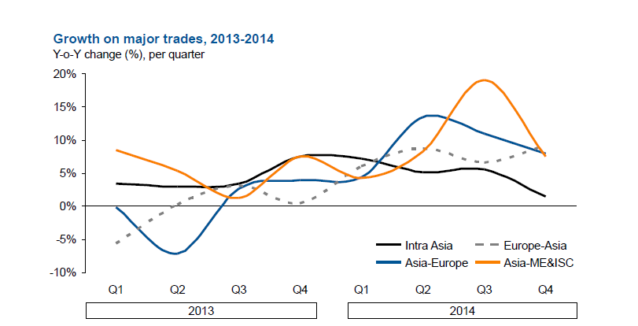
Sourse: Seabury

Figure 1.10
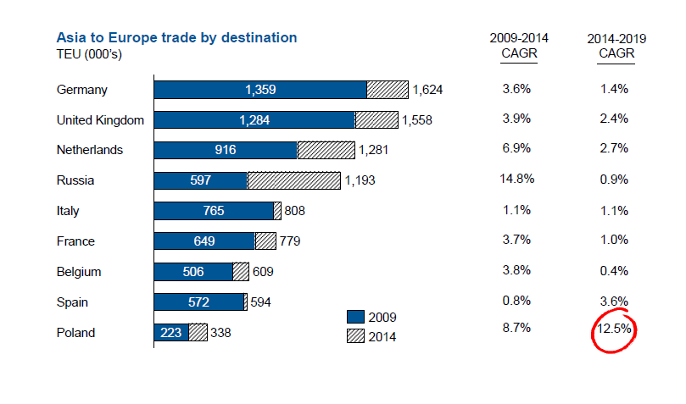
Sourse: Seabury

Figure 1.11
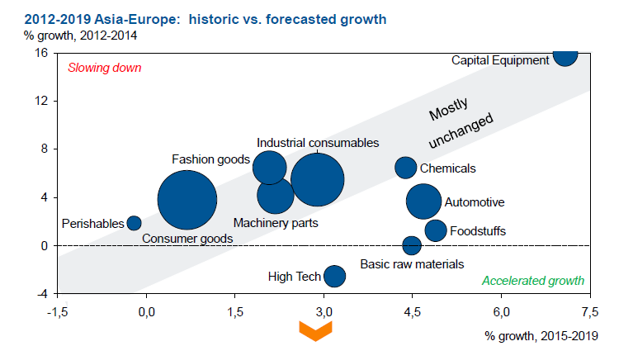
Sourse: Seabury

I.2.2. Main commodity groups
EATL efficiency is highly dependent on the types of commodities transported. For the purpose of this report, three categries of cargos have been assessed:
- Cargoes for inland transport between Europe and Asia only.
- Cargos for mixed inland and sea transport between Europe and Asia.
- Cargoes for the Euro-Asian maritime transport only.
Cargo that can be transported by rail or road from Europe to Asia and vice versa covers a rather limited market niche which includes high value and small volume goods, especially the ones that may be containerised. Those are goods for which air transport is too expensive, while maritime transport is too slow. This cargo includes positions of the Harmonised system of trade classification (HS) as listed in Table 1.18.

Table 1.18
Cargoes identified as suitable for inland transport between Europe and Asia or shiftable from maritime to inland transport
Commoditiy  Group | Description
01-05 Animal & Animal Products
01 | animals; live
02 | meat and edible meat offal
03 | fish and crustaceans, molluscs and other aquatic invertebrates
04 | dairy produce; birds' eggs; natural honey; edible products of animal origin, not elsewhere specified or included
05 | animal originated products; not elsewhere specified or included
06-15 Vegetable Products
06 | trees and other plants, live; bulbs, roots and the like; cut flowers and ornamental foliage
07 | vegetables and certain roots and tubers; edible
08 | fruit and nuts, edible; peel of citrus fruit or melons
09 | coffee, tea, mate and spices
10 | cereals
11 | products of the milling industry; malt, starches, inulin, wheat gluten
12 | oil seeds and oleaginous fruits; miscellaneous grains, seeds and fruit, industrial or medicinal plants; straw and fodder
13 | lac; gums, resins and other vegetable saps and extracts
14 | vegetable plaiting materials; vegetable products not elsewhere specified or included
15 | animal or vegetable fats and oils and their cleavage products; prepared animal fats; animal or vegetable waxes
16-24 Foodstuffs
16 | meat, fish or crustaceans, molluscs or other aquatic invertebrates; preparations thereof
17 | sugars and sugar confectionery
18 | cocoa and cocoa preparations
19 | preparations of cereals, flour, starch or milk; pastrycooks' products
20 | preparations of vegetables, fruit, nuts or other parts of plants
21 | miscellaneous edible preparations
22 | beverages, spirits and vinegar
23 | food industries, residues and wastes thereof; prepared animal fodder
24 | tobacco and manufactured tobacco substitutes
25-27 Mineral Products
25 | salt; sulphur; earths, stone; plastering materials, lime and cement
26 | ores, slag and ash
27 | mineral fuels, mineral oils and products of their distillation; bituminous substances; mineral waxes
28-38 Chemicals & Allied Industries
28 | inorganic chemicals; organic and inorganic compounds of precious metals; of rare earth metals, of radio-active elements and of isotopes
29 | organic chemicals
30 | pharmaceutical products
31 | fertilizers
32 | tanning or dyeing extracts; tannins and their derivatives; dyes, pigments and other colouring matter; paints, varnishes; putty, other mastics; inks
33 | essential oils and resinoids; perfumery, cosmetic or toilet preparations
34 | soap, organic surface-active agents; washing, lubricating, polishing or scouring preparations; artificial or prepared waxes, candles and similar articles, modelling pastes, dental waxes and dental preparations with a basis of plaster
35 | albuminoidal substances; modified starches; glues; enzymes
36 | explosives; pyrotechnic products; matches; pyrophoric alloys; certain combustible preparations
37 | photographic or cinematographic goods
38 | chemical products n.e.c.
39-40 Plastics / Rubbers
39 | plastics and articles thereof
40 | rubber and articles thereof
41-43 Raw Hides, Skins, Leather, & Furs
41 | raw hides and skins (other than furskins) and leather
42 | articles of leather; saddlery and harness; travel goods, handbags and similar containers; articles of animal gut (other than silk-worm gut)
43 | furskins and artificial fur; manufactures thereof
44-49 Wood & Wood Products
44 | wood and articles of wood; wood charcoal
45 | cork and articles of cork
46 | manufactures of straw, esparto or other plaiting materials; basketware and wickerwork
47 | pulp of wood or other fibrous cellulosic material; recovered (waste and scrap) paper or paperboard
48 | paper and paperboard; articles of paper pulp, of paper or paperboard
49 | printed books, newspapers, pictures and other products of the printing industry; manuscripts, typescripts and plans
50-63 Textiles
50 | silk
51 | wool, fine or coarse animal hair; horsehair yarn and woven fabric
52 | cotton
53 | vegetable textile fibres; paper yarn and woven fabrics of paper yarn
54 | man-made filaments; strip and the like of man-made textile materials
55 | man-made staple fibres
56 | wadding, felt and nonwovens, special yarns; twine, cordage, ropes and cables and articles thereof
57 | carpets and other textile floor coverings
58 | fabrics; special woven fabrics, tufted textile fabrics, lace, tapestries, trimmings, embroidery
59 | textile fabrics; impregnated, coated, covered or laminated; textile articles of a kind suitable for industrial use
60 | fabrics; knitted or crocheted
61 | apparel and clothing accessories; knitted or crocheted
62 | apparel and clothing accessories; not knitted or crocheted
63 | textiles, made up articles; sets; worn clothing and worn textile articles; rags
64-67 Footwear / Headgear
64 | footwear; gaiters and the like; parts of such articles
65 | headgear and parts thereof
66 | umbrellas, sun umbrellas, walking-sticks, seat sticks, whips, riding crops; and parts thereof
67 | feathers and down, prepared; and articles made of feather or of down; artificial flowers; articles of human hair
68-71 Stone / Glass
68 | stone, plaster, cement, asbestos, mica or similar materials; articles thereof
69 | ceramic products
70 | glass and glassware
71 | natural, cultured pearls; precious, semi-precious stones; precious metals, metals clad with precious metal, and articles thereof; imitation jewellery; coin
72-83 Metals
72 | iron and steel
73 | iron or steel articles
74 | copper and articles thereof
75 | nickel and articles thereof
76 | aluminium and articles thereof
78 | lead and articles thereof
79 | zinc and articles thereof
80 | tin; articles thereof
81 | metals; n.e.c., cermets and articles thereof
82 | tools, implements, cutlery, spoons and forks, of base metal; parts thereof, of base metal
83 | metal; miscellaneous products of base metal
84-85 Machinery / Electrical
84 | nuclear reactors, boilers, machinery and mechanical appliances; parts thereof
85 | electrical machinery and equipment and parts thereof; sound recorders and reproducers; television image and sound recorders and reproducers, parts and accessories of such articles
86-89 Transportation
86 | railway, tramway locomotives, rolling-stock and parts thereof; railway or tramway track fixtures and fittings and parts thereof; mechanical (including electro-mechanical) traffic signalling equipment of all kinds
87 | vehicles; other than railway or tramway rolling stock, and parts and accessories thereof
88 | aircraft, spacecraft and parts thereof
89 | ships, boats and floating structures
90-97 Miscellaneous
90 | optical, photographic, cinematographic, measuring, checking, medical or surgical instruments and apparatus; parts and accessories
91 | clocks and watches and parts thereof
92 | musical instruments; parts and accessories of such articles
93 | arms and ammunition; parts and accessories thereof
94 | furniture; bedding, mattresses, mattress supports, cushions and similar stuffed furnishings; lamps and lighting fittings, n.e.c.; illuminated signs, illuminated name-plates and the like; prefabricated buildings
95 | toys, games and sports requisites; parts and accessories thereof
96 | miscellaneous manufactured articles
97 | works of art; collectors' pieces and antiques

The list of commodities suitable for railway transportation in Eurasian trade covers a rather limited market niche which includes high value and small volume goods. Those are goods for which air transport is too expensive, while maritime transport is too slow. Therefore, in the case of products that need to be delivered rather fast and on time, railways offer a good option.
According to CCTT and OSJD the list of such goods includes:
- pharmaceuticals
- electronic products
- IT products
- fashion products
- footwear
- automotive components
- tires
- specific construction materials
- timber and wood
- chemicals
- fertilizers
- white goods
- pipes
- particular agricultural products
- machinery
Cargo not mentioned above is not typically transported by rail and generally is not “a good candidate” for overland transport. In particular, cheap and bulky products such as raw materials, petroleum products and liquefied gas which form the basis of the cargo flows in world trade (volumewise) are not and probably will not be transported overland between Europe and Asia in reasonably high volumes.
According to CCTT and OSJD electronic products are mostly transported from China to Europe, whereas there is an increasing interest to move automotive components, cars, pharmaceuticals, chemicals and food (including frozen foods) from the Europe to China.
Cases of specific services include the following ones:
• The Chongqing-Xinjiang-Europe train carries electronics, cars, and medical equipment;
• The international cargo train (Chang’an) from Xi’an to Rotterdam carries trucks, steel, aluminium, apple juice and electric power control units;
• The Zhengzhou-Xinjiang-Europe train carries electronic products, construction machinery, vehicles and parts, medical equipment and other high value products;
• The Suzhou-Manchuria-Europe train (through Siberia) carries liquid crystal monitors and laptops.
Regarding temperature sensitive products, DHL introduced in January 2014 the first temperature-controlled rail container service between China and Europe on a year-round basis.
According to CCTT 2016 Digest and OSJD reports railways are good alternative to maritime transport in case of high value and small volume goods. Therefore, in case of products that need to be delivered rather fast and on time, railways offer a good option.
Other cargo not mentioned above, is typically not transported by rail and generally does not offer a business case for transport by rail (or road) from Europe to Asia or from Asia to Europe. In general, cheap and bulky products such as raw materials, petroleum products and liquefied gas are not transported inland between Europe and Asia.
New technologies, improved Internet access, electronic payment systems, as well as express delivery created an e-commerce as a new mean of trade.
According to the WTO in 2013 business to business (B2B) e-commerce was valued at about US$ 15 trillion and business to customer (B2C) e-commrce at more than US$ 1 trillion, with the fast growth in last 5 years, according to UNCTAD estimates.
An indicator of increasing cross-border trade is the volume of small parcels passing through the customs. Trade volume in this area increased by 48 per cent between 2011 and 2014, according to the Universal Postal Union.
According to the China Post, in 2015 the volume of postal items shipments from China grew up to 120 million items. For example, the Russian Federation has become China Post’s third largest destination country after the United States and the European Union. In 2015 inbound/outbound volume between China and the Russian Federation reached 9,300 tons in total mail weight.
Given the difficulties in encapsulating interntional e-commerce transactions, it is not possible to accurately measure the size of this market using official statistics like UN Comtrade database. Private sector estimates, however, indicate that the Asia-Pacific region was the largest e-commerce market in 2014.
According to AliResearch, by 2020, more than 900 million people around the World will be international online shippers with their purchases accounting for nearly 30 per cent of all global B2C transactions. China will become the largest cross-border B2C market by 2020, with the transaction volume of imported goods purchased online reaching $245 billion.
At the same time e-shops as the biggest participants in the e-commerce market aim at optimization of the goods (postal parcels) shipment routes to customers in order to speed up and minimize costs.
According to UPS, the delivery of the goods transported via the inland route in the Chengdu – Lodz and Zhangzhou – Hamburg services is twice as fast as via maritime route with 70 per cent advantage by price compared to the air transport. The survey undertaken among UPS clients shoed that 71 per cent of the interviewers were willing to switch to the inland transport in forthcoming years.
Thus, e-commerce begins to play an important role for attracting additional cargo flows in the Euro-Asian service to the inland transport.

I.3. Euro-Asian transport flows

I.3.1. EATL transport flows general overview
According to UNCTAD and container statistics at the moment the Eurasian trade is provided primarily by maritime routes.
It should be noted that “maritime routes” or “maritime transport” in this report means the intermodal transport chain containing shipping services from Chinese (Korean, Japanese, etc) to European ports, port transshipment and the surface leg executed by rail, or truck, or both.
The railway links between China and Europe are the object of the growing interest since they can offer transport products competitive under certain conditions. The main advantage of rail connection is faster delivery. Several multinational companies have started operating regular container block trains using different routes across the EATL zone.
However, the land bridge cannot—and likely will never—compete (in full meaning of the word) with the maritime option because the potential throughput of inland routes is limited to 1–2 percent (physical volumes in metric tons) of what is carried by sea. But it may well establish itself as a complement to shipping to increase the reliability of time-sensitive supply chains involving manufacturing production sharing, such as high-value components in the automotive or computer industries.

I.3.2. Liner Shipping situation
As showed in UNCTAD Maritime transport Report 2016, regular shipping services are dominating in the Euro-Asian trade.
Partially it reflects the general leading position commercial shipping holds in global trade thanks to its incomparable economies of scale and punctual regular services highly valued in modern supply chains.
On another hand, maritime transport shows high market flexibility that helps the industry to survive through crisis and keep customers loyal. At least, three issues should be mentioned in this connection: slow steaming, shipping alliances and flexible rates.
Slow steaming concept- reduced vessel speeds to save fuel and cut costs -adopted by the majority of shipping lines is one of the important features that changed the maritime business since the 2009 crisis.
According to Clarksons Research, prior to implementing slow steaming, a typical structure for a service from the Far East to Europe included eight ships in operation to maintain weekly calls over a period of 56 days for full rotation (28 days for one leg). With the implementation of slow steaming, the number of operated vessels had increased to ten to maintain weekly calls, while transit times increased to 70 days for a full rotation (35 days for one leg). At the same time, such a speed reduction can impact almost 50% of the bunker cost of a mega-containership and a little bit more on the cost of a 5,000 TEU’s ship. Besides, slow steaming obviously decreases environmental pollution which is a good news for “green-focused” customers.
Many shippers accept a shift to slow steaming since decreased tariff seems very attractive under the crisis pressure (see Figure 1.11 and table 1.19). However, others with more expensive merchandise oppose the practice due to increased pipeline inventory associated with longer transit times.
There is no generally accepted opinion about the future of slow steaming. It gives however a chance for rail operators to offer competitive services to customers who believe that slow steaming is not acceptable for their business model.
In 2016 there are four main container carrier alliances approved by the regulators in EU, US and China: 2M, Ocean 3, KYH and G6. These structures control more than 70% of the cargo volumes moving in the major East-West trades.
Shipping alliances creation is the market trend that reflects the market players’ intention to establish the sustainable large-scale units that will be able to optimize the participants’ assets utilization and services on the main trade lanes. Vessel-sharing within the alliance helps the carriers to increase service frequency without introducing extra vessels. Rate “harmonizing” within the alliances, although legally prohibited, is also said to take place.
Almost all of the 14 largest shipping companies making up 73.1 percent of the market share them belong to alliances. As of July 2016, the world’s shipping alliances were aligned as follows: 2M Alliance: Maersk and MSC; Ocean Three Alliance: CMA CGM, UASC, China Shipping; G6 Alliance: NYK Line, OOCL, APL, MOL, Hapag-Lloyd, HMM; CKYHE Alliance: K Line, COSCO, HANJIN, Evergreen, Yang Ming (Figure 1.12). Among the top independent carriers were PIL, ZIM, Wan Hai Lines, X-Press Feeders and KMTC.
But by April 2017, the world of shipping alliances will probably see changes and reorganizations will affect nearly all of the above lines. Hapag-Lloyd, which recently merged with UASC, and five Asian carriers want to form the new vessel-sharing alliance called THE Alliance. In addition, HMM will soon join Maersk and MSC in the 2M alliance.
The exact impact of this new alignment of the major container ship operators has yet to be fully assessed. Shippers are advocating greater scrutiny and the need to conduct reviews to determine how the alliances are impacting on the industry. An immediate consequence of consolidation is the tendency for alliances to focus on reducing transit times and increasing reliability to attract shippers, at the expense of services and port calls (King, 2016). In any case, the alliances seem to be the flexible instrument that maritime container carriers will use on the East-West trade routes to strengthen their market position. The establishment of new alliances and rounds of restructuring may continue, as it is unlikely that the market will stabilize in the near future.

Figure 1.12
Market share by alliance on the Far East-Europe shipping lines, April 2016
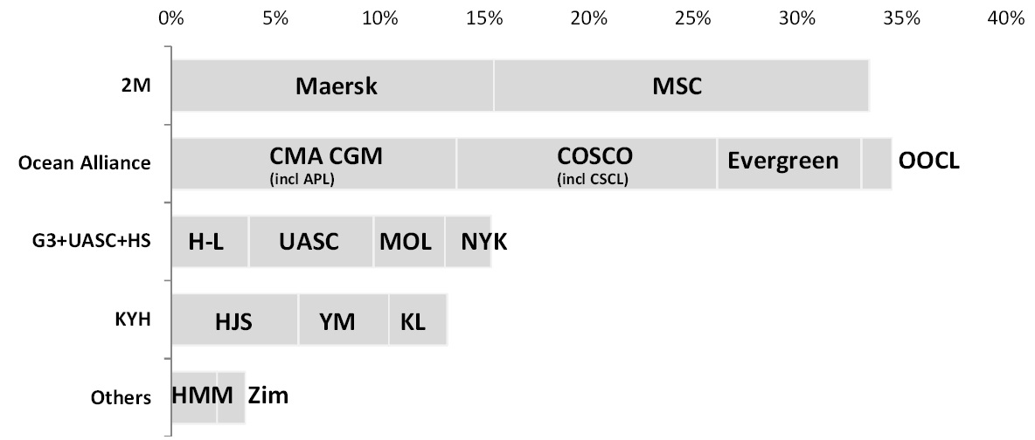
Source: Alphaliner Newsletter no 17 - 2016
Flexible rates is one of the main market instruments of ocean container carriers. Their prices promptly reflect the changes of the market situation thus keeping the business competitive. The crisis period illustrates that very well. Figure 1.13 shows the dynamics of Chinese forwarders freight index. In the beginning of the period the rate per 20ft container fell down to $1 826 in March 2010 to 739 in March 2017.
The general trend across the East-West sea routes is the decline of rates reflecting the economic situation. This trend is illustrated by Figure 1.13, 1.14 and tables 1.19 and 1.20 The Far East–Northern Europe trade route freight rates, for example, averaged as low as $629 per TEU in 2015, down by almost 46 per cent from the 2014 average and by 65 per cent, compared with rates in 2010. In contrast, Far East–Mediterranean spot rates fell by 41 per cent, reaching $739 per TEU, a decline of 41 per cent, compared with rates in 2014, and almost 58 per cent less than rates in 2010.
Important factor influencing the rates is the capacity oversupply.
In 2015, containerized trade continued to face the upsizing of container ships. The average ship size in the global fleet increased at a cumulative annual growth rate of 1.9 per cent in 2001–2009 and 18.2 per cent in 2010–2015 (Davidson, 2016).

Figure 1.13
Container Global Aggregated Price Index, January 2013 – October 2016
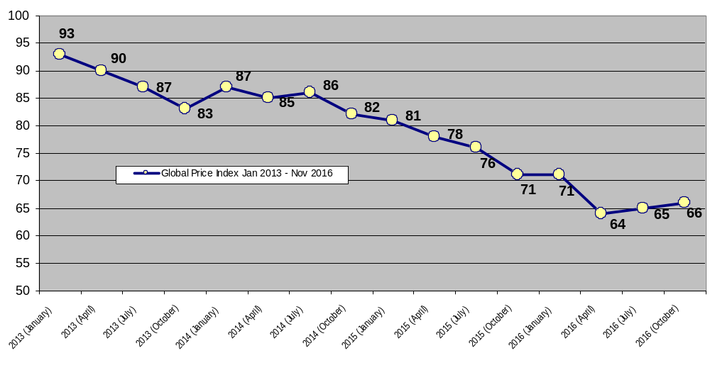
Source: Container Trades Statistics Ltd (CTS), updated December 2016, available at: https://www.containerstatistics.com/

Figure 1.14
China forwarders freight index, China-Europe shipping lines (U.S. Dollars per TEU), 2010-2017
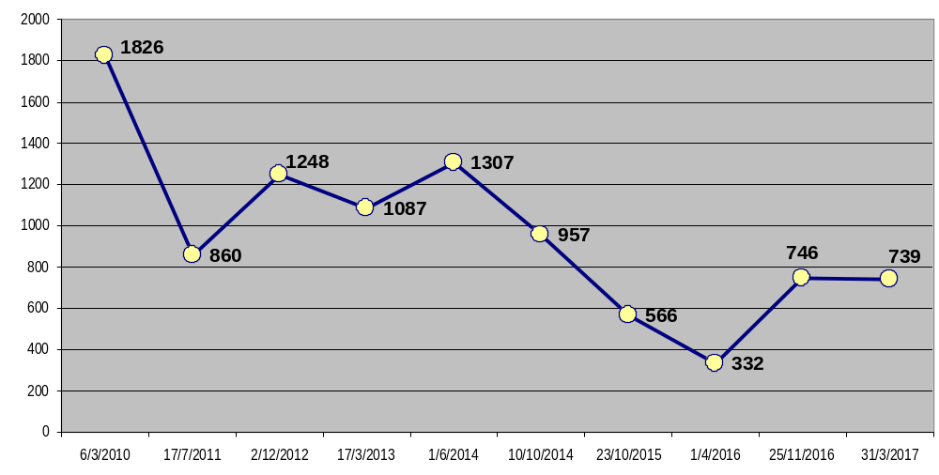
Source: http://en.shippingchina.com/scfi/index/detail/line_id/3/date2/2017-04-01.html

Table 1.19
Port-to-port freight index list on trade routes China – Europe shipping lines (U.S. Dollars per TEU) on April 6, 2017
Port of arrival in China | Port of destination in Europe
Port of arrival in China | Antwerp | Bremen | Felixstowe | Hamburg | Le Havre | Rotterdam | Zeebrugge
Guangzhou | 1850 | 300 | 2070 | 350 | 230 | 590 | 230
Shenzhen | 700 | 900 | 845 | 700 | 842 | 700 | 850
Xiamen | 1350 | 800 | 383 | 367 | 418 | 365 | 409
Ningbo | 725 | 875 | 725 | 725 | 725 | 725 | 750
Shanghai | 691 | 700 | 500 | 691 | 691 | 691 | 500
Qingdao | 720 | 580 | 486 | 720 | 720 | 720 | 738
Tianjin | - | 1080 | 750 | 850 | 725 | 700 | 800
Source: http://en.shippingchina.com

Table 1.20
Container freight markets and rates on trade routes Far East – Europe (U.S. Dollars per TEU)
Freight markets | 2009 | 2010 | 2011 | 2012 | 2013 | 2014 | 2015
Shanghai – Northern Europe | 1395 | 1789 | 881 | 1353 | 1084 | 1161 | 629
% change |  | 28.24 | -50.75 | 53.58 | -19.88 | 7.10 | -45.82
Shanghai – Mediterrenean | 1397 | 1739 | 973 | 1336 | 1151 | 1253 | 739
% change |  | 24.49 | -44.05 | 37.31 | -13.85 | 8.86 | -41.02
Source: World Maritime Review, 2016

Main carriers introduce larger vessels striving for greater efficiency, economy of scale and market share, as well as by the new IMO Tier III requirements concerning sulphur oxides (SOx) and nitrogen oxides (NOx) that went into effect on 1 January 2016 in the North American and the United States Caribbean emission control areas. New ships in 2015 added some 1.7 million TEUs to the global fleet (with 87 per cent of this volume increase in the 8,000+ TEUs sector) (Clarksons Research, 2016).
One study has noted that container ship size increases of up to 18,000 TEUs were likely to result in maximum cost savings for shipping and ports by only 5 per cent of total network costs, and that the economics of scale diminished as vessel sizes increased beyond 18,000 TEUs (Batra, 2016).
Some observers maintain that the costs of ever-larger ships may outweigh their benefits. The disadvantages include reduced service frequency, higher peaks in container traffic, greater pressure on the operations of cargo-handling services, rising terminal capital and operational costs, reductions in options available to shippers and higher supply chain risks with the concentration of trade in larger but fewer ships, as well as environmental effects arising from dredging deeper channels and expanding yard area. There will likely be a need for ports and lines to further cooperate, нужно убрать отсупincluding, for example, through terminal operator alliances, mergers and acquisitions, and joint ventures between the shipping industry and port terminals (Davidson, 2016). Anyway, the trend towards bigger vessels is still taking place.
Sutuation on main trade routes.
In 2015, total containerized trade across the mainlane East–West, secondary East–West, intraregional, South–South and North–South routes recorded a significant slowdown, with volumes increasing by 2.4 per cent to reach 175 million TEUs. Figure 1.13 shows the breakdown by main routes.

Figure 1.15
Global containerized trade by route, 2015 (Percentage share in twenty-foot equivalent units)
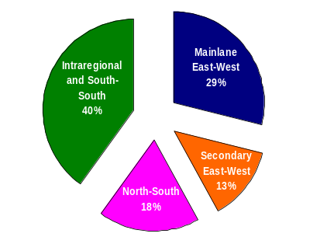
Sources:
UNCTAD (2016) Review of Maritime Transport
UNCTAD secretariat calculations, based on Clarksons Research, 2016.
Three main factors combined together are limiting containerized trade growth, namely, the decline in volumes on the head haul of the Eastern Asia–Europe trade route; the limited growth of North–South trade, owing to the impact of low commodity prices on the terms of trade and purchasing power of commodity exporting countries; and the pressure on intra-Asian trade resulting from the slowdown in China (figure 1.16).
Volumes on the mainlane East–West route increased by about 1.2 per cent in 2015, reaching 52.5 million TEUs (figure 1.17). Growth was constrained by negative performance (-2.2 per cent) on the headhaul of Europe–Asia trade, which reflected weaker import demand in Europe, adjustments in retail inventories, a weak euro and the negative impact of unilateral coercive measures on import volumes into the Russian Federation.

Figure 1.16.
Containerized cargo flows on major East–West container trade routes (million TEUs), 1995–2016
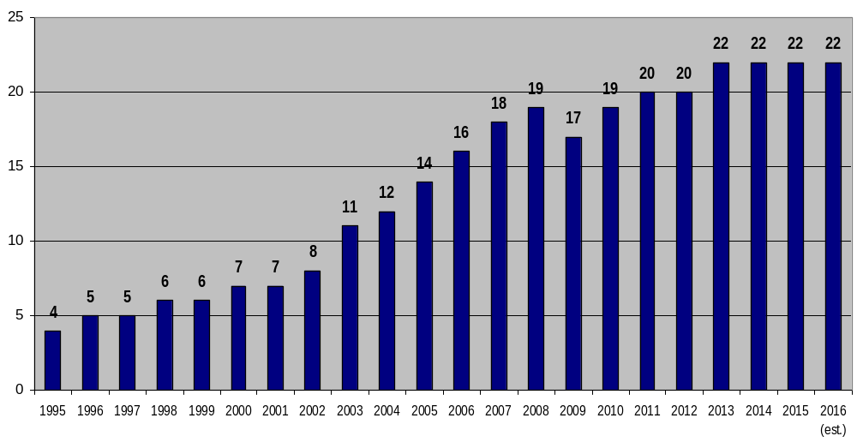
Source: World Maritime Review, 2016,
Container Trades Statistics Ltd (CTS), updated December 2016, available at: https://www.containerstatistics.com/

Chart 1.17
Containerized cargo flows on Asia-Europe and Europe-Asia container trade routes (million TEUs), 2009–2016
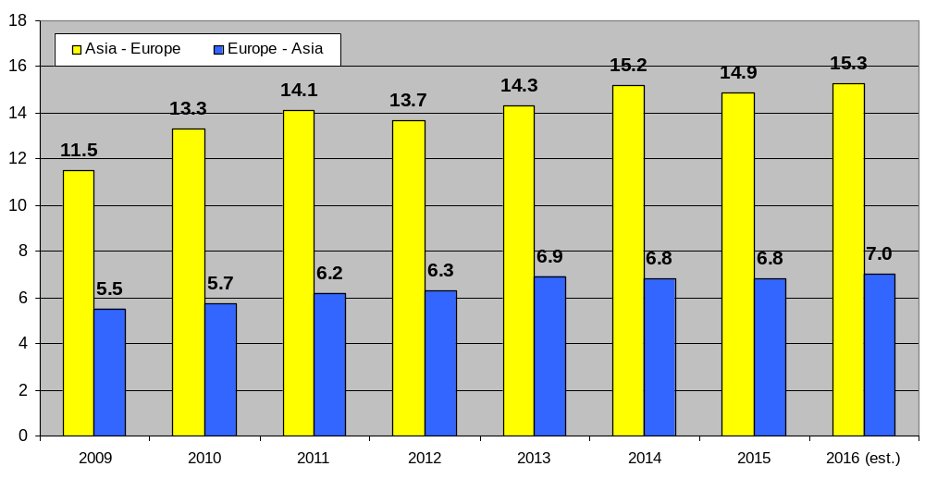
Source: World Maritime Review, 2016
The decline in 2015 of European containerized trade seems inconsistent with data indicating that, during the year, intra-European trade growth outpaced the growth of trade between the European Union and the rest of the world. While intraregional imports grew by 1.4 per cent, imports from the rest of the world remained flat. The share of intraregional imports of total European imports increased from 60 per cent in 2007 to 65 per cent in 2015 (Danish Ship Finance, 2016). Combined with statistics showing a relatively strong demand in Europe for consumer goods during the year, it has been argued that a shift may be unfolding towards regional and closer-to-end-market sourcing of goods.
Intraregional container trade expanded at an estimated 3.1 per cent in 2015. Intra-Asian trade – accounting for over two thirds of the total – expanded by 2.9 per cent, down from 6 per cent in 2014. The deceleration reflected the situation in China and the decline in imports in other economies in Asia, such as Indonesia and Japan. Intra-Asian trade continued to be supported, however, by the relocation of manufacturing centres from China to other areas in Asia and by increased imports to the Philippines, the Republic of Korea and Viet Nam, as well as by robust growth on the Asia–South Asia route (Clarksons Research, 2016).
Problems affecting the container freight market in 2015 can be traced to diverging and persistent global supply-and-demand trends and growing imbalances. This situation is expected to continue throughout 2016 and 2017, when carriers with capacities of up to 21,100 TEUs will be in service. Despite weakening demand and low freight rates, carriers continued to invest in larger vessels in 2015. The global container ship fleet is projected to grow by 4.6 per cent in 2016 and another 5.6 per cent in 2017 (AlixPartners, 2016a). Such a pace would continue to outstrip global container demand and exacerbate market fundamentals and in turn challenge container ship market conditions and freight rates in the short term, especially on the mainlanes (Clarksons Research, 2016c). Consequently, poor performance is also expected and may result in further consolidation and restructuring of the container shipping industry.

I.3.3. Railway transport
Block trains role in the Euro-Asian logistics
The number and quality of the railway services along the EATL corridors is increasing as a result of the combined efforts of the EATL countries. For the past few years the number of freight trains including regular services running between China and Western Europe has been steadily growing, as more and more wide range of consignors perceive railways as a real alternative to sea and air traffic.
In 2015, the number of container block trains operating along EATL rail routes in OSJD member states grew up to 280, of which 100 run on the regular basis according to the published schedules.
Within the framework of OSJD activity on “Organisation of large-scale container traffic between Europe and Asia” a series of projects have been implemented by different countries.
According to Chinese Railways, 815 container block trains were travelled in 2015 on the in the direction of China – Europe – China, of which from China to the countries of Europe - 550 trains, and 265 trains back (according to the information of the Chinese Railways).
For the past few years the number of regular freight trains running between China and Western Europe has been steadily growing, as more and more wide range of consignors began to perceive railways as a real alternative to the sea and air traffic.
Republic of Belarus. Currently eight regular block trains services are in place on the China – Western Europe – China route through the Byelorussian Railway in the direction of Germany, Poland, Czech Republic and Lithuania along the following routes:
- China – Poland (Chengdu – Lodz);
- China – Germany (Zhengzhou – Hamburg);
- “New Silk Way” China – Germany (Chongqing – Duisburg);
- “BMW” Germany – China (Leipzig – Shenyang);
- “Ford” Germany – China (Duisburg – Chongqing);
- China – Germany (Wuhan – Hamburg);
- China – Spain (Yiwu – Madrid).
In 2015 railway container traffic growth between China and Europe have been reached 28.6 thousand TEUs (growth by 1.9 times from 2014).
Kazakhstan. In 2015 1269 container trains proceeded through the network of the Railway of Kazakhstan in the transit traffic; the number of container trains increased by 255 trains as compared to 2014 (growth by 25%), incl. 581 trains China – Europe – China - grown by 327 trains (or by 2.2 times).
The main Kazakhstan rail routes are:
- Chengdu (China) – Lodz (Poland) - 61 trains (+16 trains against 2014, have been running since 19 December 2012);
- Zhengzhou (China) – Hamburg (Germany) - 49 trains (-22 trains against 2014, have been running since 17 July 2013);
- Chongqing (China) – Duisburg (Germany) - 146 trains (+55 trains against 2014, have been running since 19 March 2011);
- Wuhan (China) – Pardubice (Czech Republic) - 23 trains (+7 trains against 2014, have been running since 5 June 2014);
- Wuhan (China) – Hamburg (Germany) - 62 trains (+61 trains against 2014, have been running since December 2014);
- Yiwu (China) – Madrid (Spain) - 17 trains (+16 trains against 2014, have been running since 8 December 2014);
- Hefei (China) – Hamburg (Germany) - 3 trains (a new route);
- Lanzhou (China) – Hamburg (Germany) - 1 train (a new route);
- Putyan (China) – Terespol (Poland) - 1 train (a new route);
- Duisburg (Germany) – Chongqing (China) - 118 trains (+99 trains against 2014, have been running since March 2013);
- Hamburg (Germany) – Zhengzhou (China) - 32 trains (+24 trains against 2014, have been running since September 2014);
- Hamburg (Germany) – Wuhan (China) - 15 trains (+15 trains against 2014, have been running since December, 2014);
- Lodz (Poland) – Chensyan (China) - 26 trains (a new route);
- Madrid (Spain) – Yiwu (China) - 2 trains (+2 trains against 2014, was organised in December 2014);
- Kotka (Finland) in the direction of China - 7 trains (a new route);
- Hamburg (Germany) – Lanzhou (China) - 32 trains (a new route).
Besides, on 28 July 2015 the first demonstration container train “Nomad Express” was launched through the Trans-Caspian international transport route with participation of railway and sea transport/ferry operators along the route of Shikhezi (China) – Dostyk (Kazakhstan) – Aktau Port (Kazakhstan) – Kishly (Azerbaijan).
On 29 November 2015 the second container train “Nomad Express” set off along the route Lianyungang (China) – Dostyk – Aktau-Port (Kazakhstan) – Baku (Port Alyat) (Azerbaijan) – Uzlovaya/Poti (Georgia) – Istanbul (Turkey) including road transportsection Poti – Istanbul.
Mongolia. Since the end of 2014 and till April 2015 the Ulan-Bator Railway JSC (UBZD JSC) together with the railways of the People’s Republic of China, Russia, Belarus, Poland and Germany has organised 18 transit block trains through Mongolia on the following routes::
- from Germany to China along the route of Hamburg – Brest – Naushki – Ulan Bator – Zamyn-Uud – Erlian – Zhengzhou (3 trains);
- from China to Poland along the route of Chengdu – Erlian – Zamyn-Uud – Sukhe-Bator – Naushki – Brest – Lodz (6 trains);
- from China to Germany along the route Zhengzhou – Erlian – Zamyn-Uud – Sukhe-Bator – Naushki – Brest –Hamburg (9 trains).
Ukraine. According to the Ukrainian Railway PJSC transportation of containers by block trains has constituted 27% of the total amount of containers carried through the territory of Ukraine. Attractive rates for container trains have been established.
To attract sufficient volumes of container cargoes to be transported by the “Viking” and “Zubr” block trains the project participants (railway administrations of Ukraine, Belarus, Lithuania, Latvia, Estonia, Moldova, Romania and Bulgaria) have kept 2014 rates unchanged for 2015.
The train schedule for the “Viking” and “Zubr” trains for 2015/2016 provides the operation on the regular basis. Frequency of their running has been also established: three times a week for departing of the train from the Black Sea region.
In order to expand the geography of “Viking” train operation and to improve the management new participants have joined the project in May 2014: National Society of Railway Cargo Transportation of Romania “CFR Marfa”, and in March 2015 – Georgian Railway JSC.
Block train traffic has been also organised along the route Romania (Dorneşti) – Ukraine (Vadul Siret – Zernovo) – the Russian Federation (Tolyatti) for the transportation of car accessories and spare parts.
Block train is successfully operating along the route Slovakia (Kosice) – Ukraine (Uzhgorod – Zernovo) – the Russian Federation (Perspektivnaya). Car and vehicle accessories are transported by this block train.
Along with block trains operating on the specified routes, container services has been organised to cut the lead time for containers arriving at the Ukranian Black-Sea ports. Flexible scheduling is pursued in order to arrange the departure as soon as possible after the containers arrive at the ports.
Since 2015 Ukrzaliznytsia PJSC have been working towards organising container train traffic along the following route: countries of Europe – Ilyichyevsk-ferry (Ukraine) – Batumi (Georgia) – Boyuk-Kesik – Baku (Azerbaijan) – Aktau-Port – Dostyk (Kazakhstan) – China through the ferry crossings Ilyichyevsk – Batumi and Alat – Aktau-Port. It is argued that this service will attract additional volumes of container traffic between EU Member States and the countries of Caucasus region, Central Asia and China.
According to the Azerbaijani Railways CJSC, dynamic wagon weighbridges have been installed at the border stations of Boyuk-Kesik and Yalama by the customs authorities, and X-ray wagon inspection equipment has been installed at Yalama station by the border guard.

Table 1.21
List of container trains and contrailer traffic on the railways of OSJD Member Countries (as of 14.10.2016)
Train Number | Route | Train  Characteristics | Run Frequency
Byelorussian Railway (BC)
1022/1021 | Russia - Lithuania - Belarus - Russia  (Kaliningrad - Kybartai - Gudogai - Krasnoye - Kuntsevo-2/  Moscow-Tov.-Smolenskaja/Kupavna/Tuchkovo/Vorsino) | container | on request
1025/1026 | China - Russia - Belarus (Zabaikalsk - Krasnoye - Koliadichi/Brest) | container | on request
1027/1028 | Russia - Belarus (Mys Tschurkin /Uglovaja/Nakhodka/Nakhodka-Vost. - Krasnoye - Koliadichi/Brest) | container | on request
1037/1038 | China - Russia - Belarus - European countries (Zabaikalsk - Krasnoye - Brest/Malaszewicze) | container | on request
1037/1038 | Russia - Belarus - European countries  (Vladivostok/Nakhodka-Vost. - Krasnoye - Brest/Malaszewicze) | container | on request
1039/1040 | Russia - Belarus - European countries (Zabaikalsk/Vladivostok/ Nakhodka-Vost. - Krasnoye - Brest/Malaszewicze) | container | on request
1062/1061 | European countries - Belarus - Russia (Bruzgi - Krasnoye - Nowoijerusalimskaja) | container | on request
1064/1063 | France - Poland - Belarus - Russia (Malaszewicze - Brest - Krasnoye - Vorotynsk) | container | on request
1066/1065 East Wind | Germany - Poland - Belarus - Russia (Malaszewicze - Brest - Krasnoje - Bekasovo-Sort./Kuntsevo-2/Vorsino) | container | on request
1068/1067 | Germany - Poland - Belarus - Russia (Malaszewicze - Brest - Krasnoye - Moscow-Tov.-Paveletskaja/Sbornaja-Ugolnaja/Hovrino/Vorsino) | container | on request
1068/1067 | Poland - Belarus - Russia  (Malaszewicze - Brest - Krasnoye - Kuntsevo-2/Silikatnaja) | container | on request
1070/1069 China Express | China - Mongolia - Russia - Belarus - European countries (Erlian/Zamyn-Uud - Naushki - Krasnoje - Brest/Malaszewicze) | container | on request
1074/1073 | Germany - Poland - Belarus - Russia (Malaszewicze - Brest - Krasnoye - Nakhodka-Vost.) | container | on request
1076/1075 | European countries - Belarus - Russia - Kazakhstan - China (Malaszewicze/Brest - Krasnoje - Iletsk-I - Almaty-1 - Dostyk/Altynkol) | container | on request
1274/1273 | European countries - Belarus - Russia - Kazakhstan - China (Malaszewicze/Brest - Krasnoje - Iletsk-1 - Dostyk/Altynkol) | container | on request
1078/1077  Kazakhstan  Vector | European countries - Belarus - Russia - Kazakhstan (Malaszewicze/Brest - Krasnoye - Semiglavy Mar - Arys-1) | container | on request
1080/1079 | Belarus - Russia (Brest - Krasnoye - Kaluga-1/Perspektivnaja) | container | daily
1082/1081 | Belarus - Russia (Brest - Krasnoye - Kaluga-1/Perspektivnaja) | container | daily
1084/1083 | Poland - Belarus - Russia  (Malaszewicze - Brest - Krasnoye - Tikhonovo/Silikatnaja/Kuntsevo-2/ Sbornaja-Ugolnaja/Moscow-Tov.-Paveletskaja) | container | on request
1086/1085 Mongolian Vector | Belarus - Russia - Mongolia (Brest - Krasnoye - Naushki) | container | on request
1088/1087 | Belarus - Russia (Brest - Krasnoye - Kaluga-1/Perspektivnaja) | container | on request
1090/1089 | Belarus - Russia (Brest - Krasnoye - Kostariha/Nizhny Novgorod Avtozavod) | container | on request
1096/1095 | Belarus - Russia (Brest - Krasnoye - Nizhny Novgorod Avtozavod) | container | on request
1219/1220  Mercury | Lithuania - Belarus - Russia  (Draugiste (Port Klaipeda) - Gudogai - Krasnoye - Kuntsevo-2/ Moscow-Tov.-Paveletskaja/Kresty/Silikatnaja/Severnaja) | container | on request
1221/1222 | Lithuania - Belarus - Russia - Kazakhstan - Uzbekistan - Afghanistan (Draugiste (Port Klaipeda) - Gudogai - Krasnoye - Semiglavy Mar - Karakalpakhstan - Galaba) | container | on request
 | Lithuania - Belarus - Russia - Kazakhstan - Uzbekistan (Draugiste (Port Klaipeda) - Gudogai - Krasnoye - Semiglavy Mar - Karakalpakhstan - Ulugbek) | container | on request
Saule-2 | Lithuania - Belarus - Russia - Kazakhstan  (Draugiste (Port Klaipeda) - Gudogai - Krasnoje - Semiglavy Mar - Aktobe-2 (ЕСР 6600-6640, 6648-6728, 67771-67772, 69740, 6976-6997, 6999, 7030-7042, 7044-7047, 7057, 7049, 7059-7075)/Almaty-1) | container | on request
1226/1225 Baltic Wind | Lithuania - Belarus - Russia - Kazakhstan (Panariai/Draugiste (Port Klaipeda) - Gudogai - Krasnoye - Kartaly-1 - Kustanai) | container | on request
Saule-1 | Lithuania - Belarus - Russia - Kazakhstan (Draugiste (Port Klaipeda)/ Sestokai - Gudogai - Krasnoye - Kartaly-1 - Almaty-1) | container | on request
1263/1264 | Kazakhstan - Russia - Belarus  (Zhinishke - Semiglavy Mar - Zakopyt'e - Brest) | container | on request
1265/1266 | China - Kazakhstan - Russia - Belarus - European countries (Dostyk/Altynkol - Iletsk-1 - Krasnoye - Brest/Malaszewicze) | container | on request
1352/1351  Eurasia-2 | Lettland - Belarus - Russia - Kazakhstan  (Riga - Bigosovo-styk - Zaolscha-styk - Semiglavy Mar - Aktobe-2) | container | on request
1401/1402  Zubr | Estland - Lettland - Belarus - Ukraine - Moldova (Ulemiste/Muuga - Valga - Bigosovo - Berezhest - Iliechyevsk/ Iliechyevsk-Paromnaja/Odessa-Port/ Mogilev-Podolski - Giurgiulesti-Port) | container | daily
1423/1424 | Russia - Belarus - Lithuania - Russia  (Akulovo/Mikhnevo - Krasnoye - Gudogai - Kibartai - Lesnoje-Nowoje) | container | on request
1425/1426 | Russia - Belarus - Lithuania - Russia  (Mikhnevo - Krasnoye - Gudogai - Kibartai - Lesnoje-Nowoje) | container | on request
1427/1428 | Poland - Belarus - Russia (Malaszewicze - Brest - Krasnoje - Mikhnevo) | container | on request
1429/1430  Viking | Ukraine - Belarus - Lithuania (Iliechyevsk/Iliechyevsk-Paromnaja/ Odessa-Port - Berezhest - Gudogai - Draugiste (Port Klaipeda)) | container and contrailer train | daily
 | Moldova - Ukraine - Belarus - Lithuania (Giurgiulesti-Port - Mogilev- Podolski - Berezhest - Gudogai - Draugistee (Port Klaipeda) | container and contrailer train | daily
 | Romania - Moldova - Ukraine - Belarus - Lithuania (Ungeny - Mogilev-Podolski - Berezhest - Gudogai - Draugiste (Port Klaipeda)) | container and contrailer train | daily
 | Bulgaria - Ukraine - Belarus - Lithuania (Varna - Iliechyevsk- Paromnaja - Berezhest - Gudogai - Draugiste (Port Klaipeda) | container and contrailer train | daily
 | Azerbaijan - Georgia - Ukraine - Belarus - Lithuania (Aljat - Beyuk-Kyasik - Poti/Batumi - Iliechyevsk-Paromnaja - Berezhest - Gudogai - Draugiste (Port Klaipeda) | container and contrailer train | daily
Holding “Bulgarian State Railways” (Holding BDZ)
40770 | Tekirdag (Turkey) - Bulgaria - Serbia - Hungary - Vienna (Austria) | container | on request
40773 | Vienna (Austria) - Hungary - Serbia - Bulgaria - Tekirdag (Turkey) | container | on request
40781 | Sopron (Hungary) - Romania - Bulgaria - Cerkezkoy (Turkey) | container | on request
40782 | Cerkezkoy (Turkey) - Bulgaria - Romania - Sopron (Hungary) | container | on request
40783 | Sopron (Hungary) - Romania - Bulgaria - Cerkezkoy (Turkey) | container | on request
40784 | Cerkezkoy (Turkey) - Bulgaria - Romania - Sopron (Hungary) | container | on request
40785 | Sopron (Hungary) - Romania - Bulgaria - Cerkezkoy (Turkey) | container | on request
40774 | Cerkezkoy (Turkey) - Bulgaria - Serbia - Sopron (Hungary) | container | on request
40775 | Sopron (Hungary) - Serbia - Bulgaria - Cerkezkoy (Turkey) | container | on request
40776 | Cerkezkoy (Turkey) - Bulgaria - Serbia - Sopron (Hungary) | container | once a week
40777 | Sopron (Hungary) - Serbia - Bulgaria - Cerkezkoy (Turkey) | container | on request
40778 | Cerkezkoy (Turkey) - Bulgaria - Serbia - Sopron (Hungary) | container | on request
40779 | Sopron (Hungary) - Serbia - Bulgaria - Cerkezkoy (Turkey) | container | on request
40820 | Halkali (Turkey) - Bulgaria - Serbia - Croatia - Ljubljana (Slovenia) | container | on request
40821 | Ljubljana (Slovenia) - Croatia - Serbia - Bulgaria - Halkali (Turkey) | container | on request
41520 | Halkali (Turkey) - Bulgaria - Dornesti (Romania) | container | once a week
41521 | Dornesti (Romania) - Bulgaria - Halkali (Turkey) | container | once a week
40834 | Tekirdag (Turkey) - Bulgaria - Serbia - Curtici (Romania) | container | on request
40835 | Curtici (Romania) - Serbia - Bulgaria - Tekirdag (Turkey) | container | on request
40838 | Halkali (Turkey) - Bulgaria - Serbia - Hungary - Dunajska Streda (Slovakia) | container | 7 times a week
40839 | Dunajska Streda (Slovakia) - Hungary - Serbia - Bulgaria - Halkali (Turkey) | container | 7 times a week
40860 | Sindos (Greece) - Bulgaria - Romania - Sopron (Hungary) | container | on request
40861 | Sopron (Hungary) - Romania - Bulgaria - Sindos (Greece) | container | on request
40862 | Thessaloniki (Greece) - Bulgaria - Romania - Sopron (Hungary) | container | on request
40863 | Sopron (Hungary) - Romania - Bulgaria - Thessaloniki (Greece) | container | on request
41378 | Stamboliyski (Bulgaria) - Serbia - Hungary - Zeltweg (Austria) | container | on request
41379 | Zeltweg (Austria) - Hungary - Serbia - Stamboliyski (Bulgaria) | container | on request
41400 | Warna (Bulgaria) - Romania - Sopron (Hungary) | container | on request
41401 | Sopron (Hungary) - Romania - Warna (Bulgaria) | container | on request
41500 | Thessaloniki (Greece) - Bulgaria - Ploiesti (Romania) | container | on request
41501 | Ploiesti (Romania) - Bulgaria - Thessaloniki (Greece) | container | on request
41503 | Kjazhna (Romania) - Bulgaria - Sindos (Greece) | container | on request
41504 | Triasio (Greece) - Bulgaria - Curtici (Romania) | container | on request
41505 | Curtici (Romania) - Bulgaria - Triasio (Greece) | container | on request
41530 | Halkali (Turkey) - Bulgaria - Curtici (Romania) | container | on request
41531 | Curtici (Romania) - Bulgaria - Halkali (Turkey) | container | on request
41532 | Halkali (Turkey) - Bulgaria - Curtici (Romania) | container | on request
41533 | Curtici (Romania) - Bulgaria - Halkali (Turkey) | container | on request
41740 | Plovdiv (Bulgaria) - Serbia - Curtici (Romania) | container | on request
41741 | Curtici (Romania) - Serbia - Plovdiv (Bulgaria) | container | on request
42500 | Sofia (Bulgaria) - Curtici (Romania) | container | on request
42501 | Curtici (Romania) - Sofia (Bulgaria) | container | on request
42502 | Plovdiv (Bulgaria) - Curtici (Romania) | container | on request
42503 | Curtici (Romania) - Plovdiv (Bulgaria) | container | on request
42504 | Stara Zagora (Bulgaria) - Curtici (Romania) | container | on request
42505 | Curtici (Romania) - Stara Zagora (Bulgaria) | container | on request
46880 | Halkali (Turkey) - Bulgaria - Romania - Sopron (Hungary) | container | on request
46881 | Sopron (Hungary) - Romania - Bulgaria - Halkali (Turkey) | container | on request
46961 | Sopron (Hungary) - Romania - Bulgaria - Thessaloniki (Greece) | container | on request
48120 | Luleburgaz (Turkey) - Vetovo (Bulgaria) | container | 3 times a week
48121 | Vetovo (Bulgaria) - Luleburgaz (Turkey) | container | 3 times a week
Hungarian State Railway CJSC (MAV CJSC)
40600 | Tekirdag (Turkey) - Kelebia (Hungary) - Gyor (Hungary) - Koln (Germany) | container | 3 times a week
 | Koln (Germany) - Gyor (Hungary) - Kelebia (Hungary) | container | 3 times a week
 | Tekirdag (Turkey) - Kelebia (Hungary) - Gyor (Hungary) - Koln (Germany) | container | 3 times a week
 | Koln (Germany) - Gyor (Hungary) - Kelebia (Hungary) | container | 3 times a week
 | Vienna (Austria) - Gyor (Hungary) - Kelebia (Hungary) - Halkali (Turkey) | container | 3 times a week
 | Halkali (Turkey) - Kelebia (Hungary) - Gyor (Hungary) - Vienna (Austria) | container | 3 times a week
 | Cerkezkoy (Turkey) - Kelebia (Hungary) - Gyor-Rendez (Hungary) - Sopron-Rendez (Hungary) | container | 3 times a week
 | Ulm (Germany) - Gyor-Rendez (Hungary) - Kelebia (Hungary) - Cerkezkoy (Turkey) | container | 3 times a week
40764 | Thessaloniki (Greece) - Kelebia (Hungary) - Gyor (Hungary) - Vienna (Austria) | container | 3 times a week
40765 | Sopron-Rendez (Hungary) - Gyor (Hungary) - Kelebia (Hungary) - Thessaloniki (Greece) | container | 3 times a week
40770 | Halkali (Turkey) - Kelebia (Hungary) - Gyor (Hungary) - Sopron-Rendez (Hungary) | container | 3 times a week
 | Hisar (Turkey) - Kelebia (Hungary) - Gyor (Hungary) - Sopron-Rendez (Hungary) | container | 3 times a week
 | Sopron-Rendez (Hungary) - Gyor (Hungary) - Kelebia (Hungary) - Halkali (Turkey) | container | 3 times a week
40775 | Sopron-Rendez (Hungary) - Gyor-Rendez (Hungary) - Kelebia (Hungary) - Halkali (Turkey) | container | 3 times a week
40776 | Halkali (Turkey) - Kelebia (Hungary) - Gyor (Hungary) - Sopron-Rendez (Hungary) | container | 3 times a week
40838 | Halkali (Turkey) - Kelebia (Hungary) - Komarom (Hungary) - Dunajska Streda (Slovakia) | container | 2 times a week
40839 | Dunajska Streda (Slovakia) - Komarom (Hungary) - Kelebia (Hungary) - Halkali (Turkey) | container | 2 times a week
41126 | Soroksar-Terminal (Hungary) - Hegyeshalom (Hungary) - Neuss (Germany) | container | 5 times a week
41127 | Neuss (Germany) - Hegyeshalom (Hungary) - Soroksar-Terminal (Hungary) | container | 5 times a week
41129 | Neuss (Germany) - Hegyeshalom (Hungary) - Soroksar-Terminal (Hungary) | container | 5 times a week
41170 | Dobra TKD (Slovakia) - Slovenske Nove Mesto (Slovakia) - Hegyeshalom (Hungary) - Villach Sud (Austria) | container | once a week
 | Villach Sud (Austria) - Hegyeshalom (Hungary) - Slovenske Nove Mesto (Slovakia) - Dobra TkD (Slovakia) | container | once a week
 | Dobra TKD (Slovakia) - Slovenske Nove Mesto (Slovakia) - Hegyeshalom (Hungary) - Villach Sud (Austria) | container | once a week
 | Villach Sud (Austria) - Hegyeshalom (Hungary) - Hidasnemeti (Hungary) - Dobra TKD (Slovakia) | container | once a week
 | Vienna (Austria) - Hegyeshalom (Hungary) - Soroksar-Terminal (Hungary) | container | on request
 | Soroksar-Terminal (Hungary) - Hegyeshalom (Hungary) - Vienna (Austria) | container | on request
 | Vienna (Austria) - Hegyeshalom (Hungary) - Soroksar-Terminal (Hungary) | container | on request
 | Stamboliyski (Bulgaria) - Kelebia (Hungary) - Hegyeshalom (Hungary) - Sankt Michel (Austria) | container | once a week
 | Zeltweg (Austria) - Hegyeshalom (Hungary) - Subotica (Serbia) - Stamboliyski (Bulgaria) | container | once a week
41382 | Soroksar Ut (Hungary) - Hegyeshalom (Hungary) - Austria | container | 5 times a week
41384 | Soroksar-Terminal (Hungary) - Hegyeshalom (Hungary) - Austria | container | 5 times a week
42020 | Koper (Slovenia) - Hodos (Slovenia) - Soroksar-Terminal (Hungary) | container | 5 times a week
42021 | Soroksar-Terminal (Hungary) - Hodos (Slovenia) - Koper (Slovenia) | container | 5 times a week
42022 | Koper (Slovenia) - Hodos (Slovenia) - Soroksar-Terminal (Hungary) | container | 5 times a week
42023 | Soroksar-Terminal (Hungary) - Hodos (Slovenia) - Koper (Slovenia) | container | 5 times a week
42024 | Koper (Slovenia) - Hodos (Slovenia) - Soroksar-Terminal (Hungary) | container | 5 times a week
42025 | Soroksar-Terminal (Hungary) - Hodos (Slovenia) - Koper (Slovenia) | container | 5 times a week
42050 | Koper (Slovenia) - Hodos (Slovenia) - Budaors (Hungary) | container | 2 times a week
42051 | Budaors (Hungary) - Hodos (Slovenia) - Koper (Slovenia | container | 2 times a week
42052 | Koper (Slovenia) - Hodos (Slovenia) - Budaors (Hungary) | container | 2 times a week
 | Chiajna (Romania) - Curtici (Romania) - Gyor (Hungary) - Lambach (Austria) | container | 3 times a week
 | Lambach (Austria) - Gyor (Hungary) - Curtici (Romania) - Chiajna (Romania) | container | 3 times a week
42900 | Rijeka (Croatia) - Gyekenyes (Hungary) - Soroksar -Terminal (Hungary) | container | once a week
42901 | Soroksar-Terminal (Hungary) - Gyekenyes (Hungary) - Rijeka (Croatia) | container | once a week
 | Soroksar-Terminal (Hungary) - Gyekenyes (Hungary) - Koper (Slovenia) | container | on request
43796 | Koper (Slovenia) - Gyekenyes (Hungary) - Soroksar-Terminal (Hungary) | container | on request
 | Vintu de Jos (Romania) - Lokoshaya (Hungary) - Hegyeshalom (Hungary) - Koper (Slovenia) | container | once a week
 | Hellein (Austria) - Hegyeshalom (Hungary) - Lokoshaya (Hungary) - Vintu de Jos (Romania) | container | once a week
 | Bilk-Kombiterminal (Hungary) - Satoraljaujhely (Hungary) - Velka Ida (Slovakia) | container | on request
 | Bratislava (Slovakia) - Rajka (Hungary) - Hodos (Slovenia) - Koper (Slovenia) | container | on request
 | Vratimov (Czech Republic) - Rajka (Hungary) - Hodos (Slovenia) - Koper (Slovenia) | container | on request
 | Dobra u Frydek-MIstek (Czech Republic) - Rajka (Hungary) - Hodos (Slovenia) - Koper (Slovenia | container | on request
 | Zilina (Slovakia) - Rajka (Hungary) - Hodos (Slovenia) - Koper (Slovenia | container | on request
 | Koper (Slovenia) - Hodos (Slovenia) - Rajka (Hungary) - Bratislava (Slovakia) | container | on request
 | Koper (Slovenia) - Hodos (Slovenia) - Rajka (Hungary) - Vratimov (Czech Republic) | container | on request
 | Koper (Slovenia) - Hodos (Slovenia) - Rajka (Hungary) - Dobra u Frydek-MIstek (Czech Republic) | container | on request
 | Koper (Slovenia) - Hodos (Slovenia) - Rajka (Hungary) - Zilina (Slovakia) | container | on request
 | Torokbalint (Hungary) - Gyekenyes (Hungary) - Rijeka (Croatia) | container | on request
“Georgian Railway” JSC (GR)
1201/1202 | Poti/Batumi (Georgia) - Sadakhlo - Airum - Karmir-Blur/Erevan (South-Caucasus Railway) | container | according to time-table
 | Erevan/Karmir-Blur - Airum - Sadakhlo - Poti/Batumi
1203/1204 | Poti/Batumi (Georgia) - Kishly - Aliat-ferry/Baku-Port (Azerbaijan) | container | according to time-table
 | Aliat-ferry/Baku-Port (Azerbaijan) - Kishly - Poti/Batumi (Georgia)
“Kazakhstan Temir Zholy National Company” JSC (KZH)
1251/1252 | Russia - Kazakhstan - Uzbekistan  (Zabaikalsk/Rybniki/Vladivostok/Nakhodka-Vostochnaya/Bratsk/ Ust-Ilimsk/Lesosibirsk - Kulunda - Sary-Agach - Sergeli/Chukursai/ Tashkent-Tovarny) | container | on request
1275/1276 | Uzbekistan - Kazakhstan - Russia  (Ablyk/Jizzakh - Sary-Agach - Iletsk-1 - Moscow-Tovarnaya- Paveletskaya/Kuntsevo-2/Sbornaya-Ugolnaya/Moscow-Tovarnaya) | container | on request
1029/1030 | Russia - Kazakhstan (Nakhodka-Vostochnaya/Bratsk/Ust-Ilimsk/ Lesosibirsk - Kulunda - Kustanai/Aksu-1) | container | on request
1257/1258 | Kazakhstan - Russia  (Kustanai - Kartaly-1 - Moscow-Tovarnaya-Paveletskaya/Kuntsevo-2/ Sbornaya-Ugolnaya/Moscow-Tovarnaya) | container | on request
1285/1286 | Russia - Kazakhstan - Uzbekistan  (Rybniki /Vladivostok/Nakhodka-Vostochnaya /Bratsk/Ust-Ilimsk/ Lesosibirsk - Lokot - Sary-Agach - Ablyk/Ulugbek/Nukus/Pitnjak/Qarshi/ Bukhara-2/Jizzakh/Karakul) | container | on request
 | Russia - Kazakhstan - Uzbekistan - Afghanistan (Nakhodka-Vostochnaya - Lokot - Sary-Agach - Galaba) | container | on request
1031/1032 | Russia - Kazakhstan  (Perwaya Rechka/Ussuriysk/ Khabarovsk-2/ Zabaikalsk/ Vladivostok/ Nakhodka-Vostochnaya/Bratsk/Ust-Ilimsk/Lesosibirsk - Lokot - Zashchita/Zhety-Su/Almaty-1/Sorokovaya) | container | on request
 | Russia - Kazakhstan(Nakhodka-Vostochnaya - Lokot - Sorokovaya/ Astana/Atyrau/Mangyshlak/Aktau-Port) | container | on request
 | Kazakhstan - Russia(Zhinishke/Aksu-1 - Lokot - Nakhodka-Vostochnaya) | container | on request
 | Kazakhstan - Russia(Zashchita - Lokot - Moscow-Tovarnaya- Paveletskaya/Kuntsevo-2/Sbornaya-Ugolnaya/Moscow-Tovarnaya) | container | on request
1033/1034 | Russia - Kazakhstan (Novorossiysk - Kartaly-1 - Kustanai) | container | on request
1035/1036 | Russia - Kazakhstan (Buslovskaya - Semiglavy Mar - Zhinishke) | container | on request
 | Russia - Kazakhstan (Vorsino/Tuchkovo - Semiglavy Mar - Almaty-1) | container | on request
1070/1069 | Czech Republic/Slovakia - Poland - Belarus - Russia - Kazakhstan (Malaszewicze - Brest - Krasnoye - Kartaly-1 - Zashchita) | container | on request
1045/1046 | Russia - Kazakhstan - Turkmenistan (Nakhodka-Vostochnaya - Lokot - Bolashak - Turkmenbashi-2) | container | on request
1072/1071 | Kazakhstan - Russia - Belarus (Aksu-1 - Kartaly-1 - Krasnoye - Brest) | container | on request
1076/1075 | European countries - Belarus - Russia - Kazakhstan - China (Malaszewicze - Brest - Krasnoye - Iletsk-1 - Almaty-1 - Dostyk/Altynkol) | container | on request
 | Altynkol - Almaty-1 - Altynkol
1273/1274 | Poland - Belarus - Russia - Kazakhstan - China (Malaszewicze - Brest - Krasnoye - Iletsk-1 - Dostyk/Altynkol - Chengdu) | container | on request
1078/1077  Kazakhstan  Vector | Germany - Poland - Belarus - Russia - Kazakhstan (Malaszewicze - Brest - Krasnoye - Semiglavy Mar - Arys-1) | container | on request
1142/1141 | Aksu-1 - Dostyk | container | on request
1221/1222  Saule-2 | Lithuania - Belarus - Russia - Kazakhstan - Uzbekistan - Afghanistan (Draugiste (Port Klaipeda) - Gudogai - Krasnoye - Semiglavy Mar - Karakalpakstan - Galaba) | container | on request
 | Lithuania - Belarus - Russia - Kazakhstan - Uzbekistan (Draugiste (Port Klaipeda) - Gudogai - Krasnoye - Semiglavy Mar - Karakalpakstan - Ulugbek) | container | on request
 | Lithuania - Belarus - Russia - Kazakhstan  (Draugiste (Port Klaipeda) - Gudogai - Krasnoye - Semiglavy Mar - Aktobe (ЕСР 6600-6640, 6648-6728, 67771-67772, 69740, 6976-6997, 6999, 7030-7042,7044-7047, 7057, 7049, 7059-7075)/Almaty-1) | container | on request
1271/1272  Saule-3 | Lithuania - Latvia - Russia - Kazakhstan (Draugiste/Port Klaipeda) - Eglaine - Zilupe - Semiglavy Mar - Almaty-1) | container | on request
1226/1225 Baltic Wind | Lithuania - Belarus - Russia - Kazakhstan (Paneriai/Draugiste (Port Klaipeda) - Gudogai - Krasnoye - Kartaly-1 - Kustanai) | container | on request
1253/1254 New Silk Way | China - Kazakhstan - Russia - Ukraine - Slovakia/Hungary (Dostyk/ Altynkol - Iletsk-1 - Zernovo - Chop - Dobra/Chop, Batevo - Budapest) | container | on request
1255/1256 | China - Kazakhstan - Uzbekistan (Altynkol/Dostyk - Sary-Agach - Ablyk/ Sergeli/ Chukursai/Tashkent-Tovarny) | container | on request
1267/1268 | Kazakhstan - Russia (Zhety-Su - Semiglavy Mar - Obninskoye) | container | on request
 | China - Kazakhstan - Russia  (Dostyk - Semiglavy Mar - Moscow-Tovarnaya-Paveletskaya/Silikatnaya) | container | on request
 | China - Kazakhstan - Russia (Dostyk - Semiglavy Mar - Kupavna/ Khovrino/Kresty/Kuntsevo-2) | container | on request
1259/1260  Saule | China - Kazakhstan - Russia - Belarus - Lithuania - European countries (Dostyk/Altynkol - Iletsk-1 - Krasnoye - Gudogai - Draugiste (Port Klaipeda)/Sestokai) | container | on request
Saule-1 | Lithuania - Belarus - Russia - Kazakhstan (Draugiste (Port Klaipeda)/ Sestokai - Gudogai - Krasnoye - Kartaly-1 - Almaty-1) | container | on request
1262/1261 | China - Kazakhstan - Uzbekistan  (Altynkol/Dostyk - Sary-Agach - Ablyk/Sergeli/ Chukursai) | container | on request
1263/1264 | Kazakhstan - Russia - Belarus  (Zhinishke - Semiglavy Mar - Zakopytie - Brest) | container | on request
1265/1266 | China - Kazakhstan - Russia - Belarus - Poland - Germany (Dostyk/Altynkol - Iletsk-1 - Krasnoye - Brest - Malaszewicze) | container | on request
1269/1270 | China - Kazakhstan - Russia  (Dostyk/Altynkol - Semiglavy Mar - Novorossiysk/Krasnodar-Sortirovochny) | container | on request
1271/1272 | Kazakhstan - Russia - Belarus - Lithuania  (Zhinishke - Semiglavy Mar - Zakopytie - Gudogai - Klaipeda) | container | on request
1278/1277 | Russia - Kazakhstan - China (Buslovskaya - Iletsk-1 - Dostyk) | container | on request
1280/1279 Nomad Express | China - Kazakhstan - Azerbaijan - Georgia  (Dostyk/Altynkol - Aktau-Port-Ferry - Alyat - Beyuk-Kyasik - Tbilisi-  Uzlovaya/Poti) | container | on request
1282/1281 | China - Kazakhstan - Russia - Azerbaijan - Georgia  (Dostyk - Semiglavy Mar - Samur - Beyuk-Kyasik - Tbilisi-Uzlovaya) | container | on request
1284/1283 | China - Kazakhstan - Russia (Dostyk - Kartaly-1 - Formachyevo) | container | on request
1287/1288 | China - Kazakhstan - Turkmenistan - Iran along the route Dostyk/ Altynkol - Bolashak - Sarahs | container | on request
1292/1291 | Russia - Kazakhstan - China (Vartsila - Iletsk-1 - Dostyk) | container | on request
1293/1294 | Kyrgyzstan - Kazakhstan - Russia  (Alamedin - Lugovaya - Semiglavy Mar - Khovrino/ Kuntsevo-2/Vorsino) | container | on request
1350/1349  Eurasia-1 | Latvia - Russia - Kazakhstan  (Riga - Zilupe - Semiglavy Mar - Aktobe) | container | on request
1415/1416 | Estonia - Russia - Kazakhstan  (Muuga - Pechory-Pskovskiye - Iletsk-1 - Almaty-1) | container | on request
 | Estonia - Russia - Kazakhstan - Uzbekistan - Afghanistan (Muuga - Pechory-Pskovskiye - Semiglavy Mar - Karakalpakstan - Galaba) | container | on request
 | Estonia - Russia  (Muuga - Pechory-Pskovskiye - Tolyatti/Zhigulyevskoye More) | container | on request
1418/1417  Baltica-Transit | Estonia/Lithuania - Latvia (Rezekne) - Russia - Kazakhstan - Uzbekistan (Valga/ Eglaine - Zilupe - Semiglavy Mar - Aktobe - Sary-Agach - Chukursai) | container | on request
 | Estonia/ Lithuania - Latvia (Rezekne) - Russia - Kazakhstan (Valga/Eglaine - Zilupe - Semiglavy Mar - Almaty-1) | container | on request
 | Estonia/Lithuania - Latvia (Rezekne) - Russia - Kazakhstan - Uzbekistan - Afghanistan  (Valga/Eglaine - Zilupe - Semiglavy Mar - Karakalpakstan - Galaba) | container | on request
1420/1419  Baltica-Transit-2 | Estonia - Russia - Kazakhstan - Uzbekistan  (Muuga/Paldiski - Narva - Petropavlovsk - Sary-Agach - Chukursai) | container | on request
 | Estonia - Russia - Kazakhstan - Kyrgyzstan  (Muuga/Paldiski - Narva - Petropavlovsk - Lugovaya - Alamedin) | container | on request
 | Estonia - Russia - Kazakhstan - China  (Muuga - Narva - Petropavlovsk - Almaty-1/ Dostyk/Altynkol) | container | on request
1432/1431  Astana  European Train | Slovakia - Ukraine - Russia - Kazakhstan (Mativcy - Uzhgorod-2 - Topoli - Kartaly-1 - Astana) | container-contrailer | on request
Chinese Railways (KZD)
Х8014/3 | China - Kazakhstan - Russia - Belarus - Poland - European countries (Tuanjiecun - Alashankou (border) - Dostyk - Iletsk-1 - Krasnoye - Osinovka - Brest - Malaszewicze) | container | 5 times a week
Х8040/39 | European countries - Poland - Belarus - Russia - Kazakhstan - China (Malaszewicze - Brest - Osinovka - Krasnoye - Iletsk-1 - Dostyk - Alashankou (border) - Tuanjiecun) | container | 2 times a week
Х8016/5 | China - Kazakhstan - Russia - Belarus - Poland - European countries (Chengxiang - Alashankou (border) - Dostyk - Iletsk-1 - Krasnoye - Osinovka - Brest - Malaszewicze) | container | 6 times a week
Х8042 | European countries - Poland - Belarus - Russia - Kazakhstan - China (Malaszewicze - Brest - Osinovka - Krasnoye - Iletsk-1 - Dostyk - Alashankou (border) - Chengxiang) | container | 2 times a week
Х8001 | China - Kazakhstan - Russia - Belarus - Poland - European countries (Putian - Alashankou (border) - Dostyk - Iletsk-1 - Krasnoye - Osinovka - Brest - Malaszewicze) | container | once a week
Х8202/3 | China - Mongolia - Russia - Belarus - Poland - European countries (Putian - Erlian (border) - Zamyn-Uud - Sukhe-Bator - Naushki - Krasnoye - Osinovka - Brest - Malaszewicze) | container | 2 times a week
Х8002 | European countries - Poland - Belarus - Russia - Kazakhstan - China (Malaszewicze - Brest - Osinovka - Krasnoye - Iletsk-1 - Dostyk - Alashankou (border) - Putian) | container | once a week
Х8204/1 | European countries - Poland - Belarus - Russia - Mongolia - China (Malaszewicze - Brest - Osinovka - Krasnoye - Naushki - Sukhe-Bator - Zamyn-Uud - Erlian (border) - Putian) | container | once a week
Х8011/2/1 | China - Kazakhstan - Russia - Belarus - Poland - European countries (Wujiashan - Alashankou (border) - Dostyk - Iletsk-I - Krasnoye - Osinovka - Brest - Malaszewicze) | container | 3 times a week
Х8044/3 | European countries - Poland - Belarus - Russia - Kazakhstan - China (Malaszewicze - Brest - Osinovka - Krasnoye - Iletsk-I - Dostyk - Alashankou (border) - Wujiashan) | container | once a week
Х8428/7 | China - Kazakhstan - Russia - Belarus - Poland - European countries (Xia Ning - Alashankou (border) - Dostyk - Iletsk-1 - Krasnoye - Osinovka - Brest - Malaszewicze) | container | once a week
Х8402/1 | China - Russia - Belarus - Poland - European countries (Suzhouxi - Manchuria (border) - Zabaikalsk - Krasnoye - Osinovka - Brest - Malaszewicze) | container | 2 times a week
Х8408/7 | Belarus - Russia - China  (Brest - Osinovka - Krasnoye - Manchuria (border) - Suzhouxi) | container | on request
Х8426/5 | China - Kazakhstan - Russia - Belarus - Poland - European countries (Dalang, Shilong - Alashankou (border) - Dostyk - Iletsk-1 - Krasnoye - Osinovka - Brest - Malaszewicze) | container | on request
Х8065 | China - Kazakhstan - Russia - Belarus - Poland - European countries (Yiwu - Alashankou (border) - Dostyk - Iletsk-1 - Krasnoye - Osinovka - Brest - Malaszewicze) | container | 1-2 times a week
Х8054/3 | European countries - Poland - Belarus - Russia - Kazakhstan - China (Malaszewicze - Brest - Osinovka - Krasnoye - Iletsk-1 - Dostyk - Alashankou (border) - Yiwu) | container | 2 times a month
Х8057 | China - Kazakhstan - Russia - Belarus - Poland - European countries (Shenyangdong - Manchuria (border) - Zabaikalsk - Krasnoye - Osinovka - Brest - Malaszewicze) | container | on request
Х8058 | Belarus - Russia - China (Brest - Osinovka - Krasnoye - Zabaikalsk - Manchuria (border) - Shenyangdong) | container | on request
Х8024/3 | China - Kazakhstan - Russia - Belarus - Poland - European countries (Hefeidong - Alashankou (border) - Dostyk - Iletsk-1 - Krasnoye - Osinovka - Brest - Malaszewicze) | container | once a week
Х8057 | China - Russia (Bayujuan - Manchuria (border) - Zabaikalsk) | container | 5-7 times a week
Х9002/1 | China - Kazakhstan (Xingang - Alashankou (border) - Dostyk) | container | on request
Х9004/3 | China - Kazakhstan (Xinzhu - Alashankou (border) - Dostyk) | container | 2-3 times a week
Х9032/3 | China - Kazakhstan (Dongfu - Alashankou (border) - Dostyk) | container | on request
Х9006/5 | China - Kazakhstan (Jixi - Alashankou (border) - Dostyk) | container | on request
Х9010/9 | China - Kazakhstan (Hefeidong - Alashankou (border) - Dostyk) | container | on request
Х9012/1 | China - Kazakhstan (Lianyungangdong - Alashankou (border) - Dostyk) | container | on request
Х9051 | China - Kazakhstan (Hezenan - Alashankou (border) - Dostyk) | container | on request
Х9401 | China - Kazakhstan (Wuxi - Alashankou (border) - Dostyk) | container | on request
Х9055 | China - Kazakhstan (Lanzhoubey - Alashankou (border) - Dostyk) | container | 1-2 times a week
Х9024/3 | China - Kazakhstan (Shilong, Xia Ning - Alashankou (border) - Dostyk/ Khorgos (border) - Altynkol) | container | on request
Х9008/7 | China - Kazakhstan (Jiaozhou - Khorgos (border) - Altynkol) | container | 1-2 times a week
Х9014/3 | China - Kazakhstan (Lianyungangdong - Khorgos (border) - Altynkol) | container | 5-7 times a week
Х9403 | China - Kazakhstan (Wuxi - Khorgos (border) - Altynkol) | container | on request
Х8302/1 | China - Russia (Xingang - Manchuria (border) - Zabaikalsk) | container | on request
Х9202/1 | China - Mongolia (Xingang - Erlian (border) - Zamyn-Uud) | container | on request
Х9204/3 | Mongolia - China (Zamyn-Uud - Erlian (border) - Xingang) | container | 1-2 times a week
“Latvian Railway” State JSC (LDZ)
1418/1417  Baltica-Transit | Estonia/Lithuania - Latvia - Russia - Kazakhstan - Uzbekistan (Rezekne/Sebezh - Ozinki - Aktobe - Sary-Agach - Chukursai) Rezekne/Sebezh - Ozinki - Aktobe - Karakalpatia - Galaba - Afghanistan (Hairatan) | container | 1 time a week
1354/1353 Riga Express | Riga/Liepaja - Kuntsevo-2/Moscow-Tov./Silikatnaya /Khovrino | container | 2 times a week
1356/1355  Riga-Moscow | Riga/Moscow-Tov./Seliatino | container | on request
1401/1402  Zubr | Estonia - Latvia - Belarus - Ukraine (Ulemiste/Muuga - Valga - Indra - Slovechno - Iliechyevsk/Odessa)/Mogilyev-Podolski - Giurgiulesti-Port) | container | 2 times a week
1350/1349  Eurasia-1 | Latvia - Russia - Kazakhstan  (Riga - Rezekne - Sebezh - Ozinki/Aktobe) | container | on request
Lithuanian Railways JSC (LG)
1022/1021 | Kaliningrad - Kybartai (Russia) - Vaidotai - Kena (Lithuania) - Gudogai - Osinovka (Belarus) - Krasnoye - Kuntsevo-2, Moscow-Tovarnaya- Smolenskaya, Kupavna (Russia) | container | on request
1220/ 1219 Mercury | Draugiste (Port Klaipeda) - Vaidotai - Kena (Lithuania) - Gudogai - Osinovka (Belarus) - Krasnoye - Kuntsevo-2, Moscow-Tovarnaya- Smolenskaya, Silikatnaya, Kresty, Severnaya (Russia)
VIT Express | Draugiste (Port Klaipeda) - Vaidotai | container | on request
Italy Express | Kaunas - Warszawa - Ludwigshafen - Milan | container | on request
1210/1209 Vilnius Shuttle | Draugiste (Port Klaipeda) - Paneriai - Draugiste (Port Klaipeda) Lithuania | container | 2 times a week in both directions
1222/1221 | Draugiste (Port Klaipeda) - Kena (Lithuania) - Gudogai - Osinovka (Belarus) - Krasnoye - Ozinki (Russia) - Semiglavy Mar - Oazis (Kazakhstan) - Karakalpakstan - Galaba (Uzbekistan) - Afghanistan | container | on request
Saule-2 | Draugiste (Port Klaipeda) - Kena (Lithuania) - Gudogai - Osinovka (Belarus) - Krasnoye - Ozinki (Russia) - Semiglavy Mar - Aktobe, Almaty-1 (Kazakhstan)
26/1225 Baltic Wind | Paneriai, Draugiste (Port Klaipeda) - Kena (Lithuania) - Gudogai - Osinovka (Belarus) - Krasnoye - Kartaly-1 (Russia) - Aksu (Oblast) - Kustanai, Karagandy (Kazakhstan) | container | on request
1259/1260 | Zhinishke - Semiglavy Mar (Kazakhstan) - Ozinki - Zlynka (Russia) - Zakopytie - Gudogai (Belarus) - Kena - Klaipeda (Lithuania) | container | on request
1259  Saule | Dostyk - Iletsk-1 (Kazakhstan) - Kanisay - Krasnoye (Russia) - Osinovka - Gudogai (Belarus) - Kena - Draugiste (Port Klaipeda), Sestokai (Lithuania) - European countries | container | on request
1260  Saule-1 | Draugiste (Port Klaipeda), Sestokai - Kena (Lithuania) - Gudogai - Osinovka (Belarus) - Krasnoye - Aksu (Oblast) (Russia) - Kartaly-1 - Almaty-1 (Kazakhstan) | container | on request
1271/1272  Saule-3 | Draugiste (Port Klaipeda) - Eglaine - Zilupe - Semiglavy Mar - Almaty-1) | container | on request
1253/1254  Saule-4 | Draugiste (Port Klaipeda) - Eglaine - Zilupe - Kartaly-1 - Almaty-1) | container | on request
8 /1417* Baltica-Transit | Draugiste (Klaipeda) - Rokiskis (Lithuania) - Eglaine - Rezekne - Zilupe (Latvia) - Posin - Ozinki (Russia) - Semiglavy Mar - Aktobe - Sary-Agach (Kazakhstan) - Keles - Chukursai (Uzbekistan)
 | Draugiste (Port Klaipeda) - Rokiskis (Lithuania) - Eglaine - Skirotava/ Rezekne/Ziemelblazma - Zilupe - Semiglavy Mar - Dostyk/Altynkol) | container | on request
1418 /1417* Baltica-Transit | Draugiste (Port Klaipeda) - Rokiskis (Lithuania) - Eglaine - Skirotava/ Rezekne/ Ziemelblazma - Zilupe - Semiglavy Mar - Karakalpakstan - Jomboy)
1421/1422  1423/1424  1425/1426 | Grivno, Akulovo - Krasnoye (Russia) - Osinovka - Gudogai (Belarus) - Kena - Kybartai (Lithuania) - Nesterov - Lesnoye-Novoye (Russia) | container-contrailer | on request
 | Draugiste (Port Klaipeda) - Kena (Lithuania) - Gudogai - Slovechno (Belarus) - Berezhest - Iliechyevsk/ Iliechyevsk-Ferry /Odessa-Port (Ukraine)
1430/1429  Viking | Draugiste (Port Klaipeda) - Kena (Lithuania) - Gudogai - Slovechno (Belarus) - Berezhest - Mogilyev-Podolski (Ukraine) - Giurgiule§ti-Port (Moldova) | container-contrailer | daily
 | Draugiste (Port Klaipeda) - Kena (Lithuania) - Gudogai - Slovechno (Belarus) - Berezhest - Mogilyev-Podolski (Ukraine) - Ungheni (Moldova) (exp. to Romania)
110191/110190 Sestokai Express | Gadki - Trakiszki  (Poland)/Mockava - Sestokai (Lithuania) | container | once a week in both directions
1435/1436  Neman | Lithuania - Belarus (Kaunas - Gudogai - Koladichi) | contrailer | on request
“Railway of Moldova" State Enterprise (CFM)
1401/1402  Zubr | Ulemiste/Muuga - Valka (Estonia) - Lugazhy - Indra (Latvia) - Bigosovo - Slovechno (Belarus) - Berezhest - Iliechyevsk/ Iliechyevsk-Ferry/ Odessa-Port/Mogilyev-Podolski/Izov (Ukraine) - Valcinej - Oknitsa (Moldova)/Hrubieszow - Stawkow (Poland) | container | 3 times a week
1362/1361  Viking | Draugiste-Port - Kena (Lithuania) - Gudogai - Slovechno (Belarus) - Berezhest - Odessa/ Iliechyevsk/Iliechyevsk-Ferry (Ukraine) - Warna - Sofia (Bulgaria) | container-contrailer | 2 times a week
Experimental | Rybnitsa - Kolbasnaya (Moldova)/Slobodka - Izov (Ukraine)/ Hrubieszow - Zamosc (Poland)
Ulan-Bator Railway JSC (UBZD JSC)
1406  Mongolian Vector | Brest (Belarus) - Naushki (Russia)/Sukhe-Bator (Mongolia) - Ulan Bator (Mongolia) | container | 2 times a month
1405 | Xingang (China) - Erlian (China)/Zamyn-Uud (Mongolia) - Ulan Bator (Mongolia) | container | on request
1201/1202 East Wind | Zamyn-Uud (Mongolia) - Ulan Bator (Mongolia) | Fast container train | 2 times daily
1285 | Erlian (China) - Zamyn-Uud (Mongolia) - Ulan Bator - Sukhe-Bator (Mongolia) - Naushki (Russia) - Brest (Belarus) | container | 4 times a month
1286 | Brest (Belarus) - Naushki (Russia) - Sukhe-Bator (Mongolia) - Ulan Bator - Zamyn-Uud (Mongolia) - Erlian (China) | container | 2 times a month
Polish State Railways JSC (PKP JSC)
42475 | Hamburg (Germany) - Pruszkow (Poland) | container | 7 times a week
42467  42466 | Hamburg (Germany) - Mtawa (Poland) Mtawa (Poland) - Hamburg (Germany) | container | 3 times a week once a week
42479  42478 | Hamburg (Germany) - Wroclaw (Poland) Wroclaw (Poland) - Hamburg (Germany) | container | 4 times a week 2 times a week
42473  42474 | Hamburg (Germany) - Warszawa-Praga (Poland) Warszawa-Praga (Poland) - Hamburg (Germany) | container | 6 times a week 3 times a week
42471 | Hamburg (Germany) - Poznan (Poland) | container | 2 times a week
41363  41369/ 41362 | Rotterdam (Holland) - Poznan (Poland) - Rotterdam (Holland) | container | 4 times a week
42477  42468 | Bremerhaven (Germany) - Poznan (Poland) Poznan (Poland) - Bremerhaven (Germany) | container | 4 times a week once a week
402404/ 42405 | Ruhland (Germany) - Poznan (Poland)  Ruhland (Germany) - Warszawa-Praga (Poland) | container | 5 times a week
42333;  42331/42330 | Rotterdam (Holland) - Warszawa-Praga (Poland) Warszawa-Praga (Poland) - Rotterdam (Holland) | container | 3 times a week
41365 | Rotterdam (Holland) - Malaszewicze (Poland) - CIS countries | container | once a week
42453 East Wind | GroUbeeren (Germany) - Malaszewicze (Poland) - CIS countries | container | 6 times a week
42452 West Wind | CIS countries - Malaszewicze (Poland) - Seddin (Germany) | container | 5 times a week
40503  40504 | Piacenza (Italy) - Gliwice (Poland) Gliwice (Poland) - Piacenza (Italy) | container | 2 times a week once a week
42463 | Duisburg R.H. (Germany) - Pruszkow (Poland) | container | 3 times a week
42455  42462 | Duisburg (Germany) - Pruszkow (Poland) Pruszkow (Poland) - Duisburg (Germany) | container | once a week 4 times a week
4572/5472 | Zilina (Slovakia) - Skandawa (Poland) - Zilina (Slovakia) (Chernyakhovsk, Russia) | container | 7 times a week
43202,43206/  43205,43209 | Mlada Boleslav (Czech Republic) - Malaszewicze (Poland) - Mlada Boleslav (Czech Republic) - Kaluga (Russia) | container | 12 times a week
42467  42466 | Hamburg (Germany) - Mtawa (Poland) Mtawa (Poland) - Hamburg (Germany) | container | once a week once a week
41372  42476/42472  42471  42475 | Poznan (Poland) - Hamburg (Germany) Poznan (Poland) - Hamburg (Germany) Hamburg (Germany) - Poznan (Poland) Hamburg (Germany) - Poznan (Poland) | container | once a week 4 times a week  times a week  times a week
49408  49407 | Malaszewicze (Poland) - Wolfsburg (Germany) Wolfsburg (Germany) - Malaszewicze (Poland) | container | 5 times a week once a week
40424  40419 | Malaszewicze (Poland) - Vesoul (France) Vesoul (France) - Malaszewicze (Poland) | container | 5 times a week in both directions
41369/41367  41368 | Rotterdam (Holland) - Poznan (Poland) Poznan (Poland) - Rotterdam (Holland) | container | 2 times a week 2 times a week
42477  42468 | Bremerhaven (Germany) - Poznan (Poland) Poznan (Poland) - Bremerhaven (Germany) | container | 4 times a week in both directions
42404  42405 | Poznan (Poland) - Ruhland (Germany)  Ruhland (Germany) - Warszawa-Praga (Poland) | container | 5 times a week 5 times a week
42331;  42333  42330 | Rotterdam (Holland) - Warszawa-Praga (Poland) Warszawa-Praga (Poland) - Rotterdam (Holland) | container | 3 times a week in both directions
40701  40702 | Malaszewicze (Poland) - Gyor (Hungary) Gyor (Hungary) - Malaszewicze (Poland) | container | 3 times a week in both directions
42453 East Wind | GroUbeeren (Germany) - Malaszewicze (Poland) - CIS countries | container | 3 times a week
42452 West Wind | Malaszewicze (Poland) - GroRbeeren (Germany) | container | 3 times a week
43303  43302 | Duisburg R.H. (Germany) - Watbrzych (Poland) Watbrzych (Poland) - Duisburg R.H. (Germany) | container | once a week in both directions
42463 | Duisburg R.H. (Germany) - Pruszkow (Poland) | container | 3 times a week
42462 | Pruszkow (Poland) - Duisburg (Germany) | container | 2 times a week
4572/5472 | Zilina (Slovakia) - Skandawa - Zilina (Slovakia) (Chernyakhovsk, Russia) | container | 7 times a week in both directions
43202  43209 | Mlada Boleslav (Czech Republic) - Malaszewicze (Poland) - Mlada Boleslav (Czech Republic) - (Kaluga, Russia) | container | 7 times a week in both directions
41840  41841 | Velka Ida (Slovakia) - Malaszewicze (Poland) - Velka Ida (Slovakia) (Kaluga, Russia) | container | 7 times a week in both directions
17078  71078 | Malaszewicze (Poland) - Kobylnica (Poland) (Project Kaluga) Kobylnica (Poland) - Malaszewicze (Poland) (Project Kaluga) | container | once a week in both directions
Individual  timetable | Portogruaro (Italy) - Malaszewicze (Poland) Malaszewicze (Poland) - Portogruaro (Italy) | container | once a week in both directions
112002 | Chengdu (China) - Malaszewicze (Poland) - todz Olechow | container | once a week
 | Zamosc Bortatycze LHS (Poland) - Rybnitsa Oknitsa (Moldova) Rybnitsa Oknitsa (Moldova) - Zamosc Bortatycze (Poland) | container | 4 times a week in both directions
Russian Railways JSC (RZD JSC)
1022/1021 | Kaliningrad - Nesterov (Russia) - Kybartai (Lithuania) - Gudogai - Osinovka (Belarus) - Krasnoye - Kuntsevo-2/Moscow-Tovarnaya- Smolenskaya/Kupavna (Russia) | container | on request
1023/1024 | Manchuria (China) - Zabaikalsk - Suzemka (Russia) - Zernovo - Chop - Dobra/Chop, Batevo (Ukraine) - Slovakia/Hungary | container | on request
 | Nakhodka-Vostochnaya - Suzemka (Russia) - Zernovo - Chop - Dobra/ Chop, Batevo (Ukraine) - Slovakia/ Hungary | container | on request
1025/1026 | Manchuria (China) - Zabaikalsk - Krasnoye (Russia) - Osinovka - Brest (Belarus) | container | on request
1027/1028 | Nakhodka/Nakhodka-Vost. - Krasnoye (Russia) - Osinovka - Brest (Belarus) | container | on request
1251/1252 | Zabaikalsk/Rybniki/Vladivostok/Nakhodka-Vostochnaya/Bratsk/ Ust-Ilimsk/Lesosibirsk - Kulunda (Russia) - Kurkamys - Sary-Agach (Kazakhstan) - Sergeli/Chukursai (Uzbekistan) | container | on request
1275/1276 | Ablyk/Ulugbek/Nukus/Pitnjak/Qarshi/Bukhara-2/Jizzakh (Uzbekistan) - Sary-Agach - Iletsk-1 (Kazakhstan) - Kanisay - Moscow-Tovarnaya- Paveletskaya /Kuntsevo-2/Sbornaya-Ugolnaya/Moscow-Tovarnaya (Russia) | container | on request
1029/1030 | Nakhodka-Vostochnaya/Bratsk/Ust-Ilimsk/ Lesosibirsk - Kulunda (Russia) - Kustanai/Aksu-1 (Kazakhstan) | container | on request
1257/1258 | Kustanai (Kazakhstan) - Kartaly-1 - Moscow-Tovarnaya-Paveletskaya/ Kuntsevo-2/Sbornaya-Ugolnaya/Moscow-Tovarnaya (Russia) | container | on request
1285/1286 | Rybniki /Vladivostok/Nakhodka-Vostochnaya /Bratsk/Ust-Ilimsk/ Lesosibirsk - Lokot (Russia) - Sary-Agach (Kazakhstan) - Ablyk/ Ulugbek/ Nukus/ Pitnjak/Qarshi/Bukhara-2/Jizzakh (Uzbekistan) | container | on request
 | Nakhodka-Vostochnaya - Lokot (Russia) - Sary-Agach (Kazakhstan) - Galaba (Uzbekistan) - Afghanistan | container | on request
1031/1032 | Zabaikalsk/Vladivostok/Nakhodka-Vostochnaya/Bratsk/Ust-Ilimsk/ Lesosibirsk - Lokot (Russia) - Zashchita/Zhety-Su/Almaty-1 (Kazakhstan) | container | on request
 | Zhinishke/Aksu-1 (Kazakhstan) - Lokot - Nakhodka-Vostochnaya (Russia) | container | on request
 | Zashchita (Kazakhstan) - Lokot - Moscow-Tovarnaya-Paveletskaya/ Kuntsevo-2/Sbornaya-Ugolnaya/Moscow-Tovarnaya (Russia) | container | on request
1033/1034 | Novorossiysk - Kartaly-1 (Russia) - Kustanai (Kazakhstan) | container | on request
1035/1036 | Buslovskaya - Ozinki (Russia) - Semiglavy Mar - Zhinishke (Kazakhstan) | container | on request
 | Vorsino - Ozinki (Russia) - Semiglavy Mar - Almaty-1 (Kazakhstan) | container | on request
1037/1038 | China - Zabaikalsk - Krasnoye (Russia) - Osinovka - Brest (Belarus) - Malaszewicze (Poland) | container | on request
 | Vladivostok/Nakhodka-Vostochnaya - Krasnoye (Russia) - Osinovka - Brest (Belarus) - Malaszewicze (Poland) | container | on request
1039/1040 | Zabaikalsk/Vladivostok/Nakhodka-Vostochnaya - Krasnoye (Russia) - Osinovka - Brest (Belarus) - Malaszewicze (Poland) | container | on request
1062/1061 | European countries - Bruzgi - Osinovka (Belarus) - Krasnoye - Novojerusalimskaya (Russia) | container | on request
1064/1063 | France - Malaszewicze (Poland) - Brest - Osinovka (Belarus) - Krasnoye - Vorotynsk (Russia) | container | on request
1066/1065 East Wind | (Germany - Poland - Belarus - Russia) (France - Malaszewicze (Poland) - Brest - Osinovka (Belarus) - Krasnoye - Bekasovo-Sort./ Kuntsevo-2/ Vorsino (Russia) | container | on request
1068/1067 | Malaszewicze (Poland) - Brest - Osinovka (Belarus) - Krasnoye - Moscow-Tovarnaya-Paveletskaya/ Sbornaya-Ugolnaya (Russia) | container | on request
 | Malaszewicze (Poland) - Brest - Osinovka (Belarus) - Krasnoye - Kuntsevo-2/Silikatnaya (Russia)
1070/1069 | Czech Republic/Slovakia - Malaszewicze (Poland) - Brest - Osinovka (Belarus) - Krasnoye - Lokot (Russia) - Kartaly-1 - Zashchita (Kazakhstan) | container | on request
1072/1071 | Aksu-1 (Kazakhstan) - Kartaly-1 - Krasnoye (Russia) - Osinovka - Brest (Belarus) | container | on request
1074/1073 | Germany - Malaszewicze (Poland) - Brest - Osinovka (Belarus) - Krasnoye - Nakhodka-Vostochnaya (Russia) | container | on request
1076/1075 | Berlin/ Duisburg/Hamburg (Germany) - Malaszewicze (Poland) - Brest - Osinovka (Belarus) - Krasnoye - Kanisay (Russia) - Iletsk-1 - Almaty-1 - Dostyk/Altynkol (Kazakhstan) - Chongqing/Zhengzhou (China) | container | on request
 | Malaszewicze (Poland) - Brest - Osinovka (Belarus) - Krasnoye - Kanisay (Russia) - Iletsk-1 - Dostyk/Altynkol (Kazakhstan) - Chengdu (China) | container | on request
1078/1077  Kazakhstan  Vector | Germany - Malaszewicze (Poland) - Brest - Osinovka (Belarus) - Krasnoye - Ozinki (Russia) - Semiglavy Mar - Arys-1 (Kazakhstan) | container | on request
1080/1079 | Brest - Osinovka (Belarus) - Krasnoye - Kaluga-1/ Perspektivnaya (Russia) | container | on request
1082/1081 | Brest - Osinovka (Belarus) - Krasnoye - Kaluga-1/ Perspektivnaya (Russia) | container | on request
1084/1083 | Malaszewicze (Poland) - Brest - Osinovka (Belarus) - Krasnoye - Tihonovo/Silikatnaya/Kuntsevo-2/Sbornaya-Ugolnaya/ Moscow-Tovarnaya-Paveletskaya (Russia) | container | on request
1086/1085 Mongolian Vector | Brest - Osinovka (Belarus) - Krasnoye - Naushki (Russia) - Mongolia | container | on request
1088/1087 | Brest - Osinovka (Belarus) - Krasnoye - Kaluga-1/ Perspektivnaya (Russia) | container | on request
1090/1089 | Brest - Osinovka (Belarus) - Krasnoye - Kostarikha/Nizhny Novgorod Avtozavod (Russia) | container | on request
1096/1095 | Brest - Osinovka (Belarus) - Krasnoye - Nizhny Novgorod Avtozavod (Russia) | container | on request
1144/1143 | Dorne^ti (Romania) - Vadul-Siret - Zernovo (Ukraine) - Suzemka - Moscow-Tovarnaya-Paveletskaya (Russia) | container | on request
1156/1155 | Dorne^ti (Romania) - Vadul-Siret - Zernovo (Ukraine) - Suzemka - Tolyatti (Russia) | container | on request
1158/1157  Odessa | Odessa-Port - Zernovo (Ukraine) - Suzemka - Moscow -Tovarnaya- Paveletskaya/Vorsino (Russia) | container | on request
1162/1161 | Kosice (Czech Republic/Slovakia) - Uzhgorod-2 - Zernovo (Ukraine) - Suzemka - Perspektivnaya/Nizhny Novgorod Avtozavod (Russia) | container | on request
1164/1163 | Dobra (Slovakia) - Chop - Zernovo (Ukraine) - Suzemka - Moscow-Tovarnaya-Paveletskaya/Kuntsevo-2/ Silikatnaya/Vorsino (Russia) | container | on request
1219/1220  Mercury | Draugiste (Port Klaipeda) - Kena (Lithuania) - Gudogai - Osinovka (Belarus) - Krasnoye - Kuntsevo-2/ Moscow-Tovarnaya- Paveletskaya/ Kresty/Silikatnaya/Severnaya (Russia) | container | on request
1221/1222 | Draugiste (Port Klaipeda) - Kena (Lithuania) - Gudogai - Osinovka (Belarus) - Krasnoye - Ozinki (Russia) - Semiglavy Mar (Kazakhstan) - Karakalpakstan (Uzbekistan) - Galaba (Afghanistan) | container | on request
Saule-2 | Draugiste (Port Klaipeda) - Kena (Lithuania) - Gudogai - Osinovka (Belarus) - Krasnoye - Ozinki (Russia) - Semiglavy Mar - Karakalpakstan (Kazakhstan) - Ulugbek (Uzbekistan) | container | on request
 | Draugiste (Port Klaipeda) - Kena (Lithuania) - Gudogai - Krasnoye - Ozinki (Russia) - Semiglavy Mar - Aktobe /Almaty-1 (Kazakhstan) | container | on request
1226/1225 Baltic Wind | Paneriai/Draugiste (Port Klaipeda) (Lithuania) - Gudogai - Osinovka (Belarus) - Krasnoye - Kartaly-1 (Russia) - Kustanai (Kazakhstan) | container | on request
1253/1254 New Silk Way | China - Dostyk/Altynkol - Iletsk-1 (Kazakhstan) - Kanisay - Suzemka (Russia) - Zernovo - Chop (Ukraine) - Dobra (Slovakia)/Chop, Batevo - Budapest (Hungary) | container | on request
1255/1256 | China - Altynkol/Dostyk - Sary-Agach (Kazakhstan) - Ablyk/Sergeli/ Chukursai (Uzbekistan) | container | on request
1267/1268 | Zhety-Su - Semiglavy Mar (Kazakhstan) - Ozinki - Obninskoye (Russia) | container | on request
 | China - Dostyk - Semiglavy Mar (Kazakhstan) - Ozinki - Moscow-Tovarnaya-Paveletskaya/Silikatnaya (Russia) | container | on request
1259/1260 | Zhinishke - Semiglavy Mar (Kazakhstan) - Ozinki - Zlynka (Russia) - Zakopytie - Gudogai (Belarus) - Kena - Klaipeda (Lithuania) | container | on request
Saule | China - Dostyk/Altynkol - Iletsk-1 (Kazakhstan) - Kanisay - Krasnoye (Russia) - Osinovka - Gudogai (Belarus) - Kena - Draugiste (Port Klaipeda)/Sestokai (Lithuania) - European countries | container | on request
Saule-1 | Draugiste (Port Klaipeda)/Sestokai - Kena (Lithuania) - Gudogai - Osinovka (Belarus) - Krasnoye (Russia) - Kartaly-1 - Almaty-1 (Kazakhstan) | container | on request
1265/1266 | China - Dostyk/Altynkol - Iletsk-1 (Kazakhstan) - Kanisay - Krasnoye - Ozinki (Russia) - Brest (Belarus) - Malaszewicze (Poland) - Germany | container | on request
1269/1270 | China - Dostyk/Altynkol - Semiglavy Mar (Kazakhstan) - Ozinki - Novorossiysk (Russia) | container | on request
1278/1277 | Buslovskaya - Kanisay (Russia) - Iletsk-1 - Dostyk (Kazakhstan) - China | container | on request
1282/1281 | China - Dostyk - Semiglavy Mar (Kazakhstan) - Ozinki - Samur (Russia) - Yalama (Azerbaijan) - Beyuk-Kyasik - Tbilisi-Uzlovaya (Georgia) | container | on request
1284/1283 | China - Dostyk (Kazakhstan) - Kartaly-1 - Formachyevo (Russia) | container | on request
1292/1291 | Vartsila - Kanisay (Russia) - Iletsk-1 - Dostyk (Kazakhstan) - China | container | on request
1350/1349  Eurasia-1 | Riga - Zilupe (Latvia) - Posin - Ozinki (Russia) - Semiglavy Mar - Aktobe (Kazakhstan) | container | on request
1354/1353 Riga Express | Riga/Liepaja - Zilupe (Latvia) - Posin - Bekasovo-Sort./Kaluga-1/ Kuntsevo-2/Moscow-Tovarnaya/Moscow-2 Mitkovo/Obninskoye/ Vorotynsk/Khovrino/Vorsino (Russia) | container | on request
1356/1355  Riga-Moscow | Riga - Zilupe (Latvia) - Posin - Bekasovo-Sort./Moscow-Tovarnaya/ Seliatino (Russia) | container | on request
1409/1410 | Muuga - Koidula (Estonia) - Pechory-Pskovskiye - Moscow-Tovarnaya/ Shushary Octyabrskaya RW./ Moscow-2 Mitkovo/Kaluga-1/Kuntsevo-2/ Obninskoye/Tuchkovo/Vorotynsk/Khovrino/Chernikovka (Russia) | container | on request
1411/1412 | Muuga - Koidula (Estonia) - Pechory-Pskovskiye - Moscow-Tovarnaya/ Vorotynsk (Russia) | container | on request
 | Muuga - Koidula (Estonia) - Pechory-Pskovskiye - Kanisay (Russia) - Iletsk-1 - Almaty-1 (Kazakhstan) | container | on request
1415/1416 | Muuga - Koidula (Estonia) - Pechory-Pskovskiye - Ozinki (Russia) - Semiglavy Mar (Kazakhstan) - Karakalpakstan - Galaba | container | on request
 | Muuga - Koidula (Estonia) - Pechory-Pskovskiye - Tolyatti/ Zhigulyevskoye More (Russia) | container | on request
 | Valga (Estonia)/Eglaine (Latvia) - Zilupe (Latvia) - Posin - Ozinki (Russia) - Semiglavy Mar - Aktobe - Sary-Agach (Kazakhstan) - Chukursai (Uzbekistan) | container | on request
1418/1417  Baltica-Transit | Valga (Estonia)/Eglaine (Latvia) - Zilupe (Latvia) - Posin - Ozinki (Russia) - Semiglavy Mar - Almaty-1 (Kazakhstan) | container | on request
 | Valga (Estonia)/Eglaine (Latvia) - Zilupe (Latvia) - Posin - Ozinki (Russia) - Semiglavy Mar (Kazakhstan) - Karakalpakstan - Galaba (Uzbekistan) - Afghanistan | container | on request
 | Muuga/Paldiski - Narva (Estonia) - Ivangorod-Narvski - Petropavlovsk (Russia) - Sary-Agach (Kazakhstan) - Chukursai (Uzbekistan) | container | on request
1420/1419 | Muuga/Paldiski - Narva (Estonia) - Ivangorod-Narvski - Petropavlovsk (Russia) - Lugovaya (Kazakhstan) - Alamedin (Kyrgyzstan) | container | on request
Baltica-Transit-2 | Muuga - Narva (Estonia) - Ivangorod-Narvski - Petropavlovsk (Russia) - Almaty-1/Dostyk/Altynkol (Kazakhstan) - China | container | on request
 | Muuga - Narva (Estonia) - Ivangorod-Narvski - Ekaterinburg-Tov./ Blochnaya/Batareynaya/Kitoy - Kombinatskaya (Russia) | container | on request
1421/1422 | Grivno - Krasnoye (Russia) - Osinovka - Gudogai (Belarus) - Kybartai (Lithuania) - Nesterov - Lesnoye-Novoye (Russia) | contrailer | on request
1423/1424 | Grivno - Krasnoye (Russia) - Osinovka - Gudogai (Belarus) - Kybartai (Lithuania) - Lesnoye-Novoye (Russia) | contrailer | on request
1425/1426 | Akulovo/Grivno - Krasnoye (Russia) - Osinovka - Gudogai (Belarus) - Kybartai (Lithuania) - Lesnoye-Novoye (Russia) | contrailer | on request
1427/1428 | Malaszewicze (Poland) - Brest - Osinovka (Belarus) - Krasnoye - Mikhnevo (Russia) | contrailer | on request
1432/1431  Astana  European Train | Mativcy (Slovakia) - Uzhgorod-2 - Topoli (Ukraine) - Kartaly-1 (Russia) - Astana (Kazakhstan) | contrailer | on request
1101/1102  Russia-Express | Berlin - Brest - Osinovka (Belarus) - Krasnoye - Bekasovo-Sort./ Kuntsevo-2 (Russia) | fast container train | on request
Europe-Express | Kuntsevo-2/Bekasovo-Sort. - Krasnoye (Russia) - Osinovka - Brest (Belarus) - Berlin (Germany) | fast container train | on request
O’zbekiston temir yo’llari JSC (UTI)
1029/1030 | Russia - Kazakhstan - Uzbekistan  (Vladivostok/Nakhodka-Vostochnaya - Kulunda - Sary-Agach - Sergeli/ Tashkent-Tov./Chukursai) | container | on request
1031/1032 | Russia - Kazakhstan - Uzbekistan  (Rybniki /Vladivostok/Nakhodka-Vostochnaya - Lokot - Sary-Agach - Ablyk/Ulugbek/Nukus/Pitnjak) | container | on request
 | Russia - Kazakhstan - Uzbekistan - Afghanistan (Nakhodka-Vostochnaya - Lokot - Sary-Agach - Galaba) | container | on request
1221/1222 | Lithuania - Belarus - Russia - Kazakhstan - Uzbekistan - Afghanistan (Draugiste (Port Klaipeda) - Gudogai - Krasnoye - Semiglavy Mar - Karakalpakstan - Galaba) | container | on request
1255/1256 | China - Kazakhstan - Uzbekistan  (Altynkol/ Dostyk - Sary-Agach - Ablyk/Sergeli/ Chukursai) | container | on request
1262/1261 | China - Kazakhstan - Uzbekistan  (Altynkol/Dostyk - Sary-Agach - Ablyk/Sergeli/ Chukursai) | container | on request
1415/1416 | Estonia - Russia - Kazakhstan - Uzbekistan - Afghanistan  (Muuga - Pechory-Pskovskiye - Semiglavy Mar - Karakalpakstan - Galaba) | container | on request
1420/1419 Baltica Transit-2 | Estonia - Russia - Kazakhstan - Uzbekistan  (Muuga/Paldiski - Narva - Petropavlovsk - Sary-Agach - Chukursai) | container | on request
Ukrainian Railway PJSC (UZ)
1023/1024 | Manchuria (China) - Zabaikalsk - Suzemka (Russia) - Zernovo - Chop (Ukraine), Batevo (Ukraine) - Dobra (Slovakia)/Eperjeske (Hungary) | container | on request
 | Nakhodka - Suzemka (Russia) - Zernovo - Chop), Batevo (Ukraine) - Dobra (Slovakia)/Eperjeske (Hungary) | container | on request
1072/1071 | Cierna-nad-Tisou - Dobra, Kosice - Mativcy (Slovakia)/Zahony - Eperjeske (Hungary)/Medyka, Hrubieszow (Poland) - Chop/Uzhgorod-2/ Chop - Batevo/ Mostyska-2, Izov - Iliechyevsk-Ferry - Poti/Batumi - Gardabani (Georgia) - Beyuk-Kyasik - Alyat (Azerbaijan) - Aktau-Port - Dostyk (Kazakhstan) - Altynkol (China) | container | on request
1152/1151 | Stawkow - Hrubieszow (Poland) - Izov - Mogilyev-Podolski (Ukraine) - Valcinej - Rybnitsa (Moldova) | container | on request
1156/1155 | Chumesti - Dornesti (Romania) - Vadul-Siret - Zernovo (Ukraine) - Suzemka - Tolyatti (Russia) | container | once a week
1158/1157  Odessa | Odessa - Zernovo (Ukraine) - Suzemka - Moscow-Tov.-Paveletskaya/ Vorsino (Russia) | container | on request
1162/1161 | Villanova-de-Asti (Czech Republic) - Kosice - Mativcy (Slovakia) - Uzhgorod-2 - Zernovo (Ukraine) - Suzemka - Perspektivnaya/ Nizhny Novgorod Avtozavod (Russia) | container | once a week
1164/1163 | Kosice - Mativcy (Slovakia) - Chop - Zernovo (Ukraine) - Suzemka - Moscow-Tovarnaya-Paveletskaya/Kuntsevo-2/Silikatnaya/Vorsino (Russia) | container | on request
1181/1182  Kreschatik | Odessa/Iliechyevsk - Kiev-Liski (Ukraine) | container | on request
1183/1184  Podolje | Odessa/Iliechyevsk - Khmelnitski (Ukraine) | container | on request
1185/1186  Dneprovets | Odessa/Iliechyevsk - Dneppetrovsk-Liski (Ukraine) | container | on request
1187/1188  1189/1190  Nika | Nikopol - Iliechyevsk (Ukraine) | container | on request
1191/1192 | Odessa/Iliechyevsk - Kharkov-Liski (Ukraine) | container | on request
1193/1194 | Mariupol-Port - Kiev-Liski (Ukraine) | container | on request
1195/1196 | Odessa/Iliechyevsk - Dnepropetrovsk-Liski (Ukraine) | container | on request
1402/1401  Zubr | Ulemiste/Muuga - Valga (Estonia) - Lugazhy - Indra (Latvia) - Bigosovo - Slovechno (Belarus) - Berezhest - Iliechyevsk/Iliechyevsk- Ferry/ Odessa-Port/Mogilyev-Podolski (Ukraine) - Valcinej - Giurgiule^ti (Moldova) | container | 3 times a week
1430/1429  Viking | Draugiste-Port - Kena (Lithuania) - Gudogai - Slovechno (Belarus) - Berezhest - Odessa/ Iliechyevsk/ Iliechyevsk-Ferry/Mogilyev-Podolski (Ukraine) - Warna - Sofia (Bulgaria)/Poti/Batumi - Gardabani (Georgia) - Beyuk-Kyasik - Alyat (Azerbaijan)/Valcinej - Giurgiule^ti/ Ungheni (Moldova) - Iasi (Romania) | combined | 3 times a week
1144/1143 | Chumesti - Dornesti (Romania) - Vadul-Siret - Zernovo (Ukraine) - Suzemka - Moscow-Tovarnaya-Paveletskaya (Russia) | container | once a week
1432/1431  Astana  European Train | Kosice - Mativcy (Slovakia) - Uzhgorod-2 - Zernovo (Ukraine) - Suzemka - Kartaly-1 (Russia) - Aksu - Astana | contrailer | on request
1433/1434  Jaroslav | Kiev-Liski - Izov (Ukraine) - Hrubieszow - Stawkow (Poland) | combined | on request
Czech Railways JSC (CD)
40736 | Budapest (Hungary) - Kuty (Slovakia) - Decin (Czech Republic) - Bremerhaven (Germany) | container | once a week
40737 | Bremerhaven (Germany) - Decin (Czech Republic) - Kuty (Slovakia) - Budapest (Hungary | container | 2 times a week
40738 | Budapest (Hungary) - Kuty (Slovakia) - Decin (Czech Republic) - Bremerhaven (Germany) | container | once a week
41341 | Hamburg (Germany) - Decin (Czech Republic) - Melnik (Czech Republic) | container | 5 times a week
41342 | Melnik (Czech Republic) - Decin (Czech Republic) - Hamburg (Germany) | container | 4 times a week
41343 | Hamburg (Germany) - Decin (Czech Republic) - Melnik (Czech Republic) | container | 5 times a week
41344 | Melnik (Czech Republic) - Decin (Czech Republic) - Hamburg (Germany) | container | 4 times a week
41345 | Bremerhaven (Germany) - Decin (Czech Republic) - Kuty (Slovakia) - Bratislava (Slovakia) | container | once a week
41347 | Bremerhaven (Germany) - Decin (Czech Republic) - Melnik (Czech Republic) | container | once a week
41348 | Melnik (Czech Republic) - Decin (Czech Republic) - Bremerhaven (Germany) | container | once a week
41349 | Bremerhaven (Germany) - Decin (Czech Republic) - Kuty (Slovakia) - Bratislava (Slovakia) | container | once a week
41355 | Bremerhaven (Germany) - Decin (Czech Republic) - Melnik (Czech Republic) | container | once a week
41356 | Melnik (Czech Republic) - Decin (Czech Republic) - Bremerhaven (Germany) | container | 1 time a week
41357 | Bremerhaven (Germany) - Decin (Czech Republic) - Melnik (Czech Republic) | container | once a week
41360 | Lovosice (Czech Republic) - Decin (Czech Republic) - Duisburg (Germany) | container | 5 times a week
41361 | Duisburg (Germany) - Decin (Czech Republic) - Lovosice (Czech Republic) | container | 5 times a week
41362 | Lovosice (Czech Republic) - Decin (Czech Republic) - Hamburg (Germany) | container | once a week
41369 | Hamburg (Germany) - Decin (Czech Republic) - Lovosice (Czech Republic) | container | 2 times a week
41378 | Lovosice (Czech Republic) - Decin (Czech Republic) - Hamburg (Germany) | container | 4 times a week
41379 | Hamburg (Germany) - Decin (Czech Republic) - Lovosice (Czech Republic) | container | once a week
41720 | Dunajska Streda (Slovakia) - Kuty (Slovakia) - Havirov (Czech Republic) | container | once a week
41721 | Havirov (Czech Republic) - Kuty (Slovakia) - Dunajska Streda (Slovakia) | container | once a week
41730 | Dunajska Streda (Slovakia) - Kuty (Slovakia) - Ceska Trebova (Czech Republic) | container | 7 times a week
41731 | Ceska Trebova (Czech Republic) - Kuty (Slovakia) - Dunajska Streda (Slovakia) | container | 7 times a week
41732 | Dunajska Streda (Slovakia) - Kuty (Slovakia) - Ceska Trebova (Czech Republic) | container | 7 times a week
41733 | Ceska Trebova (Czech Republic) - Kuty (Slovakia) - Dunajska Streda (Slovakia) | container | 7 times a week
41752 | Bratislava (Slovakia) - Kuty (Slovakia) - Melnik (Czech Republic) | container | 2 times a week
41753 | Melnik (Czech Republic) - Kuty (Slovakia) - Bratislava (Slovakia) | container | once a week
42328 | Praha Zizkov (Czech Republic) - Decin (Czech Republic) - Hamburg (Germany) | container | 6 times a week
42335 | Hamburg (Germany) - Decin (Czech Republic) - Praha Zizkov (Czech Republic) | container | 6 times a week
42340 | Praha Zizkov (Czech Republic) - Decin (Czech Republic) - Pirna (Germany) | container | once a week
42343 | Hamburg (Germany) - Decin (Czech Republic) - Praha Zizkov (Czech Republic) | container | 2 times a week
42361 | Pirna (Germany) - Decin (Czech Republic) - Praha Zizkov (Czech Republic) | container | once a week
42362 | Praha Zizkov (Czech Republic) - Decin - Pirna (Germany) | container | 2 times a week
43201 | Malaszewicze (Poland) - Petrovice (Czech Republic) - Mlada Boleslav (Czech Republic) | container | 2 times a week
43202 | Mlada Boleslav (Czech Republic) - Petrovice (Czech Republic) - Malaszewicze (Poland) | container | 2 times a week
43204 | Mlada Boleslav (Czech Republic) - Petrovice (Czech Republic) - Malaszewicze (Poland) | container | 2 times a week
43205 | Malaszewicze (Poland) - Petrovice (Czech Republic) - Mlada Boleslav (Czech Republic) | container | 2 times a week
43206 | Mlada Boleslav (Czech Republic) - Petrovice (Czech Republic) - Malaszewicze (Poland) | container | 2 times a week
43207 | Malaszewicze (Poland) - Petrovice (Czech Republic) - Mlada Boleslav (Czech Republic) | container | 2 times a week
43400 | Koper (Slovenia) - Kuty (Slovakia) - Dobra (Czech Republic) | container | 4 times a week
43401 | Dobra (Czech Republic) - Kuty (Slovakia) - Koper (Slovenia) | container | 2 times a week
Estonian Railway JSC (EVR)
1401/1402  Zubr | Ulemiste/Muuga-Valga (Estonia) - Indra (Latvia) - Bigosovo - Slovechno (Belarus) - Berezhest - Iliechyevsk/ Iliechyevsk-Ferry/Odessa-Port/ Mogilyev-Podolski/Izov (Ukraine) - Valcinej - Oknitsa (Moldova) | container | on request
1409/1410 | Muuga - Koidula (Estonia) - Pechory-Pskovskiye (Russia) - Moscow-Tov.-Oct./Shushary Oct./Moscow-2 - Mitkovo/ Kaluga-1/ Kuntsevo-2/Obninskoye/ Tuchkovo/Vorotynsk/Khovrino/Vorsino | container | on request
1411/1412 | Muuga - Koidula (Estonia) - Pechory-Pskovskiye (Russia) - Moscow-Tov.-Oct./Vorotynsk | container | on request
1415/1416 | Muuga - Koidula (Estonia) - Pechory-Pskovskiye (Russia) - Iletsk-1 (Kazakhstan) - Almaty-1 | container | on request
 | Muuga - Koidula (Estonia) - Pechory-Pskovskiye (Russia) - Semiglavy Mar (Kazakhstan) - Karakalpakstan (Uzbekistan) - Galaba (Afghanistan)
 | Muuga - Koidula (Estonia) - Pechory-Pskovskiye (Russia) - Tolyatti/ Zhigulyevskoye More
1418/1417  Baltica-Transit | Muuga - Valga (Estonia) - Rezekne (Latvia) - Sebezh - Ozinki (Russia) - Aktobe (Kazakhstan) - Sary-Agach (Uzbekistan) - Chukursai | container | on request
 | Muuga - Valga (Estonia) - Rezekne (Latvia) - Sebezh (Russia) - Semiglavy Mar (Kazakhstan) - Dostyk/Altynkol
 | Muuga - Valga (Estonia) - Rezekne (Latvia) - Sebezh - Semiglavy Mar (Russia) - Oazis (Kazakhstan) - Karakalpatia (Uzbekistan) - Jomboy
1420/1419 Baltica Transit-2 | Muuga/Paldiski - Narva (Estonia) - Ivangorod-Narvski (Russia) - Petropavlovsk (Kazakhstan) - Sary-Agach (Kazakhstan) - Chukursai (Uzbekistan) | container | on request
 | Muuga - Narva (Estonia) - Ivangorod-Narvski (Russia) - Petropavlovsk (Kazakhstan) - Almaty-1 /Dostyk (China)
 | Muuga - Narva (Estonia) - Ivangorod-Narvski (Russia) - Petropavlovsk (Kazakhstan) - Lugovaya (Kyrgyzstan) - Alamedin
 | Muuga - Narva (Estonia) - Ivangorod-Narvski (Russia) - Ekaterinburg-Tov./Blochnaya/ Batareynaya/Kitoy - Kombinatskaya
South Caucasus Railway CJSC (SCRW CJSC)
1202/1201 | Karmir Blur/Erevan - Airum (Armenia) - Sadakhlo (Georgia) - Poti/Batumi | container | on request
Source: OSJD
A positive tendency of an increase in container freight shipment quantity under the use of unified CIM/SMGS consignment note has been noticeable, that testifies to the efficiency of its application in the international traffic between Europe and Asia.
Rapidly expanding participation of the Asian-Pacific Region countries in the world economy and trade determined the establishment of sustainable logistics chains of cargo delivery between Europe and Asia via Euro-Asian rail routes.
Container services are a flexible instrument allowing establishing logistics chains conforming to the requirements of different companies - both goods producers and retailers.
Accelerated container train is the most operative approach to containerized cargo transportation. As compared to conventional trains, its efficiency is 20-30% higher due to shorter delivery time, simplified documents of carriage and border crossing.
According to CCTT TSR Annual digest 2016 competetive advantages of cargo transportation within container block trains include:
- Relatively low rates for a long-distance transportation (per the ‘price - delivery period’ criteria)
- Absence of real alternatives for some routes (for example for routes from/to landlocked regions)
- High delivery speed, especially in transit
- Quality of service
- Cargo safety
- Regular service and stable transit time
- Simple and transparent document flow
As the quality of physical infrastructure of the EATL routes is uneven and gaps in the network exist, the EATL project had identified and prioritized infrastructure investment needs to close existing gaps as well as upgrade and modernize infrastructure, equipment and facilities along the routes (i.e. electrification of railways, building and upgrading container depots or intermodal terminals).
Modern supply chains and transport corridors characteristics
“Supply chains compete, not companies” - this principle developed by Martin Christopher, one of the classics of logistics and supply chain management, is the key to understanding the current situation and the prospects of global trade lanes, in particular – the Euro-Asian.
Globalization together with introduction of logistics principles into production, trade and distribution had dramatically changed the nature of supply chains during the recent decades. To be adequate to their desirable role, EATL corridors should meet the requirements of modern supply chains for which the corridors provide proper connectivity, capacity and economic efficiency.
The following principal features of modern supply chains should be mentioned in this context.
1) Integrated management. The first principle feature of modern supply chains that, in many ways, predetermines the rest is the presence of the integrated management.
Traditional supply chains (the “old” Silk Way is probably the best historic example) had represented the long enough series of sales in the trading cities along the route connected by trade caravans on land or by commercial shipping. Fragmentation was the key characteristics of the players’ relationship. Each of them was interested and responsible only for one particular chain link.
Modern supply chains are under the constant control which is usually carried out by high level logistic providers acting on behalf of the focus companies of the supply chains.The entire logistic network within the supply chain is constantly customized according to the market situation. Functions, costs, responsibilities and risks are distributed among the players and planning is done across the supply chain according to the strategic interests of the whole system.
The management criteria within the supply chain are much more complicated than just “time and costs”. The economic idea of supply chain management is sometimes expressed as “to reduce the total cost of owning materials and services across the entire chain”, which leads to integrated control of stock – either moving or at rest - as well as of all kinds of services, costs, risks, etc.
Accordingly, modern supply chains managers are not using just one particular “best” route or mode of transportation or transport operator while making transport decisions. They need to have several options to combine them within the currently optimal decision. Their choice is not only the transport route itself, however “short” or “fast” or “cheap” it can be. The logistics business environment along the trade lane, availability of logistic services, friendly and predictable administrative procedures, ability to flexibly switch the flow between different intermediate points – all this is important in decision making as well as political stability along the entire trade lane and safety and security factors.
2) Flexible routing. While the traditional supply chain is something like the fixed sequence of nodes and links between the origin and destination points, the modern supply chain looks more than a network connecting the regions where commodity flows are nucleated and absorbed. The actual routes can vary within this network depending on the changing situation on the commodity markets served by the supply chain and on the transport services market.
In many cases the actual route is not the shortest one, even for one particular mode, because of the hub&spoke technologies often used by long-haul transport operators (for the sake of transport flows efficiency) and logistic providers (for the sake of commodity flows efficiency).
3) Special role of nodes. Nodes of traditional supply chains – sea and inland waterway ports, railway stations, etc., had always performed the obviously necessary connecting and transshipment functions within the supply chains. At the same time traditionally they also created inevitable obstacles for traffic and cargo flows, sometimes being the bottlenecks within the supply chains.
“Traditional” node is the spot where the flow of vehicles and commodities are interrupted and players that have to co-operate in resumption of this flow often have contradictory interests. Some local players – both state agencies and commercial intermediaries - pursue pure revenue goals. The procedures are often aimed not at speeding the process but at collecting more fees (formal and sometimes informal). Scarcity of resources is a typical system problem and long enough waiting time for cargo - either onboard the vehicles or in the warehouses - is a rule. Different types of cargo are handled which aggravates the problems. Additional services adding to the total value of goods are rare. The market position of the “traditional” node is often a monopoly since it gains an advantage, primarily, due to its geographical position.
Nodes of modern supply chains are quite different. Supply chain connectivity and fastening of flows is the main goal for the players in charge, including the governmental agencies. Fast and cheap transshipment is the main efficiency factor. The technologies used are focused on intermodal units, primarily – containers. Handling operations are complemented by value added logistic services. Nodes compete with each other because their main advantages – services quality, price as well as the set of transport services catering for particular node – do not so much depend on the location factors.
4) Intermodality. Modern intercontinental supply chains are intermodal by their nature. Most of origins and destinations in the Euro-Asian trade in principle can not be connected by services of one single transport mode. It means that in spite of intermodal competition (which is one of the drivers of transport system efficiency) different modes are compelled to co-operate within the transportation process. If the transport operator is in the position to succeed in the supply chain he must either be capable to design intermodal transport product engaging other modes’ operators on attractive terms (as many shipping companies do) or it should be ready to be engaged to participate in such a product designed by someone else. The latter means offering reliable transport service with guaranteed parameters as well as meeting the market standards for intermodal transportation.
5) Regular transport services. One of the most important qualities highly valued in modern supply chains is the availability of regular transport services. Regular service with pre-announced call points, schedules and tariffs is ideal from the point of view of supply chain design and planning and it can be utilized on the “plug and play” basis without additional trimming. It is commonly accepted that the minimum frequency of the regular long-haul transport service suitable for most international supply chains is a weekly service although the well-developed trade lanes show the example of several serviced a day offered by a number of competing transport operators. Combining the regular services of different modes (e.g., ship and rail) allows creating efficient intermodal transport services within the supply chains.

Description of particular Euro-Asian block trains projects and operators
Container services to/from China
Major operators of container trains in the China - Europe - China service on various sections of the Trans-Siberian Route are as follows: CRCT, CRIMT, Kaztransservice, Kedetrans, RZD Logistics, TransContainer, UTLC, Belintertrans, Trans- Rail BCh, InterRail Holding, DB Schenker, TEL, FELB.

Table 1.22
Container services to/from China offered by DB Schenker and Trans Eurasia Logistics (TEL)
Route | Europe – China (Eastbound) | China – Europe (Westbound)
Southern | Duisburg – Chongqing  First train: trial runs in 2013  Departure days: on request | Chongqing – Duisburg  Since 2011  From terminal to terminal Lead time: 17 days  Departure day: every Saturday, Tuesday, thursday
Southern | Lodz – Chengdu  First train: trial runs in 2014  Departure days: on request | Chengdu – Lodz  Since April 2013  From terminal to terminal Lead time: 15 days  Departure day: every Saturday, Wednesday
Southern | Hamburg – Zhengzhou  First train: trial runs in 2013 via Mongolia  Departure days: non regular service | Hamburg – Zhengzhou  Since July 2013  From terminal to terminal Lead time: 16 days  Departure day: every Saturday, Wednesday
Northern | Points in Europe – China  Block trains: no scheduled train services  Single containers/groups of containers: regulars departures from different European points | Souzhou – Warsaw  Since April 2014  From terminal to terminal Lead time: 14 days  Departure day: one time every 10 days
Source: Annual TSR Digest 2015. CCTT, 2016
Based on the CRCT data, in 2014 the number trains increased by 285% (308 runs) and by 220% (326 runs) in January - July 2015 (Table 1.21). Starting from 1 July 2015 number of train slots in the new traffic schedule of the Chinese Railways increased up to 21.

Table 1.23
Block Container Trains Europe - China in 2014
From | To | Number of runs
China – Europe (Westbound)
Zhengzhou | Hamburg | 52
Chongqing | Duisburg | 79
Chongqing | Cherkessk | 6
Chengdu | Lodz | 25
Wuhan | Points in Chech Republic, Poland and Germany | 37
Souzhou | Warsaw | 43
Yiwu | Madrid | 4
Yiwu | Points in Poland | 2
Hefei | Points in Germany | 2
Shixjeczy | Chelyabinsk | 1
Kunming | Rotterdam | 1
Europe – China (Eastbound)
Duisburg | Chongqing | 33
Hamburg | Zhengzhou | 21
Madrid * | Yiwu | 2
Hamburg * | Wuhan | 9
Brest * | Souzhou | 6
Brest | Shenyang | 3
* New routes
Source: Annual TSR Digest 2015. CCTT, 2016
The inventory coverage of the cargo transported by rail is comprised with IT products (mobile phones, computers, etc.), clothes, shoes, automobiles and spare parts, bakery products, wine, coffee beans, etc.
Due to the e-commerce growth postal items may constitute significant cargo base for transportation volumes growth between China and Europe. CRCT organised pilot transportation from Chungking, Urumchi and Zhengzhou to Kazakhstan, as well as from Harbin to Russia.
Islamic Republic of Iran. Certain container services are operated via the railways of Iran, in particular:
- Block train from Bandarabaas (Iran) to Almaty (Kazakhstan) lunched in 2012 along the North - South International Transport Corridor;
- Block train Turkey- Iran-Pakistan lunched in 2009 along Trans Asian Railway (TAR);
- Block train Almaty- Tashkent-Ashghabat-Tehran-Istanbul lunched in 2002 along EATL4 route;
- Block train Inidia – Iran – Azerbaijan (or Caspian Sea) – Russia – Northern Europe (under planning).
Projects of Transkontainer
Project dedicated to BMW automobile spare parts transportation from Germany to China had been jointly implemented by TransContainer (Russia) and Far East Land Bridge and started at September 2010. Initially the transportation was carried out via the Chop station, in November 2010 the route was changed to the Dobra station. TransContainer railcars and containers provided by Far East Land Bridge are used for the transportation. Three block trains a week at average are dispatched. The ‘door-to-door’ delivery via the Leipzig / Wackersdorf (Germany) - Dobra / Brest - Zabaikalsk - Shenyang (China) route takes 22 - 25 days.

Figure 1.18
Transcontainer Sevice China – Europe - China
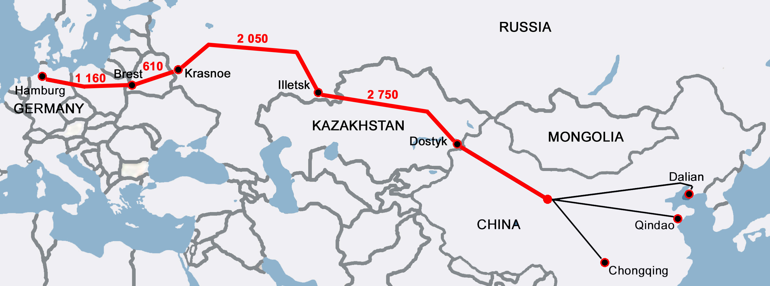
Source: Transcontainer, CCTP (Annual TSR Digest 2015. Coordinating Council on Trans-Siberian Transportation International Association, 2016)
In 2014, 164 block trains were dispatched to Europe. Within those trains there were 13,409 TEUs had been transported which was a 47% increase compared to the same period of 2013. In 2014, 100 container trains were dispatched to Zabaikalsk. Within those trains there were 9,287 TEU transported which was a 57% increase compared to the same period of 2013. In the course of 7 months of 2015, 90 container trains were dispatched to Europe. Within those trains there were 6,266 TEU transported which was a 6% decrease compared to the same period of 2014.
In the course of 7 months of 2015, 65 container trains were dispatched to Zabaikalsk. Within those trains there were 5,334 TEU transported which was a 2% decrease compared to the same period of 2014.

Figure 1.19
Container Sevice Souzhou (China) – Warsaw (Poland) by Transcontainer
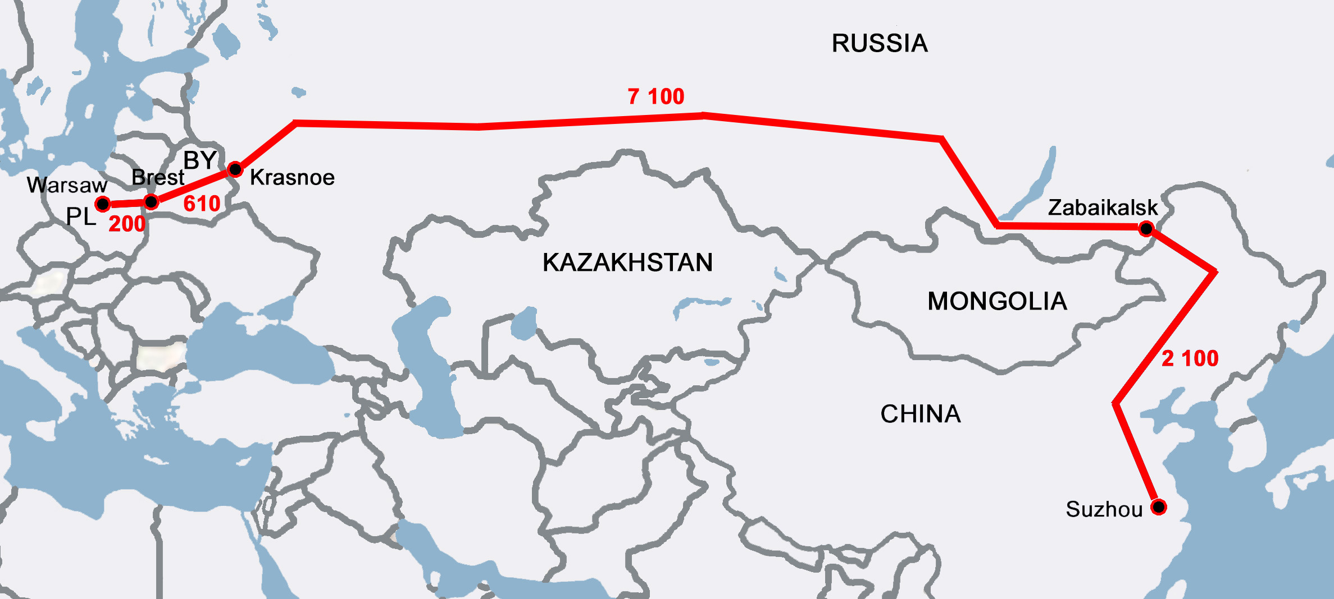
Source: Transcontainer, CCTP (Annual TSR Digest 2015. Coordinating Council on Trans-Siberian Transportation International Association, 2016)

Figure 1.20
Container Sevice Hamburg - Beijing
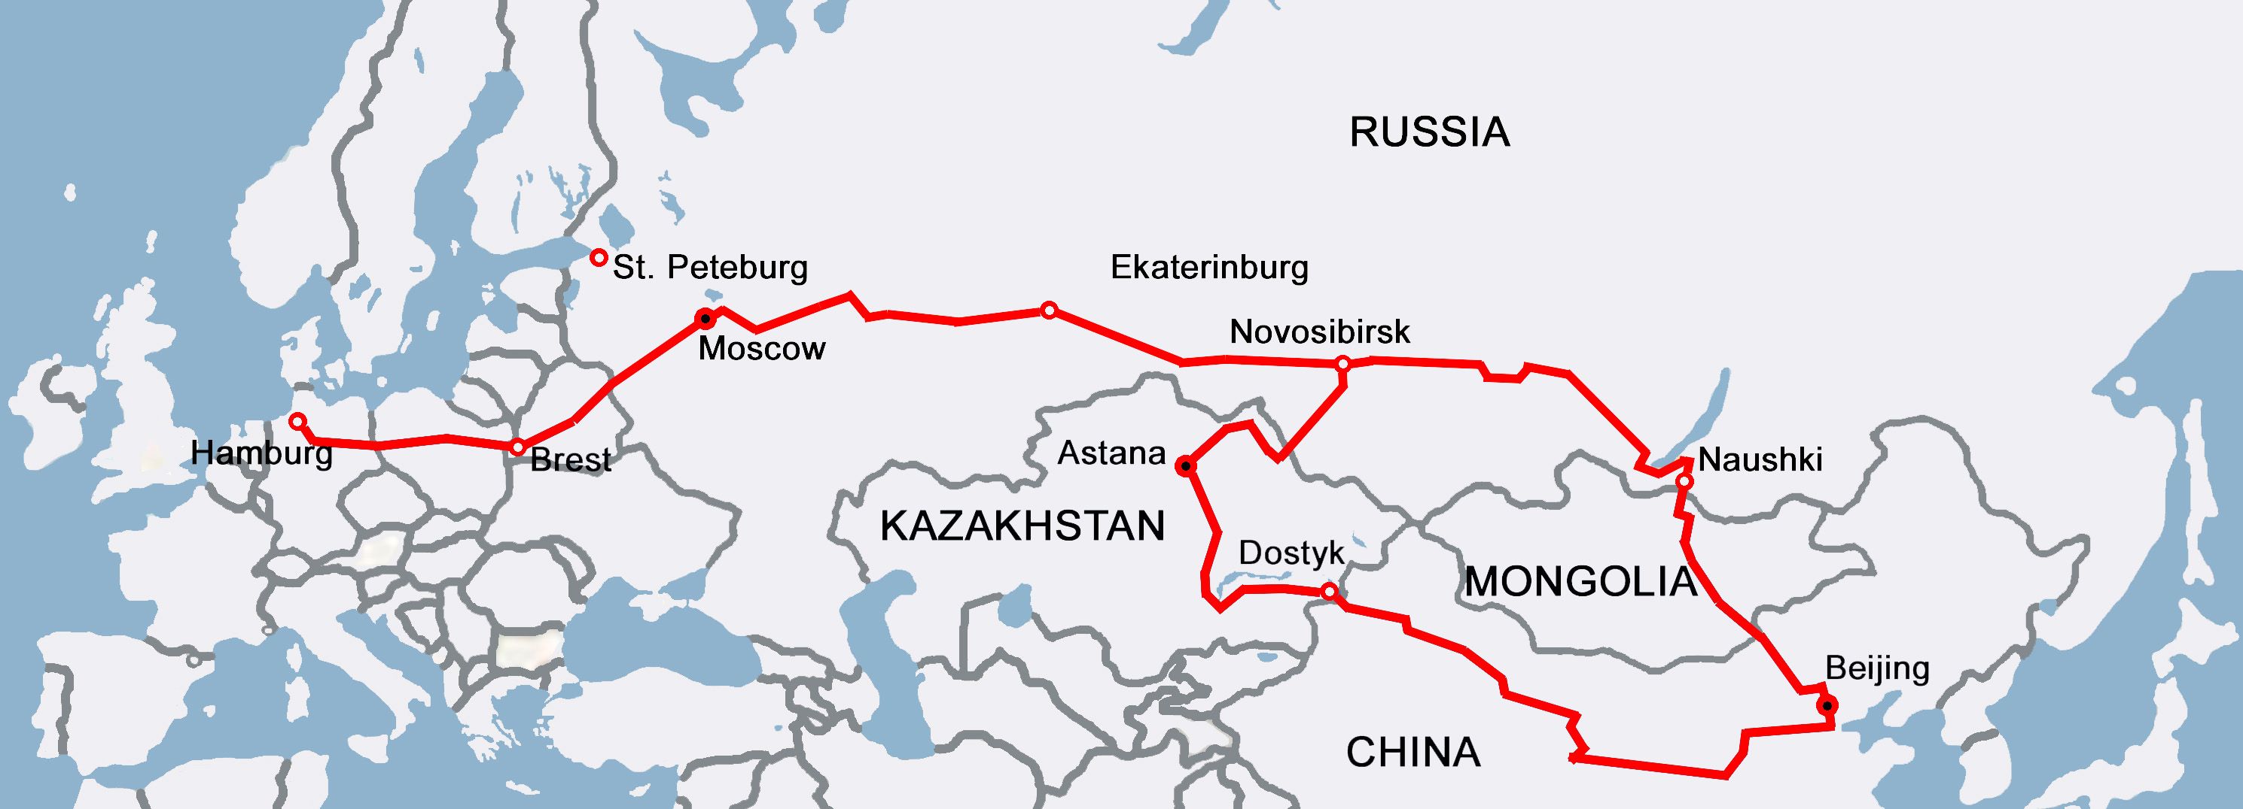
Source: Transcontainer, CCTP (Annual TSR Digest 2015. Coordinating Council on Trans-Siberian Transportation International Association, 2016)

Figure 1.21
Container Sevice from Republic of Korea to Europe
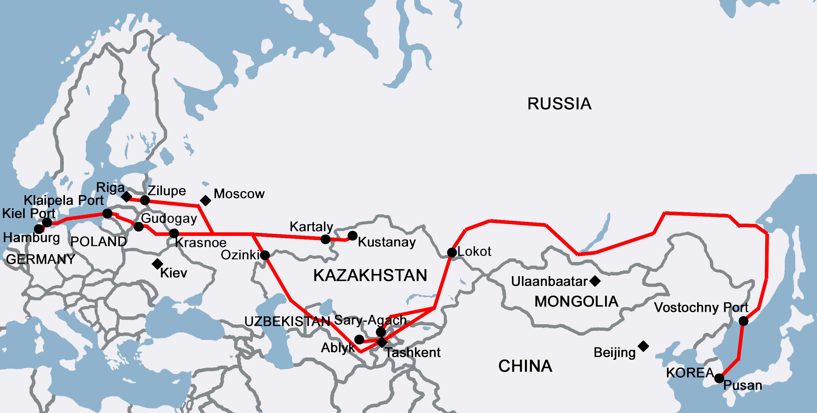
Source: Transcontainer, CCTP (Annual TSR Digest 2015. Coordinating Council on Trans-Siberian Transportation International Association, 2016)

TransContainer services via Port Vostochny
Container train No. 1031 / 1032 NakhodkaVostochnaya - Zaschita
The route is used for Kia and GM automobile spare part transportation. TransContainer is the service operator. In 2014, 74 trains were dispatched on this route with 9,285 TEU transported which is 13% fewer than in 2013.
Container train No. 1029 / 1030 NakhodkaVostochnaya - Sergeli
The route from Korea to Uzbekistan via the territories of Kazakhstan and Russia is used for the GM - Uzbekistan joint venture automobile spare part transportation. Furthermore, the route is used for mix freight, synthetic resin and polyethylene transportation. In 2014, 54 trains were dispatched on this route with 70,073 TEU transported.
Container train No. 1029 /1030 NakhodkaVostochnaya - Qostanay
The route is used for SsangYong Motor Company, Iveco, and Toyota automobile spare parts transportation. In 2014, 36 trains were dispatched on this route with 4,658 TEU transported which is 18% more than in 2013.
Container train No. 1031 /1032 NakhodkaVostochnaya - Ulugh Beg
The route is used for Isuzu mini-van spare part transportation to the SamAuto factory in Uzbekistan. In 2014, 17 trains were dispatched on this route with 1,789 TEU transported which is 2.2 times as much as in 2013.
Container train No.1031 / 1032 NakhodkaVostochnaya - Pitnyak
The route from Korea to Uzbekistan via the territories of Kazakhstan and Russia is used for the GM - Uzbekistan joint venture automobile spare part transportation. In 2014, 25 trains were dispatched on this route with 2,795 TEU transported.
Projects of RZD Logistics (RZDL) and Far East Land Bridge (FELB)
In order to establish transport and logistics chains in the international market RZDL (Russian Railways subsidiary) applies competences of its affiliates - Far East Land Bridge (FELB) specialising on transit railway container transportation on the China - Europe - China route via Zabaikalsk, while YuXinOu (Chongqing) Logistics Co. Ltd. operates regular railway container transportation on the Trans-Kazakhstani China - Europe - China route.

Figure 1.22
FELB Technology of Container delivery between China and Europe
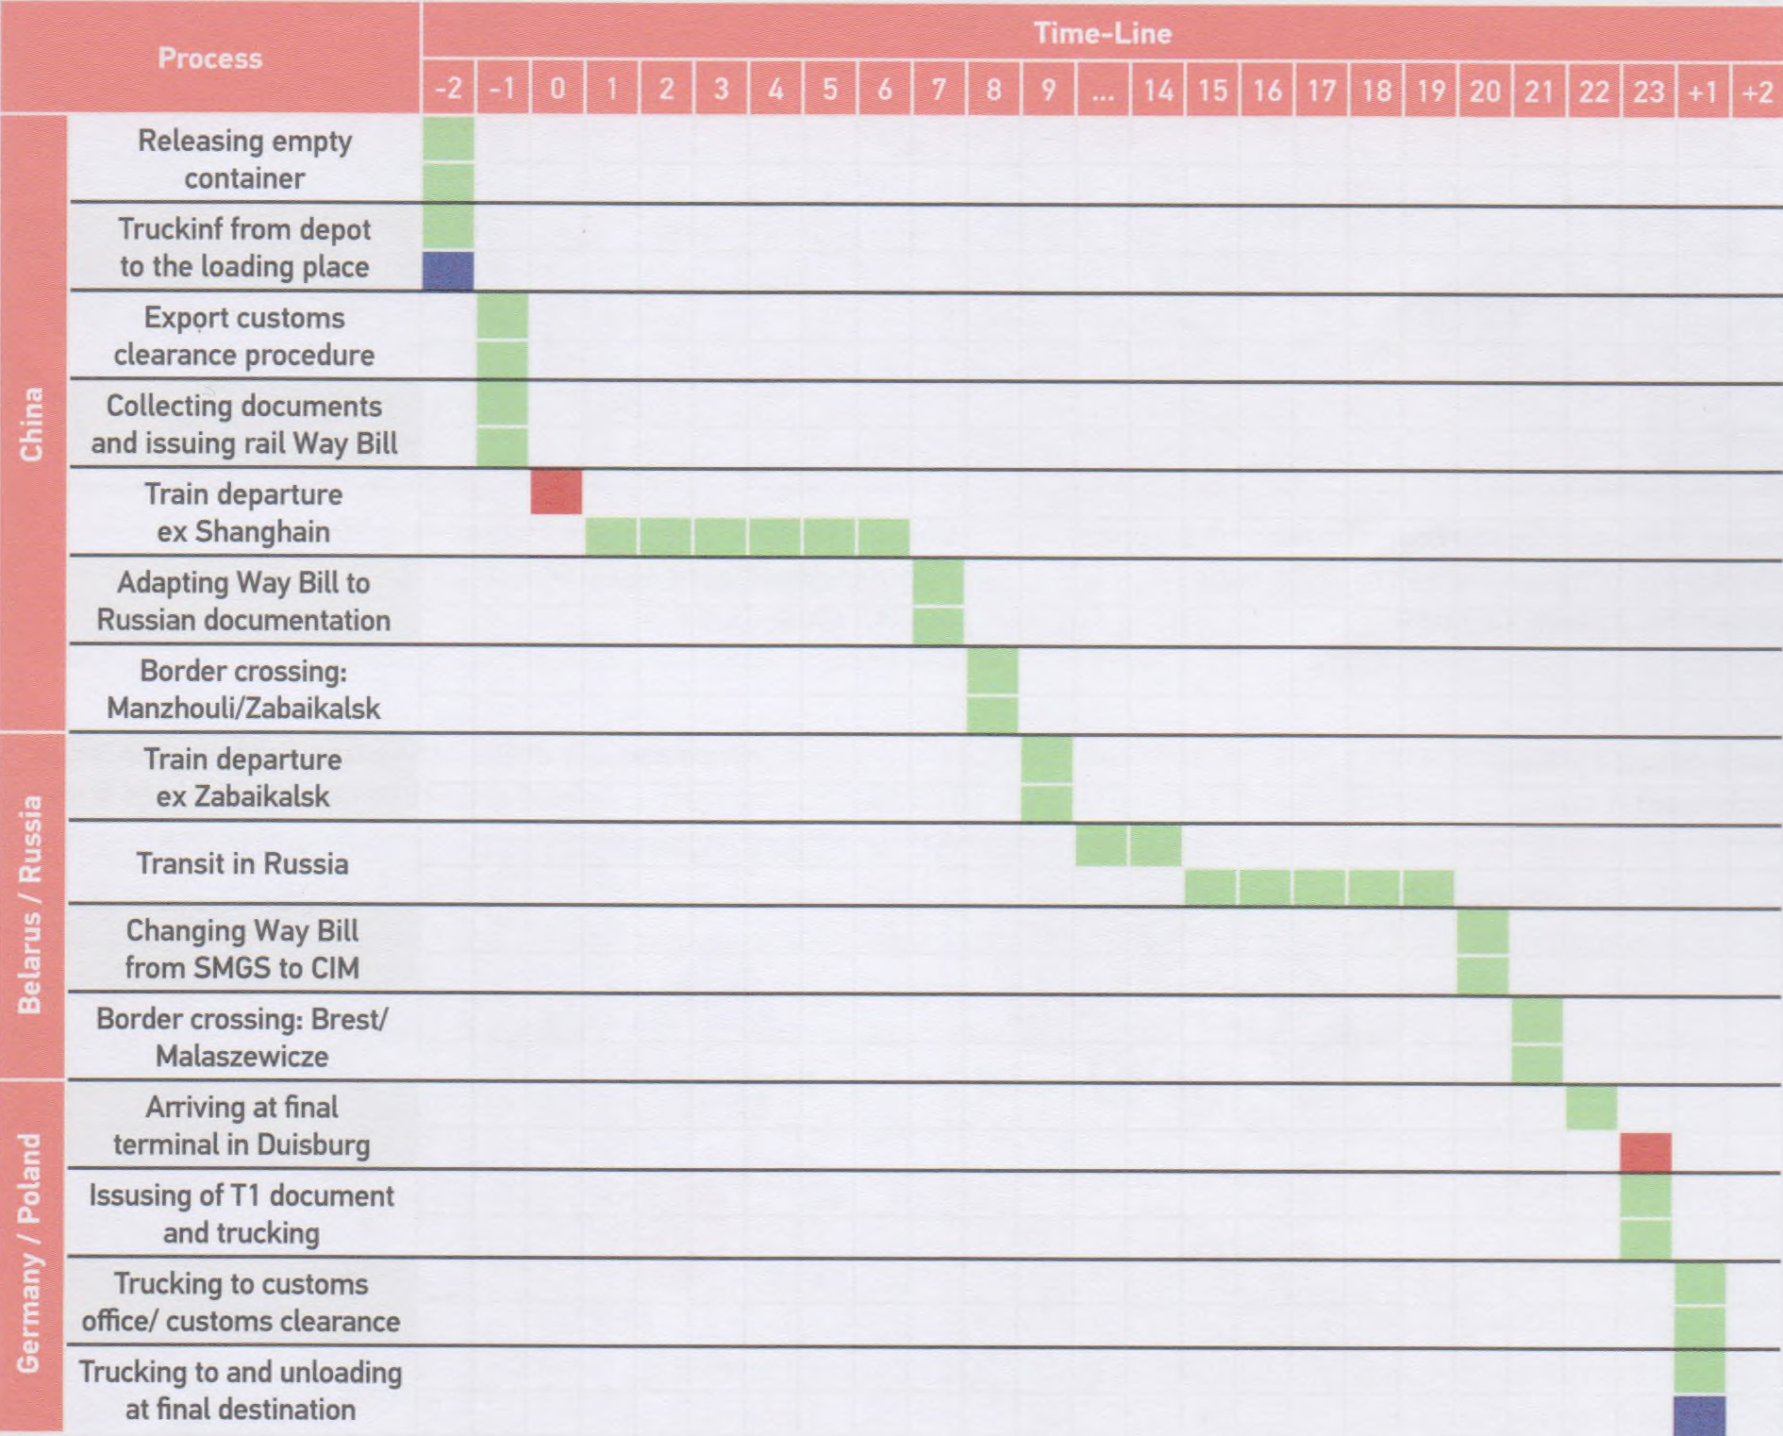
Source: Annual TSR Digest 2015. CCTT, 2016
FELB uses border points for cargo heading from China to Europe, such as Brest / Malaszewicze (Belarus / Poland) for cargo transported to Poland, Germany, Holland and Belgium; Dobra / Chop (Slovakia / Ukraine) - to Czech Republic, Slovakia, Italy, Austria and Slovenia; Zahony / Chop (Hungary / Ukraine) - to Hungary, South Germany and Austria. The consignors of commodities delivered across these routes are electronics and automotive manufacturers.
A new FELB service on the Trans-Siberian Route is the container train service from Suzhou, a large industrial center in the South-Eastern part of China, heading to Warsaw, Hamburg and Duisburg (Germany). Trains are dispatched from China to Europe on a daily basis.
It took RZDL and FELB only a few years of operation on the Trans-Siberian Route to double-cut the trip time. Todays average transit time of transportation is 14 - 16 days. Other advantages of the service include an option of ordering ‘door- to-door’ delivery and less-than-car load freight transportation.
The total number of containers transported in2014 by RZDL in the China - Europe - China transit service via the Trans-Siberian route and its Trans-Kazakhstan branch amounted to approximately 27 thousand TEU.

Figure 1.23
Souzhou (China) – Europe Container Sevices by RZD Logistics
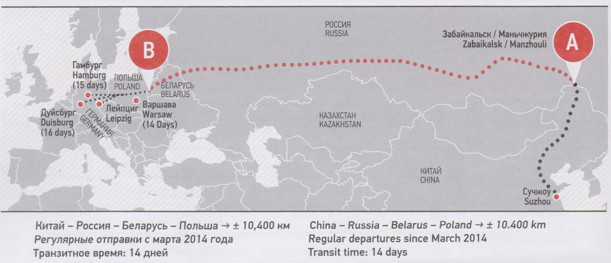
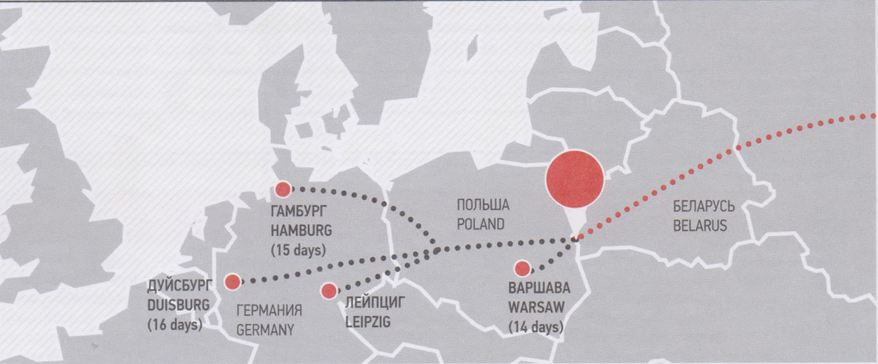
Source: Annual TSR Digest 2015. Coordinating Council on Trans-Siberian Transportation International Association, 2016
In 2014 100% of RZDL shares were contributed into the UTLC charter capital, with UTLC integrates the assets of certain Russian, Belarussian and Kazakh railway entties in order to develop the. transit container services within the Euro-Asian Economic Union and its Common market of services.
Joining UTLC will help RZDL to promote in certain transit projects for customers in China, Korea and Europe.

Figure 1.24
Asia – Europe Container Sevices by RZDL and FELB
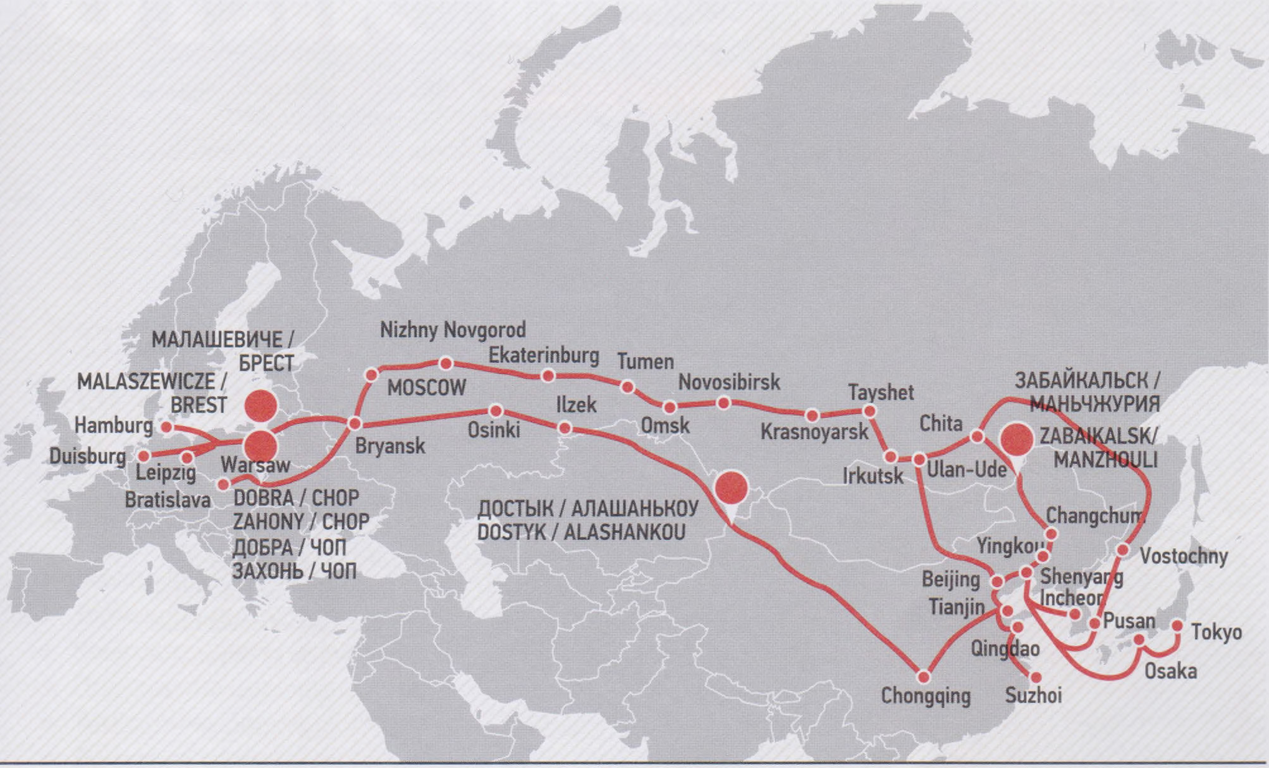
Source: RZD Logistics, Far East Land Bridge

UTLC Projects
In September 2015 United Transport and Logistics Company JSC (UTLC, affiliate of RZD) organised s container train dispatch from the port of Yingkou (PRC) to Moscow. The project was implemented according to the memorandum on cooperation between RZD and Yingkou Port Group.
The block train carrying of 45 containers with consumer goods departed from the port on September 17 and in two days covered the distance to the border point in Zabaikalsk. There the train set was added with 17 more containers.
In order to simplify the customs clearance procedures while crossing the border the early notification system was used. It allows checking the shipping documents prior the trains arrival at the destination point. That resulted in significant cut down of transit note formalisation timing. Total transit time of cargo delivery by that train is 13 days.
Far East Land Bridge as a member of UTLC group is specialized in transporting 40ft DV. 40ft HC and 20ft containers from the Far East (China, South Korea and Japan) to Russia/Europe and vice versa using the Trans-Siberian railway connection. Our clients can gain significant financial advantages from the short transit time of 14-22 days (depending on volume and relation).

DB Scheker Rail AG and TEL Projects
Based on the railway cargo transportation volumes, DB Schenker Rail AG is a global integrated transport and logistics service supplier and the largest freight railway company in the European Union territory.
One of the key business activities of the company is the establishment and development of transport routes linking the European Union countries with Russia, other former Soviet Union states, Mongolia and China.
One of these solutions’ practical examples is the regular railway service providing making up and dispatching container block trains connecting China and Germany. The service operator is Trans Eurasia Logistics GmbH (TEL), a joint venture of Deutsche Bahn AG and RZD. The service is capable of delivering cargo from more than 24 geographical points of China to Germany with final destinations in Duisburg and Hamburg.

Figure 1.25
Regular Intermodal China – Europe Sevices by DB Scheker Rail AG and TEL
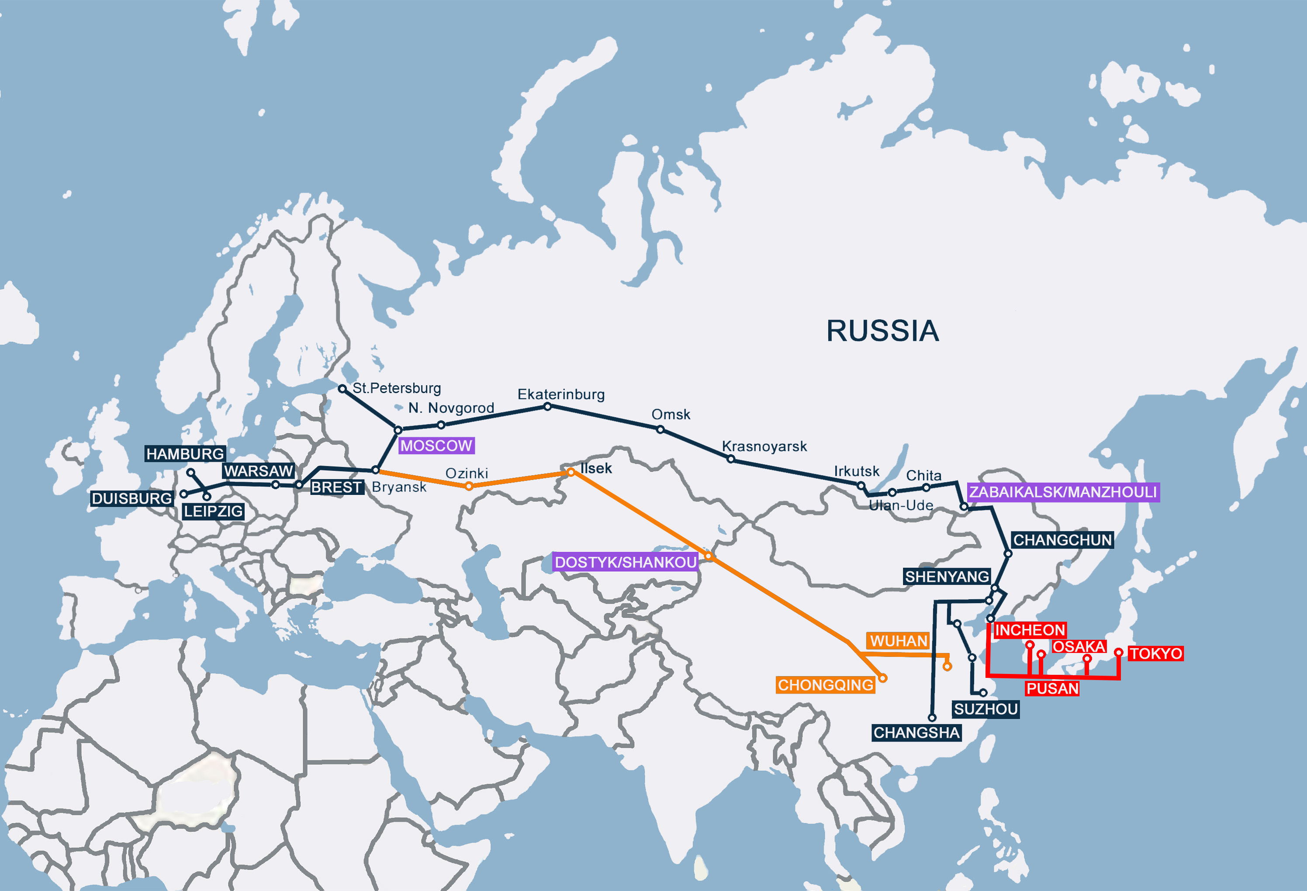
Source: Annual TSR Digest 2015. Coordinating Council on Trans-Siberian Transportation International Association, 2016
The estimated transit time from the freight transfer moment at the border crossings to Dostyk (Kazakhstan) / Alashankou (China) or at Zabaikalsk (Russia) / Manzhouli (China) to Brest (Republic of Belarus) / Malaszewicze (Poland), is 10 days. The transit time along the territory of the European Union from Malaszewicze to Duisburg / Hamburg is 1.5 days.
More than 40,000 TEU were transported through both of the routes in 2012 - 2014.
It is noteworthy that the China - Germany railway route is the longest railway route in the world.

Figure 1.26
Rail Network Covered by DB Scheker operations
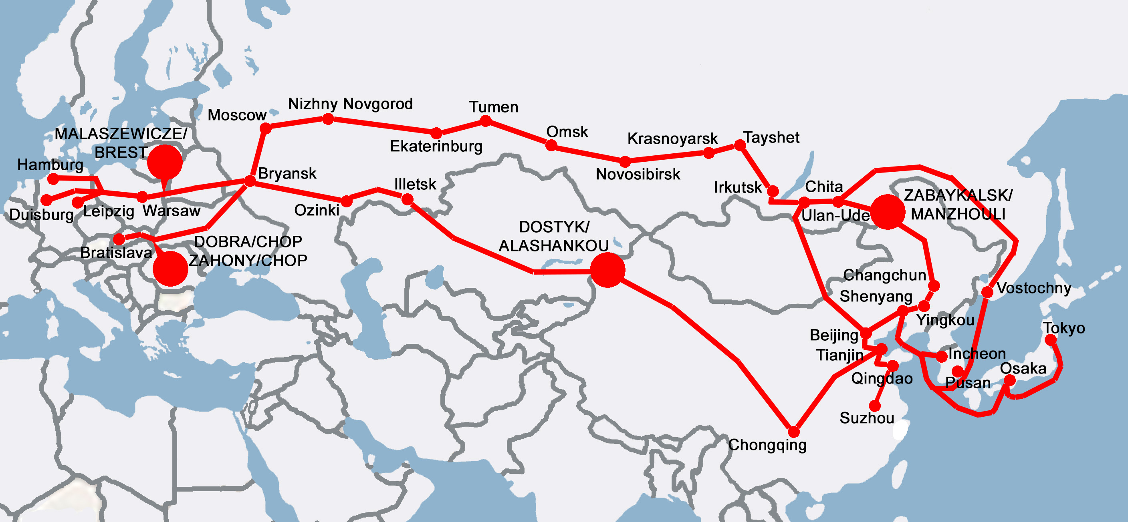
Source: Annual TSR Digest 2015. Coordinating Council on Trans-Siberian Transportation International Association, 2016
Developing Container Services
Urumchi - Zahony - Austria
Hungary’s accession to the European Union enabled the creation of a new container service which would connect Zahony with Urumchi, an industrial and logistic centre of China, and would pass through the territories of Kazakhstan, Russia and Ukraine (figure 1.26).

Figure 1.27
Regular Intermodal Services between China and Hungary/Austria
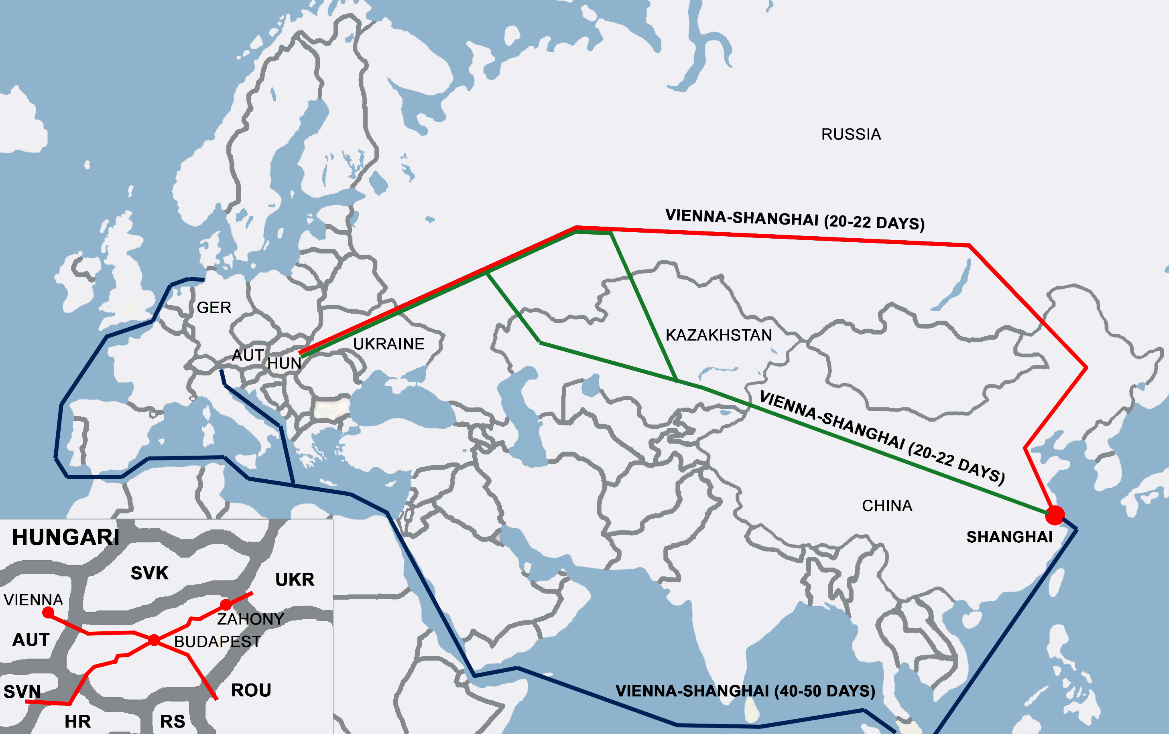
Source: Annual TSR Digest 2015. Coordinating Council on Trans-Siberian Transportation International Association, 2016

“Baikal Shuttle” Project by RZD
A new RZD transport product (with the name title ‘Baikal Shuttle’) is developed to transport goods manufactured in East Asian countries (Japan, South Korea) that have no direct connection to the Russian railways, heading to Siberia and European part of Russia as well as transit transportation to East and West European countries.
This service will provide Japanese and South Korean consignors with the ability to transport containerisable volumes of cargo on a regular basis with strictly followed frequency and schedule accuracy of the door-to-door basis. The block train en-route time is 8 days 3 hours 57 minutes. Currently it is planned to cut the transit time down to 7 days.
The set of services for consignors is formed based on specific objectives of the clients. Transport and value added logistics services within the ‘Baikal Shuttle’ transport product are provided by RZD affiliated companies - UTLC and GEFCO. The service consists of empty container delivery to a consignor’s warehouse, container pre-carriage to the port and loading it on board the ship, customs formalisation in the ports of Japan and South Korea, maritime transportation, customs procedures in the port Vostochniy, load off of container handling and loading it on the train, railway transportation to Moscow, delivery of container to a consignee’s warehouse.

FESCO Multimodal Container Services along TRANSSIB corridor
FESCO transport group (the parent entity is - Far-Eastern Shipping Company) is one of the major private logistics companies in Russia having assets in port, railway and integrated logistics business. FESCO asset diversified portfolio allows delivering cargo of a ‘door-to-door’ type and controlling all stages of multimodal transport chain. The majority of the Group operations is focused on the Far East of Russia which provides FESCO with an opportunity to get additional advantages from participating in dynamically growing volumes of trade operations between Russia and Asian countries.
Container transportation is the FESCO Groups core business. With all required assets FESCO delivers containers using multimodal schemes or organises separate maritime container transportation or railway dispatches. The Group also carries out dispatches of refrigerated containers by sea and rail. Sea lines, railway assets and owned port terminals allow performing the ‘door-to-door’ container transportation, with no risk of freight safety loss at the same time.
FESCO services provide, among other, for regular transportation based on the schedules of FESCO Shuttle container trains running on the Transsib - one of the innovative technologies of the railway transportation which allows FESCO organising fast container trains running in the territory of Russia.
Regular transportation by the flagman container train on the FESCO Moscow Shuttle route from the port of Vladivostok to the Silikatnaya station in Moscow is performed 9-12 times a week which provides multimodal services from the major ports of China, South Korea, Japan and South-East Asian countries. The transit time from China via Vladivostok to Moscow is 28-33 days; the en-route time from Vladivostok to Moscow is 11 days.

Figure 1.28
Regular FESCO Intermodal Services
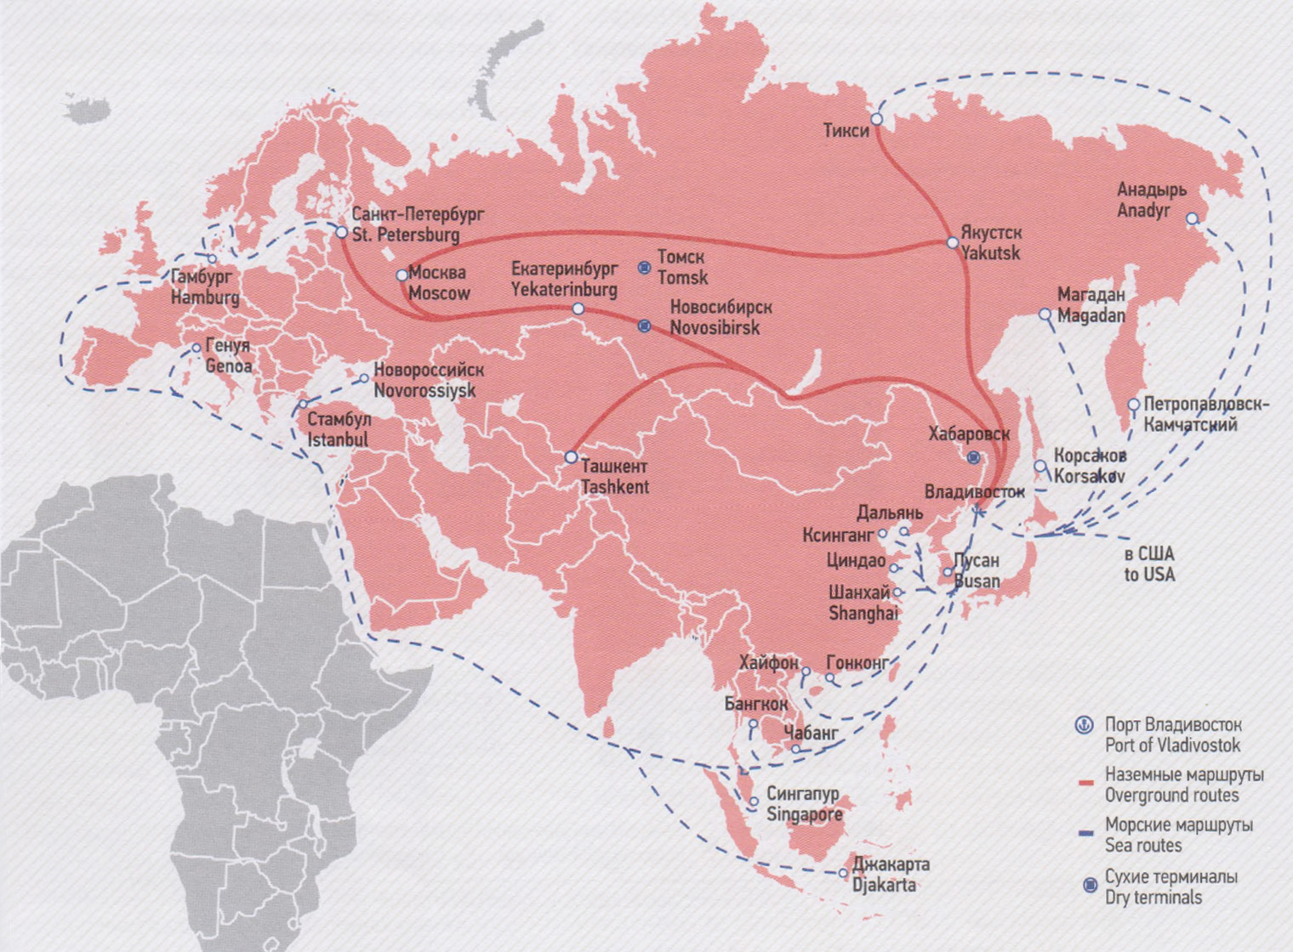
Source: Annual TSR Digest 2015. Coordinating Council on Trans-Siberian Transportation International Association, 2016

Twice a week FESCO Siberian Shuttle container trains are dispatched from Vladivostok to Novosibirsk and back to Vostochniy station. The transit time from the ports of South-East Asia via Vladivostok to Novosibirsk is 25-30 days, the en- route time from Vladivostok to Novosibirsk is 7 days. Every week containers from South-East Asia are delivered through the FESCO Ural Shuttle line to Yekaterinburg in 32-37 days, including the section from Vladivostoc to Yekaterinburg covered in 9 days. The shuttle technology is also well-proven on the Moscow-Novosibirsk and Moscow-Khabarovsk routes. The ‘Baltica-Transit Service delivers cargo from the Baltic states to Kazakhstan, Central Asian countries, Afghanistan and China.
In March 2015, FESCO opened a new FESCO Baltic Shuttle service (FBS) connecting South-East Asia via Vladivostok with Saint-Petersburg. The railway haul of FBS is the route from the Vladivostok station to the Shushary station in Saint-Petersburg. FBS is dispatched from Vladivostok once a week in accordance with the schedule. The service is organised as a loop route with a return dispatch from Saint-Petersburg to Vladivostok and via Vladivostok to SouthEast Asia and to the ports of the Far East of Russia - Petropavlovsk-Kamchatski, Magadan, Korsakov

FMS (FESCO Moscow Shuttle) - Vladivostok - Moscow
Regular transportation of cargo within container trains from the ports of South East Asia to Moscow on the basis of line maritime and railway serviceschedules, as well as forwarding in the port, terminal processing, provision of container fleet and delivery to a warehouse. The railway haul of the service is the route from the Vladivostok station to the Silikatnaya station in Moscow. The service is oriented towards the cargo heading from the ports of South-East Asia via the Vladivostok port, freight put together in the Far East Region, as well as the cargo of the third party forwarders. Return service from Moscow to Vladivostok and the ports of South East Asia is also available.
FTS (FESCO Tashkent Shuttle) - Vladivostok – Tashkent. The route originates in the ports of South-East Asia via Vladivostok and heading further to the Chukursay station in Tashkent. The final destination point is the new ULS container terminal. Currently the frequency of the train service departures is twice a month. The transit time of the whole railway route from Vladivostok to Chukuray is 12 days, the return trip of containers after unloading in Tashkent is 12 days. The multimodal route also implies a possibility of delivering cargo based on the ‘final mile’ principle, i.e. to the client’s door in the range of 500 km from the final destination point.
FESCO also provides the following services:
- FSS (FESCO Siberian Shuttle) - Vladivostok – Novosibirsk and FSSe (FESCO Siberian Shuttle eastbound) - Novosibirsk – Vladivostok;
- FUS (FESCO Ural Shuttle) - Vladivostok – Yekaterinburg;
- FAS (FESCO Amur Shuttle) - Moscow – Khabarovsk and FASw (FESCO Amur Shuttle westbound) - Khabarovsk – Moscow;
- FOS (FESCO Ob Shuttle) - Moscow - Novosibirsk
- FLS (FESCO Lena Shuttle) - Moscow - Yakutsk/ Berkakit; Vladivostok – Yakutsk. The transit time from Moscow to Berkakit is 15-17 days, and to Yakutsk it is 21-23 days. The dispatches from Vladivostok to Berkakit will be carried out once in 6-10 days. The transit time will be 6-8 days.

Container services to/from Mongolia
The ‘Mongolian Vector’ train is in service since 2002 running from Europe to Mongolia on the Brest - Ulan-Bator route.
The train is dispatched from Brest on a regular basis on the 10th, 20th and 30th day of every month. The transit time en-route from Brest to Ylan-Bator (7,340 km) at the end of 2014 was 12.36 days.
Starting from 1 March 2005 the route of the ‘Mongolian Vector’ container train was extended to China on the Hohhot (China) - Erlyan - Naushki - Brest - Duisburg route (9,821 km) via Mongolia, once a month, with the transit time of 17.97 days. In 2006, approximately 600 TEUs were transported in both directions. The ‘Mongolian Vector’ container train is in service within the framework of the joint ESCAP and OSJD project ofimproving the effectiveness of the Euro-Asian railway routes.
Starting from May 2014 a China - Europe train started its service on the Erlyan - Naushki - Brest route. The train is dispatched once a month. Thus, currently there is a loop route between Europe and China which the container train runs in both directions on.

Figure 1.29
Mongolian Vector Container Block Train Route
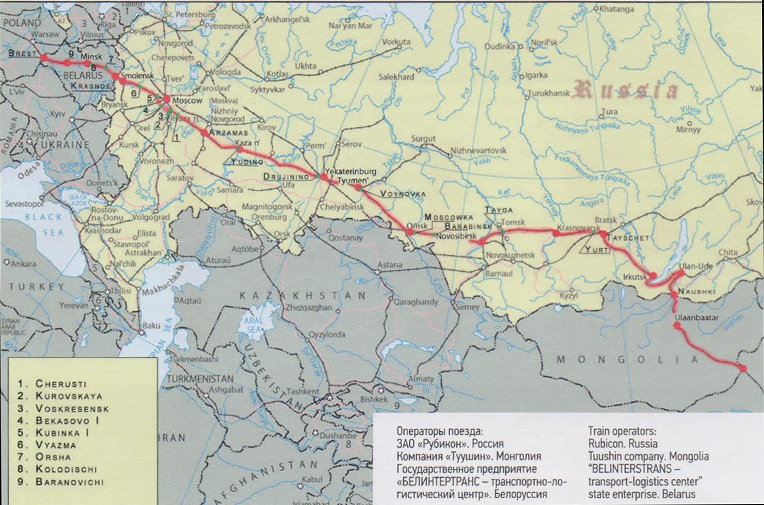
Source: BelInterTrans, 2013

Another railway container services across the EATL routes
COSCO Logistics.COSCO Logistics, the largest 3PL in China uses the routes shown in the Figure 2.6. The commodities transported include equipment, tools and building materials for cement production, electrical power station equipment including capacitor set, capacitor voltage transformer substation, and monitoring system and finally well drilling, logging, and well cementation for Kazakhstan oil fields. Currently, COSCO is examining other options with combination of sea and rail transport for transportation between China and Europe. One of the options is for the cargo to enter Europe through the port of Piraeus in Greece and then be transported by rail to central and northern Europe. [IDWP#5]

Figure 1.30
COSCO Logistics railway routes
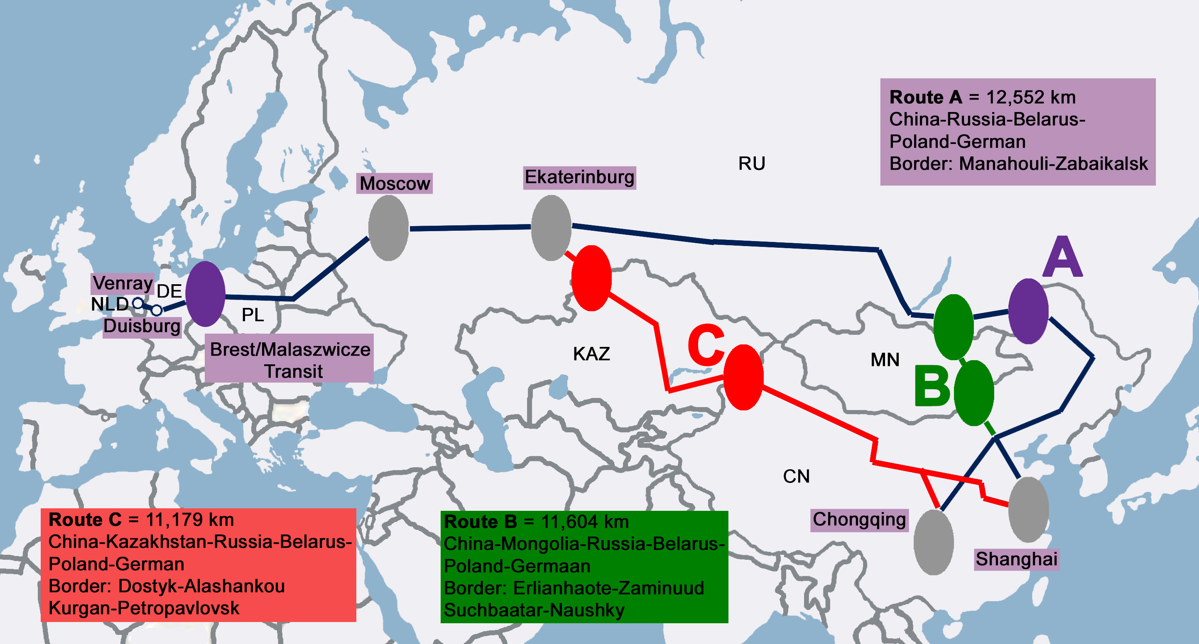

DHL.Deutshce Post -DHL uses several routes to establish the services from Asia to Europe. Since 2011, DHL has been running a daily intermodal service from Shanghai to Moscow via the Trans-Siberian Railway. A weekly express freight train service was launched in 2013 from Chengdu in western China, across Kazakhstan to its cargo port in Poland and then in Russia and Belarus by truck or train, with travel time of 12-14 days. The transported products are mainly electronics, machinery, pharmaceuticals and chemicals.
In January 2014 the company introduced the first temperature-controlled rail container service between China and Europe on a year-round basis. In March 2014, DHL Global Forwarding announced the development of rail-based forwarding services on the China-Europe route via a new joint venture called United Transport and Logistics Company (UTLC), which plans to operate door-to-door delivery times of 21 days[IDWP#5].
DB Schenker. In 1973 the company started providing rail services through the Eurasian land bridge by running the first container along the Trans-Siberian railway route. In 2008 the first train with goods between Beijing and Hamburg was launched and in the beginning of 2009 a weekly regular service between Shanghai and Beijing with Hamburg, Nuremberg and Duisburg was offered. The products transported are mainly from the automotive industry, chemical industry and manufactures of household goods. In 2009 in cooperation with the Russian Railways (RZD), DB Schenker Logistics established the Trans Eurasia Logistics GmbH.
DB Schenker operates also in the Northern rail route from Shanghai to Moscow and then to Duisburg through the Trans-Siberian line with a transit time of 18-20 days. In September of 2011 a regular train service began to operate for BMW on the route from Leipzig to Shenyang (eastbound). In November, a daily container train service was launched for this destination exclusively for BMW for automotive components. From 2012 the company offers a weekly service from Chongqing to Duisburg for IT customers. The transport time for a block train to reach its destination in Duisburg is 18 days. Further to this service, in September 2014 the first freight train run from Hamburg to Zhengzhou in China. The duration of the journey is around 17 days and is about 20 days faster than by sea. [IDWP#5].
KTZ Express.KTZ Express, established in 2013 and being the national multimodal transport and logistics company of Kazakhstan Railways (KTZ), provides rail freight services that take 16 days through Kazakhstan territory, twice or thrice less compared to sea shipping. The products transported are pharmaceuticals, farm produce and electronics with a focus on electronic companies that have their plants in Chongqing or to their suppliers such as Foxconn Technology for Apple Inc. and Acer Inc. Industries such as Hewlett Packard and Toyota Tsusho already use this rail route. There is also an interest from Europe for dedicated block train services to Asia for products such as fruit and automotive parts [23]. In October 2014, the company plans a new rail freight service from Shenzhen, Guangzhou, Wuhan and Xi’an to Europe, announced by the Governments of China and Kazakhstan [IDWP#5].
Yuxinou (Chongqing) Logistics Co., Ltd.TheYuxinou (Chongqing) Logistics Co., Ltd. provides freight railway services between Asia and Europe. One of the main services is the Yuxinou train which travels from China via Kazakhstan, Russia, Belarus and Poland to Germany with travel time 16 days. It’s one of the weekly services leaving the industrial hub of Chongqing and having as customer electronic companies such as Hewlett-Packard Co., Acer Inc., Apple Inc. and supplier Foxconn Technology Co [IDWP#5].
The Far East Land Bridge Ltd.The Far East Land Bridge is one of the first logistic companies, which provided railway services between Europe and Asia and has its base in Vienna, Austria. In 2007 they started providing two-way container rail services via the Trans-Siberian Railway route and European and Chinese rail networks. The main customers of the company are industries such as BMW, Audi, Volkswagen and Samsung [IDWP#5].
Wuhan-Europe freight trains. The Wuhan-Europe freight train is express cargo train that carries containers between Wuhan and European cities. At present, Wuhan-Europe freight train links Wuhan with over 20 countries, including Germany, Poland, Czech Republic, Russia, Belarus, 5 countries in Central Asia, etc. Besides customized trains and public trains, random trains and LCL services were also provided to serve small and micro enterprises.
In 2014, Wuhan-Europe freight train ran 4 lines, with two passing customs at Alataw Pass, and the other two passing customs at Khorgos and Manzhouli, respectively.
2015 has witnessed the opening of two-way freight trains linking Wuhan with Hamburg and Duisburg in Germany, as well as a “Russia-Manzhouli-Wuhan” timber train. A train linking Wuhan with Minsk of Belarus was launched on Sept. 24, 2015. Besides, the China-Europe freight train links Wuhan with Moscow on Oct. 24, 2015, forming a bilateral flow with the previous “Russia-Manzhouli-Wuhan” timber train.

Figure 1.31
Wuhan-Europe freight trains operation scheme (source – Hubay Government site)
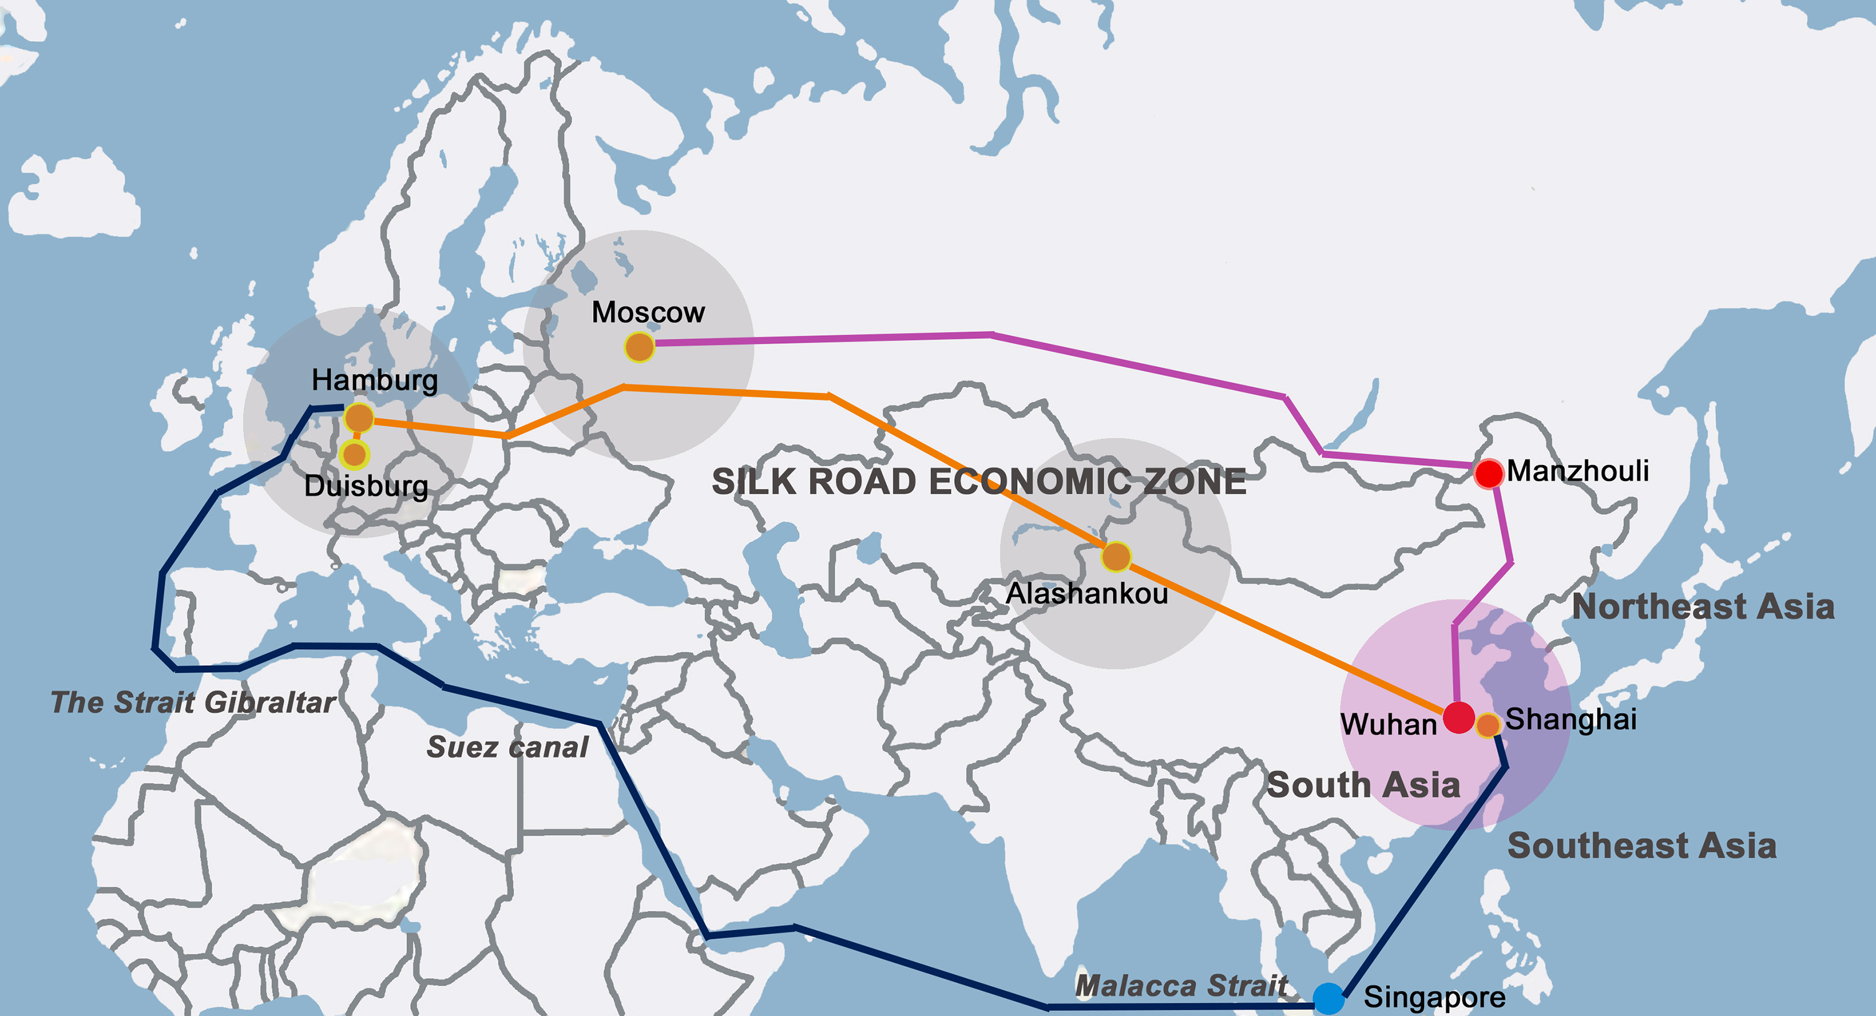
In November 2015, Wuhan Asia-Europe Logistics Co., Ltd signed commerce and trade logistics strategic reciprocal agreement with 12 Chinese and Russian logistics companies. Wuhan Asia-Europe Logistics Co., Ltd. announced on January 5, 2016 that Wuhan freight trains ran a total of 164 shifts in 2015, carrying 14,912 TEUs. The growth rate exceeded 500%, ranking first nationwide. The main cargoes transported are:
- from Wuhan: electronic equipment, automobiles, clothes, general merchandise of companies including Foxconn, Dongfeng, AOC, WISCO, etc.;
- from Europe: plastic floor, plastic compression roller, auto parts, cosmetics, fishing gears, timber, etc.
It is planned that Wuhan-Europe freight train will extend operations westwards and establish offices in countries like France [19].
China Railway Express .China Railway Express Co., Ltd. was founded in 1993 and is based in Beijing, China. The first China – Europe container block train under the family brand “China Railway Express” arrived in Poland. On 8 June 2016 the train set off from station in Chengdu, the capital of the Chinese province of Sichuan, then crossed the territories of Kazakhstan, Russia and Belarus and arrived 12 days later in Warsaw.
The twenty-two carriage train delivered electronics goods and auto parts to the Polish State Railways (PKP) Cargo Terminal in Warsaw. The arrival of the China Railway Express marked the opening of the New Silk Road - a Chinese project to open a new commercial route linking Asia and Europe. At the same time a container block train with Polish goods set off in the opposite direction to China.
The business model of railway transportation within the described supply chains is currently based on the “corporate” scheduled block trains serving individual shippers and operating from plant to plant (or from the plant to logistic center). These trains support constant guaranteed industrial cargo flows of the selected customers. Most of the examples described in I.3.3 follow this model.
The next step – introduction of public regular services for customers shipping less than full train loads – is more complicated. To make the business viable and to attract enough traffic the transport operator should contact numerous shippers not only in the origin point, but all along the route. Intermediate stops on the way mean also contracting local terminal operators and probably freight forwarders.
At the moment there are not so many known services of this type, but the number of examples is growing up. Often “corporate” train operators use the excessive capacity to attract customers from the market which seems to be the natural way to develop public regular container services..

I.3.4. Road transport
Road transport plays an undeservedly small role in Euro-Asian trade, serving primarily intra-regional connectivity.
In the meantime the results of ADB CAREC Program, NELTI Project and other important international and regional initiatives have shown that there are safe and efficient options for moving cargoes between Europe and some Asian states (incl. Central Asia, Mongolia and Afghanistan) and that road infrastructure is no impediment to long-distance transportation.
Cargoes can be carried between Europe and Asia by road transport, whose advantages are in:
- Guarantees of an acceptable tariff rates (road transport rates prescribed by competition on the market of road transport services)
- High quality and safety of cargoes delivery (cargo safety conditions, absence of transloading, door-to-door logistics, customs safety, etc.)
- Absence of cargo shipment accumulation (in contrast to rail or maritime transport)
- Benefits for small and medium enterprises, involved into export and import of goods, as well as for customers.
According to IRU Permits Study based on the World Bank QuARTA methodology, permit systems are one of the key mechanisms with which to gain access to the market for international road transport operators. There are 286 bilateral road transport agreements applied only in 12 countries of Eurasia – Armenia, Azerbaijan, Belarus, Georgia, Kazakhstan, Kyrgyz Republic, Republic of Moldova, Russian Federation, Tajikistan, Turkmenistan, Ukraine and Uzbekistan - participated in the EATL Project (with more than 10 million paper permits issued annually).
If two countries of Europe and Asia do not have concluded intergovernmental road transport agreement (as China and Germany for example), then no any bilateral, transit or third country operations is possible between them.
Table 1.22 indicates possible road transport operations between Europe and Asia in a form of matrix of corresponding EATL member countries.

Table 1.22 – Existing (possible) cargo flows by road transport between Europe and Asia in accordance with concluded bilateral/multilateral agreements on international road transport
Countries of Asia | Countries of Europe
Countries of Asia | Belarus | Bosnia and  Herzegovina | Georgia | EU-28 | FYR  Macedonia | Moldova | Russian  Federation | Serbia | Switzerland | Turkey | Ukraine
Afghanistan | - | - | + | +/- | - | - | - | - | - | + | -
Armenia | + | + | + | +/- | + | + | + | + | + | - | +
Azerbaijan | + | + | + | +/- | + | + | + | + | + | + | +
China | - | - | - | - | - | - | + | - | - | - | -
Iran | + | - | + | - | - | - | + | - | - | + | +
Kazakhstan | + | - | + | +/- | - | + | + | - | + | + | +
Kyrgyzstan | + | - | + | +/- | - | + | + | - | - | + | +
Mongolia | + | - | - | - | - | - | + | - | - | - | +
Pakistan | - | - | - | - | - | - | - | - | - | + | -
Russian Federation | + | + | + | +/- | + | + |  | + | + | + | +
Tajikistan | + | - | - | +/- | - | - | + | - | - | + | +
Turkey | + | + | + | +/- | + | + | + | + | + |  | +
Turkmenistan | + | - | + | +/- | - | - | + | - | - | + | +
Uzbekistan | + | - | + | +/- | - | + | + | - | + | + | +
India *) | - | - | - | - | - | - | - | - | - | - | -
Japan *) | - | - | - | - | - | - | - | - | - | - | -
Republic of Korea*) | - | - | - | - | - | - | - | - | - | - | -
Source: IRU, World Bank
*) India, Japan and Republic of Korea are non EATL Project countries

Legend:
+ | Existing cargo flows
+ | Road transport operations under ECMT multilateral quota
+/- | Concluded agreements and road transport operations with some EU member states
- | No agreements, no road transport operations (bilateral, transit, to/from third countries)

The People’s Republic of China is weakly integrated in the international Euro-Asian road transport system. Intergovernmental bilateral agreements on international road transport are concluded only with 4 countries (Kazakhstan, the Kyrgyz Republic, Tajikistan, and Russia). Trilateral agreement China – Mongolia – Russia (Intergovernmental Agreement on International Road Transport Along Asian Highway Network) signed on December 2016, but not entered into force. Furthermore, there is a valid quadrilateral agreement between China, Kazakhstan, the Kyrgyz Republic, and Pakistan that envisages transit cargo transportation related to Chinese and Pakistani trade across the Central Asia.
Quite restrictive characteristics of permit systems in the area of road transport of goods to and from China include:
- Lack of possibility of transit across the Chinese territory for transport operators from the Eurasian countries,
- Lack of possibility of transit for Chinese transport operators across the territory of certain Eurasian countries (in particular, Russia, Uzbekistan, etc.),
- Strictly prescribed routes and border crossing points for transport of goods,
- Lack of possibility of entering China from the territory of third country for transport operators of one country which is the partner of China under the bilateral agreement (e.g., the Russian carriers may not enter China through the territory of Kyrgyzstan),
- Limitations related to the distance of entering the territory of China for the transport operators from the Eurasian countries, and similar limitations for the Chinese carriers,
- Lack of possibility of transport of goods between China and other countries by the carriers from third countries.
The indicated limitations resulted in the situation that all international transport of goods to and from China are of near-border nature (exclusion - transportations between Pakistan and China). The prerequisite of international transportations for long distances is cargo reloading near the Chinese border. Thus, the volume of international road transport between China and its trade partners is significantly small as compared to the Chinese trade potential. Moreover, until now road transport of goods between China and Europe has been impossible.
Thus, integration of China in regional and the Eurasian transport market requires review of provisions of the existing bilateral agreements on international road transportation. Road transport development mechanisms shall be found, however, not only between China and its neighbours but between China and the European countries that will require a solution to problems related to freedom of Chinese cargo transit across the territory of Central Asia. A certain expectation for the development of international road transport between China and the Central Asian countries (to the extent of transit, bilateral transport and transport to/from third countries) is given by the multilateral SCO Agreement that was signed in September 2014 and entered into force in the beginning of 2017.
The most significant market of road transport between Europe and Asia is road transport operations between Kazakhstan and European countries.
In 2016, this market is estimated at 780 thousand tons. It is expected that it will decrease by 9.4% compared to the level of 2015, mainly due to the continuing decline in the supply of imported goods from Europe by road transport (Figure 1.32).
Road transport of export cargoes, on the contrary, is growing. In 2015, their volume amounted to 177 thousand tons (22.3% more than in 2011).

Figure 1.32 – Volume of international road transport between Kazakhstan and European countries in 2011-2016 гг., thousands tons

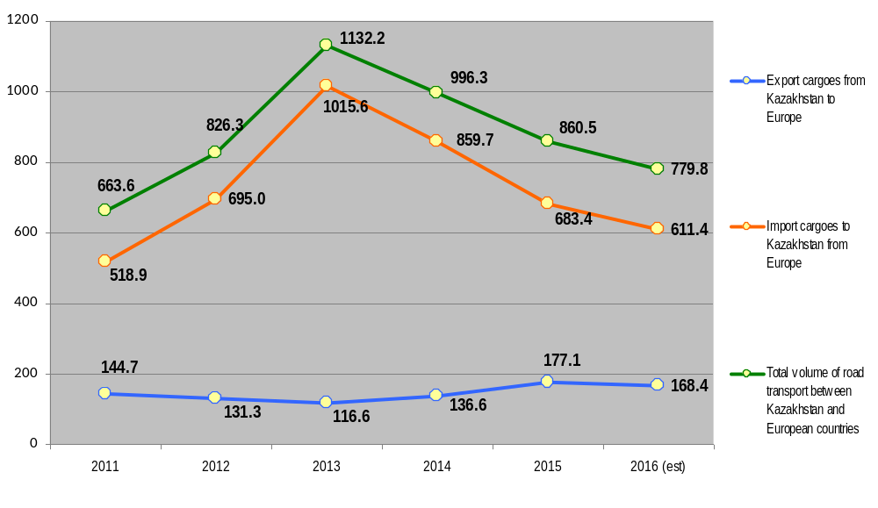

Figure 1.33 – The share of Europe – Asia and Asia Europe directions in the total volume of road transport of goods between Kazakhstan and European countries in 2011-2016, %
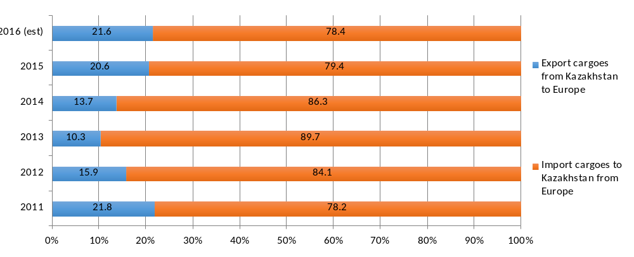
The share of Europe – Asia direction in the total volume of road transport between Kazakhstan and European countries estimated in 2016 approximately at 78% (figure 1.33).

I.3.5. Air transport

Air transport cargo flows
As a result of the fuel efficiency improving, the development of e-commerce and air transport logistics, the civil aviation plays an increasingly important role in servicing trade between Europe and Asia, competing with both maritime and inland modes of transport.
Air trade on the lanes that connect Asia with Europe grew well above long-term trend (table 1.23)
Table 1.23- Historical and forecast air cargo annual growth rates, %
Air cargo markets | History 2005-2015 | Forecast 2015-2035
World | 2.0 | 4.2
Europe – Asia | 2.1 | 4.6
Source: Boeing (2016) World Air Cargo Forecast 2016-2017
Global e-commerce is projected to more than double over the next five years, growing from $1.7 trillion to $3.6 trillion by 2020. The Asia-Pacific region is the fastest growing e-commerce trading bloc, with China at the forefront. China is the world’s largest e-commerce market with $590 billion of goods sold in 2015. Online retail sales in China were half that of the US in 2010 and by 2013 surpassed the US, growing at an average of 56 percent per year. It is forecast that by 2020, China’s e-commerce market will be bigger than the combined existing markets of the US, Britain, Japan, Germany, and France.
The explosive growth of e-commerce demand for business to consumer (B2C) deliveries of retail purchases may usher in the next freight transportation revolution. The major express carriers, including UPS, DHL, and FedEx, as well as newer entrants such as SF Express in China, all serve e-commerce flows.
Air cargo accounts for less than 1 percent of world trade tonnage, yet 35 percent of world trade value is carried by air. A high value industry, air cargo is critical for serving markets that demand speed and reliability for the transport of goods. The highest value commodities, including computing equipment, machinery and electrical equipment, account for the highest share of airborne trade tonnage versus their share of containership tonnage. Over the next 15 years as the world GDP grows and the world population demands higher value goods, the value per ton of goods traded between Europe and Asia is forecast to rise. As the average value per ton of traded goods rises, a larger percentage of trade will become addressable by air cargo. Air cargo will remain a preferred solution for transporting higher value goods that are time sensitive and economically perishable.
Airlines used freight planes (freighters) are particularly well suited for transporting high-value goods because they provide highly controlled transport, direct routing, reliability, and unique capacity considerations (volume, weight, hazmat, and dimensional). The distinct advantages of freighter aircraft allow operators to offer a higher value of service. Freighters generate 90 percent of air cargo industry revenues, a percentage that has remained relatively constant over time. Additionally, more than half of air cargo traffic is carried on freighters. The introduction of new widebody passenger airplanes with larger lower-hold capacity (sometimes referred to as “passenger belly” capacity) has not significantly reduced the freighter share over time. While lower-hold capacity increased 27 percent from 2010 to 2015, the number of large freighters in service increased by 8 percent over this same period. The share of cargo carried on freighters remains high in markets across the world, especially in the world’s largest trade routes Asia–Europe, where approximately 80 percent of total air cargo traffic is carried by freighter airplanes (figure 1.34).
Figure 1.34- Total air cargo traffic carried by freight airlines, %
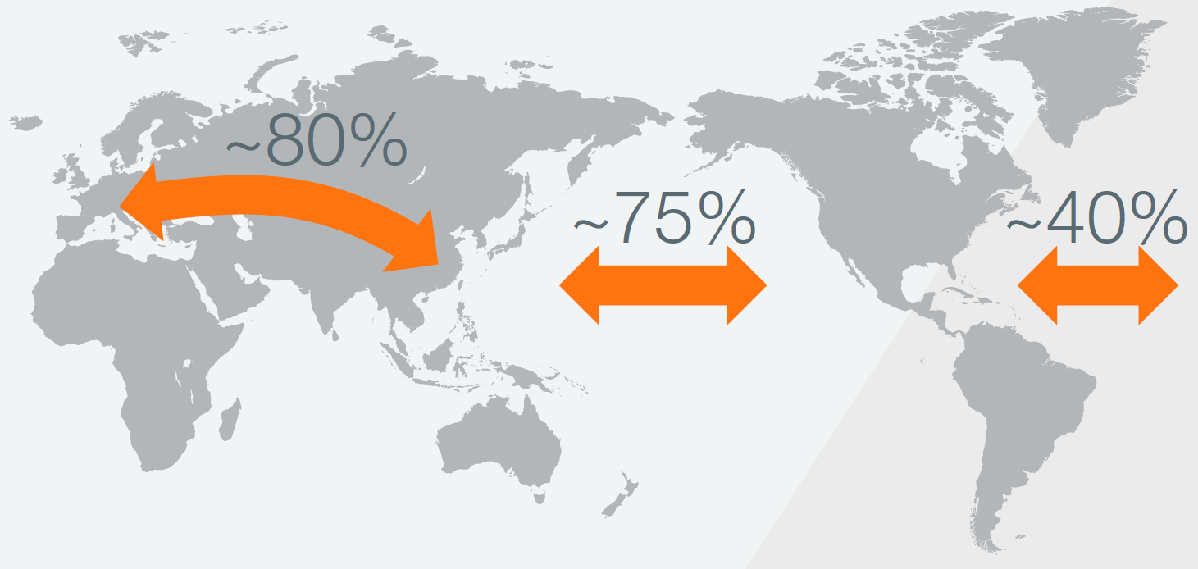

Express carriers continue to operate substantial freighter fleets, flying 40 percent of the widebody freighters and generating 40 percent of air cargo industry revenues in 2015. These operators use freighters as a link in their door-to-door proprietary transportation network—a network that is tailored to the needs of their customers by using unique schedules and specialized airplanes. The business model of express carriers cannot be replicated using only lower-hold capacity.
The majority of the remaining large freighter capacity is deployed for air freight. Air freight demand is highly concentrated—85 percent of scheduled large freighter flights operate out of the top 50 cargo airports, including airports across Asia, Middle East and Europe. Over the past five years, only 30 percent of the lower-hold capacity of new widebody aircraft has served primary cargo airport routes. This underscores the need for freighters to serve these markets and airports. Range restrictions on fully loaded passenger flights and the limited number of passenger frequencies serving high-demand cargo markets make freighters essential where both long-range and frequent service are required.
Air cargo between Europe and Asia is composed of three main service sectors: scheduled freight, charter freight, and mail. Scheduled freight is the largest component, accounting more for 90 percent of all air cargo traffic. Scheduled freight includes general and express (sometimes referred to as “integrator”) freight. The scheduled freight market share has remained more or less stable since 1992. Most shippers use regularly scheduled cargo services whenever possible because it is generally the least expensive way to ship by air.
In accordance with Boeing data the Europe-Asia market comprises approximately 20.3 percent of the world’s air cargo traffic in tonne-kilometers and 10.5 percent in tonnage. Europe-Asia air cargo traffic has averaged 6.4 percent growth per year since 1995. The market grew 6.0 percent in 2014 and 6.5 percent in 2015 (figure 1.35). The Europe-Asia annual growth chart shows overall air traffic flows between Europe and Asia that also contain some sixth-freedom traffic that flows into or out of other regions (for example, Emirates flights between Europe and Asia with commercial stops in Dubai International Airport, Qatar – in Doha Hamad International airport or AirBridgeCargo in Moscow Sheremetyevo airport).

Figure. 1.35
Volume of Europe – Asia air cargo traffic in 1995-2015, millions tonnes
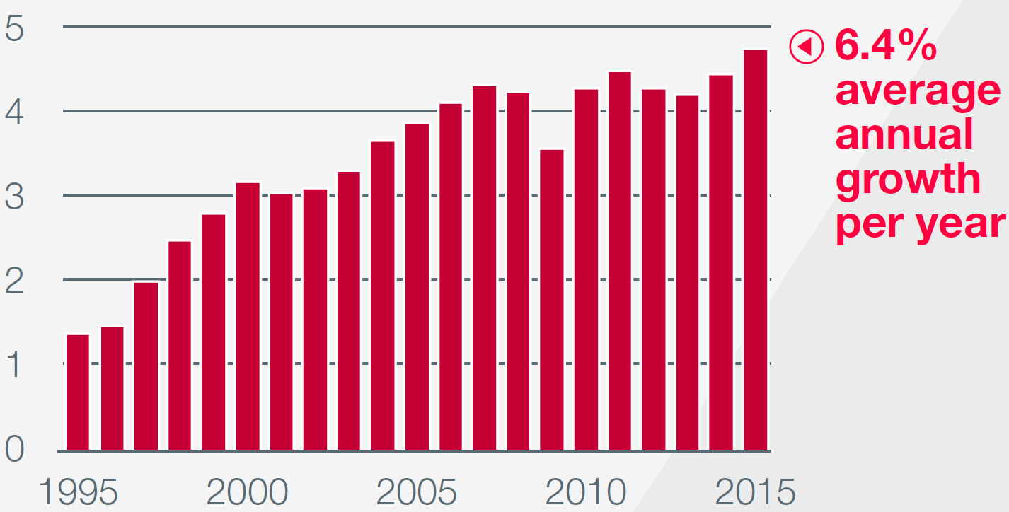
Source: Boeing (2016) World Air Cargo Forecast 2016–2017

Asia air exports to Europe account for approximately 60% of Asia-Europe market. By 2005, Europe was importing 2.4 million tonnes from and exporting 1.4 million tonnes to Asia. The gap between Europe’s imports and exports narrowed as a result of the global economic downturn of 2008 and 2009 and aggressive financial stimulus in Asia. China led the way with a stimulus package equivalent to 3.2 percent of its GDP in 2009, exceeding the 2 percent GDP stimulus recommended by the International Monetary Fund. The European economy continued to struggle from 2011 through 2013, leading European imports to grow only 2.1 percent in 2011 and contract in 2012 and 2013.
In 2015, the gap between Europe’s imports and exports was approximately 956,000 tonnes (figure 1.36). The overall Europe-Asia market grew 6.5 percent and 6.0 percent in 2015 and 2014, respectively. The Europe-to-Asia flow grew 7.7 percent in 2015 and 0.2 percent in 2014. In the Asia-to-Europe direction, traffic grew 5.7 percent and 10.1 percent in 2015 and 2014.

Figure. 1.36
Annual growth of air cargo flows on the routes Asia – Europe and Europe – Asia in 1998-2013, %
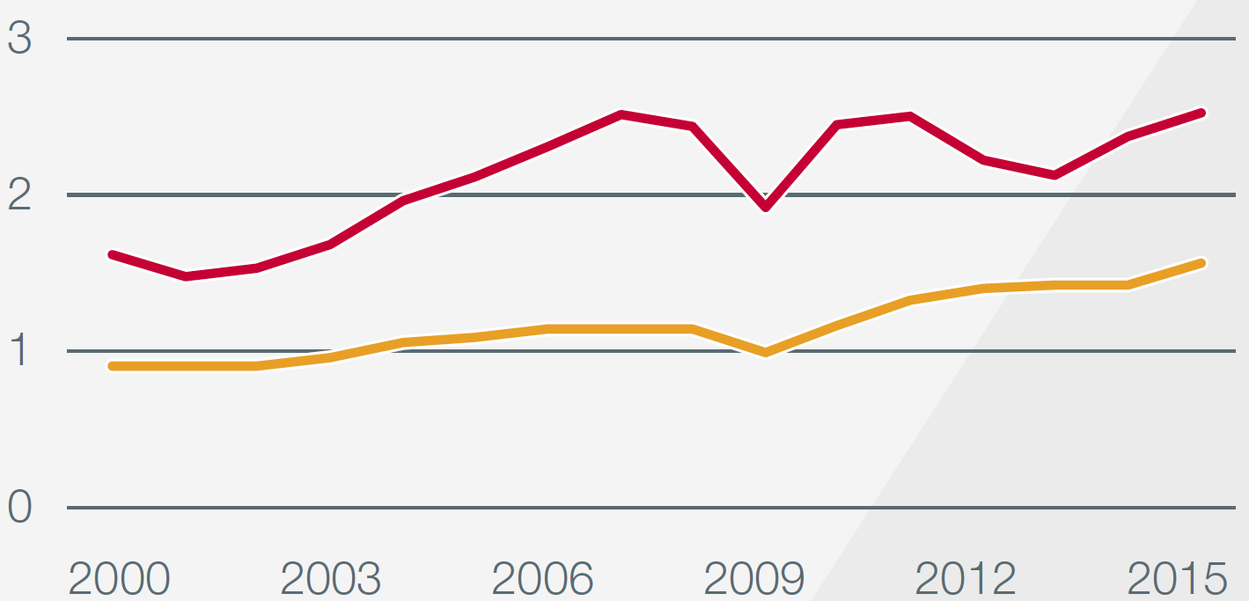
Source: Boeing (2016) World Air Cargo Forecast 2016–2017
Long-term air cargo growth has maintained a steady 6.4 percent average annual rate since 1995 despite these temporary reversals. The air cargo market in the Europe-to-Asia direction has grown 5.3 percent per year over the same 20-year period. In the Asia-to-Europe direction, the market averaged 7.2 percent per year growth.
In the Europe-to-Asia direction, the top six commodity categories account for 60 percent of air cargo traffic (figure 1.37).

Figure. 1.37
Air cargo structure by main commodity groups on the routes Asia – Europe and Europe – Asia in 2015, %
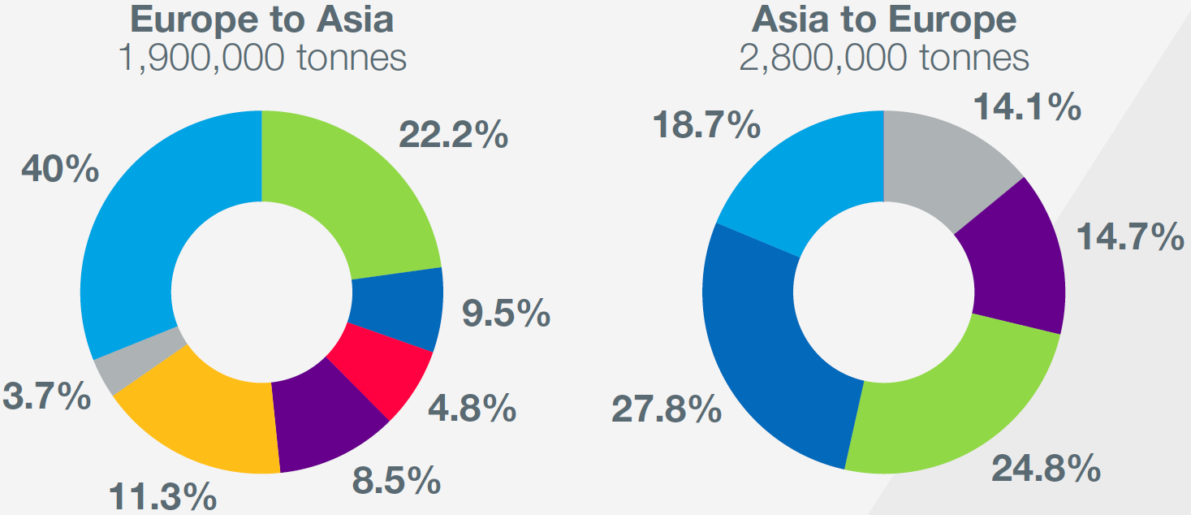
Source: Boeing (2016) World Air Cargo Forecast 2016–2017
In descending order, the categories are machinery and electrical equipment; perishables; computers, office, and communication equipment; documents and small packages; transportation equipment and parts; and apparel. In the Asia-to-Europe direction, the top four commodity categories account for 81 percent of air trade. The categories are:
- computers
- office and communication equipment
- machinery and electrical equipment
- documents and small packages and
- apparel.
One particularly fast-growing market segment between Europe and Asia has been documents and small packages, sometimes referred to as “traditional express traffic.” This trade flow has averaged 6.2 percent annual growth in daily shipment count in both directions since 2000, as the movement of business samples, legal documents, and other expedited small-batch items between Europe and Asia has increased. The total bidirectional express market averaged nearly 420,500 shipments per day in mid-2015.
Europe-Asia air cargo market forecast
Air trade flowing in both directions for the Europe-Asia air cargo market is forecast to grow an average of 4.6 percent per year over the next 20 years. The flow from Asia-to-Europe is forecast to grow at an average rate of 4.5 percent per year. The flow from Europe-to-Asia is forecast to grow 4.9 percent per year over the next 20 years.
Base, low, and high models were developed to forecast the Europe-Asia air cargo market. GDP projections of 0.5 percent below and above the baseline were assessed, and the results of these growth rates are reflected in the low and high-growth scenarios.

Figure. 1.38
Europe-Asia air cargo market forecast till 2033 by Boeing, millions tonnes
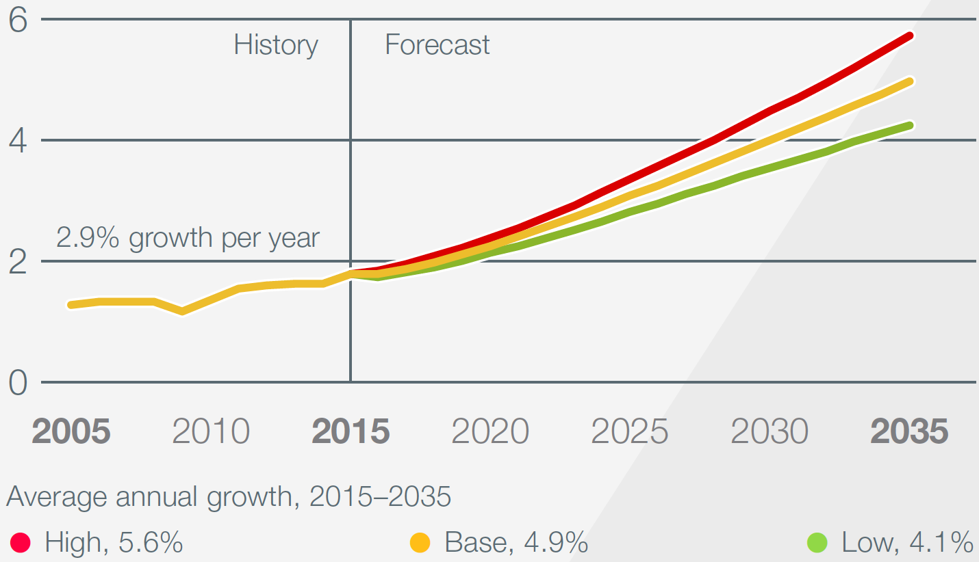
Source: Boeing (2016) World Air Cargo Forecast 2016–2017

Figure. 1.39
Asia-Europe air cargo market forecast till 2033 by Boeing, millions tonnes
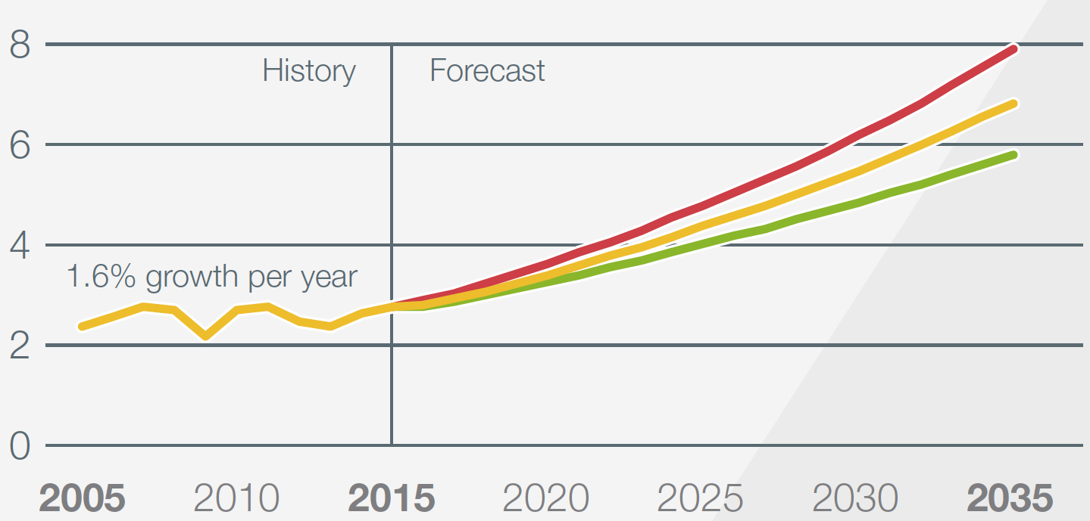
Source: Boeing (2016) World Air Cargo Forecast 2016–2017

I.4. Transport Infrastructure of EATL routes development

I.4.1. Sea ports and their hinterland connections role in EATL corridors
The role of seaports in supply chains is evolving with the progress of supply chains themselves. This evolution is most evident in the transport system of the European Union where sea ports are deeply integrated in the whole logistic infrastructure.
Port organization and functions in Europe has gone through several stages. According to [14] the following main stages can be highlighted.
Stage one. Since 1970-s on the wave of containerization enormous efforts were undertaken by different stakeholders involved in port business together with the port authorities to optimize internal port processes and make ports more efficient.
Stage two. Since the 1990scooperative interaction between ports has rapidly gained importance. The main driving forces were the emergence of short sea shipping, increasing vessel sizes and volumes and consequently the growing pressure on port capacity. During this phase different types of ports have emerged each playing special role within the sea-land interface:
- main ports: attract large volumes in all market segments and serve ocean-going vessels;
- transhipment ports: handle large container flows, although their distribution function towards the hinterland is rather limited. The main function of transshipment ports is to interconnect ocean container lines and feeder routes;
- second-tier ports: these have an important cargo-bundling and distribution function. The transshipment function can still be important, but lower volumes are generated than at main and transshipment ports;
- third-tier ports: these are largely focused on the “immediate” hinterland (closely located customers). Often not all market segments are served by these ports.
Stage three. Since the first decade of the century, a ‘terminalization phase’ is going on. Port business is increasingly focused on specialized terminals through which the hinterland is served. Ports are no longer considered to be purely transfer centers, but are becoming comprehensive flow-through areas within logistics chains, which are functionally linked to distribution developments in the hinterland.
Inland logistic centers and terminals are becoming important consolidation hubs for seaports. They act not only as cargo-bundling points, reducing capacity pressure on seaport terminals, but also as distribution centers. Seaports and inland terminals belong to the intermodal transport system serving the European supply chains.
Stage four. While port terminalization is still unfolding, the next phase in the rapidly changing logistics market is already starting to emerge, i.e. the formation of genuine port networks. [14].
In such an environment the sea ports, although competing, are more and more in constant cooperation within supply chains and the cargo flows are flexibly distributed between them following the market situation.
Sea ports are of great importance for EATL countries. They do not just provide overseas trade for maritime and landlocked countries and effective transshipment between marine transport and other modes. Trade and transport flows passing through the sea ports and the port access infrastructure benefit from the economies of scale that makes inland transportation in hinterland areas (which can extend for thousands of kilometers) cost-effective.
Besides that, the logistic infrastructure of ports themselves as well as that of the dry ports, that can be located hundreds of kilometers in the hinterland, provides enormous added value in supply chains.
According to the contemporary logistic approach, sea ports should not be analyzed or developed as isolated units. Development plans should consider also the port hinterland connections and the infrastructural objects located in the hinterland and directly linked to sea ports (logistic centers, dry ports, inland intermodal terminals). Such an approach should be used while developing national transport policies and infrastructure development plans, as well as in the regional documents adopted by EATL countries.
Developing economies’ share of world container port throughput in 2014 increased marginally to approximately 71.9 per cent. This continues the trend of a gradual rise in developing countries’share of world container throughput [Maritime review 2014].
With the strong economic growth of Asia, namely of China, cargo throughput in Asian seaports has steadily grown in the past 10 years. The major European ports Rotterdam, Antwerp, and Hamburg, have only grown by 167 per cent, 159 per cent and 144 per cent respectively in the same period of time. In 2014, the ports of Ningbo-Zhousan, Shanghai, Singapore, Tianjin have become the biggest seaports by tonnage in TEU, and world’s biggest container ports.
The EATL route network is connected to many of these major seaports. The 20 important seaports are located in the Baltic and North Sea, in the Mediterranean, on the Pacific coast, and on the Gulf in the Arabian Sea (See Table 1.22 ).
The biggest seaport on the Baltic Sea is Riga (Latvia) with an annual cargo throughput of 34,040,000 tonnes (2013). In the Mediterranean the biggest port by throughput is Piraeus (Greece) with 40,192,000 tonnes (2013), while on the Рacific coast Shanghai is the biggest port with an annual throughput of 543,000,000 tonnes (2013).
Other important ports that are not direct end points of EATL routes but are in close proximity are the major European ports in the North Sea, such as the port of Rotterdam (Netherlands)- (annual throughput of 406,549,000 tonnes (2013), as well as the ports of Bandar Abbas (Iran) and Karachi (Pakistan)-41,350,000 tonnes (2013-2014) in the Arabian Sea
In addition to maritime seaports the EATL network encompasses also major ports in the Caspian Sea, where the ports of Baku (Azerbaijan), Aktau (Kazakhstan) and Turkmenbashi (Turkmenistan) had an annual cargo throughput of 25,000,000 tonnes and 12,000,000 tonnes respectively (2011).
Port of Amirabad (Iran) is the 3rd generation of the ports, which connected to the railway network of the Islamic Republic of Iran, in particular, Bandar Abbas port, has been completed and ready to provide the services for customers.
The Black Sea ports - port of Ilyichevsk (Ukraine) and the port of Varna (Bulgaria) had annual cargo throughput of 15,530,000 tonnes and 12,950,000 tonnes respectively.
The seaports on the Pacific side, Shanghai (China), Lianyungan (China), Vladivostok (Russia) and Nakhodka/Vostochny (Russia) play an important role for the EATL as they connect Eurasia with the Republic of Korea, Japan and Taiwan Province of China. Car manufacturers such as Daewoo Motors, Kia Motors and Hyundai have been using these ports as entry gates to the Russian and Chinese markets, and use the Trans-Siberian Railways for container freight trains of automotive parts and cars from and to their production sites inside Russia and Uzbekistan.
The Baltic Sea ports of Ventsplis, Riga and Klapeida actively position themselves as regional hubs in the East-West transport link between Europe and Russia24 and the North—South transport link to the Black Sea and the Caucasus. Many container freight services connecting these ports are a witness of this positioning. The Iranian ports of Bandar Abbas and Chabahar are also looking towards building a landbridge to Afghanistan, Central Asia and China through Central Asia with the Iran Railways currently building a railway connection from Sangan, in the South East of the country close to both ports, to Herat in Afghanistan.

Table 1.24
EATL system seaports and their relation to EATL routes
 | Port | EATL rail routes connected | EATL road routes connected
 | Aktau (Kazakhstan) | 5d,6d | 3d,4,6c,6g
 | Alexandroupolis (Greece) |  | 5c
 | Amirabad (Iran) | 5a
 | Anzali (Iran) | 5 | 6
 | Arkhangelsk (Russia) |  | 1c
 | Astrakhan (Russia) | 5,5a,5b,5c | 6,6a,6c
 | Atyrau (Kazakhstan) |  | 6g
 | Baku (Azerbaijan) | 3, 3a | 4,4f,6a
 | Bandar Abbas (Iran) | 5 | 6,6f
 | Bandar Imam (Iran) | 5e | 6d
 | Batumi (Georgia) | 3, 3g, 3h, 3i, 3h,8d | 3e,3f,4,4b,4c, 4d,4e,4i,4j,4n
 | Burgas (Bulgaria) | 3j | 3e
 | Bushehr (Iran) | 5f | 6e
 | Chabahar (Iran) | 5g | 6g
 | Constanta (Romania) | 3,4,4h,4i | 4,5i
 | Derince (Turkey) | 4,4g,4h | 5,5j
 | Galati (Romania) | 3o
 | Haydarpasha (Turkey) | 4 | 5,5i
 | Igoumenitsa (Greece) |  | 5c
 | Ilyichevsk (Ukraine) | 3g,4b,4g | 4c,4i,4m,5d,5j,7
 | Iskenderun (Turkey) | 3f,4a
 | Izmir (Turkey) | 4d,4e
 | Kaliningrad (Russia)* | 8b | 3c
 | Kavala (Greece) |  | 5c
 | Kavkaz (Russia) | 8c | 3e,3f
 | Lianyungang (China) | 2,3,4,7 | 2,3,4,5
 | Makhachkala (Russia) |  | 3d
 | Mersin (Turkey) | 3f,4a
 | Murmansk (Russia) | 5h | 7
 | Nakhodka (Russia) |  | 1
 | Novorossiysk (Russia) | 8d | 3e,3f
 | Odessa (Ukraine) | 3g | 4b,4c,4i,4m,5d,7
 | Olya (Russia) | 5,5a,5d | 6,6a,6c
 | Poti (Georgia) | 3, 3g, 3h, 3i, 3h,8d | 3e,3f,4,4b, 4c,4d,4e,4i,4n
 | Samsun (Turkey) | 4b,4i | 3e,4e,4m,4n,5d
 | Shanghai (China) | 2,3,7 | 2,3,4,5
 | St-Petersburg (Russia) | 1a, 2a,5,5h | 1,7
 | Thessaloniki (Greece) |  | 5c
 | Trabzon (Turkey) |  | 4e,4m,4n
 | Turkmenbashi (Turkmenia) | 3a | 4f,6g
 | Varna (Bulgaria) | 3h, 3i,8d | 4d
 | Vladivostok (Russia) | 1,6 | 1
 | Vostochny (Russia) | 1,6 | 1
Table 1.25 shows throughput volumes for the world’s 20 leading container ports from 2013 to 2015.

Table 1.25
Biggest container terminals served Europe – Asia shipping lines and their throughput, 2013, 2014 and 2015 (Thousands of 20-foot equivalent units and percentage change)
Port | Country | 2013 | 2014 | 2015 | Percentage change 2014 - 2013 | Percentage change 2015 -2014
Shanghai | China | 33 617 | 35 290 | 36 540 | 4,98 | 3,54
Singapore | Singapore | 32 579 | 33 869 | 30 922 | 3,96 | -8,70
Shenzhen | China | 23 279 | 24 040 | 24 200 | 3,27 | 0,67
Ningbo and Zhoushan | China | 17 351 | 19 450 | 20 630 | 12,10 | 6,07
Hong Kong | China | 22 352 | 22 200 | 20100 | -0,68 | -9,46
Busan | Republic of Korea | 17 686 | 18 683 | 19 467 | 5,64 | 4,20
Guangzhou | China | 15 309 | 16610 | 17 590 | 8,50 | 5,90
Qingdao | China | 15 520 | 16 580 | 17 430 | 6,83 | 5,13
Dubai Ports | UAE | 13 641 | 15 200 | 15 590 | 11,43 | 2,57
Tianjin | China | 13 000 | 14 060 | 14110 | 8,15 | 0,36
Rotterdam | Netherlands | 11 621 | 12 298 | 12 235 | 5,83 | -0,51
Port Klang | Malaysia | 10 350 | 10 946 | 11 887 | 5,76 | 8,60
Kaohsiung | Taiwan | 9 938 | 10 593 | 10 260 | 6,59 | -3,14
Antwerp | Belgium | 8 578 | 8 978 | 9 654 | 4,66 | 7,53
Dalian | China | 10015 | 10130 | 9 450 | 1,15 | -6,71
Xiamen | China | 8 008 | 8 572 | 9180 | 7,04 | 7,09
Tanjung Pelepas | Malaysia | 7 628 | 8 500 | 9130 | 11,43 | 7,41
Hamburg | Germany | 9 257 | 9 720 | 8 821 | 5,00 | -9,25
Source: Various sources, including Port of Rotterdam (2015).
The top container ports indicated in the table 1.25 accounts more then 50 percent of the throughput of the top 100 ports, showed a 95 per cent decline in growth, from 5.6 per cent in 2014 to 0.5 per cent in 2015. Although this does not appear to be true of other smaller ports, which experienced larger gains. The top 100 container ports are estimated to have handled a throughput of 539 million TEUs in 2015, up by about 6.8 per cent from the 505 million reported in 2014 (Informa PLC, 2016) . The list of top 20 container ports includes 15 ports from developing economies, and as in the previous year, are located in Asia; the remaining five ports are from developed countries, three of which are located in Europe (the Netherlands, Belgium and Germany). The top 10 ports continue to be located in Asia. Nine of the top 20 container ports are located in China, and seven of these (excluding Dalian and Hong Kong, China) experienced positive growth. Overall, the top 20 container ports in China grew by 3.7 per cent in 2015, in spite of the economic slowdown (JOC.com, 2016a). Seven of the top 20 ports experienced a negative growth rate in container port throughput, compared with the previous year, while an additional two barely managed a positive growth rate at less than 1 per cent. The most significant declines occurred in Hong Kong (China), Hamburg (Germany) and Singapore at -9.5, -9.3 and -8.7 per cent, respectively.
Conversely the ports of Port Klang (Malaysia), Antwerp (Belgium) and Tanjung Pelepas (Malaysia) experienced the most growth at 8.6 per cent, 7.5 per cent and 7.4 per cent, respectively. The port of Tanjung Pelepas made significant strides in 2014, with 11.4 per cent growth on the completion of infrastructure investments.
Growth was expected to be reduced to around 4.4 per cent in 2015 but proved much better. Malaysian ports have consistently expanded their throughput during the last decade so that both Port Klang and Tanjung Pelepas are now handling twice the volume of 2005.
Table 1.24 shows improvements in container berth productivity in selected developing countries in 2015, compared with 2014. The highest growth is in the port of Sohar, Oman, 160 km from Dubai, which experienced a doubling in the number of container handling operations following improvements made by its operator, Hutchinson Port Holdings (Handy Shipping Guide, 2015).
The figures show that double digit growth in terminal efficiency is possible. These terminals often benefit from the experience of a global terminal operator who is part owner, part operator. It is not unusual for more than one competing international terminal operator to have a presence in the same port at different terminals, and in a limited number of cases, within the same terminal. For example, in 2013, the Antwerp Gateway common user terminal at Deurganck Dock was a joint-venture between DP World (42.5 per cent), ZIM ports (20 per cent), the former China Ocean Shipping Pacific (20 per cent), Terminal Link/CMA CGM (10 per cent) and Duisport (7.5 per cent), with DP World acting as the operator (DP World, 2013).
Unlike container ports, bulk and liquid ports are not common user ports and tend to represent the interests of a few cargo owners. This makes it difficult to obtain statistics on these sectors. Table 1.26 shows the world’s leading ports by volume. Fourteen of these top 20 ports are in China, a further three in Asia and one in Europe.

Table 1.26
Container berth productivity, selected terminals in developing countries along Europe – Asia maritime routes , 2015
Terminals | Terminal operators | Ports | Countries | Regions | Improvement (percentage)
Oman International Container Terminal | HPH | Sohar | Oman | Middle East | 101
Nam Hai Terminal |  | Haiphong | Viet Nam | Asia | 22
South Container Terminal | DP World | Jeddah | Saudi Arabia | Middle East | 20
Shuaiba Area Container Terminal |  | Shuaiba | Kuwait | Middle East | 18
Jawaharlal Nehru Container Terminal | DP World | Nehru | India | Asia | 18
Evergreen Container Terminal -LCB2 | Evergreen | Laem Chabang | Thailand | Asia | 17
First Container Terminal | Global Ports | St. Petersburg | Russian Federation | Europe | 14
Terminal Petikemas Surabaya | DP World | Surabaya | Indonesia | Asia | 11
Korea Express Busan Container Terminal | China Shipping Group | Busan | Republic of Korea | Asia | 9
South Harbor International Container Terminal (ATI) | ICTSI | Manila | Philippines | Asia | 8
Aqaba Container Terminal | APMT | Aqaba | Jordan | Middle East | 7
PSA Singapore Terminals | PSA | Singapore | Singapore | Asia | 6
Dongbu Pusan Container Terminal | Evergreen | Busan | Republic of Korea | Asia | 3
Port Akdeniz | Global Ports Holding | Antalya | Turkey | Asia | 2
Source:
UNCTAD secretariat calculations, based on the port productivity database of JOC.com (2016b) and other sources.
Note: For the purpose of this research, berth productivity is defined by JOC.com as “the average number of container moves per crane, per hour while a ship is at berth”. The relative improvement has been measured and then weighted by call size to achieve actual improvement in year-on-year performance.

Table 1.27
World’s leading ports of Asia and Europe (included in TOP-20 world ports) by total volume, 2013–2015 (Thousands of tons)
Port | Country | 2013 | 2014 | 2015 | Percentage change 2014-2013 | Percentage change 2015-2014
Ningbo and Zhoushan | China | 809 800 | 873 000 | 889 000 | 7,80 | 1,83
Shanghai | China | 776 000 | 755 300 | 717 400 | -2,67 | -5,02
Singapore | Singapore | 560 800 | 581 300 | 574 900 | 3,66 | -1,10
Tianjin | China | 500 600 | 540 000 | 541 000 | 7,87 | 0,19
Suzhou | China | 454 000 | 480 000 | 540 000 | 5,73 | 12,50
Guangzhou | China | 454 700 | 500 400 | 519 900 | 10,05 | 3,90
Qingdao | China | 450 000 | 480 000 | 500 000 | 6,67 | 4,17
Tangshan | China | 446 200 | 500 800 | 490 000 | 12,24 | -2,16
Rotterdam | Netherlands | 440 500 | 444 700 | 466 400 | 0,95 | 4,88
Dalian | China | 408 400 | 420 000 | 415 000 | 2,84 | -1,19
Rizhao | China | 309 200 | 353 000 | 361 000 | 14,17 | 2,27
Yingkou | China | 330 000 | 330 700 | 338 500 | 0,21 | 2,36
Busan | Republic of Korea | 292 400 | 312 000 | 323 700 | 6,70 | 3,75
Hong Kong | China | 276 100 | 297 700 | 256 600 | 7,82 | -13,81
Qinhuangdao | China | 272 600 | 274 000 | 253 100 | 0,51 | -7,63
Port Klang | Malaysia | 200 200 | 217 200 | 219 800 | 8,49 | 1,20
Shenzen | China | 234 000 | 223 300 | 217100 | -4,57 | -2,78
Xiamen | China | 191 000 | 205 000 | 210 000 | 7,33 | 2,44
Source: UNCTAD (2016) Review of Maritime Transport 2016
Ports indicated in Table 1.27 is experienced an 85 per cent decline in growth, from 6.3 per cent in 2014 to 0.9 per cent in 2015. Of the seven ports that experienced declines in throughput in 2015, Singapore was the only one not located in China. The Chinese port of Suzhou experienced the largest increase in throughput, 12.5 per cent. The next largest gain in port throughput was recorded by Rotterdam, the Netherlands, which experienced a growth of 4.9 per cent.

I.4.2. Infrastructure of EATL railway routes
Out of the nine EATL rail routes, six are in the East—West Direction, and three in the North—South direction. The rail routes 1 and 2 are already used by regular or ad-hoc freight trains connecting Asia, East Russia and Europe.
The EATL Rail Route 1 (known also as the Trans-Siberian route) is over 10 000 km long, its branches stretching from the eastern borders of the EU (Finland, Hungary, Poland, Lithuania) to the Russian Pacific port of Nakhodka and the Russian-Chinese border. Route 1 extends the Pan-European Transport Corridors (PETCs) II, V and IX eastwards. Its principal advantages include a small number of border crossings,the electrified traction and the uniform (1520 mm) gauge. Parts of the route situated within the Europeanpart of the Russian Federation belong to the E-rail and E-combined transport networks. Most of the routeis also part of the TAR network. At present, Route 1 provides the backbone for the long-distance surfacecontainer transport between Europe and East Asia. The capacity of Rail Route 1 in the eastern part of Russia is limited; at the moment it is planned by the Government of the Russian Federation to increase it and to modernize the Trans-Siberian railway having in mind not only the Euro-Asian traffic but the socio-economic development of the entire region.
EATL Rail Route 2 spans over more than 8 000 km from the eastern borders of the EU with Belarus and Ukraine across the Russian Federation, Kazakhstan and Eastern China to the ports of Lianyungang and Shanghai. Route 2 extends PETCs II and IX towards Asia with most parts of this route belongingto the TAR network. It coincides with Route 1 on the sections between the EU borders and the city ofYekaterinburg in central Russia. Compared to Route 1, there are some disadvantages: firstly, the broad 1520 mm gauge changes at the Kazakh-Chinese border to the 1435 mm standard prevailing in China; secondly, sections of Route 2 have not been electrified; thirdly, there are two additional border crossings and, lastly, the capacity of the section between Kazakhstan and the Chinese ports is limited.
The main branch of the EATL Rail Route 3 leads from the south-eastern EU border (Hungary-Romania) to the Lianyungang and Shanghai ports. Route 3 extends PETCs IV, VIII and IX as well as the TRACECA to Eastern China; significant parts of the route belong to the TAR network. Route 3 includes two ferrycrossings, from Constanta on the Romanian Black Sea coast to the Georgian ports of Batumi or Potiand from the Azerbaijan port of Baku on the Caspian Sea to the Aktau port in Kazakhstan. Before reaching China, Route 3 and its branches pass through a significant number of countries and border crossings;gauge changes are necessary at the borders of EECCA countries with China and Romania.
The EATL Rail Route 4 provides an alternative link between South-Eastern Europe and the Lianyungangand Shanghai ports, passing through Bulgaria, Turkey, Iran, Uzbekistan and Kazakhstan. It provides anextension to PETCs IV, VIII, X and the TRACECA route to the Chinese seaboard, also with parts ofthe route belonging to the TAR network. There are two limitations to that route: there are two gauge changes (Iran-Turkmen border and the Kazakh-Chinese border) and large sections of Route 4 have not been electrified yet.
The EATL Rail Route 5 connects northern Europe to Iran, extending from the Finnish-Russian border southward to the Caspian Sea and terminating at the port of Bandar Abbas in the Persian Gulf. Almost the entire route is part of the TAR network. For the time being, the capacity of Route 5 is limited by one missing link on the territory of Islamic Republic of Iran. Gazvin-Rasht –Astara railway (330 Km) project is one of main routes in the framework of EATL and North- South Corridor is under construction. The Gazvin- Rasht section with 164 km length is under construction with 93 percent physical progress. It is predicted that this section will be completed by the end of 2017 thoroughly. The Rasht –Astara segment with 164 km length is another section of the same railway route which the negotiation for finding the foreign investment is under measurement. When the construction work is completed, Route 5 could significantly reduce freight transport times between Iran and the EU. The total transit capacity of this route is 10 million ton annually.
The EATL Rail Route 6 provides an alternative connection between the eastern borders of the EU (Hungary,Poland) with Russia’s Pacific coast, while moving across Ukraine and Russian Federation (south of Route1) towards the port of Vladivostok as well as traversing briefly the Kazakh territory. Route 6 providesan extension of PETCs III, V and IX towards the Pacific Ocean. Again, parts of the route belong to theTAR network.
The EATL Rail Route 7 provides an alternative connection between the EU and the Lianyungang and Shanghai ports, passing through the territory of Ukraine, the Russian Federation, Kazakhstan, Uzbekistanand China. It extends PETCs III and V given that the whole route belongs to the TAR network. Large sections of Route 7 on the Kazakh, Uzbek and Chinese territory are not electrified.
The EATL Rail Route 8 passes from Poland to Ukraine, southern Russia, Georgia and Azerbaijan tothe Iranian border at Astara. Thus it provides another extension to PETCs III and V with most parts ofthe route belonging to the TAR network. Imam Khomeini port (Iran) – Bazargan (border with Turkey) - Caucuses, as part of the EATL8, EATL5 and North–South corridor is one of the priorities of the transport infrastructure in Islamic Republic of Iran. Projects on upgrading of the railway and road sections along this route is under measurement. This route is one of the main routes of the Persian Gulf- Black Sea Corridor Agreement which recently finalized among Iran, Azerbaijan, Armenia, Georgia, Bulgaria, and Greece.

The EATL Rail Route 9 provides a connection from the northern Europe through the Russian Federationto Central Asia (Kazakhstan, Uzbekistan and Tajikistan). Significant parts of the route belong to the TAR network. Since long sections of Route 9 are not electrified, the capacity of the route is subject to limitations.

Figure 1.40
Scheme of Imam Khomeini port (Iran) – Bazargan (border with Turkey) corridor as a section of EATL8, EATL5 rail routes
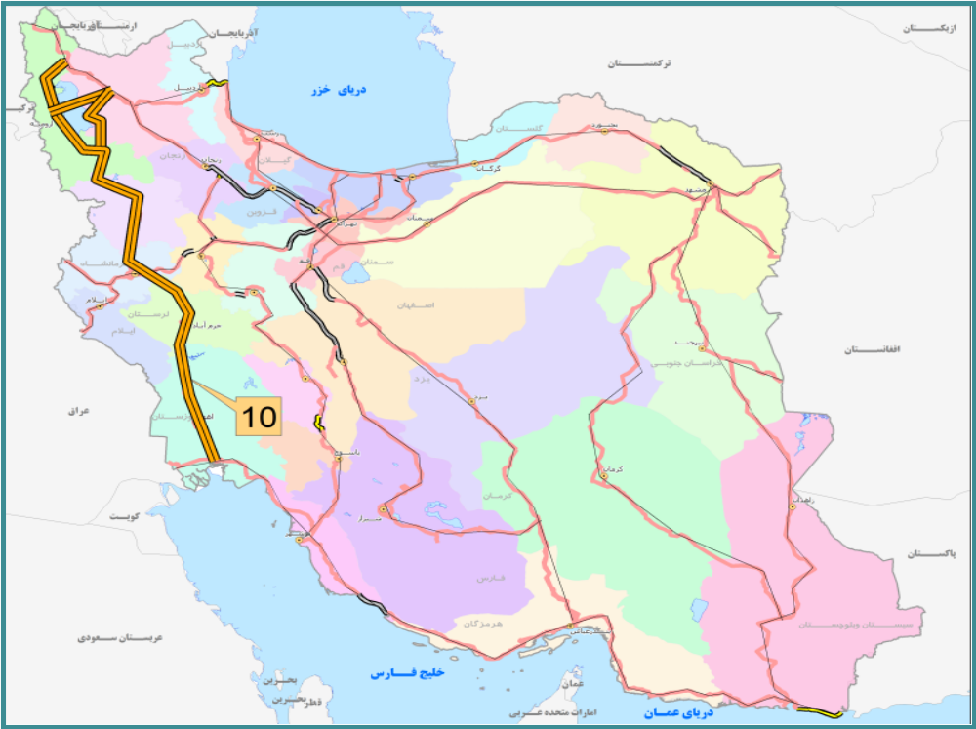
Source: Ministry of Roads and Urban Development of Islamic Republic of Ira

Figure 1.41
Scheme of EATL Rail Routes
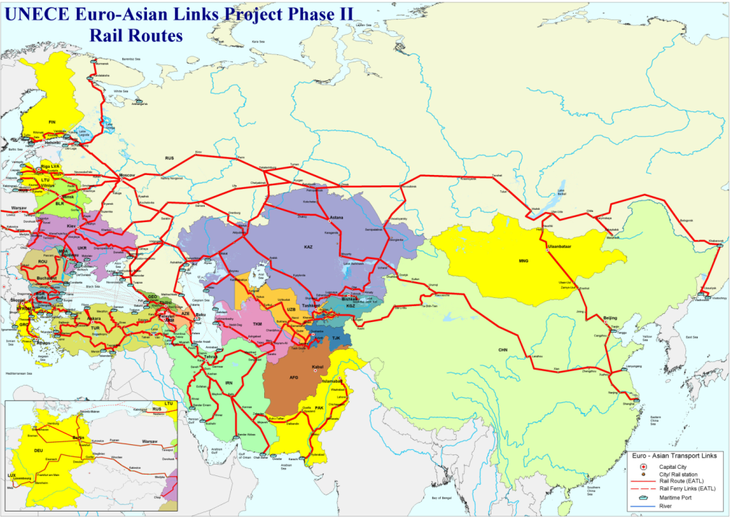
Source: UNECE, 2013

Table 1.28 - EATL Rail Routes

1 | "Trans-Siberian Railway, Northern Road"  West (N and E EU (Finland, Latvia, Lithuania, Poland, Hungary)) to East (Russia Pacific)  Countries crossed: Russia, Belarus or Ukraine  Number of gauge changes: 0
2 | "Trans-Siberian Railway, Southern Route"  West (N and E EU (Finland, Lithuania, Poland, Hungary)) to East (China)  Countries crossed: Ukraine, or Belarus, Russia, Kazakhstan, China  Number of gauge changes: 1 (Kazakhstan/China)
3 | West (SE EU (Hungary, Romania, Bulgaria) through Caucasus and Central Asia to East (China)  Countries crossed: Moldova, Turkey, Georgia, Azerbaijan, Armenia, Turkmenistan, Uzbekistan, Tajikistan, Kyrgyzstan, Kazakhstan, China  Number of gauge changes: 1 (Kazakhstan/China)  Number of ferry crossings: 2 (Caspian and Black Sea)
4 | "Southern Silk Road" or "Trans Europe-Asia Route" West (SE EU (Bulgaria) through Iran and Central Asia to East (China)  Countries crossed: Turkey, Iran, Turkmenistan, Uzbekistan, Kazakhstan, China  Number of gauge changes: 2 (Iran/ Turkmenistan, Kazakhstan/China)
5 | North (N EU (Finland)) through Caucasus and Central Asia to South (Iran)  Countries crossed: Russia, Azerbaijan, Iran, Turkmenistan, Kazakhstan, Uzbekistan  Number of gauge changes: 1 (Kazakhstan/China)  Number of ferry crossings: 1 (Black Sea)
6 | West (E EU (Hungary, Poland)) to through Central Asia to East (Russia Pacific Coast)²³ Countries crossed: Ukraine, Moldova, Russia, Kazakhstan  Number of gauge changes: 0
7 | West (E EU (Hungary and Poland)) through Central Asia to East (China)  Countries crossed: Ukraine, Kazakhstan, Uzbekistan, China)  Number of gauge changes: 1 (Kazakhstan/China)
8 | North (N and E EU (Latvia, Poland and Lithuania)) through Caucasus to South (Azerbaijan, Iran)  Countries crossed: Ukraine, Russia, Georgia, Azerbaijan, Iran  Number of gauge changes: 1 (Azerbaijan/lran)
9 | North (N EU) Finland) and Baltic Russia) through Central Asia to South (Central Asia) Countries crossed: Russia, Kazakhstan, Uzbekistan, Tajikistan  Number of gauge changes: 0

Kazakhstan and Uzbekistan, the largest economies in the Central Asian region and the countries with the most developed rail networks, carry the greatest volumes of freight transported by rail in Central Asia. The rail routes of the region going primarily via these countries serve two complementary purposes: to support the Central Asian countries’ trade with Russia and Europe or with China and to provide opportunities for Euro-Asian transit trade.
Distance is one of the main factors influencing the modal choice. The land route from the North-Western Xinjiang Uygur region of China to destinations in Germany exceeds 7 thousand kilometers. The distance between Almaty (Kazakhstan) and major economic centers in China is over 4 thousand kilometers which compares with crossing the United States from coast to coast.
Taking into account the typical distances on the EATL network and the absence of the inland water routes railways should be the dominating mode developing very fast. Unfortunately, the EATL railways face the common problem – national borders.
These borders do not only cause the delays for border-check and customs formalities. If so, the interruption and the fragmentation of the railway traffic could probably have been successfully removed. But the existence of national borders separates national railway systems which, in turn, leads to fragmentation of railway services.
Different technological standards (including different gauge), different types of electric power traction, different tariff systems, different management principles, uneven quality and capacity of network sections and, finally, the contradictory economic interests of neighboring railways, all brought together, create a serious problem of railways interoperability. It is enough to say that the European railway reform carried on for 15 years within the integrated economic environment and aimed to solve the same problem is far enough from successful ending.
In spite of that numerous logistic companies operate Euro-Asian railway services using the principle advantage of the surface route – shorter lead time in comparison with maritime routes. Some of the cases are described in paragraph I.3.3.
Prospects and opportunities for EATL transit rail routes
In spite of fact that numerous railway services have been introduced or tested on the overland EATL rail routes connecting Europe and Asia, they still play a marginal role for transcontinental transit traffic. Different opinions exist on the future growth of Euro-Asian freight volumes to be captured by these routes (Rastogi et al, 2014) but most of the sources points to the fact that maritime transport will likely remain the dominant mode in the Europe-Asia transport market (no less than 95 percent), at least for some years to come.
There are many causes for low use of the land bridge for transcontinental trade. Some of them can be eliminated or, probably, “softened” in the course of physical improvement of the infrastructure and the institutional reforms. Others (railway costs vs. shipping costs, border procedures, different technical standards on railways) will likely be in place for decades.
Most of the commentators agree that three main factors can influence the development of the overland railway Eurasian services: a) development unified legal regime across the Eurasian railway links b) appropriate choice of the business/commodity segment by railway and logistic operators and c) smart logistic decisions, probably, in synergy with maritime or air transport transportation.
Bosnia and Herzegovina. The railway network in Bosnia and Herzegovina extends for some 1,017 km. It is based on a standard gauge (1,435 mm) and the majority is single track (92 percent). Around 76 percent of the network is electrified. The only non-electrified part of the railway network is located in the north-eastern part of the country, around Tuzla, but it is important in traffic terms. All lines are single-track, except one section of 87 kilometers of Corridor Vc between Zenica and Doboj.
Prior to 1991, the railways in Bosnia and Herzegovina were a fully integrated part of the former Yugoslavian railways. When Bosnia and Herzegovina become independent in 1991, a new state railway company was formed and soon divided into three regional state owned companies reflecting the ethnic divisions of the country. In 2001, according to a new railway the railway companies in the Croat and Bosnian parts of the country were merged to create Željeznice Federacije Bosne i Herzegovine (ŢFBH). However, the railway in the RS, Željeznice Republike Srpske(ŢRS), remained separate.
Currently the sector includes two vertically integrated railway companies, and a state level coordinating body, Bosne i Herzegovine i Bosanskohercegovacke Željeznice Javna Korporacije (ZBHŢJK).
Both railway companies linger in acritical financial situation. In both companies the separation of operational functions from infrastructure management has not yet occurred.
Railways of Republika Srpska have not yet adopted their network statements. The opening of the rail market is at an early stage. The railway institutions fall short of staff.
Rehabilitation works on rail tracks are in progress. However, the bottleneck at Ivan Tunnel and Bradina ramp, which prevents the transit of Ro-La (trucks on train) trains and 40ft containers from the port of Ploče, is hampering the development of combined transport.
According to the EU experts [23], preparations in the railways area are at an early stage.
The Former Yugoslav Republic of the Macedonia. The rail network of FYR Macedonia is small, with 699km of single track rail—with only 235 km electrified. The main line of Pan-European Corridor X traverses FYR Macedonia from Tabanovce to the capital Skopje to Gevgelija, as well as the branch Corridor Xd from Veles to Bitola to Kremenica (146 km). Along Corridor X the line is electrified. The country is also traversed by Pan-European Corridor VIII. This corridor connects the Black Sea through Bulgaria and FYR Macedonia to Albania and the Adriatic Sea.
International transport accounts for 98 percent of freight transport, most of which is transported through Corridor X.
In 2007 FYR Macedonian Railways (Makedonski Železnici; MŢ) was reorganized into two separate joint stock companies—a public enterprise in charge of infrastructure management, Macedonian Railways Infrastructure (MŢ-I) and a transport company in charge of passenger and freight operations, Macedonian Railways Transport (MŢ-T). This change was part of a broader railway reform program aimed at making the FYR Macedonian rail sector comply with EU directives.
A new set of railway legislation was adopted, that regulated, in particular, general organization of the railway system, principles of access to the railway infrastructure, mechanism the collection of the track fees, methods of assignment of the infrastructure capacities, the network statement preparation, the functions of the independent and autonomous regulatory body, relations between the railway undertakings and the infrastructure manager, financing of the railway infrastructure and other issues. Almost all the requirements of the first EC railway packageDirectives have been implemented by this legislation.
An independent Regulatory Agency was established in 2009. The network statement is published.
At the same time, high track-access charges and market closure further constrainthe income of the infrastructure manager without having resulted in the tangible effects on thestate operator or the transport sector as the government had hoped for. The rail marketremains closed to licensed EU operators until accession.
According to the EU experts [26], further alignment with the EC railway packages is necessary as the railway market remains closed to competition.
Currently, the EBRD is making a loan of up to €145 million to finance the modernization of railway infrastructure in FYR Macedonia and to strengthen the country’s regional transport links.
http://www.worldbank.org/projects/P083499/railways-reform?lang=en&tab=overview
http://www.ebrd.com/news/2014/ebrd-connects-macedonian-railway-corridor-to-turkey-.html
http://www.seetoint.org/wp-content/uploads/downloads/2012/11/769_fyrom2-taiex-rw-.pdf
http://library.tee.gr/digital/m2476/m2476_evmolpidis.pdf
Montenegro. The rail network consists of 248 km of track only. Of these, 168 km are electrified and there are no double lines. A 167 km main line connects the Port of Bar on the Adriatic city to the capital, Podgorica, and to the border with Serbia with an 83 km second line that connects Niksic to Podgorica and to the Albanian border. Rail lines are standard gauge, with the line to Bar electrified. In general, the terrain is mountainous and the line has numerous bridges and tunnels.
Three rail companies operating in Montenegro are Railway Infrastructure of Montenegro (ŽICG), Railway Transport of Montenegro (ŽPCG), and Montecargo AD. The former rail company, ŢeljezniceCrne Gore (ŢCG), was transformed into a public company in 1989; it was partly privatized in June 2002 as a vertically integrated rail company. In accordance with the Law on Railways, adopted in 2004, ŢCG was replaced by two newly established joint stock companies: ŢICG and ŢPCG. In 2009, ŢPCG was further restructured, by spinning off the freight division and establishing this as Montecargo, which is a fully independent joint stock company.
Concession is offered for infrastructure management and for stations operation. The main regulatory bodies are established. Network Statement is approved and published. In accordance with the network statement of Montenegro’s rail infrastructure manager for 2015, track access charges in Montenegro for all types of trains are EUR 3 (includeing VAT) per train km.
The renewed Railway law was adopted in May 2013aiming at setting a new regulatory framework for managing the railway infrastructure and transport services, defining the competences of the Railway Directorate as the regulatory body, and improving the competitiveness and quality of transport. A five-year business planwas prepared by the Railway Directorate for 2013-2017.
The agreement on border railway transport between Montenegro and Albania was ratified in March 2013.
According to the EU experts [24], the alignment with EU Directives is almost complete.
Serbia. The length of Serbian railways is about 4100 km. The main line goes from North-West to Sowth-East: border with Hungary – Subotica – Novi Sad – Belgrad – Lapovo – Nish. From this point the lines go to Preshevo – Border with FYR Macedonia and to Dmitrovograd – border with Bulgaria. For other lines connect this main rail communication with Croatian, Montenegro, Romanian, and FYR Macedonian borders.
In 2013, the Serbian Parliament adopted the new Law on Railway, which came into force on 30 May 2013. The law represents the framework legislation for this area and replaces the old act on railway that was in force since 2005.According to the Government, the Law on Railway is aimed at introducing the necessary reforms into the country’s railway system, opening competition into this sector, improving effectiveness of the country’s railway system and integrating it into the market of transportation services and EU railway system.
The Law on Railway had introduced the principle of separation of railway infrastructure from operations. The separation is supposed to be implemented in the form of the separate accounting and, to a certain extent, management of a commercial entity managing infrastructure from a commercial entity managing transport of passengers and goods. At the same time, the Law on Railway does not explicitly prescribe that such separation has to be formally accomplished through the formation of separate legal entities.
Despite the formal separation between railway infrastructure and operations, the railway infrastructure itself remains in the ownership of the Republic of Serbia and represents a so-called good in public use, while the management of the railway infrastructure is deemed to be an activity in the public interest. However, another important novelty is that an entity that manages railway infrastructure no longer needs to be organized in the form of a ”public enterprise”, a category of legal entities formed by the Serbian state, provinces or municipalities. This opens the way for potential participation of private entities in the management of railway infrastructure.
The network statement is also introduced by the Law on Railway.
The Law on Railway also provides for the preparation and adoption of a periodical National Program on Railway Infrastructure. The program should be prepared and proposed by the Serbian Government and, subsequently, adopted by the Serbian Parliament for a term of five years.
Overall, the Law on Railway appears to represent an important step in the direction of liberalization of the Serbian railway system. However, it is yet to be seen with what degree of efficiency and diligence the important novelties that the law contains will be implemented.
It also remains to be seen to what extent the relevant state-owned railway operator will adjust to the new setting and whether such setting will bring effective liberalization to the market of railway services. According to some initial, informal reactions by the relevant public bodies to the Law, the entire railway network currently in existence should continue to be managed by the relevant state-owned railway operator, while possible new routes and/or existing routes that are potentially found in the future as being no longer viable for use by the state-owned railway operator could be possibly offered to private operators (e.g. new routes could be potentially constructed through a PPP/concession model). If so, the true liberalization of the Serbian railway market may still be some years away.
According to the EU experts [25], open access to the railway market, with transparent track access charges and capacity allocation, still needs to be achieved.
http://www.kinstellar.com/insights/detail/147/new-law-introduces-reforms-into-serbian-railway-system
Turkey.
“The length of the railway network is 12.532 km. 35% of the total length is electrified.
EATL railway corridors 3 and 4 pass through the Turkish railway network.
With the Law No. 6461 on the Liberalization of Railway Transport of Turkey dated May 1, 2013, Turkish State Railways (TCDD) was restructured as the public enterprise that operates the railway infrastructure in Turkey and Turkish State Railways Transport JSC (TCDD Transport JSC) was established as the railway operator and it is responsible for passenger and/or freight transport in Turkey as of January 1, 2017.
The following basic legislation about liberalization and safety on national railway network were published according to EU Directives by Directorate General of Railway Regulation (DGRR) of the Ministry of Transport, Maritime Affairs and Communications: “Regulations on Access to the Railway Infrastructure and Capacity Allocation”, “Regulations of Railway Vehicles Registration and Recording”, “Regulation on Railway Safety”, “Regulations on Type Approval of Rolling Stocks and Major Components”, “Regulations for Licensing of Railway Operations”, “Regulations on Public Service Obligation in Railway Passenger Transport”, “Regulations for Loco Drivers”, “Regulations for Railway Safety Critical Staff” and “Regulations for Railway Training and Examination Centre”.
In line with the basic EU legislation on railway sector, “Regulations of Interoperability on Railway Systems” and “Assignment Communiqué of Notified Bodies” will be prepared in the near future by Ministry of Transport, Maritime Affairs and Communications.
The Network Statement prepared by TCDD, which contains the necessary information concerning the railway infrastructure network, accession requirements, application and capacity allocation processes, service provided and charging, was published by the approval of the Ministry of Transport, Maritime Affairs and Communications of the Republic of Turkey on November 29, 2016. Hence, liberalization process in the Turkish railway sector have literally commenced.
Turkish State Railways (TCDD) has 8 regional directorates, 7 ports, 4 affiliated companies, 4 participations, 5 factories. TCDD manufactures and maintains railway vehicles and equipment such as locomotives, freight and passenger wagons, sleepers, switches, rail fasteners.
Operation rights of Mersin, Iskenderun, Samsun, Bandırma and Derince ports are transferred to private sector. Operations of Haydarpaşa (Istanbul) and İzmir Ports are carried out by TCDD. Stakes of İzmir Port have been recently transferred to newly-established sovereign Wealth Fund.
There are no obstacles for the private companies that want to operate trains on the national railway network in Turkey. Companies will be able to operate trains as railway operators after they take the licence and the certificate of safety from Directorate General of Railway Regulation and will be able to operate trains in the National Railway Network after they take slots from railway infrastructure manager.”

The third group of countries contains the former republics of the USSR: Armenia, Azerbaijan, Belorussia, Georgia, Kazakhstan, Kyrgyzstan, Moldova, Russian Federation, Tajikistan, Turkmenistan, Ukraine ,Uzbekistan. They are united by the common “Russian” railway gauge (1520 mm) and the common heritage of technology and organization of the soviet railway system. Some of these countries still keep this heritage; others had undertaken certain structural reforms aimed to adjusting the railway industry to market conditions.
Armenia. Armenian railways have the 845 km total length. The entire network is electrified. The system is a part of EATL corridor 3.
There were no structural reforms in the Armenian railway industry since the collapse of the USSR.
In 2007, the government of Armenia conducted a tender process for the modernization and operation of Armenian Railways. Russian Railways was the only bidder and established South Caucasus Railway (CJSC) as a wholly owned subsidiary to run the Armenian Railways. On 1 June 2008, South Caucasus Railway officially commenced its modernization and operation program and, as part of the concession agreement, received all the assets owned by Armenian Railways. The concession agreement was concluded for 30 years, with a right of extension for another 20 years after the first 20 years of operation. It means that the structure and the operation model of the Armenian railway system in the foreseeable future will be the copy of those used by Russian Railways.
http://ppp.worldbank.org/public-private-partnership/library/concession-agreement-tranfer-armenian-railway-system-south-caucasian-railway
Azerbaijan. Currently, the total length of main railroads is 2932 km including 815 km of double-track sections. 1272 km of the total length is electrified. EATL railway corridors 3,5 and 8 pass through the Azerbaijan railway system.
Azerbaijan Railways (Azerbaijani: Azərbaycan Dəmir Yolları) is the national state-owned rail transport operator in the Republic of Azerbaijan that continues to operate as a fully integrated state monopoly. The core railway businesses (infrastructure, passenger, freight, etc.) are operated by this entity. Little progress has been made in terms of competition and privatization. Freight tariffs were liberalized while passenger tariffs remain determined by the government.
It is reported that one of the biggest financial problems was the practice of barter transactions among state entities (i.e. state owned companies did not pay for services in cash), which was banned in 2006. No information on the planned structural reforms is currently available.
http://www.ebrd.com/downloads/country/strategy/azerbaijan-country-strategy.pdf
Republic of Belarus. The national railway network consists of 5,512 km, and 874 km of it are electrified. Belorussian railways are the part of EATL corridors 1 and 2. The entire system is operated by the Belaruskaya Chugunka (Belarusian Railway – BR) - the national state-owned railway company of Belarus.
Official documents do not envisage any substantial reforms in the industry that is still “soviet-shaped”. The Belarussian state program for development of rail transport in the period of 2011-2015 provides only for modernization of the sector within the existing model, in which the BR is a government corporation subordinate to the Ministry of Transport and Communications of Belarus. Besides, some legal changes necessary to improve the international operations must be undertaken.
At the same time, the Belarusian scientific community has developed a reform concept that is discussed currently.
The concept provides for a vertically integrated entity. At the central level, management of all railway enterprises should be concentrated in a holding company called Belarusian Railways, which is to be taken out of the jurisdiction of the Belarussian Ministry of Transport and Communications and must report directly to the Council of Ministers.
In turn, five companies will be subordinated to the holding general directorate: a freight company, a passenger company, a locomotive company, an engineering company (repair and maintenance of infrastructure), and an engineering company (design work). Each of these entities should perform the full range of functions supporting its type of transport operations.
The reform concept is radically different from the Russian model and is contrary to some basic principles laid down in the railway directives of the EC described above, in particular – there is no market competition within the proposed system.
http://en.cfts.org.ua/articles/railway_reform_in_belarus_a_special_way
Georgia. The national railway network consists of 1,576 km, and 1534 km of it are electrified. Georgian railways are located on the shortest route between Europe and Central Asia. EATL corridors 3 and 8 passes through Georgian territory.
Georgian Railway LLC (Sakartvelos Rkinigza) is the national fully state-owned railway company of Georgia. There were several attempts to involve the railway industry into the market-oriented reforms by privatizing the company.
In the summer of 2007, the government handed over management rights for 99 years to the London-based Parkfield Investment which had pledged to invest $1 billion into the Georgian railway network over the next decade. But by October 2007 the deal had collapsed.
In 2008 the concession tender was announced and five entities from Kazakhstan, Sweden, USA and Russia expressed their intention to purchase the 100% of shares and invest into the company’s development. But the procedure was suspended by the government without any explanations.
It is reported that the reason of the privatization problems is the strategic position of Georgian railway within the Caucasus region. The government foresees the risk of unpredictable behavior of the entity that could have become the owner.
No information about planned structural reforms is available.
http://www.eurasianet.org/departments/insight/articles/eav013108a.shtml
http://www.forbes.ru/ekonomika/vlast/59658-pochemu-u-tbilisi-poluchilis-reformy
Kazakhstan. The national railway network consists of 13 431 km, and 3000 km of it are electrified. Kazakhstan railroads are at the crossroad of EATL routes: railway corridors 1, 2, 3, 4, 5, 7 and 9 pass through the country.
The lines used to be under the control of three separate Soviet regional railway administrations, but were unified under state-owned Kazakhstan Temir Zholy enterprise (KTZ), supervised by the Ministry of Transportation and the Ministry of Finance.
The reforms in the industry were undertaken in three stages.
During the first stage (2001-2005) the “social sphere objects” were outsourced, operations were separated from technical maintenance, private capital was attracted to the latter activity.
During the second stage (2004 – 2006) the entities involved in technical maintenance were privatized. Separate directions were established for infrastructure management and operations. Two companies were established: “Lokomotive” (providing the traction services) and “Kaztemirtrans” (wagon fleet operator).
The first two stages envisaged the industry transformations very much alike those in Russia. But later the direction of the reforms was changed.
The third stage which is now implemented envisages the separation of network management and operations. At the same time, the holding will be established under the KTZ control containing the “KTZ-infrastructure” (network management), “KTZ-cargo transportation”, “KTZ-passenger transportation”, “KTZ-manufacturing and repair”. The cargo and passenger carriers will operate their own locomotives and wagon fleets. The government is subsidizing the passenger services and finances the network development. This model is very close to the EU railway industry structure.
Besides other goals, the current development strategy is aimed at winning market position of transcontinental transit. It is also planned to develop distribution centers for transporting goods on the following routes: 1) From East Coast and inland provinces of China to the EU countries (northern corridor TARN); 2) TRACECA corridor - the countries of Central Asia, the Caspian and the Black Sea (South Caucasus, Turkey) and Iran; 3) North-South - Iran, Middle East, India.
http://sk.kz/news/view/4494/4?lang=en
http://www.ktzh-gp.kz/new-ru/index.php
Kyrgyzstan. The railway network has the total length of 424 km. The railway lines in Kyrgyzstan are the separated dead-end sections entering the country from Kazakhstan in the North and from Uzbekistan in the South. These are the branches of EATL corridor 3.
The state owned company Kyrgiz Temir Sholu (Kyrgyz Railways) is the only operator in the industry. The share of railways in the national transport balance does not exceed 4%.
No information about the structural reforms is available.
Moldova. Moldavian railway network has the total length of 1232 km of which 1218 km are 1,520 mm (Russian gauge), and 14 km are 1,435 mm (standard gauge). The entire network that is single track and not electrified. EATL corridor 3 crosses the country.
CaleaFerată din Moldova (Railways of Moldova - RM) is the sole railway operator responsible for passenger and cargo transportation, as well as railway infrastructure maintenance within the country. There were no structural reforms in the industry since Moldova became the independent state.
At the same time, Moldavian railways are in urgent need of fundamental restructuring to provide adequate services and compete with other means of transport which was demonstrated by numerous projects held by international experts teams. Currently the EBRD is providing €52.5 million loan to RM. The loan will be used to co-finance the acquisition of new multi-purpose locomotives and the rehabilitation of rail infrastructure. It will also support a broader reform of the railway sector to improve safety and efficiency. Action plans to restructure the railway sector and to strengthen the institutional capacities in the key areas of environment, procurement and corporate governance will be developed with the EBRD. It is reported that the reform proposals will be based on the principles of the EC railway directives.
http://www.ebrd.com/news/2014/ebrd-and-partners-put-moldovan-railway-on-track-for-change.html
http://www.railway.md/?lang=ru
Russian Federation. Russian railway system is one of the world biggest; the length of the rail network is more than 85.3 thousand km. Rail is the main transport mode for Russian Federation.
EATL corridors 1, 2, 5, 6 , 7, and 8 pass through the Russian territory.
For the purpose of maintaining transport of export, import and transit goods along EATL1 route the Russian Federation jointly with JSC RZD – national railway infrastructure operator carries out a number of activities, including:
- modernazing the infrastructure of Baikal-Amur (BAM) and Trans-Siberian Railway routes with the development of the train-handling and carrying capacities;
- improving tariff policy for transit transportation in containers;
- realization of new marketing products, including ‘Transsib in 7 Days’;
- implementing a number of investment projects on JSC RZD terminals and warehouses infrastructure development.
At the moment, in accordance with the decree of the Government of the Russian Federation, the project will be implemented in 2013-2017, with the total cost of $17.7 bln out of which:
• $9.5 bln are the equity and debt of JSC RZD;
• $8.2 bln are the governmental funds.
This project provides for removing the infrastructural limitations and developing hinterlands to the ports and border points of the Far East on the BAM. According to the forecast of experts, by 2020 the volumes of the international transportation via the eastern border crossing points will rise up to 156.3 min tons.
According to CCTT, the implementation of this project will result in additional 574 km of mainlines put into operation, as well as the new Baikal Tunnel of 6.7 km in length constructed, with 42 switch-tracks, 680 km of autoblocking system, and 91 stations reconstructed (43 on the Transsib), enhancement of power supply devices along all main destinations of the operation domain, reconstruction of the number of large and medium artificial facilities and railway lines, reconstruction of railroad yards, border crossing stations, port and pre-port stations.
The development of the Transsib railway infrastructure will affect the service speed rise and, consequently, the rise of container train speed. In addition, the development of station infrastructure and power supply facilities will allow increasing the mass of cargo trains from 6,000 - 6,300 tons to 7,100 tons without increasing the length of trains, including through putting into operation new cargo wagons with enhanced axle loading from 23.5 to 25 tons per axle.
For the purpose of increasing the train handling capacity towards the destination of Russian major ports, JSC RZD initiated the implementation of infrastructure projects which provide for the construction of additional mainlines, lengthening station receiving-and-departure tracks, as well as the establishment of the freight terminal and logistics centers network in the territory of the Russian Federation.
The complex project of establishing the network of freight terminal and logistics centers is a comprehensive infrastructure project of JSC RZD, the scope of which includes the construction of 3 railway ports — ‘Baltiyskiy’, ‘Primorskiy’ and ‘Tamanskiy’, as well as over 50 freight terminal and logistics centers and satellites conjointly with the required reconstruction of the railway infrastructure.
At the moment JSC RZD implements a number of investment projects related to the development of the terminal and warehouse infrastructure on the Trans-Siberian rail route, including the construction and reconstruction of container terminals, ports, transport and logistics centers and warehouse complexes.
That will allow JSC RZD to provide the service to the global inland ‘West - East’ transport corridor at the Europe — Russia — Japan destination with the branch lines to China, Kazakhstan, Mongolia and the Korean Peninsula.
Tajikistan. Tajikistan railway network is 680 km long with no electrification. The system connects the main urban centers of western Tajikistan with points in neighboring Uzbekistan and Turkmenistan. EATL corridor 3 and 9 enter Tajikistan.
Tajikistan railways are fully owned and operated by the government. No information about the structural reforms is available.
Turkmenistan. Turkmenistan railway network is 4,980 km long. EATL corridor 3 passes across Turkmenistan.
The only railway operator is the state owned company Türkmen demir ýollary (Turkmen Railways). The company belongs to the Ministry of Railways of Turkmenistan. No information about the structural reforms is available.
Ukraine. Ukrainian railway network is 22.3 thousand km long; 9.7 of them are electrified. EATL corridors 1, 6, 7, 8 pass through Ukrainian territory.
The Ukrainian Railways are managed by the State Administration of Railway Transport of Ukraine "Ukrzaliznytsia", which was established in December 1991.
Numerous programs of reforms had been developed in Ukraine during in the post-soviet time. In 2006 the government had adopted the concept of the State Program for the Railway reform. The plan had three stages. In 2009 and 2011 the implementation of the Program was postponed; currently it should be realized until 2019. The ideas of the Program are very close to those of the reform implemented in Russia; one principal difference is that in Ukraine there are no plans to get rid of non-profile social oriented objects like it was done in Russia. By now there are no tangible results of the reforms in the Ukrainian railway industry.
Uzbekistan. Uzbekistan railway network is 4200 km long; more than 1600 km is electrified. EATL corridors 3,4 and 9 pass through Uzbekistan.
The national state railway operator, Uzbekiston Temir Ullari (Uzbekistan Railways) In 2001 according to the state program of reforming of railway transport was transformed from the unitary state enterprise into the open joint stock company with 100% of state ownership.
The Uzbekistan government with the support of the Asian Development Bank had for a long time investigated the possibilities of the railway reform. In 1997 the railway reform committee was established and the reform plan was published. The plan included certain standard components: outsourcing of non-profile activities and entities, phasing out internal cross-subsidizing, introduction of the international standards of book-keeping, staff optimization. At the same time, the plan did not envisage any measures aimed at competition development.
In 2001 several decrees were adopted pointed at vertical separation of the industry following the Russian reform model. According to these plans, several divisions of the company were converted into joint-stock companies: JSC Uztemiryulkonteyner (container transportation), JSC Yulreftrans (refrigerated goods transportation), JSC Uztemiryulyulovchi (passenger transportation), JSC Uztemirvagon (wagon repair).
http://railway.uz/en/gazhk/istoriya/
Summarizing the review of the group of post-soviet countries, it can be noted, that they, in turn, can be separated according to the achieved reforms progress:
- countries that have made certain progress in reforms developing the “Russian” reform model that is not alike neither “European” nor “American” one: Russian Federation and Kazakhstan;
- countries, where reforms are widely discussed and some legal acts are adopted, although practical steps seem to be moderate: Ukraine and Uzbekistan;
- countries, where reforms had not been even seriously planned: Armenia, Azerbaijan, Belarus, Kyrgizstan, Moldova, Tajikistan, Georgia, Turkmenistan.
Group four includes Asian countries that do not belong to neither of the previous three groups. They are characterized by completely different situation in the railway industry and railway reforms: Afghanistan, China, Iran, Mongolia, and Pakistan.
Afghanistan. Afghanistan railway system consists of two lines:
- 75-kilometre long stretch connecting Mazar-e-Sharif with the border of Uzbekistan which was open in 2011. According to studies conducted by the Afghan Government, the railroad is a success and has helped to ease a bottleneck of goods at the Hairatan dry port on the Uzbek-Afghan border. The line serves as a major hub for almost 50 per cent of the country’s total imports (before the line was opened the goods were reloaded to trucks at the border). This line operated by Uzbekistan railways is the connection to EATL corridor 3;
The - 6 km long line between the Turkmen border and Towraghondi.
The railway activities in the country are controlled by the Afghanistan Railway Authority (AfRA) established in 2015. Its task is to develop, design and maintain railway network in Afghanistan.
Actually, the railway industry in Afghanistan is at the starting point of its development.
http://mopw.gov.af/en/news/afghanistan-railway-authority-afra-is-a-newly-established-organisation-which-is-responsible-to-develop-design-and-maintain-railway-network-in-afghanis
http://www.centrasia.ru/newsA.php?st=1287260880
China. China has the second longest railway network in the world (121 000 km) with 24,100 km of multiple track and 18,900 km of electrified lines. The Chinese railway system is the starting part of the Eurasian railway corridors 2,3,4,7.
The railway sector in China has undergone several major rounds of reform and institutional restructuring since 1986. The most radical transformation was undertaken in 2013 when China's Ministry of Railways (which used to be one of the last world railway ministries combining political management and operations) has been split into three. The railway planning and policy making functions were entrusted to the Ministry of Communications (MOC), other administrative functions rest with a newly established State Railways Administration (SRA), while commercial activities passed to the new China Railways Corporation (CRC).
CRC is a state-owned company reporting directly to the central government. It is financed by the Ministry of Finance and regulated by MOC and SRA.
CRC transports passengers and freight, and is responsible for operating and managing the country's rail network. CRC drafts investment plans for railway construction, is responsible for implementing railway projects and is accountable for safety.
In other words, the absolute monopolist position that historically belonged to the Ministry of Railways, is practically preserved within the CRC.
Incorporation of the railway sector into MOC is part of the reform scheme aimed at building up a comprehensive national transport system. With simultaneous handing down of power by the central government, overall planning is expected to make railway construction more economic, with better use of human and material resources. The government expects railway operations to become more efficient, with stricter work standards set and policed by SRA, and improved services.
At the same time, some experts [28] argue that the transformation from the mixed-function Ministry of Railways to China Railway Corporation will not necessarily lead to better railway management. It should also be mentioned, that CRC inherited some problems from the Ministry of Railways, in particular – enormous debts that amounted to about 400 billion USD, internal cross-subsidizing of social-sensitive passenger services, etc.
http://www.railjournal.com/index.php/policy/china-implements-radical-railway-reform.html
http://www.tandfonline.com/doi/abs/10.1080/10670564.2015.1030957?journalCode=cjcc20
Islamic Republic of Iran. Iran railway network is about 12500 km long with the standard gauge; 148 km are electrified. Iran is crossed by the EATL corridors 4, 5 and 8.
Republic of Iran Railways (RAI) is the state organization in charge of railway activities.
After the sanctions against Iran were dropped in 2016, the country has good opportunities to upgrade and modernize its railway network. According to the plans, by 2025, existing lines will be electrified and double-tracked and about 12,000 km of new lines will be built, doubling the size of the network.
By 2017 3 main scenarios of the Silk Road Corridor are into consideration:
- China – Kyrgyzstan – Tajikistan – Afghanistan – Iran – Europe (rail and road corridor);
- China – Kazakhstan – Turkmenistan –Iran – Europe (rail corridor);
- China (ports) – Iran (Persian Gulf ports) – Black sea countries – Europe (multimodal transit corridor).
Mongolia. Mongolian railway network is 1815 km long. EATL corridor 1 reaches Mongolia from the North.
The main player in the sector is the Ulanbataar Railways company (UBTZ) founded in 1949 and jointly owned by the Government of Mongolia and the Russian Railways. It is responsible for infrastructure and operation on the main line between the Russian and Chinese borders.
In 2008 the Mongolian Railway Company (MTZ) - 100% state-owned joint-stock company - was established in order to manage the development of national railways and to act as a recipient of the foreign aid.
Besides that, the Boroo Tumur Eruu Gol, an iron ore company, owns 85 km of racks and 3000 wagons hauled by the UBTZ on the UBTZ network.
The State policy on railway transportation adopted in 2010 envisages the liberalization of the freight market and modernization of the regulatory framework. It is expected that the private sector will be involved into the industry development.
https://books.google.ru/books?id=kbjWCwAAQBAJ&pg=PT12&lpg=PT12&dq=mongolian+railway+reform&source=bl&ots=I4WCZZY0aV&sig=TAtCzUwHfpjh7cmEBGkAXFKvodA&hl=ru&sa=X&ved=0ahUKEwj3m67_pvbOAhVmEJoKHX2GC3kQ6AEIJDAB#v=onepage&q=mongolian%20railway%20reform&f=false
https://www.legendtour.ru/rus/mongolia/informations/ubzd.shtml
Pakistan. The total length of Pakistan railway network is 7,791 km of track all across Pakistan, stretching from Torkham to Karachi. Pakistan Railways used to have a mixture of gauges, including 1,676 mm, or "Indian gauge" track; 1,000 mm; and 762 mm narrow gauge. Currently only the Indian-gauge railway lines are operational. EATL corridor 4 reaches Pakistan from the West.
Pakistan Railways is the national state-owned railway company of Pakistan. It is reported that the company constantly faces serious economic problems; some experts even say “it is dying a slow death”. At the same time, no serious efforts to restructure the system are undertaken. Attempts to carry on the privatizing of the Pakistan Railways were rejected by the court.
http://www.railwaygazette.com/news/policy/single-view/view/pakistan-railways-out-of-intensive-care.html
http://www.dawn.com/news/1201004

Synergies between railway and maritime transport. Railway+shippingis a typical combination for intercontinental transport and logistics decisions. Currently much attention is devoted to its development.
The main goal of such a synergy is to achieve the most efficient combination of low cost transport (maritime transport) and low travel times (railways).
The strongest synergy between overland and maritime transport occurs in container intermodal transportation. In recent decades the containerization of cargoes is developing rapidly due to possibility for easy and fast change of transport modes.
The most developed model of such synergy is the traditional intermodal or “consecutive” modal combination, when the maritime leg is complemented by a railway section of the route.
An example that has gained much attention in recent years is the transport of goods by sea from China to the port of Piraeus (Greece) and then by rail to major distribution centers in Central Europe. This type of transport may be enhanced by further improving the connection and reducing the handling time during the transfer process, between modes.
The second model of sea-rail synergy is the combination of maritime and railway delivery in parallel commodity flows within a logistic solution known as “faster than sea, cheaper than rail’’.
Such a solution allows for more flexibility than shipping and fewer costs than pure rail (or air freight) for time-sensitive shipments. Within this model, unlike the “consecutive” model of sea-rail synergy, the shares of “cheap” and “fast” flows can be regulated. Within these chains rail transportation is used for a minority share freight so as to be able to smooth and reduce their inventory requirements, fill in the “gaps” in market demand or to be fast with some market novelties. This solution is used for time-sensitive supply chains involving manufacturing production such as electronics and auto parts.
According to expert opinions, the following conditions can provide effective and sustainable sea + rail synergy in the logistics chains connecting Asia and Europe:
Asian terminal points should be located in western and central China (for example, as far east as Chongqing),
European terminal points should be located in Eastern Europe (as far west as Berlin)
Guaranteed flow of high-value and time-sensitive cargo (automotive parts, electronics, etc.) from one shipper or a limited group of shippers as a basis for sustainable regular service.

I.4.3. Infrastructure of EATL road routes
The EATL Road Route 1 starts on the eastern borders of the EU with Belarus as well as the RussianFederation and continues across the Russian territory to the nation’s Pacific coast, extending PETCs II,V and IX. Parts of the route belong to the AH network. It runs parallel to the Trans-Siberian railway. The uneven quality of road infrastructure implies that Route 1 is unlikely to be used widely for transcontinental trucking or passenger car trips,especially during the winter months.
The EATL Road Route 2 is parallel to the Rail Route 2. It extends PETCs II and IXand almost the whole route belongs to the AH network.
The EATL Road Route 3 starts on the eastern borders of the EU with Ukraine and ends on the Chineseseaboard (Lianyungang and Shanghai ports), passing through the Ukraine, Russian Federation, Kazakhstan,Kyrgyzstan and eastern China. Route 3 extends PETCs II, IV, V, VIII and IX eastward and parts of theroute belong to the AH network. Altogether, there are eight border crossings between the EU points oforigin and final destinations in China. The road quality varies significantly, especially in Central Asia.
The EATL Road Route 4 connects South-Eastern Europe to the Lianyungang and Shanghai ports, passingacross Romania, Georgia, Azerbaijan, Kazakhstan, Uzbekistan, Kyrgyzstan and eastern China. It providesan extension to PETCs IV, V and IX. Route 4 involves two Ro-Ro ferry crossings (from Romania toGeorgia and Azerbaijan to Kazakhstan) and eight border crossings. The quality of the route is uneven,changing from a broad four-lane highway to a narrow two-lane road in some parts.
The EATL Road Route 5 connects South-East Europe to the Lianyungang and Shanghai ports, startingon the Serbian-Bulgarian border and continuing through Bulgaria, Turkey, Iran, Afghanistan,Uzbekistan and Kyrgyzstan. It extends PETCs IV, V, VIII and IX. Significant parts of the route belongto the AH network. There are eight border crossings and the road quality varies significantly in CentralAsia.
The EATL Road Route 6 connects northern Europe to Iran, extending from the Finnish-Russian bordersouthward to the Caspian Sea and terminating at the port of Bandar Abbas in the Persian Gulf. Almostthe whole route belongs to the AH network and it runs in parallel to the EATL Rail Route 5.
The EATL Road Route 7 connects the Murmansk port on the northern shore of the Kola Peninsula(in the proximity of Finland and Norway) with the Odessa port in southern Ukraine while passing throughnorthwest Russia and Belarus. Between St Petersburg and Odessa, Route 7 coincides with the PETC IX.
EATL Road routes are shown at Figure 1.42 and table 1.28.

Figure 1.42
Map of the EATL road routes
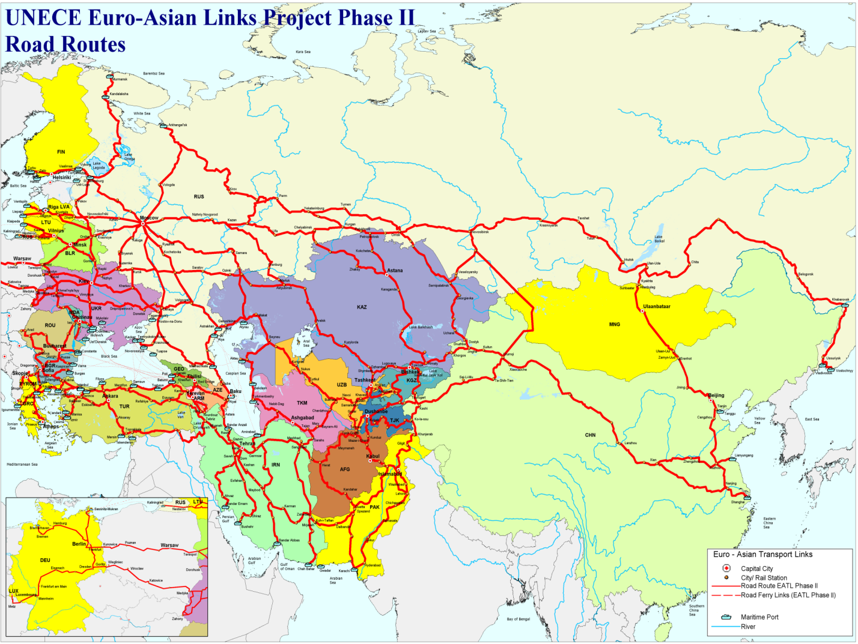
Source: UNECE, 2013

Table 1.28
EATL road routes
1 | West (N and E EU (Finland, Latvia, Lithuania, Poland, Hungary)) to East (Russia Pacific and connects to China and Mongolia - Parallel to Trans-Siberian-Railways  Countries crossed: Russia, Belarus or Ukraine
2 | West (N and E EU (Finland, Lithuania, Poland, Hungary)) to East (China) Parallel to Trans-Siberian- Railways with branches to Kazakhstan and Kyrgyzstan  Countries crossed: Ukraine, or Belarus, Russia, Kazakhstan, China
3 | West (E EU (Poland, Hungary) to East (China)  Countries crossed: Ukraine, Russia, Kazakhstan, Kyrgyzstan, China
4 | West (SE EU (Bulgaria) to East (China)  Countries crossed: Georgia, Azerbaijan, Kazakhstan, Uzbekistan, Kyrgyzstan, China  Number of ferry crossings: 2 Ro-Ro ferry crossings
5 | West (SE EU (Bulgaria and Slovakia) to South (Iran) and East (China)  Countries crossed: Turkey, Iran, Afghanistan, Kyrgyzstan, Tajikistan, Uzbekistan
6 | North (N EU (Finland)) to South (Iran) Countries crossed: Russia, Azerbaijan, Iran Kyrgyzstan, Turkmenistan  Number of ferry crossings: 1 Ro-Ro ferry crossings /Caspian Sea
7 | North (N Russia) to South (Ukraine)  Countries crossed: Russia, Belarus and Ukraine
8 | North (NW (Russia)) to South (China)  Countries crossed: Russia, and China
9 | North (Central Russia) to South (China)  Countries crossed: Russia and China

The role of road transport varies significantly across the EATL countries. In the European Union (EU 28) road transport accounts for about 75% of total freight turnover. At the same time, in Central Asian region the share of international transportation by trucks as compared with rail is lower in all Central Asian countries (with the exception of Kyrgyz Republic and Republic of Tajikistan). Here it accounts on average for less than 6 percent.
In European countries shippers prefer truck due to relatively short distances (even in international haulage), perfectly developed road network and high logistics quality and flexibility offered by road transport companies operating on the high competitive trucking market.
In the Asian part of the EATL region distances are much higher while the quality of the roads is uneven and many operators are not enough qualified and reliable.
Nevertheless the importance of road transport is increasing practically everywhere, in particular for regional and cross-border connections. The geography of the most heavily used routes underlines the importance of the west-east routes to and from China, but also the north-south corridors extending through Uzbekistan to and from Afghanistan, the Islamic Republic of Iran, and the Russian Federation.
Local cross-border market is served by small individual companies with old trucks or local market traders transporting their own merchandise.
Long-distance trade over 1,000 km is provided by comparatively modern companies operating according to international agreements in trucking industry TIR and CMR. Significant long-haul transportation is found in Central Asia, mostly under the TIR provision connecting the region with Russia and Europe. Despite the distance, time-sensitive or expensive commodities have a more reliable supply chain by roads. Uzbekistan and Kazakhstan are the most important countries for transit by road serving also the needs of their neighbors.
Prospects and opportunities for EATL road routes
Main market segments. It can be assumed that the role of road transport will grow in the most of the EATL countries following the demand for high quality and flexible logistic services. In particular, the following main spheres look reasonable:
- short-run cross border trade;
- long haul transportation on the lanes where railway links do not exist or can’t provide effective services for certain commodities (perishable, expensive, etc.);
- “road section” of intermodal rail-road transport service. This section connecting the consignor (consignee) and intermodal terminal or logistic center can be hundreds or even thousands kilometers long.
The last option is the most important one from the point of view of logistic supply chains transport provision and improving the competitiveness of EATL links.
In the EU region combined transport development is the general line of the transport policies and many shippers make their choice in favor of combined transport instead of “straight trucking”. The main reason is lower costs but environmental factor is also more and more considered. Within the highly developed intermodal networks additional effects are available such as “synchrologistic” management of flows switched from one mode to another according to the market situation. The combined rail-road services, if developed across the Euro-Asian trade lanes, could link together the Asian and European transport systems not just technologically but also within the high-quality logistic service chains.
Certain examples of projects of this kind can be found on the market. Deutsche Post DHL has developed its new service in partnership with Chinese rail operator YHF Logistics. The once-a-week service runs through to its intermodal hub in Malaszewicze, Poland, and the company then trucks shipments to Moscow to offer a 20-day transit time between Chengdu and Moscow (figure 1.32). The common sense says there is no reason to ship freight through the Russian Federation to Poland before trucking it back to Moscow, but the company representatives say this option avoids potential problems with the rail network going into Moscow.
It turned out that the intermodal decision in fact cuts transit time and transport costs significantly by overcoming potential delays that can be encountered when entering Moscow by rail [http://postandparcel.info/56547/news/innovation/dhl-launches-weekly-train-link-from-china-to-poland/].

Figure 1.43
Deutsche Post DHL combined service
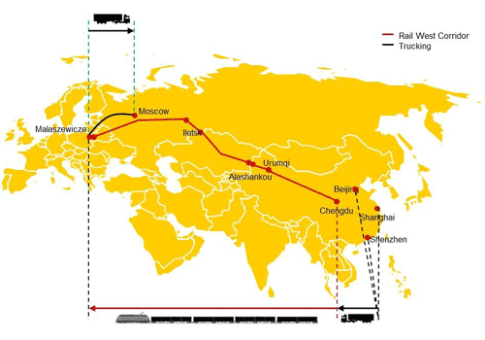
Road parameters. Long and heavy road vehicles. The harmonizing of road parameters and introduction of long and heavy vehicles (LHV), or road trains, seems to be one of the opportunities to increase the efficiency of road transportation in the EATL area.
The average standard gross weight of the freight road vehicle all around the world is about 40 tons which provides the payload of about 20 tons. The allowed length of the road combination rarely exceeds 20 meters. The full vehicle weight is limited by the bridges construction; the allowed axle load depends on the carrying capacity of the road. The vehicle length depends on road safety standards adopted in certain country.
It is very important to have the road limitations equal for all the sections of the long-haul road route. If this condition is not fulfilled, it is necessary either to pay fees for overloading on certain sections or even to partially unload the cargo and use another vehicle to pass through the leg with more strict limitations. Unfortunately, in practice it happens not only in case of two neighbor countries with different road standards but also within one country with uneven road quality.
Besides the harmonizing the road limitations across the main corridors, it is worth mentioning the option of using heavy and long vehicles.
Many countries have the experience in allowing (on certain sections of the road network) the road vehicles with weight and length that exceed the generally accepted standards. The goal is to improve the efficiency of transportation on the most loaded trade lanes.
This trucking concept is used in remote areas of Australia, the United States, and Western Canada. A road train consists of a relatively conventional prime mover, but instead of pulling one trailer or semi-trailer, the road train pulls two or more of them.
Australia has the largest and heaviest road-legal vehicles in the world, with some configurations topping out at close to 200 tons of the gross vehicle weight. The majority are between 80 and 120 tons. The train length reaches 53 meters (see figure 1.33).
Axle loads of the road train do not exceed the limit because the number of axles supporting the LHV is higher according to its increased length. As for the high gross vehicle weight, it sometimes makes necessary to enforce or rebuild the bridges along the routes where the LHV are operated.
Driving and maneuvering the Australian road trains safely without unduly obstructing traffic is only possible because of the sparse traffic and extremely flat and straight terrain through the Australian outback. The same requirements are taken into account in all the countries where LHV are allowed. Strict regulations also apply regarding licensing and driving experience. The multiple trailers are unhooked, the dollies removed and then connected individually to multiple trucks at assembly points (often located at terminals or logistic centers) when the road train gets close to populated areas with dense traffic.
Many of the EATL countries, especially in the Central Asian region, have conditions the make operation of the LHV possible. But this concept is developed not only in the regions with low economic and transport density.
In Europe the so called European module system (EMS), or Eurokombi concept is widely discussed currently. The idea is to allow longer and heavier combinations within one road vehicle using the existing equipment. Figure 2.11 shows how three standard European combinations can be converted into two by just recoupling the equipment. The EMS road train has the 25,25 m maximal length and the gross weight of 60 or 44 tons for different combinations (for volume or for weight cargoes). The average economic effect in comparison with traditional combinations is about 20-25%.
The Eurokombi vehicles are used for many years in Sweden and Finland and are already tested in the Netherlands, Denmark and Germany with positive experience.
The supporters of the LHV idea argue that this type of vehicle:
- increases transport efficiency and economic competitiveness;
- dramatically reduces the number of vehicles for a given amount of goods;
- reduces environmental impact of trucking;
- reduces road congestion and road wear;
- supports intermodal transport.
There is no doubt that the EMS concept as well as the experience of LHV operation in other regions of the world is worth serious attention of the EATL countries. The best results can be achieved if the EATL countries work at recommendations to support a harmonized application of the LHV.

Figure. 1.44
Australian road vehicle types.
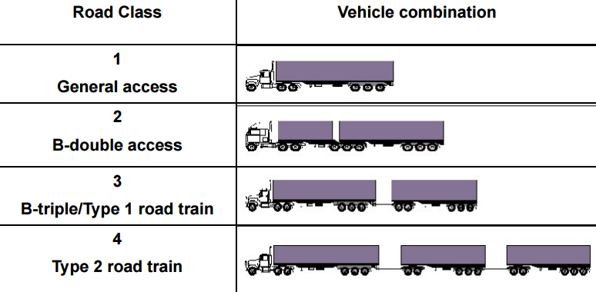
Source: Anders Lundström President of the International Forum for Road Transport Technology, IFRTT. Potential of High-Productivity Vehicles. Workshop presentation, June 24, 2009, Brussels)

Figure. 1.45
Eurokombi concept
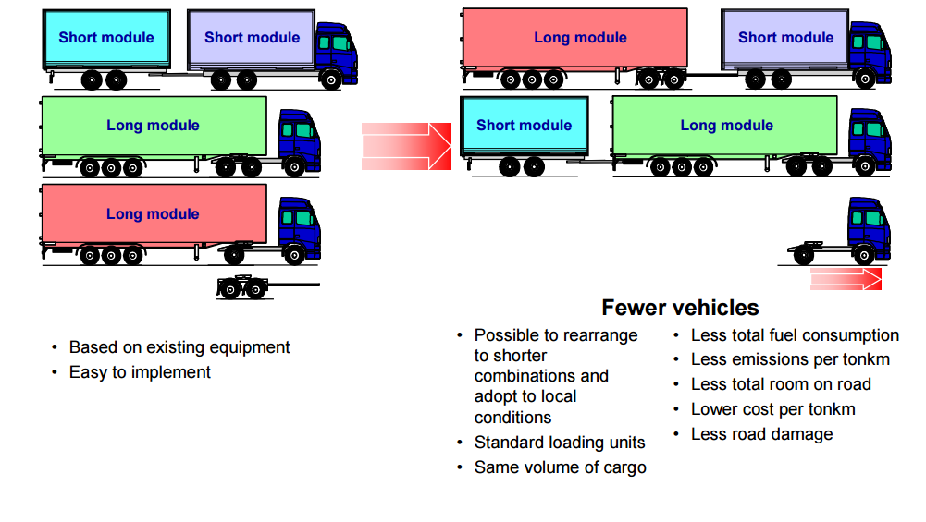
Source: Stefan Larsson, Director, Regulatory Projects. Weight and dimensions of heavy commercial vehicles as established by Directive 96/53/EC and the European Modular System (EMS). Workshop presentation ,June 24, 2009, Brussels)

I.4.4. Air transport infrastructure
In Europe and Asia, the processing of transcontinental cargoes is concentrated at hub airports. The largest hubs are, traditionally, Heathrow (London), Findel (Luxembourg), Schiphol (Amsterdam), Hong Kong, Seoul, Haneda and Narita (Tokyo). Shanghai and Beijing, China’s largest airports, have significantly increased their cargo traffic in recent years.

Table 1.30 – Top airports served Euro-Asian cargo flows, 2011-2016, thousands tons
Airports | 2011 | 2012 | 2013 | 2014 | 2015 | 2015/2011, %
Hong Kong (HKG) | 3968.4 | 4062.3 | 4161.7 | 4411.2 | 4422.2 | 111,4
Shanghai Pudong (PVG) | 3103.0 | 2939.2 | 2928.5 | 3181.4 | 3275.2 | 105,5
Seoul Incheon (ICN) | 2539.2 | 2456.7 | 2464.4 | 2557.7 | 2595.7 | 102,2
Dubai (DXB) | 2269.8 | 2267.4 | 2435.6 | 2367.6 | 2506.1 | 110,4
Tokyo Narita (NRT) | 1945.1 | 2006.2 | 2019.8 | 2132.4 | 2122.1 | 109,1
Paris Charles de Gaulle (CDG) | 2095.7 | 2151.0 | 2069.2 | 1890.8 | 2090.8 | 99,8
Frankfurt (FRA) | 2215.2 | 2066.4 | 2094.5 | 2132.1 | 2076.7 | 93,7
Taiwan Taoyuan (TPE) | 1627.5 | 1577.7 | 1571.8 | 2088.7 | 2021.9 | 124,2
Beijing Capital (PEK) | 1668.8 | 1787.0 | 1843.7 | 1831.2 | 1889.8 | 113,2
Singapore Changi (SIN) | 1898.9 | 1898.9 | 1886.0 | 1879.9 | 1887.0 | 99,4
Amsterdam (AMS) | 1549.7 | 1511.8 | 1566.0 | 1670.7 | 1655.4 | 106,8
London Heathrow (LHR) | 1569.5 | 1556.2 | 1515.1 | 1588.7 | 1591.6 | 101,4
Guangzhou Baiyun (CAN) | 1193.0 | 1246.5 | 1309.7 | 1454.0 | 1537.8 | 128,9
Doha Hamad (DOH) | 808.1 | 844.5 | 883.3 | 995.4 | 1455.0 | 180,1
Bangkok Suvarnabhumi (BKK) | 1321.8 | 1345.5 | 1236.2 | 1231.4 | 1230.6 | 93,1
Tokyo Haneda (HND) | 873.0 | 909.7 | 954.4 | 1098.2 | 1171.3 | 134,2
Shenzhen Bao’an (SZX) | 826.0 | 854.9 | 913.5 | 963.9 | 1013.7 | 122,7
Leipzig/Halle (LEJ) | 744.0 | 846.1 | 878.0 | 906.5 | 984.4 | 132,3
Al Maktoum (DWC) | … | … | … | 758.4 | 890.9 | -
Abu Dhabi (AUH) | … | … | 712.5 | 806.1 | 837.6 | -
Luxembourg Findel (LUX) | 656.7 | 614.9 | 673.5 | 708.1 | 737.6 | 112,3
Kuala Lumpur (AUH) | 702.1 | 702.2 | 713.3 | 776.7 | 775.0 | 110,4
Osaka Kansai (KIX) | 759.3 | 723.1 | 682.3 | 745.9 | 755.0 | 99,4
Cologne Bonn (CGN) | 726.3 | 730.1 | 717.1 | 742.5 | 739.5 | 101,8
Source: ACI

I.4.5. Logistic centers and dry ports in the EATL system
Smooth functioning of the supply chain requires modern infrastructure. Nowadays logistic centers are considered to be the mandatory components of logistic infrastructure carrying on numerous functions in the supply chains.
Europlatforms [20] give the following description of logistic center (LC) concept: “It is a designated area within which all operations connected with transport, logistics and distribution of goods are performed by different operators as part of deliveries, both on the national and international level. These operators may be owners of built and situated in the center: buildings, offices, warehouses, storage yards, parking places, facilities, etc. or use them pursuant to leasing or rental agreements. In order to respect the principles of free competition, the center must ensure access to all companies involved in activities described above. The logistics center must be equipped with devices and facilities available to the general public allowing to provide services. Whenever possible it should also ensure public services for the staff and users’ equipment. In order to support the development of inter-modal technologies in cargo relocation, the logistics center should be supported by many branches of transport. It is also necessary that the center be run by an entity appointed especially for this purpose from the public or private sphere”.
Logistics centers have the most extensive structure of all components comprising the logistics network. They are composed of many facilities collaborating with each other and co-operating logistics operators. LC enables to conduct operations on goods in connection with warehousing and relocating them between the shipper and the consignee, providing intermodal transportation and value-added services against the transported commodities.
Intermodal terminal is the specific component of the logistic center. It serves not only as a pivot where cargo (usually in containers, contrailers or swap-bodies) is transshipped between the modes. Logistic centers’ intermodal terminals are the origin/destination points for regularly operating block-trains linking the LC with other LCs located in sea ports, surface transport nodes, logistic hubs, industrial areas, etc. This is the most attractive feature for logistic operators locating their business on the LC.
The LC idea is currently used in most of the developed economies. Various terms, besides the Logistic Center, are used to identify the objects of the type in different countries: Terminal village, Freight village, Logistic Village, Dry Port – in English-speaking countries, GuterVerkehr Centrum (Center for Freight Transport) – in Germany and Austria, Interporto (transshipment point) – in Italy, Rail Service center – in Netherlands, Platform de Fret, Platform Logistigue (Freight platform, logistic platform) – in France.
While in Europe and in North America logistic centers have long ago become the compulsory component of logistic infrastructure, Asia is just in the early stage of LC development. To speed it up, in 2013 the Intergovernmental Agreement on Dry Ports was concluded under the auspices of the United Nations Economic and Social Commission for Asia and the Pacific (UNESCAP). The Agreement is aimed to promote the cooperation of the development of dry ports in the Asia-Pacific region. As of April 2016, the Agreement has been signed by 17 UNESCAP states.
The Agreement identifies a number of existing and potential dry port locations that are to be the basis of a coordinated effort to create nodes along an international integrated intermodal transport and logistics system.
According to the Agreement , a dry port of international importance (“dry port”) refers to an “Inland location as a logistics center connected to one or more modes of transport for the handling, storage and regulatory inspection of goods moving in international trade and the execution of applicable customs control and formalities”.
The Agreement (in its Annex I) identifies the dry ports subject to the agreement. The locations of the dry ports listed in the Agreement were chosen considering the following factors:
a) inland capitals, provincial/state capitals;
b) existing and potential industrial and agriculture centres;
c) major intersection of railways (Trans-Asian Railways), highways (Asian Highways) and inland waterways;
d) along trunk railways lines (Trans-Asian Railways),major highways (Asian Highways), inland waterways and airports/
The basic functions of dry ports include the handling, storage and regulatory inspection of goods moving in international trade and the execution of applicable customs control and formalities. Additional functions of dry ports may include, but are not limited to receipt and dispatch, consolidation and distribution, warehousing and transshipment.
The dry ports listed in the Agreement should be brought into conformity with the guiding principles for the development and operation of dry ports as described by Annex II of the Agreement. The guiding principles consider dry port functions, institutional, administrative and regulatory framework, design, layout and capacity of dry ports, their equipment and facilities.
According to the Agreement, the Parties adopt the list of dry ports as the basis for the coordinated development of important nodes in an international integrated intermodal transport and logistics system. They also intend to develop these dry ports within the framework of their national programmes and in accordance with national laws and regulations.
The implementation of the Agreement is considered by a Working Group on Dry Ports created according to the Agreement.
It appears that logistic centers in the EATL system should be the relay between transport corridors and regions. They should become international trading centers, interfaces between modes and between agencies participating in transportation and logistic process.
Being created in the hubs of EATL network, logistic centers could become the logistic “pivots” carrying on the following functions:
- acting as the points of local integration/distribution of goods in particular areas;
- serve as effective warehousing zones directly connected to transport services;
- being points of smooth transshipment between rail and road (as well as between different railway links) within intermodal transport services;
- act as platforms for industrial zones linked transport-logistic network;
- provide the possibility for value-added services execution within the supply chains;
- being located nearby the borders – provide infrastructure for effective border check procedures;
- being located on the connection points of different rail gauges – give opportunity to combine boogies exchange or freight transshipment with intermediate warehousing and/or value-added services.
In other words, Logistic Centers developed within the EATL network could become the modern market-oriented nodes of supply chains improving the competitiveness of the entire EATL system.
To be effectively inter-connected dry ports and inland terminal should provide standard – by scope and quality – logistic services. Currently these parameters differ much across the EATL terminal objects.
It seems reasonable to analyze the possibility of developing “Terminal services standard minimum” – first, in a form of recommendations or “Best practices manual”. Primarily this task should be done concerning container business.
Figure 1.46 illustrates the location of dry ports (envisaged by the 2013 Intergovernmental Agreement on Dry Ports) related to EATL railway routes.
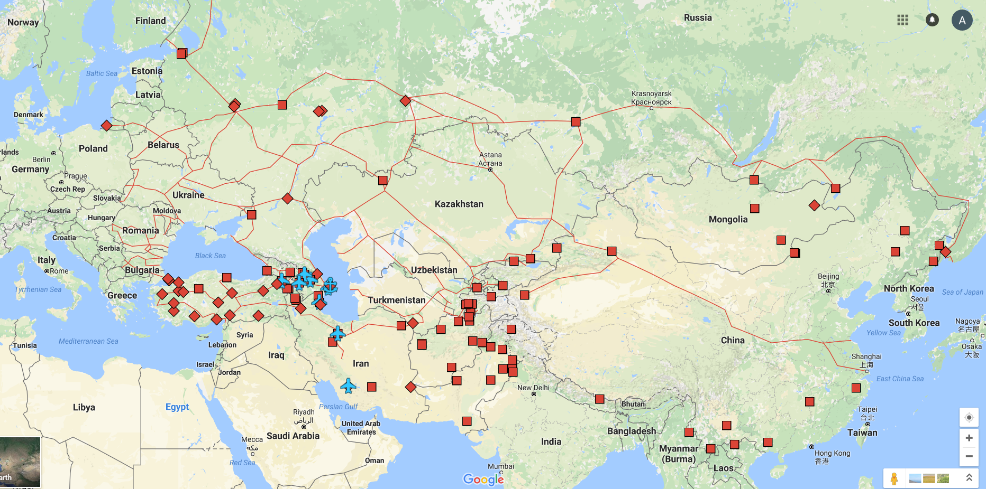

Figure 1.46. Dry ports listed in the 2013 Intergovernmental Agreement on Dry Ports related to EATL corridors

1.5. Comparative analysis of the duration and expenses of different modes of transport between Europe and Asia on selected Euro-Asian routes
During the International Euro-Asian Conference on Transport, European and Asian countries declared the desire to further connect and integrate their transport systems. One of the central ideas of such integration was to benefit from development of inland routes that are obviously shorter than the maritime lines.
At the same time, pure distance itself can not be the practical criteria of the route choice. Total transportation time (including the delays on the way), full delivery costs, service frequency and reliability, cargo “time sensitivity”, value added services en route and other factors are considered while making such a decision.
For this reason, comparative analysis of maritime and inland routes connecting Europe and Asia is undertaken constantly in numerous studies held by different agencies and researchers. The aims of such an analysis can differ. In particular, they are undertaken in order to:
- demonstrate the principle advantages of particular inland corridors;
- choose the most competitive inland route among several options; and
- evaluate the volumes of cargo that can be attracted to the inland routes,.
This section contains several examples of the sea and overland routes comparative analysis:
- the upgraded fragment of the analysis undertaken during Phase II of the EATL research;
- the study undertaken by the Russian Centre for Economic and Financial Research at the New Economic School (CEFIR);
- the research provided by PLASKE – freight forwarding company involved into the Euro-Asian intermodal container transportation;
- the Eurasian Development Bank study.

Phase II research
The Phase II study contained the section dedicated to comparative analysis of the maritime and inland Eurasian routes based on the time-cost methodology. The analysis included the total time and costs within the entire supply chain, which include road transport costs of moving containers from/to the warehouse/port, terminal handling charges, and documentation and other administrative costs.The structure of time and cost for compared routes is illustrated by figure 1.47.

Figure 1.47
Structure of time/costs considered by the EATL Phase II study
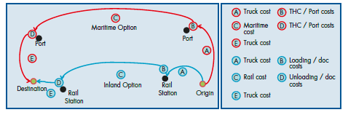
Nine scenarios were analyzed. In all scenarios, rail transport performed better than maritime in terms of travel time. The Study showed that Euro–Asian rail transport, and its intermodal combination with maritime and road transport, is a feasible and competitive transport option provided that efficient rail corridor management is established, governments are willing to cooperate and rail companies serve customers’ needs in an effective manner along the whole corridor.
In this section the selected results of this analysis are presented (6 scenarios out of 9, table 1.30). These results often can not give the definite advantage to certain option because time and costs comparison results can be contradictive ( “Total Result” column of table * where ++ means both the time and cost advantage of overland route and 0 means that the comparison result is undefined).

Table 1.30
Selected results of the comparative analysis of the maritime and inland Eurasian routes (EATL Phase II study)
Trade lane | Maritime |  | Overland |  | Result
 | Time | Cost | Time | Cost | Time | Cost | Total
Khabarovsk - Potsdam | 1093 | 6533 | 341 | 6967 | + | - | 0
Hangzhou - Kaluga | 637 | 6786 | 277 | 4715 | + | + | ++
Tashkent - Varna | 529 | 7550 | 165 | 5946 | + | + | ++
Almaty - Istanbul | 672 | 4970 | 250 | 5881 | + | - | 0
Ussuriysk (Russian Federation) to Kyiv (Ukraine) | 463 | 6290 | 289 | 5875 | + | + | ++
Shanghai - Warsaw | 569 | 6300 | 446 | 8937 | + | - | 0

This comparison was continued and “upgraded” on the base of value of time data used in the World Container Model. Since the value of time can dramatically differ for different commodities, three options were used for calculations – low, average and high value (see table 1.31).

Table 1.31
Value of time options
 | Commodities | Value of time, Euro/day/ton
Low | Solidmineralfuels | 1
Average | Foodstuffsandanimalfodder | 5
High | Machinery, transport equipment, manufactured and miscellaneous articles | 8

For calculations it was assumed that the average payload of the FEU is 15 tons. The values given in table 1.32 were converted into US dollars. After that the “Total costs difference” including all the charges en route plus the “time costs” were calculated for all the routes compared. The results are shown in table 1.33.The negative quantity of the total cost difference means that the inland transportation option is preferable.

Table 1.32
Comparison of routes taking into account the value of time
Trade lane | Total cost difference
 | Low | Average | High
Khabarovsk - Potsdam | -92,40 | -2221,50 | -3814,80
Hangzhou - Kaluga | -2323,00 | -3342,25 | -4105,00
Tashkent - Varna | -1858,80 | -2889,38 | -3660,60
Almaty - Istanbul | 615,60 | -579,19 | -1473,30
Ussuriysk (Russian Federation) to Kyiv (Ukraine) | -536,80 | -1029,44 | -1398,10
Shanghai - Warsaw | 2550,90 | 2202,66 | 1942,05

The results confirm the general conclusion made during Phase II of the project that at certain conditions many commodities can be effectively transported using the EATL rail routes. Among the analyzed trade routes the sea option is more effective only on th route Shanghai – Warsaw (for all types of commodities considered) for obvious reason – shortest land leg of the route.
The CEFIR study
The study [16 ] described in this section was undertaken by the Russian Centre for Economic and Financial Research at the New Economic School (CEFIR) in order to evaluate the transit potential of the Russian Federation in respect to goods flows between Asia and the European Union. The study compiles the information available from the RETRACK project (FP6 EC program) and work done on the development of the World Container Model (WCM). The main goal of the study was to evaluate the Euro-Asian cargo volumes that can be transported via the following routes:
– TransSib (TSR) (red line on figure *).This rail link begins in North Eastern China, going North directly into Russia. The Russian TSR ends in Moscow, from which the line continues further via Belarus to central Poland;
– TransSib – Kazakh, light blue line. This rail link starts in Western China, going via Kazakhstan in the North-Western direction. It joins the TSR line in Russia and follows the Trans-Siberian corridor further;
– Central corridor, brown line. This rail link starts in Western China, going via Kazakhstan in the Western direction and enters Russia in the South, then continues via Ukraine and finally ending in Slovakia;
– Maritime (Suez) route, dark blue line. The maritime link starts in the Eastern coastal China, uses Suez Canal to get into the Mediterranean Sea. For the West Europe, the link can be extended further through the Strait of Gibraltar.
– Arctic route, green line The potential of this route was a special point of the study; it is not described in this report.

Figure 1.48
Transport routes considered by the CEFIR study
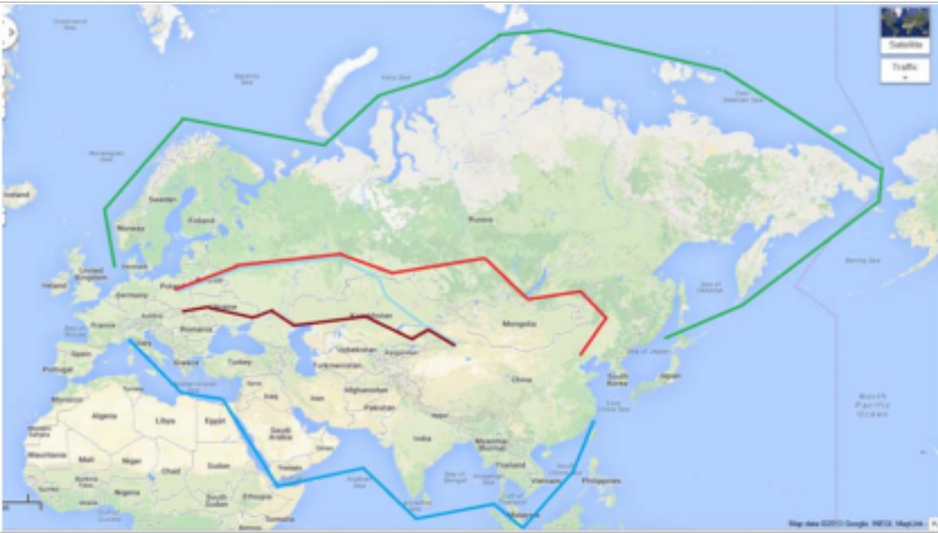
The potential assessment was made using the concept of the total logistics costs. The costs of transport between origin and destination points consist of two main components.
The first component contains the costs attributed to physical transport. These include the costs of moving loading units (containers, bulk units) between loading and discharge points and costs of transshipment (deep sea terminal costs, rail terminal costs, etc.). These are the so-called “out of pocket” costs that the cargo owners have to pay to move their goods.
The second cost component of the total logistics costs is related to the time that the goods spend in transit. The goods in transit freeze capital, causing the so- called pipeline stock keeping costs. However, the cost for capital frozen in transported goods is often not the greatest time-related cost component. While the goods are in transit, the market situation can change. Demand variability leads to capital expenditure on safety stocks that cover the uncertainty in demand during the period of transportation. Transit time also reduces company ability to react to other market events, such as introduction of new products by the competitors. In the case of new product introduction, the goods arriving later lose a substantial part of their value and are sold at a discount. The time-related component of the total logistics costs can be summed up in the Value of Time (VOT) value, which is commodity-specific.
The relevant estimations of time value for different goods are used in the World Container Model (WCM). The model has been calibrated to reflect worldwide goods flows: the VOT values used in the model have thus been proven to be realistic estimates.
For the assessment of the maritime and rail land bridge potential the total logistics costs for three rail corridors and the deep sea route indicated above were computed . The assessment of the corridors is based on their economic attractiveness: the corridors with smaller total logistics costs will be more attractive for the cargo owners.
For the objectives of the calculation, China had been split into 4 distinct regions, each having different growth prospects, economy properties, available infrastructure and various access costs to the Eastern deep sea ports: Western China (CN1), Central China (CN2), Coastal China North (CN3), Coastal China Center / South (CN4).
The model performs computations for the 4 Chinese regions, linking the regions to each of the 27 EU countries. All trade and transport volumes go to / come from the “centers” of those 4 regions.

Table 1.33
Regionalization of trade between EU and China within Chinese regions
ChineseRegion | Share of import / export
Western China | 0,05
Central China | 0,05
Coastal China North (CN3) | 0,45
Coastal China Center / South (CN4) | 0,45

The model estimated the average distances to and from each of the 27 EU countries to the European end points of the corridor. The same was also done for China: the distances were estimated between the 4 considered Chinese regions and the starting points of the corridors. These distances were used to determine the total logistics costs of transport to and from the rail corridors
The scenario 2020 used estimations over the expected at the time trade growth between China and the EU-27, expected improvements in rail infrastructure and spatial changes in the Chinese economy for the decade.
The Value of time in the model was expressed in euro/day/tonneper NSTR (Nomenclature uniforme des marchandises pour les Statistiques de Transport, Revisée)commodity typecomputed for the World Container Model (WCM). Commodity groups and corresponding Value of Time considered are presented in table 1.34.

Table 1.34
NSTR/1 commodity classification and value of time for commodity groups
NSTR/1 code | Commodity type | Value of time (Euro/day/ton)
NSTR0 | Agricultural products and live animals | 3,8
NSTR1 | Foodstuffsandanimalfodder | 5,0
NSTR2 | Solidmineralfuels | 1,0
NSTR3 | Petroleumproducts | 3,4
NSTR4 | Oresandmetalwaste | 2,6
NSTR5 | Metalproducts | 7,0
NSTR6 | Crude and manufactured minerals, building materials | 1,0
NSTR7 | Fertilizers | 1,0
NSTR8 | Chemicals | 7,0
NSTR9 | Machinery, transport equipment, manufactured and miscellaneous articles | 8,0

Main model parameters are presented in table 1.35.
For the basic model (year 2010) transit time was calculated after the interviews with the stakeholders and expert opinion (RETRACK project). Transshipment and shadow costs (reflecting a “resistance” for the goods flow, in particular, the non-physical barriers) were based on expert opinions and model calibration runs.
As for 2020, the assumption was made that the transit time between Europe and China across the rail corridors would improve. In addition, the ton-kilometer tariff and shadow costs were also expected to be reduced. These assumptions were all based on the proposed investments into the railwaysystems improvement between 2010 and 2020. The shadow costs for the rail corridors were estimated to be lower than in 2010, reflecting expected improvements in infrastructure and service. The maritime shadow costs have been kept constant.

Table 1.35
Main model parameters for 2010 and 2020
Corridor | Distance, km | Transit Time, days |  | Transport Cost, Euro/tonne/ km |  | Transshipment and shadow costs, Euro/tonne
 |  | 2010 | 2020 | 2010 | 2020 | 2010 | 2020
TSR | 8,000 | 20 | 14 | 0,07 | 0,035 | 400 | 300
TransSib – TransKazakh | 5,200 | 16 | 12 | 0,07 | 0,035 | 500 | 400
Central | 5,500 | 18 | 12 | 0,07 | 0,035 | 800 | 400
Maritime (Suez) | 16,000 | 30 | 30 | 0,0025 | 0,0025 | 100 | 100

Table 1.36 shows the model cargo distribution between the corridors.

Table 1.36
Estimated 2010 and 2020 rail corridor and maritime volumes between China and EU 27
Volumes distribution, China – EU27, % to total | 2010 | 2020
TSR corridor | 1,4 | 8,1
TransSib – Kazakh corridor | 0,2 | 6,0
Central corridor | 0,3 | 4,4
Maritime (Suez) corridor | 98,1 | 81,5
Total | 100 | 100

One of the interesting aspects of the modelling was the study of competition between the inland corridors influence. In the basic 2010 scenario the low volumes imply that inter-corridor competition does not have an impact, as the corridors “do not see” each other. The growth, if any, is a result of attracting cargo from maritime route. Contrary to the 2010 estimated situation, in 2020 competition would have an effect on rail volumes. The authors of the study conclude that less developed corridors would be more strongly affected by the intra-rail competition than the more attractive ones.
According to the modelling results, in 2010 the TSR and Kazakhstan corridors were the most attractive options, with the Kazakhstan corridor being slightly more attractive than TSR. Central corridor is not a viable option according to the modelling results.
In 2020, the TSR will become the most attractive rail land bridge, while the Kazakhstan land bridge will slightly lose its attractiveness. The most important expectation for 2020 is that the Central corridor will also become a good transport option, not being far behind the leading corridors.
The increased competitiveness of the TSR corridor in 2020 can be explained by the fact that this corridor has the fewest number of border crossings and transshipments (and the shadow costs are the lowest). Even assuming favorable developments in respect to infrastructure and alleviation of institutional barriers, border crossings and transshipment will still add extra transit time and costs. The extra times and border crossings are a strong structural resistance factor.
Generally, the modelling demonstrated that the total share of inland Euro-Asian transport can be increased from 1,9 to 18,5%. But to obtain such a result, dramatic changes should occur: transit time should decrease by 25-30%, transport costs should be at 50% level compared to the 2010 basis and transshipment and shadow costs should decrease significantly.
PLASKE company study
The research described below was provided by the PLASKE company – freight forwarder with experience in Euro-Asian intermodal container transportation.
The target of the research was the comparison of time and cost for cargo transportation via three rail EATL routes (No. 1, no. 2 and no. 7) and the sea route from China. The origin points are located nearby the sea (Shanghai), and in the remote from the sea region (Beijing). Destination point is Warsaw (Poland).
The 40’box containing motors for household sewing machines (cargo that requires no additional control measures), net weight 20 tons, was chosen as the object of transportation.
The specified delivery time is the smallest possible on the market.
Seven routes were chosen for the analysis: two of them connecting Shanghai and Warsaw and four between Beijing and Warsaw:
1a) Shanghai-Shanghai sea port – containership by sea - port of Gdańsk – railway container train - Warsaw;
1b) Shanghai- Railway route EATL No. 7 (China-[BCP Alashankou/Dostyk]-Kazakhstan-[BCP Saryagash/Keles]-Uzbekistan-[BCP Beyneu (Karakalpakia) /Oasis]- Kazakhstan -[BCP Aksaraiskaya/Ganyushkino]-Russia-[BCP Gukovo/Krasnaya Mogila] - Ukraine-[BCP Mostiska/Pshemyshl]-Poland), Warsaw;
2a) Beijing-railway container train -port Shanghai- containership by sea-port of Gdańsk- railway container train - Warsaw;
2b) Beijing - railway route EATL No. 7 (China-[BCP Alashankou/Dostyk]-Kazakhstan-[BCPSaryagash/Keles]-Uzbekistan-[BCP Beyneu (Karakalpakia) / Oasis]- Kazakhstan-[BCP Aksaraiskaya / Ganyushkino]-Russia-[BCP Gukovo/Krasnaya Mogila] – Ukraine - [BCP Mostiska/Pshemyshl] -Poland), Warsaw;
3a) Beijing-railway container train -port Shanghai-containership by sea -port of Gdańsk-railway container train -Warsaw (coincides with route 2 (a));
3b) Beijing-railwaycontainer train route No. 1 EATL (China-[ BCPMančžouli/Zabaykalsk]-Russia (Trans-Siberian railway)-[BCP Red/Osinovka]-Belarus-[BCP Brest/Terespol]-Poland), Warsaw;
4a) Beijing-railwaycontainer train -port Shanghai-containership by sea -port of Gdańsk-railway container train -Warsaw (coincides with route 2 (a));
4b) Beijing-railway route EATL No. 2 (China-[BCPAlashankou/Dostyk]-Kazakhstan-[BCP Petropavlovsk (Mamlyutka)/Kokchetav]-Russia-[Red/Osinovka]-Belarus-[BCP Brest/Terespol]-Poland), Warsaw.
The results of the routes’ comparison are presented below.
Case 1.Comparison of routes 1a and 1b (tables 1.37-1.40, figures 1.49-1.52) shows that rail traffic between China and Poland through Central Asia will be competitive for the carriage of containers in container trains only (average speed of 1000 km/day). The difference in delivery times in favor of railways in this case is big enough: 28 days.
Under normal conditions (standard train) this time advantage will likely be lost due to downtime of a train on the border crossings.
At the same time, cost difference here is the largest of all of the scenarios in the study: overland route is more expensive than sea by 8 $ 444.5. United States. The railroad crosses the territory of 7 countries (Kazakhstan, twice), and the total length of the path is 11 653 km-more than from China to Germany.

Table 1.37
Route 1a components
Route section | Length, km | Price, USD  (Commercial offer) | Price, USD (Internet data) | Time, hours
Port Handling costs Shanghai sea port | - | 100 | 100 | -
Other costs Shanghai sea port | - | 150 | 150 | -
Shanghai port-port of Gdansk (by sea) | 20486 | 2189 | 2350 | 981
Port Handling costs Gdansk sea port | - | 165,5 | 165,5 | -
Other costs Gdansk sea port | - | 250 | 250 | -
Port Gdansk- Warsaw (by rail) | 373 | 445 | 445 | 14,5
Warsaw rail terminal handling costs | - | 35 | 35 | -
Warsaw rail terminal other costs | - | 45 | 45 | -
TOTAL | 20859 | 3379,5 | 3540,5 | 995,5

Table 1.38
Route 1b components
Route section | Length, km | Price, USD  (Railway tariffs) | Time, hours
Shanghairailterminalhandlingcosts | - | 25 | -
Shanghai rail terminal other costs | - | 30 | -
China (by rail) Shanghai Jun-gunlu-Alashankou | 4529 | 6247 | 114
Kazakhstan (by rail) Dostyk-Sary-Agach | 1831 | 910 | 50
Uzbekistan (by rail) Keles-Karakalpakia | 1686 | 1399 | 46,5
Kazakhstan (by rail) Oasis-Dina Nurpeisova | 796 | 982 | 25
Russian Federation (by rail) Kigaš-Gukovo | 862 | 988 | 27
Ukraine (by rail) Krasnaya Mogila-Mostiska II | 1576 | 718 | 43
Poland (by rail) Pshemyshl-Warsaw | 380 | 445 | 9
Warsaw rail terminal handling costs | - | 35 | -
Warsaw rail terminal other costs | - | 45 | -
Total | 11660 | 11824 | 314,5

Figure 1.49
Time – distance diagram for routes 1a and 1b
Shanghai
Warsaw
Gdansk
Warsaw
DISTANCE, KM
Sea route (1a)
Rail route (1b) (1b))
TIME, HOURS
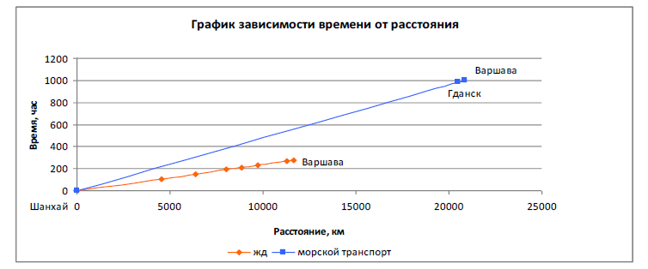

Figure 1.450
Cost – distance diagram for routes 1a and 1b
COSTS, USD
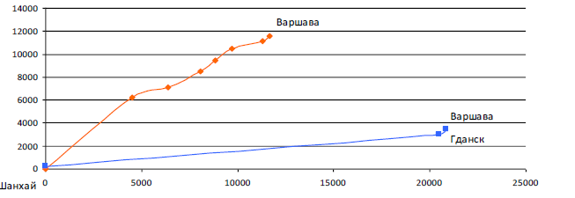
Warsaw

Rail route (1b) (1b))
Warsaw
Gdansk
Shanghai
Sea route (1a)
DISTANCE, KM
Table 1.39
Route 2a components
Route section | Length, km | Price, USD  (Commercial offer) | Price, USD (Internet data) | Time, hours
Beijing – Shanghai sea port (by rail) | 1095 | 1548 | 1548 | 26
Other costs Shanghai sea port | - | 100 | 100 | -
Shanghai port-port of Gdansk (by sea) | - | 150 | 150 | -
Port Handling costs Gdansk sea port | 20486 | 2189 | 2350 | 981
Other costs Gdansk sea port | - | 165,5 | 165,5 | -
Port Gdansk- Warsaw (by rail) | - | 250 | 250 | -
Warsaw rail terminal handling costs | 373 | 445 | 445 | 14,5
Warsaw rail terminal other costs | - | 35 | 35 | -
Other costs Shanghai sea port | - | 45 | 45 | -
TOTAL | 21954 | 4927 | 5088 | 1021,5

Table 1.40
Route 2b components
Route section | Length, km | Price, USD  (Railway tariffs) | Time, hours
Beijing rail terminal handling costs | - | 25 | -
Beijing rail terminal other costs | - | 30 | -
China (by rail) Beijing -Alashankou | 3354 | 4724 | 86,5
Kazakhstan (by rail) Dostyk-Sary-Agach | 1831 | 910 | 50
Uzbekistan (by rail) Keles-Karakalpakia | 1686 | 1399 | 46,5
Kazakhstan (by rail) Oasis-Dina Nurpeisova | 796 | 982 | 25
Russian Federation (by rail) Kigaš-Gukovo | 862 | 1113 | 27
Ukraine (by rail) Krasnaya Mogila-Mostiska II | 1576 | 718 | 43
Poland (by rail) Pshemyshl-Warsaw | 380 | 445 | 9
Warsaw rail terminal handling costs | - | 35 | -
Warsaw rail terminal other costs | - | 45 | -
Total | 10485 | 10426 | 287

Figure 1.51
Time – distance diagram for routes 2a and 2b
TIME, HOURS
Beijing
Warsaw
Gdansk
Warsaw
DISTANCE, KM
Sea route (2a)
Rail route (2b) (1b))
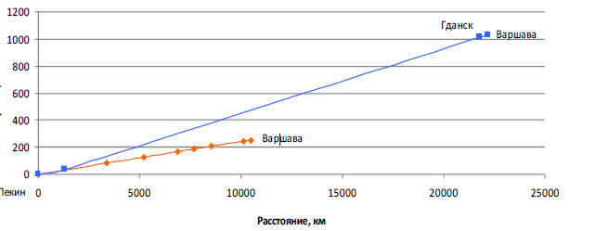

Figure 1.52
Cost – distance diagram for routes 2a and 2b
Warsaw
Warsaw
Gdansk
Beijing
COSTS, USD
DISTANCE, KM
Sea route (2a)
Rail route (2b) (1b))
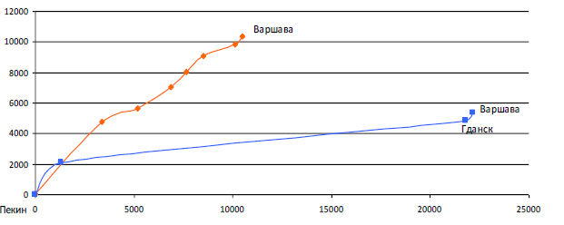

Case 2. Comparison of routes 2a and 2b shows the same tendency as in case 1.
Case 3.Route 3a is identical to route 2a. Data for route 3b components is shown in table 1.41.

Table 1.41
Route 3b components
Route section | Length, km | Price, USD  (Railway tariffs) | Time, hours
Beijing rail terminal handling costs | - | 25 | -
Beijing rail terminal other costs | - | 30 | -
China (by rail) Beijing-Manzhouli | 2335 | 3234 | 62
Russian Federation (by rail) Zabaikalsk-Krasnoe | 7069 | 1806 | 174
Belarus (by rail) Osinovka-Brest | 609 | 487 | 20
Poland (by rail) Terespol-Warsaw | 210 | 330 | 5
Warsaw rail terminal handling costs | - | 35 | -
Warsaw rail terminal other costs | - | 45 | -
TOTAL | 10223 | 5992 | 261

Figure 1.53
Time – distance diagram for routes 3a and 3b
TIME, HOURS
Beijing
Warsaw
Gdansk
Warsaw
DISTANCE, KM
Sea route (3a)
Rail route (3b) (1b))
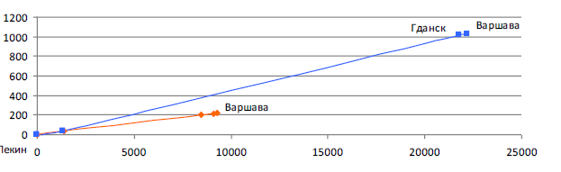

Figure 1.54
Cost – distance diagram for routes 3a and 3b
Warsaw
Warsaw
Gdansk
COSTS, USD
DISTANCE, KM
Sea route (3a)
Rail route (3b) (1b))
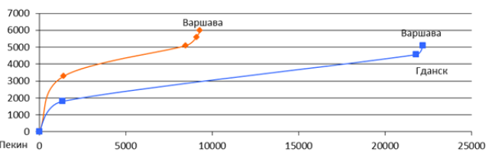

Beijing

In this case, the advantage of rail transport is obvious. The difference in delivery times is enormous: -31 days. Due to this and given the cost difference that accounts for only $ 1 065 railway route be quite competitive with sea in this case.
Case 4. Route 4a is identical to route 2a. Data for route 4b is shown in table 1.42.

Table 1.42
Route 4b components
Route section | Length, km | Price, USD  (Railway tariffs) | Time, hours
Beijing rail terminal handling costs | - | 25 | -
Beijing rail terminal other costs | - | 30 | -
China (by rail) Beijing -Alashankou | 3354 | 4675 | 86,5
Kazakhstan (by rail) Dostyk-Petropavlovsk | 1904 | 942 | 52
Russian Federation (by rail) Petropavlovsk-Krasnoe | 2845 | 1311 | 74
Belarus (by rail) Osinovka-Brest | 609 | 487 | 20,5
Poland (by rail) Terespol-Warsaw | 210 | 330 | 5
Warsaw rail terminal handling costs | - | 35 | -
Warsaw rail terminal other costs | - | 45 | -
Total | 8922 | 7880 | 238

Figure 1.55
Time – distance diagram for routes 4a and 4b
TIME, HOURS
Beijing
Warsaw
Gdansk
Warsaw
DISTANCE, KM
Sea route (4a)
Rail route (4b) (1b))
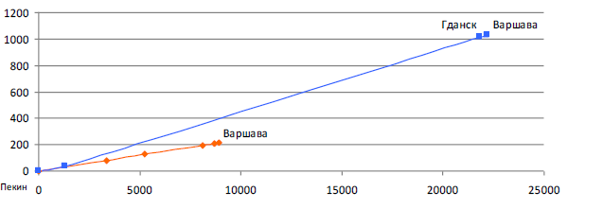

Figure 1.56
Cost – distance diagram for routes 4a and 4b
Warsaw
Warsaw
Gdansk
Beijing
COSTS, USD
DISTANCE, KM
Sea route (4a)
Rail route (4b) (1b))
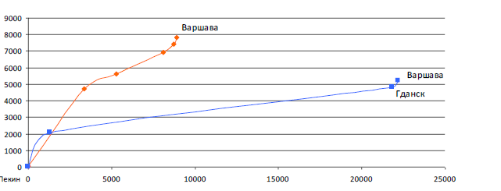

The difference in the cost of shipping container for these two routes is $ 2 953. The above chart clearly reflectsthe impact of generally higher costs for rail transportation. The railroad crosses the territory of 5 countries, and the total length of the path is 8 922 km, which is even smaller than along the route of the Trans-Siberian railway, but due to crossing the territory of Belarus the price for rail transportation increases significantly. The difference in delivery times compared to maritime transport is 33 days.
It should be noted that all the data relating to the cost of transportation on selected routes was picked from the public open sources: open publication of official statistics of the EATL countries and international organizations; analytical, statistical and empirical publications in specialized media; web sites of state and private companies as well as web resources created for the exchange of trade information.
At the same time, in each particular case price of transportation can and should be the subject of negotiation between shippers, carriers and other interested parties.Typically, this leads to the establishment of an acceptable price for these parties, which can differ significantly from the average, indicative figures obtained in this and other studies.
Eurasian Development Bank study
The Eurasian Development Bank published in 2016 the research note containing some preliminary estimates in regard to the potential transportation capacity and investment needs of various Silk Road Economic Belt (SREB) transportation routes that run across the Eurasian Economic Union’s countries.
The study argues that currently the huge potential presented by land routes from China through Central Asia to Europe is not being utilized. According to the study, out of all land routes, only two are now in actual operation:
- Urumqi (XUAR) – Kazakhstan – Omsk – Moscow – EU (as regards transit, its estimated utilization ratio at 20%); and
- Shanghai – Trans-Siberian Railroad – Brest (Trans-Siberian Railroad utilization ratio currently reaches 100%).
The land route is considerably more expensive than the marine route. The study estimates the cost of marine transportation along the Shanghai – Rotterdam route as 10 cents per ton per mile, while the cost of railroad transportation is as high as 30 cents per ton per mile. Therefore, meaningful trading volumes can be generated only when dealing with China's western provinces.
The list of goods that can be profitably carried by land from central and eastern provinces is very limited and contains:
- export goods originating from China's western provinces (mostly the Xinjiang Uyghur Autonomous Region, the Tibet Autonomous Region, and the Qinghai Province). The alternative for those provinces is to take the goods to the shore (about 3,000 km), and then carry them by sea;
- limited selection of goods originating from China's central and eastern provinces. These are high unit added value products (electronic devices, automotive parts, pharmaceuticals, standard and costume jewelry, etc.) and goods with critical delivery times (some food products, premium textiles).
The study points out at 6 potential transit corridors that can be used to deliver cargoes along the China – Europe route. These corridors are analyzed regarding their current condition and potential that can be reached after upgrading.
Route 1: Urumqi (XUAR) – Kazakhstan – Omsk – Moscow – EU. The cost of cargo delivery via this route strongly depends on the mode of transportation: it amounts to about US$ 1,300 per 1 TEU for railroad carriage. Design capacity of this route is the highest among all SREB routes at 300,000 TEUs. Its utilization ratio currently does not exceed 20% of maximum capacity.The most established version of the Urumqi – EU route is the transport corridor passing through the following cities: Lianyungang, Zhengzhou, Lanzhou, Urumqi, Khorgos, Almaty, Kyzylorda, Aktobe, Orenburg, Kazan, Nizhny Novgorod, Moscow, and Saint-Petersburg with access to Baltic Sea ports. The bulk of transit cargoes use this route and the Trans-Siberian Railroad. One of its key advantages is that there is only one customs border between China and Kazakhstan. The route's most critical problem is its limited throughput capacity. To make it competitive, it needs to be overhauled, and its transport and logistical infrastructure needs to be expanded.
The volume of funding required to modernize and improve railroads in Russia and Kazakhstan, to develop the Urumqi – Omsk – Moscow – EU route, and to build six major logistical centers (including those already in operation) is estimated at US$ 6 billion. Modernization will make it possible not only to boost cargo turnover, but also to bring railroad transportation tariffs down from US$ 1,300 per 1 TEU to US$ 1,000 per 1 TEU.
Route 2: Shanghai – Trans-Siberian Railroad – Brest; cargoes are delivered from China through Russia's Far East Maritime Province (PrimorskyKrai). The cost of cargo delivery from Vladivostok to Moscow using the Trans-Siberian Railroad currently stands at about US$ 1,100 per 1 TEU, and US$ 1,400 per 2 TEUs. The cost of railroad cargo delivery from Shanghai to Brest (including freight costs) will be about US$ 2,200 per 1 TEU, and US$ 3,000 per 2 TEUs. The overall throughput capacity of the routes is 250,000 TEUs, and it is already being fully utilized. The key problem of the route is that it has to use the busiest section of the Trans-Siberian Railroad: Omsk – Novosibirsk. This route is also longer than the Kazakhstan route. It will require construction of a number of new railroads, in some cases in mountainous areas. Subject to all those factors, this route will hardly prove to be attractive to China.
Estimates of required investments into modernization of the Trans-Siberian Railroad vary. The cost of construction of new additional sorting stations with adjacent container logistical terminals is estimated at US$ 2 billion. Efficient utilization and modernization of existing private terminals and Russian Railways terminals and construction of several new logistical centers may reduce that cost to US$ 1.2-1.4 billion. This will make it possible not only to increase the cargo turnover, but also to reduce transportation tariffs to less than US$ 1,100 per 1 TEU for the Trans-Siberian Railroad, and to about US$ 1,000 per 1 TEU for the Urumqi – Omsk – Brest route.
Route 3: Urumqi – Aktau – Makhachkala – Novorossiysk – Constanta. The cost of transportation (including transshipment to container carriers) currently stands at about US$ 4,000 per 1 TEU for deliveries to EU, and US$ 3,200 per 1 TEU for deliveries to the south of Russia. In theory, this route can be used to transport about 100 thousand TEUs per year (subject to existing port capacity and available fleet).
Route 4: Urumqi – Aktau – Makhachkala – Tbilisi – Constanta. The cost of cargo deliveries from China to Georgia will amount to US$ 3,700 per 1 TEU. The route's current theoretical throughput capacity does not exceed 50 thousand TEUs per year (subject to existing port capacity and available fleet).
The first issue arising in connection with further development of trans-Caspian routes is that none of the existing Caspian ports is ready to process massive cargo flows. All port facilities require serious modernization. To use trans-Caspian routes, it will be necessary not only to modernize the ports, but also to build new container logistical centers. Another problem is the need to use additional marine transport.
Route 5: Urumqi – Aktau – Baku – Poti – Constanta. The route is the most expensive and has the least throughput capacity of all the routes described above; besides, it has been used very little, if at all. The cost of railroad cargo delivery is as high as US$ 5,000.
This route will require the most significant outlays, including completion of construction of container facilities in Baku and port facilities in Poti, reconstruction of motorways, construction of tunnels and container logistical centers. Total required capital expenditures are estimated at not less than US$ 8 billion. That figure combined with the need to transship cargoes at several ports makes the route not very competitive.
Route 6: Urumqi – transit via Kazakhstan – Teheran (Iran). This route is much cheaper, and its throughput capacity is much higher. The cost of railroad cargo delivery is up to US$ 1,700 per 1 TEU. Potential capacity of this route is one the highest among all routes described above, and stands at 300,000 TEUs.
Minimum target investments required to develop this route are estimated at US$ 2 billion (source: Ministry of Transportation of Iran). Design of the route development program is still under way.
Table 1.43 contains the main characteristics of the routes described above.

Table 1.43
SREB Transport corridors and their potential
Route | Estimated route capacity, thousand TEUs | Railroad Transportation Cost, US$/TEU | Potential Trroughput Capacity Post-Modernisation, thousand TEUs | Railroad Transportation Cost Post-Modernisation, US$/TEU
Urumqi (XUAR) – Kazakhstan – Omsk – Moscow - EU | 300 | 1300 | 1000 | 1000
Shanghai – Trans-Siberian Railroad - Brest | 250 | 2200 | 1000 | 1000
Urumqi (XUAR) – Aktau – Makhachkala – Novorossiysk - Constanta | 100 | 4000 | 1000 | 1600
Urumqi (XUAR) – Aktau – Makhachkala – Tbilisi | 50 | 3700 | 1000 | 1600
Urumqi (XUAR) – Aktau – Baku – Poti - Constanta | 50 | 5000 |  | 1500
Urumqi (XUAR) – transit to EU via Kazakhstan and Iran | 300 | 1700 | 1000

Authors of the study come to a conclusion that transport corridors through Central Asia and the Russian Federation may potentially attract about 4% of total China – Europe marine cargo flows. Target export groups include a broad range of products manufactured in China's western provinces (mostly the Xinjiang Uyghur Autonomous Region, the Tibet Autonomous Region, and the Qinghai Province), and a limited selection of goods originating from its central and eastern provinces.
Implementation of development programs and satellite investment projects may increase the throughput capacity of SREB transport corridors to 3 million TEUs (which is about 13% of the current Euro-Asian container flow).
According to the study, the “ideal” outcome is one where up to 1 million TEUs will travel through Kazakhstan to the Russian Federation with subsequent partial delivery on to Europe (up to 30%), and another 1 million TEUs will transit through Aktau in the direction of Novorossiysk via Makhachkala to be evenly divided between the Russian and South-European markets.
The study also points out that an important restriction exists: attainment of maximum cargo throughput capacity by the SREB routes will be contingent on the Kazakhstan transportation system becoming capable of digesting 3 million TEUs.
Kazakhstan already has the required basic infrastructure (railroads, motorways, ports) in place. However, there is a major shortage of technological superstructures – modern container processing centers, customs terminals, and related logistical services. Qualified staff is also in short supply. Taken together, those factors constitute a critical infrastructural barrier preventing any major increase of cargo flows in Central Asia.
The Euro-Asian transport network system is mainly already formed. The main routes are demonstrating the practical capability of expensive and time-sensitive cargoes delivery serving as a complement to maritime routes.
For objective reasons the Euro-Asian land bridge likely will never compete in volume with maritime routes. But it may well establish itself as a complement to shipping services increasing the reliability of high-value and time-sensitive supply chains.
The current crisis situation has its negative impact on Euro-Asian inland links in several aspects:
- the general slow-down of transport demand;
- decreasing of the “critical mass” of traffic in landbridge corridors to keep the transport services across them sustainable;
- limitations of the investment potential for infrastructure projects implementation;
- growing gap between the shipping rates and the railway rates (which is one of the main disadvantages of the Euro-Asian landbridge).
At the same time, the current situation has some potential opportunities for the EATL transport routes development.
A portion of time-sensitive transit can be redirected through inland EATL routes due to “slow steaming” introduction on the maritime routes. Besides that, such events as the start of New Silk Way initiative, Creation of the Customs Union between the Russian Federation, Belarus and Kazakhstan, accession of the Russian Federation, Tajikistan and Kazakhstan to WTO improve the general political-economic climate across the EATL area.
EATL transport routes combine the functions and features of different types of transport corridors: transport and trade transit corridors, access corridors and developing corridors. On one hand, this gives wide opportunities to EATL countries; on another, very important is a clear understanding of actual possibilities, costs, benefits and risks that particular projects mean to them and their partners who depend on each other in corridors’ development process.
Competition of transport corridors on the Euro-Asian continent is not about the simple choice between transport routes and/or transport modes. It is the competition of logistic decisions based on intermodal services and value-added services and focused at the needs of particular supply chains. Main supply chains requirements are regular services, high punctuality, flexible costs, value added services availability, delivery speed appropriate for certain types of cargo. These requirements do not apply to particular sections of Euro-Asian routes, but to entire transport-logistic chains.
Decision making in supply chains, in particular – choosing the routes and modes - is made usually not by shippers themselves but by logistic operators: freight forwarders, 3 PL – providers, etc., who combine the understanding of the needs of particular supply chain with deep knowledge of transportation market and ability to put together the interests of numerous market players: carriers, terminal operators, infrastructure owners, etc.
Considering that, any transport route within the Eurasian continent would attract traffic and trade if it was competitive in the context of supply chains. No political decisions or investment projects developed beyond this context couldl be successful.. For the same reasons, any attempt to bind the freight flows within the corridors to particular fixed routes, points or to selected transport modes would seem counterproductive.
Railway transport should play the leading role within the EATL transport links.
In the current situation competitive railway services in EATL transit corridors can develop under the following conditions:
a) location of Asian terminal points in North-Western China
b) location of European terminal points in Eastern Europe and
c) existence of guaranteed flow of high-value and time-sensitive cargo (automotive parts, electronics, etc.) from one shipper or a limited group of “anchor” shippers as a basis for sustainable regular service. Besides, the service should be better operated not by pure railway carrier but by market-oriented logistic operator experienced in design of transport-logistic chains
The road transport within the EATL corridors should be harmonized with railway services and complete them rather than directly compete with rail. The following spheres look most reasonable: a) short-run cross border trade; b) long haul transportation on the lanes where railway links do not exist or can’t provide effective services for certain commodities (perishable, expensive, etc.); c) “road section” of intermodal rail-road transport service.
For effective long-haul trucking it is important to provide the even weight/length limitations for road transport along the main EATL routes.
It appears that currently the role of logistic centers in the EATL links development is underestimated. Being created in the hubs of EATL network, logistic centers could play the role of modern market-oriented nodes of supply chains improving the competitiveness of the entire EATL system.
Regular monitoring of corridors functioning is necessary not only for political needs but also as an instrument used by logistic operators willing to arrange the best possible currently transport chain.

PART II. CURRENT INITIATIVES, PROJECTS AND STUDIES IN EATL REGION

II.1. Overview of international studies, programmes and initiatives on Euro-Asian transport links development

II.1.1. UN ECE
II.1.1. The United Nations Economic Commission for Europe (UNECE)
The United Nations Economic Commission for Europe (UNECE) was set up in 1947. UNECE's major aim is to promote pan-European economic integration. UNECE includes 56 member States in Europe, North America and Asia.
The UNECE has established 57 transport agreements and conventions which are negotiated by government representatives and become legally binding for countries which ratify or accede to them. These agreements and conventions create international safety and environmental standards and regulations for transport and for motor vehicles and their trailers, harmonize national regulations, make border crossings less complicated, and provide for the development of coherent infrastructure networks for road, rail and inland waterway transport.
There are four main transport network agreements aimed at the development of coherent networks for road, rail, inland waterways and combined transport respectively:
a) The European Agreement on Main International Traffic Arteries (AGR), accepted in 1975, provides UNECE governments with the international legal framework for the construction and development of a coherent international road network with a view to developing international road transport and traffic throughout the UNECE region.
The AGR defines the E-road network, consisting of the arteries channeling major international road traffic flows in Europe, and the infrastructure parameters to which those arteries should conform. The AGR is constantly kept under review and updated whenever necessary to adapt it to new political and transport developments, such as the need for new roads in new States or those created by new traffic flows.
One of the major revisions was undertaken in order to include the international roads of the countries in the Caucasus and Central Asia. States that become Contracting Parties to the AGR commit themselves to its implementation, including the construction or upgrade of the E-roads in their territories, within the framework of their national investment programmes, although they are given complete latitude as to the timing for the completion of construction works.
To date, 37 UNECE Member States have become Contracting Parties to the AGR.
b)The European Agreement on Main International Railway Lines (AGC), accepted in 1985, similarly provides the legal and technical framework for the development of a coherent international rail network in the region. The AGC identifies the rail lines of major international importance, the E-rail network, and defines the infrastructure parameters to which they should conform.
The Agreement comprises the main body of the Agreement plus:
- definition of a network of railway lines of major international importance and
- definition of infrastructure parameters.
The AGC is also revised whenever necessary to take account of political and transportchanges in Europe. It has undergone a major revision in recent years also to include the internationalrail networks of the Caucasus and Central Asian countries.
Contracting Parties to theAGC commit themselves to its implementation, including the construction or theupgrade of the E-rail lines in their territories, within the framework of their national programmes but without any time constraints. To date, 27 UNECE Member States are Parties to the AGC.
c) The European Agreement on Important International Combined Transport Lines and Related Installations (AGTC), accepted in 1991, provides the technical and legal framework for the development of efficient international combined road/rail transport infrastructure and services. Combined road/rail transport comprises the transport of containers, swap bodies and entire trucks on railway wagons to and from especially equipped terminals. The AGTC determines important European railway lines used for international combined transport, identifies all terminals, bordercrossingpoints, ferry links and other installations important for international combined transportservices. It also establishes internationally acceptable infrastructure standards for those lines andrelated combined transport installations, and prescribes internationally acceptable performanceparameters of trains and combined transport installations and equipment.
Contracting Parties to the AGTC commit themselves to its implementation, including the construction or the upgrade of the railway lines and related combined transport installations in their territories, within the framework of their national programmes but without any time constraints. To date, 32 UNECE Member States have become Parties to the AGTC.
d) The European Agreement on Main Inland Waterways of International Importance(AGN), established in 1996, establishes the internationally agreed European network of inland waterways and ports as well as theuniform infrastructure and operational parameters to which they should conform. The geographicalscope of the E-waterways network, consisting of navigable rivers, canals and coastal routes extendsfrom the Atlantic to the Ural, connecting 37 countries and reaching beyond the European region.
By acceding to the AGN, governments commit themselves to the development and constructionof their inland waterways and ports of international importance in accordance with the uniformconditions agreed upon and within their investment programmes. To date, 18 UNECE Member States have become Parties to the AGN.
These four international Agreements define respectively the E transport networks for different modes as well as the minimum technical requirements according to which the relevant infrastructures should be built.AGTC also includes operational parameters for combined transport services.
UNECE infrastructure agreements are the only Pan-European governmental basis for the longtermdevelopment of coherent international networks for the various modes of inland transport.As such, they were taken as a basis for the determination of the Pan-European transport corridorsat the Pan-European Transport Conferences in Crete and Helsinki.
The E road and E rail networks represent the most useful basis for the identification of priorityEuro–Asian transport corridors.
To ensure seamless connections throughout Europe, including access to markets, UNECE coordinates work on a Trans-European network for motorways (TEM) and rail (TER) in Central, Eastern and South-Eastern Europe.
The UNECE Trans-European Motorways (TEM) Project accepted in 1977 is a sub-regional cooperation among Central, Eastern and South Eastern European countries. The project is aimed to facilitate road traffic in Europe, to improve the quality and efficiency of transport operations, to balance existing gaps and disparities between motorway networks in Western, Eastern, Central and South-Eastern Europe, and to assist the integration process of European transport infrastructure systems.
TEM is the backbone of the Pan -European Road Corridors in CEE and of the Transport Infrastructure Needs Assessment(TINA) exercise. Initial financial support was provided by the United Nations Development Programme (UNDP); the executing agency is UNECE. There are 15 TEM member countries: Armenia, Austria (associate member), Bosnia and Herzegovina, Bulgaria, Croatia, Czech Republic, Georgia, Hungary, Italy, Lithuania, Poland, Romania, Slovakia, Slovenia and Turkey. 4 other countries have observer status: Montenegro, Serbia, Sweden and Ukraine. Azerbaijani membership is currently pending, awaiting signature for accession.
The UNECE Trans-European Railway (TER) Project established in 1990is a sub-regional cooperation among Central, Eastern and South-Eastern European countries. The project is aimed to In order to improve the quality and efficiency of transport operations, to assist the integration process of European transport infrastructure systems, and to develop a coherent and efficient international railway and combined transport system in accordance with the UNECE Pan-European infrastructure agreements: European Agreement on Main International Railway Lines (AGC) and European Agreement on Important International Combined Transport Lines and Related Installations (AGTC).
Initial financial support was provided by the United Nations Development Programme (UNDP); the executing agency is UNECE
There are 17 member countries: Armenia, Austria, Bosnia and Herzegovina, Bulgaria, Croatia, Czech Republic, Georgia, Greece, Italy, Lithuania, Poland, Romania, Russian Federation, Serbia, Slovak Republic, Slovenia and Turkey. In addition, a number of observer countries participate in certain activities of the project: Belarus, Latvia, Moldova, Montenegro, the Former Yugoslav Republic of Macedonia and UkraineAzerbaijani membership is pending, awaiting signature for accession
The execution of the TEM and TER projects is provided by the TEM and TER Master Plan which sets out the priority infrastructure needs, the backbone networks and a realistic investment plan to develop them.
The original Master Plan was published in 2006, presenting a reliable and pragmatic short-,medium- and long-term investment strategy for developing road, rail and combined transportbackbone networks in the participating countries. The document was revised between 2008 and 2011 in order to analyze the results of road and rail infrastructure development, to describe the existing statusof road and rail networks; and to set out their development programme until the year 2020.
The revised Master Plan counts for 191 rail and 294 road projects with total cost of 188 billion Euros.

Figure 2.1
TEM Master plan revision backbone network
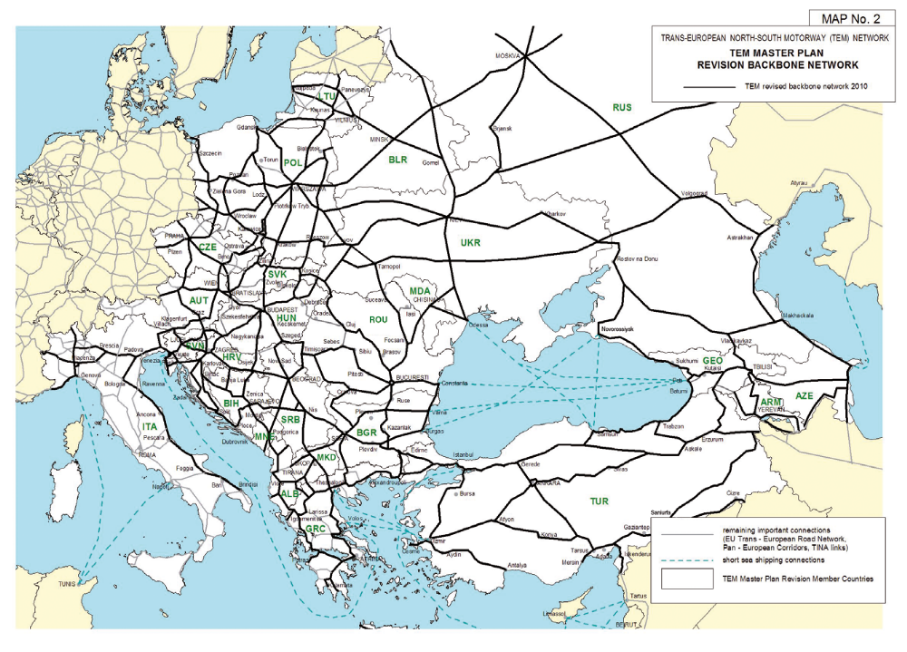
Figure 2.2
TER Master plan revision backbone network
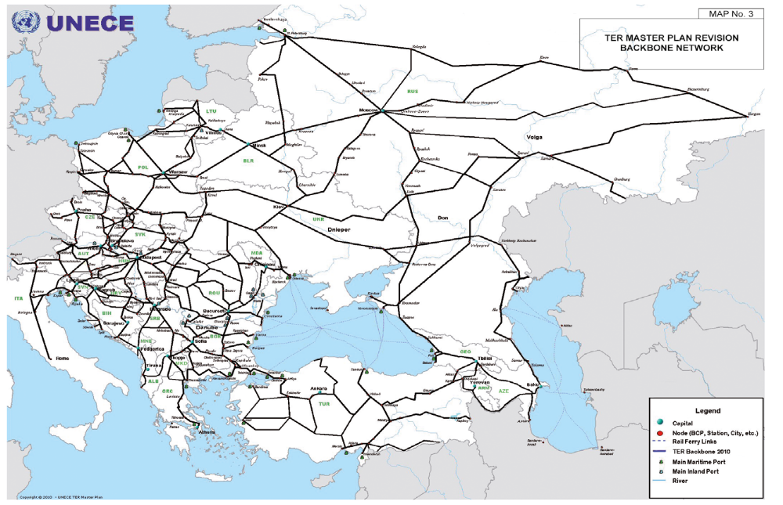
Source: http://www.unece.org/trans.html, 2013

II.1.2. UN ESCAP
Made up of 53 Member States and 9 Associate Members, with a geographical scope that stretches from Turkey in the west to the Pacific island nation of Kiribati in the east, and from the Russian Federation in the north to New Zealand in the south, the region is home to 4.1 billion people, or two thirds of the world’s population. This makes ESCAP the most comprehensive of the United Nations five regional commissions, and the largest United Nations body serving the Asia-Pacific region.
Established in 1947 with its headquarters in Bangkok, Thailand, ESCAP works to overcome some of the region’s greatest challenges by providing results oriented projects, technical assistance and capacity building to member States in the areas of Sustainable Development, Macroeconomic Policy and Financing for DevelopmentTrade, Investment and Innovation, Transport, Social Development, Environment and Development, Information and Communications Technology, Disaster Risk Reduction, Statistics, Sub-regional activities for development.
In the transport sector UNESCAP is supporting the following directions of development:
b) Asian Highway network. The Asian Highway network is a regional transport cooperation initiative aimed at enhancing the efficiency and development of the road infrastructure in Asia, supporting the development of Euro-Asia transport links and improving connectivity for landlocked countries.
c) Trans-Asian Railway network. The Trans-Asian Railway network now comprises 117,500 km of railway lines serving 28 member countries. Much like yesterday's Silk Road, today's Trans-Asian Railway aims to serve cultural exchanges and trade within Asia and between Asia and Europe. Recognizing that the network would reach its full operational capabilities through greater harmonization of standards and acknowledging the need for a regional framework to discuss related issues, Member States negotiated an Intergovernmental Agreement on the Trans-Asian Railway Network. The Agreement entered into force on 11 June 2009.
c) Intermodal regional network and dry ports. The Ministerial Conference on Transport held in the Republic of Korea in November 2006 noted that the Asian Highway and Trans-Asian Railway networks constituted important building blocks for the realization of the vision of an international integrated intermodal transport and logistics system which the ESCAP region needs to serve new trade patterns. Ministers resolved to develop policies along a number of guiding principles which included giving priority to investment in the Asian Highway and Trans-Asian Railway networks, including intermodal interfaces, and promoting the development of economic and logistics activities at intermodal interfaces.
Reaping the benefits of intermodalism requires that these intermodal interfaces such as dry ports or inland container depots be planned carefully to serve as efficient cross-over points where freight can switch modes without delays or damage.
The organization works with its member States to strengthen connectivity, optimize the use of existing infrastructure and increase the level of integration between the different transport modes. In order to finance these transport infrastructure and systems, UNESCAP offers advice on financing options and advocates public-private partnerships including network coordination, diagnostic workshops and online training materials and courses.
The project on Development of seamless rail-based intermodal transport services in Northeast and Central Asia for enhancing Euro-Asian transport links and its implementation was held by UNESCAP in 2016.
The goals of this project are as follows:
(i) review transport documentation, conventions and procedures applying to intermodal cargo transport across maritime and land borders in the sub-region;
(ii) identify problems related to border crossing efficiency which may be resolved by the streamlining and harmonization of existing documentation and procedures;
(iii) recommend improvements to documentation and procedures with a view to eliminating delays to transport at seaports and land borders and contributing to smooth transport flows across borders.
Fact-finding missions to five participating countries of Northeast and Central Asia - Korea, China, Russian Federation, Mongolia and Kazakhstan - were conducted for the purpose of identifying current practices and problems with respect border crossing documentation and control.
The study was prepared by UNESCAP Secretariat on the basis of desk research and of data collected from freight forwarders and government officials and private sector on the applicable documentation and procedures. The study provides the analysis of the current situation and presents recommendations for the harmonization and improvement of documentation and procedures in this sub-region. In particular, it recommends the adoption of a new transport document which has been designed to accommodate all transport modes, including railways, which have been so far excluded from the coverage of multi-modal transport documents.

Figure 2.3
Asian Highway network
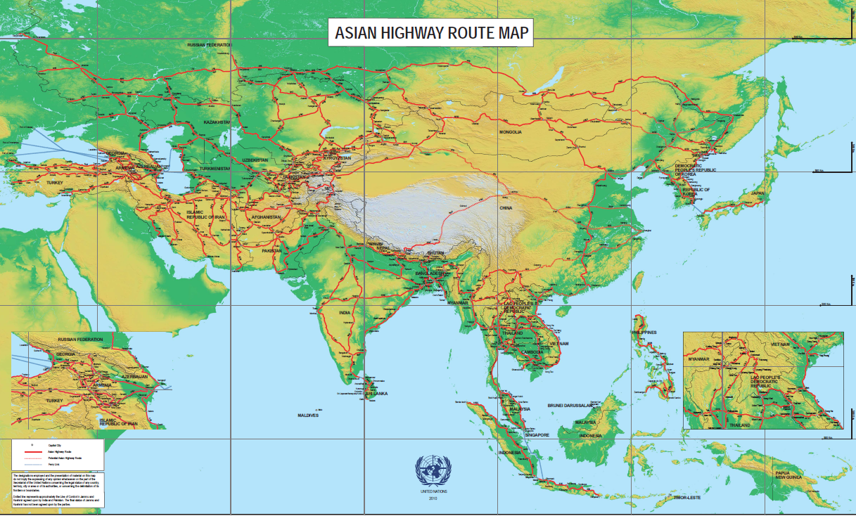
Sorce: http://www.unescap.org/, 2013

Figure 2.4
Trans-Asian Railway network
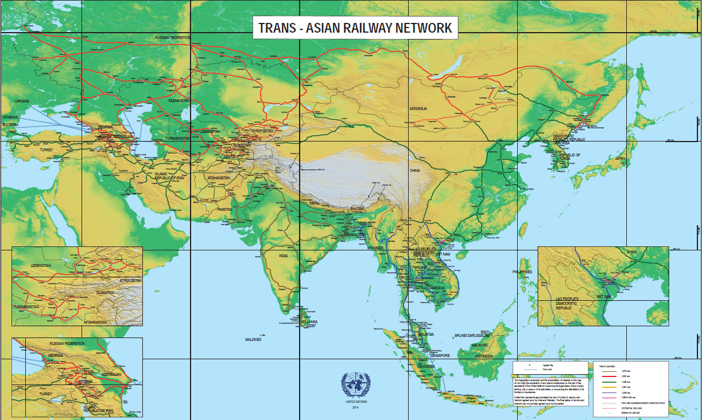
Sorce: http://www.unescap.org/, 2013

II.1.3. UN OHRLLS
The United Nations Office of the High Representative for the Least Developed Countries, Landlocked Developing Countries and the Small Island Developing States (UN-OHRLLS) was established by the United Nations General Assembly in 2001 through its resolution 56/227 with functions recommended by the Secretary-General in paragraph 17 of his report A/56/645.
The key functions of the OHRLLS are as follows:
(a) To assist the Secretary-General in ensuring the full mobilization and coordination of all parts of the United Nations system, with a view to facilitating the coordinated implementation of and coherence in the follow-up and monitoring of the Programme of Action for the Least Developed Countries at the country, regional and global levels;
(b) To provide coordinated support to the Economic and Social Council as well as the General Assembly in assessing progress and in conducting the annual review of the implementation of the Programme of Action;
(c) To support, as appropriate, the coordinated follow-up of the implementation of the Global Framework This Global Framework has now been replaced by the Almaty Declaration and Programme of Action, 2003 for Transit Transport Cooperation between Landlocked and Transit Developing Countries and the Donor Community and the Programme of Action for the Sustainable Development of Small Island Developing States;
(d) To undertake appropriate advocacy work in favour of the least developed countries, landlocked developing countries and small island developing States in partnership with the relevant parts of the United Nations as well as with the civil society, media, academia and foundations;
(e) To assist in mobilizing international support and resources for the implementation of the Programme of Action for the Least Developed Countries and other programmes and initiatives for landlocked developing countries and small island developing States;
(f) To provide appropriate support to group consultations of Least Developed Countries, Landlocked Developing Countries and Small Island Developing States.
In August, 2003, the International Ministerial Conference of Landlocked and Transit Developing Countries and Donor Countries on Transit Transport Cooperation (Almaty Ministerial Conference) was held in Almaty, Kazakhstan, setting the necessities of Landlocked and Transit Developing Countries in a universal document - Almaty Program of Action: “Addressing the Special Needs of Landlocked Developing Countries within a New Global Framework for Transit Transport Cooperation for Landlocked and Transit Developing Countries”.
The general objectives of the Program were as follows:
- reduce customs processes and fees to minimize costs and transport delays;
- improve infrastructure with respect to existing preferences of local transport modes, where road should be focused in Africa and rail in South Asia;
- implement preferences for landlocked countries’ commodities to boost their competitiveness in the international market;
- establish relationships between donor countries with landlocked and transit countries for technical, financial and policy improvements.
During the Second United Nations Conference on Landlocked Developing Countries that was held in 2014 in Vienna, Austria, a 10 year action-plan was adopted – the “Vienna Programme of Action for Landlocked Developing Countries for the Decade 2014-2024”.
The Vienna Programme is centered upon addressing the challenges faced by landlocked countries, aims to contribute to the eradication of poverty stemming from their landlockedness, through the implementation of specific actions in the priority areas identified by the document:
Priority 1: Fundamental transit policy issues
Priority 2: Infrastructure development and maintenance
(a) Transport infrastructure
(b) Energy and information and communications technology infrastructure
Priority 3: International trade and trade facilitation
(a) International trade
(b) Trade facilitation
Priority 4: Regional integration and cooperation
Priority 5: Structural economic transformation
Priority 6: Means of implementation
The main innovative feature of the Vienna Programme of Action is the particular focusto the development and expansion of efficient transit systems and transport development, enhancement of competitiveness, expansion of trade, structural transformation, regional cooperation, and the promotion of inclusive economic growth and sustainable development to reduce poverty, build resilience, bridge economic and social gaps and ultimately help transform those countries into land-linked countries.
http://unohrlls.org/

II.1.4. UNCTAD
The United Nations Conference on Trade and Development (UNCTAD), established in1964, promotes the development-friendly integration of developing countries into the worldeconomy by carrying out three key functions: operating as a forum for intergovernmentaldeliberations supported by discussions with experts and exchanges of experience for consensusbuilding; undertaking research, policy analysis and data collection; and providing technicalassistance to developing countries.
The objective of the Division on Technology and Logistics is to enhance the economicdevelopment and competitiveness of developing countries through efficient trade logisticsservices, transit transport systems, increased access to and sustainable utilization of informationand communication technology, and training and capacity-building programmes for local institutions.
Responding to the specific problems of LLDCs requires a multidimensional approach to landlockedness as a development challenge. This notably implies the implementation of policies and measures aimed at economic restructuring and specialization in these countries that take into account their transport-related obstacles. The development of productive capacities is a key element of this process.
In this context, UNCTAD supports LLDCs to tackle persisting and emerging challenges by providing advisory services and organizing high-level expert group meetings, among others to address key challenges facing these countries. Among the main outputs are:
- preparation of policy-focused studies at the request of LLDCs;
- supporting LLDCs to attract Foreign Direct Investments
http://unctad.org/en/Pages/ALDC/Landlocked%20Developing%20Countries/UN-recognition-of-the-problems-of-land-locked-developing-countries.aspx

II.1.5. UN SPECA
The United Nations Special Programme for the Economies of Central Asia (SPECA), a joint UNECE-UNESCAP initiative, was launched in 1998 to address challenges faced by Central Asian countries. It particularly aims to strengthen sub-regional cooperation and integrate the region into the world economy..
Thematic Working Group on Sustainable Transport, Transit and Connectivity (TWG-STTC) is a subsidiary body of SPECA. It focuses on developing new, and extending existing, road and rail networks in the region, as well as implementing the Programme of action resulting from the Almaty declaration of Land-Locked and Transit Developing Countries.
SPECA Project Working Group on Transport focuses on the development of Euro-Asian transport links, including the possible extension of the TER and TEM networks into the region. It plays an active role in the implementation of Vienna Program of Action for Landlocked Developing Countries for the Decade 2014-2024. The activities of the SPECA Project Working Group on transport is supported by the UNECE and UNESCAP in a coordinated and mutually reinforcing way.

Member-states: | Afghanistan, Azerbaijan, Kazakhstan, Kyrgyzstan, Tajikistan, Turkmenistan and Uzbekistan.
Priorities that are most important for the EATL development | - Implementation of international transport conventions and agreements;  - Establishment and operation of national coordinating mechanisms for transport facilitation;  - Identification and elimination of major bottlenecks along international transport routes;  - Creation of transport database;  - Establishment and strengthening of public-private partnerships;  - Road safety improvement;  - SDGs implementation
The SPECA Governing Council on its tenth session in November 2015 decided to change the title from “Project Working Group on Transport and Border Crossing” to the “Thematic Working Group on Sustainable Transport, Transit and Connectivity” (TWG-STTC) with new objectives added in line with the 2030 Sustainable Development Agenda adopted by the United Nations Sustainable Development Summit 2015 and the commitment to its implementation, including the achievement of the Sustainable Development Goals (SDGs). The 201 session of SPECA Governing Council in Ashgabat confirmed a strong potential of SPECA for supporting and facilitating the achievement of the SDGs. The SPECA framework, including its Governing Council, Economic Forums, and Working Groups can provide an important platform for supporting progress towards many of the SDGs through the exchange of best practice, capacity-building, joint development and implementation of regional projects and the sharing of experience on the use of new financial mechanisms and partnerships.
The TWG will facilitate policy discussions on strategic issues on strengthening regional cooperation and integration through enhanced transport connectivity and collection and dissemination of transport statistics with special focus on implementation of sustainable development goals. More specifically, the TWG’s activity aimed to:
- oversee the implementation of transport-related activities and initiatives at national and subregional level, including development of road and railway networks, dry ports as well as facilitate intermodal transport in SPECA countries;
- support the establishment and operation of national coordinating mechanisms for transport facilitation;
- facilitate the implementation of ESCAP agreements in transport such as the intergovernmental agreements on Asian Highway, Trans-Asian Railway and Dry Ports;
- assist in identification and elimination of major bottlenecks along international transport routes in SPECA region and beyond;
- facilitate the development of the SPECA TWG special database on transport and border crossing activities for the SPECA countries as well as collection of transport statistics;
- promote public-private partnerships in the SPECA region and innovative financing mechanism for transport infrastructure development;
- work towards improving road safety to reduce road traffic fatalities and casualties in the SPECA region;
- support the efforts of the participating countries to implement 2030 development agenda by enhancing the sustainability of transport;
- ensure more focus on those efforts which would result in strengthening regional cooperation aimed at achieving transport related SDGs;
- serve as a forum for inland transport stakeholders to discuss strategic issues, exchange of experiences, lessons learned and good practice, as well as for national and subregional efforts in transport sector related to increasing sustainability of transport and achieving SDGs;
- develop and implement transport projects, when possible, in line with relevant SDGs and targets to contribute to 2030 development agenda;

II.1.6. European Union
The European Commission aims to develop and promote transport policies that are efficient, safe, secure and sustainable, to create the conditions for a competitive industry that generates jobs and prosperity.
As of January 2014, the EU has a new transport infrastructure policy that will connect the continent from east to west, north to south. This policy aims to close the gaps between national transport networks, remove bottlenecks that still hamper the smooth functioning of the single market and overcome technical barriers such as incompatible standards for rail traffic.
The trans-European transport network, or TEN-T, is a longstanding project to modernize and ‘knit together’ today’s patchwork of national parts into a smooth-running transport network.
With the TEN-T, the EU plans to establish a core transport network by 2030, filling in missing cross-border links and making the network ‘smarter’, with deadlines to make sure that all projects contributing to the core network are implemented as a priority.
Currently nine core network corridors are identified, based on their added value for TEN-T development and their maturity status. Core network corridors were introduced to facilitate the coordinated implementation of the core network. They bring together public and private resources and concentrate EU support from the CEF, particularly to remove bottlenecks, build missing cross-border connections and promote modal integration and interoperability.
One of the EU constant priorities is the development of effective transport links with their Eastern and Southern neighbor states and, via them – with countries of Central and Eastern Asia.

Figure 2.5
Map of TEN-T corridors
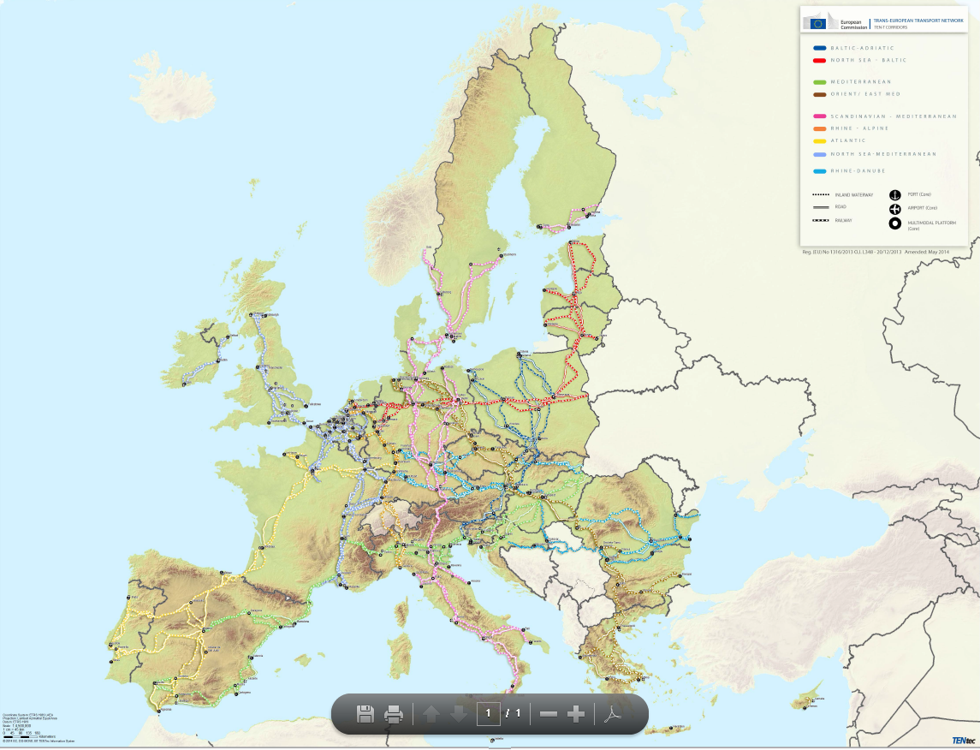
Source: http://europa.eu/pol/trans/index_en.htm
The regional EU-assistance in transport benefitting the eastern neighbors is channeled, in particular, under the TRACECA-programme, an acronym referring to Transport Corridor Europe-Caucasus-Asia. This EU programme was launched in 1993 to develop a transport corridor from Europe to China, via the Black Sea, the Caucasus, the Caspian Sea and Central Asia.
In 2009 EU and six partner countries (Armenia, Azerbaijan, Belarus, Georgia, the Republic of Moldova and Ukraine) established the Eastern Partnership (EaP), a joint initiative building also on bilateral relations. This cooperation has a certain transportation aspect – the EaP Transport Panel which is is a framework for exchange of information and best practice between the partner countries and the EU Member States. Its goal is to strengthen transport connections both between the partner countries and the EU and between partner countries themselves. It addresses reforms underpinning regulatory convergence across transport modes. Policy work conducted in this area includes certain transportation issues, in particular:
- the EaP regional transport network (approved 2013 and included in the indicative TEN-T maps);
- regulatory convergence, which became a priority notably for countries having signed Association Agreements with the EU;
- regional transport cooperation and capacity building actions in all transport modes.

II.1.7. Eurasian Economic Union
The Eurasian Economic Union (EAEU) was established in 2014 for regional economic integration. It has international legal personality and is established by members of the Treaty on the Eurasian Economic Union - Republic of Armenia, the Republic of Belarus, the Republic of Kazakhstan, the Kyrgyz Republic and the Russian Federation. Eurasian Economic Commission (EEC) is a permanent executive body of the EAEU.
The EAEU is aimed for free movement of goods, services, capital and labor on the territory of member states. Transport is one of the key integration priorities of the Union.
The Eurasian Economic Council during its session on December 26, 2016, approved the Guidelines of coordinated (agreed) transport policy of the EAEU. Their implementation will allow to remove barriers for transportation by all modes of transport and create a single transport space and a common market of transport services within the Union until 2025.
According to the Guidelines the main objectives of coordinated (agreed) transport policy are integration of transport systems of Member States into the global transport system, efficient use of transit potential of Member States, improvement of transport safety and transport services quality, attraction of foreign investments.
Key objectives include, among other issues, the establishment and development of Eurasian Transport Corridors, capacity building of the Union’s transit potential, coordination of transport infrastructure development, establishment of logistics centres and transport organisations ensuring optimisation of freight transport, etc.
The EEC is carrying out work on Partnership between the Silk Road Economic Belt (SREB) Initiave and EAEU which was approved by the presidents of the EAEU Members States and the Chinese President. In the field of transport the following achievements are expected:
- reinforcing interaction in logistics, transport infrastructure and intermodal transport;
- implementing transport infrastructure projects to expand and develop regional value chains.
During 2016 more than 40 specific projects of transport infrastructure development were identified by member states in the framework of Partnership between SREB and EAEU. Joint partnership between the EAEU and SREB streamlines creation of modern systems of international logistics centres and hubs on major international transport corridors crossing Eurasia: Western Europe–Western China, North–South, East–West and Northern Sea Route. These plans may be supplemented by meridian transport links passing through Mongolia and Kazakhstan and connecting Siberia with central and western regions of China and countries of Central and South Asia.
For EAEU Member States SREB provides an inflow of investment in transport infrastructure modernisation of which would strengthen mutual trade between the countries of the Union and increase their investment attractiveness. In the long term it would drive growth in other economic sectors.

Status | IGO
Activitie’s geographical coverage | 5 countries from Europe and Asia
Focus | - creation of single transport space and a common market of transport services;  - establishment and development of Eurasian Transport Corridors;  - capacity building of the Union’s transit potential;  - establishment of logistics centres and transport organisations ensuring optimisation of transport of goods, etc.
Main projects, programs and initiatives aimed to EATL development | “Eurasian Economic Union and «Silk Road Economic Belt» Project: Joint Partnership” (aimed to reinforcing interaction in logistics, transport infrastructure and intermodal transport; implementing transport infrastructure projects to expand and develop regional production tides).
Web | www.eurasiancommission.org/en/

II.1.8. Silk Road Economic BELT Initiative
The Silk Road Economic Belt and 21st Century Maritime Silk Road, a significant development strategy launched by the Chinese government with the intention of promoting economic co-operation among countries along the proposed Belt and Road routes. The Initiative has been designed to enhance the orderly free flow of economic factors and the efficient allocation of resources. It is also intended to further market integration and create a regional economic co-operation framework of benefit to all.
The Chinies National Development and Reform Commission (NDRC) issued its Vision and Actions on Jointly Building the Silk Road Economic Belt and 21st Century Maritime Silk Road on 28 March 2015. This document outlined the framework, key areas and mechanisms of co-operation with regard to the “One Belt – One Road” Initiative.
The Belt and Road Initiative upholds the principles of jointly developing the programme through consultation with all interested parties. Existing bilateral and multilateral co-operation mechanisms will be utilized to promote the integration of the development strategies of the countries along the route. Steps will be taken to advance the signing memorandums of understanding or co-operation plans for the establishment of a number of bilateral demonstration projects. Efforts will also be made to set up a sound bilateral joint work mechanism, and to devise an implementation plan and action roadmap for advancing the Belt and Road strategy.
The US$40 billion Silk Road Fund has been established to finance the Belt and Road Initiative. It will invest mainly in infrastructure and resources, as well as in industrial and financial cooperation. The Fund was set up as a limited liability company in December 2014 with its founding shareholders including China’s State Administration of Foreign Exchange, the China Investment Corp, the Export-Import Bank of China and the China Development Bank.
The new multilateral development bank - Asian Infrastructure Investment Bank (AIIB) has been set up with a view to complementing and cooperating with the existing MDBs in order to address infrastructure needs in Asia. AIIB will focus on the development of infrastructure and other sectors in Asia, including transport and telecommunications, , urban development and logistics.
Transportwise the Belt and Road Initiative aims to connect Asia, Europe and Africa along five routes. The Silk Road Economic Belt focusses on: (1) linking China to Europe through Central Asia and Russia; (2) connecting China with the Middle East through Central Asia; and (3) bringing together China and Southeast Asia, South Asia and the Indian Ocean. The 21st Century Maritime Silk Road, focusses on using Chinese coastal ports to: (4) link China with Europe through the South China Sea and Indian Ocean; and (5) connect China with the South Pacific Ocean through the South China Sea.
Focusing on the above mentioned five routes, the Belt and Road will take advantage of international transport routes as well as core cities and key ports to further strengthen collaboration and build six international economic co-operation corridors. These have been identified as the New Eurasia Land Bridge, China-Mongolia-Russia, China-Central Asia-West Asia, China-Indochina Peninsula, China-Pakistan, and Bangladesh-China-India-Myanmar.

Figure 2.7
Silk Road Economic Belt and the 21st Century Maritime Silk Road corridors as described in the Vision and Actions on Jointly building the Silk Road Economic Belt and 21-st Century Maritime Silk Road document
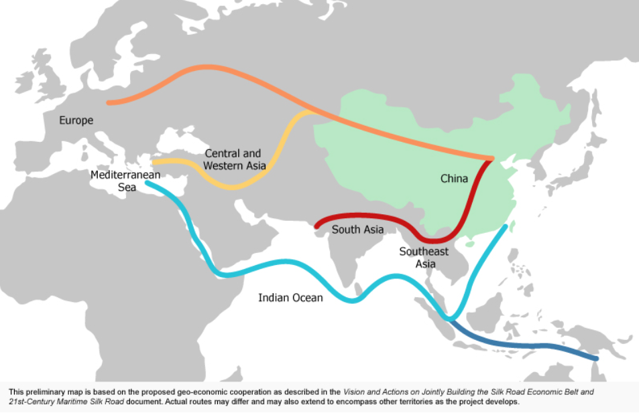
http://beltandroad.hktdc.com/en/about-the-belt-and-road-initiative/about-the-belt-and-road-initiative.aspx

II.1.9. OSCE
The Organization for Security and Co-operation in Europe (OSCE) has a comprehensive approach to security that encompasses politico-military, economic and environmental, and human aspects. It therefore addresses a wide range of security-related concerns, including arms control, confidence- and security-building measures, human rights, national minorities, democratization, policing strategies, counter-terrorism and economic and environmental activities. All 57 participating States enjoy equal status, and decisions are taken by consensus on a politically, but not legally binding basis.
Transport related issues have been high on the OSCE’s agenda in the Economic and Environmental Dimension in recent years.In the field of transport the Office of the Coordinator ofOSCE Economic and Environmental Activities (OCEEA),together with the OSCE field operations, continuesto implement the relevant Ministerial Council Decisionsadopted over the past years, namely MC DecisionNo. 11/06 on Future Transport Dialogue in the OSCE(Brussels, 2006), MC Decision No. 9/08 on Follow-Upto the Sixteenth Economic and Environmental Forum onMaritime and Inland Waterways Co-operation (Helsinki, 2008) and the most recent MC Decision No. 11/11 on Strengthening Transport Dialogue in the OSCE (Vilnius, 2011).
Based on these documents, the OCEEA and partner organizations such as the United Nations Economic Commission for Europe (UNECE) Transport Division and the World Customs Organization (WCO) are engaged in activities described below.
The security of inland transport. This issue has been noted as the weakest in the global supply chain. Relative to seaports and airports, many consider inland transportation to be under-protected. The OSCE has responded by promoting a comprehensive, integrated approach towards inland transport security taking into account the views and concerns of various stakeholders.
Good governance and anti-corruption. The OCEEA assists participating States by providing capacity building and regional training activities aimed at combating corruption in customs and other border services. In carrying out these activities, the OCEEA aims to raise awareness of the existing tools to fight corruption in border services and to work with participating States to identify concrete national follow-up activities in this field.
International legal instruments. The OCEEA assists participating States in organizing regional training activities and national seminars to discuss the implementation of the following international legal instruments in Eastern and South-Eastern Europe, the South Caucasus and Central Asia: United Nations Economic Commission for Europe (UNECE) International Convention on the Harmonization of Frontier Control of Goods (‘Harmonization Convention’); World Customs Organization (WCO) revised Kyoto Convention on the Simplification and Harmonization of Customs Procedures; World Customs Organization (WCO) SAFE Framework of Standards to Secure and Facilitate Global Trade.
Assistance to Landlocked Developing Countries.Out of 31 landlocked developing countries globally, nine are OSCE participating States or Partners for Co-operation. The specific transport challenges landlocked developing countries face include lack of direct access to deep water ports and a high level of dependence on the transit services of non-landlocked neighbors. Addressing those challenges requires the development of efficient transport systems through genuine public and private partnerships between landlocked and transit countries and their development partners. While the international donor community, including financial and development institutions and donor countries, have a major role to play in providing financial and technical support for the construction of transport infrastructure, the OSCE has focused on tackling non-physical obstacles to trade and transport. Since 2006 the OSCE has provided political and financial support to the UNECE’s Euro-Asian Transport Links Project (Phases I and II).
OSCE-UNECE Handbook of Best Practices at Border Crossings.In February 2012, the OCEEA and the Transport Division of the United Nations Economic Commission for Europe (UNECE) jointly released a OSCE-UNECE Handbook of Best Practices at Border Crossings – A Trade and Transport Facilitation Perspective. The handbook aims to assist OSCE participating States/ UNECE member States, particularly those which are landlocked developing countries with limited access to world markets, in developing more efficient border, transport and customs policies. The publication provides an overview of a range of reference materials and over 120 best practice examples. It covers areas such as available legal instruments, inter-agency and international co-operation, balancing security and facilitation measures, freight processing, risk management, border crossing point design, ICT technology use, human resource management and benchmarking.

http://www.osce.org/eea/98372?download=true

II.1.10. OSJD
The Organization for Cooperation of Railways (OSJD) was established in 1956 by the railway administrations of the ‘Eastern Block’ countries to create and improve the coordination of international rail transport. Concerning especially the transports between Europe and Asia, it has helped develop cooperation between railways and with other international organizations.

Member-states: | Azerbaijan, Albania, Afghanistan, Belarus, Bulgaria, Hungary, Vietnam, Georgia, Iran, Kazakhstan, China, Democratic People's Republic of Korea, Cuba, Kyrgyzstan, Latvia, Lithuania, Moldova, Mongolia, Poland, Russia, Romania, Slovakia, Tajikistan, Turkmenistan, Uzbekistan, Ukraine, Czech Republic, Estonia.  Apart from them, OSJD incorporates 7 railways with observer status from:France (SNCF),Germany (DB AG),Finland (VR),Serbia (ZS),Greece (OSE),Austrian-Hungarian company "GySEV",Federal Passenger Company (FPC JSC, Russia).
Priorities that are most important for the EATL development | - Development and improvement of international railway transportation with the traffic between Europe and Asia, including combined transportation;  - Development of consentaneous transport policy in the field of international railway traffic;  - Improvement of international transport law, administration of the Convention concerning International Goods Traffic by Rail (SMGS) and other legal documents connected with the international railway traffic;  - Co-operation on the solution of the problems connected with the economic, information, scientific, technological and ecological aspects of railway transport;  - Development of measures aimed at the increase of railway transport competitiveness;  - Co-operation in the field of railway operation and technical matters connected with further development of international railway traffic;  - collaboration with other international organizations, engaged in railway transportation matters, including those of combined transport.

In 1996, 13 main railway routes between Europe and Asia were identified by the OSJD on the basis of flows of goods between countries on the two continents. On a permanent basis the OSJD performs an analysis of technical and operational indicators and technical equipment of these 13 corridors, collects data on infrastructure and border crossings and studies the ways of the freight transport technology improvement. This work resulted in comprehensive measures being drafted to improve the managment of international rail transport operations along the transport corridors between Europe and Asia.
The XLIII session of the OSJD Ministerial Conference (Ulan-Bator, Mongolia, June 2-5, 2015) approved Comprehensive plans of carriage improvement and development of OSJD Railway Transport Corridors Nos. 4, 6 and 11 for a period up to 2020 and reported on the progress of the related comprehensive plans for transport corridors Nos. 9, 12 and 13.
The map of the OSJD corridors is presented on Fig.*
The interested countries signed memoranda of understanding for the development of these corridors, which served as a basis for coordinated actions by States to reorganize and modernize pertinent railway lines.

Figure 2.8
OSJD railway transport corridors
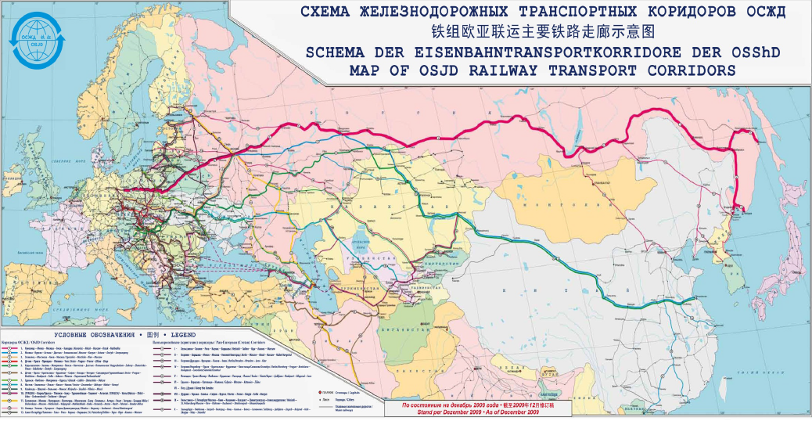
Source: OSJD, 2011
One of the projects initiated by OSJD and aimed to improve the conditions of Euro-Asian railway transportation is the CIM/SMGS consignment note. This single transport document combines the required CIM and SMGS contracts of carriage into one paper.
The customs authorities officially recognize this document of carriage. The document is valid in the EU/EFTA customs area as transit declaration T as well as in SMGS regime as a national customs (transit) document. The CIM/SMGS consignment note can not only be used for wagonload services, but also for Combined Transport.
Using the new consignment note means documents no longer have to be changed at border crossings between two legal jurisdictions, dispensing with a great deal of administrative expenditure. This is a first step towards through service for freight transport with just minimal border stops.
The development of the action plan on implementation of the Memorandum on cooperation in the technical, operational and commercial development of OSJD railway transport corridors Nos. 1-13 was continued:
To improve the efficiency of the OSJD railway transport corridors, the experts studied the possibilities of connection of the new lines to the OSJD railway transport corridors, in particular:
- at the suggestion of the Republic of Moldova, the member states of OSJD railway transport corridor No. 12 and Ukraine have agreed to extend OSJD railway transport corridor No. 12 through the territory of the Republic of Moldova from Ocniţa station to Vălcineţ station and then through the territory of Ukraine to Zhmerinka station subject to preservation of the current crossing capacity in the territory of Ukraine at this stage. The relevant changes in OSJD railway transport corridor No. 12 were approved at the annual meeting of the OSJD Commission on Transport Policy and Development Strategy (October 6-9, 2015, the OSJD Committee).
Besides, the member states of railway transport corridors Nos. 2, 5, 8 and 10 accepted the proposal made by the Republic of Kazakhstan on connection of the following railway lines:
- Iletsk – Kabdyagash – Nikeltau – Tobol as a branch line of OSJD railway transport corridor No. 2;
- Zhetygen – Altynkol as a branch line of OSJD Railway Transport Corridor No. 5;
- Beyneu – Uzen – Bolashak OSJD Transport Corridor No. 8;
- Dostyk – Mointy – Zhezkazgan – Saksaulskaya – Beyneu – Aktau-Port OSJD railway transport corridor No. 10.
In this connection, a resolution was passed to update the Comprehensive plans on improvement of the railway operations and development of OSJD railway transport corridors Nos. 2, 5, 8, 10 and 12 up to 2020, as well as the engineering and operational documentation of OSJD Transport Corridors Nos. 2, 5, 8, 10 and 12, and to amend the Memorandum on cooperation in the engineering, operational and commercial development of the OSJD railway transport corridors with regard to the above mentioned corridors.
Ukraine informed the OSJD Committee that the initiative connect port Odessa, port Ilyichyevsk (Ukraine), through the territory of Belarus, with port Klaipeda (Lithuania) was supported by the Byelorussian Railway and the Lithuanian Railways, and suggested that existing OSJD railway transport corridor No. 9 should be extended. The working bodies of the OSJD Commission on Transport Policy and Development Strategy commenced the work on this question on the basis of the OSJD regulatory documents.
The activity of OSJD Commission on Freight Traffic was carried out in the following directions:
- updating the existing international agreements and contracts in the field of combined transportation between Europe and Asia;
- implementing tariff conditions in regard to the transit freight transportation;
- updating the existing rules on common use of freight wagons in the international traffic for the purpose of ensuring their harmonization with similar international regulating documents;
- harmonising the uniform system of cargo classification and coding;
- planning and organising container block trains between Europe and Asia, including combined transport;
- practical implementation of uniform CIM/SMGS consignments notes in the rail transport between Europe and Asia;
- cooperation with the international organizations in the aim to increase the efficiency and competitiveness of the international railway transport and modal shift from other modes of transport.

II.1.11. BSEC
The Organization of the Black Sea Economic Cooperation (BSEC) was established in 1999 tofoster interaction and to ensure peace, stability and prosperity among its Member States.The membership of BSEC currently includes Albania, Armenia, Azerbaijan, Bulgaria, Georgia, Greece, Moldova, Romania, Russia, Serbia, Turkey, Ukraine.
Since its inception, BSEC paid special attention to cooperation in transport focusing mainly on how to utilize effectively intra-region transportation capacity and growing transit potential of the Black Sea region. At the Meeting of the Ministers of Transport of the BSEC Member States in 2005, it wasconcluded that the development of transport axes connecting the Trans-European TransportNetwork with the Black Sea transport network should be based on the Euro–Asian transportcorridors and on the major routes under the UNECE-UNESCAP EATL framework as well ason other international agreements and initiatives.
BSEC has theWorking Group on Transport has its regular meetings and it carries out its functions as a working organ of cooperation in transport sphere.
The meetings of the Ministers of Transport of the BSEC Member State constitute de-facto a regular high-level decision making transport forum with working group, steering committees and expert groups as the implementation mechanism. BSEC developed some important mutually supplemented projects in the region.
Cooperation on the gradual liberalization of transportsector is going on according to the Memorandum of Understanding on Facilitation of Road Transport of Goods in the BSEC Region (signed in Kyiv in 2002). The work on the MoU was institutionalized by establishing the Steering Committee on Facilitation of Road Transport of Goods. The BSEC Permanent International Secretariat (PERMIS) carries out the duty of its secretariat. This work is being done in a close cooperation and with valuable support of the International Road Transport Union (IRU) and the Union of the Road Transport Association in the BSEC region (BSEC-URTA).The Steering Committee works on the issues of gradual liberalization of transport permit system, monitoring of border waiting times, introduction of the International Vehicle Weight Certificate, harmonization of charging policies etc.
Cooperation on the development of road infrastructure was established within the Memorandum of Understanding for the Coordinated Development of the Black Sea Ring Highway (signed in Belgrade on 19 April 2007). The work on the project was institutionalized by establishing the Steering Committee as a main driving force and Joint Permanent Technical Secretariat.
Development of maritime infrastructure and links is under way within the Memorandum of Understanding on the Development of the Motorways of the Sea at the BSEC Region (signed in Belgrade on 19 April 2007). The is coordinated by the Ad Hoc Working Group pertaining to this Memorandum of Understanding.
The projects also constitute regional contribution to the extension of Trans-European Networks and the development of Euro-Asian transport links.In the meantime, parallel these projects, BSEC, continues exploring new areas where it is desirable and realistic to develop and deepen multilateral cooperation in a regional format in the transport sphere. Special attention is paid to cooperation with other international organizations such as UNECE, UNDP, IRU, IRF and BSEC sectoral dialogue partners, BRASS, BASPA, BINSA and BSEC-URTA.
BSEC has worked collaboratively with UNECE on issues related to transport facilitation. The Cooperation Agreement between BSEC and UNECE, signed in 2001, aims at accelerating thedevelopment of international transport infrastructure networks, transport and border-crossingfacilitation, and also harmonizing safety and environment standards in the area of transport.
http://www.bsec-organization.org/aoc/Transport/Pages/Information.aspx

II.1.12. TRACECA
The Transport Corridor Europe-Caucasus-Asia (TRACECA) programme was launched at a conference in Brussels in 1993 which had brought together trade and transport ministers from the original eight TRACECA countries (five Central Asian republics and three Caucasian republics). Currently TRACECA members include Armenia, Azerbaijan, Bulgaria, Georgia, Kazakhstan, Kyrgyz Republic, Moldova, Romania, Tajikistan, Turkey, Turkmenistan, Ukraine, and Uzbekistan.
At the Brussels conference, it was agreed to implement a program of a European Union funded technical assistance to develop a transport corridor on a west-east axis from Europe, across the Black Sea, through the Caucasus and the Caspian Sea to Central Asia.
In 2000, an Intergovernmental Commission (IGC) was established to oversee the implementation of the programme. The Commission’s executive body, the Permanent Secretariat (PS), created in 2001, has its headquarters in Baku and since 2006 is funded directly through contributions of the TRACECA member countries.
In 2004 the Baku Initiative on Transport was launched involving all 1998 TRACECA MLA signatory states as well as Belarus.
One of the first activities of this initiative was to set up four expert working groups to work out recommendations on transport development in the fields of land transport (road / rail), aviation, security, and infrastructure. These recommendations were presented at the Second Baku Initiative Ministerial Conference and Fifth Annual Meeting of the IGC TRACECA in May 2006 which, in turn, approved the TRACECA long-term strategy.
The present Action Plan is based on the provisions of the strategy elaborated for the TRACECA corridor region. The latter’s overall goal is to help deliver a sustainable, efficient and integrated multi-modal transport system between the EU and the TRACECA region but also among the TRACECA countries.
Currently the TRACECA countries are gradually implementing the IGC TRACECA Strategy for development of the international transport Europe-Caucasus-Asia corridor, aimed at creation of a sustainable infrastructure chain ensuring multi-modal transport with step-by-step integration of the corridor into the Trans-European Transport Networks (TEN-T).

Figure 2.9
Main TRACECA routes
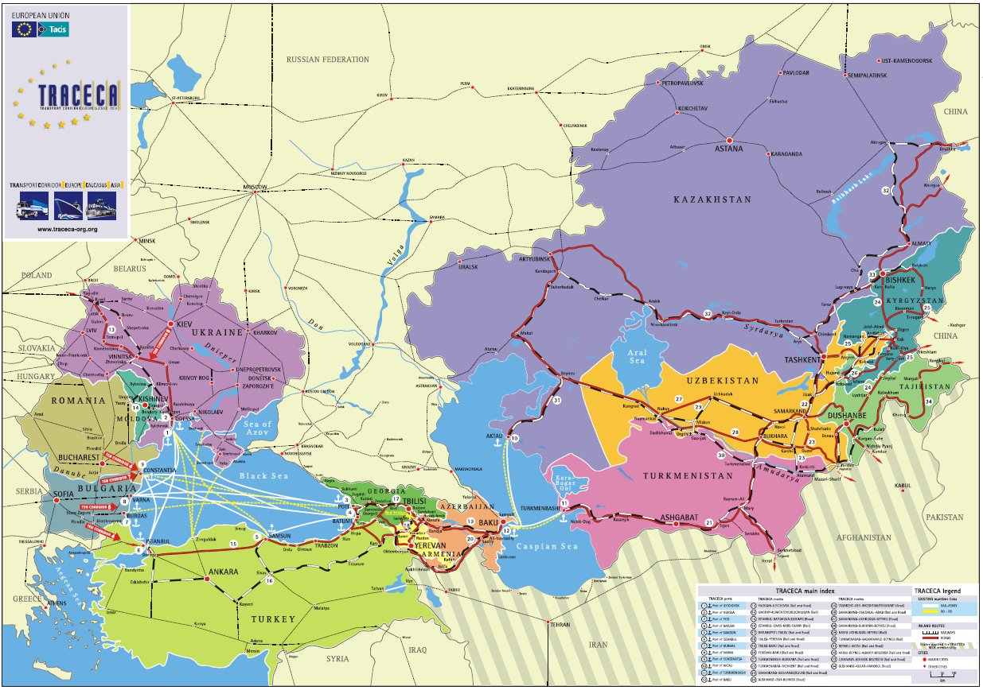
Source – TRACECA.org, 2013
As a part of the “New Silk Road” intermodal East-West transport infrastructure initiative, Azerbaijan, Kazakhstan, Georgia and Turkey agreed on creation of the Trans-Caspian International Transport Route (TITR).
In the framework of the TITR project, a cargo train that launches from China will be able to reach Europe in less than 14 days, which is the most competitive route in terms of transport time. It takes around 15-19 days for a cargo train that departs from China and passes through the Russian territories to reach Europe, and it takes more than a month for a cargo from the Eastern China to arrive in Europe using the current maritime route. Therefore, the TITR would have obvious advantages over the existing inland and maritime routes.
The agreement on the establishment of the Coordination Committee to develop the Trans-Caspian International Transport Route was signed by the representatives of the national railway companies from Azerbaijan, Kazakhstan and Georgia, and the representatives of the ports of Aktau and Baku during the 2nd International Transport and Logistics Business Forum “New Silk Road” in November 2013. During the 5th meeting of the Coordination Committee on the development of the TITR on October 20,2014 participants of the TITR project agreed to accept the Turkish State Railways to the Coordinating Committee.
The first container train over the Trans-Caspian International Transport Route was launched on July 28, 2015, the test cargo train departed from the Xinjiang province in China, travelled along theShihezi-Dostyk-Aktau-Alyat-Keshla routethrough the territories of Kazakhstan and Azerbaijan, and arrived at the Baku International Trade Port complex, located in the town of Alyat (around 30 miles south west of Baku).
The train carried caustic soda and consisted of 41 platforms and 82containers, weighing 20 tons each. It traveled for 6 days and for more than 4,000 kilometers, passing through the Kazakhport of Aktau. Therefore, it was the first successful attempt to launch a cargo train from China to the Caspian region through the Caspian Sea.
The test train showed the principle capability of the parties to reach an agreement on tariff policy and on harmonized customs procedures providing a competitive route from Asia to Europe.
The second container train via the Trans-Caspian International Transport Route arrived in Georgia on October 3, 2015. The train, consisting of 44 containers, departed from the Chinese Xinjiang province, travelled on the Alashankou-Dostyk-Aktau-Alyat-Tbilisi route and arrived in Georgia in eight days. The second test train showed that the organization of the container service on the China-Kazakhstan-Azerbaijan-Georgia-Turkey route could really meet the expectations of the TITR members.
It is expected that approximately 300,000-400,000 containers will be transported via the Trans-Caspian International Transport Route by 2020 ensuring an average speed of up to 1,100 km a day. Participants predict that the TITR will initially be able to transport up to 5.5 million tons of cargo annually, increasing to 13.5 million tons per year by 2020.
During the meeting in Baku in January2015, the Coordination Committee reached an agreement on the adoption of measures for utilizing the new Zhezkazgan - Beineurailway lines and on the capacity of Kazakhstan's Aktau and Azerbaijan’s Baku seaports in order to create favorable tariff conditions.
In January, 2016, Azerbaijan, Kazakhstan, Georgia and Ukraine decided to apply the competitive feed-in tariffs for cargo transportation via the TITR. New competitive tariffs were introduced for the TITR since June 1, 2016 with the view to reduce the costs of international cargo transportation.

In October 2016, Azerbaijan, Kazakhstan and Georgia signed an agreement on the establishment of the “Trans-Caspian International Transport Route” association with its office in Astana. Its activities are aimed at attracting transit and foreign trade cargo, as well as developing integrated logistics products via the TITR.
The heads of Azerbaijani, Georgian and Kazakh railway agencies gathered in Baku on April 1 2017 to discuss mutual issues on the TITR. As part of the meeting of the Union of Legal Entities of the “Trans-Caspian International Transport Route” Association, a protocol was signed by heads of railway agencies and heads of Baku, Batumi and Aktau sea trade ports. The parties approved the regulations on membership in the Union of Legal Entities of the “Trans-Caspian International Transport Route” Association, composition of a working group on development of the transport route, action plan for 2017, the Union charter and its logo.
There remains one important missing part of the TITR, namely, the 826-kilometer Baku-Tbilisi-Kars (BTK) railway connection. Opening of the BTK railway with an annual carrying capacity of 6.5 million tons by the end of 2017 with further integration with the “Marmaray” rail project under the Bosporus Strait will allow freight trains to travel between Europe and Asia along the fully launched Trans-Caspian International Transport Route.
However, even if all parts of the TITR corridor are linked together, there will still be a necessity to increase the transit capacity of the existing infrastructural facilities. For instance, the “Kazakhstan Temir Zholy” transport company is about to finish the expansion works in the Aktau port, which will allow to put in operation anew grain terminal with a capacity of 1.5million tons and two additional dry-cargo terminals with a total capacity of 1.5 million tons. Moreover, two universal ferries will be purchased within the framework of implementation of the new state program. Herewith, the port capacity will increase from 16.8 million tons to 21 million tons per year. In addition, Azerbaijan is also upgrading its maritime infrastructure. In accordance with the plans for modernization of the Caspian Sea infrastructure, Azerbaijani officials made a decision to launch a new port complex in Alyat as part of the Baku seaport. The first ferry terminal in Alyat with transshipment volume of 10 million tons of cargo per year was opened in 2014. At the final stage of the construction works, the Alyat port complex is expected to have an annual transport capacity of up to 25 million tonsEstablishing the Trans-Caspian International Corridor should be considered as a mutually beneficial project, which could potentially pave the way to build new multimodal transportation hubs in Eurasia.
Source: Eurasian Research Institute Weekly e-bulletin 06.10.2015-12.10.2015 • No: 36/ Development of the Trans-Caspian Internationaltransport Route.

II.1.13. ECO
The Economic Cooperation Organization (ECO) is an intergovernmental organization established in 1985 by Iran, Pakistan, and Turkey to promote economic, technical, and cultural cooperation among the member states. In 1992, the Organization was expanded to include seven new members, namely: Afghanistan, Azerbaijan, Kazakhstan, Kyrgyz Republic, Tajikistan, Turkmenistan, and Uzbekistan.
The main goals of the ECO include sustainable economic development, economic liberalization and privatization, mutually beneficial cooperation with regional and international organizations, the removal of trade barriers, and the development of transport and communications infrastructure.
The transport and communications sector, since the early years of ECO, is on the top of the agenda. The ECO Directorate of Transport and Communications has played a significant role in facilitatingECO Agreements and Declarations in the transport and communications field to foster economiccooperation, integration and cohesiveness in the ECO region.
Key documents in this field are: the Quetta Plan of Action; the Istanbul Declaration (ECO Long Term Perspectives); the Almaty Outline Plan for the Development of Transport Sector in the ECO region; the Ashgabat Declaration of 1997; the Programme of Action for ECO Decade of Transport and Communications; and the Transit Transport Framework Agreement.
The ECO transport sector hasachieved considerable progress in interconnecting road and railway networks inCentral Asian Republics with Iran, Pakistan and Turkey, and in international road transportamong all ECO countries via bilateral agreements and the construction of missing links in the ECO region.

II.1.14. GUAM
The GUAM Organization for Democracy and Economic Development is a regional organization of four post-Soviet states: Georgia, Ukraine, Azerbaijan, and Moldova.
During the GUAM Baku summit (June 18-19, 2007), held under the motto “GUAM: Bringing continents together”, which defined the long-term priorities for the organization’s development, Heads of State instructed their governments to intensify efforts regarding the transit potential of GUAM member states and to attract international support and investment to this end. At the international conference "GUAM-Transit", held in Baku on April 29-30, 2008, projects on developing the GUAM transport corridor in the direction of Baku-Tbilisi-Poti (Batumi)-IlyichevskKiev-Chisinau were presented. At that time, the main issues that needed to be urgently resolved in order to enable fully realising the corridor’s potential were also discussed. The Baku conference created an opportunity to outline the basic contours of future actions in this direction. At the GUAM summit in Batumi, held on July 1, 2008, Heads of State instructed their governments to develop a comprehensive concept of the GUAM transport corridor, also entailing involvement on the part of the private sector. Economic changes and their accompanying processes in advancing foreign economic relations require a new approach to developing transport, and redistributing freight and passenger traffic flows. Extending international cooperation, intensifying integration processes and expanding international trade requires a favourable environment for the unhindered flow of cargo and passenger traffic connected with providing interstate economic and cultural ties. The growth of transit traffic increases the efficiency of using national transport systems’ carrying capacity reserves, and stimulates their replenishment and improvement. Concluding intergovernmental agreements, adhering to existing international conventions and treaties, and developing a unified interstate strategy should make it possible to avoid tension in international relations with regard to competition between the sovereign states, on the territories of which there exist alternative transport routes. Finding the appropriate solution to these problems will make it possible to avoid tensions and moreover, will become a long-term stabilising factor in developing relationships. Whatever political and economic changes may take place, he traffic transit route chosen, developed and tested in practice along the GUAM corridor shall be a stabilising long-term factor. The present concept is being developed in accordance with the above-mentioned instructions by the Heads of State and is intended to promote the development of the GUAM transport corridor, to ensure its competitiveness, to improve the network of communication routes along the corridor, and to increase the international traffic flow through the Republic of Azerbaijan, Georgia, Ukraine and the Republic of Moldova, thereby contributing to economic prosperity and creating a zone of integration and security within the GUAM region.

II.1.15. World Bank
The World Bank is an international institutionestablished in 1944 and providing financial and technical assistance to developing countries. The World Bank Group is headquartered in Washington, D.C. 10,000 employees work in more than 120 offices worldwide.
The World Bank Groupconsists of two development institutions, namely the International Bank for Reconstruction and Development (IBRD), focusing on middle income and creditworthy poor countries, and the International Development Association (IDA), focusing on the poorest countries. Besides them, the World Bank Group includes also and three other affiliated development institutions.
The transport sector constitutes a significant part of the World Bank’s portfolio.World Bank transport projects span all transport modes and operational environments: rail, road, aviation, waterborne transport, urban transport, rural access, etc.
The World Bank’s strategy in the transport sector, and companion business plan for the next three years (2016-18), aims to facilitate the movement of people, goods and ideas in developing countries by focusing on mobility solutions that provide greater access, efficiency and safety, all in a climate-friendly way.
World Bank (IBRD/IDA) transport commitments in fiscal year 2015 (FY15) amounted to US$5.4 billion. Furthermore, in FY15, there were 197 active Bank projects with total net commitments of US$41 billion, representing 21 percent of the Bank’s total lending portfolio.
In FY15, the International Finance Corporation (member of World Bank Group) committed $585 million in transportation and logistics, and mobilized another $253 million from third-party investors. Overall, IFC has a $3 billion portfolio of transportation investments covering ports, airports, railways, canals and other sectors.
Rural and inter-urban roads remain the largest sub-sector with 48 percent of lending in FY15 (US$2.6 billion). However, the transport sector has rebalanced its portfolio with more operations in urban transport, road safety, aviation, ports, and railways, including projects that aim to improve trade competitiveness. Urban transport is a growing business for the Bank, increasing its financing share from 10 percent ($893 million) in FY11 to 20 percent (US$1.1 billion) in FY15.
According to the Infrastructure Strategy Update 2012 – 2015, in Asian region the World Bank Group will focus on supporting countries to ensure sustainable development of sub-national level roads to ensure good quality, all-year access and value for money in investments.
http://www.worldbank.org/en/topic/transport/overview#2
http://siteresources.worldbank.org/EXTINFRA/Resources/WB_InfraStrat_Brochure_EastAsiaPacific_2-16.pdf

II.1.16. ADB and CAREC Program
The Central Asia Regional Economic Cooperation (CAREC) Program is a partnership of 10 countries (Afghanistan, Azerbaijan, China, Kazakhstan, Kyrgyz Republic, Mongolia, Pakistan, Tajikistan, Turkmenistan and Uzbekistan) and six multilateral development partners (Asian Development Bank, European Bank for Reconstruction and Development, International Monetary Fund, Islamic Development Bank, United Nations Development Programme, and World Bank) working to promote development through cooperation, leading to accelerated economic growth and poverty reduction.
Asian Development Bank (ADB) serves as the CAREC Secretariat and takes the lead in organizing institutional events, such as ministerial conferences, senior officials’ meetings, and sector and sector coordinating committees’ meetings as well as liaising with partner governments and institutions.
ADB is involved in all priority sectors of CAREC—transport, trade facilitation, trade policy, and energy. Between 2001 and 2011, it has provided $5.1 billion in loans and grants in transport, trade, and energy. It has also produced CAREC-related studies.
To guide the CAREC Program in the next 10 years, ministers of CAREC countries endorsed the CAREC 2020: A Strategic Framework for the Central Asia Regional Economic Cooperation Program 2011-2020 (CAREC 2020).
Transport is among the CAREC top priorities. The CAREC Transport and Trade Facilitation Strategypresents a shared vision of transport and trade facilitation development across the region to 2017, identifying three transport goals:
- establish competitive transport corridors across the CAREC region;
- facilitate efficient movement of people and goods across borders; and
- develop safe, people-friendly transport systems.
CAREC focuses investment and other activities on the development of six competitive transport corridors that link north, south, east, and west through the pivot of Central Asia:
Corridor 1: Europe-East Asia;
Corridor 2: Mediterranean-East Asia;
Corridor 3: Russian Federation-Middle East and South Asia;
Corridor 4: Russian Federation-East Asia;
Corridor 5: East Asia-Middle East and South Asia;
Corridor 6: Europe-Middle East and South Asia.
The six CAREC corridors link the region's key economic hubs to each other, and connect the landlocked CAREC countries to other Eurasian and global markets. Each corridor improves access for CAREC countries to at least two large Eurasian markets; and the warm-water ports of Karachi and Gwadar in Pakistan open up truly global trade opportunities.
Corridors are not final products, however: once a corridor is established, it must meet the needs of its users. This means improving physical infrastructure is only part of the equation. It is also necessary to ensure border-crossing times and costs as well as other transshipment operations are completed as seamlessly as possible.

Figure 2.10
CAREC corridors
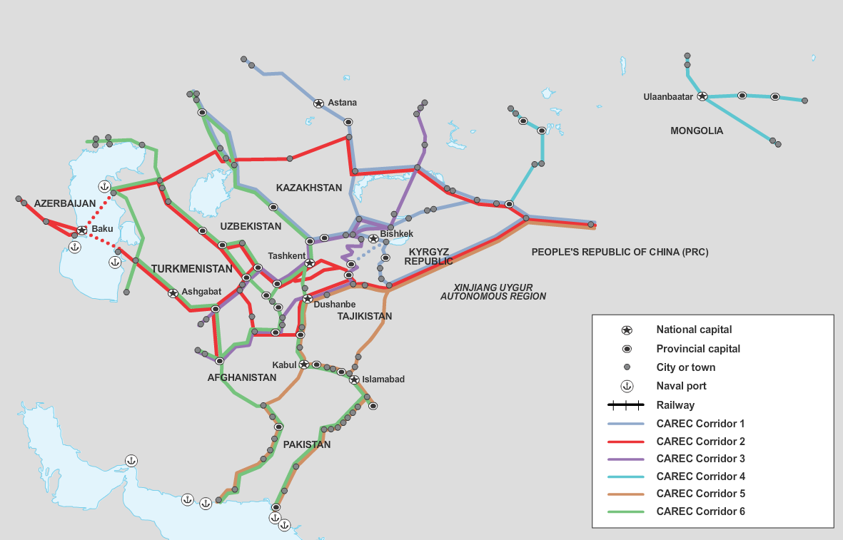
Source : http://www.carecprogram.org/index.php?page=carec-program
The Implementation Action Plan for the CAREC Transport and Trade Facilitation Strategy presents an aggressive investment plan to upgrade all six transport corridors to international standards by 2017.
CAREC 2020—the strategic framework for the CAREC Program, 2011–2020—lays out the next phase of priority investments in transport infrastructure along the corridors. CAREC expects additional investments over the coming decade to complete the infrastructure network and begin the process of developing the transport corridors into logistics corridors and—ultimately—economic corridors.

II.1.17. IDB
The Islamic Development Bank (IDB) is an international financial institution with headquarters in Jeddah, Saudi Arabia and regional offices in Almaty (Kazakhstan), Kuala Lumpur (Malaysia), Rabat (Morocco) and Dakar (Senegal). IDB was established in 1973 to support the economic development and social progress of its Member Countries.
In line with the strategic thrusts of the IDB, regional transport corridors continued to receive high priority in IDB’s transport financing activities. In particular, IDB is financing numerous projects across the CAREC area, where the IDB had assisted the countries in construction and reconstruction of almost 1,300 km of motorways and 325 km of railways that are the part of the CAREC road corridors.
In 2014 – 2016 the IDB is participating in the following projects in EATL region:
- three road projects of regional importance, two in Azerbaijan and one in Kyrgyz Republic thus committing in total US$ 471 million;
- theAlternative road corridor North-South in Kyrgyz Republic;
- road reconstruction project in Uzbekistan from Guzar to Beyneu, which is the part of Uzbek National Highway project and lies along the CAREC corridors;
- the construction of the road length Kulyab to Khalaikum in Tajikistan, which will open the new road corridor to China.
While transport corridors are developing, the IDB pays a great attention to the trade facilitation and removal of trade barriers. For this purpose the Bank via its frequent respective programs and workshops encourages its member-countries to adopt the advanced examples of international trade.
http://www.carecprogram.org/uploads/events/2015/029-14th-CAREC-Ministerial-Conference/Key-Documents/Statements/2015-CAREC-MC-MI-Statement-IDB.pdf
http://www.isdb.org/irj/go/km/docs/documents/IDBDevelopments/Internet/English/IDB/CM/Publications/39YearsInDevelopment.pdf

II.1.18. EBRD
The European Bank for Reconstruction and Development was established in 1991 in London with the aim of promoting transition to market-oriented economies in the countries of Central and Eastern Europe and Central Asia.Currently the EBRD has 63 members (61 countries, the European Union and the European Investment Bank), with a total of 29 countries of operations in central and eastern Europe, Central Asia and the Caucasus - and soon in north Africa.
Considering that transport is a key enabler of growth, providing the physical networks and services upon which the economy depends for the movement of people and goods, the EBRD is striving to develop safe, secure and sustainable transport systems, which balance economic, environmental and social needs.
The EBRD priorities within the transport sector include:
- promoting market based transport. The EBRD works to improve the efficiency, market-orientation and financial sustainability of the transport sector. This includes supporting the development of the private market for transport services and increasing private sector participation in the provision of transport infrastructure through concessions;
- developing sustainable transport. The EBRD is committed to supporting the development of sustainable transport networks in the region. Climate change mitigation and adaptation, integrated network development, pollution prevention, air quality and biodiversity protection, economic inclusion and gender equality and road safety are all important sustainable transport issues which we continue to address at the policy and project level;
- broadening activity within the sector. The Bank is committed to expanding the boundaries of its activities in the transport sector to finance the needs of emerging sub-sectors. The need for freight services is growing, including road freight, and the Bank aims to promote sustainable development and reducing CO2 emissions given the potential of logistics operations to lower energy consumption through optimized networks.
Since 1991, the EBRD has invested €14.2 billion in 280 projects in the transport sector, including 47 per cent in roads, 33 per cent in the rail network, 14 per cent in port, intermodal and logistics operations, as well as 6 per cent in the aviation sector.Among the projects, financed by EBRD, are the following:
- the railway reform In Kazakhstan. After supporting the initial restructuring of the national railways company KTZ, the Bank made several investments to help the company finance increasingly advanced efficiency measures. The Bank also participated in a bond issuance, which helped the company finance much-needed logistics infrastructure to increase cargo transit along the trade route from China to Europe;
- participation in the AIG Silk Road Fund in Azerbaijan. AIG Silk Road Fund is a private equity investment fund targeting Kazakhstan, Uzbekistan, Azerbaijan, Kyrgyzstan, Tajikistan and Turkmenistan The project will provide equity finance to small and medium-sized private sector enterprises and joint ventures operating in the countries of Central Asia;
- East-West road corridor project in Kazakhstan;
- participation in a landmark transaction in Turkey which will see a major infrastructure project – the Eurasia Tunnel – built under the Bosphorus straits. EBRD’s US$ 150 million loan will complete the US$ 1,25 billion financing together with the US$ 350 million loan from the EIB and a package of financing and guarantees from Korea’s Eximbank and K-Sure with SMBC, Standard Charter and Mizuho participation. The hedging facility for the transaction is provided by some of the lenders as well as the Deutsche Bank. The Eurasia Tunnel is designed to improve traffic management in this highly congested city of 17 million, once it is completed in 2017. It will connect Istanbul’s European and Anatolian sides – and, wider, Turkey’s European and Asian road networks.
.
http://www.ebrd.com/what-we-do/transport/overview.html
http://www.ebrd.com/news/2016/ebrd-at-25-transport.html

II.1.19. IRU
The International Road Transport Union (IRU) was founded in 1948 to represent the interests of the international road transport industry. The goals of IRU are to ensure the mobility of people and goods while improving the safety and environmental performance of road transport. The IRU holds Euro–Asian Road Transport Conferences biennially to promote and revive the “Silk Road” linking Europe and Asia.
In 2009 the New Eurasian Land Transport Initiative (NELTI) was implemented. The project was aimed to encourage regular roadfreight shipments between Europe and China and to assist in achieving the transit potentialparticularly of nations in Central Asia and the Caucasus.
The objectives of the project are to:
- contribute to the implementation of the UN Millennium Development Goals and of theAlmaty Programme of Action for landlocked developing countries in order to developEurasian land transport links;
- assist in the development of trade in landlocked countries and regions and to broadenaccess for their goods to international markets;
- increase the contribution of road transport to international trade and socio-economic development
- offer alternative delivery routes to maritime shipments to assist businesses in landlockedcountries.
NELTI consists of commercial deliveries of industrial and consumer goods across the Eurasian landmass, performed by independent transport companies from Eurasian countries along five different routes (see figure 2.11).
In the course of Phase I of the project a series of successful demonstration road transport caravans was undertaken in 2002-2007 (Lisbon-Vladivostok, Beijing-Brussels, and Black Sea Ring Caravan). One of the objectives, along with solution of commercial and political tasks, was also building up and adjusting mechanisms of logistic support and stimulating haulage, in the longer run, of Chinese freights by road transport routes along the historic Great Silk Road.
Within the framework of Phase Two of NELTI (2009-2011), the development of the system of regular road transport haulage between Asian and European countrieswas continued, with China involved in this system. Certain measures were enforced in accordance with the provisions of Memorandums of Understanding and regional agreements aimed to further the development of Euro-Asian transport communications, remove the barriers therein, simplify the border crossing procedures, harmonize the legal provisions in the transit countries, etc.

Figure 2.11
NELTI routes
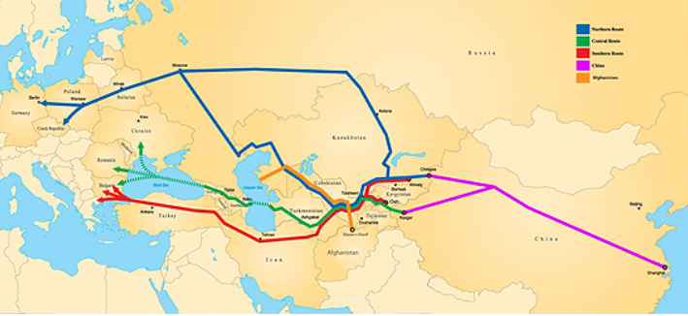
NELTI is developed in consequent phases.
NELTI-3 was launched in June 2011to identify the main impediments and non-physical barriers to international road transport within the Economic Cooperation Organization (ECO) region and help governments implement the appropriate UN multilateral instruments to stimulate economic growth by facilitating trade and international road transport.
In September 2012 IRU had launched NELTI-4 in cooperation with Arab Union of Land Transport (AULT) in the Arab world.
One of the most important aspects of the NELTI project during all its phases is monitoring. Monitored data collected en route by NELTI drivers - applying internationally recognized UNESCAP methodolology for data collection - on road conditions, waiting times at border-crossing points, quality of road infrastructure, administrative barriers etc., are subsequently analyzed by the Dutch Transport Research Institute (NEA) to develop road maps identifying the issues to be solved and the measures required to reduce the time and cost of road transport haulage between China and Europe.
NELTI monitoring has unveiled a high competitive potential for the development of the NELTI northern, central and southern routes. However, the data has also highlighted that 40 % of road transport time along the routes of the Silk Road is lost at borders due to inappropriate border crossing procedures which impede trade growth along the entire Eurasian landmass. In addition, approximately 30% of the transport costs were due to unofficial payments, borne by the hauliersen route and at border crossing points.

II.1.20. UIC
UIC is the worldwide professional association representing the railway sector and promoting rail transport. To enable UIC to effectively fulfil its mission, 3 levels have been defined for international cooperation activities:
- strategic level: coordination with and between the 6 UIC Regions (represented by UIC Regional Assemblies for Africa, Asia, North America, South America, Europe and Middle-East);
- technical/professional cooperation level structured around the following railway activities: Passenger, Freight, Rail System – including infrastructure, rolling stock, operations – and Fundamental Values including cross-sector activities such as Sustainable Development, Research Coordination, Safety, Security, Expertise Development). Strategic priorities for technical cooperation activities are set out by forums and platforms composed of member representatives;
- support services level: Finance, Human Resources, Legal, Communications and Institutional Relations.
UIC promotes intercontinental and transcontinental rail traffic and has a dedicated group of experts dealing with this issue - the Global Team of Experts (GTE) Members of the group represent rail and non-rail key stakeholders (railway undertakings, freight forwarders, rail associations, potential customers, shipping lines and others). The GTE serves as a platform for exchange among all stakeholders, and to initiate and steer projects creating the right framework conditions for developing long-distance rail traffic.
Following the results of the study ICOMOD (project aimed at establishing the viability of a rail link between Europe and Asia and at assessing the market size) and in the light of the strengthening cooperation between UIC and other International Associations, the year 2012 was aimed at reposi-tioning the UIC group. A gap analysis identified the need to continue market oriented research activities. The GTE activities are now focused on the following issues:
- analyzing and generalizing information on technical compatibility and interoperability within ITCs;
- summarizing the results of activities among international organizations and certain railway operators aimed at improving transportation along ITCs;
- forecasting of freight and passenger transportation volumes, establishing a data base of freight points of origin and destination as well as volumes structure;
- developing a marketing approach to improve the appeal of ITCs for freight owners and forwarders, presenting the opportunities and prospects offered by ITCs at international forums.
http://www.uic.org/corridors#documents

II.1.21. CCTT
The Coordinating Council on Trans-Siberian Transportation (CCTT) is a non-commercial transport association with an open-ended duration, registered in Switzerland on February 21, 1997.
The CCTT has more than 100 members from 23 countries, including railways operators from Europe, Asia and the CIS states, leading shipping companies, logistics operators and forwarders, ports and stevedoring companies, state organizations, administrations and municipalities, telecom and marketing companies, security services and mass media.
In its 20-year history the CCTT has achieved a high international standing and has become an efficient international forum for networking and real cooperation between all parties involved in Trans-Siberian freight transportation.

Status | NGO
Activitie’s geographical coverage | 23 countries from Europe and Asia
Focus | - cooperation with governments and international organizations with the aim to create new technologies of border crossing by block-trains;  - contribution to the process of transport and transit law harmonistaion;  - reduction of barriers along the rail routes between Asia and Europe
Main projects, programs and initiatives  aimed to EATL development | “Digital train” (aimed to increasing of Trans-Siberian rail route competetiveness, implementation of end-to-end IT technologies in the area of international rail transport and border crossing. Pilot trains started from Wuhan, China to Pardubice, Czech Republic in November 2012 and from Chengdu, China to Łódź, Poland in December 2012).  “Guaranteed transport and logistics product” (aimed to promotion of block trains between China and Europe, rail transport by block train “Baltic Transit” and implementation of “Transsib in 7 days Initiative. MoU on ensuring the safety of block trains China-Europe-China was signed in the framework of the Project).  “The Trans-Siberian route: a multimodal Eurasian transport network” (aimed to promotion of rail transport of goods between Europe and Asia by publishing annual Trans-Siberian Route review).  “Security train” (armed protection of containers and block trains in transit)  “Express delivery” (aimed to development of post items delivery from China to Europe in block trains. Draft MoU between CCTT, CIT and UPU is under discussion).
Web | http://en.icctt.com/cctt

II.1.22. GPST
The GPST was created to contribute to the implementation of UN transport-related Declarations, Resolutions and other recommendations at the national, regional and international levels through advocacy, awareness generation, partnership building and through technical and analytical work. As a global, business and industry-led, multi-modal, strategic, action-oriented, multi-stakeholder platform, the GPST recognised that public-private partnerships would play a vital role in helping UN Member States to implement their decisions, in order to achieve maximum positive economic, environmental and social impact.
GPST Members and Partners also acknowledged that given the resources, expertise and competence they possess, they could be effective in translating UN Member State commitments into actionable, result-oriented recommendations that can be implemented by governments and businesses.
Since it was launched in 2015, the GPST has continued to exercise a leading role in supporting governments to take actions to strengthen the international legal framework for sustainable transport in order to achieve progress in promoting more conducive environments for trade, transport and transit facilitation. The GPST works closely with businesses in the transport industry to identify best practices that promote global development objectives and win-win outcomes for both governments and businesses, and disseminates these best practices widely.
Recognizing big potential of Euro-Asian transport links and their contribution to social and economic development of large number of countries in Europe and Asia, including LLDCs, the GPST has developed a new project, entitled the “Global Silk Routes Initiative” (GSR) - an international comprehensive framework for multilateral dialogue on policy options and possible measures to enhance sustainable transport systems, inclusive of all modes of transport, in particular in developing countries, but with added perspective of the developed countries gained during current unpreceded expansion of global trade..
GSR envisages 10 priority areas of action , incl. 8 related to land/multimodal transport indicated in the table below.

Status | Partnership
Activitie’s geographical coverage | Worldwide
Focus | - implementation of UN SDG;  - platform for transport and related business cooperation and involvement into process of future transport policies elaboration
Main projects, programs and initiatives aimed to EATL development | “The New Global Silk Routes Initiative” (GSR). Initially, the focus of the GSR will be threefold:  - Facilitating implementation of UN conventions, incl. TIR Convention and the Shanghai Cooperation Organization’s Road Transport Agreement by landlocked countries;
- Facilitating Euro-Asian transport links by establishing regional freight exchanges;
- Promoting regional connectivity in Eurasia with digital navigation road and road infrastructure maps;
- Facilitating development of sustainable ancillary road transport infrastructure along Euro-Asian transport routes;
- Building human and institutional capacity – creating a School of transport diplomacy;
- Negotiating on single transport document for multimodal and intermodal transportation along Euro-Asian routes (expert group on single docubent was established);
- Green Innovative approaches to financing of hard and soft transport infrastructure with special focus on Green financing;
- Improving the road safety along Euro-Asian routes.
Web | http://gpst2030.org

II.2. Joint Initiatives and projects implrmrnted by International organisations
Development the unified legal regime. The principle problem for EATL area is that different legal regimes for rail transportation are in place across it. The majority of the EATL countries are members of the OSJD and party to their legal agreements, such as the SMGS. Others are members of the OTIF and their legal regimes, such as the COTIF/CIM 92, and some are members of both. European countries are also members of the OTIF and contracting parties to the COTIF/CIM, with some countries – Poland, the Baltic States and several others (9 states in total) being members of both organizations and contracting parties to both legal regimes.
When the railway route lays across countries using different regimes two different consignment notes for rail freight, each based on the respective legal regime, are to be filled in. Railway operators or freight forwarders therefore have to re-write a consignment note when crossing into the territory where the different legal regime applies.
The legal regimes also differ in other important aspects such as liabilities, and therefore increase uncertainty for cross-border rail freight transport crossing EATL countries.
A common CIM/SMGS consignment note has been developed to avoid reissuing of transport documents and in so doing to simplify customs clearance. But, according to DB Schenker, “CIM/SMGS consignment notes in both directions are only used in26–27 per cent of cases” as not all customs administrations accept the document.
Customs authorities should accept the joint CIM/SMGS consignment note as an equivalent to a transit customs declaration. The benefits of the joint CIM/SMGS are significant for reducing delays in cross-border rail transport as mentioned by DB Schenker -“its use reduces the standing time of rolling stock at borders from three days to 1.5 hours. This considerably increases the competitiveness of rail freight transportation.”
The CIM/ SMGS consignment note is also issued as an electronic document so that it can be exchanged electronically in advance with authorities and other transport parties.
Certain steps are made to change the legal situation in the radical way.
In 2013 a joint declaration expressing willingness to create a common legal regime for rail traffic across Asia and Europe was signed by 37 countries at a ministerial meeting in Genève. The signatories are: Armenia, Azerbaijan, Belarus, Belgium, Bosnia-Herzegovina, Bulgaria, Croatia, Cyprus, Czech Republic, Estonia, Finland, France, Germany, Greece, Italy, Kazakhstan, Kyrgyzstan, Latvia, Lithuania, The former Yugoslav Republic of Macedonia, Malta, Moldova, Mongolia, Netherlands, Pakistan, Poland, Portugal, Romania, Russia, Serbia, Spain, Sweden, Switzerland, Tajikistan, Turkey, Ukraine, Uzbekistan.
The aim is to establish 'a unified set of transparent and predictable legal conditions for international rail freight transport “from the Atlantic to the Pacific”, equivalent to the regimes for competing road, air and water transport.
The planned general conditions of transport for Euro-Asian rail transport, known as GTC EurAsia, would include a common consignment note and 'to the extent possible' a single liability regime.
Operators, associations and other stakeholders have been invited to co-operate in the development of GTC EurAsia, which is supported by the United Nations Economic Commission for Europe.
Following the declaration signature, the Group of Experts set up for this purpose by the UNECE has started its work to give substance to this unified law.
Rather than creating law overarching the two legal regimes of the CIM UR and SMGS, or creating autonomous law, OTIF advocates and will defend the establishment of an interface regime between the CIM UR and SMGS, with a common consignment note and a common liability regime. With this in mind, the validity of COTIF/CIM and SMGS for transport that is governed strictly by their respective rules would not be called into question.
The question of the legal form of the institution intended to support this new instrument is very complex. OTIF believes this should be discussed at the end of the process, as it depends to a great extent on what the law contains. OTIF uses the model of COTIF to propose high-level provisions, giving the sector the responsibility of deciding the precise conditions for applying them.
At the same time, OTIF's concept was opposed by that of OSJD, which called for the creation of a new convention to replace the CIM UR and SMGS.
OTIF and OSJD agreed to set up a technical working group (joint OTIF-OSJD working group in which CIT will also take part) which could start preparing the application documents for the new Euro-Asian legal regime
In any case, it is essential that the provisions of the new instrument are simple and practical and enable rail transport undertakings to develop. If this is not the case, as at present, the par-ties to the contract of carriage will choose to apply the agreed national law, with all the legal risks this entails. The aim of the developments taking place under the aegis of the UNECE is to avoid this risk.

II.3. Most important national level programmes and projects
Azerbaijan
In 2016, the Azerbaijani Railways carried 15,4 million tons of goods. In the first quarter of 2017 3.8 million tons of goods have been carried, which is 11% increase compared to the same period of 2016.
In the last two years, various activities have been undertaken for the renovation Azerbaijan railways infrastructure. Totally, capital repairs completed in 383 km of railway section, the catenary system renewed or rebuild. Purchase of new locomotives and different types of wagons are on the agenda. Renovation of the infrastructure aims to achieve increase in average speed of freight trains up to 60 km/h and for passenger trains up to 100 km/h in near future.
Construction works completed in sub-stations for transforming electrical supply system from DC to AC in Baku-Boyuk Kesik section (East-West Corridor), works on renewal of catenary system and upgrade of communication and signaling systems continue. Capital repairs and technical supply of 600 km railroad have started in this section within the second stage of rehabilitation of Azerbaijan railways in October 2015 and 271 km (April 2017) rehabilitated.
Feasibility studies started respectively for capital repair of Baku-Yalama railway section and for the whole Yalama-Astara route (North-South Corridor).
On March 3 2017, the first test train ran across the bridge (82.5 m) over the River Astarachay (border) which is a part of missing railway link Astara (Azerbaijan) – Astara (Iran). The 8.3 km single-track extension of the Azerbaijan Railways (ADY) network to the border was completed in 2016. Eventually, Azerbaijan will provide direct railway transit between Russia and Iran to connect Northern Europe to South-East Asia
Republic of Belarus
In 2015, the volume of cargo transportation on the Belarus Railway made up 131.4 million tons of goods. The number of regular container block trains running between China and West Europe has been steadily grown. In 2015 8 trains run between Belarus and Germany, Poland, Czech Republic and Lithuania.
Due to the improvement of train handling procedures, the time of cargo trains stops at the Brest border crossing point reduced from 36 to 10 hours with transshipment and to 6 hours without transshipment.
The Belarus Railways are completely opened for transportation of freight in all directions using the CIM/SMGS consignment note. During 2015 more than 29 thousands TEUs run under such a consignment note.
In 2015, as part of development of the railway infrastructure, the projects: “Extension of the receiving-departure lines of Orsha-Centralnaya railway station and Sitnitsa railway station” and “Development of the second stage of the Project “Electrification of the 86 km of Gomel – Zhlobin section” were successfully completed. In 2015, 279 new freight wagons were purchased.

Bulgaria
In 2015, the Bulgarian Railways continued reconstruction and modernisation of OSJD Railway Corridor No. 6, and modernised Septemvri – Plovdiv and Plovdiv – Burgas sections. Now, Plovdiv intermodal terminal is under construction.
In 2015, the National Railway Infrastructure Company (NRIC) entered the TIS (the Train Information System) of the International Organisation of Rail Infrastructure Managers on a permanent basis; that enables Bulgarian and foreign operators to monitor their international trains in real-time. Besides, the train information system makes it possible to monitor train delays at the border crossing points and causes thereof.

China
In 2015, the Chinese Railways carried 2.71 billion tons of cargo and 2.53 billion passengers.
9531 km of new railway lines were put in operation, of which 3306 km are high-speed ones.
The Chinese Railways have introduced the principle of independent administrative and economic functions. In order to promote the innovative structural systems and acceleration of the railway construction, measures were developed aimed at:
- further transformation of the governmental functions;
- facilitation of the administrative procedures;
- consolidation of the railway transport control and management;
- promotion of railway tariff reform;
- coordination of further railway transport development.

Islamic Republic of Iran
Following key projects and initiatives were implemented by Islamic Republic of Iran in the area of EATL development by 2017:
- Ashgabat agreement between Islamic Republic of Iran, Oman, Turkmenistan and Uzbekistan were signed with the aim to create an international transport and transit corridor between participated countries;
- The transit agreement – namely Persian Gulf – Black Sea – between Islamic Republic of Iran, Azerbaijan, Armenia, Georgia, Bulgaria was finalized and signing ceremony in Tehran is scheduled;
- “Road safety action plan” of for 2015-2020 is in the process of implementation;
- Missing link of Khaf – Sangan – Harat railway set in operation;
- Railway North-South corridor between Islamic Republic of Iran, Turkmenistan, Kazakhstan set in operation with completion of the 940 km new railways;
- Intergovernmental agreement on Dry ports was ratified by the parliament of Islamic Republic of Iran;
- Iran – Azerbaijan railway connection set in operation by the completion of the railway link and bridge Astara (IR) – Astara (AZ).

Kyrgyz Republic
The Kyrgyz Railway has modernized above 150 km of railway lines of the northern and southern sections with the laying of new reinforced concrete and timber sleepers for 2011-2015 years. Six new modern Evolution fifth generation diesel locomotives TE33A were put in service. Two car-repair plants were established for the purpose of modernisation and repairs of freight wagons and passenger coaches that allows extending the life of wagons.
Fibre-optic communication line is laid at Lugovaya – Bishkek – Rybachye section.
The strategic projects of construction North – South trunk railways are being successfully implemented as part of the Russia –Kazakhstan – Kyrgyzstan – Tajikistan project and China – Kyrgyzstan project.

Latvia
In 2015, the Latvian Railway carried 55.6 million tons of goods, of which 53.9 million tons – internationally.
The new Bolderāja-2 – Krievu railway line was put in service, with the construction of new Bolderāja -2 railway station.
In 2015, 47.2 km of railway lines were modernized and 93.8 km were reconstructed. The second 56 km track at Skrīveri – Krustpils section was opened.

Lithuania
In 2015, the Lithuanian Railways carried 48.1 million tons of goods.
1,435 mm gauge railway line of 115.2 km from the state border with Poland to Kaunas railway station was put in service as a result of implementation of the project “Rail Baltic”.
The projects of modernisation of the railway infrastructure of OSJD corridor No. 9 (Kena – Vilnius – Siauliai – Klaipeda), construction of the second track on Kyviskes – Valciunai section, as well as on Pavenciai – Raudėnui, Telšiai – Dusaikai and Kūlupėnai – Kretinga sections were successfully completed.
As a result of modernisation of 1,520 mm gauge infrastructure, 53.7 km of new lines and 4 bridges have been constructed and 44.1 km of the existing tracks have been reconstructed.
A computer-based system of commercial inspection of trains and wagons was installed at Kena and Kibartai border stations, as a result of which the duration of commercial inspection of trains was significantly reduced and made more exact, with the recording of all cases of incorrect loading and load securing, technical and commercial condition of wagons and coaches and cargo shortage in case theft.

Republic of Moldova
In 2015, the Moldova Railway spent more than 1.5 million US Dollars for rehabilitation project and entered into a loan agreement with the European Bank for purchase of 10 new main-line locomotives, modernisation of locomotive depots, and recovery of the railway infrastructure for 100 million Euros in aggregate.
The Railway of Moldova State Enterprise and the State Administration for Railway Transport of Ukraine signed an Agreement for electronic data exchange in the international freight transport. A significant progress is availability of all types of control (border control, customs check, sanitary inspection, veterinary inspection, etc.) on the principle of “the single window” at all railway border stations of Moldova.
Approximately 25 thousands consignments were carried over the territory of the Republic of Moldova using the CIM/SMGS consignment note in 2015.
Mongolia
In 2015, the volume of freight transit through the Ulan-Bator Railway increased by 101.38%. Two new container lines Chengdu (PRC) – UBZD – RZD – Łódź (Poland), Zhengzhou (PRC) – UBZD – RZD – Duisburg (Germany) were opened.
A new 24.5 km railway line for iron ore transportation was put in operation. Three new remote control crossing loops were constructed and put into operation.
Annex No. 9 to the International Convention on Harmonisation of Frontier Controls of Goods is successfully implemented, that is witnessed by reduction by 45 minutes of the time of border control of freight trains between Russia and Mongolia.

Figure 2.12
Transit rail corridors in Mongolia
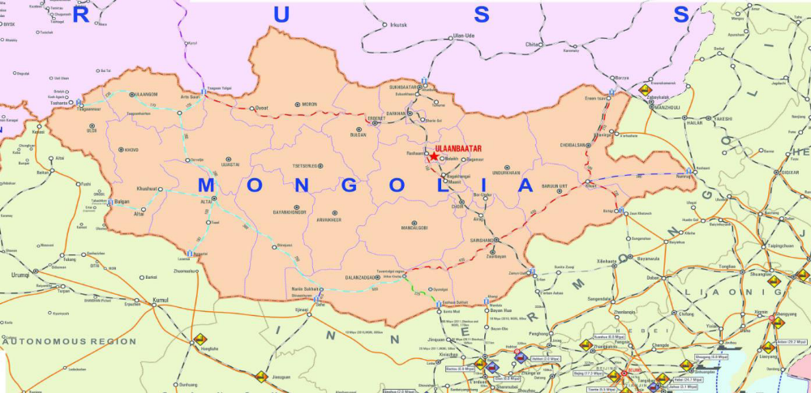
Time of railway transit via territory of Mongolia (fig **):
- Corridor Sukhbaatar – Zamiin-Uud 30 hours;
- Corridor Zamiin-Uud - Sukhbaatar 36 hours.

Figure 2.13
Time of railway transit via territory of Mongolia, hours
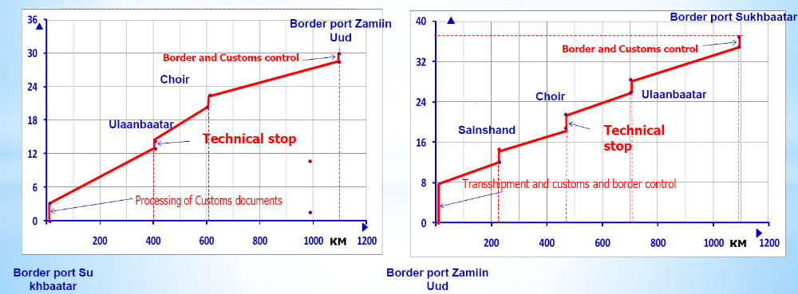

Poland
In 2015, the Polish Railways (PKP Cargo JSC) carried 117.59 million tons of goods, including 48.26 million tons on international routes. Over 800 km of railway lines were modernised due to which the train en route time in Trójmiasto – Wroclaw, Poznan – Krakow, Warsaw – Bielsko-Biala, Olsztyn – Bydgoszcz sections significantly reduced.
The PKP Cargo JSC has been effectively developed the container terminals at Poznan-Franovo station in Poland (owned by PKP Cargo), as well as in Czech Ostrava- Paskov (a terminal owned by Advanced World Transport, an affiliate of PKP Cargo Group).
The PKP Cargo JSC actively participates in the stimulation of the railway traffic from China to West and South Europe as part of the New Silk Road (to more than 10 trips weekly).
The PKP Cargo JSC has purchased 15 Siemens Vectron multisystem freight locomotives for service on the trans-border lines. For the purposes of strengthening of the cargo protection, security improvement and train monitoring, unmanned aerial vehicles are now used, as a result of which losses have been reduced almost by 60%.

Russian Federation
The cargo turnover of the Russian Railways JSC made up 2.302.738 million tons (100.3%), of which 1.304.478 million tons (100.7% to 2014) – on the international routes. 25 new container train lines: Duisburg – Korla, Värtsilä –Korla, Sergeli – Nakhodka, Hefei – Hamburg, Nakhodka-Vostochnaya – Khovrino, Koity – Novorossiysk, etc., were put into operation.
In 2015, 3.4 km of new railway lines were put into operation. Reconstruction of Babaevo station of the Oktyabrskaya Railway and construction of new Chernyshevskoye border station of the Kaliningradskaya Railway were successfully completed.
Technical upgrading of Petushki – Nizhni Novgorod section of the Gorkovskaya Railway was in progress. Tonnelnaya station of the Northern Caucasian Railway, Cherepovets-II station of the Northern Railway, Volkhovstroy-I station of the Oktyabrskaya Railway, Kinel stations of the Kuybyshevskaya Railway, Ekaterinburg-Sortirovochnaya station of the Sverdlovskaya Railway are under reconstruction.
500 new locomotives and 240 rolling stock units were purchased.
The development of market relations and competition in the freight wagon operations encouraged investments in the construction and modernisation of the carriage rolling stock: private investments of over 10 billion US Dollars were attracted, as a result of which the freight car fleet was significantly renovated and the total number of wagons reached 1 million 124 thousand units.

Republic of Tajikistan
The Rohi Ohani Tojikiston State Unitary Enterprise (Tajik Railway) carried 6.1 million tons of goods in 2015.
The construction of the new Vahdat – Yavan railway is in progress; the railway lines at Rahaty – Vahdat – Elok and Kurgantube – Yavan sections are being modernized; the construction of 40.7 km Vahdat – Yavan section is expected to be completed in 2016, on the occasion of the 25th anniversary of independence of Tajikistan.

Romania
In 2015, the Romanian Railways carried 23.821 million tons of goods (103% to the previous year level). CFR-Marfa – Romanian Freight Operator - carried 19922 operations with the unified CIM/SMGS consignment note.
The railway lines Câmpina – Predeal, Bucharest – Braşov, Curtici – Simeria, Braşov – Simeria were actively modernized to cause train running at the maximum speed of 160 km/h.
16 railway stations: Giurgiu, Slatina, Bistriţa Nord, Botoşani, Vaslui and other, have been modernised.

Republic of Uzbekistan
In 2015, the freight traffic on the Uzbek Railways made 81.8 million tons.
The first stage of electrification of 140.8 km Marakand – Karshi railway section was successfully completed. 55 locomotives and 1258 freight wagons were successfully modernised, 11 new freight electric locomotives, 650 freight wagons were delivered.

Ukraine
The Ukrainian Railway was effectively involved in the establishment of new container train lines: European countries – Ukraine (Chop), Batevo/Izov – Ilyichyevsk-Paromnaya – Georgia (Poti/ Batumi – Gardabani) – Azerbaijan – (Bejuk- Kjasik – Alyat) – Kazakhstan (Aktau-Port – Dostyk) – China through ferry crossing Ilyichyevsk – Poti/Batumi and Alyat – Aktau – Aktau-Port.
Operation on the border stations and checkpoints is now based on the principle of the “single window”, when all public control services are accessible.
The transport infrastructure of the international transport was actively developed, the amount of works totaled to 650.47 million grivnas.
In 2015, 76128 carriage operations were made under the unified CIM/SMGS consignment note that is by 10% more than in 2014.

PART III. MAIN OBSTACLES HAMPERING THE EURO-ASIAN TRANSPORT LINKS DEVELOPMENT

III.1. General overview
During the Phase I of the project the main Euro-Asian road, rail and inland water transport routes, transshipment points and ports were selected. Projects had been prioritized in order to focus on improving these routes.
311 projects proposed by the participating countries have been evaluated during Phase II of the EATL project from the standpoint of their value to connect Asia and Europe. The assessment of appropriate investment needs was undertaken which formed the basis of the updated EATL Investment Plan.
An enormous work had been done by the governments of EATL countries to implement these decisions and plans. As a result, the current infrastructure seems to generally support the existing transport flows, whereas the remaining missing links and the upgrade of existing infrastructure is the focus of the national transport strategies and the international programs.
At the same time, the existence of high-level transport infrastructure – railways, roads, inland waterways - is a necessary, but not a sufficient condition for efficient and competitive transport routes serving the trade lanes.
Numerous obstacles and bottlenecks along transport routes occur disrupting the traffic and goods flows. These obstacles can be divided into physical and non-physical barriers.
Physical barriers occur due to of natural reasons, technical and technological inconsistency, poor infrastructure maintenance, shortage of network sections/nodes capacity. A special type of physical barrier is the absence of particular section of transport network or certain object (bridge, intermodal terminal, logistic center, etc.) that could obviously improve the conditions for transportation and trade.
Non-physical barriers represent lack of proper policies, unharmonized legislation, poor regulations and administrative procedures, lack of cross-border administrative interoperability, failure in application of trade facilitation standards and best practices, insufficient attention to modern IT equipment for processing and data exchange or unskilled personnel. Besides that, one should not omit issues such as:contradictions of state and private interests and, in some cases, corruption. Non-physical barriers can cause enormous losses of time and money, decrease the quality of service or even create the serious barriers on particular trade lanes.
Especially during the general economic crisis and the shortage of infrastructure funding the attention should be given to non-physical barriers. Research results demonstrate that very often investments aimed to construct or rehabilitate infrastructure objects are way less effective than efforts focused on procedures improvement.
In Europe, in particulr EU, enormous efforts have been undertaken for decades to eliminate such barriers. This work was guided and financed within the general context of creating the common economic space. Seamless transport had been developed to provide effective trade and distribution; the whole economic and business environment had been improved under the “integrity” slogan.
The situation in the Central Asia was different.
The challenge of re-creating a trade and transport environment for countries of Central Asia - and more generally, the former Soviet Union Republics - have been taken seriously for two decades by various institutions. Visible trends for integration and harmonization had been developing in the Central Asia region. Some countries had joined the WTO; certain states had the observer status in this organization. Eurasian Economic Union and the Customs Union creation - as well as the numerous bilateral agreements - was the important step towards the free trade relationships.
At the same time, the problem was that countries did nor pursue one single integration idea as a general “umbrella” for regional plans, programs and projects. There persisted an approach of a so-called “spaghetti bowl” situation where numerous initiatives overlapped with inconsistent country membership (figure 3.1). Three main groups of initiatives can be shown to improve connectivity (Linn 2012): (1) corridor-based initiatives such as the Central Asia Regional Economic Cooperation (CAREC), (2) the Shanghai Cooperation Organization (SCO) supported by China, and (3) the Eurasian Customs Union, led by Russia.
It was expected thatit would take time to reach the goals set by numerous initiatives. At the time of preing this report, the key word for the Central Asian region in sense of tradelanes was “fragmentation”.
Transport communications as well as the tradelanes were influenced by historical “heritage”. Transit operates over long distances and generally involved many transport providers representing different economic systems. Border crossings disrupted the traffic and commodity flows. The supply chain design implied numerous difficulties such as obligatory customs broker services or mandatory transfer through a bonded warehouse or compulsory convoying of traffic. For these reasons, supply chains in the EATL region are especially fragmented and vulnerable.

Figure 3.1
The “Spaghetti Bowl” of Regional Organizations in Central Asia
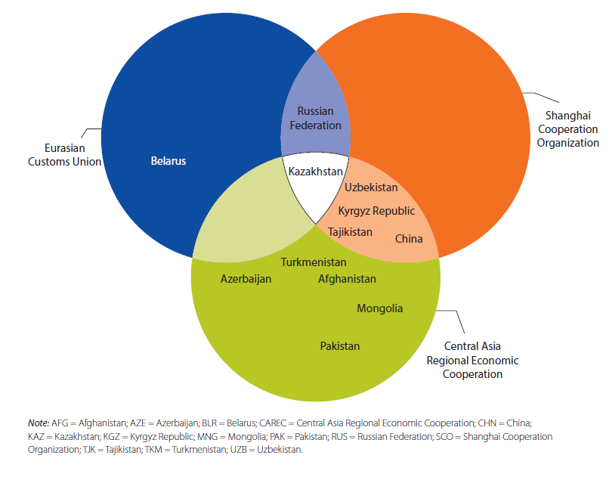

Source: Lynn 2012, World Bank
Figure 3.1 illustrates the example of imports of goods to Kazakhstan. According to Rastogi et al (2014), this logistic scheme includes three phases:
- international transit from the Russian Federation or China into Kazakhstan by truck or rail (rail wagons or containers), with intervention of transport companies, brokers, and forwarders;
- clearance and warehousing in one of the main cities in Kazakhstan, with intervention of brokers and border agencies, and third-party logistics providers(3PLs) and
- distribution logistics in Kazakhstan or Central Asia, with interventions of local transport companies.

Figure 3.2
Scheme of imports of goods to Kazakhstan
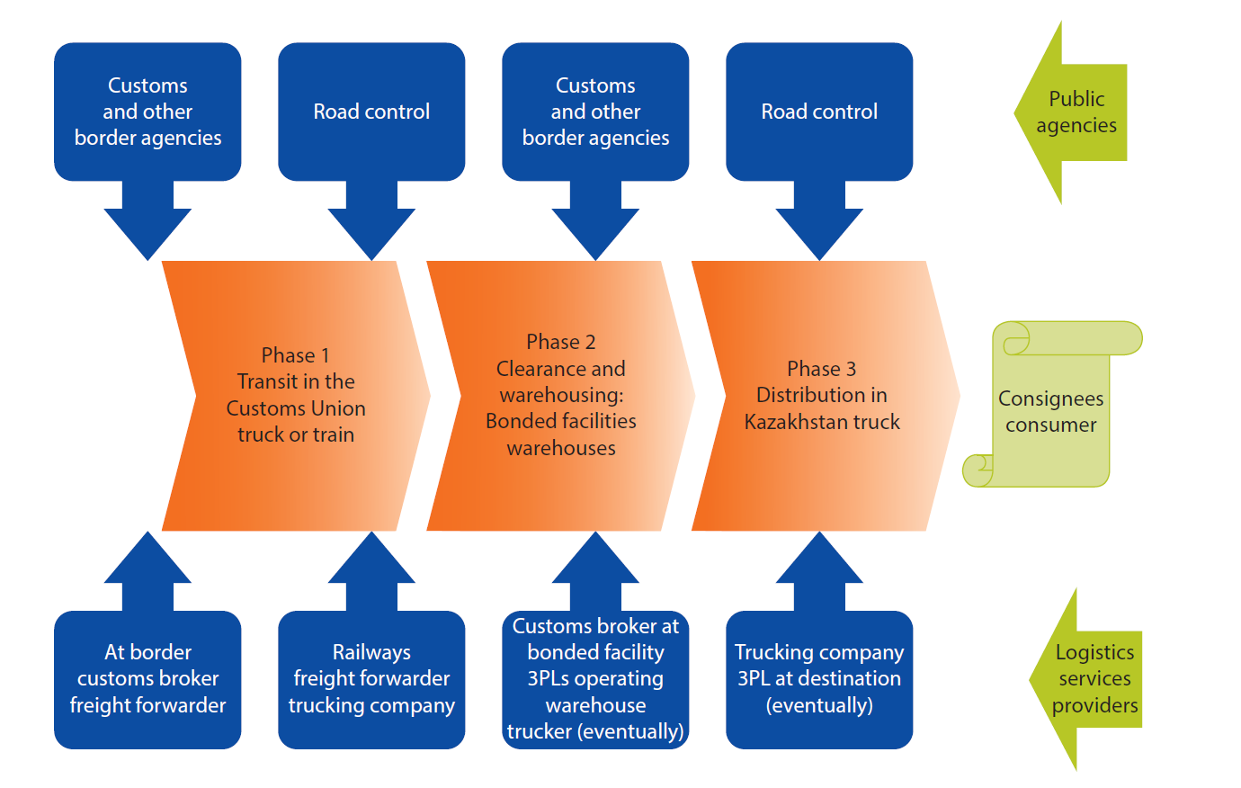
Source: Rastogi et al (2014)

All the phases of the scheme are more or less independent and the interests of different players overlap in a contradictory way while its implementation.
Non-physical barriers can cause significant delays, increase transport and logistics costs, and have a negative impact on visibility and reliability in the transport chain. Traders, shippers, and transport operators face various non-physical barriers of different types and causes, one of the main - long waiting times and queues at border crossing points (BCP) or at en-route check points.
The cross-border control procedures used on particular tradelane, once acceptable, can become outdated and start creating problems if the competing route operator had introduced modern technologies saving time and money.
Most observers and market players argue that the major barriers for transport and trade in the EATL region manifest themselves at the Border crossing points (BCP).

III.2. Border Crossing Points as bottlenecks
Several studies showed that border crossing times on EATL routes in Central Asia vary from a number of days to a few hours, but are on average too long compared to waiting times measured in other regions, such as South Asia and Europe[CAREC 2013, WP5 2015***].
A UNESCAP study on transit rail traffic in Asia and the Pacific points out that “average border-crossing times in Europe are in the 30-40 minutes range”, and that “the ECE recommendation for border stopping time is 60 minutes for international shuttle trains and 30 minutes for combined transport”.
Both transport modes, road and rail, are affected by the long delays at border crossings, but rail delays tend to be even longer than waiting times in road transport.
The ADB CCPMM data (CAREC 2013) were used for a detailed comparison of waiting times in Central Asia at the level of individual border crossings. The ASB CAREC report concludes that on a general level border crossing delays on CAREC corridors have not improved since 2009. Slight improvements could have been observed for specific borders for road corridors, but rail transport border crossing times were still extremely high ranging from 65.6 hours at Dostyk (Kazakhstan) for cargo coming from China to the comparatively short times measured for the rail border crossing Alat-Farap between Uzbekistan and Turkmenistan where it took only 6 hours to clear incoming cargo.
Figure 3.3 and 3.4 show CCPMM data with times varying substantially from one border crossing to another.
Clearance time at the Kazakahstan-China border crossing Khorgos can take up to 28.2 hours for goods crossing into Kazakhstan and 11.2 hours for goods going into China. Clearance time for cargo at Tajik border points Dusti and Fatehobad with Afghanistan are, according to the CCPMM, amongst the lowest on the CAREC corridors (5.3 hours in Dusti and 5.1 hours in Fatehobad for incoming cargo). Waiting times at Uzbek border crossings range from 5.7 hours at the border with Kazakhstan in the North, Keles, to 9.7 hours at another border crossing with Kazakhstan further South, Yallama.
Border crossings waiting times and delays constitute a significant share of the overall travel time spent by trucks and trains on EATL routes and therefore have a strong negative impact on the attractiveness of the routes. A corridor analysis conducted by UNESCAP on the road route from Almaty (Kazakhstan) to Berlin (Germany) via the Russian Federation (Kulin and Krasnoe), Belarus, and Poland, revealed that 50 per cent of the transit time was spend waiting at border crossing points between Kazakhstan and the Russian Federation (3-4 days) and between the Russian Federation and Belarus (4-7days). The overall time for the trip was 10-13 days, instead of the 6 days that were possible, if one would assume a border crossing time of 5 hours.[Informal document WP.5/GE.2, 2015 No 1].
Reliability factor. As it was mentioned above (see p*), one of the main requirements of supply chains is reliability and punctuality of services. In certain cases short lead time is not among the advantages of the certain route but logistic providers prefer this particular route because of its stable and predictable parameters.

Figure 3.3
Average border crossing times, Uzbekistan road BSP, 2013

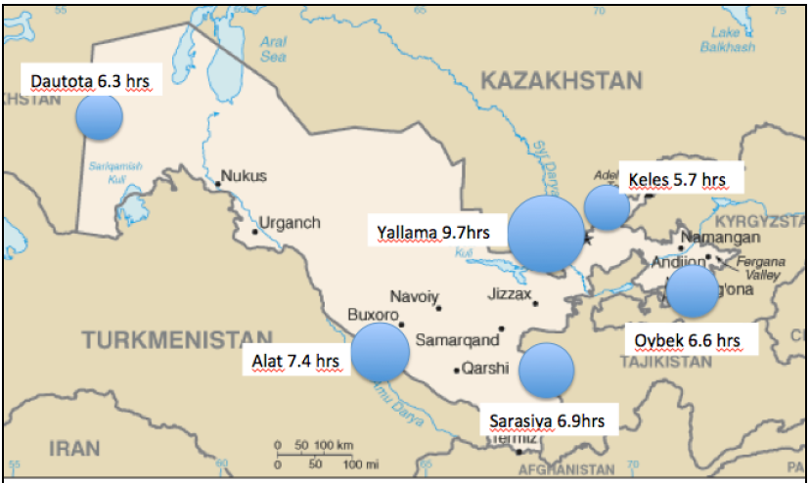

Figure 3.4
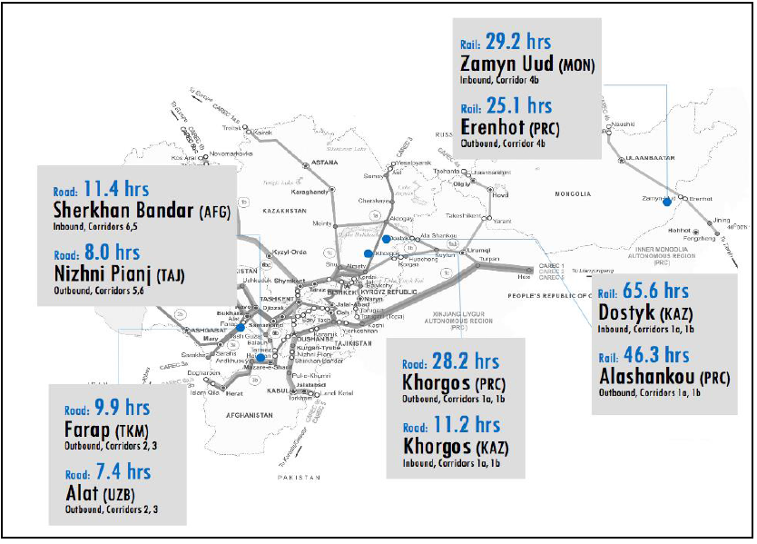
Average border crossing times for selected BCP, 2013

As for many EATL routes, especially in Central Asia , stability and predictability of services are at poor level. Unpredictable delays, low degree of reliability, the unpredictability of services
quality and price create severe disincentives to invest and increase total logistics costs.
Numerous surveys indicate the following manifestations of this:
- Transit time can vary dramatically. “Record” lead times look very attractive for shippers but the variations in everyday practice can be inacceptable for the market. Observers report the 40-90 days difference possible on certain routes
- Shortages of rolling stock and equipment occur suddenly causing the delays. In some countries lack of rolling stock at harvest season is typical
- Custom regulations, rail tariffs and road charges can change unexpectedly
- Transit controls is implemented uniformly, irrespective of the principal’s reliability and competence;
- Convoy or escort systems are applied not only against risky cargo or insecure vessels (open trucks), but also on containers or sealed box wagons;
- Obsolete freight transport rules and regulations
- Inadequate carnets and guarantee systems or the poor implementation of widespread transit systems like TIR
- Additional charges and fees (often at regional level) can be introduced without warning
- Railways can impose shipping bans to neighbor countries or to certain points for limited capacity reasons or to keep the rolling stock on national territory
- Regulatory barriers that impact the market structure and the quality of key support services (brokers, finance, insurance and other)
- Simplified border procedures that are sometimes introduced are not practical because they require a declaration within hours of arrival - while arrival time is unpredictable.

III.3. Barriers concerning goods transported
Customs procedures
Customs procedures are an obligatory process in all international road shipments involving border crossings and can be the greatest cause of vehicle delays on delivery routes between Asia and Europe. Despite the World Customs Organization’s International Convention on the Simplification and Harmonization of Customs Procedures (Revised Kyoto Convention) of 1999, the United Nations International Convention on the Harmonization of Frontier Controls of Goods of 1982 and the United Nations Customs Convention on the International Transport of Goods under cover of TIR Carnets (TIR Convention, 1975), customs regulations in practice continued to differ both in terms of requirements and procedures. In addition, there was no integrated information system or information exchange and, in a number of transit countries, customs posts were poorly equipped and employed out-of-date IT equipment that failed to provide data on cargo in a timely manner.
Export and import documents
The number of export documents varied enormously among EATL participating countries. Georgia, which requests exporters to prepare only four documents, is regarded as a regional champion, particularly when compared to other EATL participating countries such as Tajikistan, which requested at the time of writing this report eleven documents. Afghanistan and Uzbekistan requested ten, Belarus and Kazakhstan nine, while Azerbaijan, China, Kyrgyzstan and the Russian Federation require their exporters to complete eight documents.
Good practice examples related to import documentation included Armenia requiring seven, Bulgaria six, China five, the Republic of Moldova seven and Georgia requiring only four import documents. In comparison, several other EATL countries required importers to complete up to ten documents: Afghanistan, Azerbaijan, Belarus and the Russian Federation. Kazakhstan required its importers to complete twelve documents and Uzbekistan required eleven import documents.
In addition to the above, EATL landlocked countries needed more days to export a container than countries with seaports: it took on average 82 days to send an export from Tajikistan, 76 days to send an export from Kazakhstan, 74 days to send an export from Afghanistan and 71 and 63 days from Uzbekistan and the Kyrgyzstan, respectively. EATL best practice countries include Georgia with 10 days, Romania with 12 days, Armenia with 13 days and Turkey with 14 days. With regard to imports, best practices include Georgia and Romania with 13 days, Turkey with15 days, and Bulgaria with 17 days leading the EATL region. The highest number of days required for handling and clearing imports are in Uzbekistan, 92 days, Tajikistan, 83 days, Afghanistan,77 days and Kazakhstan, 62 days.
Trade and transport policy
Transport, trade and customs policies instability also was typical for the EATL region. Governments could reclassify a border crossing point putting in place restrictions for cargo movement. Kyrgyzstan, for example, has re-classified the Karamyk border crossing with Tajikistan please put when, so that transit cargo ever since could not officially exit to Tajikistan. As Karamyk was an important crossing point for goods from China into Central Asia, the border crossing point was still used for transit cargo from China but truck drivers needed to add 100 km of to their travel route to drive to the next border post to get the exit stamp on the Customs declaration.
Many of the EATL countries are parties to the TIR Convention that puts in place a common customs transit clearance procedure and a cross-border transit guarantee, the so-called TIR Carnets. The TIR Convention and its application by Customs authorities is crucial for Central Asia, Eastern European and Caucasus countries and it was broadly believed to be well functioning and accepted by Customs authorities. In 2013 the Federal Russian Customs Office of Russia (FCS RF) had introduced the limitations for Carnet TIR procedures; additional securities for Carnet TIR holding transport were required. This decision did not only impose additional costs on international road traffic. The entire functioning of the TIR system had been put in doubt; a lot of concern, confusion and uncertainty with regards to the that procedure and the validity of the carnet was in place across the market. In terms of the limitations for TIR Carnets introduced by Russia in 2013, additional security was required and, consequently, the TIR System broke down because of the additional costs for transport firms. Especially, the Turkish transport firms were affected , given the volume of the transit transport to Russia.

III.4. Barriers concerning border crossing technologies and procedures
BCP infrastructure problems
Inadequately designed border-crossing point infrastructure and equipment, as well as inadequate transport infrastructure connecting border-crossing points with transport networks, strictly speaking, have the physical character. But their impact of creation non-physical barriers to international road and rail transport cannot be ignored.
Certain countries had designed and built their border-crossing points 20 years ago and these objects still do not have proper equipment. Some border-crossing point approach roads traverse the middle of villages, causing vehicle congestions. Often border crossings do not have enough lanes or windows to meet the peak transport flows.
Opportunities to improve border-crossing points exist, as per the infrastructure priority projects identified by EATL Phase I and Phase II Studies. Nevertheless, public and private stakeholders need more exposure to international best-practice transport, logistics and border-crossing point infrastructure design and management methods to realize the full benefits of investment in hard infrastructure, modern non-intrusive detection equipment and different ways to manage expensive border-crossing point assets.

BCP Process inefficiencies
Numerous government agencies are present at border crossings to control compliance with national legislation governing immigration, taxation, environment and health protection, customs and trade policy, transport services and vehicles, and other regulations. Control measures apply to drivers, means of transport, and goods, and include document checks, weighing, scanning and measuring of vehicles, and physical inspection of the goods. These formalities take time, in particular if the multiple agencies involved do not collaborate and share documents, and information.
As many studies reveal it, un-coordinated and repetitive intervention of numerous government agencies on the same shipment, high level of physical inspection of the cargo, and inadequate infrastructure and equipment characterize the border crossings in the region. The high frequency of physical inspection of shipments and cargo at border crossings seems to be the major bottleneck in the clearance processes.
As is reported, Kazakh customs authorities at the border crossing Khorgos, for example, did not trust cargo documents for mixed load containers coming in from China and therefore systematically physically inspected these containers to match the data with the actual goods. Customs authorities also commonly physically inspected the shipments or at least opened the loading unit for primary visual inspection. Physical inspections did not only uphold the individual shipment in question but also led to congestion, as many of the equipment and infrastructure at the border crossing did not match the growing cargo volumes and frequency of such operations.
There were many reasons for the persistence of physical inspection. Often there was no effective risk management system in place that allowed the border staff to target their inspections onspecific, high and medium risk cargo and means of transport, while clearing the other cargo and trucks faster without physical inspection.
Physical inspection was also an effective instrument for rent-seeking, as truck drivers and shippers want to speed up the process. Legislation may attribute a personal responsibility for non-detected fraud or smuggling to the border officials. Furthermore, numerous border crossing points lacked equipment for non-intrusive controls, such as scanning or weighing of containers.
And finally, many of the border clearance process requirements were duplications: identical cargo and vehicle documents needed to be presented, reviewed and stamped by various agencies in a sequential process. Processes and document requirements were designed from the isolated point of view of each agency and were not optimized from the overall perspective of achieving a faster border crossing clearance through joint operations and sharing of data.

III.5. Road transportation specific barriers
Bilateral and regional road transport agreements
At the time of preparing this report, the legal framework for undertaking international road cargo shipments between Asia and Europe was mainly based on bilateral intergovernmental agreements on international road transport. These govern the procedures and conditions for undertaking international shipments and contain provisions for preferential conditions, created for carriers on a mutual basis, as well as conditions for transborder access to markets, including stipulations for transit shipments. Following these bilateral agreements, national bodies issued a fixed number of permits, which grant the right to travel through the territories of the countries specified.
The transit countries, through which the Euro-Asian routes cross, had more than 140 bilateral agreements with countries in Europe and Asia, of which75 governed transport between two transit states.
Although these bilateral agreements would aim at “facilitating trade” and “balancing bilateral road transport markets” the bilateral nature of the conditions would complicate the transport journey when several countries had to be crossed, or when vehicles and drivers came from different countries.
The most important “barrier issues” related to the above are the following:
- international bilateral agreements on road transport can lay down differing legal conditions for undertaking cargo shipments between pairs of individual countries. This can relate both to preferential conditions with regard to taxes and levies, as well as the existing procedures for issuing permits;
- specific routes and border crossings if fixed by some of the bilateral agreements can limit the actual choice of transport routes for operators from foreign countries;
- the fact that quotas of permits issued have to be equally matched can necessitate numerous rounds of negotiations, while the shortage of permits can lead to significant delays incurred by hauliers before departing for an operation and/or at border crossings;
- the distribution of permits among carriers can be linked in certain cases to corruption and discrimination towards individual hauliers;
- the procedures for agreeing and issuing permits can frequently be too bureaucratic and not transparent;
- the permit schemes sometimes can create complex formalities that lead to delays and discriminatory processes. For example, Chinese truck operators arriving at the Khorgos border crossing needed to go to Almaty to obtain the permit;
- bilateral quotas can often be too low, resulting in extremely high prices for road permits on occasion.
Driver’s visa formalities
Procedures related to visa issuance can also have a strong negative impact on the shipment of cargo along EATL routes, due to the following issues:
- , drivers may have to request visas for several transit countries, because of multiple border crossings along each proposed route;
- in a number of countries, drivers’ visas may not be issued at the border, but only at the Consular Sections of their embassies in the country of the driver’s residence. This means that drivers can be forced to temporarily relinquish their passport, which leads to loss of potential working hours. In addition, if the visa has to be processed en route in another transit state, further delays can occur. Kyrgyz, Tajik and Turkish hauliers, for example, were faced with this problem when travelling through Turkmenistan;
- the procedures for issuing visas can frequently be discriminatory, drivers from some countries may obtain visas quicker and with fewer formalities than drivers from other countries;
- the visa procedures in the transit countries may not be synchronized (neither in the list of documents required, the charges nor the length of time required for processing).
- a number of countries did not offer long-term multi-entry visas.
- long processing times and high consular charges were a serious disincentive (for example an entry visa for Iran took up to two weeks to process and a transit visa was issued for a maximum of 10 days).
It was reported by market players that drivers’ visa formalities were sometimes used by national transport authorities as protectionist measures.
Arbitrary transit charges
High transit fees and restrictive permits for international road transport were constraining intra-Asian trade and trade with Europe. Road transit fees in certain countries in effect were charges on access to the market rather than charges for infrastructure use. They usually discriminated between operators from different countries, between permit and non-permit holders, and between domestic and foreign operators. The fees were often unclear and changed without notice.

III.6. Rail transportation specific barriers
Railway gauge change
Just as in case of road, barriers for rail transportation most often manifest themselves at the border crossing points. The “classic” problem for international rail transportation is the necessity to shift from one gauge to another at certain border points.
Most of the Western European EATL countries as well as China and Afghanistan use standard 1435 mm gauge. Former Soviet Union states and Finland use the “Russian” 1520 mm gauge. Therefore, some transfer operations are necessary. This is either the cargo transshipment between different types of railcars or (usually in case of passenger transportation) – change of boogies.
Trans-loading the wagons/containers and require specific facilities and equipment such as forklifts, cranes, etc. The equipment of the border crossing points is uneven. For example, Alashankou on the Chinese side has four trans-loading centers, each equipped with a crane that can handle 36 tons, but Dostyk on the Kazhak side, where goods are trans-loaded when travelling eastward, only has one trans-loading facility.
The time spent to change gauges sometimes causes significant delays. The situation worsens when there are not enough tracks for cargo transfer or when there is a long queue of trains during peak periods.

Railway system change
Even if the neighbor countries use one and the same railway gauge, the difference in railway systems lead to operations at the border. “Different railway systems” here means:
- technologies (electric power system, signaling and communication, rolling stock requirements, etc.)
- documentation (waybills, wagon lists, etc.);
- legal network accessibility for foreign locomotives/wagons/locomotive brigades;
- special requirements (for example, Chinese Railways place an armed officer on the train, which often causes delays).
Operations caused by these differences can include:
- documentary checks for matching between consignment notes, wagon lists, and cargo documents.
- classification and switching of wagons, forming the trains to carry the cargo transshipped at the border crossing point. Timely availability of rolling stock seems to be a cause of long waiting times, in particular when trains cross into Europe where different load and train length require the splitting of trains.
- exchange of locomotives and crews;
- rolling stock technical inspections;
- preparation of rail transfer documents.
Delays at border crossing range from 6,5 hours at Saryagash (Kazakhstan) to 42,7 hours at Alashankou (China). The time required for break-of gauge operations ranges from 2,8 hours to 2,5 hours, the classification of trains from 1,7 hours to 1,2 hours, and the customs clearance from 3,7 hours to 15,1 hours.

Railway reforms in EATL countries
The end of the 20-th and the beginning of the 21-st century is the period of global railway reforms. The general aim of these reforms is to make railway industry competitive with road transport under the current economic conditions.
“Traditional” state-owned railways with their monolith opaque structure and monopolistic business approach usually fail to meet the requirements of modern logistic market and supply chains. They are not flexible enough, their tariffs are not market-oriented, service quality is poor. The picture can be added by unsatisfactory punctuality of traditional railway services. This is not a surprise that railways in almost all the economics were losing market in favor of road transport in spite of higher costs and bad environmental reputation of the trucking industry.
One of the most demanded services of railways in modern supply chains, including transcontinental, is transportation of containers (and other intermodal units – contrailers and swap-bodies) by block trains on regular basis. To provide this service certain technological level is obligatory, but not enough.
To provide competitive rail-based intermodal services the independent entity should exist that will specialize on this particular activity. This entity should be able to:
- make free deals with freight forwarders, terminal operators, trucking companies, logistic providers to subcontract additional services (or, in turn, to be subcontracted in the third party’s business);
- provide cost-based competitive tariffs and have the opportunity to change them according to the market situation;
- make arrangements with the infrastructure operators about routes and schedules necessary to design the competitive service;
- undertake all the mentioned above not only within the borders of the national railway, but on the cross-border basis as well.
In other words, effective long-haul container railway service developing on their own economic basis without the artificial support from outside needs a liberalized market-oriented environment across the railways all along the entire route. Such an environment can be created in the course of the railway structural reforms.
For the purpose of this review all the EATL states can be divided into several groups.
The first group is formed by the EU member states which follow the EC railway reform directives also known as EC railway packages.
The principle idea of the “European reform model” introduced by the directives is separating the infrastructure management from operations to establish the platform for competition of carriers “on rails”. Besides reaching this main goal the enormous efforts are undertaken to provide the interoperability of national railways and railway operators in technological, economical, commercial and legal aspects.
In particular, the EC railway directives envisage the following basic principles that should be implemented by the Member States (MS):
Management independence of Railway Undertakings (RU)
RUs according to EU law means any public or private undertaking the principal business of which is to provide services for the transport of goods and/or passengers by rail with a requirement that the undertaking must ensure traction; this also includes undertakings which provide traction only.
MS must take the appropriate measures to ensure that RU are independent with regards to management, administration and internal control over administrative, economic and accounting matters, thereby holding assets, budgets and accounts separate from those belonging to the State.
MS must also take the necessary action to enable RU to adapt their activities to the market and allow their own management bodies to be responsible for the management of their activities, and to be managed according to principles which apply to commercial companies.
Separation between infrastructure management and transport operations
The body or undertaking responsible in particular for establishing and maintaining railway infrastructure is called Infrastructure Manager (IM).
MS must ensure the separation of infrastructure management and transport operations by keeping separate profit and loss accounts and balance sheets and publishing them individually for business relating to the provision of transport services by railways undertakings and for business relating to the management of railway infrastructure.
Access to railway infrastructure and capacity allocation
The Railway Undertakings will be accorded access to the infrastructure in all other EU MS for the operation of all rail freight services and international passenger services.
Infrastructure capacity is allocated by an independent body, which may be the IM provided it is totally independent of the railway undertakings.
Network statement
Infrastructure management (IM) must publish a network statement containing the following information in particular:
- the nature of the infrastructure which is available to railway undertakings and the conditions for accessing it;
- the charging principles, including likely changes over the next five years;
- the principles and criteria for capacity allocation (characteristics, restrictions, procedures and deadlines).
Infrastructure charges
Infrastructure charges should be set and collected by an independent charging body, generally the IM - provided it is not dependent on the railway undertakings
Regulatory bodies
MS must establish a regulatory body (RB) which is independent of IMs, RUs or any other authority involved in the award of a public service contract. Any RU which considers that it has been unfairly treated or discriminated against may appeal to this body.
Operating licenses
The MS must designate the body responsible for issuing railway operating licences. The licensing authority's decisions are subject to judicial review.
The licensing authority may regularly review the situation, ay suspend, revoke or amend the operating license under certain circumstances. RU shall also comply with those provisions of national law which are compatible with EU law with regard to safety, workers protection, customs, etc.
Infrastructure integration to provide competitive freight transportation
MS has to establish international market-oriented Rail Freight Corridors to meet three challenges concerning:
- the European integration of rail infrastructures by strengthening co-operation between Infrastructure Managers on investment and traffic management;
- a balance between freight and passenger traffic along the Rail Freight Corridors, giving adequate capacity and priority for freight in line with market needs and ensuring that common punctuality targets for freight trains are met;
- the intermodality between rail and other transport modes by integrating terminals into the corridor management and development.
Besides that, certain requirements concerning safety provision, accidents and incidents investigation, certification and others are envisaged by the EC railway directives.
Although different EU-member states implement the requirements envisaged by the EC railway packages in their own way sand at different pace, considerable general progress is reached in this work and the main development direction is quite clear. For this reason the experience of Belgium, Bulgaria, Croatia, Finland, France, Germany, Greece, Italy, Latvia, Lithuania, Luxembourg, Poland, Portugal, Romania, Spain, is not described in this section.
The second group is formed by the EATL countries that have expressed their intention to join the EU.
Bosnia and Herzegovina, the Former Yugoslav Republic of Macedonia, Montenegro, Serbia, and Turkey are now within the Stabilization and Association Process which precedes the country’s accession to the European Union. The political choice made by these countries predetermines the development of railway system restructuring – it is to be designed according to the principles of the EC railway packages described above.
The EU experts regularly evaluate the progress the candidate countries make in their preparation to join the EU, in particular – in the sphere of railway reforms. The results of such observations published in 2013 and 2015 (together with other relevant information) are used in this section.

III.7. Intermodal transportation specific barriers
The main reported specific intermodal transportation problem on the EATL routes was the ferry crossings over the Caspian and Black Seas. Although the situation with the Black Sea ferry crossings used to be rather stable, the one in the Caspian Sea was considered as complicated. Trucks travelling from Asiato Europe faced delays due to the lack of ferry timing information, and because ferries were primarily geared to transport railway containers (railway companies were given preference on embarkation).
The small quota of ferry slots allocated to lorries les to queues and lengthy delays in ports, and was exacerbated by the short validity period of Turkmen transit visas for drivers. In view of the latter, the development of intermodal transport linkages, coordinating road and maritime connections over the Caspian Sea, required particular attention in the times to come.

III.8. Mismatch of public and private interests
The opinion reflected in several reports based on field visits to border-crossing points and interviews with national and international exporting and importing companies is that the interests of private industry, government, transport and border-control agencies do not match.
The Ministries of Transport and border-control agencies are concerned with border-crossing security, safety and revenue collection issues; in certain cases, their concerns are addressed through a control approach that does not balance them with the needs for national trade facilitation. Sometimes they are not in the position to assist foreign operators and/or states who can benefit from fast and cheap transit.
On the other hand, private companies engaged in supply chains try to avoid delays in operations along their chosen supply routes, paying extra costs as a result. Their staff focuses efforts on tracking their shipments and search for expediting solutions by interfacing with government and border-crossing point officials. Some private companies do not expect policy, procedure and management change and continue to trade despite the challenges, passing on additional transaction costs to the consumer.

PART IV. EATL: LOOKING INTO THE FUTURE

As noted in the Joint Statement on Future Development of Euro-Asian Transport Links signed in Geneva, on 26 February 2013, by ministers of transport from EATL countries, there was a great potential to diversify freight transport routes between Europe and Asia and increase the use of existing and projected inland transport capacities.
The development of efficient, economically justified, safe and more secure Euro-Asian inland transport routes could provide alternative or complementary transport connections to the maritime transport, facilitate existing and future trade and cargo flows between Europe and Asia, and facilitate integration of national economies in the global economy.
Development of Euro-Asian Transport Links could play a significant role in achieving the Sustainable Development Goals (SDG). Euro-Asian inland transport routes can facilitate access to markets, economic opportunities and social services to a number of countries spanning these routes, including landlocked and transit developing countries, in a manner that could significantly contribute to economic development, reduction of poverty and increase in the stability of economic prospects in these states.
The initial SWOT-analysis of the EATL transport communications that had been developed during Phase II of the EATL project gave the overall picture of the status of the Euro-Asian transport links. It helped to understand maximum benefits from strengths, to outline the ways to compensate weaknesses, to minimize threats and take the greatest possible advantage of opportunities.
The current section of the report contains the upgraded version of the SWOT analysis of the EATL project reflecting the changes and trends identified in the course of the Phase III of the project.
The following were identified as strengths of EATL routes:
- Faster delivery on EATL routes than on maritime routes for the transport of goods between Europe and the Asia-Pacific;
- Important transport option for landlocked developing countries lying on EATL routes ;
- Unutilized existing capacities along some parts of the EATL road and railway routes running East-West and North-South;
- Preferred transport option for countries along the EATL routes to reach their major trade partners (countries of Central Asia, Afghanistan, Mongolia);
- Integral part and physical extensions of Pan-European Corridors, AGR, AGC, AGTC, the Trans-European Transport Networks (TEN-T), Asian Highway (AH) network, Trans-Asian Railway (TAR), Trans-European Motorway (TEM), Trans-European Railway (TER), TRACECA and other related corridors and networks of high significance to Europe and Asia.
- Political commitment to the development of EATL inland transport routes expressed by concerned governments and various international and subregional governmental and non-governmental organizations promoting related initiatives and projects in the area of transport.
- Availability of Public-private partnerships (PPPs) for the implementation of projects and initiatives aimed at the development of Euro-Asian transport links (in addition to traditional PPPs, new institutional forms of global partnerships, in particular the Global Partnership for Sustainable Transport (GPST) should contribute to improvement of cooperation between different transport businesses and the United Nations, its specialized and regional agencies in the area of transport facilitation, harmonization of transport law and other issues essential to EATL).
- Availability of best available technological and environmental standards and best practices for planning and construction of missing links.
The following were considered to be general weaknesses observed on EATL routes (not necessarily present in all the EATL countries):
- Comparably too high costs of goods transport on EATL routes vis-à-vis the maritime routes across the Indian Ocean and the Suez Canal due to:
  - Limited competition on EATL routes versus high competition between liner shipping companies and the associated low freight rates;
  - (sometimes) Unreasonably high transit tariffs, fees and charges pursuing, primarily, the fiscal objectives; and
  - Lack of harmonized tariff rates between rail operators for cargo delivery between Europe and Asia;
- Low (ie. below the market standards of developed countries) quality of transport and logistic services across the EATL corridors compared to that of maritime routes;
- Poor development of intermodal transport across the EATL region, mainly in the Central-Asian region (few intermodal services provided on the continental Euro-Asian market; lack of logistic centers along the routes);
- Numerous physical and non-physical barriers along the inland EATL routes rendering transport operations difficult, costly, time-consuming, unpredictable and uncertain, in particular:
- inadequate, underdeveloped and poorly maintained road and rail networks with many bottlenecks and missing links on them;
- cumbersome and inefficient control procedures leading to long delays at border crossing points;
- multiple cargo checks en route, mandatory transit convoys, numerous agencies at borders requesting to approve documentation and numerous fiscal charges to be paid at certain points along the routes;
- many border posts poorly equipped and some closed down; and
- Frequent and without prior notice change of transport restrictions, rules and procedures.
- Underdeveloped market institutions as well as poor conditions for competitive business development in EATL countries, especially:
- Lack of market oriented railway reforms;
- Monopoly position of state-owned national railways in some EATL countries charging high rates often containing hidden charges;
- Disadvantageous permit systems for goods road transit for operators from neighbouring EATL countries;
- Poorly developed markets of freight forwarders, cargo integrators, 3 PL providers and other market players facilitating trade and transportation (and lack of legal base for their operation).
- Underdeveloped international co-ordination and harmonization in particular:
- No harmonized customs transit regime along all EATL routes;
- Cumbersome and costly procedures for granting of visas to professional drivers;
- Difficult monitoring of EATL routes due to the heterogeneity of existing transport and transit rules and
- some national and regional transport initiatives are aimed at shifting freight traffic and regional competition rather at cooperation within the EATL context;
- Lack of adequate support towards development of EATL infrastructure ;
- Widespread corruption along some EATL road routes (detected during some international projects implementation - NELTI, the Global Anti-Corruption Initiative, etc., as well as by international organizations - OSCE, ECO, IRU and others) forcing international operators to make illegal payments and making officially declared procedures unreliable.
- Safety and security concerns along sections of the EATL road routes;
- Absence of fully electronic document and procedure management at the border crossing points, including pre-declaration of vehicles and cargo, e-CMR, e-TIR along most of EATL routes.
- Limited institutional and human resource capacities in many EATL member countries, especially in Central Asia, Afghanistan and other LLDCs.
- Generally low level of investment potential of many EATL countries aggravated by the regional economic compelling the governments to fulfil primarily urgent needs like health, housing, pensions, etc;
- Insufficient number of alternative routes (in comparison with the European region) ;
- Relatively high risks of natural disaster, technological failures or political instability, Poorly developed risk management activities in the field of transport and development of alternative transport and transit routes .
The following were considered to be EATL inland transport connection opportunities:
- Increasing transport flow of goods between Europe and Asia due to continuous globalization;
- Rapid growth of China and India and some other Asian countries generating greater transport demand and thus new opportunities for EATL routes;
- Adoption during 2014-2015 by UN General Assembly and the ongoing implementation of UN Resolutions 70/1 "Transforming our world: the 2030 Agenda for Sustainable Development" 69/213 "The Role of Transport and Transit Corridors in Ensuring International Cooperation for Sustainable Development", 70/197 "Towards comprehensive cooperation among all modes of transport for promoting sustainable multimodal transit corridors";
- Launch of “The Ashgabat Process" on Sustainable Transport Development based on the results of the First Global UN Conference on Sustainable Transport (November 26-27, 2016, Ashgabat, Turkmenistan);
- The adoption of Ministerial Declaration on Sustainable Transport Connectivity in Asia and the Pacific and the Regional action programme for sustainable transport connectivity in Asia and the Pacific, phase I (2017-2021) during the Third Session of the UNESCAP Ministerial Conference on Transport (5-9 December 2016, Moscow, Russian Federation);
- Ongoing Implementation of the Vienna Programme of Action for Landlocked Developing Countries for the Decade 2014-2024;
- Establishment of the Eurasian Economic Union (EAEU) in 2014 and implementation of coordinated (agreed) transport policies among its member states with gradual creation of a single transport space and common market of transport services;
- The start of “One Belt – One Road” (OBOR) initiative;
- Creation of the Global Partnership for Sustainable Transport (GPST) creation and launch of its work on key transport issues related to the development of EATL , for example its proposal to develop a Global Transit Document (GTrD) to facilitate inter-modal transit of goods across multiple jurisdictions taking into account related legal and insurance issues during the transit of goods;
- Accession of EATL countries to the WTO, including Russian Federation (2012), Republic of Tajikistan (2013) and Republic of Kazakhstan (2015), signing the WTO Trade Facilitation Agreement (TFA);
- Economic reforms in certain EATL countries improving the business climate and transparency of procedures as evidenced by the growth indices of competitiveness and LPI in some EATL countries;
- Developing trade among EATL countries, in particular between landlocked developing countries in Central Asia and their transit developing neighbours;
- Implementation of certain infrastructure projects improving the transport-logistic network within the EATL area, including the Eurasia Tunnel crossing the Bosporus strait undersea, construction of road corridor "Europe - Western China", construction and launch of operation in the new commercial sea and dry port Alyat (Republic of Azerbaijan), construction of road corridor North-South in the Republic of Armenia, a large-scale reconstruction of the railway lines of BAM and TRANSSIB in the Russian Federation, etc.
- Increase in volumes of “time-sensitive” goods transit due to “slow steaming” on the maritime routes.
- Further expansion of universal railway legal regime, in particular – enlarging coverage of the CIM/SMGS consignment note along EATL railway routes, as well as CMR consignment note and TIR carnet along EATL road routes;
- Railway reforms in certain EATL countries improving the environment for long-haul block-trains operations.
- Availability of good practices in facilitating border-crossing procedures
- Increasing efforts to advance regional cooperation and integration among some EATL countries offering new opportunities to address existing challenges in a coordinated way.
The following were considered to be EATL inland transport connection threats:
- The risks of further "slowdown" of the Chinese and other fast-growing Asian economies and thereby low growth or reduction of the physical volume of trade between Europe and Asia;
- Replacement of productive capacities by trans-national businesses from China to other Asian and Pacific countries (such as Vietnam and Indonesia), making the switching freight traffic from maritime to land transport routes inappropriate;
- The increasing trend of economic nationalism, persisting conflicts and political instability along some parts of EATL routes;
- The persisting low transport costs of maritime routes making them the most attractive and simple transport option for the majority of supply chains in Euro-Asian trade;
- The continuing growth of the efficiency of international air transport and air cargo logistics taking away the most attractive "luxury" goods from the sea and inland Euro-Asian routes to air transport;
- Global warming and the expected opening of the Arctic North-West passage to container traffic resulting in even more competitive maritime routes;
- Frozen conflicts and political instability in some countries and regions of Eurasia increasing the risk for inefficient operation of some Euro-Asian land transport routes.
EATL Roadmap to 2030 (“Strengths - Weaknesses – Opportunities - Threats” matrix).
The main goal of Project Phase III was to identify the measures that would make the EATL routes operational.
In fact, these links had already been functioning accumulating the everyday experience of trade and transport. In this context, the task was rather to generalize this experience and formulate the coordinated measures that could facilitate the further growth in transport flows on EATL routes.
Table 1 presents the “Strengths - Weaknesses – Opportunities – Threats” matrix for EATL area further development.
The table lists strengths, weaknesses, opportunities and threats for several issues recognized as important to the development and further operationalization of EATL routes such as: (i) SDG implementation, (ii) LLDCs improved access to the markets, (iii) Inland transport and international trade between Europe and Asia, (iv) EATL Infrastructure, (v) procedures along EATL routes, (vi) Container block trains, (vii) Road transport and Euro-Asian connectivity, (viii) Universal legal regimes, and (ix) Railway reforms in certain EATL countries. By grouping strengths, weaknesses, opportunities and threats in that way, the table shows in clear way which are the strengths to build on, weaknesses to address, opportunities to seize and threats to minimize for each of the nine issues of importance. Hence, the table can serve as an effective tool for different actors in formulating adequate action under each of the nine issues of importance.

Table 4.1 - Strengths - Weaknesses - Opportunities- Threats (SWOT) matrix for further EATL development
Issue | SWOT
Issue | Strengths | Weaknesses | Opportunities | Threats
 | EATL development and further operationalization can increase due to: | EATL development and further operationalization can be weaken by: | EATL development and further operationalization should benefit from: | EATL development and further operationalization can be at risk from:
EATL and SDG implementation | - Inclusion of EATL issues in the SDGs 2, 8, 9, 11, 12;  - Political commitments of governments, IGOs and NGOs on SDGs implementations; and  - Increased role of new global partnerships on sustainable development (such as GPST). | - Low involvement of some EATL countries in the EATL routes coordinated development. | - Opportunities generated under global trends on sustainable transport development; and  - Multiplicative effects created by inland EATL routes development for socio-economic growth, employment, trade and transport costs for exporters and consumers. | - Frozen conflicts and increasing political instability in some EATL countries taking the attention away from the SDGs implementation.
EATL and LLDCs improved access to the markets | - EATL being the important transport option for LLDCs and their access to sea ports and world markets.; and  - Mainstreaming of the Vienna Programme of Action in national and sectoral development strategies. | - Low regional and interregional connectivity in LLDCs,  - Limited LLDCs investment potential; and  - Non-harmonized transport, transit, and border crossing procedures among neighbouring LLDCs | - Future improvement of regional connectivity between LLDCs increasing their access to regional and global markets;  - More inclusive and sustainable economic growth in LLDCs;  - Possible import cost reduction; and  - Increasing flexibility for SMEs in LLDCs to integrate in global supply chains. | - Further decreasing LLDCs investment potential.
Inland transport and international trade between Europe and Asia | - Faster delivery of goods between Europe and Asia; and  - Trade partners located along the routes. | - Higher costs of goods transport compared to maritime routes. | - Growth in inland container transport of “time-sensitive” cargo. | - Further/possible move of productive capacities from China to South-East-Asia favouring maritime shipping;  - Further "slowdown" of Chinese and other Asian economies;  - The increasing trend of economic nationalism; and  - The continuing growth in the efficiency of international air transport and air cargo logistics.
EATL infrastructure | - Free capacities along some routes East-West and North-South;  - EATL routes forming an integral part and being physical extensions of the Trans-European and Asian Transport Networks, OSJD and other related corridors and networks of high significance for Europe and Asia; and  - Ongoing activities in the framework of international projects and initiatives implemented by IGOs and NGOs with the aim to develop infrastructure and to increase the Euro-Asian land transport links efficiency. | - Inadequate, underdeveloped and poorly maintained road and rail network sections along EATL routes with bottlenecks and missing links;  - Poor development of intermodal and combined transport; and  - Undeveloped infrastructure of border crossing points. | - Planned infrastructure projects;  - Start of the One Belt – One Road (OBOR) Initiative;  - PPPs, innovative options and other mechanisms for EATL infrastructure development financing;  - Potential increase in coordinated development of some EATL routes (such as OSJD corridors in framework of Complex Plans developed by OSJD Committee);  - Elimination of bottlenecks and missing links;  - Improved coordination of infrastructure programs and projects by governments of the EATL countries; and  - Advanced development of railway and logistic infrastructure and dry ports for more efficient container transportation. | - Preference for raw commodity goods transport vis-à-vis containerized transport.
Harmonization and facilitation of procedures along EATL routes | - Participation of EATL countries in key international agreements and UN conventions, such as CMR, TIR, Harmonisation Convention as well as in WTO TFA. | - Non-accession of some EATL countries to international conventions and United Nations agreements  - Low level of international co-ordination and harmonization of border crossing procedures;  - Widespread corruption at border crossing points;  - Absence of fully electronic transport and customs documents/procedures, including electronic pre-declaration systems;  - Limited institutional and human resource capacities. | - Start of TIR carnets in Pakistan;  - China accession to the TIR Convention;  - Entry into force and implementation of new regional transport agreements (SCO, China-Mongolia-Russia, etc.);  - Dissemination of best decisions and models in the area of international trade, transport and border crossing (UN ECE – OSCE Handbook of best practices at border crossings, WCO standards, Safe-TIR, TIR-EPD etc.);  - Further development of bilateral and multilateral forms of cooperation in the field of transport between EATL countries;  - Enhanced development of the freight-forwarding and high level logistic providers segment (3PL and higher). | - Persistent non-accession of some EATL countries to international conventions and United Nations agreements  - Continuing poor implementation in some EATL countries of international programs and initiatives related to facilitation and harmonization of transport, transit and border crossing procedures.
Container block trains | - Container block train in regular services. | - High competition between liner shipping companies and the associated low freight rates;  - Unreasonably high transit tariffs, fees and charges that pursue, primarily, the fiscal objectives;  - The lack of harmonized tariff rates for container transport between Europe and Asia for rail transport operators;  - The low quality of transport and logistic services across the EATL corridors compared to that of maritime routes;  - Insufficient number of intermodal logistic centers on EATL routes; and  - Empty containers back haul. | - Increasing capacity for operating container block trains between Europe and Asia due to efforts of IGOs, NGOs (in particular OSJD, Coordinating Council on Trans-Siberian Transportation international Association, etc.), transport businesses;  - Growth in “time-sensitive” containerized land transit;  - Certain infrastructure projects are being implemented improving the transport-logistic network within the EATL region  - Demonstration block trains projects and marketing of block train services between Europe and Asia  - Increasing the share of scheduled block train services | - Persisting preference for raw commodity goods transport vis-à-vis containerized transport;  - Continuing growth in the efficiency of international air transport and air cargo logistics; and  - Conservation of high container freight rates or further decline on the liner shipping market.
Road transport and Euro-Asian connectivity | - Existing network of roads;  - Strong role of road transport in trade between neighbouring countries along Euro-Asian routes; | - Numerous non-physical barriers and corruption at the border crossing points;  - Absence of fully electronic transport and customs documents/procedures;  - Transit permits, limitation of transit permits quotas;  - Visa formalities for drivers;  - Unnecessary delays at border crossing points;  - Insufficient infrastructure of border crossing points, dry ports and logistical centers for serving road transport; and  - Insufficient ancillary roadside infrastructure and services along Euro-Asian routes (road safety issues). | - Progressing modernization and upgrade of road transport infrastructure and creation of new road corridors (such as “Europe – West China” corridors, SCO routes, China – Mongolia – Russia corridors, BSEC Ring Highway, etc.);  - Geographical expansion of TIR system (Pakistan and China’s accession);  - New possibilities from implementation of electronic instruments (e-CMR, e-TIR);  - Entry into force and implementation of new regional agreements aimed to facilitation of international road transport (SCO agreement, Agreement between China, Mongolia and Russia on AH3 and AH4 routes, etc.);  - Increasing involvement of road transport in long haul operations between Europe and Asia, in particular between Central Asia, Iran, Turkey and EU and between China and its neighbouring countries; and  - Increasing involvement of SMEs in Euro-Asian trade. | - Persisting market access limitation and restrictions for road transport carriers under bilateral road transport agreements;  - Persisting restrictions in the area of road transport operations between China and other countries; and  - Increasing traffic and traffic jams in vicinity of major cities along the Euro-Asian road routes.
Universal legal regimes | - Availability of international good practice for creation of national legal regimes and administrative procedures for facilitation of transport operation; and  - Availability of trade and transit facilitation measures for facilitation of multimodal transport of goods between Europe and Asia. | - Absence of harmonised administrative and customs procedures among some of the EATL countries in international trade. | - Increasing implementation of unified consignment documents/invoices for land transport on regional or global level, and of the proposed the Global Transit Document (GTrD) for multimodal delivery of goods;  - Expansion of universal railway legal regime, in particular –CIM/SMGS consignment note along EATL railway routes, CMR consignment note and TIR carnet along EATL road routes;  - Introduction of UNECE legal regime for the international carriage of goods by rail (Draft legal provisions for Unified Railway Law (URL); and  - Creation of GTrD expert group in the framework of GPST in 2016. | - Potential complication (e.g. political instability), leading to delays in harmonization of legal regimes.
Railway reforms in certain EATL countries | - Availability of good practice for railway reforms. | - Monopolistic position of national railway system operators blocking railway reforms; and  - Lack of legal basis for private operators to arrange competitive railway services. | - Creation of competitive market of rail transport operations between Europe and Asia. | - Potential complication leading to delays in implementation of railways reforms.

PART V. CONCLUSIONS AND RECOMMENDATIONS
In the context of above mentioned SWOT Matrix, it was relevant to identify the best options and mechanisms for further EATL development by governments, international intergovernmental and non-governmental organizations and the business community. These recommendations have been prepared in recognition of the fact that conditions in which transport systems develop differ among countries and regions along the EATL routes.
These recommendations seek to propose options on how to most effectively develop EATL routes at national, international and business levels by “translating” the policy language into potentially actionable initiatives that governments, IGOs, NGOs and businesses could undertake in order to reap the benefits of these important policy instruments.
TRANSPORT POLICY
Establishing of transport policies based on good practice available internationally and developing bilateral and international forms of cooperation should be a priority to help further operationalize the EATL routes.
Recommendations:
For governments and IGOs
1. Continue the activities within the EATL project in co-ordination with other similarly focused initiatives (UNECE, UNESCAP, SPECA, OSJD, ECO, CCTT, UIC, IRU, GPST etc.) with the aim to increase the EATL efficiency:
- Implement at the national level the provisions of UN Resolutions 69/213 "The Role of Transport and Transit Corridors in Ensuring International Cooperation for Sustainable Development" and 70/197 "Towards comprehensive cooperation among all modes of transport for promoting sustainable multimodal transit corridors";
- Implement the provisions of Ministerial Declaration on Sustainable Transport Connectivity in Asia and the Pacific and the Regional action programme for sustainable transport connectivity in Asia and the Pacific, phase I (2017-2021) by Asian EATL countries;
- Participate in the regional and international projects and initiatives implemented by IGOs and NGOs in the area of Euro-Asian Transport links, trade, transport and transit facilitation (UNECE, UNESCAP, SPECA, OSCE, OSJD, ECO, CAREC, CCTT, UIC, IRU, GPST etc.);
- Develop solutions for improving national transport policies including transit and border crossing provisions with the participation of all relevant stakeholders; and
- Integrate EATL achievements in national transport plans and programs.
2. Analyse and disseminate best decisions and models in the sphere of international trade and transport (UNECE – OSCE Handbook of best practices at border crossings, WCO standards, etc.):
- Carry out studies on transport-logistical competitiveness based on internationally recognized methodologies;
- Promote policies helping national businesses, especially small and medium-sized enterprises, to participate better in international trade and transport; and
- Simplify and synchronize visa issuing procedures, introduce long-term multi-entry visas where possible.
3. Develop bilateral and multilateral forms of cooperation in the field of transport between EATL countries.
- Improve the monitoring of infrastructure developments, the execution of transport facilitation plans, and the functioning of transport corridors;
- Improve collection and dissemination of transport and trade statistics and other relevant data, develop the harmonized approach in trade and transport activities monitoring and forecasting to produce reliable commonly used forecasts;
- Collaborate on prompt exchange of trade and transport data between the neighbouring countries across the EATL routes;
- Promote harmonization of regional policies, in particular – within regional initiatives and programs - so as to strengthen regional synergy, competitiveness and regional value chains;
- Support national transport and trade facilitation action plans and committees with participation of all the groups of stakeholders;
- Join and implement initiatives aimed at EATL development, such as the project on “Merging of Eurasian integration and the Economic Belt of the Silk Road”; and
- Improve the monitoring and high-level coordination of regional initiatives, programs and projects.
5. Develop cooperation at the administrative and business levels together with intergovernmental cooperation
- Continue and enhance international coordination and cooperation of national agencies and bodies responsible for all kinds of border and customs controls and procedures;
- Establish or strengthen national committees on trade and transport facilitation, with the involvement of all relevant stakeholders; and
- Introduce international early-warning system to inform involved countries along transport corridors about the changes in the administrative regimes, charges, infrastructure restrictions, etc.
6. Encourage development of the freight-forwarding and logistic providers segment (3PL and higher) by providing legal conditions for market competition development in the transport and logistic sector.
7. Put railway reforms among highest policy priorities:
- Create competitive market of rail transport operations between Europe and Asia;
- Create favourable conditions for independent national and foreign entities to undertake railway international and transit operations between Europe and Asia;
- Provide mechanisms for changing railway tariffs according to the market situation;
- Provide necessary market conditions in neighbouring segments (e.g. in wagon manufacturing) to avoid lack of equipment and services used by railways for transport operations between Europe and Asia; and
- Introduce railway reform to discontinue monopolism in operations throughout the industry.

For transport businesses and NGOs:
4. Contribute to the development of cooperation between businesses, governments and international organizations:
- Involve in public-private partnerships, training and knowledge-exchange projects;
- Participate in national committees on trade and transport facilitation;
- Cooperate with policymakers, legislators and opinion makers, in order to promote harmonisation of national transport regulations with international standards and best practices along the Euro-Asian inland transport routes; and
- Initiate the public consultations process on the possibilities and benefits of accession to key United Nations transport agreements and conventions.
5. Support development of the freight-forwarding and logistic providers segment (3PL and higher)
- Undertake efforts to build human capacity in the logistic sector (training, educational programs, international knowledge and experience exchange, etc.); and
- Contribute to establishing of associations and other non-governmental structures expressing the interests of cargo owners, transport and logistics operators, freight-forwarding providers involved in international trade and transport between Europe and Asia.

FACILITATION, PROCEDURES AND INSTITUTIONS
Institutional reforms and trade facilitation should be a priority for operationalization of EATL routes
Recommendations:
For governments and IGOs
1. Implement universal trade and transit facilitation measures, paperless technologies for transport and border crossing:
- Standardize and unify trade and transport documents;
- Encourage shift to electronic documents with the aim of full paperless technologies of transport and transit implementation;
- Implement or scale up trade facilitation initiatives such as single-stop inspections, single window for documentation, electronic payment, etc.
- Prevent fixing specific routes or border crossing points for international trade and traffic, instead enable flexibility across for tradelanes;
- Prevent discrimination in visa regimes for drivers; offer long-term and multi-entry visas;
- Prevent arbitrary derogations or limitations of international agreements concerning trade and transportation;
- Use standardized practical tools to identify the obstacles to trade and transport flows, e.g. the World Bank “Trade and Transport Facilitation Assessment: A Practical Toolkit for Country Implementation”; and
- Promote the development of international road transport between China and neighbouring countries under TIR carnets
2. Accede to and implement international agreements and United Nations conventions in the field of transport and transit, in particular:
- Accede, if not done so yet, to the United Nations conventions and agreements on transport and transit facilitation, including the International Convention on the Harmonization of Frontier Control of Goods, the Customs Convention on the International Transport of Goods under Cover of TIR Carnets (TIR Convention), and the Convention on the Contract for the International Carriage of Goods by Road (CMR);
- Accede to the E-CMR Protocol and implement e-CMR consignment note for international road transport between Europe and Asia;
- Promote implementation of the electronic TIR carnet project (e-TIR);
- Implement the Shanghai Cooperation Organisation’s Intergovernmental Agreement on Creation of Favourable Conditions for International Road Transport and operationalise the SCO’s transport routes under this Agreement; and
- Join and implement the Intergovernmental Agreement on International Road Transport along the Asian Highway Network signed in 2016 by China, Mongolia and the Russian Federation.
3. Implement best practices and standards adopted internationally:
- Implement best practices at border crossings recommended by UNECE and OSCE in their Joint Handbook; and
- Implement the WCO standards and best practices in accordance with the Handbook on Transit adopted in 2017.
3. Harmonize legal provisions on transport, trade and transit facilitation in the framework of regional and bilateral agreements:
- Introduce solutions based on best international practices in bilateral and regional cooperation as well as introduce them into trade and transport national legislation;
- Harmonize procedures in the international road transport and introduce permits-free system of transit road transport;
- Introduce the rule of obligatory “early warning” about changes in rules, tariffs, and procedures related to international trade and transport;
- Provide special simplified control procedures for cargo owners and transport operators with good reputation;
- Limit compulsory convoy or escort to high risk commodities only;
- Implement legislation allowing the operation of long-and-heavy road vehicles across the main trade corridors and in the hinterland of logistic centers; and
- Promote multilateral and regional permit systems for road transport aimed at eliminating quantitative limits and focus on provision of quality and safety for road transport services.
4. Develop institutions and procedures facilitating the long-haul container block trains operation and related services and activities by promoting a better business environment so as to assist all the interested parties to organize and operate long-haul container trains.
5. Implement procedures for enabling paperless technologies accelerating trade and transport operations:
- Identify non-physical barriers and evaluate their influence according to agreed common benchmarking procedures;
- Simplify visa requirements and formalities for personnel involved in international transportation;
- Remove internal checkpoints, as possible;
- Record and analyse the reasons for border-crossing point congestion, queuing and time delays;
- Develop and implement the system of border-crossing point performance indicators to evaluate the results of investment projects and changes in procedures; and
- Decrease the number of documents necessary for export or import procedures;
- Introduce optimization of border crossing procedures on the basis of through joint operations and sharing of data.
6. Introduce best international practice when amending railway legislation:
- Follow the provisions of the Joint Declaration expressing willingness to create a common legal regime for rail traffic across Asia and Europe of 2013;
- Cooperate in the development of general conditions for Euro-Asian rail transport (GTC Eurasia);
- Introduce competition within the railway sector using the most effective international models;
- Introduce new UNECE legal regime for the international carriage of goods by rail (legal provisions for Unified Railway Law (URL); and
- Envisage the legal conditions for the access of foreign rail operators to the national network, at least, in container train operations.
For transport businesses and NGOs:
2. Support governments in implementation of international agreements and United Nations conventions in the field of transport and transit:
- Formulate recommendations for governments or regional cooperation authorities on how to create favourable conditions for regional transport and transit operations (including accession to international agreements and UN conventions, conclusion of new regional agreements to promote trade, transport and transit facilitation; and
- Participate in the implementation of activities under the Vienna Programme of Action.
4. Contribute to developing the container block trains operations and related services and activities:
- Establish container pools;
- Organizing training programs and inter-railway staff exchange programs in the area of organization and promotion of container block trains;
- Issue research work analysing the successful cases and the failures in inland container train operations;
- Analyse the possibility of developing “Terminal services standard minimum” for use by the terminal staff across the EATL corridors - in a form of recommendations or “Best practices manual”; and
- Improve the quality of transport and logistics services, punctuality and cargo safety conditions.
5. Assist in implementing procedures and paperless technologies accelerating trade and transport operations:
- Help identifying non-physical barriers and evaluating their influence according to agreed common benchmarking procedures;
- Provide data and analysis on the reasons for border-crossing point congestion, queuing and time delays; and
- Develop single transit document for multimodal transport.

INFRASTRUCTURE
The EATL transport network was nearly formed by the time this report was written and proved its efficiency for certain tradelanes and commodities. Numerous initiatives, programmes and projects were undertaken to improve the infrastructure in the EATL region. Therefore, it seemed reasonable that efforts should focus on coordination, standardization of infrastructure parameters and implementation of the most effective “point-focused” projects
Recommendations:
For governments and IGOs
1. Eliminate bottlenecks and missing links on the potentially most effective inland transit routes and tradelanes in the EATL area:
- Focus at identifying and removing obvious physical bottlenecks rather than at high-scale infrastructure projects;
- Provide transport policy aimed at complementation of road and rail transport rather than competition in the Eurasian corridors and ports hinterlands;
- Develop logistic centers at the nodes of the EATL corridors;
- Encourage the development of international logistic hubs; and
- Modernize the infrastructure of border crossing points.
2. Encourage introduction of public-private cooperation and other market-oriented and innovative forms for infrastructure project financing:
- Develop the necessary policies and regulatory frameworks to promote private sector involvement in infrastructure development;
- Promote enabling environment to attract foreign direct infrastructure investments;
- Encourage the PPPs for development of Euro-Asian routes infrastructure.
3. Coordinate infrastructure programs and projects. Using the “system approach” to infrastructure programs develop the transport and logistic infrastructure in the framework of regional cooperation and unions of economic integration:
- Encourage creating transport-logistic and industrial clusters in order to foster knowledge networks and links among companies;
- Promote economies of scale for transport systems through intermodal transport development, creation of dry ports, logistic centers, etc.;
- Provide development of sea ports coordinated with the development of port hinterland connections and the infrastructural objects located in the hinterland and directly linked to sea ports;
- Motivate the developers and operators to cooperate in creation of high-scale multipurpose logistic sites serving domestic, international and transit trade and transportation;
- Create logistic centers and dry ports as market-oriented nodes of supply chains improving the competitiveness of the entire EATL system;
- Harmonize the total vehicle weight and axle weight limits along the main EATL road routes to provide effective road transportation; and
- Further improve GIS applications and develop tools to support “smart” decisions in transportation and supply chains.
4. Advance development of railway and logistic infrastructure providing effective container transportation, in particular, by promoting the cross-border cooperation of railway infrastructure administration to provide the harmonized technologies for block trains’ border crossing.
5. Prioritize infrastructure projects providing time-effective transportation:
- Ensure technical and operational interoperability of railway and road systems of neighbouring countries;
- Encourage harmonization of railway technological standards and road axle load limits to facilitate regional connectivity, where feasible;
- Implement IT-systems to ensure transparency in border crossing procedures, customs and transit transport rules, regulations, fees and charges;
- Upgrade border crossing points equipping them with modern surveillance methods for security (vehicle scanning equipment, etc.), as well as the necessary IT infrastructure and supportive systems; and
- Develop a Border-Crossing Point Design Guide for border crossing points of different types and scales based on BCP best-practice examples.
6. Introduce effective mechanisms of railway infrastructure development in reform programs:
- Establish independent bodies responsible for infrastructure management and development;
- Introduce adequate infrastructure fees within the railway industry paying special attention to intermodal trains; and
- Encourage private participation in development and operation of certain infrastructure objects (terminals, railway logistic centers, railway sections built and operated by private companies).
For transport businesses and NGOs:
1. Involve in public-private cooperation and other market-oriented and innovative forms of infrastructure projects financing by intensifying participation in national and international programmes that propose financial and technical assistance in the area of transport infrastructure development.
2. Contribute to the development of railway and logistic infrastructure providing effective transport for containers:
- Involve in development of multi-purpose logistic centers with intermodal terminals;
- Develop effective reloading capacities for containers and other intermodal units in the gauge-changing points;
- Engage in replacing where possible the boogie change procedures for block trains by effective container transhipment on railway gauge changing stations; and
- Expand marketing and promotion of Euro-Asian inland transport routes and block train services.
3. Get involved in infrastructure projects providing time-effective transportation:
- Invest in projects in sea ports aimed at improvement of sea-rail interoperability to ensure the synergy between the two modes;
- Help design border-crossing points of different types and scales based on BCP best-practice examples; and
- Adopt modern and innovative transport systems, including Intelligent Transport Systems (ITS).

REFERENCES
- World Air Cargo Forecast 2014–2015. Boeing, Seattle, 2014
- UNCTAD, 2015. Trade and development report
- Rastogi, Cordula, and Jean-François Arvis. 2014. The Eurasian Connection: Supply-Chain Efficiency along the Modern Silk Route through Central Asia. Directions in Development. Washington, DC: World Bank
- John Arnold. 2005. Best Practices in Corridor Management. Washington, DC: World Bank
- Kunaka, Charles, and Robin Carruthers (2014). Trade and Transport Corridor Management Toolkit. Washington, DC: World Bank. doi: 10.1596/978-1-4648-0143-3. License: Creative Commons Attribution CC BY 3.0 IGO
- Informal document WP.5/GE.2, 2015. No 5// Information from participants on recent developments in transport infrastructure priority projects on EATL routes
- Informal document WP.5/GE.2, 2015 No 1// Identification of cargo flows on the Euro-Asian transport links. Euro Asian Transport Links. Transport flows and non-physical barriers
- AGTC (2003), cited in UNESCAP Transit Transport Issues in Landlocked and Developing Transit Countries. Landlocked Developing Countries Series No1, (New York 2003), p. 35
- TRACECA Project (2003): Harmonization of Border Crossing Procedures, Recommendation of Border Harmonization Evaluation Workshop, cited in UNESCAP Transit Transport Issues in Landlocked and Developing Transit Countries. Landlocked Developing Countries Series No1, (New York 2003), p. 35
- CAREC (2013) CARECCPMM Corridor Performance Measurement and Monitoring Annual Report, 2013
- UNESCAP Transit Transport Issues in Landlocked and Developing Transit Countries. LandlockedDevelopingCountriesSeries No1, (NewYork 2003)
- Linn, Johannes. 2012. “Central Asian Regional Integration and Cooperation: Realityor Mirage?” In Eurasian Integration Yearbook 2012, 96–117. Almaty: EurasianDevelopment Bank
- Euro-Asian transport: maritime ports - challenges and opportunities. Informal document WP.5/GE.2 (2015) No. 1.
- Informal document WP.5/GE.2 (2015) No. 2 Сопоставительный анализ продолжительности и издержек железнодорожных и морских перевозок между Европой и Азией по выбранным маршрутам евро-азиатских транспортных связей
- European Parliament. THE EVOLVING ROLE OF EU SEAPORTSIN GLOBAL MARITIME LOGISTICS –CAPACITIES, CHALLENGES ANDSTRATEGIES. STUDY. 2009
- UNECE. Hinterland connections of Seaports. 2010
- CEFIR study
- EvgenyVinokurov, Director, Centre for Integration Studies, Eurasian Development Bank Transport Corridors of the Silk Road Economic Belt across the Eurasian Economic Union: Preliminary Estimates for Transportation Capacity and Investment Needs (Working paper)
- Saroj Kumar Jha, Regional Country Director for Central Asia, Word Bank. Presentation at Third China Round Table on WTO Accessions. Post Accession “Maximizing the Benefits of WTO Membership and Global Economic Integration”, Dushanbe, Tajikistan, June 2-4, 2015
- Hubay Government official site. http://en.hubei.gov.cn/news/newslist/201601/t20160106_773725.shtml
- Europlatforms. European Logistic Platforms Association. Official site http://www.europlatforms.eu/
- EvgenyVinokurov, Director, Centre for Integration Studies, Eurasian Development Bank. Working Paper Transport Corridors of the Silk Road Economic Belt across the Eurasian Economic Union: Preliminary Estimates for Transportation Capacity and Investment Needs. – 2016. - http://papers.ssrn.com/sol3/papers.cfm?abstract_id=2771587
- INTERGOVERNMENTAL ORGANISATION FOR INTER-NATIONAL CARRIAGE BY RAIL (OTIF). 25th Session. Work on the unification of Euro-Asian rail freight transport law. Point of information. http://www.otif.org/fileadmin/user_upload/otif_verlinkte_files/04_recht/03_CR/03_CR_25_2014/CR_25_5-1_e_Information_Unification_Eurasian_freight_railway_law.pdf
- COMMISSION STAFF WORKING DOCUMENT. BOSNIA AND HERZEGOVINA 2015 REPORT. Brussels, 10.11.2015 - SWD(2015) 214 final
- COMMISSION STAFF WORKING DOCUMENT. MONTENEGRO 2015 REPORT. Brussels, 10.11.2015 - SWD(2015) 210 final
- COMMISSION STAFF WORKING DOCUMENT. SERBIA 2015 REPORT. Brussels, 10.11.2015 - SWD(2015) 211 final
- COMMISSION STAFF WORKING DOCUMENT. THE FORMER YUGOSLAV REPUBLIC OF MACEDONIA 2015 REPORT. Brussels, 10.11.2015 - SWD(2015) 212 final
- COMMISSION STAFF WORKING DOCUMENT. TURKEY 2015 REPORT. Brussels, 10.11.2015 - SWD(2015) 216 final
- Railway Reform in South East Europe and Turkey. On the Right Track? Document of the World Bank. ReportNo. 60223-ECA - March 2011
- Hong Ju. Railway Sector Reform in China: controversy and problems. Journal of Contemporary China. Volume 24, 2015 - Issue 96 http://www.tandfonline.com/doi/abs/10.1080/10670564.2015.1030957?journalCode=cjcc20
- Report on the activities of the Organisation for Cooperation between Railways (OSJD) in 2015. Warsaw, 2016
- Draft Report on Documentation and Procedures for the Development of Seamless Rail-Based Intermodal Transport Services in Northeast and Central Asia. UNESCAP, 2016
- Information on container trains operating with regular itineraries between Europe and Asia. Transmitted by the Organization for Cooperation between Railways (OSJD). Informal document WP.5/GE.2 (2015) No. 3/Rev.1, 17 May 2016

ANNEXES

Table A16a
Import of meat, fish or crustaceans, molluscs or other aquatic invertebrates; preparations thereof (HS 16) to Asia from selected European countries in 20111-2015, million US dollars
Countries of Asia  (Importers) | Year | Countries of Europe (exporters)
Countries of Asia  (Importers) | Year | Belarus | Bosnia and  Herzegovina | Georgia | EC | FYR  Macedonia | Moldova | Russian  Federation | Serbia | Switzerland | Turkey | Ukraine | TOTAL
Afghanistan | 2011 | 0 |  |  | 12.5 |  |  |  |  |  | 0.8 |  | 13.3
 | 2012 | 0 |  |  | 5 |  |  |  |  |  | 0.4 |  | 5.4
 | 2013 | 0 | 0.5 |  | 6 |  |  |  |  |  | 0.3 |  | 6.8
 | 2014 | 0 |  |  | 2.2 |  |  |  |  |  | 0.2 |  | 2.4
 | 2015 | 0 |  |  |  |  |  |  |  |  | 0.1
Armenia | 2011 | 0.2 | 1 | 0.1 | 0.1 |  |  |  |  |  |  | 0.5 | 1.9
 | 2012 |  | 0.9 | 0.1 | 1.2 |  |  |  |  |  |  | 0.5 | 2.7
 | 2013 |  | 0.8 | 0.1 | 1 |  |  |  |  |  |  | 0.4 | 2.3
 | 2014 |  | 0.5 | 0.2 | 1.5 |  |  |  |  |  |  | 0.3 | 2.5
 | 2015 |  | 0.2 | 0.1 |  |  |  |  |  |  |  | 0.2
Azerbaijan | 2011 |  |  | 0 | 5.6 |  |  | 15.4 | 0 | 0.1 | 3.9 | 0.1 | 36,4
 | 2012 |  |  | 0.0 | 6.3 |  |  | 12.2 | 0.1 | 0.0 | 4.9 | 0.4 | 24.0
 | 2013 |  |  | 0.1 | 6.8 |  |  | 16.0 | 0.0 |  | 5.2 | 0.4 | 28.7
 | 2014 |  |  | 0.3 | 10.0 |  |  | 14.7 |  | 0.0 | 4.3 | 0.3 | 29.9
 | 2015 |  |  | 0.1 |  |  |  | 7.1 |  | 0 | 2.6 | 1 | 9,8
China | 2011 |  |  |  | 4.4 |  |  | 0.1 | 0.0 | 0.1 | 0.5 |  | 5.1
 | 2012 |  |  |  | 8.9 | 0 |  | 0.3 | 0.0 | 0.0 | 0.3 |  | 9.5
 | 2013 |  |  |  | 8.5 |  |  | 0.5 |  | 0.0 | 0.3 |  | 9.3
 | 2014 |  |  |  | 9.8 |  |  | 0.4 |  | 0 | 0.6 | 0 | 10.8
 | 2015 | 0.5 |  |  |  |  |  | 0.8 |  | 0 | 0.3 | 0
Iran | 2011 |  |  |  | 0.4 |  |  |  |  |  |  |  | 0.4
 | 2012 |  |  |  | 0.5 |  |  |  |  |  |  |  | 0.5
 | 2013 |  |  |  | 0.9 |  |  |  |  |  |  |  | 0.9
 | 2014 |  |  |  | 1.1 |  |  |  |  |  |  | 0 | 1.1
 | 2015 |  | 0.9 |  |  |  |  |  |  |  |  | 0
Kazakhstan | 2011 |  |  |  | 5.2 |  |  | 38.8 | 0.0 |  | 0.0 | 1.5 | 45.5
 | 2012 |  |  |  | 6.8 |  |  | 106.5 | 0.1 |  | 0 | 1.8 | 115.2
 | 2013 |  |  | 0,,1 | 4.9 |  | 0.0 | 98.4 |  | 0.0 |  | 1.8 | 105.1
 | 2014 |  |  |  | 3.2 |  |  | 72.1 |  |  | 0 | 1.6 | 76.9
 | 2015 |  |  |  |  |  |  |  |  |  | 0 | 0.4
Kyrgyzstan | 2011 | 0 |  |  | 1.6 |  |  | 1.7 |  |  | 0,,2 | 0.8 | 4.1
 | 2012 |  |  |  | 1.6 |  |  | 1.6 |  |  | 0.3 | 0.8 | 4.3
 | 2013 | 0.1 |  |  | 1.4 |  |  | 1.5 |  |  |  | 0.7 | 3.7
 | 2014 | 0.2 |  |  | 1.5 |  | 0.1 | 1.2 |  |  | 0.6 | 0.5 | 4.1
 | 2015 | 0.1 |  |  |  |  |  | 1.5 |  |  | 0.1 | 0.3
Mongolia | 2011 |  |  |  | 1.6 |  |  | 2.4 |  |  |  |  | 4.0
 | 2012 |  |  |  | 1.6 |  |  | 3.2 |  |  |  |  | 4.8
 | 2013 |  |  |  | 1.8 |  |  | 4.0 |  |  |  |  | 5.8
 | 2014 |  |  |  | 1.2 |  |  | 2.6 |  |  |  |  | 3.8
 | 2015 |  |  |  |  |  |  | 1.3
Pakistan | 2011 |  |  |  | 0.0 |  |  | 1.2 |  |  | 5,,3 |  | 1.2
 | 2012 |  |  |  | 0.0 |  |  |  |  | 0.0 |  |  | 0.0
 | 2013 |  |  |  | 0.1 |  |  |  |  | 0.0 | 0.0 |  | 0.1
 | 2014 |  |  |  | 0.2 |  |  |  |  |  |  |  | 0.2
 | 2015
Russian Federation | 2011 | 281.9 |  |  | 243.6 |  |  |  |  | 0.0 | 0.0 | 31.8 | 557.3
 | 2012 | 534.0 |  |  | 256.6 |  |  |  |  | 0.0 | 0.0 | 36.9 | 827.5
 | 2013 | 522.0 |  |  | 234.8 |  |  |  |  | 0.0 | 0.0 | 33.6 | 790.4
 | 2014 | 403.0 |  |  | 163.1 |  |  |  |  | 0.0 | 0.0 | 18.4 | 584.5
 | 2015 | 212 |  |  |  |  | 0 |  |  | 0 | 0
Tajikistan | 2011 |  |  |  | 0.4 |  |  | 1.6 |  |  | 0.3 | 0.0 | 2.3
 | 2012 |  |  |  | 0.6 |  |  | 2.2 |  |  | 0.5 | 0.0 | 3.3
 | 2013 |  |  |  | 0.8 |  |  | 1.0 |  |  | 0.3 | 0.0 | 2.1
 | 2014 |  |  |  | 1 |  | 2.0 |  |  |  | 0.3 |  | 3.3
 | 2015 |  |  |  |  |  |  | 1 |  |  | 0.2
Turkey | 2011 |  | 0.1 |  | 2.5 |  |  |  |  |  |  |  | 2.6
 | 2012 | 0.0 | 1.5 | 0.1 | 7.4 | 0.4 |  |  |  |  |  |  | 9.4
 | 2013 | 0.0 | 1.2 |  | 7 |  |  |  |  | 0.0 |  |  | 8.2
 | 2014 |  | 4.0 |  | 7.3 |  |  |  |  |  |  |  | 11,3
 | 2015 |  | 6.2 |  |  |  |  |  |  | 0
Turkmenistan | 2011 | 0.0 |  | 5.5 |  |  |  | 3.2 |  |  | 1.0 | 0.0 | 9.7
 | 2012 | 0.1 |  |  |  |  |  | 4.4 |  |  | 1.1 | 0.0 | 5.6
 | 2013 | 0.6 |  |  |  |  |  | 1.0 |  |  | 0.9 | 0.0 | 2.5
 | 2014 | 1.6 | 0.0 |  |  |  | 1.2 |  | 0.1 |  | 1.6 | 0.0 | 4.5
 | 2015 | 82 |  |  |  |  |  | 0.8 | 0 |  | 0.4 | 0
Uzbekistan | 2011 | 0.0 |  | 12.8 | 0.1 |  |  | 0.3 |  |  | 0.1 | 1.2 | 14.5
 | 2012 | 0.1 |  |  | 0.7 |  |  | 0.7 |  |  | 0.4 | 0.7 | 2.6
 | 2013 | 0.0 |  |  | 1.7 |  |  | 0.3 |  |  | 0.3 | 0.9 | 3.2
 | 2014 |  |  |  | 1.1 |  | 8.2 |  |  |  | 0.2 | 0.4 | 9.9
 | 2015 |  |  |  |  |  |  | 0.8 |  |  | 0.1 | 0.4
India *) | 2011 |  |  | 19.3 | 1.6 |  |  |  |  |  |  |  | 20,9
 | 2012 |  |  |  | 2,2 | 0.0 |  |  |  |  |  | 0.0 | 2,2
 | 2013 | 0.6 |  |  | 1.5 |  |  |  |  |  |  |  | 2.1
 | 2014 |  |  |  | 1.7 |  | 0.6 |  |  |  |  |  | 2.3
 | 2015
Japan *) | 2011 |  |  | 2.9 | 75.0 |  |  | 0.4 |  | 0.0 | 0.3 |  | 78.6
 | 2012 |  |  |  | 91,4 |  |  | 1.1 |  | 0.0 | 0,,8 |  | 93,3
 | 2013 |  |  |  | 82.8 |  |  | 1.0 |  | 0.0 | 0.4 |  | 84.2
 | 2014 |  |  |  | 85.3 |  | 1.4 |  |  | 0.1 | 0.4 |  | 87,2
 | 2015 |  | 0.8 |  |  |  |  | 2.3 |  | 0.1 | 0.3
Republic of Korea *) | 2011 |  |  |  | 0.1 |  |  | 0.0 |  |  |  |  | 0.1
 | 2012 |  |  |  | 61.1 |  |  | 0.0 |  |  |  | 0.0 | 61.1
 | 2013 |  |  |  | 0 |  |  | 0.0 |  |  |  |  | 0.0
 | 2014 |  |  | 0.1 | 0.1 |  |  |  |  |  |  |  | 0.2
 | 2015 | 0.03 |  |  |  |  |  | 0
TOTAL | 2011 | 421.1 | 1.1 | 40.6 | 354.82 | 0 | 0 | 65.1 | 0 | 0.2 | 6.9 | 35.9 | 925.7
 | 2012 | 534.3 | 2.4 | 0.2 | 451,9 | 0.4 | 0 | 132.2 | 0.2 | 0 | 7.9 | 41.1 | 1170,6
 | 2013 | 523.5 | 2.5 | 0.2 | 360 | 0 | 0.0 | 123.7 | 0.0 | 0 | 7.7 | 37.8 | 1055.4
 | 2014 | 476.1 | 4.5 | 0.6 | 290.3 | 0.0 | 118.2 | 91.0 | 0.1 | 0.1 | 8.2 | 21.5 | 1010.6
 | 2015
Souce: UN Comtrade database
*) India, Japan and Republic of Korea are non EATL Project countries

Table A16b
Export of meat, fish or crustaceans, molluscs or other aquatic invertebrates; preparations thereof (HS 16) from Asia to selected European countries in 2011-2015, million US dollars
Countries of Asia  (Exporters) | Year | Countries of Europe (importers)
Countries of Asia  (Exporters) | Year | Belarus | Bosnia and  Herzegovina | Georgia | EC | FYR  Macedonia | Moldova | Russian  Federation | Serbia | Switzerland | Turkey | Ukraine | TOTAL
Afghanistan | 2011 | 0 |  |  |  |  |  |  |  |  |  |  | 0.0
 | 2012 | 0.0 |  |  |  |  |  |  |  |  |  |  | 0.0
 | 2013 | 0 |  |  |  |  |  |  |  |  |  |  | 0.0
 | 2014 | 0 |  |  |  |  |  |  |  |  |  |  | 0.0
 | 2015 | 0
Armenia | 2011 |  |  | 1.2 | 1.2 |  |  | 0.4 |  |  |  | 0.1 | 2.9
 | 2012 |  |  | 2.5 | 0.1 |  |  | 1.5 |  |  |  | 0.2 | 4.3
 | 2013 |  |  | 2.0 | 0.0 |  |  | 1.5 |  |  |  | 0.3 | 3.8
 | 2014 |  |  | 1.8 |  |  |  | 1.0 |  |  |  | 0.1 | 2.9
 | 2015 |  |  | 1.3 |  |  |  | 0.6
Azerbaijan | 2011 | 0.4 |  | 0.8 | 0 |  |  |  |  |  |  |  | 1.2
 | 2012 | 0.4 |  | 0.3 |  |  |  |  |  |  |  |  | 0.7
 | 2013 | 0.6 |  | 0.4 |  |  |  |  |  |  |  |  | 1.0
 | 2014 | 0.7 |  | 0.2 |  |  |  |  |  |  |  |  | 0.9
 | 2015 | 0.5 |  | 0.2
China | 2011 |  |  | 0.6 | 347 | 0.1 | 0.4 | 66.9 | 0.2 | 2.7 | 0.2 |  | 418.1
 | 2012 |  | 0.0 | 0.5 | 350 |  | 0.3 | 67.3 | 0.1 | 1.7 | 0.1 |  | 420.0
 | 2013 |  | 0.0 | 0.5 | 373 | 0.1 | 0.6 | 69.3 | 0.1 | 2.8 | 0.2 |  | 446.6
 | 2014 |  | 0.1 | 0.9 | 430.0 | 0.1 | 0.5 | 25.2 | 0.0 | 3 | 2.2 |  | 462.0
 | 2015 |  | 0 | 0.4 |  | 0.1 | 0.3 | 51.8 | 0.1 | 2.6 | 2.5
Iran | 2011 |  |  |  | 0.5 |  | 0.0 |  |  | 0.3 | 0.2 |  | 1.0
 | 2012 |  |  | 0.0 | 0.1 |  | 0.0 |  |  | 0.2 | 0.0 |  | 0.3
 | 2013 |  |  | 0.0 | 0.2 |  |  |  |  | 0.1 | 0.4 |  | 0.7
 | 2014 |  |  | 0.0 | 0.2 |  |  |  |  | 0.1 | 0.6 |  | 0.9
 | 2015 |  |  | 0 |  |  |  |  |  | 0 | 0.1
Kazakhstan | 2011 | 0 |  |  | 0.1 |  |  | 0.1 |  | 0.0 |  |  | 0.2
 | 2012 |  |  |  | 0.0 |  |  | 0.4 |  |  | 0.0 |  | 0.4
 | 2013 | 0 |  |  | 0.0 |  |  | 3.5 |  |  |  |  | 3.5
 | 2014 |  |  |  | 0.0 |  |  | 1.7 |  |  |  |  | 1.7
 | 2015
Kyrgyzstan | 2011 |  |  |  | 0.0 |  |  |  |  |  |  |  | 0.0
 | 2012 |  |  |  | 0.0 |  |  | 0.4 |  |  | 0.0 |  | 0.4
 | 2013 |  |  |  | 0.0 |  |  |  |  |  | 0.4 |  | 0.4
 | 2014 |  |  |  | 0.0 |  |  |  |  |  |  |  | 0.0
 | 2015
Mongolia | 2011 |  |  |  | 0.0 |  |  | 0.2 |  |  |  |  | 0.2
 | 2012 |  |  |  | 0.0 |  |  | 0.3 |  |  |  |  | 0.3
 | 2013 |  |  |  | 0.0 |  |  | 0.0 |  |  |  |  | 0.0
 | 2014 |  |  |  | 0.0 |  |  | 0.2 |  |  |  |  | 0.2
 | 2015 |  |  |  |  |  |  | 0.5
Pakistan | 2011 |  |  |  |  |  |  |  |  |  |  |  | 0.0
 | 2012 |  |  |  |  |  |  |  |  |  |  |  | 0.0
 | 2013 |  |  |  |  |  |  |  |  |  |  |  | 0.0
 | 2014 |  |  |  | 0.0 |  |  |  |  |  |  |  | 0.0
 | 2015
Russian Federation | 2011 | 25.2 |  | 3.2 | 2.8 |  | 3.5 |  |  | 0.1 | 0.0 |  | 34.8
 | 2012 | 32.9 |  | 5.0 | 1.3 |  | 3.7 |  |  | 0.1 | 0.0 |  | 43.0
 | 2013 | 44.4 |  | 5.0 | 0.4 |  | 3.4 |  |  | 0.2 | 0.0 |  | 53.4
 | 2014 | 49.3 |  | 4.8 | 0.4 |  | 3.1 |  |  | 0.1 | 0.1 |  | 57.8
 | 2015 | 31.4 |  | 3.4 |  |  | 1.2 |  |  | 0.1 |  | 0
Tajikistan | 2011 |  |  |  |  |  |  |  |  |  |  |  | 0.0
 | 2012 |  |  |  |  |  |  |  |  |  | 0.5 |  | 0.5
 | 2013 |  |  |  | 0.2 |  |  |  |  |  | 0.3 |  | 0.5
 | 2014 |  |  |  |  |  |  |  |  |  |  |  | 0.0
 | 2015
Turkey | 2011 |  | 0.1 | 0.6 |  | 0.1 |  |  |  | 0.1 |  |  | 0.9
 | 2012 |  | 0.2 | 0.8 |  |  |  |  |  | 0.1 |  |  | 1.1
 | 2013 |  | 0.1 | 1.2 |  | 0.3 | 0.0 |  |  | 0.0 |  |  | 1.6
 | 2014 |  | 0.0 | 1.1 |  | 0.5 | 0.0 |  | 0.5 | 0.0 |  |  | 2.1
 | 2015 |  | 0 | 0.8 |  | 0.3 |  |  | 0 | 0.3
Turkmenistan | 2011 |  |  |  |  |  |  |  |  |  |  |  | 0.0
 | 2012 |  |  |  |  |  |  |  |  |  |  |  | 0.0
 | 2013 |  |  | 0.3 |  |  |  |  |  |  |  |  | 0.3
 | 2014 |  |  | 0.3 |  |  |  |  |  |  |  |  | 0.3
 | 2015 |  |  | 0.3
Uzbekistan | 2011 |  |  |  |  |  |  |  |  |  |  |  | 0.0
 | 2012 | 0.1 |  |  |  |  |  |  |  |  |  |  | 0.1
 | 2013 | 0.2 |  |  |  |  |  |  |  |  |  |  | 0.2
 | 2014 | 1.6 |  |  |  |  | 0.0 |  |  |  |  |  | 1.6
 | 2015 | 1
India *) | 2011 | 0.1 | 0.0 |  | 44.2 |  | 0.0 | 5.6 |  | 0.5 |  | 0.0 | 50.4
 | 2012 | 0.1 |  |  | 41,5 |  | 0.1 | 8.1 |  | 0.2 |  | 1.2 | 51,2
 | 2013 | 0.2 | 0.0 |  | 59.1 |  | 0.0 | 9.6 | 0.0 | 0.3 |  | 1.1 | 70.3
 | 2014 |  | 0.0 |  | 69.6 | 0.0 |  | 3.6 |  | 0.3 | 0.0 | 0.1 | 73.6
 | 2015 |  | 0.1 |  |  |  | 0 | 1.1 | 0 | 0.3 | 0 | 0
Japan *) | 2011 |  |  | 0.0 | 2.9 |  |  | 0.0 |  |  |  |  | 2.9
 | 2012 |  |  | 0.0 | 1,8 |  |  | 0.0 |  |  |  |  | 1,8
 | 2013 |  |  | 0.0 | 2.2 |  |  | 0.0 |  |  |  | 0.0 | 2.2
 | 2014 |  |  |  | 1.8 |  |  | 0.0 |  |  |  | 0.0 | 1.8
 | 2015 |  |  | 0.1 |  |  | 1 | 0 |  |  |  | 0
Republic of Korea *) | 2011 |  |  |  |  |  |  |  |  |  |  |  | 0.0
 | 2012 |  |  |  | 29.7 |  |  |  |  |  |  |  | 29.7
 | 2013 |  |  |  |  |  |  |  |  |  |  |  | 0.0
 | 2014 |  |  |  |  |  |  |  |  |  |  |  | 0.0
 | 2015
TOTAL | 2011 | 25.7 | 0.1 | 6.4 | 398.7 | 0.2 | 3.9 | 73.2 | 0.2 | 3.7 | 0.4 | 0.1 | 512.6
 | 2012 | 33.5 | 0.2 | 9.1 | 424,5 | 0.0 | 4.1 | 77.6 | 0.1 | 2.3 | 0.6 | 1.4 | 553,4
 | 2013 | 45.4 | 0.1 | 9.4 | 435.1 | 0.4 | 4 | 83.9 | 0.1 | 3.4 | 1.3 | 1.4 | 584.5
 | 2014 | 51.6 | 0.1 | 9.1 | 502 | 0.6 | 3.6 | 31.7 | 0.5 | 3.5 | 2.9 | 0.2 | 605.8
 | 2015
Souce: UN Comtrade database
*) India, Japan and Republic of Korea are non EATL Project countries

Table A17a
Import of sugars and sugar confectionery (HS 17) to Asia from selected European countries in 20111-2015, million US dollars
Countries of Asia  (Importers) | Year | Countries of Europe (exporters)
Countries of Asia  (Importers) | Year | Belarus | Bosnia and  Herzegovina | Georgia | EC | FYR  Macedonia | Moldova | Russian  Federation | Serbia | Switzerland | Turkey | Ukraine | TOTAL
Afghanistan | 2011 | 0.1 |  |  | 2.2 |  |  | 1.5 |  |  | 4.9 | 1.8 | 10.5
 | 2012 | 0.1 |  |  | 2.3 |  |  | 0.4 |  |  | 4.4 | 0.8 | 8.0
 | 2013 | 0.1 |  |  | 2.3 |  |  |  |  |  | 2.7 | 0.2 | 5.3
 | 2014 |  |  |  | 0.6 |  |  |  |  |  | 1.3 | 0.3 | 2.2
 | 2015 |  |  |  |  |  |  |  |  |  | 1.7 | 0.3
Armenia | 2011 | 0 |  | 0.1 | 4.3 |  |  | 2.3 |  |  |  | 3.6 | 10.3
 | 2012 | 0.0 |  | 0.1 | 5.2 |  |  | 2.4 |  |  | 10.4 | 3.2 | 21.3
 | 2013 | 0.1 |  | 0.2 | 5.2 |  |  | 2.6 |  |  |  | 3.7 | 11.8
 | 2014 | 0.0 |  | 0.2 | 5.4 |  |  | 2.8 |  |  |  | 3.8 | 12.2
 | 2015 | 0 |  | 0 |  |  |  | 4.7 |  |  |  | 3.1
Azerbaijan | 2011 | 1.6 |  |  | 3.8 |  | 0 | 21.6 |  |  | 1.3 | 17.7 | 46.0
 | 2012 | 1.3 |  |  | 4.1 |  | 0.1 | 21.6 | 0 |  |  | 16.6 | 43.7
 | 2013 | 0.9 |  |  | 4.1 |  | 0.1 | 19.3 |  |  | 13.6 | 16.9 | 54.9
 | 2014 | 0.6 |  |  | 5.8 |  | 1.1 | 0.2 |  |  |  | 19.2 | 26.9
 | 2015 | 0.5 | 0 |  |  |  | 0 | 12.6 |  |  | 12 | 14.3
China | 2011 |  |  |  | 27.8 |  |  | 0 |  |  | 0.8 | 2.2 | 30.8
 | 2012 |  |  |  | 50 |  |  | 0.0 | 0.0 |  | 1.9 | 1.4 | 53.3
 | 2013 | 0 |  |  | 43.6 |  |  | 0.1 |  |  | 3.4 | 1.5 | 48.6
 | 2014 |  |  |  | 46.9 |  |  | 0.5 |  |  |  | 1.9 | 49.3
 | 2015 |  | 0 |  |  |  |  | 37.8 |  |  | 7.6 | 2.2
Iran | 2011 |  |  |  | 0.4 |  |  |  |  |  | 15.9 | 0.0 | 16.3
 | 2012 |  |  |  |  |  |  |  |  |  | 10.5 | 0 | 10.5
 | 2013 |  |  |  | 11.8 |  |  |  |  |  | 4.5 |  | 16.3
 | 2014 |  |  |  | 9.0 |  |  |  |  |  | 4.4 | 0.1 | 13.5
 | 2015 |  |  |  |  |  |  | 0 |  |  | 7.4 | 3
Kazakhstan | 2011 | 45.5 |  | 0 | 0.4 |  | 0.0 |  |  |  | 4.2 | 25.3 | 75.4
 | 2012 | 37.4 |  |  |  |  | 0.6 | 79.3 |  |  | 6.6 | 94.4 | 218.3
 | 2013 | 28.5 |  | 0.0 | 13.8 |  | 0.0 | 66.5 |  |  | 10.5 | 29.1 | 148.4
 | 2014 | 28.7 |  | 0.0 | 53.0 | 5.3 |  | 56.4 |  |  | 7.2 | 17.4 | 168.0
 | 2015 | 21.7 | 0 | 0 |  |  | 25.9 | 34.7 | 0 |  | 3.2 | 27
Kyrgyzstan | 2011 | 46.2 |  |  | 3.3 |  | 15.0 | 13.3 |  |  | 4.3 | 5.9 | 88.0
 | 2012 | 26.7 |  |  |  |  |  | 8.0 |  |  | 6 | 15.6 | 56.3
 | 2013 | 15.1 |  | 0.0 | 3.2 |  |  | 7.0 |  |  | 8.0 | 20.7 | 54.0
 | 2014 | 10.3 |  |  | 17.9 |  |  | 9.1 |  |  | 8.3 | 7.2 | 52.8
 | 2015 | 5.2 |  |  |  |  | 0.4 | 6.3 |  |  | 3 | 20.6
Mongolia | 2011 | 0.5 |  |  |  |  |  | 9.1 |  |  |  | 2.5 | 12.1
 | 2012 | 0.6 |  |  |  |  |  | 2.8 |  |  |  | 4.2 | 7.6
 | 2013 | 0.7 |  |  |  |  |  | 9.7 |  |  |  | 4.5 | 14.9
 | 2014 | 0.6 |  |  |  |  |  | 7.4 |  |  |  | 5.6 | 13.6
 | 2015 | 0.2 |  |  |  |  |  | 5.5 |  |  |  | 5.1
Pakistan | 2011 |  |  |  | 11.8 |  |  |  |  |  | 0.1 |  | 11.9
 | 2012 |  |  |  | 9.2 |  |  |  |  |  | 0.2 |  | 9.4
 | 2013 |  |  |  | 12 |  |  | 1.1 |  |  | 0.2 | 0.0 | 13.3
 | 2014 |  |  |  | 13.5 |  |  | 0.8 |  |  | 0.5 | 0.0 | 14.8
 | 2015 |  |  |  |  |  |  | 0.8 |  |  | 0.7 | 0.1
Russian Federation | 2011 | 166.8 |  |  | 127.8 |  | 2.6 |  | 0.1 |  |  | 95.8 | 393.1
 | 2012 | 170.8 |  |  | 156.2 |  | 4.2 |  | 0.1 |  |  | 80.3 | 411.6
 | 2013 | 245.2 |  |  | 158.6 |  | 2.5 |  | 0.2 |  |  | 68.4 | 474.9
 | 2014 | 207.7 |  |  | 182 |  | 35.7 |  | 0.2 |  |  | 19.3 | 444.9
 | 2015 | 179.9 |  |  |  |  | 0.9 |  | 0.1 |  |  | 5.9
Tajikistan | 2011 | 14.4 |  |  | 0.5 |  |  | 26.6 |  |  |  | 2.2 | 43.7
 | 2012 | 9.1 |  |  | 3.5 |  |  | 10.9 |  |  |  | 2.5 | 26.0
 | 2013 | 3.0 |  |  | 0.4 |  |  | 9.0 |  |  |  | 3.2 | 15.6
 | 2014 | 3.0 |  |  |  |  |  | 9.2 |  |  |  | 4.1 | 16.3
 | 2015 |  |  |  |  |  |  | 4.7 |  |  |  | 5.4
Turkey | 2011 |  |  |  | 0.8 | 0.0 |  | 5.0 |  |  |  | 1.1 | 6.9
 | 2012 |  |  |  | 1.4 |  |  | 21.0 |  |  |  | 3.5 | 25.9
 | 2013 |  | 0.0 | 0.0 | 1.2 | 0 |  | 20.6 |  |  |  | 2.9 | 24.7
 | 2014 |  | 0.3 |  | 2 |  |  | 40.1 |  |  |  | 0.1 | 42.5
 | 2015 |  | 1.5 |  |  |  |  | 16.2 |  |  |  | 2.9
Turkmenistan | 2011 | 4.4 |  |  | 37.8 |  |  | 10.7 |  |  |  | 9.6 | 62.5
 | 2012 | 9.1 |  |  | 33.9 |  |  | 7.9 |  |  |  | 12.0 | 62.9
 | 2013 | 3.0 | 0.0 |  | 38.5 |  |  |  |  |  |  | 16.3 | 57.8
 | 2014 | 3.0 | 0.3 |  | 39.3 |  |  | 4.2 |  |  |  | 10.5 | 57.3
 | 2015 | 2.4 | 1.5 |  |  |  |  | 5.5 |  |  |  | 9.6
Uzbekistan | 2011 | 2.6 |  |  | 30.1 |  |  | 8.7 |  |  | 1.4 | 0.1 | 42.9
 | 2012 | 32.7 |  |  | 20.9 |  |  | 1.2 |  |  | 1.8 | 3.6 | 60.2
 | 2013 | 16.8 |  |  | 12.3 |  |  | 0.0 |  |  | 2.2 | 5.2 | 36.5
 | 2014 | 2.9 |  |  | 7.4 |  |  | 1.6 |  |  | 1.0 | 0.3 | 13.2
 | 2015 | 0.1 |  |  |  |  |  | 2.4 |  |  | 0.8 | 0.7
India *) | 2011 |  |  |  | 37.8 |  |  | 0.0 |  |  | 0.5 | 0.0 | 38.3
 | 2012 |  |  |  | 33.5 |  |  | 0.0 |  |  | 1.8 | 0.0 | 35.3
 | 2013 |  |  |  | 38.7 |  |  | 2.2 |  |  | 1.4 | 0.0 | 42.3
 | 2014 |  |  |  | 37 |  |  | 0.0 | 0.0 |  | 2.0 | 0.0 | 39.0
 | 2015 |  |  |  |  |  |  | 0 |  |  | 1 | 0
Japan *) | 2011 |  |  |  | 29.3 |  |  | 0.0 |  |  | 0.7 |  | 30.0
 | 2012 |  |  |  | 101.0 |  |  | 0.0 |  |  | 0.9 | 0.0 | 101.9
 | 2013 |  |  |  | 97.7 |  |  | 0.5 |  |  | 1.8 | 0.0 | 100.0
 | 2014 |  |  |  | 54.6 |  |  | 0.0 |  |  | 1.8 | 0.0 | 56.4
 | 2015 |  |  |  |  |  |  | 0 |  |  | 1.7 | 0
Republic of Korea *) | 2011 |  |  |  | 0.6 |  |  | 0.0 |  |  |  |  | 0.6
 | 2012 |  |  |  | 0.6 |  |  | 0.0 |  |  |  |  | 0.6
 | 2013 |  |  |  | 0.5 |  |  | 0.0 |  |  |  |  | 0.5
 | 2014 |  |  |  | 0.2 |  |  | 2.1 |  |  |  |  | 2.3
 | 2015 |  |  |  |  |  |  | 0.1
TOTAL | 2011 | 282.1 | 0 | 0.1 | 1.7 | 0 | 17.6 | 98.8 | 0.1 | 0 | 34.1 | 167.8 | 602.3
 | 2012 | 287.8 | 0 | 0.1 | 421.8 | 0 | 4.9 | 155.5 | 0.1 | 0 | 44.5 | 238.1 | 1152.8
 | 2013 | 313.4 | 0 | 0.2 | 443.9 | 0 | 2.6 | 138.6 | 0.2 | 0 | 48.3 | 172.6 | 1119.8
 | 2014 | 256.8 | 0.6 | 0.2 | 474.6 | 5.3 | 36.8 | 134.4 | 0.2 | 0.0 | 26.5 | 89.8 | 1025.2
 | 2015
Souce: UN Comtrade database
*) India, Japan and Republic of Korea are non EATL Project countries

Table A17b
Export of sugars and sugar confectionery (HS 17) from Asia to selected European countries in 2011-2015, million US dollars
Countries of Asia  (Exporters) | Year | Countries of Europe (importers)
Countries of Asia  (Exporters) | Year | Belarus | Bosnia and  Herzegovina | Georgia | EC | FYR  Macedonia | Moldova | Russian  Federation | Serbia | Switzerland | Turkey | Ukraine | TOTAL
Afghanistan | 2011 |  |  |  | 0 |  |  |  |  |  |  |  | 0.0
 | 2012 |  |  |  | 0 |  |  |  |  |  |  |  | 0.0
 | 2013 |  |  |  | 0.0 |  |  |  |  |  |  |  | 0.0
 | 2014 |  |  |  | 0.0 |  |  |  |  |  |  |  | 0.0
 | 2015 |  |  |  | 0
Armenia | 2011 |  |  |  |  |  |  | 0.0 |  |  |  |  | 0.0
 | 2012 |  |  |  |  |  |  | 0.0 |  |  |  |  | 0.0
 | 2013 |  |  |  | 0.0 |  |  | 0.0 |  |  |  |  | 0.0
 | 2014 | 0.0 |  |  |  |  |  | 0.1 |  |  |  |  | 0.1
 | 2015 |  |  |  |  |  |  | 0.1
Azerbaijan | 2011 |  |  | 1.5 |  |  |  | 0.0 |  |  |  |  | 1.5
 | 2012 |  |  | 5.2 |  |  |  | 0.0 |  |  |  |  | 5.2
 | 2013 |  |  | 0.4 | 0.0 |  |  | 0.0 |  |  |  |  | 0.4
 | 2014 |  |  | 0.6 | 0.0 |  |  | 0.4 |  |  |  |  | 1.0
 | 2015 |  | 0.1 | 0.2 |  |  |  | 0.3
China | 2011 | 3.8 | 0.5 | 0.3 | 74.3 | 0.4 |  | 58.8 | 4.7 |  | 7.5 | 4.2 | 154.5
 | 2012 | 3.3 | 0.5 | 0.2 | 70.4 | 0.4 |  | 56.3 | 5.2 |  | 6.7 | 5.6 | 148.6
 | 2013 | 3 | 0.4 | 0.3 | 77.6 | 0.3 |  | 56.3 | 3.4 |  | 7.4 | 6.6 | 155.3
 | 2014 | 0.1 | 0.3 | 0.4 | 81.5 | 0.2 |  | 53.4 | 1.2 |  | 8.8 | 5.0 | 150.9
 | 2015 | 1.5 | 0.5 |  |  |  |  | 7.8 | 0.2 |  | 4.4 | 4.3
Iran | 2011 | 0 | 0.0 | 0.5 | 0.4 |  |  | 0.0 |  |  |  | 0.1 | 1.0
 | 2012 | 0.0 | 0.0 | 0.6 | 10.7 |  |  | 0.3 |  |  |  | 0.1 | 11.7
 | 2013 | 0 | 0.0 | 0.2 | 0.7 |  |  | 0.2 |  |  |  | 0.1 | 1.2
 | 2014 |  | 0.0 | 0.1 | 0.4 |  |  |  |  |  |  | 0.1 | 0.6
 | 2015 |  | 0 | 0 |  |  |  | 0 |  |  |  | 0.1
Kazakhstan | 2011 | 0 |  | 0.0 | 0.4 |  | 0.0 |  |  |  |  |  | 0.4
 | 2012 |  |  | 0.0 | 0.4 |  | 0.6 | 11.8 |  |  |  |  | 12.8
 | 2013 | 0.1 |  | 0.0 | 0.4 |  | 0.0 | 23.1 |  |  |  |  | 23.6
 | 2014 | 0.0 |  |  | 0.5 |  | 5.9 | 0.3 |  |  |  |  | 6.7
 | 2015 | 0 |  |  |  |  | 26.9 | 14.1
Kyrgyzstan | 2011 |  |  |  |  |  |  | 0.0 |  |  |  |  | 0.0
 | 2012 |  |  |  | 3.9 |  |  |  |  |  |  |  | 3.9
 | 2013 |  |  |  |  |  |  |  |  |  |  |  | 0.0
 | 2014 |  |  |  |  |  |  | 23.1 |  |  |  |  | 23.1
 | 2015 |  |  |  |  |  | 0.4 | 0
Mongolia | 2011 |  |  |  |  |  |  |  |  |  |  |  | 0.0
 | 2012 |  |  |  |  |  |  |  |  |  |  |  | 0.0
 | 2013 |  |  |  |  |  |  | 9.7 |  |  |  |  | 9.7
 | 2014 |  |  |  |  |  |  |  |  |  |  |  | 0.0
 | 2015
Pakistan | 2011 | 0.3 |  |  | 13.0 |  |  | 0.1 |  |  |  | 0.0 | 13.4
 | 2012 | 0.2 |  |  | 13.0 | 0.0 |  | 0.2 |  |  |  | 1.2 | 14.6
 | 2013 | 0.4 | 0.0 |  | 63.6 | 0.0 |  | 1.1 | 0.0 |  |  | 0.3 | 65.4
 | 2014 |  | 0.0 |  | 18.0 | 0.0 |  | 0.8 | 0.1 |  |  | 0.3 | 19.2
 | 2015 |  |  |  |  |  |  | 0.6 | 0.1 |  |  | 0.1
Russian Federation | 2011 | 16.8 |  |  | 32.1 | 0.0 | 5.0 |  | 0.2 |  |  | 40.1 | 94.2
 | 2012 | 24.8 | 1.5 |  | 32.1 | 0.1 | 2.8 |  | 0.1 |  |  | 42.1 | 103.5
 | 2013 | 34.4 | 0.1 |  | 39.3 | 0.0 | 2.8 |  | 1.2 |  |  | 47.2 | 125.0
 | 2014 | 42.6 | 0.1 |  | 30.8 | 0.0 | 2.3 |  | 0.0 |  |  | 48.1 | 123.9
 | 2015 | 27.8 | 0 |  | 0 |  | 1.6 |  | 0.1 |  |  | 3.5
Tajikistan | 2011 |  |  |  |  |  |  |  |  |  |  |  | 0.0
 | 2012 |  | 1.5 | 0.0 |  |  |  |  |  |  |  |  | 1.5
 | 2013 |  | 0.1 |  |  |  |  | 0.0 |  |  |  |  | 0.1
 | 2014 |  | 0.1 |  |  |  |  |  |  |  |  |  | 0.1
 | 2015 |  | 0
Turkey | 2011 | 0.8 |  | 4.5 |  | 2.5 |  | 13.3 |  |  |  | 5.1 | 26.2
 | 2012 | 0.4 | 3.7 | 4.8 |  | 2.5 |  | 17.8 |  |  |  | 4.1 | 33.3
 | 2013 | 1.6 | 3.3 | 5.3 |  | 2.5 |  | 20.6 |  |  |  | 16.3 | 49.6
 | 2014 | 0.6 | 1.7 | 4.5 |  |  |  | 27.8 |  |  |  | 5.1 | 39.7
 | 2015 | 1.4 | 3.3 | 3.6 | 2.5 |  | 5.5 |  |  |  |  | 2.9
Turkmenistan | 2011 |  | 3.7 |  | 123.1 |  |  |  |  |  |  |  | 126.8
 | 2012 |  | 3.7 |  | 116.0 |  |  |  |  |  |  |  | 119.7
 | 2013 |  | 3.3 |  | 148.8 |  |  |  |  |  |  |  | 152.1
 | 2014 |  | 4.0 |  | 154.3 |  |  |  |  |  |  |  | 158.3
 | 2015 |  |  |  |  |  |  | 16.6
Uzbekistan | 2011 |  |  |  |  |  |  |  |  |  |  |  | 0.0
 | 2012 |  |  |  |  |  |  |  |  |  |  |  | 0.0
 | 2013 |  |  |  |  |  |  | 0.0 |  |  |  |  | 0.0
 | 2014 |  |  |  |  |  |  | 0.0 |  |  |  |  | 0.0
 | 2015 |  | 3.3 |  |  |  |  | 0
India *) | 2011 | 0.9 | 1.2 | 2.0 | 105.7 |  |  | 4.9 | 0.0 |  |  | 0.0 | 114.7
 | 2012 | 0.9 | 0.5 | 1.1 | 137.4 | 0.0 |  | 13.0 | 0.0 |  |  | 1.7 | 154.6
 | 2013 | 1.1 | 0.0 | 0.2 | 103.5 | 0.0 |  | 2.2 | 0.0 |  |  | 0.4 | 107.4
 | 2014 | 0.1 | 0.6 | 0.9 | 91.0 | 0.1 |  | 3.2 | 0.0 |  |  | 2.0 | 97.9
 | 2015 | 0.7 | 0.3 | 0.1 |  |  |  | 1.8 | 0 |  |  | 2.4
Japan *) | 2011 | 0.0 |  | 0.0 | 2.7 | 0.2 |  | 0.6 |  |  |  | 0.0 | 3.5
 | 2012 |  |  | 2.8 | 2.8 |  |  | 0.6 |  |  |  | 0.0 | 6.2
 | 2013 |  | 0.0 | 0.0 | 4.0 |  |  | 0.5 |  |  | 0.0 | 0.0 | 4.5
 | 2014 | 0.0 | 0.0 |  | 4.2 |  |  | 0.5 |  |  | 0.0 | 0.0 | 4.7
 | 2015 | 0 |  |  |  |  |  | 0.5 |  |  | 0.1 | 0
Republic of Korea *) | 2011 |  |  |  |  |  |  |  |  |  |  |  | 0.0
 | 2012 |  |  |  |  |  |  |  |  |  |  |  | 0.0
 | 2013 |  |  |  |  |  |  |  |  |  |  |  | 0.0
 | 2014 |  |  |  |  |  |  |  |  |  |  |  | 0.0
 | 2015
TOTAL | 2011 | 22.6 | 5.4 | 8.8 | 351.7 | 3.1 | 5 | 77.7 | 4.9 | 0.0 | 7.5 | 49.5 | 536.2
 | 2012 | 29.6 | 11.4 | 14.7 | 386.7 | 3.0 | 3.4 | 100.0 | 5.3 | 0.0 | 6.7 | 54.8 | 615.6
 | 2013 | 40.6 | 7.2 | 6.4 | 437.9 | 2.8 | 2.8 | 113.7 | 4.6 | 0 | 7.4 | 70.9 | 694.3
 | 2014 | 43.4 | 6.8 | 6.5 | 380.7 | 0.3 | 8.2 | 109.6 | 1.3 | 0 | 8.8 | 60.6 | 626.2
 | 2015
Souce: UN Comtrade database
*) India, Japan and Republic of Korea are non EATL Project countries

Table A62a
Import of apparel and clothing accessories; knitted or crocheted (HS 62) to Asia from selected European countries in 20111-2015, million US dollars
Countries of Asia  (Importers) | Year | Countries of Europe (exporters)
Countries of Asia  (Importers) | Year | Belarus | Bosnia and  Herzegovina | Georgia | EC | FYR  Macedonia | Moldova | Russian  Federation | Serbia | Switzerland | Turkey | Ukraine | TOTAL
Afghanistan | 2011 |  |  |  | 16.4 | 0.0 |  | 0 |  | 0 | 1.3 |  | 17.7
 | 2012 |  |  |  | 3.6 | 0.2 |  | 0 |  |  | 2.9 |  | 6.7
 | 2013 |  |  |  | 2 | 0.1 |  |  |  |  | 2.1 |  | 4.2
 | 2014 |  |  |  | 0.7 | 0.0 |  | 0 |  |  | 2.5 | 0 | 3.2
 | 2015 |  |  |  | 0.5 | 0.1 |  |  |  |  | 3 |  | 3.6
Armenia | 2011 | 0.2 |  |  | 22.4 |  |  | 0.1 |  | 0.5 |  | 0.1 | 23.3
 | 2012 | 0.2 |  |  | 27 |  |  | 0.6 |  | 0.5 |  | 0.1 | 28.4
 | 2013 | 0.2 |  |  | 28.3 |  |  | 0.8 |  | 0.6 |  | 0.1 | 30.0
 | 2014 | 0.5 |  |  | 33.2 |  |  | 0.4 |  | 0.6 |  | 0.1 | 34.8
 | 2015 | 0.1 |  |  | 30.6 |  | 0 | 0.4 |  | 0.6 |  | 0.1 | 31.8
Azerbaijan | 2011 | 0.2 |  | 0.4 | 54.9 |  |  | 0.6 |  | 1.2 | 6.3 | 0.1 | 63.7
 | 2012 | 0.4 | 0.0 | 0.1 | 55.4 |  |  | 0.9 | 0 | 0.9 | 7.8 | 0.1 | 65.6
 | 2013 | 0.3 |  | 1.2 | 70.2 |  |  | 1.1 |  | 0.8 | 12.0 | 0.2 | 85.8
 | 2014 | 0.3 |  | 1.8 | 79.2 |  |  | 0.9 | 0.0 | 1.2 | 16.1 | 0.1 | 99.6
 | 2015 | 0.1 |  | 1.8 | 58.7 | 0 | 0.1 | 0.8 |  | 1 | 15.7 | 0 | 78.2
China | 2011 | 0 |  |  | 544.9 |  |  | 0 | 2.6 | 58.1 | 11.7 | 0 | 617.3
 | 2012 | 0.0 |  |  | 708.2 |  |  | 0.0 | 2.6 | 52.8 | 18.2 | 0 | 781.2
 | 2013 |  | 0.0 |  | 870.4 | 0 |  | 0.1 | 0.1 | 48.8 | 23.5 | 0.0 | 942.9
 | 2014 | 0.0 | 0.1 |  | 985.4 | 0.1 |  | 0.1 | 0.1 | 50.2 | 18.2 |  | 1054.2
 | 2015 | 0 | 0 |  | 968.5 | 0 |  | 0.2 | 0.1 | 45.2 | 17 | 0 | 1031
Iran | 2011 | 0 | 0 |  | 19.3 | 0.0 |  | 0.0 |  | 0.3 | 16.8 |  | 36.4
 | 2012 |  |  |  | 13.0 |  |  |  |  | 0.8 | 13.5 | 0 | 27.3
 | 2013 |  |  | 0 | 7.1 |  |  |  |  | 0.2 | 6.1 |  | 13.4
 | 2014 |  | 0.0 | 0.1 | 11.2 |  |  |  |  | 0.3 | 17.6 |  | 29.2
 | 2015 | 0 |  | 0.3 | 12.5 |  |  | 0 |  | 0.4 | 36.3 |  | 49.5
Kazakhstan | 2011 | 3.2 |  | 0 | 134.1 |  | 0.0 |  |  | 0.5 | 25.3 | 0.5 | 163.6
 | 2012 | 3.5 |  | 0.0 | 159.5 |  | 0.4 | 38.2 |  | 0.9 | 54.3 | 1 | 257.8
 | 2013 | 5.1 |  | 0.6 | 179.3 |  | 0.1 | 62.4 | 0.0 | 0.9 | 32.1 | 0.7 | 281.2
 | 2014 | 5.8 | 0.0 | 2.0 | 165.5 |  |  | 90.6 | 0.0 | 0.5 | 37.4 | 1 | 302.8
 | 2015 | 3.4 |  | 0.1 | 115.7 |  |  | 74.2 | 0 | 0.5 | 39 | 0.2 | 233.1
Kyrgyzstan | 2011 | 4.9 |  |  | 3.6 |  |  | 0.2 |  | 0 |  | 0.0 | 8.7
 | 2012 | 0.9 |  | 0.0 | 3.8 |  |  | 0.5 |  | 0.0 |  | 0.0 | 5.2
 | 2013 | 0.8 |  |  | 6 |  | 0.0 | 0.5 |  | 0.0 |  | 0.0 | 7.3
 | 2014 | 0.7 |  |  | 0.0 |  | 0 | 1.2 | 0.0 | 0 |  | 0 | 1.9
 | 2015 | 0.4 |  |  | 6.3 |  |  | 0.3 | 0 | 0 |  |  | 7
Mongolia | 2011 |  |  |  | 5.9 |  |  | 0.2 |  | 0 | 0.7 |  | 6.8
 | 2012 | 0.0 |  |  | 6.9 |  |  | 0.2 |  | 0.0 | 1.1 |  | 8.2
 | 2013 | 0.0 |  |  | 7.6 |  |  | 0.3 |  | 0.0 | 2.3 | 0.0 | 10.2
 | 2014 | 0.0 |  |  | 8.5 |  |  | 0.2 |  | 0.0 | 1.6 | 0.0 | 10.3
 | 2015 |  | 0 |  | 7.1 |  |  | 0.2 |  | 0 | 1 |  | 8.3
Pakistan | 2011 |  |  |  | 2.8 |  |  | 0.0 | 0.0 | 0.2 | 0.3 | 0.0 | 3.3
 | 2012 |  | 0.0 |  | 2.8 |  |  |  | 0.0 | 0.2 | 0.4 |  | 3.4
 | 2013 |  |  |  | 3.4 |  |  |  | 0.0 | 0.0 | 0.4 |  | 3.8
 | 2014 |  |  |  | 2.6 |  |  | 0.0 |  | 0.0 | 0.6 |  | 3.2
 | 2015 |  |  |  | 2.9 |  |  |  | 0 | 0 | 1.2 |  | 4.1
Russian Federation | 2011 | 236.6 |  |  | 2351.4 | 0.1 | 4.9 |  | 1.6 | 13.6 | 118.2 | 11.2 | 2737.6
 | 2012 | 261.3 |  |  | 2424.3 | 0.3 | 2.5 |  | 1.8 | 13.5 | 142.4 | 10.5 | 2856.6
 | 2013 | 283.7 |  | 0.1 | 2655.3 | 0.4 | 3.8 |  | 3.5 | 13.7 | 137.2 | 8.8 | 3106.5
 | 2014 | 275.1 |  | 0.1 | 2467.6 | 0.4 | 0.8 |  | 2.1 | 10.8 | 113.0 | 6.0 | 2875.9
 | 2015 | 146.4 |  | 0.2 | 1441.2 | 0.2 | 0.8 |  | 0.9 | 6.2 | 82.5 | 3.4 | 1681.8
Tajikistan | 2011 |  |  |  | 1.2 |  |  | 0.3 |  |  |  | 0.0 | 1.5
 | 2012 |  |  |  | 1.6 |  |  | 0.5 |  |  |  |  | 2.1
 | 2013 | 0.0 | 0.0 | 0.0 | 1.8 |  |  | 0.2 |  | 0.0 |  | 0.0 | 2.0
 | 2014 | 0.0 |  | 0.0 | 1.3 |  |  | 0.1 |  | 0.0 |  | 0.0 | 1.4
 | 2015 | 0 |  | 0 | 1 |  |  | 0.7 |  |  |  | 0 | 1.7
Turkey | 2011 | 0 | 0.0 | 11.1 | 608.6 | 0.0 | 0.7 | 0.0 | 1.6 | 6.2 |  | 0.4 | 628.6
 | 2012 |  | 0.1 | 17.2 | 530.8 | 0.1 | 0.6 | 1.2 | 0.9 | 5.5 |  | 0.4 | 556.8
 | 2013 |  | 0.1 | 15.1 | 630.8 | 0.3 | 0.6 | 0.1 | 0.4 | 5.5 |  | 0.3 | 653.2
 | 2014 | 0.0 |  | 14.8 | 705.9 | 0.0 | 0.5 | 1.2 | 0.4 | 4.6 |  | 0.5 | 727.9
 | 2015 | 0 | 0 | 11.6 | 636.5 | 2.4 | 0.8 | 1.4 | 1.4 | 4.4 |  | 0.4 | 658.9
Turkmenistan | 2011 | 0.1 |  |  | 2.2 |  |  | 0.9 | 0.4 | 0.4 | 4.7 | 0.1 | 8.8
 | 2012 | 0.1 |  | 0.0 | 3.8 |  |  | 1.5 | 0.2 | 0.4 | 10.1 | 0.0 | 16.1
 | 2013 | 0.0 |  | 0.0 | 3.8 |  |  | 0.9 |  | 0.7 | 10.5 | 0.0 | 15.9
 | 2014 | 0.1 |  | 0.0 | 5.2 |  |  | 0.8 | 0.4 | 0.7 | 10.3 | 0.0 | 17.5
 | 2015 | 0.2 |  | 0 | 4.2 |  |  | 0.1 |  | 0.4 | 17.9 | 0 | 22.8
Uzbekistan | 2011 | 0.1 |  |  | 15.7 |  | 0.0 | 0.1 |  | 0.6 | 1.1 | 0.0 | 17.6
 | 2012 |  |  | 0.0 | 16.3 |  |  | 0.2 |  | 0.3 | 7.4 |  | 24.2
 | 2013 | 0.0 |  |  | 17.6 |  |  | 0.3 |  | 0.3 | 1.2 | 0.0 | 19.4
 | 2014 | 0.0 |  |  | 15.5 |  |  | 0.1 |  | 0.3 | 2.5 | 0.0 | 18.4
 | 2015 | 0.1 |  | 0 | 9.9 |  |  | 0.1 |  | 0.3 | 2 |  | 12.4
India *) | 2011 |  |  | 0.0 | 44.5 |  |  | 0.0 | 0.2 | 2.9 | 1.8 |  | 49.4
 | 2012 |  |  |  | 40.2 |  |  | 0.0 | 0.0 | 2.8 | 1.4 |  | 44.4
 | 2013 | 0.0 |  |  | 53.1 |  |  | 0.0 |  | 2.5 | 2.4 |  | 58.0
 | 2014 |  | 0.0 | 0.0 | 58.8 | 0.0 |  | 0.0 |  | 1.6 | 2.1 | 0.1 | 62.6
 | 2015 | 0 |  |  | 52.9 | 0 |  | 0.1 |  | 0.6 | 2.3 |  | 55.9
Japan *) | 2011 | 0 |  |  | 1112.8 | 0.0 |  | 0.0 |  | 34.3 | 6.9 | 0.0 | 1154.0
 | 2012 | 0.0 | 0.0 |  | 1176.7 | 0.0 |  | 0.0 | 0.0 | 24.0 | 11.6 | 0.0 | 1212.3
 | 2013 | 0.0 | 0.0 |  | 1213 | 0.0 |  | 0.2 | 0.0 | 22.5 | 8.6 | 0.0 | 1244.3
 | 2014 | 0.0 | 0.0 |  | 1172.6 | 0.0 |  | 0.2 |  | 21.1 | 9.9 |  | 1203.8
 | 2015 | 0 | 0 |  | 1010.3 | 0 |  | 0.2 | 0 | 20.6 | 7.1 | 0.1 | 1038.3
Republic of Korea*) | 2011 |  |  |  | 314.8 |  |  | 0.0 | 0.0 | 17 | 5.1 |  | 336.9
 | 2012 |  | 0.0 |  | 348.6 | 0.0 |  | 0.2 | 0.0 | 11.6 | 6.7 | 0.0 | 367.1
 | 2013 | 0.0 |  |  | 385 | 0.0 |  | 0.0 |  | 8.7 | 6.9 | 0.0 | 400.6
 | 2014 | 0.0 |  |  | 461 | 0.0 | 0.0 | 0.0 |  | 0.6 | 5.4 |  | 467.0
 | 2015 |  |  |  | 448.6 |  |  | 0 |  | 5.5 | 5.4 | 0 | 459.5
TOTAL | 2011 | 245.3 | 0.0 | 11.5 | 5255.5 | 0.1 | 5.6 | 2.4 | 6.4 | 135.8 | 200.2 | 12.4 | 5875.2
 | 2012 | 266.4 | 0.1 | 17.3 | 5522.5 | 0.6 | 3.5 | 44.0 | 5.5 | 114.2 | 277.8 | 12.1 | 6264.0
 | 2013 | 290.1 | 0.1 | 17.0 | 6134.7 | 0.8 | 4.5 | 66.9 | 4.0 | 105.2 | 245.3 | 10.1 | 6878.7
 | 2014 | 282.5 | 0.1 | 18.8 | 6174.2 | 0.5 | 1.3 | 95.8 | 3.0 | 92.5 | 237.2 | 7.8 | 6913.7
 | 2015 | 150.7 | 0.0 | 14.0 | 4807.4 | 2.7 | 1.7 | 78.7 | 2.4 | 85.7 | 230.4 | 4.2 | 5377.9
Souce: UN Comtrade database
*) India, Japan and Republic of Korea are non EATL Project countries

Table A2
Export of apparel and clothing accessories; knitted or crocheted (HS 62) from Asia to selected European countries in 2011-2015, million US dollars
Countries of Asia  (Exporters) | Year | Countries of Europe (importers)
Countries of Asia  (Exporters) | Year | Belarus | Bosnia and  Herzegovina | Georgia | EC | FYR  Macedonia | Moldova | Russian  Federation | Serbia | Switzerland | Turkey | Ukraine | TOTAL
Afghanistan | 2011 |  | 0.0 |  | 0 | 0.0 |  |  |  |  |  |  | 0.0
 | 2012 |  |  |  | 0 | 0.0 |  |  |  | 0.0 | 0.0 |  | 0.0
 | 2013 |  |  |  | 0.1 | 0.0 |  |  |  | 0.0 |  |  | 0.1
 | 2014 |  |  |  | 0.1 | 0.0 |  |  |  | 0 |  | 0.0 | 0.1
 | 2015 |  |  |  | 0 | 0 |  |  |  | 0 | 0 | 0 | 0
Armenia | 2011 | 0 | 0.0 |  | 35.1 | 0.0 |  | 1.3 |  | 0.0 | 0.2 |  | 36.6
 | 2012 | 0 | 0.0 |  | 26.5 |  | 0.0 | 1.0 |  | 0.0 | 0.2 | 0.0 | 27.7
 | 2013 | 0.1 | 0.0 |  | 36.1 |  | 0.0 | 1.6 |  | 0.8 | 0.3 |  | 38.9
 | 2014 |  | 0.0 |  | 50.3 |  | 0.0 | 1.4 |  | 1.9 | 1.3 |  | 54.9
 | 2015 | 0 | 0 |  | 40.1 |  | 0 | 1.5 |  | 1.2 | 1 | 0 | 43.8
Azerbaijan | 2011 |  |  | 5.0 | 0 |  |  |  |  | 0.0 | 0.0 |  | 5.0
 | 2012 |  |  | 0.8 | 0.0 |  |  |  |  | 0.0 | 0.1 |  | 0.9
 | 2013 |  |  | 0.7 | 0.0 |  |  |  |  |  | 0.2 |  | 0.9
 | 2014 | 0.0 |  | 2.6 | 0.1 |  |  |  | 0.0 | 0 | 0.0 |  | 2.7
 | 2015 |  |  | 1.7 | 0 |  |  |  |  | 0 | 0.1 |  | 1.8
China | 2011 | 22.2 | 33.5 | 23.9 | 23321.0 | 8.2 | 8.0 | 1082.6 | 63.1 | 364.2 | 748.3 | 123.7 | 25798.7
 | 2012 | 18.6 | 31.6 | 19.0 | 19509.4 | 8.8 | 9.2 | 1682.6 | 49.2 | 816.3 | 521.1 | 347.4 | 23013.2
 | 2013 | 25.7 | 33.7 | 16.2 | 18761.2 | 9.3 | 7.8 | 1998.6 | 57.6 | 871.2 | 563.1 | 295.0 | 22639.4
 | 2014 | 3.2 | 33.9 | 19.0 | 19971.4 | 9.0 | 9.6 | 1967.6 | 31.7 | 928.7 | 560.7 | 133.4 | 23668.2
 | 2015 | 17.9 | 28.6 | 14.8 | 17711.1 | 8.1 | 6.9 | 1254.2 | 43.2 | 870.5 | 523.6 | 79.4 | 20558.3
Iran | 2011 |  | 0.0 | 0.1 | 0.1 |  | 0.0 |  |  | 0.0 | 0.0 | 0.0 | 0.2
 | 2012 |  |  | 0.3 | 0.0 |  |  |  |  | 0.0 | 0.0 | 0.0 | 0.3
 | 2013 |  |  | 0.1 | 0.1 |  |  | 0.0 |  | 0.0 | 0.1 |  | 0.3
 | 2014 | 0.0 | 0.0 | 0.0 | 0.1 |  |  | 0.0 |  | 0.0 | 0.0 |  | 0.1
 | 2015 |  |  | 0 | 0 |  |  |  | 0 | 0 | 0 |  | 0
Kazakhstan | 2011 | 0 |  | 0.0 | 0.1 |  |  |  | 0.0 | 0.0 | 0.0 | 0.0 | 0.1
 | 2012 | 0.0 |  | 0.0 | 0.1 |  |  | 368.2 | 0.0 | 0.0 | 0.0 | 0.6 | 368.9
 | 2013 | 0.1 |  | 0.1 | 0.3 | 0.0 |  | 7.9 | 0.0 | 0.0 |  | 1.8 | 10.2
 | 2014 | 0.1 | 0.0 | 0.0 | 1.8 |  |  | 6.4 | 0.0 | 0 | 0.1 | 0.5 | 8.9
 | 2015 | 0.3 | 0 | 0 | 0.9 |  |  | 5.2 | 0 | 0 | 0.1 | 0.9 | 7.4
Kyrgyzstan | 2011 | 0.1 |  |  | 0.0 |  |  | 51.2 |  | 0.0 |  | 0.0 | 51.3
 | 2012 | 0.1 |  |  | 0.0 |  |  | 51.2 |  | 0.0 |  |  | 51.3
 | 2013 |  |  |  | 0.0 |  |  | 51.2 |  | 0.0 | 0.1 |  | 51.3
 | 2014 | 0.0 |  |  | 0.0 |  |  | 0.0 |  | 0 |  |  | 0.0
 | 2015 | 0 | 0 |  | 0 |  |  | 0.2 |  | 0 |  |  | 0.2
Mongolia | 2011 |  |  |  | 1.1 |  | 0.0 | 0.0 |  | 0.0 | 0.0 |  | 1.1
 | 2012 |  |  |  | 1.9 |  | 0.0 | 0.0 | 0.0 | 0.0 |  |  | 1.9
 | 2013 |  |  |  | 3.2 |  | 0.0 | 0.0 |  | 0.1 | 0.1 |  | 3.4
 | 2014 |  | 0.0 |  | 5.1 |  |  | 0.0 |  | 0.1 | 0.0 |  | 5.2
 | 2015 |  | 0 |  | 2.2 |  |  | 0 |  | 0.1 | 0.1 |  | 2.4
Pakistan | 2011 | 1.4 | 0.8 | 0.2 | 1086.2 | 0.2 | 0.1 | 38.6 | 1.6 | 20.0 | 44.1 | 3.3 | 1196.5
 | 2012 | 0.7 | 0.7 | 0.2 | 1011.7 | 0.3 | 0.2 | 38.6 | 1.8 | 24.5 | 19.3 | 2.9 | 1100.9
 | 2013 | 1.3 | 1.1 | 0.2 | 1070.0 | 0.5 | 0.2 | 41.4 | 2.4 | 28.7 | 18.0 | 3.9 | 1167.7
 | 2014 | 0.0 | 1.6 | 0.2 | 1402.9 | 0.6 | 0.3 | 47.5 | 3.1 | 32.1 | 19.6 | 4.7 | 1512.6
 | 2015 | 1.2 | 1.7 | 0.1 | 1461.2 | 0.6 | 0.3 | 48.4 | 5.2 | 37.9 | 21.8 | 3.4 | 1581.8
Russian Federation | 2011 | 14.8 | 0.0 | 0.4 | 18.6 | 0.0 | 0.3 |  | 0.0 | 0.0 | 1.0 | 5.8 | 40.9
 | 2012 | 45.0 | 0.0 | 0.4 | 19.9 | 0.0 | 0.1 |  | 0.0 | 0.2 | 1.1 | 4.8 | 71.5
 | 2013 | 73.0 | 0.0 | 0.4 | 19.8 | 0.0 | 0.2 |  | 0.2 | 0.2 | 0.2 | 4.4 | 98.4
 | 2014 | 95.4 | 0.0 |  | 21.8 | 0.0 | 0.1 |  | 0.0 | 0.3 | 0.1 | 3.0 | 120.7
 | 2015 | 52.3 | 0 | 0.5 | 13.8 |  | 0.1 |  | 0 | 0.3 | 1.5 | 1.5 | 70.0
Tajikistan | 2011 | 0 | 0.0 |  | 18.3 |  |  | 3.2 | 0.0 |  |  | 0.0 | 21.5
 | 2012 | 0.4 | 0.0 |  | 12.1 | 0.0 |  | 3.2 | 0.0 | 0.0 |  | 0.0 | 15.7
 | 2013 | 0.0 |  |  | 15.6 |  |  | 2.6 | 0.0 |  |  | 0.0 | 18.2
 | 2014 | 0.1 |  |  | 16.7 |  |  | 1.9 | 0.0 | 0.0 |  | 0.0 | 18.2
 | 2015 | 0 | 0 |  | 10.9 | 0 |  | 0.9 | 0 |  |  |  | 11.8
Turkey | 2011 | 4 | 19.0 | 44.6 | 4494.2 | 5.8 |  | 263.6 | 11.0 | 50.4 |  | 25.8 | 4918.4
 | 2012 | 4.0 | 18.5 | 47.1 | 4321.5 | 5.4 | 0.6 | 263.6 | 12.3 | 163.4 |  | 153.2 | 4989.6
 | 2013 | 4.0 | 20.9 | 40.1 | 4396.6 | 5.8 |  | 251.5 | 13.8 | 160.3 |  | 22.1 | 4915.1
 | 2014 | 5.2 | 29.6 | 39.7 | 4607.7 | 10.2 |  | 233.8 | 23.2 | 167.8 |  | 38.5 | 5155.7
 | 2015 | 7.8 | 25.5 | 36.1 | 4071.9 | 10.9 |  | 175.4 | 23 | 154.7 |  | 23.7 | 4529
Turkmenistan | 2011 | 0.1 | 0.0 | 0.0 | 11.1 |  |  | 2.9 | 0.0 | 0.0 | 3.2 | 0.2 | 17.5
 | 2012 | 0.1 | 0.0 | 0.0 | 10.5 | 0.0 | 0.0 | 2.9 | 0.0 | 0.0 | 0.7 | 0.3 | 14.5
 | 2013 | 0.2 |  | 0.0 | 13.2 | 0.0 |  | 3.2 | 0.1 | 0.0 | 0.4 | 0.6 | 17.7
 | 2014 | 0.1 | 0.0 | 0.0 | 13.9 | 0.0 |  | 1.5 | 0.0 | 0.1 | 0.7 | 0.3 | 16.6
 | 2015 | 0.1 | 0 | 0 | 11.1 | 0 |  | 2.5 | 0 | 0.2 | 0.7 | 0.2 | 14.8
Uzbekistan | 2011 | 0 | 0.0 | 0.0 | 0.0 |  | 0.0 | 3.5 |  |  | 0.0 | 0.0 | 3.5
 | 2012 | 0.0 |  |  | 0.0 |  |  | 4.7 |  | 0.0 | 0.0 | 0.0 | 4.7
 | 2013 |  |  |  | 0.0 |  | 0.0 | 5.5 |  | 0.0 |  | 0.0 | 5.5
 | 2014 | 0.0 |  |  | 0.0 |  | 0.0 | 4.3 |  | 0.0 | 0.0 | 0.0 | 4.3
 | 2015 | 0 |  |  | 0.1 | 0 | 0 | 7.9 |  | 0 | 0 | 0 | 8
India *) | 2011 | 2.1 | 2.3 | 0.9 | 3702.7 | 0.7 | 0.4 | 106.9 | 6.1 | 53.9 | 115.9 | 7.2 | 3999.1
 | 2012 | 2.6 | 2.0 | 1.2 | 2964.4 | 0.7 | 0.6 | 108.1 | 5.3 | 94.8 | 68.3 | 7.7 | 3255.7
 | 2013 | 3.3 | 3.1 | 1.0 | 2922.3 | 0.9 | 0.9 | 135.7 | 5.5 | 97.9 | 71.0 | 9.4 | 3251.0
 | 2014 | 0.0 | 2.7 | 1.0 | 3099.9 | 1.0 | 1.0 | 152.3 | 6.7 | 108.5 | 71.2 | 8.2 | 3452.5
 | 2015 | 2.2 | 2 | 0.6 | 2846.6 | 0.8 | 0.8 | 105 | 5.4 | 109.6 | 61.1 | 5.1 | 3139.2
Japan *) | 2011 | 0 | 0.0 | 0.1 | 49.5 | 0.1 | 0.0 | 1.2 | 0.0 | 3.2 | 0.4 | 0.1 | 54.6
 | 2012 | 0.0 | 0.0 | 0.0 | 46.9 | 0.0 | 0.0 | 0.7 | 0.0 | 3.1 | 0.5 | 0.0 | 51.2
 | 2013 | 0.0 | 0.0 | 0.0 | 48.8 | 0.0 | 0.0 | 0.7 | 0.0 | 3.0 | 0.4 | 0.0 | 52.9
 | 2014 | 0.0 | 0.0 | 0.0 | 53.4 | 0.0 | 0.0 | 1.4 | 0.0 | 2.7 | 0.4 | 0.0 | 57.9
 | 2015 | 0 | 0 | 0.1 | 56.3 | 0 | 0 | 0.8 | 0 | 3.3 | 0.3 | 0 | 60.8
Republic of Korea *) | 2011 | 0 | 0.1 |  | 31.4 | 0.0 | 0.0 | 15.5 | 0.1 | 1.2 | 0.5 | 0.1 | 48.9
 | 2012 | 0.0 | 0.1 | 0.0 | 34.8 | 0.0 | 0.0 | 15.2 | 0.1 | 2.0 | 0.5 | 0.2 | 52.9
 | 2013 | 0.0 | 0.0 | 0.0 | 29.1 | 0.0 | 0.0 | 14.4 | 0.1 | 0.7 | 0.9 | 0.0 | 45.2
 | 2014 |  | 0.0 | 0.0 | 27.3 | 0.0 | 0.0 | 13.2 | 0.1 | 1.4 | 0.7 | 0.0 | 42.7
 | 2015 | 0 | 0.1 | 0.5 | 23.0 | 0 | 0 | 2.4 | 0.1 | 1.4 | 0.6 | 0.1 | 28.2
TOTAL | 2011 | 44.7 | 55.7 | 75.2 | 32769.4 | 15.0 | 8.8 | 1570.5 | 81.9 | 492.9 | 913.6 | 166.2 | 36193.9
 | 2012 | 71.5 | 52.9 | 69.0 | 27959.7 | 15.2 | 10.7 | 2540.0 | 68.7 | 1104.3 | 611.8 | 517.1 | 33020.9
 | 2013 | 107.7 | 58.8 | 58.8 | 27316.4 | 16.5 | 9.1 | 2514.3 | 79.7 | 1162.9 | 654.8 | 337.2 | 32316.2
 | 2014 | 104.1 | 67.8 | 62.5 | 29272.5 | 20.8 | 11 | 2431.3 | 64.8 | 1243.6 | 654.8 | 188.6 | 34121.8
 | 2015 | 81.8 | 57.9 | 54.4 | 26249.2 | 20.4 | 8.1 | 1604.4 | 76.9 | 1179.2 | 610.9 | 114.3 | 30057.5
Souce: UN Comtrade database
*) India, Japan and Republic of Korea are non EATL Project countries

UNESCAP (2016) Asia-Pacific Trade and Investment Report 2016. Recent Trends and Developments
World Tradw Organization.International Trade Statistics 2015
CCTT Annual TSR Digest 2016
UNCTAD Maritime transport reviews, containerstatistics.com
Thefour alliances mentioned include the following carriers: 2M - Maersk and Mediterranean Shipping Co., Ocean 3 - CMA CGM, United Arab Shipping Co. and China Shipping, CKYHE - Cosco, “K” Line, Yang Ming, Hanjin, Evergreen, G6 - APL, MOL, Hyundai Merchant Marine, OOCL, NYK Line, Hapag-Lloyd.
Information on container trains operating with regular itineraries between Europe and Asia. Transmitted by the Organization for Cooperation between Railways (OSJD).
CCTT TSR Annual digest 2016
An analysis of international road transport permit systems in Eurasia: current practices and prospects (2016). IRU Analytical Study, Moscow, Russia
Quantitative Analysis of Road Transport Agreements (QuARTA). (2013). A World Bank Study, Washington,USA
Boeing (2016) World Air Cargo Forecast 2016–2017
http://www.globalconstructionreview.com/markets/how-islamic-republic-set-become-land-br8i8d8ge/
A strategic network choice model for global container flows: specification, estimation and application, LórántTavasszy, MichielMinderhoud, Jean-François Perrin, Theo Notteboom, Journal of Transport Geography, Volume 19, Issue 6, November 2011, Pages 1163–1172
Retrack – Reorganization of Transport Networks by advanced Rail freight concepts: http://www.retrack.eu/
GPST (2016) Business and Industry Contributions Sustainable Transport and the 2030 Agenda for Sustainable Development 12 January 2016
http://gpst2030.org/upload/iblock/c23/summary_of_gpst_strategy.pdf
GPST (2016) Global Silk Routes Initiative By Global Partnership for Sustainable Transport
Report on the activities of the Organisation for Cooperation between Railways (OSJD) in 2015. Warsaw, 2016
Cyprus and Malta have no railways
UN ECE. Joint Statement on Future Development of Euro-Asian Transport Links, 26 February 2013. Avalable: http://www.unece.org/fileadmin/DAM/trans/doc/2013/itc/Joint_Declaration_on_EATL.pdf

