Proposal for Corrigendum 1 to Supplement 9 to the 06 series of amendments to UN Regulation No. 16 (Safety-belts)
Note by the secretariat
The text reproduced below is amending ECE/TRANS/WP.29/GRSP/2017/21 prepared by the expert from the Netherlands to correct typos. The modifications to the existing text of the UN Regulation are marked in bold for new or strikethrough for deleted characters.
I. Proposal
Paragraph 6.4.1.4.1.1. , correct to read:
"6.4.1.4.1.1. In the case of the driver, contact of the chest with the steering assembly would be allowed, if the latter meets the requirements of Regulation No. 12 and provided contact does not occur at a speed higher than 24 km/h. For this assessment the seat shall be considered to be in one of the positions specified in paragraph 7.7.1.5. below."
Paragraph 8.3.6., correct to read:
"8.3.6. Any i-Size seating position shall allow the installation of the ISOFIX child restraint fixture "ISO/F2X", "ISO/R2", and the support leg installation assessment volume as defined in Appendix 2 of Annex 17, as well as the booster seat fixture "ISO/B2" as defined in Appendix 5 of Annex 17, without the ISOFIX attachments (see detail B). It shall be possible to occupy all adjacent i-Size seating positions simultaneously. This is deemed to be demonstrated when the vertical median planes of individual adjacent positions are at least 440 mm apart.
The support leg …"
Annex 17,
Appendix 2, paragraph 3.1., correct to read:
"3.1. It has to be possible to accommodate the CRF(s), with or without i-Size support leg installation assessment volume, without interference with the vehicle interior. The CRF base shall have a pitch angle of 15° ± 10°, above the horizontal plane passing through the ISOFIX anchorages system. ISOFIX attachments, according to detail Y of figures 1 to 98,..."
Appendix 2, Paragrah 3.3., amend to read:
"3.3. Should the above requirements not be met …. These alternative positions shall be described in the vehicle handbook and with the additional information specified in table 2 and/or 3 given in Appendix 3 to this annex. …"

Annex 17, Appendix 3, Table 1, correct to read:

Table 1
This table gives technical information specifically intended e.g. for child restraint system manufacturer and as such translation into national languages is not required.
 | Seating position
Seat position number | 1 | 2 | 3 | 4 | 5 | 6 | 7 | 8 | 9
Seating position suitable for universal belted (yes/ no)
i-Size seating position (yes/ no)
Seating position suitable for lateral fixture (L1/ L2)
Largest suitable rearward facing fixture (R1/ R2X/ R2/ R3)
Largest suitable forward facing fixture (F1/ F2X /F2/ F3)
Largest suitable booster fixture (B2/B3)
"
Appendix 5, the title, correct to read:
"Annex 17 – Appendix 5
Provisions concerning the installation of forward-facing booster seat child restraint systems of universal i-Size and specific categories installed on vehicle seating positions or i-Size seating positions"
Appendix 5, paragraph 4, correct to read:
"4. Booster seat child restraint system fixtures:
…
The fixtures above shall be constructed with a mass of 7 kg +- 0,2 1 kg and shall be of suitable durability and stiffness to satisfy the functional requirements."

Appendix 5, figure 2 ISO B2, to be replaced as follows:
"Figure 2
…
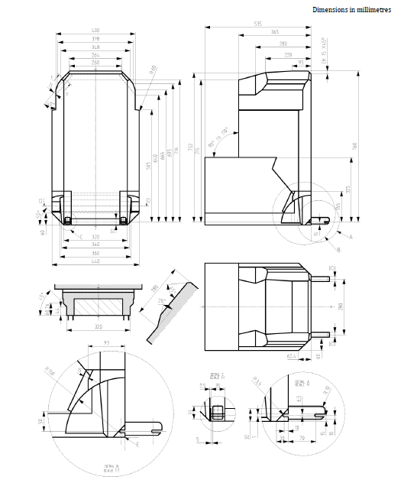
"
Appendix 5, Figure 3 ISO/B3, to be replaced as follows:
"Figure 3
…
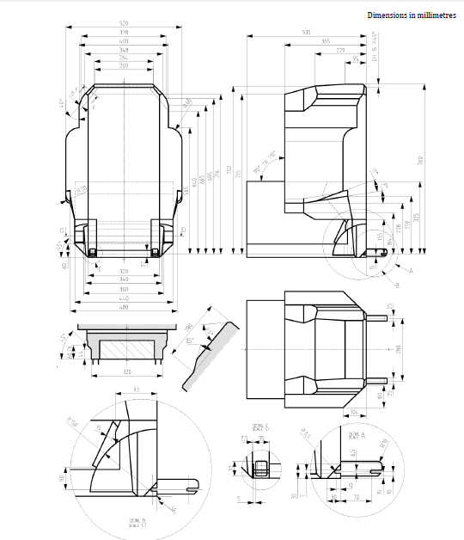
"
II. Justification
1. Paragraph 8.3.6. dots at the end of the paragraph, indicating that the remaining previous text shall be kept, were omitted.
2. Corrigendum of Table 1: Deletes "F1" in the table, as this fixture is part of corresponding ISO Standard but not in UN Regulation No. 16.
3. Appendix 5: Replaces "universal" by "i-size" in the title of Appendix 5, as UN Regulation No. 129 booster seats can be only i-Size or specific.
4. Replaces figures “1 to 9” by “1 to 8”
5. Annex 17, Appendix 3, paragraph 3.3. shall be deleted because Tables 3 and 4 were deleted by Supplement 8 to the 06 series of amendments.
6. Replaces tolerance of booster seats from “+- 0,2 kg” to “+- 1kg”, to be consistent with ISO reccomendations.

