Proposal for amendments to Regulation No. 67
(Equipment for liquefied petroleum gas (LPG))

- Proposal

Insert a new paragraph 6.15.10.8., to read:

“6.15.10.8. Filling unit shall not be located at bottom surface of the vehicle. Center of outlet of filling unit shall be above 350 mm from the ground surface when vehicle is in its reference mass. In case the outlet of filling unit is located between 350 mm – 1200 mm above the ground, in vertical plane the angle between horizontal road surface and outlet plane of the filling unit shall be equal to or greater than 60 degrees if outlet is looking downwards.” (See Figure 1)

Figure 1
Angle between horizontal road surface and outlet plane of filling unit
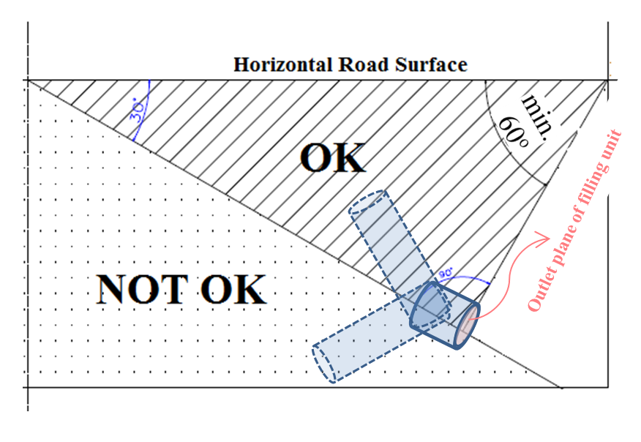

Insert a new paragraph 1.8. to Annex 10, to read:

“1.8. Service Life
The service life of the containers shall be defined by its manufacturer and may vary with application. The maximum service life shall be 15 years.”

Insert a new paragraphs to 4.3., to read:

(i) End of service life of the container (Month/Year)
(j) Date of production (Month/Year)

- Justification

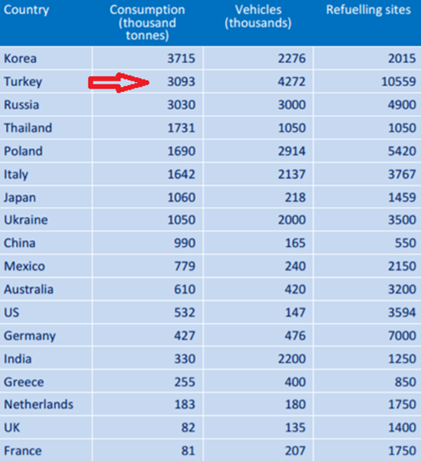
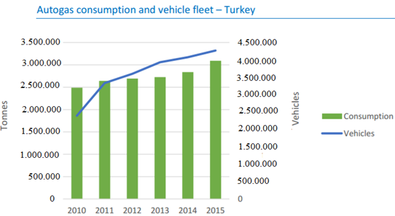

Justification for paragraph 1.8:
Maximum service life of CNG tank is defined in R-110. However, there are no restrictions regarding maximum service life of LPG tank in R-67. Countries follow their national legislations with regard to LPG tank service life. In this regard, it is proposed to add Paragraph 1.8 in Annex-10.

Item 4.18.9 of National AİTM Regulation which was revised and published in Turkey on 26/10/2016 in the Official Journal states that “The maximum service life of LPG tank shall be 15 years. However, in case of the manufacturer of the tank limiting the service life to a lower extent; then that limit shall be considered”.

Justification for paragraph 4.3.:
Countries follow their national legislations for showing the production date and service life of LPG tank on the marking plate on the LPG tank. Item 4.18.4.2 of National AİTM Regulation in Turkey regulates to show the tank production date on the marking plate on tank. In that regard, it is proposed to add item (i) and (j) in paragraph 4.3.

Justification for paragraph 6.15.10.8.:
There are no restrictions regarding the location of filling unit of LPG tank outside of the vehicle. Countries follow their national legislations.

In practice, the LPG tank filling unit located under the vehicle causes some problems, such as:
- Difficulty in filling the tank,
- Risks involved on occupational health and safety of LPG filling operators,
- Forces operators to kneel down or lie down on the ground in order to fill the tank,
- When the vehicle is in laden position, the filler pistol may be unable to fit the space between ground and filling unit and prevents the filling.

Problems during filling with various application under the vehicle:

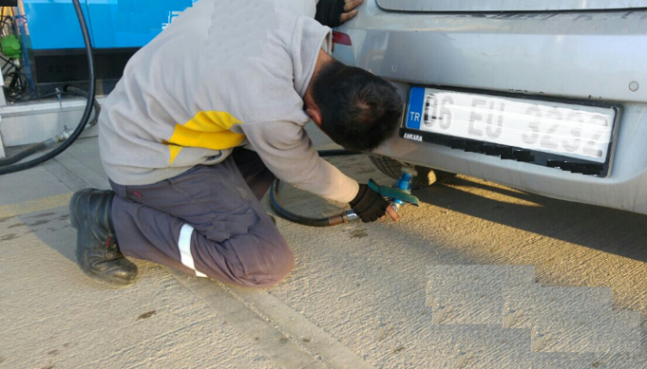
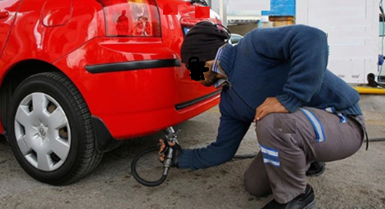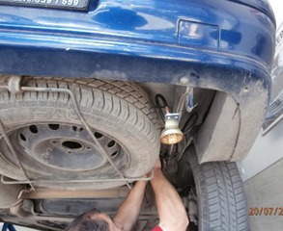

Alternative solutions:

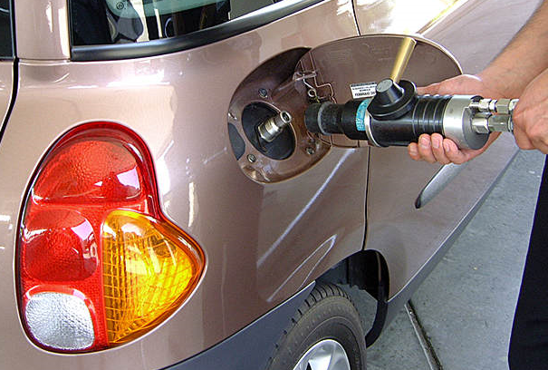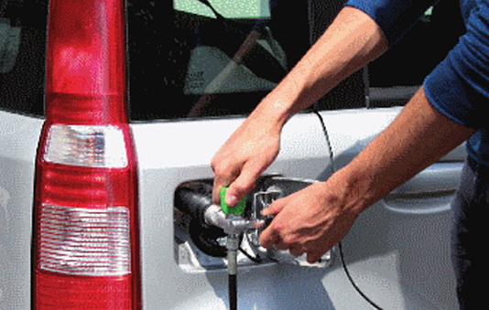
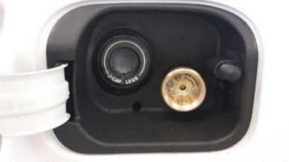
Item 4.18.1 of National AITM Regulation in Turkey regulates the filling unit location (for new modifications and manufacturing) in order to solve the above mentioned problems.
In this regard, it is proposed to add paragraph 6.15.10.8.

Contact: Fatih ÖZÇINAR (fatih.ozcinar@sanayi.gov.tr)
Ministry of Science, Industry and Technology
Ankara/TURKEY

