|  |  |  |  |
| --- | --- | --- | --- |
|  | United Nations | ECE/TRANS/WP.29/GRSG/2017/14 | |
| _unlogo | **Economic and Social Council** | | Distr.: General  17 July 2017  Original: English |

**Economic Commission for Europe**

Inland Transport Committee

**World Forum for Harmonization of Vehicle Regulations**

**Working Party on General Safety Provisions**

**113th session**

Geneva, 10-13 October 2017

Item 2(a) of the provisional agenda

**Amendments to regulations on buses and coaches:**

**Regulation No. 107 (M2 and M3 vehicles)**

Proposal for Supplement 7 to the 06 series of amendments and Supplement 2 to the 07 series of amendments to Regulation No. 107 (M2 and M3 vehicles)

Submitted by the expert from the Czech Republic[[1]](#footnote-2)\*

The text reproduced below was prepared by the expert from the Czech Republic to clarify in UN Regulation No. 107 the provisions on "double insulation" and "reinforced insulation" in trolleybuses. It is based on informal document GRSG-112-16 distributed during the 112th session of the Working Party on General Safety Provisions (GRSG) (see report ECE/TRANS/WP.29/GRSG/91, para. 6). The modifications to the current text of UN Regulation No. 107 are marked in bold characters for new and strikethrough for deleted characters.

I. Proposal

*Annex 12*

*Paragraph 3.10.12.,* amend to read:

"… AC value.

~~Reinforced insulation in trolleybuses is not allowed for circuits directly connected to overhead line.~~

**Circuits directly connected to overhead line shall be double insulated**."

II. Justification

1. Reinforced insulation is generally used in many cases of double insulated systems, e.g. in case of a power screw terminal inside of a metal box of inverter, there is an air gap with a large distance between the screw and the metal lid: this air gap is considered as "reinforced insulation" as shown on the following figure on "AIR GAP" and "LARGE DISTANCE".

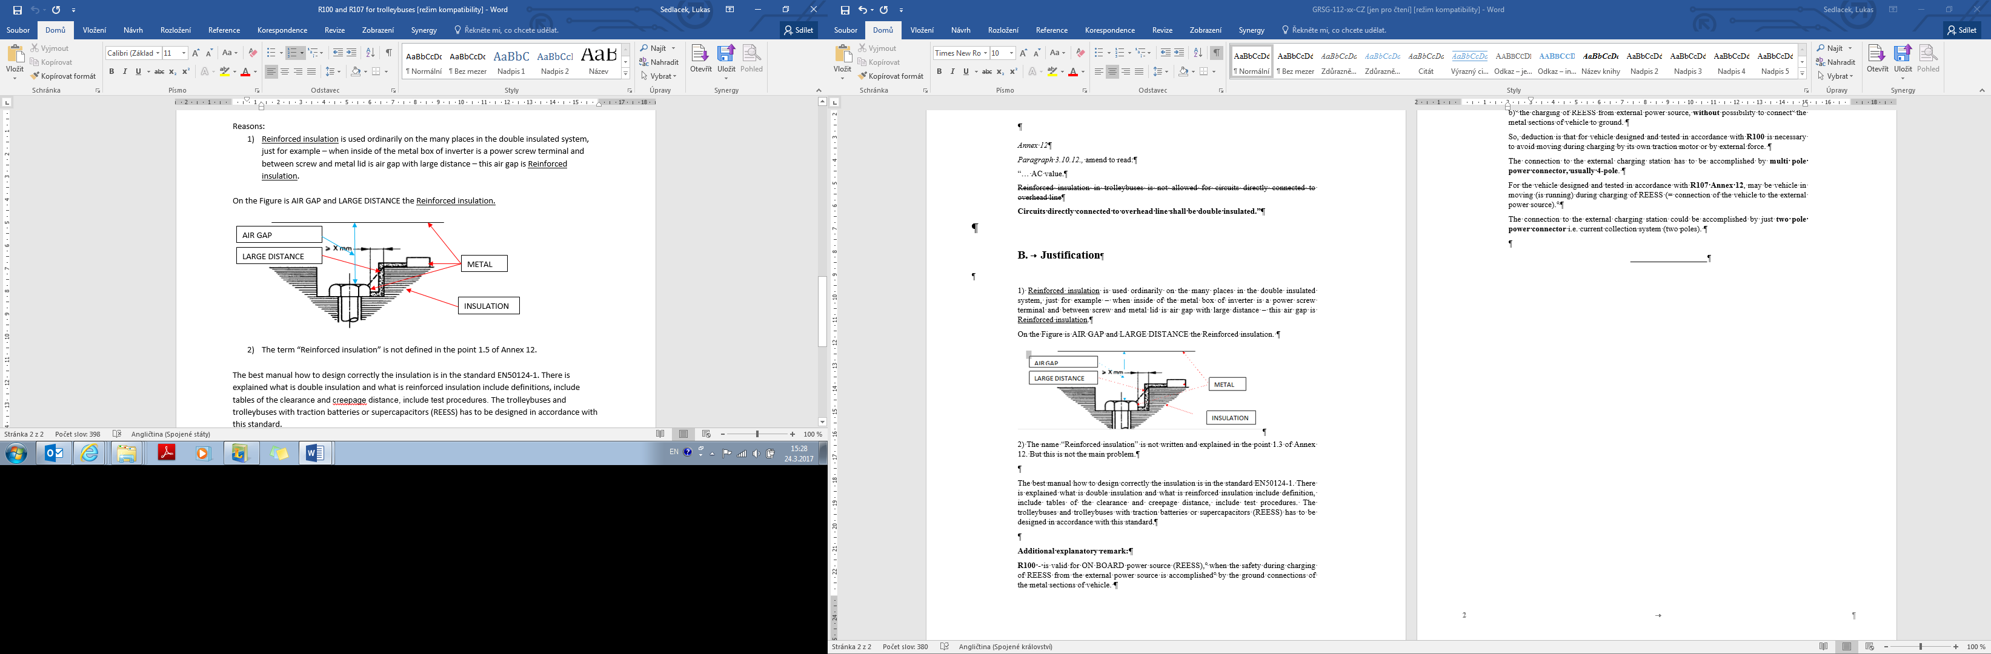

2. The designation of "reinforced insulation" is not defined in paragraph 1.3. of Annex 12. Nevertheless, this is not the main problem. European standard EN50124-1 provides the best technical specifications on how to design correctly the insulation. There are also explanations on double insulation and reinforced insulation, including definitions, tables of clearance, creepage distance and test procedures. Conventional trolleybuses and trolleybuses with Rechargeable Energy Storage Systems (REESS), such as traction batteries or super-capacitors, shall be designed in accordance with this standard.

**Additional explanatory remark**

3. UN Regulation No. 100 is valid for ON BOARD power sources, when electrical safety during the charging period of REESS from an external power source is ensured through ground connections of the metal sections of vehicle.

4. UN Regulation No. 107, Annex 12 is valid for:

(a) the propulsion system (inverter and traction motor) which is directly supplied from external power source, without a possibility to connect the metal sections of vehicle to ground;

(b) the charging of REESS from external power source, without a possibility to connect the metal sections of vehicle to ground.

5. Therefore, our deduction is that for vehicles designed and tested in accordance with UN Regulation No. 100 it is necessary to avoid any movement during charging from its own traction motor or from external force. A multi-pole power connector, usually four-pole, shall connect with the external charging station.

6. For vehicles designed and tested in accordance with UN Regulation No. 107, Annex 12, vehicles may move during charging process of REESS (i.e. the vehicle is connected to the external power source). A two-pole power connector, i.e. current collection system (two poles), could connect with the external charging station.

1. \* In accordance with the programme of work of the Inland Transport Committee for 2016–2017 (ECE/TRANS/254, para. 159 and ECE/TRANS/2016/28/Add.1, cluster 3.1), the World Forum will develop, harmonize and update Regulations in order to enhance the performance of vehicles. The present document is submitted in conformity with that mandate. [↑](#footnote-ref-2)