|  |  |  |  |
| --- | --- | --- | --- |
|  | United Nations | ECE/TRANS/WP.29/GRSP/2016/8 | |
| _unlogo | **Economic and Social Council** | | Distr.: General  26 February 2016  Original: English |

**Economic Commission for Europe**

Inland Transport Committee

**World Forum for Harmonization of Vehicle Regulations**

**Working Party on Passive Safety**

**Fifty-ninth session**

Geneva, 9-13 May 2016

Item 9 of the provisional agenda

**Regulation No. 16 (Safety-belts)**

Proposal for Supplement 8 to the 06 series of amendments to Regulation No. 16 (Safety-belts)

Submitted by the expert from the Netherlands[[1]](#footnote-2)\*

The text reproduced below was prepared by the expert from the Netherlands to clarify a number of installation items of Child Restraint Systems (CRS). It is based on ECE/TRANS/WP.29/2015/21 distributed at the fifty-eighth session of the Working Party on Passive Safety (GRSP). The modifications to the current text of UN Regulation No. 16 are marked in bold for new or strikethrough for deleted characters.

I. Proposal

*Paragraph 8.3.4.,* amend to read:

"8.3.4. Safety-belts or restraint systems incorporating retractors shall be soinstalledthat the retractors are able to operate correctly and stow the strap efficiently. **In case of both a belt adjusting device for height as well as a flexible shoulder adjustment device for height, in at least its highest and its lowest position, checks shall be made that the retractor automatically adjusts the strap to the shoulder of the concerned wearer after coupling, as well as that the tongue-plate rolls up in case of an uncoupling.**"

*Annex 17, Appendix 1,*

*Paragraph 2.7*., amend to read:

"2.7. Ensure that the fixture is located with its ~~centreline on the apparent centreline~~ **vertical plane of symmetry** ~~of the seating position~~ **within** ±25 mm ~~with its centreline parallel with the centreline of the vehicle~~ **of the vertical plane of symmetry of the seating position.**"

*Paragraph 3.2*., amend to read:

"3.2. The lap portion of the belt shall touch the fixture on both sides at the rear of the lap belt path (see Figure 3). **The seat belt webbing shall always cover the points BP on the left and right ends of the curved edge; the exact position of point BP on the curved edge is indicated in detail W of Figure 1.**

*Figures 1 to* 3, amend to read:

# "Figure 1

# **Specifications of the fixture**

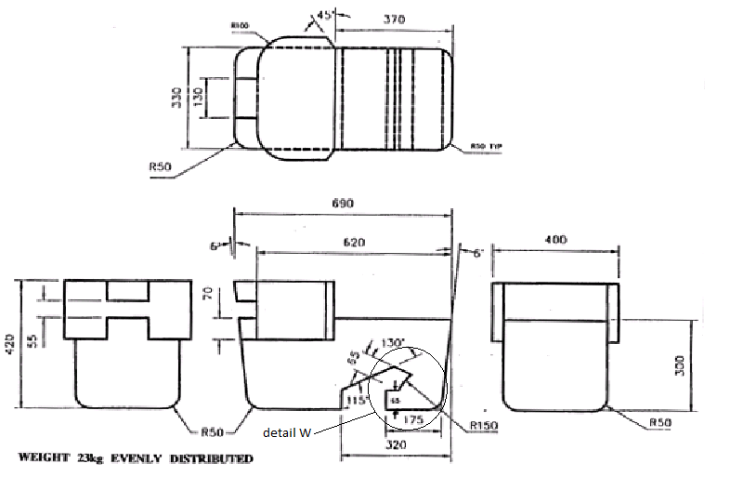

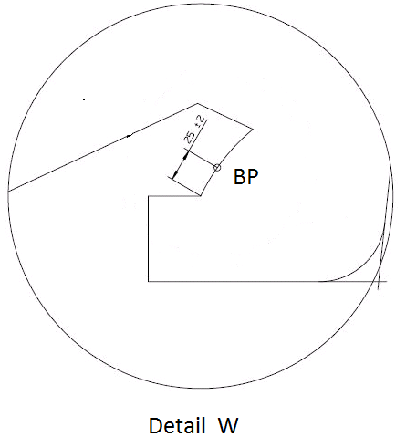

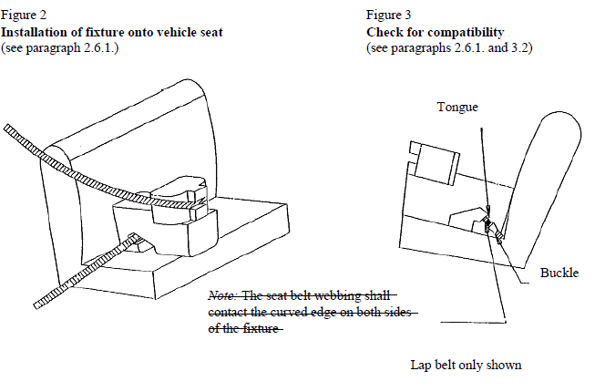"

*Annex 17, Appendix 3, Table 1,* amend to read:

# "Table 1

# **Table of vehicle handbook information on child restraint systems**

# **installation suitability for various seating positions**

| *Mass Group* | | *Seating position (or other site)* | | | | |
| --- | --- | --- | --- | --- | --- | --- |
| *Front passenger* | *Rear outboard* | *Rear centre* | *Intermediate outboard* | *Intermediate centre* |
| Group | 0 up to 10 kg |  |  |  |  |  |
| Group | 0+ up to 13 kg |  |  |  |  |  |
| Group | I 9 to 18 kg |  |  |  |  |  |
| Group | II 15 to 25 kg |  |  |  |  |  |
| Group | III 22 to 36 kg |  |  |  |  |  |

|  |  |  |
| --- | --- | --- |
| Key of letters to be inserted in the above table: | | |
| U | = | Suitable for "universal" category restraints approved for use in this mass group. |
| UF | = | Suitable for forward-facing "universal" category restraints approved for use in this mass group. |
| L | = | Suitable for particular child restraints given on attached list. These restraints may be of the "specific vehicle", "restricted" ~~or~~ **,**"semi-universal" **or universal** categories. |
| B | = | Built-in restraint approved for this mass group. |
| X | = | Seat position not suitable for children in this mass group. |

"

II. Justification

The above proposal concerns four items:

1. Paragraph. 8.3.4.: The possibility of benefiting from a better belt routing at the shoulder section may not reduce the automatically adjusting function of the retractor; this should be definitely verified with the introduction of flexible shoulder adjusting devices for height (so-called generation belts) in all circumstances.

2. Annex 17, Appendix 1, paragraph 2.7.: The present definition will cause **unusual** installation configurations under certain circumstances. This refers to the definition of seats as laid down in UN Regulation No. 17. For example in paragraph 2.3.1. of the UN Regulation you will find the following definition:

"2.3.1. "*Forward-facing seat*" means a seat which can be used while the vehicle is in motion and which faces towards the front of the vehicle in such a manner that the vertical plane of symmetry of the seat forms an angle of less than + 10° or - 10° with the vertical plane of symmetry of the vehicle;"

If the test provision would focus on the vertical plane of symmetry of the seat, instead of the vehicle, it will reproduce the real installation situation to be checked.

3. Annex 17, Appendix 1, paragraph 3.2.: So far the test requirements for the belt path are in paragraph 3.2. and Figures 2 and 3. Moreover, the current text could lead to misinterpretation. Accordingly, with the current proposal all test requirements are now concentrated in paragraph 3.2. and most notably what is meant of "shall contact" is clarified by adding a coverage point BP that is also defined in detail W.

4. Annex 17, Appendix 3, Table 1: If a certain seating position in a vehicle is unfit to install the gabarit (of Appendix 1) and receive the "U" key letter meaning suitable for universal CRS, this does not necessarily mean that no universal CRS will fit. Therefore, the vehicle manufacturer should be able to mention here which universal CRS will fit anyway.

1. \* In accordance with the programme of work of the Inland Transport Committee for 2014–2018 (ECE/TRANS/240, para. 105 and ECE/TRANS/2014/26, programme activity 02.4), the World Forum will develop, harmonize and update Regulations in order to enhance the performance of vehicles. The present document is submitted in conformity with that mandate.. [↑](#footnote-ref-2)