|  |  |  |  |
| --- | --- | --- | --- |
|  | United Nations | ST/SG/AC.10/44/Add.3 | |
|  | **Secretariat** | | Distr.: General  7 February 2017  English  Original: English and French |

**Committee of Experts on the Transport of Dangerous Goods  
and on the Globally Harmonized System of Classification  
and Labelling of Chemicals**

Report of the Committee of Experts on the Transport of Dangerous Goods and on the Globally Harmonized System of Classification and Labelling of Chemicals on its eighth session

held in Geneva on 9 December 2016

Addendum

Annex III

Amendments to the sixth revised edition of the Globally Harmonized System of Classification and Labelling of Chemicals (GHS) (ST/SG/AC.10/30/Rev.6)

Chapter 1.2

Delete the definitions of “Skin corrosion”, “Skin irritation”, “Serious eye damage”, “Eye irritation”, “Dermal corrosion” and “Dermal irritation”.

Amend the definition of “Respiratory sensitizer” to read as follows:

“***Respiratory sensitizer*** means a substance or mixture that induces hypersensitivity of the airways occurring after inhalation of the substance or mixture;”.”

In the definition of “Skin sensitizer” replace “a substance” with “a substance or mixture”.

Chapter 1.5

Table 1.5.1 For the hazard class “Aspiration hazard”, categories 1 and 2, replace the text in the column “Cut-off value/concentration limit” with “ ≥ 1.0%” .

1.5.3.3.1 Add the following sentence at the end of the paragraph:

“Guidance on the preparation of SDS’s under the requirements of the GHS can be found in Annex 4.”.

1.5.3.3.3 Delete. Current paragraph 1.5.3.3.4 becomes new paragraph 1.5.3.3.3.

1.5.3.3.3 (new, former 1.5.3.3.4) Amend the end of the second sentence to read as follows: “…when such cargoes are transported in bulk according to IMO instruments”.

Table 1.5.2 Amend item (f) under section 14 “Transport information” to read as follows:

“(f) transport in bulk according to IMO instruments”.

Chapter 2.1

2.1.1.2 (c) and note “b” under table 2.1.1 Remove the comma after “practical”.

Chapter 2.2

2.2.2 Amend to read as follows:

“**2.2.2 Classification criteria**

2.2.2.1 A flammable gas is classified in Category 1A, 1B or 2 according to the following table. Flammable gases that are pyrophoric and/or chemically unstable are always classified in Category 1A.

**Table 2.2.1: Criteria for categorisation of flammable gases**

|  |  |  |  |
| --- | --- | --- | --- |
| **Category** | | | **Criteria** |
| **1A** | **Flammable gas** | | Gases, which at 20 °C and a standard pressure of 101.3 kPa:  (a) are ignitable when in a mixture of 13% or less by volume in air; or  (b) have a flammable range with air of at least 12 percentage points regardless of the lower flammability limit  unless data shows they meet the criteria for Category 1B |
| **Pyrophoric gas** | | Flammable gases that ignite spontaneously in air at a temperature of 54 ºC or below |
| **Chemically unstable gas** | **A** | Flammable gases which are chemically unstable at 20°C and a standard pressure of 101.3 kPa |
| **B** | Flammable gases which are chemically unstable at a temperature greater than 20°C and/or a pressure greater than 101.3 kPa |
| **1B** | **Flammable gas** | | Gases which meet the flammability criteria for Category 1A, but which are not pyrophoric, nor chemically unstable, and which have at least either:  (a) a lower flammability limit of more than 6% by volume in air; or  (b) a fundamental burning velocity of less than 10 cm/s; |
| **2** | **Flammable gas** | | Gases, other than those of Category 1A or 1B, which, at 20 °C and a standard pressure of 101.3 kPa, have a flammable range while mixed in air |

***NOTE 1****: Ammonia and methyl bromide may be regarded as special cases for some regulatory purposes.*

***NOTE 2:*** *Aerosols should not be classified as flammable gases. See Chapter 2.3.*

***NOTE 3:*** *In the absence of data allowing classification into Category 1B, a flammable gas that meets the criteria for Category 1A is classified per default in Category 1A.*

***NOTE 4:*** *Spontaneous ignition for pyrophoric gases is not always immediate, and there may be a delay.*

***NOTE 5:*** *In the absence of data on its pyrophoricity, a flammable gas mixture should be classified as a pyrophoric gas if it contains more than 1% (by volume) of pyrophoric component(s).”.*

2.2.3 Amend to read as follows:

“**2.2.3** **Hazard communication**

2.2.3.1 General and specific considerations concerning labelling requirements are provided in *Hazard communication: Labelling* (Chapter 1.4). Annex 1 contains summary tables about classification and labelling. Annex 3 contains examples of precautionary statements and pictograms which can be used where allowed by the competent authority.

**Table 2.2.2: Label elements for flammable gases**

|  |  |  |  |  |  |  |
| --- | --- | --- | --- | --- | --- | --- |
|  | **Category 1A** | **Gases categorized as 1A by meeting pyrophoric or unstable gas A/B criteria** | | | **Category 1B** | **Category  2** |
| **Pyrophoric gas** | **Chemically unstable gas** | |
| **Category A** | **Category B** |
| **Symbol** | Flame | Flame | Flame | Flame | Flame | *No symbol* |
| **Signal word** | Danger | Danger | Danger | Danger | Danger | Warning |
| **Hazard statement** | Extremely flammable gas | Extremely flammable gas.  May ignite spontaneously if exposed to air | Extremely flammable gas.  May react explosively even in the absence of air | Extremely flammable gas.  May react explosively even in the absence of air at elevated pressure and/or temperature | Flammable gas | Flammable gas |

2.2.3.2 If a flammable gas or gas mixture is classified as pyrophoric and/or chemically unstable, then all relevant classification(s) should be communicated on the safety data sheet as specified in Annex 4, and the relevant hazard communication elements included on the label.”.

2.2.4.1 Amend to read as follows:

“2.2.4.1 *Decision logic* *for flammable gases*

To classify a flammable gas, data on its flammability, on its ability to ignite in air and on its chemical instability are required. In case of categorisation in Category 1B, data on its lower flammability limit or its fundamental burning velocity are required. The classification is according to decision logic 2.2.

***Decision logic 2.2***

**Footnote[1]**

No

Yes

Yes

The substance/mixture is a gas

Not classified   
as a flammable gas

Yes

No

No

Category 1A

Pyrophoric gas and chemically unstable gas A



Danger

Does it have a flammable range with air at 20°C and   
a standard pressure of 101.3 kPa ?

Does it ignite spontaneously in air at 54°C or below? 1

Yes

Is it chemically unstable at 20°C and   
a standard pressure of 101.3 kPa ?

No

Category 1A

Pyrophoric gas and chemically unstable gas B



Danger

Category 1A

Pyrophoric gas



Danger

Is it chemically unstable at 20°C and a standard pressure of   
101.3 kPa ?

Category 1A

Chemically unstable gas A



Danger

No

Yes

**”.**

Is it chemically unstable at a temperature greater than 20°C and/or a pressure greater than 101.3 kPa ?

2.2.4.4 to 2.2.4.4.4 Renumber as 2.2.4.2 to 2.2.4.2.4.

Is it chemically unstable at a temperature greater than 20°C and/or a pressure greater than101.3 kPa ?

Yes

Category 1A

Chemically unstable gas B



Danger

No

Yes

No

At 20 °C and a standard pressure of 101.3 kPa, does it:

(a) ignite when in a mixture of 13% or less by volume in air?; or

(b) have a flammable range with air of at least 12 percentage points regardless of the lower flammable limit?

No

Category 2

*No symbol*

Warning

Category 1A



Danger

Yes

Does it have a lower flammability limit > 6% by volume in air, and/or   
does it have a fundamental burning velocity < 10 cm/s ?

No or unknown

Category 1B



Danger

2.2.4.2.1 (new, former 2.2.4.4.1) Amend the end of the first sentence to read as follows:

“…selection of cylinder valve outlets” and, if using fundamental burning velocity for Category 1B, see ISO 817:2014 “Refrigerants-Designation and safety classification”, Annex C: Method of test for burning velocity measurement of flammable gases).”.

2.2.5 Amend paragraphs 1 to 5 under “Calculation” to read as follows:

“1. Ascertain the equivalency factors (Ki) for the inert gases versus nitrogen:

Ki (Ar) = 0.55

Ki (He) = 0.9

2. Calculate the equivalent mixture with nitrogen as balance gas using the Ki figures for the inert gases:

2%(H2) + 6%(CH4) + [27% × 0.55 + 65% × 0.9](N2) = 2%(H2)+ 6%(CH4) + 73.35%(N2) = 91.35%

3. Adjust the sum of the contents to 100%:

× [2%(H2) + 6%(CH4) + 73.35%(N2)] = 2.46%(H2) + 7.37%(CH4) + 90.17%(N2)

4. Ascertain the Tci coefficients for the flammable gases:

Tci H2 = 5.5%

Tci CH4 = 8.7%

5. Calculate the flammability of the equivalent mixture using the formula:

 = **1.29 > 1**

Therefore the mixture is flammable in air.”.

Chapter 2.6

2.6.4.2.2 At the end of the paragraph before sub-paragraphs (a) to (d) delete “(23°C and 60°C, respectively)”.

Chapter 2.7

2.7.2.2 Amend the end of the paragraph to read as follows: “…and the reaction spreads over the whole length of the sample (100 mm) in 10 min or less.”.

Chapter 2.17

2.17.2.1 Amend the text before sub-paragraphs (a) to (c) to read as follows: “Any explosive while in a desensitized state shall be considered in this class unless, in that state:”.

2.17.2.1 (a) Amend to read as follows: “It is intended to produce a practical explosive or pyrotechnic effect;”.

2.17.2.1 (b) Replace “their corrected burning rate” with “the corrected burning rate”.

2.17.2.1 (c) Replace “Their exothermic decomposition” with “The exothermic decomposition”.

In note 1, amend the beginning of the first sentence to read as follows: “*Substances or mixtures which meet the criterion (a) or (b) in their desensitized state…”*.

Chapter 3.1

3.1.1 Amend the definition for “acute toxicity” to read as follows:

*“Acute toxicity* refers to serious adverse health effects (i.e., lethality) occurring after a single or short-term oral, dermal or inhalation exposure to a substance or mixture.”.

3.1.2.1 Insert the following sentence before the current last sentence (“Explanatory notes…Table 3.1.1”):

“While some *in vivo* methods determine LD50/LC50 values directly, other newer *in vivo* methods (e.g. using fewer animals) consider other indicators of acute toxicity, such as significant clinical signs of toxicity, which are used by reference to assign the hazard category.”.

Table 3.1.1 Amend to read as follows:

**“Table 3.1.1: Acute toxicity estimate (ATE) values and criteria for acute toxicity hazard categories**

|  |  |  |  |  |  |
| --- | --- | --- | --- | --- | --- |
| **Exposure route** | **Category 1** | **Category 2** | **Category 3** | **Category 4** | **Category 5** |
| **Oral** (mg/kg bodyweight)  *See notes (a) and (b)* | ATE ≤ 5 | 5 < ATE ≤ 50 | 50 <ATE ≤ 300 | 300 < ATE ≤ 2000 | 2000 < ATE ≤ 5000 *See detailed criteria in Note (g)* |
| **Dermal** (mg/kg bodyweight)  *See notes (a) and (b)* | ATE ≤ 50 | 50 < ATE ≤ 200 | 200 < ATE ≤ 1000 | 1000 < ATE ≤ 2000 |
| **Gases** (ppmV)  *See notes (a), (b) and (c)* | ATE ≤ 100 | 100 < ATE ≤ 500 | 500 < ATE ≤ 2500 | 2500 < ATE ≤ 20000 | *See detailed criteria in Note (g)* |
| **Vapours** (mg/l)  *See notes (a), (b), (c), (d) and (e)* | ATE ≤ 0.5 | 0.5 <ATE ≤ 2.0 | 2.0 < ATE ≤ 10.0 | 10.0 < ATE ≤ 20.0 |
| **Dusts and Mists** (mg/l)  See notes (a), (b), (c) and (f) | ATE ≤ 0.05 | 0.05 < ATE ≤ 0.5 | 0.5 < ATE ≤ 1.0 | 1.0 < ATE ≤ 5.0 |

***Note****:* *Gas concentrations are expressed in parts per million per volume (ppmV).*”.

3.1.2.3 Add the following new sentence at the end of the paragraph:

“In cases where data from human experience (i.e. occupational data, data from accident databases, epidemiology studies, clinical reports) are also available, they should be considered in a weight of evidence approach consistent with the principles described in 1.3.2.4.9.”.

Chapter 3.2

3.2.1.1 Amend to read as follows:

*“Skin corrosion* refers to the production of irreversible damage to the skin; namely, visible necrosis through the epidermis and into the dermis occurring after exposure to a substance or mixture.

*Skin irritation* refers to the production of reversible damage to the skin occurring after exposure to a substance or mixture.”.

Consequential amendment: Delete related footnote 1 and renumber subsequent footnotes accordingly.

Chapter 3.3

3.3.1.1 Amend to read as follows:

*“Serious eye damage* refers to the production of tissue damage in the eye, or serious physical decay of vision, which is not fully reversible, occurring after exposure of the eye to a substance or mixture.

*Eye irritation* refers to the production of changes in the eye, which are fully reversible, occurring after exposure of the eye to a substance or mixture.”.

Consequential amendment: Delete related footnote 1 and renumber subsequent footnotes accordingly.

Chapter 3.4

3.4.1.1 Amend to read as follows:

*“Respiratory sensitization* refers to hypersensitivity of the airways occurring after inhalation of a substance or a mixture.

*Skin sensitization* refers to an allergic response occurring after skin contact with a substance or a mixture.”.

Consequential amendment: Delete related footnote 1 and renumber subsequent footnotes accordingly.

Chapter 3.5

3.5.1.1 Insert a new paragraph to read as follows:

“3.5.1.1 *Germ cell mutagenicity* refers to heritable gene mutations, including heritable structural and numerical chromosome aberrations in germ cells occurring after exposure to a substance or mixture.”.

Current paragraphs 3.5.1.1 to 3.5.1.4 become new paragraphs 3.5.1.2 to 3.5.1.5.

Chapter 3.6

3.6.1 Amend the first sentence to read as follows:

*“Carcinogenicity* refers to the induction of cancer or an increase in the incidence of cancer occurring after exposure to a substance or mixture.”.

Chapter 3.7

3.7.1.1 In the first paragraph, amend the first sentence to read as follows: *“Reproductive toxicity* refers to adverse effects on sexual function and fertility in adult males and females, as well as developmental toxicity in the offspring, occurring after exposure to a substance or mixture.”

In the last sentence of the last paragraph, replace “Nonetheless, chemicals with these effects” with “Nonetheless, substances and mixtures with these effects”.

Chapter 3.8

3.8.1.1 Amend the first sentence to read as follows:

*“Specific target organ toxicity – single exposure* refers to specific, non-lethal toxic effects on target organs occurring after a single exposure to a substance or mixture.”

Chapter 3.9

3.9.1.1 Amend the first sentence to read as follows:

*“Specific target organ toxicity – repeated exposure* refers to specific toxic effects on target organs occurring after repeated exposure to a substance or mixture.”.

Chapter 3.10

3.10.1 Amend the title to read: “**Definitions and general considerations**”

3.10.1.1 Delete. Current paragraph 3.10.1.2 becomes new paragraph 3.10.1.1.

3.10.1.3 Renumber as 3.10.1.2 and amend to read:

“*Aspiration hazard* refers to severe acute effects such as chemical pneumonia, pulmonary injury or death occurring after aspiration of a substance or mixture.”

3.10.1.4 and 3.10.1.5 Renumber as 3.10.1.3 and 3.10.1.4.

Annex 1

A1.2 Amend to read as follows:

**“A1.2 Flammable gases** (see Chapter 2.2 for classification criteria)

| **Classification** | | | | **Labelling** | | | | **Hazard statement codes** |
| --- | --- | --- | --- | --- | --- | --- | --- | --- |
| **Hazard class** | **Hazard category** | | | **Pictogram** | | **Signal word** | **Hazard statement** |
| **GHS** | **UN Model Regulationsa** |
| **Flammable gases** | **1A** | **Flammable gas** | |  |  | **Danger** | **Extremely flammable gas** | H220 |
| **Pyrophoric gas** | |  |  | **Danger** | **Extremely flammable gas** | H220 |
| **May ignite spontaneously if exposed to air** | H232 |
| **Chemically unstable gas** | **A** |  |  | **Danger** | **Extremely flammable gas** | H220 |
| **May react explosively even in the absence of air** | H230 |
| **B** |  |  | **Danger** | **Extremely flammable gas** | H220 |
| **May react explosively even in the absence of air at elevated pressure and/or temperature** | H231 |
| **1B** | | |  |  | **Danger** | **Flammable gas** | H221 |
| **2** | | | *No pictogram* | *Not required* | **Warning** | **Flammable gas** | H221 |

a *Under the UN Recommendations on the Transport of Dangerous Goods, Model Regulations, the symbol, number and border line may be shown in black instead of white. The background colour stays red in both cases.”*

Annex 3

Section 1, Table A3.1.1

**H220**

In column 4, under “hazard category”, replace “1” with “1A”.

**H221**

In column 4, under “hazard category”, replace “2” with “1B, 2”.

**H230**

In column 4, under “hazard category”, replace “A (Chemically unstable gases)” with “1A, chemically unstable gas A”.

**H231**

In column 4, under “hazard category”, replace “B (Chemically unstable gases)” with “1A, chemically unstable gas B”.

**H232**

In column 4, under “hazard category”, replace “Pyrophoric gas” with “1A, pyrophoric gas”.

Section 2, paragraph A3.2.3.3

Amend the beginning of the last sentence to read as follows:

“For example in P280 “**Wear protective gloves/protective clothing/eye protection/face protection/hearing protection/…**” could read…” *(remainder of the sentence unchanged)*

Section 2, Table A3.2.1

**P103**

Amend the text in column (2) to read as follows: “**Read carefully and follow all instructions**”.

Add the following new condition for use in column (5) below “Consumer products”:   
*“- omit where P202 is used.”.*

Section 2, Table A3.2.2

**P201**

Add the following condition for use in column (5) for all hazard classes except “Explosives”:

“*- omit for consumer products where P202 is used.*”

**P202**

Insert a new row for the hazard class: “Reproductive toxicity, effects on or via lactation (chapter 3.7)”, hazard category “Additional category”.

**P210**

For the hazard class “Flammable gases” replace “1, 2” with “1A, 1B, 2” in column (4).

**P280**

Amend the text of the precautionary statement in column 2 to read as follows:

**“Wear protective gloves/protective clothing/eye protection/face protection/hearing protection/…”**

For the hazard classes “Explosives”, “Flammable gases”, “Flammable liquids”, “Flammable solids”, “Self-reactive substances and mixtures”, “Pyrophoric liquids”, “Pyrophoric solids”, “Self-heating substances and mixtures”, “Substances and mixtures which, in contact with water, emit flammable gases”, “Oxidizing liquids”, “Oxidizing solids”, “Organic peroxides”, “Desensitized explosives”, “Germ cell mutagenicity”, “Carcinogenicity” and “Reproductive toxicity”, amend the condition for use in column (5) to read as follows:

“Manufacturer/supplier or the competent authority to specify the appropriate personal protective equipment.”.

**P231+P232**

Delete the entries for pyrophoric liquids and pyrophoric solids.

Section 2, Table A3.2.3

**P301**

For the hazard class “Acute toxicity, oral” add “, 5” in column (4).

**P302**

For the hazard class “Acute toxicity, dermal” add “, 5” in column (4).

**P312**

Merge the two existing rows for categories 4 and 5 for acute toxicity, oral and acute toxicity by inhalation.

**P332**

Add the following new condition for use in column (5): *“- may be omitted if P333 is given on the label.”*.

**P375**

For the hazard class “Desensitized explosives” add “, 4” in column (4).

**P377**

For the hazard class “Flammable gases” replace “1, 2” with “1A, 1B, 2” in column (4).

**P381**

For the hazard class “Flammable gases” replace “1, 2” with “1A, 1B, 2” in column (4)

**P301+P312**

For the hazard class “Acute toxicity, oral” add “, 5” in column (4).

**P302+P352**

For the hazard class “Acute toxicity, dermal” add “, 5” in column (4).

Section 2, Table A3.2.4

**P403**

For the hazard class “Flammable gases” replace “1, 2” with “1A, 1B, 2” in column (4).

Section 2, Table A3.2.5

**P501**

Delete the entry for “Explosives”.

For the hazard class “Acute toxicity, inhalation” add “, 3” in column (4).

**P503**

Insert a new precautionary statement P503 to read as follows:

|  |  |  |  |  |
| --- | --- | --- | --- | --- |
| **Code** | **Disposal precautionary statements** | **Hazard class** | **Hazard category** | **Conditions for use** |
| **(1)** | **(2)** | **(3)** | **(4)** | **(5)** |
| P503 | **Refer to manufacturer/ supplier/… for information on disposal/recovery/ recycling** | Explosives (chapter 2.1) | Unstable explosives and Divisions 1.1, 1.2, 1.3, 1.4, 1.5 | … Manufacturer/supplier or the competent authority to specify appropriate source of information in accordance with local/regional/national/international regulations as applicable |

Section 3

A3.3.1.1 At the end of the existing text in A3.3.1.1 add the current text of A3.3.1.6 as amended to read as follows:

“It will be subject to further refinement and development over time though the overall approach set out below will remain”.

A3.3.1.2 Former A3.3.2.3 becomes new paragraph A3.3.1.2. In the first sentence replace “Precautionary statements should appear on GHS labels along with” with “Precautionary statements should, as an important part of hazard communication, appear on GHS labels, generally along with”

Current paragraphs A3.3.1.2 to A3.3.1.5 become new paragraphs A3.3.1.3 to A3.3.1.6.

A3.3.1.3 (Former A3.3.1.2) In the first sentence replace “chemical product” with “substance or mixture” and in the second sentence replace “chemicals” with “substances or mixtures”.

In the third sentence, replace “on consumer product labels” with “on consumer products”.

A3.3.1.6 (Former A3.3.1.5) Insert at the beginning the text of current paragraph A3.3.3.2, and amend to read as follows:

“A3.3.1.6 The understanding and following of precautionary label information, specific safety guidelines, and the safety data sheet for each product before use are part of occupational health and safety procedures. Consistent use of precautionary statements will reinforce safe handling procedures and will enable the key concepts and approaches to be emphasized in workplace training and education activities.”

Current paragraphs A3.3.3.3 and A3.3.4.7 become new paragraphs A3.3.1.7 and A3.3.1.8.

A3.3.2 Amend to read as follows:

*“***A3.3.2 Flexibility in the use of precautionary statements**

**A3.3.2.1 *Omission of precautionary statements where the advice is not relevant***

Subject to any requirements of competent authorities, those responsible for labelling may decide to omit other precautionary statements for a hazard class and category where the information is clearly not appropriate or is adequately addressed by other information on the label, taking into account the nature of the user (e.g. consumer, employers and workers), the quantity supplied, and the intended and foreseeable circumstances of use. Where a decision is made to omit a precautionary statement the supplier of thesubstance or mixture should be able to demonstrate that the precautionary statement is not appropriate for the intended and foreseeable use, including potential emergency situations.

**A3.3.2.2 *Combination or consolidation of precautionary statements***

A3.3.2.2.1 To provide flexibility in the application of precautionary phrases, combinations or consolidations of precautionary statements are encouraged to save label space and improve readability. The matrix and the Tables in Section 2 of Annex 3 include a number of combined precautionary statements. However, these are only examples and those responsible for labelling should further combine and consolidate phrases where this contributes to clarity and comprehensibility of label information.

A3.3.2.2.2 Combinations of precautionary statements can also be useful for different types of hazard where the precautionary behaviour is similar. Examples are P370+P372+P380 “**In case of fire: Explosion risk. Evacuate area**” and P210+P403 “**Keep away from heat, sparks and open flame and store in a cool well ventilated place**”.

**A3.3.2.3 *Variations of text not affecting the safety message***

A3.3.2.3.1 Subject to any requirements of competent authorities, the precautionary statements that appear on labels or in safety data sheets may incorporate minor textual variations from those set out in the GHS where these variations assist in communicating safety information and the safety advice is not diluted or compromised. These may include spelling variations, synonyms or other equivalent terms appropriate to the region where the product is supplied and used.

A3.3.2.3.2 In all cases, clear plain language is essential to convey information on precautionary behaviour. Furthermore, to ensure clarity of safety messages any variations should be applied consistently on the label and in the safety data sheet.

**A3.3.2.4 *Application of precautionary statements concerning medical response***

A3.3.2.4.1 Where a substance or mixture is classified for a number of health hazards, this may trigger multiple precautionary statements relating to medical response i.e. calling a poison center/doctor/… (series P310-P312) and getting medical advice/attention (series P313-315). Usually, the label need only include one precautionary statement reflecting the response at the highest level with the greatest urgency, which should always be combined with at least one route of exposure or symptom (‘IF’ statement).

***NOTE:*** *This does not apply to P314 “****Get medical advice/attention if you feel unwell****” nor P315 “****Get immediate medical/advice attention****” which are not combined with a separate “IF” statement and should appear without prioritisation.*

A3.3.2.4.2 In general, the following principles should be applied:

(a) Where the classification of a substance or mixture triggers several different precautionary statements a system of prioritisation should be applied. P310 “**Immediately call a POISON CENTER/doctor/…**”, should be prioritised over P311-P313; P311 “**Call a POISON CENTER/doctor/…**” over P312 and P313; and where only P312 “**Call a POISON CENTER/doctor/…if you feel unwell**” and P313 “**Get medical advice/attention**” are triggered, P311 “**Call a POISON CENTER/doctor/…**” should be used;

(b) Routes of exposure, including P308 “**IF exposed or concerned**”, may be combined when triggered with a medical response statement. If the response statement is triggered with three or more routes of exposure then P308 may be used instead. However, relevant “IF” statements describing symptoms (e.g. P332, P333, P337, P342) should be included in full. If a route of exposure is triggered multiple times it should only be included once.

For example:

* if P301 and P305 “**IF SWALLOWED:**” and “**IF IN EYES:**” are triggered with P313 “**Get medical advice/attention**” and P312 “**Call a POISON CENTER/doctor/…if you feel unwell**”, then P301 + P305 + P311 “**IF SWALLOWED OR IN EYES: Call a POISON CENTER/doctor/...**”, should appear.
* if P304, P302, P301 and P333 “**IF INHALED:**”, “**IF ON SKIN:**”, “**IF SWALLOWED:**” and “**If skin irritation or rash occurs:**”, are triggered with P310 “**Immediately call a POISON CENTER/doctor/…**”, and P311 “**Call a POISON CENTER/doctor/…**”, then P308 + P332 + P310 “**IF exposed or concerned or if skin irritation or rash occurs: Immediately call a POISON CENTER/doctor/…**”, should appear.
* if P305 and P302 “**IF IN EYES:**” and “**IF ON SKIN**” are triggered with P310 “**Immediately call a POISON CENTER/doctor/…**”, P313 “**Get medical advice/attention**”, and P314 “**Get medical advice/attention if you feel unwell**”, then P305 + P302 + P310: “**IF IN EYES OR ON SKIN: Immediately call a POISON CENTER/doctor/…**” and P314 “**Get medical advice/attention if you feel unwell**” should appear separately.”.

A3.3.3.1 Amend the second sentence to read as follows:

“To this end the needs of, and the information sources available to two groups of users should be taken into account: consumers and employers/workers.”

A3.3.3.2 Current A3.3.3.4 becomes new paragraph A3.3.3.2. Delete the table and amend the paragraph to read as follows:

“A3.3.3.2 In addition to the appropriate precautionary statements in the matrix, taking into account the guidance in this section, the general precautionary statements laid out in Table A3.2.1 are appropriate for consumers and should also appear on GHS labels.”

A3.3.4 Amend to read as follows: “***Matrix of precautionary statements by hazard class/category***”

The first two sentences of current A3.3.4.1 become new paragraph A3.3.4.2. Delete the remaining two sentences (“Derogations …precautionary behaviour.”).

Delete current paragraph A3.3.4.6 (“Where a substance or mixture…symptoms of intoxication”.)

A3.3.4.1 Insert the following new paragraph:

“A3.3.4.1 This section sets out a matrix listing the recommended precautionary statements for each hazard class and hazard category of the GHS by type of precautionary statement (see A3.2.2.1). The matrix guides the selection of appropriate precautionary statements, and includes elements for all categories of precautionary action. All specific elements relating to particular hazard classes should be used. In addition, general precautionary statements not linked to a certain hazard class or category should also be used where relevant (see A3.3.3).”

Current paragraphs A3.3.4.2, A3.3.4.3, A3.3.4.4 and A3.3.4.5 become new paragraphs A3.3.4.3, A3.3.4.4, A3.3.4.5 and A3.3.4.6 respectively.

Section 3, matrix tables in paragraph A3.3.5.1

* For all the matrix tables in A3.3.5.1, amend the layout of the first half of the matrix as follows *(the layout of the part of the matrix containing the precautionary statements remains unchanged)*:

Replace:

|  |  |  |  |  |
| --- | --- | --- | --- | --- |
| [**HAZARD CLASS]****[GHS Chapter]** | | | | |
|  |  |  | | **Symbol** [symbol name  according to 1.4.10.3] |
| **Hazard category** | **Signal word** | **Hazard statement** | | [Graphic symbol] |
| [hazard category number or designation] | [Signal word text] | [H code] | [Hazard statement text] |

With:

|  |  |  |  |  |  |
| --- | --- | --- | --- | --- | --- |
| [**HAZARD CLASS]****[GHS Chapter]** | | | | | |
| **Hazard category** | **Symbol** | | **Signal word** | **Hazard statement** | |
| [hazard category number or designation] | [symbol name according to 1.4.10.3] | [graphic symbol] | [Signal word text] | [H code] | [Hazard statement text] |

* For the tables applicable to the following hazard classes and categories:

- “Explosives”, categories: Unstable explosive and divisions 1.1 to 1.5

- “Flammable gases”, category: Pyrophoric gas

- “Flammable liquids”, categories 1 to 4

- “Flammable solids”, categories 1 and 2

- “Self-reactive substances and mixtures”, types A to F

- “Pyrophoric liquids” and “Pyrophoric solids”: category 1

- “Self-heating substances and mixtures”, categories 1 and 2

- “Substances and mixtures which, in contact with water, emit flammable gases”, “Oxidizing liquids” and “Oxidizing solids”, categories 1 to 3

- “Organic peroxides”, Types A to F

- “Desensitized explosives”, categories 1 to 4

- “Germ cell mutagenicity”, “Carcinogenicity” and “Reproductive toxicity”: categories 1 and 2

Under the column “Prevention”, amend precautionary statement P280 to read as follows:

“**Wear protective gloves/protective clothing/eye protection/face protection/hearing protection/…**

Manufacturer/supplier or the competent authority to specify the appropriate personal protective equipment.”

* In the tables for Explosives (Unstable explosives and Divisions 1.1, 1.2, 1.3, 1.4 and 1.5), replace precautionary statement P501 by the following:

“P503  
**Refer to manufacturer/supplier/… for information on disposal/recovery/recycling.**

Manufacturer/supplier or competent authority to specify appropriate source of information in accordance with local/regional/national/international regulation as applicable.”.

* Replace the matrix tables for flammable gases (including those applicable to pyrophoric gases and chemically unstable gases) with the following:

“

|  |  |  |  |  |  |  |  |  |
| --- | --- | --- | --- | --- | --- | --- | --- | --- |
| **FLAMMABLE GASES** **(Chapter 2.2)** | | | | | | | | |
| **Hazard category** | **Symbol** | | | **Signal word** | **Hazard statement** | | | |
| 1A | Flame | |  | Danger | H220 | | Extremely flammable gas | |
| 1B | Flame | | Danger | H221 | | Flammable gas | |
| 2 | *No symbol* | | *No symbol* | Warning | H221 | | Flammable gas | |
| **Precautionary statements** | | | | | | | | |
| **Prevention** | | **Response** | | | | **Storage** | | **Disposal** |
| P210 **Keep away from heat, hot surfaces, sparks, open flames and other ignition sources. No smoking.** | | P377 **Leaking gas fire: Do not extinguish, unless leak can be stopped safely.**  P381 **In case of leakage, eliminate all ignition sources.** | | | | P403 **Store in a well-ventilated place.** | |  |

|  |  |  |  |  |  |  |  |  |
| --- | --- | --- | --- | --- | --- | --- | --- | --- |
| **FLAMMABLE GASES**  **(CHAPTER 2.2)**  **(Pyrophoric gases)** | | | | | | | | |
| **Hazard category** | **Symbol** | | | **Signal word** | | **Hazard statement** | | |
| 1A, Pyrophoric gas | Flame | |  | Danger | | H220 | Extremely flammable gas | |
| H232 | May ignite spontaneously if exposed to air | |
| **Precautionary statements** | | | | | | | | |
| **Prevention** | | **Response** | | | **Storage** | | | **Disposal** |
| P210 **Keep away from heat, hot surfaces, sparks, open flames and other ignition sources. No smoking.**  P222 **Do not allow contact with air. –** *if emphasis of the hazard statement is deemed necessary.*  P280 **Wear protective gloves/protective clothing/eye protection/face protection/hearing protection/....** Manufacturer/supplier or the competent authority to specify the appropriate personal protective equipment. | | P377 **Leaking gas fire: Do not extinguish, unless leak can be stopped safely.**  P381 **In case of leakage, eliminate all ignition sources.** | | | P403 **Store in a well-ventilated place.** | | |  |

***Note****: This table lists only precautionary statements that are assigned due to the flammability and the pyrophoricity of the gas. For other precautionary statements that are assigned based on chemical instability, see the respective table for chemically unstable gases A and B.*

|  |  |  |  |  |  |  |  |  |
| --- | --- | --- | --- | --- | --- | --- | --- | --- |
| **FLAMMABLE GASES**  **(CHAPTER 2.2)**  **(Chemically unstable gases)** | | | | | | | | |
| **Hazard category** | **Symbol** | | | **Signal word** | **Hazard statement** | | | |
| 1A, chemically unstable gas A | Flame | |  | Danger | H220 | | Extremely flammable gas | |
| H230 | | May react explosively even in the absence of air | |
| 1A, chemically unstable gas B | Flame | | Danger | H220 | | Extremely flammable gas | |
| H231 | | May react explosively even in the absence of air at elevated pressure and/or temperature | |
| **Precautionary statements** | | | | | | | | |
| **Prevention** | | **Response** | | | | **Storage** | | **Disposal** |
| P202 **Do not handle until all safety precautions have been read and understood.**  P210 **Keep away from heat, hot surfaces, sparks, open flames and other ignition sources. No smoking.** | | P377 **Leaking gas fire: Do not extinguish, unless leak can be stopped safely.**  P381 **In case of leakage, eliminate all ignition sources.** | | | | P403 **Store in a well-ventilated place.** | |  |

***Note:*** *This table lists only the precautionary statement that is assigned due to the flammability and the chemical instability of the gas. For the other precautionary statements that are assigned based on pyrophoricity, see the respective table for pyrophoric gas.”.*

Section 5

A3.5.1 Delete “From South African Bureau of Standards (SABS 0265:1999)” and related pictograms.

Annex 4

A4.3.9 In table A4.3.9.2, amend the text in column 3 for the row applicable to chapter 2.2 as follows:

“

| **Chapter** | **Hazard class** | **Property/Safety characteristic/Test result and  Remarks/Guidance** |
| --- | --- | --- |
| 2.2 | Flammable gases | for pure flammable gases:  − no data on the explosion/flammability limits is needed because these are indicated based on Table A4.3.9.1  − indicate the TCi (maximum content of flammable gas which, when mixed with nitrogen, is not flammable in air, in %) as per ISO 10156  - indicate the fundamental burning velocity if the gas is classified as Category 1B based on fundamental burning velocity, generally determined by ISO 817:2014, Annex C  for flammable gas mixtures:  − indicate the explosion/flammability limits, if tested or indicate whether the classification and category assignment is based on the calculation as per ISO 10156  - indicate the fundamental burning velocity if the gas mixture is classified as Category 1B based on fundamental burning velocity, generally determined by ISO 817:2014, Annex C |

”

A4.3.14.7 Amend to read as follows:

**“A4.3.14.7 Transport in bulk according to IMO instruments**

This sub-section only applies when cargoes are intended to be carried in bulk according to IMO instruments: e.g., chapter VI or VII of SOLAS9, Annex II or Annex V of MARPOL10, the IBC Code11, the IMSBC Code12 and the IGC Code13 (or earlier versions eGC Code14 or GC Code15).

For liquid bulk cargoes, provide the product name (if name is different to that given in A4.3.1.1) as required by the shipment document and in accordance with the name used in the lists of product names given in chapters 17 or 18 of the IBC Code or the latest edition of the IMO’s MEPC.2/Circular. Indicate ship type required and pollution category.

For solid bulk cargoes, provide the bulk cargo shipping name, whether or not the cargo is considered harmful to the marine environment (HME) according to MARPOL Annex V, whether it is a material hazardous only in bulk (MHB) according to the IMSBC Code, and which group it should be shipped according to the IMSBC.

For liquefied gas cargoes in bulk provide the product name and ship type according to the IGC Code (or earlier versions, i.e.: EGC Code or GC Code).”.

Insert the related footnotes 9 to 15 as follows and renumber subsequent footnotes in Annex 4 accordingly:

“9 ***SOLAS*** *means the International Convention for the Safety of Life at Sea, 1974, as amended.*

10 ***MARPOL*** *means the International Convention for the Prevention of Pollution from Ships, 1973, as modified by the Protocol of 1978 relating thereto, as amended.*

11 ***IBC Code*** *means the International Code for the Construction and Equipment of Ships carrying Dangerous Chemicals in Bulk (International Bulk Chemical Code).*

12 ***IMSBC Code*** *meansthe International Maritime Solid Bulk Cargoes Code, as amended.*

13 ***IGC Code*** *means the International Code for the Construction and Equipment of Ships Carrying Liquefied Gases in Bulk, including applicable amendments to which the vessel has been certified.*

14  ***EGC Code*** *means the Code for Existing Ships Carrying Liquefied Gases in Bulk.*

15 ***GC Code*** *means the Code for the Construction and Equipment of Ships Carrying Liquefied Gases in Bulk (Gas Carrier Code).”.*

Annex 7

Example 7

Replace the statement “Wear protective gloves, protective clothing/eye protection/face protection [as specified….]” with “Wear protective gloves/protective clothing/eye protection/face protection/hearing protection/…[as specified….]”

*(Reference: consequential amendment to the amendment of the text of precautionary statement P280)*

Example 9

Insert the following new example 9:

“**Example 9: Fold-out labels**

This example illustrates one way to label containers where the manufacturer/supplier or competent authority has determined there is insufficient space to place the GHS pictogram(s), signal word, and hazard statement(s) together, as provided in 1.4.10.5.4.1, on the surface of the container. This might occur, for example, when the container is small, there are a large number of hazard statements assigned to the chemical, or the information needs to be displayed in multiple languages, so that the information may not be printed on the label in a size that is easily legible.

Metal container

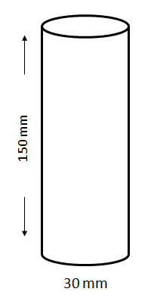

A fold-out label is securely affixed to the immediate container (i.e. the fold-out label is attached so that it remains affixed during the foreseeable conditions and period of use). The fold-out label is produced in such a way that the front part cannot be detached from the remainder of the label and the label can repeatedly be closed again so it is not hanging loose.

The information is structured as follows and is provided, if applicable, in all the languages used for the label:

Front page

Information to be provided on the front page of the multilayer/fold-out label should contain at least:

GHS information:

* Product identifier[2]*
* Hazard pictogram(s)
* Signal word
* Supplier identification (name, address and telephone number of the company)

Additional information:

* A symbol to inform the user that the label can be opened to illustrate that additional information is available on inside pages
* If more than one language is used on the fold-out label: the country codes or language codes

Text pages/Pages inside

GHS information:

* Product identifier including, as applicable, hazardous components contributing to the classification
* Signal word
* Hazard statements
* Precautionary statements
* Additional information (e.g. directions for use, information required by other regulations, etc.)

Additional information:

* If more than one language is used on the fold-out label: the country codes or language codes

Back page (affixed to the immediate container):

* Product identifier*
* Hazard pictogram(s)
* Signal word
* Supplier identification (name, address and telephone number of the company)

The product identifier (if applicable) and the signal words on the front page and the back page are in all languages used on the label.

If there is enough space on the front or on the back page, these pages can also be used to display text.

The text on the inside pages (text pages) can also be distributed on more than one page, if the available space is not sufficient. In general it is better to spread the text across more than one page than to have smaller letters that make the text difficult to read. In all cases, the visibility and easy legibility of the label elements should be ensured without the aid of any device other than corrective lenses and contrasted with any other information on the hazardous product or the container.

It is recognized that some regulatory systems (e.g. pesticides) may have specific requirements for the application of labels using a multilayer or booklet style format. Where this is the case, labelling would be undertaken in accordance with the competent authority’s requirements.

The size of the fold-out label and the number of folds should be in a rational relationship to the size of the container. This may limit the number of languages, which can be displayed on the fold-out label.

**Examples:**

Application of the labelling principles discussed in this example are illustrated for a multilingual label in the accordion style below:

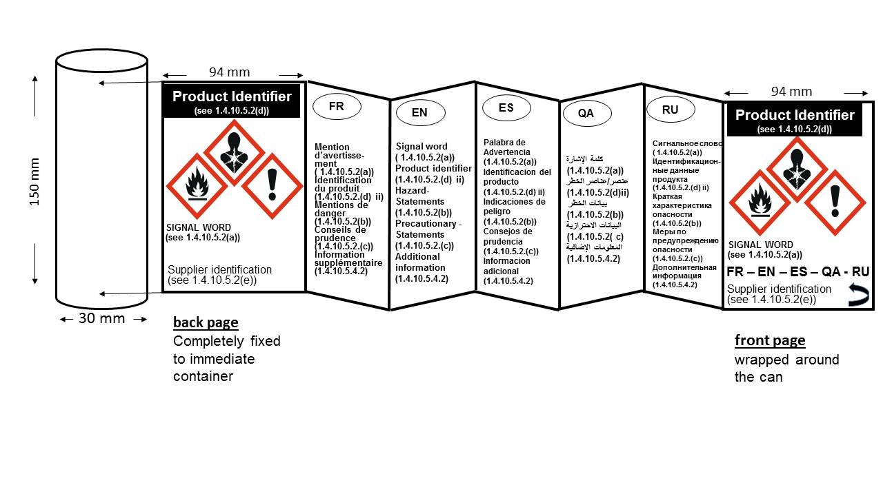

Additionally, the labelling principles discussed in this example could also be applied to any other foldout label styles such as e.g. book style, order book style and window style.

**Book style**

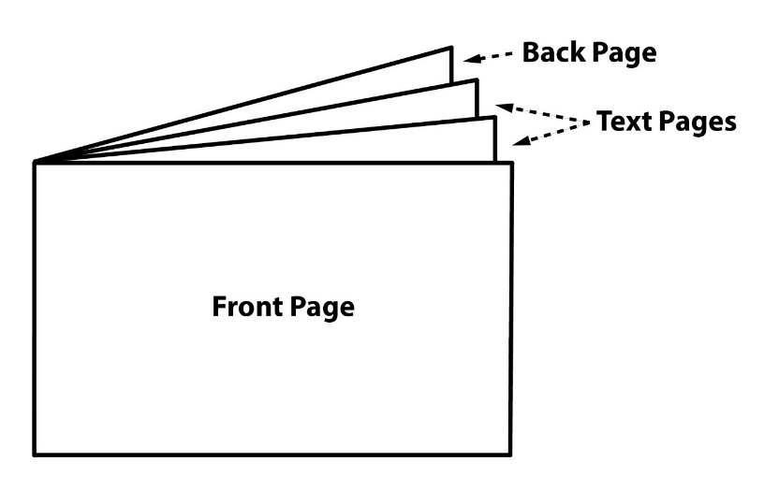

**Order book style**

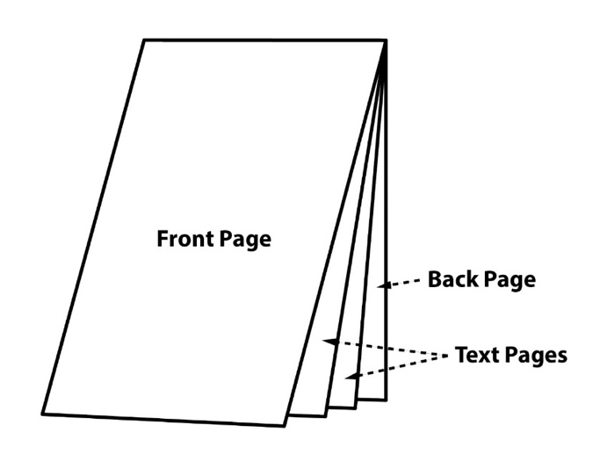

**Window style**

**”**

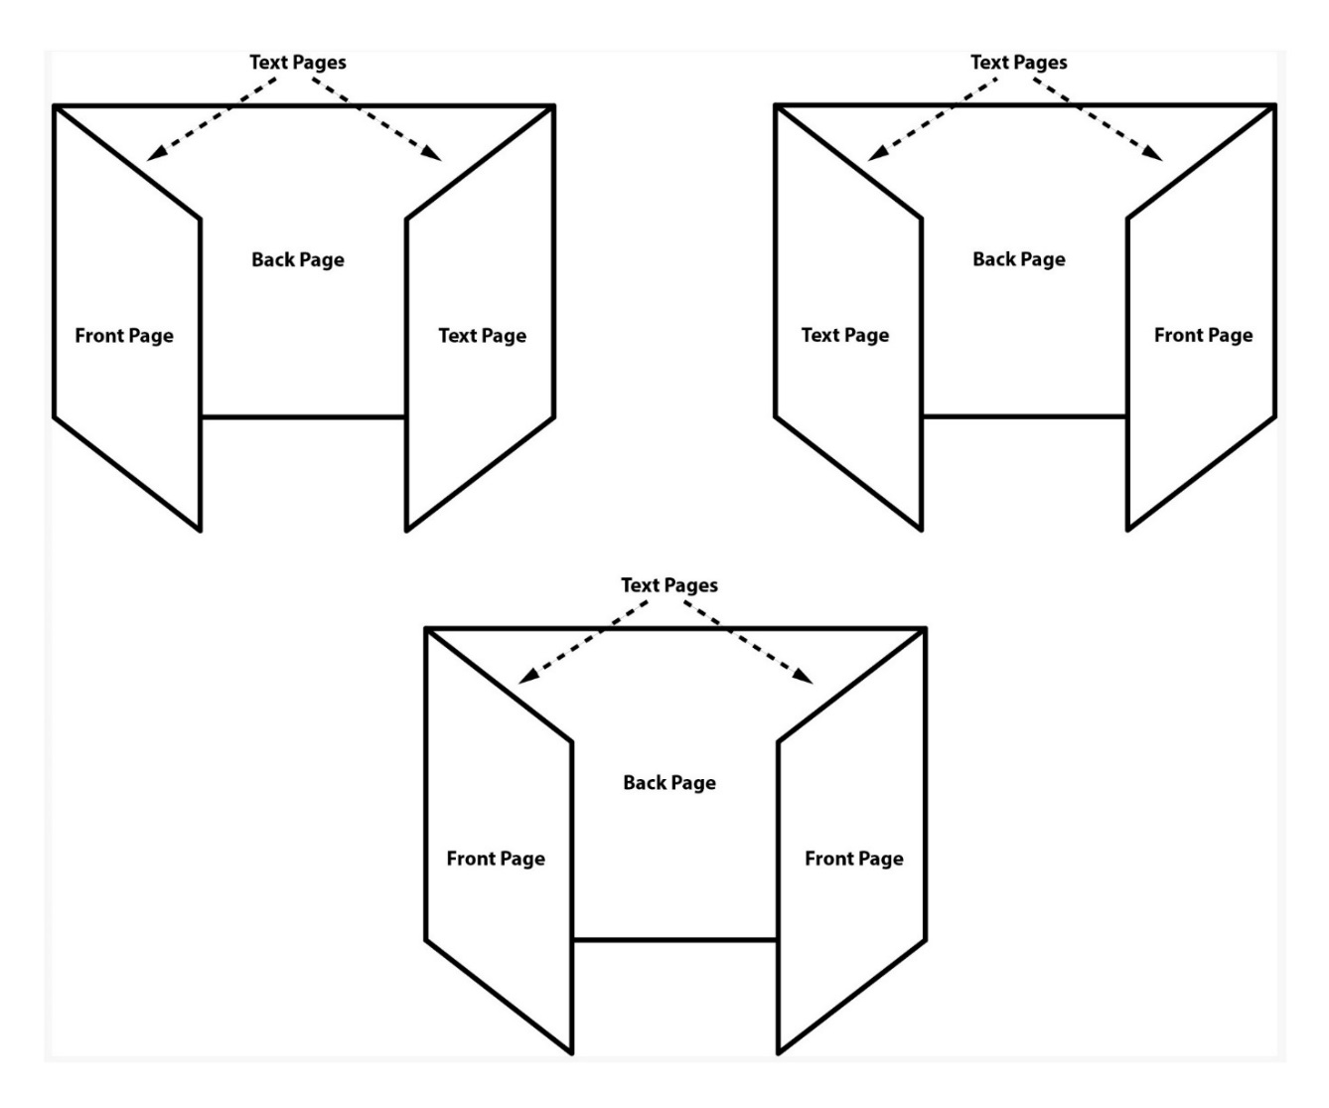

1. *In the absence of data on its pyrophoricity, a flammable gas mixture should be classified as a pyrophoric gas if it contains more than 1% (by volume) of pyrophoric component(s).*
2. * The product identifier on the front and back page does not include hazardous components. If hazardous components are required on the label they are displayed in the appropriate languages on the text pages.